Diversity of Moss-Dwelling Testate Amoebae from Kaimur Wildlife Sanctuary, Bihar, India: A Preliminary Survey

ABSTRACT

The presence of moss-dwelling testate amoebae at the Kaimur Wildlife Sanctuary, Bihar has not been reported in literature before. The current study represents the first documentation of testate amoeba in this conservation area. Testate amoebae are single-celled protists that are characterized by being encased by external tests of chitin (shells) and are commonly known to be a good bioindicator due to their strong susceptibility to environmental variations. In November 2024, as part of faunal survey, moss samples were collected from soil by scraping with a spatula into polythene bags and brought to the laboratory for further processing by the non-flooded petri dish method then preparing permanent slide mounts and examined using microscopes equipped with camera attachment for image capturing and species-level identification to determine the diversity of testate amoeba living in moss microhabitats in the sanctuary. The study showed 13 species belonging to 6 genera and 6 families. The results are the first report of testate amoebae in Kaimur Wildlife Sanctuary, Bihar and have demonstrated the ecological importance of moss as an important microhabitat in sustaining testate amoeba diversity as they respond rapidly to environmental changes.

Keywords: Testate amoebae; protozoa; moss; Kaimur Wildlife Sanctuary; pollution indicator.

1. INTRODUCTION

This article reports the microfauna inhabiting moss ecosystems. Of these, testate amoebae (TA) are unicellular protozoans encased in shells of protection, which are generally considered as important bioindicators of the environmental conditions. The current work is the preliminary report on this microfauna from the Kaimur Wildlife Sanctuary (KWS), Bihar.

KWS in the districts of Kaimur and Rohtas, Bihar India is a large area with diverse habitats including rocky plateaus and dry deciduous forests. These habitats support a wide range of faunal communities, such as relatively little-known microfauna [1]. Although the vertebrate diversity of the sanctuary has been quite well reported, there is a complete dearth of peer-reviewed information on the invertebrate microfauna, especially the moss associated TA.

Traditionally the main targets of zoological surveys carried out in KWS have been vertebrates and comparatively larger invertebrates [2]. Nontheless, microfaunal groups, especially TA, have not been have not been systematically described, leaving a significant gap. This gap is particularly significant in Indian protected areas, where diversity of insects and arthropods has been studied in an organized fashion to facilitate ecological evaluation.
Although testate amoebae have been reported from different states, their occurrence in Bihar has received limited attention [3], which leaves a significant gap in knowledge on the distribution and ecological significance of the organism in the region. Specifically, their presence and distribution patterns in the wildlife sanctuaries and national parks of Bihar are still underexplored and hence the necessity of targeted studies on ecologically important landscapes. Therefore, the lack of studies on microscopic biota in KWS highlights that specific research on TA is necessary to understand their role in ecosystem structure and functioning.

The TA inhabit a wide range of ecological habitats and are highly sensitive to environmental disturbances [4]. They are sensitive to changes of the environment due to their short generation times thereby forming good predictors of ecological change [5,6,7]. These shelled protozoa are ubiquitous in the world, being found both in tropical and polar areas and in both terrestrial and aquatic (including marine) environments. They are highly sensitive to changes in moisture, pH, and other environmental parameters and thus their applicability in the monitoring of the environmental dynamics is found to be significant [8]. Also, they have been found to be affected by climatic conditions, which allow application in the reconstructions of past hydrological regimes, and the evaluation of current ecological health [9,10,11,12].

TA being a functional diverse group of shelled protozoa is very important in ecosystem processes particularly in soils and aquatic microecosystems. In addition to providing valuable information as bioindicators, they are important in the cycle of nutrients and decomposing organic matter, both of which have effects on the ecological mechanisms [5]. There is an ecologically significant relationship between TA and mosses since the moss microhabitats are wet, nutrient-rich environments where they can survive. Moss beds provide structured microecosystems by not only increasing diversity of microfauna but also enabling complex food web, which connects the larger communities of microbiomes [13].

The current research is a description of the diversity of TA in the microhabitats of KWS that are composed of moss. It develops the existing knowledge of the abundance of these taxa in tropical ecosystems and highlights the importance of these groups in the ecology of moss communities [4]. Also, the results provide a wider biogeographical view of the protozoan diversity in diverse Indian environments and emphasize the need to preserve microhabitats in tropical protection zones. The descriptions of 13 species of 6 genera and 6 families adds to the known fauna list of the area. Based on the rising rates of environmental pollution in Bihar, the ecological sensitivity of TA to ecological upheavals is an added advantage that validates their use as effective bioindicators of ecosystem health. The subsequent taxonomic and ecological studies of protozoa in the future will therefore be useful in the environmental surveillance and conservation planning, especially on a state level.

2. GLOBAL AND INDIAN DIVERSITY OF TESTATE AMOEBAE

Free-living TA are widely distributed across the world and they are over 675 species belonging to 104 genera and 22 families and have even been reported in the polar regions. In India, its richness is displayed in 209 species distributed in 37 genera and belonged to two classes and two orders [14]. Their extensive geographic distribution points to the unprecedented versatility of TA and supports their role as bioindicators as they can be found in non-polar ice, as well as in a variety of ecosystems all over India and elsewhere.

3. MATERIAL AND METHODS

The moss samples (12 Lots) for the present study were collected on 24th November 2024 as part of a faunal survey program within the KWS in Bihar. The samples were obtained from soil by scraping with a spatula into polythene bags and brought to the laboratory for further processing. The processing of samples followed the non-flooded petri dish method outlined by Foissner [15]. A portion of the moss sample collected from the soil was placed in a Petri dish, spread out in a thin layer. A small amount of distilled water is added to moisten the sample without flooding it, ensuring the water only saturates the material and mimics natural microhabitats. The sample is then incubated at room temperature for a few hours or overnight, allowing microorganisms to become active. Subsequently, permanent slide mounts were prepared from each sample and examined using microscopes equipped with camera attachment for image capturing and species-level identification. All the registered permanent slides were deposited in the National Zoological collections of Gangetic Plains Regional Centre, Zoological Survey of India, Patna.

4. RESULTS AND DISCUSSION

The study yielded the following new records to KWS, Bihar belonging to 13 species in 6 genera and 6 families during this preliminary investigation.
Systematic list of Testate Amoebae from KWS, Bihar: Findings from the present study (Plate 1, 2, 3) (Classification as per Adl et al., 2019) [16, 17]
Domain Amorphea Adl et al., 2012
Supergroup Amoebozoa Lühe, 1913, sensu Cavalier-Smith, 1998
Phylum Tubulinea Smirnov et al., 2005
Class Elardia Kang et al., 2017
Order Arcellinida Kent, 1880
Family Netzeliidae Kosakyan et al., 2016

1. Cyclopyxis arcelloides (Penard, 1902) Deflandre, 1929
1902. Centropyxis arcelloides Penard, Faune Rhizopodique du bassin du Léman, Geneve, p. 309.
1929. Centropyxis (Cyclopyxis) arcelloides Deflandre, Arch. Protistenkd., 67, p.367.
Distribution: India: Andhra Pradesh, Arunachal Pradesh, Himachal Pradesh, Kerala, Manipur, Meghalaya, Mizoram, Odisha, Sikkim, Tamil Nadu, Uttar Pradesh, Uttarakhand, West Bengal, Chandigarh, Punjab, Bihar
Remarks: Present record from KWS, Bihar
2. Cyclopyxis eurystoma Deflandre, 1929
1929. Centropyxis (Cyclopyxis) eurystoma Deflandre, Arch. Protistenkd., 67: 370.
Distribution: India: Arunachal Pradesh, Assam, Himachal Pradesh, Kerala, Maharashtra, Nagaland, Tamil Nadu, Telangana, Uttarakhand, West Bengal, Punjab, Bihar
Remarks: Present record from KWS, Bihar
Family Phryganellidae Jung, 1942
3. Phryganella acropodia (Hertwig & Lesser, 1874)
1909. Phryganella acropodia Hopkinson, The British Freshwater Rhizopoda and Heliozoa, 2: 74, pl.20, figs.13-14.
Distribution: India: Himachal Pradesh, Sikkim, Tamil Nadu, Telangana, Uttarakhand, Punjab, Bihar
Remarks: Present record from KWS, Bihar
Family Difflugiidae Wallich, 1864
4. Difflugia globulosa (Dujardin, 1837) Penard, 1902
1837. Difflugia globosa Dujardin, Ann. Sci. nat. Zool. (2) 8: 310, pl. 9. Fig. 1.
1902. Difflugia globulosa Penard, Faune Rhizopodique du Bassin de Leman. Geneve: Kundig, pp.714.
Distribution: India: Andhra Pradesh, Assam, Himachal Pradesh, Meghalaya, Odisha, Rajasthan, Tamil Nadu, Uttar Pradesh, West Bengal, Punjab, Bihar
Remarks: Present record from KWS, Bihar
Family Centropyxidae Jung, 1942
5. Centropyxis aerophila Deflandre, 1929
1929. Centropyxis aerophila Deflandre Arch. Protistenkd., 67:330.
Distribution: India: Andhra Pradesh, Arunachal Pradesh, Himachal Pradesh, Kerala, Manipur, Meghalaya, Mizoram, Nagaland, Odisha, Sikkim, Tamil Nadu, Telangana, Tripura, Uttar Pradesh, Uttarakhand, West Bengal, Chandigarh, Punjab, Bihar
Remarks: Present record from KWS, Bihar
6. Centropyxis aculeata (Ehrenberg, 1838) Stein, 1859
1958. Centropyxis aculeata minima Van Oye, Etude sur les Rhizopdes des marais du-ouest d’Uvira (Congo-belge), Hydrobiologia, 10:85-137.
Distribution: India: Andhra Pradesh, Arunachal Pradesh, Assam, Himachal Pradesh, Kerala, Maharashtra, Meghalaya, Mizoram, Nagaland, Odisha, Rajasthan, Sikkim, Tamil Nadu, Telangana, Tripura, Uttar Pradesh, Uttarakhand, West Bengal, Chandigarh, Bihar
Remarks: Present record from KWS, Bihar
7. Centropyxis ecornis (Ehrenberg, 1841)
1841. Arcella ecornis Ehrenberg, Abh. Akad. Wiss. Berlin, p. 368.
1879. Centropyxis ecornis Leidy, Freshwater Rhizopods of North America, pl.30, figs.20-24.
Distribution: India: Andhra Pradesh, Arunachal Pradesh, Assam, Himachal Pradesh, Kerala, Maharashtra, Meghalaya, Nagaland, Odisha, Sikkim, Tamil Nadu, Telangana, Uttar pradesh, Uttarakhand, West Bengal, Punjab, Bihar
Remarks: Present record from KWS, Bihar
8. Centropyxis platystoma (Penard, 1890) Deflandre, 1929
1929. Centropyxis platystoma Defalndre, Arch. Protistenkd., 67: 338.

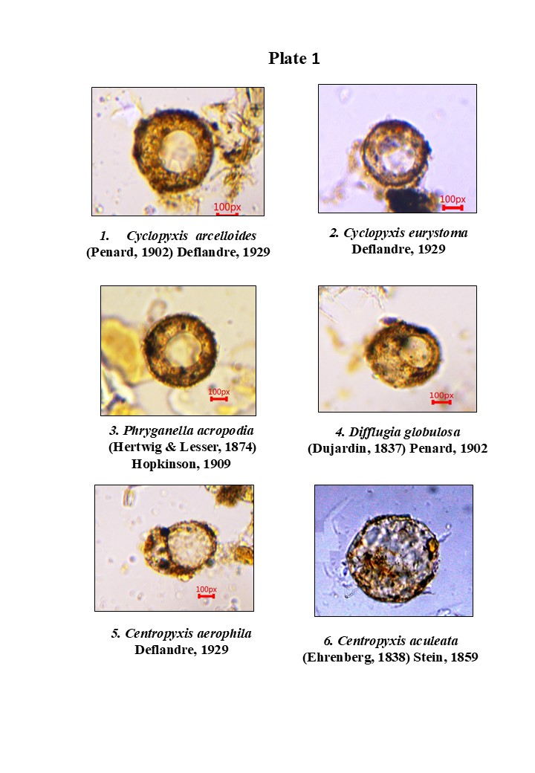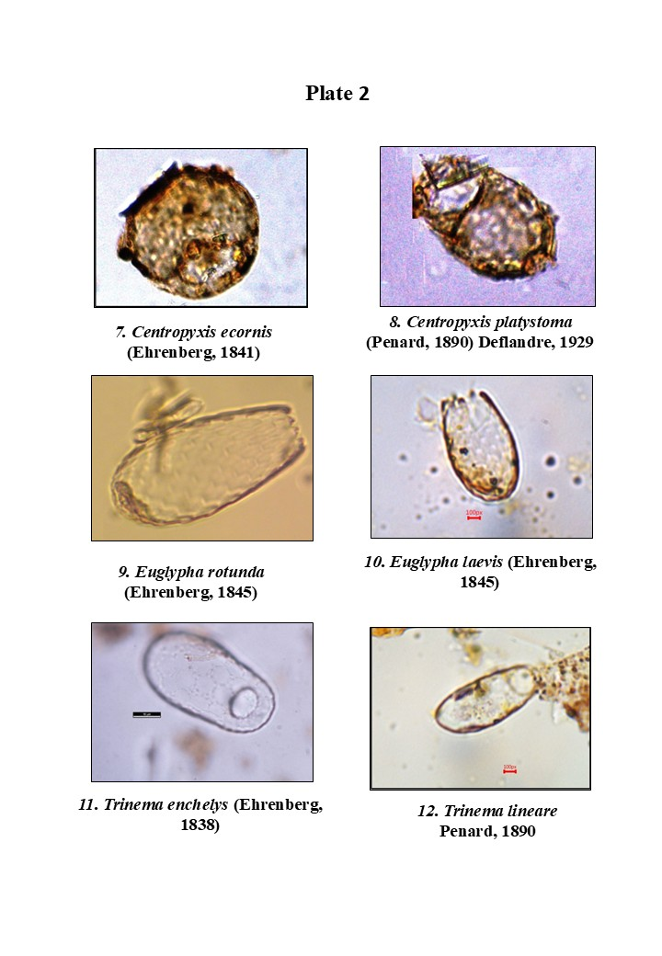
Plate 1, 2, 3: Microphotographs of Testate Amoebae from KWS, Bihar

Distribution: India: Andhra Pradesh, Arunachal Pradesh, Assam, Himachal Pradesh, Kerala, Manipur, Meghalaya, Mizoram, Nagaland, Odisha, Sikkim, Tamil Nadu, Tripura, Uttar Pradesh, West Bengal, Chandigarh, Punjab, Bihar
Remarks: Present record from KWS, Bihar
Phylum Cercozoa Cavalier-Smith, 2018
Class Silicofilosea Adl et al., 2012
Order Euglyphida Cavalier-Smith, 1997
Family Euglyphidae Lara et al., 2007
9. Euglypha rotunda (Ehrenberg, 1845)
1911. Euglypha rotunda Wailes and Penard, Proc. R. Irish Acad., 31: 60-62.
Distribution: India: Himachal Pradesh, Kerala, Maharashtra, Odisha, Telangana, Tripura, Uttarpradesh, Uttarakhand, Punjab, Bihar
Remarks: Present record from KWS, Bihar
10. Euglypha laevis (Ehrenberg, 1845)
1845. Euglypha laevis Ehrenberg, Ber. Akad., Berlin, p. 307.
1849. Euglypha laevis Perty, Mitth. nat. Ges. Bern., p. 163
Distribution: India: Himachal Pradesh, Kerala, Maharashtra, Odisha, Telangana, Uttar Pradesh, Uttarakhand, Bihar
Remarks: Present record from KWS, Bihar
Family Trinematidae Adl et al., 2012
11. Trinema enchelys (Ehrenberg, 1838)
1890. Trinema lineare Penard, Mem. Soc. Geneve, 31: 187, pl. 11. Figs. 5-17.
1915. Trinema lineare Cash, Wailes and Hopkinson, Ray. Soc. Publ. London, 3: 91, pl. 47, figs. 11-21.
Distribution: India: Andhra Pradesh, Assam, Himachal Pradesh, Kerala, Maharashtra, Odisha,Sikkim, West Bengal, Bihar
Remarks: Present record from KWS, Bihar
12. Trinema lineare Penard, 1890
1890. Trinema lineare Penard, Mem. Soc. Geneve, 31: 187, pl. 11. Figs. 5-17.
1915. Trinema lineare Cash, Wailes and Hopkinson, Ray. Soc. Publ. London, 3: 91, pl. 47, figs. 11-21.
Distribution: India: Andhra Pradesh, Arunachal Pradesh, Assam, Himachal Pradesh, Manipur, Meghalaya, Mizoram, Nagaland, Odisha, Tripura, Uttarpradesh, Uttarakhand, Chandigarh, Punjab, Bihar
Remarks: Present record from KWS, Bihar
13. Trinema complanatum Penard, 1890
1890. Trinema complanatum Penard, Mem. Soc. Geneve, 31: 187, pl.10, figs. 1-4.
Distribution: India: Andhra Pradesh, Arunachal Pradesh, Himachal Pradesh, Kerala, Meghalaya, Mizoram, Nagaland, Sikkim, Uttar Pradesh, Uttarakhand, Punjab, Bihar
Remarks: Present record from KWS, Bihar

5. CONCLUSION

Moss dwelling TA are very useful microfauna in understanding the dynamics of the environment, as mosses generally grow well in wet or waterlogged environments. They are quick in responding to the changes in environmental conditions, and thus these microorganisms are dependable bioindicators of pollution and other environmental disturbances [18, 19].

Considering the present diversity on TA in Kaimur Wildlife Sanctuary (KWS) and other protected areas of Bihar, there is a necessity of more site-specific research with much detail, since this is only preliminary study. These studies should also evaluate their potential for monitoring ecological changes, especially in the landscapes where anthropogenic pressures occur by providing details of bio indicator species. Such future studies of particular microhabitats will enhance our knowledge on the dynamics of the ecosystems, help in the comparison of the effectiveness of the protective area network and help in the sustainable management of the unique ecosystems.

DISCLAIMER (ARTIFICIAL INTELLIGENCE)

Author(s) hereby declare that NO generative AI technologies such as Large Language Models (ChatGPT, COPILOT, etc.) and text-to-image generators have been used during the writing or editing of this manuscript.

Competing interests

Authors have declared that no competing interests exist.

REFERENCES

- MoEF&CC (2021). National Parks and Wildlife Sanctuaries in India. Ministry of Environment, Forest and Climate Change, Government of India. 454.
- Bhattacharyya, T. P. & Ghosh, M. K. (2004). Faunal Composition of Kaimur Wildlife Sanctuary: Bihar. Conservation Area Series No, 22. The Director, Zoological Survey of India, Kolkata.
- Kumar VM, Sathish, L Bindu, Kumar A. (2024). First Report on Moss-Dwelling Testate Amoebae from Bihar, India: Species Diversity and Ecological Significance. Bionature. 44(2):73-81.
Available:https://doi.org/10.56557/bn/2024/v44i22044
- Smith HG, Bobrov A, Lara E. (2007). Diversity and biogeography of testate amoebae. In: Foissner W, Hawksworth DL, editors. Protist Diversity and Geographical Distribution. Topics in Biodiversity and Conservation, vol 8. Dordrecht: Springer. 173-185. https://doi.org/10.1007/978-90-481-2801-3_8.
- Ogden CG, Hedley RH. (1980). An Atlas of Freshwater Testate Amoebae: 95 Plates. British Museum (Natural History) and Oxford University Press. 222.
- Mitchell EAD, Gilbert D. (2004). Vertical micro-distribution and response to nitrogen deposition of testate amoebae in Sphagnum. J Eukaryot Microbiol. 51(5):485-495.
- Mitchell EAD, Charman DJ, Warner BG. (2008). Testate amoebae analysis in ecological and paleoecological studies of wetlands: past, present and future. Biodivers Conserv. 17(9):2115-2137.
- Nguyen-Viet H, Bernard N, Mitchell EAD, Cortet J, Badot P-M, Gilbert D. (2007). Relationship between testate amoeba (protist) communities and atmospheric heavy metals accumulated in Barbula indica (Bryophyta) in Vietnam. Microb Ecol. 53(1):53-65.
- Vincke S, Gremmen N, Beyens I, Van de Vijver B. (2004). The moss dwelling testaceans fauna of Ile de Possession. Polar Biol. 27(11):753-766.
- Mattheeussen R, Ledeganct P, Vincke S, Van de Vijver B, Nijs I, Beyens L. (2005). Habitat selection of aquatic testate amoebae communities on Qeqertarsuq (Disko Island), West Greenland. Acta Protozool. 44(3):253-263.
- Bobrov A, Charman DJ, Warner BG. (1999). Ecology of testate amoebae (Protozoa: Rhizopoda) on peatlands in Western Russia with special attention to niche separation in closely related taxa. Protist. 150(2):125-136.
- Jassey VE, Signarbieux C, Hättenschwiler S, Bragazza L, Buttler A, Delarue F, et al. (2013). An unexpected role for mixotrophs in the response of peatland carbon cycling to climate warming. Sci Rep. 3:2354.
- Mitchell EAD, Charman DJ, Warner BG. (2015). Testate amoebae analysis in ecological and paleoecological studies of wetlands: past, present and future. Biodivers Conserv. 7(2):211-230.
- Bindu L, Purushothaman J, Ambili A, Chaudhary A (2024). Checklist of Fauna of India: Testate Amoeba (Protozoa: Tubulinea; Cercozoa; Stramenopiles). Version 1.0. Zool Surv India. doi: 10.26515/Fauna/1/2023/Protista:Tubulinea;Cercozoa;Stramenopiles.
- Foissner W. (1992). Estimating the species richness of soil protozoa using non-flooded petri dish method. In: Lee JJ, Soldo AT, editors. Protocols in Protozoology. Allen Press.
- Adl SM, Simpson AG, Lane CE, Lukes J, Bass D, Bowser SS, et al. (2012). The revised classification of eukaryotes. J Eukaryot Microbiol. 59(5):429–493.
- Adl SM, Bass D, Lane CE, Lukes J, Schoch CL, Smirnov A, et al. (2019). Revisions to the classification, nomenclature, and diversity of eukaryotes. J Eukaryot Microbiol. 66(1):4–119.
- Freitas YDG, Ramos BRDO, da Silva YG, Sampaio GS, da Silva Nascimento L, Branco CWC, et al (2022). Testate amoebae: A review on their multiple uses as bioindicators. Acta Protozool; 61:1-21.
- Kuuri-Riutta O, Väliranta M, Tuittila ES. (2022). Literature review on testate amoebae as environmental indicators and as a functional part of the microbial community in northern peatlands. Mires Peat. 28:28.

