Review Article
Epipremnum aureum (Linden & Andre) G.S Bunting (Araceae): A Comprehensive review of its ornamental, phytochemical, environmental and pharmacological potential

ABSTRACT
The monocotyledonous family Araceae is well known for its ornamental values due to the presence of interesting leaf and flower shape, size and structure. Epipremnum aureum, widely known as the Money plant belonging to the family Araceae, created a special position among other Aroids. This plant is grown primarily as an ornamental and indoor plant in different regions of the globe. Apart from this, this plant species is involved in various scientific investigations and applications. The present review article highlighted the multifarious uses of ornamental aroid species Epipremnum aureum along with its morphological characteristics, propagation methods and phytochemical properties. From literature review it was confirmed that, besides the ornamental purposes of use, the plant acts as a reservoir of different major bioactive compounds like alkaloids, steroids, terpenoids, flavonoids, tannins, cardiac glycosides, phenolics and triterpenoids. On the environmental significance point of view, Money plant is well known for purification of polluted water and air caused by formaldehyde and Zn like hazardous materials. Biological properties like antioxidant activities, antidiabetic nature, antimicrobial, antiviral and anticancer potency are detected in the extract prepared from different parts of the plant. Utilization of previously documented experimental results in the development of drugs will be necessary for understanding the pharmacognosical importance of the plant. Further studies regarding quantitative phytochemical analysis, determination of anticancer activities against various type of cancer cell, antifungal properties, and cardiovascular protective power of different parts are necessary. Similarly comparative analysis of biological activities of extraction prepared from different plant parts and different extraction solvents are necessary to explore the hidden pharmacological secrets of Epipremnum aureum, which will be beneficial for the human and environment.

Keywords: Araceae, Epipremnum aureum, Money plant, ornamental, pharmacognosy, phytoremediation, biological property

INTRODUCTION
The family Araceae occupies a special position among monocotyledonous plant families due to its food, medicinal and ornamental values. The members of this family range from tiny floating hydrophytes to large climbers grown in forest. Beside this, many are cultivated and grown in different regions as an ornamental plant due to their attractive flower or leaves. This family is represented by 23 species under 18 genera in Odisha including 3 ornamental species (Saxena & Brahmam, 1996). The genus Epipremnum Schott comprises 14 species of slender to gigantic root climbing lianas. This plant belongs to the tropical and sub tropical regions and commonly known as Money plant, Devil’s Ivy, Silver vine and Golden vine, is widely available across Indian subcontinent (Moodley et al., 2017). The distribution of the species is cosmopolitan with a dispersion centre in French Polynesia (Boyce 2004). This ornamental plant species is widespread and invasive too (Valadares, 2011). Among the ornamental aroid species, the Epipremnum aureum (Money plant) is grown as an indoor plant due to its ethical and environmental significance. Due to the robustness, easy method of propagation, perennial growth, fibrous root system, as well as potency to grow on minimal light and nutrient, it is considered as a promising plant for development of nature based technologies for treatment of waste water by removing the nutrient (Yadav et al., 2021). This plant is also considered as a symbol of prosperity. In some regions, roots and leaves of these plants are traditionally used for treatment of different diseases in ancient times due to which it is considered as an ayurvedic medicinal plant (Ramya et al., 2023). The practice of employing ornamental plants for their biological properties has been increasing for quite some time. The present review aims to discuss the different aspects of Epipremnum aureum, which is primarily grown as an ornamental plant.

METHODOLOGY
To gather the information regarding the multiple utility Epipremnum aureum, several research databases like google scholar, research gate, Wiley online library, JSTOR, Scopus database, Springer nature database were followed. The literatures were searched in this online database by using the different key words Epipremnum aureum, money plant, biological properties, ornamental aroids etc. In this literature search the obtained research papers were carefully reviewed and obtained scientific information were described as follows.

RESULTS

Origin, Distribution, Morphology and Classification
The Money plant is native indigenous to Solomon Islands, Moorea and various regions of Southeast Asia, including the Philippines, Indonesia and Malaysia (Kotwal et al., 2025). This climbing plant primarily prefers wet tropical biomes for its growth and development (POWO, 2025). The distribution of the species is cosmopolitan with a dispersion centre in French Polynesia (Boyce, 2004). This plant is native to South eastern Asia and New Guinea (D’Souza at al., 2022). This ornamental plant species is introduced to different parts of the globe including Assam, Bangladesh, Brazil, Cameroon, Caroline etc, is widespread as a result became invasive (Valadares, 2011).
Leaves of this plant are ever green, heart shaped, alternate, simple or variegated with white, cream, yellow and green color with waxy coating. The variation in size and color of leaves depending upon light is a notable feature. Plants generate trailing stems during climbs up trees and these produce roots when they reach the ground. Flowers are born on inflorescence called spadix, which is usually accompanied by a leaf-like structure known as spathe (Meshram & Srivastava, 2014)
According to the (POWO, 2025) the systematic position of the Epipremnum aureum is described as follows

Kingdom: Plantae
Phylum: Streptophyta
Class: Equisetopsida
Subclass: Magnoliidae
Order: Alismatales
Family: Araceae
Genus: Epipremnum
Species: aureum
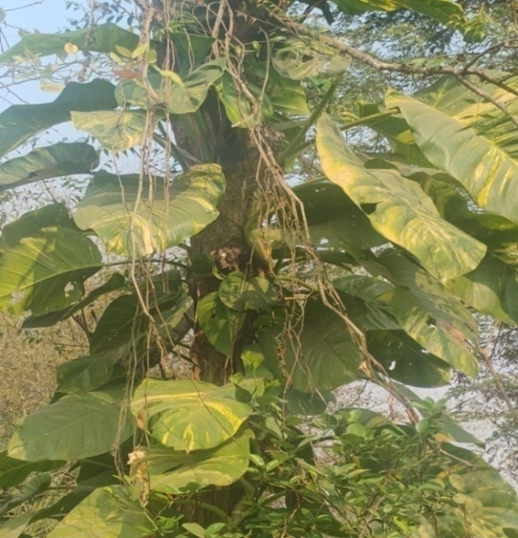
Fig. 1: Photograph of Epipremnum aureum (Linden & Andre) G.S Bunting growing in natural habitat

Taxonomy
Large root climbing hemi epiphyte up to 16 m height with diameter 5-40 mm in adult, with prominent irregular whitish longitudinal crests with variegated yellow patches. Old stems with papery epidermis, petiolar sheath extending to midway and turns chartaceous on drying. Leaf blade (10-93×5-60 cm), entire, ovate, chordate, thick, fleshy, apex truncate, yellow or white variegated, venation reticulate. Branches pendulous, rooting at nodes (WFO, 2026; Sharma et al., 1996).

Propagation & Growth factors
Epipremnum aureum is propagated by tip cutting or stem cutting method as it produces roots easily in soil or water. The best time period for using cutting methods is either the summer or spring season. This plant requires very little care and does not need direct sunlight. The optimal temperature for the growth of the money plant is 22⁰-26⁰ C. The plant requires frequent watering from spring to autumn but maximum watering should be avoided during the winter season. This plant is capable of tolerating heat and humid environmental conditions. Sandy loam to clay loam soil supports better growth of this plant (Meshram & Srivastava, 2015).

Cultural value
It is widely believed that, if money plants grow well it brings prosperity and positive energy. The well growth of this plant is considered as an indicator of wealth. According to the vastu experts, the planting of money plants inside the house brings good luck to the house. It is believed that placing a money plant in front of a sharp corner or angle reduces stress and anxiety. Vastu experts suggests planting of money plant inside the house as it attracts good luck to house (Meshram & Srivastava, 2015)

Phytoremediation potency (purification of air and water)
Eco-friendly and cost effective nature based technologies that use plants as a major component are becoming probable for treatment of waste water. The plant is considered as one of the important indoor plants as it is capable of removing formaldehyde, which is a carcinogenic compound that is released by many household products (Xu et al., 2011). Money plants possess the ability to remove both fluoride and total dissolved solids from polluted water and are capable of surviving more than 2 months without nutrients. Apart from that, physiochemical analysis of water reveals that the plant can accumulate dissolved heavy metals and anionic contaminants like chloride and sulfate. This result indicates that it may be considered as a potential plant for cost effective phytoremediation of fluoride contaminated water (Singh et al., 2019). Accumulation of the Zn in the stem and leaf tissue elaborates that the plant is capable for translocation of Zn to aerial parts, hence acting as a potential plant to solve hazardous effects of toxicity caused by Zn (Abbas et al., 2019). The result of Yadav et al. (2021) supports use of this plant in nature based technologies for removal of nutrients from various types of waste water. This plant achieved removal of total nitrogen and total phosphorus from primary treated domestic waste water, secondary effluent, greywater. The majority of removal happened within the first 15 days. This plant can be utilized for reduction of COD in waste water, indicating that the plant is suitable for growing in industrial effluent or polluted water (Qing et al., 2021). Money plant is a popular houseplant (indoor plant) which is capable of removing pollutants like xylene, formaldehyde and benzene (Panchal et al., 2022). The experimental work involved on removal of formaldehyde by the stems of E. aureum, indicates that the efficiency of removal by stems is 0.089 mg. M⁻³.h⁻¹.and the rate of purification is 40.0 (Zuo et al., 2022). Phytoremediative potential of E. aureum to improve the chemical properties of irrigation water, showed a good ability to reduce the salinity of the irrigation water (Lastiri-Hernandez et al., 2023). The findings of Meza-Gonzalez (2025) states that E. aureum have capacity to tolerate copper concentration up to 10 mg L⁻¹ without morphological damage whereas susceptible to ≥ 15 mg L⁻¹. This indicates that the plant is effective for moderate copper contamination, highlighting its significance in eco-friendly water treatment. Air phytoremediation by using four ornamental potted plants, to accessing the removal efficiency of Volatile organic compounds (VOCs) Benzene, Toluene, Benzaldehyde and Acetophenone across different environmental condition shows that the removal efficiency of E. aureum is 77.23% (Elhadad et al., 2025). The phytoremediation potential of three ornamental plant species for anthracene contaminated soil indicates that the highest anthracene removal efficiency was demonstrated in case of Epipremnum aureum (52.82 ± 2.23%), in comparisons with Portulaca grandiflora and Tagetes erecta (Paul et al., 2025). Anthracene is toxic to the leguminous plants like Pisum sativum and Vigna radiata. The ornamental plant E. aureum can be utilized for the phytoremediation of anthracene and other polycyclic aromatic hydrocarbons, potentially preventing their entry to the food chain, Due to its resistance to low concentration of anthracene (Paul et al., 2025). E. aureum used as a floating macrophyte in the anode chamber and as a cathodic plant. The coupled Constructed wetlands – Microbial fuel cells (CWs-MFC) system demonstrated high efficiency in COD removal, power generation, and nutrient removal, making it promising for sustainable treatment of waste water (Rajpurohit & Behera, 2025).

Phytochemical properties
Previously conducted preliminary qualitative phytochemical analysis using ethanol, acetone and chloroform as extraction solvent confirms the presence of steroid, terpenoids, saponins, tannins and flavonoids (Das et al., 2015). Leaves of this plant showed higher concentration of alkaloid, phenolics, terpenoids and flavonoids in the methanol extracted solvent (Meshram & Srivastava, 2016). GC-MS analysis of acetone root extract of this plant detected 21 types of organic compounds mainly carbohydrates, fatty acids, phenols, alcohols, alkaloids, vitamins and flavonoids with different retention time (Ali, 2018). The total phenol and flavonoid content of methanolic leaf extract of this plant were found to be 125.21 and 52.22 mg g⁻¹ (Prabakaran et al., 2019). Preliminary phytochemical analysis of leaves of E. aureum by Venkatesh et al. (2021) confirmed the presence of glycosides, tannins, flavonoids, phenolic, triterpenoids and steroids.

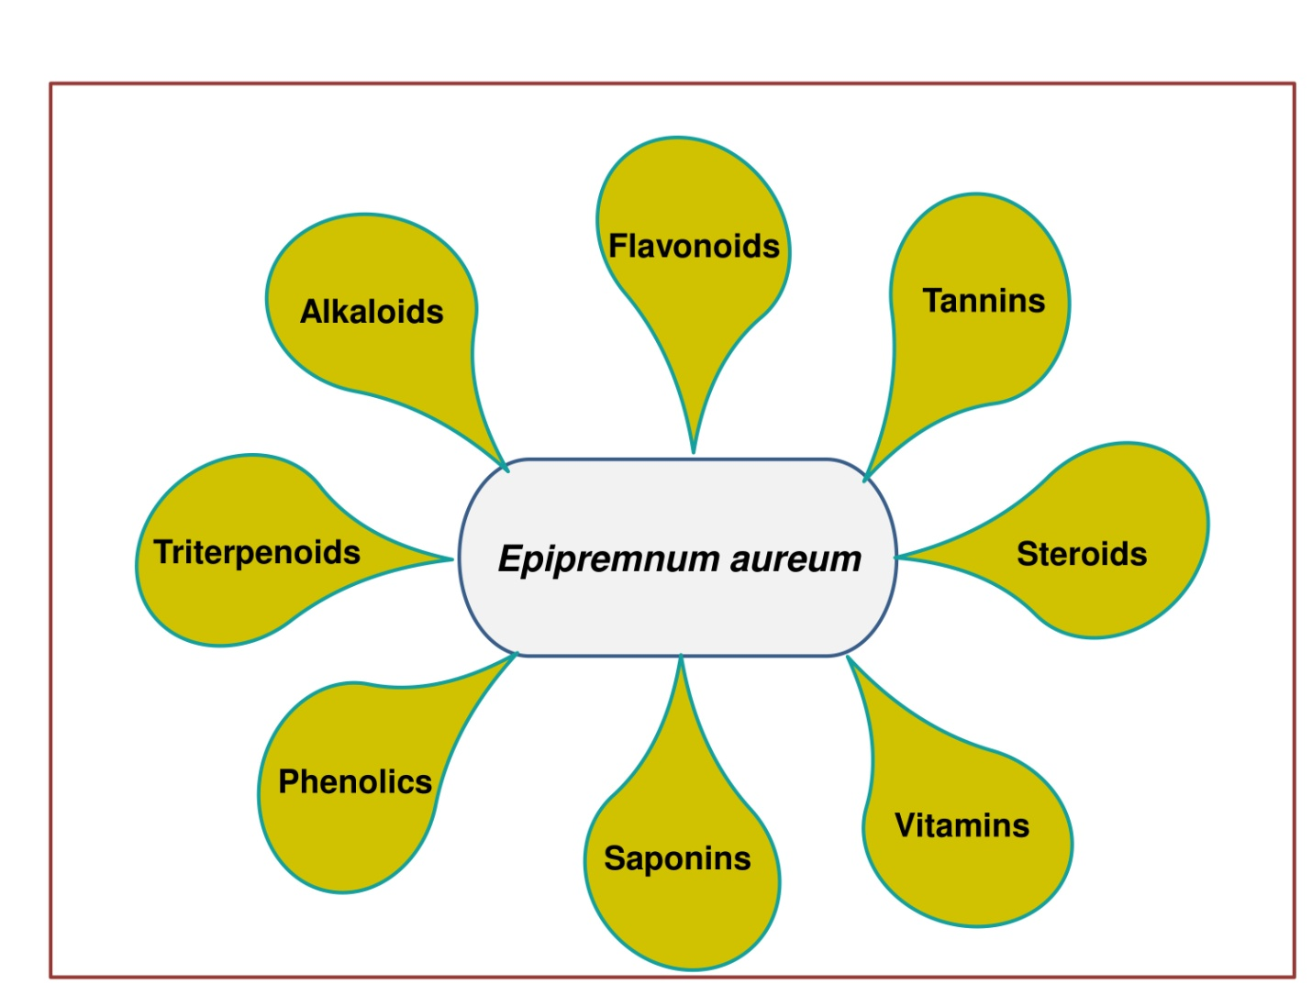
Fig. 2: Chart representing bioactive compounds present in different parts of Epipremnum aureum (Linden & Andre) G.S Bunting

Antitermite effect
All parts of the plant, especially root extract using ethanol is used as a potent antitermite product (Srivastava et al., 2011). Pyrrolidine alkaloids present in the E. aureum have exposed strong in vitro antitermite and antirepellant activities against subterranean termites Odontotermes obesus. This finding suggests that the plant bears potential antitermite properties (Meshram et al., 2019).

Pharmacological activities

Anticancer Potency
Different concentration of E. aureum acetone root extract was assayed against human liver cancer cell line (HEPG-2) to determine the in vitro cytotoxicity. From the result it was observed that, most effective concentration was at 50 μg/ml and the IC50 value was 36.7 μg/ml (Ali, 2018). The special properties like cytotoxicity against the cancer cell as well as immuno-modulating characters are reported in Epipremnum (Salawu et al., 2023). The extract prepared from the aerial part of E. aureum using chloroform and ethanol extracts possess a considerable cytotoxic effect. From the microscopic examination of both the extract suggest that chloroform extract is more effective to check breast cancer due to the presence of apoptotic bodies, nuclear fragmentation and tiny nuclei with strong chromatic condensation (Patil &Wadkar, 2024).

Antimicrobial properties
Methanolic leaf extract of this plant possesses antibacterial activity against E. coli and S. aureus as well as antifungal activity against C. albicans (Sonawane et al., 2011). The evaluation of antimicrobial activity of leaf extract shows a considerable zone of inhibition at a concentration of 3-6 mg/ml against microbes like S. aureus, S. paratyphi and E. coli (Mehta et al., 2013).From this study it was confirmed that the methanolic extract of root is the most effective antimicrobial extract. Antimicrobial activity of aqueous, ethanolic and acetone extract of different parts including leaves, blades, petioles, stems and roots were analyzed by Ali (2018) using bacteria like E. coli, S. aureus and fungi like A. flavus and C. albicans. A. flavus was resistance to all extracts, whereas acetone extract of root proved to be the most effective extract with antimicrobial properties. Similarly, the Minimum inhibitory concentration values of root extract of E. aureum made by acetone as the extraction solvent, against E. coli, S. aureus and C. albicans were 3 mg/ml, 5 mg/ml and 9 mg/ml respectively (Ali, 2028).

Antiviral potency
E. aureum showed the highest virus decreasing characteristics on examination under both kit and quantitative real time polymerase chain reaction in H1N1 influenza virus as a model. The emerging leaves of live plants have the capacity to decrease viral content, when plant coating pot was electrically grounded to the earth (Song et al., 2023).
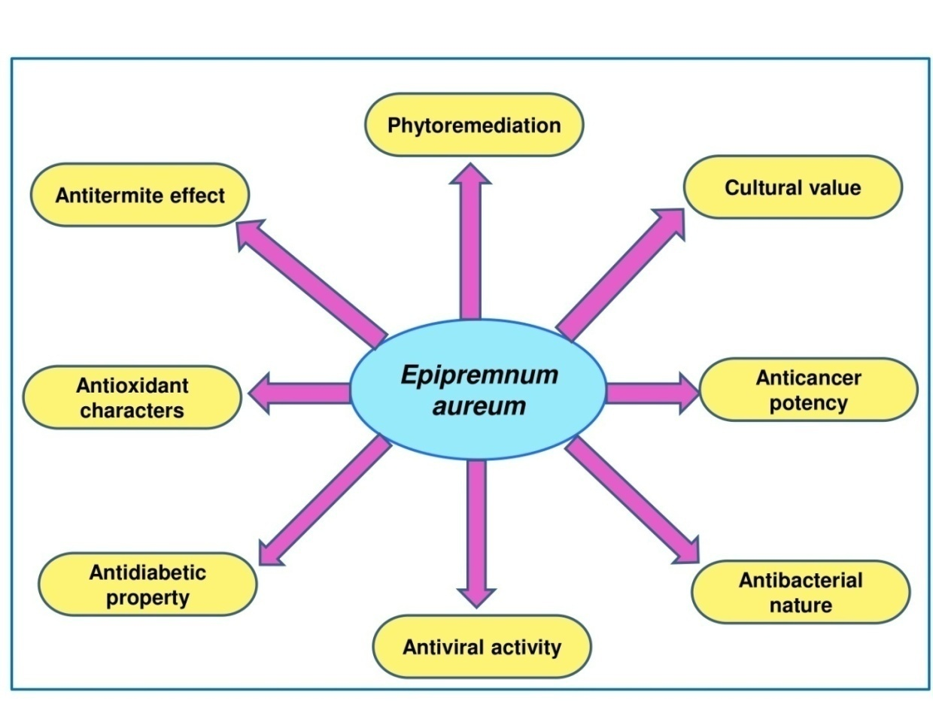

Fig. 3: Figure representing multipotency of Epipremnum aureum (Linden & Andre) G.S Bunting plant
Antitumor property
Ethanolic leaves extract of E. aureum was evaluated against DAL tumor bearing mice by liquid tumor models. Oral administration of EEEA in tumor bearing mice for 14 days showed notable reduction in percentage increase in body weight, tumor volume, tumor weight, viable cell count compared with untreated mice. The EEEA exhibits significant antitumor activity in both methods (Venkatesh et al., 2021).

Antioxidant characteristics
According to Das et al. (2015) although ethanol, acetone and chloroform extract of the plant were proven effective against free radicals, the highest antioxidant activity was detected in ethanol extract in comparison to other two extracts. Crude methanolic and aqueous extract of this plant act as a potential source of natural antioxidant which justified its uses in folklore medicine (Sherikar & Mahanthesh, 2015) Leaves of this plant also showed high antioxidant activity due to catalase and peroxidase enzyme. Leaves also showed maximum free radical scavenging potential than other parts due to catalase and peroxidase enzymes (Meshram & Srivastava, 2016). The pure ethanol, methanol and ethyl acetate extract of leaves shows better actively relative to aqueous extract. Likewise the DPPH free radical scavenging ability was found to be highest in methanolic extract (95%) followed by ethanolic (89%) and ethyl acetate (86%) extract (Prabakaran et al., 2019). Ethyl acetate extract fraction and alkaloidl extract of the aerial part of the money plant shows higher DPPH radical scavenging activity in comparison to methanolic and other fractions (Salawu et al., 2023). The microscopic examination of the chloroform and ethanol extracts obtained from the aerial parts of E. aureum revealed the presence of apoptotic bodies, nuclear fragmentation and tiny nuclei with strong chromatin condensation. The result suggests the chloroform extract of E. aureum is more effective against breast cancer (Patil & Wadkar, 2024).

Anti diabetic activity
In vitro evaluation of antihyperglycemic activity of the methanolic extract of E. aureum by the inhibition of two enzymes namely alpha amylase and alpha glucosidase and nephrotoxic activity against gentamicin induced nephrotoxicity, showed that the methanolic extract of E. aureum leave may be useful in reducing the gentamicin induced nephrotoxicity (Benhouda et al., 2025).

Antiulcer nature
Investigation on the potency of the ethanolic stem extract of E. aureum on pylorous ligated and ethanol induced gastric ulcer by oral administration of extract showed that the plant extract showed highest gastroprotectivity of 71.3% at the doses of 400mg/kg. This finding confirmed that the plant extract can be used in the treatment of stomach ulcer by developing phytostimulation (Jazeela et al., 2022).

DISCUSSION
From this review it was clearly observed that the Epipremnum aureum plant although well known for its ornamental properties, but it act as a potential plant for mitigating environmental pollution due to its phytoremediation abilities. This plant is an important indoor plant as it is capable to remove carcinogenic compounds produced from many household products (Xu et al., 2011) and the it acts as potential plant for cost effective method for treatment of polluted water (Singh et al., 2019). Plant can be propagated easily by tip cutting or stem cutting method and requires little care (Meshram & Srivastava, 2015), indicating that, the species can be involved in environmental pollution management due to potential activity with the expenditure of low cost and little effort. The previously conducted studies highlighted the presence of bioactive compounds by preliminarily phytochemical screening. However, in present scenario the quantitative study and detail analysis of diverse phytochemical groups using key techniques like High performance liquid chromatography (HPCL) for soluble compounds and Gas chromatography-Mass spectrometry (GC-MS) for volatile compounds are necessary, to elaborate the presence of diverse group of phytochemicals. Extraction prepared from different parts of the E. aureum shows effect against micro organisms like E. coli, S. aureus, S. paratyphi, A. flavus and C. albican (Mehta et al., 2013; Ali 2018), indicating its antimicrobial potency. Determination of antimicrobial activities against bacterial stain causing skin diseases, tuberculosis, pneumonia, botulism and cholera, may be useful for development of antimicrobial compounds. During literature review it has been observed that the antioxidant activities of plant extract was determined by analyzing the DPPH free radical scavenging potential, however other methods like ABTS, FRAP and ORAC assays are need to involve as it provides comprehensive data. The chloroform extract of the plant is capable to check breast cancer (Patil & Wadkar, 2024), hence determining the ability of plant extract against carcinoma, sarcomas, lymphomas, leukemia and melanoma will necessary for better understating. This review describes some cultural significance of the plant, but literature regarding the ethnomedicinal usage of E. aureum plant by indigenous communities remains insufficient although the plant possess lot of pharmacological properties. Proper ethnobotanical investigation is required to access the medicinal usage of plant in traditional herbal medicine.

CONCLUSION
Epipremnum aureum is native to South eastern Asia and New Guinea, now widely grown as an ornamental plant in different regions of the world. The plant required little care and low coast for propagation. This plant possesses antiulcer properties and effective against control of bacteria and virus like microorganisms. This plant is able to control growth of cancer cell, check diabetics and reduces oxidative stress. The use of Epipremnum aureum as an ornamental and indoor plant not only provides aesthetic values but also plays a crucial role in. mitigating environmental pollution by purifying air and water. Further studies regarding detail quantitative phytochemical analysis and exploration of hidden pharmacological properties will necessary for discovery of drugs, beneficial for human beings.

Disclaimer (Artificial intelligence)

Author(s) hereby declare that NO generative AI technologies such as Large Language Models (ChatGPT, COPILOT, etc.) and text-to-image generators have been used during the writing or editing of this manuscript.

REFERENCE
Abbas, R., Khan, D. A. S., & Mehnaz, D. S. (2019). Evaluation of potential of Epipremnum aureum Engl. in removing zinc (Zn) toxicity. Pakistan Journal of Botany, 51(5), 1-6.
Ali, E. A. (2018). Antimicrobial activity, cytotoxicity, and phytochemicals screenings of Epipremnum aureum (Linden and Andre) GS Bunting extracts. The Egyptian Journal of Experimental Biology,14(2), 219-25.
Benhouda, A. L., Benhouda, D., &Hanfer, M. (2025). Assessment of Nephroprotective and Antidiabetic Effects of Epipremnum aureum from Algeria in Albinos Rats. Egyptian Journal of Veterinary Sciences, 1-9.
Boyce, P. (2004) A review of Epipremnum (Araceae) in cultivation. Aroideana, 27(1), 205-11.
Das, S. K., Sengupta, P., Mustapha, M. S., Kifayatudullah, M.,&Gousuddin, M. (2015) Phytochemical Investigation and Antioxidant Screening of Crude Leaves Extract from Epipremnum aureum. International Jounal of Pharmacognosy and Phytochemical Research, 7(4), 684-689.
Elhadad, S. M., Shalaby, E. A., Saleh, I. H., & Omar, M. Y. (2025). Comparative evaluation of air phytoremediation potential of four ornamental potted plants for ecofriendly biofilter applications. Scientific Reports, 15, 45659.
Jazeela, D’Souza, U. P., Jyothi, D., & Joshi, H. (2022). Evaluation of Antiulcer activity of Alcoholic stem extract of Epipremnum aureum (Linden Andre) GS Bunting. Research Journal of Pharmacy and Technology, 15(12), 5779-5784.
Kotwal, J., Jain, A., Kashyap, R., Pise, A., Patil, P., & Kimbahune, V. (2025). Money plant leaf (Epipremnum aureum): A comprehensive study of raw datasets with manual classification, Data in brief, 63, 1-10.
Lastiri-Hernández, M. A., Álvarez-Bernal, D., Cruz-Cárdenas, G., Silva-García, J. T., Conde-Barajas, E., & Oregel-Zamudio, E. (2023). Potential of Epipremnum aureum and Bacopa monnieri (L.) Wettst for saline phytoremediation in Artificial Wetlands. Water, 15(1), 194.
Mehta, R., Bhagwat, A.,& Sawant, C. (2013). Antimicrobial potential of methanolic extracts of leaves of Epipremnumaureum (Linden & Andre) g. S. Bunting. International Journal of Pharmacy and Pharmaceutical Sciences, 5 (3), 918-922.
Meshram, A., & Srivastava, N. (2014). Molecular and physiological role of Epipremnum aureum. InternationalJournal of Green Pharmacy, 8, 73-6.
Meshram, A.,&Srivastava, N. (2015). Epipremnum aureum (Jade pothos): a multipurpose plant with its medicinal and pharmacological properties. Journal of Critical Reviews, 2(2), 1-5.
Meshram, A., & Srivastava, N. (2016). Phytochemical screening and in vitro antioxidant potential of methanolic extract of Epipremnum aureum (Linden and Andre) GS Bunting. International Journal of Pharmacutical Research and Allied Science, 5(2), 1-6.
Meshram, A., Bhagyawant, S. S., & Srivastava, N. (2019). Characterization of pyrrolidine alkaloids of Epipremnum aureum for their antitermite activity against subterranean termites with SEM studies. Proceedings of the National Academy of Sciences, India Section B: Biological Sciences, 89(1), 53-62.
Meza-González, D. A., Gómez-Navarro, C. S., Sandoval-García, K., Zárate-Guzmán, A. I., Zárate-Navarro, M. A., & Romero-Cano, L. A. (2025). Phytoremediation of Copper-Contaminated Water Using Epipremnum aureum: Adsorption Mechanisms and Continuous Flow Performance in Green Wall Systems. Processes, 14(1), 100.
Moodley, D.Proches, S., &Wilson, J. R. U. (2017). Assessing and managing the threat posed by Epipremnum aureum in South Africa. Journal of South African Botany, 109, 178–188.
Panchal V, Sapra P, Mankad A (2022) Bio efficacy of Epipremnum aureum: a review. International Association of Biologicals and Computational Digest, 1(2), 59-63.
Paul, S., Singha, E. R., Singh, B. K., Das, I., Giri, S., & Giri, A. (2025). A Study on the Comparative Efficacy of Anthracene Phytoremediation by Epipremnum aureum, Portulaca grandiflora and Tagetes erecta. Bulletin of Environmental Contamination and Toxicology, 115(4), 46.
Paul, S., Dey, A., Singh, B. K., & Giri, A. (2025). Anthracene: multiparametric toxicity assessment in Pisum sativum, Vigna radiata and Epipremnum aureum, and remediation efficacy by Epipremnum aureum. Environmental Science and Pollution Research, 32(20), 12513-12523.
Patil, S. S., & Wadkar, K. A. (2024). In vitro anti-cancer activity of Epipremnum aureum. Bangladesh Journal of Pharmacology, 19(1), 23-28.
POWO. (2025). "Plants of the World Online. Facilitated by the Royal Botanic Gardens, Kew. Published on the Internet; https://powo.science.kew.org/.
Prabakaran, M., Hemapriya, V., Kim, S. H., & Chung, I. M. (2019). Evaluation of antioxidant and anticorrosion properties of Epipremnum aureum. Arabian Journal for Science and Engineering, 44(1), 169-178.
Qing, L. S., Ghazi, R. M., & Muhammad, M. (2021). Potential of Epipremnum aureum in reduction of chemical oxygen demand in wastewater. Malaysian Journal of Analytical Sciences, 25(6), 977- 986.
Rajpurohit, P., & Behera, M. (2025). High-strength domestic wastewater treatment using Epipremnum aureum as the cathodic plant in a constructed wetland-microbial fuel cell. Journal of Water Process Engineering, 69, 106724.
Ramya, K. S. S. L., Shaik, T., Ramesh, B., & Shankar, K. R. (2023). Antioxidant and anti-cataract activity of ethanolic extract of leaves: and Epipremnum aureum In vitro in vivo study. Asian Journal of Pharmacy and Pharmacology, 9(3), 70-77.
Salawu, K. M., Ogbole, O. O., Abiodun, O. O., Mohammed, A., Abdullahi, A. A., & Ajaiyeoba, E. O. (2023). Epipremnum aureum (Linden and André) GS Bunting (Araceae): Free Radicals Scavenging, Cell Growth Inhibition and Cytotoxic effects on Rhabdomyosarcoma and Laryngeal Carcinoma Cancer Cells. Pharmaceutical Journal of Kenya, 27(1), 26-32.
Saxena, H. O., & Brahmam, M. (1996). The Flora of Orissa, Volume 4, Regional Research Laboratory, Odisha.
Sharma, B. D., Karthikeyan, S., & Singh, N. P. (1996). Flora of Maharashtra state Monocotyledons. Botanical Survey of India, Calcutta.
Sherikar, A. S., & Mahanthesh, M. C. (2015). Evaluation of aqueous and methanolic extract of leaves of Epipremnum aureum for radical scavenging activity by DPPH Method, total phenolic content, reducing capacity assay and FRAP assay. Journal of Pharmacognosy and Phytochemistry, 4(4), 36.
Singh, K. P., Shyam Kumar, A., Paniteja, M., & Singh, S. (2019). Novel properties of Epipremnum aureum for treatment of fluoride-contaminated water. SN Applied Sciences, 1(7), 741.
Song, H. J., Yang, S. W., Jo, J. W., Choi, Y. K., Lee, I. S., Lee, B. U., Lee, S. H., Kim, H. H., Kim, K. J., & Kim, H. J. (2023). Submerged leaves of live indoor foliage plants adsorb H1N1 influenza virus from suspension. Plant Signaling & Behavior, 18(1), 2163869.
Srivasatava, N., Shwarupa, S., & Bhagyawant, S. S. (2011). Comparative study on the anti-termite, antimicrobial and antioxidant activity of leaf and root extracts of Pothos aurea (Epipremnum aureum L.).Journal of Pharmaceutical Research and Clinical Practice, 1, 1-11.
Sonawane, C. S., Jagdale, D. M., Patil, S. D., Patil, L. J., & Kadam, V. J. (2011). Phytochemical screening and in vitro antimicrobial activity studies of Epipremnum aureum Linn. leaves extracts. Der Pharmacia Sinica, 2, 267-72.
Venkatesh, S., Muhamed, K., Mridhul Mohan, P., Asheena Asharaf, V. V., Anjitha, P., & Suresh, A. (2021). Anti-Tumor and Anti-Oxidant Activity of Ethanolic Extract of Epipremnum aureum Linn. Leaves against DAL Induced Tumor in Swiss Albino Mice. International Journal of Current Science Research and Review, 4(08), 1008-1021.
WFO (2026). World Flora Online. Published on the Internet; http://www.worldfloraonline.org.
Xu, Z., Wang, L., & Hou, H. (2011). Formaldehyde removal by potted plant–soil systems. Journal of Hazardous Materials, 192(1), 314-318.
Yadav, R. K., Sahoo, S., Yadav, A. K., & Patil, S. A. (2021). Epipremnum aureum is a promising plant candidate for developing nature-based technologies for nutrients removal from wastewaters. Journal of environmental chemical engineering, 9(5), 106134.
Valadares, R. T. (2011). Notassobreinvasão de Epipremnum aureum (Linden & André) GS Bunting (Araceae) no Parque Natural Municipal Morro da Manteigueira, Vila Velha, ES. Natureza Online, 9(1), 27-29.
Zuo, L., Wu, D., Yu, L., & Yuan, Y. (2022). Phytoremediation of formaldehyde by the stems of Epipremnum aureum and Rohdea japonica. Environmental Science and Pollution Research, 29(8), 11445-11454.

