Original Research Article

EXPRESSION OF MUCINS 1, 2, 5AC AND GALECTIN 3 IN TESTIS APPENDIX IN CHILDREN WITH CRYPTORCHIDISM

ABSTRACT
In humans, at about week 6, sex cords develop within the forming testes. Testes normally descend to the scrotum; cryptorchidism occurs when one or two testes do not descend to scrotum and in some case are accompanied by the appendix testis. The appendix testis is a small sessile or polypoid structure located at the antero superior pole of the testis, adjacent to the head of the epididymis. Mucins 1, 2, 5AC and galectin-3 can be involved in development of testis appendix and cryptorchidism. In this work with use histochemistry and immunofluorescence to evaluate mucins 1, 2, 5AC and galectin-3 expression in testis appendix in children with cryptorchidism. Mucins 1, 2, and 5AC, as well as galectin-3, were expressed in the epithelium and stroma, while colocalization was observed between mucins 1, 2, and 5AC and galectin-3. Our results suggest that O-glycans linked in mucins 1, 2, and 5AC and galectin-3 represent important elements in testis appendix development in children with cryptorchidism.

Key words: Glycosylation, testis appendix, mucins, Galectin-3

1. INTRODUCTION
In mammals, the reproductive system is initially indistinguishable between the two sexes but is predetermined to develop along the female pathway. To become a male requires modification of this process, involving a chain of events initiated by activation of the Sry gene, resulting in testis formation (Koopman P et al., 1991; Lovell-Badge R et al., 1990; Capel B. 2000). This is the first step along the male pathway but does not itself result in a male phenotype. Rather, body-wide masculinization is driven by hormones produced by the fetal testis, primarily testosterone (Jost A. 1972; Pomajzl A.J, et al 2024). Impaired fetal androgen action interferes with masculinization and can result in disorders of sexual differentiation (Hughes I. A et al 2006; Sarafoglou, K et al 2000). Mild disorders of human male reproductive development, cryptorchidism (Virtanen H.E.et al 2007) [and hypospadias (Baskin L.S et al 2001; Boisen K.A 2005; Boisen K.A 2004), are among the most common congenital disorders and are risk factors for: low sperm counts and testicular cancer (Skakkebaek N.E et al 2001). In some cases, cryptorchidism is accompanied by appendix testis. The appendix of the testis is described as a small sessile globular structure located at the upper pole of the testis just below the head of the epididymis and is considered to be a remnant of the cephalic end of the paramesonephric duct (Sahni D. et al 1996). Glycosylation plays an important role in biological activity of glycoproteins involved in control of cell differentiation (Bulmer J.C 1996; Tanda N et al 1996). Alterations in O-glycosylation of cell membrane glycoconjugates in neoplastic lesions from a variety of organs including lung, stomach, ovary, skin and endometrium has been reported (Eckart L et al 2002; Kamura V et al 1992) Abnormal O-glycosylation, especially in mucin and mucin type glyproteins, results in exposure of peptide core, as well as in the exposure of the normally cryptic core Tn (GalNAcα1-O-ser/Thr), sialyl-Tn(NeuAα2-6GalNAcα1-O-Ser/Thr) T (Galβ1-3GalNAcα1-O-Ser/Thr) antigens (Yamashita Y et al 1995; Cruz L. M. G. et al 2022). which are distributed discontinuously along the peptide backbone. Tn antigen is the precursor of T antigen by action of galactosyltranserase which be deficient in cells and premature sialylation can occur leading to formation of antigens relationated with cancer progression (Shuman, J et al 2000; Castellanos M. S. L et al 2025).

2. MATERIALS AND METHODS
2.1 Reagents
Anti-MUC1, MUC2 and MUC 5AC antibodies acquired from primary mouse INVITROGEN, Mouse monoclonal anti-galectin-3 Abcam antibody, Streptavidin peroxidase P8125 Sigma Chemical Co. USA. 3-Amino-9-Ethyl-carbazole (AEC) kit as substrate for peroxidase was obtained from Vector Laboratories
2.2 Tissues
The material for the present study was donated by Dr. Gerardo Lopez Cruz, consisted in 10 testis appendices obtained by surgery procedure in children. After surgery the testis appendix were embedded in paraffin in tissue processor (MICROM Germany)
2.3 Histochemistry
Paraffin-embedded blocks from testis appendix were cut in 6 µm-thick sections. Select sections were labeled with Anti-MUC1, MUC2, and MUC.5AC anti Galectin-3 dilution 1:100, overnight at 4ºC. Unbound conjugate was removed by washing six times with PBS. The binding of lectins or antibody was revealed by incubating with 3-amino-9-ethyl-carbazole (AEC), following instructions of manufacturer (Invitrogen), during 15 min at 37°C. The reaction was stopped by washing with water. Slides were observed with an AXIOSCOP 40 microscope (Zeiss, Germany) equipped with a digital camera AXIOCAM MRC (Zeiss) and micrographs were analyzed with the ZEN 2011 Software (Zeiss).
2.4 Immunofluorescence
Double labeling of slides was performed as follows: Tissue samples were labeled with Anti-MUC1, MUC2, MUC, 5AC dilution 1:1000 overnight at 4°C Unbound antibodies were removed by washing six times with PBS, the slides were subsequently incubated with monoclonal anti-galectin-3 antibody used at 1:100 overnight at 4°C, following the same procedure as previously described, except that MUC1, MUC2, MUC 5AC binding was indirectly recognized with extravidin-FITC conjugated (Sigma Chemical Co.) and visualized using a green filter. Anti-galectin antibodies were revealed with extravidin red-X conjugates (Invitrogen) and visualized using a red filter. Slides were observed with an AXIOSCOP 40 microscope (Zeiss), equipped with a digital camera AXIOCAM MRC (Zeiss) and micrographs were analyzed with the ZEN 2011 Software (Zeiss).
3. RESULTS

3.1 Histochemistry
Table 1 shows the results of antibody recognition in ten samples of appendix testis.
Table 1 Antibody recognition in samples of appendix testis.
ANTIBODIES
MUC1 MUC2 MUCIN5AC GALECTIN-3
+ - + - + - + -
Stroma 9 1 10 0 9 1 10 0
Epithelium 9 1 10 0 9 1 10 0
+ Number of positive samples.
- Number of negative samples

For Mucin 1, recognition in stroma and epithelium was observed in nine samples (Fig. 1A), one sample was negative. For Mucin 2, recognition in epithelium and stroma was observed in ten samples (Fig. 1B). For mucin 5AC in nine samples recognition was observed in stroma and epithelium (Fig. 1C), one sample was negative. Finally, for galectin three, recognition in epithelium and stroma was observed in ten samples (Fig. 1D).

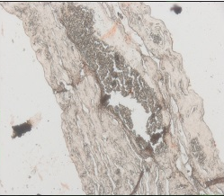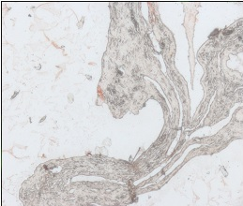
B
A
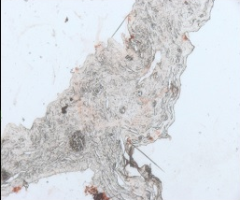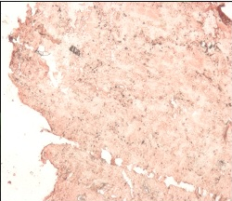
C
D

Figure 1.Mucins and galectin-3 histochemistry in samples of appendix testis. In A) Mucin 1 recognition in epithelium and stroma. B) Mucin 2 recognition in epithelium and stroma. C) Mucin 5AC recognition in epithelium and stroma. D) Galectin 3 recognition in epithelium and stroma. The blue arrows indicate recognition in epithelium. The green arrows indicate recognition in stroma. Micrographs 10X

3.2 Immunofluorescence.
Double labeling histochemistry shows colocalization in stroma and epithelium for Mucin 1 and Galectin-3 (Fig. 2A), Double labeling histochemistry shows colocalization in stroma for Mucin 2 and Galectin-3 (Fig. 2B), Double labeling histochemistry shows colocalization in stroma for Mucin 5AC and Galectin-3 (Fig. 2C),

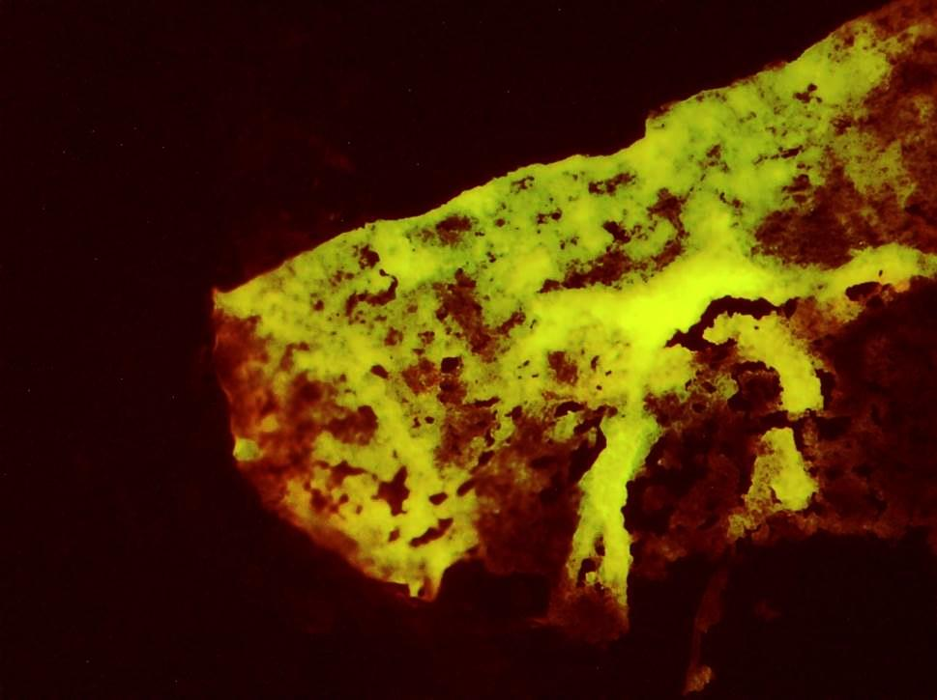
B
A
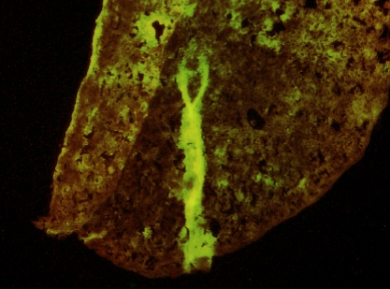
C
Figure 2. A) Double labeling histochemistry shows colocalization in stroma and epithelium for Mucin 1 and Galectin-3. B) Double labeling histochemistry shows colocalization in stroma for Mucin 2 and Galectin-3. C) Double labeling histochemistry shows colocalization in stroma for Mucin 5AC and Galectin-3. The blue arrows indicate colocalization in stroma. The green arrows indicate colocalization in epithelium. Micrographs 10X

4. DISCUSSION.
The appendix of the testis is a small sessile or polypoid structure located at the anterosuperior pole of the testis, adjacent to the head of the epididymis. The shape is variable, being globular, pyriform, flat and leaf-like, forked, or lobed. Grossly, it is most often sessile and varies from 1 to 7 mm in greatest dimension in autopsy specimens (Val-Bernal J. F et al 2006). Histologically, it contains a loose connective tissue core, composed of fibroblasts and smooth muscle cells, large number of blood vessels, a few dilated lymphatic vessels, and occasional lymphocytes. This structure is covered by a single layer of low columnar or cuboidal Müllerian-type epithelium, continuous with the mesothelium of the tunica vaginalis at its base. Invaginations of the surface may result in appearance of glandular structures in the core. Some alterations have been associated with testis appendix like cryptorchidism or testicular dysgenesis syndrome (Ivell R et al 2003).
Glycan expression can be involved in development of testis appendix and cryptorchidism (Lopez G et al 2011). Mucins are high molecular weight glycoproteins produced by many epithelial tissues. These include the membrane-associated mucins and the secreted mucins. Membrane-associated mucins are expressed in various epithelial cells to form the glycocalyx at mucosal surfaces acting as a protective barrier against infection. Secreted mucins serve as an anti-adhesion molecule and contribute to signal transduction (Li Z. et al 2021).
In this study, we evaluated the expression of mucin-1, mucin-2, and mucin-5AC in samples of testicular appendages from children with cryptorchidism. Our results demonstrate that all mucins and galectin-3 are expressed in the stroma and epithelium.
Mucin-1 has been identified in mature germ cells and in non-epithelial germ cells of the human testis (Li Z. et al 2021). The presence of mucin-1 mRNA has been reported in testes with normal spermatogenesis together with mucin-9 and mucin-13, but is absent in testes with impaired spermatogenesis, suggesting a relationship between mucin-1 expression and germ cell maturation (Zolini et al 2019). The expression of mucin-1 has been reported in the apical membrane in normal mucosa, while diffuse distribution in the cytoplasm is associated with cellular stress, inflammation, and tumorigenesis (Khemiri M. et al 2019). There is insufficient literature describing mucin-1 expression of in testis appendix in children with cryptorchidism.
Mucin-2 expression is typically restricted to specific epithelial tissues, predominantly the intestinal tract, where it is produced by goblet cells. It has also been documented in respiratory epithelium, certain glandular tissues, and in pathological conditions involving mucinous differentiation. Aberrant expression of mucin-2 in non-intestinal tissues, including reproductive organs, often reflects metaplastic changes or neoplastic transformation (Yuan Z et al 2026; Russo et al 2006). In human testis, mucin-2 mRNA has not been reported (Seo J.T et al 2005). Expression has, however, been observed in primary mucinous cystadenocarcinoma of the testis (Shahini E et al. 2023). Literature on mucin- 2 expression in testis appendix in children with cryptorchidism remains limited.
Mucin 5AC belongs to the subset of five secreted gel-forming mucins (mucin-2, mucin-5B, mucin-5AC, mucin-6, and mucin-19) encoded by a gene cluster on chromosome 11p15. Mucin-5AC is a glycoprotein with multiple cysteine-rich domains in both N- and C-terminal regions that are responsible for the formation of polymers, a critical feature for gel forming (Thornton, D.J et al 2008).
Mucin-5AC mRNA has been reported in the urethra, foreskin, vas deferens, bladder, prostate, and testicles; however, protein expression has only been confirmed by immunohistochemistry in the urethra. (Russo et al 2006). In testicular mucinous borderline tumors, mucin-5AC expression has been observed, together with CDX2, CK20, and mucin-2, supporting classification as intestinal-type tumors (Shirota, T et al 2026). Evidence for mucin-5AC expression in testis appendix of children with cryptorchidism is insufficient.
Galectins are a family of beta-galactoside-binding lectins involved in diverse extracellular and intracellular processes, including homeostasis, cell adhesion, cellular turnover, and immunity. Galectin‑3 mRNA and protein are significantly elevated in non‑seminomatous testicular germ cell tumors compared with both normal testes and seminomas, suggesting an association of LGALS3 with non‑seminomatous differentiation (Devouassoux-Shisheboran et al 2006). Changes in galectin-3 expression has also been reported in seminomas compared to normal tissue, while galectin-3 expression is strong in tumour cells (Kayser K et al 2003). In adult human testes galectin‑3 was reported to be specifically expressed in mature Sertoli cells and in Leydig cells, but absent in fetal and prepubertal testes,suggesting hormone-dependence regulation (Devouassoux-Shisheboran et al 2006). Literature on galetin-3 expression in testis appendix in children with cryptorchidism is currently insufficient.
Our results demonstrated colocalization between mucin-1, mucin-2 and mucin-5AC with galectin-3, suggesting a functional interaction based on O-glycans. The colocalization between mucin-1 and galectin-3 suggests a possible modulation of membrane signaling and epithelial protection, while the colocalization between mucin-2 and galectin-3 suggests a structural organization of mucus or extracellular matrix in connective tissue. The colocalization between mucin-5AC and galectin-3 could be related to the elastic properties of the stroma in the Müllerian remnant; however, further studies are needed to describe the mechanisms by which mucins-1, mucin-2 and mucin-5AC, as well as galectin-3, participate in the development of the testicular appendages and their relationship with cryptorchidism.
5.CONCLUSION
Our results suggest that O-glycans linked in mucins-1, mucin-2, and mucin-5AC and galectin-3 represent important elements in testis appendix development in children with cryptorchidism.
Limitation of this study
The present study was conducted using samples of testicular appendages from children with cryptorchidism. Samples of testicular appendages from patients without cryptorchidism were excluded from the study, so it was not possible to compare the expression of mucin 1, mucin 2, mucin 5AC, and galectin-3 in both groups. This is because testicular appendages cause testicular pain until adolescence, resulting in a scarcity of literature related to the study of the expression of mucin 1, mucin 2, mucin 5AC, and galectin-3 in the testicular appendages of patients without cryptorchidism.
Ethical approval
The study protocol was approved by the Institutional Review Board of Research of the Medical School of UABJO.
DISCLAIMER (ARTIFICIAL INTELLIGENCE)

Authors hereby declare that NO generative AI technologies such as Large Language Models (ChatGPT, COPILOT, etc) and text-to-image generators have been used during writing or editing of this manuscript.

REFERENCES
Baskin LS, Himes K, Colborn T. (2001). Hypospadias and endocrine disruption: is there a connection? Environ. Health Perspect. 109(11): 1175-1183. DOI: https://doi.org/10.1289/ehp.011091175
Boisen KA, Chellakooty M, Schmidt IM, Kai CM, Damgaard IN, Suomi AM, Toppari J, Skakkebaek NE, Main KM. (2005). Hypospadias in a cohort of 1072 Danish newborn boys: prevalence and relationship to placental weight, anthropometrical measurements at birth, and reproductive hormone levels at three months of age. J. Clin. Endocrinol. Metab. 90(7): 4041-4046. DOI: https://doi.org/10.1210/jc.2005-0302
Boisen KA, Kaleva M, Main KM, Virtanen HE, Haavisto AM, Schmidt IM, Chellakooty M, Damgaard IN, Mau C, Reunanen M, Skakkebaek NE, Toppari J. (2004). Difference in prevalence of congenital cryptorchidism in infants between two Nordic countries. Lancet. 363: 1264-1269. DOI: https://doi.org/10.1016/s0140-6736(04)15998-9
Capel B. (2000). The battle of the sexes. Mech. Dev. 92(1): 89-103. DOI: https://doi.org/10.1016/s0925-4773(99)00327-5
Castellanos M S L, Velasco I B G, Cruz P A H. (2025). Expression of Sialic Acid α2-3, α2-6 and Galectin 3 in Michigan Cancer Foundation-7 cells Stimulated with TNFα. J. Biol. Nat. 17(2): 110–120. DOI: https://doi.org/10.56557/joban/2025/v17i29489
Cruz L M G, Montalvo IA G, Rojas B F, Velasco I B G, Cruz P A H. (2022). Expression of antigen Thomsen–Friedenreich recognized by Amaranthus leucocarpus lectin in MCF cells stimulated with lipopolysaccharide. J.Biol.Nat. 14(1):27–39. DOI: https://doi.org/10.56557/joban/2022/v14i17902
Devouassoux-Shisheboran M, Deschildre C, Mauduit C, Berger G, Mejean-Lebreton F, Bouvier R, Droz J P, Fénichel P, Benahmed M. (2006). Expression of galectin-3 in gonads and gonadal sex cord stromal and germ cell tumors. Oncology Reports. 16(2): 335-340. DOI: https://doi.org/10.3892/or.16.2.335
Hughes IA, Deeb A. (2006). Androgen resistance. Best Pract. Res. Clin. Endocrinol. Metab. 20(4): 577-598. DOI: https://doi.org/10.1016/j.beem.2006.11.003
Ivell R, Hartung S. (2003). The molecular basis of cryptorchidism. Mol. Hum. Rep. 9(4): 175-181 DOI: https://doi.org/10.1093/molehr/gag025
Jost A. (1972). A new look at the mechanisms controlling sex differentiation in mammals. Johns Hopkins Med. J. 130(1): 38-53.
Kamura V, Shanthi P, Madhavan M. (1992). Lectin binding patterns in benign and malignant lesions of the breast. Indian J Pathol Microbiol. 35(4): 289-297.
Kayser K, Hoeft D, Hufnagi P, Caselitz J, Zick Y, André S, Kaltner H, Gabius HJ. (2003). Combined analysis of tumor growth pattern and expression of endogenous lectins as a prognostic tool in primary testicular cancer and its lung metastases. Histol Histopathol.Jul;18(3):771-779. DOI: https://doi.org/10.14670/hh-18.771
Khemiri M, Doghri R, Mrad K. Friedrich K,Oueslati, R. (2019). Mucin-1 expression and localization in epithelial cells shows characteristic and distinct patterns in inflammatory bowel diseases and colorectal cancer. Int J Clin Exp Pathol. May 1;12(5):1731-1737.
Koopman P, Gubbay J, Vivian N, Goodfellow P, Lovell-Badge R. (1991). Male development of chromosomally female mice transgenic for Sry. Nature. 351: 117-121. DOI: https://doi.org/10.1038/351117a0
Laack E, Nikbakht H, Peters A, Kugler C, Jasiewicz Y, Edler L, Hossfeld DK, Schumacher U. (2002). Lectin histochemistry of the resected adenocarcinoma of the lung, Helix pomatia agglutinin binding is an independent prognostic factor. Am J Pathol 160(3): 1001-1008. DOI: https://doi.org/10.1016/s0002-9440(10)64921-8
Li Z, Zhang Y, Zhang X, Cao C, Luo X, Gui Y, Tang Y, Yuan S. (2021).OTOGL, a gelforming mucin protein, is nonessential for male germ cell development and spermatogenesis in mice. Reprod Biol Endocrinol. Jun 26;19(1):95. DOI: 10.1186/s12958-021-00779-0. Erratum in: Reprod Biol Endocrinol. 2021 Sep 8;19(1):136. DOI: https://doi.org/10.1186/s12958-021-00779-0
Lopez G, Jmenez S, Martinez R, Pina MS, Gallegos B, Pérez-Campos E, Zenteno E, Hernández P. (2011). Glycosylation pattern in the appendix testis in children with cryptorchidism. Prep Biochem Biotechnol.41(1):22-29. DOI: https://doi.org/10.1080/10826068.2010.525398
Lovell-Badge R, Robertson E. (1990). XY female mice resulting from a heritable mutation in the primary testis-determining gene, Tdy. Development. 109(3): 635-646. DOI: https://doi.org/10.1242/dev.109.3.635
Peel S, Bulmer J N.(1996). Lectin histochemistry of pregnant rat uterine tissues. J Anat.188: 197-205.
Pomajzl AJ, Leslie SW. (2024). Appendix Testis Torsion. In: StatPearls [Internet]. Treasure Island (FL): StatPearls Publishing;2025 Jan-. Available from: https://www.ncbi.nlm.nih.gov/books/NBK546994/
Rey RA, Grinspon RP. (2024). Anti-Müllerian hormone, testicular descent and cryptorchidism. Front Endocrinol (Lausanne). Mar 4;15:1361032. DOI: https://doi.org/10.3389/fendo.2024.1361032
Russo C L, Spurr-Michaud S, Tisdale A, Pudney J, Anderson D, Gipson I K. (2006). Mucin gene expression in human male urogenital tract epithelia. Hum Reprod. Nov;21(11):2783-2793. DOI: https://doi.org/10.1093/HUMREP/DEL164
Sahni D, Jit I, Joshi K, Sanjeev.(1996). Incidence and structure of the appendices of the testis and epididymis. J Anat.189(pt2): 341-348.
Sarafoglou K, Ostrer H. (2000). Clinical review 111: familial sex reversal: a review. J. Clin. Endocrinol. Metab.85(2):483-493. DOI: https://doi.org/10.1210/jcem.85.2.6418
Seo J T, Lee J S, Jun J H, Yang M H. (2005). Expression of Mucin Genes in the Human Testis and Its Relationship to Spermatogenesis. Yonsei Med J. Oct;46(5):667-672. DOI: https://doi.org/10.3349/ymj.2005.46.5.667
Shahini L, Elshani A, Cena V, Dermaku V, Metushi A, Muçaj S. (2023). Primary Mucinous Cystadenocarcinoma of the Testis: A Case Report and Literature Review. International Journal of Biomedicine. 13(1):168-171 DOI: https://doi.org/10.21103/article13(1)_cr1
Shirota T, Nakanishi H, Hakariya T, Nishimura N, Sato S, Nakashima M. (2026) Primary Mucinous Borderline Tumor of the Testis: A Case Report. IJU Case Reports.9(2), e70139. DOI: https://doi.org/10.1002/iju5.70139
Shuman J, Dongxu Q, Koganty R, Longenecker R, Campbell P. (2000) Glycosylations versus conformational preferences of cancer associated mucin core. Glyconconj J 17: 835-848 DOI: https://doi.org/10.1023/A:1010909011496
Skakkebaek NE, Rajpert-De Meyts E, Main KM. (2001). Testicular dysgenesis syndrome: an increasingly common developmental disorder with environmental aspects. Hum. Reprod. 16(5): 972-978. DOI: https://doi.org/10.1093/humrep/16.5.972
Tanda N, Mori S, Nose M, Saito T, Song ST, Sato A, Teshima T. (1996). Expression of Phaseolus vulgaris leukoagglutinin-binding oligosaccharides in oral squamous cell carcinoma: Possible association with the metastatic potential. Pathol Int 46: 639-645. DOI: https://doi.org/10.1111/j.1440-1827.1996.tb03666.x
Thornton D J, Rousseau K, McGuckin M A. (2008). Structure and function of the polymeric mucins in airways mucus. Annu Rev Physiol. 70:459-486. DOI: https://doi.org/10.1146/annurev.physiol.70.113006.100702
Val-Bernal J F, Val D, Garijo M F. (2006). Ectopic epididymal tissue in appendix testis. Virchows Arch. 449(3): 373-375 DOI: https://doi.org/10.1007/s00428-006-0248-8
Virtanen HE, Cortes D, Rajpert-De Meyts E, Ritzén EM, Nordenskjöld A, Skakkebaek NE, Toppari J. (2007). Development and descent of the testis in relation to cryptorchidism. Acta Paediatr. 96(5): 622-627. DOI: https://doi.org/10.1111/j.1651-2227.2007.00244.x
Yamashita Y, Chunng YS, Horie R, Kanagi R, Sowa M. (1995). Alterations in gastric mucin with malignant transformation novel pathway for mucin synthesis J Natl Cancer Inst. 87(6): 441-446 DOI: https://doi.org/10.1093/jnci/87.6.441
Yuan Z, Xia Z, Ling L Xie, J. Zhang F. (2026). Mucin 2 and unfolded protein response reshape the mucus barrier in inflammatory bowel disease (Review). Mol Med Rep. Jan;33(1):18. DOI: https://doi.org/10.3892/mmr.2025.13728
Zolini A M, Negrón-Pérez V M, Hansen P J. (2019). Importance of prostate androgen-regulated mucin-like protein 1 in development of the bovine blastocyst. BMC Dev Biol. Jul 5;19(1):15. DOI: https://doi.org/10.1186/s12861-019-0195-7

