Case report

CONCERNS OF UNREGULATED ANTIBIOTIC USE IN A BUDGERIGAR:

A CASE REPORT ON A MULTIDRUG-RESISTANT INFECTION

ABSTRACT
Antimicrobial resistance (AMR) threatens global health, and inappropriate antibiotic use in companion animals accelerates the emergence of multidrug-resistant (MDR) organisms. Pet birds, maintained in close human contact, represent potential vectors for AMR transmission. We report a fatal case of MDR bacterial and fungal infection in a one-year-old budgerigar (Melopsittacus undulatus) following unsupervised administration of enrofloxacin and tetracycline by its owner. The bird presented with anorexia, watery diarrhea, lethargy, reduced vocalization, dehydration, and weakness. Microbiological examination (based on colony morphology, Gram staining and biochemical characteristics) of cloacal swabs revealed bacterial isolates and yeast that demonstrated resistance to amoxicillin, gentamicin, ciprofloxacin, cefotaxime, amikacin, tetracycline, and enrofloxacin via the Kirby-Bauer disk diffusion method. Despite evidence-based antimicrobial and antifungal therapy with supportive care, the bird showed progressive clinical deterioration and died. This case report demonstrates the severe consequences of unsupervised antimicrobial administration in exotic pets, including MDR pathogen selection, gastrointestinal dysbiosis, therapeutic failure, and death. Urgent regulatory intervention to restrict non-prescription antimicrobial access, coupled with enhanced client education on responsible medication practices, is essential to mitigate AMR proliferation at the human-animal interface.

Keywords: Antimicrobial resistance (AMR), Budgerigar (Melopsittacus undulatus), Multidrug-resistant (MDR)

- INTRODUCTION
The emergence of antimicrobial resistance (AMR) is a critical challenge to the global public health system and it was reported to have caused nearly 5 million deaths worldwide in 2019 (Murray et al., 2022). The increase in AMR is affecting the therapeutic options available not only in human medicine but also in veterinary medicine as the drugs become less efficient in treating bacterial infections (Masud et al., 2024; Oliveira et al., 2024). The study of antimicrobial resistance in exotic pets remains limited. Due to their close contact with humans, these animals pose an increased risk of untreatable bacterial infections, presenting significant challenges for both veterinary care and public health (Muñoz-Ibarra et al., 2022). Inappropriate use of antimicrobial agents, poor infection control practices, inadequate sanitation, and improper food handling practices are considered as important factor in the emergence and dissemination of AMR (Oliveira et al., 2024). One of the key drivers in the emergence of AMR among common bacterial pathogens is the over-the-counter use of antimicrobials agents. This issue is more prevalent among exotic pets like birds where the antimicrobials are administered indiscriminately at improper dosage without any proper veterinary supervision based on empirical knowledge passed on by other pet bird rearers. Many drugs used in common domestic animals have not been pharmacologically evaluated in exotic pets and these are used by mere extrapolation (Petritz and Chen, 2018). Pet birds are considered as the third most important companion animal next to dogs and cats. Keeping pet birds has positive impact on the quality of life of people (Akbari and Asadpour, 2022) these also kept as ornamental birds which adds to the aesthetic value (Masud et al., 2024). These birds live in close association with humans, majority of these pet birds belong to Passeriformes or Psittaciformes or Columbiformes species (Sigirci et al., 2020; Hasib et al., 2025) and are reported to play important role in the spread of zoonotic pathogens like Salmonella, avian tuberculosis, Listeriosis, Staphylococcus, Campylobacters and Chlamydia along with many multidrug resistant bacterial agents like Escherichia coli (Masud et al., 2024; Hasib et al., 2025). Antimicrobial resistance (AMR) is a major global health concern impacting humans, animals, and the environment. Adopting a One Health perspective underscores the interconnectedness of these sectors, highlighting how resistant microorganisms can disseminate across healthcare, agricultural, and environmental settings (Al-Khalaifah et al., 2025). Transmission of AMR or MDR bacterial pathogens can occur in both directions from man to birds or vice versa through close contact or via contamination of environment (Sigirci et al., 2020). Budgerigars (Melopsittacus undulatus) are among the most commonly kept pet birds that are popular worldwide. However, these birds are often present to clinics with digestive issues; their small body size, delicate physiology, and susceptibility to bacterial and fungal infections make proper therapeutic intervention essential. Here we report a unique case in a budgerigar with a history of self-medication induced MDR bacterial infection, resulting in dysbiosis of the gastrointestinal tract and secondary bacterial infection. Here the effective therapeutic options are compromised and outcome resulted in the death of the pet bird.
- CASE HISTORY

A one-year-old budgerigar with a body weight of 38 g was presented to the Avian and Exotic Pet Unit at Madras Veterinary College, Chennai, Tamil Nadu with a history of anorexia, watery diarrhoea, lethargy, and decreased vocalization for five days. The owner reported administering enrofloxacin and tetracycline without veterinary consultation along with multivitamins and mineral supplements (for approximately a month), believing these drugs would control a suspected gastrointestinal infection. Clinical examination revealed profuse watery diarrhoea, drooping wings, ruffled feathers, generalized weakness, marked dehydration, poor body condition score and mild cloacal staining (Fig. 1).
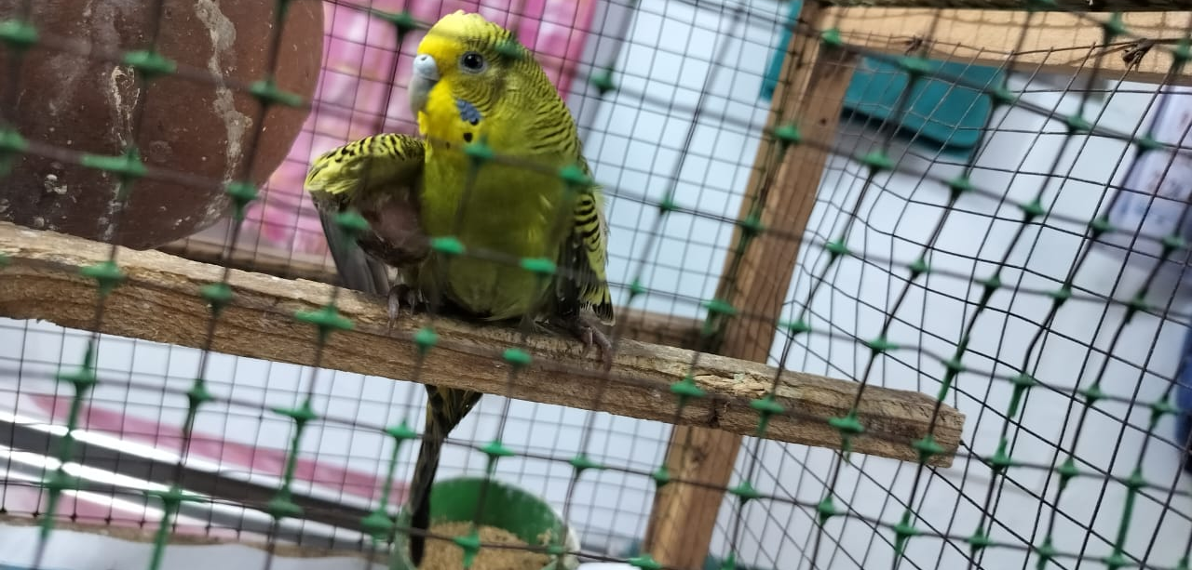
Fig. 1: The budgerigar with drooping wings, ruffled feathers, marked dehydration and poor body condition score.
- DIAGNOSIS AND CLINICAL MANAGEMENT
Diagnostic procedures were initiated immediately. A Cloacal swab was collected aseptically from the bird for microbiological investigation. The swab sample was inoculated onto nutrient broth and incubated at 37◦C for 24 h followed by streaking on to nutrient agar plates for bacterial isolation, and isolates were identified based on colony morphology, Gram staining and biochemical characteristics. In addition, the cloacal swab was examined by wet mount preparation and culture for isolation of yeasts from the sample. The bacterial isolates obtained were subjected to antimicrobial susceptibility testing against amoxicillin, gentamicin, ciprofloxacin, cefotaxime, amikacin, tetracycline and enrofloxacin by Kirby-Bauer disk diffusion method. The yeast isolate was also tested against antifungal agents. Supportive treatment like rehydration with injection Lactated Ringer's (LR) @ 10 mL/kg body weight SC and multivitamin (zipvit pet drops @2 drops Bid) supplementation was given to the budgerigar for 2 days.
- DISCUSSION
The bacterial culture yielded a mixture of both Gram positive and Gram-negative organisms which exhibited resistance against multiple drugs like amoxicillin, gentamicin, ciprofloxacin, cefotaxime and amikacin (Fig. 2 A). Resistance to tetracycline and enrofloxacin was presumed due to prior exposure due to unsupervised use of antimicrobials by the owner, which could have contributed to the selection and development of MDR bacterial strains. Screening of the samples for fungus revealed the presence of yeasts in the sample. This secondary fungal bloom in the cloacal swab samples indicates that there is severe alteration in the normal flora of the gastrointestinal tract resulting in dysbiosis induced by prolonged and inappropriate usage of anti-microbial agents. The yeasts obtained were sensitive to ketoconazole (Fig. 1 A and B). The issue of increasing AMR among pet/ornamental birds although scarce but has been documented elsewhere in few studies. Sigirci and colleagues (2020) reported that 37.7% of the E. coli isolates obtained from parakeets, canaries, parrots, Indian Nightingales and finches in Turkey.
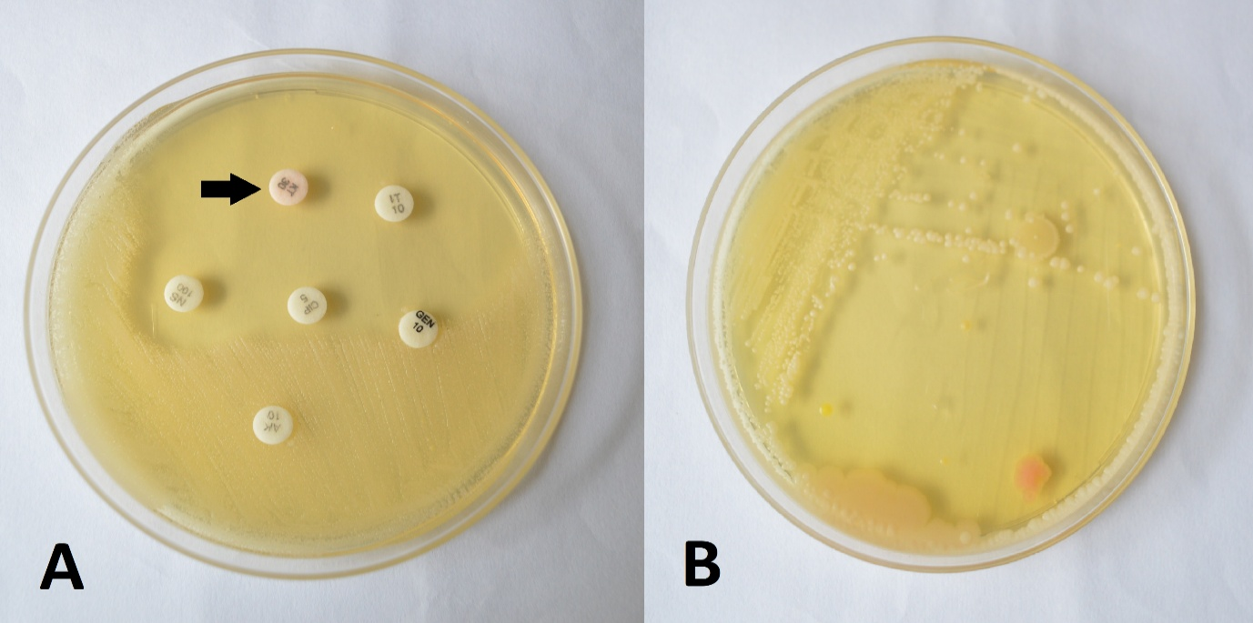
Fig. 2: In ABST the organisms which exhibited resistance against multiple drugs like amoxicillin, gentamicin, ciprofloxacin, cefotaxime and amikacin (A) but sensitive to ketoconazole (A - Arrow). Yeast growth (B)
Prolonged exposure of pet birds to antimicrobials exerts a selective pressure on their gut microbiota, facilitating the acquisition and persistence of multiple resistance genes through cross-transmission, genetic mutations, or environmental contamination (Magiorakos et al., 2012; Ahaduzzaman et al., 2014; Hasib et al., 2025). The gut microbiota is strongly impacted by the environmental pressure induced by the presence of xenobiotics and infection in general cause dysbiosis of the digestive tract in which the normal microbial community is altered (Le Roy et al., 2019). Liang and colleagues (2023) reported that long term of use of anti-microbials in chicken dramatically disturbed their gut microbiome which has resulted in reduced immune response.
In Bangladesh, Hasib et al. (2025) processed 150 cloacal swabs from pet bird majority of them were collected from budgerigars followed by other psittacine species and isolated E. coli in 48.7% of the samples, out of which 43.83% were identified as ESBL producers. All the isolates obtained in this study were found to be resistant to multiple antimicrobials for which the authors have suggested widespread and unregulated use of broad-spectrum antimicrobials for emergence of MDR bacteria. These ESBL producing E. coli were observed to be 100% resistant to ampicillin and ceftriaxone, 90.6% to sulphamethoxazole-trimethoprim, 87.5% to tetracycline. gentamicin and ciprofloxacin resistance were also observed in 53.1% and 37.5% of isolates.
Despite initiation of therapy based on culture and sensitivity results including anti-fungal treatment (Ketoconozole @ 2mg/body wt.), fluid support, and assisted feeding the bird’s condition continued to decline due to severe systemic compromise. The budgerigar succumbed within a few days of presentation. This could be due to multiple factors like delayed presentation after onset of illness, severe dysbiosis-induced malnutrition. This report highlights the need to educate the pet bird rearers about the ill effects of using antimicrobial agents without proper guidance. The practice of using antimicrobials among ornamental bird rearers is a common practice which needs to be stopped completely in an effort to protect the efficacy of available antimicrobials and also in preventing the spread of the MDR pathogens to humans. Necessary policy changes are also required in regulating the antimicrobial availability use in our country in the fight against next pandemic of antimicrobial resistance.
- CONCLUSION
This case illustrates the severe consequences of self-medication and unsupervised antibiotic use in exotic pets. The emergence of MDR pathogens, treatment failure, and secondary infections highlight the urgent need for veterinary-supervised antimicrobial therapy. Educating pet owners, regulating antibiotic access, and promoting responsible antimicrobial stewardship are essential steps toward safeguarding the health of exotic animals and preventing the spread of antimicrobial resistance.
Ethical approval (where ever applicable)
Not applicable
DISCLAIMER (ARTIFICIAL INTELLIGENCE)
Author(s) hereby declares that NO generative AI technologies such as Large Language Models (ChatGPT, COPILOT, etc) and text-to-image generators have been used during writing or editing of this manuscript.
Consent (where ever applicable)
No manuscripts will be peer-reviewed

REFERENCES

Ahaduzzaman, M., Hassan, M. M., Alam, M., Islam, S., & Uddin, I. (2014). Antimicrobial resistance pattern against Staphylococcus aureus in environmental effluents. Research Journal for Veterinary Practitioners, 2, 13–16.

Akbari, P., & Asadpour, L. (2022). An evaluation of antimicrobial resistance and virulence potential of Escherichia coli obtained from feces of ornamental birds in Guilan, Iran. Iranian Journal of Medical Microbiology, 16(5), 405–411.

Al-Khalaifah, H., Rahman, M.H., Al-Surrayai, T., Al-Dhumair, A. and Al-Hasan, M., 2025. A One-Health perspective of antimicrobial resistance (AMR): Human, animals and environmental health. Life, 15(10), p.1598.

Hasib, F. M. Y., Bayzid, M., Das, T., Rana, E. A., Kamal, T., Hossain, M. A., & Alim, M. A. (2025). Multidrug‐resistant extended‐spectrum beta‐lactamase (ESBL) producing Escherichia coli in pet birds of Bangladesh. Veterinary Medicine and Science, 11(5), e70509.

Le Roy, C. I., Woodward, M. J., Ellis, R. J., La Ragione, R. M., & Claus, S. P. (2019). Antibiotic treatment triggers gut dysbiosis and modulates metabolism in a chicken model of gastro-intestinal infection. BMC Veterinary Research, 15(1), 37.

Liang, X., Zhang, Z., Wang, H., Lu, X., Li, W., Lu, H., Roy, A., Shen, X., Irwin, D. M., & Shen, Y. (2023). Early-life prophylactic antibiotic treatment disturbs the stability of the gut microbiota and increases susceptibility to H9N2 AIV in chicks. Microbiome, 11(1), 163.

Magiorakos, A. P., Srinivasan, A., Carey, R. B., Carmeli, Y., Falagas, M. E., Giske, C. G., Harbarth, S., Hindler, J. F., Kahlmeter, G., Olsson-Liljequist, B. J. C. M., & Paterson, D. L. (2012). Multidrug-resistant, extensively drug-resistant and pandrug-resistant bacteria: An international expert proposal for interim standard definitions for acquired resistance. Clinical Microbiology and Infection, 18(3), 268–281.

Masud, R. I., Jahan, R., Bakhtiyar, Z., Antor, T. H., Jany, D. A., Fahim, N. A. I., & Rahman, M. T. (2024). Role of ornamental birds in the transmission of zoonotic pathogen and AMR: A growing public health concern. German Journal of Microbiology, 4(3), 45–55.

Muñoz-Ibarra, E., Molina-López, R.A., Durán, I., Garcias, B., Martín, M. and Darwich, L., 2022. Antimicrobial resistance in bacteria isolated from exotic pets: The situation in the Iberian Peninsula. Animals, 12(15), p.1912.

Murray, C. J., Ikuta, K. S., Sharara, F., Swetschinski, L., Aguilar, G. R., Gray, A., Han, C., Bisignano, C., Rao, P., Wool, E., & Johnson, S. C. (2022). Global burden of bacterial antimicrobial resistance in 2019: A systematic analysis. The Lancet, 399 (10325), 629–655.

Oliveira, M., Antunes, W., Mota, S., Madureira-Carvalho, Á., Dinis-Oliveira, R. J., & Dias da Silva, D. (2024). An overview of the recent advances in antimicrobial resistance. Microorganisms, 12(9), 1920.

Petritz, O. A., & Chen, S. (2018). Therapeutic contraindications in exotic pets. Veterinary Clinics: Exotic Animal Practice, 21(2), 327–340.
Sigirci, B. D., Celik, B., Halac, B., Adiguzel, M. C., Kekec, I., Metiner, K., Ikiz, S., Bagcigil, A. F., Ozgur, N. Y., Ak, S., & Kahraman, B. B. (2020). Antimicrobial resistance profiles of Escherichia coli isolated from companion birds. Journal of King Saud University – Science, 32(1), 1069–1073.

