Original Research Article
Toxicity Evaluation of Tetrabromobisphenol A bis (2-hydroxyethyl) ether (TBBPA-DHEE) Exposure on Behavioural Alterations in Adult Zebrafish (Danio rerio)

ABSTRACT
Tetrabromobisphenol A (TBBPA) is the most widely used flame retardant, accounting for approximately 60% of the brominated flame retardant (BFR) market, owing to its flame resistance, thermal stability, and hydrolysis resistance. It may function as an endocrine disruptor, leading to adverse impacts such as embryonic complications, neurotoxicity, reproductive damage, and hepatotoxicity. Tetrabromobisphenol A bis (2-hydroxyethyl) ether (TBBPA-DHEE) remains one of the crucial derivatives and is increasingly used as a safer management option in electronics, thermoplastic polyesters, and circuit board coatings; however, research shows that it may pose toxic risks comparable to, or even greater than, those of its parent compound, although its neurotoxic effects are not yet fully understood. Thus, the current study evaluates the dose-dependent exposure and neurotoxic effect of TBBPA-DHEE. Further, behavioural analysis was performed, including the open field test (OFT), novel tank test (NTT), swimming behaviour test, and dark-light test (DLT), and results displayed that increased anxiety-like behaviour, impaired memory, and decreased locomotor activity could be observed in zebrafish exposed to medium and high concentrations of TBBPA-DHEE. In contrast, low concentration didn’t display noticeable changes. Moreover, the study's findings show a significant dose-dependent increase in neurobehavioural dysfunction. Such a study provides deeper insights into TBBPA-DHEE-induced significant neurobehavioural dysfunctions in zebrafish in a dose-dependent manner. It thus raises substantial concerns about the potential implications for human health.
Keywords: TBBPA-DHEE; Neurotoxicant; Behavioural Impairment; Dose-Dependent; Zebrafish.
1. INTRODUCTION
Among the widely used brominated flame retardants (BFR), Tetrabromobisphenol A (TBBPA) remains the most extensively utilized, occupying about 60% of the BFR market (Abdallah, 2016; Liu et al., 2019; Wang et al., 2019). There has been an increasing demand for tetrabromobisphenol A (TBBPA) owing to its high flame-retardant efficiency, excellent thermal stability, and strong hydrolytic resistance. The global annual production of TBBPA is estimated at approximately 2.3 × 10⁴ to 4.5 × 10⁴ tons/year (US EPA, n.d.; Sunday et al., 2022). In China, the annual market demand for TBBPA exhibited a rising trend, increasing from 5.21 × 10⁶ tons/year in 2014 to 6.43 × 10⁶ tons/year in 2017 (US EPA, n.d.; Liu et al., 2016; Sunday et al., 2022). Previous research has shown that it is a potent environmental endocrine disruptor and may lead to embryonic development toxicity, neurotoxicity, reproductive toxicity, and hepatotoxicity. TBBPA derivatives have occupied about 18% of the total production, and include tetrabromobisphenol A bis (2-hydroxyethyl ether), (TBBPA-BHEE), tetrabromobisphenol A bis (glycidyl ether) (TBBPA-BGE), tetrabromobisphenol A bis(allylether) (TBBPA-BAE), tetrabromobisphenol A bis(dibromopropylether) (TBBPA-BDBPE), and Tetrabromobisphenol A bis (2-hydroxyethyl) ether (TBBPA-DHEE) (Qu et al., 2016; Zhu et al., 2018; Okeke et al., 2023). Among these, TBBPA-DHEE remains one of the important derivatives mainly used in the production of materials like engineering polymers, thermoplastic polyesters, laminations for electric boards, coatings, and polystyrene foam, which are highly used nowadays, and its utilization is increasing day by day (Tian et al., 2014; Sunday et al., 2022). The dihydroxy molecule TBBPA-DHEE can be easily liberated in the environment during manufacturing, product use, and waste disposal. Due to its high stability, it can remain in the environment for an extended period. Its potential for biotoxicity, bioaccumulation, and environmental persistence has gained significant interest, classifying it as a pervasive pollutant and an environmental toxicant. Research has revealed that it has been found ubiquitously in water, air, soil, and even in living organisms (Luo et al., 2023; Ge and Yu, 2025). The structure of TBBPA-DHEE is similar to TBBPA, which has already shown subsequent risk to aquatic organisms as well as to humans. Results of the neurotoxicity study reveal that it induces apoptosis and toxicity in the primary cell culture of mice, impaired uptake of neurotransmitters through the plasma membrane and motor activity in adult rats (Hendriks et al., 2012; Szychowski and Wójtowicz, 2015). Another study showed that a single TBBPA exposure after birth may hinder neurodevelopment and synaptic plasticity in mice (Luo et al., 2023; Okeke et al., 2023; Zhang et al., 2025).
Thus, an effort has been made to explore and identify the possible risks and toxicological effects of TBBPA-DHEE. Currently, inadequate research has been done to study the risk and toxicity of TBBPA-DHEE on human health. It may also lead to disruption of the neuroendocrine pathway and reproductive toxicity. The molecular mechanism behind the cytotoxic effect of TBBPA-DHEE on PC 12 cells is attributed to the activation of ROS-induced caspases and a reduction in GSH level (Liu et al., 2016; Liu et al., 2020; Luo et al., 2023). Experiments conducted in TBBPA-exposed mice displayed impaired motor behaviour like elevated horizontal movement and an increase in freezing time in the Open field test (OFT) and altered spontaneous movement in the Y-maze test (Nakajima et al., 2009). Several toxicological studies due to TBBPA exposure have been reported in both rodents and aquatic organisms. However, only a few reports are available on the neurotoxicity effects of TBBPA-DHEE exposure to aquatic organisms (Chen et al., 2016).
Zebrafish (Danio rerio), a vertebrate animal model, is extensively used for performing several behavioural assays. Apart from the inherent distinct characteristics, including low cost and maintenance, high fecundity, genetic similarity to humans, physiology, and development, it serves as an excellent model for the study of toxicological, developmental, neurobehavioural, and reproductive research (Segner, 2009; Rosa et al., 2022). The etiology and pathogenicity of compounds inducing brain disorders can be explored due to their tractable genetics and sociability. Also, they possess parallel social behaviour that is under the regulation of identical pathways as those of mammals (Gerlai 2011; Kalueff et al., 2014). TBBPA-DHEE, being a derivative of TBBPA and possessing structural similarity, very less is known about its adverse effects on neurobehaviour and the associated possible hazards to the organisms (Feng et al.,2023; Luo et al., 2023). The neurotoxicity and behavioural alterations in adult zebrafish exposed to different concentrations of TBBPA-DHEE and the susceptibility of mature zebrafish to various concentrations were studied. The behavioural changes were investigated by performing and analyzing various behavioural assays. The findings of this study will help determine the concentration of TBBPA-DHEE that may be a potential risk in exerting neurobehavioural impairment and other neurotoxicity to aquatic organisms, as well as a possible risk factor and toxicant to humans when exposed for a prolonged period, determining the toxicity of TBBPA-DHEE. The current study aims to investigate the dose-dependent neurotoxic effect and behavioural impairment in adult zebrafish exposed to TBBPA-DHEE.

2. Materials and methods
2.1 Chemicals
TBBPA-DHEE, with a purity of 98%, was purchased from Sigma-Aldrich (08320CN) and dissolved in dimethyl sulfoxide (DMSO), an organic solvent.
2.2 Experimental animals
All experimental procedures were conducted in strict accordance with the Committee for the Purpose of Control and Supervision of Experiments on Animals (CPCSEA) guidelines and standard zebrafish welfare protocols. The research was conducted in accordance with internationally accepted guidelines for the care and use of laboratory animals (e.g., Organization for Economic Cooperation and Development (OECD) Guidelines for the Testing of Chemicals, Section 4), and all efforts were made to minimize stress and ensure the welfare of the animals throughout the study. Three to four-month-old adult zebrafish wild strains were brought from the distributor Aqua Fish Culture. They were acclimatized for about two weeks under optimum pH and temperature of about 28.0 ± 2◦C and a 14:10 h of light: dark cycle. Proper aeration, filters, and deionized water were used for housing. All the water parameters, such as Hardness, salinity, and chloride content, were observed and maintained. Fishes were fed twice a day with food flakes, i.e., terabits taiyoto bits, as per their body weight.
2.3 Preparation of TBBPA-DHEE and experimental design
TBBPA-DHEE was solubilized with DMSO, and a stock solution was prepared which was further diluted with distilled water. The adult zebrafish were randomly selected and divided into 5 groups, each with 10 fish placed in a 4-litre water tank. The 5 groups were divided as group-1 control, group-2 DMSO control, group-3 low (L, 5 mg/L), group-4 medium (M, 10 mg/L), and group-5 high (H, 20 mg/L) concentration of TBBPA-DHEE exposed group. The concentration, dosage, and duration of exposure were based on previously obtained data and the pilot study conducted on adult zebrafish using TBBPA-DHEE (Okeke et al., 2023). The concentrations used were 5 mg/L, 10 mg/L and 20 mg/L as low, medium and high dose respectively. The control group was maintained under similar conditions for a particular exposure period and was kept in deionized water. Fish were exposed to the respective concentrations of TBBPA in different groups for 15 days. During this period, half of the water in the tank was removed and replaced with fresh, dechlorinated water.
2.4 Estimation of Fish Biometry
The final body weight and body length of different experimental groups were measured on the experiment's first and last day and analyzed using ANOVA. During the experiment, zebrafish from every group were placed in a water box filled with ice. Body measurements were taken to determine body weight and body length. Body length was calculated using ImageJ software (National Institutes of Health, Bethesda, MD, USA).
2.5 Behaviour study
The behavioural and cognitive assessment of zebrafish was done on the final day of the experiment. Fishes were relocated to the recording room before the recording and were acclimatized for about a week according to the environment. The following behavioural assessments were performed to analyse anxiety-related behaviour and locomotory behaviour. The duration and setup of recording varied depending on the different tests and were performed using a digital imaging system, a Logitech B525 HD webcam, and a laptop. The recordings were analysed with the help of Toxtrac software and ImageJ.
2.5.1 Open field test
This test is used for analysing anxiety-related behaviour in zebrafish, also known as thigmotaxis. An organism's ability to explore the borders and corners of a tank rather than staying in the centre is observed and recorded as described previously (Nahar and Jat, 2021; Nahar et al., 2024). Adult fish were placed in an open tank of dimensions 37 cm in length, 29 cm in width, and 18cm in height, made up of acrylic glass filled with 2 L of water. A single fish from each group was placed in the tank, and recordings were made for approximately 6 min for each group. The total and average distance, speed covered, and the frozen events of different groups are obtained using Toxtrac software (https://sourceforge.net/projects/toxtrac/). The endpoints measured include average speed, mobility average speed, total distance, frozen events, and explored area/ total no. of areas. Average speed is the mean swimming velocity of the fish measured over the entire test duration, which includes active swimming, pauses, freezing or immobility episodes. Average mobility speed measures the mean velocity only during periods when the fish is actively moving. The explored area measures the proportion or absolute area of the arena that the fish visits at least once during the test period, and the total number of areas refers to the arena subdivision into predefined zones or grids (e.g., center vs periphery).
2.5.2 Novel tank test
OFT, also known as a Geotaxis tank, is known for the animal’s ability to react in an alien environment by diving into the bottom of the tank, increasing frozen time and number, and reducing exploration. In the novel tank, time spent in the lower zone of the tank is increased with increased anxiety, as described previously (Nahar and Jat, 2021). Test tanks were transferred to the behavioural testing room, and recording was done between 9:00 am to 1:00 pm. The novel tank is a trapezoid tank of about 1.5 L with dimensions of 27.9 cm at the top, a height of 15.2 cm, and a width of 6.4cm from the top and 5.1 cm from the bottom, in which water is filled maximally up to 1L and is divided into two equal portions by a horizontal line drawn from outside. The camera is set in the front, facing the front view of the tank. Fish spending more time in the lower zone is believed to be under more stress. Each fish is recorded for about 6 min of every group using a camera, and the following endpoints, i.e., latency to the upper half of the tank, transitions to the upper half, time spent, and freezing time, were determined.
2.5.3 Light-dark test
This is also known as the scototaxis behaviour test. The apparatus consists of a dark and a light chamber made up of an acrylic sheet and is divided into two equal-sized chambers. Dimensions of the tank include 15cm (H) x 10cm (W) x 40cm (L), and it is partitioned by two small central sliding doors through which the fish is placed before starting the experiment, and the door is opened to record the preference and time spent by the fish in each zone. The recording is done for about 6 minutes using a video recording camera. The different endpoints, such as time spent and transitions in the light zone and dark zone, and the overall preference of the zone, are obtained through the assessment (Magno et al., 2015).
2.5.4 Swimming test tank
The swimming test is performed to analyze the fish's motor coordination and social behaviour. The test is performed in an apparatus of about 20 cm in diameter holding a capacity of about 700 ml of water. It involves placing fish in groups with a paper 324-cm2 grid divided into 36 blocks placed underneath the apparatus. Fish from each group were placed in a tank altogether, and the recording was done for about 30 minutes with an interval of 30 seconds. The image analysis was done using the image tool program GeoGebra (https://www.geogebra.org/geometry/tbdrcyd2). The endpoints obtained from this assessment include the nearest neighbor distance and area occupied by the fish, as described previously (Nahar and Jat, 2021).
2.6 Statistical Analysis
All the experimental data are represented as Mean ± SEM. One-way ANOVA followed by Tukey’s post-hoc test was used to analyze the behavioural alterations among different groups (*p < 0.05, **P < 0.01, ***p < 0.001, ns; non-significant). GraphPad Prism software version 9.5.1 (GraphPad Software, San Diego, CA, USA) was used for graphical analysis and data interpretation.
3. results and discussion
3.1 Morphometric Analysis
Morphometric analysis identifies the alterations in the size and shape of organisms. Adult zebrafish were exposed to low, medium, and high levels of TBBPA-DHEE, and their growth was compared to control and DMSO-exposed groups. A significant reduction in body weight was observed in the TBBPA-DHEE–exposed groups relative to both control and DMSO groups (p<0.01). The weight decreased further with increasing TBBPA-DHEE dose (Fig. 1A). In contrast, body length showed only minimal alterations across the exposed groups. A slight increase in body length (p<0.01) was observed in the TBBPA–DHEE group exposed to different concentrations compared with the control and DMSO groups (Fig. 1B).
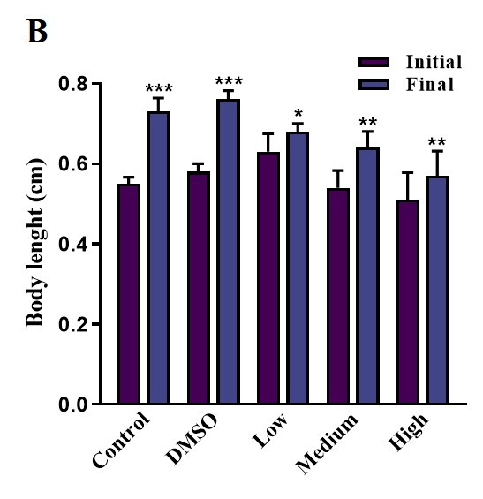
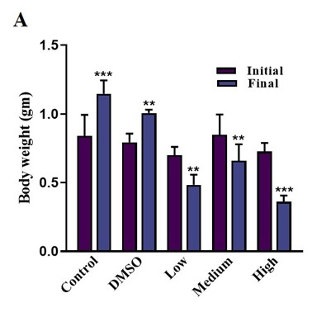
Fig. 1. Effect of TBBPA-DHEE on morphometric parameters, initial/final body weight, and body length. A) Body weight, B) body length.
Data expressed as mean ± SEM (n = 10 fish/group). *P < 0.05, **P < 0.01, ***P = 0.001; compared to control group
3.2 Effect of TBBPA-DHEE on the exploratory behaviour of zebrafish in the Open field tank
The effect of TBBPA-DHEE on anxiety and exploratory behaviour was assessed. In OFT, fish exposed to low, medium, and high doses of TBBPA-DHEE exhibit alterations in average and mobility average speed. The average speed and mobility average speed were decreased in high and medium dose (p<0.001) groups as compared to the low, DMSO control and control groups (Fig. 2A, 2B). Also, total distance travelled was significantly reduced in the exposed group (p<0.01) as compared to control group (Fig. 2C). Explored area/Total no. of areas showed less exploration area with increasing concentration of TBBPA-DHEE as compared to the control and DMSO group (p<0.01, Fig. 2D). Freezing behaviour demonstrated a dose-dependent increase in freezing events following TBBPA-DHEE exposure. Zebrafish exposed to the highest concentration exhibited the highest number of freezing episodes (p<0.001) followed by the medium and low concentration groups, when compared with the control and DMSO-exposed groups (Fig. 2E). The trajectory pattern of the behaviour obtained through OFT is displayed (Fig. 2F). The exploratory pattern in the open field tank displays a preference for the peripheral zone, restricting its movement towards central zone in the TBBPA-exposed group as compared to control and DMSO-exposed group (Table 1).
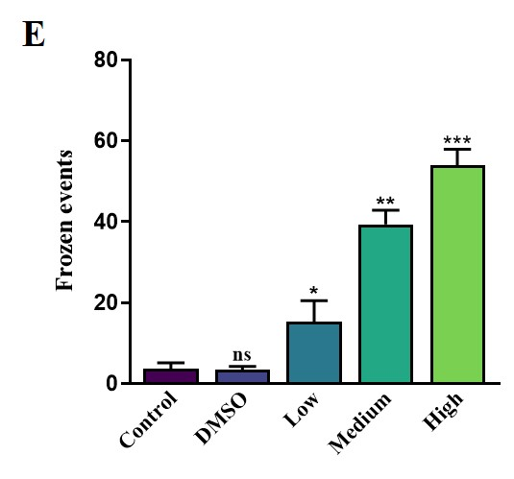
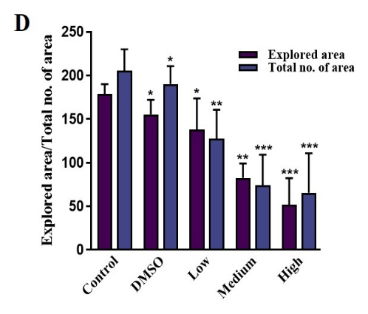
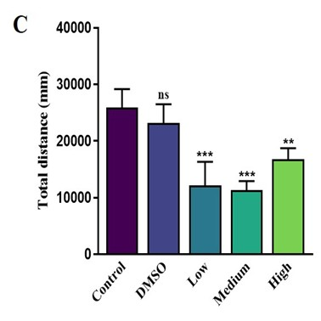
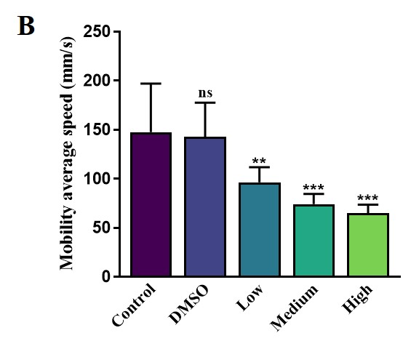
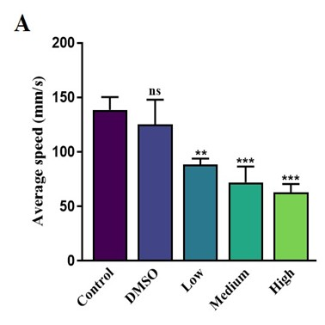
Fig. 2. Effect of TBBPA-DHEE in open field test. A) Total distance travelled in the arena, B) Mobility average speed, C) Number of frozen events, D) Explored/ Total number of areas, E) Average speed, F) ToxTrac-based trajectory videograph displaying exploratory behavior of zebrafish in the open field test.
Data expressed as mean ± SEM (n = 10 fish/group). *p< 0.05, **p < 0.01, ***p <0.001; compared to control group
Table 1. Effect of TBBPA-DHEE on different endpoints of open field behavior in adult zebrafish
Behavioral endpoints | Control | DMSO Control | Low Dose | Medium Dose | High Dose
Average speed | 138.44 ± 11.87 | 125.11 ± 22.91 | 72.07 ± 14.48 | 62.91 ± 7.59* | 88.46 ± 5.27**
Mobility Speed | 147.33 ± 49.69 | 142.34 ± 35.30 | 74.14 ± 10.29** | 64.68 ± 8.89** | 96.34 ± 15.26*
Total Distance | 25958.68 ±  3212.38 | 23173.7 ±  3330.34 | 12149.52±  4189.75* | 11358.73 ±  1562.54*** | 16765.67 ±  1958.66**
Explored area | 179 ± 11.46 | 155 ± 16.60* | 138 ± 35.64 | 83 ± 16.41* | 52 ± 30.67
Total no. of area | 617 ± 24.48 | 571 ± 20.28** | 382 ± 33.45 | 222 ± 35.09* | 196 ± 45.34
Frozen events | 3.62 ± 1.52 | 3.33 ± 0.88** | 15.37 ± 5.14 | 39.36 ± 3.49** | 53.90 ± 4.064*
*Data are represented as mean ± SEM. Experimental groups are compared with control animals using one-way ANOVA followed by a post hoc test, showing significant difference at p values: * shows p< 0.05, ** indicates p<0.01, and, *** represents p<0.001
3.3 Effect of TBBPA-DHEE on zebrafish displaying anxiety-like behaviour in the Novel tank test
NTT was performed to analyze the anxiety-like and cognitive behaviour among different groups of zebrafish exposed to TBBPA-DHEE. The impaired behaviour was assessed by the amount of time spent in the upper zone as compared to the lower zone. A significant reduction in time spent in the upper zone exposed to medium and high doses of TBBPA (p<0.01) compared with the control and DMSO groups, whereas in the low dose TBBPA group, a slight increase in upper zone occupancy could be observed (p<0.001; Fig. 3A). Also, the latency to enter in the upper zone and the number of erratic movements were markedly increased in the high dose TBBPA group, followed by the medium and low dose groups (p<0.01), as compared to control and DMSO (Fig. 3B, 3C). A similar dose-dependent trend was observed in the number of transitions between zones, with significantly higher transitions in TBBPA-exposed fish, particularly at higher concentrations (p<0.01; Fig. 3D). The trajectory pattern of the behaviour obtained through NTT is displayed (Fig. 3E, Table 2).
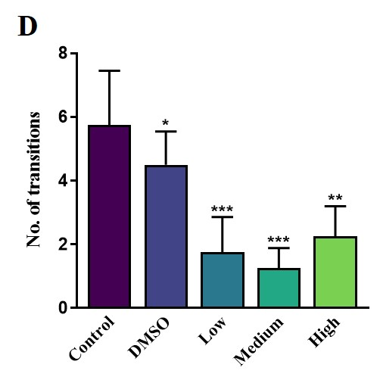
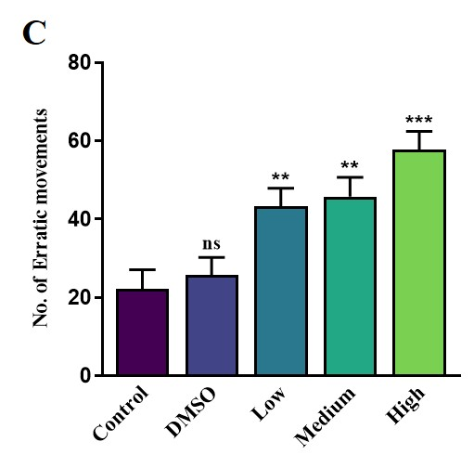
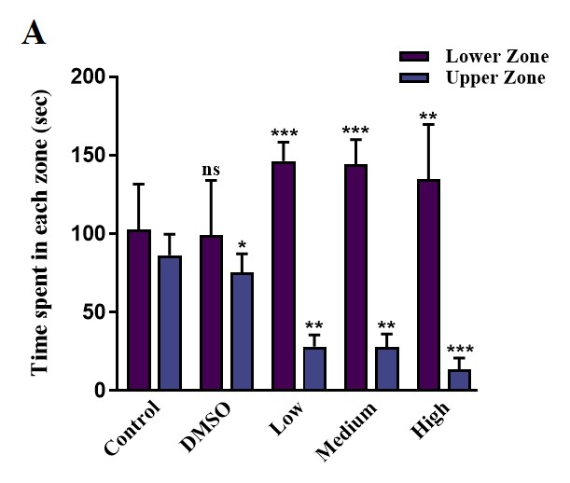
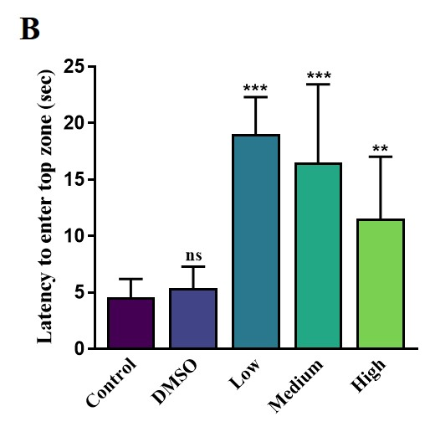
Fig. 3. Effect of TBBPA in novel tank test concerning these endpoints, A) Time spent in each zone B) Latency to enter the top zone, C) Number of erratic movements, D) Number of transitions.
Data expressed as mean ± SEM (n = 10 fish/group). p < 0.05, **p < 0.01; ***p<0.001, compared to control group
Table 2. Effect on different endpoints of novel tank test in adult zebrafish following exposure to TBBPA-DHEE
Behavioral endpoints | Control |  | DMSO control |  | Low Dose |  | Medium Dose |  | High Dose
 | Lower | Upper | Lower | Upper | Lower | Upper | Lower | Upper | Lower | Upper
Time Spent in each zone (sec) | 192.25±  29.06 | 167.75±  13.38 | 185.75±  34.86 | 174.25±  11.86* | 225.19±  34.79 | 134.81±  7.18** | 284.75 ±  16.02* | 75.25±  8.30* | 327.95±  12.03* | 32.05 ±  7.38**
Latency to enter the top zone | 4.58 ± 1.62 |  | 5.38 ± 1.91** |  | 19.00 ± 3.29 |  | 16.50 ± 6.91 |  | 11.50 ± 5.52
No. of Transitions | 5.75 ± 1.70 |  | 4.50 ± 1.04* |  | 1.75 ± 1.11 |  | 1.25 ± 0.63*** |  | 2.25 ± 0.95**
Erratic | 59.25 ± 5.19 |  | 56.75 ± 6.10** |  | 22.25 ±4.85*** |  | 49.75 ± 5.45* |  | 57.75 ± 4.68****
Data are represented as mean ± SEM. Experimental groups are compared with control animals using one way ANOVA followed by post hoc test, showing significant difference at p values: * shows p < 0.05, ** indicates p <0.01 and *** represent p< 0.001
3.4 TBBPA-DHEE altered the light-dark preference test in zebrafish
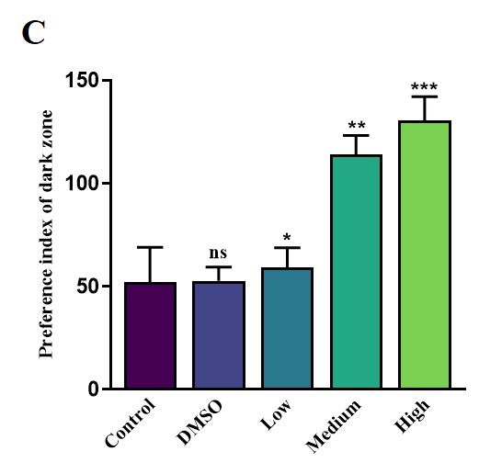
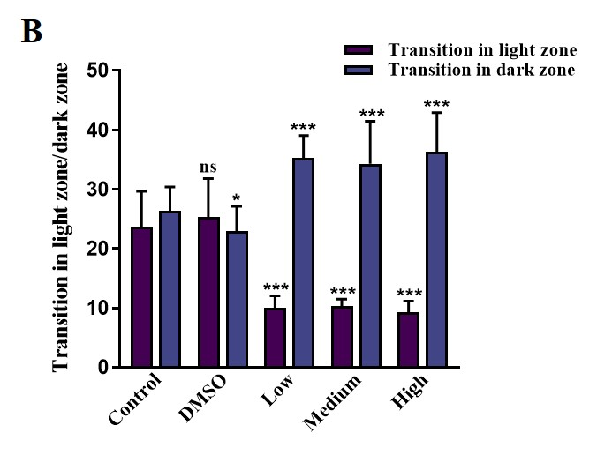
The light–dark behavioral test demonstrated significant, dose-dependent behavioral changes following TBBPA exposure. Zebrafish exposed to high concentrations of TBBPA spent more time in the dark zone and exhibited an increased number of transitions toward the dark compartment compared to the control and DMSO groups (p<0.001; Fig. 4A, 4B). Similar, though less pronounced, effects were observed in the medium- and low-dose TBBPA groups, supporting a concentration-dependent response. Consistent with these findings, the dark zone preference index was significantly increased in the TBBPA-treated groups, with the highest values observed in the high-dose group, followed by the medium- and low-dose groups (p<0.01; Fig. 4C). In contrast, control and DMSO-treated zebrafish predominantly remained in the light zone, exhibiting fewer transitions into the dark compartment, which is indicative of normal exploratory behaviour Table 3.
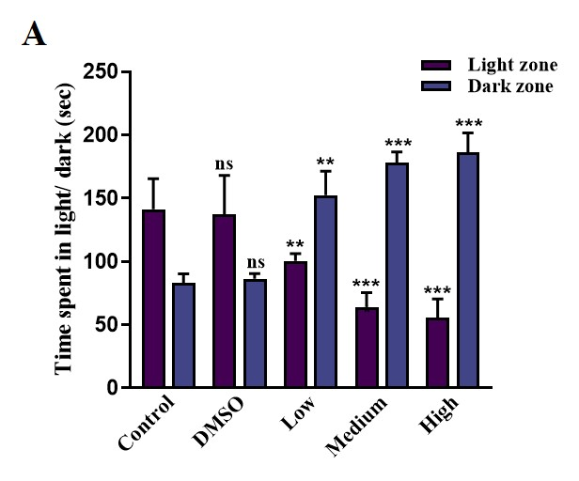

Fig. 4. Effect of TBBPA-DHEE in light dark test concerning these endpoints A) Time spent in light/dark zone, B) Transitions in light/dark zone, C) Preference index of dark zone.
Data expressed as mean ± SEM (n = 10 fish/group). p < 0.05, **p < 0.01; ***p<0.001, compared to control group
Table 3. Effect on different endpoints of light-dark test in adult zebrafish following exposure to TBBPA-DHEE
Behavioral endpoints | Control |  | DMSO control |  | Low Dose |  | Medium Dose |  | High Dose
 | Light | Dark | Light | Dark | Light | Dark | Light | Dark | Light | Dark
Time Spent (in sec) | 207.61±23.97 | 152.39± 7.23 | 198.75±  30.53 | 161.25±4.06* | 101.81±  5.81** | 258.19±  18.98* | 70.93±  11.36** | 289.07±  8.66* | 48.87±14.52* | 311.13±  15.57
Transition in light vs dark zone | 23.6± 6.01 | 26.33 ±4.06 | 25.33±  6.49 | 23± 4.16* | 10±2.08 | 35.33 ±  3.71** | 10.33±  1.20* | 34.33±  7.13 | 9.33 ±  1.86** | 36.33±  6.57*
Preference index of dark zone | 59 ±9.81 |  | 52.67 ± 6.64 |  | 52 ± 17.04 |  | 114 ± 9.17* |  | 130.33 ±  11.68**
Data are represented as mean ± SEM. Experimental groups are compared with control animals using one way ANOVA followed by post hoc test, showing significant difference at p values* shows p< 0.05, ** indicates p<0.01 and *** represents p< 0.001
3.5 Effect of TBBPA-DHEE on the swimming behaviour of adult zebrafish
Adult zebrafish exposed to TBBPA-DHEE demonstrated a dose-dependent change in swimming behaviour when compared to control and DMSO. The high-dose TBBPA-DHEE group exhibited a significant reduction in nearest neighbour distance, suggesting that individuals remained in closer proximity, and a substantial decrease in the area occupied within the tank compared to control and DMSO-treated fish (p<0.01; Fig. 5A, 5B). The medium-dose group displayed intermediate behavioural changes, characterized by moderately reduced nearest neighbour distance and area occupied compared to control and DMSO groups, but less pronounced than those observed in the high-dose group. However, in fishes exposed to low concentrations of TBBPA-DHEE, only a slight difference with less distance and area covered could be observed and was more in line with the control, indicating intact locomotor activity and shoaling dynamics (p<0.01; Fig. 5C, 5D). The behavioural endpoints of all the behavioural tests are mentioned in Table 4.
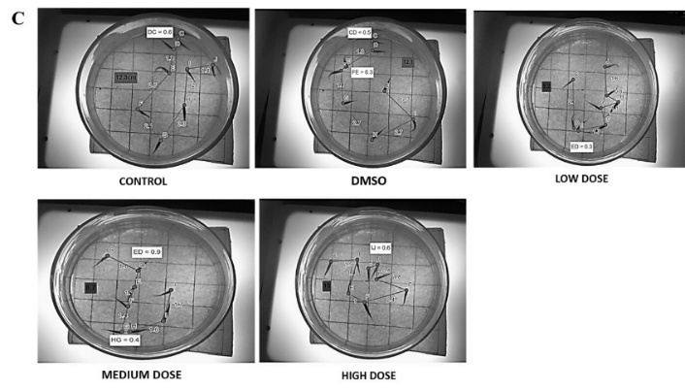
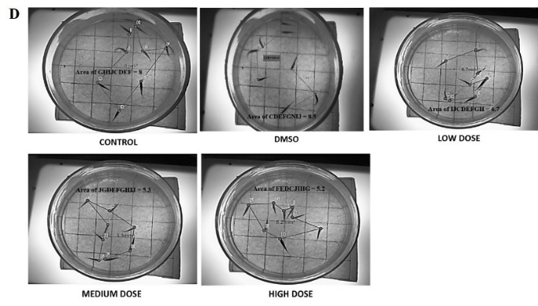
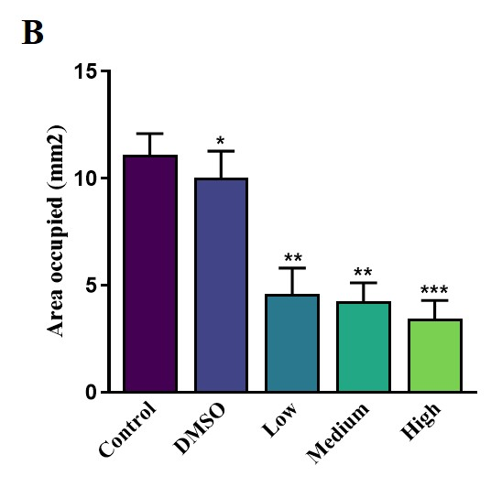
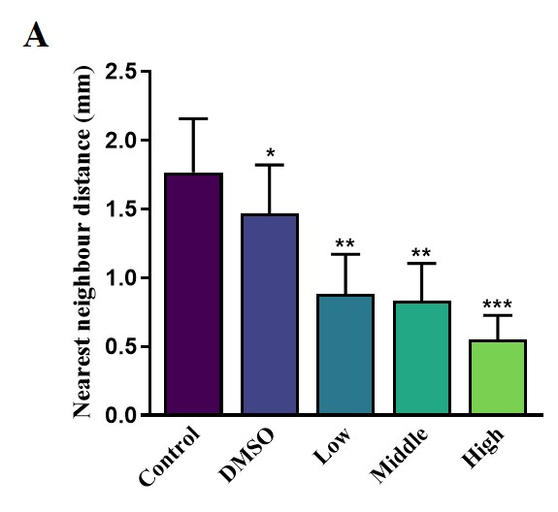
Fig. 5. Effect of TBBPA-DHEE on the swimming behaviour test concerning these endpoints A) Nearest neighbour distance, B) Area occupied, C) The nearest distance travelled by the fish in the swimming tank, D) The area occupied by the fish in the swimming tank.
Data expressed as mean ± SEM (n = 10 fish/group). *p < 0.05, **p < 0.01; ***p<0.001, compared to control group
Table 4. Effect on different endpoints of light-dark test in adult zebrafish following exposure to TBBPA-DHEE
Behavioral endpoints | Control | DMSO  control | Low Dose | Medium Dose | High Dose
Nearest neighbour distance | 1.77 ± 0.389 | 1.47 ± 0.353 | 0.88 ± 0.287* | 0.83 ±0.270 | 0.55±0.177*
Area occupied | 11.10 ± 0.995 | 10.02 ± 1.257 | 4.62 ± 1.191** | 4.27 ± 0.854*** | 3.45 ± 0.851
Data of experimental groups are compared with control animals using one way ANOVA followed post hoc test, showing significant difference at p values: * shows p< 0.05, ** indicates p<0.01 and *** represents p<0.001
4. Discussion
TBBPA-DHEE, an environmental neurotoxicant, is known to have a potential effect on the brain and behaviour. The behavioural alterations are an indication of neural and neuroendocrine disruption. Earlier studies have shown that the possible mechanism behind its action as a neurotoxicant and endocrine disruptor could be due to its capacity to interfere with the neurotransmitter system, leading to increased oxidative stress, neuroinflammation, and possibly disrupting the blood-brain barrier, exposing the brain to it (Yu et al., 2018). It is found that TBBPA-DHEE exposure results in the formation of reactive oxygen species, initiates cell death, influx of calcium ions, and an increase of extracellular glutamate in the cells of the cerebral granule (Reistad et al., 2007; Nakajima et al., 2009). The current study investigated the dose-dependent effect of TBBPA-DHEE on the physiological parameters, i.e., body weight and body length, and behaviour of adult zebrafish. The neurobehavioral toxicity exerted by TBBPA was assessed through the OFT, NTT, light-dark preference test (LDT), and swimming pattern analysis. Zebrafish were exposed to different concentrations of TBBPA-DHEE: 5 mg/L as a low, 10 mg/L as a medium, and 20 mg/L as a high dose.
The findings from the current study revealed that exposure to the increasing concentration of TBBPA resulted in a decline in behavioural performance, with inflated behavioural impairment in the highest dose group. Also, morphometric analysis reveals the preliminary effect of TBBPA-DHEE on the body weight and body length of zebrafish. Previous studies highlight the effect of hormones on the morphometric parameters and regulation (Nahar and Jat, 2021). TBBPA-DHEE, being a potent endocrine disruptor, was involved in the study; a slight difference in the initial and final body length was observed in the exposed group as compared to the control. Also, there were significant differences and a sharp decline in the body weight of the exposed groups as compared to the control group maintained under optimum conditions. To examine the anxiety-like behaviour and exploration pattern, OFT was performed. The observations from the OFT showed reduced exploration and thus increased anxiety-like behaviour in the high dose as compared to the control and DMSO control group. The behavioural endpoints of the OFT include average speed, mobility average speed, total distance travelled, explored area/ total no. of areas, and frozen events of different groups, indicating that the highest variation with control was observed in medium and high doses of TBBPA-DHEE, with low doses displaying almost normal behaviour compared to control. This behaviour suggests that its highest concentration could elevate anxiety and increase thigmotaxis. These findings are similar to the previous studies, indicating that TBBPA-DHEE may disrupt dopaminergic signalling and could be the possible reason for decreased exploratory behaviour (Dong et al., 2021).
Novel tank test assesses the anxiety-like behaviour in zebrafish, along with the locomotor and cognitive tests. The different behavioural endpoints of the novel tank test include time spent in each zone, latency, number of transitions, and erratic movements. These endpoints indicate the stress and anxiety that may be due to different concentrations of TBBPA-DHEE exposure. Previous studies associated with zebrafish novel tank behaviour reveal that control zebrafish initially prefer to remain in the lower zone, reflecting a normal behaviour that may arise due to stress generated in an unacquainted environment. This is justified with time, as fish begin to explore the upper region after habituation (Egan et al., 2009). However, it was observed that in this study, TBBPA-DHEE exposure resulted in altered behaviour compared to normal.
The number of transitions between the lower and upper zones, also known as the novel tank test, is an established measure of exploratory drive and anxiety-like response in zebrafish. In the current study, the exposure to TBBPA-DHEE caused Zebrafish exposed to different concentrations of TBBPA-DHEE displayed a significant result compared to those of earlier studies, which resulted in increased transition to the upper zone under some stress, and could be related to the compensatory neurological mechanism, as mild environmental stress may sometimes increase locomotor activity (Stewart et al., 2012; Lin et al., 2022). In our study, fish displayed a preference in the lower zone than the upper zone in the TBBPA-DHEE-exposed group, as compared to the control and DMSO. A concentration-dependent decrease in the number of transitions to the upper zone, with the maximum concentration of 20 mg/L being the highest, followed by the 10 mg/L concentration. On the other hand, the zebrafish treated with lower concentrations showed relatively higher transitions to the upper zone than the medium and high concentrations, yet significantly lower than the control and DMSO groups. The disparity may be due to a difference in dosage and coping strategies.
Latency to enter the upper zone determines the exploratory behaviour of zebrafish and is an indicator of anxiety. An anomalous behaviour could be observed in latency. Fish treated with 5 mg/L of TBBPA-DHEE displayed a higher latency to enter the upper zone as compared to the control group. However, a reduced latency could be observed in groups exposed to 10 mg/L and 20 mg/L of TBBPA-DHEE. The varying concentration and exposure to different groups may reflect differential neurobehavioral effects and could be attributed to the non-monotonic, biphasic behavioural response among different doses. The increased latency at 5 mg/L is regulated by activation of the hypothalamic–pituitary–interrenal (HPI) axis and specifies a mild anxiogenic response, resulting in escalated stress and vigilance (Stewart et al., 2012; Lin et al., 2022). Previous studies have already mentioned it as a potent endocrine disruptor. However, low-dose exposure to TBBPA-DHEE could increase behavioural inhibition by modifying neuroendocrine signalling reduced latency in higher doses, 10 mg/L and 20 mg/L, could be associated with behavioural disinhibition exerted due to neurotoxicity. Its high concentration may lead to neurotransmitter dysregulation, oxidative stress, and neuronal damage, resulting in altered behavioural control and suppression (Liu et al., 2023; Guo et al., 2024). The number of transitions between the upper and lower zones signifies the exploratory and motor functions. The adequate balance between both zones could be observed in the control group, which reflects a healthy exploratory behaviour and the least anxiety. Meanwhile, groups exposed to 10 mg/L of TBBPA-DHEE resulted in decreased zone transitions, which could be due to elevated anxiety, neurological dysfunction, and compromised motor coordination, whereas the 5 mg/L and 20 mg/L groups displayed slight significant differences or patterns of transition in a dose-dependent manner. This behaviour could again be attributed to behavioural suppression due to neurotoxicity, similar to the previous studies indicating the disruption of behavioural activity due to neurotoxicants, resulting in diminished exploratory behaviour (Zhang et al., 2021).
Extreme anxiety hinders the behavioural and motor responses, and in fish exposed to 20 mg/L of TBBPA-DHEE, abrupt directional changes and frequent high-speed darting were observed, displaying higher erratic movements as compared to the control group, exhibiting a calm and tranquil state with fewer erratic movements. However, in our study, similar behaviour was observed in the 5 mg/L and 10 mg/L groups, displaying slightly higher erratic movements than those of the control. According to the previous study, it was reported that dopaminergic and serotonergic signalling and their dysregulation may be associated with erratic swimming. Hindered sensorimotor processing is linked to TBBPA exposure (Barros et al., 2020, Toni et al., 2023).
The light-dark test depicts anxiety-like behaviour in zebrafish, along with cognitive functions. Increased stress disrupts the balance between transitions and time spent in both zones. Previous study depicts the behaviour of zebrafish exposed to TBBPA-DHEE, indicating an altered behaviour in light-dark test parameters, including transitions, time spent in each zone, and preference index for the dark zone (Jarema et al., 2015).
In our study, TBBPA-DHEE exposure showed a varying result, with more prominent behavioural impairment in the exposed group. However, all the exposed groups do not display dose-dependent alterations in behavioural endpoints, and only a slight difference in impairments could be observed among the exposed groups. TBBPA-DHEE-exposed groups, 5 mg/L. 10 mg/L and 20 mg/L showed anxiety-like behaviour, spending more time in the dark zone as compared to the control and DMSO control group, resulting in normal exploratory behaviour, with freely exploring and frequent transitions between light and dark zones. Time spent in both the zones, although more in the light zones than the dark zones, was observed in the control and DMSO group exhibiting a free-swimming and exploratory, stress-free behaviour.
Transition in light-dark zones was highly increased in all TBBPA-DHEE-exposed groups, showing an increased number of transitions in dark zones as compared to light zones. The exposed groups showed an inhibition of exploratory behaviour even in low doses, an increased avoidance and anxiety-like responses (Blaser and Rosemberg, 2012). Time spent in the dark zone significantly increased in all the TBBPA-DHEE exposed groups and was maximum in the 20 mg/L, and the time and occupancy in the light zone decreased simultaneously. Whereas, those in the control and DMSO control group spent more time spent in the light zone was higher than the exposed group. This change in the occupancy of light and dark zones justifies the anxiogenic effect of TBBPA-DHEE, and an increase in time spent in the dark zone represents escape and increased anxiety-like behaviour (Blaser and Rosemberg, 2012). The dark zone preference index was significantly increased, showing the overall preference for the dark zone over the light zone, and was highest in the 20 mg/L group than that of other two groups, 5 mg/L and 10 mg/L. This finding aligns with the previous studies of and further confirms the anxiogenic effect of TBBPA (Costa et al., 2020).
The swimming behaviour test was performed to assess the effect of TBBPA on the swimming behaviour and locomotion of zebrafish in a dose-dependent manner. The behavioural endpoints include nearest neighbour distance and area occupied. In our study, a normal exploratory and locomotory behaviour swimming patterns could be observed in the control group, covering more distance from the neighbor and occupying a higher area. Fish exposed to low and medium doses showed decreased neighbor distance and minimum area occupied as compared to the control group, while the high dose group had the lowest nearest neighbor distance and area occupied, as fish in this group remained close, avoiding covering and exploring the tank. This is similar to the previous studies; the observed behaviour could be due to increased anxiety and stress that triggered fish to remain in closer proximity and in groups, covering less distance and occupying a minimum area (Miller and Gerlai, 2012). The possible mechanism involves TBBPA-induced neurotransmitter disruptions, mainly the dopaminergic and serotonergic pathways responsible for motor control and social behaviour (Bozhko et al., 2022).
Thus, the findings of our study indicate that TBBPA-DHEE exerts neurobehavioral impairment in a dose-dependent manner, with the more profound and neurotoxic effect observed in high doses, 20 mg/L of TBBPA-DHEE. While low-dose (5 mg/L) exposure may induce anxiety-like behaviour through stress axis modulation and sometimes has shown a neutral effect similar to control due to its lower concentration, medium (10 mg/L) and high (20 mg/L) doses may induce behavioural impairment, possibly due to endocrine disruption, neurotransmitter dysregulation, and oxidative stress.
5. Conclusion
Our findings highlighted the dose-dependent effect of TBBPA-DHEE exposure on neurobehavioral impairment in adult zebrafish, altering individual and social behaviours. Several behavioural assays performed revealed that the most prominent effect of TBBPA-DHEE was observed at high doses. Even at low doses, the exploratory and locomotory behaviour of zebrafish was disrupted, displaying anxiety-like behaviour. These dose-dependent behavioural changes underscore the need for integrative toxicological evaluations that consider both neurological and endocrine endpoints.
Previous studies elucidated that the possible mechanisms behind these observations may include neurotransmitter dysregulation, oxidative stress, endocrine disruption, and neuroinflammation. The findings of this study may provide compelling evidence that TBBPA-DHEE acts as a potent neurotoxicant and may induce neurobehavioural impairment in adult zebrafish; meanwhile, its chronic exposure may raise serious concerns about ecological and health impacts. The study has certain limitations, as it focused on the behavioural outcomes and lacks investigation at the molecular level. The duration and exposure of the TBBPA-DHEE need to be further evaluated and verified in the natural ecosystem. Future research may focus on gaining insights into the molecular mechanisms involved in the behavioural outcomes and the related pathways associated with these findings, aiming to gain in-depth knowledge and regulate the environmental usage and exposure of TBBPA-DHEE.

Competing interests
No potential conflict of interest was reported by the authors. The authors declare that they have no known competing financial interests or personal relationships that could have appeared to influence the work reported in this paper.

Abbreviations
ANOVA One-way analysis of variance
DMSO Dimethyl sulfoxide
LDT Light-dark preference test
NTT Novel tank test
OFT Open field test
TBBPA Tetrabromobisphenol A
TBBPA-DHEE Tetrabromobisphenol A bis (2-hydroxyethyl) ether

Disclaimer (Artificial intelligence)

Author(s) hereby declare that NO generative AI technologies such as Large Language Models (ChatGPT, COPILOT, etc.) and text-to-image generators have been used during the writing or editing of this manuscript.

Disclaimer
This paper is an extended version of a preprint document of the same author.
The preprint document is available in this link: https://www.researchsquare.com/article/rs-7062856/v1
[As per journal policy, preprint article can be published as a journal article, provided it is not published in any other journal]

References
A. Liu, Z. Zhao, G. Qu, et al., Identification of transformation/degradation products of tetrabromobisphenol A and its derivatives, TrAC Trends Anal. Chem. 111 (2019) 85–99, https://doi.org/10.1016/j.trac.2018.12.003.
A. Nakajima, D. Saigusa, N. Tetsu, et al., Neurobehavioral effects of tetrabromobisphenol A in mice, Toxicol. Lett. 189 (2009) 78–83, https://doi.org/10.1016/j.toxlet.2009.05.003.
A. Stewart, S. Gaikwad, E. Kyzar, et al., Modeling anxiety using adult zebrafish, Neuropharmacology 62 (2012) 135–143, https://doi.org/10.1016/j.neuropharm.2011.07.037
A.V. Kalueff, A.M. Stewart, R. Gerlai, Zebrafish as a model for complex brain disorders, Trends Pharmacol. Sci. 35 (2014) 63–75, https://doi.org/10.1016/j.tips.2013.12.002.
B. Zhu, G. Zhao, L. Yang, B. Zhou, Tetrabromobisphenol A induces neurodevelopmental toxicity by disrupting thyroid hormones in zebrafish larvae, Chemosphere 197 (2018) 353–361, https://doi.org/10.1016/j.chemosphere.2018.01.080.
B.P.D. Costa, L.A. Moura, S.A.G. Pinto, et al., Zebrafish models in neural and behavioral toxicology across life stages, Fishes 5 (2020) 23, https://doi.org/10.3390/fishes5030023.
D.V. Bozhko, V.O. Myrov, S.M. Kolchanova, et al., AI-driven phenotyping of zebrafish psychoactive drug responses, Prog. Neuropsychopharmacol. Biol. Psychiatry 112 (2022) 110405, https://doi.org/10.1016/j.pnpbp.2021.110405.
E.S. Okeke, W. Feng, C. Song, et al., Transcriptomic profiling reveals neuroendocrine-disrupting effects of TBBPA-DHEE in zebrafish (Danio rerio), Sci. Total Environ. 858 (2023) 160089, https://doi.org/10.1016/j.scitotenv.2022.160089.
F. Liu, Q. Luo, Y. Zhang, et al., Transgenerational neurotoxicity of tetrabromobisphenol A in Caenorhabditis elegans, Sci. Total Environ. 703 (2020) 134920, https://doi.org/10.1016/j.scitotenv.2019.134920
G. Qu, A. Liu, L. Hu, et al., Advances in analysis of TBBPA/TBBPS and their derivatives and transformation products, TrAC Trends Anal. Chem. 83 (2016) 14–24, https://doi.org/10.1016/j.trac.2016.06.021.
H. Liu, R. Fu, Y. Zhang, et al., Integrated transcriptomic and metabolomic analysis of imidacloprid-induced behavioral disorders in zebrafish, Sci. Total Environ. 870 (2023) 161541, https://doi.org/10.1016/j.scitotenv.2023.161541.
H. Segner, Zebrafish (Danio rerio) as a model for investigating endocrine disruption, Comp. Biochem. Physiol. C 149 (2009) 187–195, https://doi.org/10.1016/j.cbpc.2008.10.099.
H.S. Hendriks, R.G.D. Van Kleef, M. Van den Berg, R.H.S. Westerink, Multiple novel modes of action involved in in vitro neurotoxicity of tetrabromobisphenol A, Toxicol. Sci. 128 (2012) 235–246, https://doi.org/10.1093/toxsci/kfs136.
J. Chen, R.L. Tanguay, Y. Xiao, et al., Developmental TBBPA exposure induces neurobehavioral alterations in larval zebrafish, Environ. Pollut. 216 (2016) 53–63, https://doi.org/10.1016/j.envpol.2016.05.059.
J. Wang, X. Zhao, Y. Wang, Z. Shi, Tetrabromobisphenol A, hexabromocyclododecane isomers and polybrominated diphenyl ethers in foodstuffs from Beijing, China, Sci. Total Environ. 666 (2019) 812–820, https://doi.org/10.1016/j.scitotenv.2019.02.324
J.G.S. Rosa, C. Lima, M. Lopes-Ferreira, Zebrafish larvae behavior models for drug screening and preclinical trials, Int. J. Mol. Sci. 23 (2022) 6647, https://doi.org/10.3390/ijms23126647.
K. Liu, J. Li, S. Yan, et al., Status of tetrabromobisphenol A (TBBPA) in China: A review, Chemosphere 148 (2016) 8–20, https://doi.org/10.1016/j.chemosphere.2016.01.023.
K. Zhang, J. Liang, N.R. Brun, et al., Rapid zebrafish behavioral profiling identifies neurodevelopmental toxicants, Environ. Sci. Technol. 55 (2021) 1919–1929, https://doi.org/10.1021/acs.est.0c06949.
K.A. Jarema, D.L. Hunter, R.M. Shaffer, et al., Behavioral effects of flame retardants in zebrafish, Neurotoxicol. Teratol. 52 (2015) 194–209, https://doi.org/10.1016/j.ntt.2015.08.010.
K.A. Szychowski, A.K. Wójtowicz, TBBPA induces neurotoxicity and apoptosis in cultured mouse hippocampal neurons, Pharmacol. Rep. 68 (2015) 20–26, https://doi.org/10.1016/j.pharep.2015.06.005.
L.D.P. Magno, A. Fontes, B.M.N. Gonçalves, et al., Light/dark preference test pharmacology in zebrafish, Pharmacol. Biochem. Behav. 135 (2015) 169–176, https://doi.org/10.1016/j.pbb.2015.05.014.
L.Y. Lin, J.L. Horng, C.A. Cheng, et al., Sublethal ammonia alters emotions and cognition in zebrafish, Ecotoxicol. Environ. Saf. 244 (2022) 114058, https://doi.org/10.1016/j.ecoenv.2022.114058.
M. Dong, Y. Li, M. Zhu, Z. Qin, Tetrabromobisphenol A: A neurotoxicant or not?, Environ. Sci. Pollut. Res. 28 (2021) 54466–54476, https://doi.org/10.1007/s11356-021-15166-w.
M. Luo, Z. Wu, T. Xu, et al., Neurotoxicity and mechanisms of TBBPA-DHEE exposure in adult zebrafish, Comp. Biochem. Physiol. C 267 (2023) 109572, https://doi.org/10.1016/j.cbpc.2023.109572.
M. Nahar, D. Jat, Long-term alcohol exposure induces behavioral impairments and oxidative stress in adult zebrafish, Zebrafish 18 (2021) 110–124, https://doi.org/10.1089/zeb.2020.1913.
M. Nahar, R. Rai, D. Jat, Vitamin B12 mitigates chronic alcoholism-induced alterations in adult zebrafish, Int. J. Neurosci. (2024), http://doi.org/10.1080/00207454.2024.2398564
M. Toni, C. Arena, C. Cioni, G. Tedeschi, Temperature- and chemical-induced neurotoxicity in zebrafish, Front. Physiol. 14 (2023) 1276941, https://doi.org/10.3389/fphys.2023.1276941.
M.A.E. Abdallah, Environmental occurrence, analysis and human exposure to the flame retardant tetrabromobisphenol-A (TBBP-A): A review, Environ. Int. 94 (2016) 235–250, https://doi.org/10.1016/j.envint.2016.05.026.
N. Miller, R. Gerlai, Automated tracking of zebrafish shoals and analysis of shoaling behavior, Methods Mol. Biol. 916 (2012) 217–230, https://doi.org/10.1007/978-1-61779-597-8_16
O.E. Sunday, H. Bin, M. Guanghua, et al., Review of the environmental occurrence, analytical techniques, degradation and toxicity of TBBPA and its derivatives, Environ. Res. 206 (2022) 112594, https://doi.org/10.1016/j.envres.2021.112594.
Q. Liu, X. Ren, Y. Long, et al., Neurotoxicity of emerging TBBPA derivatives in rat pheochromocytoma cells, Chemosphere 154 (2016) 194–203, https://doi.org/10.1016/j.chemosphere.2016.03.117.
R. Gerlai, Using zebrafish to study the genetics of complex brain disorders, Curr. Top. Behav. Neurosci. 12 (2011) 3–24, https://doi.org/10.1007/7854_2011_180.
R.E. Blaser, D.B. Rosemberg, Measures of anxiety in zebrafish (Danio rerio): Dissociation of black/white preference and novel tank test, PLoS ONE 7 (2012) e36931, https://doi.org/10.1371/journal.pone.0036931.
R.J. Egan, C.L. Bergner, P.C. Hart, et al., Stress and anxiety phenotypes in zebrafish, Behav. Brain Res. 205 (2009) 38–44, https://doi.org/10.1016/j.bbr.2009.06.022.
S. Barros, A.M. Coimbra, N. Alves, et al., Chronic simvastatin exposure disrupts zebrafish brain energy metabolism, J. Toxicol. Environ. Health A 83 (2020) 113–125, https://doi.org/10.1080/15287394.2020.1733722.
T. Reistad, E. Mariussen, A. Ring, F. Fonnum, In vitro neurotoxicity of tetrabromobisphenol A in cerebellar granule cells, Toxicol. Sci. 96 (2007) 268–278, https://doi.org/10.1093/toxsci/kfl198.
U.S. EPA, Risk evaluation for 4,4′-(1-methylethylidene)bis[2,6-dibromophenol] (TBBPA), U.S. Environ. Prot. Agency (n.d.).
W. Feng, T. Xu, J. Zuo, et al., Mechanisms of TBBPA-DHEE-induced developmental neurotoxicity in juvenile zebrafish, Comp. Biochem. Physiol. C 265 (2023) 109530, https://doi.org/10.1016/j.cbpc.2022.109530.
X. Ge, Y. Yu, Migration and transformation of chemical pollutants as mixtures, Toxicol. Assess. Comb. Chem. Environ. (2025) 83–102, https://doi.org/10.1002/9781394158355.ch06.
X. Guo, R. Zhang, C. Li, et al., Azoxystrobin disrupts male zebrafish behavior via oxidative stress, Ecotoxicol. Environ. Saf. 269 (2024) 115744, https://doi.org/10.1016/j.ecoenv.2023.115744.
X. Zhang, L. Guo, Y. Luo, et al., Neurotoxicity induced by TBBPA bis(2-hydroxyethyl) ether in zebrafish embryos, Toxics 13 (2025) 76, https://doi.org/10.3390/toxics13020076.
Y. Tian, J. Chen, Y. Ouyang, et al., Sensitive detection of tetrabromobisphenol A derivatives by reactive extractive ESI-MS/MS, Anal. Chim. Acta 814 (2014) 49–54, https://doi.org/10.1016/j.aca.2014.01.035.
Y. Yu, R. Ma, L. Yu, et al., Combined effects of cadmium and TBBPA in female rats, Chem. Biol. Interact. 289 (2018) 23–31, https://doi.org/10.1016/j.cbi.2018.04.024.

