Original Research Article
First Report of Testate Amoebae from Salim Ali-Jubba Sahni Bird Sanctuary (Baraila Lake), Bihar, India

ABSTRACT
Moss associated testate amoebae of The Salim Ali-Jubba Sahni Bird Sanctuary formally known as Baraila Lake within the Vaishali district, Bihar in Bihar is yet to be reported from the literature. Therefore, this article serves as the preliminary faunal survey attempt to document the state of species richness of testate amoebae in this sanctuary. Testate amoebae belong to the single celled organisms classified under protist fauna characterized by developing complex covering of outer chitin shells; they are renowned as bio indicators owing to their high reactivity to any changes in the environment. Upon analysing the moss samples collected 11 species of testate amoebae span over 6 genera and 6 families were found during this preliminary investigation. All of these are new records for Salim Ali-Jubba Sahni Bird Sanctuary.
Keywords: Testate Amoebae, Protozoa, Moss, Salim Ali-Jubba Sahni Bird Sanctuary, Pollution Indicator
INTRODUCTION
Testate amoebae, unicellular protozoans enclosed in protective shells are valuable bioindicators of environmental conditions. This study documents for the first time this microfauna in Salim Ali-Jubba Sahni Bird Sanctuary (SAJSBS) a part of the rich biodiversity of Bihar, India. SAJSBS formally known as Baraila Lake serves as a major wetland ecosystem within the Vaishali district, Bihar. The sanctuary spread across 12.7 km² of land and positioned between 25°45′58″ and 25°45′37″ N and 85°31′48″ and 85°34′50″ E. The government of Bihar established this area as a protected sanctuary in 1997 and thereafter official notification through the Gazette of India during 2016 [1].
Map. 1: Study area, Salim Ali-Jubba Sahni Bird Sanctuary in Bihar (Source: SOI & Google Earth)
SAJSBS is popular for its diverse vegetation and wildlife, it is most famous for its hot springs and numerous tracts of ecosystems that host many species of mammals, birds and reptiles besides many groups of Insects. SAJSBS has a significant role in wildlife protection and is a very crucial wildlife avenue that links other forests in Bihar. As a sanctuary, it has an inherent ecological value for both conservation and ecotourism purposes, which has been recognised by the Ministry of Environment, Forest and Climate Change, Government of India.
While the diversity of testate amoebae has been documented in various states and eco-regions across India, only a few preliminary studies have been conducted in Bihar [2] leaving significant gaps in understanding their distribution and ecological roles in the region, Particularly, their presence and diversity within the wildlife sanctuaries and national parks of Bihar remain largely unexplored, highlighting the need for focused research in these ecologically significant areas.
Shelled protozoa specifically testate amoebae are the species that occupy large numbers of habitats. They are very susceptible to ecological alterations [3] and are therefore good biomarkers to ecological variations because of their short generation intervals [4,5,6]. These organisms are found in different parts of the world and from tropical to polar regions and from land to sea water environments. Due to their ability to respond to changes in moisture, pH, and other factors in the environment they are used as indicators of ecological change [7]. Testate amoebae also depend on the water quality, pollution, and climate change parameters and therefore are applied for paleo- reconstructions of past water conditions and contemporary ecological status [8,9,10,11]. A diverse group of shelled protozoa (testate amoebae) are essential to ecosystem functioning, especially in soil and aquatic microhabitats. Because of their sensitivity to changes in the environment, these protists are also important as bioindicators and play an essential role in nutrient cycling and decomposition of organic material [12]. There has been a well documented association of testate amoebae with mosses, as moss microhabitats provide moist, nutrient rich environments in which they can survive and reproduce. Besides enriching the microfauna diversity, these moss layers also create microecosystems that support complex food webs, that way microbial communities are linked with higher trophic levels [13].
This study is the first to report the diversity of testate amoebae in SAJSBS within the moss-dominated microhabitats. By documenting these protozoan species, this research enhances our understanding of testate amoebae distribution in tropical ecosystems and underscores their ecological roles within moss communities [3]. Furthermore, insights into their diversity contribute to the broader biogeographical understanding of protozoa across India’s varied landscapes, highlighting the importance of conserving microhabitats in tropical sanctuaries. Thus, the faunal diversity of the given area has been expanded by studying 11 species, 6 genera, and 6 families. Future work on the protozoan taxonomy could be very useful in monitoring and management of the environment in the state.
GLOBAL AND INDIAN DIVERSITY OF TESTATE AMOEBAE
Free living amoebae also show a high degree of world distribution with 675 plus species belonging to 104 genera and 22 families and with records from the polar areas. In India this diversity is reflected in the distribution of 209 species belonging to 37 genera classified under two classes and two orders [14]. This wide dispersal underlines the versatility of testate amoebae and these organisms’ role as bioindicators, as they are found in polar ice and other places in India as well as other environments.
MATERIAL AND METHODS
The moss samples for the present study were collected on 28th September 2024 as part of a faunal survey program within the SAJSBS in Bihar. The samples were obtained from various biotopes like Tree, soil and wall (Map. 1; 25.01.109° N and 86.42.022° E) by scraping with a spatula into polythene bags and brought to the laboratory for further processing. The processing of samples followed the non-flooded petri dish method outlined by Foissner [15]. Subsequently, permanent slide mounts were prepared from each sample and examined using Labomed (Lx 400) microscopes equipped with a Sony CMOS camera attachment for image capturing and species-level identification. All the registered permanent slides were deposited in the National Zoological collections of Gangetic Plains Regional Centre, Zoological Survey of India, Patna.
RESULTS & DISCUSSION
The study yielded the following new records to SAJSBS, Bihar belonging to 11 species of testate amoebae span over 6 genera and 6 families during this preliminary investigation (Figures 1 to 11).
Systematic list of Testate Amoebae from SAJSBS, Bihar: Findings from the present study (Classification as per Adl et al., 2019) [16, 17]
Domain Amorphea Adl et al., 2012
Supergroup Amoebozoa Lühe, 1913, sensu Cavalier-Smith, 1998
Phylum Tubulinea Smirnov et al., 2005
Class Elardia Kang et al., 2017
Order Arcellinida Kent, 1880
Family Netzeliidae Kosakyan et al., 2016
- Cyclopyxis eurystoma Deflandre, 1929
1929. Centropyxis (Cyclopyxis) eurystoma Deflandre, Arch. Protistenkd., 67: 370.
Distribution: India: Arunachal Pradesh, Assam, Himachal Pradesh, Kerala, Maharashtra, Nagaland, Tamil Nadu, Telangana, Uttarakhand, West Bengal, Punjab, Bihar
Remarks: Present record from SAJSBS, Bihar
- Cyclopyxis kahli Deflandre, 1929
1929. Centropyxis (Cyclopyxis) kahli Deflandre, Arch. Protistenkd., 67:371.
Distribution : India: Himachal Pradesh, Kerala, Tamil Nadu, Uttarakhand, Bihar
Remarks: Present record from SAJSBS, Bihar
Family Phryganellidae Jung, 1942
- Phryganella acropodia (Hertwig & Lesser, 1874)
1909. Phryganella acropodia Hopkinson, The British Freshwater Rhizopoda and Heliozoa, 2: 74, pl.20, figs.13-14.
Distribution: India: Himachal Pradesh, Sikkim, Tamil Nadu, Telangana, Uttarakhand, Punjab, Bihar
Remarks: Present record from SAJSBS, Bihar
Family Difflugiidae Wallich, 1864
- Difflugia globulosa (Dujardin, 1837) Penard, 1902
1837. Difflugia globosa Dujardin, Ann. Sci. nat. Zool. (2) 8: 310, pl. 9. Fig. 1.
1902. Difflugia globulosa Penard, Faune Rhizopodique du Bassin de Leman. Geneve: Kundig, pp.714.
Distribution: India: Andhra Pradesh, Assam, Himachal Pradesh, Meghalaya, Odisha, Rajasthan, Tamil Nadu, Uttar Pradesh, West Bengal, Punjab, Bihar
Remarks: Present record from SAJSBS, Bihar
Family Cryptodifflugiidae Jung, 1942
Family Centropyxidae Jung, 1942
- Centropyxis aerophila Deflandre, 1929
1929. Centropyxis aerophila Deflandre Arch. Protistenkd., 67:330.
Distribution: India: Andhra Pradesh, Arunachal Pradesh, Himachal Pradesh, Kerala, Manipur, Meghalaya, Mizoram, Nagaland, Odisha, Sikkim, Tamil Nadu, Telangana, Tripura, Uttar Pradesh, Uttarakhand, West Bengal, Chandigarh, Punjab, Bihar
Remarks: Present record from SAJSBS, Bihar
- Centropyxis ecornis (Ehrenberg, 1841)
1841. Arcella ecornis Ehrenberg, Abh. Akad. Wiss. Berlin, p. 368.
1879. Centropyxis ecornis Leidy, Freshwater Rhizopods of North America, pl.30, figs.20-24.
Distribution: India: Andhra Pradesh, Arunachal Pradesh, Assam, Himachal Pradesh, Kerala, Maharashtra, Meghalaya, Nagaland, Odisha, Sikkim, Tamil Nadu, Telangana, Uttar pradesh, Uttarakhand, West Bengal, Punjab, Bihar
Remarks: Present record from SAJSBS, Bihar

- Centropyxis platystoma (Penard, 1890) Deflandre, 1929
1929. Centropyxis platystoma Defalndre, Arch. Protistenkd., 67: 338.
Distribution: India: Andhra Pradesh, Arunachal Pradesh, Assam, Himachal Pradesh, Kerala, Manipur, Meghalaya, Mizoram, Nagaland, Odisha, Sikkim, Tamil Nadu, Tripura, Uttar Pradesh, West Bengal, Chandigarh, Punjab, Bihar
Remarks: Present record from SAJSBS, Bihar
Phylum Cercozoa Cavalier-Smith, 2018
Class Silicofilosea Adl et al., 2012
Order Euglyphida Cavalier-Smith, 1997
Family Euglyphidae Lara et al., 2007
- Euglypha rotunda (Ehrenberg, 1845)
1911. Euglypha rotunda Wailes and Penard, Proc. R. Irish Acad., 31: 60-62.
Distribution: India: Himachal Pradesh, Kerala, Maharashtra, Odisha, Telangana, Tripura, Uttarpradesh, Uttarakhand, Punjab, Bihar
Remarks: Present record from SAJSBS, Bihar
- Euglypha laevis (Ehrenberg, 1845)
1845. Euglypha laevis Ehrenberg, Ber. Akad., Berlin, p. 307.
1849. Euglypha laevis Perty, Mitth. nat. Ges. Bern., p. 163
Distribution : India: Himachal Pradesh, Kerala, Maharashtra, Odisha, Telangana, Uttar Pradesh, Uttarakhand, Bihar
Remarks: Present record from SAJSBS, Bihar
Family Trinematidae Adl et al., 2012
- Trinema lineare Penard, 1890
1890. Trinema lineare Penard, Mem. Soc. Geneve, 31: 187, pl. 11. Figs. 5-17.
1915. Trinema lineare Cash, Wailes and Hopkinson, Ray. Soc. Publ. London, 3: 91, pl. 47, figs. 11-21.
Distribution: India: Andhra Pradesh, Arunachal Pradesh, Assam, Himachal Pradesh, Manipur, Meghalaya, Mizoram, Nagaland, Odisha, Tripura, Uttarpradesh, Uttarakhand, Chandigarh, Punjab, Bihar
Remarks: Present record from SAJSBS, Bihar
- Trinema complanatum Penard, 1890
1890. Trinema complanatum Penard, Mem. Soc. Geneve, 31: 187, pl.10, figs. 1-4.
Distribution: India: Andhra Pradesh, Arunachal Pradesh, Himachal Pradesh, Kerala, Meghalaya, Mizoram, Nagaland, Sikkim, Uttar Pradesh, Uttarakhand, Punjab, Bihar
Remarks: Present record from SAJSBS, Bihar
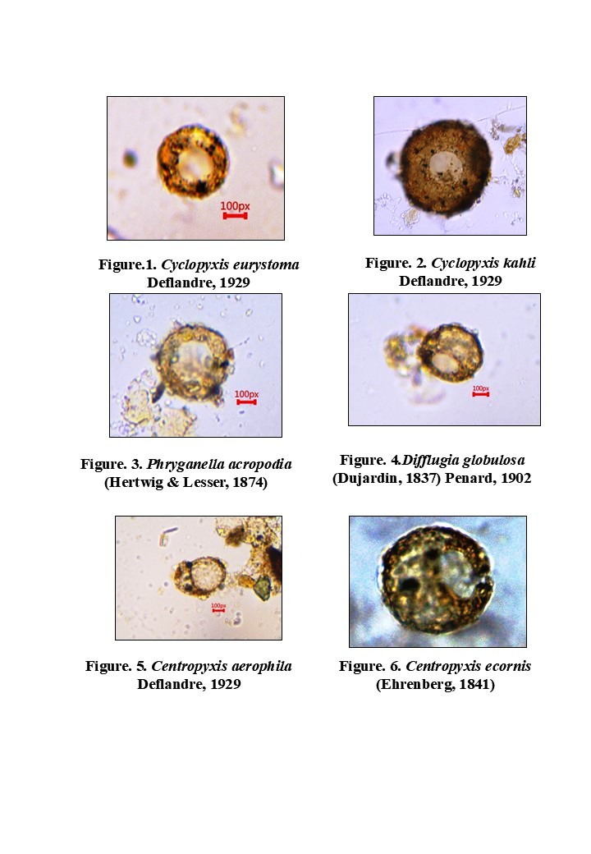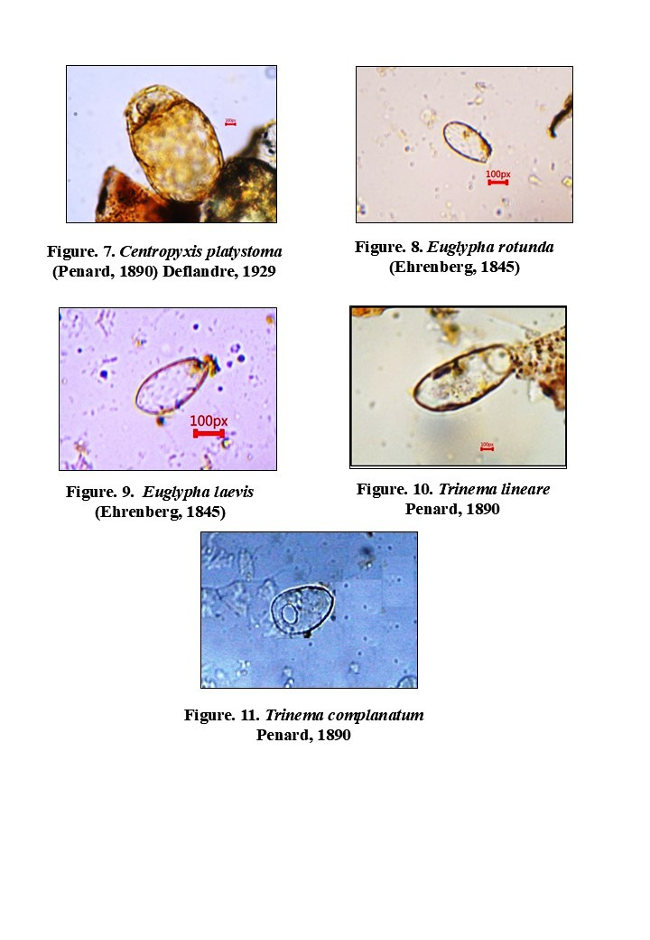

CONCLUSION
Moss-associated testate amoebae are most helpful for studying changes to the environment because mosses tend to grow in wet or in moist habitats. They also adapt quickly to changes in their environment, and hence are ideal as pollution and other ecological changes as biomarkers. This makes their study invaluable especially in these un-investigated ecosystems like wildlife sanctuaries and national parks in Bihar. It is therefore critical to gain knowledge of the distribution and spacial heterogeneity of protozoans, especially testate amoebae, in these ecosystems due to rising effects of climate change and human activities. Commensurate with the responses they give to communities of these small organisms, they give prime data on major environmental issues, as such constituting significant importance in the field of biodiversity and ecosystems.
In the present study, it proposed to evaluate the health and overall states of ecosystems in Bihar and other regions through the species richness of testate amoebae. These organisms, which are now well documented to inhabit both terrestrial and aquatic environments, serve as baseline biomarkers, providing essential information for the assessments and inventory of ecosystems while also contribute new distributional records of species.
Therefore, on the basis of the current state of knowledge about testate amoebae present within the SAJSBS and other protected regions of Bihar, targeted, extensive site-specific research are required. Such inquiries should address their function on overseeing of ecological condition, equitable in areas that have felt the influence of human beings. Thus, the microhabitat-centered studies will contribute to improving our understanding of the ecological mechanisms, approximating efficiency of the protected area network, and providing directions for the sustainable use of these unique environments.

Disclaimer (Artificial intelligence)

Author(s) hereby declare that NO generative AI technologies such as Large Language Models (ChatGPT, COPILOT, etc.) and text-to-image generators have been used during the writing or editing of this manuscript.

REFERENCES
- MoEF&CC. (2021). National Parks and Wildlife Sanctuaries in India. Ministry of Environment, Forest and Climate Change, Government of India. (Comp.). Pg. 454.
- Kumar, V.M. Sathish, Bindu. L, and Anil Kumar. (2024). “First Report on Moss-Dwelling Testate Amoebae from Bihar, India: Species Diversity and Ecological Significance”. Bionature. 44 (2):73-81. https://doi.org/10.56557/bn/2024/v44i22044
- Smith, H.G., Bobrov, A., Lara, E. (2007). Diversity and biogeography of testate amoebae. In: Foissner, W., Hawksworth, D.L. (eds) Protist Diversity and Geographical Distribution. Topics in Biodiversity and Conservation, vol 8. Springer, Dordrecht. https://doi.org/10.1007/978-90-481-2801-3_8.
- Ogden, C. G., & Hedley, R. H. (1980). An Atlas of Freshwater Testate Amoebae. British Museum (Natural History).
- Mitchell , EAD and Gilbert , D. (2004). Vertical micro-distribution and response to nitrogen deposition of testate amoebae in Sphagnum. Journal of Eukaryotic Microbiology, 51 : 485 – 495 .
- Mitchell, Edward & Charman, Dan & Warner, Barry. (2008). Mitchell EAD, Charman DJ, Warner BG.. Testate amoebae analysis in ecological and paleoecological studies of wetlands: past, present and future. Biodivers Conserv 17: 2115-2137. Biodiversity and Conservation. 17. 10.1007/s10531-007-9221-3.
- Nguyen-Viet, H., Bernard, N., Mitchell, E. A. D., Cortet, J., Badot, P.-M., and Gilbert, D. (2007). Relationship between testate amoeba (protist) communities and atmospheric heavy metals accumulated in Barbula indica (Bryophyta) in Vietnam. Microbial Ecol. 53: 53-65.
- Vincke S, Gremmen N, Beyens I, Van de Vijver B (2004a). The moss dwelling testaceans fauna of IIe de Possession. Polar Biology 27:753-766.
- Mattheeussen R, Ledeganct P, Vincke S, Van de Vijver B, Nijs I, Beyens L. (2005). Habitat selection of aquatic testate amoebae communities on Qeqertarsuq (Disko Island), West Greenland. Acta Protozoologica 44:253-263.
- Bobrov, A., Charman, D. J and Warner, B. G. (1999). Ecology of Testate Amoebae (Protozoa: Rhizopoda) on Peatlands in Western Russia with Special Attention to Niche Separation in closely related taxa. Protist. 150(2): 125-136.
- Jassey, V. E., Signarbieux, C., Hättenschwiler, S., Bragazza, L., Buttler, A., Delarue, F and Mitchell, E. A. D. (2013). An unexpected role for mixotrophs in the response of peatland carbon cycling to climate warming. Scientific Reports. 3: 23-54.
- Ogden, C.G., Hedley, R.H. (1980). An atlas of freshwater testate amoebae: 95 plates. British Museum (Natural History) and Oxford University Press (London and Oxford). Pp. 222.
- Mitchell EAD, Charman DJ, Warner BG. (2015). Testate amoebae analysis inecological and paleoecological studies of wetlands: past, present and future. Biodiversity and Conservation.17(2):211-230.
- Bindu, L., Purushothaman, J., Ambili, A., Chaudhary, A. (2024). Checklist of Fauna of India:Testate Amoeba (Protozoa: Tubulinea; Cercozoa; Stramenopiles). Version 1.0. Zoological Survey India. DOI: https://doi.org/10.26515/Fauna/1/2023/Protista:Tubulinea; Cercozoa; Stramenopiles.
- Foissner, W. (1992). Estimating the species richness of soil protozoa using non-flooded petridish method. In Protocols in Protozoology. Lee, J.J and Soldo,A.T.(eds), Allen Press.
- Adl S. M., Simpson A. G. B., Lane C. E., Lukes J., Bass D., Bowser S. S., Brown M. W., Burki F., Dunthorn M., Hampl V., Heiss A., Hoppenrath M., Lara E., Le Gall L., Lynn D. H., McManus H., Mitchell E. A. D., Mozley-Stanridge S. E., Parfrey L. W., Pawlowski J., Rueckert S., Shadwick L., Schoch C. L., Smirnov A., Spiegel F. W. (2012). The revised classification of eukaryotes. J. Eukaryot. Microbiol. 59: 429-493
- Adl, S.M., Bass, D., Lane, C.E., Lukes, J., Schoch, C.L., Smirnov, A. (2019). Revisions to the classification, nomenclature, and diversity of eukaryotes. Journal of Eukaryotic Microbiology. 66: 4-119.

