Artificial Intelligence and Development in India: A Hierarchical Framework of Enablers, Constraints, and Sequencing
Abstract
The study evaluates Artificial Intelligence (AI) as a conditional rather than automatic driver of India’s transition to a developed economy under the vision of Viksit Bharat-2047. It is a conceptual study that is based on a systematic analysis of government policies, a review of evidence from sectoral implementations, and global benchmarking studies. It employs a sectoral and institutional analytical framework to assess the deployment of Artificial Intelligence in agriculture, health, manufacturing, and public governance to highlighting the constraints that shape AI’s developmental outcomes. It suggests that the economic impact of AI relies less on enhanced algorithms and more on the alignment of four foundational enablers (4Cs): connectivity, computational capacity, contextual data, and workforce competency. The findings indicate that misalignment and incompleteness in fundamental conditions will lead to fragmented AI adoption and a narrow distribution of technological advancement. India’s ability to transform AI technology into a tool of sustained inclusive development will depend on a coherent institutional framework and the resolution of structural constraints in the proper sequence.
Keywords: Artificial Intelligence, Economic Development, Viksit Bharat, Digital Transformation, India, Fourth Industrial Revolution, AI Policy, Sustainable Development.
- Introduction
Artificial Intelligence (AI) is causing a substantial structural transformation in the global economy. It has the potential to significantly transform the entire manufacturing system across all sectors of the economy (Shabbir & Anwer, 2018). This transformation is closely associated with the national objective of achieving developed-economy status by 2047 under the Viksit Bharat Vision-2047 (NITI Aayog, AI for Viksit Bharat Report 2025). To achieve this objective, we need sustained improvement in the efficiency of factors across all sectors, including agriculture, manufacturing, services, and public governance. Artificial intelligence techniques, such as machine learning and natural language processing, are highly effective at addressing substantial economic complexity by minimizing information friction, enabling real-time optimization, and reducing coordination costs (Kumar, 2024). As highlighted in the 2025 Digital Progress and Trends Report by the World Bank, AI has the capability to increase access to knowledge, boost productivity, and unlock new opportunities. Nonetheless, these benefits largely depend on key enablers, such as the degree of digital connectivity, computational capacity, contextual data, and the availability of a competent workforce at the broad level (World Bank 2025).
Figure 1: AI as Cognitive Infrastructure: Scalable Intelligence and Automation
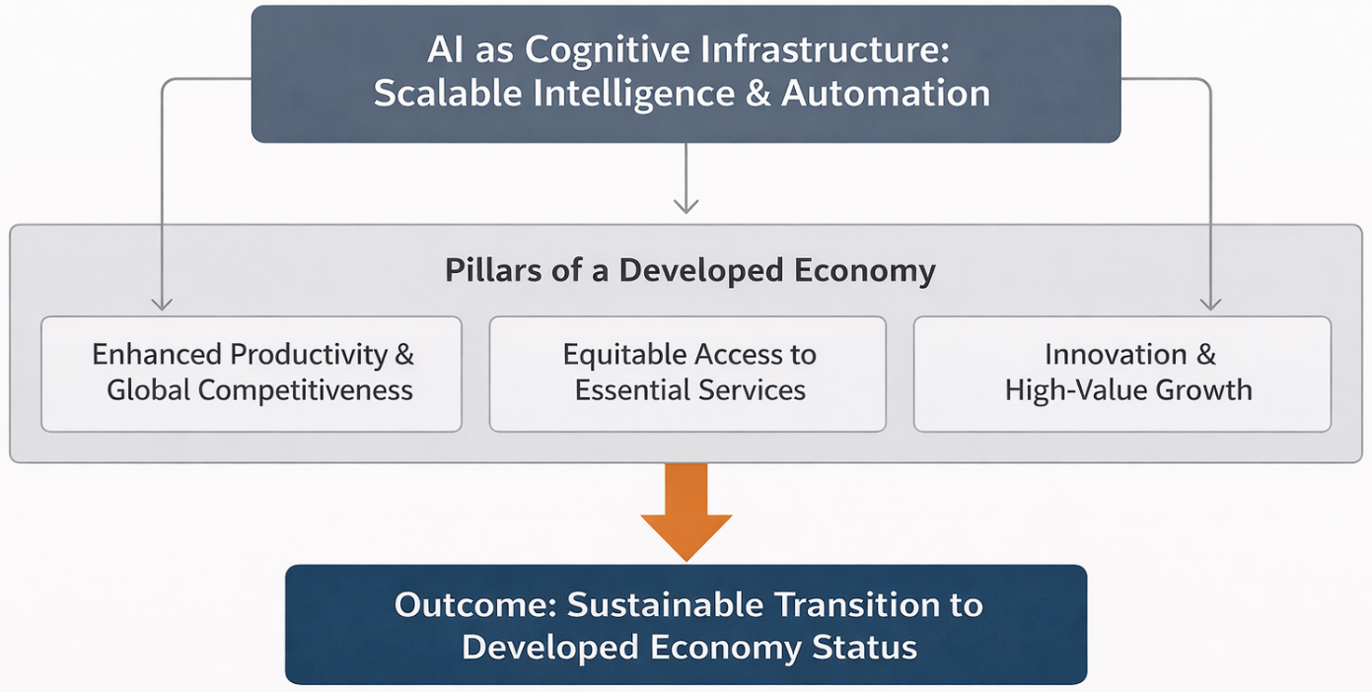
Source: Prepared by the researcher
The Indian government recognizes these enabling conditions in its recently introduced policy framework. The government is critically examining the implications of AI for specific sectors. In this regard, the government has taken several initiatives to establish a regulatory framework conducive to the adoption of AI in India. The India AI Mission, the National AI governance guidelines, and other initiatives are balancing risk mitigation and innovation while trying to leverage AI as a tool for inclusive growth. The scaled adoption of AI can be achieved through integrated public systems. For instance, the Digital Public Infrastructure initiative is based on the public systems of Aadhaar and UPI (NITI Aayog, 2025).
Nevertheless, there is no assurance that a country will necessarily reap the long-term broad benefits of AI. Structural deficits continue to exist systematically. The digital infrastructure, digital literacy, and connectivity gaps are particularly evident in rural and underprivileged regions. Several empirical studies indicate that the widening skills gap is a primary concern for AI. Labor-market evidence indicates that economies such as India are susceptible to dual vulnerabilities. Ganuthula and Balaraman (2025) argue that a large fraction of India’s labour force is engaged in jobs that are vulnerable to automation and are incapable of benefiting from the emergent jobs based on Artificial Intelligence. If this gap continues, the outcome of AI-induced growth may be exclusion rather than inclusion and opportunity.
Ethical and governance concerns further complicate the AI transition. Artificial Intelligence (AI) has the potential to trigger significant risks, including algorithmic bias, data misuse, opaque decisions, and privacy violations. It is very crucial to address these biases with proper diligence and ensure that AI-ML systems are transparent, equitable, and beneficial to all (Hanna et al., 2025). India’s AI strategy primarily emphasizes adaptability and flexibility to sectoral characteristics. But it is frequently poorly implemented, unreliable, and constrained. It is apparent in high-risk sectors, including finance and public service delivery (Government of India, India AI Governance Guidelines, 2025). Artificial Intelligence (AI) requires the trust and acceptance of the general public to become widely adopted. There should be enforceable standards based on transparency and accountability to gain public trust in AI.
In this regard, the paper uses a sectoral and institutional analytical framework to examine the progress and evolution of AI in India. It investigates the application of artificial Intelligence (AI) across the public sector, manufacturing, agriculture, and health, while accounting for institutional and infrastructural constraints. The research examines the conditions under which AI can serve as a general-purpose technology rather than a technology with narrow benefits.
- Objectives
This paper has three interrelated objectives.
- It synthesises and critically examines the strategic frameworks and policy initiatives through which the Indian government and industry are working to position Artificial Intelligence as a long-term driver of economic growth.
- It examines sector-specific AI applications in agriculture, health, and manufacturing, with a focus on technical feasibility, economic relevance, scalability, and institutional integration.
- It identifies and examines the enabling factors and systemic constraints that condition the developmental impact of AI.
- Methodology
The research adopts a conceptual narrative review approach that is based on policy analysis with sector-specific evidence relevant to AI-led development in India. The core objective of this paper is to enhance the conceptual understanding of Hierarchical Institutional Constraints, Foundational enablers, and sequencing. This approach focuses on an analytical synthesis of heterogeneous sources instead of a statistical meta-analysis. The study is based on four broad categories of resources. 1) government publications and official press releases to establish policy intent and institutional design. 2) institutional reports from academics and public research organisations that document relevant AI initiatives. 3) reports from global institutions like the World Bank and the ILO that outline the foundational enablers and comparative constraints of AI. 4) selected industry and professional body reports to capture skill-demand patterns and the dynamics of industrial transformation. Evidence components are arranged thematically, covering sectoral applications, system enablers, and constraints. In the absence of any specific impact evaluation, cases are considered evidence of technological feasibility and institutional direction rather than the magnitude of economic impact.
- Sectoral Discussion and Evidence Interpretation
The section analyses the use of Artificial Intelligence in major sectors of the Indian economy. It also attempts to enhance the understanding of how sector-specific conditions can determine outcomes. This research is conceptual and interpretive, based on the review of secondary data and sources. The focus is to study implementation patterns, institutional integration, and pragmatic constraints rather than normative policy recommendations or expected macroeconomic impacts. Table 1 provides a consolidated overview of sectoral AI applications and the nature of evidence currently available.
Table 1: Sectoral Applications of Artificial Intelligence in India
Sector | Illustrative AI Applications | Primary Function | Evidence Type | Key Sources
Agriculture | Digital Crop Survey, Agri Farm Registry, AI advisory systems | Advisory support, risk mitigation, and administrative coordination | Pilot implementations, institutional reports | FAO; World Bank; NITI Aayog; Government of Gujarat
Healthcare | TANUH, Aarogya Aarohan | Screening support, early risk identification | Institutional deployments, proof-of-concept | Indian Institute of Science
Manufacturing | Predictive maintenance, quality analytics in large firms | Process optimisation, efficiency improvement | Firm-level case documentation | World Economic Forum; McKinsey & Company
Public Governance | Digital public infrastructure platforms | Service delivery, data integration | Policy frameworks, operational platforms | Government of India; NITI Aayog
Note: Evidence strength varies across sectors. Reported cases illustrate technological feasibility and institutional direction rather than causal estimates of economic impact.
Source: Compiled by the author from various key sources.
Figure 2: Sectoral AI Deployment Pathways and Institutional Interfaces
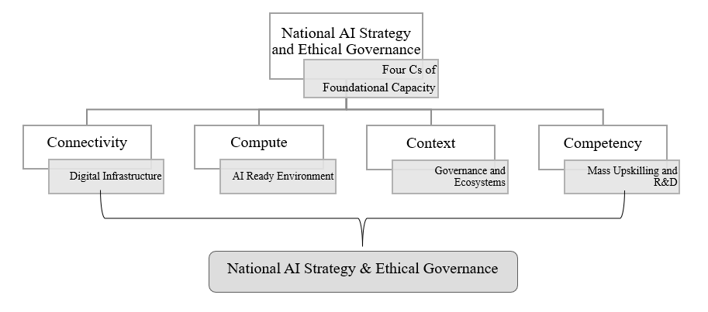
Source: Prepared by the researcher
Figure 2 schematically illustrates how AI applications interact with sector-specific data systems, service delivery mechanisms, and organisational capacities across agriculture, healthcare, and manufacturing.
4.1 Agriculture
The agriculture sector is one of the leading sectors that is increasingly adopting Artificial Intelligence to address agrarian problems. A variety of constraints that reduce productivity and increase income volatility adversely impact Indian farmers. This sector is particularly prone to asymmetric information, climate disturbances, and inefficient resource use (FAO, 2024). An AI-enabled decision-support service has the potential to resolve these farm-related issues through agricultural smart advisory, real-time monitoring, and risk-mitigation services (World Bank, 2024).
Gujarat has successfully implemented a layered AI deployment model. The state proposes to create an end-to-end digital ecosystem through the Digital Crop Survey, Digital Agri Farm Registry, and i-Khedut portal. These initiatives collectively aim to address problems at different stages of the agricultural cycle (Government of Gujarat, 2023; NITI Aayog, 2018). These initiatives primarily link farm-level information to service delivery systems to enhance coordination, data integration, and administrative efficiency. Farmers get AI-backed advisory tools which help them decide what to sow, when, and how to apply inputs. By integrating climate- and soil-related data, these AI systems can help address climate- and productivity-related challenges. It can significantly reduce information uncertainty at the agricultural level (Jha et al., 2019). However, the distribution of AI benefits is not uniform. The widespread adoption of AI by small and marginal farmers continues to remain limited due to unequal access to digital connectivity, the integrity of data, and the competence of users. Therefore, regions or individuals with access to more sophisticated digital infrastructure and institutional support continue to reap the benefits of these AI-based initiatives.
4.2 Healthcare
The healthcare system in India is confronting deep-rooted challenges. It has two rising dimensions. The first challenge is the rising burden of lifestyle-related non-communicable diseases. The second challenge is the urban-rural divide in the quality of treatment. Under these circumstances, a variety of targeted experiments are underway to establish techniques for evaluation and diagnosis based on artificial Intelligence, especially in areas where specialist availability is low and delays in diagnosis are common.
The Indian Institute of Science (IISc) has launched Translational AI for Neuro-health and Urban Health Initiatives (TANUH). This IISc Project uses AI to conduct community screening at scale via machine learning (ML) models. These models have been trained to analyze imaging data for the early detection of possible neurological and oral health threats (Indian Institute of Science, 2024). According to preliminary indications from these initiatives, AI can be extremely helpful to scale up early detection of health risks without delays in diagnosis.
Similarly, the Aarogya Aarohan initiative employs an artificial intelligence-powered mobile application to help classify oral cancer using images collected by frontline health workers. This initiative aids in increasing the screening capacity by enabling faster detection of high-risk cases for further clinical examination among the underprivileged section of society (Indian Institute of Science, 2024). The technological solutions and institutional commitments will only be effective at scale if additional capabilities, clinical integration, and workforce training complement them at a foundational level.
  - Manufacturing
In India, the adoption of AI in the manufacturing sector presents a contrasting scenario. While many large-scale enterprises have effectively incorporated the different elements of AI in their business systems, small-scale enterprises (SMEs) are still lagging in adopting and implementing AI systems. The use of artificial Intelligence in the manufacturing industry is generally embedded in production planning, quality control, predictive maintenance, and supply chain optimization (Li et al., 2017). All these processes require high data availability, technical know-how, a skilled workforce, and capital intensity, but a lack of these resources severely hinders SMEs from effectively adopting AI.
India’s participation in the Global Lighthouse Network of the World Economic Forum also shows its commitment. Manufacturing facilities certified as lighthouses deploy AI-based solutions to streamline supply chains, minimise interruptions, and achieve quality consistency and precision (World Economic Forum, 2019). As documented in industry cases, firms that adopted AI-enabled real-time analytics and predictive systems achieved measurable improvements in their operations (McKinsey & Company, 2021).
The financial capacity and size of firms often influence their adoption of AI. Many micro, small, and medium enterprises possess limited data availability, access to capital, technical know-how, and organisational readiness. Due to these constraints, SMEs cannot implement AI-enabled machinery, even though it has the potential to improve productivity significantly. This imbalance of artificial Intelligence in manufacturing further exacerbates the pre-existing structural imbalance among large firms and SMEs.
- Cross-Cutting Analysis and Structural Constraints
Although evidence from individual sectors shows how artificial Intelligence is being used in many productive sectors, such as agriculture, health, and manufacturing, it does not explain why realised outcomes are so starkly different across these sectors. The analysis shows that AI adoption operates through a set of interrelated enablers and constraints, and their configuration, sequencing, and institutional quality determine whether observed deployments remain isolated instances or evolve toward system-level transformation (Maragno et al., 2023).
5.1 Foundational Enablers: The Four Cs
The success of AI in any sector depends on the simultaneous availability of four foundational enablers: 1) Connectivity, 2) Compute, 3) Context, and 4) Competency. As highlighted by recent assessments of global development, all these enablers are complementary to one another rather than independent levers (World Bank 2025).
Connectivity is the first enabler. Being connected does not mean only having internet access; it means having the reliability, latency, and affordability required for an AI application to process real-time data. India has made considerable progress in augmenting access to and the affordability of digital services. However, large-scale gaps persist in network quality and last-mile connectivity, especially in rural and semi-urban areas (World Bank 2025). Due to these limitations, the flow of real-time data is severely restricted, thereby reducing the functionality of AI-based systems in rural and semi-urban areas.
Computing processing capability is another enabler. High-performance computing is required to train, deploy, and scale AI application models, but India is highly dependent on imported devices and cloud infrastructure. According to NITI Aayog (2025), India’s reliance on imported devices and cloud infrastructure could have adverse consequences for costs, accessibility, and strategic autonomy due to over-dependence on foreign resources. When computing resources are scarce, expensive, and highly import-dependent, the deployment of AI is often limited to pilot projects or large enterprises.
Contextual data is the third enabler. AI systems require high-quality, locally relevant contextual datasets to produce the required output. However, India faces a significant shortage of relevant data in different sectors. The available data is either poorly standardised, fragmented amongst agencies, or underutilised due to governance and coordination-related issues (GoI 2024; NITI Aayog 2025). Any AI model is extensively trained on relevant contextual data. Therefore, poor data access and improper governance can result in AI systems that produce complicated, contextually incorrect, and misleading outcomes.
Competency is the fourth enabler. The effective use of AI requires a skilled workforce to integrate algorithms into organisations’ regular operations and decision-making processes. Analysis indicates that there is a growing gap between the skills required by AI (automation)-intensive applications and the skills actually possessed by the available workforce (ILO, 2018). Such a skill mismatch constrains the economy’s absorption capacity despite the presence of infrastructure and data.
Figure 3: The Four Cs as Complementary Enablers of AI-Led Development
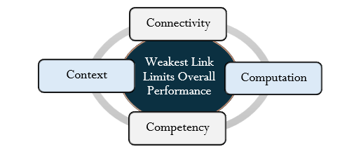
Source: Prepared by the researcher
Figure 3 demonstrates that Connectivity, Compute, Context, and Competency mutually reinforce each other and that the weakest of these constrains overall system performance.
5.2 Critical Risks and Distributional Challenges
The unbalanced deployment of foundational enablers creates distributional risks that cascade across sectors. Labour market polarisation, significant skill shortages, and extensive job losses and relocations are critical issues that need to be carefully addressed(Acemoglu & Restrepo, 2020). The automation of administrative, routine analytical, and support jobs is driving a growing demand for advanced technical and managerial skills while posing an existential threat to semi-skilled workers (Gray & Suri, 2019). Informal employment predominantly characterises India’s labour market. The majority of the workforce is engaged in unskilled or semi-skilled jobs. There is currently no mechanism to reskill the workforce to meet the increased demand for technical skills (ILO, 2018). In this case, the negative impacts of AI may outweigh its positive impacts, and the overall situation may be negatively affected by these dynamics.
Governance risks further complicate AI growth. The extensive use of data-driven technologies presents structural risks such as algorithmic opacity, data misuse, privacy breaches, and detrimental biases Dehkharghanian et al., 2023; Hanna et al., 2025). Despite India adopting a flexible and responsive regulatory approach across sectors, there remains a policy deficit in institutional enforcement capacity (Government of India, 2024). In the absence of reliable accountability mechanisms, it is impossible to build public trust in AI-enabled systems. This trust issue may also limit the adoption of AI systems in high-risk areas.
There are risks associated to concentration effects. So far, deployment of AI in India has benefited bigger firms, better-resourced areas, and financially capable entities. Without clear mechanisms to expand access to data, computing, and skills to weaker sections, AI adoption can worsen existing inequalities. Manufacturing and advanced services have also shown a similar trend: small firms have growth potential but face entry barriers due to limited resources.
5.3 Hierarchical Constraint Perspective
The study indicates a hierarchical order of the constraints on AI deployment. Employing the principles of interpretive structural modelling, these constraints can be categorised in a hierarchical order based on their driving power and dependence.
Infrastructures and institutional capacity represent the lowest foundational level of the hierarchical constraint. It covers connectivity, computational access, and data governance. Such factors have a strong impact on AI’s higher-order outcomes. After the Capacity constraints for the organization need to be addressed. The primary focus at the top of the hierarchy is on deployment, productivity gains, and service expansion.
Figure 4: Hierarchical Framework of Interconnected Challenges Related to Artificial Intelligence

Source: Prepared by the researcher
The order indicated here is critical to the analysis. Higher-level policy initiatives or isolated trial projects cannot enhance AI adoption if fundamental barriers are not properly addressed. On the other hand, investing in infrastructure, data systems, and human skills creates a feasible space for an AI implementation. Thus, the outcome of AI deployment is driven less by the speed of AI rollout than by the sequencing and coherence of the enabling conditions.
Figure 5: Challenges towards AI Adoption in Transforming India
Source: Prepared by the researcher
Figure 5 illustrates the various challenges of AI in transforming India.
6: Policy Implications and Synthesis
The analysis so far establishes that the artificial Intelligence does not function as an autonomous driver of development outcomes. Rather, the economic and social outcomes are mediated through a hierarchy of foundational, organisational, and institutional constraints. Therefore, the policy implications should be focused on addressing these hierarchical constraints.
6.1 Implications of the Constraint Hierarchy
A key implication of the hierarchical framework developed in Section 5 is that not all constraints exert equal influence over AI outcomes. The digital connectivity, access to computation, and contextual data governance are indispensable foundational conditions for AI. Deficiencies at this level may propagate upward, weakening the effectiveness of the entire ecosystem’s capacity, skill development, and sectoral implementation. Therefore, downstream interventions cannot compensate for upstream deficiencies. This logic corresponds with various comprehensive studies that recognise digital infrastructure and institutional preparedness as essential for the scalable implementation of AI (World Bank, 2025).
This perspective helps explain why many AI initiatives exhibit strong pilot performance but limited scalability. It is crucial to understand the right sequence of foundational institutional reforms to achieve sustainable development and equitable benefits of AI. Unresolved fundamental constraints, in the wrong order, led to the restricted and fragile adoption of AI, which depends heavily on institutional support for its sustenance. It reinforces that AI policy is less about the metrics of superficial AI deployment and more about how systematically stringent driving constraints are being progressively addressed.
6.2 Mission Orientation as Capacity Sequencing
Artificial intelligence policy requires rethinking within the prevailing framework. It is best understood as a mission-oriented sequence of capacity formation across the constraints hierarchy rather than irrationally imposing technology without addressing the core issues. Therefore, the focus should be on institutional preparedness, a favourable economic environment, and positive structural changes. The most appropriate solution is to implement a wide range of feasible and sustainable initiatives to address fundamental bottlenecks. (Government of India, 2018; NITI Aayog, 2025).
According to various studies on the agriculture, health, and manufacturing sectors, it was found that the adoption of AI becomes more adaptable and robust when key enablers such as connectivity, computing capacity, data systems, and human skills work together (Mary Simon et al., 2025).
6.3 Coordination Without Centralisation
The hierarchical logic also impacts institutional coordination. The widespread application of AI and Related technologies across sectors and regulatory domains, including all levels of government, has created coordination challenges that cannot be solved through centralisation. This coordination requires maintaining an optimal balance among standards, incentives, and learning to foster a conducive environment for AI, rather than concentrating control (Government of India, 2025).
The decentralised pilot trials are valuable for identifying contexts, challenges, and institutional learning. However, pilot projects should be treated only as diagnostic tools, not as proof of scalability. Taking pilot project success as evidence and inferring that the system is ready can create ambiguity and lead to false positives about the feasibility and sustainability of such AI projects. For analytical coherence, we must complement central funding with decentralised experiments to develop foundational capacities and governance frameworks.
6.4 Synthesis: From Deployment to Development Capacity
To conclude, the study indicates that the developmental implications of AI in India will largely depend on the consistency of institutional alignment. Development outcomes emerge only when high-driving constraints are resolved in sequence (Pilz et al., 2025). AI is a multipurpose tool, and its benefits depend on the existing economic structure, governance abilities, and human capital. These conditions will determine to what extent AI will operate as a tool of inclusive development rather than merely as an uneven-owth driver (Brynjolfsson, 2022). Policies that solely focus on encouraging the uptake of AI technology may neglect these more fundamental determinants (World Bank, 2025). We provide a diagnostic framework that explains why similar technologies yield such different outcomes across sectors and regions by proposing a hierarchy of foundational constraints and enabling factors.
Figure 6: Sequencing Logic Linking Foundational Enablers, Sectoral Deployment, and Development Outcomes.
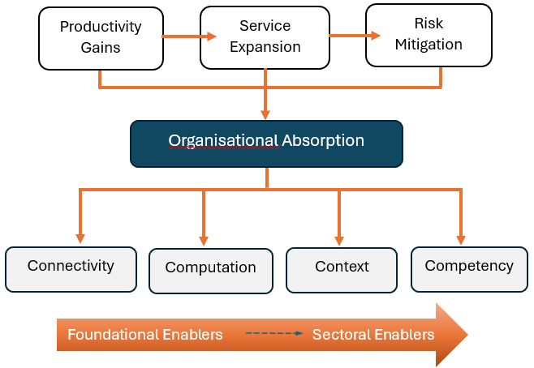
Source: Prepared by the researcher
Figure 6 illustrates how foundational capacities condition institutional absorption and sectoral AI deployment.
Conclusion
This study provides an analysis of AI adoption in India, based on a framework of constraints and enablers. The study finds that AI is not an automatic driver of development; it is conditional. Foundational capacities, institutional absorption, and the sequencing of constraint resolution mediate the economic and social impacts of AI deployment. AI applications have the best outcome when supported by enabling digital infrastructure, accessible processing resources, contextually relevant data environments, and a competent workforce that can integrate algorithmic solutions in the workplace. However, if these conditions are weak and only partially fulfilled, AI adoption remains limited and dependent on exceptional institutional support.
The main contribution of the paper is a hierarchical perspective on AI-related constraints. It departs from conventional deployment metrics and focuses on the core of the system-building process and institutional capacity building. Systematic relaxation of driving constraints is necessary to broaden the scope for viable AI applications across various sectors. The evolution of AI as a general-purpose technology will depend on the economic and institutional setup rather than on AI technology itself. The economy’s foundational capabilities strongly determine the developmental outcomes of AI. Desired developmental outcomes cannot be achieved solely through application-specific interventions. It requires a comprehensive and coordinated effort. Development does not happen by chance; it happens when the conditions are conducive.
Artificial Intelligence should not be seen as a quick fix to development goals. AI is a complex tool that needs careful management. The future potential of AI in India cannot be realised through isolated technological interventions alone, but rather through coordinated, sustained investments in foundational capacity and institutional coherence. The adoption of this approach will create a more grounded understanding of AI-led development that prioritises sequencing, complementarity, and structural integrity rather than superficial misrepresentation of AI adoption.

COMPETING INTERESTS DISCLAIMER:
I declare that they have no known competing financial interests, non-financial interests, or personal relationships that could have appeared to influence the work reported in this paper.

Disclaimer (Artificial Intelligence)

I hereby declare that NO generative AI technologies such as Large Language Models (ChatGPT, COPILOT, etc.) and text-to-image generators have been used during the writing or editing of this manuscript.

References
Acemoglu, D., & Restrepo, P. (2020). The wrong kind of AI? Artificial Intelligence and the future of labor demand. Cambr J Reg Econ Soc, Cambr Pol Econ Soc, 13(1), 25–35. https://doi.org/10.1093/cjres/rsz022
Brynjolfsson, E. (2022). The Turing Trap: The Promise & Peril of Human-Like Artificial Intelligence. Daedalus, 151(2), 272–287. https://doi.org/10.1162/DAED_a_01915
Dehkharghanian, T., Bidgoli, A. A., Riasatian, A., Mazaheri, P., Campbell, C. J. V., Pantanowitz, L., Tizhoosh, H. R., & Rahnamayan, S. (2023). Biased data, biased AI: deep networks predict the acquisition site of TCGA images. Diagnostic Pathology, 18(1). https://doi.org/10.1186/s13000-023-01355-3
Food and Agriculture Organization of the United Nations. (2024). FAOSTAT statistical database. https://www.fao.org/faostat/en/
Ganuthula, V. R. R., & Balaraman, K. K. (2025). Skill-Based Labour Market Polarization in the Age of AI: A Comparative Analysis of India and the United States [Preprint]. arXiv. https://arxiv.org/abs/2501.15809
Government of Gujarat. (2023). i-Khedut portal and digital agriculture initiatives. https://ikhedut.gujarat.gov.in/
Government of India. (2018). National strategy for artificial Intelligence: #AIForAll. NITI Aayog. https://www.niti.gov.in/sites/default/files/2019-01/NationalStrategy-for-AI-Discussion-Paper.pdf
Government of India. (2025). India AI Governance Guidelines. Press Information Bureau. https://static.pib.gov.in/WriteReadData/specificdocs/documents/2025/nov/doc2025115685601.pdf
Gray, M., & Suri, S. (2019). Ghost work: How to stop silicon valley from building a new global underclass. Houghton Mifflin Harcourt.
Hanna, M. G., Pantanowitz, L., Jackson, B., Palmer, O., Visweswaran, S., Pantanowitz, J., Deebajah, M., & Rashidi, H. H. (2025). Ethical and Bias Considerations in Artificial Intelligence/Machine Learning. Modern Pathology, 38(3), 100686. https://doi.org/10.1016/j.modpat.2024.100686
IndiaAI Mission. (2025). Report on AI Governance Guidelines Development. Government of India. https://indiaai.gov.in/article/report-on-ai-governance-guidelines-development
Indian Institute of Science. (2024). Aarogya Aarohan: AI-based oral cancer screening initiative. https://iisc.ac.in/
Indian Institute of Science. (2024). Translational Artificial Intelligence for Neuro-health and Urban Health (TANUH). https://iisc.ac.in/
International Labour Organization. (2018). Women and men in the informal economy: A statistical picture (3rd ed.). https://www.ilo.org/global/publications/books/WCMS_626831/lang--en/index.htm
Jha, K., Doshi, A., Patel, P., & Shah, M. (2019). A comprehensive review on automation in agriculture using artificial Intelligence. Artificial Intelligence in Agriculture, 2(1), 1–12. https://doi.org/10.1016/j.aiia.2019.05.004
Kumar, V. S. (2024). Artificial Intelligence in Economic Analysis: An Overview of Techniques, Applications and Challenges. Asian Journal of Economics, Finance and Management, 6(1), 388–396. https://doi.org/10.56557/ajefm/2024/v6i1246
Li, B. hu, Hou, B. cun, Yu, W. tao, Lu, X. bing, & Yang, C. wei. (2017). Applications of artificial Intelligence in intelligent manufacturing: a review. Frontiers of Information Technology and Electronic Engineering, 18(1), 86–96. https://doi.org/10.1631/FITEE.1601885
Maragno, G., Tangi, L., Gastaldi, L., & Benedetti, M. (2023). Exploring the factors, affordances and constraints outlining the implementation of Artificial Intelligence in public sector organizations. International Journal of Information Management, 73, 102686. https://doi.org/10.1016/j.ijinfomgt.2023.102686
McKinsey & Company. (2021). How a steel plant in India tapped the value of data and won global acclaim. https://www.mckinsey.com/industries/metals-and-mining/how-we-help-clients/how-a-steel-plant-in-india-tapped-the-value-of-data-and-won-global-acclaim
NITI Aayog. (2018). National strategy for artificial Intelligence: #AIForAll. Government of India. https://www.niti.gov.in/sites/default/files/2019-01/NationalStrategy-for-AI-Discussion-Paper.pdf
NITI Aayog. (2025). AI for Viksit Bharat: The opportunity for accelerated economic growth. Government of India. https://niti.gov.in/
Pilz, K. F., Heim, L., & Brown, N. (2025). Increased Compute Efficiency and the Diffusion of AI Capabilities. Proceedings of the AAAI Conference on Artificial Intelligence, 39(26), 27582–27590. https://doi.org/10.1609/aaai.v39i26.34971
Shabbir, J., & Anwer, T. (2018). Artificial Intelligence and its Role in Near Future. http://arxiv.org/abs/1804.01396
World Bank. (2024). World development indicators. World Bank Group. https://data.worldbank.org/
World Bank. (2025). Digital progress and trends report 2025: Strengthening AI foundations. World Bank Group. https://www.worldbank.org/en/publication/dptr2025-ai-foundations
World Economic Forum. (2019). Global Lighthouse Network: Scaling intelligent manufacturing. https://www.weforum.org/reports/global-lighthouse-network-scaling-intelligent-manufacturing/

