Original Research Article
Elimination of crystal violet from aqueous solution by adsorption of the bone of beef of the species Gudali (Bos Indicus) Adamawa

Abstract: Activated Carbon derived from the bones of Bos Indicus Gudali (ACB) is introduced in this study as a novel and environmentally friendly option for the adsorption of Crystal Violet dye (CV) from water. Various characterization techniques, including semiquantitative X-ray analysis, X-ray diffraction, Scanning Electron Microscopy (SEM), Fourier-Transform Infrared Spectroscopy (ATR–FTIR), and Point of Zero Charge (pHPZC), were employed to analyze the bone pyrolysis process. The study investigated how various factors such as the mass of the adsorbent, the initial pH of the solution, contact time, initial dye concentration, and temperature influence the batch adsorption process. Kinetic data were examined using several models including Intra-particle diffusion, Elovich, Pseudo-first-order, and Pseudo-second-order. The findings indicated that the Pseudo-second-order model accurately captured the kinetics of CV adsorption onto ACB. For the isothermal data analysis, the Langmuir, Freundlich, Temkin, and Dubinin-Radushkevich models were employed. The equilibrium data for CV adsorption onto ACB fit the Langmuir isotherm model most effectively, revealing a maximum adsorption capacity of 17.331 mg g−1 at 303 K. Moreover, the Dubinin-Radushkevich model suggested that the nature of the adsorption was physical. The thermodynamic analysis confirmed that the adsorption process was physical, spontaneous, and exothermic.
Keywords: Adsorption, Bones, Crystal Violet, Isotherm, Kinetic, Thermodynamic.

1. Introduction
Nowadays, water is at the center of human life, population growth and industrial activities are increasing pressure on its reserves on a planetary scale. Releases from industries are among the effluents causing enormous harm to human health, particularly the various dyes which are used in excess in these industries. As a result, the waste water is highly concentrated in dye. The low biodegradability of dyes makes their treatment difficult to achieve thus constituting a source of pollution of the environment. Different types of synthetic dyes appear in wastewater effluents from various industries, for example: textiles, printing, leather, laundry, tannery, rubber painting processes (Brahimi et al., 2015; Sharma and Bhattacharya, 2017; Akartasse et al., 2017; Khan et al., 2020; Fathi et al., 2021; Mishra et al.,2023). The latter are known for their toxicity and their release into the environment is a source of pollution since their existence even in low concentrations is clearly visible especially by the coloring of surface waters which can affect aquatic ecosystem activities by reducing light penetration.
In view of the many environmental problems that have a direct impact on the health of living beings, scientists have developed several techniques for eliminating dyes, including: filtration , oxidation, coagulation-flocculation, precipitation chemical , ion exchange, catalysis, photo catalysis, electrochemical (Akbari et al., 2002; Laasri et al., 2007; Fernandes et al., 2004; Erdem et al., 2004; Rojas-Mayorga et al.,2015; Domga et al., 2015b; Domga et al., 2017; Nidheesh et al., 2018; Le et al., 2020 ; Lee et al., 2011; Kali et al., 2022a, 2022b; 2022c; Abd El-Monaem et al., 2023; Eltaweil et al., 2023a ;Domga et al., 2025b) and adsorption ( Ravikumar et al., 2007; Béné et al., 2016; Tcheka et al., 2018; Arbam et al.,2019; Abia et al.,2019a; Abia et al.,2019b; Adjia et al.,2019; El Hammari et al., 2023, Tabaght et al., 2023, Aaddouz et al., 2023, Domga, 2025a).
In this research, adsorption was chosen because of its ease of implementation, cost, and effectiveness. With a view to protecting the environment, the use of available materials as potential adsorbents has been the subject of several studies by researchers. (El-Geundi et al., 1997; Boukhlifi and Bencheikh, 2000; Annadurai et al., 2002; Mall et al., 2005; Hammou et al., 2014; Varghese et al., 2019; Leivisk¨a et al., 2019; Sheibani et al., 2021; Mohamed et al., 2024). Activated carbon was selected as the material of choice, and various sources of it have been investigated. These include materials like peat, banana peel, orange peel, eucalyptus bark, citrus waste biomass, rice husk, barley husk, Citrus sinensis bagasse, and gasse pith. Numerous studies have examined these waste materials for their potential applications, including research by Ho et al. (1998), Morais et al. (1999), Chen et al. (2001), Annadurai et al. (2002), Sivaraj et al. (2001), Safa and Bhatti (2011), Haq et al. (2011), Bhatti et al. (2012), and Asgher and Bhatti (2012). In this study, we focus on activated carbon derived from cattle bones for removing dyes from water.
Beef bones are produced in slaughterhouses as waste. They are mainly composed of collagen, minerals (such as calcium, phosphorus, and magnesium), and amino acids (such as glycine and proline), which are valuable waste products. Pyrolysis of beef bones produces a carbon-rich material while destroying organic matter and forming a product rich in minerals, mainly calcium and phosphorus. Animal-based activated carbon is booming due to its textural and structural properties and its non-toxicity, which allows for its use in various fields such as agriculture for the manufacture of plant fertilizers (Domga et al., 2018), veterinary medicine to treat digestive disorders and poisoning in animals, in construction materials for porcelain (Domga, 2025 , Asgari, G et al., 2025), and in the bleaching industry.
Research carried out on animal waste has shown satisfactory results during the elimination of Direct Red 75 and Direct Red 80, Basic Red 12, methylene blue, methyl orange, chromium (VI) (Mohammadine et al., 2013; Domga et al., 2015a; Domga et al., 2016; Domga et al., 2018; Domga et al., 2022a; Domga et al., 2022b, Domga, 2025). No research has been carried out on the effectiveness of animal activated carbon in removing crystal violet. This dye finds its application in the textile industry as well as in the manufacturing of paints and printing inks, as noted by Mittal et al. (2010) and Senthilkumaar et al. (2006). Notably, it is carcinogenic and poses significant management challenges due to its resistance to microbial breakdown and its tendency to persist across various environments (Chakraborty et al., 2011). Additionally, crystal violet is toxic to mammalian cells (Franco et al., 2020).
The present study is part of this perspective and has as general objective the use of materials from particular animal waste, the bones of beef of the Gudali species (Bos indicus) in the Adamawa region of Cameroon (Figure 1) in order to eliminate a cationic dye, crystal violet, by adsorption. Phosphoric acid is used as chemical activating agent to improve adsorbent properties. The study examined the influence of various parameters, including the amount of adsorbent, dye concentration, contact time, pH, temperature, kinetics, equilibrium, and thermodynamics. Additionally, the textural and structural properties were analyzed.
Developing countries like Cameroon, and more specifically its northern regions (Adamawa, Garoua, and Maroua), face challenges in utilizing waste from artisanal slaughterhouses (beef bones). This work focuses on valorizing enormous quantities of animal biomass (beef bones of the Gudali breed) found in artisanal slaughterhouses in the city of Ngaoundere (Adamawa, Cameroon) in order to eliminate the harmful effects of visual pollution and foul odors through an environmentally friendly, cost-effective, and sustainable technique (the production of activated charcoal from Gudali beef bones).

 | 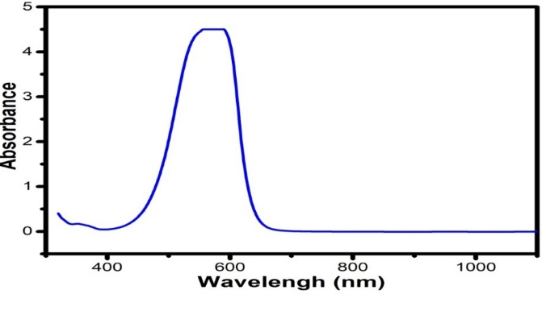
Figure 3. Crystal Violet molecule | Figure 4. Absorption spectrum of CV.

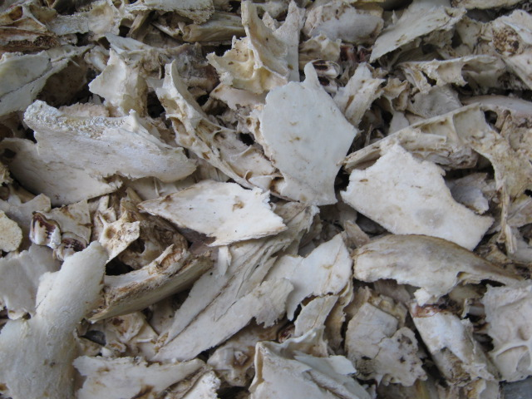 | 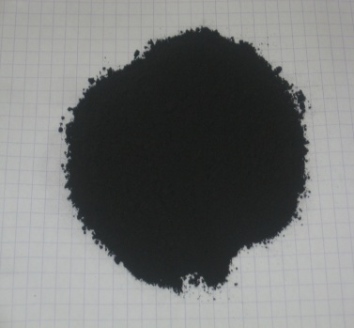
Figure 1. Beef bones | Figure 2. Activated Carbon Prepared from Bos Indicus Gudali Bones (ACB)

2. Materials and methods
2.1. Materials
Zebu (Gudali) cattle bones were first degreased, thoroughly washed with distilled water, and subsequently dried in an oven at 110 °C for 24 hours. A total of 200 g of dried bones was then milled and sieved to particle sizes ranging from 0.2 to 5 mm over an 18-hour period. The resulting bone powder was impregnated with an 85% phosphoric acid (H₃PO₄) solution, followed by washing with hot distilled water until a neutral pH was achieved. The treated sample was dried at 110 °C for 24 hours and subsequently pyrolysed at 500 °C for 2 hours. Pyrolysis was performed in a Heraeus MR model 260E muffle furnace with a heating rate of 5 °C min⁻¹.
2.2. Characterization of Adsorbent Materials
Infrared (IR) spectra of the sample were recorded using a FT/IR-4100 spectrophotometer (JASCO Benelux BV) with KBr pellet preparation. Scanning electron microscopy (SEM) images were obtained using a TESCAN VEGA II instrument to characterise the ACB material. Mineral composition was determined via a semiquantitative X-ray powder diffraction (XRD) analysis. XRD measurements were conducted on powdered samples using a Siemens Bruker D8 Advance diffractometer equipped with a Co–Kα anticathode (λ = 1.7903 Å). Diffractograms were collected over a 2θ range of 5°–64°, under analytical conditions of 40 mA and 20 kV, with a step size of 0.02°. Interplanar spacings (d-spacing, dhkl) corresponding to the observed diffraction peaks were calculated using Bragg’s law, and crystalline phases were identified with reference to the Joint Committee on Powder Diffraction Standards (JCPDS) files.
2.3. Adsorption Experiments
2.3.1. Analytical Methods
Crystal Violet was a commercial grade (MF: C₂₅H₃₀N₃Cl, MW: 408) and it was used without further purification (Figure 3). A stock solution of Crystal Violet was prepared by dissolving 1 g of the CV powder in 1000 mL of distilled water. For the adsorption experiments, the stock solution was diluted to achieve the desired concentration range of 10–60 mg·L⁻¹. Initial solution pH was adjusted to desired value by adding either a solution of 0.1M HCl, or a solution of 0.1M NaOH drop wise.

2.3.2 Determination of CV Concentration
UV-visible spectrum of CV absorption was obtained by a spectral scan from 300 to 1100 nm, of a 10 ppm solution (Figure 4). This spectrum shows that the maximum wavelength absorption peak, λmax is: 586 nm. Concentrations of CV solution were obtained by measuring the absorbance at 586 nm using a “Pharo 100” spectrophotometer.
2.3.3. Equilibrium Adsorption Studies
Adsorption experiments were conducted at room temperature using a 250 mL conical flask. In each trial, an adsorbent dose ranging from 0.2 to 0.6 g was measured and placed into reactors containing 50 mL of CV solution with concentrations varying between 10 and 60 ppm. The pH levels were adjusted incrementally from 3 to 11. The mixture was stirred with a magnetic stirrer for a time interval ranging between 10 to 60 minutes. The suspension was filtered and the residual concentration was determined by UV-visible spectrophotometry. All experiments were conducted at the initial solution pH (11). Pseudo-first-order, pseudo-second-order, intra-particle diffusion, and Elovich models were used to analyze the kinetic mechanisms underlying adsorption. Additionally, the Langmuir, Freundlich, and Temkin isotherm models were utilized to characterize the adsorption process. The adsorption capacity, expressed as the amount of dye adsorbed per gram of adsorbent (mg g⁻¹), and adsorption efficiency, (%) was obtained using the following equations:
$q_{t(e)}=\frac{{(C}_{i}-C_{t}) . V}{m}$ (Eq.1)
Where C_{i} is the initial dye concentration (mg L⁻¹), C_{e} and C_{t} are the equilibrium e and time t dye concentrations respectively (mg L⁻¹), V is the volume of CV solution (L), and m is the adsorbent quantity (g).
3. Results and Discussion
3.1. Adsorbents Characterization
A semi-quantitative X-ray powder diffraction method was used to determine elemental analysis of ACB the composition shows a high yield of calcium (49.73%) and phosphorus (43.21 %), resulting in a calcium-to-phosphorus (Ca/P) ratio of 1.15. Additionally, trace amounts of silicon (3.82%), magnesium (1.31 %), sodium (0.77 %), aluminum (0.32 %), iron (0.26 %), chlorine (0.26 %), sulfur (0.15 %), potassium (0.07 %), strontium (0.03 %), copper (0.05 %), and zinc (0.02 %) are present. Among bone minerals, carbonates are the most abundant substances, with carbonate apatite being the predominant component depending on their crystal positioning. Studies have established that hydroxyapatite can be derived from natural bone, as highlighted by various researchers (Landi et al., 2003; Best et al., 2008; Tadic and Epple, 2004; Figueiredo et al., 2009).
3.1.1. XRD Analysis
The XRD analysis of the synthesized ACB, as shown in Figure 5, revealed that Ca₁₀(PO₄)₆(OH)₂ serves as the primary constituent of the ACB. The identified hydroxyapatite crystal structure was confirmed by XRD peaks observed at 25.9°, 29.0°, 3.8°, 32.1°, 32.9°, 34.1°, 39.9°, 46.7°, and 49.5°, which align perfectly with standard hydroxyapatite patterns. These results are consistent with previous studies by Moreno-Piraján et al. (2010), Rojas-Mayorgaa et al. (2013), and Patela et al. (2015). Furthermore, the findings support that the amorphous organic components were removed during calcination, corroborating earlier reports in the literature (Figueiredo et al., 2010).
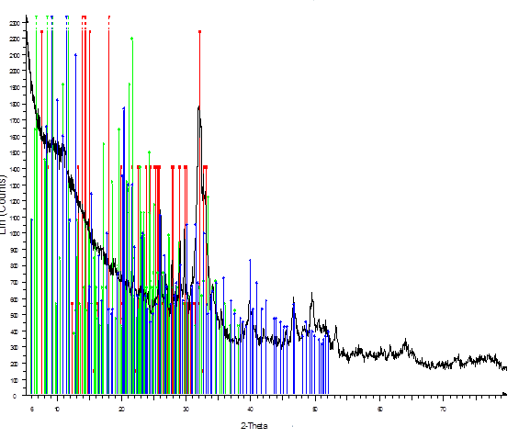
Figure 5. XRD of the synthesized ACB.
3.1.2. FTIR Analysis
Figure 6 (a,b) shows FTIR spectra of ACB, before and after CV adsorption respectively. The ACB sample showed strong bands at 1023, 872, 724, 599, and 558 cm⁻¹, corresponding to the stretching and bending modes of PO₄³⁻ groups, which are characteristic of the natural hydroxyapatite structure (Rehman and Bonfield, 1997; Paschalis et al., 1997; Mkukuma et al., 2004; Kagne et al., 2008; Asgari et al., 2014). Additionally, the peak observed between 1454–1943 cm⁻¹ is indicative of C꞊O, C꞊C, and C꞊N groups associated with the organic phase of the bone matrix. A broad peak within the 2011–3359 cm⁻¹ range corresponds to C-H and O-H stretching vibrations, respectively (Rojas-Mayorgaa et al., 2013). Furthermore, the peak in the 800–500 cm⁻¹ region is attributed to C-H and CH꞊CH₂ stretching vibrations typically present in aromatic structures (Hernández-Montoya et al., 2012). A reduction in the intensity of -OH bands at 3359 cm⁻¹ was noted, and the emergence of a new peak at 599 cm−1 is attributed to the presence of an alkyl halide band.

(a)
(b)
Figure 6. FTIR spectra of ACB before CV adsorption (a) and after CV adsorption (b)

3.1.3. Scanning Electron Microscopy
The impregnation of phosphoric acid on beef bones is beneficial. This effect will lead to the development of high surface areas and pore volumes in the resulting activated carbons. The SEM images are displayed in Figure 7 ACB. As seen, the surface of ACB has a porous structure with deep holes of different sizes as shown by the arrow in Fig. 5.
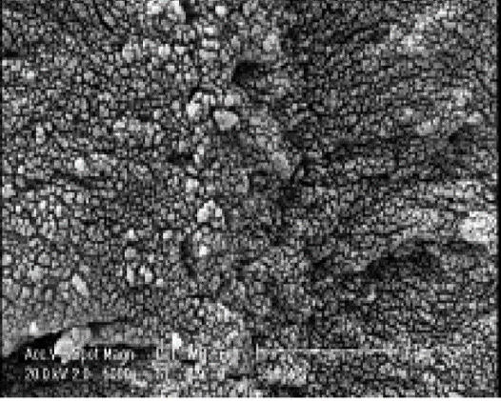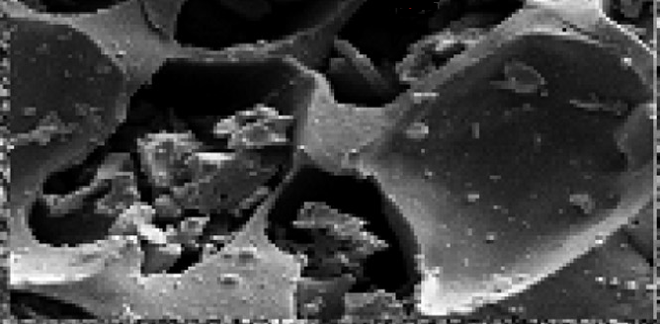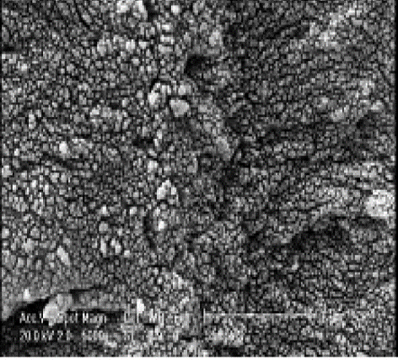
Figure 7. SEM images of ACB.

3.2. Crystal Violet Adsorption
3.2.1. Effect of contact time and mass adsorbent
Figure 8 shows the dependence of the of adsorption capacity with the contact time. From that curve which shows q_{t} versus t (min) for six ACB adsorbent samples with mass of 0.2, 0.3, 0.4, 0.5, and 0.6 g respectively. The effect of ACB amount on the CV adsorption was carried out by varying the mass from 0.2 to 0.6 g. Other parameters such as pH 11, initial dye concentration (10.0 mg L⁻¹) and stirring speed (100.0 rpm) were fixed. Figure 6 shows the q_{e} values (mg. g⁻¹) of CV corresponding to varying amounts of ACB. As the ACB mass increases from 0.2 g to 0.6 g, the q_{e} value (mg. g⁻¹) declines from 9.97 to 2.44 mg. g⁻¹. This phenomenon can be attributed to the binding of vacancies at active sites, as noted by Pavan et al. (2014). The reduction in adsorbent capacity might stem from particle aggregation, which occurs due to a higher mass of the adsorbent. This aggregation could reduce the overall number of active sites available on the adsorbent's surface while simultaneously increasing the diffusional path length (Safa et al., 2011; Domga et al., 2015; Domga et al., 2016; Domga et al., 2018; Domga et al., 2022a; Domga et al., 2022b). Figure 8 shows that at 0.2 g of ACB adsorbent, q_{e} was 9.97 mg.g⁻¹, respectively. Thus, 0.2 g was chosen as optimum mass value for the subsequent adsorption experiments.

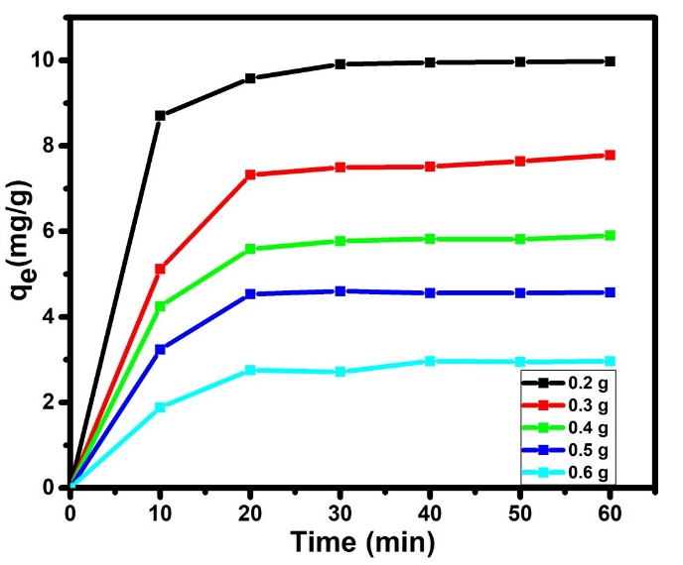 | 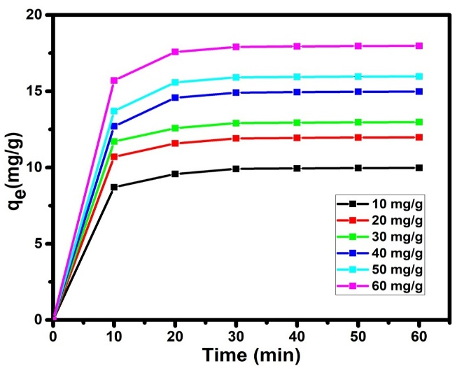
Figure 8. Effect of mass adsorbent on CV adsorption. | Figure 9. Effect of initial dye concentration.

3.2.2. Effects of contact time and initial dye concentration
Figure 9 illustrates the effect of the initial dye concentration. It can be observed that the amount of CV adsorbed on ACB increases during the initial phase. However, after a certain period, when the adsorption of CV molecules reaches its maximum, the process stabilizes, resulting in a plateau. The adsorption of crystal violet (CV) onto the ACB adsorbent proceeds in three distinct stages. During the initial 10 min, the adsorption rate is rapid, followed by a slower increase up to 20 min, and ultimately reaching equilibrium after 30 min. The rapid initial phase can be attributed to the large surface area and abundance of active sites on the ACB, which readily interact with dye molecules in solution, thereby enhancing the adsorption rate (Pavan et al., 2014). Beyond 30 min, the adsorption rate remains essentially constant, reflecting the gradual saturation of active sites on the ACB surface responsible for CV adsorption (Gupta et al., 2012). Consequently, an equilibrium time of 30 min was selected for CV adsorption studies. From Figure 9, it is also possible to observe that the adsorption capacity was increased from 8.681 to 17.331 mg g⁻¹ when the CV concentration increased from 10.0 to 60.0 mg L⁻¹. This result is attributed to the driving force that surpasses the mass transfer resistance (Pavan et al., 2014; Domga et al., 2015; Domga et al., 2016; Domga et al., 2018; Domga et al., 2022a; Domga et al., 2022b). q_{e}, increases rapidly when the initial concentration of CV C₀ steadily with increasing initial concentration. This is probably because when the CV concentration increases, the driving force of diffusion increases due to the higher concentration gradient (Domga et al., 2015; Domga et al., 2016; Domga et al., 2018).

3.2.3. pH at Zero Point Charge
The pH of the solution is an important critical role in adsorption studies as it can impact the properties of both the adsorbent and the adsorbate, along with the adsorption mechanism itself. To examine this, the influence of solution pH on the adsorption of CV using activated animal carbon was investigated at a concentration of 10 mg/L, with 0.2 g of activated carbon, across a pH range of 2 to 12. Figure 10 shows the variations of the amount adsorbed versus medium pH. The pH at the Zero Point of Charge (pHZPC) is a crucial parameter that determines whether the surface of an adsorbent tends to acquire a negative or positive charge (Asgari et al., 2014; Yao et al., 2016; Asgari et al., 2017).
 | 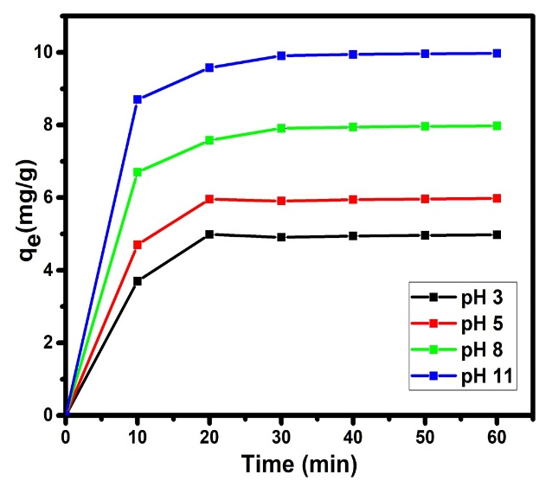
Figure 10. pH at Zero Point Charge | Figure 11. Effect of pH

3.2.4. Effects of contact time and pH solution on CV adsorption
The influence of pH solution of CV adsorption is shown in Figure 11. On that figure, it is possible to observe that pH solution affected the efficiency of CV adsorption. The CV qe increased from 5.216 to 9.875 mg/g when pH increased from 3 to 11 values. These behaviors can be explained considering both the chemical formula of the CV and Zero Point Charge (pH_{ZPC}) of ACB adsorbent. In fact, CV is a cationic dye (Figure 3) and the pH_{zpc} of ACB obtained was 6.84 (Figure 10) and Figure 12 proposed mechanism for adsorption of CV on the surface Bos Indicus Gudali bones adsorbent.
As illustrated in Figure 8, the pHzpc value of ACB was determined to be 6.84. This indicates that the surface of ACB carries a negative charge in solutions with a pH above 6.84 and a positive charge in solutions with a pH below this value. An analysis of the final pH demonstrated that ACB exhibits remarkable buffering capabilities. These properties can be attributed to its primary component, calcium hydroxyapatite (CaHa). It has been noted that acidic and basic solutions (within the pH range of 3–11) are buffered through reactions occurring at the reactive surface sites of CaHa, consistent with the equations presented below:
$≡{PO}^{-}+H^{+}↔≡{POH}^{0}$ (Eq.2)

$≡{CaOH}_{2}^{+}↔≡{CaOH}^{0}+H^{+}$ (Eq.3)
When the initial pH is below pHzpc, the final pH tends to increase due to the consumption of H⁺ ions through surface protonation of ≡PO⁻ and ≡CaOH⁰ groups. In acidic conditions, the surface charge of CaHa is predominantly influenced by positively charged ≡CaOH²⁺ and neutral ≡POH⁰ sites. Conversely, at a higher initial pH (above pHzpc), the final pH decreases as hydroxyl radicals are utilized during the deprotonation of ≡CaOH²⁺ and ≡POH⁰ sites. This behavior is documented by Srivastava et al. (2014) and Asgari et al. (2014). Under acidic conditions, lower adsorption of CV ions occurs due to the formation of ≡CaOH²⁺ and the competition between excessive H⁺ ions in the solution and CV molecules, as noted by Asgari et al. (2014). The maximum adsorption efficiency of CV under alkaline conditions can likely be attributed to its interaction with hydroxyl radicals.
The association of CV and ACB can be described as below:
When pH is below pH_{PZC},
$Ca_{5}(PO_{4})_{3}OH +H^{+}⇄\left[Ca_{5}(PO_{4})_{3}\right]OH_{2}^{+}$ (Eq.4)
The rest of$Ca_{5}(PO_{4})_{3}OH$ works with CV by hydrogen bond,
$Ca_{5}(PO_{4})_{3}OH+{\left[C_{25}H_{30}N_{3}\right]}^{+}$ ⇄$Ca_{5}(PO_{4})_{3}OH⋯{\left[C_{25}H_{30}N_{3}\right]}^{+}$ (Eq.5)
When pH is above pH_{PZC},
$Ca_{5}(PO_{4})_{3}OH+{OH}^{-}⇄{\left[Ca_{5}(PO_{4})_{3}O\right]}^{-}$ $+H_{2}O$ (Eq.6)
This part of${\left[Ca_{5}(PO_{4})_{3}O\right]}^{-}$ works with CV by electrostatic attraction,
${\left[Ca_{5}(PO_{4})_{3}O\right]}^{-}+{\left[C_{25}H_{30}N_{3}\right]}^{+}⇄{\left[Ca_{5}(PO_{4})_{3}O\right]}^{-}-{\left[C_{25}H_{30}N_{3}\right]}^{+}$ (Eq.7)
The rest of$Ca_{5}(PO_{4})_{3}OH$ works with CV by hydrogen bond
$Ca_{5}(PO_{4})_{3}OH+{\left[C_{25}H_{30}N_{3}\right]}^{+}$ ⇄$Ca_{5}(PO_{4})_{3}OH⋯{\left[C_{25}H_{30}N_{3}\right]}^{+}$ (Eq.8)

Figure 12: Proposed mechanism for adsorption of CV on the surface Bos Indicus Gudali bones adsorbent.
3.3. Influence of contact time on CV adsorption by ACB and Kinetic modeling
The impact of reaction time on the adsorption of CV onto ACB was examined using real groundwater samples, with the findings highlighting the role of contact time. As illustrated in Figure 8, the adsorption process of CV onto ACB occurs in three distinct stages. Upon further increase of contact time, adsorption process eventually reaches equilibrium, resulting in the removal efficiency remaining nearly constant. In designing an adsorption system, kinetic data is arguably one of the most critical factors for determining the adsorption rate. Therefore, at this stage of the study, the kinetics of CV removal using ACB were evaluated through various models, including the pseudo-first-order, pseudo-second-order, intra-particle diffusion, and Elovich models (Leyva-Ramos et al., 2013; Ghasemi et al., 2018).

Table 1. Non-linear and linearized isotherm model equations.
Isotherm model | Non-linear equation | Linearized equation | Plot | Eqs
Pseudo-first order model | $$\frac{{dq}_{t}}{dt}=k_{1}(q_{e}-q_{t})$$ | $$log\left(q_{e}-q_{t}\right)=logq_{e}-\frac{t}{2,303}K_{1}$$ | $$\log\left(q_{e}-q_{t}\right)vs.t$$ | (Eq.9)
Pseudo-second order model | $$\frac{{dq}_{t}}{dt}=k_{2}(q_{e}-q_{t})^{2}$$ | $$\frac{t}{q_{t}}=\frac{1}{k_{2}q_{e}^{2}}+\frac{t}{q_{e}}$$ | $$\frac{t}{q_{t}}vs.t$$ | (Eq.10)
Intra-particle | $$q_{t}=k_{int}t^{0,5}+X_{i}$$ | $$q_{t}=k_{int}t^{0,5}+X_{i}$$ | $$q_{t }vs.t^{1/2}$$ | (Eq.11)
Elovich | $$q_{t}=\frac{1}{β}ln⁡(αβ)+\frac{1}{β}lnt$$ | $$q_{t}=\frac{1}{β}ln⁡(αβ)+\frac{1}{β}lnt$$ | $$q_{t} vs.lnt$$ | (Eq.12)

Where q_{t} and q_{e} represent the amount of dye adsorbed at equilibrium (mg g⁻¹) and at time t (min), and k₁ (min⁻¹) and k₂ (g mg⁻¹min⁻¹) are the pseudo-first-order and pseudo-second- order rate constants, respectively. The rate constants k₁, k₂, and the calculated q_{e} (cal) obtained from Eq (4) and (5) along with the experimental qe (exp) (Figure 4) and coefficients of determination R², are presented in Tables 1 and 2. C is the intercept indicating the thickness of the boundary layer (mg/g); α the initial adsorption rate (mg/g·min) and β representing the desorption constant (mg/g). The parameters obtained from the intra-particle diffusion model with different initial mass are displayed in Table 2. The pseudo-first-order, pseudo-second-order, intra-particle diffusion and Elovich models are listed in Table 1 and the linear plots of four models.
The results indicate that the pseudo-second-order model aligns more effectively with the experimental data, exhibiting a higher R² value compared to the pseudo-first-order model. As shown in the kinetic data in Table 2, the q_{e},calc value closely matched the q_{e},exp value, confirming a strong correlation between the experimental data and the pseudo-second-order model. These findings highlight that both CV and ACB significantly influenced the adsorption process under the specified conditions. Additionally, the excellent fit of CV adsorption onto ACB with the pseudo-second-order model suggests that the rate-limiting step in adsorption by the ACB adsorbent is physical adsorption. Furthermore, the formation of chemical bonds plays a crucial role in shaping the pseudo-second-order kinetics. A previous study also supported these conclusions, demonstrating that the pseudo-second-order model was the most accurate for describing CV adsorption onto ACB and various other adsorbents (Yao et al., 2016).
The process of contaminant uptake onto the adsorbent comprises several stages, each potentially influencing the adsorption rate. These adsorption mechanisms may include film diffusion, pore diffusion, and intraparticle diffusion, as highlighted by Tomar et al. (2013). The slowest diffusion mechanism, referred to as the rate-limiting step, determines the overall adsorption rate. To identify the rate-limiting step in CV adsorption onto ACB, the intraparticle diffusion (Eq. 5) and Elovich (Eq. 6) models were employed. These models are described through the equations presented below, based on the studies by Salifu et al. (2013) and Mohan et al. (2014).
The kinetic plot of qt versus t_{1/2} (intra-particle diffusion model) for the adsorption of CV onto ACB has been outlined. The data reveals multiple steps in the adsorption process, suggesting that various mechanisms, such as film diffusion and intra-particle diffusion, may be at play during the adsorption of CV onto ACB. The initial section of the plot suggests that surface diffusion (also referred to as boundary layer diffusion) likely restricted CV adsorption onto ACB at the start of the reaction. The subsequent region points to intra-particle or pore diffusion as the predominant adsorption-limiting mechanism. As indicated by the results, the positive intercept value (C) in the Weber and Morris model confirms that film diffusion occurred during the adsorption of CV onto ACB. Additionally, the qt vs. t^{0.5} plots, displayed in Table 2, do not pass through the origin, indicating that intra-particle diffusion was not the sole rate-limiting step. This observation further supports the conclusion that surface diffusion likely plays a significant role as the main rate-controlling mechanism in CV adsorption onto ACB. Additional insights from the Elovich model, also presented in Table 2, reinforce that during the initial stage of CV adsorption onto ACB, film diffusion served as the principal rate-controlling step. Furthermore, the parameter β for ACB, measured at 0.755 mg/g, suggests that the adsorbents may exhibit a high affinity for forming chemical interactions (Mohan et al., 2014; Petrović et al., 2016). Based on these findings, it can be inferred that diffusion through the liquid film surrounding ACB is the primary rate-limiting step during the adsorption of CV from the bulk solution onto ACB.
Table 2. Kinetic constants of the pseudo-first order, pseudo-second order, intraparticular and Elovich models for CV.
ACB | Pseudo-first order model |  |  | Pseudo-first  order model |  |  | Intra-particle |  |  | Elovich
Mass  (g) | $$q_{e}\left(cal\right)$$  (mg/g) | $$K_{1}$$  (1/min) | $$R^{2}$$ | $$q_{e}(cal)$$  (mg/g) | $$K_{2}$$  (g/mg/mi) | $$R^{2}$$ | $$K_{int}$$ | $$C$$ | $$R^{2}$$ | $$α$$ | $$β$$ | $$R^{2}$$
0.2 | 1.782 | 0.119 | 0.983 | 10.256 | 0.067 | 0.999 | 0.257 | 8.212 | 0.759 | 147.229 | 0.619 | 0.861
0.3 | 1.586 | 0.064 | 0.831 | 8.425 | 0.025 | 0.996 | 0.488 | 4.358 | 0.684 | 7.108 | 0.323 | 0.788
0.4 | 1.327 | 0.074 | 0.827 | 6.274 | 0.046 | 0.998 | 0.308 | 3.764 | 0.685 | 7.491 | 0.509 | 0.794
0.5 | 1.494 | 0.097 | 0.923 | 4.852 | 0.071 | 0.995 | 0.236 | 2.996 | 0.547 | 5.911 | 0.649 | 0.667
0.6 | 1.494 | 0.097 | 0.923 | 3.295 | 0.052 | 0.995 | 0.211 | 1.499 | 0.737 | 2.332 | 0.755 | 0.831

3.4. Isotherm and equilibrium adsorption study
The impact of ACB doses ranging from 10 to 60 g/L on CV adsorption was evaluated under the experimental conditions outlined in Table 3. As seen in Table 3, the amount of CV adsorbed onto ACB rose from 8.681 mg/g to 17.331 mg/g with increasing ACB doses. This rise in CV removal efficiency is likely due to the greater availability of active sites for adsorption as more ACB was introduced to interact with a constant amount of CV ions (Yao et al., 2016). These findings highlight the density of reactive groups present on the external surface of ACB, as the binding of CV improved proportionally with higher doses of ACB (Rojas-Mayorgaa et al., 2013).
Additionally, the data confirmed that the ACB produced through the pyrolysis process is an efficient adsorbent for removing CV from actual groundwater. The experimental results of CV adsorption onto the ACB were evaluated using the Langmuir, Freundlich, and Temkin isotherm models. The parameters and constants associated with these models are detailed in the nomenclature section.
Table 3. Non-linear and linearized isotherm model equations
Isotherm model | Non-linear equation | Linearized equation | Plot | Eqs
Langmuir | $$q_{e}=\frac{q_{max}K_{L}C_{e}}{1+K_{L}C_{e}}$$ | $$\frac{C_{e}}{q_{e}}=\frac{1}{K_{L}q_{max}}+\frac{C_{e}}{q_{max}}$$ | $$\frac{C_{e}}{q_{e}}{vs.C}_{e}$$ | (13)
Freundlich | $$q_{e}=k_{F}C_{e}^{1/{n_{F}}}$$ | $${lnq}_{e}=\frac{1}{n_{F}}{lnC}_{e}+{lnK}_{F}$$ | $${lnq}_{e}{vs.lnC}_{e}$$ | (14)
Temkin | $$q_{e}=\frac{RT}{b}\ln{(AC_{e}})$$ | $${lnq}_{e}=BlnA+BlnC_{e}$$ | $${lnq}_{e}vs.lnC_{e}$$ | (15)
Dubinin-Radushkevich | $$q_{e}=q_{D}e^{k_{ad}ε^{2}}$$ | $${lnq}_{e}={lnq}_{D}-K_{ad}ε^{2}$$ | $${lnq}_{D}vs.ε^{2}$$ | (16)

Where q_{max} is the maximum monolayer adsorption capacity of the adsorbent (mg g⁻¹), K_{L} is the Langmuir adsorption constant (L mg⁻¹) which is related to the free energy of adsorption, and Ce (mg L⁻¹) is the equilibrium dye concentration. K_{F} [mg g⁻¹(L mg⁻ ¹)^{1/n}] is Freundlich constant an indicator of the adsorption capacity of the adsorbent while n_{F} indicates favorability of the adsorption process (adsorption intensity) or surface heterogeneity where n_{F} value between 1 and 10 represents favorable adsorption. The Temkin isothermal model witch B = RT/b, $q_{e}$ (mg.g⁻¹) and Ce (mg.L⁻¹) are respectively the equilibrium adsorbed amount and the equilibrium concentration. In addition, T is the temperature (K), R is the gas constant (8.314 J.mol⁻¹.K⁻¹). The constant B is related to the heat of adsorption. q_{D} is the theoretical isotherm saturation capacity (mg g-1), K_{ad} (mol². J⁻²) and ε are D–R isotherm constants. ε can be determined using Eq.17.
$ε=RTln(1+\frac{1}{C_{e}})$ (Eq.17)
The mean free energy of adsorption (E, kJ mol⁻¹) can be calculated by using Eq.18.
$E=\frac{1}{\sqrt{2K_{ad}}}$ (Eq.18)

Tabe 4. Plotted models, Fitted models and the Correlation coefficient (R²).

Models |  | Concentration (mol/L)
 |  | C=10 | C=20 | C=30 | C=40 | C=50 | C=60
Langmuir | $q_{m}$ $(mg/g)$ | 8.681 | 11.442 | 12.563 | 14.225 | 15.291 | 17.331
Langmuir | $K_{L}$ (L/mg) | 0.011 | 8.404 | 9.365 | 3.152 | 3.406 | 3.899
Langmuir | R² | 0.999 | 0.987 | 0.989 | 0.972 | 0.976 | 0.981
Freundlich | $K_{F}$ [mg/g(L/mg)^{1/n}] | 0.454 | 0.246 | 0.151 | 0.113 | 0.089 | 0.080
Freundlich | $${1/n}_{F}$$ | 0.032 | 0.763 | 1.432 | 1.897 | 2.377 | 2.570
Freundlich | R² | 0.827 | 0.999 | 0.999 | 0.999 | 0.999 | 0.999
Temkin | A | 6.865$×{10}^{-14}$ | 0.032 | 0.028 | 0.023 | 0.019 | 0.016
Temkin | B | -0.298 | -8.643 | -17.652 | -26.163 | -35.167 | -43.170
Temkin | R² | 0.836 | 0.999 | 0.999 | 0.999 | 0.999 | 0.999
Dubinin Raduskevich | $K_{ad}$ ${(mol}^{2}{.KJ}^{-2})$ | $5.$ ${10}^{-5}$ | $2.$ ${10}^{-5}$ | $2.$ ${10}^{-4}$ | $6.$ ${10}^{-4}$ | $1.5$ ${10}^{-4}$ | $2.3$ ${10}^{-4}$
Dubinin Raduskevich | $q_{D}$ $(mg/g)$ | 0.72256 | 0.479 | 0.547 | 1.152 | 0.496 | 0.597
Dubinin Raduskevich | E (KJ/mol) | 0.100 | 0.158 | 0.050 | 0.029 | 0.058 | 0.047
Dubinin Raduskevich | R² | 0.989 | 0.999 | 0.999 | 0.999 | 0.999 | 0.999

Table 4 presents the parameters of the fitted isotherms, along with the calculated and experimental adsorption capacities of the synthesized ACB in CV adsorption. The table highlights that CV adsorption onto the synthesized ACB aligns well with the Langmuir model, as evidenced by the highest correlation coefficient (R² = 0.95) across all concentrations when compared to other isotherms. This finding suggests that the adsorption of CV occurs on a homogeneous surface and forms a monolayer, consistent with the principles of the Langmuir isotherm for the given ACB surface. To further assess the suitability of the Langmuir model, the equilibrium constant R_{L} (R_{L} = 1 / (k_{L} C_{e})) was utilized, with its calculated values provided in Table 4. The adsorption process is interpreted based on RL values, where RL > 1 indicates unfavorable adsorption, RL = 1 denotes linear adsorption, 0 < RL < 1 signifies favorable adsorption, and RL = 0 represents an irreversible process (Asgari et al., 2014). The results demonstrated that RL values fell within the range of 0 to 1, indicating favorable adsorption behavior.
This experimental data is in agreement with many other available data (Rojas-Mayorgaa et al., 2013; Tomar et al., 2013; Mohan et al., 2014). However, as results indicated in Table 4 Freundlich isotherm model moreover, provided good correlations with the data under investigation. In the Freundlich model the value of 1/n is the adsorption intensity and as observed in Table 4, 1/n is given for different concentration values at under favorable conditions (0 $<$1/n$<$1) confirming the favorable conditions for adsorption of CV onto ACB (Asgari et al., 2014).
Additional points observed in Table 4 are that, the calculated adsorption capacity of ACB from the Langmuir model (q_{e,calc}) (17. 331 mg/g) matched well with the experimental adsorption capacity (q_{e,exp}) under selected conditions (Table 4), (17.458 mg/g), which confirms the suitability of the Langmuir model to explain the adsorption process on ACB. The maximum adsorption capacity of prepared ACB in this study was comparable with commercial ACB and ACB as made under different conditions used for CV removal, reported in the literature (Rojas-Mayorgaa et al., 2014; Rojas-Mayorga et al., 2015). Therefore, in this study, experimental maximum saturation adsorption capacity of ACB was studied. For this purpose, 0.2 g of the bone char was added to 250 mL of solution with 10mg/L of CV. The solution was equilibrated and experimented repetitively several times until a ACB was fully saturated. Lastly, a maximum saturation experimental adsorption capacity of bone char was calculated using Eq.7. q_{max,exp} for bone char was 17.945 mg/g. These results demonstrate the advantages or benefits of ACB for use in removing CV from water. However, this result shows that the q_{max,exp} values of ACB are significantly higher than that reported by Rojas-Mayorga et al. (2013). From this data, it can be suggested that CV was favorably adsorbed onto ACB and ACB is an appropriate adsorbent due to their high adsorption capacity and their easy attainability at low costs for the removal of CV from groundwater.

well with the experimental adsorption capacity (qe,exp) under selected conditions (Table 4), (17.458 mg/g), which confirms the suitability of the Langmuir model to explain the adsorption process on ACB. The maximum adsorption capacity of prepared ACB in this study was comparable with commercial ACB and ACB as made under different conditions used for CV removal, reported in the literature

3.5. Effect of temperature and thermodynamics of adsorption
Effect of temperature on CV removal efficiency by ACB under optimal conditions was evaluated. Results indicated that the adsorption efficiency, increased from 8.57 to 14.45 mg.g⁻¹ (Figure 13) as temperature increased from 303 to 343 K; it also validated the endothermic adsorption process. By increasing the temperature in aqueous solution, the mobility of CV across the external boundary layer and in the internal pores of the ACB particle increases and the changing forces on the diffusing CV decrease, and thereby, the adsorption capacity of adsorbent increases (Rojas-Mayorgaa et al., 2014; Asgari et al., 2014). The thermodynamic feasibility of the process in CV-ACB system was evaluated taking bases on the free energy change (ΔGº). The free energy of an adsorption reaction, enthalpy (ΔHº) and entropy (ΔSº) were calculated using Eq.19 - 22.
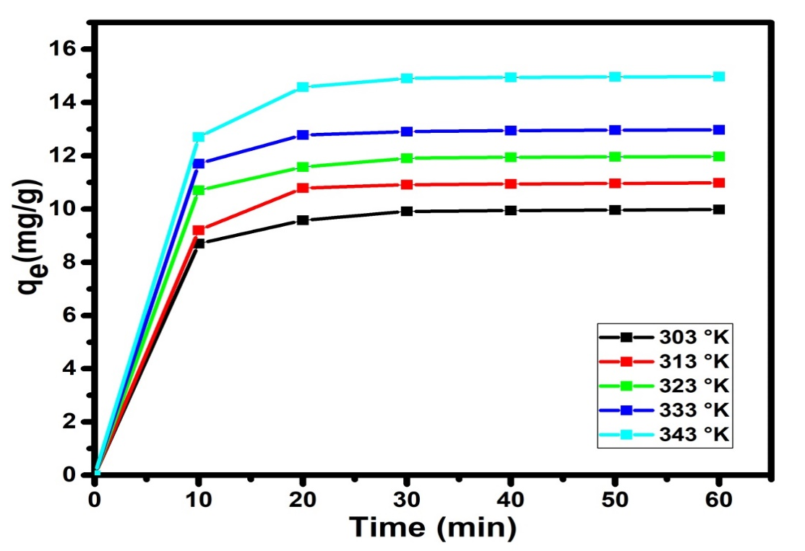
Figure 13: Effect of temperature adsorbent on CV adsorption.
3.6. Thermodynamic parameters
Important thermodynamic properties like Gibbs free standard energy ΔG° (Kj.mol⁻¹), standard enthalpy (ΔH°) (Kj.mol⁻¹)) and standard entropy (ΔS°) (Kj.mol⁻¹.K⁻¹) are calculated using the adsorbed relative amounts obtained at different temperatures.
The Gibbs free standard energy was evaluated by the equation below:
ΔG° = -$RTlnk_{d}$ (Eq.19)
The equilibrium constant $k_{d}$ was calculated using the ratio ΔS°:
$k_{d}=\frac{C_{0}-C_{e}}{C_{e}}$(Eq.20)
With $q_{e}$and $Ce$, the adsorbed amount (mg/g) and the equilibrium concentration of the metals in the solution (mg/L), respectively. The standard enthalpy (ΔH°) and entropy (ΔS°) values ​​were determined from the Van't Hoff equation:
$$Lnk_{d}=\frac{ΔS°}{R}-\frac{ΔH°}{RT} (Eq.21)$$ΔG° = ΔH° -TΔS° (Eq.22)
The representation of $lnk_{d}$ as a function of 1/T of the Van't Hoff equation is a line of slope ΔH°/R and intercept ΔS°/R, R is the universal gas constant (8.314 J/mol·K.).
The values ​​of (ΔH°) and (ΔS°) were deduced from the slope and the function $lnk_{d}$= f (1/T) gives the ordinate at the origin of the equation of the line. The thermodynamic data of the CV adsorption onto CAA are presented in Table 5. The values of ΔGº at 303, 313, 323, 333 and 343 K were calculated to be −21.134, −21.474, −21.805 and −22.145 KJ/mol, respectively, that confirmed that the adsorption of CV onto ACB was spontaneous and thermodynamically favorable. The standard Gibbs free energy change (ΔG°) decreases as the solution's temperature increases. This phenomenon occurs because adsorption becomes more favorable, signifying a strong driving force for the process. The values of ΔH° and ΔS° were determined to be -10.823 kJ/mol and 0.034 kJ/mol·K, respectively. The negative standard enthalpy (ΔH°) confirms that the adsorption of CV onto ACB is an exothermic reaction. Furthermore, analysis of the values of the standard enthalpy of adsorption (<40 kJ/mol) shows that it is a physisorption (Salifu et al., 2013). The positive value of (ΔS°) presents decreasing appearance at the solid/liquid interface during the adsorption CV were adsorbed by the adsorbent.
Table 5. Thermodynamic parameters of adsorption CV onto ACB
Dye | $$R^{2}$$ | ${∆H}^{0}$ (KJ/mol) | $${∆S}^{0}(KJ/mol.K)$$ | ${∆G}^{0}$(KJ/mol)
 |  |  |  | 293 K | 298 K | 303 K | 313 K
CV | 0.991 | -10.823 | 0.034 | -21.134 | -21.474 | -21.805 | -22.145

3.7. Comparison of adsorption capacity of Activated Carbon Prepared from Bos Indicus Gudali bones adsorbent with other available adsorbents.
To facilitate comparison, Table 6 highlights the adsorption capacities of different adsorbents. The results clearly indicate that Activated Carbon derived from Bos Indicus Gudali bones exhibits significantly higher efficiency in removing Crystal Violet dye from aqueous solutions compared to numerous previously documented adsorbents.

Table 6. Comparison of maximum adsorption capacities of various types of adsorbents
Adsorbents
  q_{m} (mg/g)
  References
Modified ball clay  Date stone activated carbon | 62.5 | Auta et Hameed.(2012
  12.02
  Alqaragully (2014)
Modified Mango Seeds | 69.07 | Mouthe et al. (2015)
Pozzolan | 0.576 | Moffo, 2016
Moroccan pyrophyllite | 13.88 | Miyah et al. (2016)
Zeolite a synthesized from coal fly ash |  | Jumaeri et al. (2017)
  10.672
  Coconut shell activated carbon
  46.53
  Aljeboree et al. (2017)
Modified Cameroonian local clay material | 114.54 | Tcheka et al. (2018)
Limon peel powders | 3.871 | Kagongbe et al. (2019)
Peanut husk | 20.95 | Sohail et al. (2021)
Calcium Carbonate from Chicken Eggshell Waste
  1.464
  Nandiyanto et al. (2024)
Naturel polysaccharide | - 10,80 | Mohamed et al. (2024)
Activated Carbon Bone | 17.331
  This work

This demonstrate the potential use of Activated Carbon derived from Bos Indicus Gudali Bones (ACB) (Picture 2) as an affordable and effective material for purifying wastewater contaminated with Crystal Violet dye.
4. Conclusion
The findings suggest that ACB is an innovative and cost-effective adsorbent material for removing CV from aqueous solutions. Kinetic studies revealed that dye adsorption on ACB adhered to pseudo-second-order kinetics across various dye concentrations. Equilibrium data analysis showed that CV adsorption aligned with the Langmuir isotherm model. Thermodynamic analysis demonstrated that the adsorption process of CV onto ACB was spontaneous, exothermic, and predominantly physical in nature. Carbonaceous materials are widely employed in both domestic and industrial applications, particularly for the adsorption of pollutants. Among these materials, activated carbon has long been used and continues to undergo development, driven in part by the increasing demand for high-quality water. Activated carbons are employed in water purification systems, the treatment of urban and industrial wastewater, and domestic water treatment. This study demonstrates that activated carbons are highly porous, complex materials that are effective in binding both organic and inorganic pollutants. Their most critical property is adsorption capacity, which, together with their excellent textural and physicochemical characteristics, underpins their extensive use as adsorbents, catalysts, and catalyst supports.
The performance of activated carbons is strongly influenced by the textural properties of the particles and their surface chemistry. Control over the material’s texture, particularly microporosity, is essential. Furthermore, a detailed understanding of the nature of active sites, including surface functional groups and molecular interactions, is crucial. Comprehensive characterisation and analytical techniques are therefore required to elucidate adsorption mechanisms, inform regeneration strategies, and guide the optimisation and development of new carbon materials.
Research focused on coal-based carbons for water treatment is likely, in the medium term, to produce materials tailored to address specific challenges, ensuring both operational efficiency and compliance with emerging regulatory standards. The advent of novel carbon forms, such as nanofibres and nanotubes, also promises significant future advancements. Recent studies on catalytic processes using carbon as a catalyst or catalyst support suggest that these approaches are efficient, cost-effective, and technically feasible at an industrial scale.

Conflict of Interest: The authors declare that there are no conflicts of interest.

Disclaimer (Artificial intelligence)

Author(s) hereby declare that NO generative AI technologies such as Large Language Models (ChatGPT, COPILOT, etc) and text-to-image generators have been used during writing or editing of manuscripts.

References
Aaddouz, M., Azzaoui K., Akartasse N., Mejdoubi E. (2023). Removal of methylene blue from aqueous solution by adsorption onto hydroxyapatite nanoparticles. Journal of Molecular Structure, 1288, 135807. https://doi.org/10.1016/j.molstruc.2023.135807.
Abd El-Monaem, E.M., Elshishini, H.M., Bakr, S.S., El-Aqapa, H.G., Hosny, M., Andaluri, G., El-Subruiti, G.M., Omer, A.M., Eltaweil, A.S. (2023). A comprehensive review on LDH-based catalysts to activate persulfates for the degradation of organic pollutants. NPJ Clean Water. https://doi.org/10.1038/s41545-023-00245-x.
Adjia, Zangué., H, Ebio, Nko’o., G, Noumi, Guy, B., Villiéras, F., Kamga, R,. Kagongbe, D., Domga, R. (2019). Design and application of sintered clay pellets for the removal of methylene blue. International Journal of Applied Research, 5(1), 92-99.
Akbari, A., Remigy, J.C., Aptel, P. (2002). Treatment of textile dye effluents using a polyamide-based nanofiltration membrane. Chemistry Engineering and Processing, 41, 601–609.
Annadurai, G., Juang, R.S., Lee, D.J. (2002). Use of cellulose-based wastes for adsorption of dyes from aqueous solutions. Journal of Hazardous Materials, 92, 263–274.
Arbam, T., Domga, R., Dangwang, D., Younai, Felix., Djonga, w., Kagongbe, D., Ebio, N., Noumi, G. (2019). Adsorption of Cr (VI) onto clay modified by sodium chloride and clay modified by aluminum hydroxide of Karewa (North Cameroon). International Research Journal of Advanced Engineering and Science, 4(1), 247-255.
Asgari, G., Feradmal, J., Poormohammadi, A., Sadrnourmohamadi, M., Akbari, S., Taguchi. (2017). Optimization for the removal of high concentrations of phenol from saline wastewater using electro-Fenton process. Desalination and Water Treatment, 57, 27331–27338.
Asgari, G., Seid, Mohammadi, A.M., Poor, mohammadi, A., Ahmadian, M. (2014). Removal of cyanide from aqueous solution by adsorption onto bone charcoal. Fresenius Environmental Bulletin, 23, 720–727.
Asgher, M., Bhatti, H.N. (2012). Evaluation of thermodynamics and effect of chemical treatments on sorption potential of citrus waste biomass for removal of anionic dyes from aqueous solutions. Ecological Engineering, 38, 79–85.
Auta, M.,Hameed B,H. (2012). Modified mesoporous clay adsorbent for adsorption isotherm and
kinetics of methylene blue. Chem. Eng. J; 198–199:219–227.
Béné, M., Domga, Dangwang, D., Domga, R ., Tchatchueng, B., Kobbe-Dama, N., Tatsimo, S.( 2016). Preparation of crosslinked polyacrylamide hydrogels and their application to the removal of Manganese (II) ions from aqueous solution. International Journal of Innovation Sciences and Research, 6, (6), 996-1002.
Best, S.M., Porter, A.E., Thian, E.S., Huang, J. (2008). Bioceramics Past, present and for the future. Journal of European Ceramic Society, 28, 1319–1327.
Bhatti, H.N., Akhtar, N., Saleem, N. (2012). Adsorptive removal of methylene blue by low cost Citrus sinensis bagasse: equilibrium, kinetic and thermodynamic characterization. Arabian Journal of Science and Engineering, 37, 9–18.
Boukhlifi, F., Bencheikh, A. (2000). Caracterisation des biosorbants naturels utilises pour la depollution des eaux usees. Ann. Chim. Sci. Mat. 25, 153–160. https://doi.org/ 10.1016/S0151-9107(00)88722-X.
Chakraborty, S., Chowdhury, S., das Saha, P. (2011). Adsorption of Crystal Violet from aqueous solution onto NaOH-modified rice husk. Carbohydr. Polym. 86 https://doi. rg/10.1016/j.carbpol.2011.06.058
Chen, B., Hui, C.W., McKay, G. (2001). Film-pore diffusion modelling and contact time optimization for the adsorption of dyestuffs on pith. Chemical Engineering Journal, 84, 77– 94.
Daouda, Abia., Yowe, Kidwe., Domga, Richard., Domga., Massai, Harouna. (2019). Adsorption of Cu²⁺ and Cr⁶⁺ in Aqueous Solution by a Thermally Modified Biosorbent Based on Cotton Cakes. American Journal of Physical Chemistry,8 (4), 2019, 66-74.
Daouda, Abia., Amana, Tokodne., Noumi, Guy., Domga, Richard., Domga. (2019). Adsorption of Rhodamine B onto Orange Peel Powder. American Journal of Chemistry, 9, (5), 142-149.
Domga, Richard., Massai, Harouna., Tcheka, Constant., Tchatchueng , J, B., Arbam, Tsafam., Domga., Kobbe-Dama, Nathalie., Dangwang, Dikdim. (2015a). Batch Equilibrium, Kinetic and Thermodynamic Studies on the Adsorption of Methylene Blue in Aqueous Solution onto Activated Carbon Prepared from Bos Indicus Gudali Bones. chemistry journal, 1(6), 172-181.
Domga R, Togue-Kamga F, Noubactep C, Tchatchueng JB. (2015b). Discussing porosity loss
of Fe⁰ packed water filters at ground level. Chemical Engineering Journal 263:127-134.
Domga, Richard., Tcheka, Constant., Mouthe, A, G, A., Kobbe-Dama, Nathalie., Domga., Tchatchueng, J, B., Alifa, Tchigo., Arbam, Tsafam. (2016). Batch equilibrium adsorption of methyl orange from aqueous solution using animal activated carbon from gudali bones. International Journal of Innovation Sciences and Research, 5 (7), 798-805.
Domga R, Togue-Kamga F, Tchatchueng JB (2017). Mathematic analysis of porosity loss in granular metallic iron (Fe⁰) water filter. International Journal of Emerging Engineering Research and Technology 5(11): 28-35.
Domga, Richard., Domga., Tchatchueng, J, B., Nyounai, Félix., Fadeune, G, S., Fabane, Fidèle., Béné, Mathieu., Assokeng, Thomas., Arbam, Tsafam., NÔN, B, E. (2018). Synthesis of animal activated carbon from gudali (bos inducus) bones and its adsorption for chromium (VI) in aqueous solution. International Journal of Engineering Research and Science and Techology, 7 (1) 1-15.
Domga Richard, Musongo Balike, Kom Blaise, Inna Samomssa, Heukwa-Tefoung Anne, Togue Kamga Fulbert, Tchatchueng Jean Bosco (2025). A new model for analysing porosity loss in metallic iron packed-beds for water treatment Journal of Material and Environmental Sustainability Research, 5(4):38-50.
Domga Richard (2025). Removal of the methylene blue using activated charcoal derived from the
pyrolisis of Gudali (Bos Indicus) bones Generis Publishing 56p.
EL-Geundi, M.S. (1997). Adsorbents for industrial pollution control. Adsorption Science and Technology,15, 777–787.
El Hammari, L., Hamed, R., Azzaoui, K., et al. (2023). Optimization of the adsorption of lead (II) by hydroxyapatite using a factorial design: Density functional theory and molecular dynamics. Frontiers in Environmental Science, 11, 112019. https://doi.org/10.3389/fenvs.2023.1112019.
Eltaweil, A.S., Bakr, S.S., Abd El-Monaem, E.M., El-Subruiti, G.M. (2023). Magnetic hierarchical flower-like Fe3O4@ZIF-67/CuNiMn-LDH catalyst with enhanced redox cycle for Fenton-like degradation of Congo red: optimization and mechanism. Environ. Sci. Pollut. Res. 30 https://doi.org/10.1007/s11356-023-27430-2.
Erdem, E., Karapinar, N., Donat, R. (2004). The removal of heavy metal cations by natural zeolites. J. Colloid Interface Sci. 280 https://doi.org/10.1016/j.jcis.2004.08.028.
Fathi, A., Boutaleb, N., Bahlaouan, B., Bennani, M., Lazar, S., and El Antri, S. (2021). Filamentous fungi and natural supports as a carrier in moving bed biofilm reactors for ecological treatment of halieutic industrial effluent. Desalination and water treatment, 237, 37-44.
Fernandes, A., Morao, A., Magrinho, M., Lopes, A., Goncalves, I. (2004). Electrochemical degradation of C. I. Acid Orange 7. Dyes and Pigments, 61, 287–296.
Figueiredo, M., Fernando, A., Martins, G., Freitas, J., Judas, F., Figueiredo, H. (2010). Effect of the calcination temperature on the composition and microstructure of hydroxyapatite derived from human and animal bone. Ceramic International, 36, 2383–2393.
Figueiredo, M., Henriques, J., Martins, G., Guerra, F., Judas, F., Figueiredo, H. (2009). Physicochemical characterization of biomaterials commonly used in dentistry as bone substitutes-comparison with human bone. Journal of Biomaterials Materials Research, 92B, 409–419.
Ghasemi, N., Ghasemi, M., Moazeni, S., Ghasemi, P., Alharbi, N.S., Gupta, V.K., Agarwal, S. Burakova, I.V., Tkachev, A.G. (2018). Zn (II) removal by amino-functionalized magnetic nanoparticles: kinetics, isotherm, and thermodynamic aspects of adsorption. Journal of Industrial and Engineering Chemistry, 62, 302–310.
Gupta, V, K., Pathania, D., Agarwal, S., Sharma, S. (2012). Decoloration of hazardous dye from water system using chemically modified Ficus carica adsorbent. Journal of Molecular Liquids, 174, 86–94.
Hammou, A., Moussout, H., Slimani, M.Y.S., Boukhlifi, F., Daou, I. (2014). Bentonite/chitosan biocomposite as an adsorbent for hexavalent chromium from aqueous solutions. J. Adv. Chem. 10, 2786–2795. https://doi.org/10.24297/jac.v10i6.883.
Haq, I., Bhatti, H.N., Asgher, M. (2011). Removal of solar red BA textile dye from aqueous solution by low cost barley husk: equilibrium, kinetic and thermodynamic study. Canadian Journal of Chemical Engineering, 89, 593–600.
Hernández-Montoya, V., Ramírez-Montoya, L.A., Bonilla-Petriciolet, A., Montes- Morán, M.A. (2012). Optimizing the removal of fluoride from water using new carbons obtained by modification of nut shell with a calcium solution from egg shell. Biochemical Engineering Journal, 62, 1–7.
Ho, Y.S., McKay, G. (1998). Sorption of dye from aqueous solution by peat. Chemical Engineering Journal, 70, 115–124.
Jumaeri., E Kusumastuti., S. J, Santosa., Sutarno. (2017). Adsorption of crystal violet dye using zeolite a synthesized from coal fly ash, IOP Conf. Ser.: Mater. Sci. Eng. 172 012028.
Kagne, S., Jagtap, S., Dhawade, P., Kamble, S.P., Devotta, S.. Rayalu, S.S. (2008). Hydrate cement: a promising adsorbent for the removal of fluoride from aqueous solution. Journal of Hazardous Materials, 154, 88–95.
Kagongbe D.,Adjia Zangue H., Inna S., Noumi Guy B., Villieras F., and Ebio Nko’o G.(2019). Removal of Violet Crystal from Aqueous Solution by Limon Peel Powders from Adamawa Region of Cameroon, International Journal of Engineering Research & Technology, Vol. 8,Issue 07.
Kali, A., Amar, A., Loulidi, I., Hadey, C., Jabri, M., Alrashdi, A.A., Lgaz, H., Sadoq, M., El-Kordy, A., Boukhlifi, F. (2022a). Efficient adsorption removal of an anionic azo dye by lignocellulosic waste material and sludge recycling into combustible briquettes. Colloids Interfaces 6. https://doi.org/10.3390/colloids6020022.
Kali, A., Amar, A., Loulidi, I., Jabri, M., Hadey, C., Lgaz, H., Alrashdi, A.A., Boukhlifi, F.(2022b). Characterization and adsorption capacity of four low-cost adsorbents based on coconut, almond, walnut, and peanut shells for copper removal. Biomass Convers. Biorefin. https://doi.org/10.1007/s13399-022-02564-4.
Kali, A., Dehmani, Y., Loulidi, I., Amar, A., Jabri, M., El-kord, A., Boukhlifi, F. (2022c). Study of the adsorption properties of an almond shell in the elimination of methylene blue in an aquatic. Moroccan J. Chem. 10, 509–522. https://doi.org/ 10.48317/IMIST.PRSM/morjchem-v10i3.33140.

Kannan, N., Sundaram, M.M. (2001). Kinetics and mechanism of removal of methylene blue by adsorption on various carbons-a comparative study, Dyes and Pigments, 51, 25–40.
Khan, S., Ali, S., Muhammad, S., Khan, B., Ali, A., Hesham, E. L., and Begum, S. (2020). Bacterial contamination in drinking water of urban Peshawar: a comparative study at the sources and user points of tube wells. Desalination and Water Treatment, 181, 221-227.
Laasri, L., Elamrani, M.K., Cherkaoui, O. (2007). Removal of two cationic dyes from a textile effluent by filtration-adsorption on wood sawdust. Environ. Sci. Pollut. Res. https://doi.org/10.1065/espr2006.08.331.
Landi, E., Celotti, G., Logroscino, G., Tampieri, A. (2003). Carbonated hydroxyl-apatite as bone substitute. Journal of European Ceramic Society, 23, 2931–2937.
Le, O.T.H., Tran, L.N., Doan, V.T., van Pham, Q., van Ngo, A., Nguyen, H.H. (2020). Mucilage extracted from dragon fruit peel (Hylocereus undatus) as flocculant for treatment of dye wastewater by coagulation and flocculation process. Int. J. Polym. Sci. https://doi.org/10.1155/2020/7468343.
Lee, Y.C., Kim, E.J., Yang, J.W., Shin, H.J. (2011). Removal of malachite green by adsorption and precipitation using aminopropyl functionalized magnesium phyllosilicate. J. Hazard. Mater. 192 https://doi.org/10.1016/j. jhazmat.2011.04.094.
Leyva-Ramos, R., Rivera-Utrilla, J., Medellin-Castillo, N, A., Sanchez-Polo, M. (2010). Kinetic modeling of fluoride adsorption from aqueous solution onto bone char. Chemical Engineering Journal, 158, 458–467.
Leivisk¨a, T., Leskel¨a, T., Tanskanen, J .(2019). Effect of alkali regeneration on pore characteristics and performance of ferric oxyhydroxide and akagan´eite sorbents. J. Water Process Eng. 31 https://doi.org/10.1016/j.jwpe.2019.100838.
Mahmoodi, N.M., Arami, M. (2006). Bulk phase degradation of Acid Red 14 by nanophotocatalysis using immobilized titanium (IV) oxide nanoparticles. Journal of Photochemistry and Photobiology A. Chemistry, 182, 60–66.
Mall, I.D., Srivastava, V.C., Agarwal, N.K., Mishra, I.M. (2005). Removal of congo red from aqueous solution by bagasse fly ash and activated carbon: kinetic study and equilibrium isotherm analyses, Chemosphere, 61, 492–501.
Meshko, V., Markovska, L., Mincheva, M., Rodrigues, A.E. (2001). Adsorption of basic dyes on granular activated carbon and natural zeolite. Water Research, 35, 3357–3366.
Mishra R. K., Mentha S. S., Misra Y., Dwivedi N. (2023) Emerging pollutants of severe environmental concern in water and wastewater: A comprehensive review on current developments and future research, Water-Energy Nexus, 6, 74-95, https://doi.org/10.1016/j.wen.2023.08.002.
Mittal, A., Mittal, J., Malviya, A., Kaur, D., Gupta, V.K. (2010). Adsorption of hazardous dye crystal violet from wastewater by waste materials. J. Colloid Interface Sci. 343 https://doi.org/10.1016/j.jcis.2009.11.060.
Miyah, Y., Anissa Lahrichi., Meryem Idrissi., Saı¨d Boujraf., Hasnae Taouda ., Farid Zerrouq . (2016).
Assessment of adsorption kinetics for removal potential of Crystal Violet dye from aqueous
solutions using Moroccan pyrophyllite. Journal of the Association of Arab Universities for
Basic and Applied Sciences, http://dx.doi.org/10.1016/j.jaubas.2016.06.001.
Mkukuma, L.D., Skakle, J.M.S., Gibson, I.R., Imrie, C.T., Aspden, R.M., Hukins, D.W.L. (2004). Effect of the proportion of organic material in bone on thermal decomposition of bone mineral: an investigation of a variety of bones from different species using thermogravimetric analysis coupled to mass spectrometry, high temperature X-ray diffraction, and Fourier transform infrared spectroscopy. Calcified Tissue International, 75, 321–328.
Moffo Fosso. (2016). Etude de l’adsorption des colorants par la pouzzolane en milieu aqueux : cas du
cristal violet, Mémoire présenté en vue de l’obtention du diplôme de professeur de
l’enseignement secondaire deuxième grade, Université de Yaoundé I, 53p.
Mohamed, Sadoq., Hafssa, Atlas., Smail, Imame., Abderahim, Kali., Abdelouahed, Amar., Ilyasse,
Loulidi., Maria, Jabri., Badr-Edine, Sadoq., Mbarka, Ouchabi., Palsan, Sannasi. Abdullah.,
Fatima, Boukhlifi. (2024). Elimination of crystal violet from aqueous solution by adsorption
on naturel polysaccharide: Kinetic, isotherm, thermodynamic studies and mechanism
analysis, Arabian Journal of Chemistry, 17,105453.
Mohammadine, E, H., Rachid, S., Rachid, M., Saïd, ElAntri., Saïd, Lazar. (2013). Removal of two textile dyes from aqueous solutions onto calcined bones. Journal of the Association of Arab Universities for Basic and Applied Sciences, 14(1), 51-59, DOI: 10.1016/ j.jaubas.2013.03.002.
Mohan, D., Kumar, S., Srivastava, A. (2014). Fluoride removal from ground water using magnetic and nonmagnetic corn stover biochars. Journal of Ecological Engineering, 73, 798–806.
Morais, L.C., Freitas, O.M., Goncalves, E.P., Vasconcelos, L.T., Gonzaa Lez Bec, C.G. (1999). Reactive dyes removal from wastewaters by adsorption on eucalyptus bark: variables that define the process. Water Research, 33, 979–988.
Moreno-Piraján J.C, Gómez-Cruz R., García-Cuello V.S., Giraldo L. (2010). Binary system Cu(II)/Pb(II) adsorption on activated carbon obtained by pyrolysis of cow bone study. Journal of Analytical and Applied Pyrolysis, 89, 122–128.
Mouthe, Anombogo, Ghislain, Arnaud., Andrada, Măicăneanu., Jean, Baptiste, Bike, Mbah., Chrisdel, Chancelice, Ndjeumi., Richard Kamga. (2015). Optimitization of Crystal
Violet Adsorption Performances on to H₃PO₄⁻Modified Mango Seeds Kernel using a Box
Behnken Experimental Design. Int.J. ChemTech Res.,8(11), 502-510.
Nandiyanto A.B.D., Putri M. E., Fiandini M., Ragadhita R., Kurniawan T., Farobie O., Bilad M. R.
(2024) Characteristics of Ammonia Adsorption on Various Sizes of Calcium Carbonate
Microparticles from Chicken Eggshell Waste, Mor. J. Chem., 12(3), 1073-1096.
Nidheesh, P.V., Zhou, M., Oturan, M.A. (2018). An overview on the removal of synthetic dyes from water by electrochemical advanced oxidation processes. Chemosphere 197. https://doi.org/10.1016/j.chemosphere.2017.12.195.
Paschalis, E.P., Betts, F., DiCarlo, E., Mendelsohn, R., Boskey, A.L. (1997). FTIR microspectroscopic analysis of normal human cortical and trabecular bone. Calcified Tissue International, 61, 480–486.
Patela, S., Hanb, J., Qiu, W., Gao, W. (2015). Synthesis and characterization of mesoporous bone char obtained by pyrolysis of animal bones, for environmental application. Journal of Environment Chemical Engineering, 3, 2368–2377.
Pavan, FA., Camacho, E,S., Lima, E,C., Dotto, G, L., Branco, V, T, A., Dias, S, L, P. (2014). Formosa papaya seed powder (FPSP): preparation, characterization and application as an alternative adsorbent for the removal of crystal violet from aqueous phase. Journal of Environment Chemical Engineering, 2, 230–238.
Petrović, M., Šoštarić, T., Stojanović, M., Milojković, J., Mihajlović, M., Stanojević, M., Stanković, S. (2016). Removal of Pb²⁺ ions by raw corn silk (Zea mays L.) as a novel biosorbent. Journal Taiwan Institute Chemical Engineers, 58, 407–416.
Ravikumar, K., Krishnan, S., Ramalingam, S., Balu, K. (2007). Optimization of process variables by the application of response surface methodology for dye removal using a novel adsorbent. Dyes and Pigments, 72, 66–74.
Rehman, I., Bonfield, W. (1997). Characterization of hydroxyapatite and carbonated apatite by photo acoustic FTI, spectroscopy. Journal of Materials Science: Materials in Medicine, 8, 1–4.
Rojas-Mayorga, C.K., Silvestre-Albero, J., Aguayo-Villarreal, I.A., Mendoza-Castillo, D.I. Bonilla-Petriciolet, A. (2015). A new synthesis route for bone chars using CO₂ atmosphere and their application as fluoride adsorbents. Microporous Mesoporous Mater, 209, 38–44.
Rojas-Mayorgaa, C.K., Bonilla-Petricioleta, A., Aguayo-Villarreala, I, A., Hernández- Montoyaa, V., Moreno-Virgena, M.R., Tovar-Gómeza, R., Montes-Morán M.A. (2013). Optimization of pyrolysis conditions and adsorption properties of bone char for fluoride removal from water. Journal of Analytical and Applied Pyrolysis, 104, 10–18.
Safa, Y., Bhatti, H.N. (2011a). Kinetic and thermodynamic modeling for the removal of Direct Red 31 and Direct Red 26 dyes from aqueous solutions by rice husk. Desalination, 273, 313–322.
Safa, Y., Bhatti, H, N. (2011b). Adsorptive removal of direct textile dyes by low cost agricultural waste: application of factorial design analysis. Chemical Engineering Journal, 167:35– 41.
Salifu, A., Petrusevski, B., Ghebremichael, K., Modestus, L., Buamah ,R., Aubry C., Amy, G.L. Aluminum (hydr)oxide coated pumice for fluoride removal from drinking water: synthesis, equilibrium, kinetics and mechanism. Chemical Engineering Journal., 2013, 228, 63–74.
Sharma, S., and Bhattacharya, A. J. A. W. S. (2017). Drinking water contamination and treatment
techniques. Applied water science, 7(3), 1043-1067.
Senthilkumaar, S., Kalaamani, P., Subburaam, C. (2006). Liquid phase adsorption of Crystal violet onto activated carbons derived from male flowers of coconut tree. J. Hazard Mater. 136 https://doi.org/10.1016/j.jhazmat.2006.01.045
Sheibani, M., Zare-Shahabadi, V., Ghaedi, M., Asfaram, A., Anaraki-Ardakani, H. (2021). Designing, modelling, and optimising amido black and Eosin B dyes adsorption on MWCNT/ZrO2/Pb nanocomposites from aqueous solution by response surfacemethodology. Int. J. Environ. Anal. Chem. https://doi.org/10.1080/03067319.2021.1980784.
Sivaraj, R., Namasivayam, C., Kadirvelu, K. (2001). Orange peel as an adsorbent in the removal of acid violet 17 (acid dye) from aqueous solutions. Waste Management, 21,105 -110.
Sohail Abbas, Tariq Javeed, Shagufta Zafar, Muhammad Babar Taj, Ahmad Raza Ashraf, Muhammad Imran Din. (2021). Adsorption of crystal violet dye by using a low-cost adsorbent – peanut husk , Desalination and Water Treatment , 233, 387–398.
Srivastava, S.K., Gupta, V.K., Dwivedi, M.K., Jain, S. (1995). Caesium PVC-Crown (dibenzo-24-crown-8) based membrane senso. Analytical Proceedings Including Analytical Communication, 32, 21–23.
Tabaght, F.E, Azzaoui, K., Idrissi, A.E., et al., (2023). Synthesis, characterization, and biodegradation studies of new cellulose-based polymers. Scientific Reports, 13, 1673. https://doi.org/10.1038/s41598-023-28298-5.
Tadic, D., Epple, M. (2004). A thorough physicochemical characterization of 14 calcium phosphate-based bone substitution materials in comparison to natural bone. Biomaterials ,25, 987–994.
Tcheka, C., Raluca P., Andrada, M., Nkuigue, F., Hamou, M., Domga, Richard. (2018). Tetra-n-butylammonium bromide (TBAB) modified cameroonian local clay material for adsorption of crystal violet dye from aqueous solution. Advancements in Materials, 2, 1-16.
Tomar, V., Prasad, S., Kumar, D. (2013). Adsorptive removal of fluoride from water samples using Zr–Mn composite material. Microchemical Journal, 111, 116–124.
Varghese, A.G., Paul, S.A., Latha, M.S. (2019). Remediation of heavy metals and dyes from wastewater using cellulose-based adsorbents. Environ. Chem. Lett. https://doi. org/10.1007/s10311-018-00843-z.
Yao, S., Zhang, J., Shen, D., Xiao, R., Gu, S., Zhao, M., Liang, J. (2016). Removal of Pb (II) from water by the activated carbon modified by nitric acid under microwave heating. Journal Colloid Interface Science, 463, 118–127.
Asgari, G., Dayari, A., Ghasemi, M., Seid-Mohammadi, A., Gupta, V. K., & Agarwal, S. (2019). Efficient fluoride removal by preparation, characterization of pyrolysis bone: Mixed level design experiment and Taguchi L8 orthogonal array optimization. Journal of Molecular Liquids, 275, 251-264.

