Extraction and Characterization of Hedyotis purpurascens Hook.f. Ethanolic Leaf Extract by Using HPLC and FTIR Techniques

T. Betty ª, V. Vasini ª, R. Arunkumar ª, R. P. Malini ª
and P. Sumathi ^{a*}

ª PG and Research Department of Botany, Kongunadu Arts and Science College (Autonomous), Coimbatore – 29, India.

Authors’ contributions

This work was carried out in collaboration among all authors. All authors read and approved the final manuscript.

Article Information

DOI: 10.9734/AJRIB/2026/XXXXX

Open Peer Review History:
This journal follows the Advanced Open Peer Review policy. Identity of the Reviewers, Editor(s) and additional Reviewers, peer review comments, different versions of the manuscript, comments of the editors, etc are available here:

Received: DD/MM/20YY
Original Research Article
Published: DD/MM/20YY

Abstract

Medicinal plants remain a vital reservoir of structurally diverse bioactive compounds with significant therapeutic potential. In this context, the present study aimed to explore and analyze the phytochemical profile of Hedyotis purpurascens Hook.f. through advanced analytical techniques. The ethanolic leaf extract was subjected to High-Performance Liquid Chromatography (HPLC) and Fourier Transform Infrared Spectroscopy (FTIR) to establish a reliable chemical fingerprint. HPLC analysis, performed using Ampelopsin, quercetin, and myricetin as reference standards, revealed twelve distinct chromatographic peaks. A prominent peak at a retention time of 4.919 min closely matched that of Ampelopsin (4.992 min), strongly indicating its presence in the extract. This comparative chromatographic evaluation enhances the precision of compound identification and ensures reproducibility, which is crucial for quality control. Complementary FTIR analysis further confirmed the existence of key functional groups, including phenolic, aromatic, carbonyl, amine, and alkane moieties, reflecting the extract’s rich phytochemical complexity. The integration of HPLC and FTIR methodologies provides a robust, reproducible, and scientifically validated chemical signature for H. purpurascens. These findings not only substantiate its phytochemical diversity but also lay a strong analytical foundation for future pharmacological validation, standardization, and the development of evidence-based herbal formulations.

Keywords: Hedyotis purpurascens; HPLC; FTIR; ampelopsin; phytochemical profiling.

1. Introduction

Plant-derived secondary metabolites continue to play a pivotal role in modern drug discovery and development. Over the past several decades, natural products have provided structurally diverse and biologically active molecules that serve either as direct therapeutic agents or as templates for semi-synthetic and synthetic drug development (Priya et al., 2024). Natural products remain an indispensable reservoir of innovative chemical scaffolds with proven pharmacological relevance, particularly in the treatment of infectious diseases, cancer, and inflammatory disorders (Arunkumar et al., 2024). The structural complexity, stereochemical diversity, and evolutionary optimization of plant metabolites offer advantages that are often difficult to replicate through purely synthetic chemistry. Consequently, systematic exploration and scientific validation of medicinal plants remain a priority in pharmaceutical and phytochemical research (Indumathi et al., 2025).

In this context, the analytical characterization of medicinal plants is fundamental to ensuring quality, reproducibility, and biological validity. Variations in geographical origin, harvesting season, extraction method, and processing conditions can significantly influence phytochemical composition. Therefore, establishing standardized analytical protocols is essential for authentication, quality control, and therapeutic consistency. Among the available analytical techniques, chromatographic fingerprinting has emerged as a reliable and widely accepted approach for the comprehensive profiling of plant extracts (Gowtham et al., 2025). In particular, High-Performance Liquid Chromatography (HPLC) is extensively employed for the separation, identification, and quantification of phytoconstituents. HPLC provides high resolution, sensitivity, and reproducibility, enabling precise detection of bioactive compounds even in complex herbal matrices. The method allows for the generation of characteristic chromatographic patterns, often referred to as “chemical fingerprints,” which are invaluable for quality assurance and comparative phytochemical analysis (Allabaksh et al., 2024).

In addition to chromatographic techniques, spectroscopic methods play a complementary role in phytochemical investigations. Fourier Transform Infrared Spectroscopy (FTIR) spectroscopy is widely utilized for rapid functional group analysis and structural characterization of plant-derived compounds. FTIR operates by measuring the absorption of infrared radiation corresponding to molecular vibrations, thereby providing information about characteristic functional groups such as hydroxyl, carbonyl, amine, and aromatic moieties (Shehu et al., 2025). Chromatographic techniques like HPLC offer efficient separation and identification capabilities, while FTIR serves as a rapid and reliable tool for functional group identification and material authentication. The integration of HPLC and FTIR, therefore, represents a robust analytical strategy, combining precise compound separation with rapid structural confirmation. Such complementary methodologies enhance reliability, reproducibility, and standardization in herbal research.

The need for rigorous phytochemical characterization becomes even more important when studying traditionally used but scientifically underexplored medicinal plants. Hedyotis purpurascens Hook.f., belonging to the family Rubiaceae, is one such species. Members of the Rubiaceae family are known for their diverse secondary metabolites, including alkaloids, flavonoids, terpenoids, and phenolic compounds, many of which exhibit antioxidant, anti-inflammatory, antimicrobial, and anticancer activities (Sultan et al., 2022; González-Castelazo et al., 2023). Although H. purpurascens has been utilized in indigenous medicinal systems for various therapeutic purposes, detailed chemical profiling and standardization studies remain limited. The absence of comprehensive analytical data restricts its pharmacognostic validation and potential therapeutic development.

Flavonoids, in particular, constitute a significant class of plant secondary metabolites widely recognized for their antioxidant and pharmacological properties (D’Amelia et al., 2018). Compounds such as ampelopsin, quercetin, and myricetin are reported to exhibit anti-inflammatory, cardioprotective, neuroprotective, and anticancer effects (Kou et al., 2012; Verma et al., 2024). Comparative chromatographic analysis using such reference standards enhances the reliability of phytochemical identification and facilitates semi-quantitative or quantitative evaluation (Kirova, 2026). Establishing whether these bioactive flavonoids are present in H. purpurascens could provide preliminary evidence supporting its traditional medicinal claims and open avenues for further pharmacological investigations.

In light of these considerations, the present study aims to systematically explore and characterize the phytochemical composition of the ethanolic leaf extract of H. purpurascens. The research integrates HPLC-based chromatographic comparison using selected flavonoid standards with FTIR spectral analysis to establish a comprehensive chemical profile. By combining separation-based and spectroscopy-based analytical approaches, the study seeks to generate a scientifically validated and reproducible chemical signature for the species. This integrated analytical framework not only contributes to the pharmacognostic standardization of H. purpurascens but also provides a foundational platform for future bioactivity-guided studies and therapeutic exploration.

2. Materials and Methods

2.1 Plant Material and Extraction

Fresh leaves of H. purpurascens were collected from Maharajamettu, Theni district, Tamil Nadu, India. The plant material was taxonomically identified and authenticated by a qualified botanist. A voucher specimen (Voucher No: KASC/BOT/25/0034) was deposited in the herbarium of PG and Research Department of Botany, Kongunadu Arts and Science College, Coimbatore, for future reference. The collected leaves were washed thoroughly, shade-dried at room temperature, and pulverized into coarse powder using a mechanical grinder (Pandiyan and Ilango, 2022).

2.2 Preparation of ethanolic extract

The dried leaf powder was subjected to Soxhlet extraction with analytical-grade ethanol as the solvent. Approximately 30 g of powdered material was extracted for 12 hours until complete exhaustion. The extract was filtered and concentrated under reduced pressure using a rotary evaporator to obtain a semi-solid mass. The percentage yield of the extract was calculated based on the initial dry weight of plant material and stored at 4ºC until further analysis (Kma et al., 2023).

2.3 HPLC Analysis

HPLC analysis was carried out to identify and compare the phytoconstituents present in the plant extract with reference standards of ampelopsin, myricetin, and quercetin. The analysis was performed using a reverse-phase HPLC system (Shimadzu/Agilent system equipped with a UV-Visible detector). Separation was achieved on a C18 reversed-phase column (250 mm × 4.6 mm, 5 µm particle size). The flow rate was maintained at 1.0 mL/min with an injection volume of 20 µL. Detection was carried out at 254 nm. The total run time was 20-30 minutes. The plant extract was filtered through a 0.45 µm membrane filter before injection. Standard solutions of ampelopsin, myricetin, and quercetin were produced separately in HPLC-grade methanol at known concentrations and filtered before analysis. Compounds in the extract were identified by comparing peak retention durations and UV spectra to those of reference standards.

2.4 FTIR Analysis

FTIR analysis was carried out on a PerkinElmer Spectrum Two FTIR spectrophotometer (PerkinElmer Inc., USA) with a diamond Attenuated Total Reflectance (ATR) accessory. The dried plant extract was directly put on the ATR crystal surface, with steady pressure applied to achieve good contact between the sample and the crystal. Spectral data were collected in the mid-infrared range (4000-400 cm⁻¹) at a resolution of 4 cm⁻¹, with 16 scans per sample. A background spectrum was acquired before each study to eliminate ambient and instrumental interferences. The spectra were analyzed using the instrument's software, and the characteristic absorption bands were used to identify the functional groups in the extract.

3. Results and Discussion

3.1 HPLC profile of ethanolic leaf extract

The HPLC chromatogram of the ethanolic leaf extract exhibited twelve well-resolved peaks within a retention window of 2.7-28.2 min, indicating the presence of multiple secondary metabolites with varying polarity (Table 1 and Fig. 1). The chromatographic separation exhibited quality peak symmetry and baseline resolution, suggesting appropriate method suitability for phytochemical fingerprinting.

Table 1. Table representing the peaks obtained in HPLC

S. No | Retention time (min) | Area [mAU] | Height [mAU] | Area (%) | Concentration
1 | 2.769 | 12087093 | 2126.077 | 12.08 | 27.106
2 | 4.003 | 5139365 | 391.102 | 5.139 | 11.525
3 | 4.359 | 393281 | 106.538 | 0.393 | 0.882
4 | 4.919 | 19157014 | 972.957 | 19.15 | 42.961
5 | 5.675 | 2091922 | 114.380 | 2.091 | 4.691
6 | 13.585 | 363072 | 21.669 | 0.363 | 0.814
7 | 14.643 | 725744 | 44.861 | 0.725 | 1.628
8 | 17.833 | 3525649 | 213.803 | 3.525 | 7.907
9 | 18.689 | 368811 | 14.925 | 0.368 | 0.827
10 | 23.763 | 322178 | 20.274 | 0.322 | 0.723
11 | 26.103 | 152692 | 15.017 | 0.152 | 0.342
12 | 28.211 | 264621 | 18.077 | 0.264 | 0.593

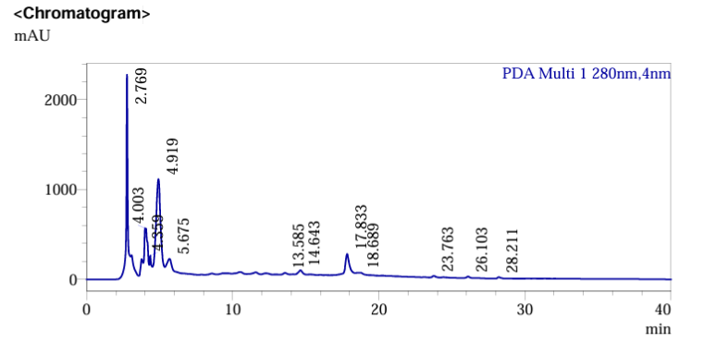

Fig. 1. HPLC chromatogram of H. purpurascens extract

During the detection of constituents, a prominent peak appeared at 4.919 min with an area of 19,157,014 mAU, which contributes 42.96% of the total chromatographic area. The high relative abundance of this peak indicates that the compound is a dominant phytochemical in the ethanolic extract. When compared with authenticated standards (Ampelopsin, Quercetin, and Myricetin) taken under study, it is observed that under identical chromatographic conditions, the retention time closely matched that of Ampelopsin (4.992 min). Minor variation in retention time (±0.07 min) falls within acceptable analytical deviation limits for HPLC comparison (Aminu et al., 2019).

Table 2. Table represents the comparison of the standards

Standard | Retention Time (min) | Area (mAU) | Concentration (µg/mL)
Ampelopsin | 4.992 | 458624 | 10
Quercetin | 6.111 | 856321 | 10
Myricetin | 10.990 | 903517 | 10

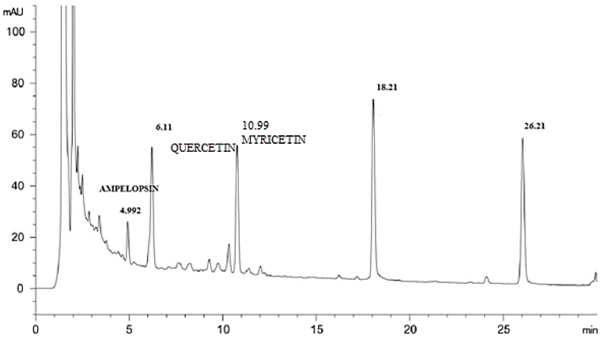

Fig. 2. HPLC chromatogram of Ampelopsin standard

The absence of detectable peaks corresponding to Quercetin (6.111 min) and Myricetin (10.990 min) suggests that either these flavonols are absent or present below the detection threshold under the study conditions (Table 2 and Fig. 2). Such variability in flavonoid composition is common among the Rubiaceae family members and is influenced by ecological factors, developmental stage, and extraction solvent polarity (Gouveia and Castilho, 2011). Earlier in the HPLC and FTIR profiling of the inflorescence of H. purpurascens, nine chromatographic peaks were identified, with rutin confirmed at 3.795 min, closely matching the standard (3.811 min). Rutin accounted for 27.29% of the peak area, indicating its prominence as a flavonoid marker (Betty et al., 2024).

The earlier eluted peaks (2.769-5.675 min) may represent relatively polar phenolic constituents, whereas late eluted peaks (17.833-28.211 min) correspond to less polar or more structurally complex molecules. Similar multi-peak chromatographic patterns have been reported in other medicinal plants that are rich in flavonoids and phenolic acids (Dai and Mumper, 2010; Ignat et al., 2011).

3.2 Confirmation and Significance of Ampelopsin (Dihydromyricetin)

The chromatographic analysis revealed a clear and well-resolved separation of the phytoconstituents present in the extract. The retention time of the ampelopsin standard (4.992 min) closely matched that of the corresponding peak in the extract (4.919 min), thereby confirming its occurrence in the sample. The substantial peak area percentage (42.96%) indicates that ampelopsin constitutes a major phytochemical component. Ampelopsin, also referred to as dihydromyricetin (DHM) (Fig. 3), is a naturally occurring flavonoid predominantly isolated from Ampelopsis grossedentata and Hovenia dulcis. Traditionally consumed as vine tea in East Asia, it has attracted considerable scientific interest due to its diverse pharmacological properties (Wu et al., 2013). Its identification in H. purpurascens further enhances the chemotaxonomic and pharmacognostic relevance of the species.

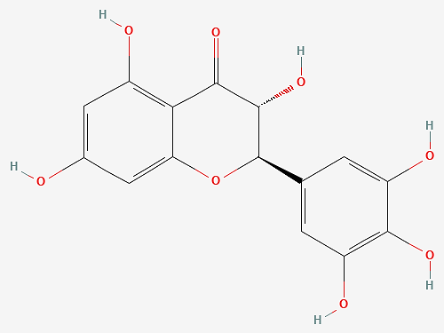

Fig. 3. Structure of Ampelopsin

Phenolic compounds are extensively acknowledged for their anti-inflammatory properties, primarily attributed to the suppression of cyclooxygenase pathways and mitigation of oxidative stress. Ampelopsin (dihydromyricetin) has been documented to exert significant antioxidant and anti-inflammatory activities through regulation of the NF-κB signaling pathway (Zhao et al., 2021). Additionally, accumulating evidence indicates that DHM can safeguard neuronal cells from oxidative and inflammatory injury, underscoring its potential therapeutic significance in neurodegenerative disorders (Sun et al., 2022). Further investigations have also demonstrated its hepatoprotective, neuroprotective, and anticancer effects, largely mediated by the induction of apoptosis and modulation of mitochondrial signaling mechanisms (Wu et al., 2013; Zuo et al., 2018; Chen et al., 2015).

The notably high peak area percentage (42.96%) suggests that ampelopsin could be considered a promising chemical marker for the quality control and standardization of this species. Marker-based standardization approaches are increasingly advocated in herbal drug validation to maintain reproducibility and ensure batch-to-batch uniformity (Li et al., 2008).

3.3 Interpretation of Minor Peaks and Phytochemical Diversity

Polyphenolic-rich plant extracts typically exhibit synergistic biological activity, where minor compounds enhance or modulate the activity of major constituents (Wagner & Ulrich-Merzenich, 2009). Although Ampelopsin dominated the chromatographic profile, other peaks collectively accounted for approximately 57% of the total area, indicating a chemically diverse extract. Peaks observed at 2.769 min (12.08%) and 17.833 min (7.907%) represent substantial secondary constituents that warrant future isolation and structural elucidation.

3.4 FTIR Spectral Analysis and Functional Group Characterization

The FTIR spectrum revealed prominent absorption bands corresponding to hydroxyl (3365.17 cm⁻¹), aliphatic C-H (2972.73 and 2924.52 cm⁻¹), carbonyl and conjugated C=C groups (1667.16 and 1514.81 cm⁻¹), and C–O/C–N stretching vibrations (1268.93–1038.48 cm⁻¹), indicating the presence of phenolic and aromatic constituents. The broad O-H stretching band confirms the characteristic of hydrogen-bonded hydroxyl groups of polyphenolic compounds. These functional features are consistent with flavonoid structures, particularly ampelopsin (dihydromyricetin), which contains multiple hydroxyl substituents and aromatic rings. Thus, the FTIR profile substantiates the occurrence of bioactive flavonoids and supports the chromatographic identification of ampelopsin in the extract (Table 3 and Fig. 4).

The FTIR findings complement the HPLC data by confirming functional groups typically associated with flavonoids. Infrared fingerprinting serves as a rapid authentication tool for herbal materials and is widely employed in pharmacognostic standardization (Alam and Mishra, 2017). Combining chromatographic profiling with FTIR functional group analysis enhances analytical confidence and reduces the possibility of misidentification. Such integrated approaches are recommended for herbal drug authentication and quality control (Enders et al., 2021). Although extended calibration would enhance precision, the present validation confirms method suitability for phytochemical screening.
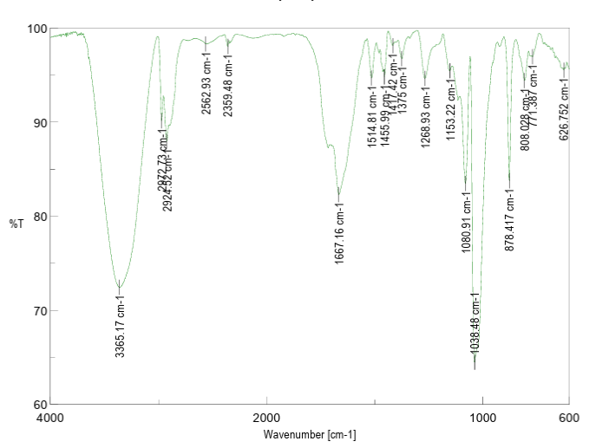
Fig. 4. FTIR spectrum of ethanolic leaf extract

Table 3. Table represents the functional groups in FTIR

S. No | Functional Group/Assingment | Types of Intensity | Characteristic Absorption (cm-1)
1 | Phenols & Alcohols  O-H (free), usually sharp  O-H (H-Bonded), usually broad | Stretching Vibration, H-bonded- Strong | 3365.17
2 | Alkanes  CH3, CH2, CH | Stretching Vibration, Strong | 2972.73  2924.52
3 | Carboxylic Acids & Derivatives  O-H (Very broad) | Stretching Vibration, Strong | 2562.9
4 | Aldehydes  H-C=O | C-H Stretch off C=O | 2359.48
5 | Arenes  C=C(in ring) (2 bands)  (3 if conjugated) | Stretching Vibration, mid-weak | 1514.81
6 | Alkenes  C=C | Stretching Vibration, Variation | 1667.16
7 | Aromatic Alkanes compounds  CH2 & CH3 deformation | Bending Vibration, Medium | 1455.99
8 | Aldehydes & Ketones  CH2 | Bending Vibration, Medium | 1417.42
9 | Alkanes  CH3 | Bending Vibration, CH3 Deformation | 1375
10 | Carboxylic Acids & Derivatives  O-C (sometimes 2-peaks)) | Stretching Vibration, Medium | 1268.93
11 | Amines  C-N | Stretching Vibration, Medium Strong | 1153.22  1080.91  1038.48
12 | Arenes  C-H bending& ring puckering | Bending Vibration, strong-Medium | 878.41  808.03  771.38
13 | Alkynes  C-H Deformation | Bending Vibration, Strong | 626.752
4. Conclusion

The present study systematically explored and analyzed the phytochemical composition of the ethanolic leaf extract of H. purpurascens using complementary analytical techniques. Chromatographic fingerprinting through High-Performance Liquid Chromatography established a distinct and reproducible profile, revealing multiple phytoconstituents, including a prominent peak corresponding closely to a flavonoid reference standard. This confirms the presence of bioactive compounds that may contribute to the plant’s traditional therapeutic relevance. Concurrently, Fourier Transform Infrared Spectroscopy analysis identified characteristic functional groups such as phenolic, carbonyl, aromatic, amine, and alkane moieties, further supporting the extract’s chemical diversity. The integration of chromatographic and spectroscopic methodologies provided a robust and validated chemical signature for the species. Establishing such a reproducible phytochemical fingerprint is essential for quality control, authentication, and pharmacognostic standardization. Overall, the findings lay a strong scientific foundation for future bioactivity-guided studies, pharmacological validation, and the development of standardized herbal formulations derived from H. purpurascens.

Disclaimer (Artificial Intelligence)

Author(s) hereby declare that NO generative AI technologies such as Large Language Models (ChatGPT, COPILOT, etc) and text-to-image generators have been used during writing or editing of this manuscript.

Competing Interests

Authors have declared that no competing interests exist.

References

Alam, G., & Mishra, A. K. (2017). Traditional and modern approaches for standardization of herbal drugs: a review. Acta Biomedica Scientia, 2348, 2168.
Allabaksh, S., & Senthilraj, R. (2024). A Quantitative HPLC Analysis of Phytoconstituents and Assessment of Antioxidant Properties of the Rhizome of Curcuma angustifolia Roxb. Rasayan Journal of Chemistry, 17(2), 588-597.
Aminu, N., Chan, S. Y., Khan, N. H., Farhan, A. B., Umar, M. N., & Toh, S. M. (2019). A simple stability-indicating HPLC method for simultaneous analysis of paracetamol and caffeine and its application to determinations in fixed-dose combination tablet dosage form. Acta Chromatographica, 31(2), 85-91.
Arunkumar, R., Kaffoor, H. A., Priya, S. V., & Jemimma, H. L. (2024). A Review of the Multifaceted Therapeutic Potential of Endangered Medicinal Plant Tacca chantrieri (Dioscoreaceae): Insights into Its Phytochemical Composition and Pharmacological Activities. Journal of Ayurvedic and Herbal Medicine, 10(4), 107-112.
Betty, T., Malini, R. P., Vasini, V., & Sumathi, P. (2024). Analysis of bioactive compounds in Hedyotis purpurascens inflorescence using HPLC and FTIR techniques. Journal of Xidian University, 18(4). https://doi.org/10.5281/zenodo.10936152
Chen, S., Zhao, X., Wan, J., Ran, L., Qin, Y., Wang, X., Gao, Y., Shu, F., Zhang, Y., Liu, P., Zhang, Q., Zhu, J., & Mi, M. (2015). Dihydromyricetin improves glucose and lipid metabolism and exerts anti-inflammatory effects in nonalcoholic fatty liver disease: A randomized controlled trial. Pharmacological research, 99, 74–81. https://doi.org/10.1016/j.phrs.2015.05.009
D’Amelia, V., Aversano, R., Chiaiese, P., & Carputo, D. (2018). The antioxidant properties of plant flavonoids: their exploitation by molecular plant breeding. Phytochemistry Reviews, 17(3), 611-625.
Dai, J., & Mumper, R. J. (2010). Plant phenolics: extraction, analysis and their antioxidant and anticancer properties. Molecules (Basel, Switzerland), 15(10), 7313–7352. https://doi.org/10.3390/molecules15107313.
Enders, A. A., North, N. M., Fensore, C. M., Velez-Alvarez, J., & Allen, H. C. (2021). Functional group identification for FTIR spectra using image-based machine learning models. Analytical Chemistry, 93(28), 9711-9718.
González-Castelazo, F., Soria-Jasso, L. E., Torre-Villalvazo, I., Cariño-Cortés, R., Muñoz-Pérez, V. M., Ortiz, M. I., & Fernández-Martínez, E. (2023). Plants of the Rubiaceae family with effect on metabolic syndrome: Constituents, pharmacology, and molecular targets. Plants, 12(20), 3583.
Gouveia, S., & Castilho, P. C. (2011). Characterisation of phenolic acid derivatives and flavonoids from different morphological parts of Helichrysum obconicum by a RP-HPLC-DAD-(-)-ESI-MS^{n} method. Food chemistry, 129(2), 333–344. https://doi.org/10.1016/j.foodchem.2011.04.078.
Gowtham, P., Arunkumar, R., & Abdul, K. H. (2025). Chemical Composition and Biological Activities of Annona muricata Linn Extracts: A GC-Based Investigation. The Indian Journal of Nutrition and Dietetics, 62(3), 274-289. https://doi.org/10.21048/IJND.2025.62.3.48609
Ignat, I., Volf, I., & Popa, V. I. (2011). A critical review of methods for characterisation of polyphenolic compounds in fruits and vegetables. Food chemistry, 126(4), 1821–1835. https://doi.org/10.1016/j.foodchem.2010.12.026.
Indumathi, R., Athira, P., Arunkumar, R., & Kanivalan, I. (2025). Restorative Efficacy of Elaeocarpus gaussenii Weibel (Elaeocarpaceae) through In vitro Evaluations. Advances in Bioresearch, 16(5), 223-231.
Kirova, G. K. (2026). Advances in Analytical Methods for Quality Control and Authentication of Nutraceuticals: A Comprehensive Review. Nutraceuticals, 6(1), 5.
Kma, L., Marbaniang, C., Tongbram, C. M., & NathSharan, R. (2023). Determination of the safe dose of aqueous extract of Apium graveolens L. by acute and sub-acute toxicit y study. Journal of Plant Science Research, 10, 1-7.
Kou, X., & Chen, N. (2012). Pharmacological potential of ampelopsin in Rattan tea. Food Science and Human Wellness, 1(1), 14-18.
Li, S., Han, Q., Qiao, C., Song, J., Lung Cheng, C., & Xu, H. (2008). Chemical markers for the quality control of herbal medicines: an overview. Chinese medicine, 3, 7. https://doi.org/10.1186/1749-8546-3-7.
Pandiyan, R., & Ilango, K. (2022). Pharmacognostical, physicochemical and phytochemical evaluation of Huberantha senjiana (Annonaceae) leaf: An endemic tree of Gingee Hills Tamil Nadu India. Journal of Pharmacy & Pharmacognosy Research, 10(1), 158-172.
Priya, S. V., Karthika, K., Akbar, A. S. S., Kumar, R. A., & Athira, P. (2024). GC‐MS Profiling and In Silico Pass Prediction of Phytoconstituents Present in Ethanolic Stem Extract of Medicinally Important Plant Vincetoxicum subramanii. Asian Journal of Biological and Life Sciences, 13(3), 807.
Shehu, A. A., Pandey, P., & Kushwaha, R. (2025). Advanced analytical techniques for the identification of plant derived bioactive compounds. RSYN Chemical Sciences, 2(1), 36-50.
Sultan, S., Mohd Ali, K. A., Mohamed Akram, N. D., Ashraf, K., Ashraf, M., & Singh, G. K. S. (2022). Antimicrobial activity of secondary metabolites isolated from endophytic fungi associated with Rubiaceae species. International Journal of Pharmaceuticals, Nutraceuticals and Cosmetic Science (IJPNaCS), 5(1), 33-47.
Sun, Y., Liu, S., Yang, S., Chen, C., Yang, Y., Lin, M., Liu, C., Wang, W., Zhou, X., Ai, Q., Wang, W., & Chen, N. (2022). Mechanism of Dihydromyricetin on Inflammatory Diseases. Frontiers in pharmacology, 12, 794563. https://doi.org/10.3389/fphar.2021.794563
Verma, V. K., Bhardwaj, P., Prajapati, V., Bhatia, A., Purkait, S., & Arya, D. S. (2024). Flavonoids as therapeutics for myocardial ischemia-reperfusion injury: a comprehensive review on preclinical studies. Laboratory Animal Research, 40(1), 32.
Wagner, H., & Ulrich-Merzenich, G. (2009). Synergy research: approaching a new generation of phytopharmaceuticals. Phytomedicine: international journal of phytotherapy and phytopharmacology, 16(2-3), 97–110. https://doi.org/10.1016/j.phymed.2008.12.018.
Wu, S., Liu, B., Zhang, Q., Liu, J., Zhou, W., Wang, C., Li, M., Bao, S., & Zhu, R. (2013). Dihydromyricetin reduced Bcl-2 expression via p53 in human hepatoma HepG2 cells. PloS one, 8(11), e76886. https://doi.org/10.1371/journal.pone.0076886
Zhao, Y., Liu, X., Ding, C., Gu, Y., & Liu, W. (2021). Dihydromyricetin reverses thioacetamide-induced liver fibrosis through inhibiting NF-κB-mediated inflammation and TGF-β1-regulated of PI3K/Akt signaling pathway. Frontiers in Pharmacology, 12, 783886.
Zuo, Y., Xu, Q., Lu, Y., Sun, D., Wang, K., Lei, Y., Liang, X., & Li, Y. (2018). Dihydromyricetin induces apoptosis in a human choriocarcinoma cell line. Oncology letters, 16(4), 4229–4234. https://doi.org/10.3892/ol.2018.9220.

Disclaimer/Publisher’s Note: The statements, opinions and data contained in all publications are solely those of the individual author(s) and contributor(s) and not of the publisher and/or the editor(s). This publisher and/or the editor(s) disclaim responsibility for any injury to people or property resulting from any ideas, methods, instructions or products referred to in the content.
__________________________________________________________________________________________
© Copyright (2026): Author(s). The licensee is the journal publisher. This is an Open Access article distributed under the terms of the Creative Commons Attribution License (http://creativecommons.org/licenses/by/4.0), which permits unrestricted use, distribution, and reproduction in any medium, provided the original work is properly cited.

