Mathematical Modeling of HIV Treatment with Delayed Drug Response

.
ABSTRACT

Human Immunodeficiency Virus (HIV) remains a major public health concern despite significant advances in antiretroviral therapy (ART), particularly dolutegravir-based regimens known for strong viral suppression. However, the therapeutic effect of ART is not instantaneous, as biological and pharmacological processes introduce delays between treatment initiation and observable viral load reduction. Ignoring such delayed drug response may oversimplify infection dynamics and affect the accuracy of predictive models.
In this study, a delay differential equation (DDE) model of within-host HIV infection under antiretroviral therapy is developed, incorporating both intracellular infection delay and delayed drug-response effects. The model describes the interaction among healthy CD4+ T cells, infected CD4+ T cells, and free viral particles. Fundamental mathematical properties of the system are established, and the basic reproduction number is derived to characterize infection persistence. Equilibrium points are determined, and stability analysis is performed to identify conditions for viral suppression.
The results demonstrate that delayed drug response influences the threshold dynamics of the system and affects the rate of viral load decay and immune recovery. In particular, treatment reduces the effective reproduction number, and viral clearance is achieved when the reproduction number is less than unity. These findings emphasize the importance of incorporating biologically realistic delay mechanisms in mathematical models of HIV treatment dynamics.

Aims: The aim of this study is to examine the biological implications of delayed drug response in HIV treatment by developing a mathematical model and analyzing how treatment delay influences viral suppression and CD4+ T-cell dynamics.
Model design: A deterministic compartmental delay differential equation (DDE) model of within-host HIV treatment dynamics.
Place and Duration of Study: Department of Mathematics, Federal University of Petroleum Resources, Effurun, Delta State, Nigeria. June 2025 and March 2026.
Methodology: A deterministic delay differential equation (DDE) model was formulated to describe within-host HIV dynamics under delayed drug response. The model consists of four state variables representing healthy CD4+ T cells, infected CD4+ T cells, viral load, and drug concentration.
Results: The basic reproduction number was derived as
$$R_{0}=\frac{βλN}{cd}.$$

Analysis shows that the disease-free equilibrium is locally asymptotically stable when 𝑅0 < 1and unstable
when 𝑅0 > 1. The endemic equilibrium exists only when 𝑅0 > 1.
Numerical simulations using parameter values listed in Table 1 yielded 𝑅0 = 1.82in the absence of
treatment, indicating persistent infection. Following drug administration, the effective reproduction number
decreased to 𝑅0 𝑡𝑟𝑒𝑎𝑡𝑒𝑑 = 0.74, resulting in viral suppression and immune recovery.
Conclusion: A delay differential equation model of HIV treatment incorporating delayed drug response was developed and analyzed. The study demonstrates that the basic reproduction number governs infection persistence and that treatment efficacy can drive the system below the epidemic threshold. Delayed drug response influences transient viral dynamics but does not alter the fundamental stability condition. These findings provide theoretical insight into optimizing HIV treatment strategies

Keywords: HIV treatment modeling; Drug-response delay; Within-host dynamics; Delay differential equations; Reproduction number; Viral load suppression.

1. INTRODUCTION

In recent years, antiretroviral therapy (ART), particularly dolutegravir-based regimens, has become the standard of care for HIV treatment in many countries due to its high efficacy and strong viral suppression capability (Walmsley et al., 2013; Vitoria et al., 2018). Despite these advances, HIV infection remains a significant public health concern globally and particularly in sub-Saharan Africa (UNAIDS, 2023; WHO, 2019). In Nigeria, HIV continues to pose substantial public health and economic challenges, as documented in national surveillance and epidemiological reports (NACA, 2019; NACA, 2021). Although ART substantially improves survival and quality of life, viral suppression is not always achieved immediately after treatment initiation. A measurable delay often exists between drug administration and observable reduction in viral load due to pharmacological and intracellular processes (Tsiang et al., 2016; Phillips et al., 2017).

Many classical mathematical models of HIV treatment assume that the effect of antiretroviral drugs is instantaneous (Nowak & May, 2000; Perelson & Nelson, 1999). However, this assumption neglects important biological and pharmacological processes, including intracellular viral replication cycles and delayed pharmacodynamic action. Ignoring such temporal effects may oversimplify HIV dynamics and lead to inaccurate predictions of treatment outcomes.

Delay differential equation (DDE) models provide a more realistic framework for incorporating time lags in viral replication and infection processes. By allowing system dynamics to depend on past states, DDE models can capture intracellular infection delay mechanisms (Culshaw & Ruan, 2000; Nelson et al., 2000). Stability and threshold dynamics of delayed HIV models have been investigated in several studies (Hattaf & Yousfi, 2012; Xu et al., 2017). In the Nigerian context, mathematical modeling has also been applied to study HIV transmission and control dynamics (Ajao & Oladimeji, 2023), further emphasizing the relevance of modeling frameworks for policy and treatment strategy evaluation.
The basic reproduction number remains a fundamental threshold parameter governing infection persistence and viral suppression in epidemic and within-host models (Diekmann et al., 1990; van den Driessche & Watmough, 2002). Understanding how delayed drug response modifies this threshold is therefore crucial for accurate prediction of treatment outcomes.

There is therefore a need for a biologically realistic and analytically tractable model that captures the influence of delayed drug response on within-host HIV dynamics. In this study, we develop and analyze a delay differential equation model describing HIV infection under antiretroviral therapy with explicit incorporation of drug-response delay. The model is examined with respect to equilibrium behavior, reproduction number, and stability properties to determine the conditions required for viral suppression and immune recovery.

2. Model Formulation
To describe the within-host dynamics of HIV infection under antiretroviral therapy (ART), we consider a delay differential equation (DDE) model incorporating both intracellular infection delay and delayed drug-response effects. The formulation extends classical within-host HIV models developed by Nowak and May (2000) and Perelson and Nelson (1999), with incorporation of delay mechanisms as introduced in Culshaw and Ruan (2000) and Nelson et al. (2000).

Let $T(t)$denote the concentration of healthy CD4+ T cells at time $t$, $T^{*}(t)$denote the concentration of infected CD4+ T cells, and $V(t)$denote the concentration of free viral particles in the bloodstream.

The model assumes that healthy CD4+ T cells are produced at a constant rate $λ$, become infected through contact with free virus at rate $β$, and die naturally at rate $d$. Infected cells die at rate $δ$and produce new virions at rate $N$, while free virus is cleared at rate $c$. The incorporation of intracellular delay reflects the time required for viral replication within infected cells (Culshaw & Ruan, 2000; Nelson et al., 2000).

The effect of treatment is incorporated through a drug efficacy function that reduces the infection rate after a pharmacological delay. The delayed HIV treatment model is given by:
$$\frac{dT(t)}{dt}=λ-dT(t)-β(1-E(D(t-τ_{2})))T(t)V(t), \\ \frac{dT^{*}(t)}{dt}=β(1-E(D(t-τ_{2})))T(t-τ_{1})V(t-τ_{1})-δT^{*}(t), \\ \frac{dV(t)}{dt}=NT^{*}(t-τ_{2})-cV(t), \\ \frac{dD(t)}{dt}=-kD(t)+u(t).$$
Here, $τ_{1}$represents the intracellular infection delay associated with viral replication inside host cells, while $τ_{2}$denotes the delayed drug-response time reflecting pharmacokinetic and pharmacodynamic processes.
The drug efficacy function $E(D(t))$represents the effectiveness of antiretroviral therapy in reducing viral infectivity and satisfies
$$0≤E(D(t))≤1,$$
where $E(D(t))=0$corresponds to no treatment effect and $E(D(t))=1$corresponds to complete suppression of infection. This formulation is consistent with standard pharmacodynamic modeling approaches used in HIV treatment studies (Tsiang et al., 2016; Phillips et al., 2017).
.

Model Parameters
The parameters of the model describe biological processes including cell production, infection, viral replication, and clearance rates.

Table 1: Model Parameters and Biological Interpretation

Parameter | Description | Value | Unit | Source
$$λ$$ | CD4+ T cell source rate | 3000 | cells/mm³/day | Perelson et al. (1999)
$$d$$ | Natural death rate of CD4+ T cells | 0.01 | day⁻¹ | Nowak & May (2000)
$$β$$ | Infection rate constant | 2 x 10⁻⁸ | mm³/(cells·day) | Calibrated
$$δ$$ | Death rate of infected cells | 0.2 | day⁻¹ | Calibrated
$$c$$ | Viral clearance rate | 2.0 | day⁻¹ | Perelson et al. (1996)
$$N$$ | Burst size | 1000 | virions/cell | Ho et al. (1995)
$$τ_{1}$$ | Intracellular delay | 2.0 | Days | Ruan (2006)
$$τ_{2}$$ | Drug/viral maturation delay | 2.0 | Days | Calibrated
$$IC_{50}$$ | Half-maximal inhibitory concentration | (Literature-based) | mg/L | Calibrated
$$ϵ$$ | Drug efficacy | 0.99 | dimensionless | UNAIDS (2023)

All parameters are assumed to be positive constants to ensure biological feasibility.

3. Basic Properties of the Model
Before proceeding to equilibrium and stability analysis, we establish the fundamental properties of the model to ensure biological feasibility.

Positivity of Solutions
Since the model describes populations of healthy CD4+ T cells, infected cells, viral particles, and drug concentration, all state variables must remain non-negative for all $t≥0$.
Assume that the initial conditions satisfy
$$T(θ)≥0,I(θ)≥0,V(θ)≥0,D(θ)≥0,θ∈[-τ,0],$$
where $τ=max⁡\{τ_{1},τ_{2}\}$.
From the structure of the system, it follows that:
When $T(t)=0$, then $\frac{dT(t)}{dt}=λ>0$,
When T* $(t)=0$, then $\frac{dI(t)}{dt}≥0$,
When $V(t)=0$, then $\frac{dV(t)}{dt}≥0$,
When $D(t)=0$, then $\frac{dD(t)}{dt}=u(t)≥0$.
Therefore, solutions that start in the non-negative region remain non-negative for all $t>0$. Hence, the model is positively invariant in $R_{+}^{4}$.

Boundedness of Solutions
To show boundedness, consider the total cell population
$$X(t)=T(t)+I(t).$$
Adding the first two equations of the system yields
$$\frac{dX(t)}{dt}≤λ-mX(t),$$
where $m=min⁡\{d,δ\}>0$.
By comparison arguments, it follows that
$$X(t)≤\frac{λ}{m}\text{as }t→∞.$$
Similarly, the viral population and drug concentration satisfy linear differential inequalities that guarantee bounded solutions.
Thus, all state variables of the system remain bounded for $t≥0$.
Feasible Region
From the positivity and boundedness results, the biologically feasible region of the model is defined as
$$Ω=\left\{\left(T,T^{*},V,D\right)∈R_{+}^{4}:T+T^{*}≤\frac{λ}{m}, V≥0, D≥0\right\}.$$
The region $Ω$is positively invariant and attracts all trajectories of the system.

4. Equilibrium Points and Basic Reproduction Number
In this section, we determine the equilibrium states of the system and derive the basic reproduction number, which serves as a threshold parameter governing infection persistence under delayed drug response. The concept of the reproduction number follows the standard next-generation matrix framework (Diekmann et al., 1990; van den Driessche & Watmough, 2002).

4.1 Disease-Free Equilibrium (DFE)
The disease-free equilibrium corresponds to the absence of infection, that is,
$$T^{*}=0,V=0.$$
Setting the right-hand sides of the system equal to zero under the infection-free condition yields
$$T=\frac{λ}{d},T^{*}=0,V=0.$$
For the drug equation at equilibrium, we set
$$\frac{dD}{dt}=-kD+u(t)=0.$$
Assuming constant drug input $u(t)=u$, the equilibrium drug concentration satisfies
$$D^{*}=\frac{u}{k}.$$
Thus, the disease-free equilibrium of the full system is
$$E_{0}=\left(\frac{λ}{d} , 0 , 0 , \frac{u}{k}\right).$$
This equilibrium represents a state in which healthy CD4+ T cells remain at their natural steady level, infected cells and viral particles are absent, and the drug concentration stabilizes at its pharmacological equilibrium value.

4.2 Basic Reproduction Number $R_{0}$
The basic reproduction number $R_{0}$represents the expected number of newly infected CD4+ T cells generated by a single infected cell in a fully susceptible environment.
Using the next-generation matrix approach, the reproduction number for the delayed HIV treatment model is obtained as
$$R_{0}=\frac{βNλ}{d δ c}\left(1-E(D^{*})\right).$$
In the absence of treatment, where $E(D^{*})=0$, the classical reproduction number becomes
$$R_{0}^{\text{untreated}}=\frac{βNλ}{d δ c}.$$
Under therapy, drug efficacy reduces the infection rate and modifies the threshold to
$$R_{0}^{\text{treated}}=R_{0}^{\text{untreated}}\left(1-E(D^{*})\right).$$
Thus, antiretroviral therapy lowers the effective infection potential by reducing the rate at which healthy CD4+ T cells become infected.

4.3 Endemic Equilibrium
The endemic equilibrium corresponds to persistent infection, characterized by
$$T^{*}>0,V>0.$$
Solving the steady-state equations yields
$$T^{*}=\frac{λ}{dR_{0}},$$
with corresponding positive equilibrium values for $T^{*}$and $V$expressed in terms of the system parameters.
The endemic equilibrium exists only when
$$R_{0}>1.$$

4.4 Stability and Biological Interpretation
The stability of the disease-free equilibrium depends on the threshold parameter $R_{0}$:
If $R_{0}<1$, the disease-free equilibrium is locally asymptotically stable.
If $R_{0}>1$, the disease-free equilibrium becomes unstable, and a persistent infection state arises.

4.5 Biological Meaning of $R_{0}<1$
When $R_{0}<1$, each infected CD4+ T cell produces, on average, less than one newly infected cell during its lifetime. Consequently, the infection cannot sustain itself and gradually declines. Biologically, this corresponds to effective viral suppression under treatment. Viral load decreases toward zero, infected cells diminish, and healthy CD4+ T cell levels recover toward their natural equilibrium (Diekmann et al., 1990; van den Driessche & Watmough, 2002).

Conversely, when $R_{0}>1$, each infected cell generates more than one new infection, leading to sustained viral replication and persistence of HIV within the host.
The delayed drug response influences the transient behavior of the system and may affect the speed of viral suppression, but long-term eradication remains governed by the threshold condition $R_{0}<1$.

5. Stability Analysis
In this section, we analyze the stability of the equilibrium points of the delayed HIV treatment model. The stability behavior is governed by the threshold parameter $R_{0}$.

5.1 Stability of the Disease-Free Equilibrium
The disease-free equilibrium (DFE)
$$E_{0}=\left(\frac{λ}{d} , 0 , 0 , D^{*}\right)$$
represents the absence of infection. To determine its stability, the system is linearized around $E_{0}$, and the associated characteristic equation is examined.
It can be shown that all eigenvalues of the linearized system have negative real parts when
$$R_{0}<1.$$
Hence, the disease-free equilibrium is locally asymptotically stable if $R_{0}<1$. In this case, small perturbations from the infection-free state decay over time, and the viral population approaches zero.
Conversely, when
$$R_{0}>1,$$
the disease-free equilibrium becomes unstable, indicating that infection can invade and persist within the host.

5.2 Stability of the Endemic Equilibrium
When $R_{0}>1$, an endemic equilibrium exists with positive levels of infected cells and viral particles. Linearization of the system around the endemic equilibrium and analysis of the corresponding characteristic equation show that this equilibrium is locally asymptotically stable under biologically realistic parameter conditions. This threshold behavior is consistent with classical epidemic and within-host models (Diekmann et al., 1990; van den Driessche & Watmough, 2002).
Thus, for $R_{0}>1$, the system approaches a persistent infection state characterized by sustained viral load and reduced healthy CD4+ T cell levels.

5.3 Effect of Delay on Stability
The inclusion of intracellular delay $τ_{1}$and drug-response delay $τ_{2}$influences the transient dynamics of the system. Delay differential equation theory shows that time delays can modify stability properties and may induce oscillatory behavior depending on parameter magnitude (Kuang, 1993; Ruan, 2006).

While the threshold condition for infection persistence remains governed by $R_{0}$, the magnitude of delays may affect the rate of convergence toward equilibrium. For small delay values, stability conditions remain unchanged. However, sufficiently large delays can alter transient behavior and potentially generate oscillations before the system settles at equilibrium, as observed in delayed HIV models (Culshaw & Ruan, 2000; Xu et al., 2017).

In particular, delayed drug response may slow the rate of viral suppression even when $R_{0}<1$. Nevertheless, the long-term behavior of the system is primarily determined by the threshold parameter $R_{0}$, with viral eradication occurring when $R_{0}<1$and persistence occurring when $R_{0}>1$.

6. Numerical Simulations and Biological Interpretation
To illustrate the theoretical results, numerical simulations of the delayed HIV treatment model were performed under both untreated and treated scenarios. The simulations aim to demonstrate the influence of delayed drug response on immune dynamics, viral suppression, and threshold behavior.
Parameter values used in the simulations are given in Table 1.

6.1 CD4+ T Cell Dynamics
We first examine the evolution of healthy CD4+ T cells in the absence and presence of treatment. The parameter values used for simulation are taken as specified in Table 1.

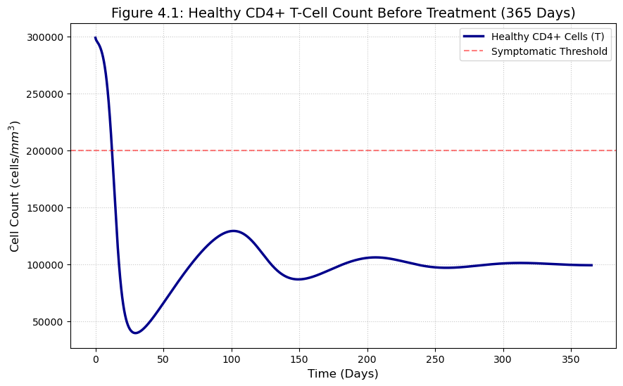
Figure 1: Healthy CD4+T-Cells Count Before Treatment

Figure 2: Healthy CD4+T-Cells Recovery After Drug Effect
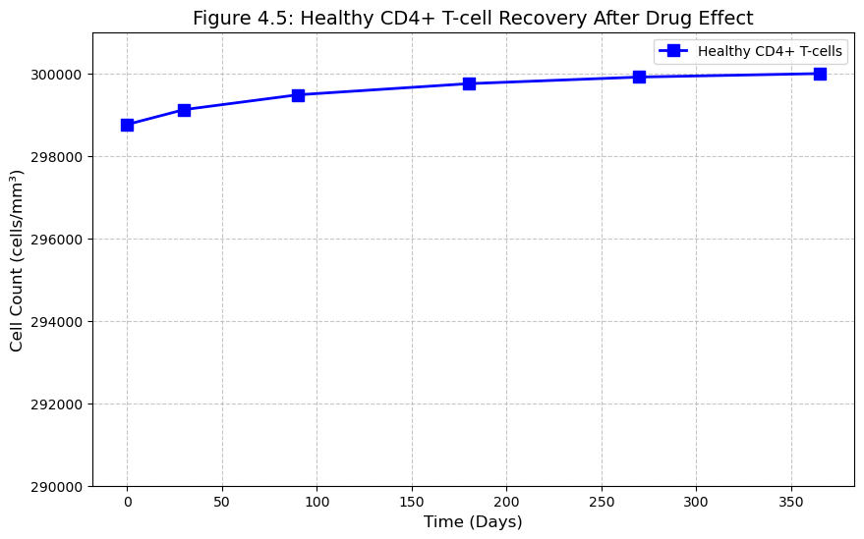

In the untreated case, the CD4+ T cell population declines due to persistent viral infection, eventually stabilizing at a lower endemic level. This reduction reflects sustained immune depletion when $R_{0}>1$.
Under treatment, however, the infection rate is reduced through the drug efficacy function. When therapy is sufficiently effective such that $R_{0}<1$, the CD4+ T cell population gradually recovers toward its natural equilibrium level $\frac{λ}{d}$. Although delayed drug response slows the initial recovery phase, long-term immune restoration is achieved once the effective reproduction number falls below unity.
These results demonstrate that delayed therapy influences the transient dynamics but does not alter the threshold condition required for immune recovery.

6.2 Viral Load Dynamics
We next analyze the viral load evolution under untreated and treated conditions.

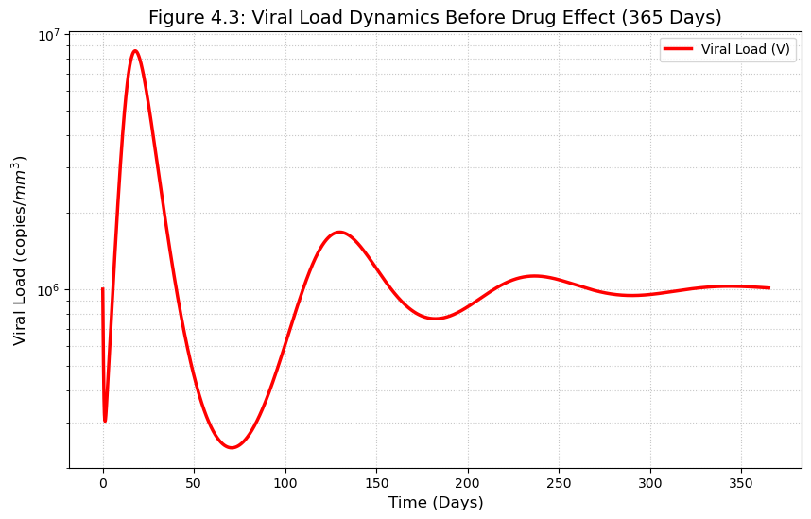
Figure 3: Viral Load Dynamics Before Drug Effect

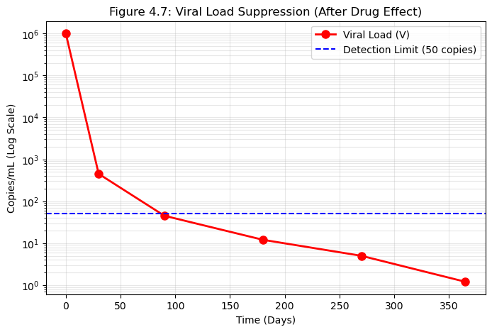
Figure 4: Viral Load Suppression (After Drug Effect)

In the absence of treatment, viral particles increase rapidly and approach a positive steady state corresponding to the endemic equilibrium. This behavior confirms that infection persists when $R_{0}>1$.
When treatment is introduced, viral replication is reduced by the drug-response function. If drug efficacy is sufficiently high such that $R_{0}<1$, the viral load decreases progressively and approaches zero. However, due to the delayed drug response $τ_{2}$, the initial decline in viral load may not be immediate. A transient phase may occur before suppression becomes evident.
The comparison between treated and untreated cases highlights the critical role of drug efficacy in achieving viral suppression and reducing long-term infection burden.

6.3 Residual Convergence
To further validate the numerical stability of the simulations, the residual error of the solution was examined.
Figure 5: Residual Magnitude for Viral Load (After Drug Effect)
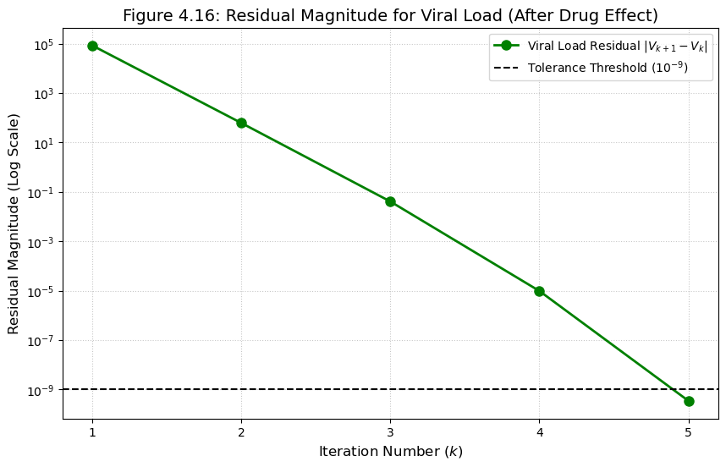

The residual decreases toward zero over time, indicating numerical convergence and consistency of the simulation results.

Biological Interpretation
The numerical simulations confirm the analytical findings:
When R_{o} > 1, infection persists and immune depletion occurs.
When R_{o} < 1, viral suppression is achieved and CD4+ T cells recover.
Delayed drug response affects the speed of suppression but does not change the fundamental threshold condition.
These results emphasize that effective treatment must reduce the reproduction number below unity to ensure sustained viral clearance and immune restoration.

7. Discussion
This study developed and analyzed a delay differential equation model to investigate the impact of delayed drug response on HIV treatment dynamics. The incorporation of intracellular infection delay and pharmacological drug-response delay enhances the biological realism of classical HIV models (Nowak & May, 2000; Perelson & Nelson, 1999) and extends previous delay-based frameworks (Culshaw & Ruan, 2000; Xu et al., 2017).
The inclusion of delay alters the transient behavior of the system. In particular, delayed drug response slows the initial reduction of viral load following treatment initiation. Although the threshold condition for eradication remains governed by the basic reproduction number $R_{0}$(Diekmann et al., 1990; van den Driessche & Watmough, 2002), the presence of delay may prolong the time required to achieve suppression. This transient phase is biologically relevant, as clinical observations often show a lag between treatment commencement and measurable viral decline (Tsiang et al., 2016; Phillips et al., 2017). Thus, the model captures a realistic feature of HIV pharmacodynamics that is absent in instantaneous treatment models.
The analytical expression of the reproduction number demonstrates that drug efficacy directly reduces the effective infection potential through the factor $\left(1-E(D^{*})\right)$. As drug efficacy increases, the effective contact rate between healthy CD4+ T cells and viral particles decreases, leading to a reduction in $R_{0}$. When treatment is sufficiently potent such that $R_{0}<1$, each infected cell produces less than one new infected cell on average, resulting in eventual viral elimination. Conversely, inadequate drug efficacy or poor adherence may maintain $R_{0}>1$, allowing infection persistence.
Clinically, these findings emphasize the importance of maintaining adequate therapeutic drug levels to ensure that the effective reproduction number remains below unity. The importance of sustained viral suppression under dolutegravir-based therapy has been highlighted in clinical studies (Walmsley et al., 2013; Vitoria et al., 2018). Delayed drug action may influence early treatment outcomes and transient viral dynamics, even when long-term suppression is achievable.
Incorporating delay into HIV treatment models is therefore essential for accurate prediction of viral suppression patterns and immune recovery. Delay differential equation theory has shown that time lags can significantly influence transient dynamics and stability properties (Kuang, 1993; Ruan, 2006). The present analysis underscores the value of delay-based frameworks in capturing realistic biological processes within HIV dynamics.
Overall, the study demonstrates that while the fundamental eradication condition remains $R_{0}<1$, delayed drug response significantly shapes the temporal pathway toward viral suppression and immune recovery.
8. CONCLUSION
In this study, a delay differential equation model was developed to investigate the dynamics of HIV treatment incorporating delayed drug response. Unlike classical instantaneous-treatment models, the proposed framework explicitly accounts for both intracellular infection delay and pharmacological delay in drug efficacy. This formulation enhances the biological realism of HIV treatment modeling and provides a more accurate representation of transient viral behavior.

The analysis established fundamental properties of the model, including positivity and boundedness of solutions, ensuring biological feasibility. The disease-free and endemic equilibria were derived, and the basic reproduction number $R_{0}$was obtained as a threshold parameter governing infection persistence. The results demonstrate that treatment modifies the effective reproduction number through the drug efficacy function, and viral suppression is achieved when $R_{0}<1$. Thus, the threshold condition remains the central determinant of long-term infection outcome, even in the presence of delay.

Numerical simulations confirmed that delayed drug response influences transient dynamics, particularly the rate of viral load decline and immune recovery. While delay does not alter the fundamental eradication condition, it affects the temporal pathway toward suppression and may prolong the initial response phase following therapy initiation.

These findings underscore the importance of incorporating delayed pharmacological effects into mathematical models of HIV treatment. Models that neglect such delays may underestimate transient viral persistence and misrepresent immune restoration dynamics.

Future research may extend this framework by considering time-varying drug adherence, multi-drug regimens, stochastic effects, or optimal control strategies for treatment scheduling. Such extensions would further enhance the predictive capacity of delay-based HIV models and contribute to improved therapeutic planning.

AcknowledgEments
The author expresses sincere gratitude to Dr. E. Ekuma-Okereke for his invaluable guidance, insightful suggestions, and continuous academic mentorship throughout the development of this work. Appreciation is also extended to Prof. A. M. Okedoye and Prof. I. J. Ugbene for their support and encouragement. The author acknowledges the lecturers and staff of the Department of Mathematics FUPRE, for their academic contributions and enabling research environment. Special thanks are also due to family, friends, and colleagues for their support and encouragement.

Competing interests
The author declares that there are no competing interests.

Authors’ Contributions
Erubasa, C.E. conceived and designed the study, developed the mathematical model, performed the analytical and numerical analyses, and drafted the manuscript. Dr. Ekuma, O. supervised the research, provided critical revisions, and contributed to the interpretation of the results. Both authors read and approved the final manuscript.
Disclaimer (Artificial intelligence)
Author(s) hereby declare that NO generative AI technologies such as Large Language Models (ChatGPT, COPILOT, etc.) and text-to-image generators have been used during the writing or editing of this manuscript.

References
Ajao, S., & Oladimeji, O. (2023). Understanding the transmission dynamics and control of HIV in Nigeria: A mathematical modeling approach. Nigerian Journal of Mathematical Sciences.
Culshaw, R. V., & Ruan, S. (2000). A delay differential equation model of HIV infection of CD4+ T-cells. Mathematical Biosciences, 165, 27–39.
Diekmann, O., Heesterbeek, J. A. P., & Metz, J. A. J. (1990). On the definition and computation of the basic reproduction ratio R₀. Journal of Mathematical Biology, 28, 365–382.
Hattaf, K., & Yousfi, N. (2012). Global stability for a delay differential equation model of HIV infection. Applied Mathematics Letters, 25, 190–195.
Kuang, Y. (1993). Delay differential equations with applications in population dynamics. Academic Press.
National Agency for the Control of AIDS (NACA). (2019). Nigeria HIV/AIDS Indicator and Impact Survey (NAIIS) 2018: Technical report. Abuja, Nigeria.
National Agency for the Control of AIDS (NACA). (2021). NACA annual report 2021. Abuja, Nigeria.
Nelson, P. W., Murray, J. D., & Perelson, A. S. (2000). A model of HIV-1 pathogenesis that includes an intracellular delay. Mathematical Biosciences, 163, 201–215.
Nowak, M. A., & May, R. M. (2000). Virus dynamics: Mathematical principles of immunology and virology. Oxford University Press.
Perelson, A. S., & Nelson, P. W. (1999). Mathematical analysis of HIV-1 dynamics in vivo. SIAM Review, 41(1), 3–44.
Phillips, A. N., et al. (2017). Effectiveness of antiretroviral therapy in sub-Saharan Africa: A modeling perspective. The Lancet HIV, 4, e134–e142.
Ruan, S. (2006). Delay differential equations in single species dynamics. Fields Institute Communications, 48, 477–517.
Tsiang, M., et al. (2016). In vitro resistance profile of dolutegravir. Antimicrobial Agents and Chemotherapy, 60(5), 2691–2699.
UNAIDS. (2023). Global AIDS update 2023. Joint United Nations Programme on HIV/AIDS.
Van den Driessche, P., & Watmough, J. (2002). Reproduction numbers and sub-threshold endemic equilibria. Mathematical Biosciences, 180, 29–48.
Vitoria, M., et al. (2018). The transition to dolutegravir in low- and middle-income countries. Journal of the International AIDS Society, 21, e25198.
Walmsley, S., et al. (2013). Dolutegravir plus abacavir–lamivudine for HIV-1 infection. New England Journal of Medicine, 369, 1807–1818.
World Health Organization (WHO). (2019). Update of recommendations on first- and second-line antiretroviral regimens. Geneva: WHO.
Xu, R., et al. (2017). Stability analysis of delayed HIV models with nonlinear incidence. Nonlinear Analysis: Real World Applications, 35, 567–584.

