Unveiling the Pathogenicity and Cultural Behavior of Colletotrichum capsici Causing Chilli Anthracnose

Abstract
Chilli (Capsicum annuum L.) represents a vital economic crop globally, yet its production faces severe constraints due to Anthracnose, a devastating fungal disease incited by Colletotrichum capsici. Prevalent in tropical climates, this pathogen causes extensive pre- and post-harvest damage. The present investigation focused on isolating the pathogen from infected samples, confirming its virulence via Koch’s postulates, and profiling its cultural characteristics on distinct solid media. Pathogenicity tests involved the artificial inoculation of healthy chilli fruits, which reproduced typical symptoms like sunken, necrotic lesions with concentric rings of acervuli thereby validating the isolate's identity. To determine the optimal environment for mycelial proliferation, the fungus was cultured on Potato Dextrose Agar (PDA), Sabouraud’s Dextrose Agar (SDA), and Czapek’s Dox Agar. Statistical analysis demonstrated that nutrient composition significantly influenced fungal development. PDA proved to be the superior substrate, supporting the maximum radial growth of 69.33 mm. This was followed by SDA (59.33 mm), whereas Czapek’s Dox Agar resulted in comparatively restricted growth. These findings are pivotal, as identifying the most effective growth medium is a prerequisite for generating sufficient inoculum. This, in turn, facilitates further research into host-plant resistance screening and in vitro fungicide testing, providing a foundational step toward designing robust, evidence-based management strategies to mitigate yield losses.
Keywords: Colletotrichum capsici, anthracnose, pathogenicity, cultural characteristics
1. Introduction
Chilli (Capsicum annuum L.) is one of the most valuable commercial spice and vegetable crops cultivated globally. Renowned for its unique pungency, vibrant color, and aroma, it holds a central place in the cuisines of tropical and sub-tropical nations. Beyond its culinary applications, chilli possesses significant nutritional and pharmaceutical value. It is an excellent source of Vitamins A, C, and E, and is rich in antioxidants. The pungency in chilli is attributed to capsaicin, an alkaloid with proven anti-inflammatory, analgesic, and anti-obesity properties, making the crop economically vital for both the food and pharmaceutical industries (Kiruthika et al., 2024). India is a global leader in chilli cultivation, contributing approximately 43% of the world's production, yet the actual productivity per hectare often falls short of the potential due to various biotic and abiotic constraints (Anonymous, 2024).
The crop is subjected to a wide array of diseases caused by fungi, bacteria, viruses, and nematodes at different stages of its growth. Among these biotic stresses, fungal diseases are the most detrimental, often turning chilli cultivation into a challenge by causing significant reductions in both the quality and quantity of the produce. Of particular concern is Anthracnose, a devastating fungal disease that has emerged as a major bottleneck in chilli production worldwide. “While several species of Colletotrichum are associated with this disease, Colletotrichum capsici (Syd.) Butler and Bisby is regarded as the most destructive pathogen in India and other Asian countries” (Rithesh et al., 2025).
Anthracnose typically manifests as a "ripe fruit rot" or "die-back." The symptoms generally appear as small, circular, sunken necrotic lesions on the fruit surface. As the disease progresses, these lesions enlarge and often merge, developing concentric rings of acervuli (fruiting bodies) that contain masses of pink to orange conidia. In severe cases, the fruit dries up, loses its pungency, and becomes unmarketable. The disease is not limited to the field; it frequently remains latent and activates during post-harvest storage and transit, leading to extensive losses in the supply chain (Kumar et al., 2021).
Economically, the impact of C. capsici is profound. Recent estimates suggest that Anthracnose can cause yield losses ranging from 10% to 80%, depending on the cultivar susceptibility and environmental conditions (Chen et al., 2024). The pathogen is highly aggressive under warm and humid conditions—specifically, temperatures between 25–30°C and relative humidity above 80%—which are typical of the chilli-growing seasons in India.
Current management strategies rely heavily on the repeated application of synthetic fungicides such as mancozeb and azoxystrobin. However, the indiscriminate use of these chemicals has led to the emergence of fungicide-resistant pathogen strains, residual toxicity in the produce, and severe environmental hazards (Saxena et al., 2016; Chen et al., 2024). Consequently, there is an urgent need to shift towards sustainable management practices, including the use of biological control agents and botanicals. To develop such effective bio-interventions, a thorough understanding of the pathogen's fundamental biology is required. Therefore, this study aims to isolate C. capsici, confirm its pathogenicity, and investigate its cultural characteristics on various solid media to identify the optimal conditions for its growth and sporulation, serving as a prerequisite for future in vitro management studies.
2. Materials and Methods
2.1 Experimental Site and Source of Plant Material
The present investigation was conducted during the Kharif season of 2023 at the Department of Plant Pathology, PDKV, Akola Seeds of susceptible chilli cultivars, specifically Capsicum annuum cv. AK-47 and Indum-11, were procured from a certified local seed agency. To eliminate seed-borne contaminants, the seeds were surface sterilized by immersing them in a 1% sodium hypochlorite (NaOCl) solution for 2 minutes, followed by three successive washings with sterile distilled water to remove residual chemical traces. The seeds were sown (@ 10 seeds/pot) in plastic pots (15 cm diameter) filled with a steam-sterilized potting mixture consisting of soil, sand, and Farm Yard Manure (FYM) in a 2:1:1 ratio (v/v). After germination (approx. 7–10 days), the seedlings were thinned to maintain four healthy, uniform seedlings per pot. These plants were maintained in a screen house under controlled environmental conditions and watered regularly to ensure vigorous growth prior to inoculation.
2.2 Isolation and Preparation of Inoculum
The pathogen, Colletotrichum capsici, was isolated from naturally infected chilli fruits exhibiting characteristic anthracnose symptoms. The pure culture was maintained on Potato Dextrose Agar (PDA) slants at 4℃. For inoculum preparation, the isolate was sub-cultured onto fresh PDA Petri plates and incubated at 28℃. for 7 days to induce sporulation. A spore suspension was prepared by flooding the fully grown culture plates with 5–10 mL of sterile distilled water containing a drop of Tween-20 (0.1%) as a surfactant to disperse the conidia. The colony surface was gently scraped with a sterilized camel-hair brush or glass rod to release the conidia. The resultant slurry was filtered through a double-layered muslin cloth to separate mycelial fragments from the spores. The final concentration of the spore suspension was adjusted to 2×10⁶ conidia/mL using a haemocytometer (Thind and Jhooty, 1990).
2.3 Pathogenicity Test on Seedlings (Koch’s Postulates)
Pathogenicity was established on 45-day-old healthy chilli seedlings using the standard foliar spray method (Shekhawat and Prasad, 1971). The spore suspension (2×10⁶ conidia/mL) was sprayed onto the foliage using a sterilized hand atomizer until the point of run-off. To facilitate spore germination and penetration, the inoculation was performed in the evening hours. Immediately after spraying, the plants were covered with moistened, perforated polythene bags to create a micro-climate of high humidity (>90%) for 48 hours. Control plants were sprayed with sterile distilled water and similarly covered. After 48 hours, the bags were removed, and the plants were kept under observation in the screen house. Symptom development was monitored daily, and re-isolation was performed from the resulting lesions to compare the morphological characteristics with the original parent culture.
2.4 Pathogenicity Test on Fruits (Pin-Prick Method)
To assess fruit infection, healthy, semi-ripe chilli fruits were harvested and washed thoroughly with tap water, followed by surface sterilization with 0.1% mercuric chloride (HgCl) for 2 minutes. The fruits were then rinsed three times with sterile distilled water and air-dried in a laminar air flow chamber. Using a sterilized needle, the fruits were pin-pricked (approx. 1 mm deep) at three distinct equidistant spots to create an entry point for the pathogen. A 20 μL droplet of the standard spore suspension (2×10⁶ conidia/mL) was carefully placed on each wounded site. Control fruits were inoculated with sterile distilled water. The inoculated fruits were placed in a moist chamber constituted by Petri plates lined with wet blotting paper and incubated at 28℃. The development of necrotic lesions, acervuli formation, and lesion size were recorded 5 to 7 days post-inoculation (Montri et al., 2009).
2.5 Cultural Characteristics on Solid Media
To determine the physiological requirements of the pathogen, the cultural characteristics of C. capsici were evaluated on five different solid media:
- Potato Dextrose Agar (PDA) (Riker and Riker, 1936)
- Sabouraud’s Dextrose Agar (SDA)
- Czapek’s Dox Agar (CDA) (Thom and Raper, 1945)
- Malt Extract Agar (MEA)
- Chilli Leaf Extract Agar
Protocol: The synthetic and semi-synthetic media were prepared according to standard compositions. For the host-specific Chilli Leaf Extract Agar, 200 g of fresh, healthy chilli leaves were washed, macerated in 500 mL of distilled water, and boiled for 20 minutes. The extract was filtered through a muslin cloth, the volume made up to 1000 mL, and solidified with 20 g of agar before autoclaving at 121℃ (15 psi) for 20 minutes.
Sterilized molten media (approx. 20 mL) were poured into 90 mm Petri plates under aseptic conditions. Upon solidification, a 5 mm mycelial disc, cut from the actively growing margin of a 7-day-old culture using a sterilized cork borer, was placed in the center of each plate in an inverted position.
2.6 Observations and Statistical Analysis
The experiment was conducted using a Completely Randomized Design (CRD) with three replications for each treatment. The plates were incubated at 28℃. Radial growth was measured in two perpendicular directions once the pathogen covered the Petri plate in the fastest-growing medium (approx. 7–10 days). Colony characteristics, including texture (cottony/fluffy/sparse), margin (regular/irregular), colour, and zonation, were visually recorded. Data obtained were subjected to Analysis of Variance (ANOVA), and treatment means were compared using the Critical Difference (CD) test at a 5% level of significance (P=0.05) (Gomez and Gomez, 1984).

3. Results and Discussion
3.1 Pathogenicity test
Pathogenicity test according to Koch’s postulate. The two varieties of chilli plant is used to prove pathogenicity. The varieties was AK-47 and Indus-11. The Colletotrichum capsici, isolated from anthracnose of chilli was proved pathogenic by artificial inoculation with spore suspension on leaves and branches of both varieties. After that the humidity was maintained by covering the inoculated chilli plants for 48 hrs after inoculation. Symptoms appeared seven days after inoculation. Symptoms on affected plants causes necrosis of tender twigs from the tip to backward. The entire branch or the entire top of the plant may wither away. Numerous black dots (acervuli of fungus) are found scattered all over the necrotic surface of the affected twigs and leaves. Reisolations were made from artificially inoculated leaves and twig showing typical symptoms of Anthracnose disease which yielded fungal pathogens to those of the original organism.

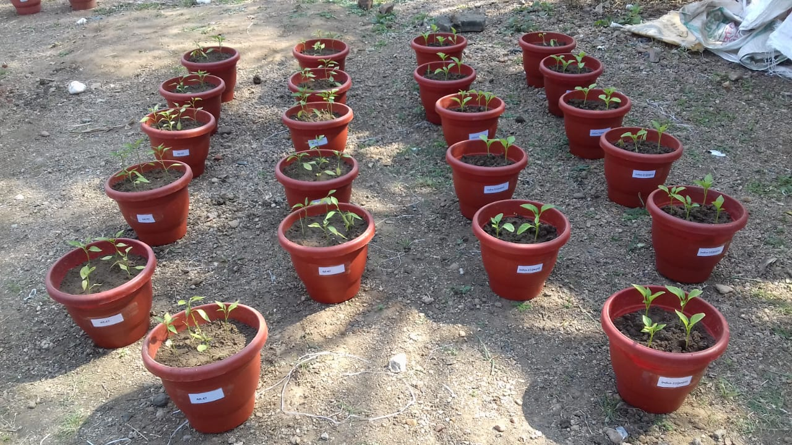
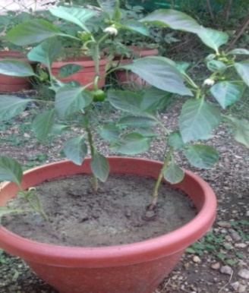
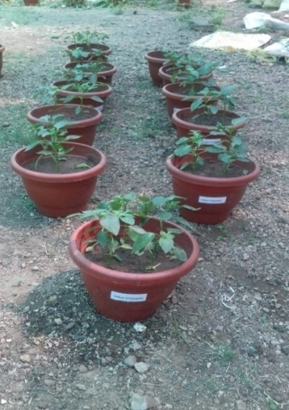
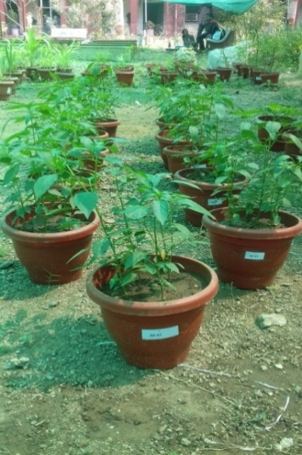
variety-AK-47
variety-Indum-11

(a) Pot culture for pathogenisity test
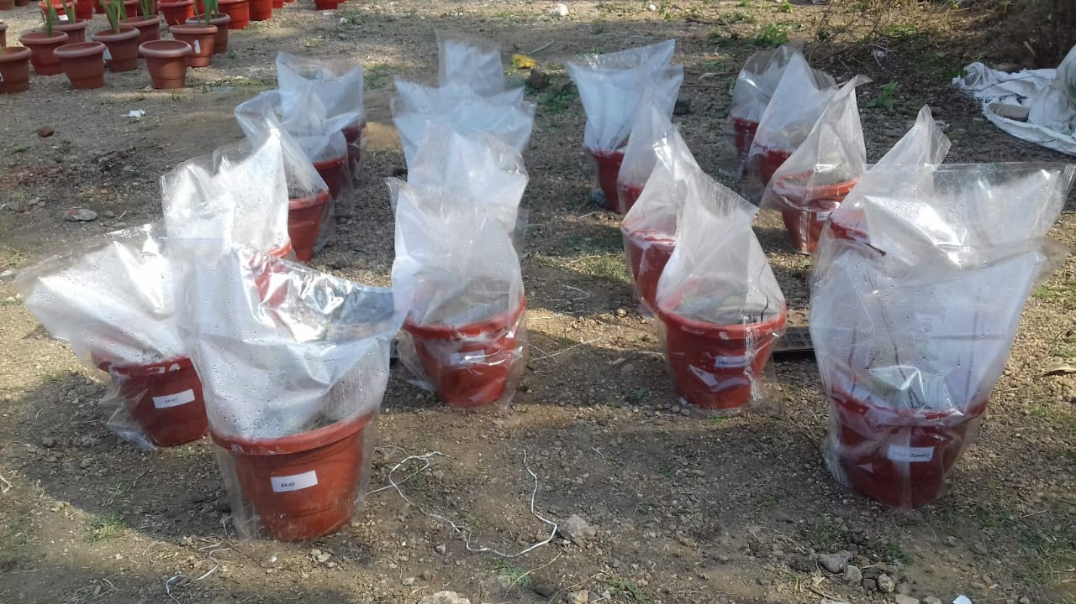
variety-AK-47
variety-Indum-11

(b) Humidity was maintain for pathogenisity test
Figure 2. (a) Pot culture for pathogenisity test; (b) Humidity was maintain for pathogenisity test

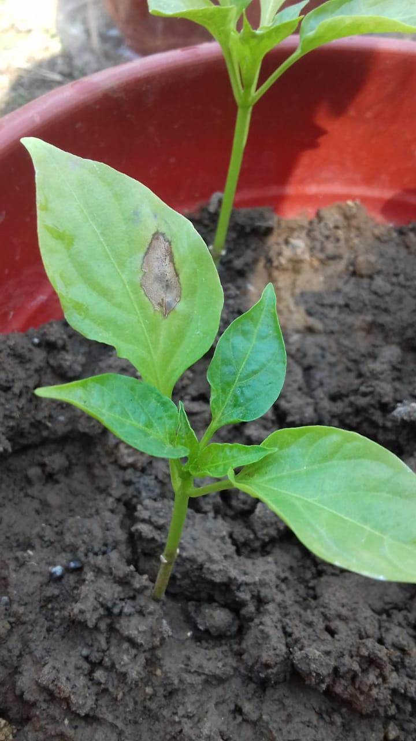
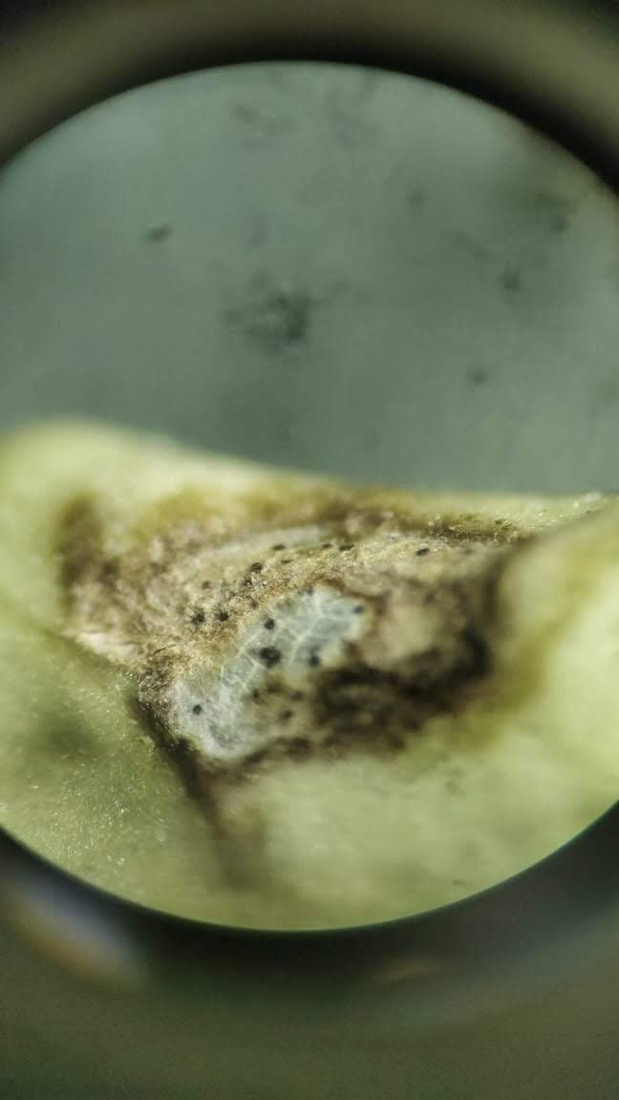
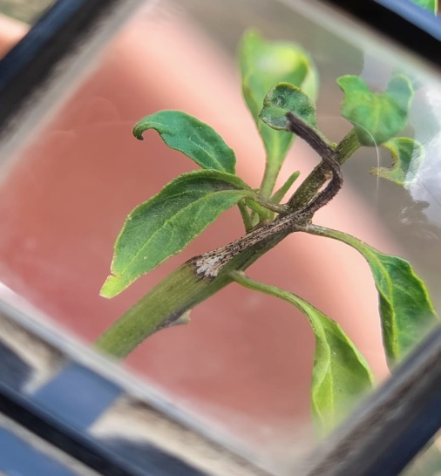
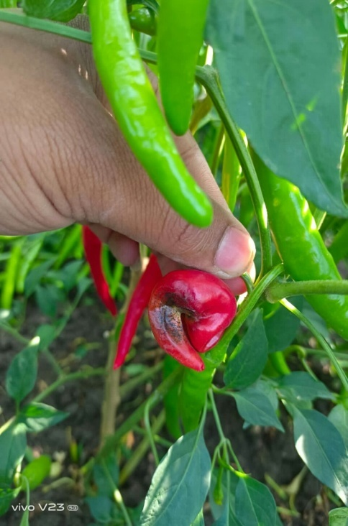
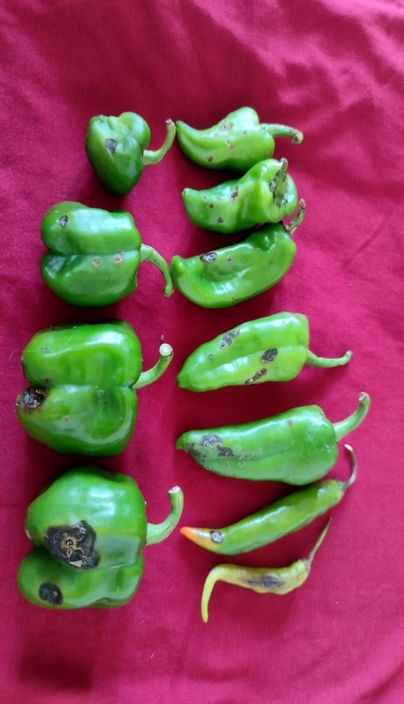
(a) Initial symptoms on leaves of variety Indum-11
(b) Stereoscopic image of acervuli on leaves
(c) Symptom on twig of variety AK-47
(d) Symptom on red fruit of chilli variety AK-47
(e) Symptoms on green fruits of capsicum variety-Indum-11
Figure 3. (a)-(e) Sypmtoms on different parts of chilli crop
3.2 Cultural characters of Isolated Pathogen
The variation in cultural characters of Colletotrichum capsici was studied on the five different solid media and the results thus obtained are presented in Table 1 Fig. 1 The radial growth, colony characters and sporulation of the fungus were recorded, when the maximum growth was attained on any one of the tested media. The effect of different culture media on the growth of fungi differed significantly.
Table 1. Growth of Colletotrichum capsici on different solid media
Treatments | Mean colony diameter (mm)
Treatments | 3 DAI | 5 DAI | 7 DAI
-Potato Dextrose Agar | 32.33 | 42.33 | 69.33
-Chilli extract agar | 0.00 | 19.66 | 40.66
-Malt extract Agar | 28.33 | 33.33 | 51.33
-Sabouraud’s Dextrose Agar | 24.33 | 39.33 | 59.33
-Czapek’s Dox Agar | 26.66 | 36.67 | 53.66
F Test | Sig | Sig | Sig
S.E. (+m) | 0.29 | 0.33 | 0.33
CD (P= 0.01) | 1.33 | 1.49 | 1.49

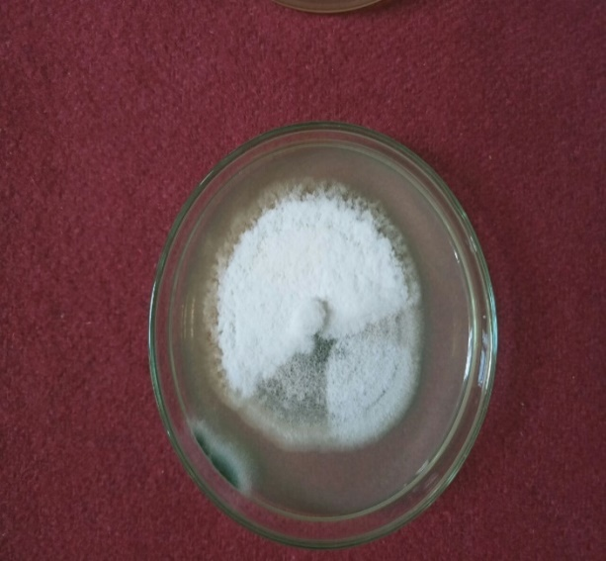
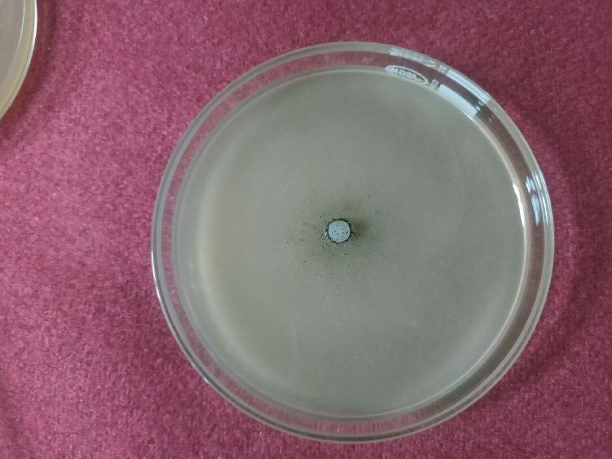
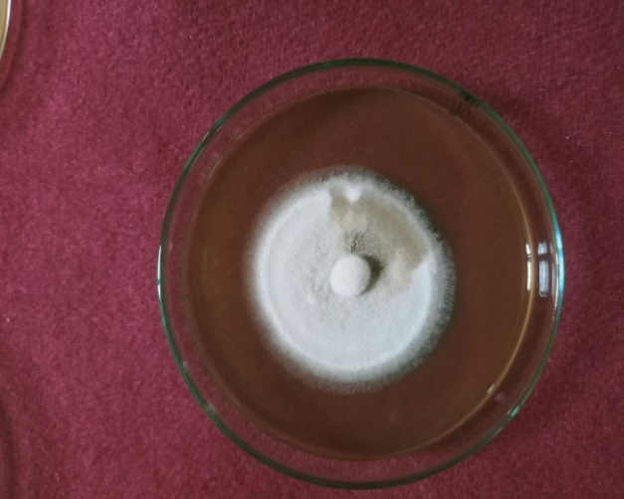
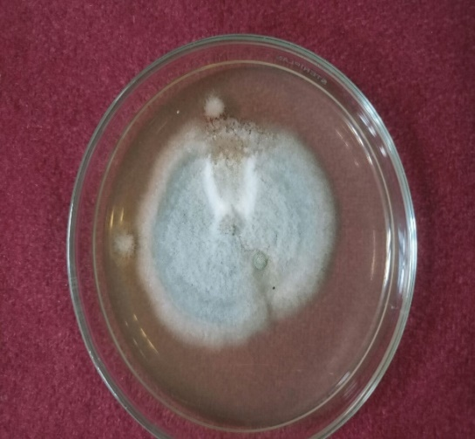
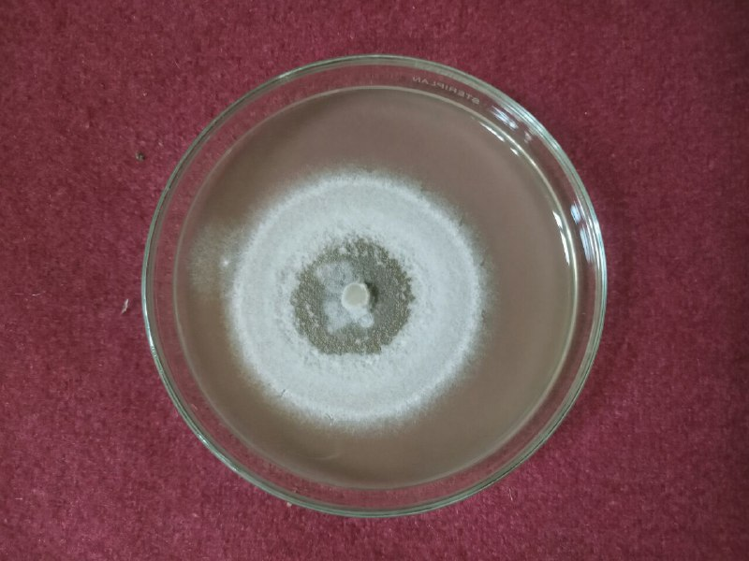
Figure 4. Growth of Colletotrichum capsici on different solid media
T₁
T₂
T₃
T₄
T₅

Fig. 1. Growth of Colletotrichum capsici on different solid media

Table 2. Cultural characteristics and sporulation of Colletotrichum capsici on different solid media after 7 days of Incubation

Media | Growth characteristic | Sporulation (10 DAI)
Potato Dextrose Agar | Greyish white colony with acervuli at periphery | ++
Chilli extract agar | Only acevuli are found | -
Malt extract Agar | White to greyish | -
Sabouraud’s Dextrose Agar | White to greyish colony colour with acervuli | +
Czapek’s Dox Agar | Whitish colour with concentric rings | +
Here,
- = No sporulation
+ = Good sporulation
++ = Excellent sporulation
The data present in table 1 maximum radial growth of C. capsici was recorded on PDA media (68mm), which was found to be significantly superior to all other media followed by Sabouraud’s dextrose agar, Czapek’s dox agar and malt extract agar. The least radial growth was recorded in chilli extract media (40mm). Mycelium colour varied from whitish to greyish. The growth varied from flat to raised and fluffy to sparse. Acervuli are found early on PDA followed by Sabouraud’s dextrose media and chilli extract, while acervuli were not recorded in Malt extract, Czapek media, and chilli extract agar. Sporulation also showed greater variation in different media, ranging from excellent to poor. Excellent sporulation was recorded on PDA Media, good sporulation in Sabouraud’s dextrose media, while sporulation was not recorded in Malt extract, Czapek media, and chilli extract agar.

Conclusion
The present investigation conclusively established the pathogenic nature of Colletotrichum capsici causing anthracnose in chilli through the successful fulfillment of Koch’s postulates. Artificial inoculation of susceptible chilli varieties resulted in the development of characteristic anthracnose symptoms, including necrosis of tender twigs and the formation of black acervuli, thereby confirming the virulence of the pathogen. Reisolation of the fungus from infected tissues further validated its role as the causal agent of the disease.
The study also revealed significant variation in the cultural behaviour of C. capsici across different solid media. Among the five media evaluated, Potato Dextrose Agar proved to be the most suitable for mycelial growth and sporulation, recording the maximum radial growth and excellent sporulation. Sabouraud’s Dextrose Agar and Czapek’s Dox Agar supported moderate growth and sporulation, while chilli extract agar exhibited the least growth and poor sporulation. Differences in colony morphology, pigmentation, texture, and acervuli formation across media highlighted the influence of nutrient composition on fungal growth and reproductive potential.
These findings provide valuable insights into the biology, growth preferences, and pathogenic behaviour of C. capsici. Identification of suitable culture media and confirmation of pathogenicity are essential prerequisites for further studies on disease epidemiology, host–pathogen interactions, and screening of effective management strategies. The information generated in this study can serve as a scientific basis for developing integrated and sustainable approaches for managing chilli anthracnose under field conditions.

Disclaimer (Artificial intelligence)
Author(s) hereby declare that NO generative AI technologies such as Large Language Models (ChatGPT, COPILOT, etc) and text-to-image generators have been used during writing or editing of manuscripts.

Reference

- Agrios, G. N. 2005. Plant Pathology, 5th Ed. Academic Press, San Diego, p.922. Anonymous, FAO (2010). FAO Production Year book 2010. Rome: FAO, p. 333.
- Akhtar, J., A. Kandan, B. Singh, P. Kumar and S. C. Dubey, 2016. Detached non-wounded fruit inoculation technique for pathogenicity of Colletotrichum capsici on chilli. Indian Phytopathology, 69(2): 200-201.
- Anonymous, 2021. Agricultural Statistics at a Glance 2021, Government of India, Ministry of Agriculture and Farmers Welfare, Department of Agriculture and Farmers Welfare, Directorate of Economicsand Statistics.
- Bailey, J. A. and M. J. Jeger (Eds.) 1992. Colletotrichum: Biology, Pathology and Control. Commonwealth Mycological Institute.
- Pakdeevaraporn, P., S. Wasee, P. W. J. Taylor and O. Mongkolporn, 2005. Inheritance of resistance to anthracnose caused by Colletotrichum capsici in Capsicum. Plant Breeding 124: 206- 208.
- Poonpolgul, S. (2007). Chili pepper anthracnose in Thailand. In The First International Symposium on Chili Anthracnose, Convention Center, Seoul National University, Korea, 2007 (Vol. 23).
- Prajapati, M. K., S. Rawat, P. Singh and K. Shankar, 2020. Cultural and morphological characterization of Colletotrichum capsici causing anthracnose of chilli (Capsicum anum L.). Journal of Pharmacognosy and Phytochemistry, 9(3): 1985-1989
- Sandee, Aphidech, Sarawut Sachan and Surasak Khankhum, 2011. Morphological, pathological and molecular variability of Colletotrichum capsici causing anthracnose of chilli in the North-east of Thailand. African Journal of Microbiology Research. 5(25): 4368-4372.
- Saxena, A., R. Raghuwanshi, V. K. Gupta and H. B. Singh, 2016. Chilli anthracnose: the epidemiology and management. Frontiers in microbiology, 7: p.1527.
- Sydow, H. 1913. Enumeration of Philippine fungi with notes and decriptions of new species, II. Philipp J. Sci, 8: 475-508.
- Than, P. P., H. Prihasturi, S. Phoulivong, P. W. J. Taylor and D. Hyde, 2008. Chilli anthracnose disease caused by Colletotrichum species. J. Zhejiang Univ Sci 9: 764-778.
- Thippeswamy, B., H. V. Sowmya and M. Krishnappa, 2011. Seed borne fungi of Vegetable crops in Karnataka. J. Pl. Dis. Sci. 6(1): 5-10.
- Wijesekara H. R. and D. K. Agarwal, 2006. Taxonomic studies on five species of the genus Colletotrichum. Indian Phytopathology, 59(2): 203-20.
- Yun, H. K., A. H. Ahmad, S. Muid and J. S. S. Seelan, 2009. First report of Colletotrichum spp. causing diseases on Capsicum spp. in Sabah, Borneo, Malaysia. Journal of Threatened Taxa, : 419-424.

