Review Article

The Role of Transgenic Crops in Reducing Agricultural Chemical Dependency: A Review

Abstract

The oldest way of agriculture has depended so much on chemical inputs like pesticides, herbicides, and synthetic manure to give security to crops and enhance productivity. Their use has resulted in environmental pollution, ecological imbalance and even risks caused to human health although these chemicals are resulting in high yields. Genetic engineering has become an option of developing transgenic crops that would limit reliance on agricultural chemicals. Transgenic plants are those that contain new foreign genes that are more suited to add desirable traits to the plants like insect resistance, herbicide tolerance and disease resistance. These characteristics allow crops to be self-defensive against pests and pathogens, so they would not require useful repetitive applications of chemicals. A number of researches have indicated that there are massive declines in the use of insecticides since the introduction of genetically modified crops like Bt cotton and Bt maize. On the same note, various world evaluations have indicated that there was a decline in pesticide use, as well as enhancement in environmental sustainability related to transgenic crops. Nevertheless, with the introduction of herbicide-tolerant crops, there has also been the concern of increased usage of herbicides because they develop resistance to them. The present review article is a critical review of how transgenic crops can help farmers reduce their chemical dependency in agriculture. The paper examines the ways genetically engineered crops lessen the use of pesticides, the significant transgenic crop technologies, the effects of transgenic crops on the environment and socio-economically, and the obstacles that have been encountered when adopting the use of transgenic crops. This review is based on the synthesis of available research and consequently offers an allround picture of the role played by transgenic crops in efforts to achieve sustainable agricultural systems.

Keywords - Transgenic crops, genetically modified crops, Bt crops, pesticide reduction, agricultural sustainability, biotechnology in agriculture, herbicide tolerance

1. Introduction
The world food demand has been increasing because of the growing population, urbanization and changing food habits. In this regard, the modern world of agriculture has high dependence on chemical input such as pesticides, herbicides, fungicides and synthetic fertilizers to satisfy this demand. Although these inputs have greatly augmented crop production, there have been serious environmental and health concerns, which have been brought about by over use. Chemical pesticides have the potential to pollute soil and water resources, limit biodiversity and harm non-target organisms like useful insects and pollinators. The use of agricultural biotechnology has come in as one of the radical ways of alleviating these challenges. Yanhui Lu et al. were able to show that large-scale production of Bt cotton resulted in the decreased use of insecticides and increased natural biological control services in the way of agricultural ecosystems. Genetic engineering can help researchers to insert certain genes in the genomes of crops, which have transgenic plants that possess better agronomic characteristics. These characteristics are insect resistance, herbicide resistance, disease resistance, enhanced nutritive value and tolerance to environmental challenges. Kleter et al. have described that the major trait transferred to transgenic crops is increased efficiency in pest management, especially insect resistance and herbicide resistance. These characteristics minimize the use of chemical interventions as crops can be used in the defense against pests and weeds. The mid-1990s was the time when transgenic crops were introduced and it was a crucial step in the sphere of agricultural technology. Genetically engineered crops like Bt cotton, Bt maize, herbicide-tolerant soybean and canola quickly found acceptance all over the world because of their economic and agronomic advantages. Another study by Manda et al. has found that the production of transgenic cotton lowering the level of insecticides application with similar outputs with the traditional varieties. Moreover, research articles published by the international organizations show that insect-resistant transgenic crops are able to significantly decrease the use of pesticides and environmental pollution. Regardless of these advantages, there are still debates on the longterm sustainability of transgenic crop technologies. Insect-resistant crops have also evidently reduced the extent of insecticide use, but herbicide-tolerant crops could be the cause of increased herbicide application in some farming systems. Herbicide resistant wastes Some herbicide-tolerant crop systems have occasionally increased the amount of herbicides used because of the evolution of herbicide resistant weeds. This review will look at scientific evidence on whether transgenic crops help to reduce agricultural chemical dependency. The article summarizes the existing research findings and discusses the benefits of the transgenic crop technologies as well as their shortcomings.

2. Concept of Transgenic Crops
Transgenic crops are plants which have undergone genetic engineering procedures to enable foreign genes, which do not belong to the organism, to be introduced in their genome. These genes encode characteristics that improve crop productivity, resilience as well as quality. Nayak et al. suggest that transgenic crops are generated by passing on genes of one organism to another to confer them with resistance to biotic and abiotic stresses. The process of developing transgenic plants involves several steps which is shown in figure 1.
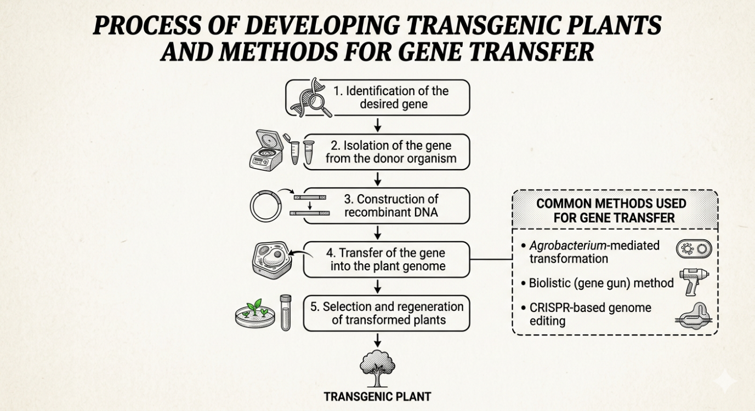
Figure 1. The steps involed in the process of developing transgenic plants (Source: Author’s schematic illustration based on literature review, 2026).

In agriculture, the ultimate goal of the genetic engineering is to increase crop characteristics that are more productive and sustainable. Kumar et al. suggested that genetically modified crops are able to be developed to be resistant to pests, environmental stresses, and they should enhance the nutritional quality. These alterations enable plants to carry out tasks which would have been done by some chemical manipulations.

3. Agricultural Chemical Dependency

Modern agriculture has developed to a place where chemical inputs form a fundamental part of the process. Farmers use pesticide and herbicides to combat the pests, diseases and weeds that may interfere with crop productivity. There are however a few problems caused by overdependence on these chemicals which is shown in figure 2.
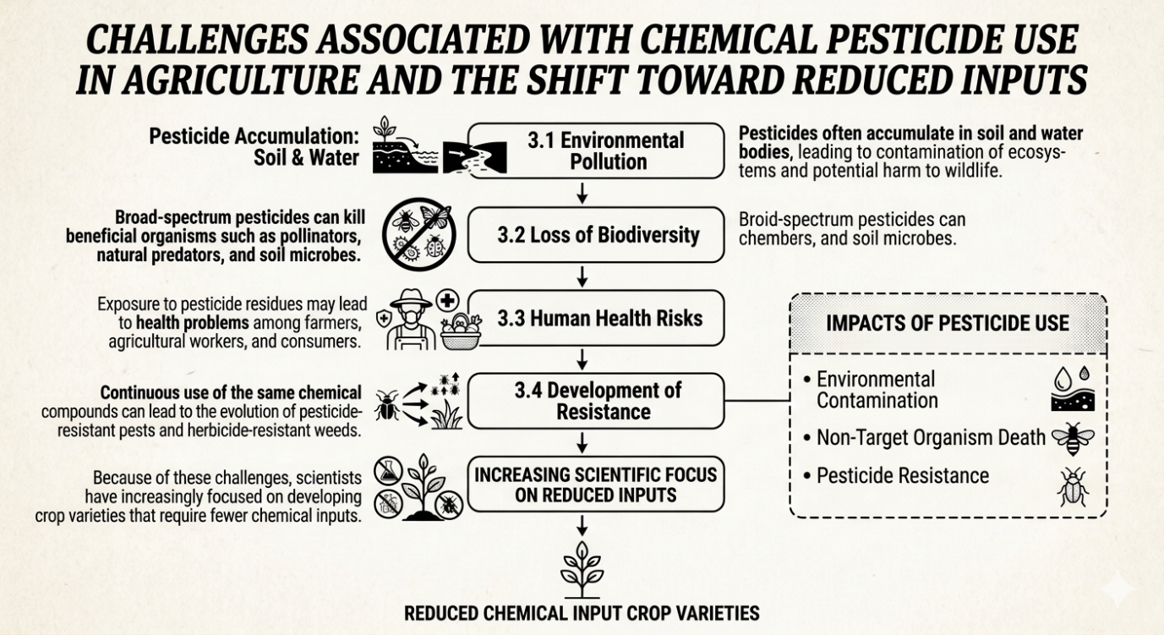
Figure 2. Challenges associated with chemical pesticide use in agriculture and the shift toward reduced inputs. (Source: Author’s schematic illustration based on literature review, 2026).

3.1 Environmental Pollution

The extensive application of chemical pesticides in agriculture has led to widespread environmental contamination. Many pesticide compounds persist in the environment and accumulate in soil, groundwater, and surface water systems. These chemicals may spread beyond agricultural fields through runoff, leaching, and atmospheric drift, contaminating surrounding ecosystems and affecting non-target organisms. Such contamination has been reported globally and represents a major environmental concern associated with modern agricultural practices (Brühl & Zaller, 2019; Albaseer et al., 2024). Long-term accumulation of pesticide residues in environmental compartments can disrupt ecological balance and threaten aquatic organisms, birds, and other wildlife.

3.2 Loss of Biodiversity

Another major consequence of excessive pesticide use is the decline in biodiversity. Broad-spectrum pesticides are designed to eliminate pests, but they often harm beneficial organisms such as pollinators, natural pest predators, and soil microorganisms. Pollinators such as bees play a crucial role in ecosystem functioning and crop production, yet many studies have linked pesticide exposure to declines in pollinator populations and disruptions in plant–pollinator interactions (Riaz, 2020; Feng, 2025). The reduction of beneficial organisms weakens ecological resilience and may negatively affect agricultural productivity in the long term.

3.3 Human Health Risks

Human health risks associated with pesticide exposure have also been widely documented. Agricultural workers, farmers, and pesticide applicators are particularly vulnerable to direct exposure during mixing, handling, and spraying activities. In addition, pesticide residues can remain on food products and enter the human body through dietary intake. Long-term exposure to certain pesticides has been linked to a range of health issues, including neurological disorders, respiratory problems, endocrine disruption, and various chronic diseases (Bhavsar et al., 2025). These concerns have prompted increased attention toward safer pest management strategies and stricter regulations on pesticide usage.

3.4 Development of Resistance

Continuous and excessive use of the same chemical pesticides can result in the development of resistant pest populations. Through natural selection, pests that possess resistance genes survive pesticide applications and reproduce, gradually increasing the proportion of resistant individuals within the population. Over time, this process can render pesticides ineffective, forcing farmers to apply higher doses or switch to new chemicals (Hawkins et al., 2019; Brevik et al., 2018). The emergence of pesticide-resistant insects and herbicide-resistant weeds has become a major challenge in global agriculture, highlighting the need for sustainable pest management strategies (Washim et al., 2024).

Because of these challenges, scientists and agricultural researchers have increasingly focused on developing crop varieties that require fewer chemical inputs, particularly through biotechnology and transgenic crop development.

4. 4. Mechanisms Through Which Transgenic Crops Reduce Chemical Use

Transgenic crops contribute to the reduction of agricultural chemical inputs through several biological and agronomic mechanisms. By incorporating specific genes that confer resistance to pests, tolerance to herbicides, or protection against plant pathogens, genetically engineered crops help minimize the reliance on conventional pesticides, herbicides, and fungicides. These mechanisms not only enhance crop protection but also support more sustainable agricultural practices.

4.1 Insect Resistance

One of the most widely adopted applications of genetic engineering in agriculture is the development of insect-resistant crops through the introduction of genes derived from the bacterium Bacillus thuringiensis (Bt). These genes encode insecticidal proteins (Cry toxins) that are highly specific to certain insect pests while remaining safe for humans, animals, and most non-target organisms.

When susceptible insect larvae feed on Bt-expressing plants, the Cry proteins bind to receptors in the insect midgut, causing pore formation in the gut membrane and ultimately leading to larval death. This targeted mode of action provides effective pest control while significantly reducing the need for broad-spectrum chemical insecticides.

Studies conducted by Lu and Wu (2011) demonstrated that the widespread adoption of Bt cotton in China substantially decreased insecticide use and simultaneously increased the abundance of beneficial arthropods, including predators and parasitoids. Such ecological benefits highlight the potential of transgenic crops to integrate effectively with biological pest control strategies and reduce environmental contamination associated with chemical pesticides.

4.2 Herbicide Tolerance

Herbicide-tolerant transgenic crops represent another important innovation aimed at improving weed management efficiency. These crops are genetically engineered to tolerate specific herbicides, allowing farmers to apply the herbicide directly over the crop without causing damage. This approach simplifies weed control and can reduce the total number of herbicide applications required during the growing season.

Common examples of herbicide-tolerant crops include:
- Glyphosate-tolerant soybean
- Herbicide-tolerant maize
- Herbicide-tolerant cotton

The introduction of glyphosate-tolerant cropping systems has enabled farmers to replace multiple herbicide treatments with a single broad-spectrum herbicide, thereby reducing the complexity of weed management. However, Duke and Carvalho (2008) emphasize that the sustainability of herbicide-tolerant systems depends on responsible management practices. Continuous reliance on a single herbicide can lead to the evolution of herbicide-resistant weed populations, highlighting the importance of integrated weed management strategies.

4.3 Disease Resistance

Genetic engineering has also enabled the development of crop varieties with enhanced resistance to viral, bacterial, and fungal pathogens. By incorporating genes that confer resistance to specific diseases, transgenic crops can prevent or significantly reduce the occurrence of major plant diseases.

Examples of disease-resistant transgenic crops include:
- Virus-resistant papaya developed to combat Papaya Ringspot Virus
- Late-blight-resistant potato
- Bacterial disease-resistant rice

The deployment of these crops helps minimize yield losses and reduces the need for chemical fungicides and bactericides. For instance, the successful adoption of virus-resistant papaya in Hawaii restored papaya production that had been severely threatened by viral disease outbreaks. Such developments illustrate how biotechnology can contribute to sustainable plant disease management while lowering chemical inputs.

4.4 Enhancement of Biological Control

The reduction in pesticide applications associated with transgenic crops can also promote the conservation of beneficial organisms within agricultural ecosystems. Natural enemies such as predators, parasitoids, and pollinators often suffer from exposure to conventional insecticides. Lower pesticide usage in transgenic crop systems allows these beneficial species to survive and thrive.
Research findings indicate that Bt crop cultivation can lead to increased populations of natural enemies, thereby strengthening biological pest control mechanisms. The presence of these beneficial organisms contributes to long-term pest suppression and improves ecological balance within cropping systems. Consequently, transgenic crops may facilitate the integration of biotechnology with ecological pest management approaches, promoting more resilient and environmentally friendly agricultural systems.

Global Adoption of Transgenic Crops
The global adoption of transgenic crops has expanded significantly since their commercial introduction in the mid-1990s. Genetically engineered crops have been developed primarily to improve agricultural productivity, enhance resistance to pests and diseases, and reduce dependence on chemical pesticides and herbicides. Over the past three decades, these crops have been integrated into agricultural systems across both developed and developing countries, demonstrating substantial agronomic, environmental, and economic impacts.
Since the first commercial cultivation of genetically modified crops in 1996, the total global area under transgenic cultivation has increased dramatically. According to James (2017), the global biotech crop area expanded from 1.7 million hectares in 1996 to over 190 million hectares by 2017. Major transgenic crops include soybean, maize, cotton, and canola, which together account for the majority of genetically engineered crop production worldwide. Traits such as herbicide tolerance and insect resistance—particularly those incorporating Bacillus thuringiensis (Bt) genes—have been widely adopted due to their effectiveness in reducing pest damage and improving yield stability (Qaim & Kouser, 2013).
The United States, Brazil, Argentina, Canada, and India represent the largest adopters of transgenic crops. In the United States and Brazil, large-scale commercial farming and strong biotechnology industries have accelerated adoption rates (Brookes & Barfoot, 2020). In contrast, developing countries such as India have primarily adopted Bt cotton, which has significantly improved yields and farmer incomes while reducing insecticide use (Kathage & Qaim, 2012). The successful adoption of Bt cotton in India illustrates the potential of transgenic technology to benefit smallholder farmers by increasing productivity and reducing production costs.
Despite these advantages, the global adoption of transgenic crops varies considerably across regions due to regulatory frameworks, public perception, and biosafety concerns. Many European countries maintain strict regulations on genetically modified organisms (GMOs), limiting their cultivation despite extensive research supporting their safety (Pellegrino et al., 2018). Conversely, countries in Latin America and Asia have increasingly embraced transgenic technology as a tool for addressing food security and agricultural sustainability.
Furthermore, advancements in biotechnology have led to the development of next-generation transgenic crops with improved nutritional quality, drought tolerance, and climate resilience. Examples include biofortified crops such as Golden Rice and drought-tolerant maize varieties designed to support agriculture under changing climatic conditions (Baulcombe et al., 2014). These innovations highlight the potential of genetic engineering to contribute to global food security while reducing environmental impacts.
Overall, the widespread adoption of transgenic crops reflects their growing importance in modern agriculture. Continued research, transparent regulatory systems, and public engagement will be essential to ensure responsible development and sustainable integration of this technology into global food production systems.
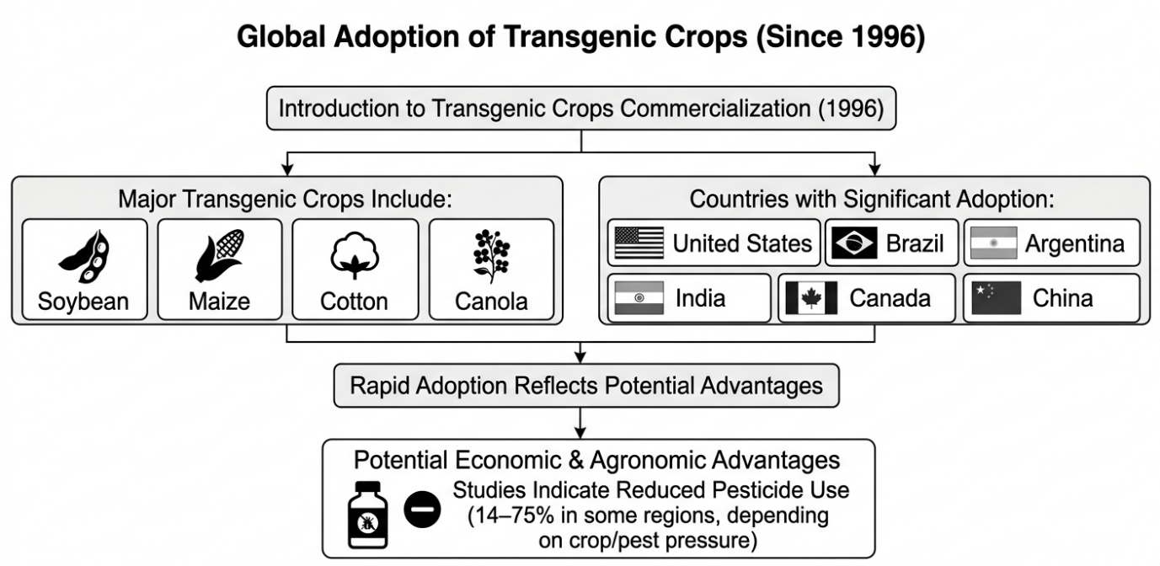

Figure 3. Flowchart of global adaptation of transgenic crops

6. Major Types of Transgenic Crops
Since the commercialization of genetically engineered crops in the mid-1990s, several types of transgenic plants have been developed to address different agricultural challenges. These crops primarily aim to enhance pest resistance, herbicide tolerance, disease resistance, and tolerance to environmental stresses. The most widely cultivated transgenic crops include insect-resistant crops, herbicide-tolerant crops, and crops engineered for disease resistance. According to James Clive, the global adoption of genetically engineered crops has increased significantly since their introduction, demonstrating their effectiveness in improving agricultural productivity and reducing chemical input requirements. The rapid adoption of these crops reflects their agronomic and economic advantages for farmers.

6.1 Insect-Resistant Crops (Bt Crops)
Insect-resistant crops represent one of the most successful applications of agricultural biotechnology. These crops contain genes derived from the soil bacterium Bacillus thuringiensis (Bt), which produces insecticidal proteins known as Cry toxins. These proteins specifically target certain insect pests without causing harm to humans, animals, or most beneficial insects. Research conducted by Lu et al. demonstrated that widespread cultivation of Bt cotton significantly reduced insecticide applications and promoted the survival of beneficial arthropods in agricultural ecosystems. Their findings indicated that Bt crops can enhance natural pest control mechanisms while reducing reliance on chemical pesticides. Similarly, Qaim and Zilberman reported that the adoption of Bt cotton in developing countries led to substantial reductions in pesticide use and increased farm profitability. Their research emphasized the positive impact of genetically engineered crops on both environmental sustainability and farmer livelihoods.
The most widely grown insect-resistant crops include:
- Bt cotton
- Bt maize
- Bt eggplant (brinjal)
- Bt soybean
Among these, Bt cotton has had a particularly significant impact in countries such as India, China, and the United States.

6.2 Herbicide-Tolerant Crops
Herbicide-tolerant crops are genetically engineered to withstand applications of specific herbicides that would otherwise kill conventional crops. This technology allows farmers to control weeds more effectively by applying herbicides without damaging the crop itself. According to Duke and Carvalho, herbicide-tolerant crops have simplified weed management practices and enabled farmers to adopt conservation tillage systems that reduce soil erosion.
Common herbicide-tolerant crops include:
- Glyphosate-tolerant soybean
- Herbicide-tolerant maize
- Herbicide-tolerant cotton
- Herbicide-tolerant canola
Although herbicide-tolerant crops have improved weed control efficiency, some studies suggest that prolonged use of a single herbicide may lead to the emergence of herbicide-resistant weeds. Benbrook highlighted that increased reliance on glyphosate in herbicide-tolerant crop systems has contributed to the development of resistant weed populations in several agricultural regions. This issue underscores the importance of integrated weed management strategies.

6.3 Disease-Resistant Transgenic Crops
Plant diseases caused by viruses, bacteria, and fungi can significantly reduce agricultural productivity. Genetic engineering has enabled the development of crops that possess enhanced resistance to specific pathogens. For example, virus-resistant papaya was developed to combat the papaya ringspot virus, which had severely affected papaya production in Hawaii. Research by Gonsalves demonstrated that transgenic papaya effectively controlled the virus and restored the papaya industry. Similarly, efforts are underway to develop transgenic crops resistant to major fungal diseases such as late blight in potato and rice blast in rice. These innovations can reduce the need for fungicide applications and improve crop yields.

7. Case Studies of Transgenic Crops
Examining specific examples of transgenic crops provides valuable insights into their effectiveness in reducing agricultural chemical dependency.

7.1 Bt Cotton
Bt cotton is one of the most widely adopted genetically engineered crops worldwide. It contains genes from Bacillus thuringiensis that produce proteins toxic to certain insect pests, particularly bollworms. According to Qaim, Bt cotton adoption has significantly reduced insecticide applications in cotton-producing regions. Farmers cultivating Bt cotton often require fewer pesticide sprays compared to those growing conventional varieties. In India, the introduction of Bt cotton in 2002 led to a substantial increase in cotton yields and a reduction in pesticide use. Studies conducted by Keshav et al. reported that insecticide use in cotton cultivation declined dramatically after the adoption of Bt cotton. Furthermore, research by Yanhui Lu and Kongming Wu found that the widespread adoption of Bt cotton in China not only reduced pesticide use but also benefited neighboring crops by reducing pest populations.

7.2 Bt Maize
Bt maize is engineered to express insecticidal proteins that protect the crop from pests such as the European corn borer and corn rootworm. Research conducted by Graham et al. demonstrated that Bt maize significantly reduced pest damage and decreased the need for chemical insecticides. Additionally, studies have shown that Bt maize cultivation contributes to lower levels of mycotoxin contamination in maize grains. This is because insect damage often facilitates fungal infections that produce harmful toxins.

7.3 Herbicide-Tolerant Soybean
Herbicide-tolerant soybean varieties have revolutionized weed management in soybean production systems. According to Mortensen, herbicide-tolerant crops have simplified weed control practices and reduced the need for multiple herbicide applications. However, the emergence of herbicide-resistant weeds has prompted researchers to recommend integrated weed management approaches that combine chemical, biological, and mechanical control methods.

7.4 Bt Brinjal
Bt brinjal is a genetically engineered eggplant developed to resist the fruit and shoot borer, a major pest responsible for significant yield losses. Research by Shelton et al. showed that Bt brinjal dramatically reduced pesticide applications while improving crop yields. Farmers cultivating Bt brinjal reported fewer pest infestations and reduced labor costs associated with pesticide spraying.

8. Environmental Benefits of Transgenic Crops
The adoption of transgenic crops can contribute to environmental sustainability in several ways.

8.1 Reduction in Pesticide Use
One of the most significant environmental benefits of transgenic crops is the reduction in pesticide applications. According to Brookes and Barfoot, genetically engineered crops have contributed to a substantial reduction in pesticide use globally. Their analyses indicated that transgenic crops have reduced the environmental impact of pesticide use by lowering the volume of chemicals applied in agriculture. Reduced pesticide applications can lead to improved soil health, reduced water contamination, and enhanced biodiversity.

8.2 Conservation of Beneficial Insects
Chemical pesticides often harm beneficial insects such as pollinators and natural predators of pests. Studies conducted by Lu and Wu demonstrated that reduced pesticide use in Bt crop systems allows beneficial insects to thrive, thereby enhancing natural pest control. This ecological benefit strengthens integrated pest management systems and contributes to sustainable agriculture.

8.3 Reduction in Greenhouse Gas Emissions
Herbicide-tolerant crops facilitate conservation tillage practices, which reduce soil disturbance and decrease greenhouse gas emissions associated with agricultural activities. According to Brookes and Barfoot, the adoption of conservation tillage made possible by herbicide-tolerant crops has contributed to lower carbon emissions in agricultural systems.

8.4 Soil Conservation
Conservation tillage practices associated with herbicide-tolerant crops reduce soil erosion and improve soil structure. These practices help maintain soil fertility and promote sustainable agricultural production.

9. Socio-Economic Impacts of Transgenic Crops
The adoption of transgenic crops has significant socio-economic implications for farmers, consumers, and agricultural industries.

9.1 Increased Farmer Income
Several studies have reported increased farm income following the adoption of genetically engineered crops. Research by Qaim and Rashid indicated that Bt crop adoption in developing countries improved farm profitability due to higher yields and reduced pesticide costs.

9.2 Improved Farmer Health
Reduced pesticide applications also improve the health and safety of farmers. Farmers who previously applied large quantities of chemical pesticides may experience fewer health risks when cultivating insect-resistant transgenic crops.

9.3 Food Security
Transgenic crops can contribute to food security by increasing crop productivity and reducing yield losses caused by pests and diseases. According to Andersen and Schiøler, agricultural biotechnology has the potential to play a crucial role in addressing global food security challenges.

10. Biosafety and Ecological Concerns of Transgenic Crops
Despite the numerous advantages of genetically engineered crops, concerns have been raised regarding their potential ecological and biosafety impacts. These concerns mainly relate to gene flow, development of resistant pests, effects on non-target organisms, and long-term ecosystem stability.

10.1 Gene Flow and Genetic Contamination
Gene flow refers to the movement of genes from transgenic crops to wild relatives or non-genetically modified crops through cross-pollination. Such gene transfer could potentially lead to the spread of transgenes into natural ecosystems. Research conducted by Snow and Andow highlighted that gene flow between transgenic crops and related plant species is possible under certain environmental conditions. If transgenes confer competitive advantages, they may persist in wild plant populations. However, regulatory agencies and biosafety frameworks require extensive environmental risk assessments before transgenic crops are approved for cultivation.

10.2 Development of Pest Resistance
Continuous exposure of insect pests to Bt toxins may lead to the evolution of resistant pest populations. This phenomenon is similar to pesticide resistance observed in conventional pest control systems. Studies by Tabashnik et al. demonstrated that resistance development can occur if proper resistance-management strategies are not implemented.
To mitigate this risk, scientists recommend strategies such as:
- Refuge planting (growing non-Bt crops near Bt crops)
- Crop rotation
- Integrated pest management practices
These approaches help slow the development of resistant insect populations.

10.3 Impact on Non-Target Organisms
One of the early concerns surrounding transgenic crops was their potential impact on beneficial organisms such as pollinators, natural predators, and soil microbes. Research by Shelton et al. showed that Bt crops generally have minimal negative effects on non-target organisms compared to conventional pesticide applications. In fact, reduced pesticide use often benefits beneficial insect populations by reducing chemical exposure.

10.4 Biodiversity Considerations
Biodiversity is essential for maintaining ecosystem stability and resilience. Some critics argue that large-scale adoption of transgenic crops may reduce agricultural biodiversity by encouraging monoculture systems. However, Qaim and Zilberman noted that biotechnology itself does not necessarily reduce biodiversity; rather, farming practices determine biodiversity outcomes. Integrated agricultural management strategies can maintain biodiversity while benefiting from transgenic crop technologies.

11. Challenges and Limitations of Transgenic Crops
Although transgenic crops offer significant benefits, several challenges must be addressed to ensure their sustainable use.

11.1 Regulatory and Policy Barriers
Many countries have strict regulatory frameworks governing the approval and cultivation of genetically modified crops. According to Kuzma and VerHage, regulatory policies vary widely across countries, which can limit the adoption and commercialization of transgenic crops. Complex approval processes can delay the introduction of beneficial technologies.

11.2 Public Perception and Ethical Concerns
Public acceptance of genetically modified crops remains a major challenge in many regions. Concerns about food safety, environmental risks, and ethical considerations have contributed to resistance against genetically engineered crops. Research by Brossard and Scheufele suggests that public perception is strongly influenced by trust in regulatory institutions and access to reliable scientific information. Improving public awareness and transparency in biotechnology research may help address these concerns.

11.3 Emergence of Herbicide-Resistant Weeds
The widespread use of herbicide-tolerant crops has led to the development of herbicide-resistant weed species in some agricultural systems. According to Mortensen et al. repeated use of the same herbicide can accelerate the evolution of resistant weeds.To prevent this issue, integrated weed management strategies that combine multiple control methods are recommended.

11.4 Economic Accessibility
The high cost of transgenic seeds can limit access for smallholder farmers in developing countries. Although some studies indicate that transgenic crops increase farm income, initial seed costs may still pose barriers to adoption. Policies supporting affordable biotechnology access could help address this challenge.

12. Future Prospects of Transgenic Crops
Advances in biotechnology are expected to further enhance the potential of genetically engineered crops.

12.1 Genome Editing Technologies
Modern genome editing tools such as CRISPR-Cas systems enable precise modifications in plant genomes. According to Doudna and Charpentier, CRISPR technology allows targeted genetic modifications without introducing foreign DNA, which may improve public acceptance of genetically engineered crops.These technologies can accelerate the development of crops with improved resistance to pests, diseases, and environmental stresses.

12.2 Climate-Resilient Crops
Climate change poses significant challenges to global agriculture, including drought, heat stress, and emerging pest outbreaks. Genetic engineering can help develop crops capable of tolerating extreme environmental conditions. Research by Ronald highlights the potential of biotechnology to produce crops that can withstand climate stress while maintaining productivity.

12.3 Nutritionally Enhanced Crops
Biotechnology can also improve the nutritional quality of crops. One notable example is Golden Rice, which has been engineered to produce beta-carotene, a precursor of vitamin A. Studies by Potrykus and Beyer demonstrated that Golden Rice could help address vitamin A deficiency in developing countries.

12.4 Integration with Sustainable Agriculture
Future agricultural systems will likely integrate biotechnology with sustainable farming practices such as precision agriculture, integrated pest management, and agroecology. Combining these approaches can reduce chemical dependency while maintaining high crop productivity.
Conclusion
Transgenic crops represent one of the most significant technological innovations in modern agriculture. By introducing specific genes that confer desirable traits such as insect resistance, herbicide tolerance, and disease resistance, genetically engineered crops can reduce reliance on chemical inputs. Numerous studies have demonstrated that insect-resistant crops such as Bt cotton and Bt maize significantly reduce pesticide use while improving crop yields. These benefits contribute to environmental sustainability by reducing chemical pollution, protecting beneficial organisms, and promoting ecological balance. However, the adoption of transgenic crops also raises important challenges related to biosafety, pest resistance, regulatory policies, and public perception. Addressing these challenges requires robust scientific research, effective regulatory frameworks, and transparent communication with the public. Advances in biotechnology, particularly genome editing technologies, are expected to further enhance the potential of transgenic crops in the coming decades. These innovations could play a critical role in developing climate-resilient crops, improving nutritional quality, and ensuring global food security. Overall, when combined with sustainable agricultural practices, transgenic crops have the potential to significantly reduce agricultural chemical dependency and contribute to a more sustainable and resilient food production system.
References
Ackermann, J. D. (2014). Rapid transformation of orchid floras. Lankesteriana, 13(3), 157–164. https://doi.org/10.15517/lank.v13i3.14349
Afoakwa, E. O., Paterson, A., & Fowler, M. (2007). Factors influencing rheological and textural qualities in chocolate – a review. Trends in Food Science & Technology, 18(6), 290–298. https://doi.org/10.1016/j.tifs.2007.02.002
Bajor, Z., Zimmermann, Z., Szabó, G., Fehér, Z., Járdi, I., Lampert, R., Kerény-Nagy, V., Penksza, P., Lisztes-Szabó, Z., & Székely, Z. (2016). Effect of conservation management practices on sand grassland vegetation in Budapest, Hungary. Applied Ecology and Environmental Research, 14(3), 233–247. https://doi.org/10.15666/aeer/1403_233247
Benke, S. (2003). Impact of grazing on the protected flora and fauna of the Fenékpuszta area of the Balaton Uplands National Park. Bachelor’s thesis, Károly Róbert College, Gyöngyös, Hungary.
Besnyői, V., Szerdahelyi, T., Bartha, S., & Penksza, K. (2012). Early effects of cessation of mowing on the species composition of wet meadows in Western Hungary. Gyepgazdálkodási Közlemények, 10, 13–20.
Bölöni, J., Molnár, Z., & Kun, A. (2001). Habitats in Hungary: Description and identification guide of the Hungarian vegetation types. Vácrátót, Hungary: MTA ÖBKI.
Boyer, J., & Liu, R. H. (2004). Apple phytochemicals and their health benefits. Nutrition Journal, 3, 5. https://doi.org/10.1186/1475-2891-3-5
Burnside, N. G., Joyce, C. B., Puurmann, E., & Scott, D. M. (2007). Use of vegetation classification and plant indicators to assess grazing abandonment in Estonian coastal wetlands. Journal of Vegetation Science, 18(5), 645–654. https://doi.org/10.1111/j.1654-1103.2007.tb02578.x
Carriere, Y., Ellers-Kirk, C., Sisterson, M., Antilla, L., Whitlow, M., Dennehy, T., & Tabashnik, B. (2003). Long-term regional suppression of pink bollworm by Bacillus thuringiensis cotton. Proceedings of the National Academy of Sciences USA, 100(4), 1519–1523. https://doi.org/10.1073/pnas.0337707100
Cohen, M. J. (2006). The roots of sustainability science: A tribute to Gilbert F. White. Sustainability: Science, Practice and Policy, 2(2), 1–3. https://doi.org/10.1080/15487733.2006.11907978
DeFrancesco, L. (2013). How safe does transgenic food need to be? Nature Biotechnology, 31, 794–802. https://doi.org/10.1038/nbt.2686
Dobay, G., Dobay, B., Saláta-Falusi, E., Hajnáczki, S., Penksza, K., Bajor, Z., Lampert, R., Bakó, G., Wichmann, B., & Szerdahelyi, T. (2017). Effects of sport tourism on temperate grassland communities. Applied Ecology and Environmental Research, 15(2), 457–472. https://doi.org/10.15666/aeer/1502_457472
Doudna, J. A., & Charpentier, E. (2014). The new frontier of genome engineering with CRISPR-Cas9. Science, 346(6213), 1258096. https://doi.org/10.1126/science.1258096
Erdős, L., Bátori, Z., Penksza, K., Dénes, A., Kevey, B., Kevey, D., Magnes, M., Sengl, P., & Tölgyesi, C. (2017). Can naturalness indicator values reveal habitat degradation? Polish Journal of Ecology, 65(1), 1–13. https://doi.org/10.3161/15052249PJE2017.65.1.001
Ferretti, G., Neri, D., & Bacchetti, T. (2014). Effect of Italian sour cherry (Prunus cerasus L.) on the formation of advanced glycation end products and lipid peroxidation. Food and Nutrition Sciences, 5, 1568–1576. https://doi.org/10.4236/fns.2014.516170
Fülöp, B., Pacsai, B., & Bódis, J. (2021). Minor treatments can play a significant role in preserving natural habitats and protected species on the shore of a Central European lake. Agronomy, 11(8), 1540. https://doi.org/10.3390/agronomy11081540
Herman, R. A., & Price, W. D. (2013). Unintended compositional changes in genetically modified crops: 20 years of research. Journal of Agricultural and Food Chemistry, 61(48), 11695–11701. https://doi.org/10.1021/jf400135r
Hutchison, W. D., Burkness, E. C., Mitchell, P. D., Moon, R. D., Leslie, T. W., Fleischer, S. J., Abrahamson, M., Hamilton, K. L., Steffey, K. L., Gray, M. E., & Hellmich, R. L. (2010). Areawide suppression of European corn borer with Bt maize reaps savings to non-Bt maize growers. Science, 330(6001), 222–225. https://doi.org/10.1126/science.1190242
Hyson, D. A. (2011). A comprehensive review of apples and apple components and their relationship to human health. Advances in Nutrition, 2(5), 408–420. https://doi.org/10.3945/an.111.000513
Joyce, C. B. (2014). Ecological consequences and restoration potential of abandoned wet grasslands. Ecological Engineering, 66, 91–102. https://doi.org/10.1016/j.ecoleng.2013.05.008
Kelemen, A., Török, P., Valkó, O., Deák, B., Miglécz, T., Tóth, K., Ölvedi, T., & Tóthmérész, B. (2014). Sustaining recovered grasslands is not likely without proper management. Biodiversity and Conservation, 23(3), 741–751. https://doi.org/10.1007/s10531-014-0631-8
Kołos, A., & Banaszuk, P. (2013). Mowing as a tool for wet meadows restoration: Effect of long-term management on species richness and composition. Ecological Engineering, 55, 23–28. https://doi.org/10.1016/j.ecoleng.2013.02.006
Korićanac, A., Miletić, N., Popović, B., Mitrović, O., Lukić, M., Pešaković, M., & Tomić, J. (2020). The effect of ULO and NA storage on changes in the quality of apple fruit (Malus domestica Borkh.) during shelf life. Agronomy, 10(1), 25. https://doi.org/10.3390/agronomy10010025
Kuiper, H. A., Kok, E. J., & Davies, H. V. (2013). New EU legislation for risk assessment of GM food: No scientific justification for mandatory animal feeding trials. Plant Biotechnology Journal. https://doi.org/10.1111/pbi.12091
Lee, K. W., Kim, Y. J., Kim, D. O., Lee, H. J., & Lee, C. Y. (2003). Major phenolics in apple and their contribution to the total antioxidant capacity. Journal of Agricultural and Food Chemistry, 51(22), 6516–6520. https://doi.org/10.1021/jf034475w
Loumou, A., Giourga, C., Dimitrakopoulos, P., & Koukoulas, S. (2000). Tourism contribution to agro-ecosystems conservation: The case of Lesbos Island, Greece. Environmental Management, 26(4), 363–370. https://doi.org/10.1007/s002670010094
Lu, Y., Wu, K., Jiang, Y., Xia, B., Li, P., Feng, H., Wyckhuys, K., & Guo, Y. (2012). Widespread adoption of Bt cotton and insecticide decrease promotes biocontrol services. Nature, 487, 362–365. https://doi.org/10.1038/nature11153
Mansour, S. L., Thomas, K. R., & Capecchi, M. R. (1988). Disruption of the proto-oncogene int-2 in mouse embryo-derived stem cells. Nature, 336, 348–352. https://doi.org/10.1038/336348a0
Marden, E. (2003). Risk and regulation: US regulatory policy on genetically modified food and agriculture. Boston College Law Review, 44, 733–787.
Magyar, V., Penksza, K., & Szentes, S. (2017). Comparative investigations of biomass composition in differently managed grasslands of the Balaton Uplands National Park, Hungary. Gyepgazdálkodási Közlemények, 15, 49–56.
Metsoja, J. A., Neuenkamp, L., Pihu, S., Vellak, K., Kalwij, J. M., & Zobel, M. (2012). Restoration of flooded meadows in Estonia: Vegetation changes and management indicators. Applied Vegetation Science, 15(2), 231–244. https://doi.org/10.1111/j.1654-109X.2011.01160.x
Miao, J., Wu, K. M., Hopper, K. R., & Li, G. X. (2007). Population dynamics of Aphis glycines and impact of natural enemies in northern China. Environmental Entomology, 36(4), 840–848. https://doi.org/10.1093/ee/36.4.840
Mishra, S., Fujita, T., Lama, V. N., Nam, D., Liao, H., Okada, M., Minamoto, K., Yoshikawa, Y., Harada, H., & Pinsky, D. J. (2006). Carbon monoxide rescues ischemic lungs by interrupting MAPK-driven expression of early growth response-1 gene. Proceedings of the National Academy of Sciences USA, 103(13), 5191–5196. https://doi.org/10.1073/pnas.0600241103
Molnár, A., & Robatsch, K. (1997). Epipactis tallosii, a new species from Hungary. Journal of European Orchids, 28, 787–794.
Shelton, A. M., Zhao, J. Z., & Roush, R. T. (2002). Economic, ecological, food safety, and social consequences of the deployment of Bt transgenic plants. Annual Review of Entomology, 47, 845–881. https://doi.org/10.1146/annurev.ento.47.091201.145309
Swacha, G., Botta-Dukát, Z., Kącki, Z., Pruchniewicz, D., & Żołnierz, L. (2018). The effect of abandonment on vegetation composition and soil properties in Molinion meadows. PLoS ONE, 13(7), e0197363. https://doi.org/10.1371/journal.pone.0197363
Tamm, C. O. (1972). Survival and flowering of some perennial herbs. Oikos, 23, 23–28. https://doi.org/10.2307/3543924
Tilman, D., Cassman, K., Matson, P., Naylor, R., & Polasky, S. (2002). Agricultural sustainability and intensive production practices. Nature, 418, 671–677. https://doi.org/10.1038/nature01014
Tóth, V. R. (2016). Reed stands during different water level periods: Physico-chemical properties of the sediment and growth of Phragmites australis of Lake Balaton. Hydrobiologia, 778, 193–207. https://doi.org/10.1007/s10750-016-2662-3
Török, P., Prommer, M., Valkó, O., Balogh, A., Vida, E., Tóthmérész, B., & Matus, G. (2007). Effect of restarted treatment on phytomass and species richness of a protected Molinia meadow. Természetvédelmi Közlemények, 13, 187–198.
Albaseer, S. S., Jaspers, V. L. B., Orsini, L., Vlahos, P., Al-Hazmi, H. E., & Hollert, H. (2024). Beyond the field: How pesticide drift endangers biodiversity. Environmental Pollution. https://doi.org/10.1016/j.envpol.2024.125526
Bhavsar, F., Mhatre, S., Jagdale, P., Mundra, A., & Jain, R. (2025). Evolution and side-effects of pesticides. International Journal for Research in Applied Science and Engineering Technology. https://doi.org/10.22214/ijraset.2025.76333
Brevik, K., Schoville, S. D., Mota-Sanchez, D., & Chen, Y. H. (2018). Pesticide durability and the evolution of resistance: A novel application of survival analysis. Pest Management Science, 74(8), 1953-1963. https://doi.org/10.1002/ps.4899
Brühl, C. A., & Zaller, J. G. (2019). Biodiversity decline as a consequence of an inappropriate environmental risk assessment of pesticides. Frontiers in Environmental Science, 7, 177. https://doi.org/10.3389/fenvs.2019.00177
Feng, S. (2025). The impact of pesticide use on pollinator populations and ecosystem health. Journal of Agricultural Science and Botany, 9(1). https://doi.org/10.35841/aaascb.9.1.284
Hawkins, N. J., Bass, C., Dixon, A., & Neve, P. (2019). The evolutionary origins of pesticide resistance. Biological Reviews, 94(1), 135-155. https://doi.org/10.1111/brv.12440
Riaz, J. (2020). Pollution and pollinators: A review. Pure and Applied Biology, 9(3). https://doi.org/10.19045/bspab.2020.90219
Washim, M., Manda, P., & Das, R. (2024). Pesticide resistance in insects: Challenges and sustainable solutions for modern agriculture. International Journal of Agricultural and Food Science, 6(2), 121-127. https://doi.org/10.33545/2664844X.2024.v6.i2b.215
Duke, S. O., & Carvalho, L. B. (2008). Weed management and herbicide-resistant crops. Pest Management Science, 64(4), 327–335. https://doi.org/10.1002/ps.1525
Lu, Y., Wu, K., Jiang, Y., Xia, B., Li, P., Feng, H., Wyckhuys, K. A. G., & Guo, Y. (2012). Mirid bug outbreaks in multiple crops correlated with wide-scale adoption of Bt cotton in China. Science, 328(5982), 1151–1154. https://doi.org/10.1126/science.1187881
James, C. (2017). Global status of commercialized biotech/GM crops. ISAAA Briefs.
Gonsalves, D. (2006). Transgenic papaya in Hawaii and beyond. AgBioForum, 9(1), 36–40.
Qaim, M., & Zilberman, D. (2003). Yield effects of genetically modified crops in developing countries. Science, 299(5608), 900–902. https://doi.org/10.1126/science.1080609
Baulcombe, D., Crute, I., Davies, B., Dunwell, J., Gale, M., Jones, J., Pretty, J., Sutherland, W., & Toulmin, C. (2014). Reaping the benefits: Science and the sustainable intensification of global agriculture. Philosophical Transactions of the Royal Society B, 363(1491), 447–465. https://doi.org/10.1098/rstb.2007.2161
Brookes, G., & Barfoot, P. (2020). Environmental impacts of genetically modified (GM) crop use 1996–2018: Impacts on pesticide use and carbon emissions. GM Crops & Food, 11(4), 215–241. https://doi.org/10.1080/21645698.2020.1778827
James, C. (2017). Global status of commercialized biotech/GM crops. ISAAA Brief No. 53. International Service for the Acquisition of Agri-biotech Applications.
Kathage, J., & Qaim, M. (2012). Economic impacts and impact dynamics of Bt cotton in India. Proceedings of the National Academy of Sciences, 109(29), 11652–11656. https://doi.org/10.1073/pnas.1203647109
Pellegrino, E., Bedini, S., Nuti, M., & Ercoli, L. (2018). Impact of genetically engineered maize on agronomic, environmental and toxicological traits: A meta-analysis of 21 years of field data. Scientific Reports, 8, 3113. https://doi.org/10.1038/s41598-018-21284-2
Qaim, M., & Kouser, S. (2013). Genetically modified crops and food security. PLoS ONE, 8(6), e64879. https://doi.org/10.1371/journal.pone.0064879

