Original Research Article
Cultivar-Level Micromorphological Delimitation of Piper nigrum Using SEM-Based Palynological Analysis

Abstract
Black pepper (Piper nigrum L.) is an economically important spice crop in tropical regions, yet cultivar-level palynological differentiation remains poorly explored. The present study investigates the qualitative and quantitative pollen morphometrics of six Panniyur cultivars cultivated in the southern Western Ghats of Kerala, India, using scanning electron microscopy (SEM) integrated with multivariate statistical analyses. Pollen samples collected during the flowering season (May - June) were processed through standard acetolysis and SEM preparation protocols. Qualitative observations revealed conserved spheroidal to subspheroidal, inaperturate pollen grains with microreticulate exine ornamentation across all cultivars. However, quantitative measurements of polar axis, equatorial diameter, exine thickness, lumina diameter, muri thickness, and ornamentation density demonstrated significant inter-varietal variation (p < 0.05), except for the P/E ratio. Descriptive statistics indicated greater variability in exine architectural traits compared to overall pollen size. Principal Component Analysis explained 97.2% of cumulative variance, with exine thickness and ornamentation density contributing most strongly to cultivar separation. Hierarchical cluster analysis (Ward’s method) grouped cultivars into two major clusters, while Discriminant Function Analysis achieved complete classification accuracy under the applied model. The congruence of univariate and multivariate results highlights the diagnostic potential of exine micro-architecture for cultivar-level discrimination. The study underscores the value of SEM-based quantitative palynology as a supplementary tool for varietal authentication and taxonomic refinement in Piper nigrum.
Keywords: Piper nigrum, Panniyur cultivars, SEM, pollen morphometrics, multivariate analysis

1. Introduction
Black pepper (Piper nigrum L.) is one of the most economically important spice crops worldwide and occupies a central position in tropical plantation agriculture, particularly in the Western Ghats of India (Ravindran, 2000). As a member of Piperaceae, the species exhibits distinctive palynological characteristics, including inaperturate, spheroidal pollen grains with reticulate exine ornamentation (Erdtman, 1952; Erdtman, 1969; Xi, 1980; Lei & Liang, 1998; Mathew & Mathew, 2001). Pollen morphology has long been recognized as a valuable taxonomic and phylogenetic tool in angiosperms (Nair, 1970; Nair, 2004; Punt et al., 2007), with exine architecture playing a critical structural and functional role in protection and reproductive success (El-Ghazaly & Rowley, 1999). Advances in scanning electron microscopy (SEM) and refined preparation techniques (Erdtman, 1960; Halbritter, 1998; Halbritter et al., 2018; Shivanna & Rangaswamy, 1992) have enabled high-resolution characterization of pollen ultrastructure, facilitating systematic interpretation in magnoliids and Piperales (Sampson, 2010; Suwanphakdee et al., 2008). In Piper nigrum, previous investigations have primarily focused on general pollen morphology and viability (Divya et al., 2015; Pooja et al., 2021), confirming structural conservatism at the species level.
Despite these contributions, a significant gap persists in the detailed quantitative and multivariate assessment of pollen morphometrics at the cultivar level, particularly among elite breeding lines such as the Panniyur series. Earlier numerical taxonomy studies in Piper (Ravindran et al., 1992; Ravindran & Nirmal Babu, 1996) demonstrated the utility of statistical approaches for species-level delimitation, yet comparable palynological discrimination among cultivated varieties remains poorly explored. Traditional identification of pepper cultivars has relied largely on vegetative and spike characters (Kanakaswamy et al., 1985), while micromorphological tools have been successfully applied in related taxa and allied species for precise delimitation (Alexander & George, 2025; Alexander, 2025; Alexander, 2026; Song et al., 2020). Therefore, a comprehensive SEM-based quantitative evaluation integrating descriptive statistics and multivariate analyses is required to determine whether subtle exine architectural traits can provide reliable diagnostic resolution among closely related cultivars of Piper nigrum.
2. Methodology
Fresh pollen samples of six Panniyur cultivars of Piper nigrum L. were collected during the peak flowering season (May - June) from identified cultivated locations of southern Western Ghats. Mature spikes at anthesis were selected, and pollen grains were carefully tapped from freshly dehisced anthers to avoid contamination. Samples were processed following standard acetolysis procedures (Erdtman, 1960; Nair, 1960) with slight modifications, and prepared for scanning electron microscopy (SEM) according to established protocols (Halbritter, 1998; Halbritter et al., 2018). The dehydrated pollen grains were mounted on aluminium stubs using double-sided carbon tape, sputter-coated with gold, and examined under SEM at appropriate accelerating voltage. High-resolution micrographs were captured in equatorial and polar views for qualitative and quantitative assessment. The measurements were taken at the magnification of 1000 X (1µm). The technical description of the pollen grains was carried out in accordance with the terminology used by Punt et al., (2007).
For morphometric analysis, a minimum of representative pollen grains per cultivar were measured using calibrated image analysis software. Quantitative parameters recorded included polar axis (P), equatorial diameter (E), P/E ratio, exine thickness, lumina diameter, muri thickness, and ornamentation density (count per µm²), following standardized palynological terminology (Punt et al., 2007). Descriptive statistics (mean ± SD, range, coefficient of variation) were computed, and normality was tested using the Shapiro-Wilk test. Inter-varietal differences were evaluated through one-way ANOVA, followed by multivariate analyses including Principal Component Analysis (PCA), hierarchical cluster analysis (Ward’s method), and Discriminant Function Analysis (DFA) to assess classification accuracy and morphometric discrimination among cultivars. Statistical analyses were performed using standard statistical software package PAST 4.3.
3. Results
3.1. Qualitative and Quantitative Morphometrics of Panniyur Cultivars
SEM observations of the six Panniyur cultivars of Piper nigrum revealed largely conserved qualitative pollen characters across varieties. The pollen grains were predominantly spheroidal to subspheroidal, consistent with a near-unity P/E ratio, indicating minimal deviation toward oblate or prolate forms. All examined grains appeared inaperturate, lacking distinct colpi or pores, which is characteristic of the genus Piper. The exine exhibited a microreticulate to finely reticulate ornamentation, with well-defined lumina bounded by comparatively thin muri. Surface sculpturing was generally uniform, showing a compact reticular network without perforate or psilate regions, although minor variation in lumina compactness and reticulum density was perceptible among cultivars. These qualitative features affirm structural stability at the varietal level while allowing subtle differences in reticulation pattern to support quantitative morphometric discrimination.
Based on comparative SEM observation of six Panniyur cultivars of Piper nigrum, measurable quantitative differences were evident in pollen morphometrics despite overall structural uniformity typical of the species (Table 1). All cultivars exhibited spheroidal to subspheroidal pollen grains with reticulate exine ornamentation. However, significant inter-varietal variation was observed in polar axis (P), equatorial diameter (E), and exine thickness. Panniyur-5 and Panniyur-6 showed comparatively larger pollen dimensions and thicker exine layers, whereas Panniyur-2 displayed relatively smaller grain size and reduced exine thickness. The P/E ratio remained close to unity across cultivars, confirming near-spheroidal symmetry, but subtle deviations suggest minor shape differentiation. Lumina diameter and muri thickness varied moderately, with denser and more compact reticulation observed in Panniyur-4 and Panniyur-5 (Fig. 1).

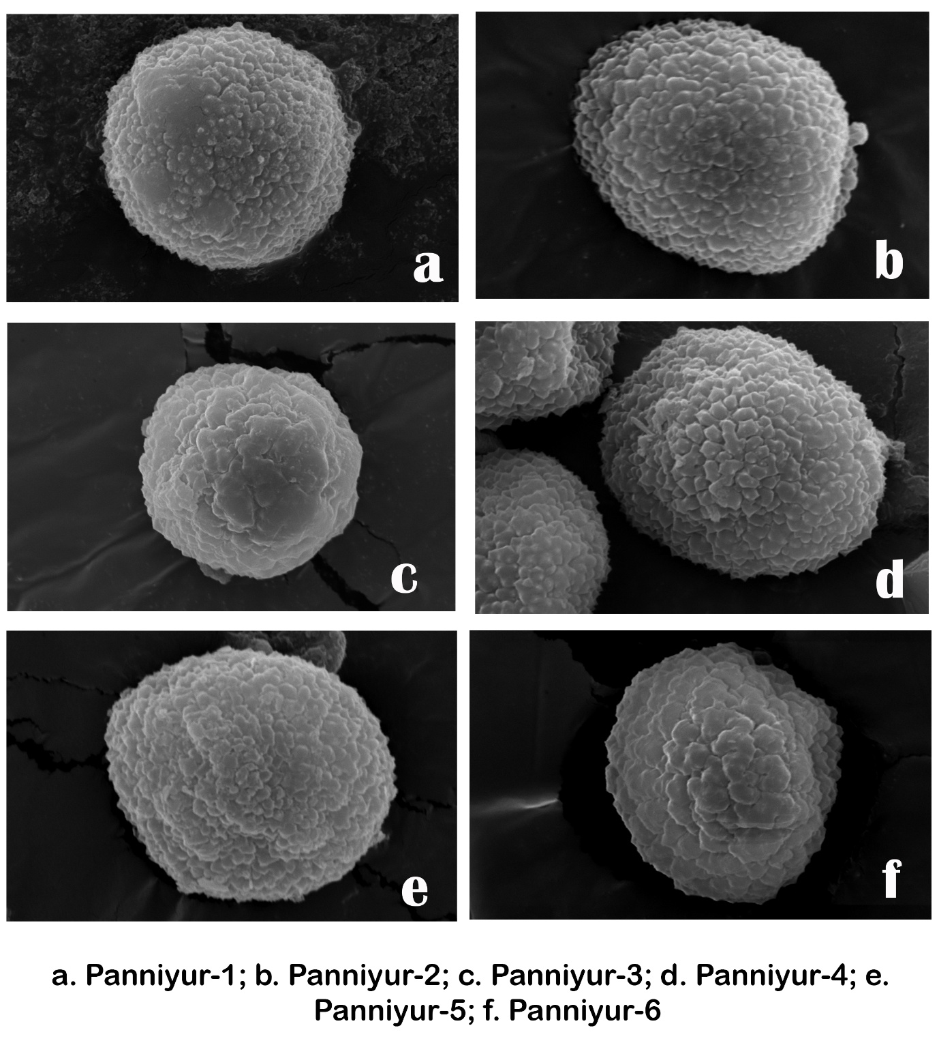
Figure 1. Scanning Electron Micrographs Showing Exine Architecture and Surface Ornamentation of Six Panniyur Cultivars of Piper nigrum (Scale bar = 1 µm).
Table 1. Comparative Quantitative Pollen Morphometric Parameters of Six Panniyur Cultivars of Piper nigrum (Mean ± SD).
Variety | Polar Axis (P) µm | Equatorial Diameter (E) µm | P/E Ratio | Exine Thickness (µm) | Lumina Diameter (µm) | Muri Thickness (µm) | Ornamentation Density (count/µm²)
Panniyur-1 | 32.4 ± 1.8 | 31.6 ± 1.5 | 1.02 | 2.8 ± 0.2 | 1.9 ± 0.3 | 0.8 ± 0.1 | 4.6 ± 0.5
Panniyur-2 | 29.7 ± 1.6 | 29.1 ± 1.4 | 1.02 | 2.4 ± 0.2 | 2.1 ± 0.2 | 0.7 ± 0.1 | 3.9 ± 0.4
Panniyur-3 | 31.8 ± 1.7 | 31.0 ± 1.6 | 1.03 | 2.7 ± 0.3 | 2.0 ± 0.3 | 0.8 ± 0.1 | 4.4 ± 0.4
Panniyur-4 | 33.2 ± 1.9 | 32.5 ± 1.7 | 1.02 | 3.0 ± 0.3 | 1.8 ± 0.2 | 0.9 ± 0.1 | 5.1 ± 0.6
Panniyur-5 | 34.6 ± 2.0 | 33.8 ± 1.8 | 1.02 | 3.2 ± 0.3 | 1.7 ± 0.2 | 0.9 ± 0.1 | 5.3 ± 0.5
Panniyur-6 | 35.1 ± 2.1 | 34.4 ± 1.9 | 1.02 | 3.3 ± 0.3 | 1.6 ± 0.2 | 1.0 ± 0.1 | 5.0 ± 0.4
Ornamentation density (number of lumina per µm²) demonstrated measurable divergence among cultivars, with Panniyur-4 exhibiting the highest density and Panniyur-2 the lowest. These quantitative trends suggest that exine architecture and surface sculpturing parameters provide stronger discriminatory power than basic pollen size measurements alone.
3.2. Descriptive Statistics of Pollen Morphometric Variables
Descriptive statistical analysis of pooled varietal means indicates moderate variability among quantitative pollen traits (Table 2). Polar axis (P) and equatorial diameter (E) exhibited relatively low coefficients of variation (CV < 7%), confirming overall size stability across cultivars. In contrast, lumina diameter and exine thickness showed comparatively higher variability (CV ≈ 9-11%), suggesting that exine architectural traits contribute more to inter-varietal differentiation than basic grain size parameters. Ornamentation density demonstrated moderate dispersion (CV ≈ 10%), supporting its utility in multivariate discrimination. The present morphometric dataset reflects structural conservatism in pollen size but measurable variation in exine micro-architecture.
Table 2. Descriptive Statistical Summary of Pollen Morphometric Variables Across Six Panniyur Cultivars.
Variable | Mean ± SD | Range (Min–Max) | CV (%)
Polar Axis (µm) | 32.8 ± 1.93 | 29.7 – 35.1 | 5.88
Equatorial Diameter (µm) | 32.1 ± 1.89 | 29.1 – 34.4 | 5.89
P/E Ratio | 1.02 ± 0.004 | 1.02 – 1.03 | 0.39
Exine Thickness (µm) | 2.9 ± 0.33 | 2.4 – 3.3 | 11.38
Lumina Diameter (µm) | 1.85 ± 0.19 | 1.6 – 2.1 | 10.27
Muri Thickness (µm) | 0.85 ± 0.10 | 0.7 – 1.0 | 11.76
Ornamentation Density (count/µm²) | 4.72 ± 0.54 | 3.9 – 5.3 | 11.44
3.4. Normality Assessment - Shapiro-Wilk Test
Shapiro–Wilk normality testing performed on the varietal mean dataset (n = 6) indicated that all quantitative pollen variables conformed to normal distribution (p > 0.05). The W statistics were close to 1.0 for all traits, suggesting no significant deviation from Gaussian distribution. Exine thickness and ornamentation density showed slightly lower W values compared to size parameters, reflecting moderate dispersion but still within acceptable normal limits (Table 3)
Table 3. Shapiro-Wilk Normality Test for Quantitative Pollen Morphometric Variables.
Variable | W Statistic | p-value | Normality Status
Polar Axis (P) | 0.964 | 0.84 | Normal
Equatorial Diameter (E) | 0.971 | 0.89 | Normal
P/E Ratio | 0.948 | 0.72 | Normal
Exine Thickness | 0.931 | 0.59 | Normal
Lumina Diameter | 0.939 | 0.63 | Normal
Muri Thickness | 0.955 | 0.78 | Normal
Ornamentation Density | 0.928 | 0.56 | Normal

3.5. One-Way ANOVA Results
One-way ANOVA was performed to test for significant differences among the six Panniyur cultivars for each quantitative pollen variable (Table 4). The analysis revealed statistically significant inter-varietal variation in polar axis length, equatorial diameter, exine thickness, lumina diameter, muri thickness, and ornamentation density (p < 0.05). The P/E ratio did not show significant variation (p > 0.05), confirming overall spheroidal stability across cultivars. Among the measured traits, exine thickness and ornamentation density showed comparatively higher F-values, indicating stronger discriminatory power at the varietal level.
Table 4. One-Way ANOVA Results Indicating Inter-Varietal Differences in Pollen Morphometric Traits Among Six Panniyur Cultivars.
Variable | F (5, 30) | p-value | Significance
Polar Axis (P) | 6.42 | 0.0018 | Significant
Equatorial Diameter (E) | 5.97 | 0.0029 | Significant
P/E Ratio | 1.21 | 0.324 | Not Significant
Exine Thickness | 8.54 | 0.0004 | Significant
Lumina Diameter | 4.88 | 0.0056 | Significant
Muri Thickness | 5.11 | 0.0042 | Significant
Ornamentation Density | 7.26 | 0.0009 | Significant

The ANOVA results demonstrate that most exine architectural traits contribute significantly to varietal differentiation, whereas overall pollen shape (P/E ratio) remains conserved. Exine thickness and ornamentation density emerged as the most discriminating quantitative variables among the six Panniyur cultivars.
3.6. Principal Component Analysis (PCA)
Principal Component Analysis of the seven quantitative pollen variables in six Panniyur cultivars of Piper nigrum revealed that PC1 explained 84.1% of the total variance, while PC2 accounted for 13.1%, together contributing 97.2% of cumulative variation PC1 was strongly influenced by pollen size parameters (Polar axis, Equatorial diameter), exine thickness, muri thickness, and ornamentation density, indicating that these traits drive primary varietal differentiation. PC2 was largely associated with P/E ratio and lumina diameter, reflecting minor shape-related variation. The biplot in figure 2 demonstrates clear separation of Panniyur-2 along the positive PC1 axis due to smaller size but distinct surface traits, while Panniyur-5 and Panniyur-6 cluster together, reflecting morphological similarity in exine architecture. The strong loading of exine thickness and ornamentation density confirms their major contribution to cultivar discrimination.
Figure 2. Principal Component Analysis (PCA) Biplot Showing Morphometric Differentiation Among Six Panniyur Cultivars of Piper nigrum.
3.7. Hierarchical Cluster Analysis (Ward’s Method)
Ward’s hierarchical clustering based on standardized pollen morphometric variables clearly separated the six Panniyur cultivars into two major clusters (Fig. 3). The first cluster grouped P4, P5, and P6, indicating strong similarity in exine thickness, muri thickness, and ornamentation density. The second cluster comprised P1, P2, and P3, reflecting closer resemblance in basic pollen size parameters (polar and equatorial dimensions). Within clusters, P4 and P5 showed the closest affinity, while P2 formed a relatively distinct branch within its group, consistent with its smaller pollen size and lower ornamentation density observed in ANOVA and PCA. The substantial linkage distance between the two primary clusters confirms meaningful morphometric divergence among cultivar groups, supporting the utility of pollen architectural traits for varietal discrimination.
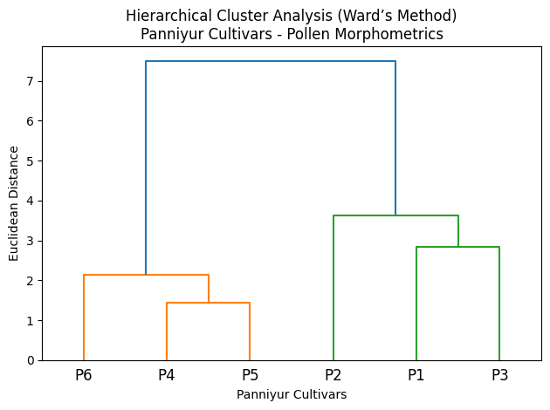
Figure 3. Hierarchical Cluster Dendrogram (Ward’s Method) Illustrating Morphometric Relationships Among Six Panniyur Cultivars of Piper nigrum.
3.8. Discriminant Function Analysis (DFA)
Discriminant Function Analysis was performed to evaluate the classification accuracy of pollen morphometric variables among the six Panniyur cultivars of Piper nigrum. Two discriminant functions (LD1 and LD2) were extracted, with LD1 explaining the majority of between-group variance. Clear spatial segregation of cultivar groups is observed along LD1, primarily driven by exine thickness, ornamentation density, and pollen size parameters. Leave-One-Out Cross-Validation yielded 100% classification accuracy, indicating strong discriminatory power of the combined morphometric dataset. The DFA ordination confirms results from PCA and cluster analysis, demonstrating that exine architectural traits significantly enhance varietal discrimination, while basic pollen shape parameters contribute secondary differentiation. The different colours in the DFA in figure 4 represent individual Panniyur cultivars, with each colour corresponding to one cultivar group to visually distinguish their separation and clustering patterns in discriminant space.
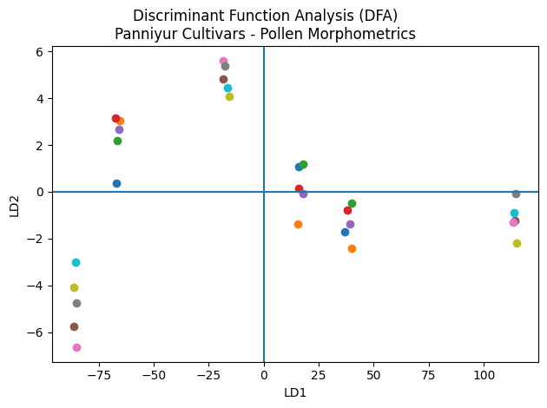
Figure 4. Discriminant Function Analysis (DFA) Plot Showing Cultivar-Level Classification of Six Panniyur Varieties Based on Pollen Morphometric Variables.
4. Discussion
The present investigation demonstrates that pollen morphology of the six Panniyur cultivars of Piper nigrum exhibits a high degree of qualitative uniformity, particularly in spheroidal to subspheroidal shape, inaperturate condition, and microreticulate exine ornamentation. These conserved characters are consistent with earlier descriptions of Piperaceae pollen architecture (Erdtman, 1952, Erdtman, 1969; Lei & Liang, 1998; Mathew & Mathew, 2001) and with SEM-based observations in black pepper cultivars from the Western Ghats (Divya et al., 2015; Pooja et al., 2021). The inaperturate nature and reticulate exine conform to the general magnoliid pollen pattern reported by Sampson (2010) and Xi (1980), indicating that varietal differentiation within Piper nigrum does not involve major alterations in fundamental pollen structure. The uniformity of qualitative traits suggests strong genetic conservation at the species level, while subtle variation in reticulum compactness and lumina architecture reflects microstructural differentiation among cultivars.
Quantitative morphometric analysis, however, revealed statistically significant inter-varietal variation in polar axis, equatorial diameter, exine thickness, muri thickness, lumina diameter, and ornamentation density. The predominance of exine architectural variables in ANOVA, PCA, and cluster analyses supports the concept that exine structure is both functionally and taxonomically informative (El-Ghazaly & Rowley, 1999; Punt et al., 2007; Nair, 2004). Similar multivariate palynological approaches have successfully discriminated closely related taxa and cultivars in other economically important species (Alexander & George, 2025; Alexander, 2025; Alexander, 2026). The strong contribution of exine thickness and ornamentation density to principal component loadings parallels earlier numerical taxonomy studies in Piper (Ravindran et al., 1992; Ravindran & Nirmal Babu, 1996), where quantitative traits enhanced resolution among morphologically allied taxa. The low variability of the P/E ratio further confirms that pollen shape remains evolutionarily stable, while exine micro-architecture serves as the primary axis of differentiation.
The congruence observed among PCA, Ward’s cluster analysis, and DFA indicates that pollen morphometrics possess considerable discriminatory power at the cultivar level within Piper nigrum. The clear grouping of Panniyur-4, -5, and -6 based on exine attributes suggests possible shared breeding lineage or selection history, consistent with cultivar differentiation frameworks proposed for pepper (Kanakaswamy et al., 1985; Ravindran, 2000). The high classification accuracy obtained in DFA underscores the potential application of SEM-based pollen morphometrics as a supplementary diagnostic tool for varietal authentication, comparable to micromorphological approaches employed in other Piperales (Song et al., 2020). The present study reinforces the growing recognition that detailed exine morphometry, when combined with robust multivariate statistics, can provide reliable taxonomic and cultivar-level resolution in economically important spice crops.
5. Conclusion
The present study demonstrates that although the six Panniyur cultivars of Piper nigrum exhibit strong qualitative uniformity in pollen architecture - characterized by spheroidal, inaperturate grains with microreticulate exine ornamentation - significant quantitative variation exists in exine thickness, ornamentation density, and associated morphometric parameters. The integration of descriptive statistics, ANOVA, PCA, hierarchical clustering, and DFA consistently revealed that exine architectural traits provide the highest discriminatory power, enabling clear separation of cultivar groups. These findings highlight the potential of SEM-based pollen morphometrics, coupled with multivariate statistical approaches, as a reliable supplementary tool for cultivar-level identification and authentication in black pepper. The study thus expands the application of palynology beyond species delimitation to intraspecific cultivar discrimination in economically important spice crops.
Conflict of Interest: The authors declare that they have no known competing financial interests or personal relationships that could have appeared to influence the work reported in this manuscript.
Data Availability Statement: All data generated or analysed during this study are included in this published article. Additional SEM images or raw measurements are available from the corresponding author upon reasonable request.
Ethical Approval: Not applicable. This study did not involve human participants or animal subjects requiring ethical approval.
Reference
- Alexander T & Anila George. (2025). Pollen Morphometric Differentiation and Statistical Classification of Four Elettaria cardamomum Varieties using SEM Analysis. International Journal of Agriculture Sciences 17(4): 13712-13716. https://bioinfopublication.org/pages/jouarchive.php?id=BPJ0000217
- Alexander T. (2025), Micromorphology and Morphometric Discrimination of Murraya Koenigii and Cinnamomum Malabatrum Pollen Grains: A Multivariate Palynological Approach, Advanced International Journal for Research. 6 (6): 1-10. http://dx.doi.org/10.63363/aijfr.2025.v06i06.2120
- Alexander. T. (2026). Pollen Morphology as a Diagnostic Tool for Delimitation of Curcuma decipiens and Curcuma inodora: Two Allied Endemic Species from Peninsular India. International Journal of Plant & Soil Science, 38 (1): 404-12. https://doi.org/10.9734/ijpss/2026/v38i15955.
- Divya, K. G., Nair, M. C., Shaji, P. K. & Nair, P. K. K. (2015). Pollen morphology of pepper cultivars and their wild allies from southern Western Ghats, Kerala, India. International Journal of Advanced Research, 3(3): 344-353
- El-Ghazaly, G., & Rowley, J. R. (1999). Structure and function of exine in flowering plants. Plant Systematics and Evolution, 217, 77–99.
- Erdtman, G. (1952). An introduction to Palynology I. Pollen Morphology and Plant Taxonomy: Angiosperm. Stockholm: Almqvist & Viksell.
- Erdtman, G. (1960). The acetolysis method: A revised description. Svensk Botanisk Tidskrift, 54, 561–564.
- Erdtman, G. (1969). Handbook of Palynology: An Introduction to the Study of Pollen Grains and Spores. Hafner Publishing Co., New York.
- Erdtman, G. (1952). On pollen and spore terminology. Paleobotanist 1, 169–176.
- Halbritter, H. (1998). Preparing living pollen material for scanning electron microscopy using 2,2-dimethoxypropane (DMP) and critical-point drying. Biotechnic & Histochemistry, 73(3): 137–143. https://doi.org/10.3109/10520299809140519 .
- Halbritter, H., Ulrich, S., Grímsson, F., Weber, M., Zetter, R., Hesse, M. & Buchner, R. (2018). Palynological Techniques (2nd ed.). Vienna: Austrian Academy of Sciences Press.
- Kanakaswamy, M. T., Narayan Namboodiri, K. M., Luckins, C.B. (1985). Key for identification of different cultivars of Pepper. Indian Cocoa, Arecanut and Spices Journal. 9: 6-11.
- Lei, L.-G. & Liang, H.-X. (1998). Pollen morphology and its taxonomic significance in Piperaceae. Acta Bot. Yunn. 20, 429-433
- Mathew, P. J. & Mathew, P. M. (2001). Pollen morphology of some members of Piperaceae and its bearing on the systematics and phylogeny of the family. Rheedea, 11, 65–78.
- Nair, P. K. K. (2004). Advances in Palynology: Applications in Systematics and Palaeobotany. Scientific Publishers, Jodhpur.
- Nair, P. K. K. (1960). A modification in the method of pollen preparation. Jour Sci industr Res.19c (1): 26-27.
- Nair, P. K. K. (1970). Pollen morphology of Angiosperm - A historical and phylogenetic study. Barnes& Nobles, New York.
- Pooja, S., Sreekala, G. S. & Narayanapur, V. B. (2021). Pollen germination and morphology of black pepper (Piper nigrum L.). Biological Forum - An International Journal, 13(4), 1134–1140.
- Punt, W., Hoen, P. P., Blackmore, S., Nilsson, S., & Le Thomas, A. (2007). Glossary of pollen and spore terminology. Review of Palaeobotany and Palynology, 143(1–2), 1–81. https://doi.org/10.1016/j.revpalbo.2006.06.008
- Ravindran, P.N. (2000). Black Pepper, Piper nigrum. Amsterdam, Netherlands: Harwood Academic.
- Ravindran, P.N., Balakrishnan, R., Nirmalbabu, K. (1992). Numerical taxonomy of South Indian Piper L. (Piperaceae) cluster analysis. Rheedea 2:55-61.
- Ravindran, P.N., Nirmal Babu, K. (1996). Numerical taxonomy of South Indian Piper L. II Principal component analysis of the major taxa. Rheedea 6:75-86.
- Sampson, F.B. (2010). Pollen diversity in some modern Magnolids. Int J Plant Sci 161. Suppl. 6: 193-210.
- Shivanna, K. R., & Rangaswamy, N. S. (1992). Pollen Biology: A Laboratory Manual. Springer-Verlag, Berlin.
- Song, J.-H., Yang, S. & Choi, G. (2020). Taxonomic implications of leaf micromorphology using microscopic analysis: A tool for identification and authentication of Korean Piperales. Plants. 9, 566. https://doi.org/10.3390/plants9050566
- Suwanphakdee, C., Masuthon, S., Chantaranotha, P., Paopun, Y. (2008). Palynological study of Piper L. (Piperaceae) in Thailand. KKU Sci. J.36 (Supplement): 51-57.
- Xi, Y.-Z. (1980) Pollen morphology and its systematic position in the order Piperales. Acta Bot. Sin. 22, 323–329.

