Comparative Analysis of Butterfly Diversity and Community Structure in Two Distinct Protected Areas of the Western Ghats, India

ABSTRACT
The Western Ghats of India represents a globally significant biodiversity hotspot, yet the spatial distribution of its pollinator networks remains highly localized and vulnerable to micro-climatic shifts. This study investigates the community composition and diversity of butterfly pollinators (Order: Lepidoptera) across two distinct protected areas: the Anshi-Dandeli Tiger Reserve and Kudremukh National Park. Over an eight-month sampling period (June, 2024–February, 2025), a total of 4,702 individuals across 103 unique species were recorded. Our findings reveal a highly active, yet spatially compartmentalized, pollinator network. While both habitats exhibited robust community stability, Kudremukh National Park supported significantly higher carrying capacity and species richness (N=2411, S=82) compared to Anshi-Dandeli (N=2291, S=62). Alpha diversity metrics indicated an exceptionally diverse community at Kudremukh (H' = 3.995), which was statistically significantly higher than Anshi-Dandeli (H' = 3.702, Hutcheson t-test p < 0.0001). Despite these differences in overall richness, both ecosystems were heavily dominated by the families Nymphalidae and Pieridae. Analysis of beta diversity (Jaccard Index = 0.412) demonstrated substantial spatial species turnover, indicating that less than half of the pollinator species pool is shared between the two reserves. These results underscore the high degree of localized endemism within the Western Ghats and highlight the necessity of conserving multiple, geographically distinct habitat mosaics to sustain comprehensive plant-pollinator networks.
Keywords: Butterflies, pollinators, bio-indicators, biodiversity, ecosystem health
INTRODUCTION
Insects constitute the most diverse and ecologically significant group of organisms on Earth, playing a pivotal role in the functioning of terrestrial ecosystems. Among the various ecosystem services, they provide, pollination is arguably the most critical for the maintenance of global biodiversity and food security. It is estimated that nearly 87.5% of all flowering plants (angiosperms) rely on animals for pollination, with insects forming the vast majority of these pollinators (Proctor, 1996; Ollerton et al., 2011). Within the class Insecta, the order Lepidoptera (butterflies and moths) ranks as one of the most vital pollinator groups, second only to Hymenoptera (bees and wasps). Unlike many other pollinators, Lepidopterans have a unique life history that allows them to interact with plants at multiple trophic levels, as herbivores during their larval stages and as nectar-feeders and pollinators as adults (Nagarathna, 2024). This dual interaction makes them exceptional bio-indicators of ecosystem health, as their survival depends on the availability of host plants for larvae and nectar sources for adults. Butterflies are highly sensitive to environmental changes, including habitat fragmentation, climate fluctuations, and pollution. Their short life cycles and specific micro-habitat requirements allow them to respond rapidly to perturbations in their environment. Consequently, the diversity and community structure of butterfly assemblages are widely used by ecologists to monitor the health of forest ecosystems and the effectiveness of conservation management strategies (Bonebrake et al., 2010). A decline in butterfly diversity often signals the early degradation of a habitat, preceding the loss of vertebrate species (Scott and Lemieux, 2005). In the context of the current insect apocalypse, the noted global decline in insect biomass and diversity, generating regional baseline data for these taxa has become a scientific priority (Sanchez-Bayo and Wyckhuys, 2019).
The Western Ghats of India, recognized as one of the world's eight hottest hotspots of biological diversity, serves as a crucial repository for distinct flora and fauna (Myers et al., 2000). The Anshi-Dandeli Tiger Reserve and Kudremukh National Park being the part of the Western Ghats and protected areas, they serve as the last strongholds for biodiversity in human-dominated landscapes.These sites offer a compelling comparative framework due to their contrasting topographical and vegetative characteristics.Anshi-Dandeli Tiger Reserve is characterized by deep valleys and steep slopes, predominantly covered by moist deciduous and semi-evergreen forests. It represents a transition zone between the northern and southern Western Ghats, supporting a mix of fauna. In contrast, Kudremukh National Park is renowned for its unique shola-grassland ecosystem, a mosaic of stunted evergreen forests nestled in the folds of rolling high-altitude grasslands. The distinct floristic composition and altitudinal variance between these two sites are expected to influence the diversity, abundance, and functional composition of butterfly communities. While the systematics of Indian butterflies is well-documented, quantitative ecological studies focusing on community dynamics, diversity indices, and seasonal abundance in specific protected areas remain limited. This research addresses these gaps by providing a comprehensive assessment of butterfly pollinator diversity over an eight-month period (June 2024 to February 2025), encompassing the critical post-monsoon and winter seasons. The primary objectives of this study were to document and compare the species richness and abundance of butterflies in Anshi-Dandeli Tiger Reserve and Kudremukh National Park; to analyse the community structure using alpha and beta diversity indices to understand dominance and evenness patterns; and to evaluate the similarity in species composition between these two geographically and ecologically distinct habitats. By elucidating the diversity patterns of these pollinator communities, this study aims to contribute vital baseline data necessary for the long-term monitoring and management of the Western Ghats' fragile ecosystems.
MATERIALS AND METHODS
The study was conducted across two protected areas within the Western Ghats of Karnataka, India: Kudremukh National Park and Anshi-Dandeli Tiger Reserve. Field surveys were carried out over an eight-month period, spanning from June 2024 to February 2025, with observations recorded at regular monthly intervals. A total of 30 transect lines were established across each of the two protected areas. These transects were designed with a standard width of four meters and lengths primarily spanning 250 meters, with certain pathways extending up to one kilometre depending on the terrain. To capture a representative sample of the local biodiversity, transects were strategically laid to traverse diverse vegetative micro-habitats, including riparian zones, herbaceous patches, and dense shrubberies. Lepidopteran diversity and abundance were assessed using the standard line transect walk or Pollard walk method (Pollard, 1977).
Data collection was primarily conducted through visual observation during the transect walks, with a specific focus on recording entomological activity near the flowering sites of herbs, shrubs, and trees. All the observations were recorded between 10.00 a.m. and 4.00 p.m. Visual surveys were supplemented by photographic documentation to aid in accurate identification and to maintain a visual record. A catch-record-and-release method was also employed for live examinations in the field.For cryptic or morphologically similar species that could not be readily identified in situ, voucher specimens (limited to one or two individuals per species) were collected using aerial sweep nets and transported back to the laboratory for detailed taxonomic examination. For every recorded individual, its family, genus and species name (wherever possible) were documented. Butterfly identification was meticulously done by utilizing the standard guides (Field Guides for Butterfly Identification), internet sources like Butterfly conservation; Butterflies of India and National Park Service web pages, published taxonomic keys, and peer-reviewed entomological literature ( Kunte and Ravikanthachari, 2020).
The data collected over the eight-month sampling period (June 2024 to February 2025) were collated and organized by genus and species (wherever possible) and family for both study sites: Anshi-Dandeli Tiger Reserve and Kudremukh National Park. All the below given statistical analyses were performed.
To assess the lepidopteran diversity within each site, (Alpha Diversity and Community Structure) we calculated several standard alpha diversity indices:
- Shannon-Wiener Index (H'): To evaluate the uncertainty in predicting the species identity of an individual, calculated as H' = – ƩPiIn(Pi), where pi is the proportion of individuals belonging to thei^{th} species.
- Simpson’s Index of Diversity (1-D): To estimate the probability that two individuals randomly selected from a sample will belong to different species, calculated as 1 –Ʃpi²
- Margalef’s Richness Index (d): To measure species richness adjusted for sample size, calculated as d = (S - 1)/ln(N), where S is the number of species and N is the total number of individuals.
- Pielou’s Evenness Index (J'): To quantify how equal the abundances of the species are, calculated as J' = H' / ln(S).
To visualize the community evenness and dominance patterns, Rank-Abundance curves (Whittaker plots) were constructed by plotting the log-transformed abundance of species against their abundance rank.
Beta Diversity and Similarity
To compare the species composition between the two sites, (Beta Diversity and Similarity) we employed beta diversity measures:
- Jaccard Similarity Index
- (J): A qualitative measure of species overlap, calculated as the intersection of species sets divided by the union of species sets.
- Sørensen-Dice Coefficient:Applies a greater mathematical weight to the species that are shared between the two habitats, providing a deeper understanding of the foundational core community.
Differences in diversity between the two sites were statistically tested using the Hutcheson t-test, a modified t-test specifically designed for comparing Shannon diversity indices (H'). All the statistical analysis were carried out using the PAST software
RESULTS
Over the comprehensive eight-month field study, a total of 4,702 individual Lepidoptera pollinators were documented across the two protected areas. The taxonomic assessment revealed a highly active pollinator network. Kudremukh National Park supported both a higher total carrying capacity and a broader species richness, recording 2,411 individuals representing 82 distinct species. In contrast, the Anshi-Dandeli Tiger Reserve recorded 2,291 individuals representing 62 distinct species.
Descriptively, while both habitats supported robust populations, the community composition in both reserves was heavily dominated by species belonging to the families Nymphalidae (brush-footed butterflies) and Pieridae (whites and sulphurs), which collectively accounted for the majority of the recorded butterfly families (Figure. 1)
The calculated alpha diversity metrics indicated that both study sites harbour highly stable, ecologically complex pollinator communities characterized by an absence of aggressive single-species dominance. Both habitats recorded exceptionally high Simpson’s Diversity scores(1-D = 0.969 for Anshi-Dandeli; 1-D = 0.976 for Kudremukh) and strong Pielou’s Evenness values (J' = 0.897 for Anshi-Dandeli; J' = 0.907 for Kudremukh).
Despite the general stability of both areas, Kudremukh National Park consistently exhibited superior biodiversity metrics across all parameters. When normalized for sample size, Margalef’s Richness was notably higher in Kudremukh (d = 10.401) compared to Anshi-Dandeli (d = 7.884). Furthermore, the Shannon-Wiener diversity was higher in Kudremukh (H' = 3.995) than in Anshi-Dandeli (H' = 3.702) as presented in Table 1.
The Hutcheson t-test confirmed that this spatial variation in biodiversity is highly significant. The Shannon diversity of pollinator populations at Kudremukh National Park is statistically significantly greater than that of the Anshi-Dandeli Tiger Reserve (t₄₆₉₂ = -13.03, p < 0.0001). This profound difference suggests that Kudremukh likely offers greater micro-habitat heterogeneity or a more continuous availability of specific floral host plants throughout the seasonal shifts.
Analysis of beta diversity revealed a high degree of species turnover and spatial compartmentalization between the two geographically separated reserves. The Jaccard Similarity Index was calculated at 0.412, demonstrating that the two habitats share only 41.2% of their total recorded species pool. Similarly, the Sørensen-Dice coefficient yielded a similarity score of 0.583.These spatial turnover metrics indicate that while Anshi-Dandeli and Kudremukh share a generalized foundational core of ubiquitous butterfly species, more than half of the recorded biodiversity is site-specific. This restricted overlap highlights the localized endemism and specialized plant-pollinator associations present within different sub-regions of the Western Ghats, emphasizing the unique ecological value of preserving both distinct habitats.
To visually represent the community structure, species richness, and species evenness across the two protected areas, a rank-abundance curve (Whittaker plot) was generated on a logarithmic scale (Figure 2). Both habitats demonstrate a characteristic log-normal distribution model, typical of stable, highly diverse tropical forest ecosystems. The left-most portions of both curves exhibit a steep initial gradient, reflecting the high local dominance of a few highly abundant species, predominantly belonging to the Nymphalidae and Pieridae families. However, the curve representing Kudremukh National Park extends considerably further along the x-axis, clearly stating its higher absolute species richness (S = 82) compared to the Anshi-Dandeli Tiger Reserve (S = 62). Furthermore, the Kudremukh curve displays a marginally shallower rate of decline through the intermediate species ranks, structurally representing its superior community evenness (J' = 0.907) and indicating a less abrupt hierarchical ecological assemblage. Finally, the extended right-hand tails observed in both plots underscore the presence of a substantial number of rare species (singletons and doubletons) that heavily anchor the localized biodiversity of the Western Ghats..
DISCUSSION
The results of this study clearly indicate that Kudremukh National Park supports a richer and more diverse butterfly assemblage compared to Anshi-Dandeli Tiger Reserve during the sampled post-monsoon and winter seasons. The significantly higher Shannon and Margalef indices in Kudremukh (p<0.001) suggest that this site offers a wider array of ecological niches or more stable microclimatic conditions favoured by a broader range of taxa.While both habitats demonstrate robust community stability, their significant differences in alpha and beta diversity offer critical insights into the ecological dynamics of the Western Ghats.Western Ghats is high in endemism (Holloway, 1974, Sudheendrakumar et al., 2000); each habitat has a specific set of microenvironment suitable for endemic species (Holloway, 1974).
Kudremukh National Park exhibited significantly higher species richness (S=82) and Shannon-Wiener diversity (H'=3.995) than Anshi-Dandeli. This strongly aligns with the habitat heterogeneity hypothesis (Tews et al., 2004), which posits that structurally complex environments provide more ecological niches. Kudremukh’s topographical gradients and unique shola-grassland mosaics likely sustain a more diverse array of micro-climates and host plants compared to the relatively more homogenous moist-deciduous tracts of Anshi-Dandeli. This corroborates historical findings by Kunte (2000), who noted that mixed evergreen and shola ecosystems in the Western Ghats consistently support the highest butterfly richness.Thefindings are also in consistent with Stewart et al., 2022, who emphasized the role of habitat features such as floral resources and water availability in shaping pollinator communities.
Despite variations in species richness, both sites were heavily dominated by Nymphalidae and Pieridae. The ecological dominance of Nymphalidae is a well-documented hallmark of tropical forest ecosystems, often attributed to their highly polyphagous larval stages and strong dispersal capabilities (DeVries, 1987; Bonebrake et al., 2010). However, the overwhelming abundance of Pieridae contrasts with some broader tropical community studies, particularly in Neotropical and Southeast Asian forests where Lycaenidae or Hesperiidae frequently exhibit higher localized species counts (Robbins & Opler, 1997). This localized Pieridae dominance may be due to regional density of their preferred host plants within specific study sites.A critical finding of this study is the high spatial species turnover, indicated by a Jaccard Similarity Index of 0.412. Sharing only ~41% of their species pool highlights the pronounced localized endemism characteristic of the Western Ghats (Kunte, 2008). Such high beta diversity emphasizes that individual, isolated mega-reserves are insufficient to capture regional Lepidoptera diversity. As argued by Tscharntke et al. (2012), effective conservation in fragmented landscapes requires protecting a mosaic of geographically distinct habitats. Our results underscore that conserving regional butterfly diversity necessitates protecting localized understory floral resources across multiple, distinct geographic nodes rather than relying on a single protected area.
It is important to acknowledge that this study was conducted over an 8-month period, potentially missing species with strict summer phenologies. Additionally, the presence of unidentified morphospecies in the dataset suggests that the true species richness may be underestimated. Future long-term monitoring incorporating molecular barcoding could further resolve the taxonomic ambiguity and reveal deeper patterns of cryptic diversity in these critical habitats. This study highlights the butterfly pollinator diversity within the Western Ghats. While both Kudremukh National Park and Anshi-Dandeli Tiger Reserve support stable communities dominated by Nymphalidae and Pieridae, Kudremukh exhibits significantly higher species richness and alpha diversity. Crucially, a high species turnover of nearly 60% between the sites reveals strong localized endemism.

DECLARATION
The authors declare that they have no competing interests. We also declare that AI tools have been utilized for language improvement
REFERENCES
Bonebrake, T.C., Ponisio, L.C., Boggs, C.L. and Ehrlich, P.R. 2010. More than just indicators: a review of tropical butterfly ecology and conservation. Biol. Conserv., 143(8): 1831-1841.
Butterflies of India. https://www.ifoundbutterflies.org
Butterfly Conservation. https://butterfly-conservation.org/butterflies/identify-a-butterfly
DeVries, P. J. 1987. The butterflies of Costa Rica and their natural history: Papilionidae, Pieridae, Nymphalidae.
Field Guides for Butterfly Identification. https://butterfly-monitoring.net/field-guides
Holloway, J. D. 1974. The biogeography of Indian butterflies. In Ecology and Biogeography in India ,pp. 473-499. Dordrecht: Springer Netherlands.
Kunte, K. and Ravikanthachari, N. 2020. Butterflies of Bengaluru. Karnataka Forest Department (Research Wing), pp. 196.
Kunte, K. 2000. India, a Lifescape: butterflies of peninsular India. Universities Press.
Kunte, K. 2008. The Wildlife (Protection) Act and conservation prioritization of butterflies of the Western Ghats, southwestern India. Curr. Sci., pp. 729-735.
Myers, N., Mittermeier, R. A., Mittermeier, C. G., Da Fonseca, G. A. and Kent, J. 2000. Biodiversity hotspots for conservation priorities. Nat., 403(6772): 853-858.
Nagarathna, N., Haleshi, C., Mahanthesha, K. and Sreenivasa, G. 2024. Study on the diversity of insect pollinators and their host plants in Chitradurga, Karnataka, India. J. Ento. Res.
National Parks Service. https://www.nps.gov/band/learn/nature/id-of-common-butterflies.htm
Ollerton, J., Winfree, R. and Tarrant, S. 2011. How many flowering plants are pollinated by animals?. Oikos, 120(3): 321-326.
Pollard, E. 1977. A method for assessing changes in the abundance of butterflies. Biol. Conserv., 12(2): 115-134.
Proctor, M., Yeo, P. and Lack, A. 1996. The natural history of pollination. pp. 479.
Robbins, R. K. and Opler, P. A. 1997. Butterfly diversity and a preliminary comparison with bird and mammal diversity. Biodiversity II: understanding and protecting our biological resources. pp. 69-82.
Sanchez-Bayo, F. and Wyckhuys, K. A. 2019. Worldwide decline of the entomofauna: A review of its drivers. Biol. Conserv., 232: 8-27.
Scott, D. and Lemieux, C. 2005. Climate change and protected area policy and planning in Canada. For. Chron., 81(5): 696-703.
Stewart, A. B., Diller, C., Dudash, M. R. and Fenster, C. B. 2022. Pollination-precision hypothesis: support from native honey bees and nectar bats. New Phytol., 235(4): 1629-1640.
Sudheendrakumar, V. V., Binoy, C. F., Suresh, P. V. and Mathew, George. 2000. Habitat associations of butterflies in the Parambikulam Wildlife Sanctuary, Kerala, India. J. Bombay Nat. Hist. Soc., 97(2): 193-201.
Tews, J., Brose, U., Grimm, V., Tielbörger, K., Wichmann, M. C., Schwager, M. and Jeltsch, F. 2004. Animal species diversity driven by habitat heterogeneity/diversity: the importance of keystone structures. J. Biogeogr., 31(1): 79-92.
Tscharntke, T., Tylianakis, J. M., Rand, T. A., Didham, R. K., Fahrig, L., Batáry, P. and Westphal, C. 2012. Landscape moderation of biodiversity patterns and processes-eight hypotheses. Biol. Rev., 87(3): 661-685.

Table 1. Comparison of diversity indices between Anshi-Dandeli Tiger Reserve and Kudremukh National Park.

Metric | Anshi-Dandeli | Kudremukh | Ecological Interpretation
Species Richness (S) | 62 | 82 | Absolute count of distinct species.
Margalef's Richness (d) | 7.884 | 10.401 | Richness normalized for sample size. Kudremukh demonstrates notably higher inherent species richness.
Shannon-Wiener (H') | 3.702 | 3.995 | Accounts for both abundance and evenness. Kudremukh is more diverse.
Simpson's Index (1-D) | 0.969 | 0.976 | Probability that two randomly selected individuals are of different species. Both sites show extremely high diversity.
Pielou's Evenness (J') | 0.897 | 0.907 | Measures how equally populations are distributed. Both sites are highly stable, lacking aggressive dominance by a single species.

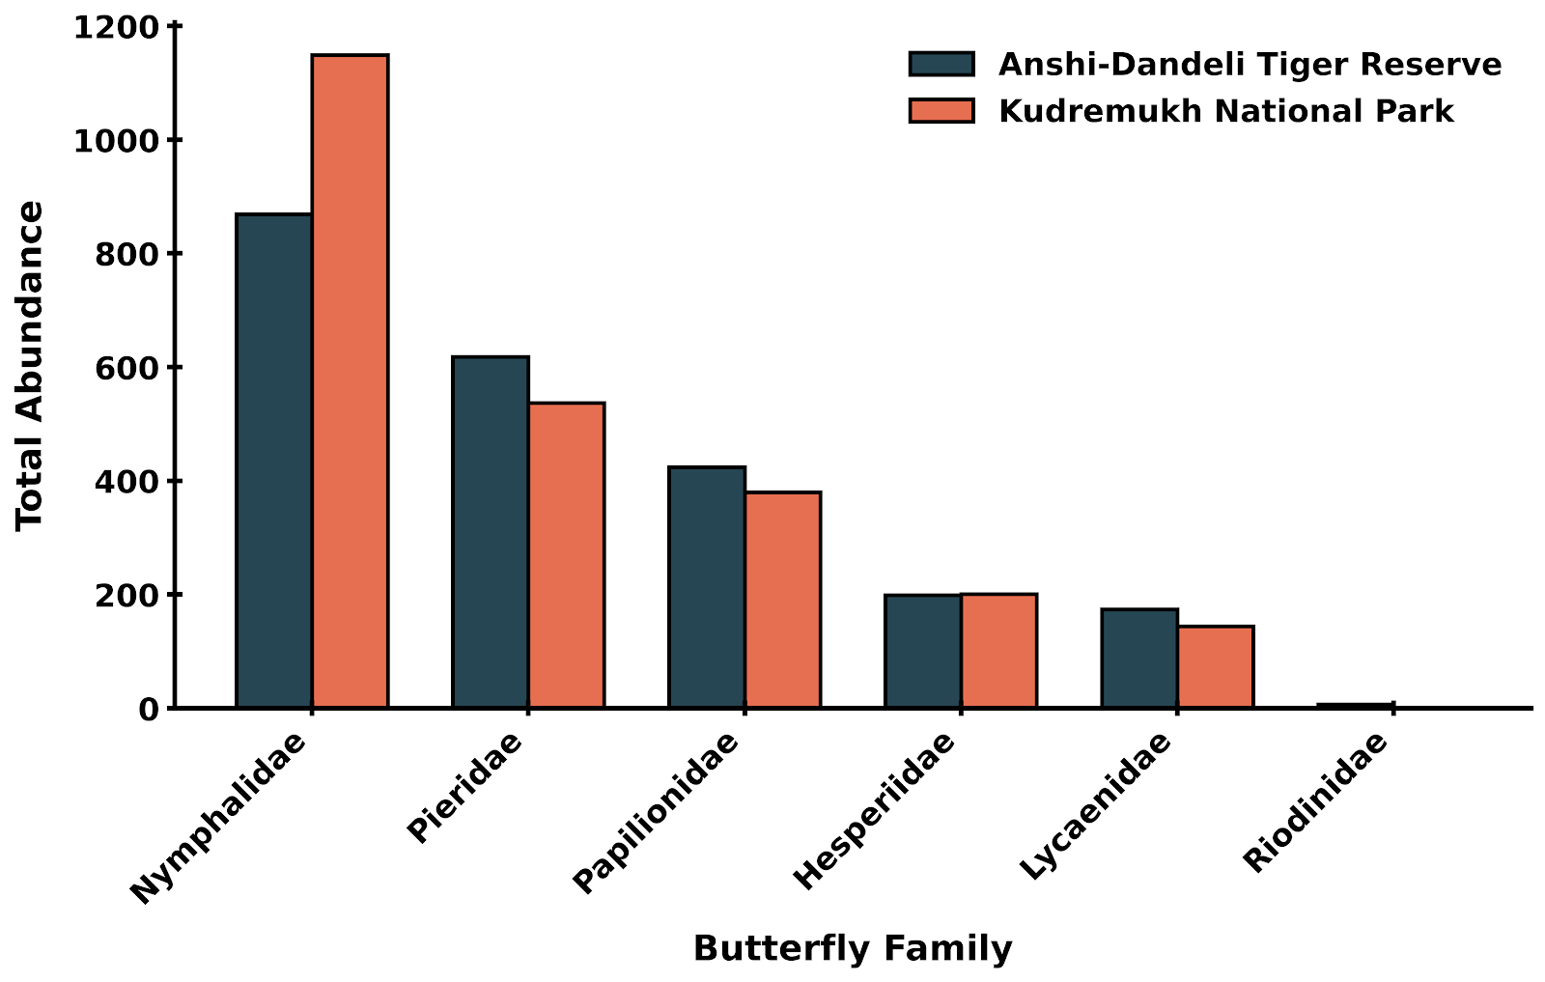
Fig. 1. Family-wise Abundance This bar chart shows the distribution of insect counts across families. Nymphalidae is the dominant family in both sites, but their relative proportions and the presence of minor families differ significantly.

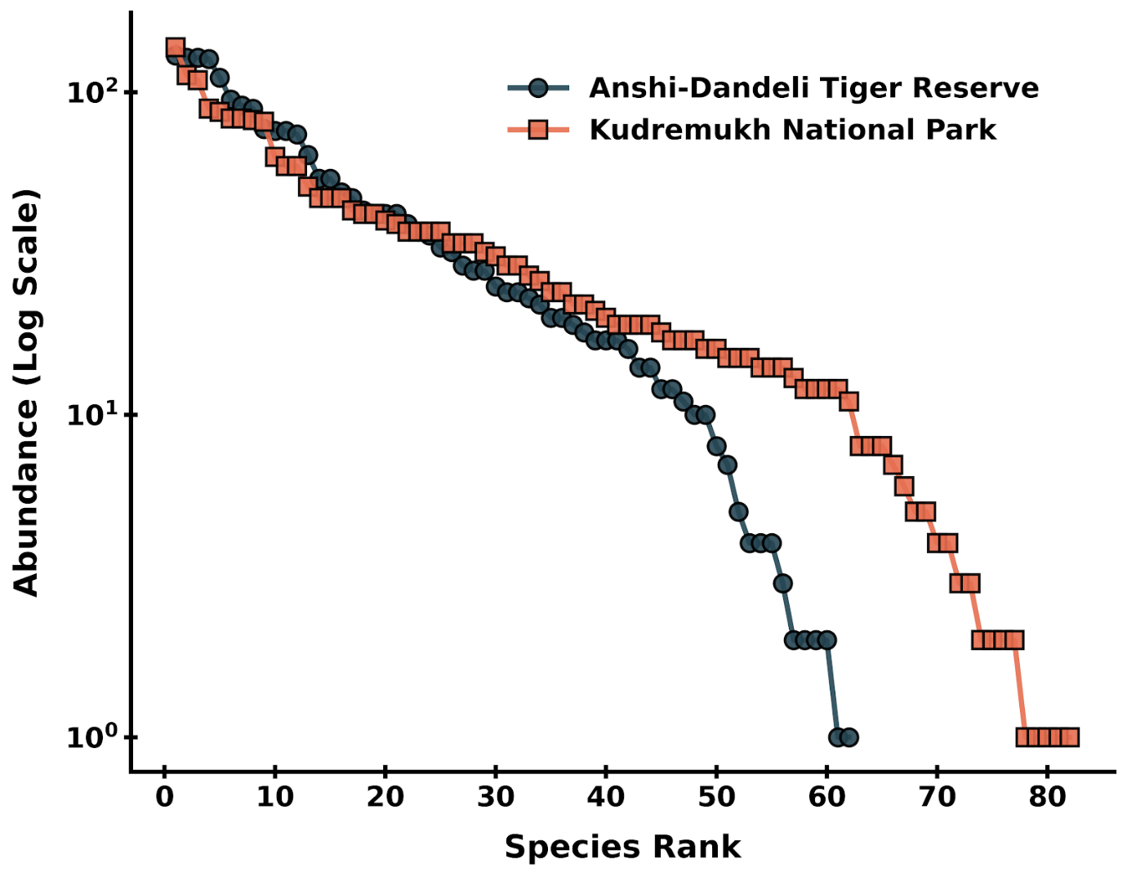

Fig. 2. Rank-Abundance Curve (Whittaker Plot) This plot visualizes the community structure. A steeper curve (like Anshi-Dandeli) indicates higher dominance by a few species, while a shallower curve (Kudremukh) indicates greater evenness. The longer tail for Kudremukh reflects its higher species richness.

