Original Research Article

In vitro exposure to leaf extract of Catharanthus roseus (L.) G. Don enhances blastogenic responses in avian lymphocytes

.
ABSTRACT

Abstract
Aims: The present study investigates the in vitro immunomodulatory potential of a fifty percent hydromethanolic leaf extract of Catharanthus roseus (CRE)
Study design: Presence of various phytoconstituents through biochemical assays was conducted using various biochemical tests and immunomodulatory potential was explored by assessing lymphocyte blastogenic responses using a chicken lymphocyte culture–based proliferation assay.
Place of Study: The study is conducted in the Department of Molecular Biology and Genetic Engineering, College of Basic Sciences and Humanities, G.B. Pant University of Agriculture and Technology, Pantnagar, Uttarakhand, India.
Methodology: After collection of the plant material (leaves) from the authentic source, fifty percent hydro-methanolic extract was prepared that was used for phytochemical and cell culture-based analyses
Results: Preliminary phytochemical screening of the CRE indicated the presence of several bioactive constituents, including phenolic compounds, flavonoids, alkaloids, tannins and saponins. A concentration of 0.6 mg/mL was identified as the highest level that maintained full cell viability and was therefore designated as the maximum non-cytotoxic dose (MNCD) for further immunomodulatory studies. At non-cytotoxic concentrations, CRE markedly stimulated lymphocyte activation, as evidenced by enhanced blastogenic responses. Both B-lymphocyte and T-lymphocyte proliferation showed a significant increase relative to mitogen-stimulated control cultures.
Conclusion: The detection of multiple phytochemical classes in CRE suggests a bioactive profile that may contribute to immune modulation. Accordingly, the present findings furnish preliminary experimental evidence for the potential immunostimulatory role of CRE in avian model.

Keywords: Catharanthus roseus; immunomodulatory effect; chicken lymphocytes; Lymphocytes Proliferation Assay
1. INTRODUCTION

Medicinal plants remain one of the most important natural resources for disease prevention and therapy and continue to support primary healthcare in many parts of the world. Their long-standing use in traditional medical systems reflects the empirical knowledge accumulated over centuries regarding plant-based remedies and their therapeutic potential (Ekor, 2014). The pharmacological significance of botanicals is largely attributed to their chemically diverse secondary metabolites, which include alkaloids, phenolics, flavonoids, terpenoids, tannins, and saponins. These compounds occur in different plant organs such as leaves, roots, stems, flowers, and bark and their distribution often determine the biological activity and medicinal utility of the plant (Ambwani et al, 2018). A growing body of evidence indicates that such phytochemicals can influence multiple physiological pathways and contribute to clinically relevant effects, including antioxidant defense, modulation of inflammatory responses, antimicrobial action and regulation of immune functions (Alamgir and Uddin, 2010; Ambwani et al., 2019; Pandey and Ambwani, 2022).
Catharanthus roseus (L.) G. Don, commonly known as Madagascar periwinkle (Vinca rosea), Sadabahar or sadaphuli is a widely recognized medicinal and ornamental plant belonging to the family Apocynaceae. Although native to Madagascar, it is now distributed throughout tropical and subtropical regions, including the Indian subcontinent (Das and Sharangi, 2017). The plant has a long-standing reputation in traditional medicine systems, particularly in Chinese and Asian folk practices, where it has been used for managing a range of ailments such as diabetes, inflammatory conditions, and microbial infections (Ibrahim et al., 2011; Kumar et al., 2013; Chaturvedi et al., 2022).
A major scientific interest in Catharanthus roseus arises from its ability to synthesize a diverse spectrum of secondary metabolites, notably indole alkaloids. Among these, vincristine and vinblastine are highly valued plant-derived anticancer agents and have been extensively studied for their role in chemotherapy, especially in hematological malignancies and pediatric cancers (Noble, 1990; van der Heijden et al., 2004; Mendonce et al., 2025). Beyond anticancer alkaloids, Catharanthus roseus also contains phenolic compounds and other phytochemicals that contribute to its biological activities (Mustafa and Verpoorte, 2007; Nisar et al., 2017; Paarakh et al., 2029). Since oxidative stress and reactive oxygen species are linked to cellular damage, aging and multiple pathological conditions, plant-based antioxidants are increasingly explored as natural therapeutic candidates (Pisoschi et al., 2016). In this context, leaf extracts of Catharanthus roseus have demonstrated dose-dependent free radical scavenging properties, supporting its potential role as an antioxidant-rich medicinal resource (Esther et al., 2016).
Despite substantial research on alkaloid-mediated anticancer effects, other bioactive fractions of Catharanthus roseus, including non-alkaloid components and primary metabolites such as polysaccharides, have received comparatively less attention, particularly in relation to immune modulation and immunotherapy-oriented applications. Therefore, further investigations are warranted to explore its immunomodulatory potential using relevant experimental models. In the present study, the fifty percent hydromethanolic leaf extract of Catharanthus roseus (CRE) was evaluated for its in vitro immunomodulatory activity using a chicken lymphocyte culture system, with emphasis on lymphocyte blastogenic response as an indicator of immune stimulation. Phytochemical screening of CRE was carried out using qualitative and quantitative biochemical methods, and its antioxidant activity was determined by assessing hydrogen peroxide scavenging potential.

2. material and methods

2.1 Plant collection
Leaves of Catharanthus roseus used in the present study were obtained from the Medicinal Plant Research and Development Center (MRDC), G.B. Pant University of Agriculture and Technology (GBPUA&T), Pantnagar. The plant material was taxonomically authenticated by Dr. D. S. Rawat, Department of Biological Sciences, C.B.S.H., GBPUA&T, Pantnagar. Freshly collected leaves were rinsed thoroughly with clean water to remove adhering debris, shade-dried at room temperature and pulverized into a fine powder. The dried powdered material was subsequently used for preparation of a 50% hydromethanolic extract (CRE).
2.2 Extraction of plant material and sample preparation
The hydromethanolic extract of Catharanthus roseus leaves (CRE) was prepared by maceration with minor modifications (Deb et al., 2018). Briefly, 50 g of leaf powder was soaked in a 1:1 solvent mixture of methanol and distilled water in a tightly sealed container and incubated for 48 h at 40°C under continuous agitation in a shaking incubator. This extraction procedure facilitates the release of soluble phytoconstituents by softening plant tissues and improving diffusion of metabolites into the solvent. After extraction, the mixture was filtered to remove insoluble debris and the filtrate was concentrated by evaporating the solvent under hot circulating air at 40°C. The concentrated residue obtained was finally lyophilized to yield a dry extract, which was stored under appropriate conditions (-20°C) until further use. The percentage yield of CRE after lyophilization was calculated using the formula:
Percent yield (%) = (Weight of lyophilized extract / Dry weight of plant material) × 100

2.3 Phytochemical analysis
The qualitative phytochemical analysis of Catharanthus roseus leaves was conducted to identify phenolics, alkaloids, flavonoids, saponins, and tannins, following the standard protocols outlined by Deb et al. (2018).
Phytochemical profiling of CRE was performed by estimating the total phenolic content (TPC) and total flavonoid content (TFC) using standard spectrophotometric methods (Ben Mansour et al., 2011). The total phenolic content was determined using a calibration curve of Gallic acid, while the flavonoid content was assessed using a calibration curve of Rutin (Ambwani et al., 2025).
TFC in CRE was quantified using the Folin–Ciocalteu method. Gallic acid (50–350 µg/mL) was used as a reference standard. Briefly, 1 mL of CRE (200 µg/mL) or standard solution was mixed with 5 mL of Folin–Ciocalteu reagent (pre-diluted 1:10 with distilled water) followed by 4 mL of 7.5% sodium carbonate. The mixture was vortexed briefly and incubated at 20°C for 30 min for colour development. Absorbance was measured at 765 nm using a spectrophotometer against a blank. The TFC of CRE was determined using a colorimetric aluminium chloride assay. Briefly, 0.5 mL of CRE (500 µg/mL) was diluted with 2.5 mL distilled water, followed by addition of 150 µL of 5% NaNO₂. After incubation at room temperature for 6 min, 300 µL of 10% AlCl₃·6H₂O was added and the mixture was allowed to stand for another 5 min. Subsequently, 1 mL of 1 M NaOH was added to develop the colour, and the final reaction volume was made by adding 0.55 mL distilled water. The solution was mixed thoroughly and absorbance was recorded immediately at 510 nm against a reagent blank (all reagents excluding extract, replaced by distilled water).
2.4 Hydrogen peroxide scavenging effects
The ability of the hydromethanolic leaf extract (CRE) to scavenge hydrogen peroxide was assessed as per the method described by Ruch et al. (1989). Ascorbic acid was taken as positive control.
2.5 In vitro lymphocyte culture
Peripheral blood was collected from healthy broiler chickens (4–6 weeks old) obtained from a local poultry processing facility and transported to the laboratory under sterile conditions for immediate processing (Thakur et al., 2025a; 2025b). Lymphocytes were isolated immediately using lymphocytes separation media (LSM, Himedia, India) by density gradient centrifugation. After collection of lymphocytes these were cultured in Roswell Park Memorial Institute medium (RPMI-1640). Viable cell counts were determined using the trypan blue dye exclusion method, and the cell density was adjusted to 1 × 10⁷ cells/mL. Cell seeding and culture conditions were maintained as per standardized lymphocyte culture procedures (Ambwani et al., 2023). The cells were incubated for 24 h at 37°C in 5% CO₂, providing optimal conditions for stabilization prior to experimental treatments.
As the study was conducted exclusively in vitro using blood samples collected from healthy birds after slaughter, prior approval from the Institutional Animal Ethics Committee was not required.
2.6 Determination of maximum non-cytotoxic dose (MNCD)
The cytotoxicity of CRE was assessed by the MTT assay, which estimates viability based on mitochondrial metabolic activity (Ambwani et al., 2024). Lymphocytes were exposed to different concentrations of CRE in triplicate and incubated for 24 h at 37°C in 5% CO₂. Following incubation, culture media was replaced with MTT solution and the plates were incubated for an additional 4 h in the dark. Formazan crystals formed during the reaction were dissolved using dimethyl sulfoxide (DMSO). After 15 min, absorbance was measured at 570 nm using a microplate ELISA reader. Cell viability was calculated using the formula:
Percent cell viability (%) = (OD of treated cells / OD of control cells) × 100
The highest concentration of CRE showing no cytotoxicity was considered as the MNCD and was used for subsequent immunomodulatory evaluation.
2.7 Evaluation of immunomodulatory activity by lymphocyte proliferation assay
The immunomodulatory effect of CRE was examined by lymphocyte proliferation assay using mitogen stimulation (Thakur et al., 2025a; 2025b; 2025c). Lymphocytes were exposed to the MNCD of CRE in the presence of mitogens, including concanavalin A (Con A) and phytohaemagglutinin (PHA) for assessing T-cell proliferation, and lipopolysaccharide (LPS) for assessing B-cell proliferation. Lymphocyte density was adjusted to 1 × 10⁷ cells/mL, and 200 µL of cell suspension was dispensed into flat-bottom 96-well tissue culture plates. CRE-treated wells were compared with mitogen-stimulated control wells (without extract). Proliferation responses were assessed using the MTT method, and the proliferative response of B and T lymphocytes was interpreted based on metabolic activity relative to controls.
2.8 Statistical analysis
All experimental results were expressed as mean ± standard deviation (SD). Data were analyzed using one-way analysis of variance (ANOVA) followed by Tukey’s post hoc test for multiple comparisons. Differences were considered statistically significant at P < 0.05.
3. results and discussion

3.1 Percent yield of the extract
Per cent yield of hydromethanolic extract of leaves of Catharanthus roseus (CRE) was calculated to be 20.71%. (Table 1; Figure 1).
3.2 Phytochemical Analysis
Qualitative biochemical assays revealed presence of phenolics, flavonoids, alkaloids, tannins, saponins, etc. in CRE (Table 2). In CRE total phenolic content was estimated to be 81.5 µg GAE/mg of extract while the flavonoid content was found to be 55 mg RE/ g of the extract (Table 3).
3.4 Hydrogen peroxide scavenging effect of CRE
The hydrogen peroxide scavenging activity increased progressively with incubation time, indicating a time-dependent effect. A clear dose–response relationship was observed in the hydrogen peroxide scavenging assay for CRE. Increasing concentrations of the extract resulted in progressively greater scavenging activity, reflecting its potential to mitigate oxidative stress through reactive oxygen species neutralization. The scavenging efficacy of CRE highlighted its promising antioxidant potential. (Figure 2).
3.4 Cytotoxicity profiling and selection of maximum non-cytotoxic dose (MNCD) of CRE
The hydromethanolic leaf extract of Catharanthus roseus (CRE) produced a clear dose-dependent cytotoxic response in chicken splenocyte/lymphocyte cultures (Figure 3). Cell viability progressively declined with increasing extract concentration, indicating that higher doses adversely affected lymphocyte survival under in vitro conditions. Among the tested doses, CRE concentrations ranging from 0.8 to 4 mg/mL showed marked cytotoxicity, and the highest concentration (4 mg/mL) resulted in 43.76% cytotoxicity, confirming concentration-linked cellular stress and loss of viability. In contrast, lower concentrations (0.6 mg/mL to 0.05 mg/mL) maintained 100% cell viability, suggesting that these doses were biologically safe for functional lymphocyte assays. Since 0.6 mg/mL was the maximum concentration that retained complete viability, it was selected as the maximum non-cytotoxic dose (MNCD) for subsequent immunomodulatory evaluation. Establishing MNCD is essential in immunopharmacological screening, because immune activation or suppression can only be meaningfully interpreted when the tested dose does not compromise baseline cell survival.
3.4 Effect of CRE on mitogen-induced lymphocyte proliferation
Following MNCD standardization, CRE was evaluated for immunomodulatory activity using mitogen-stimulated chicken lymphocyte culture. Treatment of lymphocytes with MNCD of CRE resulted in significant enhancement of lymphocyte blastogenic response, reflected as an increase in both B-cell and T-cell proliferation compared with mitogen-treated control cultures (Figure 4). This observation indicates that CRE at a non-cytotoxic concentration exhibits an immunopotentiating effect, potentially by improving lymphocyte responsiveness to mitogenic stimulation rather than causing nonspecific cellular activation. This is a functionally important finding, because lymphocyte proliferation assays serve as a reliable indicator of immunomodulatory activity and are widely used for screening plant extracts intended for immune support. In poultry health management, such immunopotentiation may translate into improved resistance against infectious challenges, especially during periods of physiological stress and high production demand.
The present findings align with existing literature indicating that Catharanthus roseus leaves are a rich source of bioactive phytochemicals with antioxidant and immunomodulatory potential. Phytochemical screenings across multiple studies have consistently reported the presence of flavonoids, phenolic compounds, alkaloids, tannins, and terpenoids in different parts of the plant. Such diversity of secondary metabolites supports the biological activities attributed to this species (Jayaraj et al., 2019; Mendonce et al., 2025). These compounds are known to participate in plant defense and stress adaptation and often translate into pharmacological effects in animal systems. Flavonoids, in particular, play multifunctional roles in both plant physiology and mammalian health. Beyond their protective role against oxidative stress in plants, flavonoids exhibit radical-scavenging, metal-chelating, and signalling-modulatory functions that can influence immune responses in higher organisms (Mathesius, 2018). The antioxidant capacity demonstrated by Catharanthus roseus leaf extracts in earlier comparative studies further corroborates the ability of this species to neutralize reactive oxygen species (Bhutkar and Bhise, 2011). Since oxidative stress is closely linked with immune dysregulation and inflammatory responses, the antioxidant properties of the extract may partly explain its immunological effects. Traditionally, Catharanthus roseus is recognized for its anticancer alkaloids such as vincristine and vinblastine; however, non-alkaloid phytochemicals also contribute to its therapeutic value (Sain and Noble, 1990; Sharma, 2013; Kumar et al., 2013). Anti-inflammatory effects observed in animal models following supplementation with Catharanthus roseus leaf extract suggest that the plant can modulate inflammatory pathways and cytokine responses (Wahjuni et al., 2015). Because immune activation and inflammation are tightly interconnected, such anti-inflammatory activity may reflect broader immunomodulatory potential. Recent pharmacological research highlights that phenolics and flavonoids can regulate immune cell proliferation, cytokine secretion, and oxidative balance, thereby influencing both innate and adaptive immunity. The immunostimulatory effect of CRE observed in the present work is consistent with earlier indications that Catharanthus roseus contains biologically active constituents capable of modulating physiological pathways. Gulati et al. (2002) previously categorized Catharanthus roseus among plants with suggested immunomodulatory potential, supporting the plausibility of the findings. Additionally, Catharanthus roseus is well recognized for its strong pharmacological profile, particularly its anticancer and antidiabetic activities, largely attributed to its diverse secondary metabolite composition including terpenoid indole alkaloids (Ibrahim et al., 2011). The presence of these compounds in Catharanthus roseus leaves supports the hypothesis that its immunomodulatory action may occur through redox-sensitive signalling pathways and cytokine regulation. Moreover, several plant-derived antioxidants are now recognized as adjuncts in immune-supportive therapies due to their capacity to mitigate oxidative damage and sustain cellular immune functions. Overall, the available evidence indicates that Catharanthus roseus leaves represent a promising phytochemical reservoir with combined antioxidant and immune-modulating properties. Nevertheless, most data remain derived from in vitro assays or limited animal studies. Future work should prioritize standardized extraction methods, dose–response studies, and molecular-level investigations to clarify mechanisms of action. Such studies will be essential to translate traditional knowledge into evidence-based therapeutic applications. While these therapeutic properties have been extensively reported, immunological investigations remain comparatively less explored in avian systems. Notably, despite the rich body of literature on the anticancer potential of Catharanthus roseus, particularly through vinca alkaloids such as vincristine and vinblastine, direct evidence of its immunomodulatory effects in chicken lymphocytes is limited.
4. Conclusion

The present findings, therefore, provide preliminary experimental support for CRE as a potential avian immunostimulant, and suggest that Catharanthus roseus may possess bioactivity extending beyond its well-known anticancer and metabolic applications. Although in vitro findings indicate immunopotentiation, further investigations are required before application in poultry production systems can be proposed. Future studies should focus on in vivo validation in broilers or layers, assessment of humoral and cell-mediated immune markers (antibody titres, cytokine profiles, oxidative stress indices), evaluation of safety margins and dose optimization and identification of the bioactive fraction(s) responsible for lymphocyte activation. Such evidence would help determine whether CRE could be developed as a phytogenic immune enhancer for improving poultry health and productivity under field conditions.

Competing interests

The authors declare that they have no conflict of interest.

References
Alamgir, M., & Uddin, S. J. (2010). Ethnomedicinal plants as immunomodulatory agents. Ethnomedicine, 37, 1–12.
Ambwani, S., Chand, P., Kaur, A., Semwal, S., Verma, J., & Ambwani, T. K. (2024). Unraveling the medicinal properties of Tinospora cordifolia in chicken lymphocytes: Antioxidant and immunomodulatory perspectives. Journal of Scientific Research and Reports, 30(12), 282–297.
Ambwani, S., Chand, P., Kumawat, S. K., Singh, H., & Koranga, D. (2025). In vitro analysis of antioxidant capacity of Bauhinia variegata (L.) Benth leaf extract. Pharmacological Research – Natural Products, 8, 100350.
Ambwani, S., Dolma, R., Sharma, R., Kaur, A., Singh, H., Ruj, A., & Ambwani, T. K. (2023). Dexamethasone-induced modulation of inflammatory and oxidative biomarkers in chicken splenocytes. Veterinary Immunology and Immunopathology, 262, 110632.
Ambwani, S., Tandon, R., & Ambwani, T. K. (2019). Metal nano delivery systems for improved efficacy of herbal drugs. Biosciences Biotechnology Research Asia, 16(2), 251–261.
Ambwani, S., Tandon, R., Ambwani, T. K., & Malik, Y. S. (2018). Current knowledge on nanodelivery systems and their beneficial applications in enhancing the efficacy of herbal drugs. Journal of Experimental Biology and Agricultural Science, 6(1), 87–107.
Ben Mansour, R., Gargouri, B., Bouaziz, M., Elloumi, N., Belhadj Jilani, I., Ghrabi, Z., & Lassoued, S. (2011). Antioxidant activity of ethanolic extract of inflorescence of Ormenis Africana in vitro and in cell cultures. Lipids in Health and Disease, 10, 1-7. https://doi.org/10.1186/1476-511X-10-78.
Bhutkar, M., & Bhise, S. B. (2011). Comparative antioxidant properties of Catharanthus rosea and Catharanthus alba. International Journal of PharmTech Research, 3(3), 1551–1556.
Chaturvedi, V., Goyal, S., Mukim, M., Meghani, M., Patwekar, F., & Patwekar, M. (2022). A comprehensive review on Catharanthus roseus (L.) G. Don: Clinical pharmacology, ethnopharmacology, and phytochemistry. Journal of Pharmacological Research and Development, 4(2), 17–36.
Das, S., & Sharangi, A. B. (2017). Madagascar periwinkle (Catharanthus roseus L.): Diverse medicinal benefits. Journal of Pharmacognosy and Phytochemistry, 6(5), 1695–1701.
Deb, K., Kaur, A., Ambwani, S., & Ambwani, T. K. (2018). Preliminary phytochemical analyses of hydromethanolic leaf extract of Melia azedarach L. Journal of Medicinal Plants Studies, 6(3), 4–8.
Ekor, M. (2014). Safety concerns in herbal medicine use. Frontiers in Pharmacology, 4, 177.
Esther, A. E., Maureen, C. O., Ruffina, A. N., Mbaukwu, O. A., & Iroka, F. C. (2016). Preliminary phytochemical and proximate composition of Catharanthus roseus. International Journal of Botany Studies, 1(3), 8–10.
Ganju, L., Karan, D., Chanda, S., Srivastava, K. K., Sawhney, R. C., & Selvamurthy, W. (2003). Immunomodulatory effects of plant-derived agents. Biomedicine & Pharmacotherapy, 57(7), 296–300.
Gulati, K., Ray, A., Debnath, P. K., & Bhattacharya, S. K. (2002). Immunomodulatory Indian medicinal plants. Journal of Natural Remedies, 2(2), 121–131.
Ibrahim, M., Mehjabeen, S. S., & Narsu, M. L. (2011). Pharmacological evaluation of Catharanthus roseus. International Journal of Pharmaceutical Applications, 2(3), 165–173.
Jayaraj, A. J., Uchimahali, J., Gnanasundaram, T., & Thirumal, S. (2019). Evaluation of antimicrobial activity and phytochemical analysis of whole-plant extract of Vinca rosea. Asian Journal of Pharmaceutical and Clinical Research, 12(8), 132–136.
Kuhl, K., & Hanania, N. A. (2012). Targeting IgE in asthma. Current Opinion in Pulmonary Medicine, 18(1), 1–5.
Kumar, A., Patil, D., Rajamohanan, P. R., & Ahmad, A. (2013). Isolation and characterization of vinblastine and vincristine from endophytic Fusarium oxysporum. PLoS ONE, 8(9), e71805. https://doi.org/10.1371/journal.pone.0071805
Mathesius, U. (2018). Flavonoid functions in plants. Plants, 7(2), 30.
Mendonce, K. C., Palani, N., Rajadesingu, S., Radhakrishnan, K., Ayyar, M., & Priya, L. S. (2025). Pharmacological potential of bioactive compounds in Catharanthus roseus extract: A comprehensive review. Toxicology Reports, 14, 101998. https://doi.org/10.1016/j.toxrep.2025.101998
Middleton, E., Kandaswami, C., & Theoharides, T. C. (2000). The effects of plant flavonoids on mammalian cells: Implications for inflammation, heart disease, and cancer. Pharmacological Reviews, 52(4), 673–751.
Mishra, J. N., & Verma, N. K. (2017). A brief review on Catharanthus roseus. International Journal of Pharmacy and Pharmaceutical Sciences, 2, 20–23.
Mustafa, N. R., & Verpoorte, R. (2007). Phenolic compounds in Catharanthus roseus. Phytochemistry Reviews, 6, 243–258.
Nguyen, T. T. M., & Thao, L. N. T. (2021). Inhibitory effects of medicinal plants on human PBMC proliferation and IL-2 secretion. Medical and Pharmaceutical Research, 5(1), 22–29.
Nisar, A., Mamat, A. S., Hatim, M. I., Aslam, M. S., & Syarhabil, M. (2016). An updated review on Catharanthus roseus: Phytochemical and pharmacological analysis. Indian Journal of Pharmaceutical Sciences, 3(2), 631–653.
Noble, R. L. (1990). The discovery of the vinca alkaloids—chemotherapeutic agents against cancer. Biochemistry and Cell Biology, 68(12), 1344–1351.
Paarakh, M. P., Swathi, S., Taj, T., Tejashwini, V., & Tejashwini, B. (2019). Catharanthus roseus Linn: A review. Acta Scientific Pharmaceutical Sciences, 3(10), 19–24.
Pandey, Y., & Ambwani, S. (2022). Nano metal-based herbal theranostics for cancer management: Coalescing nature’s boon with nanotechnological advancement. Current Pharmaceutical Biotechnology, 23(1), 30–46.
Pisoschi, A. M., Pop, A., Cimpeanu, C., & Predoi, G. (2016). Antioxidant capacity in plant-derived products. Oxidative Medicine and Cellular Longevity, 2016, 9130976.
Ruch, R. J., Cheng, S.-j., & Klaunig, J. E. (1989). Prevention of cytotoxicity and inhibition of intercellular communication by antioxidant catechins isolated from Chinese green tea. Carcinogenesis 10 (6), 1003–1008. doi:10.1093/carcin/10.6.1003
Sain, M., & Sharma, V. (2013). Catharanthus roseus: An anticancerous drug-yielding plant. International Journal of Pure and Applied Biosciences, 1, 139–142.
Thakur, A. V., Ambwani, S., Ambwani, T. K., & Kumar, S. (2025a). Assessment of immunomodulatory properties of Acacia catechu leaf extract employing a chicken lymphocyte culture system. Journal of Phytopharmacology, 14(3), 165–169. https://doi.org/10.31254/phyto.2025.14306
Thakur, A. V., Ambwani, S., Kumar, S., & Ambwani, T. K. (2025b). Exploring the immunomodulatory potential of Clitoria ternatea using chicken lymphocytes. Journal of Phytopharmacology, 14(4), 287–290.
Thakur, A. V., Ambwani, S., Kumar, S., & Ambwani, T. K. (2025c). Phytochemical analysis and biological activities of Andrographis paniculata. European Journal of Medicinal Plants, 36(5), 115–126.
van der Heijden, R., Jacobs, D. I., Snoeijer, W., Hallard, D., & Verpoorte, R. (2004). The Catharanthus alkaloids: Pharmacognosy and biotechnology. Current Medicinal Chemistry, 11(5), 607–628.
Wahjuni, S., Santi, S. R., & Gunawan, A. N. (2015). Supplementation of Catharanthus roseus leaf extract as an anti-inflammatory agent in hypercholesterolemic Wistar rats. Pure and Applied Chemical Sciences, 3(1), 1–9.

Table 1: Percentage Yield of CRE
S. No. | Plant Material | Weight of Dried plant leaves (gm) | Weight of hydromethanolic extract obtained (gm) | Percent Yield (%)
1. | Leaves of Catharanthus roseus | 100 | 20.71 | 20.71

Table 2: Qualitative assessment of phytochemical constituents present in the hydromethanolic extract of Catharanthus roseus leaves.
S. No. | Phytochemical constituent | Result
1 | Alkaloids | +
2 | Flavonoids | +
3 | Phenolic compounds | +
4 | Tannins | +
5 | Saponins | +
6 | Terpenoids | +
7 | Carbohydrates | +

Table 3. Total phenolic and flavonoid content of hydromethanolic extract of Catharanthus roseus leaves.
S. No. | Parameter | Concentration (µg/ml) | Content
1 | Total phenolic content (TPC) | 400 | 81.5 mg GAE/ g extract
2 | Total flavonoid content (TFC) | 500 | 55 mg RE/ g extract

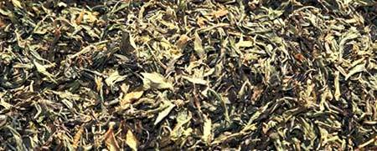
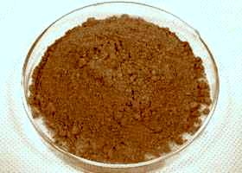

Figure 1 Dried leaves of Catharanthus roseus (sadabahar) and powderd extract

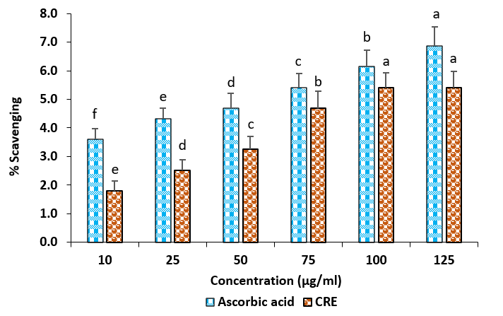
Figure 2: Hydrogen peroxide (H₂O₂) scavenging activity of Catharanthus roseus at different concentrations. Values are expressed as mean ± standard deviation (SD) of triplicate determinations.

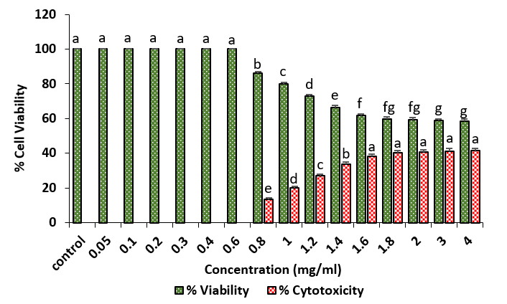
Figure 3: Determination of the maximum non-cytotoxic dose of the hydromethanolic extract of Catharanthus roseus using the MTT cytotoxicity assay. Results are expressed as mean ± SD of triplicate experiments.

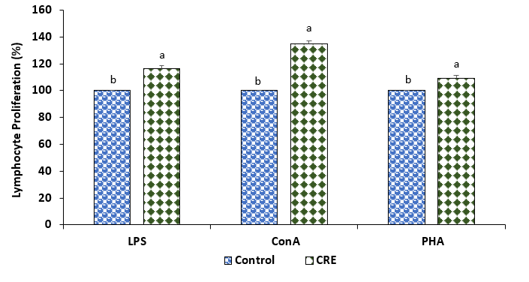
Figure 4: Effect of LPS, ConA, and PHA on lymphocyte proliferation under Catharanthus roseus extract treatment. Results are expressed as mean ± SD (n = 3).

