Optimisation of Oyster Mushroom (Pleurotus ostreatus) Cultivation Using Locally Available Substrates

Abstract:

The present research trial was conducted at the School of Agriculture, Loyola Academy Degree & P.G College, during the Kharif season 2024, to determine the effective yield of oyster mushroom production using locally available substrates, with four treatments (paddy straw, coconut coir, cardboard paper, and sawdust), each replicated 3 times in a CRD experimental design. The project data analysis revealed that T1 (paddy straw) was more efficient than the other treatments, namely T₂ (coconut coir), T₃ (sawdust), and T₄ (cardboard). Analysis of variance showed a significant difference @ 1 % and 5 % level of significance for all the parameters, but high significance was observed for paddy straw treatment during the experiment.

Key Words: Oyster mushroom, paddy straw, coconut coir, cardboard paper, sawdust.

Introduction:
Mushroom cultivation, which is having a high demand for profits, which plays a key role in the agribusiness sector, and the Oyster mushroom (Pleurotus ostreatus) is an edible mushroom with excellent flavour and taste with a great source of protein. It belongs to the class Basidiomycetes, subclass Hollobasidiomycetidae, order Agaricales. It commonly grows in the woods of hilly areas and grows in temperate and subtropical regions of the world. The invention, manifestation of non-conventional crops in the subsisting farming system, can help in enhancing the social as well as the profitable status of small growers. Mushrooms are the source of redundant ordinary power and virility and are used in the preparation of numerous international dishes and have medicinal properties like anti-cancerous, anti-cholesterol and anti-tumorous. Mushrooms are useful against diabetes, ulcers, and lung diseases. (Quimio, 1976). Mushrooms are a good source of protein, vitamins, and minerals (Khan et al., 1981). Mushrooms contain about 85-95% water, 3% protein, 4% carbohydrates, 0.1% fats, 1% minerals, and vitamins (Tewari, 1986). Mushrooms contain an appreciable amount of potassium, phosphorus, copper, and iron, but a low level of calcium. (Anderson and Feller, 1942).

Mushroom protein is intermediate between that of animals and vegetables. (Kurtzman, 1976). Apart from these, mushrooms also contain a valuable amount of Niacin, pantothenic acid, and biotin (Subramanian, 1986), which can be grown in agricultural and industrial waste. Mushrooms are the reproductive organs of fungi, which are neither plants nor animals but part of a separate kingdom known as Fungi. Unlike plants, fungi do not produce their own food through photosynthesis. Instead, they obtain nutrients by breaking down organic matter in the environment. Fungi have a unique structure, composed of a vast network of filaments known as mycelium. This mycelial network exists mostly underground or within decaying organic matter, and it is responsible for nutrient absorption. The edible part of a mushroom is the basidiocarp, which is the fleshy, spore-bearing fruiting body that appears above ground. This structure includes the cap, gills, and stalk that are commonly harvested and consumed.

Among different species of mushrooms, oyster mushrooms are a very frequently and commonly cultivated species. They mainly rank 2nd in the largest cultivated mushroom type worldwide. China produces the highest oyster mushroom production, which is mainly contributing for about 74.00 per cent of the total global output production. When compared to the other countries involving in oyster mushroom production include Italy, Poland, Netherlands, Romania, Republic of Korea, Spain, Lithuania and India [Fig. 1]. The genus Pleurotus, which consist oyster mushrooms, which has focused the garnered significant research attention due to its lignolytic features as a white-rot fungus. Apart from being edible and savory, these mushrooms contain an essential bioactive element which have different significant biological impacts. Which is owing to their simple growth and more cost-effective and ecologically friendly cultivation techniques, with high biological efficiencies and good sources of nutritional and medicinal benefits, oyster mushrooms are widely famous and cultivated in many parts of the countries world-wide [W.G. Sganzerla, 2022].

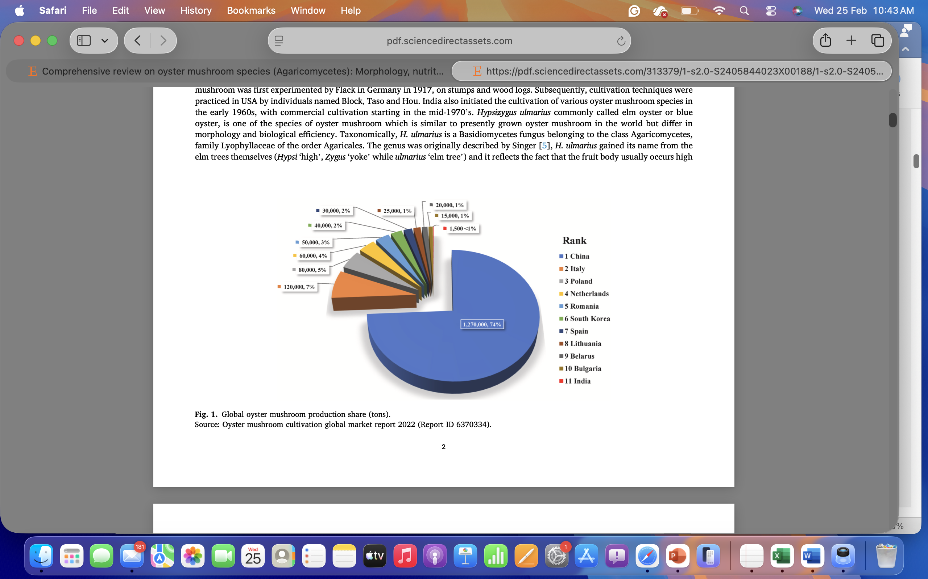

Figure:1-Global production (Source: Oyster mushroom cultivation global market report 2022 (Report ID 6370334).
Oyster mushroom is mainly used for its culinary purpose which serves as an important dietary component [ S. Yingyue et.al.,2014, Aditya et.al 2020]. Abundant in proteins, lipids, vitamins, carbohydrates, amino acids, minerals and fibers, these mushrooms boast a vast wealth of nutritional benefits [Table 1]. However, they are low in calories, fat content, less cholesterol levels and less sodium levels, which make mushrooms an excellent choice for health-conscious individuals. Adding oyster mushrooms in our diets which will lead to the reduction and risk of several health issues, which include obesity, diabetes, cancer and heart diseases, while simultaneously boosting the immune body system. Beyond the nutritional value, of the mushrooms have a vast wide range of bioactive elements and compounds like peptides, polysaccharides, fatty acids, oligosaccharides, glycoproteins, and nucleosides, which have been used in traditional usage of medicine to combat the various ailments. Oyster mushrooms found to have a plethora of health-promoting properties, which include antioxidant, antidiabetic, anticancer, antimicrobial, anti-inflammatory, antihypertensive, antiatherogenic, anti-hyperglycaemic and immuno-modulating characters, and versatile natural remedy. [I.S. Yingyue et.al.,2014, Ijeh, et. al 2009, M.A. Khan et.al,2012.]

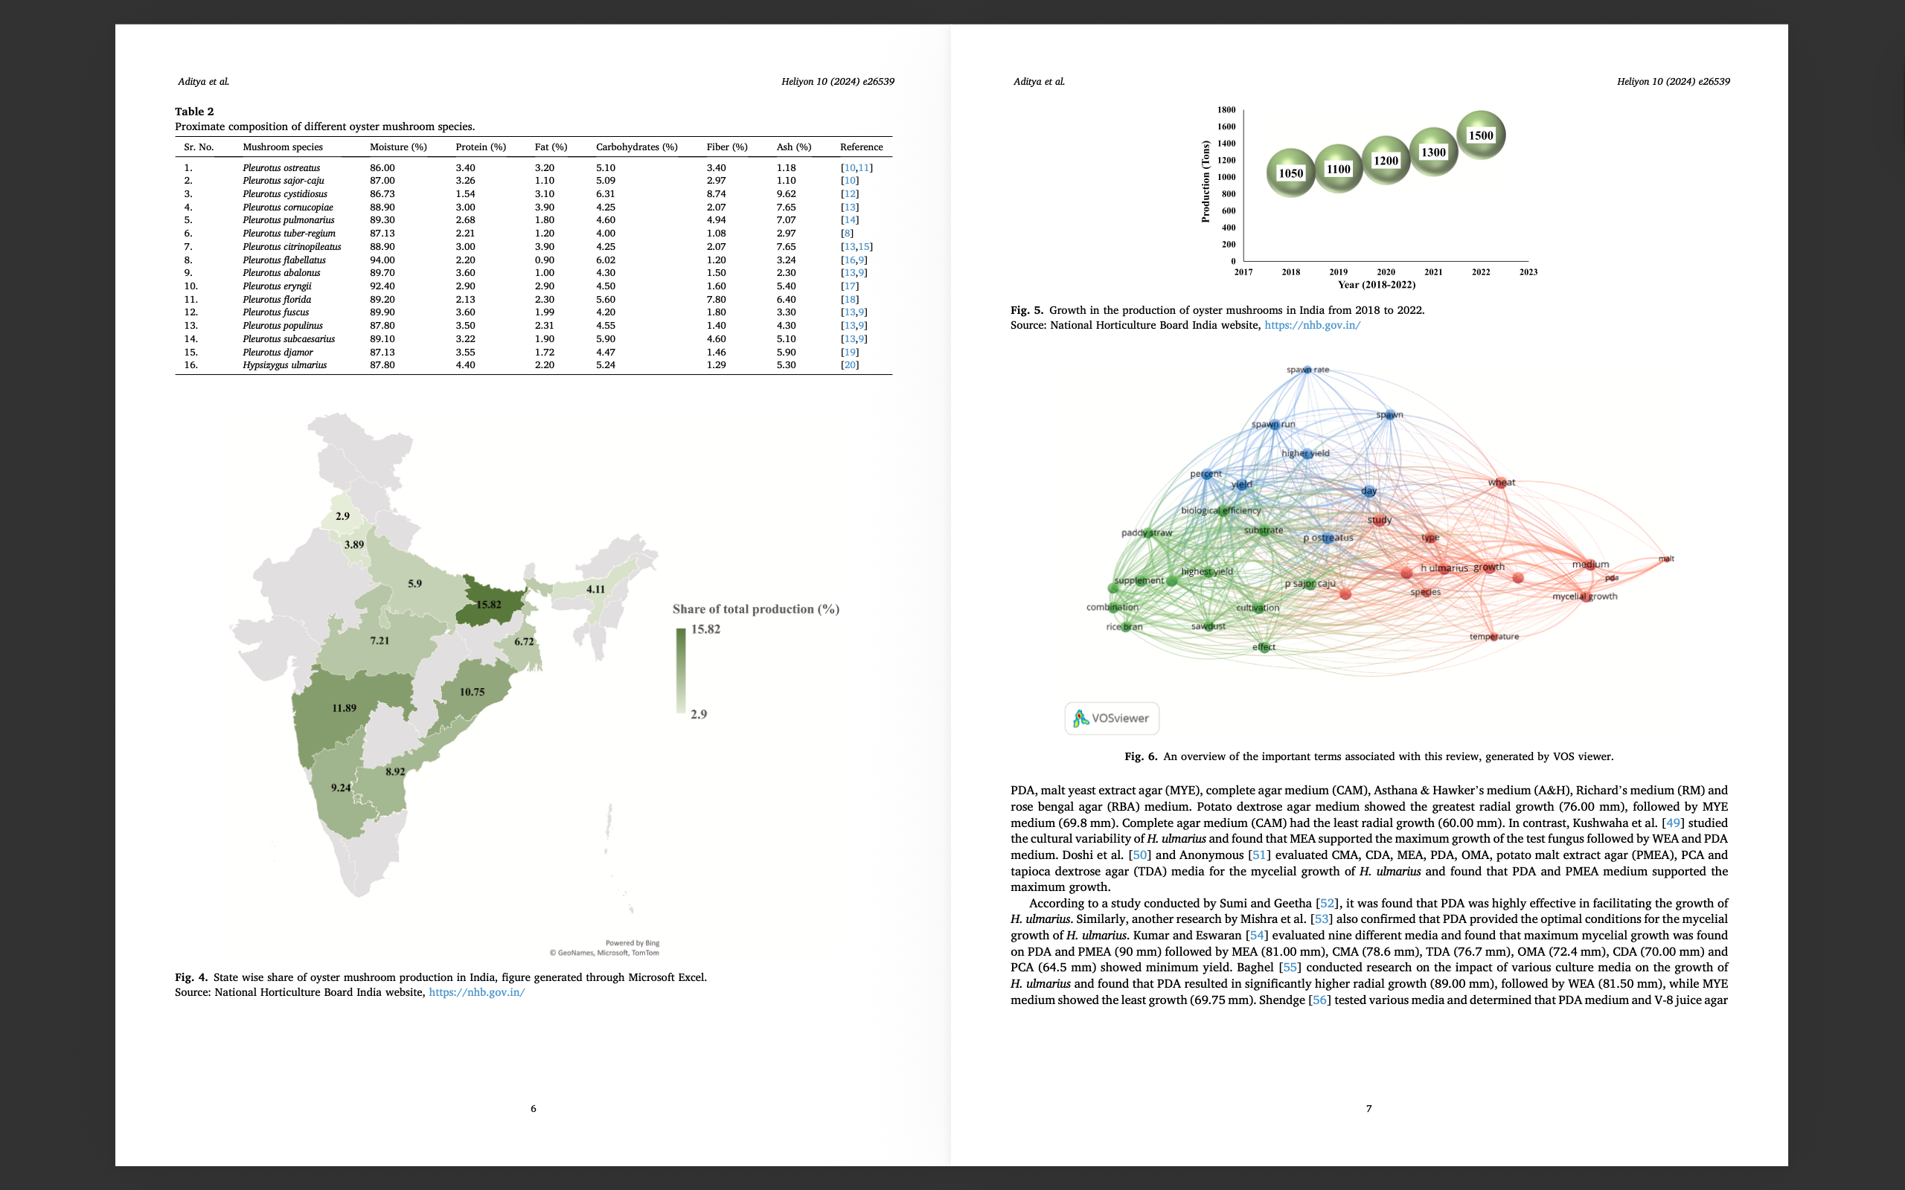

Table.1- Nutritional benefits

Materials and Methods:

The research trial was conducted during the kharif season 2024, at the School of Agriculture, Loyola Academy Degree and P.G. College, by using 4 treatments (paddy straw, coconut coir, cardboard and sawdust, represented in Fig. 1) with 3 replications by following Completely Randomized Block Design (CRD). The experiment was primarily conducted to determine the yield attributes among the four treatments. Data recorded for the mushroom production technology includes the number of pinheads, pileus thickness, pileus length, stalk Length, and stalk diameter. Analysis of variance has been recorded at 0.01 % and 0.05 % level of significance for the mentioned parameters in the present investigation. For the Preparation of culture media, a pure culture of oyster mushroom is maintained on media prepared from potato dextrose agar (PDA). Malt extract agar (MEA), peptone, and agar. 78g of PDA, 60g of malt extract agar, 30g of agar, and 10g of peptone were added into 2dm3 of distilled water in a flask. Then it was placed on bunsen burner to mix. This prepared media was placed on a hot plate to dissolve agar and then autoclaved at 121 degrees Celsius for 15 minutes. 15ml of medium was dispensed into 9 cm diameter petri dishes. These are inoculated with the oyster mushroom cultures by using a spatula and incubated at 25 degrees Celsius.
The spawn production: Preparation of master culture or mother spawn is carried out under completely sterile conditions. Pure culture raised either from tissue or spores is inoculated in a suitable substratum (wheat, sorghum or rye) which provides food to the mycelium. Ten kg. of wheat grains are boiled in 15 liters of water for 20 minutes. Water is then drained off and the grains are put over the sieve or on a wire mesh tray for 8-10 hours to dry or remove excess of water. Grains are now mixed with gypsum (calcium sulphate) and chalk powder (calcium carbonate) at the rate of 2% and 0.5%, respectively on dry weight basis. 10 Kg of dry wheat grains will require about 200g gypsum and 50g chalk powder. This will help to check the pH of the medium and also prevent sticking of grains with one another.

The grains are filled into half or one-liter glucose bottles or PP bags which are plugged with non-absorbent cotton and sterilized at 22 lb. p.s.i pressure for 1.5-2 hours. Sterilized bottles are allowed to cool down overnight. Next day bottles are inoculated with the bits of agar medium colonized with the mycelium of pure culture. Inoculated bottles are incubated at 25± 1ºC. After 7 days of inoculation, bottles are shaken vigorously so that mycelial threads are broken and become well mixed with the grains. Two weeks after inoculation, the bottles are ready as stock culture for further multiplication of spawn. One bottle of stock culture or master culture or mother spawn is sufficient to multiply 30-40 grain bottles or pp bags. Master spawn or master culture bottles / bags are further used for inoculation of a large number of other grain bags/bottles prepared by the same technique and the resultant is the commercial spawn.

For the bag design: We need polypropylene bags for mushroom cultivation. The bag should be high clarity and crystal clear in order to enhance the image of the product inside the bag. These bags offer highly protective barrier against moisture and vapours. The size of the bag should be 12 (inches) width* 18 (inches) height Thickness about 0.04mm. For mushroom cultivation, the polypropylene bags are disinfected with formalin. The soaked paddy straw in water and formalin is taken out and kept for shade drying for 2 hours, and disinfected with Bavistin. Later, paddy straw and spawn were filled in bags up to 20%. Repeat it for 3 layers of spawn and straw alternatively by keeping the bag airtight with rubber bands, make holes in the bag to allow aeration and incubate in a dark room for 15-20 days. After the mycelium growth, remove the polypropylene bag cover to the half portion. (Fig 2a and 2b).

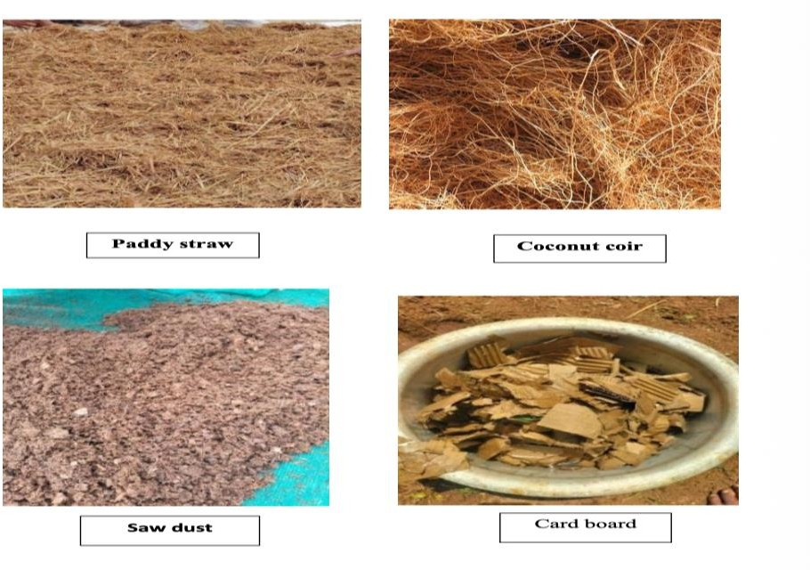

Fig. 2.: Different Substrates of Mushroom
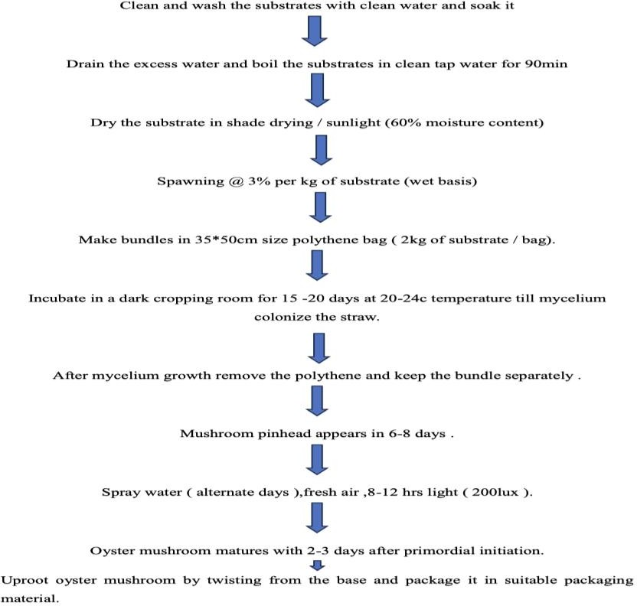
Fig. 2a: Procedure for Mushroom Cultivation

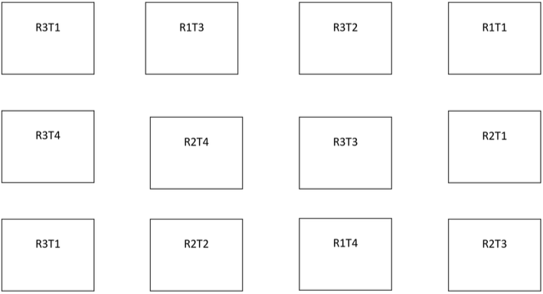

Fig: 2b. CRD Layout of the experiment

Results and Discussions:
Analysis for the number of Pinheads: The data for the number of pinheads were found to be Significant at the 1% and 5% levels of significance, CD (0.01) = 9.971, CD (0.05) = 6.854. Comparison of Treatment Means with Critical Difference at the 0.05 % level of significance. The number of pin heads observed in different treatments are Treatment 1 (control) paddy straw is 45, Treatment 2 coconut coir is 23, Treatment 3 is sawdust 20, Treatment 4 paper is15. When compared to all other treatments paddy straw showed moderate number of pin heads which is control in our experiment. An ideal number of pinheads in mushroom cultivation depends on the species and substrate, but generally, a moderate density is best to avoid clusters of tiny, unmarketable mushrooms. In oyster mushrooms, roughly 30-50 pinheads per spot can yield high-quality, matured mushrooms, while excessive pinning (often 75+ for some species) leads to overcrowding. Too many pinheads cause the mushrooms to compete for nutrients, resulting in small, stunted, or misshapen fruits.

Analysis of Stalk Diameter: The highest stalk diameter is observed in paddy straw (T1), i.e., (0.363), followed by coconut coir (T2), i.e., (0.324), and next, Saw-dust (T3), i.e. (0.21), cardboard (T4), i.e. (0.207), has the least stalk diameter. There is a significant difference between all 4 treatments. When compared to all other treatments paddy straw showed highest stalk diameter which is control in our experiment. A high (thick/sturdy) stalk diameter is generally preferred in mushroom cultivation. A thick, firm stalk indicates a healthy, high-quality mushroom. A thicker stalk indicates that the fungus has enough nutrition, suggesting a good substrate mixture. Using superior substrates like paddy straw can result in a higher stalk diameter. In summary, a higher stalk diameter is a positive indicator of good growing conditions and higher quality.

Analysis of stalk Length: The highest stalk diameter was observed in i.e., Cardboard (T4) (5.433cm), followed by coconut coir (T2), i.e. (3.933), and next sawdust (T3), i.e., (3.5) (2.33) when compared to paddy straw (T1) i.e. 1.9, has the least stalk length. There is a significant difference between all 4 treatments. For most commercially cultivated mushrooms, such as oyster mushrooms, the stalk (stipe) length should be low. A short, thick, and compact stalk is considered a sign of high quality. A short, thick stalk indicates that the mushroom matured properly in a good, high-oxygen environment. Long, thin stalks (stretching) are often a sign of high levels or poor air exchange during the growing stage. While very long stems can increase the total weight, they are often considered undesirable by consumers and are usually trimmed off before cooking anyway, making short, stout stems more desirable for culinary use. For the best quality, aim for conditions that minimize excessive stalk elongation, as shorter, thicker stalks are preferred for consumption.

Analysis of Pileus Length: The highest pileus length was observed in paddy straw (T1), i.e., (2.167 cm), followed by coconut coir (T2), i.e. (0.703), next is sawdust (T3), i.e., (0.097), and Cardboard (T4), i.e. (1.567) has the least pileus length. There is a significant difference between all 4 treatments. Highest pileus length is observed in paddy straw. In mushroom cultivation, particularly for species like oyster mushrooms (Pleurotus ostreatus), a high (large) pileus diameter/width is generally desired. Large-sized fruit bodies with wider, thicker pilei are generally considered of superior quality and rank higher in market value. For premium quality, a larger pileus combined with a shorter (not long) stipe is ideal. Studies show that paddy straw promote larger pileus diameters in the case of mushroom cultivation. Paddy straw often produces larger diameters (approx. 8.1 cm) compared to other materials. here is a strong positive correlation between pileus width and the overall fresh weight or biological efficiency of the mushroom, meaning larger caps typically signify a higher quality and higher-yielding crop.

Analysis of Pileus Thickness: The highest pileus diameter was observed in paddy straw (T1), i.e., (0.653cm), followed by coconut coir (T2), i.e., (0.45cm) and the sawdust (T3), i.e., (0.18 cm). Cardboard (T4), i.e., (0.04cm), has the least pileus diameter. There is a significant difference between the T1 & T2. Desired pileus thickness was observed in T1(paddy straw) followed by coconut coir. Rice straw and coconut coir can produce thicker pilei (e.g., 0.56 cm) compared to other, less dense agricultural wastes. The first flush usually produces the thickest mushrooms, with thickness decreasing in subsequent flushes. Most studies report a range between 0.41 cm and 0.60 cm. A higher pileus thickness is considered a key indicator of quality and higher biological efficiency in mushroom cultivation. Pileus thickness is directly related to the overall weight of the mushroom. A thicker cap generally results in a higher, more valuable yield. High-thickness, high-quality mushrooms are often achieved by optimizing the substrate. Increased pileus thickness is often, but not always, correlated with a larger cap diameter (5.5–25 cm) and increased biological efficiency. Thickness is a key quality metric, with thicker, firmer mushrooms preferred in the market.

Analysis of Yield: The highest yield was observed in paddy straw (T1), i.e., (21 gm), followed by coconut coir (T2), i.e. (14 gm), next is Saw dust (T3), i.e., (8 gm), and cardboard (T4), i.e. (7 gm) has the least pileus. There is a significant difference between all 4 treatments. Oyster mushrooms are high-yielding, often producing a biological efficiency (BE) of 50–100%+, meaning 1 kg of dry substrate can yield roughly 500g–1kg+ of fresh mushrooms over multiple flushes. A typical 10 lb (4.5 kg) bag can produce 2.5–3 lbs (1.1–1.3 kg) of mushrooms in the first flush alone. The first flush is usually the most productive, accounting for 60–70% of the total harvest. The second flush typically provides the remaining 30–40%. First flushes are highest, decreasing in subsequent, second and third flushes. Optimal temperatures (20–30°C) and high humidity (~85%) are necessary for maximum production. Approx. 800g of fresh mushrooms per kg of dry substrate is achievable. Up to 12 kg per square foot can be achieved in specialized farming. Adding supplements like wheat bran can increase yield but requires careful management to avoid contamination. On average, 1 ton of dry wheat or paddy straw can produce between 500 kg and 700 kg of fresh mushrooms within 45–60 days. High-quality first-generation spawn can yield significant results; for instance, 1 kg of spawn mixed with 20 kg of pasteurized straw can produce up to 20 kg of mushrooms.

The results of the data analysis clearly indicated that paddy straw (T1) was the most effective substrate, yielding the highest growth and production of oyster mushrooms compared to the other treatments. Coconut coir (T2), sawdust (T3), and cardboard (T4) were less efficient in terms of overall yield and growth performance. The findings suggest that paddy straw is the most suitable and efficient substrate for oyster mushroom cultivation, out-performing the other organic materials tested in this experiment. This highlights the potential of paddy straw as a cost-effective and high-yielding substrate for commercial mushroom farming. Analysis (Table 2.A to 2.F) and Average graphical representation (Fig 3.A to Fig 3.E) were mentioned below.

Table-2. A. Analysis for Number of Pinheads
Source of Variation | Degree of freedom | Sum of Squares | Mean Sum of Squares | F. Cal | F. Tab
Treatments | n-1 (4-1=3) | 3530.917 | 1176.972 | 88.82 | 4.07
Error | 8 | 106 | 13.25 | - | -
Total | 11 | - | - | - | -
Treatment Average | (T1 = 61.67) | (T2 = 55.67) | (T3 = 33.33) | (T4 = 19)
Treatments found to be significant at 1% and 5% level of Significance
CD (0.01) = 9.971, CD (0.05) =6.854

Table-2. C. Analysis for Pileus Thickness
Source of Variation | Degree of freedom | Sum of Squares | Mean Sum of Squares | F. Cal | F. Tab
Treatments | n-1 (4-1=3) | 0.677 | 0.226 | 30.547 | 4.07
Error | 8 | 0.059 | 0.007 | - | -
Total | 11 | - | - | - | -
Treatment Average | (T1 = 0.653) | (T2 = 0.450 | (T3 =0.18) | (T4 =0.04)
Treatments found to be significant at 1% and 5% level of Significance
CD (0.01) = 0.235, CD (0.05) =0.162

Table 2. D. Analysis for Pileus Length
Source of Variation | Degree of freedom | Sum of Squares | Mean Sum of Squares | F. Cal | F. Tab
Treatments | n-1 (4-1=3) | 7.545 | 2.515 | 20.84 | 4.07
Error | 8 | 0.96 | 0.12 | - | -
Total | 11 | - | - | - | -
Treatment Average | (T1 = 2.167) | (T2 = 0.703) | (T3 =0.09) | (T4 =1.56)
Treatments found to be significant at 1% and 5% level of Significance
CD (0.01) = 0.951, CD (0.05) =0.654

Table 2. B. Analysis for Stalk Length
Source of Variation | Degree of freedom | Sum of Squares | Mean Sum of Squares | F. Cal | F. Tab
Treatments | n-1 (4-1=3) | 14.78 | 4.927 | 115.92 | 4.07
Error | 8 | 0.34 | 0.043 | - | -
Total | 11 | - | - | - | -
Treatment Average | (T1 = 5.433 | (T2 = 3.93) | (T3 =3.5) | (T4 =2.33)
Treatments found to be significant at 1% and 5% level of Significance
CD (0.01) = 0.565, CD (0.05) =0.388

Table 2. E. Analysis for Stalk Diameter
Source of Variation | Degree of freedom | Sum of Squares | Mean Sum of Squares | F. Cal | F. Tab
Treatments | n-1 (4-1=3) | 0.057 | 0.019 | 15.57 | 4.07
Error | 8 | 0.01 | 0.001 | - | -
Total | 11 | - | - | - | -
Treatment Average | (T1 = 0.363) | (T2 = 0.324) | (T3 =0.32) | (T4 = 0.207)
Treatments found to be significant at 1% and 5% level of Significance
CD (0.01) = 0.096 CD (0.05) =0.066

Table 2. F. Analysis for Harvest
Source of Variation | Degree of freedom | Sum of Squares | Mean Sum of Squares | F. Cal | F. Tab
Treatments | n-1 (4-1=3) | 37.0 | 123.3 | 16.44 | 4.07
Error | 8 | 6.0 | 7.5
Total | 11 | - | - | - | -
Treatment Average | (T1 = 21.66) | (T2 = 14) | (T3 =7.66) | (T4 =8.66)
Treatments found to be significant at 1% and 5% level of Significance
CD (0.01) = 7.50, CD (0.05) =5.15.

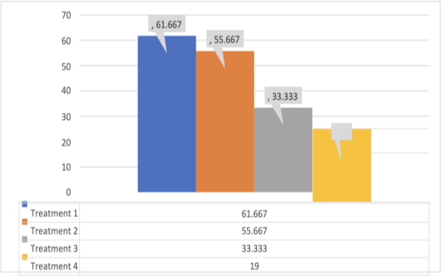
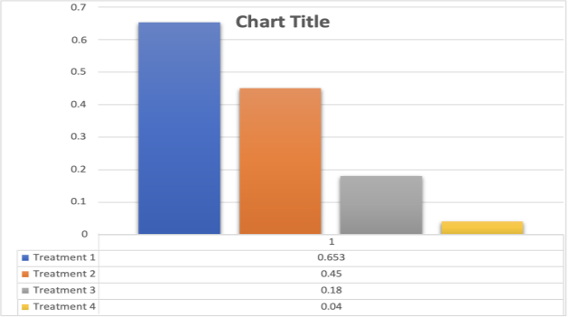
Fig 3. A. Average Number of Pinheads Fig.3. B. Average Pileus Thickness

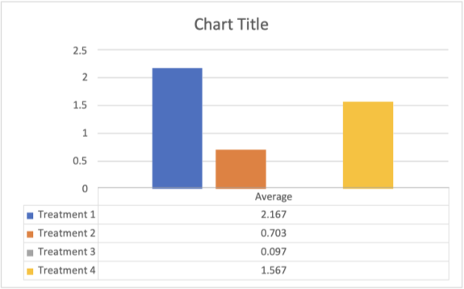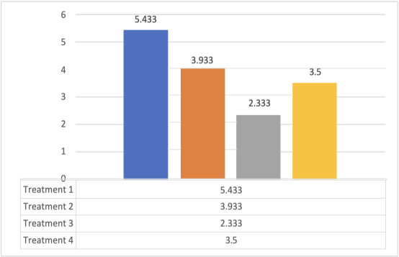

Fig. 3. C Average Pilus Length Fig.3. D. Average Stalk Length
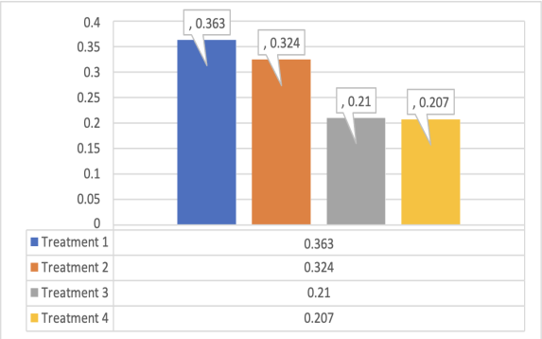
Fig. 3. E. Average Stalk Diameter

Conclusions:
The experiment entitled “Optimisation of Oyster Mushroom (Pleurotus ostreatus) Cultivation Using Locally Available Substrates” was carried out at the Loyola Academy, Secunderabad. The experiment was laid out in the Completely Randomised Block Design with four treatments in different substrates T1 (paddy straw) T2 (coconut coir), T3 (saw dust), and T4 (Cardboard). The project data analysis revealed that the T1 (paddy straw) has shown higher efficiency compared to other treatments, viz., T2 (coconut coir), T3 (saw dust), and T4 (Cardboard) with moderate number of Pinheads, good Stalk Diameter, less stalk Length, high Pileus length and thickness and high yield were observed respectively.
References:
- Quimio TH. Indoor cultivation of Pleurotus ostreatus. Philippines Agriculturist. 1978; 61:253-262.
- Khan SM, Kausar AG, Ali MA. Yield performance of different strains of oyster mushroom (Pleurotus spp.) on paddy straw in Pakistan. Mush. Sci. X1 Sydney. 1981;(1):675-67.
- Tewari RP. Mushroom cultivation. Extension Bulletin. Indian Institute of Horticulture Research, Banglore, India. 1986; 8:36.
- Anderson EE, Feller CR. The food value of mushroom Agaricus Compestri. Pool. Am. Soc. Hort. 1942; 41:3010-303.
- Kurtzman RH Jr. Nutrition of Pleurotus sapidus: effects of lipids. Mycologia. 1976; 68:268-295.
- Subramanian TR. Nutritive Value. Mushroom Extension bulletin. Indian Institute of Horticulture Research, India. 1986; 8:36.
- W.G. Sganzerla, S.D. Todorov, A.P.G. Silva, Research trends in the study of edible mushrooms: nutritional properties and health benefits, Int. J. Med. Mushrooms 24 (2022):1–18, https://doi.org/10.1615/IntJMedMushrooms.2022043738.
- S. Yingyue, G. Min, J. Qunil, F. Lijun, F. Weilin, S. Tingting, T. Fangfang, C. Weiming, Effects of cold stimulation on primordial initiation and yield of Pleurotus pulmonarias, Sci. Hortic. 167 (2014) 100–106, https://doi.org/10.1016/j.scienta.2013.12.021.
- Aditya, Bhatia J.N. Jarial R.S., Mushrooms: immunity booster and nutritive food for future generations, the proceedings (E-Book) of the national webinar on impact of COVID-19 pandemic on environment and future prospects held on 21st June 2020 (2020) 107–112).
- I. Ijeh, I.A. Okwujiako, P.C. Nwosu, Phytochemical composition of Pleurotus tuber-regium and effect of its dietary incorporation on body/organ weights and serum triacylglycerols in albino mice, J. Medicinal Pl. Res. 3 (2009) 939–943, https://doi.org/10.5897/JMPR.9000998.
- M.A. Khan, M. Tania, Nutritional and medicinal importance of Pleurotus mushroom: an overview, Food Rev. Int. 28 (2012) 313–329, https://doi.org/10.1080/ 87559129.2011.637267.

