Unveiling the Pathogenicity and Cultural Behaviour of Colletotrichum capsici Causing Chilli Anthracnose

Abstract
Anthracnose caused by Colletotrichum capsici is a major disease affecting chilli (Capsicum annuum), particularly in warm and humid regions. This study focuses on confirming the pathogenicity of C. capsici through Koch’s postulates and investigating its cultural characteristics on various solid media. Symptoms such as sunken black lesions and necrosis were observed on inoculated chilli plants. Potato Dextrose Agar (69.33 mm) was identified as the most suitable medium for fungal growth and sporulation, followed by Sabouraud’s Dextrose Agar(59.33mm) and Czapek’s Dox Agar. These findings are critical for understanding the biology of the pathogen and designing effective management strategies.
Keywords: Colletotrichum capsici, chilli, anthracnose, pathogenicity, cultural characteristics, solid media.

1. Introduction
The chilli crop is subjected to various diseases caused by fungi, bacteria, viruses, nematodes and physiological disorders at different stages of development. Plant diseases have turned into a dilemma as it can cause significant reduction in both quality and quantity of agricultural products.
Anthracnose caused by Colletotrichum capsici significantly affects chilli production, particularly under humid conditions. Given the environmental concerns over chemical fungicides, the use of biological control agents and botanicals offers a sustainable approach to disease management. This study evaluates the antifungal efficacy of various bioagents and plant extracts under in-vitro conditions.
Anthracnose of chillis prevalent in tropical and sub-tropical countries such as India, Thailand, China and Indonesia. In India, anthracnose or die- back of chilli is usually caused by three species of Colletotrichum namely Colletotrichum capsici, Colletotrichum aculatum and Colletotrichum gleosporoides. Colletotrichum capsici Syd. Butler and Bisby involved in severe losses in fruits at the ripe stage of plant (Saxena et al., 2016). Colletotrichum capsici is a fungal pathogen that causes anthracnose disease in chilli, leading to severe yield losses. Colletotrichum capsici is the most important plant pathogen in the world, found mainly on the countries involved in Chilli production, causing economically important disease called Anthracnose (die back or fruit rot, leaf spot, wilt, damping off, etc.) and is known to result the decline in yield up to 50% (Pakdeevaraporn et al., 2008). Colletotrichum capsici is one of the most important plant pathogens worldwide causing the economically important disease anthracnose in a wide range of hosts including cereals, legumes, vegetables, others crops and in tree fruits also (Bailey and Jeger, 1992) [1]. Anthracnose of chilli caused by Colletotrichum capsici (Syd.) Butler and Bisby was reported for the first time in India by (Sydow, 1913) Anthracnose disease generally appears during warm and humid weather and disease attacks all plant parts at any growth stage. The disease causes necrosis of tender twigs from the tip to backward. The teleomorph stage of some Colletotrichum species is Glomerella and both stages are widely and prevalent in hot Anthracnose disease caused by Colletotrichum species is one of the most economically important diseases reducing marketable yield from 10% to 80% of the crop production in developing countries (Poonpolgul and Kumphai, 2007).
The disease is particularly destructive during high humidity and warm conditions. This study investigates the pathogenicity and cultural behavior of C. capsici under controlled laboratory conditions.
2. Materials and Methods
Pathogenicity test
Seeds of chilli AK 47 and capsicum Indum-11 susceptible to anthracnose disease (Collectotrichum capsici) were surface sterilized with 0.1% sodium hypochlorite and sown (@ 10 seeds / pot) in the plastic pots filled with steam sterilized potting mixture of soil: sand: FYM (2:1:1). After a week, four healthy growing chilli seedlings per pot were maintained, watered regularly and kept in the screen house for further development. The test pathogen (Colletotrichum capsici) was mass multiplied on the basal culture medium PDA in Petri dishes. Spore-cum mycelial suspension of Colletotrichum capsici was prepared from seven days old culture in plates by flooding with 5-10 ml sterile distilled water. The resultant spore-cum-mycelial suspension was suitably diluted with sterile distilled water to get inoculum concentration of 2 x 10 spores / ml. Forty-five days old seedlings of chilli were artificially spray inoculated (automizer) with the spore-cum-mycelial suspension (2 x 10 spores / ml) of the test pathogen. Chilli seedlings without inoculum were maintained as uninoculated suitable control. Pots (both inoculated and uninoculated) were kept in the screen house, covered with polythene bags during evening hours.
2.1 Preparation of inoculum
Inoculum was prepared by harvesting spores from 7-day old culture, grown on PDA, by adding a small quantity of distilled sterilized water and then gently shaking with a sterilized glass rod.
2.2 Inoculation
The epidermal layer of the host was damaged by carborandom powder before inoculation. The suspension of Colletotrichum capsici was used for inoculating the plants in pots by spraying the seedlings with the help of automizer. Inoculated seedlings were covered with polythene bags for 24 hours prior to inoculation. Seedlings were inoculated in the evening and covered with polythene bags for 2 days to provide 100 per cent humidity for successful infection.
2.3 Inoculation procedure for fruits
Fruits were washed thoroughly with distilled water and surface sterilized with 0.1 per cent aquecous HgCl solution for 2 minute and again rinsed with distilled sterilized water and incubated at 28 ± 2⁰C for 48 hr to see the presence of incipient infection. Healthy materials were picked up and inoculated by making ten pricks per fruits with droplet of spore suspension of Colletotrichum casici with a needle. The inoculated material was kept in moist chamber in Petriplates. Fruits were kept under bell jar to maintain the humidity and incubated at room temperature 28 ± 2”C along with the uninoculated control. The initiation of symptoms i.e. infectivity, the incidence and intensity was recorded.

2.4 Reisolation
After inoculating the plants with Colletotrichum casici the host plants were examined periodically for development of symptoms. Reisolations from infected tissues were made and the isolates were compared with the original one.
2.5 Cultural and morphological characteristics of Colletotrichum capsici
Five different media, three synthetic, i.e. Malt extract Agar, Sabroud extract Agar and Czapek’s dox Agar and two semisynthetic, i.e. Potato Dextrose Agar and Chilli Extract Agar Media, were used to study the radial growth as well as colony characteristics of C. capsici such as colour, texture and margin. The characteristics were compared with the colour chart (Akhtar and Singh, 2007). The test fungus was grown on autoclaved, molten and cooled medium were poured aseptically on to sterilized Petri plates and allowed for solidification of the media and then each plates were centrally inoculated with 5 mm culture disc of pathogen cut from the margins of 7 to 10 days old culture by using sterilized cork borer under aseptic condition then incubated at 28 ± 2⁰C in BOD incubator. Pathogen was identified for its morphological structures such as acervuli, presence and absence of satae, septation of mycelium, conidia shape and size and presence of oil globules were examined under stereo-binocular microscope.
2.5.1 Preparation of media
A) Potato dextrose Agar
Potato dextrose agar (PDA) medium was made by slicing 200 g of peeled potatoes into pieces and boiling them in 800 ml distilled water until they were thoroughly cooked. The starch extract was strained through muslin cloth. Dextrose and agar (20 g each) were added into it and the volume was adjusted to one litre. Autoclave the media for 15 min at 121⁰C and 15 Ibs pressure. Final pH of the medium should be 5-6 ± 0.5.
Chart 1: Composition of Potato Dextrose Agar

Sr. No. | Media | Composition
1. | Potato dextrose agar (PDA) | Potato (peeled) | : | 200.00 g
1. | Potato dextrose agar (PDA) | Dextrose | : | 20.00 g
1. | Potato dextrose agar (PDA) | Agar agar | : | 20.00 g
1. | Potato dextrose agar (PDA) | Distilled water | : | 1000 ml

B) Chilli extract agar medium
Aqueous extracts of the chilli leaves was prepared by grinding with mixture-cum grinder. The 10 gm washed leaves chilli was macerated in 10 ml distilled water (w/v) the macerates obtained were filtered through double layered muslin cloth. Each of the filtrate obtained was further filtered through Whatman No. 1 filter paper using funnel and volumetric flasks (100 ml cap.). The final clear extracts filtrates obtained formed the standard aqueous extract of 100 per cent.
Chart 2: Composition of Chilli Extract Agar
Sr. No. | Media | Composition
2. | Chilli extract agar | Chilli extract | : | 10% Leaves extract
2. | Chilli extract agar | Dextrose | : | 20.00 g
2. | Chilli extract agar | Agar agar | : | 20.00 g
2. | Chilli extract agar | Distilled water | : | 1000 ml

C) Czapek Dox Agar
Czapek Dox Agar is a synthetic medium containing sodium nitrate as the sole source of nitrogen. It is used for the containing sodium nitrate as the also be used for chlamydospore production by Candida albicans. The medium has good buffering action due to the presence of different salts. Suspend Sucrose 30.0 gm, Sodium Nitrate 2.0 gm, Dipotassium Phosphate 1.0 gm, Magnesium Sulfate 0.5 gm, Potassium Chloride 0.5 gm, Ferrous Sulfate 0.01 gm and Agar 15.0 gm in one liter of purified water. Heat with frequent agitation to boiling to completely dissolve the medium. Autocalve at 121⁰C for 15 minutes.
Chart 3: Composition of Czapek Dox Agar

Sr.  No. | Media | Composition
3. | Czapek Dox Agar | sucrose | : | 30.00 g
3. | Czapek Dox Agar | Sodium nitrate | : | 2.00 g
3. | Czapek Dox Agar | Diapotassium phosphate | : | 1.00 g
3. | Czapek Dox Agar | Magnesium sulphate | : | 0.5 g
3. | Czapek Dox Agar | Potassium chloride | : | 0.5 g
3. | Czapek Dox Agar | Ferrous sulphate | : | 0.01 g
3. | Czapek Dox Agar | Agar agar | : | 15.00 g
3. | Czapek Dox Agar | Distilled water | : | 1000 ml

D) Sabouraud agar or Sabouraud dextrose agar (SDA)
Sabouraud agar or Sabouraud dextrose agar (SDA) is a type of agar growth medium containing peptones. It was created by and is named after, Raymond Sabouraud in 1892. In 1977 the formulation was adjusted by Chester W. Emmons when the pH level was brought closer to the neutral range and the dextrose concentration lowered to support the growth of other microorganisms. The acidic pH (5.6) of traditional Sabouraud agar inhibits bacterial growth. Suspend 40 gm dextrose, 10 gm peptone and 20 gm agar in one liter of purified water. Heat with frequent agitation to boiling to minutes. Final completely dissolve the medium. Autoclave at 121⁰C for 15 pH of the medium should 5.6.
Chart 4: Composition of Sabouraud Dextrose Agar
Sr.  No. | Media | Composition
4. | Sabouraud dextrose agar (SDA) | Dextrose | : | 40.00 g
4. | Sabouraud dextrose agar (SDA) | Peptone | : | 10.00 g
4. | Sabouraud dextrose agar (SDA) | Agar agar | : | 20.00 g
4. | Sabouraud dextrose agar (SDA) | Distilled water | : | 1000 ml

E) Malt Extract Agar
Malt Extract Agar is recommended for the detection, isolation and enumeration of fungi, particularly yeasts and moulds, in various materials and for the cultivation of the strains for microbiological vitamin assays. Suspend 50 grams of the medium in one liter of purified water. Heat with frequent agitation to boiling to completely dissolve the medium. Autocalve at 121⁰C for 15 minutes.
Chart 5: Composition of Malt Extract Agar

Sr. No. | Media | Composition
5. | Malt extract agar | Malt extract (powder) | : | 50.00 g
5. | Malt extract agar | Glucose | : | 20.00 g
5. | Malt extract agar | Peptone | : | 1.00 g
5. | Malt extract agar | Agar agar | : | 20.00 g
5. | Malt extract agar | Distilled water | : | 1000 ml

3. Results and Discussion
3.1 Pathogenicity test
Pathogenicity test according to Koch’s postulate. The two varieties of chilli plant is used to prove pathogenicity. The varieties was AK-47 and Indus-11. The Colletotrichum capsici, isolated from anthracnose of chilli was proved pathogenic by artificial inoculation with spore suspension on leaves and branches of both varieties. After that the humidity was maintained by covering the inoculated chilli plants for 48 hrs after inoculation. Symptoms appeared seven days after inoculation. Symptoms on affected plants causes necrosis of tender twigs from the tip to backward. The entire branch or the entire top of the plant may wither away. Numerous black dots (acervuli of fungus) are found scattered all over the necrotic surface of the affected twigs and leaves. Reisolations were made from artificially inoculated leaves and twig showing typical symptoms of Anthracnose disease which yielded fungal pathogens to those of the original organism.

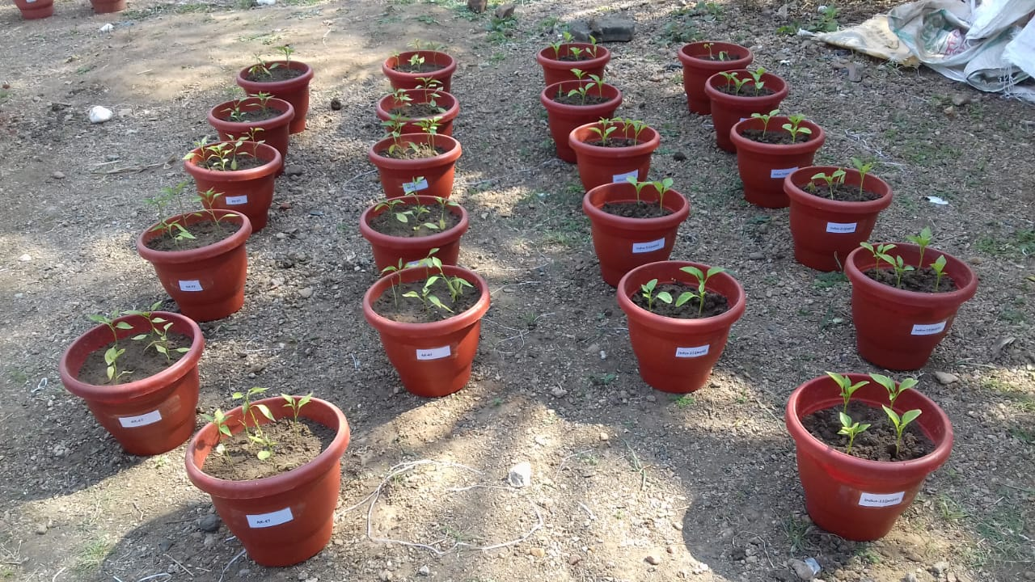
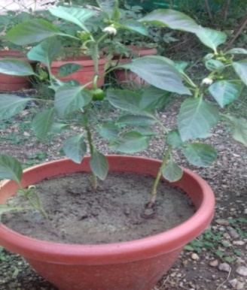
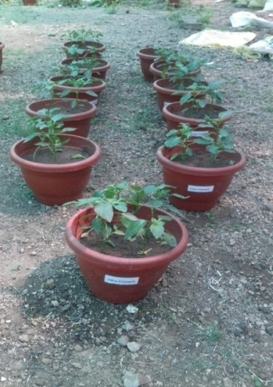
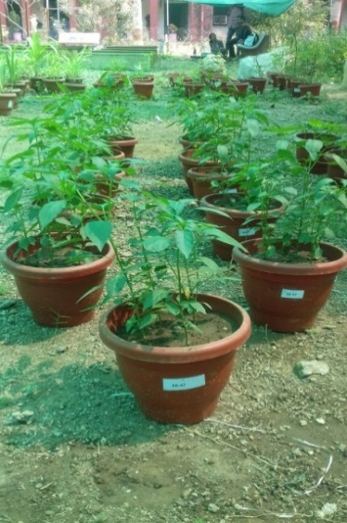
variety-AK-47
variety-Indum-11

(a) Pot culture for pathogenisity test
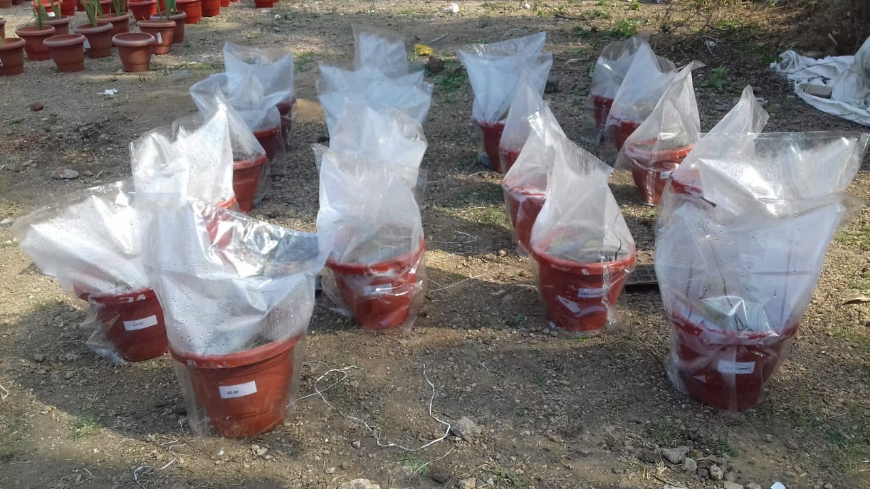
variety-AK-47
variety-Indum-11

(b) Humidity was maintain for pathogenisity test
Plate 2. (a) Pot culture for pathogenisity test; (b) Humidity was maintain for pathogenisity test

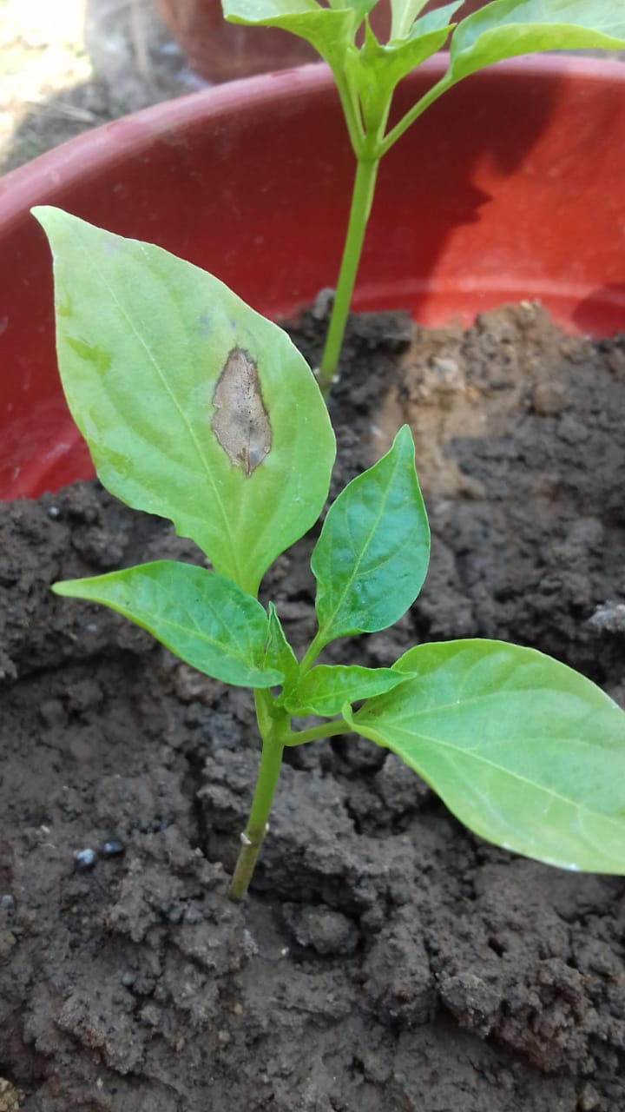
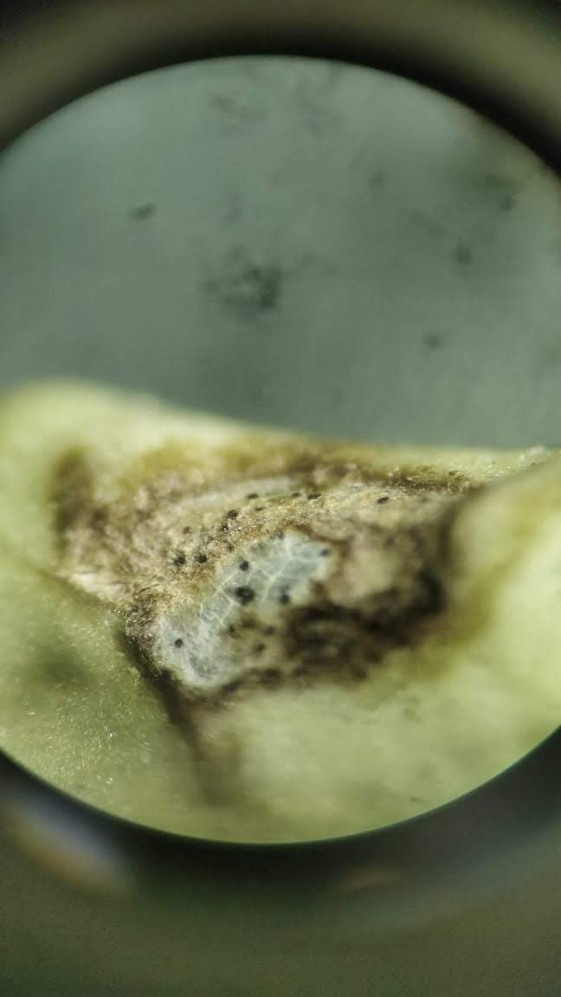
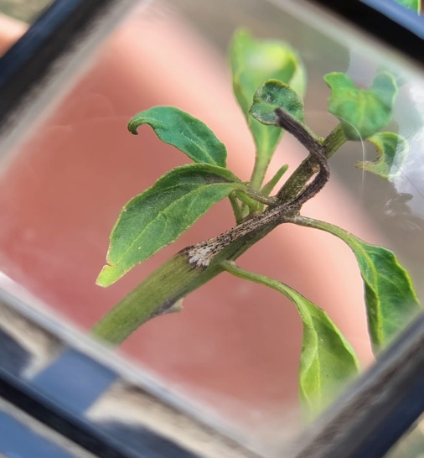
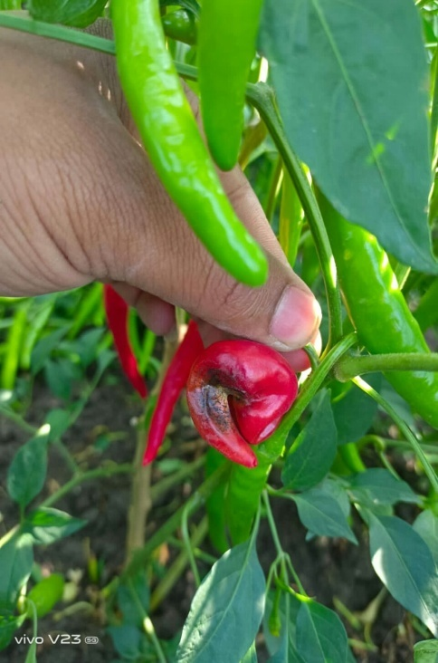
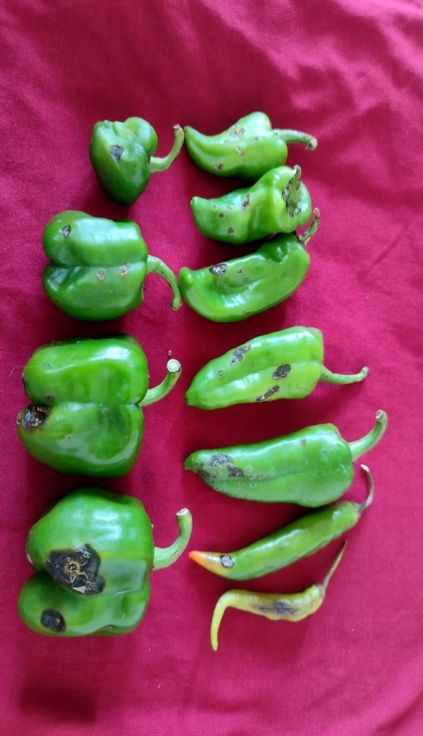
(a) Initial symptoms on leaves of variety Indum-11
(b) Stereoscopic image of acervuli on leaves
(c) Symptom on twig of variety AK-47
(d) Symptom on red fruit of chilli variety AK-47
(e) Symptoms on green fruits of capsicum variety-Indum-11
Plate 3. (a)-(e) Sypmtoms on different parts of chilli crop
3.2 Cultural characters of Isolated Pathogen
The variation in cultural characters of Colletotrichum capsici was studied on the five different solid media and the results thus obtained are presented in Table 1 Fig. 1 and Plate 4. The radial growth, colony characters and sporulation of the fungus were recorded, when the maximum growth was attained on any one of the tested media. The effect of different culture media on the growth of fungi differed significantly.
Table 1. Growth of Colletotrichum capsici on different solid media
Treatments | Mean colony diameter (mm)
Treatments | 3 DAI | 5 DAI | 7 DAI
-Potato Dextrose Agar | 32.33 | 42.33 | 69.33
-Chilli extract agar | 0.00 | 19.66 | 40.66
-Malt extract Agar | 28.33 | 33.33 | 51.33
-Sabouraud’s Dextrose Agar | 24.33 | 39.33 | 59.33
-Czapek’s Dox Agar | 26.66 | 36.67 | 53.66
F Test | Sig | Sig | Sig
S.E. (+m) | 0.29 | 0.33 | 0.33
CD (P= 0.01) | 1.33 | 1.49 | 1.49

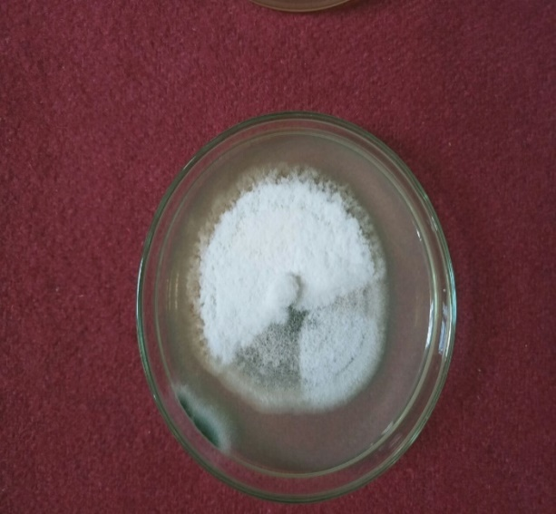
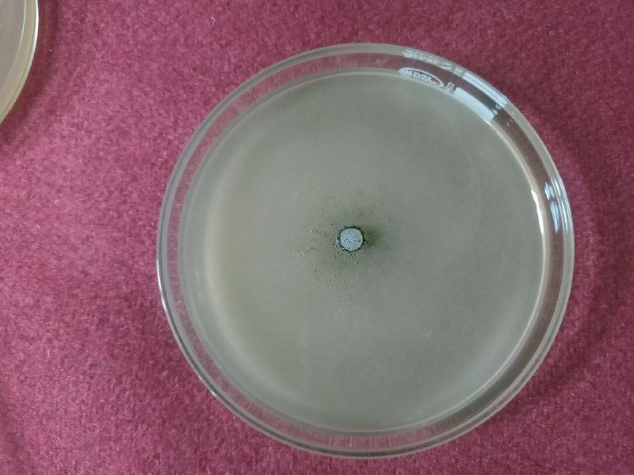
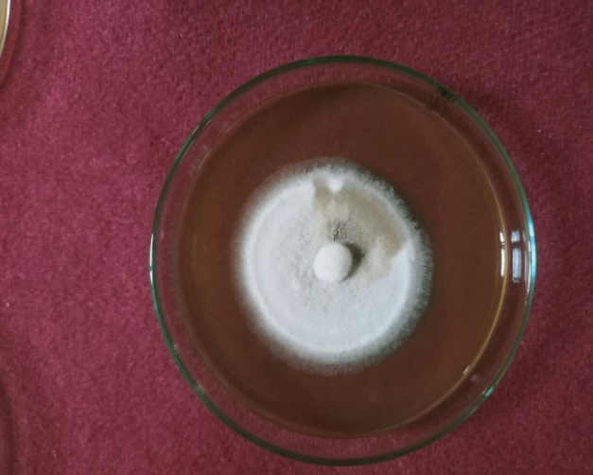
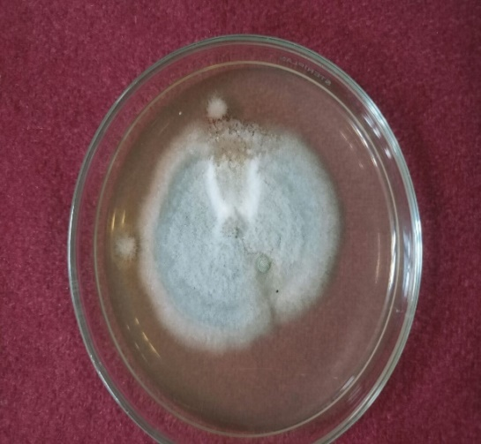
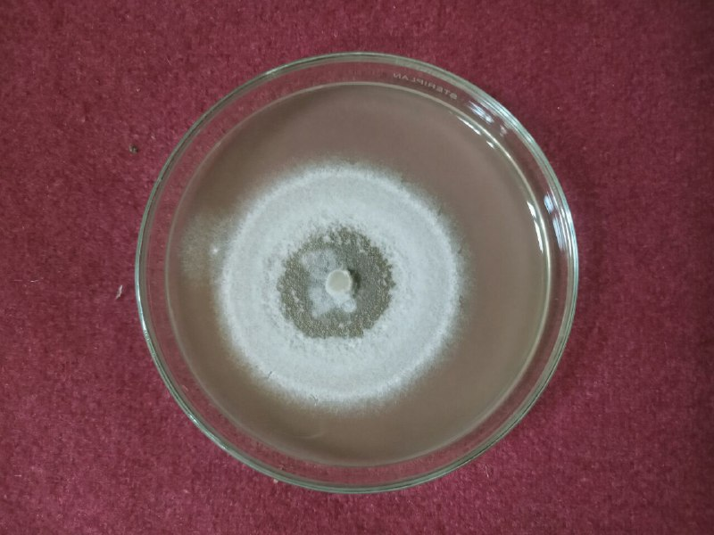
Plate 4. Growth of Colletotrichum capsici on different solid media
T₁
T₂
T₃
T₄
T₅

Fig. 1. Growth of Colletotrichum capsici on different solid media

Table 2. Cultural characteristics and sporulation of Colletotrichum capsici on different solid media after 7 days of Incubation

Media | Growth characteristic | Sporulation (10 DAI)
Potato Dextrose Agar | Greyish white colony with acervuli at periphery | ++
Chilli extract agar | Only acevuli are found | -
Malt extract Agar | White to greyish | -
Sabouraud’s Dextrose Agar | White to greyish colony colour with acervuli | +
Czapek’s Dox Agar | Whitish colour with concentric rings | +
Here,
- = No sporulation
+ = Good sporulation
++ = Excellent sporulation
The data present in table 1 maximum radial growth of Colletotrichum capsici was recorded on PDA media (68mm), which was found to be significantly superior to all other media followed by Sabouraud’s dextrose agar, Czapek’s dox agar and malt extract agar. The least radial growth was recorded in chilli extract media (40mm). Mycelium colour varied from whitish to greyish. The growth varied from flat to raised and fluffy to sparse. Acervuli are found early on PDA followed by Sabouraud’s dextrose media and chilli extract, while acervuli were not recorded in Malt extract, Czapek media, and chilli extract agar. Sporulation also showed greater variation in different media, ranging from excellent to poor. Excellent sporulation was recorded on PDA Media, good sporulation in Sabouraud’s dextrose media, while sporulation was not recorded in Malt extract, Czapek media, and chilli extract agar.

Conclusion
The present investigation conclusively established the pathogenic nature of Colletotrichum capsici causing anthracnose in chilli through the successful fulfillment of Koch’s postulates. Artificial inoculation of susceptible chilli varieties resulted in the development of characteristic anthracnose symptoms, including necrosis of tender twigs and the formation of black acervuli, thereby confirming the virulence of the pathogen. Reisolation of the fungus from infected tissues further validated its role as the causal agent of the disease.
The study also revealed significant variation in the cultural behaviour of C. capsici across different solid media. Among the five media evaluated, Potato Dextrose Agar proved to be the most suitable for mycelial growth and sporulation, recording the maximum radial growth and excellent sporulation. Sabouraud’s Dextrose Agar and Czapek’s Dox Agar supported moderate growth and sporulation, while chilli extract agar exhibited the least growth and poor sporulation. Differences in colony morphology, pigmentation, texture, and acervuli formation across media highlighted the influence of nutrient composition on fungal growth and reproductive potential.
These findings provide valuable insights into the biology, growth preferences, and pathogenic behaviour of C. capsici. Identification of suitable culture media and confirmation of pathogenicity are essential prerequisites for further studies on disease epidemiology, host–pathogen interactions, and screening of effective management strategies. The information generated in this study can serve as a scientific basis for developing integrated and sustainable approaches for managing chilli anthracnose under field conditions.
Reference

Agrios, G. N. 2005. Plant Pathology, 5th Ed. Academic Press, San Diego, p.922. Anonymous, FAO (2010). FAO Production Year book 2010. Rome: FAO, p. 333.
Akhtar, J., A. Kandan, B. Singh, P. Kumar and S. C. Dubey, 2016. Detached non-wounded fruit inoculation technique for pathogenicity of Colletotrichum capsici on chilli. Indian Phytopathology, 69(2): 200-201.
Anonymous, 2021. Agricultural Statistics at a Glance 2021, Government of India, Ministry of Agriculture and Farmers Welfare, Department of Agriculture and Farmers Welfare, Directorate of Economicsand Statistics.
Bailey, J. A. and M. J. Jeger (Eds.) 1992. Colletotrichum: Biology, Pathology and Control. Commonwealth Mycological Institute.
Pakdeevaraporn, P., S. Wasee, P. W. J. Taylor and O. Mongkolporn, 2005. Inheritance of resistance to anthracnose caused by Colletotrichum capsici in Capsicum. Plant Breeding 124: 206- 208.
Poonpolgul, S. (2007). Chili pepper anthracnose in Thailand. In The First International Symposium on Chili Anthracnose, Convention Center, Seoul National University, Korea, 2007 (Vol. 23).
Prajapati, M. K., S. Rawat, P. Singh and K. Shankar, 2020. Cultural and morphological characterization of Colletotrichum capsici causing anthracnose of chilli (Capsicum anum L.). Journal of Pharmacognosy and Phytochemistry, 9(3): 1985-1989
Sandee, Aphidech, Sarawut Sachan and Surasak Khankhum, 2011. Morphological, pathological and molecular variability of Colletotrichum capsici causing anthracnose of chilli in the North-east of Thailand. African Journal of Microbiology Research. 5(25): 4368-4372.
Saxena, A., R. Raghuwanshi, V. K. Gupta and H. B. Singh, 2016. Chilli anthracnose: the epidemiology and management. Frontiers in microbiology, 7: p.1527.
Sydow, H. 1913. Enumeration of Philippine fungi with notes and decriptions of new species, II. Philipp J. Sci, 8: 475-508.
Than, P. P., H. Prihasturi, S. Phoulivong, P. W. J. Taylor and D. Hyde, 2008. Chilli anthracnose disease caused by Colletotrichum species. J. Zhejiang Univ Sci 9: 764-778.
Thippeswamy, B., H. V. Sowmya and M. Krishnappa, 2011. Seed borne fungi of Vegetable crops in Karnataka. J. Pl. Dis. Sci. 6(1): 5-10.
Wijesekara H. R. and D. K. Agarwal, 2006. Taxonomic studies on five species of the genus Colletotrichum. Indian Phytopathology, 59(2): 203-20.
Yun, H. K., A. H. Ahmad, S. Muid and J. S. S. Seelan, 2009. First report of Colletotrichum spp. causing diseases on Capsicum spp. in Sabah, Borneo, Malaysia. Journal of Threatened Taxa, : 419-424.

