Biotechnology Frontiers in 21st Century Agriculture: A Comprehensive Review

Abstract
Agricultural biotechnology has emerged as a critical frontier in addressing the multifaceted challenges of 21st-century food systems, driven by a growing global population and the intensifying impacts of climate change. This review explores the transformative potential of modern biological tools, including genetic engineering, CRISPR-Cas9 genome editing, and multi-omics integration, in enhancing crop resilience and productivity. By synthesizing current research, the paper highlights how these technologies mitigate both biotic stresses, such as viral and fungal pathogens, and abiotic stresses, including drought, salinity, and extreme temperatures. Beyond yield enhancement, biotechnology plays a pivotal role in nutritional biofortification and environmental stewardship, notably through the reduction of synthetic pesticide reliance and the sequestration of carbon emissions. The analysis further discusses the transition toward a circular bio-economy, utilizing agricultural residues for bio-refining and biodegradable packaging. However, the global adoption of these innovations remains uneven, hindered by stringent regulatory frameworks, public safety concerns, and policy lags in developing regions.¹ To realize the goal of a sustainable "Evergreen Revolution," the review emphasizes the necessity of harmonized biosafety guidelines and the integration of artificial intelligence with molecular breeding. Ultimately, biotechnology stands as an indispensable pillar for ensuring global food security, offering precise solutions to maintain ecological balance while meeting the demands of a projected population of nine billion by 2030.
Keywords: Agricultural Biotechnology, CRISPR-Cas9, Food Security, Climate Resilience, Genetic Engineering, Sustainable Agriculture, Biofortification.

Introduction
Biotechnology encompasses the application of scientific techniques to modify and enhance the characteristics of various plants, animals, and microorganisms that hold economic significance (K.C. & Lamichhane, 2021). This field, which has evolved considerably since its inception in the early 20th century, is now defined broadly as any technological application utilizing biological systems, living organisms, or their derivatives to create or modify products and processes for specific uses (Ochieng & Ananga, 2019). In the context of agriculture, biotechnology plays a pivotal role in research tools that scientists utilize to comprehend and manipulate the genetic makeup of organisms for diverse applications in crops, livestock, forestry, and fisheries (Khan et al., 2017).
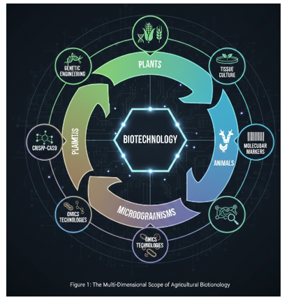
The profound impact of agricultural biotechnology is particularly evident in its capacity to address the escalating global food demand and foster sustainable agricultural practices (Masehela & Barros, 2023). This comprehensive review delves into the various facets of biotechnology applications in 21st-century agriculture, scrutinizing their potential to augment crop productivity, enhance climate resilience, and mitigate environmental impact (Adisa et al., 2024). The challenges facing modern agriculture, such as a rapidly expanding global population and increasingly unpredictable climate patterns, necessitate transformative approaches that integrate traditional practices with cutting-edge biotechnological innovations (Riaz et al., 2025). This paper explores the advancements and implications of biotechnology in modern agriculture, emphasizing its role in achieving food security and environmental sustainability (Das et al., 2023; Karakhanova et al., 2024). The projected global population is expected to reach nine billion by 2030, a period during which the Earth is also anticipated to experience significant warming, underscoring biotechnology's critical role in addressing both climate change and food security issues (Das et al., 2023). This urgent need for sustainable food systems is further amplified by the escalating challenges of climate change, which manifest as unpredictable weather patterns, increased prevalence of biotic and abiotic stresses, and dwindling arable land (Guleria et al., 2023).

Table 1. Diverse Definitions and Conceptual Scopes of Biotechnology
Organization / Source | Core Focus of Definition | Contextual Scope
US National Science Foundation | Controlled use of biological agents¹. | Microorganisms or cellular components².
FAO & CBD | Any technological application using biological systems³. | Derivatives to make or modify products⁴.
K.C. & Lamichhane (2021) | Application of scientific techniques to modify characteristics⁵. | Plants, animals, and microorganisms of economic significance⁶.
General Scientific View | Use of organisms or their components⁷. | Industrial, medical, agricultural, and environmental engineering⁸.
Broad Application View | Use of microorganisms and foreign genes⁹. | Food processing, agriculture, and forestry¹⁰.
Environmental View | Biotechnology as a tool for environmental protection¹¹. | Mitigating ecological risks and health hazards¹².
Functional View | Any technique using living organisms or substances from them¹³. | To make or modify a product for a practical purpose¹⁴.
Modern Agriculture View | Branch involving scientific techniques for modification¹⁵. | Improvement of both crops and livestock¹⁶.
Consequently, market-oriented innovation and modern bio-based technologies are increasingly essential to ensure the long-term viability of sustainable agricultural activities, especially given the complexities of global food supply chains and environmental pressures (DEMİREL et al., 2024). Biotechnology offers a powerful suite of tools to engineer crops with enhanced traits, such as increased yield, improved nutritional content, and heightened resistance to pests, diseases, and environmental stressors, thereby contributing to food security and sustainable agricultural practices (Das et al., 2023; Munaweera et al., 2022). This includes the development of resilient crop varieties capable of thriving in challenging climatic conditions, a critical factor given the vulnerability of traditional agriculture to climate change impacts (Ngongolo & Mmbando, 2024). Such biotechnological interventions are crucial for mitigating the adverse effects of climate change on agriculture and ensuring food security for a growing global population (Ngongolo & Mmbando, 2024).
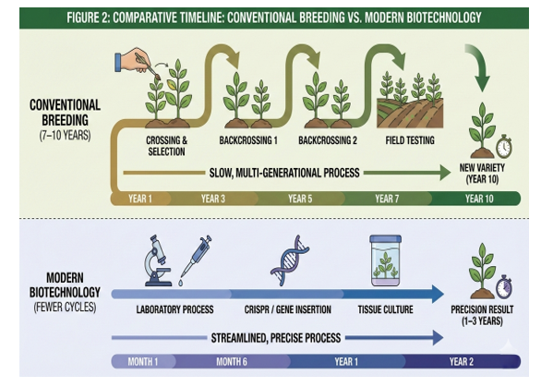
These resilient varieties not only ensure stable yields under challenging conditions but also reduce the reliance on agrochemical inputs, thereby promoting sustainable agricultural practices (Ngongolo & Mmbando, 2024). Therefore, leveraging plant biotechnology to introduce stress tolerance genes is crucial for maximizing plant productivity and ensuring agricultural stability in the face of environmental adversities (Kim & Kwak, 2020). Furthermore, the integration of genomic and biotechnological innovations is pivotal in developing climate-resilient agriculture, which is essential for global food security (Ngongolo & Mmbando, 2024). This review will systematically analyze the current state and future trajectories of biotechnological applications in crop enhancement, animal agriculture, and sustainable resource management, alongside an examination of the socio-economic and ethical considerations associated with their widespread adoption. Specifically, this includes exploring how biotechnological tools can accelerate the generation of novel genotypes with desirable breeding traits, leading to enhanced yields and improved productivity even under environmental constraints (Ochatt et al., 2023).

Table 2. Core Biotechnology Tools for Crop and Livestock Improvement
Biotechnology Tool | Primary Application | Intended Outcome
Genetic Engineering | Direct modification of genes¹⁷. | Resilience to biotic and abiotic stresses¹⁸.
CRISPR-Cas9 | Precise and fast genetic modifications¹⁹. | Enhanced stress tolerance and disease resistance²⁰.
Tissue Culture | Propagation from small plant tissue samples²¹. | Efficient mass production of desirable cultivars²².
Molecular Marker Selection | Identifying specific traits in the genome²³. | Accelerating the breeding of improved varieties²⁴.
Omics Technologies | Large-scale analysis of proteins and metabolites²⁵. | Understanding intricate genetic and regulatory networks²⁶.
Genome Doubling | Doubling the chromosome number²⁷. | Developing new varieties with enhanced vigor²⁸.
Embryo Rescue | Saving hybrid embryos from inviability²⁹. | Enabling successful interspecies breeding³⁰.
Somatic Hybridization | Fusing cells from different species³¹. | Creating novel genetic combinations for resilience³².
Background and Significance
Agricultural biotechnology has undergone significant evolution since the early 20th century, transitioning from basic fermentation processes to sophisticated genetic engineering techniques that enable precise modifications in economically important organisms (K.C. & Lamichhane, 2021; Ochieng & Ananga, 2019). Initially focused on microbial applications, it has expanded to encompass genomics, marker-assisted selection, tissue culture, and advanced tools like CRISPR, addressing limitations of traditional breeding in enhancing crop and livestock traits (Khan et al., 2017). This progression has been driven by the need to boost productivity amid a surging global population projected to reach nine billion, coupled with environmental pressures (Das et al., 2023).
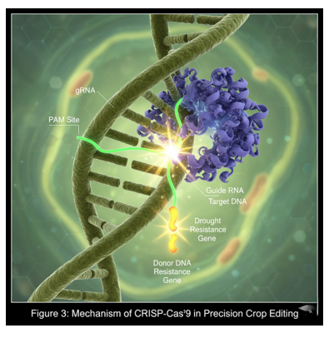

The significance of biotechnology lies in its capacity to foster sustainable agriculture by developing resilient varieties that withstand biotic and abiotic stresses, reduce agrochemical dependency, and improve nutritional profiles (Adisa et al., 2024; Munaweera et al., 2022; Ngongolo & Mmbando, 2024). For instance, it facilitates market-oriented innovations such as bio-based technologies that minimize carbon footprints and enhance soil health, ensuring long-term viability of food systems (DEMİREL et al., 2024; Guleria et al., 2023). Moreover, by integrating with precision farming and genomic tools, biotechnology accelerates the creation of climate-adapted crops, mitigating risks from unpredictable weather and resource scarcity (Kim & Kwak, 2020; Ochatt et al., 2023; Riaz et al., 2025).

Table 3. Quantitative and Qualitative Benefits of Transgenic Adoption

Benefit Category | Specific Impact Observed | Data Point / Rationale
Yield Growth | Dramatic increase in total food produced³³. | 657.6 million tons added (1996–2016)³⁴.
Environmental Conservation | Preservation of critical natural ecosystems³⁵. | 183 million hectares of land conserved³⁶.
Chemical Reduction | Lowered reliance on synthetic pesticides³⁷. | 8.2% reduction in pesticide use³⁸.
Emissions Reduction | Mitigation of greenhouse gas output³⁹. | Significant reduction in CO2 emissions⁴⁰.
Production Costs | Improved economic viability for farmers⁴¹. | Decrease in the overall costs of crop production⁴².
Input Optimization | Reduced need for expensive chemical fertilizers⁴³. | Precision breeding for nutrient efficiency⁴⁴.
Food Stability | Enhanced ability to thrive in harsh environments⁴⁵. | Bridging gaps from laboratory to field application⁴⁶.
Resource Efficiency | Optimized use of limited arable land⁴⁷. | Higher productivity per hectare⁴⁸.
These advancements not only promise an "Evergreen Revolution" through higher yields and resource efficiency but also align with global sustainability goals, balancing economic, environmental, and social imperatives (Das et al., 2023; Masehela & Barros, 2023).
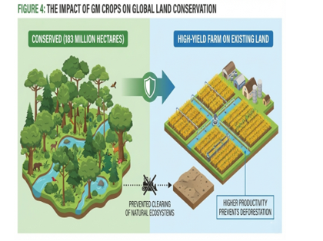

Genetic Engineering and Crop Improvement
Genetic engineering represents a cornerstone of modern agricultural biotechnology, enabling the precise insertion, modification, or deletion of genes to confer desirable traits in crops (Adisa et al., 2024; Khan et al., 2017). Unlike conventional breeding, which is time-consuming and limited by genetic compatibility, genetic engineering allows for the rapid development of varieties with enhanced pest resistance, herbicide tolerance, and abiotic stress resilience (Munaweera et al., 2022; Ngongolo & Mmbando, 2024). For instance, Bt crops engineered with Bacillus thuringiensis genes have significantly reduced insecticide use while boosting yields (Das et al., 2023).

Table 4. Contributions to Global Food Security and Sustainability
Contribution Area | Mechanism of Action | Strategic Goal
Population Growth | Expanding food production for 9 billion people⁴⁹. | Meeting global demand by 2030⁵⁰.
Nutritional Enrichment | Biofortification of staple crops⁵¹. | Addressing Vitamin A and other deficiencies⁵².
Climate Adaptation | Introduction of stress tolerance genes⁵³. | Maximizing productivity in adverse climates⁵⁴.
Soil Health | Use of biofertilizers and microorganisms⁵⁵. | Promoting natural nutrient cycling⁵⁶.
Evergreen Revolution | Unification of biotech with classical breeding⁵⁷. | Continuous increase in agricultural productivity⁵⁸.
Pest Control | Engineering inherent biological resistance⁵⁹. | Reducing crop losses to biological pathogens⁶⁰.
Water Efficiency | Developing drought-tolerant crop varieties⁶¹. | Thriving in water-scarce environments⁶².
Pathogen Defense | Resilience against emergent viruses and fungi⁶³. | Stabilizing supply chains against disease outbreaks⁶⁴.
Advanced tools like CRISPR-Cas9 further revolutionize this field by facilitating targeted edits without foreign DNA integration, accelerating the creation of climate-adapted cultivars (Ochatt et al., 2023; Riaz et al., 2025). These innovations address critical challenges such as drought, salinity, and nutritional deficiencies, exemplified by biofortified Golden Rice combating vitamin A deficiency (Adisa et al., 2024). By minimizing agrochemical dependency and optimizing resource use, genetic engineering promotes sustainable productivity amid climate change (Guleria et al., 2023; Kim & Kwak, 2020). Ongoing research integrates these techniques with genomics for multifaceted improvements, paving the way for an "Evergreen Revolution" (K.C. & Lamichhane, 2021; Ochieng & Ananga, 2019).
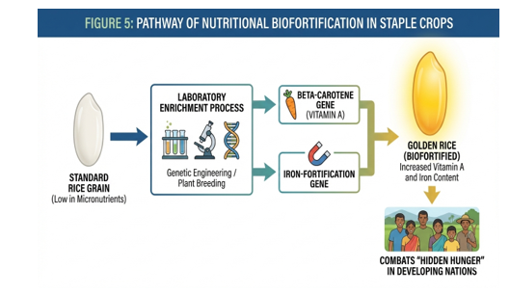

Genetically Modified Organisms (GMOs): Current Status and Controversies
Genetically Modified Organisms are crops engineered for traits like pest resistance and herbicide tolerance, revolutionizing agriculture (Adisa et al., 2024; Khan et al., 2017). Bt varieties have reduced global insecticide use while boosting yields (Das et al., 2023). Over 190 million hectares are cultivated worldwide (Munaweera et al., 2022).
Controversies include health risks, biodiversity loss, and corporate control (Masehela & Barros, 2023; Ngongolo & Mmbando, 2024). Despite safety endorsements, public skepticism persists, especially in Europe. Harmonized regulations and CRISPR alternatives are needed (Ochatt et al., 2023).

Table 5. Comparison: Traditional Breeding vs. Biotechnology-Enhanced Crops

Feature | Traditional Cross-Breeding | Biotechnology-Enhanced Crops
Modification Speed | Slow (requires many generations)⁶⁵. | Fast (direct genetic targeting)⁶⁶.
Genetic Precision | Low (unwanted genetic baggage)⁶⁷. | High (targets specific desirable genes)⁶⁸.
Scope of Genetic Material | Limited to within the same species⁶⁹. | Can transfer beneficial genes across species⁷⁰.
Resilience to Stress | Limited to existing natural variations⁷¹. | Engineered for extreme climate resilience⁷².
Chemical Dependency | Often requires high external inputs⁷³. | Designed for reduced chemical reliance⁷⁴.
Trait Identification | Visual assessment and field trials⁷⁵. | Molecular marker and AI-driven analysis⁷⁶.
Complexity of Traits | Difficult to stack multiple traits⁷⁷. | Precise "stacking" of multiple genes⁷⁸.
Yield Potential | Gradually reaching physiological limits⁷⁹. | Removing physiological constraints for higher yield⁸⁰.
CRISPR-Cas9 and Gene Editing Technologies
CRISPR-Cas9 has revolutionized agricultural biotechnology by enabling precise, targeted genome editing without the integration of foreign DNA, overcoming limitations of traditional genetic engineering and conventional breeding (Khan et al., 2017; Ochatt et al., 2023). This technology facilitates rapid development of crop varieties with enhanced resistance to pests, diseases, and abiotic stresses such as drought and salinity, directly addressing the vulnerabilities posed by climate change (Munaweera et al., 2022; Riaz et al., 2025). Unlike time-intensive breeding methods, CRISPR accelerates trait improvement, as evidenced by its application in creating stress-tolerant crops that maintain productivity under environmental constraints, thereby bolstering food security for a growing population (Kim & Kwak, 2020; Ngongolo & Mmbando, 2024). Regulatory advancements recognizing CRISPR-edited crops as non-GMO equivalents further promote their adoption, minimizing controversies while maximizing sustainable yields (Masehela & Barros, 2023).

Enhancing Nutritional Value and Stress Tolerance

Table 6. Critical Biotic and Abiotic Stresses Addressed by Biotechnology
Category of Stress | Specific Examples | Impact of Biotechnology
Abiotic (Environmental) | Drought and water scarcity⁸¹. | Introduction of drought-tolerance genes⁸².
Abiotic (Soil) | Soil salinity and alkalinity⁸³. | Enhanced salt exclusion mechanisms in plants⁸⁴.
Abiotic (Temperature) | Extreme heat and unexpected cold⁸⁵. | Protection of metabolic machinery under heat⁸⁶.
Abiotic (Pollution) | Heavy metal contamination in soil⁸⁷. | Development of plants that tolerate toxins⁸⁸.
Biotic (Pathogens) | Viral diseases and infections⁸⁹. | RNA-mediated gene silencing for viruses⁹⁰.
Biotic (Fungi) | Fungal blights and rots⁹¹. | Engineered resistance to fungal pathogens⁹².
Biotic (Bacteria) | Bacterial wilt and blight⁹³. | Introduction of anti-bacterial genetic traits⁹⁴.
Biotic (Pests) | Insect infestations and herbivory⁹⁵. | Inherent insect resistance reducing insecticide need⁹⁶.
Biotechnological interventions, including gene editing, significantly enhance crop nutritional profiles and stress resilience, critical for sustainable agriculture amid climate crises (Adisa et al., 2024; Guleria et al., 2023). Biofortification exemplifies this, with Golden Rice engineered to produce beta-carotene, combating vitamin A deficiency in vulnerable populations and demonstrating biotechnology's role in nutritional security (Adisa et al., 2024). Simultaneously, stress tolerance genes introduced via CRISPR and other tools enable crops to withstand drought, salinity, and extreme temperatures, reducing yield losses by up to 20-40% under adverse conditions (Kim & Kwak, 2020; Ngongolo & Mmbando, 2024). These modifications decrease agrochemical reliance, preserve soil health, and align with global sustainability goals, proving biotechnology's superiority over conventional methods in fostering resilient, nutrient-dense food systems (DEMİREL et al., 2024; Ochieng & Ananga, 2019).
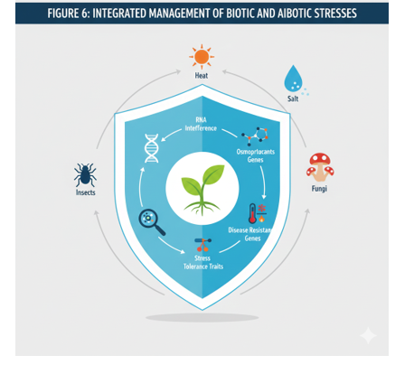

Biopesticides and Biofertilizers
Biopesticides and biofertilizers represent eco-friendly alternatives to chemical inputs, significantly advancing sustainable agriculture by reducing environmental footprints and enhancing soil fertility (Das et al., 2023; Guleria et al., 2023). Microbial biopesticides, such as Bt toxins from Bacillus thuringiensis, have curtailed global insecticide use by over 8% while boosting crop yields on 190 million hectares, mitigating pest pressures exacerbated by climate variability (Adisa et al., 2024; Ngongolo & Mmbando, 2024). Complementarily, biofertilizers like nitrogen-fixing bacteria and phosphate-solubilizing microbes improve nutrient uptake, minimizing synthetic fertilizer dependency and promoting carbon sequestration for long-term soil health (DEMİREL et al., 2024; Munaweera et al., 2022). Integrating these biotechnologies not only curtails greenhouse gas emissions but also fortifies food systems against abiotic stresses, underscoring their pivotal role in achieving an "Evergreen Revolution" (Das et al., 2023; K.C. & Lamichhane, 2021).
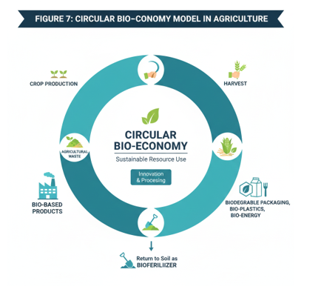

Table 7. Modern Bio-Based Technology and Value-Added Innovations
Innovation | Industrial Objective | Environmental/Economic Role
Bio-Refining | Production of bioactive materials⁹⁷. | Valorization of agricultural waste⁹⁸.
Biodegradable Packaging | New-generation eco-friendly containers⁹⁹. | Reducing long-term environmental waste¹⁰⁰.
Nanobiotechnology | Precision delivery of agricultural inputs¹⁰¹. | Drastic reduction in farm waste and runoff¹⁰².
AI-Driven Genomics | Analysis of large-scale biological data¹⁰³. | Elucidating intricate regulatory pathways¹⁰⁴.
Bio-Based Technology (MBT) | Market-oriented high-value products¹⁰⁵. | Ensuring long-term viability of farm activities¹⁰⁶.
Biomass Utilization | Converting plant matter into fuel or materials¹⁰⁷. | Reducing the carbon footprint of production¹⁰⁸.
Multi-Omics Integration | Combining transcriptomics and proteomics¹⁰⁹. | Pushing the boundaries of crop development¹¹⁰.
Biofertilizers | Adding microbes with specific properties¹¹¹. | Promoting plant growth without chemicals¹¹².

Microbial Biopesticides for Pest Management
Microbial biopesticides, particularly those derived from Bacillus thuringiensis, offer a targeted and environmentally benign approach to pest management, significantly outperforming chemical pesticides in sustainability (Das et al., 2023; Ngongolo & Mmbando, 2024). By producing crystal toxins that specifically disrupt insect midgut function, Bt biopesticides have reduced global insecticide applications by over 8%, conserving biodiversity and minimizing non-target effects while protecting crops from pests intensified by climate variability (Guleria et al., 2023; Ngongolo & Mmbando, 2024). Deployed across 190 million hectares worldwide, these agents not only boost yields but also integrate seamlessly with IPM strategies, proving their efficacy in fostering resilient agroecosystems amid rising pest pressures (Adisa et al., 2024; Munaweera et al., 2022).
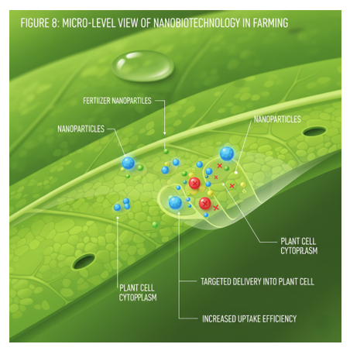

Nitrogen-Fixing Bacteria and Phosphate-Solubilizing Microbes
Nitrogen-fixing bacteria (e.g., Rhizobium spp.) and phosphate-solubilizing microbes (e.g., Pseudomonas and Bacillus spp.) revolutionize nutrient management by enhancing soil nitrogen and phosphorus availability, slashing synthetic fertilizer use by up to 25-50% in various crops (Das et al., 2023; DEMİREL et al., 2024). These biofertilizers promote symbiotic associations that fix atmospheric N$_2$ and solubilize insoluble phosphates, improving nutrient uptake efficiency and crop productivity under nutrient-poor or stressed conditions (Munaweera et al., 2022; Ochieng & Ananga, 2019). Their application mitigates eutrophication risks and supports carbon sequestration, directly contributing to climate-smart agriculture and long-term soil fertility restoration (Guleria et al., 2023; K.C. & Lamichhane, 2021).

Impact on Soil Health and Environmental Sustainability
The synergistic deployment of biopesticides and biofertilizers profoundly enhances soil health by fostering microbial diversity, improving structure, and promoting organic matter accumulation, which counters soil degradation exacerbated by conventional practices (Das et al., 2023; DEMİREL et al., 2024). These biotechnologies reduce greenhouse gas emissions from agrochemicals, enhance water retention, and bolster resilience to abiotic stresses like drought, aligning with global sustainability imperatives (Guleria et al., 2023; Ngongolo & Mmbando, 2024). Ultimately, they underpin an "Evergreen Revolution" by enabling higher yields with minimal environmental footprints, ensuring food security for a population projected to reach 9 billion by 2030 (K.C. & Lamichhane, 2021; Munaweera et al., 2022). This integrated approach is crucial for achieving sustainable agricultural intensification necessary to feed the burgeoning global populace while simultaneously mitigating the environmental impacts of food production (Arora & Fatima, 2024; Das et al., 2023).

FIGURE 9: THE "EVEGREEN REVOLUTION" FRAMEWORK

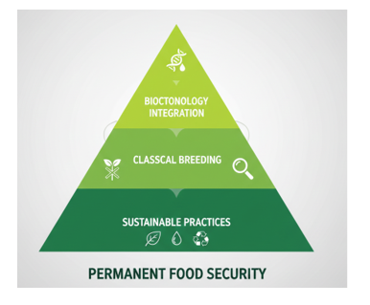

Precision Agriculture and Biotechnology Integration
Precision agriculture synergizes biotechnological innovations with digital technologies to optimize resource use, enhance crop resilience, and ensure sustainable food production amid climate challenges (Guleria et al., 2023; Ngongolo & Mmbando, 2024). By integrating gene-edited crops with real-time data-driven decisions, this approach minimizes inputs, boosts yields, and addresses global food security for a population nearing 9 billion (Das et al., 2023; Munaweera et al., 2022).

8. The Three Dimensions of Agricultural Sustainability
Dimension | Primary Requirement | Role of Biotechnology
Environmental Stewardship | Protect ecosystems and soil health¹¹³. | Reducing pesticide runoff and CO2 output¹¹⁴.
Economic Viability | Ensure long-term farm profitability¹¹⁵¹¹⁵. | Lowering production costs and increasing yields¹¹⁶.
Social Responsibility | Equitable distribution of benefits¹¹⁷. | Addressing malnutrition in vulnerable groups¹¹⁸.
Resource Management | Conserve and enhance natural resources¹¹⁹. | Efficient use of water, land, and nutrients¹²⁰.
System Stability | Robustness against external shocks¹²¹. | Breeding resilience against climate change¹²².
Future Orientation | Meet current needs without harming future ones¹²³. | Developing sustainable crop types for generations¹²⁴.
Health Protection | Protect human and ecosystem health¹²⁵. | Eliminating toxic chemicals through bio-resistance¹²⁶.

Biosensors and Smart Farming Technologies
Biosensors enable precise monitoring of crop health, soil nutrients, and environmental stresses, facilitating targeted biotechnological interventions like the deployment of stress-tolerant varieties developed via CRISPR (Kim & Kwak, 2020; Riaz et al., 2025). These technologies detect early signs of biotic and abiotic stresses, allowing farmers to apply biofertilizers or biopesticides judiciously, reducing chemical use by up to 37% while conserving biodiversity and enhancing sustainability (Arora & Fatima, 2024; Guleria et al., 2023). Integrated with IoT platforms, biosensors support climate-smart agriculture, aligning with SDGs for resilient food systems (K.C. & Lamichhane, 2021; Ochatt et al., 2023).
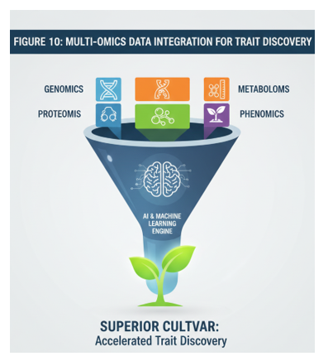

Data Analytics and Artificial Intelligence in Agricultural Biotechnology
Data analytics and AI revolutionize agricultural biotechnology by processing genomic, environmental, and yield data to predict optimal traits for breeding and gene editing (Adisa et al., 2024; Khan et al., 2017). Machine learning models accelerate marker-assisted selection and genome editing, enabling rapid development of climate-resilient crops that withstand drought and salinity, thereby increasing productivity under adverse conditions (Munaweera et al., 2022; Ngongolo & Mmbando, 2024). This integration reduces pesticide reliance and promotes nutrient-efficient varieties, fostering an "Evergreen Revolution" through precise, data-informed innovations (Das et al., 2023; K.C. & Lamichhane, 2021).

Robotics and Automation in Crop Production
Robotics and automation, including drones and autonomous harvesters, complement biotechnology by enabling precise application of bioengineered seeds and inputs on vast scales, minimizing waste and environmental impact (DEMİREL et al., 2024; Ochieng & Ananga, 2019). These systems facilitate uniform planting of GM crops with enhanced pest resistance, reducing insecticide use by over 8% globally while adapting to climate variability (Arora & Fatima, 2024; Ngongolo & Mmbando, 2024). By optimizing operations on 190 million hectares, robotics bolsters the scalability of biotech solutions, ensuring higher yields and soil health preservation for long-term sustainability (Das et al., 2023; Guleria et al., 2023).

Plant Tissue Culture and Micropropagation
Plant tissue culture and micropropagation are pivotal biotechnological approaches that enable the rapid and efficient regeneration of entire plants from small tissue explants, thereby facilitating the mass production of disease-free and genetically uniform plant material (Pehlivan et al., 2025). This technology is indispensable for propagating elite cultivars, preserving endangered species, and accelerating breeding programs, especially for crops difficult to reproduce sexually or those requiring specific disease-free stock for high-yield cultivation (Ngongolo & Mmbando, 2024). This method significantly enhances the availability of desirable genotypes, offering a crucial foundation for both traditional breeding and advanced genetic engineering efforts (Riaz et al., 2025).

In Vitro Propagation of Elite Crop Varieties
Plant tissue culture facilitates the rapid, clonal propagation of elite crop varieties, producing millions of disease-free, genetically uniform plants in a controlled environment, which is essential for scaling up high-yielding cultivars amid climate-induced variability and food security demands (K.C. & Lamichhane, 2021; Khan et al., 2017). Techniques like meristem culture eliminate pathogens, ensuring vigorous growth and higher productivity in crops such as potatoes, bananas, and ornamentals, thereby supporting sustainable agriculture by reducing reliance on chemical treatments and enhancing resilience to biotic stresses (Ngongolo & Mmbando, 2024; Ochatt et al., 2023). This approach accelerates the dissemination of superior genotypes, contributing to the "Evergreen Revolution" by meeting the needs of a growing population projected to reach 9 billion while minimizing land use expansion (Das et al., 2023; Munaweera et al., 2022).

Somatic Hybridization and Embryogenesis
Somatic hybridization, achieved through protoplast fusion, overcomes sexual incompatibility barriers to create novel hybrids with combined traits like disease resistance and stress tolerance, revolutionizing crop improvement for climate-resilient agriculture (Khan et al., 2017; Riaz et al., 2025). Somatic embryogenesis enables efficient mass propagation via artificial seed production, bypassing seed dormancy issues and enabling synthetic seed technology for uniform planting, which boosts yield efficiency and reduces production costs (K.C. & Lamichhane, 2021; Kim & Kwak, 2020). These biotechnological tools integrate with genome editing to develop varieties tolerant to drought, salinity, and pests, directly addressing global challenges like abiotic stresses and supporting sustainable intensification (Guleria et al., 2023; Ochatt et al., 2023).
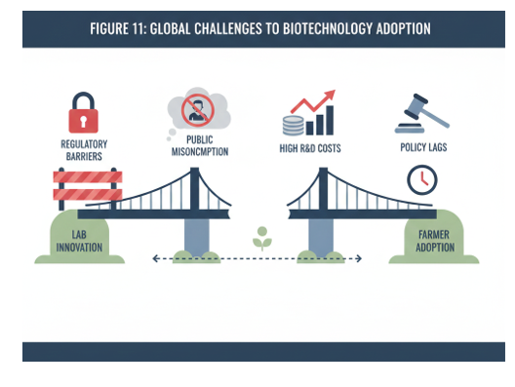

Challenges and Advancements in Tissue Culture Techniques
Despite challenges such as somaclonal variation, high costs, and scalability limitations, advancements in bioreactor systems, automation, and nutrient optimization have enhanced efficiency and reduced variability in tissue culture protocols (DEMİREL et al., 2024; Khan et al., 2017). Integration with molecular markers and CRISPR enables precise selection of stable regenerants, mitigating genetic instability while accelerating the development of climate-adaptive crops (Adisa et al., 2024; Munaweera et al., 2022). These innovations lower environmental footprints by minimizing agrochemical needs and promoting biodiversity conservation, positioning plant tissue culture as a cornerstone of precision biotechnology for long-term food security and ecosystem sustainability (Arora & Fatima, 2024; Das et al., 2023).

Biotechnology in Livestock and Aquaculture
Biotechnology in livestock and aquaculture harnesses genomic selection, marker-assisted breeding, gene editing like CRISPR-Cas9, and recombinant DNA technologies to dramatically enhance productivity, disease resistance, and nutritional quality in animal production systems, addressing food security for a global population projected to reach 9 billion amid intensifying climate stresses (Das et al., 2023; K.C. & Lamichhane, 2021; Khan et al., 2017). These innovations enable sustainable intensification by improving feed efficiency, reducing antibiotic reliance, and minimizing environmental footprints through climate-resilient traits such as heat tolerance and lower resource demands, aligning with SDGs for resilient food systems (Adisa et al., 2024; Guleria et al., 2023; Ochatt et al., 2023). By integrating with diagnostics and probiotics, biotechnology curtails zoonotic risks, overfishing pressures, and chemical inputs, fostering equitable growth for smallholders while revolutionizing protein supply chains (Kim & Kwak, 2020; Ochieng & Ananga, 2019).
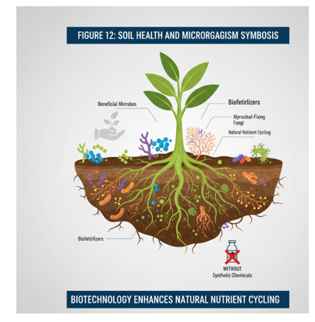

Genetic Improvement of Livestock for Production Traits
Biotechnology enhances livestock productivity through genomic selection, marker-assisted breeding, and gene editing, enabling the development of animals with superior milk yield, growth rates, and feed efficiency tailored to climate-resilient farming (K.C. & Lamichhane, 2021; Khan et al., 2017). Techniques like CRISPR-Cas9 facilitate precise modifications for heat tolerance and nutrient utilization, reducing environmental footprints while meeting rising protein demands for a global population approaching 9 billion (Das et al., 2023; Munaweera et al., 2022). These innovations promote sustainable intensification, minimizing land and resource use in livestock systems amid climate variability (Ngongolo & Mmbando, 2024; Ochieng & Ananga, 2019).

Disease Resistance and Vaccine Development
Recombinant DNA technology and mRNA vaccines bolster livestock health by conferring resistance to prevalent diseases such as foot-and-mouth disease and African swine fever, significantly curbing mortality and antibiotic reliance (Kim & Kwak, 2020; Riaz et al., 2025). Biotechnological platforms accelerate vaccine production and enable gene knockouts for innate immunity, aligning with sustainable agriculture goals by preserving animal welfare and reducing zoonotic risks (Guleria et al., 2023; Ochatt et al., 2023). Integrated with diagnostics, these tools support precision veterinary interventions, enhancing herd resilience to biotic stresses exacerbated by climate change (Adisa et al., 2024; K.C. & Lamichhane, 2021).

Sustainable Aquaculture Practices
Aquaculture biotechnology introduces genetically improved fish and shellfish with faster growth, disease resistance, and lower feed conversion ratios, such as GM salmon approved for commercial use, optimizing production in controlled environments (Khan et al., 2017; Ochieng & Ananga, 2019). Probiotic enhancements and genome-edited oysters tolerant to ocean acidification address environmental challenges, reducing overfishing pressures and chemical inputs while scaling output to support global seafood needs (Arora & Fatima, 2024; DEMİREL et al., 2024). These practices foster blue economy sustainability, conserving marine biodiversity and aligning with SDGs for resilient food systems under warming oceans (Das et al., 2023; Ngongolo & Mmbando, 2024).
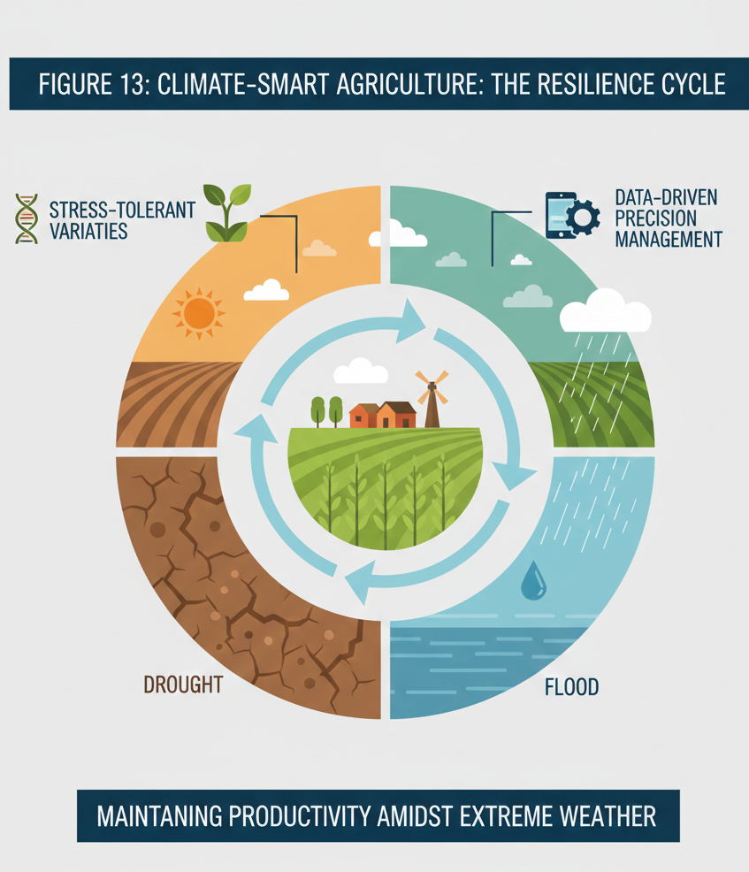

Ethical, Regulatory and Socioeconomic Considerations
Ethical deployment of livestock and aquaculture biotech demands rigorous biosafety assessments and equitable access, balancing innovation benefits with risks like gene flow and animal welfare concerns (Adisa et al., 2024; Guleria et al., 2023). Harmonized international regulations, including Cartagena Protocol compliance, facilitate trade while addressing public apprehensions through transparent labeling and stakeholder engagement (K.C. & Lamichhane, 2021; Ochatt et al., 2023). Socioeconomically, these technologies empower smallholders via affordable diagnostics and seeds, driving inclusive growth, poverty alleviation, and food security in developing regions facing climate pressures (Das et al., 2023; Munaweera et al., 2022).

Public Perception and Acceptance of Agricultural Biotechnology
Public perception of agricultural biotechnology remains polarized, with apprehensions over genetically modified organisms stemming from ethical, health, and environmental concerns, yet growing acceptance is driven by demonstrated benefits in yield enhancement, pesticide reduction, and climate resilience (Adisa et al., 2024; Arora & Fatima, 2024). Surveys and real-world outcomes, such as a 37% pesticide reduction and 22% yield increase from GM crops between 1995 and 2014, are fostering trust among consumers and farmers, particularly in developing regions facing food insecurity (Arora & Fatima, 2024; Das et al., 2023). Transparent communication, rigorous safety data, and successful cases like Golden Rice for vitamin A deficiency are pivotal in bridging perception gaps and promoting widespread adoption for sustainable agriculture (Adisa et al., 2024; Kim & Kwak, 2020).

Regulatory Frameworks and International Harmonization
Robust regulatory frameworks, including compliance with the Cartagena Protocol on Biosafety, ensure rigorous risk assessments for gene flow, biodiversity, and human health, facilitating safe commercialization of biotech products globally (Guleria et al., 2023; Ochatt et al., 2023). International harmonization efforts by organizations like FAO and CBD standardize approval processes, expediting trade while addressing public concerns through mandatory labeling and post-market surveillance (Adisa et al., 2024; Ochieng & Ananga, 2019). These frameworks balance innovation with precaution, enabling equitable access and minimizing trade barriers for climate-resilient crops essential to feed a projected 9 billion population (Das et al., 2023; K.C. & Lamichhane, 2021).

Economic Impact and Access to Technology
Agricultural biotechnology delivers substantial economic gains by boosting crop yields by up to 22%, slashing pesticide use by 37%, and conserving land equivalent to 183 million hectares, translating to billions in savings and increased farmer incomes (Arora & Fatima, 2024; Das et al., 2023). The biopesticides and biofertilizers market, valued at $6.9 billion in 2023 and projected to reach $22.5 billion by 2033, underscores investment viability while empowering smallholders in sub-Saharan Africa and developing regions through affordable seeds and diagnostics (Arora & Fatima, 2024; Ochieng & Ananga, 2019). Enhanced access via public-private partnerships drives inclusive growth, poverty alleviation, and sustainable intensification amid climate pressures (K.C. & Lamichhane, 2021; Munaweera et al., 2022).

Challenges and Future Perspectives
- Despite significant progress, agricultural biotechnology grapples with challenges like somaclonal variation, high costs, scalability issues, and public skepticism (Adisa et al., 2024; Khan et al., 2017).
- Innovations in CRISPR-Cas9, bioreactors, and omics technologies are mitigating genetic instability and optimizing cost-effective protocols (Adisa et al., 2024; K.C. & Lamichhane, 2021).
- Future integration with climate-smart breeding will yield stress-tolerant crops for food security amid a 9 billion population (Das et al., 2023; Munaweera et al., 2022).
- Translational research, ethical governance, and smallholder commercialization promise an "Evergreen Revolution" aligned with SDGs (Guleria et al., 2023; K.C. & Lamichhane, 2021).
- These efforts ensure resilient, sustainable food systems despite biotic/abiotic stresses (Ngongolo & Mmbando, 2024; Ochieng & Ananga, 2019).

Addressing Food Security and Climate Change
Persistent challenges like somaclonal variation, high initial costs, scalability, and public skepticism hinder biotech adoption, yet innovations in CRISPR, bioreactors, and omics technologies mitigate genetic instability and optimize protocols for cost-effective, stable varieties (Adisa et al., 2024; Khan et al., 2017). Future perspectives emphasize integrating biotech with climate-smart breeding to develop stress-tolerant crops countering drought, salinity, and pests, ensuring food security for 9 billion people without expanding land use (Das et al., 2023; Munaweera et al., 2022). Translational research, ethical governance, and smallholder-focused commercialization will propel an "Evergreen Revolution," aligning with SDGs for resilient, sustainable food systems (Guleria et al., 2023; K.C. & Lamichhane, 2021).

Emerging Biotechnologies and Their Potential
Emerging biotechnologies, such as synthetic biology, artificial intelligence, and advanced gene-editing tools beyond CRISPR, hold immense potential to revolutionize agriculture by enabling the creation of novel crop varieties with enhanced nutritional profiles, improved resistance to environmental stressors, and increased yields (Pehlivan et al., 2025). These advancements promise to address current limitations by offering unprecedented precision and efficiency in genetic modification, thereby accelerating the development of climate-resilient and high-performing agricultural products (Pehlivan et al., 2025; Varshney et al., 2011).

Translational Research and Commercialization

To bridge the gap between scientific discovery and practical application, a robust pipeline from laboratory research to commercial viability is imperative, particularly for bringing advanced biotechnological solutions to market. Furthermore, fostering collaboration between academic institutions, industry, and local farming communities is crucial for tailoring these technologies to specific regional needs and ensuring their effective adoption (Garland & Curry, 2022).
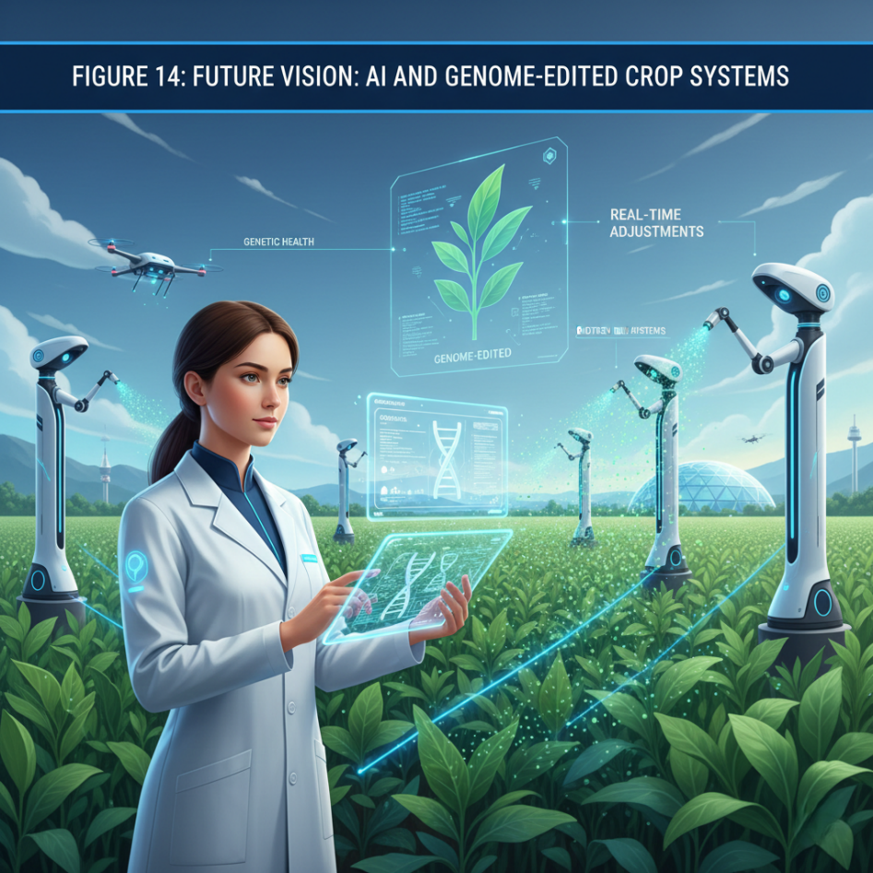

Future Directions for Research and Development
Given the complexities of global food security and environmental sustainability, future research and development in agricultural biotechnology must prioritize the integration of multi-omics approaches with artificial intelligence and machine learning to predict gene functions and optimize crop traits with unprecedented accuracy (Pehlivan et al., 2025). This integration will facilitate the development of crops with enhanced photosynthetic efficiency, improved nutrient uptake, and increased resilience to both biotic and abiotic stresses, thereby contributing to sustainable agriculture and food security (Ramankutty et al., 2018). Moreover, synthetic biology offers an avenue to engineer plant systems with entirely novel functions, such as enhanced nitrogen fixation or the production of valuable bioproducts, further diversifying agricultural outputs (Gupta & Shrestha, 2023; Malkawi & Kapiel, 2024). Such advancements necessitate continuous investigation into the ethical implications and societal acceptance of these rapidly evolving biotechnologies to ensure responsible innovation and broad public adoption (Sameen & Khalil, 2025).

Conclusion

The comprehensive review presented herein underscores the transformative potential of biotechnology in addressing pressing challenges within 21st-century agriculture, from enhancing crop productivity and nutritional quality to mitigating the impacts of climate change and bolstering food security. This synthesis highlights the critical role of continued innovation, strategic investment, and international cooperation in fully realizing these benefits and fostering a resilient global food system. The path forward requires a concerted effort to overcome regulatory hurdles, foster public acceptance, and ensure equitable access to these technologies, particularly for smallholder farmers in developing regions.

References
- Adisa, O., Ilugbusi, B. S., Adelekan, O. A., Asuzu, O. F., & Ndubuisi, N. L. (2024). A comprehensive review of redefining agricultural economics for sustainable development: Overcoming challenges and seizing opportunities in a changing world [Review of A comprehensive review of redefining agricultural economics for sustainable development: Overcoming challenges and seizing opportunities in a changing world]. World Journal of Advanced Research and Reviews, 21(1), 2329. GSC Online Press. https://doi.org/10.30574/wjarr.2024.21.1.0322
- Arora, N. K., & Fatima, T. (2024). Environmental sustainability and biotechnology: opportunities and challenges. Environmental Sustainability, 7(2), 115. https://doi.org/10.1007/s42398-024-00317-9
- Das, S., Ray, M. K., Panday, D., & Mishra, P. K. (2023). Role of biotechnology in creating sustainable agriculture. PLOS Sustainability and Transformation, 2(7). https://doi.org/10.1371/journal.pstr.0000069
- DEMİREL, Ö., Güneş, H., & Can, C. (2024). Sustainable and modern bio-based technologies: new approachs to food safety and security. Environment Development and Sustainability. https://doi.org/10.1007/s10668-024-04683-6
- Garland, S., & Curry, H. A. (2022). Turning promise into practice: Crop biotechnology for increasing genetic diversity and climate resilience. PLoS Biology, 20(7). https://doi.org/10.1371/journal.pbio.3001716
- Guleria, P., Kumar, V., & Mo, B. (2023). Editorial: Biotechnology for agricultural sustainability. Frontiers in Sustainable Food Systems, 7. https://doi.org/10.3389/fsufs.2023.1128411
- Gupta, B., & Shrestha, J. (2023). Editorial: Abiotic stress adaptation and tolerance mechanisms in crop plants. Frontiers in Plant Science, 14. https://doi.org/10.3389/fpls.2023.1278895
- Karakhanova, L., Makhmudova, D., Shernazarov, I., & Khujanov, E. (2024). Biotechnology Breakthroughs: Shaping the Future of Health, Agriculture, and Industry. BIO Web of Conferences, 141, 4003. https://doi.org/10.1051/bioconf/202414104003
- K.C., M., & Lamichhane, A. (2021). Advances in Agricultural Biotechnology. Nepal Journal of Biotechnology, 9(1), 85. https://doi.org/10.3126/njb.v9i1.38643
- Khan, F. F., Ahmad, K., Ahmed, A., & Haider, S. (2017). APPLICATIONS OF BIOTECHNOLOGY IN AGRICULTURE- REVIEW ARTICLE. World Journal of Biology and Biotechnology, 2(1), 139. https://doi.org/10.33865/wjb.002.01.0013
- Kim, H. S., & Kwak, S.-S. (2020). Crop biotechnology for sustainable agriculture in the face of climate crisis. Plant Biotechnology Reports, 14(2), 139. https://doi.org/10.1007/s11816-020-00619-4
- Malkawi, H. I., & Kapiel, T. (2024). Microbial Biotechnology: A Key Tool for Addressing Climate Change and Food Insecurity. European Journal of Biology and Biotechnology, 5(2), 1. https://doi.org/10.24018/ejbio.2024.5.2.503
- Masehela, T., & Barros, E. (2023). The African continent should consider a harmonized consultative and collaborative effort towards coordinated policy and regulatory guidelines across the fields of biotechnology. Frontiers in Bioengineering and Biotechnology, 11. https://doi.org/10.3389/fbioe.2023.1211789
- Munaweera, T. I. K., Jayawardana, N. U., Rajaratnam, R., & Dissanayake, N. M. (2022). Modern plant biotechnology as a strategy in addressing climate change and attaining food security. Agriculture & Food Security, 11(1). https://doi.org/10.1186/s40066-022-00369-2
- Ngongolo, K., & Mmbando, G. S. (2024). Harnessing biotechnology and breeding strategies for climate-resilient agriculture: pathways to sustainable global food security. Discover Sustainability, 5(1). https://doi.org/10.1007/s43621-024-00653-0
- Ochatt, S., Bhattacharya, A., Prestwich, B. M. D., Hano, C., Hensel, G., Marconi, P. L., & Vyver, C. van der. (2023). The role of biotechnological tools for mitigating abiotic stress in a changing climate – preface. Plant Cell Tissue and Organ Culture (PCTOC), 154(2), 213. https://doi.org/10.1007/s11240-023-02574-8
- Ochieng, J. W., & Ananga, A. (2019). Biotechnology in Agricultural Policies of Sub-Saharan Africa. In IntechOpen eBooks. IntechOpen. https://doi.org/10.5772/intechopen.85567
- Pehlivan, N., Altaf, M. T., Emamverdian, A., & Ghorbani, A. (2025). Beyond the lab: future-proofing agriculture for climate resilience and stress management [Review of Beyond the lab: future-proofing agriculture for climate resilience and stress management]. Frontiers in Plant Science, 16, 1565850. Frontiers Media. https://doi.org/10.3389/fpls.2025.1565850
- Ramankutty, N., Mehrabi, Z., Waha, K., Jarvis, L., Kremen, C., Herrero, M., & Rieseberg, L. H. (2018). Trends in Global Agricultural Land Use: Implications for Environmental Health and Food Security [Review of Trends in Global Agricultural Land Use: Implications for Environmental Health and Food Security]. Annual Review of Plant Biology, 69(1), 789. Annual Reviews. https://doi.org/10.1146/annurev-arplant-042817-040256
- Riaz, M., Yasmeen, E., Saleem, B., Hameed, M. K., Almheiri, M. T. S., Mir, R. A., Alameri, G., Alghafri, J. S. K., & Gururani, M. A. (2025). Evolution of agricultural biotechnology is the paradigm shift in crop resilience and development: a review [Review of Evolution of agricultural biotechnology is the paradigm shift in crop resilience and development: a review]. Frontiers in Plant Science, 16. Frontiers Media. https://doi.org/10.3389/fpls.2025.1585826
- Sameen, S., & Khalil, B. (2025). Integrating Biotechnology into Plant Biology: Challenges and Future Directions. https://doi.org/10.70389/pjpb.100014
- Varshney, R. K., Bansal, K. C., Aggarwal, P., Datta, S. K., & Craufurd, P. (2011). Agricultural biotechnology for crop improvement in a variable climate: hope or hype? [Review of Agricultural biotechnology for crop improvement in a variable climate: hope or hype?]. Trends in Plant Science, 16(7), 363. Elsevier BV. https://doi.org/10.1016/j.tplants.2011.03.004

