Temperature-Mediated Changes in Abscisic Acid Levels in Indian Mustard under Early, Timely and Late Sowing Environments in Doon Valley

ABSTRACT
Temperature is a major abiotic stress that affects phytohormone regulation in Indian mustard (Brassica juncea L.). The present study indicated temperature-mediated changes in abscisic acid levels under early, timely, and late-sowing environments in the Doon Valley during two Rabi seasons (2023-24 & 2024-25). Five Indian mustard germplasms, namely Varuna, Kanti, Maya, Kranti, and Vardan, were sown to investigate the impact of temperature variation on the synthesis of abscisic acid. Field experiments were conducted at Jigyasa University, Dehradun, under three sowing environments: early, timely, and late. Early and timely sowing was conducted in 2023-24, and timely and late sowing was conducted in 2024-25. Leaf samples collected at vegetative and flowering stages were analyzed for ABA content by high-performance liquid chromatography (HPLC).
In both rabi seasons (2023-24 & 2024-25), timely sown crops of Indian mustard synthesize more abscisic acid due to low temperature at the time of sampling, whereas early and late sown crops synthesize comparatively less abscisic acid due to moderate or high temperature. At the time of sampling, the severity of low temperature was very high, whereas that of high temperature was only slightly higher; consequently, the influence of low temperature on abscisic acid synthesis in Doon Valley was greater.
In terms of genotypic performance, Maya performed very well in the timely sowing of both the rabi seasons (2023-24 & 2024-25), whereas Vardan (early vs. timely) and Kanti (late vs. timely) showed smaller percentage differences. ANOVA indicated that the reduction in abscisic acid levels in the early (F = 40.09; p < 0.001) and late (F = 56.02; p < 0.001) seasons was highly significant, suggesting that low-temperature stress favours abscisic acid synthesis when sowing is timed.

The study concludes that low-temperature stress enhances abscisic acid biosynthesis in Indian mustard in the Doon Valley. These results also indicated the importance of sowing time in regulating stress hormone responses, including abscisic acid.
Keywords: Abscisic Acid, Phytohormone, Temperature Stress, High-performance liquid chromatography (HPLC), Analysis of Variance (ANOVA)

1.0 INTRODUCTION
1.1 Indian Mustard

Indian mustard (Brassica juncea) is one of the main edible oil-producing crops in India. Mustard oil is commonly used in northern India for cooking and frying. Mustard oil contains 25% protein. Indian mustard is a member of the family Cruciferae (Brassicaceae), genus Brassica, and species Brassica juncea. Peculiarities of Indian mustard are that every part of the crop is valuable in terms of eating, medicinal purposes, and preservative purposes for a long time. According to the ICAR-Directorate of Rapeseed-Mustard Research, Bharatpur, Rajasthan, India, is the 3rd-largest producer of rapeseed-mustard in the world, accounting for 14% of global production after Canada and China. It has also become the 2nd-largest edible oil crop in India. According to the ICAR report, with a production of 13.2 million metric tons (MMT) in 2023-24, rapeseed-mustard ranked 1st in production among nine edible oil crops cultivated in India. By area, among nine edible oil crops, rapeseed mustard was cultivated on 33.3% of the land and accounted for 33.2% of the production in 2023-24. In terms of production intensity (kg/hectare), rapeseed mustard yield was 1443 kg/hectare. Although Indian mustard is cultivated in many Indian states, Rajasthan, Uttar Pradesh, Madhya Pradesh, Haryana, and West Bengal are major producers, with Rajasthan contributing 45.40%, Uttar Pradesh 14.24%, Madhya Pradesh 13.28%, Haryana 10.78%, and West Bengal 6% in 2023-24.

1.2 Abscisic Acid

Plant growth and development are stimulated by numerous processes regulated by phytohormones. Plants have developed a unique and complex system to cope with high & low temperatures, or cold stress, by synthesizing phytohormones, of which abscisic acid is critical. Synthesis of abscisic acid is regulated by unfavourable environmental factors, such as low & high temperatures. Both these factors are well known to activate abscisic acid synthesis.

Abscisic acid, a phytohormone naturally occurring in plants and commonly known as a plant stress hormone, plays an important role in plant growth & development and regulates physiological processes under unfavourable environmental conditions, including high & low temperatures. In addition to abscisic acid, auxins, cytokinins, gibberellins, ethylene, and jasmonate are also major plant hormones.

Abscisic acid is classified as a terpenoid compound, also known as an isoprenoid, made up of isoprene, which is a 5-carbon compound. Abscisic acid is made up of 3 isoprene units, which is why it is known as a sesquiterpenoid. Abscisic acid contains 15 carbons, 20 hydrogens, and 4 oxygen molecules.

Under unfavourable climatic conditions, abscisic acid initiates cell signaling, influences the expression of stress-response genes, and promotes plant resistance to abiotic stress.

1.2.1 Abscisic Acid Regulation under High Temperature

Abscisic acid regulates stomatal closure under high-temperature conditions, when increased water loss via transpiration occurs. The closure of stomatal guard cells reduces transpiration. Stomatal closure is mediated by a cell-signaling mechanism initiated by increased abscisic acid levels. Abscisic acid regulates seed germination under abiotic stress conditions, such as high or low temperatures, water scarcity, and drought. Increased abscisic acid levels prohibit seed germination, while an increased gibberellin level promotes germination. Under adverse environmental conditions, abscisic acid promotes leaf senescence to redirect nutrient allocation and ensure plant survival. Abscisic acid interacts antagonistically with certain phytohormones to regulate plant growth and development. For instance, abscisic acid plays an important role in seed dormancy, while gibberellins play a role in seed germination. Another example: abscisic acid inhibits cell division & plant growth, whereas cytokinins promote these processes.

1.2.2 Abscisic Acid Regulation under Low Temperature

Low-temperature stress induces the expression of cold-responsive genes, which play a crucial role in maintaining high abscisic acid levels. An increase in abscisic acid levels promotes the activity of antioxidant enzymes that protect Indian mustard from oxidative stress induced by low temperature. Oxidative stress is the inability of a crop to counterbalance the production of ROS (Reactive Oxygen Species), leading ultimately to cell damage. Examples of ROS include singlet oxygen, the hydroxyl radical, and hydrogen peroxide. Oxidative stress is mitigated by the antioxidant defence mechanism, which is controlled by abscisic acid. Oxidative defence mechanisms protect against ROS through both enzymatic and non-enzymatic pathways. Enzymatic contents are superoxide dismutase (SOD), catalase (CAT), guaiacol peroxidase (GPX), ascorbate peroxidase (APX), glutathione reductase, while non-enzymatic contents are compatible solutes, ascorbic acid, etc.

In Brassica juncea, the metabolism, especially proteins & carbohydrates affected by low temperature, is regulated to some extent by the signalling of abscisic acid. Abscisic acid regulates all essential processes like protein stabilization and antioxidant defence, and enables Brassica juncea to tolerate unfavourable low-temperature stress. In brief, abscisic acid regulates essential processes, such as protein stabilization and antioxidant defence, and enables Brassica juncea to tolerate unfavourable low-temperature stress.

2.0 METHODOLOGY
Indian mustard (Brassica juncea L.) germplasms, namely Varuna, Kanti, Maya, Kranti & Vardan, were sown in two rabi seasons, 2023-24 and 2024-25. In the first rabi season, 2023-24, germplasms were sown under a timely sowing environment (26th October 2023) and an early sowing environment (26th September 2023). In the second rabi season, 2024-25, germplasms were sown under a timely sowing environment on 30th October 2024 and a late sowing environment on 30th November 2024 at Jigyasa University (Formerly Himgiri Zee University), Sherpur, Dehradun, campus (Latitude 30.33896 ° and Longitude 77.880248 °). This area lies within the Doon Valley, which is located in the foothills of the Himalayas in Uttarakhand, between the Shivalik Hills and the Lower Himalaya, and experiences temperature drops of up to 4 °C from December to February. Optimal growth temperature is 15-250 °C in Indian mustard with high photosynthetic efficiency. Temperatures outside this range may affect productivity and lead to low- or high-temperature stress, respectively. In this research, we are focusing on high and low temperature-induced biosynthesis of abscisic acid in five germplasms of Indian mustard (Brassica juncea), i.e., Varuna, Kanti, Maya, Kranti & Vardan, in vegetative and flowering stages. To analyze abscisic acid level, we had taken 100 grams of leaf samples from Varuna, Kanti, Maya, Kranti & Vardan separately on 28th November 2023 from early sown, on 20th January 2024 from timely sown, on 11th February 2025 from timely sown, and on 08th March 2025 from late sown Indian mustard (Brassica juncea L.) germplasms.

2.1 Abscisic Acid Separation and Quantification

During the research trial, abscisic acid was separated and quantified from the leaf tissue of Brassica juncea (Indian mustard) using HPLC (High Performance Liquid Chromatography), which is a very quick and precise method with minimum sample preparation. Abscisic acid was separated and quantified from leaf tissue of five germplasms of Brassica juncea, such as Varuna, Kanti, Maya, Kranti, & Vardan.

2.1.1 Sample Preparation

100 grams of fresh green leaves were collected, washed thoroughly with distilled water to remove dust & other contaminants, and then dried on blotting paper. Cleaned and dried leaves, preserved by liquid nitrogen to ensure denaturation of the sample. Grind leaves uniformly using a mechanical grinder for efficient extraction. Grinded leaves powder was transferred into a clean glass beaker, and 100 mL of a methanol-water mixture was added in a 70:30 ratio. Generally, 1 mL of solvent needs to be added per gram of leaf tissue. Mixed a mixture of solvent and powdered leaf tissue using a magnetic stirrer. Sonicate the mixture for 15-30 minutes to completely break down the cell wall and for efficient extraction. Kept the mixture at room temperature for 24 hours, shaking periodically. Filtered the mixture by filter paper to remove the solid part. Centrifuged filtered mixture at 10000 rpm for 10 minutes for complete removal of the solid part. Separated the supernatant, which contains soluble compounds including abscisic acid. Evaporation of supernatant was performed under reduced pressure by rotatory evaporator to get a concentrated extract up to 5-10 ML at 40 °C. Reformed the concentrated extract by adding 1 mL of methanol. Filtered reformed sample by a 0.4µm syringe filter to separate particulate matter before HPLC injection. To set up HPLC, a mobile phase for abscisic acid analysis was prepared using 0.1% acetic acid as the aqueous phase and acetonitrile as the organic phase. For optimal separation, a C18 reverse-phase HPLC column was used. UV detector set at 254 nm. Flow rate maintained at 0.5-1.0 ML/minute. After all these setups, I injected 10 µl of the sample into the HPLC.

3.0 TEMPERATURE VARIATION

3.1 Temperature Pattern (2023-24)

The temperature pattern showed clear seasonal variation from late September to mid-October 2023, with a maximum of 35°C and a minimum of 20–22 °C. From late October to November, a cooling trend was recorded with a maximum mean of 26–29 °C and a minimum mean of 11–15 °C. The coldest period was recorded from late December to mid-January, with a maximum mean temperature of 11 to 15°C and a minimum mean temperature of 4 to 7 °C. By mid- to late February, the maximum temperature reached 26 °C, whereas the mean minimum temperature was 9–10 °C.

Table 1: Summary of Temperature Variation from 26th September 2023 to 26th February 2024 in Sherpur, Dehradun, Uttarakhand

Week N. | Date Range | Max. Mean (°C) | Min. Mean (°C) | Max. Actual (°C) | Min Actual (°C)
1 | 26th Sep.-2nd Oct.-2023 | 35.14 | 22.00 | 26.00 | 19.00
2 | 03rd -9th Oct.-2023 | 35.29 | 21.00 | 37.00 | 20.00
3 | 10th -16th Oct.-2023 | 35.00 | 20.29 | 37.00 | 16.00
4 | 17th -23rd Oct.-2023 | 30.14 | 16.43 | 32.00 | 16.00
5 | 24th -30th Oct.-2023 | 32.57 | 15.57 | 34.00 | 14.00
6 | 31st Oct.-6th Nov.-2023 | 31.00 | 15.43 | 32.00 | 13.00
7 | 07th -13th Nov.- 2023 | 28.86 | 14.00 | 31.00 | 12.00
8 | 14th -20th Nov.- 2023 | 29.00 | 12.71 | 31.00 | 12.00
9 | 21st-27th Nov 2023 | 26.00 | 11.71 | 28.00 | 9.00
10 | 28th Nov.-04th Dec.-2023 | 24.29 | 11.57 | 26.00 | 9.00
11 | 05th -11th Dec.- 2023 | 24.71 | 8.71 | 27.00 | 7.00
12 | 12th-18th Dec.-2023 | 22.29 | 7.00 | 23.00 | 6.00
13 | 19th-25th Dec.- 2023 | 22.57 | 6.57 | 25.00 | 5.00
14 | 26th Dec. -2023 to 01st Jan. -2024 | 15.14 | 8.86 | 22.00 | 7.00
15 | 2nd-8th Jan. 2024 2024 | 11.86 | 6.86 | 16.00 | 6.00
16 | 9th -15th Jan.- 2024 | 13.00 | 4.71 | 15.00 | 3.00
17 | 16th -22nd Jan.- 2024 | 13.14 | 4.86 | 17.00 | 3.00
18 | 23rd -29th Jan.- 2024 | 16.14 | 5.71 | 22.00 | 4.00
19 | 30th Jan.-05^{tth Feb.} 2024 | 20.00 | 9.86 | 23.00 | 9.86
20 | 06th -12th Feb.- 2024 | 23.00 | 6.86 | 25.00 | 5.00
21 | 13th -19th Feb.- 2024 | 26.43 | 9.14 | 30.00 | 7.00
22 | 20th -26th Feb.- 2024 | 26.00 | 10.43 | 28.00 | 8.00
Source: https://www.accuweather.com/en/in/sherpur/3008767/weather-forecast/3008767

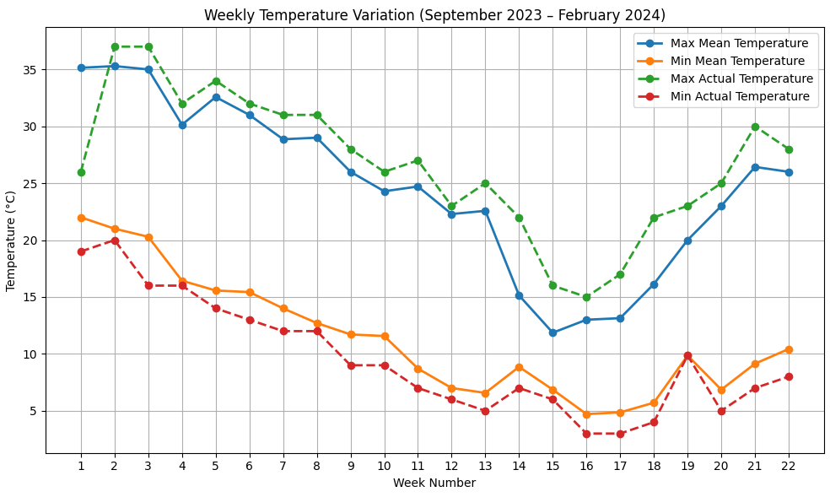

Fig. 1: Weekly temperature variation from 26th September 2023 to 26th February 2024

3.2 Temperature Pattern (2024-25)
The maximum mean temperature gradually reduced from 33.29 °C in early November and reached the lowest value during late December and early January (15–17°C); similarly, the minimum mean temperature reduced to 5–7°C from mid-December to mid-January. From mid- to late March, the mean maximum temperature increased to 34 °C, and the mean minimum temperature to 15–17 °C.

Table 2: Summary of Temperature Variation from 30th October, 2024, to 1st April, 2025, in Sherpur, Dehradun, Uttarakhand
Week N. | Date Range | Max. Mean (°C) | Min. Mean (°C) | Max. Actual (°C) | Min Actual (°C)
1 | 30th Oct. to 05th Nov.-2024 | 33.29 | 16.71 | 35 | 15
2 | 06th-11th Nov.-2024 | 29.43 | 18.14 | 31 | 17
3 | 13th-19th Nov.-2024 | 24.86 | 14.29 | 27 | 13
4 | 20th-26th Nov.-2024 | 27.43 | 10.86 | 29 | 10
5 | 27th Nov. to 03rd Dec.-2024 | 27.29 | 9.71 | 29 | 8
6 | 04th-10th Dec.-2024 | 23.57 | 8.29 | 27 | 6
7 | 11th-17th Dec.-2024 | 21.86 | 5.43 | 23 | 4
8 | 18th-24th Dec.-2024 | 20.14 | 6.86 | 23 | 5
9 | 25th-31st Dec.-2024 | 16.86 | 9.57 | 23 | 8
10 | 01st-07th Jan.-2025 | 15.43 | 8.14 | 19 | 8
11 | 08th-14th Jan.-2025 | 17.71 | 7.00 | 22 | 4
12 | 15th-21st Jan.-2025 | 19.43 | 8.57 | 25 | 6
13 | 22nd-28th Jan 2025 | 23.57 | 7.43 | 25 | 5
14 | 29th Jan.-04th Feb. 2025 | 21.86 | 9.43 | 23 | 7
15 | 05th-11th Feb. 2025 | 25.00 | 9.00 | 27 | 8
16 | 12th-18th Feb. 2025 | 25.86 | 10.14 | 28 | 9
17 | 19th-25th Feb. 2025 | 25.29 | 11 | 28 | 10
18 | 26th Feb-04th Mar. 2025 | 24.86 | 13.57 | 29 | 10
19 | 05th-11th Mar. 2025 | 28.43 | 12.86 | 29 | 8
20 | 12th-18th Mar. 2025 | 29.43 | 14.71 | 32 | 12
21 | 19th-25th Mar. 2025 | 34.14 | 15.57 | 32 | 12
22 | 26th Mar.- 01st Apr. 2025 | 34.14 | 17.14 | 32 | 12
Source: https://www.accuweather.com/en/in/sherpur/3008767/weather-forecast/3008767

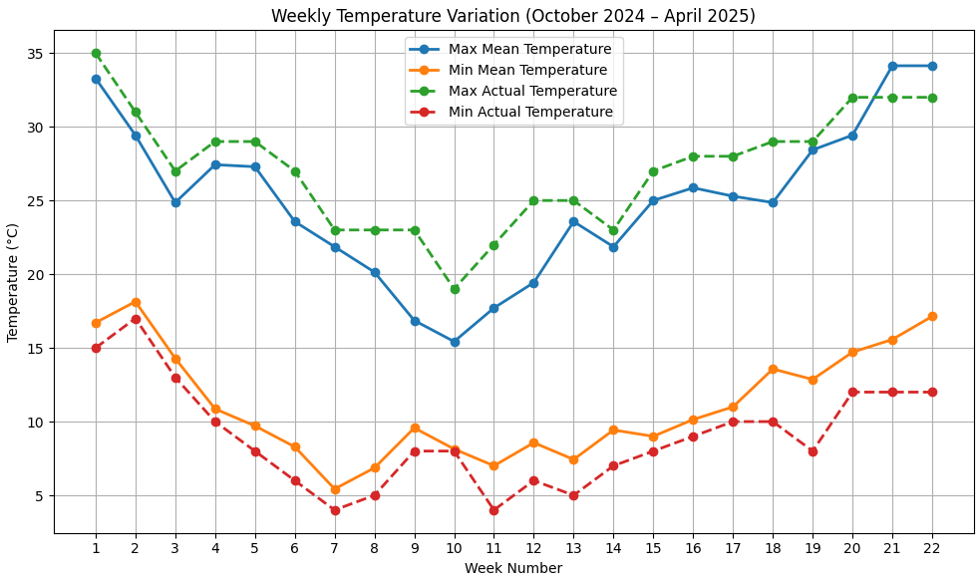

Fig. 2: Weekly temperature variation from 30th October, 2024, to 1st April, 2025

4.0 RESULT AND DISCUSSION

4.1 Analysis of ABA (Abscisic Acid) Levels under Early and Timely Sowing during 2023–24 Season
The information in Table 3 and Figure 3 clearly shows how abscisic acid levels changed in Indian mustard crops when they were sown early & timely during the rabi season of 2023–2024. These changes were closely linked to the ambient temperature at the time of sample collection.
There was 0.637 g/100 g of abscisic acid under an early sowing environment, with the highest temperature that week at 26°C and the lowest at 11.7°C. Moderate temperatures result in lower temperature stress, which, in turn, lowers abscisic acid levels. Abscisic acid is a stress hormone that is synthesized when crops are exposed to temperature stress.
The abscisic acid concentration was 0.813 g/100 g under a timely sowing environment, with the highest temperature that week at 13.1°C and the lowest at 4.9°C in Doon Valley. A higher level of abscisic acid during timely sowing conditions means that the crop is responding more strongly to low temperatures, since abscisic acid is a key hormone for reducing cold stress.
Table 03: ABA Level in 2023–24 Season (Early vs Timely Sowing)
Sowing Type | Sampling Date | ABA Level (Avg.) | Max Temp (Week) | Min Temp (Week)
Early | 28 Nov 2023 | 0.637 g/100g | ~26°C | ~11.7°C
Timely | 20 Jan 2024 | 0.813 g/100g | ~13.1°C | ~4.9°C

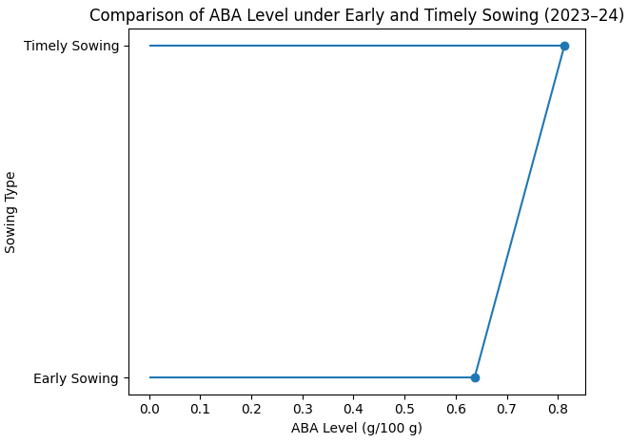

Fig. 3: Comparative analysis of abscisic acid level under early and timely sowing environments

Table 4 and Fig. 4 indicate that the level of abscisic acid (ABA) changed in five germplasms of Indian mustard when sown early or timely during the 2023–24 season. For all five germplasms, the concentration of ABA was higher in timely sown germplasms than in early sown germplasms.
ABA levels ranged from 0.761 g/100 g in Kanti to 0.898 g/100 g in Maya under a timely sowing environment. On the other hand, germplasms sown under early sowing conditions had lower ABA concentrations, ranging from 0.593 g/100 g in Kanti to 0.671 g/100 g in Vardan. Overall, the lower ABA concentration in early-sown germplasms indicates that warmer weather during early sowing suppressed ABA synthesis.
Maya germplasm had the highest ABA concentration under a timely sowing environment (0.898 g/100 g) and the largest percentage reduction (27.7%) under an early sowing environment. This shows that Maya is highly sensitive to temperature stress. With percentage differences of 18.4% and 16.8%, Kranti and Kanti, respectively, showed a moderate reduction in ABA levels, indicating an average response to early sowing stress.
Varuna showed a 14.5% decrease, suggesting that ABA levels are comparatively more stable in both sowing conditions than the other four germplasms. Vardan exhibited the smallest percentage change (10.5%), indicating more resilient germplasm and a more stable hormonal response to early planting.

Table 4: ABA (Abscisic Acid) Level in timely and early sown (2023-24) germplasms of Indian mustard (Brassica juncea L.)

Germplasms | Timely Sown | Early Sown | % Difference (T-L)
Varuna | 0.803 | 0.658 | 14.5%
Kanti | 0.761 | 0.593 | 16.8%
Maya | 0.898 | 0.621 | 27.7%
Kranti | 0.827 | 0.643 | 18.4%
Vardan | 0.776 | 0.671 | 10.5%

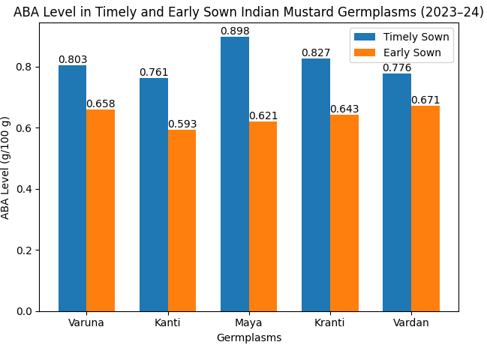
Fig. 4: Level of ABA (Abscisic Acid) in timely and early sown germplasms of Indian mustard (Brassica juncea L.)

4.2 Analysis of ABA Levels under Timely and Late Sowing during 2024–25 Season
The information in Table 5 and Figure 5 clearly shows how abscisic acid levels changed in Indian mustard crops when they were sown timely & late during the rabi season of 2024–2025. These changes were closely associated with the ambient temperature at the time of sample collection.
There was 0.530 g/100 g of abscisic acid under late-sowing conditions, with the highest temperature that week at 28.4°C and the lowest at 12.9°C. Here, moderate temperatures also result in lower temperature stress, which, in turn, lowers abscisic acid levels. It's possible that the higher temperatures during late sowing reduced stress caused by cold, which meant that ABA-mediated stress signaling wasn't needed as much, and hormone levels were lower.
The abscisic acid concentration was 0.762 g/100 g under timely sowing conditions, with the highest temperature that week at 25°C and the lowest at 9°C, indicating cold stress, particularly at night, in Doon Valley. The higher level of ABA observed during timely sowing suggests a more favourable physiological response to low-temperature stress.
Overall, the results show that low temperature stress during timely sowing greatly increases ABA biosynthesis, while warmer temperatures during late sowing greatly decrease ABA biosynthesis. These results show that ABA levels are very sensitive to changes in temperature and emphasize the hormone's important role in the mitigation of temperature-induced stress in Indian mustard.
Table 05: ABA Level in 2024-25 Season (Late vs Timely Sowing)

Sowing Type | Sampling Date | ABA Level (Avg.) | Max Temp (Week) | Min Temp (Week)
Timely | 11 Feb 2025 | 0.762 g/100g | ~25°C | ~9°C
Late | 08 Mar 2025 | 0.530 g/100g | ~28.4°C | ~12.9°C

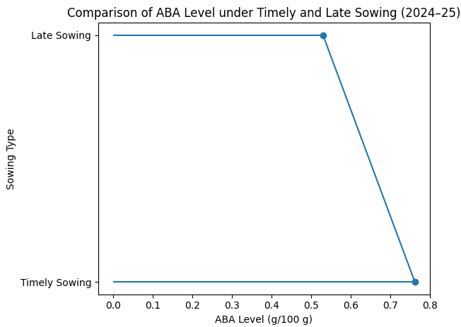

Fig. 5: Comparative analysis of abscisic acid level under timely and late sowing environments

Abscisic acid level in all five germplasms of Indian mustard exhibits variation under timely and late sowing environment as indicated in Table 6. Abscisic acid level was higher in all germplasms of Indian mustard sown under a timely environment compared to germplasms sown under a late environment, suggesting a higher impact of sowing time and severity of temperature stress.

Under a timely sowing environment, abscisic acid levels were 0.693 g/100g to 0.869 g/100g, in which Maya had the highest level of abscisic acid 0.869 g/100g, followed by Varuna 0.768 g/100g, Vardan 0.717 g/100g and Kanti 0.693 g/100g. On the other hand, germplasms which had sown under late environment, resulted in comparatively low abscisic acid level ranging from 0.514 g/100g to 0.551 g/100g. Kranti had lowest abscisic acid level 0.514 g/100g whereas highest level 0.551g/100g was observed in observed Vardan, sown under late sowing environment. Highest absicisic acid reduction 34.8 % shown by Maya, indicated highly sensitive toward low temperature stress, followed by Kranti 24.8 % and Varuna 24.7% under late sowing environment. Conversely, germplasms such as Kanti and Vardan had lower reduction of abscisic acid level 15.2% and 16.6 % respectively, indicating stability under temperature stress condition.

Table 06: ABA (Abscisic Acid) Level in timely and late sown (2024-25) germplasms of Indian mustard (Brassica juncea L.)

Germplasms | Timely Sown | Late Sown | % Difference (T-L)
Varuna | 0.768 | 0.521 | 24.7%
Kanti | 0.693 | 0.541 | 15.2%
Maya | 0.869 | 0.521 | 34.8%
Kranti | 0.762 | 0.514 | 24.8%
Vardan | 0.717 | 0.551 | 16.6%

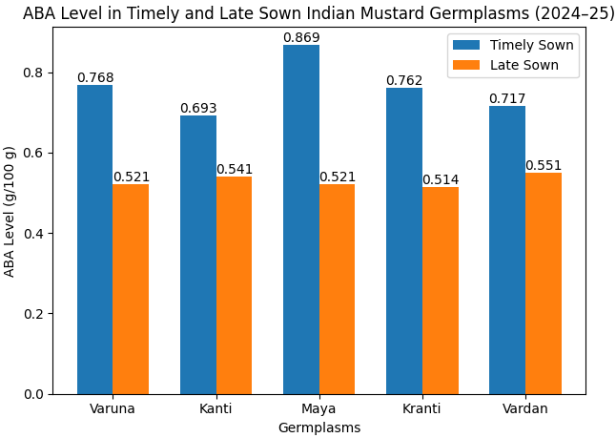
Fig. 6: Level of ABA (Abscisic Acid) in timely and late-sown germplasms of Indian mustard (Brassica juncea L.)

4.3 Consolidated Analysis of ABA Levels under Timely vs. Early and Timely vs. Late Sowing during the 2023-24 & 2024-25 Seasons
Table 7 shows the level of abscisic acid of germplasms of Indian mustard, sown under early, timely and late sowing environments. The results clearly indicated variation in abscisic acid levels across different temperature levels.
Abscisic acid levels were high, 0.813 & 0.762 g/100 g, in germplasms of Indian mustard sown under a timely sowing environment due to low temperature stress, whereas abscisic acid levels were comparatively low, 0.637 g/100 g, in germplasms sown under an early environment due to comparatively moderate temperature, and the lowest level, 0.530 g/100g of abscisic acid, was recorded in germplasms sown under late sowing environment
Overall results indicate that germplasms sown under a timely sowing environment had higher abscisic acid levels due to low-temperature stress.

Table 07: Comparative Insight of ABA Level vs Temperature in Early, Timely, and Late Sowing

Sowing Type | Temperature Range at Sampling | ABA Level Trend | Inference
Early | Warmer (~26/12°C) | Low (0.637 g/100 g) | Less ABA due to mild conditions
Timely | Cooler (~13/5°C & 25/9°C) | High (0.813 & 0.762) | Higher ABA due to cold stress
Late | Warmer (~28/13°C) | Lowest (0.530 g/100g) | ABA suppression due to heat

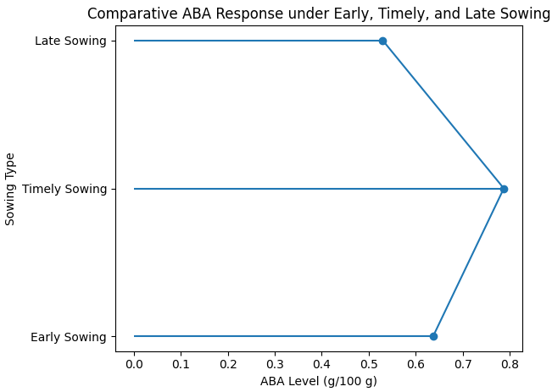

Fig. 7: Comparative analysis of abscisic acid level under timely, early and late sowing environments

4.4 Analysis of Variance (ANOVA)
ANOVA Timely Sown vs. Late Sown (2024–25)
F-statistic = 56.02  P-value = 0.0000703 (<< 0.05)  F critical = 5.317 | This indicates that the reduction in ABA under late sowing is statistically significant.

ANOVA Timely Sown vs. Early Sown (2023–24)
F-statistic = 40.09  P-value = 0.000225 (<< 0.05)  F critical = 5.318 | This indicates that the reduction in ABA under early sowing is statistically significant.

Both late- and early-sown germplasms show a statistically significant reduction in ABA levels relative to timely-sown counterparts, with highly significant F-values (56.02 and 40.09) and very low P-values (<0.001). This confirms that timely sowing favours higher ABA accumulation, which may be associated with improved physiological performance and stress tolerance. The consistency of these findings across two different sowing environments and years strengthens the conclusion that sowing time critically modulates hormonal profiles in Indian mustard.
Table 8: ANOVA (Analysis of Variance) Test for ABA Levels in Timely Sown and Late Sown (2024–25) Germplasm of Indian Mustard (Brassica juncea L.)

Groups | Count | Sum | Average | Variance
ABA Level in Timely Sown Germplasm | 5 | 3.809 | 0.7618 | 0.0045677
ABA Level in Late Sown Germplasm | 5 | 2.648 | 0.5296 | 0.0002448

Source of Variation | SS | df | MS | F-statistic | P-value | F critical value
Between Groups | 0.1347921 | 1 | 0.1347921 | 56.017 | 0.0000703 | 5.317
Within Groups | 0.01925 | 8 | 0.00240625
Total | 0.1540421 | 9

Table 9: ANOVA (Analysis of Variance) Test for ABA Levels in Timely Sown and Early Sown (2023-24) Germplasm of Indian Mustard (Brassica juncea L.)

Groups |  |  | Count | Sum |  |  | Average |  | Variance
ABA Level in Timely Sown Germplasm |  |  | 5 | 4.065 |  |  | 0.813 |  | 0.002899
ABA Level in Early Sown Germplasm |  |  | 5 | 3.186 |  |  | 0.6372 |  | 0.000956
Source of Variation | SS | df | MS |  | F-statistic | P-value |  | F crit
Between Groups | 0.0772641 | 1 | 0.0772641 |  | 40.08826 | 0.000225 |  | 5.317655
Within Groups | 0.0154188 | 8 | 0.00192735
Total | 0.0926829 | 9

*SS-Sum of Square, *df-Degree of Freedom, *MS-Mean Square, *F-F-Static or F-Ratio, *P-value-Probability Value, *F crit-F-critical value, *ABA-Abscisic Acid

5.0 CONCLUSION

The present study concluded that low-temperature stress in the Doon Valley led to increased abscisic acid levels in Indian mustard (Brassica juncea L.). In both rabi seasons (2023-24 & 2024-25), timely sown crops of Indian mustard synthesize more abscisic acid due to low temperature at the time of sampling, whereas early and late sown crops synthesize comparatively less abscisic acid due to moderate or high temperature. At the time of sampling, the severity of low temperature was very high, whereas that of high temperature was only slightly higher; consequently, the influence of low temperature was greater on abscisic acid synthesis in Doon Valley.

In terms of genotypic performance, Maya performed very well in the timely sowing of both the rabi seasons (2023-24 & 2024-25), whereas Vardan (early vs. timely) and Kanti (late vs. timely) showed smaller percentage differences. ANOVA indicated that the reduction in abscisic acid levels in the early (F = 40.09; p < 0.001) and late (F = 56.02; p < 0.001) seasons was highly significant, suggesting that low-temperature stress favours abscisic acid synthesis when sowing is timed.

REFERENCE

- Gupta, A., Chauhan, S., Tyagi, S. D., & Singh, S. (2023). Genetic Variability, Heritability, Genetic Advance and Cluster Analysis in Indian Mustard (Brassica juncea L. Czern & Coss.) Under Timely and Late Sown Conditions. International Journal of Plant & Soil Science, 35(19), 292–301. https://doi.org/10.9734/ijpss/2023/v35i193554
- Kumari, A., & Kumari, V. (2018). Genetic Variability and Divergence Studies for Seed Yield and Component Characters in Indian Mustard [Brassica juncea (l.) Czern. & coss.] Over Environments. International Journal of Current Microbiology and Applied Sciences, 7(07), 3376–3388. https://doi.org/10.20546/ijcmas.2018.707.393
- Nambara, E., and Marion-Poll, A. (2005). “Abscisic acid biosynthesis and catabolism.” Annual Revie of Plant Biology, 56, 165-185.
- Kermode, A. R. (2005). “Role of abscisic acid in seed dormancy and germination.” Seed Science Research, 15(3), 85-95.
- Zhang, S., Wang, H., and Li, J. (2018). “Development and validation of an HPCL method for quantification of abscisic acid in plant tissues.” Journal of Chromatography A, 1562, 1-8.
- Yadav, S. K., et al. (2022). “Advances in ABA-mediated stress tolerance in Indian mustard: A genomic perspective.” Frontiers in Plant Science.
- Zhu, J. K. (2016). “Abiotic stress signaling and responses in plants.” Cell.
- Singh, A., et al. (2019). “Cross-talk between ABA and other phytohormone in Brassica juncea under salinity stress.” Journal of Plant Growth Regulation.
- Zhang, X., et al. (2020). “Functional characterization of NCED genes in drought tolerance in Brassica species.” Plant Physiology.
- Cutler, S. R., et al. (2010). “ABA signaling mechanism and roles of PYR/PYL/RCAR receptors.” Nature Structural & Molecular Biology.
- Liu, Y., & Zhang, L. (2020). Role of Abscisic Acid in Plant Response to Low Temperature Stress. Plant Science, 286, 42-54.
- Chinnusamy, V., & Zhu, J (2009). Cold Stress Regulation of Gene Expression in Plants. Trends in Plant Science, 14(6), 322-329.
- Xu, L., & Zhang, X. (2016). Abscisic Acid and Cold Stress Response in Plants. International Journal of Molecular Sciences, 17(6), 944.
- Li, X., & Yang, S. (2015). Abscisic Acid and Cold Stress in Plants. The Role of ABA in Cold Tolerance. Plant Molecular Biology, 88(2), 145-157.
- Zhang, L., & Liu, Y. (2019). Role of Abscisic Acid in Cold Stress Adaptation. Journal of Plant Growth Regulation, 38(2), 325-334.
- Ashraf, M., & Harris, P. J. C. (2013). Photosynthesis under stressful environment: An overview. Journal of Plant Physiology, 5(1), 123-130.
- Cutler, A. J., Rodriguez, P. L. Finkelstein, R. R., & Abrams, S. R. (2010). Abscisic Acid: Emergence of a core signaling network. Annual Review of Plant Biology, 61, 651-679.
- Lobell, D. B., & Gourdji, S. M. (2012). The influence of climate change on global crop productivity. Plant Physiology, 160(4), 1686-1697.
- Pradhan, A. K., et al. (2016). Genetics and breeding for climate resilience in Indian mustard. Plant Breeding, 135(3), 255-271.
- Xie, X., Wang, Y., Williamson, L., & Holroyd, G. (2006). Interaction of ABA signaling and drought tolerance. Journal of Plant Growth Regulation, 25(3), 219-229.
- Seo, M., & Koshiba, T. (2002). Complex regulation of ABA biosynthesis in plant. Trend in Plant Science, 7(1), 41-48.
- Mostafaei, E., Zehtab-Salmasi, S., Salehi-Lisar, Y., & Ghassemi-Golezani, K. (2018). Changes in photosynthetic pigments, osmolytes and antioxidants of Indian mustard by drought and exogenous polyamines. Acta Biologica Hungarica, 69(3), 313–324. https://doi.org/10.1556/018.68.2018.3.7
- Rehman, R. S., Ali, M., Ali Zafar, S., Hussain, M., Pasha, A., Saqib Naveed, M., Ahmad, M., & Waseem, M. (2022). Abscisic Acid Mediated Abiotic Stress Tolerance in Plants. Asian Journal of Research in Crop Science, 1–17. https://doi.org/10.9734/ajrcs/2022/v7i130128
- Nehal, N., Khan, A., Sharma, N., Tripathi, S. K., & Singh, M. (2018). Role of GA 3 , SA and ABA on growth and yield of Indian mustard [Brassica juncea (L.) Czern. & Coss.] under rainfed condition. ~ 199 ~ Journal of Pharmacognosy and Phytochemistry, 2.
- Pillai, A. J., & Walia, P. (2024). Heat Stress in Indian Mustard (Brassica juncea L.): A Critical Review of Impacts and Adaptation Strategies. PLANT CELL BIOTECHNOLOGY AND MOLECULAR BIOLOGY, 25(5–6), 1–11. https://doi.org/10.56557/pcbmb/2024/v25i5-68673
- Sahay, S., & Gupta, M. (2018). Plant Archives Vol. 18(1), 737–744.
- Vishwakarma, K., Upadhyay, N., Kumar, N., Yadav, G., Singh, J., Mishra, R. K., Kumar, V., Verma, R., Upadhyay, R. G., Pandey, M., & Sharma, S. (2017). Abscisic acid signaling and abiotic stress tolerance in plants: A review on current knowledge and future prospects. In Frontiers in Plant Science (Vol. 8). Frontiers Research Foundation. https://doi.org/10.3389/fpls.2017.00161
- Dixit, S., Grover, A., Pushkar, S., & Singh, S. B. (2022). ABA-induced SA accumulation causes higher susceptibility in B. juncea as compared to tolerant genotypes against A. brassicae. https://doi.org/10.1101/2022.04.28.489833
- Majid, A., Rather, B., Masood, A., & Khan, N. (2021). Abscisic Acid and Nitrogen Showed Coordinated Action on Antioxidant System and Osmotic Adjustment to Alleviate Salinity Inhibited Photosynthetic Potential in &lt;em&gt;Brassica juncea&lt;/em&gt; L. https://doi.org/10.20944/preprints202106.0147.v1
- Majid, A., Rather, B. A., Masood, A., Sehar, Z., Anjum, N. A., & Khan, N. A. (2021). Abscisic Acid in Coordination with Nitrogen Alleviates Salinity-Inhibited Photosynthetic Potential in Mustard by Improving Proline Accumulation and Antioxidant Activity. Stresses, 1(3), 162–180. https://doi.org/10.3390/stresses1030013
- Sehgal, A., Reddy, K. R., Walne, C. H., Barickman, T. C., Brazel, S., Chastain, D., & Gao, W. (2022). Climate Stressors on Growth, Yield, and Functional Biochemistry of two Brassica Species, Kale and Mustard. Life, 12(10). https://doi.org/10.3390/life12101546
- Naveen, N., Kumari, N., Avtar, R., Jattan, M., Ahlawat, S., Rani, B., Malik, K., Sharma, A., & Singh, M. (2021). Evaluation of effect of Brassinolide in Brassica Juncea leaves under drought stress in field conditions. Horticulturae, 7(11). https://doi.org/10.3390/horticulturae7110514
- Sakpal, A., Yadav, S., Choudhary, R., Saini, N., Vasudev, S., Yadava, D. K., Ercişli, S., Marc, R. A., & Yadav, S. K. (2023). Heat-Stress-Induced Changes in Physio-Biochemical Parameters of Mustard Cultivars and Their Role in Heat Stress Tolerance at the Seedling Stage. Plants, 12(6). https://doi.org/10.3390/plants12061400
- Iqbal, N., Sehar, Z., Fatma, M., Umar, S., Sofo, A., & Khan, N. A. (2022). Nitric Oxide and Abscisic Acid Mediate Heat Stress Tolerance through Regulation of Osmolytes and Antioxidants to Protect Photosynthesis and Growth in Wheat Plants. Antioxidants, 11(2). https://doi.org/10.3390/antiox11020372
- Wang, Q., Wang, Q., Li, S., Li, S., Li, J., Huang, D., & Huang, D. (2024). The Utilization and Roles of Nitrogen in Plants. Forests, 15(7), 1191.

