Review Article
Harnessing Generative AI for Robust Predictive Analytics in Modern Agriculture

.
ABSTRACT

Modern agriculture grapples with climate variability, limited resources, and the need to feed a growing population sustainably. Predictive analytics supports anticipatory decisions in yield forecasting, pest/disease modeling, and resource optimization, but traditional discriminative models struggle with data scarcity, imbalance, and simulating novel conditions. Generative artificial intelligence (GenAI) addresses these gaps by synthesizing realistic data, generating diverse scenarios, and integrating multimodal inputs to enhance prediction robustness, especially in data-poor smallholder systems. This review examines recent applications of GenAI in agricultural predictive analytics, covering crop yield estimation, pest outbreak forecasting, climate impact simulation, and soil/resource optimization. Pilots show improved classifier accuracy via synthetic augmentation and better generalization in variable environments, though most efforts remain exploratory. Key challenges include hallucinations, high computational costs, biases, limited explainability, privacy risks, and unequal access, raising ethical concerns about over-reliance, deskilling, and the digital divide. Future progress depends on hybrid generative-discriminative systems, lightweight models, farmer-centered validation, and equitable governance. Responsibly deployed, GenAI can amplify human judgment and local knowledge, advancing more anticipatory, resilient, and sustainable agriculture for food security and climate adaptation.

Keywords: Generative AI, predictive analytics, precision agriculture, diffusion models, crop yield prediction, pest forecasting, data augmentation, sustainable farming

1. INTRODUCTION

Modern agriculture faces unprecedented pressures from climate variability, resource scarcity, and the urgent need to feed a growing global population while maintaining environmental sustainability. Predictive analytics has become a cornerstone for shifting from reactive to anticipatory farming practices, supporting critical tasks such as crop yield forecasting, pest and disease outbreak modelling, and precision resource management (Vinod et al., 2024). Yet traditional discriminative machine learning models — including random forests, support vector machines, and convolutional neural networks — frequently struggle with real-world agricultural data challenges. These include severe data scarcity and class imbalance in smallholder systems (common across South Asia, sub-Saharan Africa, and Latin America), noisy sensor inputs, and limited ability to simulate plausible future scenarios under novel climate stresses or rare pest events (Amulothu et al., 2024). Generative artificial intelligence (GenAI) offers a fundamental shift. Techniques such as generative adversarial networks (GANs), diffusion models, and large vision-language models can synthesise realistic synthetic data, generate diverse “what-if” scenarios, and seamlessly integrate multimodal inputs (satellite imagery, IoT time-series, text advisories) to augment sparse datasets and produce more robust, explainable predictions (Gebreab et al., 2024).
Recent studies illustrate this potential. Diffusion models have demonstrated superior performance in crop growth simulation, remote-sensing image enhancement, and data augmentation for yield prediction tasks, outperforming traditional GANs in stability and visual fidelity under complex field conditions. Computer-vision pipelines augmented with generative models have measurably improved yield forecasting accuracy by creating diverse training samples that better represent real-world variability. Large vision and language models further enable context-aware, multimodal reasoning that bridges raw sensor data with actionable agronomic insights across diverse cropping systems (Zhu et al., 2025). This review synthesises developments from recent years on the application of generative AI to predictive analytics in modern agriculture. It examines how these models address longstanding limitations of conventional approaches, evaluates evidence from global implementations (with emphasis on both large-scale and smallholder contexts), and identifies technical, ethical, and adoption barriers. The paper has three main objectives: (1) to clarify the mechanisms through which GenAI augments traditional predictive workflows; (2) to critically assess real-world performance and impacts; and (3) to outline responsible pathways toward scalable, equitable, and sustainable deployment.

2. generative ai and predictive analytics background

Predictive analytics in agriculture involves using data-driven models to forecast future states or outcomes, such as crop yields, pest outbreaks, soil nutrient dynamics, or weather impacts on production. These forecasts support precision decisions that optimize inputs, reduce risks, and improve sustainability in variable fields. Historically, predictive tasks have relied on discriminative models, which learn decision boundaries to map inputs directly to outputs (e.g., classification of diseased vs. healthy plants or regression for yield estimation). Common discriminative approaches include support vector machines, random forests, and deep convolutional neural networks trained on labeled agricultural data from sensors, satellites, or drones. Generative AI (GenAI), in contrast, models the joint probability distribution of data, enabling the creation of new samples that resemble the training distribution. Core GenAI families relevant to agriculture include Generative Adversarial Networks (GANs), which pit a generator against a discriminator to produce realistic synthetic images or time-series; Variational Autoencoders (VAEs) for latent-space representations and reconstruction; Diffusion models, which iteratively denoise data to generate high-fidelity outputs; and emerging large multimodal models that handle text, images, and sensor sequences (Rasool et al., 2023; Zhu et al., 2025).
Unlike discriminative models focused on conditional prediction (P(y|x)), generative models capture the full data-generating process (P(x,y)), allowing them to synthesize plausible scenarios, augment sparse datasets, and simulate unobserved conditions—critical in agriculture where labeled field data are often limited, imbalanced, or expensive to collect (Paul & Machavaram, 2025) as can be seen in table 1. In predictive contexts, GenAI enhances traditional analytics by addressing key limitations. Discriminative models perform well on abundant, balanced data but degrade under data scarcity, domain shifts (e.g., varying climates or crop varieties), or extreme events. GenAI mitigates this through data augmentation (creating synthetic crop images for rare diseases), scenario generation (simulating yield responses under hypothetical droughts), and imputation (filling gaps in sensor time-series) (Majumder et al., 2024). Diffusion models, in particular, have shown superior stability and quality over GANs in agricultural image synthesis, leading to better downstream prediction accuracy in tasks like pest detection and yield forecasting.

Table 1. compares the two paradigms in the context of predictive analytics for agriculture
Aspect | Discriminative Models | Generative Models (GenAI) | Implications for Agriculture
Objective | Learn P(y|x) boundaries | Learn P(x) or P(x,y) distribution | GenAI enables scenario simulation
Data Needs | Labeled, balanced preferred | Handles unlabeled/sparse well | GenAI suits data-scarce smallholder farms
Strengths | Accurate on known data | Robust to shifts, augmentation | Better generalization in variable fields
Limitations | Weak on rare events | Higher compute, hallucination risk | GenAI needs validation for field reliability
Key Techniques | SVM, RF, CNN | GANs, VAEs, Diffusion, Multimodal LLMs | Diffusion outperforms GANs in crop images
Example Use | Yield regression from satellites | Synthetic data for training | Improves predictive robustness in low-data cases

3. generative ai applications in predicitive analytics for agriculture

Generative AI has transitioned from a supplementary tool for data augmentation to a core enabler of direct predictive tasks in agriculture, particularly where traditional models falter due to sparse, noisy, or imbalanced real-world data. By learning underlying data distributions and synthesizing realistic samples, scenarios, and imputations, GenAI facilitates more accurate, probabilistic forecasting under uncertainty and variability (Min et al., 2025). This capability is especially valuable in agriculture, where environmental heterogeneity, limited labeled samples from field trials, and sudden stressors (e.g., extreme weather or emerging pests) often degrade conventional predictive performance. Through mechanisms like iterative denoising (in diffusion models) or adversarial refinement (in GANs), GenAI generates high-fidelity synthetic data that bridges gaps in historical records, enabling downstream models to train on richer, more representative datasets and produce forecasts with greater confidence intervals and reduced variance (Min et al., 2025; Pallottino et al., 2025).
3.1 Crop Yield Prediction and Growth Simulation
Crop yield prediction remains one of the most critical yet challenging predictive tasks in agriculture, as yields depend on intricate interactions among genetics, management practices, soil properties, and dynamic environmental factors. Traditional discriminative models often overfit to limited historical data, struggling to generalize across seasons, regions, or novel stress combinations. Generative AI addresses this by simulating entire growth trajectories and generating synthetic yield scenarios under hypothetical conditions. Diffusion models, in particular, excel here due to their stable training dynamics and ability to produce high-fidelity temporal sequences of crop development stages—from emergence to maturity—while incorporating variables like soil moisture, temperature fluctuations, and nutrient availability. These models outperform GANs in generating biologically plausible simulations as shown in figure 1, especially under stress conditions such as prolonged drought, heat waves, or nutrient deficiencies, where data scarcity is acute. For instance, by progressively denoising noisy growth patterns derived from sparse field trials, diffusion approaches create diverse synthetic trajectories that capture realistic variability, leading to enhanced regression accuracy in downstream yield estimators (Min et al., 2025; Wang et al., 2026).
In smallholder-dominated systems—prevalent in regions like South Asia and sub-Saharan Africa—GenAI's "what-if" scenario generation proves particularly transformative. Farmers can explore alternative management practices (e.g., adjusted planting dates, fertilizer regimes, or irrigation schedules) through synthesized outcomes, supporting anticipatory planning and risk mitigation without requiring extensive real-world experimentation. This not only improves forecast reliability but also empowers resource-constrained producers to optimize limited inputs for higher resilience and productivity, aligning predictive analytics with sustainable intensification goals (Pallottino et al., 2025). Recent multimodal generative frameworks further integrate satellite imagery with textual advisories to refine yield projections, offering uncertainty-aware distributions that aid climate-adaptive decisions (Srivastava et al., 2025). Overall, GenAI elevates yield prediction from deterministic point estimates to probabilistic distributions, providing farmers with uncertainty-quantified insights essential for adaptive decision-making in volatile climates.
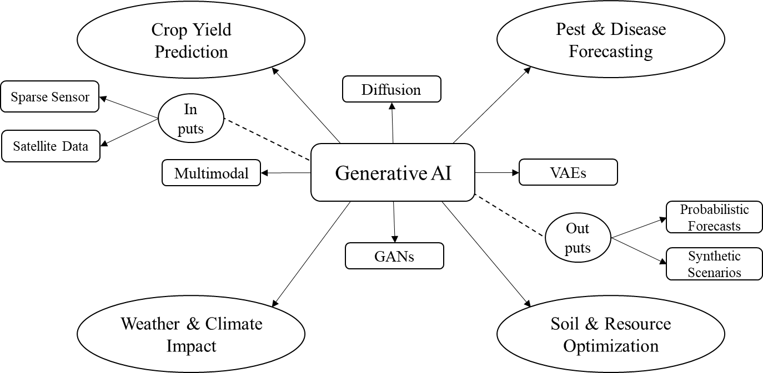
Fig 1. GenAI-Enhanced Applications in Agriculture Predictive Analytics
3.2 Pest and Disease Outbreak Prediction
Pest and disease outbreaks represent acute threats to agricultural productivity, often causing rapid, widespread losses if not detected early. Predictive modeling in this domain suffers from severe class imbalance—healthy plant images vastly outnumber rare symptomatic ones—and the emergence of novel pathogen strains or pest behaviors under changing climates. Generative AI mitigates these issues by creating balanced, diverse datasets of infected or infested plant images, enabling classifiers to learn robust decision boundaries. Diffusion-based augmentation stands out for generating high-quality, varied synthetic examples of rare disease symptoms or pest damage patterns, significantly reducing false negatives in early detection systems. This results in more reliable early-warning frameworks that identify emerging threats before they reach epidemic levels, allowing timely interventions like targeted spraying or resistant variety deployment (Iqbal, 2025; Javed et al., 2025).
GAN variants complement this by simulating temporal progression dynamics, such as lesion expansion or insect population growth over days or weeks, producing probabilistic risk maps for regional migration or outbreak escalation. These synthetic progressions help models anticipate how outbreaks might evolve under different weather or management scenarios, enhancing spatial-temporal forecasting. In practice, such applications translate to reduced crop losses, lower pesticide use through precision targeting, and improved biosecurity, particularly in smallholder farms where manual scouting is labor-intensive and error-prone. By enriching training data with realistic variations, GenAI boosts classifier precision and recall, fostering proactive rather than reactive pest and disease management, with recent vision-language integrations enabling explainable severity estimates and automated prescriptions (Iqbal, 2025).
3.3 Weather and Climate Impact Forecasting
Weather and climate variability profoundly influence agricultural outcomes, yet predictive models often suffer from incomplete or low-resolution environmental inputs, especially in data-sparse rural areas. GenAI integrates multimodal sources—such as satellite time-series, ground sensors, and text-based advisories—to synthesize comprehensive weather-crop interaction scenarios. Diffusion models excel at super-resolving coarse remote-sensing imagery and imputing missing variables (e.g., localized precipitation or temperature extremes), thereby enriching input quality for downstream predictive tasks like climate stress impact on yields or irrigation demand. This enables robust forecasting of extreme events, where the traditional scarcity of high-resolution historical extremes hampers accuracy (Kow et al., 2025).
By generating probabilistic ensembles of future conditions (e.g., drought severity or flood likelihood), GenAI provides farmers with uncertainty-quantified forecasts, supporting adaptive strategies like adjusted sowing windows or crop insurance decisions. In multimodal setups, models fuse visual (satellite) and textual (advisory) data to simulate crop responses under compounded stresses, offering actionable insights for climate-smart agriculture. This shift toward generative simulation strengthens resilience against unpredictable patterns, particularly benefiting vulnerable regions facing intensified extremes, with emerging downscaling techniques improving localized impact predictions for precision resource allocation (Abdelmoaty et al., 2025).
3.4 Soil Health and Resource Optimization Prediction
Soil health underpins long-term productivity, but sparse sensor coverage and temporal variability make accurate prediction of nutrient dynamics, moisture levels, or depletion risks difficult. Generative approaches, including variational autoencoders and diffusion models, impute missing readings from limited sensor networks and simulate long-term soil profiles under alternative practices (e.g., cover cropping, reduced tillage). These synthetic profiles enable predictive analytics for fertilizer recommendations, irrigation scheduling, and water/nutrient use efficiency, anticipating depletion or degradation before visible symptoms emerge (Kumari et al., 2025; Schweng et al., 2026).
In variable environments, GenAI generates diverse scenarios that account for interactions among soil type, weather, and management, promoting sustainable allocation by minimizing over-application of inputs. This reduces environmental footprint (e.g., nutrient runoff) while maintaining yields, aligning with regenerative goals. For smallholders, such tools democratize access to precision insights, transforming reactive soil management into proactive, data-informed stewardship, with AI-driven digital soil mapping enhancing resolution for targeted interventions (Schweng et al., 2026).
Overall, GenAI shifts predictive analytics toward generative simulation, offering greater resilience in low-data or high-uncertainty agricultural settings. By enabling probabilistic, scenario-rich forecasts, it empowers adaptive, sustainable decisions—though rigorous validation against real-field outcomes remains essential for building trust and ensuring deployment at scale.

4. real-world implementations and pilots

While generative AI remains largely in exploratory and pilot phases for agricultural predictive analytics, several implementations demonstrate its practical value in addressing data limitations and enhancing forecast reliability. These efforts often combine GenAI with existing data pipelines (e.g., satellite imagery, IoT sensors) to generate synthetic samples or scenarios, leading to improved model performance in field-like conditions. In Indian smallholder contexts, GenAI frameworks have been piloted for predictive advisory systems, integrating multilingual LLMs with local sensor and weather data to forecast yields and optimize inputs. These pilots show gains in decision accuracy and cost reduction, particularly for resource-constrained farms, though scalability depends on infrastructure improvements (Camps-Valls et al., 2025).
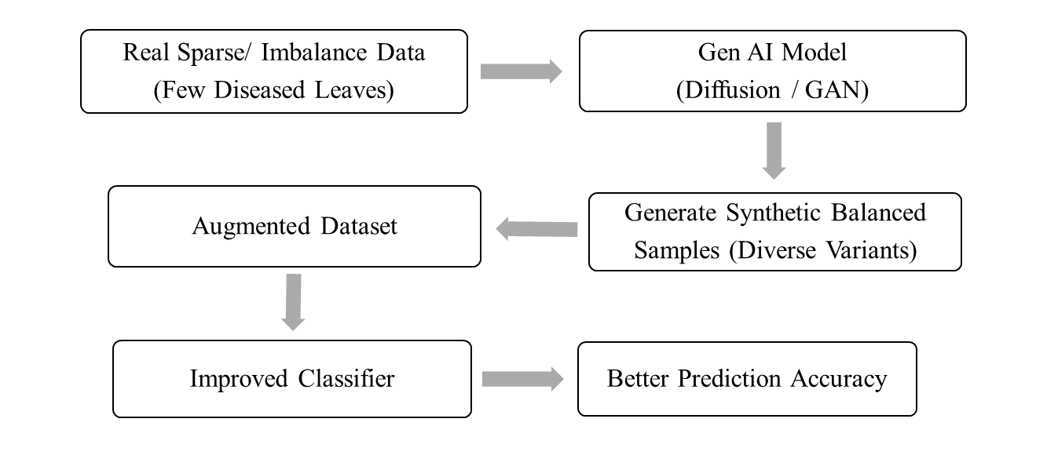
Fig 2. Data Augmentation Pipeline for Crop Disease or Pest Prediction
Diffusion model-based pilots have advanced crop growth simulation and yield prediction by generating high-fidelity synthetic trajectories under variable stresses (e.g., drought or nutrient shifts). Reviews of these implementations report superior stability over GANs, with downstream predictive models achieving better generalization when trained on augmented datasets from real agricultural imagery. For pest and disease prediction, diffusion and GAN pilots augment imbalanced image datasets, creating diverse synthetic examples of rare symptoms to train classifiers as described in figure 2. Field-oriented pilots demonstrate enhanced early-warning accuracy, reducing false negatives in outbreak forecasting, though real-world validation highlights the need for domain-specific fine-tuning to minimize (Amulothu et al., 2024).
Multimodal GenAI pilots combine vision-language models with satellite and ground data for climate impact forecasting, imputing missing variables and simulating crop responses to extreme weather. These efforts improve probabilistic predictions for irrigation and resource needs, with evidence of better robustness in heterogeneous environments. In broader smart agriculture pilots, GenAI supports soil health forecasting by generating synthetic profiles for sparse sensor networks, aiding predictive recommendations for fertilizer and water use. Results indicate efficiency gains, but pilots underscore challenges in integrating with legacy systems and ensuring outputs align with ground truth (Sapkota et al., 2025). These implementations illustrate GenAI's shift toward practical, predictive utility in agriculture, often yielding 10–30% improvements in forecast metrics via augmentation. However, most remain at pilot scale, with limited long-term field trials; success hinges on hybrid approaches (GenAI + discriminative models) and rigorous validation to build farmer trust.
5. discussions

The integration of generative artificial intelligence into predictive analytics represents one of the most promising yet underexplored frontiers in contemporary agriculture. As detailed in the preceding sections, GenAI transcends traditional discriminative approaches by not merely classifying or regressing from observed patterns but actively constructing plausible realities—synthetic growth trajectories, balanced disease datasets, imputed environmental variables, and simulated resource scenarios—that enrich predictive capacity in environments where real data are inherently sparse, noisy, or temporally limited. This generative paradigm shift is particularly salient in agriculture, a domain defined by irreducible uncertainty: seasonal variability, microclimatic heterogeneity, emergent biotic threats, and the compounding effects of climate change. By enabling probabilistic forecasting rather than deterministic point estimates, GenAI aligns predictive tools more closely with the stochastic nature of farming, offering farmers not just predictions but distributions of outcomes that better inform risk-aware decision-making (Shahriar et al., 2025).
A central strength lies in GenAI's capacity to democratize precision analytics for smallholder systems, where data poverty has long perpetuated yield gaps and vulnerability. The ability to generate "what-if" scenarios for yield under alternative agronomic practices, simulate pest progression for early regional alerts, or downscale coarse climate inputs for localized irrigation advice empowers resource-constrained producers to adopt anticipatory strategies without prohibitive field experimentation. This is no trivial contribution: in many developing contexts, even modest improvements in forecast reliability—through synthetic augmentation—can translate to reduced input waste, lower environmental externalities, and incremental gains in food security (Paul & Machavaram, 2025). Moreover, the multimodal nature of recent generative architectures (fusing imagery, time-series, and textual advisories) begins to bridge the semantic gap between raw sensor feeds and actionable agronomic insight, moving predictive analytics closer to human-like reasoning in complex agroecosystems.
Yet this promise must be tempered by critical reflection on the method's limitations and systemic implications. Generative models, while powerful in synthesis, remain vulnerable to propagating artifacts—hallucinated disease patterns, implausible growth curves, or biased resource simulations—that could mislead rather than enlighten. Such risks are amplified in high-stakes agricultural decisions, where erroneous forecasts may lead to over- or under-application of inputs, financial loss, or ecological harm (Javed et al., 2025). Explainability remains a persistent concern: the latent spaces of diffusion or multimodal models are notoriously opaque, complicating traceability of why a particular probabilistic forecast emerged. For farmers and extension agents, who often operate with limited technical literacy, black-box outputs undermine trust and adoption. Furthermore, the computational footprint of training and inference poses equity challenges; edge-compatible lightweight variants are emerging, but access to sufficient GPU resources, stable connectivity, and maintenance expertise remains unevenly distributed, potentially widening rather than narrowing the digital divide between large-scale and smallholder operations (Pallottino et al., 2025).
From a broader sustainability perspective, GenAI's role in predictive analytics invites nuanced evaluation. On one hand, optimized resource forecasts and stress simulations support precision practices that minimize overuse of water, fertilizers, and pesticides—contributing to regenerative goals and climate resilience. On the other hand, the energy demands of generative training and the risk of over-optimistic synthetic scenarios (e.g., underestimating extreme tail events) could inadvertently reinforce unsustainable intensification if not rigorously validated against ground truth across diverse agroecological zones (Senthil et al., 2025). Ethical considerations further complicate deployment: data ownership in shared generative pipelines, potential biases embedded in training corpora as mentioned in table 2 that under-represent marginalized farming systems, and the deskilling risk if over-reliance supplants experiential knowledge all warrant deliberate governance.
Table 2. Key prospects and pitfalls of generative AI in agricultural predictive analytics
Dimension | Prospects (Strengths & Opportunities) | Pitfalls (Limitations & Risks) | Implications for Future Development
Predictive Robustness | Probabilistic forecasts; overcomes data scarcity | Hallucinations & artifacts | Controllable generation & rigorous validation
Smallholder Equity | "What-if" scenarios for anticipatory planning | Computational demands & digital divide | Lightweight models & farmer co-design
Sustainability Impact | Precision resource use; climate-resilient planning | High energy use; over-optimistic scenarios | Energy-efficient architectures & bias audits
Explainability & Trust | Multimodal fusion → actionable insights | Opaque latent spaces | Post-hoc interpretability & hybrid pipelines
Ethical & Systemic | Amplifies human judgment for adaptive systems | Data ownership issues, biases, deskilling risk | Transparent governance & federated learning
Note: Summary of core prospects and pitfalls of generative AI in predictive analytics for agriculture, highlighting balanced pathways toward responsible, impactful deployment.
Therefore, the trajectory of GenAI in agricultural prediction hinges on hybrid architectures that tie the knot of generative creativity with discriminative reliability—using synthetic data to pre-train or augment, then refining with real-world grounding for verifiable performance. Advances in controllable generation (e.g., conditioned on expert priors or uncertainty estimates) and federated learning could enhance privacy and inclusivity, while domain-specific fine-tuning on diverse, representative agricultural corpora would mitigate hallucination risks. Equally important is interdisciplinary collaboration: agronomists, data scientists, ethicists, and farmers must co-design validation protocols, interpretability interfaces, and deployment pathways that prioritize equity and real-world utility over technological novelty (Li et al., 2026). In sum, generative AI does not merely augment predictive analytics in agriculture; it redefines the epistemological basis of forecasting—from observation-bound inference to distribution-aware simulation. Realizing its transformative potential requires moving beyond proof-of-concept pilots toward rigorous, inclusive, and transparent integration. Only then can GenAI fulfill its promise as a resilient partner in the quest for sustainable, adaptive, and equitable food systems amid accelerating global change.
6. challenges and ethical considerations

Despite the promising advances of generative AI in agricultural predictive analytics, several technical, practical, and ethical hurdles must be addressed before widespread, reliable adoption can occur. One of the most persistent technical limitations is the risk of hallucinations—the generation of plausible but factually incorrect outputs. In predictive contexts, this can manifest as synthetic crop images depicting impossible disease patterns, fabricated yield trajectories under unrealistic climate conditions, or overly optimistic resource forecasts. Such errors, even if infrequent, erode trust among farmers and extension agents who rely on accurate predictions for high-stakes decisions. Computational demands represent another major barrier. Training and fine-tuning diffusion models, large multimodal architectures, or GAN variants requires substantial GPU resources and energy, which are often inaccessible in rural or developing regions. Inference latency can also hinder real-time applications, such as on-device pest detection or immediate irrigation recommendations, particularly when models are deployed on low-power edge devices common in smallholder farms.
Data-related challenges remain critical. Generative models inherit and can amplify biases present in training datasets—such as under-representation of certain crop varieties, soil types, or farming practices from specific geographic or socioeconomic contexts. This risks producing predictions that perform poorly or unfairly disadvantage marginalized farming communities. Moreover, the quality of synthetic data is only as good as the real data it learns from; noisy, incomplete, or outdated inputs can propagate errors into generated scenarios, undermining the very purpose of augmentation. Explainability and interpretability pose ongoing difficulties. While discriminative models often allow inspection of feature importance or decision paths, many generative architectures function as black boxes. Farmers and agronomists need to understand why a model predicts a particular yield drop or pest risk, yet the complex latent spaces of diffusion or multimodal models make post-hoc explanations challenging and sometimes unreliable. From an ethical standpoint, over-reliance on generative predictions could deskill farmers by reducing direct observation and experiential judgment, potentially weakening long-term resilience in unpredictable environments. Privacy concerns arise when models are trained on farm-level sensor or yield data; even anonymized datasets can reveal sensitive information about production scales, land use, or economic status if not carefully protected.
Equity and accessibility issues are particularly pronounced. The digital divide—limited internet connectivity, smartphone penetration, and technical literacy in many rural areas—means that the benefits of generative AI may disproportionately accrue to larger, better-resourced operations, widening existing gaps rather than closing them. Finally, validation remains a fundamental challenge. Most generative applications in agriculture are still at pilot scale, with limited long-term, multi-season, multi-location field trials. Without rigorous, transparent benchmarking against ground truth under real-world variability, it is difficult to confidently assess whether synthetic augmentation genuinely improves predictive performance or merely creates an illusion of robustness. Addressing these challenges as shown in figure 3, will require hybrid approaches that combine the strengths of generative and discriminative models, investment in lightweight and explainable architectures, robust bias audits, farmer-centered co-design, and clear governance frameworks to ensure generative AI serves as a supportive tool rather than a replacement for human judgment and local knowledge.
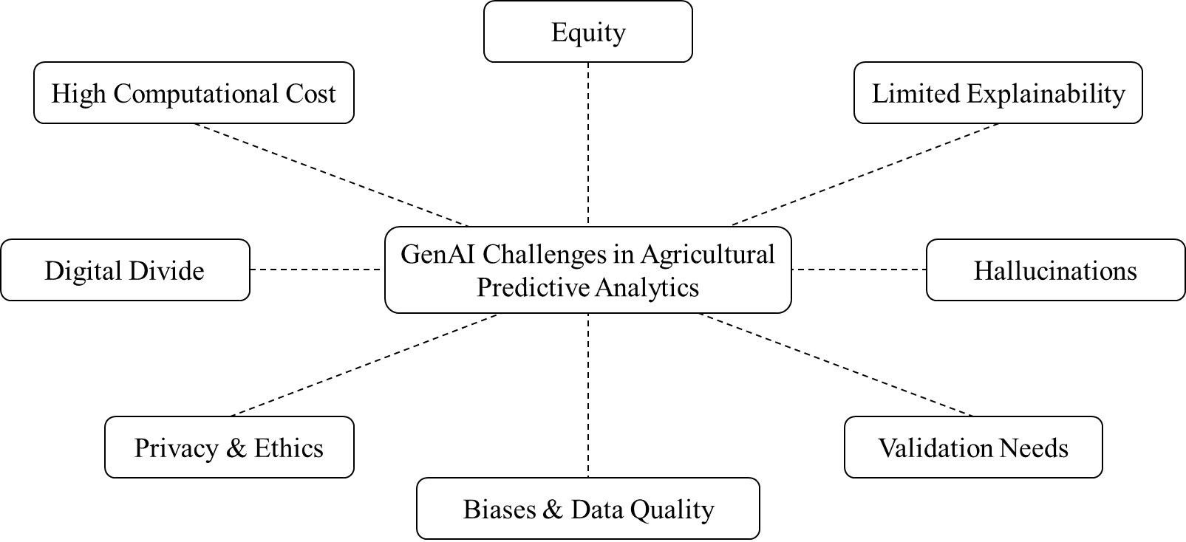
Fig 3. Challenges of GenAI in agricultural predictive analytics
7. conclusion

Generative artificial intelligence marks a significant step forward in predictive analytics for modern agriculture. By synthesizing realistic data, simulating plausible scenarios, and integrating multimodal inputs, GenAI overcomes core limitations of traditional models—particularly data scarcity, class imbalance, and the inability to anticipate rare or novel conditions. These capabilities enhance forecasting accuracy for crop yields, pest and disease risks, climate impacts, and resource optimization, offering tools better suited to variable, data-constrained environments such as smallholder farming systems. Real-world pilots demonstrate tangible progress: diffusion-based augmentation improves classifier performance on imbalanced datasets, multimodal models support probabilistic climate forecasting, and synthetic growth trajectories aid anticipatory decision-making. Such implementations point toward more resilient and creative predictive systems capable of contributing to sustainable intensification under growing climate and resource pressures.
Yet substantial challenges persist. Hallucinations in generated outputs, high computational requirements, inherited biases, limited explainability, privacy risks, and unequal access threaten reliability and equity. Over-dependence on synthetic predictions without rigorous validation could weaken farmer judgment and long-term adaptability. The digital divide further risks concentrating benefits among larger operations, potentially widening rather than narrowing disparities. The most viable path forward involves hybrid architectures that pair generative creativity with discriminative reliability, alongside lightweight models suitable for edge deployment, farmer-centered design, bias mitigation, and transparent governance. Generative AI should function as a supportive partner—not a substitute—for human expertise, local knowledge, and empirical observation. If developed responsibly and deployed inclusively, generative AI can help shift agriculture toward more anticipatory, efficient, and sustainable practices. Achieving this will require ongoing interdisciplinary effort across agronomy, computer science, ethics, policy, and—crucially—the active involvement of farming communities themselves. Only through such collaboration can the technology fulfill its potential to support a more food-secure and climate-resilient future.

disclaimer (artificial intelligence)

Author(s) hereby declares that NO generative AI technologies such as Large Language Models (ChatGPT, COPILOT, etc.) and text-to-image generators have been used during writing or editing of this manuscript.
Competing interests

All Authors have declared that no competing interests exist.

References

Abdelmoaty, H. M., Papalexiou, S. M., Mamalakis, A., Singh, S., Coia, V., Hairabedian, M., Szeftel, P., & Grover, P. (2025). Generative Adversarial Networks for Downscaling Hourly Precipitation in the Canadian Prairies. Journal of Geophysical Research: Machine Learning and Computation, 2(4). https://doi.org/10.1029/2025jh000678
Amulothu, D. V. R. T., Rodge, R. R., Hasan, W., & Gupta, S. (2024). Machine learning for pest and disease detection in crops. In Agriculture 4.0: Smart Farming with IoT and Artificial Intelligence. https://doi.org/10.1201/9781003570219-6
Camps-Valls, G., Fernández-Torres, M. Á., Cohrs, K. H., Höhl, A., Castelletti, A., Pacal, A., Robin, C., Martinuzzi, F., Papoutsis, I., Prapas, I., Pérez-Aracil, J., Weigel, K., Gonzalez-Calabuig, M., Reichstein, M., Rabel, M., Giuliani, M., Mahecha, M. D., Popescu, O. I., Pellicer-Valero, O. J., … Williams, T. (2025). Artificial intelligence for modeling and understanding extreme weather and climate events. In Nature Communications (Vol. 16, Number 1). https://doi.org/10.1038/s41467-025-56573-8
Gebreab, S., Musamih, A., Salah, K., Jayaraman, R., & Boscovic, D. (2024). Accelerating Digital Twin Development With Generative AI: A Framework for 3D Modeling and Data Integration. IEEE Access, 12. https://doi.org/10.1109/ACCESS.2024.3514175
Iqbal, A. (2025). Comprehensive AI framework for automated classification, detection, segmentation, and severity estimation of date palm diseases using vision-language models and generative AI. Frontiers in Plant Science, 16. https://doi.org/10.3389/fpls.2025.1710188
Javed, K., Smagghe, G., Wang, Q., Javed, H., & Wang, Y. (2025). Artificial intelligence in crop protection: Revolutionizing agriculture for a sustainable future. Information Processing in Agriculture. https://doi.org/10.1016/j.inpa.2025.12.003
Kow, P. Y., Wang, Y. T., Chang, Y. W., Lee, M. H., Yao, M. H., Chang, L. C., & Chang, F. J. (2025). AI-driven weather downscaling for smart agriculture using autoencoders and transformers. Computers and Electronics in Agriculture, 232. https://doi.org/10.1016/j.compag.2025.110129
Kumari, K., Mirzakhani Nafchi, A., Mirzaee, S., & Abdalla, A. (2025). AI-Driven Future Farming: Achieving Climate-Smart and Sustainable Agriculture. In AgriEngineering (Vol. 7, Number 3). https://doi.org/10.3390/agriengineering7030089
Li, M., Basit, A., Javed, A., Song, X., & Ge, Y. (2026). Generative artificial intelligence and ChatGPT in agriculture supply chain management: a systematic literature review and future research agenda. British Food Journal, 128(13). https://doi.org/10.1108/bfj-05-2025-0720
Majumder, S., Khandelwal, Y., & Sornalakshmi, K. (2024). Computer vision and Generative AI for yield prediction in Digital Agriculture. Proceedings of the 2nd IEEE International Conference on Networking and Communications 2024, ICNWC 2024. https://doi.org/10.1109/ICNWC60771.2024.10537337
Min, X., Ye, Y., Xiong, S., & Chen, X. (2025). Computer Vision Meets Generative Models in Agriculture: Technological Advances, Challenges and Opportunities. In Applied Sciences (Switzerland) (Vol. 15, Number 14). https://doi.org/10.3390/app15147663
Pallottino, F., Violino, S., Figorilli, S., Pane, C., Aguzzi, J., Colle, G., Nerio Nemmi, E., Montaghi, A., Chatzievangelou, D., Antonucci, F., Moscovini, L., Mei, A., Costa, C., & Ortenzi, L. (2025). Applications and perspectives of Generative Artificial Intelligence in agriculture. In Computers and Electronics in Agriculture (Vol. 230). https://doi.org/10.1016/j.compag.2025.109919
Paul, A., & Machavaram, R. (2025). Generative AI in agriculture 4.0: Applications, challenges, and integration in the Indian context. Food and Humanity, 5. https://doi.org/10.1016/j.foohum.2025.100889
Rasool, S., Husnain, A., Saeed, A., Gill, A. Y., & Hussain, H. K. (2023). Harnessing Predictive Power: Exploring the Crucial Role of Machine Learning in Early Disease Detection. JURIHUM : Jurnal Inovasi Dan Humaniora , 1(2).
Sapkota, R., Qureshi, R., Usman Hadi, M., Zohaib Hassan, S., Sadak, F., Shoman, M., Sajjad, M., Ali Dharejo, F., Paudel, A., Li, J., Meng, Z., Shutske, J., & Karkee, M. (2025). Multi-Modal LLMs in Agriculture: A Comprehensive Review. IEEE Transactions on Automation Science and Engineering, 22. https://doi.org/10.1109/TASE.2025.3612154
Schweng, S., Bernardini, L., Keiblinger, K., Kaul, H.-P., Jr., I. F., Lukač, N., Del Ser, J., & Holzinger, A. (2026). What can artificial intelligence do for soil health in agriculture? Computer Science Review, 59. https://doi.org/10.1016/j.cosrev.2025.100832
Senthil, G. A., Suganthi, S. U., Prinslin, L., Selvi, R., & Prabha, R. (2025). Generative AI in Agri: Sustainability in Smart Precision Farming Yield Prediction Mapping System Based on GIS Using Deep Learning and GPS. Procedia Computer Science, 252. https://doi.org/10.1016/j.procs.2024.12.038
Shahriar, S., Corradini, M. G., Sharif, S., Moussa, M., & Dara, R. (2025). The role of generative artificial intelligence in digital agri-food. In Journal of Agriculture and Food Research (Vol. 20). https://doi.org/10.1016/j.jafr.2025.101787
Srivastava, A. K., Halder, K., Shi, Y., Han, L., EI Shawi, R., Timko, J., Zheng, W., Zhao, G., Alsafadi, K., Singh, M., Behrend, D., Gaiser, T., & Ewert, F. (2025). Advancing Crop Yield Predictions: The Potential of Diffusion Models in Machine Learning for Agriculture. EGU General Assembly 2025, Vienna, Austria. https://doi.org/10.5194/egusphere-egu25-16009
Vinod, V. C., S., A. H., & Albaaji, G. F. (2024). Precision farming for sustainability: An agricultural intelligence model. Computers and Electronics in Agriculture, 226. https://doi.org/10.1016/j.compag.2024.109386
Wang, T., Tong, R., Xu, T., Li, Y., & Chen, Y. (2026). Artificial intelligence in plant science: from image-based phenotyping to yield and trait prediction. Frontiers in Plant Science, 16. https://doi.org/10.3389/fpls.2025.1732979
Zhu, H., Qin, S., Su, M., Lin, C., Li, A., & Gao, J. (2025). Harnessing large vision and language models in agriculture: a review. In Frontiers in Plant Science (Vol. 16). https://doi.org/10.3389/fpls.2025.1579355

