Case report
Venous Malformation of Buccal Mucosa in A 65 year old female: A Case Report

.
ABSTRACT

Background: Venous malformations are congenital, low-flow vascular anomalies that often remain unnoticed until adulthood, when they may present as bluish, compressible swellings of the oral mucosa.These lesions may mimic hemangiomas, arteriovenous malformations, or reactive lesions, posing diagnostic challenges.
Case Presentation: A 65-year-old female with no significant medical history presented with a painless swelling on the left buccal mucosa of three months’ duration. Examination revealed a soft, compressible bluish lesion that showed positive blanching on diascopy, suggesting a vascular origin.Initially, a provisional diagnosis of hemangioma was made. The patient underwent local ultrasonography, which revealed a low-flow vascular lesion consistent with a venous malformation.
Management:The lesion was asymptomatic and stable in size; hence, conservative observation with regular follow-up was advised.
Conclusion:This case highlights the importance of clinical evaluation, diascopy, and imaging for accurate diagnosis of oral vascular lesions. Conservative management is appropriate for stable, asymptomatic venous malformations, preventing unnecessary intervention.

Keywords: Venous malformation; Buccal mucosa; Oral vascular lesion; Diascopy; Conservative management.

1. INTRODUCTION

Vascular anomalies of the oral cavity include a wide spectrum of lesions that can be classified as vascular tumors or vascular malformations according to the ISSVA system.¹² Vascular tumors, like hemangiomas, show endothelial proliferation, while vascular malformations are structural anomalies of vessels present at birth.³
Venous malformations are low-flow, congenital anomalies of veins that typically enlarge slowly over time due to progressive dilation.⁴,¹³ Oral venous malformations are less frequent than cutaneous ones but often involve the buccal mucosa, lips, or tongue.⁵,⁶ Clinically, they appear as soft, compressible, bluish lesions that blanch upon pressure, a finding that helps distinguish them from pigmented non-vascular lesions or reactive growths.⁷
Accurate differentiation from hemangiomas, arteriovenous malformations (AVMs), and other vascular or reactive lesions is crucial for proper management and to prevent unnecessary surgical intervention.⁸,⁹ This report presents a case of buccal mucosal venous malformation in an elderly female, highlighting clinical evaluation, imaging confirmation, and conservative management

2. PRESENTATION OF CASE

A 65-year-old female presented with a swelling on the left buccal mucosa of three months’ duration. She reported to the Department of Oral Medicine and Radiology with insidious onset, gradual increase, and no pain, bleeding, or trauma. The patient had no significant medical history.
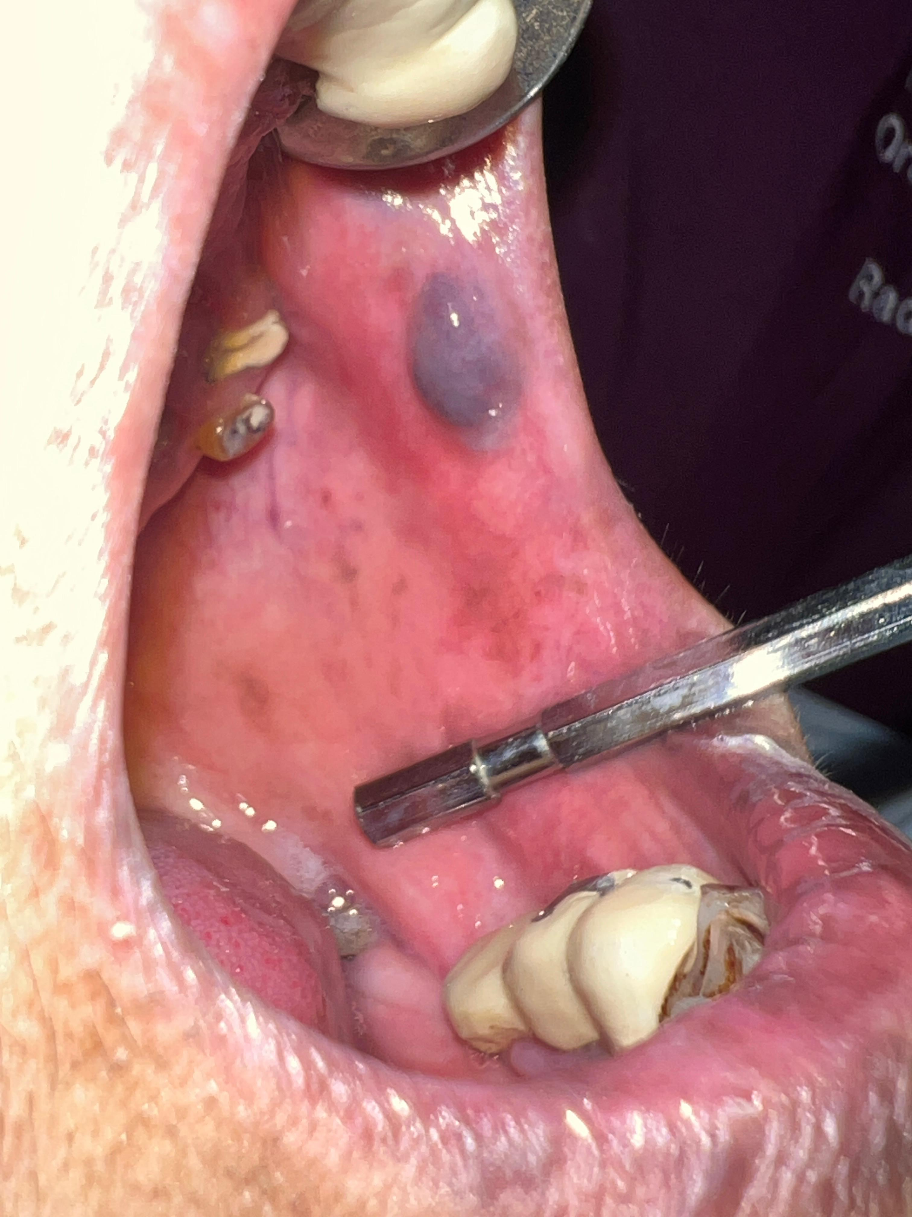
Fig 1 Vascular Malformation on left buccal mucosa in 65 yr old.

Intraoral examination revealed a solitary, bluish-purple, well-defined swelling measuring approximately 1.2 × 1.0 cm on the left buccal mucosa near the occlusal plane (fig 1).
The lesion was soft, compressible, non-tender

Showed positive blanching on diascopy, confirming its vascular nature (fig 2).
A provisional diagnosis of hemangioma was made initially based on clinical appearance.
To further characterize the lesion, local ultrasonography was advised, which revealed dilated venous channels with low-flow characteristics, consistent with a venous malformation.
As the lesion was asymptomatic and stable, conservative management with periodic observation was planned.
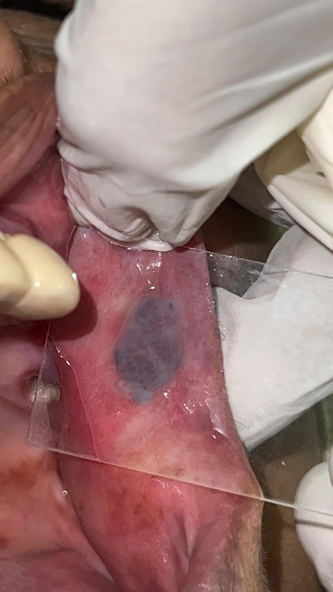
Fig 2. Positive Blanching Test

On follow-up, there was no significant change in size or appearance, and the patient continues under regular monitoring.

Differential Diagnosis:
- Hemangioma – typically appears in infancy; shows proliferative phase, involution, and endothelial proliferation on histology¹²,¹⁴.
- Arteriovenous malformation (AVM) – high-flow lesion with pulsation, bruit, and imaging evidence of arterial-venous shunting¹⁴,¹⁵.
- Venous lake – superficial, smaller lesions of lips, often sun-exposed areas; blanching positive but usually smaller¹⁶.
- Pyogenic granuloma – rapidly growing, friable, red lesion, often bleeds on minor trauma¹⁷.
- Mucocele – mucous extravasation cyst; fluctuant, non-blanching, typically lower lip¹⁸.

3. discussion

Venous malformations are categorized under low-flow vascular anomalies and are distinguished from vascular tumors by their structural nature and lack of endothelial proliferation.¹
According to the International Society for the Study of Vascular Anomalies (ISSVA), vascular anomalies include both vascular tumors, such as hemangiomas, and vascular malformations, such as venous malformations, which are present at birth but may not become clinically evident until later in life due to slow expansion.²
Hemangiomas typically present early in life with a proliferative phase followed by spontaneous involution, which contrasts with the clinical behavior of venous malformations that persist throughout life without involution.³
Oral venous malformations often present as soft, compressible, bluish-purple swellings in the mucosa and are more frequent in the head and neck region, including the buccal mucosa, lips, and tongue.⁴
The blanching (diascopy) test is a useful clinical tool to assess vascularity; true vascular lesions, such as venous malformations, typically show blanching due to blood displacement under pressure, unlike pigmented or non-vascular lesions.⁵
In the present case, the lesion demonstrated positive blanching upon diascopy, supporting a vascular origin and narrowing the differential diagnosis toward a venous anomaly rather than a non-vascular pathology.⁶
Initial clinical evaluation led to a provisional diagnosis of hemangioma due to the vascular appearance, but the late onset in a 65-year-old female without prior history of a childhood vascular lesion made hemangioma less likely.⁷
Ultrasonography with Doppler evaluation is a non-invasive imaging modality that helps distinguish low-flow venous malformations from high-flow arteriovenous malformations and from hemangiomas by demonstrating flow characteristics and vessel architecture.⁸
In the present case, Doppler ultrasonography revealed features consistent with a low-flow vascular lesion, confirming the diagnosis of a venous malformation and excluding high-flow lesions.⁹
Differential diagnosis for bluish-purple oral swellings includes venous lake, varix, mucocele, pyogenic granuloma, and reactive vascular or pigmented lesions; venous lakes are typically small and superficial, often located on sun-exposed lips, and mucoceles are fluctuant, non-blanching cystic swellings.¹⁰
Pyogenic granulomas are reactive vascular lesions that present as bright red, friable masses prone to bleeding and do not exhibit the same compressibility or blanching pattern as venous malformations.¹¹
Given the lesion’s clinical features and imaging findings, a diagnosis of venous malformation of the left buccal mucosa was made.¹²
Management of venous malformations depends on symptoms, esthetic concerns, or functional impairment; asymptomatic and stable lesions may be observed without intervention, while sclerotherapy, laser therapy, or surgical excision may be considered for symptomatic or problematic lesions.¹³
Sclerotherapy with agents such as ethanol, polidocanol, or bleomycin has been shown to reduce lesion size by inducing fibrosis, and laser therapy (diode, Nd:YAG, CO₂) offers precise ablation with good hemostasis and minimal damage to surrounding tissues.¹⁴
Conservative observation in asymptomatic cases has been supported by recent case series and clinical reviews, emphasizing the benign nature and indolent course of many low-flow venous malformations.¹⁵
The present case remained stable in size over the follow-up period without any progression, reinforcing the decision for conservative management in an asymptomatic patient.¹⁶

4. Conclusion

Venous malformations of the oral cavity are slow-growing, low-flow vascular anomalies that can remain unnoticed for years and may present later in life as soft, bluish, compressible swellings. Early recognition and accurate diagnosis are essential to differentiate them from other vascular and reactive lesions, preventing unnecessary interventions. Non-invasive assessment, including clinical evaluation and imaging, allows for precise characterization of these lesions.
Asymptomatic and stable venous malformations can be safely managed with careful observation and periodic follow-up, reserving active treatment for cases that cause functional impairment, discomfort, or cosmetic concerns. This case emphasizes the value of a patient-centered, conservative approach and highlights the importance of individualized management strategies in achieving optimal outcomes while minimizing risks.

Consent (where ever applicable)

Written informed consent was obtained from the patient.

References

- Lowe LH, Marchant TC, Rivard DC, Scherbel AJ. Vascular malformations: classification and terminology. Radiographics. 2012;32(1):E1–20.
- Wassef M, Blei F, Adams D, et al. Vascular anomalies classification: update from ISSVA 2018. Pediatr Dermatol. 2019;36(Suppl 1):S5–S17.
- Mulliken JB, Glowacki J. Classification of hemangiomas and vascular malformations in infants and children. Plast Reconstr Surg. 1982;69(3):412–22.
- Brandão L, Bohay RN, Woods JE. Oral vascular lesions: a practical approach to diagnosis. J Oral Maxillofac Surg. 2014;72(2):339–346.
- Neville BW. (2017). Oral Maxillofacial Pathology (4th ed.). Elsevier.
- González-Arriagada WA, Herrera M, Guzmán E, et al. Vascular malformations in the head and neck: clinical and imaging features. Oral Surg Oral Med Oral Pathol Oral Radiol. 2018;126(5):412–420.
- Torres MC, Santana LJ, Bravo AR, Mardones MM. Vascular anomalies of the oral cavity: review of classification and treatment applied to two clinical cases. Int J Odontostomatol. 2020;14(1):48–54.
- Yakes WF, Rossi P, Odink H, et al. Angiographic classification of venous malformations and implications for treatment. Radiology. 1996;199(1):89–95.
- Ghosh LM, Pushplata, Gulati SP. Doppler ultrasound in evaluation of vascular lesions. Indian J Radiol Imaging. 2002;12(4):485–490.
- Baugh RF, Sheffield LA. Venous lake of the oral cavity: case report and review. Oral Surg Oral Med Oral Pathol. 1993;76(5):642–644.
- Flaitz CM, Hicks MJ. Oral vascular lesions in adults: evaluation and differential diagnosis. Oral Surg Oral Med Oral Pathol Oral Radiol Endod. 2001;92(5):487–494.
- García-Pola Vallejo MJ, González García R, Rodríguez-Campo FJ, et al. Clinical management of oral hemangiomas and vascular malformations: case series. Med Oral Patol Oral Cir Bucal. 2007;12(5):E361–E366.
- Patel M, Rosen RJ, Bernstein EF. Treatment of vascular malformations: current options and future directions. J Am Acad Dermatol. 2015;72(2):407–421.
- Horbach SE, Madern GC, Lokhorst MM, et al. Sclerotherapy for low-flow vascular malformations: systematic review. J Plast Reconstr Aesthet Surg. 2016;69(5):e161–e175.
- Kumar A, et al. Conservative follow-up strategy for asymptomatic vascular malformations. J Clin Diagn Res. 2022;16(7):ZE14–ZE18.
- Zeng Z, et al. Long-term follow-up of oral venous malformations. Oral Dis. 2021;27(4):939–948.

