Original Research Article

To study of Physicochemical, Microbial and IR Spectral Analysis of Zn (II) - Cyclophosphamide complex

.
ABSTRACT

The present study investigates the complex formation of Cyclophosphamide with Zn(II) metal ion using polarographic, spectroscopic, and antimicrobial analyses. The method is using for analysis of cyclophosphamide complex is physiochemical and microbial culture. The results are showing, infrared spectral analysis further supported complex formation, as the P=O stretching band shifted from 1275 cm⁻¹ to 1285 cm⁻¹ and the C–O stretching band from 1200 cm⁻¹ to 1215 cm⁻¹ in the Zn(II) complex, indicating coordination through the P=O group. Based on polarographic, amperometric, analytical, and IR spectral data, a probable structure of the Zn(II)–Cyclophosphamide complex was proposed. The synthesized complex exhibited antibacterial activity against Klebsiella pneumoniae, Staphylococcus aureus, and Bacillus subtilis with inhibition zones of 15 mm, 13 mm, and 18 mm respectively, while no activity was observed against Escherichia coli. The enhanced antimicrobial activity may be attributed to increased lipophilicity of the metal complex, facilitating better penetration into microbial cell membranes.

Keywords: Zn(II)–Cyclophosphamide complex, Physicochemical, Microbial and IR Spectral Analysis

1. INTRODUCTION

Cyclophosphamide (CP) is a synthetic alkylating cytostatic agent belonging to the nitrogen mustard class, widely utilized as a potent chemotherapeutic and immunosuppressive drug (Ayza et al., 2022; Gamal-Eldeen et al., 2022; Rajput, S. K., & Singh, S., 2025). As a prodrug, it undergoes hepatic activation via the cytochrome P-450 system to form active metabolites, namely phosphoramide mustard and acrolein, which inhibit DNA replication and induce apoptosis in neoplastic cells (Al-Jumaili, M. H. A., et al., 2025; Ayza et al., 2022; Morad et al., 2005; Hengst, J. C., & Kempf, R. A., 1984). Despite its high efficacy against various malignancies and autoimmune disorders, the clinical utility of cyclophosphamide is often hampered by significant systemic toxicities, including nephrotoxicity, cardiotoxicity, and urotoxicity (Moore, M. J., 1991; Basuli, F., & Mikata, Y., 2014; Ayza et al., 2022).
Bioinorganic and medicinal chemistry have seen a significant increase in interest in the coordination of metal ions with physiologically active ligands, (Chaudhary, A., et al., 2015; Sonawane, H. R. et. al., 2023). In addition to providing structural variety, metal-based complexes frequently show higher biological activity than free ligands. Ni(II) stands out among transition metals because of its redox characteristics, varied coordination geometries, and capacity to form stable chelates with donor atoms of nitrogen and oxygen, (Chohan, Z. H., & Supuran, C. T., 2005; Kumar, M., et. al., 2024). In recent decades, bioinorganic chemistry has focused on the synthesis of transition metal complexes to enhance the therapeutic index of existing drugs while minimizing adverse effects (Camellia, N., et al., 2022; Jungwirth et al., 2011; Sen et al., 2022). Because of their crucial function in cellular metabolism, enzyme control, and their potential to increase the stability and bioavailability of coordinated ligands, zinc(II) ions in particular are of great interest, (Abdelrahman et al., 2024; Prasad et al., 2021). According to earlier studies, complexing nitrogen mustard derivatives with metal ions may alter the nitrogen lone pair's reactivity, which may delay the production of extremely reactive aziridinium cations and prolong the medication's half-life in physiological settings.
An essential method for verifying the coordination behavior of ligands to metal centers is infrared (IR) spectroscopy (Stuart, B. 2000). Changes in distinctive vibrational bands, such as metal–ligand stretching frequencies, nitrosourea nitrogen (N–N), and carbonyl (C=O), offer important information on binding modes and structural alterations during complexation. These spectroscopic characteristics aid in clarifying the composition and geometry of the resultant complex when combined with elemental analysis, UV–Vis spectroscopy, and thermal research, (Nokamoto, K. 1983). Several spectroscopic methods, including UV-Vis, FT-IR, NMR, and X-ray diffraction, were used to demonstrate the formation of metal-ligand interactions. Stoichiometry and bonding modes were examined in relation to the coordination of metal ions to the ligand. Successful complexation was shown by the existence of metal-to-ligand charge transfer bands in the UV-Vis spectra, (Kramer et al., 2014). The establishment of metal-ligand bonds was supported by the FT-IR spectra, which showed changes in the ligand's distinctive stretching frequencies. Following the completion of the reaction, the mixture was dried for a full day in a vacuum desiccator filled with phosphorus pentoxide. The creation of the nickel complex was shown by the formation of a light green solid. After filtering and cleaning with cold ethanol to get rid of contaminants, the product was either dried outdoors or in a desiccator, (Alexandratos, S. D., & Zhu, X., 2018; Moreira, J. M., et al., 2022; Reddy, G. N., et al., 2023). A multi-analytical approach is necessary for the characterization of such metal-drug complexes in order to verify their biological potential and structural integrity. An essential technique for locating certain functional groups and coordination sites involved in metal-ligand interaction is infrared (IR) spectrum analysis, (Kim, W. K., 2025; Abdelrahman et al., 2024). Additionally, assessing the microbial activity and physicochemical characteristics (such solubility and stability) offers insights into the behavior of the complex and secondary therapeutic advantages, like antibacterial potential (Abdelrahman et al., 2024). Through in-depth IR spectrum analysis and physicochemical evaluations, this study attempts to investigate the production and characterisation of the Zn(II)-Cyclophosphamide complex. In order to ascertain whether the addition of Zn(II) improves the therapeutic efficiency of cyclophosphamide while maybe reducing its intrinsic toxicities, the complex's pharmacological and microbiological activities are also assessed. This investigation aims to contribute to the growing body of research on metal-based drug development and to explore the viability of Zn(II) complexes in enhancing the efficacy of established to physicochemical, microbial and IR Spectral Analysis of Zn (II) - Cyclophosphamide complex.

2. material and methods

Synthesis of the Zn(II)-Cyclophosphamide Complex
The complex is typically synthesized using a molar ratio (often 1:1 or 1:2) of Zinc(II) chloride or acetate to Cyclophosphamide.
• Procedure: Dissolve the metal salt and the ligand in a suitable solvent (e.g., ethanol or methanol).
•Reaction: The mixture is stirred under reflux for several hours at a controlled temperature (approx. 600 C).
•Isolation: The resulting precipitate is filtered, washed with cold solvent to remove unreacted precursors, and dried in a vacuum desiccator.
Several spectroscopic methods, including UV-Vis, FT-IR, NMR, and X-ray diffraction, were used to demonstrate the formation of metal-ligand interactions (Muchuweni et al., 2020). Stoichiometry and bonding modes were examined in relation to the coordination of metal ions to the ligand. Successful complexation was suggested by the presence of metal-to-ligand charge transfer bands in the UV-Vis spectra (Manikandan & Karthikeyan, 2020). The establishment of metal-ligand bonds was supported by the FT-IR spectra, which showed changes in the ligand's distinctive stretching frequencies. Following the completion of the reaction, the mixture was dried for a full day in a vacuum desiccator filled with phosphorus pentoxide. The creation of the nickel complex was shown by the formation of a light green solid (Alkhatib & Alsulami, 2023). After filtering and cleaning with cold ethanol to get rid of contaminants, the product was either dried outdoors or in a desiccator. After that, the complex was described using a number of methods. The metal-to-ligand ratio was verified by elemental analysis, (Saulawa et al., 2024; More et al., 2017).
By displaying changes in significant functional groups like C=O and N–N=O, infrared (IR) spectroscopy assisted in identifying the bonding sites. Electronic transitions were investigated using UV–Vis spectroscopy, and the compound's stability was assessed using thermal analysis. NMR spectroscopy was also employed, if necessary, to identify any changes in chemical shift brought on by metal coordination, (More et al., 2017; Prabhakara et al., 2007).
To test antimicrobial activity, the agar well diffusion method was used against selected bacteria such as E. coli, Staphylococcus aureus, Klebsiella pneumoniae, and Bacillus subtilis. Nutrient agar plates were prepared and inoculated with bacterial cultures. Wells were made in the agar, and different concentrations of Zn(II) complex (25, 50, and 100 µg/mL) were added. After incubation at 37°C for 24 hours, the zones of inhibition around the wells were measured to assess antibacterial effectiveness.
The antimicrobial potential of Zn(II) complex was evaluated using the agar well diffusion method against E. coli and S. aureus. Nutrient agar plates were uniformly swabbed with overnight bacterial cultures standardized to 0.5 McFarland turbidity (approximately 1.5 × 10⁸ CFU/mL).
•Wells (6 mm diameter) were bored into the agar.
•Different concentrations of Zn(II) complex solutions (25, 50, and 100 µg/mL) were introduced into the wells.
•Plates were incubated at 37°C for 24 hours.
•The diameter of inhibition zones around each well was measured in millimeters.
The synthesized Zn(II) complex shows enhanced activity against all the pathogenic bacteria understudy except for E. coli., Table 1 shows antimicrobial behaviour of Zn(II)-Cyclophosphamide Complex. Table shows that in case of Klebsiella pneumonia the complex shows inhibition zone 32 mm and the percentage over control drug is 8.57%. 35mm and 7.89% inhibitory zone and % change over control drug, respectively is observed against Staphylococcus aureus. Whereas, against Bacillus subtilis, the percentage change over lomustine complex is 31mm and -10.71% percentage over control drug was observed. No antimicrobial activity against E. coli was observed. Based on the above discussion, conclusion may be drawn that the complex is more effective against Bacillus subtilis whereas less effective against Staphylococcus aureus and Klebsiella pneumonia and no activity of complex was observed for E. coli. The agar well diffusion method was used against E. coli, S. aureus, B. subtilis, and K. pneumoniae.

3. results and discussion

3.1 Synthesis and Physical Appearance
The Zn (II) moved to a higher negative value with a reduction in the diffusion current as the concentration of drug Cyclophosphamide increased, showing complex formation of Zn (II) with Cyclophosphamide. When Lingane's treatment is applied to the observed polarographic data, the graph of ΔE1/2 Vs log CX (ΔE1/2 = shift in the half wave potential) was linear, revealed 1:2 Zn (II) Cyclophosphamide complex formation with formation constant value β2 = 6.10.
3.2 Proposed Structure
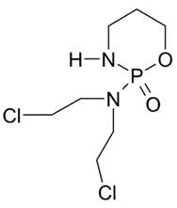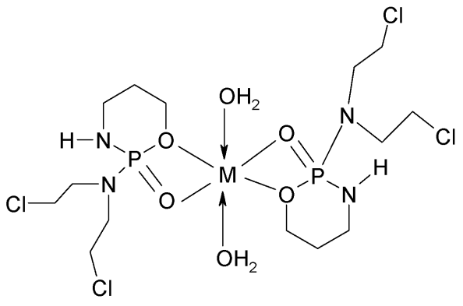
(A) (B)
Fig.1 (A) Structure of Cyclophosphamide, (B) Cyclophosphamide Complex metal M = Zn, Co, Ni, Fe
3.2 Infrared (IR) Spectral Analysis
Chemical structure of Cyclophosphamide is shown in (Fig.1). In the IR of Cyclophosphamide, a strong peak appears at 2800cm-1 due to stretching of –NH group (17). A medium band is obtained at 1480cm-1 due to the CH2-CH2 group. A strong peak is obtained at 1275cm-1 due to the P=O group (27). A medium peak appeared at 1200 cm-1 because of C-O group (28). A peak is also obtained at 1100cm 1-1due to C-N stretching vibration. A strong peak is also observed at 850cm due to CH2-Cl group. The Zn (II) Cyclophosphamide IR spectra is depicted in (Fig. 1) and bands at (Table 1). When comparing the IR spectra of Zn (II) Cyclophosphamide and Cyclophosphamide, the strong peak at 1275cm-1 because of P =O is shifted to 1285cm-1 and a band appears at 1200 cm-1 because off C-O group in pure drug is shifted to 1215cm-1. The C-O group vibration 1200cm-1 further reconfirms the involvement of P=O groups in the complexation to 1215cm-1 due to complexation. Thus, a probable structure to 1:2 Zn(II) of Cyclophosphamide complex may be given in based on polarographic data, Amperometric study, analytical data, and IR studies.
Table 1: Cyclophosphamide and its Zn (II) complex: The main IR signals (cm-1) and their assignment

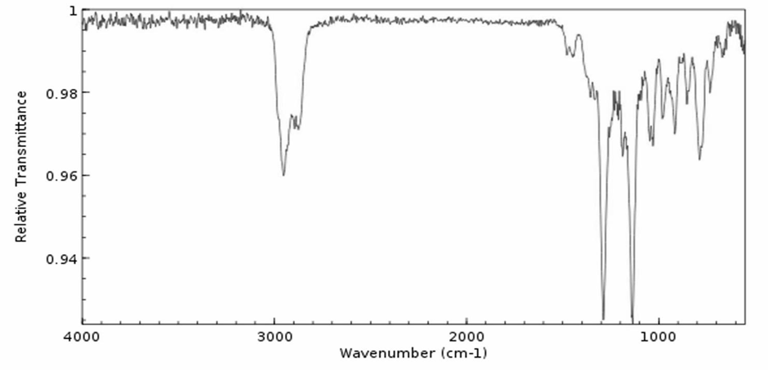
Fig. 2: IR spectrum of Zn(II) Cyclophosphamide complex
3.3 Antimicrobial Activity
The antimicrobial activity of Zn(II) cyclophosphamide against different pathogenic bacteria. Zn(II) with cyclophosphamide shows variable inhibition power against test pathogens. In case of Klebsiella pneumonia, the complex shows 15 mm inhibition activity and percentage change -50%, in S. aureus 13 mm inhibitory zone and 44.4% change over control drug is recorded and 18 mm inhibitory zone for B. subtilis and percentage of inhibition found to be -28.5%. Zn(II) cyclophosphamide complex is not effective against E. coli. On the above basis, it can be inferred that the prepared Zn(II) complex is more efficient than the parent drug in terms of antibacterial action against the bacteria under investigation.
Table 2: Antimicrobial study on Zn(II) Cyclophosphamide complex
* = including diameter of the filter paper disc (6 mm)
Fig. 3: Antimicrobial study on Zn(II) Cyclophosphamide complex

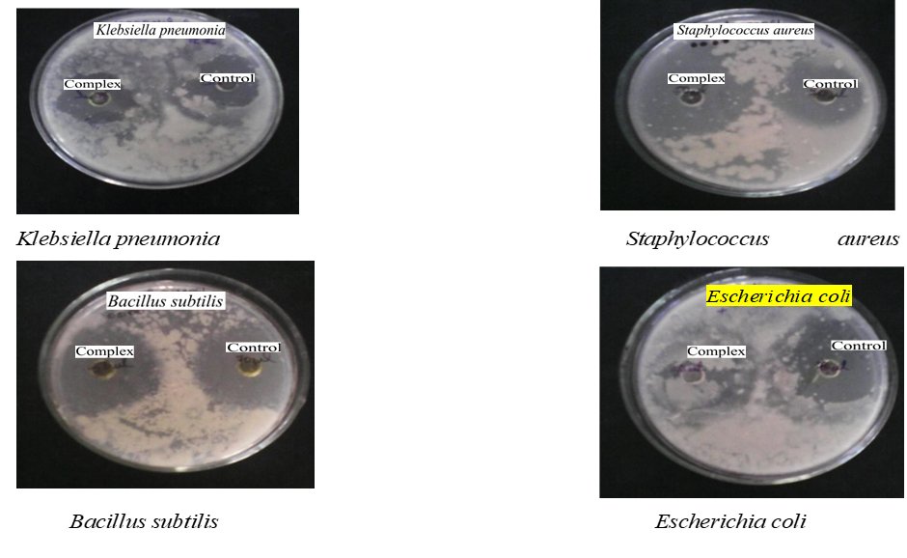
Fig 4: Antimicrobial study on Zn(II) Cyclophosphamide complex

4. Conclusion
The present study successfully investigated the complex formation between Cyclophosphamide and Zn(II) metal ion using polarographic, spectroscopic, and antimicrobial studies. The polarographic analysis clearly indicated that the half-wave potential (E1/2) of Zn(II) shifted towards a more negative value with increasing concentration of Cyclophosphamide. This shift, accompanied by a decrease in diffusion current, confirmed the formation of a complex between Zn(II) and Cyclophosphamide. Application of Lingane’s treatment to the polarographic data produced a linear relationship between ΔE1/2 and log CX, which indicated the formation of a 1:2 metal–ligand complex (Zn(II): Cyclophosphamide). The calculated stability constant (β₂ = 6.10) suggested that the complex formed is moderately stable. Infrared spectral studies further supported the formation of the Zn(II)–Cyclophosphamide complex. In the IR spectrum of the free drug, characteristic peaks corresponding to functional groups such as –NH stretching (2800 cm⁻¹), CH₂–CH₂ stretching (1480 cm⁻¹), P=O stretching (1275 cm⁻¹), C–O stretching (1200 cm⁻¹), C–N stretching (1100 cm⁻¹), P–O stretching (909 cm⁻¹), and CH₂–Cl vibration (850 cm⁻¹) were observed. Upon complex formation, noticeable shifts occurred in some of these peaks. The P=O stretching band shifted from 1275 cm⁻¹ to 1285 cm⁻¹, and the C–O stretching band shifted from 1200 cm⁻¹ to 1215 cm⁻¹ in the Zn(II) complex. These spectral changes strongly suggest the involvement of the P=O functional group in coordination with the Zn(II) ion, confirming complex formation. Based on polarographic, amperometric, analytical, and IR spectral data, a probable structure for the 1:2 Zn(II)–Cyclophosphamide complex has been proposed. The antimicrobial activity of the synthesized Zn(II) Cyclophosphamide complex was evaluated against selected pathogenic bacteria, including Klebsiella pneumoniae, Staphylococcus aureus, Bacillus subtilis, and Escherichia coli. The results demonstrated that the Zn(II) complex exhibited varying degrees of antibacterial activity. The complex showed an inhibition zone of 15 mm against Klebsiella pneumoniae, 13 mm against Staphylococcus aureus, and 18 mm against Bacillus subtilis, indicating significant antibacterial effectiveness compared with the control drug. However, the complex did not show any inhibitory activity against Escherichia coli. Overall, the results suggest that complexation of Cyclophosphamide with Zn(II) enhances its antibacterial activity against certain pathogenic bacteria. The improved biological activity may be attributed to the increased lipophilicity of the metal complex, which facilitates better penetration of the complex into microbial cell membranes. Therefore, the synthesized Zn(II) Cyclophosphamide complex may have potential applications in the development of more effective antimicrobial agents.

Consent (where ever applicable)
Not applicable

Ethical approval (where ever applicable)

Not applicable

References

Abdelrahman, S. E. S. A. H., El Hawary, S., Mohsen, E., El Raey, M. A., Selim, H. M. R. M., Hamdan, A. M. E., Ghareeb, M. A., & Hamed, A. A. (2024). Bio-fabricated zinc oxide nanoparticles mediated by endophytic fungus Aspergillus sp. SA17 with antimicrobial and anticancer activities: In vitro supported by in silico studies. Frontiers in Microbiology, 15, Article 1366614. https://doi.org/10.3389/fmicb.2024.1366614
Alkhatib, F. M., & Alsulami, H. M. (2023). Synthesis, characterization, DFT calculations and biological activity of new Schiff base complexes. Heliyon, 9(9), e18988. https://doi.org/10.1016/j.heliyon.2023.e18988
Alexandratos, S. D., & Zhu, X. (2018). Through-bond communication between polymer-bound phosphinic acid ligands and trivalent metal ions probed with FTIR spectroscopy. Vibrational Spectroscopy, 95, 80–89. https://doi.org/10.1016/j.vibspec.2018.01.005
Al-Jumaili, M. H. A., Bakr, E. A., Huessien, M. A., Hamed, A. S., & Muhaidi, M. J. (2025). Development of heterocyclic-based anticancer agents: A comprehensive review. Heterocyclic Communications, 31(1), 20220179. https://doi.org/10.1515/hc-2022-0179
Ayza, M. A., Zewdie, K. A., Yigzaw, E. F., Ayele, S. G., Tesfaye, B. A., Tafere, G. G., & Abrha, M. G. (2022). Potential protective effects of antioxidants against cyclophosphamide-induced nephrotoxicity. International Journal of Nephrology, 2022, 1–12. https://doi.org/10.1155/2022/5096825
Basuli, F., & Mikata, Y. (2014). Medicinal applications of transition metal complexes. Springer.
Chohan, Z. H., & Supuran, C. T. (2005). Metal-based drugs: synthesis, characterization and antibacterial activity of Co(II), Cu(II), Ni(II) and Zn(II) complexes with triazole Schiff bases. Journal of Enzyme Inhibition and Medicinal Chemistry, 20(3), 303–307. https://doi.org/10.1080/147563604123313234
Camellia, N., et al. (2022). Synthesis, characterization, antibacterial and antioxidant studies of isoniazid-based Schiff base ligands and their Ni(II) complexes. Journal of Coordination Chemistry, 75(8), 1384–1402. https://doi.org/10.1080/00958972.2022.361371908
Chaudhary, A., et al. (2015). Synthesis, characterization and antimicrobial activity of Ni(II) chelates with Schiff base ligands. International Journal of Polymeric Materials and Polymeric Biomaterials, 64(14), 128–138. https://doi.org/10.1155/2015/136285
Gamal-Eldeen, A. M., Agwa, H. S., Zahran, M. A.-H., Raafat, B. M., El-Daly, S. M., Banjer, J. J., Almehmadi, M. M., Alharthi, A., Hawsawi, N. M., Althobaiti, F., & Abo-Zeid, M. A. M. (2022). Phthalimide analogs enhance genotoxicity of cyclophosphamide and inhibit its associated hypoxia. Frontiers in Chemistry, 10, Article 890675. https://doi.org/10.3389/fchem.2022.890675
Hengst, J. C., & Kempf, R. A. (1984). Immunomodulation by cyclophosphamide. Clinics in Immunology and Allergy, 4(2), 199–216.
Jain, S., Joshi, A., & Maurya, D. (2025). Examination of physicochemical, microbial, pharmacological and IR studies of Ni(II) lomustine complex. Asian Journal of Microbiology, Biotechnology and Environmental Sciences, 10(2), 263–272.
Jungwirth, U., Kowol, C. R., Keppler, B. K., Hartinger, C. G., Berger, W., & Heffeter, P. (2011). Anticancer activity of metal complexes: Involvement of redox processes. Antioxidants & Redox Signaling, 15(4), 1085–1127. https://doi.org/10.1089/ars.2010.3663
Kim, W. K., An, J. M., Lim, Y. J., Kim, K., Kim, Y. H., & Kim, D. (2025). Recent advances in metallodrug: Coordination-induced synergy between clinically approved drugs and metal ions. Materials Today Advances, 25, 100569.
Kramer, W. W., Cameron, L. A., Zarkesh, R. A., Ziller, J. W., & Heyduk, A. F. (2014). Donor–acceptor ligand-to-ligand charge-transfer coordination complexes of nickel(II). Inorganic Chemistry, 53(16), 8825–8837. https://doi.org/10.1021/ic501008p
Kumar, M., Singh, A. K., Singh, V. K., Yadav, R. K., Singh, A. P., & Singh, S. (2024). Recent developments in the biological activities of 3d-metal complexes with salicylaldehyde-based N, O-donor Schiff base ligands. Coordination Chemistry Reviews, 505, 215663. https://doi.org/10.1016/j.ccr.2024.215663
Karthikeyan, B., George, D. J., Manikandan, G., & Thomas, T. (2020). A comparative study on k-means clustering and agglomerative hierarchical clustering. International Journal of Emerging Trends in Engineering Research, 8(5).
Moore, M. J. (1991). Clinical pharmacokinetics of cyclophosphamide. Clinical Pharmacokinetics, 20(3), 194–208. https://doi.org/10.2165/00003088-199120030-00002
Morad, Y., Banin, E., Averbukh, E., Berenshtein, E., Obolensky, A., & Chevion, M. (2005). Treatment of ocular tissues exposed to nitrogen mustard: Beneficial effect of zinc desferrioxamine combined with steroids. Investigative Ophthalmology & Visual Science, 46(5), 1640. https://doi.org/10.1167/iovs.04-1165
Moreira, J. M., Campos, G. F., de Campos Pinto, L. M., Martins, G. R., Tirloni, B., Schwalm, C. S., & de Carvalho, C. T. (2022). Copper(II) complexes with novel Schiff-based ligands: Synthesis, crystal structure, thermal (TGA–DSC/FT-IR), spectroscopic (FT-IR, UV–Vis) and theoretical studies. Journal of Thermal Analysis and Calorimetry, 147(6), 4087–4098. https://doi.org/10.1007/s10973-021-11049-6
More, G., et al. (2017). Synthesis, spectroscopic, and biological activity studies of the Ni(II) complexes of tridentate Schiff bases. Rasayan Journal of Chemistry, 10(4), 1511-1520.
Muchuweni, E., Martincigh, B. S., & Nyamori, V. O. (2020). Recent advances in graphene-based materials for dye-sensitized solar cell fabrication. RSC Advances, 10(72), 44453–44469. https://doi.org/10.1039/D0RA08851J
Nakamoto, K. (1983). Infrared spectra of inorganic and coordination compounds. Wiley.
National Center for Biotechnology Information. (2025). Lomustine. PubChem. https://pubchem.ncbi.nlm.nih.gov/compound/Lomustine
Prasad, S., DuBourdieu, D., Srivastava, A., Kumar, P., & Lall, R. (2021). Metal–curcumin complexes in therapeutics: An approach to enhance pharmacological effects of curcumin. International Journal of Molecular Sciences, 22(13), 7094. https://doi.org/10.3390/ijms22137094
Prabhakara, M. C., Basavaraju, B., & Naik, H. S. B. (2007). Co(III) and Ni(II) complexes containing bioactive ligands: Synthesis, DNA binding, and photocleavage studies. Bioinorganic Chemistry and Applications, 2007, 1-7. https://doi.org/10.1155/2007/36497
Rajput, S. K., & Singh, S. (2025). The influence of alkylating agent on environment: Cyclophosphamide. In S. Singh (Ed.), Hazardous chemicals (pp. 629–643). Academic Press. https://doi.org/10.1016/B978-0-323-99876-7.00027-5
Reddy, G. N., Losetty, V., Reddy, K. R., Yadav, C. H., & Sampath, S. (2023). Synthesis, spectroscopic characterization, physicochemical properties, biological activity and docking study of Cu(II) and La(III) metal complexes with a Schiff base ligand. Polyhedron, 244, 116615. https://doi.org/10.1016/j.poly.2023.116615
Sen, S., Won, M., Levine, M. S., Noh, Y., Sedgwick, A. C., Kim, J. S., Sessler, J. L., & Arambula, J. F. (2022). Metal-based anticancer agents as immunogenic cell death inducers: The past, present, and future. Chemical Society Reviews, 51(4), 1212–1233. https://doi.org/10.1039/d1cs00417d
Sonawane, H. R., Vibhute, B. T., Aghav, B. D., Deore, J. V., & Patil, S. K. (2023). Versatile applications of transition metal incorporating quinoline Schiff base metal complexes: An overview. European Journal of Medicinal Chemistry, 258, 115549. https://doi.org/10.1016/j.ejmech.2023.115549

