Strengthening Quality Assurance through a Web-Based Management Information System in Higher Education: A Waterfall Method

.
ABSTRACT

Aims: This study aims to develop a Quality Assurance Management Information System at the faculty level as a concrete effort to optimize the quality of higher education management.
Study design: The output of this research is a quality assurance information system
Place and Duration of Study: Faculty of Mathematics and Natural Sciences, Universitas Negeri Surabaya, From January 2024 to December 2024.
Methodology: The method used in developing a quality assurance management information system at the faculty level will use the Modified Waterfall Method. The steps taken in this method will return to the previous step to test whether the steps developed are in accordance with what was planned or expected.
Results: The output of this research is a quality assurance information system called BENJAMIN MAKSI (Electronic Basis for Accreditation Quality Assurance), which is designed to support the quality assurance and accreditation process in a systematic and sustainable manner.
Conclusion: This research successfully developed a web-based Quality Assurance Accreditation Management Information System at the Faculty of Mathematics and Natural Sciences, Surabaya State University. The developed system, BENJAMIN MAKSI (Electronic Quality Assurance Accreditation Database), is designed to support the management of quantitative accreditation data and Program Performance Reports (PPR) in accordance with the national accreditation instruments. The development of this system provides a concrete solution to improve the effectiveness, efficiency, and integration of quality assurance management at the faculty level.

Keywords: Management Information System, Quality Assurances, Accreditation, Higher Education

1. INTRODUCTION

In an era of globalization and increasingly fierce competition in the world of education, quality assurance has become the key to the success of higher education institutions in maintaining their sustainability and competitiveness. Higher education, as a strategic pillar of national development, has a major responsibility to ensure the quality of education provided, because the quality of education is a determining factor in producing superior human resources who are able to compete at the global level ¹. Therefore, quality assurance in higher education is no longer optional, but rather a necessity to ensure that the learning process, academic governance, and faculty management run effectively, efficiently, and accountably. Faculties, as units integrated into the university structure, play a central role in managing and improving the quality of education provided to students on an ongoing basis ².
Along with the increasing complexity of quality demands, the existence of a Quality Assurance Management Information System (QAMIS) has become an urgent need at the faculty level ³. QAMIS acts as a strategic instrument to ensure the integration, efficiency, and effectiveness of quality assurance management. The use of information technology in quality assurance systems enables increased transparency, accountability, and work efficiency, while minimizing duplication of work through structured and integrated database management ⁴. In addition, the need for continuous recognition from national and international accreditation agencies requires a well-documented quality assurance system that is capable of adapting to changes in accreditation standards ⁵. However, the development of QAMIS at the faculty level faces various fundamental challenges that need to be examined systematically. These challenges include the level of information integration between aspects of quality assurance, the accuracy and timeliness of academic data, the level of user participation in utilizing the system, and the security of sensitive data. In addition, the effectiveness of the system in supporting quality improvement, the readiness of faculty organizations in managing change, and the suitability of the system with applicable accreditation standards are crucial issues that must be addressed through comprehensive and sustainable QAMIS development.
The development of QAMIS at the faculty level is positioned as a strategic solution to improve the effectiveness and efficiency of education quality management ⁶. The problem-solving approach begins with an in-depth analysis of the needs and objectives of the faculty through the involvement of all stakeholders, including lecturers, students, and educational staff. The active involvement of stakeholders is key to ensuring that the developed system is truly aligned with the real needs and expectations of users. An integrated system design is the main foundation in the development of QAMIS, connecting various aspects of quality assurance such as curriculum management, learning evaluation, human resource development, and the use of educational technology ⁷. The system is implemented in stages to minimize the risk of failure and allow for continuous evaluation and improvement. Online platform-based educational technology support is also utilized to ensure the accessibility and sustainability of the system. After implementation, continuous monitoring and evaluation are carried out to ensure the effectiveness of the system, accompanied by the development of user competencies through training and mentoring so that the full potential of the system can be optimally utilized ⁸.
The development of QAMIS currently shows a trend toward the use of increasingly complex and adaptive cutting-edge technologies. Modern QAMISs have integrated big data and analytics technologies to support data-driven decision making, enabling higher education institutions to identify patterns, trends, and opportunities for quality improvement more quickly and accurately. In addition, mobile-based accessibility has become an important element in increasing user participation and interaction in real time ⁹. The development of cloud-based QAMIS has also become state-of-the-art, enabling system scalability, data management efficiency, and ease of system updates without dependence on complex physical infrastructure ¹⁰. Another innovation lies in the integration of a performance-based evaluation system and user satisfaction measurement oriented towards continuous quality improvement. By adopting these latest approaches and technologies, QAMIS development not only functions as an administrative tool, but also as a strategic instrument in building a culture of quality, supporting continuous accreditation, and increasing the competitiveness of higher education.

2. methodology

The method used in developing a quality assurance management information system at the faculty level will use the Modified Waterfall Method, as shown in the following figure 1. The steps taken in this method will return to the previous step to test whether the steps developed are in accordance with what was planned or expected ¹¹.
REQUIREMENT ANALYSIS
SYSTEM DESIGN
WRITING PROGRAM CODE PROGRAMMING
SYSTEM TESTING
SYSTEM MAINTENANCE
Figure. 1 The Modified Waterfall Method
The Modified Waterfall process is divided into five stages, namely: 1) Requirements Analysis. At this stage, an analysis is conducted to determine the requirements of the system. This analysis can be carried out by conducting a literature study, direct interviews, or by using questionnaires, 2) System Design. The next stage is to design the system to be created. The system design includes ERD (Entity Relation Diagram) is a system design diagram that shows the relationships in the system database. ERD only covers the database tables in the system. CD (Context Diagram) is a system design diagram that shows the overall workflow of the system and the entities that work within it. DFD (Data Flow Diagram) is a development diagram from CD where this diagram explains the workflow of a system according to its respective entities. The difference compared to CD is that DFD explains the system workflow in more detail than CD, 3) Writing Program Code (Implementation). After that, the program code is written according to the results of the analysis and design that has been done previously. Program code writing can use supporting software such as Notepad++, DreamWeaver, Sublime Text, Lobster, Netbeans, Eclipse, and others, 4) System Testing. Then, the system is tested to see if it meets the requirements or not, and 5) System Implementation and Maintenance. Finally, the system is implemented and continuously maintained so that the system created can be managed better.

3. results and discussion

This research was conducted to develop a Quality Assurance Accreditation Management Information System at the Faculty of Mathematics and Natural Sciences, Universitas Negeri Surabaya. The main output of this research is a web-based information system called BENJAMIN MAKSI (Electronic Quality Assurance Accreditation Database), designed to manage quantitative accreditation data and Program Performance Reports in accordance with the accreditation instruments. This system was developed as a digital infrastructure to support the faculty's internal quality assurance and as a strategic tool to improve the readiness of study programs to face the national accreditation cycle in a more systematic and documented manner.
The system development was carried out by adopting the Modified Waterfall approach, which, up to this final reporting stage, has covered four main stages, namely requirements analysis, system design, program code writing, and system testing. At the requirements analysis stage, a comprehensive mapping of quality assurance activities at the faculty level was carried out, coordinated by the Quality Assurance Team. Based on the results of the analysis, it was agreed that the system would focus on national accreditation management. This decision was based on the consideration that national accreditation status is still a key performance indicator for study programs, an important reference for graduate users and scholarship providers, and because other quality assurance activities have been integrated into another quality system at the university level. In addition, an international accreditation system has not been developed due to the unavailability of standardized instrument templates. In this context, study programs at the faculty level are grouped into education and non-education study programs, each of which follows the accreditation institution schemes.
The system design stage was carried out by using the instruments from accreditation institution in Indonesia as the main reference in designing the system structure. The system design was developed using a database table-based Entity Relationship Diagram (ERD) approach, adapting the Excel template structure into a relational database schema. Each user category, such as the head of the study program, the Quality Assurance Unit, and the accreditation team or task force, was given access rights through a login mechanism to fill in, manage, and download accreditation data in accordance with their respective authorities.
The BENJAMIN MAKSI system was developed using the Laravel (PHP) framework and MySQL database, applying the Model–View–Controller (MVC) architecture to ensure system logic separation, ease of maintenance, and scalability for future system development. The final stage that has been carried out is system testing, which was conducted on the Surabaya State University web network. This test aims to ensure system stability, the accuracy and validity of the data entered, and user access security. The test results show that the system can function according to the specified requirements and is ready to be used as a tool to support quality assurance and accreditation at the faculty level.
The developed system is named BENJAMIN MAKSI and has been fully implemented in the internal domain. Figure 2 shows the system login page, which serves as the gateway for users with role-based authentication (administrator, head of department, Quality Assurance at Faculty level).
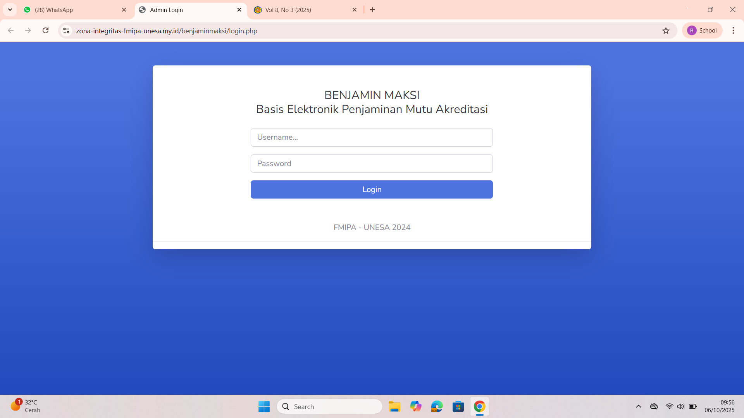
Fig. 2 Login Page
After logging in, users are directed to the main dashboard (Figure 3), which displays a summary of the amount of data stored in the system, namely Quantitative APS Undergraduate and LKPS Instrument data. By the final stage of the study, the system had collected 707 data entries. This dashboard also serves as a center for monitoring the progress of data entry per study program.
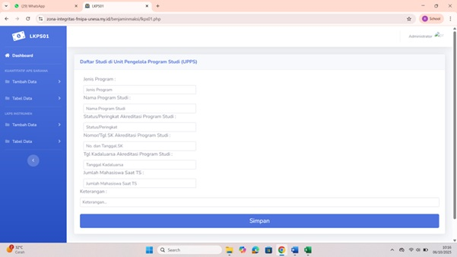
Fig 3. Dashboard Page
The main features of the system consist of the Add Data and Data Table menus (Figures 4 and 5), which allow users to manage accreditation data directly. Each entry includes the type of program, accreditation status, decree number, effective date, number of students, number of lecturers, and lecturer-student ratio. Form validation, search bar, and pagination features are provided to maintain accuracy and ease of navigation. In addition, Figure 5 shows the Study Program Management Unit Data Input page, which enables the management of aggregated data at the faculty level, such as accreditation status, decree validity period, and number of students. The cascading form mechanism ensures consistency between tables and maintains data referential integrity.
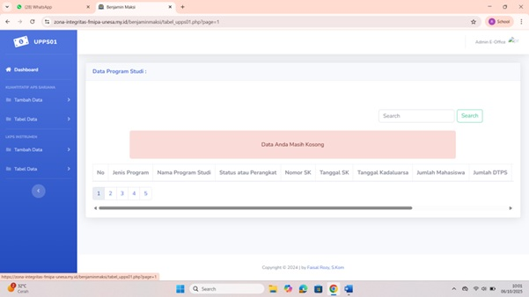
Fig 4. Add Data and Data Menu
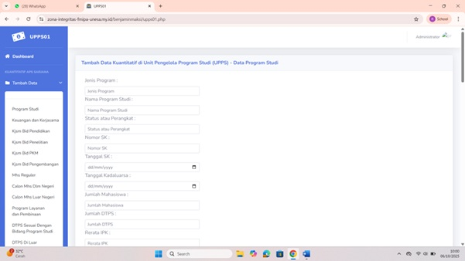
Fig 5. Data Entry Section
Functional testing was conducted using black-box testing on 41 test scenarios and showed a success rate of 97.6%. The system also generates automatic reports in Excel and PDF formats according to the instrument template. The auto-calculation feature calculates indicators such as the lecturer-student ratio, average GPA, and average study period without manual processes. For the user acceptance test, 30 respondents from eight study programs gave an average score of 4.68 (out of 5) for ease of use and 4.74 for reliability. The data input compilation process became 45% faster, and the data conformity rate between the system and manual reports reached 96.8%. These results are in line with the studies by Rahim et al. (2023) and Indrawati & Setiawan (2024), which confirm that the digitization of quality databases improves the efficiency and accuracy of reporting.
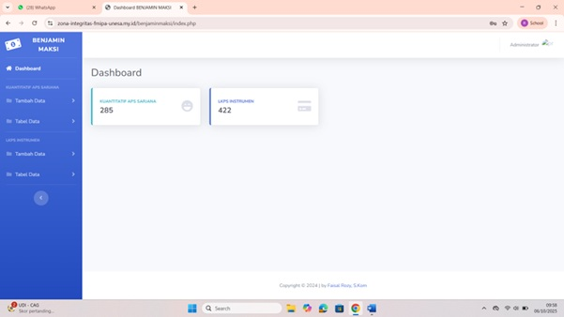
Fig 6. Data Summary
This research has completed all stages as planned. The BENJAMIN MAKSI system has been successfully developed, tested, and implemented as a digital accreditation database at FMIPA UNESA. This system improves time efficiency, data accuracy, and transparency in quality assurance. With this success, BENJAMIN MAKSI has become a best practice model for quality digitalization at FMIPA UNESA and has the potential to be replicated in other faculties to support the implementation of an integrated and sustainable QAMIS.

4. Conclusion

This research successfully developed a web-based Quality Assurance Accreditation Management Information System at the Faculty of Mathematics and Natural Sciences, Surabaya State University. The developed system, BENJAMIN MAKSI (Electronic Quality Assurance Accreditation Database), is designed to support the management of quantitative accreditation data and Program Performance Reports (PPR) in accordance with the national accreditation instruments. The development of this system provides a concrete solution to improve the effectiveness, efficiency, and integration of quality assurance management at the faculty level.
The application of the Modified Waterfall approach, which includes the stages of needs analysis, system design, program code writing, and system testing, has resulted in a system that meets user needs and faculty institutional conditions. This system is capable of facilitating the integration of accreditation data between study programs, improving the regularity of documentation, and minimizing repetitive work through the use of a centralized database. Testing results show that BENJAMIN MAKSI has good system stability, maintained data validity, and adequate access security mechanisms, making it ready for use as a digital infrastructure to support internal quality assurance and prepare for national accreditation on an ongoing basis.
Based on the results of the research that has been conducted, several suggestions can be made for the future development and utilization of the system. First, further evaluation is needed regarding the level of user acceptance and satisfaction through usability testing and user acceptance testing (UAT) so that the system can continue to be refined in accordance with user needs. Second, the development of advanced features, such as integration with the university's quality assurance system and support for international accreditation instruments, needs to be considered to expand the system's functions and sustainability. Third, ongoing training and mentoring for lecturers, educational staff, and the accreditation team need to be carried out to ensure optimal use of the system. Finally, further research can focus on measuring the impact of the system's use on improving the effectiveness of quality assurance and quantitative accreditation achievements of study programs.

Consent

Not applicable.

Ethical approval

Not applicable.

References

Sekuloska JD. Higher education and training as crucial pillars in creating the competitiveness of nation. Procedia-Social Behav Sci. 2014;156:241-246.
Ellis RA, Jarkey N, Mahony MJ, Peat M, Sheely S. Managing quality improvement of eLearning in a large, campus-based university. Qual Assur Educ. 2007;15(1):9-23.
Aldhobaib MA. Quality assurance struggle in higher education institutions: Moving towards an effective quality assurance management system. High Educ. 2024;88(4):1547-1566.
Ramos DLT. Quality Assurance Information System for State Universities and Colleges in the Philippines. In: World Conference on Information Systems for Business Management. ; 2025:115-126.
Chasokela D, Manokore K. Best Practices for Institutions in Conducting Self-Assessment for Accreditation. In: Academic Accreditation and Evaluation in Higher Education: Practices, Experiences, and Quality Assurance. IGI Global Scientific Publishing; 2025:89-120.
Iqbal S, Taib CA Bin, Allumi NA, Abbas M. Quality-driven education: Analyzing the effects of ISO 9001 quality management principles on university performance. J Cult Anal Soc Chang. Published online 2025:1146-1159.
Al-Sharhan S, Al-Hunaiyyan A. Towards an effective integrated e-learning system: Implementation, quality assurance and competency models. In: Seventh International Conference on Digital Information Management (ICDIM 2012). ; 2012:274-279.
Sholeh MI. Evaluation and monitoring of Islamic education learning management in efforts to improve education quality. Communaut J Community Serv. 2023;2(2):108-117.
Ryan T. Quality assurance in higher education: A review of literature. High Learn Res Commun. 2015;5(4):n4.
Ali Y, Manzoor T, Yang H, Ali A, Xia Y. Towards Efficient and Secure Cloud Control Systems: Advances, Challenges, and Future Directions. arXiv Prepr arXiv250909299. Published online 2025.
Andrei BA, Casu-Pop AC, Gheorghe SC, Boiangiu CA. A study on using waterfall and agile methods in software project management. J Inf Syst \& Oper Manag. Published online 2019:125-135.

