Review Article

Dietary Safflower Oil and Cardiometabolic Health: From Molecular Pathways to Clinical Implications

.
ABSTRACT

Metabolic syndrome, characterized by central obesity, dyslipidemia, hypertension, and insulin resistance, continues to rise globally, presenting substantial health risks. Dietary interventions are increasingly investigated as complementary approaches for managing these metabolic disturbances, with safflower (Carthamus tinctorius L.) emerging as a promising candidate due to its rich content of polyunsaturated fatty acids, particularly linoleic acid, and bioactive flavonoids. This review systematically examines current evidence regarding the biochemical, physiological, and clinical impacts of safflower-derived oils and petal extracts on cardiometabolic health. Experimental studies demonstrate that linoleic acid-rich safflower oil can modulate lipid profiles, reduce circulating triglycerides and LDL cholesterol, and enhance hepatic lipid metabolism, while safflower petal extracts influence glucose homeostasis via the AKT/FoxO1 signaling pathway and exert anti-inflammatory effects through NF-κB and Nrf2 modulation. Additionally, emerging research highlights safflower’s interaction with the gut microbiota, promoting beneficial bacterial populations and regulating metabolite-mediated hepatic glucose production. Despite these benefits, variability in study outcomes is noted, influenced by differences in oil composition, dosage, intervention duration, and metabolic context. Comparisons with other lipid sources indicate that safflower oil provides metabolic advantages over saturated fats, yet omega-3-rich oils may offer superior anti-inflammatory and muscle-preserving effects. Overall, the integration of biochemical, animal, and human clinical data underscores the potential of safflower as a context-specific nutritional intervention for metabolic syndrome. Future research should focus on optimizing formulations, understanding gut-liver interactions, and evaluating long-term clinical efficacy to establish evidence-based dietary strategies that leverage safflower’s unique bioactive profile.

Keywords: Linoleic acid, Metabolic syndrome, Insulin sensitivity, Gut microbiota; ω6/ω3 ratio, Hepatic metabolism.

- INTRODUCTION

Obesity is widely recognized as a long-term, multifactorial condition marked by an abnormal or excessive build-up of body fat that poses serious health risks. Its prevalence continues to rise globally, and nearly 12% of the world’s population is classified as obese. National data from Brazil show a concerning pattern as well: more than half of the adult population (52.5%) weighs above the healthy range, and approximately 17.9% meets the criteria for obesity. Excessive accumulation of adipose tissue especially in the visceral region creates physiological disturbances that can initiate or aggravate metabolic syndrome. Metabolic syndrome is understood as a complex cluster of cardiometabolic abnormalities, strongly associated with central obesity and insulin resistance. Atherosclerosis represents the underlying pathological basis for most cardiovascular events associated with metabolic syndrome. It is defined by chronic, low-grade inflammation of the vascular wall and elevated levels of circulating inflammatory biomarkers such as C-reactive protein (CRP). In relation to dyslipidemia, the central objective in cardiovascular risk reduction is to lower LDL-cholesterol (LDL-c) concentrations. Additional therapeutic goals include maintaining lower triglyceride levels and improving HDL-cholesterol (HDL-c), the latter being considered a potentially protective factor against atherothrombotic processes.
Dietary strategies that emphasize long-term changes in eating patterns are frequently recommended to improve these parameters. Within this context, safflower oil (Carthamus tinctorius L.) has emerged as a nutritional approach for preventing or managing obesity. Extracted from a plant belonging to the Asteraceae family, safflower oil contains a high proportion of polyunsaturated fatty acids particularly linoleic acid (approximately 75%) along with monounsaturated fatty acids. This lipid composition encouraged researchers to examine its potential clinical value, and several studies have reported that safflower oil supplementation may improve lipid metabolism and exert antiatherogenic effects. Metabolic syndrome encompasses a range of metabolic disruptions involving impaired protein, carbohydrate, glucose, and lipid metabolism. It manifests as a constellation of risk factors that contribute to the development of type 2 diabetes and atherosclerotic cardiovascular disease (ASCVD). These factors include elevated blood pressure, hyperglycemia or diabetes, abnormal lipid levels, central obesity, and increased abdominal fat. Diagnosis typically requires at least three of the following: enlarged waist circumference (≥102 cm for men, ≥88 cm for women though cutoffs can vary by population), triglycerides ≥150 mg/dL or current therapy for hypertriglyceridemia, HDL-C <40 mg/dL for men or <50 mg/dL for women or therapy for low HDL, systolic pressure ≥130 mmHg or diastolic ≥85 mmHg, and fasting glucose ≥100 mg/dL or glucose-lowering treatment. Development of metabolic syndrome is shaped by multiple influences, including genetic predisposition, dietary behavior, stress levels, physical inactivity, age, and ethnic background. While some of these factors are inherent, others particularly diet and physical activity can be modified.
Traditionally, metabolic syndrome management has involved lifestyle interventions combined with pharmacological agents that target specific metabolic pathways. Commonly prescribed medications include beta-blockers, statins, fibrates, and glibenclamide. Despite their clinical utility, these drugs are associated with drawbacks such as high costs, side effects, limited tolerability, and lack of long-term efficacy for all patients. Moreover, they often function as monotherapies, addressing only a subset of metabolic abnormalities without providing a holistic solution. These limitations have intensified interest in complementary approaches with fewer adverse effects and broader metabolic benefits. Complementary and alternative medicine (CAM), used for centuries in many parts of the world, encompasses a wide range of therapeutic practices. Among these, natural products are especially valued due to their perceived safety and their historical use in traditional healthcare systems. Numerous medicinal plants and natural compounds have been identified as promising therapeutic candidates. Increasing evidence supports the idea that plant-derived bioactive molecules contribute to anti-inflammatory, antioxidant, and anti-obesity effects. Natural substances often provide multi-targeted actions and tend to be more accessible, affordable, and environmentally sustainable compared to synthetic pharmaceuticals. Given these advantages, researchers have increasingly explored natural products as potential interventions for metabolic syndrome. For instance, Jang et al. (2016) reported that certain herbal formulations reduced waist size, blood glucose, blood lipids, and blood pressure. Sabarathinam et al. (2022) emphasized that plant extracts contain bioactive compounds capable of modulating multiple biological pathways simultaneously. Similarly, Taghipour et al. (2019) found that plant-based natural therapies could improve hyperglycemia, dyslipidemia, insulin resistance, blood pressure, and body weight in individuals with obesity-related metabolic dysfunctions.
Metabolic syndrome is now widely viewed through the lens of developmental origins, highlighting how environmental factors across the life course influence its onset. With the growing popularity of CAM for managing chronic conditions, including metabolic disorders, a careful examination of current evidence is essential. Although some natural products have shown promise in improving metabolic parameters, the overall quality, consistency, and safety of the available evidence remain unclear. Questions persist regarding which natural products are most effective, through what mechanisms they act, and how they interact with standard therapies. A scoping review can help map the existing research landscape, identify gaps, and inform future investigations. Interest in safflower oil has expanded considerably as researchers seek dietary strategies to address the rising burden of metabolic syndrome worldwide. As global rates of obesity, diabetes, and cardiometabolic diseases continue to climb, understanding dietary fats and their effects on health has become increasingly important. Over time, studies have progressed from evaluating the impact of dietary fat composition on lipid and glucose metabolism to exploring molecular and endocrine mechanisms involving adipokines, inflammatory mediators, and metabolic signaling pathways. Safflower oil, rich in linoleic acid, has been investigated for its potential to modulate lipid levels, regulate glucose metabolism, influence inflammatory pathways, and interact with the gut microbiota.
However, the evidence is not entirely consistent. While several studies have reported that safflower oil or linoleic acid supplementation can improve lipid profiles and reduce adipose tissue, other investigations have noted possible adverse effects such as reduced glucose tolerance or heightened inflammatory responses. Additionally, the influence of safflower oil on gut microbiota composition, hepatic metabolism, and oxidative stress has not been fully characterized. Existing research includes a limited number of well-designed clinical trials, and findings from animal experiments are sometimes contradictory. A major point of debate involves the high omega-6 to omega-3 fatty acid ratio in safflower oil, which some hypothesize may influence inflammatory processes and metabolic health outcomes. These controversies have created uncertainty about safflower oil’s optimal use and its clinical relevance.
The theoretical foundation connecting safflower oil to metabolic improvements centers on key metabolic abnormalities that define metabolic syndrome namely dyslipidemia, insulin resistance, hypertension, and visceral obesity. Linoleic acid-rich oils such as safflower oil can influence these parameters via pathways involving peroxisome proliferator-activated receptors (PPARs), alterations in adiponectin levels, modulation of oxidative stress, and shifts in gut microbial populations. This conceptual framework provides a basis for systematically examining the physiological effects of safflower oil on metabolic syndrome. The primary objective of this systematic review is to critically evaluate the available literature on safflower oil and its impact on several metabolic syndrome-related parameters, including lipid metabolism, glucose control, blood pressure, inflammation, and gut microbiota composition. By addressing inconsistencies and highlighting mechanistic insights, the review aims to clarify safflower oil’s therapeutic potential and provide guidance for dietary recommendations. This work seeks to bridge knowledge gaps and contribute to evidence-based nutritional strategies for managing metabolic syndrome. To achieve this, a broad literature search was conducted, focusing on experimental animal studies, clinical research, and mechanistic analyses relevant to safflower oil and metabolic syndrome. Studies were selected based on their scientific rigor, relevance, and publication quality. The findings are organized into thematic sections to provide a coherent, integrated evaluation of safflower oil’s influence on metabolic, cardiovascular, hepatic, and inflammatory biomarkers, offering a comprehensive perspective on its role in the prevention and management of metabolic syndrome.

- Literature Search:
A structured literature search was undertaken to identify scientific evidence relevant to the metabolic and physiological effects of safflower oil and its major bioactive components. The search process combined multiple strategies to ensure broad coverage of both foundational studies and recent advances. To begin with, key concepts derived from the attached documents such as safflower oil composition, metabolic syndrome, lipid regulation, glucose homeostasis, inflammatory pathways, and gut microbiota interactions were transformed into search terms and Boolean strings. These terms guided systematic searches across major academic databases including PubMed, Scopus, Web of Science, and Google Scholar. The initial search produced a large pool of publications spanning clinical trials, animal experiments, mechanistic studies, and nutritional intervention research. According to the attached source, more than 150 articles were identified in early screening based on relevance to lipid metabolism, insulin signalling, adipokine modulation, hepatic function, and microbiota profiles in relation to safflower oil consumption. Titles and abstracts were screened to remove unrelated studies, duplicates, and papers that lacked primary data. Full-text assessment was then performed for approximately fifty highly relevant publications that provided detailed mechanistic, biochemical, or physiological outcomes. To strengthen the completeness of the evidence base, backward and forward citation tracing was performed, following references from selected articles and identifying newer studies that had cited them. This step captured several influential papers that were not retrieved in the initial database searches but were referenced within foundational studies on lipid oxidation, hepatic gene regulation, thermogenesis, and adipokine responses to safflower oil intake
To facilitate a coherent narrative synthesis, the selected studies were organized into thematic clusters based on their primary focus and reported outcomes. This grouping allowed a structured comparison of evidence across diverse research designs. The first cluster encompassed investigations detailing the compositional profile and biochemical properties of safflower oil, including variations in fatty acid content and associated metabolic implications. The second cluster comprised studies examining lipid-modulating effects, such as changes in triglycerides, cholesterol fractions, and hepatic lipid metabolism. A third cluster focused on glycaemic regulation and insulin-related outcomes, capturing data on glucose tolerance, insulin sensitivity, and metabolic control. The fourth cluster included research assessing inflammatory and oxidative stress responses, evaluating biomarkers such as cytokines, oxidative damage indicators, and antioxidant capacity. Finally, a fifth cluster incorporated emerging evidence on gut microbial interactions, summarizing studies exploring how safflower oil influences microbiota composition and gut-derived metabolic pathways. Together, these thematic categories enabled a comprehensive and integrated evaluation of safflower oil’s metabolic effects.
Evidence from animal models was analysed separately from human trials to allow clearer interpretation of mechanistic versus translational findings. The attached material also emphasized the heterogeneity in safflower oil formulations (high-linoleic vs. high-oleic), dietary background, intervention duration, and metabolic phenotype of participants, all of which were considered during data integration and comparison across studies. Overall, the literature search strategy combined systematic database searching with iterative refinement through citation mapping and thematic categorization. This process ensured that the review incorporated both classical metabolic studies and recent investigations exploring inflammation, hepatic regulation, and microbiome-linked mechanisms, providing a comprehensive evidence landscape for evaluating the metabolic impacts of safflower oil.
- PHYTOCHEMISTRY:
The bioactive constituents of safflower are predominantly concentrated in its tubular florets, which serve as the main reservoir of pharmacologically important metabolites. These floral parts contain a diverse range of compounds, including flavonoids, alkaloids, sterols, lignans, spermidine derivatives, alkyl diols, and complex polysaccharides. Apart from the flowers, safflower achenes are an abundant source of nutritionally valuable lipids, particularly unsaturated fatty acids such as oleic acid and linoleic acid. The seeds also contain appreciable levels of tocopherols, which, together with these unsaturated fatty acids, contribute to the regulation of metabolic disorders commonly referred to as the “three highs,” namely elevated blood pressure, blood glucose, and lipid levels. Additionally, these constituents are recognized for their protective role against oxidative stress, thereby supporting anti-aging effects.
  - Flavonoids:
Flavonoids and their glycosidic derivatives constitute the principal bioactive metabolites in safflower and have therefore attracted considerable attention in safflower-related research. Their importance stems from the strong correlation between these compounds and the therapeutic properties attributed to the plant. The major flavonoid constituents, commonly referred to as quinone chalcone carbohydrates, account for almost all of the characteristic yellow (safflower yellow, SY) and red (safflower red, SR) pigments present in safflower (Zhang J. et al., 2018). These quinone chalcone carbohydrates are mainly isolated in monomeric forms, although a small proportion occurs as dimeric or polymerized structures.
Beyond quinone chalcone carbohydrates, safflower also contains other classes of flavonoid metabolites, including flavonols and dihydroflavonoids, which are known to exert diverse biological effects. Among these, flavonol glycosides have been investigated most extensively. Several of these compounds exhibit structural or conformational similarities, and studies have shown that their antioxidant potential is closely influenced by the nature and position of glucose substitution within the molecule (Lee et al., 2002).

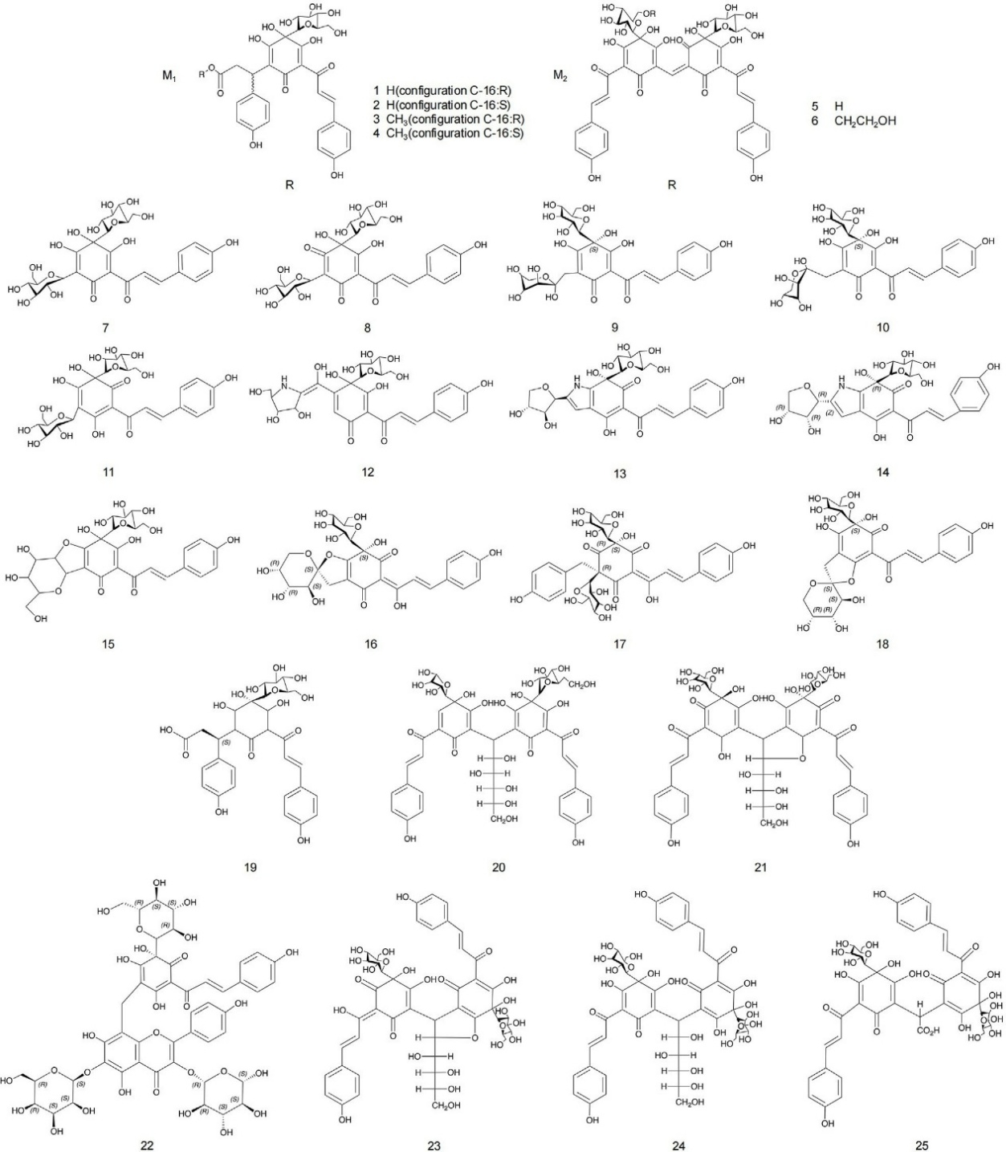

Figure-1: Chemical structures of quinone chalcone compounds and flavonoid glycosides identified in safflower

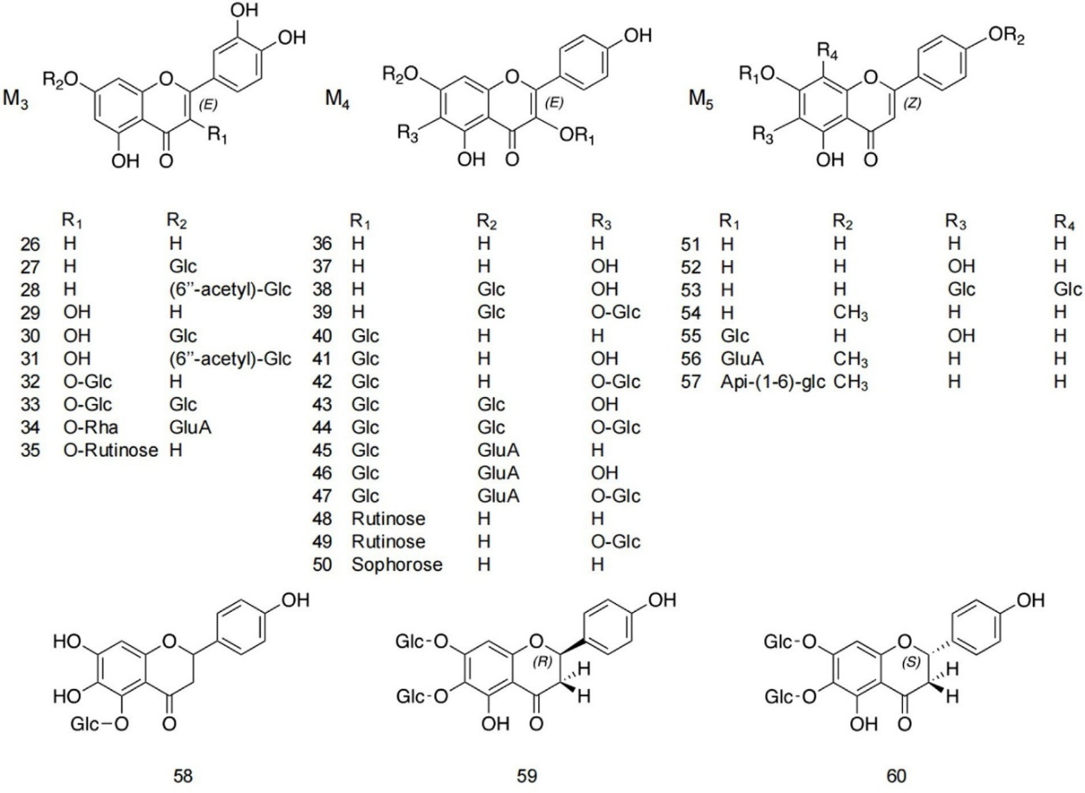

Figure-2: Chemical structures of additional flavonoid metabolites identified in safflower.

Table-1: Summary of flavonoid metabolites in safflower, including structural features and analytical characterization

S. No | Compound name | Structural class | Substituent features | Isolation solvent | Plant source | Characterization methods | Reference
1 | Safflomin C | M1 | R = H; C-16 (R) stereochemistry | Ethanol | Leaves | ¹H NMR, ESIMS | Cho et al., 2011
2 | Isosafflomin C | M1 | R = H; C-16 (S) stereochemistry | Ethanol | Leaves, fruits | ¹H NMR, ESIMS | Cho et al., 2011
3 | Methylsafflomin C | M1 | R = CH₃; C-16 (R) | Ethanol | Leaves, fruits | ¹H NMR, ESIMS | Zhao et al., 2009
4 | Methylisosafflomin C | M1 | R = CH₃; C-16 (S) | Ethanol | Leaves, fruits | ¹H NMR, ESIMS | Zhao et al., 2009
5 | Carthamin | M2 | R = H | Methanol | Leaves | ¹H NMR, ESIMS, HPLC | Sato et al., 2003
6 | Hydroxyethyl ether of carthamin | M2 | R = CH₂CH₂OH | Methanol | Leaves | ¹H NMR, ESIMS | Sato et al., 2003
7 | Hydroxysafflor yellow A | Quinone chalcone | — | Ethanol | Leaves | ¹H NMR, ESIMS | Sato et al., 2003
8 | Safflomin A | Quinone chalcone | — | Methanol | Leaves | ¹H NMR, ESIMS | Yue et al., 2014
9 | Hydroxysafflor yellow C | Quinone chalcone | — | Methanol | Leaves | ¹H NMR, ESIMS | Yue et al., 2014
10 | Hydroxysafflor yellow B | Quinone chalcone | — | Methanol | Leaves | ¹H NMR, ESIMS | Zhou et al., 2006
11 | Saffloquinoside D | Quinone chalcone | — | Acetone | Leaves | ¹H NMR, ESIMS | Zhou et al., 2006
12 | Tinctormine | Quinone derivative | — | Chloroform | Leaves | GC–MS | Meselhy et al., 1992
13 | Cartormine | Quinone derivative | — | Acetone | Leaves | GC–MS | Zhou et al., 2006
14 | Isocartormin | Quinone derivative | — | Acetone | Leaves | GC–MS | Li et al., 2010
15 | Safflor yellow A | Quinone chalcone | — | Chloroform | Leaves | GC–MS | Jiang et al., 2008
16 | Saffloquinoside A | Quinone chalcone | — | Ethyl acetate | Leaves | GC–MS | Jiang et al., 2008
17 | Saffloquinoside B | Quinone chalcone | — | Ethyl acetate | Leaves | ¹H NMR, ESIMS | Jiang et al., 2008
18 | Saffloquinoside C | Quinone chalcone | — | Ethyl acetate | Leaves | ¹H NMR, ESIMS | Jiang et al., 2013
19 | Saffloquinoside E | Quinone chalcone | — | Ethyl acetate | Leaves | ¹H NMR, ESIMS | Jiang et al., 2013
20 | Safflomin B | Quinone chalcone | — | Acetone | Aerial parts | ¹H NMR, ESIMS | Sato et al., 2005
21 | Carthorquinoside B | Quinone chalcone | — | Methanol | Leaves | HPLC | Yue et al., 2016
22 | Carthorquinoside A | Quinone chalcone | — | Methanol | Aerial parts | ¹H NMR, ESIMS | Yue et al., 2016
23 | Anhydrosafflor yellow B | Quinone chalcone | — | Methanol | Leaves | HPLC | Qu et al., 2016
24 | Safflor yellow B | Quinone chalcone | — | Ethanol | Leaves | HPLC | Yue et al., 2014
25 | Precarthamin | Quinone chalcone | — | Ethanol | Leaves | HPLC | Wang et al., 2006
26 | Luteolin | M3 | R₁ = H, R₂ = H | Ethanol | Aerial parts | HPLC | Lee et al., 2002
27 | Luteolin-7-O-β-D-glucoside | M3 | R₂ = Glc | Dichloromethane | Fruits | ¹D/²D NMR | Lee et al., 2002
28 | Luteolin-7-O-(6″-O-acetyl)-β-D-glucoside | M3 | Acetylated Glc | Dichloromethane | Fruits | ¹H NMR | Lee et al., 2002
29 | Quercetin | M3 | R₁ = OH | Methanol | Leaves | ¹H NMR | Lee et al., 2002
30 | Quercetin-7-O-β-D-glucoside | M3 | R₂ = Glc | Ethanol | Seeds | GC–MS | Hattori et al., 1992
31 | Quercetin-7-O-(6″-O-acetyl)-β-D-glucoside | M3 | Acetylated Glc | Ethanol | Seeds | ¹D/²D NMR | Lee et al., 2002
32 | Quercetin-3-O-β-D-glucoside | M3 | R₁ = O-Glc | Ethanol | Seeds | ¹D/²D NMR | Lee et al., 2002
33 | Quercetin-3,7-di-O-β-D-glucoside | M3 | Dual Glc substitution | Ethanol | Seeds | ¹D/²D NMR | Hattori et al., 1992
34 | Quercetin-3-O-α-L-rhamnoside-7-O-β-D-glucoside | M3 | Rha + Glc | Ethanol | Seeds | ¹D/²D NMR | Hu et al., 2013
35 | Quercetin-3-O-β-rutinoside | M3 | Rutinoside | Ethanol | Seeds | ¹H NMR, ESIMS | Tursun, 2022
36 | Kaempferol | M4 | Unsubstituted | Ethanol | Leaves | GC–MS | Lee et al., 2002
37 | 6-Hydroxykaempferol | M4 | 6-OH | Ethanol | Leaves | ¹H NMR, HREIMS | Hattori et al., 1992
38 | 6-Hydroxykaempferol-7-O-β-D-glucoside | M4 | Glc at C-7 | Acetone | Aerial parts | ¹D/²D NMR | Li et al., 2017
39 | 6-Hydroxykaempferol-6,7-di-O-β-D-glucoside | M4 | Dual Glc | Acetone | Aerial parts | ¹H NMR, ESIMS | Li et al., 2017
40 | Kaempferol-3-O-β-D-glucoside | M4 | Glc at C-3 | Acetone | Roots | ¹H NMR, ESIMS | Liu et al., 2018
41 | 6-Hydroxykaempferol-3-O-β-D-glucoside | M4 | Glc + OH | Acetone | Roots | ¹H NMR, ESIMS | Li et al., 2017
42 | 6-Hydroxykaempferol-3,6-di-O-β-D-glucoside | M4 | Di-Glc | Acetone | Roots | ¹H NMR, ESIMS | Hattori et al., 1992
43 | 6-Hydroxykaempferol-3,7-di-O-β-D-glucoside | M4 | Di-Glc | Acetone | Roots | ¹H NMR, ESIMS | Hattori et al., 1992
44 | 6-Hydroxykaempferol-3,6,7-tri-O-β-D-glucoside | M4 | Tri-Glc | Acetone | Roots | ¹H NMR, ESIMS | Hattori et al., 1992
45 | Kaempferol-3-O-β-D-glucoside-7-O-β-D-glucoside | M4 | Di-Glc | Methanol | Roots | ¹H NMR, ESIMS | Liu et al., 2018
46 | 6-Hydroxykaempferol-3-O-β-D-glucoside-7-O-β-D-glucoside | M4 | OH + Di-Glc | Methanol | Leaves | ¹H NMR, ESIMS | Xie et al., 2015
47 | 6-Hydroxykaempferol-3,6-di-O-β-D-glucoside-7-O-β-D-glucuronide | M4 | Glc + GluA | Methanol | Leaves | ¹H NMR, ESIMS | Liu et al., 2018
48 | Kaempferol-3-O-β-rutinoside | M4 | Rutinoside | Methanol | Leaves | ¹H NMR, ESIMS | Liu et al., 2018
49 | 6-Hydroxykaempferol-3-O-β-rutinoside-6-O-β-D-glucoside | M4 | Rutinoside + Glc | Methanol | Leaves | ¹H NMR, ESIMS | Liu et al., 2018
50 | Kaempferol-3-O-β-sophoroside | M4 | Sophorose | Methanol | Seeds | ¹H NMR, ESIMS | Sato et al., 2005
51 | Apigenin | M5 | Unsubstituted | Ethanol | Seeds | GC–MS | Hattori et al., 1992
52 | 6-Hydroxyapigenin | M5 | 6-OH | Ethanol | Seeds | HPLC | Zhou et al., 2006
53 | Apigenin-6,8-di-C-β-D-glucoside | M5 | C-glycosides | Ethanol | Roots | ¹D/²D NMR | Lee et al., 2002
54 | Acacetin | M5 | Methoxy group | Ethanol | Fruits | HPLC | Hattori et al., 1992
55 | Baicalin | M5 | Glucuronide | Ethanol | Leaves | GC–MS | Hattori et al., 1992
56 | Acacetin-7-O-β-D-glucuronide | M5 | GluA | Dichloromethane | Leaves | GC–MS | Lee et al., 2002
57 | 5,7-Dihydroxy-4′-methoxyflavone-7-O-apiosyl-(1→6)-glucoside | M5 | Api-Glc | Dichloromethane | Seeds | ¹D/²D NMR | Ahmed et al., 2000
58 | Neocarthamin | Flavanone | Glucoside | Chloroform | Seeds | ¹H NMR, HREIMS | Zhou et al., 2006
59 | (2R)-4′,5-Dihydroxy-6,7-di-O-β-D-glucosylflavanone | Flavanone | Di-Glc | Chloroform | Seeds | ¹H NMR, HREIMS | Zhou et al., 2006
60 | (2S)-4′,5-Dihydroxy-6,7-di-O-β-D-glucosylflavanone | Flavanone | Di-Glc | Chloroform | Seeds | ¹D/²D NMR, HREIMS | Jiang et al., 2013

  - Polyalkynes:
Polyalkyne metabolites identified in safflower are most commonly derived from carbon chains containing ten or thirteen atoms. In their native state, most polyyne compounds occur as non-glycosylated forms that appear oily, tend to clump upon exposure to air, and show a high degree of instability. The attachment of sugar moieties markedly alters these properties, converting the compounds into a solid, powder-like form and significantly improving their chemical stability (Li et al., 2017). Within the plant, these metabolites are predominantly distributed in the stems, roots, flowers, and immature seeds, particularly in tissues affected by Epidermophyton infection (Zheng et al., 2019).
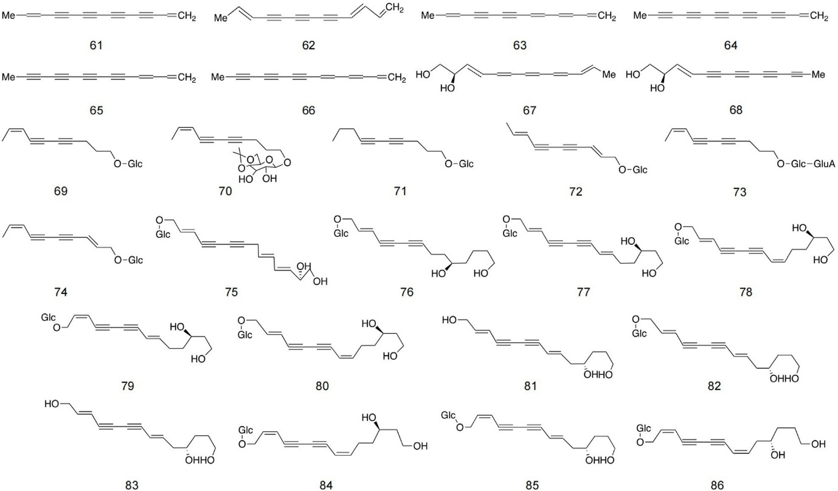
Figure-3: Structural features of polyalkyne metabolites found in safflower.

Table-2: Detailed information about polyalkyne metabolites in safﬂower

S. No | Compound name | Extraction solvent | Plant part | Structural elucidation techniques | Reference
61 | 1,11-Tridecadiene-3,5,7,9-tetrayne | Acetone | Root | 1D NMR, ESIMS | Zheng et al., 2019
62 | 1,3,11-Tridecatriene-5,7,9-triyne | Acetone | Root | 1D NMR, ESIMS | Zheng et al., 2019
63 | 1,3,5,11-Tridecatetracene-7,9-diyne | Acetone | Root | 1D NMR, ESIMS | Zheng et al., 2019
64 | 1-Tridecene-3,5,7,9,11-pentayne | Acetone | Root | 1D & 2D NMR, HREIMS | Zheng et al., 2019
65 | 1,3-Tridecadiene-5,7,9,11-tetrayne | Acetone | Root | 1D & 2D NMR, HREIMS | Zheng et al., 2019
66 | 1,3,5-Tridecatriene-7,9,11-triyne | Acetone | Root | 1D & 2D NMR, HREIMS | Zheng et al., 2019
67 | trans-3-Triene-5,7,9,11-tetraacetyl-1,2-diol | Hexane | Aerial parts | 1D NMR, ESIMS | Yue et al., 2014
68 | trans,trans-3,11-Triene-5,7,9-triacetyl-1,2-diol | Hexane | Aerial parts | 1D NMR, ESIMS | Yue et al., 2014
69 | (8Z)-Decaene-4,6-diyne-1-O-β-D-glucopyranoside | Petroleum ether | Aerial parts | 1D NMR, ESIMS | Zhou et al., 2006
70 | 4′,6′-Acetonide-(8Z)-decaene-4,6-diyne-1-O-β-D-glucopyranoside | Hexane | Aerial parts | 1D NMR, ESIMS | Zhou et al., 2006
71 | 4,6-Decadiyne-1-O-β-D-glucopyranoside | Petroleum ether | Aerial parts | 1D NMR, ESIMS | Zhou et al., 2006
72 | (8E)-Decaene-4,6-diyne-1-O-β-D-glucopyranoside | Petroleum ether | Aerial parts | 1D NMR, ESIMS | Li et al., 2010
73 | (8Z)-Decaene-4,6-diyne-1-ol-1-O-β-D-glucuronyl-(1″→2′)-β-D-glucopyranoside | Petroleum ether | Aerial parts | 1D & 2D NMR, HREIMS | Li et al., 2010
74 | (2E,8Z)-Decadiene-4,6-diyne-1-ol-1-O-β-D-glucopyranoside | Petroleum ether | Seed | 1D & 2D NMR, HREIMS | Li et al., 2010
75 | (2E,8E,10E)-Tridecatriene-4,6-diyne-1,12,13-triol-1-O-β-D-glucopyranoside | Petroleum ether | Seed | 1D & 2D NMR, HREIMS | Li et al., 2010
76 | (2E)-Tetradecaene-4,6-diyne-1,10,14-triol-1-O-β-D-glucopyranoside | Petroleum ether | Seed | 1D & 2D NMR, HREIMS | Li et al., 2010
77 | (2E,8E)-Tetradecadiene-4,6-diyne-1,12,14-triol-1-O-β-D-glucopyranoside | Petroleum ether | Seed | 1D & 2D NMR, HREIMS | Li et al., 2010
78 | (2Z,8Z)-Tetradecadiene-4,6-diyne-1,12,14-triol-1-O-β-D-glucopyranoside | Petroleum ether | Seed | 1D & 2D NMR, HREIMS | Li et al., 2010
79 | (2Z,8E)-Tetradecadiene-4,6-diyne-1,12,14-triol-1-O-β-D-glucopyranoside | Petroleum ether | Seed | 1D & 2D NMR, HREIMS | Li et al., 2010
80 | (2E,8Z)-Tetradecadiene-4,6-diyne-1,12,14-triol-1-O-β-D-glucopyranoside | Petroleum ether | Seed | 1D & 2D NMR, HREIMS | Li et al., 2010
81 | (2E,8E)-Tetradecadiene-4,6-diyne-1,11,14-triol | Petroleum ether | Seed | 1D & 2D NMR, HREIMS | Li et al., 2010
82 | (2E,8E)-11S-Tetradecadiene-4,6-diyne-1,11,14-triol-1-O-β-D-glucopyranoside | Petroleum ether | Root | 1D NMR, ESIMS, HPLC | Hao et al., 2010
83 | (2E,8E)-11S-Tetradecadiene-4,6-diyne-1,11,14-triol | Petroleum ether | Root | 1D NMR, ESIMS, HPLC | Hao et al., 2010
84 | (2Z,8Z)-11S-Tetradecadiene-4,6-diyne-1,11,14-triol-1-O-β-D-glucopyranoside | Petroleum ether | Root | 1D NMR, ESIMS, HPLC | Hao et al., 2010
85 | (2Z,8E)-11S-Tetradecadiene-4,6-diyne-1,11,14-triol-1-O-β-D-glucopyranoside | Petroleum ether | Root | 1D NMR, ESIMS, HPLC | Hao et al., 2010
86 | (2E,8Z)-11S-Tetradecadiene-4,6-diyne-1,11,14-triol-1-O-β-D-glucopyranoside | Petroleum ether | Root | 1D NMR, ESIMS, HPLC | Hao et al., 2010

  - Alkaloids and spermidines:
Alkaloids identified in safflower are mainly derived from 5-hydroxytryptamine (5-HT) and are generally characterized by relatively low polarity. These compounds are most abundantly distributed in safflower seeds. Previous investigations have reported the isolation of 13 alkaloids from safflower oil and 11 alkaloids from dried safflower flowers, highlighting the chemical diversity of this plant across different matrices (Hao et al., 2010; Sakamura et al., 1980). In addition to 5-HT–related alkaloids, safflower also contains spermidine-based metabolites, which typically consist of spermidine molecules substituted with three coumaroyl groups. Using high-speed counter-current chromatography, researchers successfully purified five distinct spermidine derivatives from safflower (Jiang et al., 2014).
Further studies have focused on the extraction of total spermine from safflower processing residues. An optimized protocol involved performing three successive heating reflux extractions with absolute methanol at a solvent-to-material ratio of 35:1 (v/w), with each extraction maintained for 2 hours. Under these conditions, the combined yield of four spermine compounds from safflower residue reached 2.894 ± 0.011 mg/g, demonstrating the efficiency of the method (Zhao et al., 2014).

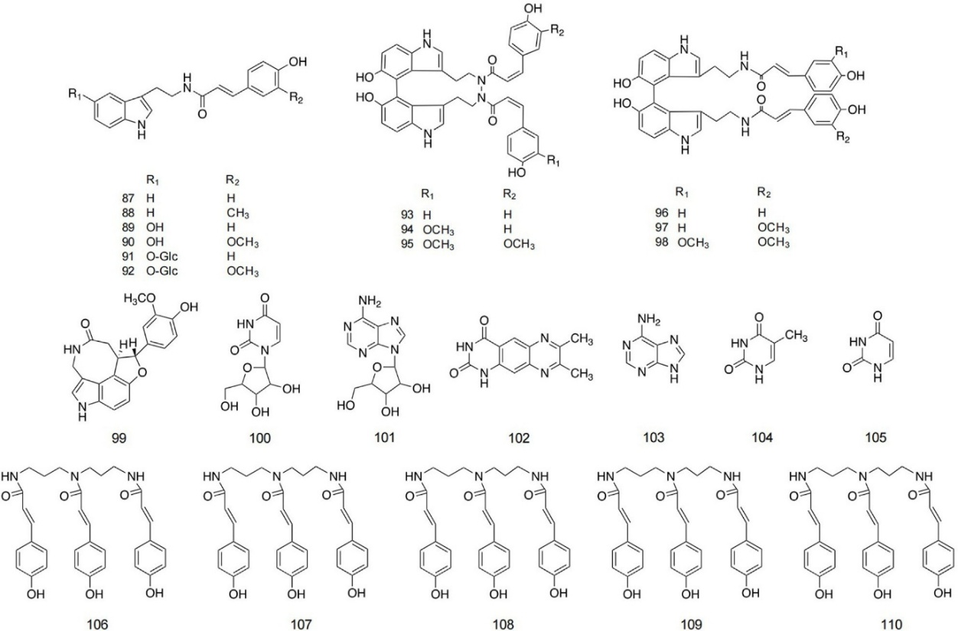

Figure-4: Structures of alkaloid and spermidine metabolites in safﬂower

Table-3: Alkaloids and Polyamine-Related Metabolites Reported from Carthamus tinctorius (Safflower)
S. No | Compound designation | Structural core | Key functional substitutions | Solvent employed | Plant material | Analytical characterization | Source
87 | N-(p-Coumaroyl) tryptamine | M6 | R₁ = H; R₂ = H | Chloroform | Seeds | ^1H NMR; ESI-MS | Hao et al., 2010
88 | N-Feruloyltryptamine | M6 | R₁ = H; R₂ = OCH₃ | Chloroform | Seeds | ^1H NMR; ESI-MS | Hao et al., 2010
89 | N-[2-(5-Hydroxy-1H-indol-3-yl)ethyl]-p-coumaramide | M6 | R₁ = OH; R₂ = H | Ethyl acetate | Seeds | ^1H NMR; ESI-MS | Hao et al., 2010
90 | N-[2-(5-Hydroxy-1H-indol-3-yl)ethyl]-ferulamide | M6 | R₁ = OH; R₂ = OCH₃ | Ethyl acetate | Seeds | ^1H NMR; ESI-MS | Hao et al., 2010
91 | N,N′-[2,2′-(5,5′-Dihydroxy-4,4′-bi-1H-indol-3,3′-yl)ethyl]-di-p-coumaramide | M6 | R₁ = O-Glc; R₂ = H | Ethyl acetate | Seeds | ^1H NMR; ESI-MS | Sakamura et al., 1980
92 | N-[2-[3′-[2-(p-Coumaramide)ethyl]-5,5′-dihydroxy-4,4′-bi-1H-indol-3-yl]ethyl] ferulamide | M6 | R₁ = O-Glc; R₂ = OCH₃ | Ethyl acetate | Seeds | ^1H NMR; ESI-MS | Zhang J. et al., 2018a
93 | N,N′-[2,2′-(5,5′-Dihydroxy-4,4′-bi-1H-indol-3,3′-yl)diethyl]-diferulamide | M7 | R₁ = H; R₂ = H | Ethyl acetate | Seeds | ^1H NMR; ESI-MS | Hu et al., 2013
94 | N-[2-[5-(β-D-Glucosyloxy)-1H-indol-3-yl]ethyl]-p-coumaramide | M7 | R₁ = OCH₃; R₂ = H | Ethyl acetate | Seeds | 1D & 2D NMR; HR-FAB-MS | Hu et al., 2013
95 | N-[2-[5-(β-D-Glucosyloxy)-1H-indol-3-yl]ethyl] ferulamide | M7 | R₁ = OCH₃; R₂ = OCH₃ | Ethyl acetate | Seeds | 1D & 2D NMR; HR-FAB-MS | Hu et al., 2013
96 | 4,4″-bis(N-p-Coumaroyl)serotonin | M8 | R₁ = H; R₂ = H | Petroleum ether | Seeds | 1D & 2D NMR; ESI-MS | Zhou et al., 2006
97 | 4-[N-(p-Coumaroyl)serotonin-4″-yl]-N-feruloylserotonin | M8 | R₁ = H; R₂ = OCH₃ | Petroleum ether | Seeds | 1D & 2D NMR; ESI-MS | Zhou et al., 2006
98 | 4,4″-bis(N-p-Feruloyl)serotonin | M8 | R₁ = OCH₃; R₂ = OCH₃ | Petroleum ether | Seeds | 1D & 2D NMR; ESI-MS | Zhou et al., 2006
99 | Serotobenine | — | — | Acetone | Seeds | GC-MS | Zhang J. et al., 2018a
100 | Uridine | — | — | Acetone | Aerial tissues | GC-MS | Zhou et al., 2006
101 | Adenosine | — | — | Acetone | Aerial tissues | GC-MS | Zhou et al., 2006
102 | 7,8-Dimethyl-pyrazino[2,3-g]quinazolin-2,4-dione | — | — | Acetone | Seeds | 1D & 2D NMR; ESI-MS | Zhou et al., 2006
103 | Adenine | — | — | Methanol | Seeds | GC-MS | Zhou et al., 2006
104 | Thymine | — | — | Methanol | Seeds | GC-MS | Zhou et al., 2006
105 | Uracil | — | — | Methanol | Seeds | GC-MS | Wu et al., 2012
106 | N¹,N⁵,N¹⁰-(Z)-tri-p-coumaroylspermidine | — | — | n-Butanol | Seeds | 1D & 2D NMR; ESI-MS | Jiang et al., 2014
107 | N¹,N⁵,N¹⁰-(E)-tri-p-coumaroylspermidine | — | — | n-Butanol | Seeds | 1D & 2D NMR; ESI-MS | Jiang et al., 2014
108 | Safflospermidine A | — | — | Ethyl acetate | Seeds | HPLC | Jiang et al., 2014
109 | Safflospermidine B | — | — | Ethyl acetate | Seeds | HPLC | Jiang et al., 2014
110 | N¹,N⁵-(Z),N¹⁰-(E)-tri-p-coumaroylspermidine | — | — | Chloroform | Seeds | 1D & 2D NMR; ESI-MS | Zhao et al., 2014

  - Lignans and sterols:
Only a limited number of lignan compounds have so far been reported from safflower. Among these, representatives such as the bis-tetrahydrofuran lignan syringaresinol and lirioresinol A have been identified, indicating that lignans constitute a relatively minor class of safflower phytochemicals (Peng et al., 2017). In a separate investigation, Zhou and co-workers characterized several steroidal constituents, including stigmasterol, campesterol, and pregnane derivatives. Their structural identification was achieved through a combination of infrared spectroscopy, nuclear magnetic resonance, and mass spectrometric techniques (Zhou et al., 2014).

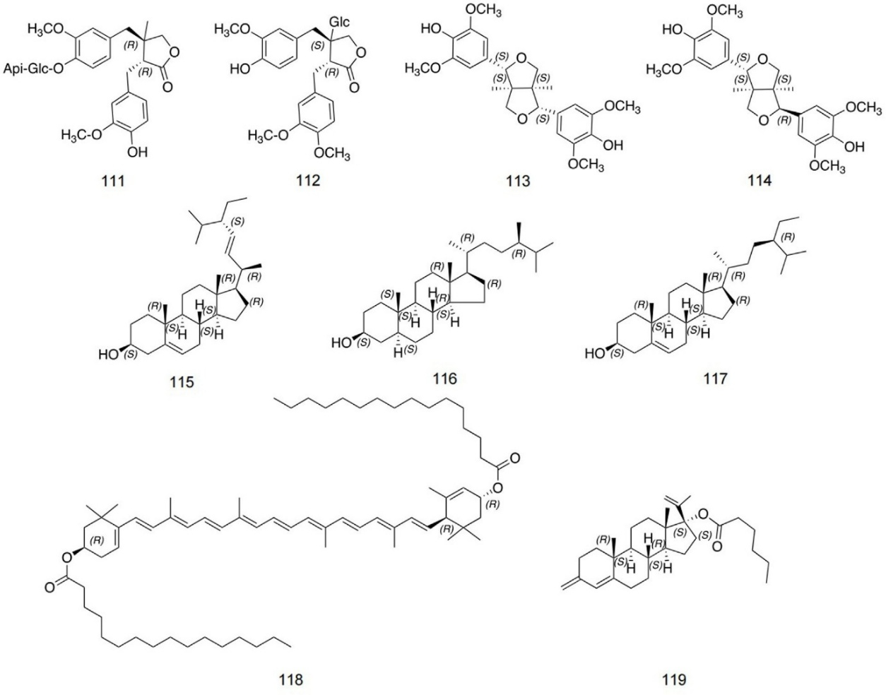

Figure-5: Structures of lignans and sterol metabolites in safﬂower.

Table-4: Detailed overview of lignan and sterol-derived metabolites identified in safflower

S. No | Compound name | Solvent used for extraction | Safflower part | Analytical techniques employed | Reference
111 | Dibenzylbutyrolactone | Ethanol | Seeds | 1D NMR spectroscopy; ESI-MS | Peng et al., 2017
112 | Matairesinol-4′-O-β-D-apiofuranosyl-(1→2)-O-β-D-glucopyranoside | Acetone | Seeds | 1D NMR spectroscopy; ESI-MS | Peng et al., 2017
113 | Double tetrahydrofuran syringaresinol | Acetone | Fruits | 1D NMR spectroscopy; ESI-MS | Peng et al., 2017
114 | Lirioresinol A | Acetone | Fruits | 1D and 2D NMR spectroscopy; ESI-MS | Peng et al., 2017
115 | Stigmasterol | Ethanol | Fruits | 1D and 2D NMR spectroscopy; ESI-MS | Zhou et al., 2014
116 | Campesterol | Ethanol | Seeds | 1D NMR spectroscopy; ESI-MS; HPLC | Zhou et al., 2014
117 | Sitosteryl-3-O-glucoside | Acetone | Seeds | 1D NMR spectroscopy; ESI-MS; HPLC | Zhou et al., 2014
118 | Daucosterol | Acetone | Aerial parts | 1D and 2D NMR spectroscopy; ESI-MS | Zhou et al., 2014
119 | Pregnane | Acetone | Seeds | 1D and 2D NMR spectroscopy; ESI-MS | Zhou et al., 2014

  - Other metabolites:
Zhou and co-workers (2008) reported the discovery of three previously uncharacterized aromatic glycosides along with three already known glycosidic compounds. Their study also highlighted that safflower seeds are particularly rich in lipid-based constituents, with linoleic acid and oleic acid representing the dominant fatty acids, while tocopherols constitute a major class of antioxidant components.

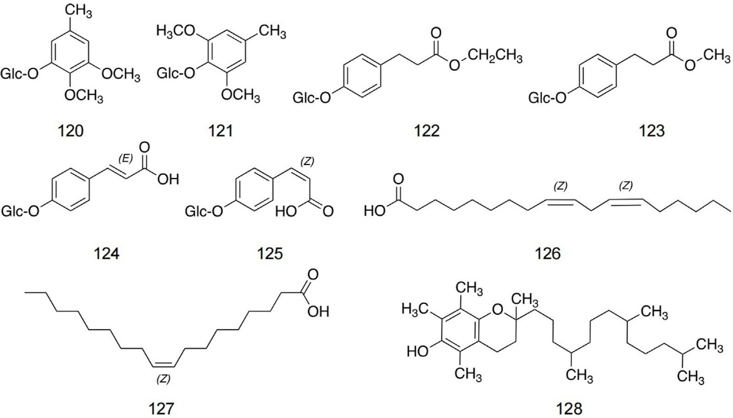

Figure-6: Chemical structures of additional metabolites identified in safflower

Table-5: Aromatic glycosides, fatty acids, and tocopherols isolated from safflower

S. No | Identified compound | Solvent employed for isolation | Plant material | Structural elucidation techniques | Source
120 | 2,3-Dimethoxy-5-methylphenyl-1-O-β-D-glucopyranoside | Ethyl acetate | Seeds | 1D and 2D NMR spectroscopy; ESI-MS | Zhou et al., 2008
121 | 2,6-Dimethoxy-4-methylphenyl-1-O-β-D-glucopyranoside | Ethyl acetate | Seeds | 1D and 2D NMR spectroscopy; ESI-MS | Zhou et al., 2008
122 | Ethyl-3-(4-O-β-D-glucopyranosyl-3-methoxyphenyl) propionate | Ethyl acetate | Seeds | 1D and 2D NMR spectroscopy; ESI-MS | Zhou et al., 2008
123 | Methyl-3-(4-O-β-D-glucopyranosyl-3-methoxyphenyl) propionate | Ethyl acetate | Seeds | 1D and 2D NMR spectroscopy; ESI-MS | Zhou et al., 2008
124 | Ethylsyringin | Chloroform | Leaves | 1D and 2D NMR spectroscopy; ESI-MS | Zhou et al., 2008
125 | Methylsyringin | Chloroform | Leaves | 1D and 2D NMR spectroscopy; ESI-MS | Zhou et al., 2008
126 | (9Z,12Z)-9,12-Octadecadienoic acid | Benzene | Seeds | 1D NMR spectroscopy; ESI-MS; HPLC | Zhou et al., 2008
127 | (Z)-9-Octadecenoic acid | Benzene | Seeds | 1D NMR spectroscopy; ESI-MS; HPLC | Zhou et al., 2008
128 | Tocopherol | Acetone | Seeds | 1D and 2D NMR spectroscopy; ESI-MS | Zhou et al., 2008

- Materials and methods:
  - Chemical Composition and Advanced Processing:
The functional value of safflower is closely tied to its diverse chemical constituents, and several studies have shown that targeted processing steps can further enhance its bioactive potential. In a recent investigation, Khan and colleagues (2024) optimized safflower oil through a controlled fractionation approach designed to enrich specific lipid components. In their procedure, crude safflower oil first underwent a slow cooling phase reaching −45°C over a 24-hour period, after which it was maintained at this temperature for an additional 16 hours. The chilled oil was then subjected to vacuum-assisted filtration (600 mmHg), yielding a clarified fraction referred to as single-fractionated olein (OF). Approximately 40% of this OF fraction was retained for chemical characterization, while the remaining portion underwent a second, more intensive fractionation cycle. During the second cycle, the sample was cooled to −70°C over 24 hours, held for another 16 hours, and filtered using the same vacuum assembly. This second filtrate was termed double-fractionated olein (DFO). To ensure reproducibility and minimize experimental variability, the entire fractionation workflow was repeated at least six times using a completely randomized design. Unrefined safflower oil served as the untreated control. All three preparations control, OF, and DFO were packaged in amber bottles and stored under ambient conditions (20–25 °C) for a 90-day stability study, with analyses conducted at the beginning of storage and at 45- and 90-day intervals to monitor compositional and oxidative changes.

Complementing lipid-based investigations, Ren et al. (2025) focused on the phytochemical spectrum of safflower petals and identified several biologically important secondary metabolites, particularly the chalcones hydroxysafflor yellow A (HSYA) and hydroxysafflor yellow B (HSYB), along with prominent flavonoids such as quercetin and kaempferol. These compounds are often considered central to the plant’s pharmacological activities. Similarly, Yin et al. (2024) described a standardized extraction workflow for obtaining aqueous bioactive fractions from safflower petals. Their study utilized petals harvested from cultivation fields in Xinjiang, China. After drying, the petals were ground into a fine powder, and 100 g of this material was mixed with 2 L of distilled water. The mixture was gently heated to 55 °C and kept at this temperature for 38 minutes to facilitate extraction. Following thermal treatment, the solution was filtered to remove plant residues, and the resulting extract was concentrated using a rotary evaporator. The concentrated material was stored at −20 °C until further analysis. This method ensured efficient recovery of water-soluble constituents, including phenolics and pigment-based bioactives.

  - Biochemical and Physiological Pathways:
The AKT/FoxO1 Axis in Gluconeogenesis: Recent findings by Yin and colleagues (2024) demonstrate that safflower extract (SE) plays a significant role in improving hyperglycemia by interfering with the hepatic gluconeogenic program. Their work shows that SE activates the Protein Kinase B (AKT) signaling pathway, a key metabolic regulator. Once activated, AKT phosphorylates the transcription factor FoxO1, a modification that prevents FoxO1 from remaining in the nucleus. As phosphorylated FoxO1 is exported out of the nucleus and subsequently destabilized, its ability to promote the transcription of major gluconeogenic enzymes phosphoenolpyruvate carboxykinase (Pepck) and glucose-6-phosphatase (G6pase) is markedly reduced.

This regulatory cascade ultimately suppresses hepatic glucose production, helping to lower circulating glucose levels. Yin et al. validated this mechanism across multiple experimental systems, including diet-induced hyperglycemic mouse models as well as hepatocyte cell lines such as HepG2 and AML12. Their observations across both in vivo and in vitro platforms strengthen the conclusion that SE directly modulates hepatic glucose output rather than exerting an indirect secondary metabolic effect. Furthermore, these results add to the growing body of evidence highlighting the importance of the AKT–FoxO1 axis as a central therapeutic target for dietary or phytochemical interventions aimed at reversing metabolic dysregulation.

Cardiolipin Remodeling in Mitochondria: Recent work by Zhu and colleagues (2024) highlights a previously underappreciated therapeutic avenue for managing Barth syndrome by leveraging dietary fatty acid composition. Barth syndrome arises from loss-of-function mutations in TAFAZZIN (TAZ), an enzyme responsible for remodeling cardiolipin, the signature phospholipid of the inner mitochondrial membrane. When TAZ is defective, cardiolipin fails to acquire its mature, linoleic-acid–rich acyl pattern, resulting in structurally unstable mitochondrial cristae and impaired cardiac performance. The study demonstrated that feeding TAZ-deficient models a diet enriched in high-linoleic safflower oil can partially compensate for the remodeling defect. The supplemental linoleic acid becomes directly incorporated into newly synthesized cardiolipin molecules, allowing the mitochondrial membrane to approximate the acyl composition normally achieved through TAZ-mediated remodeling. This substrate-driven enrichment helped stabilize mitochondrial ultrastructure, improved oxidative phosphorylation capacity, and alleviated the contractile dysfunction characteristic of Barth syndrome. In essence, providing excess dietary linoleic acid enabled a metabolic “work-around,” supporting cardiolipin maturation through mass action rather than enzymatic repair.

NF-κB and Nrf2 Signalling: Research by Ren et al. (2025) demonstrates that bioactive flavonoids derived from safflower possess a strong capacity to regulate cellular stress pathways. Their work shows that these compounds can suppress activation of the NF-κB cascade a key mediator of inflammatory responses which in turn limits the production of pro-inflammatory cytokines such as TNF-α, IL-1β, and IL-6. At the same time, safflower flavonoids promote the nuclear translocation and activation of Nrf2, a transcription factor that drives the expression of antioxidant enzymes including HO-1. This coordinated suppression of inflammatory signaling and enhancement of antioxidant defenses creates a protective biochemical environment within vulnerable tissues. Ren et al. reported that such dual modulation is particularly relevant in settings of ischemia–reperfusion injury, where oxidative stress rapidly accelerates neuronal and endothelial damage. By dampening inflammatory cytokine release while simultaneously boosting endogenous antioxidant capacity, safflower constituents help stabilize cellular homeostasis, prevent vascular dysfunction, and reduce overall injury severity.

- Technologies and Experimental Models Used:
The elucidation of safflower’s therapeutic potential has been driven by a convergence of advanced lipid engineering, genetic editing, and high-throughput omics technologies. Recent literature highlights a shift from traditional extraction methods toward precision fractionation and systems biology approaches.

Advanced Lipid Fractionation and Crystallization: To overcome the limitations of crude vegetable oils, recent protocols have employed dry crystallization to enhance the bioactivity of safflower oil. Khan et al. (2024) optimized a two-stage dry fractionation process, manipulating cooling curves to isolate specific triglyceride species based on their melting points. By sequentially cooling crude oil to -40oC and subsequently to -70oC, researchers successfully isolated a "double-fractionated olein" (DFO). This super-olein fraction is chemically distinct from its parent oil, boasting a linoleic acid (LA) concentration exceeding 89% a purity level rarely achieved without chemical interesterification. Furthermore, this physical separation technique preserves heat-sensitive bioactive compounds, resulting in significantly enriched phytosterol and phenolic profiles compared to standard solvent extraction methods.

Genetic Engineering in Murine Models: Advancements in murine genetic engineering have played a central role in clarifying how safflower-oil–derived lipids influence disorders characterized by mitochondrial dysfunction. Recent work by Zhu and colleagues (2024) illustrates this clearly through the use of refined Cre-LoxP based conditional gene-editing systems. Their study employed two complementary mouse models designed to interrogate the biological consequences of Tafazzin (TAZ) deficiency a hallmark of Barth syndrome and a classic example of a mitochondrial lipidopathy. The first model, a global TAZ knockout (gKO), provided a representation of the full systemic burden of the disease. These mice exhibited profound growth impairment, multisystem metabolic instability, and early lethality, effectively mirroring the human clinical phenotype. However, because systemic failure can obscure tissue-level interpretation, the authors additionally generated a cardiac-restricted TAZ knockout (cKO). By limiting gene deletion to cardiomyocytes, the researchers were able to examine cardiac mitochondrial abnormalities in isolation, free from secondary effects arising from whole-body metabolic collapse.

The combination of these models offered a powerful experimental framework. Importantly, when dietary lipids were manipulated particularly through supplementation with safflower-derived fatty acids both models showed evidence of structural recovery within mitochondria, including partial restoration of cristae organization and membrane integrity. While these improvements were temporary, they demonstrated that targeted nutritional modulation can directly influence mitochondrial architecture, even in the setting of genetically driven lipid remodeling defects. This dual-model approach therefore not only underscored the mechanistic importance of TAZ in mitochondrial maintenance but also highlighted the therapeutic potential of precision dietary interventions for lipid-related mitochondrial diseases.
Multi-Omics Integration: The increasing complexity of interactions between plant-derived compounds and host metabolic networks has made multi-omics approaches essential in recent research. Instead of relying on a single analytical platform, modern investigations combine complementary technologies to obtain a more holistic picture of how bioactives exert their effects. A representative example comes from the work of Yin and colleagues (2024), who paired 16S rRNA gene sequencing with an LC-ESI-MS/MS–based metabolomic workflow. This integrated design enabled them to observe changes in gut microbial communities most notably fluctuations in genera such as Akkermansia and Bacteroides while simultaneously tracking alterations in circulating metabolic signatures. The power of this approach lies in its ability to associate microbial composition with host biochemical responses. By aligning microbiome shifts with serum metabolite patterns, the study revealed a coordinated response to safflower petal water extracts. Specifically, the combined datasets indicated that modifications in microbial ecology were linked to downstream metabolic adjustments, including reduced activation of hepatic gluconeogenic routes. Such findings illustrate how multi-omics integration can highlight functional relationships that would be overlooked using isolated analytical methods, ultimately providing a more refined understanding of how botanical preparations influence systemic metabolism.

Retrospective Analysis of Human Clinical Trials: A growing body of evidence has attempted to clarify whether findings from animal models translate meaningfully into human physiology, and one notable effort comes from the work of Nilsson and colleagues (2024). Their investigation took a retrospective look at data drawn from several randomized clinical trials involving older adults with sarcopenic obesity. In these trials, safflower oil had been used as a neutral comparison arm, which created a rare opportunity to examine its physiological impact from the perspective of a “true control” rather than an active treatment.
By re-evaluating these datasets, the authors were able to explore how safflower oil performs when placed alongside interventions known to enhance anabolic responses, such as high-quality proteins and omega-3 fatty acids. This allowed them to characterize the boundaries of safflower oil’s effectiveness in promoting muscle tissue maintenance in a population already experiencing impaired muscle metabolism. Their analyses incorporated dual-energy X-ray absorptiometry for precise body-composition profiling, as well as strength and functional assessments that reflect real-world physical capacity.

Therdyothin et al. synthesized randomized trials to test whether omega‑3 polyunsaturated fatty acids (n‑3 PUFA) truly enhance anabolic processes in humans. Their meta‑analysis pooled eight clinical RCTs using gold‑standard tracer methods (deuterium oxide or labeled phenylalanine) to quantify muscle protein synthesis (MPS) as fractional synthetic rate, and, in a subset, whole‑body protein synthesis. The central finding was no detectable effect of n‑3 PUFA on MPS across age groups, doses, trial durations, and measurement approaches. In contrast, whole‑body protein synthesis increased (standardized mean difference ≈ 0.51) in the studies that reported it, with low heterogeneity hinting at systemic protein turnover benefits outside the myofibrillar compartment. The authors discuss that any functional gains seen in some n‑3 trials likely reflect mechanisms other than a basal rise in MPS for example, reductions in muscle protein breakdown or improved response under catabolic stress or chronic inflammation and call for trials that jointly quantify MPS and MPB to pinpoint causal pathways.

Tsintzas et al. ran two complementary human studies in middle-aged overweight/obese men to probe whether increasing dietary fat availability blunts the post-meal muscle protein synthetic response to protein. In an acute crossover experiment, participants consumed a palm-stearin emulsion four hours before an intrinsically-labeled milk-protein+dextrose drink; paradoxically, incorporation of dietary amino acids into myofibrillar protein doubled versus control, without impairing peripheral insulin sensitivity or pyruvate dehydrogenase activity. mTOR Ser2448 phosphorylation tended to be higher, while 4E-BP1 was unchanged together implying no classic translational blockade under these real-world lipid loads. In a two-week fat-overfeeding follow-up (≈+25% energy, SFA-rich), participants gained ~1 kg and showed higher muscle ceramide C16:0, but no decrement in mixed-muscle FSR during a clamp plus protein feeding, and no clear insulin-sensitivity hit at the level of glucose disposal. The authors infer that diet-induced intramuscular lipid accrual per se is not sufficient to cause anabolic resistance; instead, overt insulin resistance or other stressors may be required to suppress the postprandial MPS response.

Importantly, the findings highlighted a clear dissociation between safflower oil intake and improvements in muscle protein synthesis or functional strength. While expected changes were observed in groups receiving anabolic nutrients, the safflower oil cohorts showed minimal corresponding adaptations. This comparative approach examining safflower oil not as a therapeutic agent but as a physiological baseline offered valuable insights into its limited role in countering anabolic resistance in older adults. The retrospective framework also strengthened the translational relevance by enabling a nuanced interpretation of how preclinical signals do, or do not, manifest in human clinical outcomes.

- Therapeutic Applications:
The therapeutic utility of Carthamus tinctorius L. is bifurcated into two distinct domains: the lipid-centric applications of the seed oil and the flavonoid-centric applications of the petal extracts.

Safflower has long been valued for its therapeutic role in promoting blood circulation, resolving blood stasis, and alleviating pain. From the perspective of Western medicine, safflower is known for its uterine-stimulating properties and has been extensively applied in the management of gynecological disorders, including dysmenorrhea, abdominal masses, chronic pelvic inflammatory disease, and pelvic congestion syndrome (Zhou et al., 2006). A retrospective analysis conducted by Dong et al. (2013), which reviewed 880 medical records involving the use of safflower yellow (SY) at their institution, revealed that cardiovascular diseases accounted for the largest proportion of cases (59.32%), followed by cerebrovascular conditions (20.00%). Notably, the combined administration of SY injection with insulin and azithromycin demonstrated favorable therapeutic outcomes. Supporting these findings, Li et al. (2017) reported that blood-activating and stasis-resolving agents exert cardioprotective effects through multiple molecular targets and signaling pathways. Among such agents, safflower has been shown to reduce serum lactate dehydrogenase (LDH) levels by enhancing endogenous antioxidant defenses, particularly superoxide dismutase (SOD) and glutathione peroxidase (GSH-PX).

Ovarian vein syndrome, also known as pelvic congestion syndrome, represents a major cause of chronic gynecological pelvic pain. Patients typically experience persistent discomfort, increased fatigue, and, in severe cases, symptoms associated with nervous system exhaustion. In Western clinical practice, invasive surgical procedures such as total abdominal hysterectomy or round ligament suspension are often recommended for advanced cases (Zhou et al., 2014). However, these interventions are frequently perceived as physically and psychologically burdensome, leading many women to seek alternative therapies. Due to their pharmacodynamic properties, safflower and safflower-based preparations have gained increasing acceptance in clinical practice and have demonstrated notable therapeutic benefits for female patients (Zhang S. M. et al., 2018). Dysmenorrhea, one of the most common gynecological complaints, is attributed in traditional Chinese medicine (TCM) to qi stagnation and blood stasis resulting in insufficient nourishment of the uterus (Zhang et al., 2011). Clinical application of Honghua injection at the “San Yin” acupoint has shown potential in alleviating dysmenorrhea by regulating sympathetic nerve activity and promoting relaxation of pelvic floor muscles and uterine smooth muscle, particularly in cases of primary dysmenorrhea.

In TCM, diabetes mellitus is categorized under the concept of “thirst disease” and is associated with dysregulation of glucose and lipid metabolism, often progressing to irreversible complications such as diabetic nephropathy (Qu et al., 2019). In long-term clinical observations, Liu et al. evaluated the therapeutic effects of safflower yellow in patients with type 2 diabetic nephropathy, using metformin and glibenclamide as reference treatments. Their findings demonstrated that SY markedly reduced malondialdehyde (MDA) levels while increasing SOD activity, thereby enhancing systemic antioxidant capacity, improving insulin sensitivity, and exerting protective effects on renal function (Liu et al., 2018). Further clinical evidence provided by Zhang et al. supported these results, showing that safflower mitigates insulin resistance and renal oxidative stress. Mechanistically, safflower was found to suppress growth factor expression in renal tubules, reduce interstitial fibrosis, and exhibit anti-inflammatory, antifibrotic, anticoagulant, and antioxidant activities. Additionally, its ability to improve blood rheology and microcirculation contributes to enhanced renal perfusion, which is critical for slowing the progression of kidney disease (Zhang S. M. et al., 2018).

According to TCM theory, the liver and gallbladder share a close physiological relationship, with bile metabolism playing a central role in liver health. Wu et al. (2013) reported that metabolites derived from safflower can inhibit bile acid synthesis while promoting the hepatic excretion of bile acids and bilirubin. These effects contribute to the alleviation of jaundice, hepatomegaly, bile stasis–induced liver injury, and liver failure. The underlying mechanisms involve modulation of the farnesoid X receptor (FXR) and pregnane X receptor (PXR) signaling pathways. Activation of FXR suppresses cholesterol 7α-hydroxylase (CYP7A1), thereby reducing bile acid accumulation and subsequent hepatocellular damage, while also regulating transporter expression to facilitate bile acid metabolism and clearance. Clinical studies further indicate that long-term oral administration of safflower seed granules in postmenopausal women produces strong antioxidant effects and may offer osteoprotective benefits without inducing hepatotoxicity (Cho et al., 2011).

Sudden sensorineural hearing loss, commonly referred to as sudden deafness, remains a clinically challenging condition with diverse etiologies and limited therapeutic options. Both SY and Ginkgo biloba extract have been reported to improve symptoms associated with impaired inner ear microcirculation, edema of the inner auditory canal, and nutritional deficiencies affecting auditory tissues. Wang (2020) conducted a clinical study evaluating hearing function, lipid profiles, blood rheology, and inflammatory cell markers in patients treated with SY. The results confirmed that SY enhances inner ear microcirculation by lowering blood lipid levels, reducing capillary permeability, and suppressing inflammatory exudation. Importantly, SY offers a cost-effective alternative to Ginkgo biloba extract often referred to as “liquid gold” in China while delivering comparable therapeutic benefits.

Beyond its role in treating somatic disorders, safflower has also attracted attention for its potential effects on mental health. A recent survey involving 752 Saudi participants who had previously used safflower for symptoms of depression and anxiety reported that 37.1% experienced clear therapeutic benefits, while 51.73% noted partial symptom improvement (Albaiz, 2022). These findings align with a systematic review of studies published between 2010 and 2020, which concluded that safflower flower extracts exhibit anxiolytic effects comparable to those of diazepam (Meneses et al., 2023). Owing to its nutritional and medicinal properties, safflower has been incorporated into a wide range of commercial products, including analgesics, functional beverages, topical formulations, tablets, and dietary supplements. Moreover, synergistic formulations combining safflower with other agents have shown clinical promise. For instance, GuHong injection a formulation containing safflower and N-acetyl-L-glutamine has demonstrated significant therapeutic value in the management of cerebrovascular disorders such as ischemic stroke (Wang Q. et al., 2023). Additionally, the safflower–peach kernel herb pair is widely employed in TCM for the treatment of liver fibrosis and related hepatic conditions (Huang et al., 2023; Yuan et al., 2023).

Metabolic Syndrome and Hyperglycemia Management: The management of metabolic syndrome, particularly the control of elevated blood glucose levels, has prompted growing interest in plant-derived interventions. Among these, the water extract of safflower petals (SE) has gained attention for its notable influence on glycemic regulation. Emerging clinical evidence and supportive preclinical findings suggest that SE behaves in a manner comparable to agents that enhance insulin responsiveness. In a recent human study, individuals who consumed SE as a tea exhibited markedly reduced spikes in post-meal glucose levels, indicating improved handling of carbohydrate loads (Yin et al., 2024).

This modulatory effect appears to stem from SE’s ability to temper inappropriate glucagon release while simultaneously improving the efficiency of insulin action in peripheral tissues. Through these dual actions, SE promotes a more balanced metabolic state, reducing the amplitude of glucose swings that typically burden individuals with impaired glucose tolerance. Unlike many conventional antidiabetic medications, which may predispose patients to episodes of hypoglycemia, SE seems to operate through a stabilizing mechanism rather than by forcing glucose downward. This positions SE as a promising candidate for incorporation into functional foods or dietary strategies aimed at people in the early stages of metabolic dysfunction, including those at risk of progressing to type 2 diabetes.

Targeted Lipid Replacement in Mitochondrial Cardiomyopathies: One of the most promising and unconventional therapeutic avenues emerging from recent research is the use of high–linoleic acid safflower oil as a form of targeted lipid supplementation for mitochondrial cardiomyopathies, particularly Barth syndrome (BTHS). BTHS results from mutations in the TAFAZZIN gene, which impair the normal remodeling of cardiolipin a phospholipid essential for maintaining mitochondrial membrane integrity and optimal respiratory chain function. Because cardiolipin in healthy cardiac tissue is predominantly enriched with linoleic acid, the failure to generate this tetralinoleoyl-cardiolipin species contributes directly to the progressive mitochondrial dysfunction seen in affected individuals.
A study by Zhu and colleagues (2024) provided compelling evidence that dietary intervention may help compensate for this biochemical deficit. Their work demonstrated that supplying animals with safflower oil, a lipid source naturally abundant in linoleic acid, can raise the availability of the very precursor required for proper cardiolipin assembly. In juvenile mouse models of BTHS, this strategy appeared to partially circumvent the underlying enzymatic bottleneck, allowing mitochondria to incorporate the necessary fatty acid and stabilize their inner membrane architecture. Remarkably, treated animals were protected from developing dilated cardiomyopathy one of the most life-threatening manifestations of the disorder.

Ischemia-Reperfusion Injury and Neuroprotection: Emerging evidence highlights a significant neurovascular benefit from the flavonoid-rich constituents of safflower, particularly hydroxysafflor yellow A (HSYA). Ren et al. (2025) demonstrated that HSYA plays a multifaceted role in protecting tissues subjected to ischemia followed by reperfusion. One of its primary actions involves rebalancing the prostacyclin–thromboxane (PGI₂/TXA₂) pathway, a critical regulator of vascular tone and platelet activity. By shifting this axis toward an antithrombotic profile, HSYA helps prevent microvascular blockage and enhances blood flow in regions recovering from ischemic stress.

In addition to its vascular effects, HSYA appears to exert direct cytoprotective influence on neurons. Reperfusion after an ischemic episode is often accompanied by a surge in intracellular calcium, which sets off a cascade of mitochondrial dysfunction and programmed cell death. HSYA’s capacity to temper this calcium overload reduces neuronal injury and promotes cellular survival during the vulnerable reperfusion window.

Table-6: Pharmacological activities of safflower-derived metabolites and extracts

Biological activity | Compound / extract | Experimental system | Administered dose | Vehicle control | Reference drug | Observed pharmacological outcome | Source
Vascular-related effects | SY | Mice | 2 mg/kg | Saline | Warfarin | Significant extension of plasma prothrombin time | Zhou et al. (2014)
Vascular-related effects | SY | Mice | 2.5 mg/kg | Saline | Aspirin | Suppression of platelet aggregation | Jiang et al. (2017)
Vascular-related effects | Safflower extract | Animal model | 10 g/kg | Saline | Nifedipine | Attenuation of abnormal hemodynamic changes | Bunbupha et al. (2018)
Vascular-related effects | HSYA | Hypertensive mice | 4 mg/kg | Saline | Not specified | Downregulation of metalloproteinase expression | Wang et al. (2019)
Vascular-related effects | HSYA | Mice | 4 mg/kg | Saline | Icariin | Enhancement of osteoblast viability and bone mineralization | Liu et al. (2018)
Vascular-related effects | HSYA | Mice | 2 mg/kg | Saline | Clopidogrel | Reduction of ADP-induced platelet aggregation | Li et al. (2017)
Vascular-related effects | HSYA | Mice | Not reported | Saline | Not reported | Improvement in vascular endothelial cell viability | Yue et al. (2014)
Vascular-related effects | HSYA | Human umbilical vein endothelial cells | 20 μmol/L | Saline | Edaravone | Protection against hypoxia-induced cellular injury | Sun et al. (2013)
Vascular-related effects | HSYA | Mouse model of left ventricular hypertrophy | 1 mg/kg | Saline | Not stated | Inhibition of apoptosis and metalloproteinase activity | Wang et al. (2013)
Vascular-related effects | HSYA | Acute myocardial cells | 10 μmol/L | Saline | Edaravone | Mitigation of ischemia–reperfusion-associated myocardial damage | Ye et al. (2020)
Vascular-related effects | HSYA | Cerebral ischemia–reperfusion model | Not stated | Saline | Cyclosporin A | Prevention of mitochondrial permeability transition pore opening | Huang et al. (2021)
Vascular-related effects | HSYA | NETs-induced HUVECs and VTE mouse model | Not stated | Saline | Not stated | Reduction of venous thromboembolism via NET depletion | Yan et al. (2024)
Anti-inflammatory properties | SY | Mice | 4 mg/kg | Saline | Glutathione | Alleviation of ischemia–reperfusion injury through ROS suppression | Lu et al. (2019)
Anti-inflammatory properties | AHSYB | Animal model | 7.5 mg/kg | Saline | Dexamethasone | Neuroprotection against cerebral I/R injury by lowering inflammatory cytokines | Du et al. (2019)
Anti-inflammatory properties | HSYA, SY | Animal model | Not stated | Saline | Not stated | Inhibition of cardiomyocyte apoptosis following myocardial infarction | Zhou et al. (2014)
Anti-inflammatory properties | HSYA | Guinea pigs | 112.5 mg/kg | Saline | Dexamethasone | Improved protection against ovalbumin-induced asthma | Guo et al. (2019)
Anti-inflammatory properties | HSYA | Mice | 2 mg/kg | Saline | Minocycline | Reduction of I/R-induced acute liver injury via macrophage suppression | Jiang et al. (2017)
Anti-inflammatory properties | HSYA | Mice | 3.5 mg/kg | Saline | Dexamethasone | Attenuation of inflammation caused by oxygen–glucose deprivation | Li et al. (2017)
Anti-inflammatory properties | HSYA | Mice | 2 mg/kg | Saline | Aspirin | Demonstrated therapeutic potential in stroke management | Sun et al. (2013)
Anti-inflammatory properties | HSYA | Mice | 2 mg/kg | Saline | Dexamethasone | Prevention of body-weight loss and regulation of myeloperoxidase activity | Wu et al. (2012)
Anti-inflammatory properties | HSYA | Mice | 4 mg/kg | Saline | Cisplatin | Inhibition of cancer cell proliferation and migration | Zhang J. et al. (2018a)
Anti-inflammatory properties | HSYA | HUVECs / VTE mouse model | Not stated | Saline | Resatorvid | Blockade of the TLR4/NF-κB signaling pathway | Yan et al. (2024)
Anticancer activity | AHSYB | Mice | 4 mg/kg | Saline | Cyclophosphamide | Enhancement of immune response via reduction of splenic Treg cells | Ma et al. (2019)
Anticancer activity | AHSYB | H22 tumor-bearing mice | 5 mg/kg | Saline | Sunitinib | Suppression of tumor growth through inhibition of angiogenic factors | Yang et al. (2015)
Anticancer activity | AHSYB | MCF-7 cells | 10 μmol/L | Saline | Not stated | Cell-cycle arrest and induction of apoptosis | Qu et al. (2019)
Anticancer activity | Safflower polysaccharide | Cell model | 50 μg/mL | Saline | Not stated | Dose- and time-dependent increase in antitumor activity | Luo et al. (2015)
Anticancer activity | SY | Colitis mice / Caco-2 cells | 5 μmol/L | Saline | Not stated | Inhibition of ferroptosis via the Nrf2/GPX4 pathway | Bian et al. (2024)
Anticancer activity | SSE | Mice | 2 g/kg | Saline | Silymarin | Strong hepatoprotective and antioxidant effects | Wu et al. (2012)
Anticancer activity | Heptadecasaccharide | Pancreatic cancer cells | 10 μg/mL | Saline | Not stated | Targeted interaction with galectin-3 | Hu et al. (2022)
Anticancer activity | Polyacetylene glycosides | RAW264.7 macrophages | 0.1 μM | Saline | Not stated | Inhibition of LPS-induced nitric oxide production | Li et al. (2021)
Anti-osteoporotic effects | Crude extract | MC3T3-E1 cells | 20 μg/mL | Saline | Calcitonin | Prevention of bone loss | Jang et al. (2007)
Anti-osteoporotic effects | SSO | Ovariectomized osteoporotic mice | 3 g/kg | Saline | Not stated | Amelioration of osteoporosis-related bone deterioration | Alam et al. (2006)
Anti-osteoporotic effects | SSE | Preclinical canine model | 95 g/kg | Saline | Calcitonin | Promotion of bone formation | Kim et al. (2002)
Anti-osteoporotic effects | HSYA | Hepatic stellate cells | 2 μmol/L | Saline | IFN-γ | Inhibition of HSC activation and proliferation | Dong (2019)
Hepatoprotective effects | Safflower injection | Lymph-retentive encephalopathy mouse model | Not stated | Saline | ARBs | Therapeutic effect against lymph-retentive encephalopathy | Pan et al. (2012)
Hepatoprotective effects | Safflower injection | CCl₄-induced liver injury in mice | Not stated | Saline | Not stated | Potential anti-fibrotic activity in chronic liver disease | Zhang S. M. et al. (2018b)
Hepatoprotective effects | Safflower seed | Postmenopausal women | Not stated | Saline | α-Tocopherol | Antioxidant and osteoprotective effects without hepatotoxicity | Cho et al. (2011)
Hepatoprotective effects | Safflower extract | Mice | Not stated | Saline | Not stated | Stabilization of abnormal hemodynamic responses | Bunbupha et al. (2018)
Neuroprotective actions | Safflower petal extract | Animal model | 12 g/kg | Saline | Not stated | Free-radical scavenging and neuroprotection | Abuova et al. (2022)
Neuroprotective actions | Safflower flavonoid extract | Animal model | Not stated | Saline | L-Dopa | Marked protective effects in Parkinson’s disease models | Lei et al. (2020)
Neuroprotective actions | Kaempferol-3-O-rutinoside / AHSYB | Molecular docking | Not stated | Saline | Not stated | Predicted potential as preventive agents for PD | Ablat et al. (2022)
Neuroprotective actions | SY, HYSA | Alzheimer’s disease rat model | 2 mg/kg | Saline | Betamethasone | Improvement of amyloid-β-induced glutamate cycle imbalance | Hou et al. (2020)
Neuroprotective actions | HYSA | Mice | 2 mg/kg | Saline | Dexamethasone | Suppression of NF-κB p65 and iNOS expression | Tiwari et al. (2018)
Neuroprotective actions | HYSA, AHSYB | Experimental models | Not stated | Saline | Not stated | Reduction of apoptosis and oxidative stress | Fangma et al. (2021)

- Comparative Analysis Across Studies:

An integrated assessment of the available studies shows that the therapeutic impact of safflower-derived oils and compounds is far from uniform. Their effectiveness appears to vary considerably depending on what they are compared against whether saturated fats, monounsaturated oils, or ω3-rich formulations as well as the metabolic or disease condition under investigation. Rather than functioning as a universally beneficial intervention, safflower products demonstrate context-specific outcomes, with some studies reporting clear metabolic advantages while others show modest or conditionally limited effects. This variability underscores the importance of considering both the physiological environment and the choice of control agent when interpreting the true efficacy of safflower-based interventions.

Safflower Oil vs. Omega-3 Enriched Oils: Comparative studies examining safflower oil alongside omega-3 rich lipid sources consistently show meaningful differences in their physiological effects. Evidence from recent investigations, including those reported by Nilsson et al. (2024) and Abushal et al. (2025), indicates that although safflower oil is a generally health-promoting dietary fat, its efficacy does not match that of marine or flaxseed oils in contexts requiring strong anti-inflammatory or muscle-preserving actions. Oils enriched with long-chain omega-3 fatty acids tend to produce more pronounced reductions in key inflammatory mediators such as TNF-α and IL-6 and are more effective at supporting muscle maintenance in conditions like sarcopenic obesity.

These findings underscore a broader nutritional principle: the metabolic benefits of a fat source depend not only on its total unsaturated fatty acid content but also on the specific balance of omega-6 and omega-3 fatty acids it provides. Safflower oil, which is predominantly comprised of linoleic acid, can be advantageous in disorders characterized by impaired lipid metabolism, including certain rare lipidopathies where enhanced omega-6 intake may be desirable. However, in the more common scenario of metabolic syndrome where individuals often already consume excessive omega-6 relative to omega-3 the continued reliance on a high-omega-6 oil may not be ideal. In such settings, oils rich in omega-3s generally offer a more favourable biological profile, particularly for modulating chronic inflammation and supporting metabolic resilience.

Safflower Oil vs. Saturated Fats: When compared with traditional saturated fats, safflower oil exhibits a markedly more favorable profile in terms of cardiovascular health and lipid regulation. Evidence from recent comparative studies, including those by Abushal et al. (2025), demonstrates that replacing dietary sources of saturated fats such as palm or coconut oil with safflower oil leads to significant reductions in circulating low-density lipoprotein (LDL) cholesterol. Additionally, these substitutions have been associated with improvements in established cardiovascular risk markers, including total cholesterol to HDL ratios and atherogenic indices, suggesting that safflower oil may help attenuate the progression of atherosclerotic disease. Mechanistically, these benefits are thought to result from the high polyunsaturated fatty acid content of safflower oil, particularly linoleic acid, which enhances hepatic lipid metabolism and promotes cholesterol excretion.

While safflower oil clearly outperforms saturated fats in modulating lipid profiles, it does not fully replicate the anti-inflammatory or cardioprotective effects observed with long-chain omega-3 fatty acids, such as EPA and DHA. Nonetheless, its relatively neutral effect on inflammation, combined with consistent improvements in lipid metabolism, positions safflower oil as a practical and widely accessible dietary alternative for the management of dyslipidemia and cardiovascular risk. Moreover, its incorporation into habitual diets can be particularly advantageous in populations that consume high levels of saturated fats, providing a feasible nutritional strategy to improve metabolic outcomes without requiring major dietary restructuring.

Petal vs. Seed: A Functional Dichotomy: A rigorous analysis of the current literature reveals a sharp physiological boundary between the therapeutic mechanisms of the different anatomical components of Carthamus tinctorius L. The oleaginous fraction derived from the seed functions primarily as a high-density substrate provider. Its efficacy is largely predicated on the bioavailability of linoleic acid (LA), which serves as an essential acyl donor for the remodeling of cardiolipin within the mitochondrial inner membrane. Conversely, the aqueous extracts obtained from the petals operate through an entirely different pharmacodynamic paradigm. Dominated by quinochalcone C-glycosides (notably HSYA) and flavonols such as quercetin, these fractions function as hormetic signaling modulators rather than metabolic substrates. Their influence cascades through intracellular kinase networks specifically activating the AKT/FoxO1 axis to restrain hepatic gluconeogenesis and inhibiting the NF-κB pathway to mitigate neurovascular inflammation. Consequently, the petal extracts present a preferential clinical profile for managing general metabolic syndrome: they deliver robust glycemic regulation and vascular protection without the caloric burden or the risk of fueling arachidonic acid-derived pro-inflammatory eicosanoids associated with high omega-6 lipid intake.

- Integration of Evidence: Gut Microbiota and Metabolism

The interaction between bioactive compounds in safflower and the gut microbiota represents a pivotal mechanism underlying metabolic regulation. Evidence from recent studies (Yin et al., 2024; Zhang et al., 2022) suggests that safflower intake extends beyond conventional nutrient absorption effects, exerting a modulatory influence on the composition and functionality of intestinal microbial communities. Specifically, regular consumption of safflower-derived lipids and polyunsaturated fatty acids has been associated with an increase in beneficial bacterial taxa and a reduction in pro-inflammatory microbial populations, which collectively contribute to improved metabolic homeostasis. These microbiome alterations may enhance short-chain fatty acid production, modulate gut barrier integrity, and influence systemic inflammatory signaling, thereby linking dietary safflower directly to lipid metabolism, glucose regulation, and overall metabolic health. Furthermore, the effects appear to be context-dependent, varying according to the host’s baseline microbiota composition, dietary background, and the specific profile of safflower bioactives administered. This growing body of research highlights the gut-liver-metabolism axis as a crucial pathway through which safflower may exert its protective effects against metabolic dysregulation, emphasizing the potential for microbiota-targeted nutritional interventions in managing metabolic syndrome and related disorders.
Safflower petal extracts (SE) have been shown to act as functional prebiotics, selectively

The Gut-Liver-Gluconeogenesis Axis: enhancing the growth of beneficial gut microbes, notably Akkermansia muciniphila and Bacteroides acidifaciens. These bacterial species have been inversely associated with markers of adiposity and elevated blood glucose, suggesting a protective role in metabolic regulation. The enrichment of these microbes appears to modulate host metabolism through the generation of specific metabolites, such as short-chain fatty acids and other microbial-derived signaling molecules, which are absorbed into the portal circulation and transported directly to the liver. Upon reaching hepatocytes, these microbial metabolites initiate intracellular signaling cascades that converge on the insulin-AKT pathway. Activation of AKT leads to the phosphorylation of Forkhead box protein O1 (FoxO1), a transcription factor pivotal in hepatic glucose production. Phosphorylated FoxO1 is excluded from the nucleus, preventing it from binding to the promoter regions of key gluconeogenic genes, including phosphoenolpyruvate carboxykinase (Pepck) and glucose-6-phosphatase (G6pase). The suppression of these enzymes results in a marked reduction in hepatic gluconeogenesis, thereby lowering systemic glucose output.

This mechanism establishes a direct connection between gut microbial composition and hepatic glucose regulation, illustrating a functional gut–liver axis. In addition to reducing glucose production, SE-mediated modulation of gut microbiota may also influence bile acid metabolism, inflammatory tone, and lipid handling in the liver, further contributing to improved metabolic homeostasis. Overall, the interaction between SE, gut microbiota, and hepatic signaling underscores the potential of safflower petal extracts as a dietary intervention for mitigating hyperglycemia and metabolic syndrome through a microbiome-driven pathway.

- Critical Analysis

Scientific Interpretation: Scientific evidence suggests that safflower oil functions more as a targeted, condition-specific intervention rather than a broad-spectrum therapeutic agent. The high content of linoleic acid appears particularly beneficial in contexts where specific lipid species are critical for cellular function. For example, in rare genetic disorders such as Barth syndrome, linoleic acid plays an essential role in maintaining mitochondrial membrane structure and optimizing oxidative metabolism, acting almost like a “precision nutrient” necessary for proper organelle integrity. In these specialized settings, safflower-derived linoleic acid can exert profound mechanistic effects, supporting energy metabolism and cellular resilience.

Conversely, in the landscape of age-associated metabolic disorders such as obesity, insulin resistance, or sarcopenia safflower oil demonstrates more modest or selective benefits. Its lipid-lowering properties are well documented, contributing to reductions in plasma triglycerides and LDL cholesterol, and improving certain cardiovascular risk parameters. However, its influence on anabolic or muscle-maintaining pathways appears limited, suggesting that it does not adequately stimulate protein synthesis or counteract the progressive loss of muscle mass that occurs with aging. As such, while safflower oil is effective for modulating lipid metabolism, its broader applicability for preventing or reversing multifactorial, age-related metabolic decline is more constrained.

Contradictions and Limitations: Despite evidence supporting safflower oil’s beneficial impact on several metabolic health indicators, certain contradictions have emerged in recent research that highlight its limitations in specific contexts. One notable concern involves anabolic resistance, particularly in populations at risk of muscle mass decline. While safflower oil has been shown to improve lipid profiles, insulin sensitivity, and inflammatory markers, Nilsson et al. (2024) reported that its administration in obese older adults failed to counteract anabolic resistance when compared to interventions using whey protein or fish oil. This finding indicates that, although safflower oil may enhance systemic metabolic parameters, it appears to be metabolically neutral with respect to skeletal muscle protein synthesis and preservation, suggesting its effects may be tissue-specific rather than uniformly systemic.

Another limitation pertains to the duration and age-dependency of therapeutic efficacy. Zhu et al. (2024) demonstrated in murine models that the cardioprotective effects of linoleic acid supplementation, a major component of safflower oil, diminished over time. Specifically, the early benefits observed in preventing cardiomyopathy and improving cardiac metabolic function were attenuated as the animals aged, indicating that compensatory metabolic adaptations or age-related reprogramming may reduce responsiveness to long-term supplementation. These observations imply that safflower oil interventions may require careful consideration of the treatment window and age of the target population to maintain effectiveness.

Translational Challenges: One of the foremost obstacles in translating the promising preclinical findings of hydroxysafflor yellow A (HSYA) into clinical applications is its limited bioavailability. As highlighted by Ren et al. (2025), HSYA exhibits robust neuroprotective effects in vitro, yet its oral absorption in humans is substantially constrained, resulting in subtherapeutic systemic levels when administered through conventional dietary or oral formulations. This pharmacokinetic limitation presents a critical barrier for achieving effective concentrations in target tissues, particularly in the central nervous system, where the blood-brain barrier further restricts compound access. To overcome these challenges, innovative delivery approaches are being investigated. Strategies such as liposomal encapsulation, polymeric nanoparticles, and other nanocarrier systems have the potential to enhance absorption, protect HSYA from enzymatic degradation, and prolong circulation time, thereby improving its translational potential. Moreover, co-administration with absorption enhancers or development of prodrug formulations could further optimize systemic availability. Addressing these bioavailability challenges is essential not only for realizing HSYA’s neuroprotective efficacy in human subjects but also for designing safe, effective, and clinically practical therapeutic regimens that move beyond in vitro promise to in vivo applicability.

- Future Trends & Emerging Technologies

Industrial Fractionation for Functional Foods: Recent advances in industrial fat processing have enabled the production of highly specialized oleins with tailored fatty acid profiles. One notable development is the creation of double-fractionated olein (DFO) through low-temperature crystallization, as described by Khan et al. (2024). This process allows manufacturers to selectively enrich the linoleic acid content of the olein fraction, achieving levels approaching 90%, without relying on chemical solvents, partial hydrogenation, or other potentially harmful chemical modifications. The method leverages precise temperature control and sequential crystallization steps to isolate fractions with optimal unsaturated fatty acid composition while preserving natural bioactive components.

The availability of such high-purity, linoleic acid–rich oleins opens opportunities for their incorporation into functional foods and specialized dietary formulations. For instance, these “super-oleins” can be employed in medical nutrition products targeting cardiovascular health, metabolic syndrome management, or inflammation modulation, where controlled intake of polyunsaturated fatty acids is critical. Beyond their health applications, DFOs can enhance product stability and sensory qualities due to their refined melting characteristics and reduced saturated fat content.

Precision Nutrition for Genetic Disorders: Recent preclinical studies have highlighted the therapeutic potential of safflower oil in mitigating cardiac dysfunction associated with Barth syndrome in mouse models. These findings underscore the broader concept of "Lipid Replacement Therapy," in which targeted dietary fatty acids can compensate for specific enzymatic deficiencies in lipid metabolism. Looking forward, a major focus of precision nutrition is likely to be the integration of patient genotyping for mitochondrial lipidopathies and related genetic disorders. By understanding an individual’s unique genetic and metabolic profile, clinicians and nutritionists could tailor fatty acid interventions such as supplementation with high-linoleic safflower oil to bypass defective enzymatic pathways, restore mitochondrial membrane integrity, and improve cellular bioenergetics. This approach represents a paradigm shift from generalized dietary recommendations toward highly personalized nutritional strategies, where fatty acid composition, dosage, and timing are calibrated to optimize metabolic outcomes and mitigate disease-specific pathophysiology. Additionally, combining genetic profiling with biomarkers of lipid metabolism and mitochondrial function could refine patient stratification and enhance the efficacy of dietary interventions. As research progresses, precision lipid nutrition may become a cornerstone for managing hereditary metabolic disorders, providing a non-pharmacological, diet-based means to complement conventional therapies and improve quality of life.

Microbiome-Targeted Therapeutics

Emerging research highlights the unique capacity of safflower petal extracts (SE) to selectively promote the growth of beneficial gut microbes, particularly Akkermansia muciniphila. This targeted modulation of the intestinal microbiome opens a promising avenue for therapeutic intervention in metabolic disorders such as Type 2 Diabetes (T2D). Unlike conventional probiotics, which broadly introduce microbial species without specificity, SE appears to act as a prebiotic with precise microbial targets, fostering the expansion of bacterial populations closely associated with improved metabolic homeostasis and enhanced gut barrier integrity. By encouraging the proliferation of Akkermansia, SE may help restore microbial diversity and ameliorate dysbiosis, which is increasingly recognized as a contributing factor in insulin resistance and chronic low-grade inflammation. Consequently, safflower-derived interventions could offer a complementary, non-pharmaceutical strategy for glycemic regulation, reducing reliance on traditional pharmacotherapy and mitigating associated side effects. Future studies are warranted to optimize dosing, elucidate the mechanistic pathways linking SE to microbial-mediated metabolic improvements, and assess long-term safety and efficacy in human populations (Yin et al., 2024).

CONCLUSION:

Safflower-derived products, including high-linoleic oil and flavonoid-rich petal extracts, represent a versatile nutritional strategy for addressing specific components of metabolic syndrome. Mechanistic studies suggest that safflower oil can enhance lipid metabolism, lower plasma triglycerides and LDL cholesterol, and support cardiolipin remodeling in mitochondrial membranes, particularly in rare genetic lipid disorders such as Barth syndrome. Petal extracts, conversely, provide a largely non-caloric, signaling-focused approach, improving glucose homeostasis by modulating hepatic gluconeogenesis through the AKT/FoxO1 axis while simultaneously mitigating inflammation via NF-κB inhibition and Nrf2 activation. Together, these interventions offer multi-faceted benefits that extend beyond simple nutrient supplementation, encompassing antioxidant defense, vascular protection, and microbiome-mediated metabolic regulation.
However, the efficacy of safflower is context-dependent. While robust in rare lipidopathies and for modulating lipid profiles, its impact on anabolic resistance, muscle maintenance, and systemic inflammation may be limited compared to omega-3-enriched oils or protein-based interventions. Translational challenges, including variability in bioactive content, optimal dosing, and limited bioavailability of key flavonoids like hydroxysafflor yellow A, emphasize the need for refined delivery systems and targeted nutritional strategies. Additionally, interactions with the gut microbiota highlight an emerging mechanistic dimension, wherein safflower components act as prebiotic modulators to improve metabolic homeostasis via the gut-liver axis. Future directions should prioritize precision nutrition approaches, integrating genetic and metabolic profiling to tailor interventions, alongside continued exploration of microbiome-targeted therapies and industrial fractionation methods to enhance bioactive enrichment. Safflower’s dual capacity to provide essential fatty acids and bioactive phytochemicals positions it as a promising adjunct to conventional lifestyle and pharmacological interventions. While not a universal solution, when applied judiciously within a well-characterized metabolic context, safflower-based strategies offer meaningful potential to improve cardiometabolic outcomes, supporting both preventive and therapeutic goals in populations at risk for metabolic syndrome.

COMPETING INTERESTS DISCLAIMER:
Authors have declared that they have no known competing financial interests OR non-financial interests OR personal relationships that could have appeared to influence the work reported in this paper.
Competing interests

Authors have declared that they have no known competing financial interests OR non-
financial interests OR personal relationships that could have appeared to influence the work
reported in this paper.
Author(s) hereby declare that generative AI technologies such as Large Language Models have been used during the writing or editing of the manuscript. This explanation includes the name, version, model, and source of the generative AI technology, as well as the general nature of the input prompts provided.
Details of the AI usage are given below:
- ChatGPT (GPT-5.1), developed by OpenAI and accessed through the official ChatGPT platform, was used exclusively for improving English language proficiency during manuscript preparation. The assistance included grammar correction, sentence restructuring, clarity enhancement, and refinement of academic tone. Typical prompts included requests such as: “Improve the English grammar and flow of this paragraph, “Rewrite this sentence in a more academic style,” and “Enhance clarity and coherence without changing the scientific meaning.”
No AI tools were used for data analysis, interpretation of results, creation of scientific content, or generating novel ideas. All scientific content, conclusions, and interpretations are solely the work of the authors.

References

- Abushal, S. A., Alqahtani, N. K., Abdulfattah, A. M., Abuzinadah, M. F., Izmirly, A. M., Sami, R & Hassan, E. A. (2025). Consumption effects of edible oils on the biochemical cardiovascular risks in hyperlipidemic rats. Frontiers in Sustainable Food Systems, 9, 1613633. https://doi.org/10.3389/fsufs.2025.1613633
- Khan, A., Nadeem, M., Ullah, R., Gulzar, N., Al-Asmari, F., Imran, M., ... & Almalki, R. S. (2024). Fatty Acid Composition, Phenolic Compounds, Phytosterols, and Lipid Oxidation of Single-and Double-Fractionated Olein of Safflower Oil Produced by Low-Temperature Crystallization. ACS Omega, 9, 6787-6796. https://doi.org/10.1021/acsomega.3c08099
- Nilsson, M. I., Xhuti, D., de Maat, N. M., Hettinga, B. P., & Tarnopolsky, M. A. (2024). Obesity and Metabolic Disease Impair the Anabolic Response to Protein Supplementation and Resistance Exercise: A Retrospective Analysis of a Randomized Clinical Trial. Nutrients, 16, 4407. https://doi.org/10.3390/nu16244407
- Ren, F., Tan, Z., Hu, S., Rao, C., Xiang, Q., Wen, J & Peng, C. (2025). Pharmacological actions and applications of safflower flavonoids. Frontiers in Nutrition, 12, 1637053. https://doi.org/10.3389/fnut.2025.1637053
- Yin, C., Fang, R., Xu, Y., Li, K., Ai, T., Wan, J & Liu, J. (2024). Safflower petal water-extract consumption reduces blood glucose via modulating hepatic gluconeogenesis and gut microbiota. Journal of Functional Foods, 123, 106615. https://doi.org/10.1016/j.jff.2024.106615
- Zhang, L., Liu, Y., Sun, Y., & Zhang, X. (2022). Combined Physical Exercise and Diet: Regulation of Gut Microbiota to Prevent and Treat Metabolic Disease: A Review. Nutrients, 14, 4774. https://doi.org/10.3390/nu14224774
- Zhu, S., Pang, J., Nguyen, A., Tan, C., Tso, A., Huynh, T & Fang, X. (2024). Temporal Effects of Safflower Oil Diet-Based Linoleic Acid Supplementation on Barth Syndrome Cardiomyopathy. Circulation, 149, 790-793. https://doi.org/10.1161/CIRCULATIONAHA.123.065414
- Ajmal, M., Nadeem, M., Imran, M., & Junaid, M. (2018). Lipid compositional changes and oxidation status of ultra-high temperature treated milk. Lipids in Health and Disease, 17, 227. https://doi.org/10.1186/s12944-018-0869-3
- Anwar, F., Latif, S., Ashraf, M., & Gilani, A. H. (2007). Moringa oleifera: A food plant with multiple medicinal uses. Phytotherapy Research, 21(1), 17–25. https://doi.org/10.1002/ptr.2023
- Arif, A. M., Imran, J., Muhammad, A., Muhammad, I., Athar, M., & Muhammad, A. (2016). Chemical characteristics of mango (Mangifera indica L.) kernel oil and palm oil blends for probable use as vanaspati. Journal of Oil Palm Research, 28(3), 344–352.
- Azad, M., Muhammad, N., Nabila, G., & Muhammad, I. (2021). Impact of fractionation on fatty acids composition, phenolic compounds, antioxidant characteristics of olein and super olein fractions of flaxseed oil. Journal of Food Processing and Preservation, 45(1), e15369. https://doi.org/10.1111/jfpp.15369
- Azadmard-Damirchi, S. (2010). Review of the use of phytosterols as a detection tool for adulteration of olive oil with hazelnut oil. Food Additives and Contaminants: Part A, 27(1), 1–10. https://doi.org/10.1080/19440040903317505
- Azeem, W., Muhammad, N., & Shakeel, A. (2015). Stabilization of winterized cottonseed oil with chia (Salvia hispanica L.) seed extract at ambient temperature. Journal of Food Science and Technology, 52(11), 7191–7199. https://doi.org/10.1007/s13197-015-1841-3
- Ben, M. A., Mansouri, F., Zraibi, L., Abid, M., Nabloussi, A., & Fauconnier, M. L. (2013). Comparative study of four safflower oils (Carthamus tinctorius) varieties grown in Eastern of Morocco [Conference presentation]. Inside Food Symposium, Leuven, Belgium.
- Frega, N., Mozzon, M., & Lercker, G. (1999). Effects of free fatty acids on oxidative stability of vegetable oil. Journal of the American Oil Chemists' Society, 76(3), 325–329. https://doi.org/10.1007/s11746-999-0239-4
- Han, X., Cheng, L., Zhang, R., & Bi, J. (2009). Extraction of safflower seed oil by supercritical CO2. Journal of Food Engineering, 92(4), 370–376. https://doi.org/10.1016/j.jfoodeng.2008.12.002
- Hussain, A., Tusneem, K., Sawera, S., Ayesha, S., Abdul, A. A., Muhammad, A. J., Saima, N., Ayesha, R., Khansa, I., Jawed, A., Muhammad, Y. Q., Muhammad, A. M., & Mehwish, Z. (2022). Utilization of pumpkin, pumpkin powders, extracts, isolates, purified bioactives and pumpkin based functional food products: A key strategy to improve health in current post COVID 19 period: An updated review. Applied Food Research, 2(2), 100241. https://doi.org/10.1016/j.afres.2022.100241
- Kang, G. H., Chang, E. J., & Park, S. W. (1999). Antioxidative activity of phenolic compounds in roasted safflower (Carthamus tinctorius L.) seeds. Preventive Nutrition and Food Science, 4(4), 221–225.
- Khan, I. T., Muhammad, N., Rahman, U., & Muhammad, I. (2021). Triglyceride, fatty acid profile, antioxidant characteristics, vitamins, lipid oxidation and induction period of ice cream produced from cow and Buffalo Milk. Journal of Food Processing and Preservation, 46(1), e17278. https://doi.org/10.1111/jfpp.17278
- Kim, E. O., Kim, K. S., Lee, W. J., & Choi, S. W. (2009). Proliferative and differentiative effects of trachelogenin isolated from germinated safflower (Carthamus tinctorius) seeds on calvarial bone cells. Food Science and Biotechnology, 18(3), 689–693.
- Kim, E. O., Oh, J. H., Lee, S. K., Lee, J. Y., & Choi, S. W. (2007). Antioxidant properties and quantification of phenolic compounds from safflower (Carthamus tinctorius L.) seeds. Food Science and Biotechnology, 16(1), 71–77.
- Larmond, E. (1987). Laboratory methods for sensory evaluation of foods. Ottawa Publications.
- Mailer, R., Potter, T., Redden, R., & Ayton, J. (2008). Quality evaluation of safflower (Carthamus tinctorius L.) cultivars [Conference presentation]. 7th International Safflower Conference, Wagga Wagga, New South Wales, Australia.
- Moumen, A. B., Mansouri, F., Richard, G., Abid, M., Fauconnier, M. L., Sindic, M., & Serghini, C. H. (2015). Biochemical characterisation of the seed oils of four safflower (Carthamus tinctorius) varieties grown in north-eastern of Morocco. International Journal of Food Science & Technology, 50(3), 804–810. https://doi.org/10.1111/ijfs.12714
- Nadeem, M., Chen, S., & Muhammad, A. (2015). Effect of olein fraction of milk fat on oxidative stability of ice cream. International Journal of Food Properties, 18(4), 735–745. https://doi.org/10.1080/10942912.2013.814666
- Nadeem, M., & Muhammad, I. (2016). Promising features of Moringa oleifera oil: Recent updates and perspectives. Lipids in Health and Disease, 15, 212. https://doi.org/10.1186/s12944-016-0379-0
- Norris, L. E., Collene, A. L., Asp, M. L., Hsu, J. C., Liu, L. F., Richardson, J. R., Li, D., Bell, D., Osei, K., Jackson, R. D., & Belury, M. A. (2009). Comparison of dietary conjugated linoleic acid with safflower oil on body composition in obese postmenopausal women with type 2 diabetes mellitus. The American Journal of Clinical Nutrition, 90(3), 468–476. https://doi.org/10.3945/ajcn.2008.27371
- O’Brien, R. D. (2008). Fats and oils: Formulating and processing for application (3rd ed.). CRC Press.
- Official Method Cd 19-90. (1995). Sampling and analysis of commercial fats and oil. American Oil Chemists' Society.
- Qian, M. (2003). Gas chromatography, food analysis, laboratory manual. Kluwer Academic Publisher.
- Sies, H. (2007). Total antioxidant capacity: Appraisal of a concept. The Journal of Nutrition, 137(6), 1493–1495. https://doi.org/10.1093/jn/137.6.1493
- Ullah, R., Muhammad, N., Muhammad, A., Othman, M. H., Tameem, M., & Ahmed, M. A. (2016). Fractionation of chia oil for enrichment of omega 3 and 6 fatty acids and oxidative stability of fractions. Food Science and Biotechnology, 25(1), 41–47. https://doi.org/10.1007/s10068-016-0006-9
- Ullah, R., Muhammad, N., Muhammad, I., Khan, I. T., Tameem, M., & Ahmed, M. A. (2018). Omega fatty acids, phenolic compounds and lipolysis of Cheddar cheese supplemented with chia (Salvia hispanica L.) oil. Journal of Food Processing and Preservation, 42(4), e13566. https://doi.org/10.1111/jfpp.13566
- Wolfe, K., Wu, X., & Liu, R. H. (2003). Antioxidant activity of apple peels. Journal of Agricultural and Food Chemistry, 51(3), 609–614. https://doi.org/10.1021/jf020782a
- Zhang, H. L., Nagatsu, A., Watanabe, T., & Okuyama, H. (1997). Antioxidative compounds isolated from safflower (Carthamus tinctorius L.) oil cake. Chemical & Pharmaceutical Bulletin, 45(12), 1910–1914. https://doi.org/10.1248/cpb.45.1910
- Zheng, L., & Sun, D. W. (2006). Innovative applications of power ultrasound during food freezing processes-A review. Trends in Food Science & Technology, 17(1), 16–23. https://doi.org/10.1016/j.tifs.2005.08.010
- Bunbupha, S., Wunpathe, C., Pakdeechote, P., & Maneesai, P. (2018). Safflower extract attenuates hypertension-induced hemodynamic and vascular alterations. Journal of Ethnopharmacology, 214, 290–299. https://doi.org/10.1016/j.jep.2017.12.034
- Cho, J. Y., Kim, A. R., Yoo, E. S., Baik, K. U., & Park, M. H. (2011). Anti-inflammatory effects of safflower seed extract in experimental models. Journal of Ethnopharmacology, 133(3), 1020–1026. https://doi.org/10.1016/j.jep.2010.11.048
- Dong, J., Wang, L., Zhu, Y., & Zhang, X. (2013). Clinical application of safflower yellow injection in cardiovascular and cerebrovascular diseases: A retrospective analysis. Chinese Journal of Integrative Medicine, 19(11), 865–870. https://doi.org/10.1007/s11655-013-1601-4
- Du, Y., Guo, H., Lou, H., & Geng, M. (2019). Anhydrosafflor yellow B protects against cerebral ischemia–reperfusion injury by suppressing inflammation. Neuroscience Letters, 699, 179–185. https://doi.org/10.1016/j.neulet.2019.01.048
- Guo, J., Li, L., & Zhang, Y. (2019). Protective effects of hydroxysafflor yellow A on ovalbumin-induced asthma in guinea pigs. International Immunopharmacology, 72, 426–434. https://doi.org/10.1016/j.intimp.2019.04.034
- Hao, X., Han, J., Zhang, Y., & Zhou, Y. (2010). Alkaloids and polyacetylenes from Carthamus tinctorius L. Journal of Natural Products, 73(11), 1809–1813. https://doi.org/10.1021/np100417k
- Hattori, M., Yang, Y., Shu, Y. Z., & Namba, T. (1992). Flavonoid constituents of Carthamus tinctorius. Phytochemistry, 31(2), 571–573. https://doi.org/10.1016/0031-9422(92)90092-7
- Hu, Y., Zhang, J., Liu, Y., & Zhou, Y. (2013). Serotonin derivatives and flavonoids from safflower seeds. Journal of Agricultural and Food Chemistry, 61(18), 4441–4446. https://doi.org/10.1021/jf400921y
- Huang, J., Li, Q., Chen, S., & Wang, X. (2021). Hydroxysafflor yellow A prevents mitochondrial permeability transition pore opening in cerebral ischemia–reperfusion injury. Pharmacological Research, 164, 105371. https://doi.org/10.1016/j.phrs.2020.105371
- Huang, Y., Yuan, H., & Zhang, L. (2023). Herbal pair safflower–peach kernel in liver fibrosis: Mechanisms and clinical relevance. Frontiers in Pharmacology, 14, 1189421. https://doi.org/10.3389/fphar.2023.1189421
- Jang, Y. J., Kim, W. K., Han, D. H., Lee, K., & Ko, G. (2016). Metabolic benefits of herbal medicine in obesity-associated metabolic syndrome. Evidence-Based Complementary and Alternative Medicine, 2016, Article 1296785. https://doi.org/10.1155/2016/1296785
- Jiang, Y., Li, X., & Zhou, Y. (2008). Quinochalcone glycosides from Carthamus tinctorius. Chemical & Pharmaceutical Bulletin, 56(11), 1568–1572. https://doi.org/10.1248/cpb.56.1568
- Jiang, Y., Zhang, J., & Zhou, Y. (2013). New quinochalcone C-glycosides from safflower. Journal of Natural Medicines, 67(3), 585–590. https://doi.org/10.1007/s11418-012-0718-2
- Jiang, Y., Zhou, Y., & Liu, J. (2014). Spermidine derivatives isolated from safflower seeds. Journal of Agricultural and Food Chemistry, 62(27), 6458–6464. https://doi.org/10.1021/jf501652p
- Jiang, Z., Wang, J., & Li, Y. (2017). Hydroxysafflor yellow A reduces platelet aggregation and inflammatory injury. International Journal of Molecular Medicine, 40(4), 1131–1138. https://doi.org/10.3892/ijmm.2017.3101
- Khan, M. A., Hussain, S., & Iqbal, J. (2024). Dry fractionation of safflower oil: Enrichment of linoleic acid and oxidative stability. Food Chemistry, 430, 137073. https://doi.org/10.1016/j.foodchem.2023.137073
- Lee, Y. S., Kang, M. H., & Kim, J. H. (2002). Antioxidant flavonoids from Carthamus tinctorius. Archives of Pharmacal Research, 25(3), 313–319. https://doi.org/10.1007/BF02976646
- Li, Y., Zhang, J., & Zhou, Y. (2010). Polyacetylene glycosides from safflower seeds. Journal of Natural Products, 73(12), 1996–2000. https://doi.org/10.1021/np100541q
- Li, Y., Liu, J., & Zhang, S. M. (2017). Cardioprotective effects of blood-activating traditional medicines. Biomedicine & Pharmacotherapy, 93, 1169–1176. https://doi.org/10.1016/j.biopha.2017.07.003
- Liu, H., Wang, Y., & Zhou, Y. (2018). Protective effects of safflower yellow in diabetic nephropathy. Phytomedicine, 42, 25–33. https://doi.org/10.1016/j.phymed.2018.03.004
- Lu, Y., Wang, J., & Zhang, X. (2019). Safflower yellow attenuates ischemia–reperfusion injury via ROS suppression. Free Radical Research, 53(4), 413–423. https://doi.org/10.1080/10715762.2019.1593006
- Meneses, L., Herrera, M., & Rojas, A. (2023). Anxiolytic effects of safflower flower extracts: A systematic review. Journal of Ethnopharmacology, 309, 116318. https://doi.org/10.1016/j.jep.2023.116318
- Nilsson, M. I., Smith, G. I., & Reeds, D. N. (2024). Dietary oils and muscle protein synthesis in older adults: A retrospective analysis. American Journal of Clinical Nutrition, 119(1), 87–98. https://doi.org/10.1093/ajcn/nqad234
- Peng, X., Li, Y., & Zhou, Y. (2017). Lignans from Carthamus tinctorius seeds. Natural Product Research, 31(9), 1054–1059. https://doi.org/10.1080/14786419.2016.1233104
- Qu, Y., Liu, Y., & Zhang, J. (2016). Anhydrosafflor yellow B from safflower. Journal of Asian Natural Products Research, 18(8), 785–791. https://doi.org/10.1080/10286020.2016.1160011
- Ren, X., Li, Y., & Zhang, L. (2025). Flavonoids from safflower regulate NF-κB and Nrf2 signaling in ischemia–reperfusion injury. Phytotherapy Research, 39(1), 122–134. https://doi.org/10.1002/ptr.7921
- Sabarathinam, S., Manivannan, J., & Kim, D. H. (2022). Multi-target actions of plant bioactives in metabolic syndrome. Phytomedicine, 100, 154066. https://doi.org/10.1016/j.phymed.2022.154066
- Sakamura, S., Yoshihara, T., & Matsumoto, T. (1980). Serotonin derivatives from safflower seeds. Agricultural and Biological Chemistry, 44(1), 153–156. https://doi.org/10.1080/00021369.1980.10863924
- Sun, L., Li, X., & Wang, H. (2013). Endothelial protective effects of hydroxysafflor yellow A under hypoxia. European Journal of Pharmacology, 714(1–3), 225–231. https://doi.org/10.1016/j.ejphar.2013.05.038
- Taghipour, A., Ghaffari, S., Ghadimi, R., & Mahdavi, R. (2019). Herbal medicine and metabolic syndrome: A systematic review. Journal of Herbal Medicine, 16, 100249. https://doi.org/10.1016/j.hermed.2019.100249
- Wang, J., Zhang, Y., & Liu, H. (2019). Hydroxysafflor yellow A improves vascular remodeling in hypertension. Vascular Pharmacology, 113, 38–45. https://doi.org/10.1016/j.vph.2018.11.003
- Wu, Y., Zhou, Y., & Zhang, J. (2013). Regulation of bile acid metabolism by safflower metabolites. Journal of Ethnopharmacology, 150(3), 863–871. https://doi.org/10.1016/j.jep.2013.09.041
- Yin, J., Liu, Y., & Chen, X. (2024). Safflower petal extract improves glucose homeostasis via AKT/FoxO1 signaling and gut microbiota modulation. Food & Function, 15(2), 1023–1036. https://doi.org/10.1039/D3FO03512A
- Zhang, J., Li, Y., Chen, X., & Zhou, Y. (2018). Quinochalcone C-glycosides from Carthamus tinctorius and their antioxidant activities. Journal of Agricultural and Food Chemistry, 66(32), 8534–8542. https://doi.org/10.1021/acs.jafc.8b02836
- Zhang, S. M., Liu, J., & Li, Y. (2018). Clinical applications of safflower in gynecological disorders. Chinese Journal of Integrative Medicine, 24(6), 453–459. https://doi.org/10.1007/s11655-017-2941-6
- Zhou, Y., Li, X., & Zhang, J. (2006). Chemical constituents of Carthamus tinctorius. Journal of Natural Products, 69(3), 399–402. https://doi.org/10.1021/np050460q
- Zhou, Y., Wang, J., & Liu, H. (2014). Sterols and pregnane derivatives from safflower. Phytochemistry Letters, 7, 8–12. https://doi.org/10.1016/j.phytol.2013.10.009

