Artificial Intelligence and Development in India: A Hierarchical Framework of Enablers, Constraints, and Sequencing

Abstract
The study evaluates Artificial Intelligence (AI) as a conditional rather than automatic driver of India’s transition to a developed economy under the vision of Viksit Bharat-2047. The research employs a sectoral and institutional analytical framework to assess the deployment of Artificial Intelligence in agriculture, health, manufacturing and public governance to highlight the constraints that influence developmental outcomes of Artificial Intelligence. The research conducted on the basis of an analysis of government policies, reviews of evidence from sectoral implementation and global benchmarking studies suggests that the economic impact of AI rely less on enhanced algorithms and more on the aligned reinforcement of foundational enablers, digital connectivity, computational resources capability capacity, contextual data governance and workforce competency. The findings indicate that if not addressed properly, misalignment and incompleteness of fundamental conditions will lead to AI adoption fragmentation and a narrow distribution in technological advance. India’s ability to transform AI technology into sustained inclusive development will depend on coherent institutional design and sequential resolution of structural constraints, and not mere directionless diffusion of technology.
Keywords: Artificial Intelligence, Economic Development, Viksit Bharat, Digital Transformation, India, Fourth Industrial Revolution, AI Policy, Sustainable Development.
- Introduction
Economies around the world are undergoing a major structural change due to Artificial Intelligence (AI). AI is a general-purpose technology that can radically transform productivity and the organization of economic activity. This transformation, for India, is strongly linked to the national goal of achieving developed-economy status by 2047 in the Viksit Bharat vision (NITI Aayog-AI for Viksit Bharat, 2025). Sustained improvements will be required in factor productivity across agriculture, manufacturing, services and public governance to achieve this objective.
Artificial intelligence technologies such as machine learning and natural language processing are well-suited for managing economic complexity at scale, as they reduce information frictions, enable real-time optimisation, and lower coordination costs. The World Bank also recognises this potential, stating that AI can expand access to knowledge, raise productivity and open new opportunities, adding that these benefits are dependent on foundational enablers, digital connectivity, compute capacity, contextual data and broad-based human capability (World bank, Digital progress and trends report, 2025).
Figure 1: AI as Cognitive Infrastructure: Scalable Intelligence and Automation
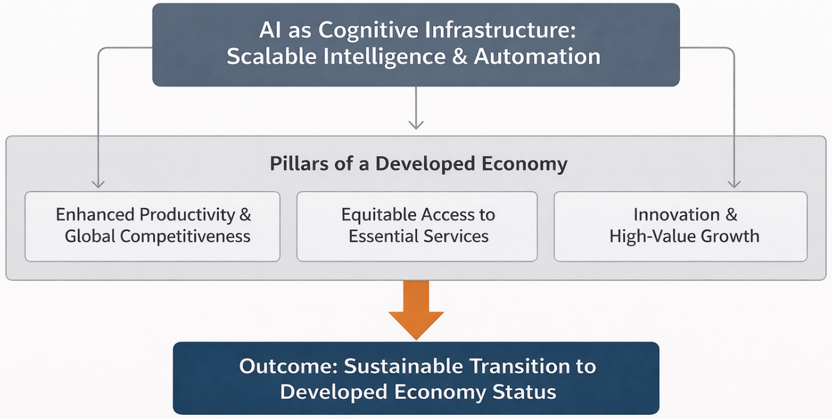
Source: Prepared by the researcher
India recognizes these enabling conditions in its recent policy approach. Government of India has initiated various programs that aim to creating a regulatory framework regarding the use of AI. Government is evaluating the impact of AI on certain sectors. The recently launched initiatives such as India AI Mission and National AI governance guidelines etc., seeks to balance risk mitigation with innovation, while at the same time trying to cast AI as an instrument for inclusive growth. Initiatives such as the Digital Public Infrastructure deployed on the platform of Aadhaar, UPI etc., shows that integrated public systems can help in the scaling of the deployment of AI (NITI Aayog, 2025). However, there is no guarantee that a country will automatically reap the broad-based, sustained benefits of AI from technology. Structural constraints still persist. We still observe a significant gap in connectivity, digital infrastructure, and digital literacy especially in rural and disadvantaged areas. Numerous empirical studies indicate that a widening skills mismatch is a significant concern of AI. Evidence from the labour markets suggests that economies like India face dual vulnerability. A Large section of the workforce in India, is employed in occupations at risk of automation and at the same time are weakly linked to the newly emerging AI-intensive jobs (Ganuthula & Balaraman, 2025). If this gap persists, AI-led growth could lead to exclusion rather than opportunity.
Governance and ethical factors make the transition even more complicated. AI poses significant threats that include algorithmic bias, data misuse, opaque decisions and privacy breach etc. India’s AI strategy emphasizes flexibility and adaptability to sectoral characteristics. However, the implementation is frequently inconsistent and restricted. It is evident in high-stakes sectors such as finance and public service delivery, etc. (Government of India, India AI Governance Guidelines, 2025). AI requires the trust of the public if it has to flourish and become widely accepted and adopted. To build public trust, there needs to be enforceable standards, transparency and accountability.
In this context, the paper uses a sectoral and institutional analytical framework to examine AI progress in India. The study examines the application of Artificial Intelligence (AI) in agriculture, health, manufacturing and public sector, keeping the institutional and infrastructural constraints in consideration. The Analysis critically examines the conditions under which AI can act as a general-purpose technology rather than a technology with limited benefits.
- Objectives
This paper has three interrelated objectives.
- It synthesises and critically examines strategic frameworks and policy initiatives, through which the Indian government and industry are working to position Artificial Intelligence as a long-term economic growth driver.
- It examines sector-specific AI applications in agriculture, health, and manufacturing, with a focus on technical feasibility, economic relevance, scalability and institutional embeddedness.
- It identifies and examines the enabling factors and systemic constraints that condition the developmental impact of AI.
- Methodology
The research adopts a systematic narrative review approach that intertwines policy analysis with sector-specific evidence relevant to AI-led development in India. This approach focuses on an analytical synthesis of heterogeneous sources instead of a statistical meta-analysis. The study draws on four broad categories of resources. First, government publications and official press releases to establish policy intent and institutional design. Second, institutional reports from academic and public research organisations to document applied AI initiatives. Third, reports from global institutions like the World Bank to frame foundational enablers and comparative constraints. Finally, selected industry and professional body reports to capture skill demand patterns and dynamics of industrial transformation. The components of evidence are organized thematically from sectoral application to system enabler and constraint. In situations where precise impact evaluations are absent, cases are perceived as evidence of technological feasibility and institutional direction rather than the extent of economic impact.
- Sectoral Discussion and Evidence Interpretation
The section outlines the use of Artificial Intelligence in the major sectors of the Indian economy and how sector-specific conditions could determine outcomes. The study is empirical and interpretive. The focus is on implementation patterns, institutional embedding and pragmatic constraints, rather than normative policy recommendations or expected macroeconomic impacts. Table-1 provides a consolidated overview of sectoral AI applications and the nature of evidence currently available.
Table 1: Sectoral Applications of Artificial Intelligence in India
Sector | Illustrative AI Applications | Primary Function | Evidence Type | Key Sources
Agriculture | Digital Crop Survey, Agri Farm Registry, AI advisory systems | Advisory support, risk mitigation, administrative coordination | Pilot implementations, institutional reports | FAO; World Bank; NITI Aayog; Government of Gujarat
Healthcare | TANUH, Aarogya Aarohan | Screening support, early risk identification | Institutional deployments, proof-of-concept | Indian Institute of Science
Manufacturing | Predictive maintenance, quality analytics in large firms | Process optimisation, efficiency improvement | Firm-level case documentation | World Economic Forum; McKinsey & Company
Public Governance | Digital Public Infrastructure platforms | Service delivery, data integration | Policy frameworks, operational platforms | Government of India; NITI Aayog
Note: Evidence strength varies across sectors. Reported cases illustrate technological feasibility and institutional direction rather than causal estimates of economic impact.
Source: Compiled by the author from various key sources.
Figure 2: Sectoral AI Deployment Pathways and Institutional Interfaces
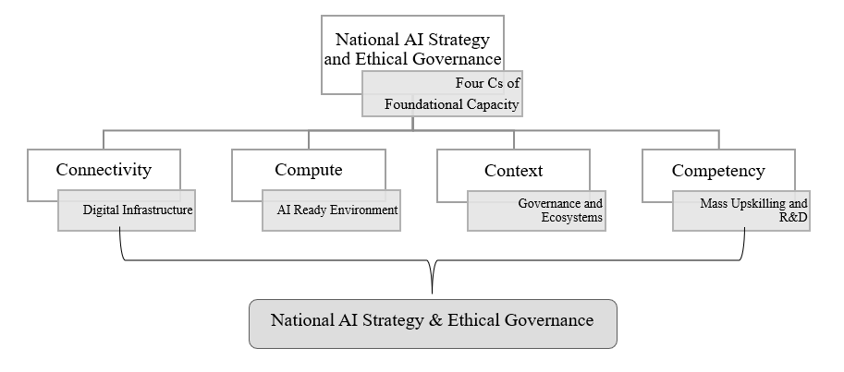
Source: Prepared by the researcher
The figure-1 schematically illustrates how AI applications interact with sector-specific data systems, service delivery mechanisms, and organisational capacity across agriculture, healthcare, and manufacturing.
4.1 Agriculture
Agriculture is a leading example of how India is solving agriculture related problems using AI. The agriculture sector is subject to productivity constraints and income volatility. This sector is especially susceptible to asymmetric information, climate disruptions and inefficient use of resources (FAO, 2024). An AI-enabled decision support service could address these farm-related issues focusing on agriculture advisory, monitoring and risk-mitigation (World Bank, 2024).
Gujarat is a good example of this layered AI deployment model. The state has sought to construct an integrated digital ecosystem through initiatives like the Digital Crop Survey; the Digital Agri Farm Registry; and the i-Khedut portal, which cover multiple stages of the agricultural cycle (Government of Gujarat, 2023; NITI Aayog, 2018). These programs mainly connect farm-level data with service delivery systems for better coordination, integration of data, and administrative efficiency. In this type of ecosystem, farmers get AI-backed advisory tools that help them in deciding which crop to sow, when to sow, and how to administer and apply inputs. When combined with climate and soil data, these AI systems assist in addressing climate-related challenges, hence diminishing information uncertainty at the agricultural level. However, the distribution of AI benefit is not uniform. The scalability in adoption, especially among small and marginal farmers, continues to remain limited due to unequal access to digital connectivity, integrity of data, and competence of users. Therefore, advantages of these AI based initiatives remain increasingly concentrated in regions where more sophisticated digital infrastructure and institutional support are available.
4.2 Healthcare
The healthcare system in India is currently confronted with the dual structural challenge: 1) the increasing burden of lifestyle-related non-communicable diseases 2) the urban-rural divide in access to quality treatment. Due to these conditions, AI-based evaluation and diagnostic techniques have become an area of focused experimentation, especially in situations where specialist availability is limited and diagnostic delays are common.
The Indian Institute of Science (IISc) has launched an initiative named Translational Artificial Intelligence for Neuro-health and Urban Health (TANUH). This AI-based initiative has been developed to facilitate community-level screening using imaging data-based machine-learning models to detect possible neurological and oral health threats (Indian Institute of Science, 2024). The initial experience indicates that it can assist with early identification of health risks at scale without referral-dependent diagnostic delays.
Similarly, the Aarogya Aarohan initiative utilises AI-powered picture along with mobile applications used by frontline health workers to diagnose for oral cancer. The initiative helps augment the screening capacity by facilitating early detection of high-risk cases for further clinical assessment of the underprivileged (Indian Institute of Science, 2024). The technological solution and institutional commitment represented by these endeavours will be effective on mass-level only if followed up with complementary capabilities, clinical integration and workforce training.
  - Manufacturing
We notice a contrasting scenario regarding AI adoption when we take manufacturing into the picture. While large enterprises have successfully incorporated AI elements into their systems, smaller enterprises (SMEs) still lag behind in adopting and implementing AI solutions. Use of artificial intelligence in this industry is generally embedded in production planning, quality control, predictive maintenance and supply-chain optimisation processes. All these processes require high data availability and capital intensity.
India's participation in the Global Lighthouse Network of the World Economic Forum also shows its commitment. Manufacturing facilities certified as lighthouses utilize AI-based solutions to smoothen its production flows, reduce interruptions and ensure high-quality consistency and precision (World Economic Forum, 2019). As per documented cases in the industry, firms that adopted AI-enabled real-time analytics and predictive systems exhibited measurable improvement in their operations (McKinsey & Company, 2021).
AI adoption by firms is often dependent on the size of the firm. Many micro, small and medium enterprises face constraints due to lack of data availability, access to capital, technical knowledge and organizational readiness. Consequently, they are unable to implement the AI-enabled machinery despite the potential for greater productive efficiency. As a result, the use of artificial intelligence in manufacturing seems to be unbalanced and reinforces existing structural imbalances between large firms and the SMEs.
- Cross-Cutting Analysis and Structural Constraints
Although the evidence from individual sectors shows how Artificial Intelligence is being used in many productive sectors like agriculture, health, and manufacturing but it does not explain why realised outcomes are so starkly different across these sectors. The analysis shows that AI adoption works through a set of interrelated enablers and constraints, and their configuration, sequencing and institutional quality determine whether the observed deployments continue as isolated instances or evolve towards system-level transformation.
5.1 Foundational Enablers: The Four Cs
The success of AI in any sector, depends on simultaneous availability of four foundational enablers: 1) Connectivity, 2) Compute, 3) Context and 4) Competency. As highlighted by recent assessments of global development, these are complementary enablers, not independent levers (World Bank 2025).
Connectivity is the first enabler. Being connected does not only mean having internet access; it means having the required reliability, latency, and affordability for an AI application to process real-time data. India has made considerable progress in augmenting access to and affordability for digital services. However, large-scale gaps persist in network quality and last-mile connectivity, especially in rural and semi-urban areas (World Bank 2025). Due to these limitations, the flow of real-time data is severely restricted, which reduces the functionalities of AI-based systems in rural and semi-urban areas.
Computing processing capability is another enabler. AI applications are increasingly utilizing high-performance computing resources for their models’ training, deployment and scaling. As per NITI Aayog (2025), India’s dependency on imported devices and cloud infrastructure raises the complications of cost, access and strategic autonomy. When computing is scarce or expensive, the deployment of AI is often limited to pilot projects or large corporations.
Contextual data is the third enabler. AI systems require high quality, locally relevant contextual datasets to produce required output. The contextual data across various sectors in India is either poorly standardised or fragmented among the various agencies or under-utilised due to governance and interoperability issues (Government of India, 2024; NITI Aayog, 2025). The absence of effective data governance may lead to AI systems that generates complex yet contextually incorrect and misleading outputs.
Competency is the fourth enabler. For efficient AI utilisation, the workforce must possess the expertise and specialised skill sets required to integrate algorithms into standard procedures and decision-making processes. Analysis indicates that there is a growing gap between the skills required by AI (automation)-intensive applications and the skills actually possessed by the available workforce (ILO, 2018). Such a mismatch, restrains the absorption capacity despite the presence of infrastructure and data.
Figure 3: The Four Cs as Complementary Enablers of AI-Led Development
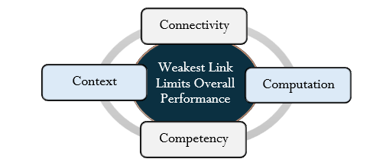
Source: Prepared by the researcher
Figure-2 demonstrates that Connectivity, Compute, Context, and Competency mutually reinforce and that the weakest of these constrains overall system performance.
5.2 Critical Risks and Distributional Challenges
The unbalanced deployment of foundational enablers creates distributional risks that cascade across sectors. Labour market polarisation, significant skill shortages, and extensive job losses and relocations are critical issues. The increasing automation of administrative, routine analytical, and support jobs is driving an increasing demand for advanced technical and managerial skills. India has a labour market predominantly characterised by informal employment. The majority of the workforce is engaged in unskilled or semi-skilled jobs. There is currently no mechanism to reskill the workforce in response to the increased demand for technical skills (ILO, 2018). In this scenario, the negative impact of AI may exceed the positive impact of AI, and the overall situation might get adversely affected by these dynamics.
Governance risks complicate the growth of AI further. The extensive use of data-driven technologies presents structural risks like an algorithmic opacity, data misuse, privacy breaches and detrimental biases. Despite India adopting a flexible and responsive regulatory approach across sectors, there remains a policy deficit in institutional enforcement capacity (Government of India, 2024). In the absence of reliable accountability mechanisms, one cannot build public trust in AI-enabled systems. This may also limit the adoption of AI systems in high-risk areas.
There is a risk related to concentration effects. AI deployment in India so far has favoured larger companies, better-resourced regions and financially resourceful entities. If we do not have explicit mechanisms to broaden access to data, compute, and skills, AI adoption may worsen existing inequalities, both regionally and at the firm level. This trend can also be seen in manufacturing and advanced services where smaller firms continue to face entry obstacles despite having potential to grow.
5.3 Hierarchical Constraint Perspective
The study indicates a hierarchical order of the constraints on AI deployment. Employing the principles of interpretive structural modelling, these constraints can be categorised in hierarchical order based on their driving power and dependence.
Infrastructures and institutional capacity represent the lowest foundational level of the hierarchal constraint. It covers connectivity, computing access and data governance. Such factors have a strong impact on higher order outcomes of AI. Capacity constraints of organization lies after it. The top of the hierarchy is deployment and productivity gains or service expansion.
Figure 4: Hierarchical Framework of Interconnected Challenges related to Artificial Intelligence

Source: Prepared by the researcher
The order indicated here is critical to the analysis. High-level policy initiatives or isolated trial projects won't result in long-term increases in AI adoption if fundamental barriers are not addressed. In contrast, investing in infrastructure, data systems, and human skills creates option value, thereby expanding the feasible space for implementing AI in various sectors. Consequently, the outcome of AI development is driven less by the speed of AI rollout than by the sequencing and coherence of enabling conditions.
Figure 5: Hierarchical Structure of AI Adoption Constraints in India
Source: Prepared by the researcher
This figure-3 illustrates the various challenges of AI in Transforming India
6: Policy Implications and Synthesis
The analysis so far establishes that the Artificial Intelligence does not function as an autonomous driver of development outcomes. Rather, the economic and social outcomes are mediated through a hierarchy of foundational, organizational and institutional constraints. Therefore, policy implications should be focused towards addressing these hierarchal constraints.
6.1 Implications of the Constraint Hierarchy
A key implication of the hierarchical framework developed in Section-5 is that not all constraints exert equal influence over AI outcomes. The digital connectivity, access to compute and data governance are impactful foundational conditions. Deficiencies at this level propagate upward, and weaken the effectiveness of ecosystem capacity, skill development, and sectoral implementation. Therefore, downstream interventions cannot compensate for upstream deficiencies. This logic corresponds with comprehensive evaluations that recognize digital infrastructure and institutional preparedness as essential for the scalable implementation of AI (World Bank, 2025).
This perspective helps explain why many AI initiatives exhibit strong pilot performance but limited scalability. It's important to know what needs to be done first in order for the incorporation of AI to yield sustainable development and inclusive gains. Unresolved fundamental constraints in right order led to the restricted and fragile adoption of AI, which depends heavily on institutional support for sustain. This means that AI policy is less about the metrics of superficial AI deployment and more about how systematically stringent-driving constraints are being progressively addressed.
6.2 Mission Orientation as Capacity Sequencing
Artificial intelligence policy requires rethinking within the prevailing framework. It is best understood as mission-oriented sequencing of capacity formation across the constraint’s hierarchy rather than irrationally imposing technology without addressing the core issues. This shifts the focus towards institutional preparedness, conducive economic environment and positive structural changes. The most appropriate solution is enforcing a wide variety of feasible and sustainable initiatives to tackle fundamental bottlenecks. (Government of India, 2018; NITI Aayog, 2025).
According to study conducted on agriculture, health, and manufacturing sector it was found that the adoption of AI becomes more adaptable and stronger, when key enablers such as connectivity, computing access capacity, data systems and human skills work together.
6.3 Coordination Without Centralisation
The hierarchical logic also impacts institutional coordination. The widespread application of AI and AI-related technologies in all kinds of sectors and regulatory domains including all levels of government have created coordination challenges that cannot be solved via centralisation. In this regard, coordination entails bringing together standards, incentives, and learning, rather than concentrating control (Government of India, 2025).
The decentralized pilot trials are valuable for identifying contexts, challenges and institutional learning. However, pilot projects should be treated only as diagnostic tools and not proof of scalability. Taking the success of pilot projects as evidence inferring that the system is ready can create ambiguity and false positive around feasibility and sustainability of such AI projects. Central funding in the development of foundational capacity and governance frameworks must be complemented by decentralised experimentation for analytical coherence.
6.4 Synthesis: From Deployment to Development Capacity
To sum up, the study shows that the developmental implications of AI in India will largely hinge on the consistency of institutional alignment. Development outcomes emerge only when high-driving constraints are resolved in sequence. AI is a multi-purpose tool, and its benefits depend on the existing economic structure, governance ability and human capital. These conditions will define how far AI will be an inclusive development tool rather than just an uneven growth driver. Policies aimed solely at speeding up adoption of AI technology may overlook these deeper determinants of impact (World Bank, 2025). By proposing a hierarchy of constraints and enabling factors we provide the analytical framework that explains why similar technologies get such different results in various sectors and regions.
Figure 6: Sequencing Logic Linking Foundational Enablers, Sectoral Deployment, and Development Outcomes.
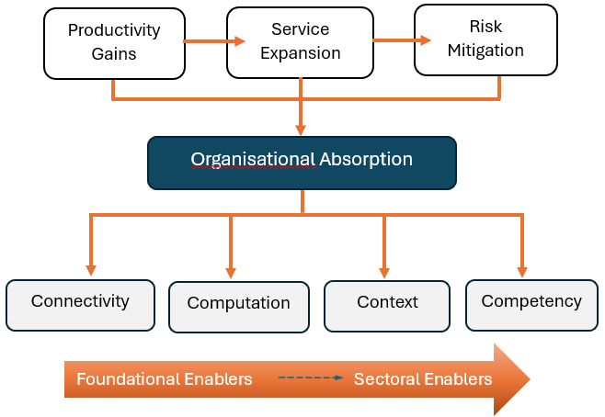
Source: Prepared by the researcher
The figure illustrates how foundational capacities condition institutional absorption and sectoral AI deployment.
Conclusion
This study carried out on the adoption of Artificial Intelligence in India provides an analysis based on a framework of constraints and enablers. Instead of treating AI as an autonomous driver of development, it is found that the economic and social impact of AI are mediated by foundational capacities, institutional absorption and the sequencing with which constraints are resolved.
The performance of AI applications is optimal when they are built into supportive digital infrastructure, available computing resources, contextually relevant data systems and a workforce capable of integrating algorithmic tools into the workplace. Whereas if these conditions are weak and partially fulfilled, AI adoption remains restricted, weak, and dependent on exceptional institutional support.
The main contribution of the paper is a hierarchical perspective on AI related constraints. The analysis moves away from deployment metrics to a focus on system-building process and institutional capacity building. Driving constraints should be relaxed in a systematic fashion to expand the set of feasible AI applications in different sectors. The evolution of AI, as a general-purpose technology, will depend on the economic and institutional set-up rather than the AI technology itself. Foundational capabilities strongly influence developmental results and outcomes. Application-specific interventions alone will not produce desired development outcomes. Development transpires not by chance but when the circumstances are rightly oriented.
AI shouldn’t be regarded as an automatic shortcut to achieving development objectives. The future potential of AI in India will not be realised through an isolated technological intervention but through sustained investments in foundational capacities and institutional coherence. This approach will help in fostering a more grounded understanding of AI-led development which emphasises sequencing, complementarity and structural integrity rather than pseudo visibility of adoption.

COMPETING INTERESTS DISCLAIMER:
Authors have declared that they have no known competing financial interests OR non-financial interests OR personal relationships that could have appeared to influence the work reported in this paper.

References
- Food and Agriculture Organization of the United Nations. (2024). FAOSTAT statistical database. https://www.fao.org/faostat/en/
- Ganuthula, V. R. R., & Balaraman, K. K. (2025). Skill-Based Labor Market Polarization in the Age of AI: A Comparative Analysis of India and the United States [Preprint]. arXiv. https://arxiv.org/abs/2501.15809
- Government of Gujarat. (2023). i-Khedut portal and digital agriculture initiatives. https://ikhedut.gujarat.gov.in/
- Government of India. (2018). National strategy for artificial intelligence: #AIForAll. NITI Aayog. https://www.niti.gov.in/sites/default/files/2019-01/NationalStrategy-for-AI-Discussion-Paper.pdf
- Government of India. (2025). India AI Governance Guidelines. Press Information Bureau. https://static.pib.gov.in/WriteReadData/specificdocs/documents/2025/nov/doc2025115685601.pdf
- IndiaAI Mission. (2025). Report on AI Governance Guidelines Development. Government of India. https://indiaai.gov.in/article/report-on-ai-governance-guidelines-development
- Indian Institute of Science. (2024). Aarogya Aarohan: AI-based oral cancer screening initiative. https://iisc.ac.in/
- Indian Institute of Science. (2024). Translational Artificial Intelligence for Neuro-health and Urban Health (TANUH). https://iisc.ac.in/
- International Labour Organization. (2018). Women and men in the informal economy: A statistical picture (3rd ed.). https://www.ilo.org/global/publications/books/WCMS_626831/lang--en/index.htm
- McKinsey & Company. (2021). How a steel plant in India tapped the value of data and won global acclaim. https://www.mckinsey.com/industries/metals-and-mining/how-we-help-clients/how-a-steel-plant-in-india-tapped-the-value-of-data-and-won-global-acclaim
- NITI Aayog. (2018). National strategy for artificial intelligence: #AIForAll. Government of India. https://www.niti.gov.in/sites/default/files/2019-01/NationalStrategy-for-AI-Discussion-Paper.pdf
- NITI Aayog. (2025). AI for Viksit Bharat: The opportunity for accelerated economic growth. Government of India. https://niti.gov.in/
- World Bank. (2024). World development indicators. World Bank Group. https://data.worldbank.org/
- World Bank. (2025). Digital progress and trends report 2025: Strengthening AI foundations. World Bank Group. https://www.worldbank.org/en/publication/dptr2025-ai-foundations
- World Economic Forum. (2019). Global Lighthouse Network: Scaling intelligent manufacturing. https://www.weforum.org/reports/global-lighthouse-network-scaling-intelligent-manufacturing/

