Original Research Article
Elimination of crystal violet from aqueous solution by adsorption of the bone of beef of the species Gudali (Bos Indicus) Adamawa

Abstract: Activated Carbon Prepared from Bos Indicus Gudali Bones (ACB) is used in this paper as a new and an eco-friendly adsorbent for the removal of Crystal Violet dye (CV) from aqueous solution. A semiquantitative X-ray, X-ray diffraction analyses, Scanning Electron Microscopy (SEM), infrared spectroscopy (ATR–FTIR), Point of Zero Charge (pH_{PZC}) were used for the characterization of bone pyrolysis. The effects of adsorbent mass, initial pH of solution, contact time, initial dye concentration, and temperature were studied in batch adsorption mode. Kinetic data were evaluated by Intra-particle diffusion, Elovich, Pseudo-first-order and Pseudo-second-order models. The result outlined that Pseudo-second-order model properly described the adsorption kinetics of CV onto ACB. Langmuir, Freundlich, Temkin and Dubinin-Radushkevich isotherm models were used for analysis of the isothermal data. The data at equilibrium of CV adsorption onto ACB was better fitted with the Langmuir isotherm. Based on the Langmuir isotherm model, the maximum adsorption capacity was 17.331 mg g⁻¹ at 303 K. Dubinin-Radushkevich isotherm models indicated adsorption is physical. The thermodynamic data indicated that
adsorption was a physical, spontaneous, and exothermic process.
Keywords: Adsorption, Bones, Crystal Violet, Isotherm, Kinetic, Thermodynamic.

1. Introduction
Nowadays, water is at the center of human life, population growth and industrial activities are increasing pressure on its reserves on a planetary scale. Releases from industries are among the effluents causing enormous harm to human health, particularly the various dyes which are used in excess in these industries. As a result, the waste water is highly concentrated in dye. The low biodegradability of dyes makes their treatment difficult to achieve thus constituting a source of pollution of the environment. Different types of synthetic dyes appear in wastewater effluents from various industries, for example: textiles, printing, leather, laundry, tannery, rubber painting processes (Brahimi et al., 2015; Sharma and Bhattacharya, 2017; Akartasse et al., 2017; Khan et al., 2020; Fathi et al., 2021; Mishra et al.,2023). The latter are known for their toxicity and their release into the environment is a source of pollution since their existence even in low concentrations is clearly visible especially by the coloring of surface waters which can affect aquatic ecosystem activities by reducing light penetration.
In view of the many environmental problems that have a direct impact on the health of living beings, scientists have developed several techniques for eliminating dyes, including: filtration , oxidation, coagulation-flocculation, precipitation chemical , ion exchange, catalysis, photo catalysis, electrochemical (Akbari et al., 2002; Laasri et al., 2007; Fernandes et al., 2004; Erdem et al., 2004; Rojas-Mayorga et al.,2015; Domga et al., 2015b; Domga et al., 2017; Nidheesh et al., 2018; Le et al., 2020 ; Lee et al., 2011; Kali et al., 2022a, 2022b; 2022c; Abd El-Monaem et al., 2023; Eltaweil et al., 2023a ;Domga et al., 2025b) and adsorption ( Ravikumar et al., 2007; Béné et al., 2016; Tcheka et al., 2018; Arbam et al.,2019; Abia et al.,2019a; Abia et al.,2019b; Adjia et al.,2019; El Hammari et al., 2023, Tabaght et al., 2023, Aaddouz et al., 2023, Domga, 2025a).
In this research, adsorption was chosen because of its ease of implementation, cost, and effectiveness. With a view to protecting the environment, the use of available materials as potential adsorbents has been the subject of several studies by researchers. (El-Geundi et al., 1997; Boukhlifi and Bencheikh, 2000; Annadurai et al., 2002; Mall et al., 2005; Hammou et al., 2014; Varghese et al., 2019; Leivisk¨a et al., 2019; Sheibani et al., 2021; Mohamed et al., 2024). The choice fell on activated carbon, and several materials of various origins were researched, such as activated carbon such as peat, banana peel, orange peel, eucalyptus bark, citrus waste biomass, rice husk, barley husk, citrus sinensis bagasse and gasse pith (Ho et al., 1998 ; Morais et al., 1999 ; Chen et al., 2001 ; Annadurai et al., 2002 ; Sivaraj et al., 2001, Safa and Bhatti, 2011 ; Haq et al., 2011 ; Bhatti et al., 2012 ; Asgher and Bhatti, 2012) are some of the waste materials which have been tested upon for this purpose. In this study, we focus on activated carbon derived from cattle bones for removing dyes from water.
Beef bones are produced in slaughterhouses as waste. They are mainly composed of collagen, minerals (such as calcium, phosphorus, and magnesium), and amino acids (such as glycine and proline), which are valuable waste products. Pyrolysis of beef bones produces a carbon-rich material while destroying organic matter and forming a product rich in minerals, mainly calcium and phosphorus. Animal-based activated carbon is booming due to its textural and structural properties and its non-toxicity, which allows for its use in various fields such as agriculture for the manufacture of plant fertilizers (Domga et al., 2018), veterinary medicine to treat digestive disorders and poisoning in animals, in construction materials for porcelain (Domga, 2025), and in the bleaching industry.
Research carried out on animal waste has shown satisfactory results during the elimination of Direct Red 75 and Direct Red 80, Basic Red 12, methylene blue, methyl orange, chromium (VI) (Mohammadine et al., 2013; Domga et al., 2015a; Domga et al., 2016; Domga et al., 2018; Domga et al., 2022a; Domga et al., 2022b, Domga, 2025). No research has been carried out on the effectiveness of animal activated carbon in removing crystal violet. This dye finds its application in the textile industry and the production of paints and printing inks (Mittal et al., 2010; Senthilkumaar et al., 2006). Notably, it is carcinogenic and poses significant management challenges due to its resistance to microbial breakdown and its tendency to persist across various environments (Chakraborty et al., 2011). Additionally, crystal violet is toxic to mammalian cells (Franco et al., 2020).
The present study is part of this perspective and has as general objective the use of materials from particular animal waste, the bones of beef of the Gudali species (Bos indicus) in the Adamawa region of Cameroon (Picture 1) in order to eliminate a cationic dye, crystal violet, by adsorption. Phosphoric acid is used as chemical activating agent to improve adsorbent properties. Specifically, the effect of various parameters such as, amount of adsorbent, dye concentration, contact time, pH, temperature, kinetics, equilibrium and thermodynamic was investigated upon as well as the determination of textural and structural properties.
Developing countries like Cameroon, and more specifically its northern regions (Adamawa, Garoua, and Maroua), face challenges in utilizing waste from artisanal slaughterhouses (beef bones). This work focuses on valorizing enormous quantities of animal biomass (beef bones of the Gudali breed) found in artisanal slaughterhouses in the city of Ngaoundere (Adamawa, Cameroon) in order to eliminate the harmful effects of visual pollution and foul odors through an environmentally friendly, cost-effective, and sustainable technique (the production of activated charcoal from Gudali beef bones).

 | 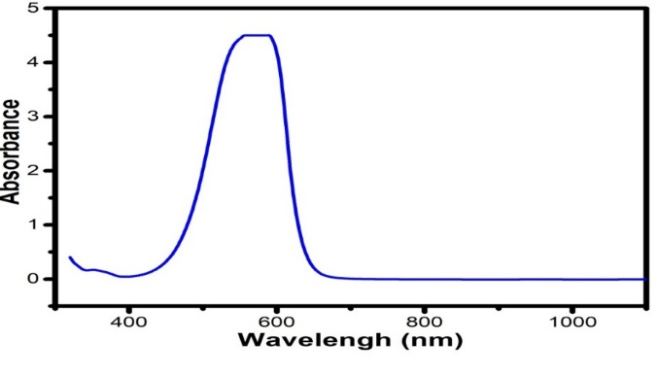
Figure 1. Crystal Violet molecule | Figure 2. Absorption spectrum of CV.

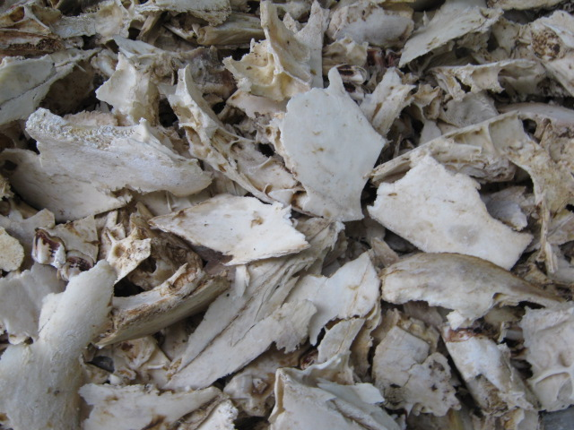 | 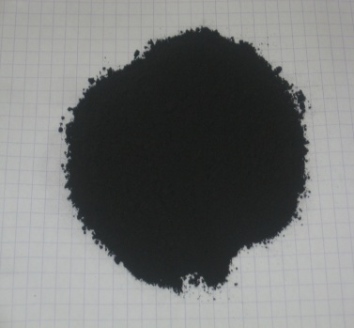
Picture 1. Beef bones | Picture 2. Activated Carbon Prepared from Bos Indicus Gudali Bones (ACB)

2. Methodology
2.1. Material
The zebu cattle bones were degreased Gudali collected, thoroughly washed with distilled water then dried in an oven at 110°C for 24 h, 200g of zebu cattle Gudali bone were dried, milled and sieved (0.2-5 mm) for 18 h and impregnated with a solution of phosphoric acid H₃PO₄ 85%. Then, sample was washed with hot distilled water until a neutral pH and dried at 110°C for 24h. The sample was then pyrolyzed for 2 h at 500°C, the pyrolysis was conducted in the muffle furnace Heraeus, MR model 260E with a heating rate of 5°C. min⁻¹.
2.2. Characterization of Adsorbent Materials
IR spectra of the sample were obtained using a FT/IR-4100 Spectrophotometer (JASCO Benelux BV) in KBr pellets. Scanning electron microscopy (SEM) images were obtained with TESCAN, VEGA II model equipment for ACB material. A semiquantitative X-ray powder diffraction method was used to determine mineral composition. X-ray diffraction analyses on powders were performed using a Siemens Bruker D8 Advance unit with Co-Kα anticathode (λ = 1.7903 Å). The diffractograms were recorded from 5° to 64° degrees with analytic conditions of 40 mA, 20 kV, 0.02° steps. d-spacing, dhkl, corresponding to different diffraction picks have been calculated using Bragg’s equation and JCPDS (Joint Committee on Powder Diffraction Standards) files were utilized in order to identify the crystalline phases.
2.3. Adsorption Experiments
2.3.1. Analytical Methods
Crystal Violet was a commercial grade (MF: C₂₅H₃₀N₃Cl, MW: 408) and it was used without further purification (Figure 1). Stock solution of Crystal Violet was prepared by dissolving 1g of the CV powder in 1000 mL distilled water. For adsorption experiments the stock solution was diluted to a desired concentration range of 10-60 mg. L⁻¹. Initial solution pH was adjusted to desired value by adding either a solution of 0.1M HCl, or a solution of 0.1M NaOH drop wise.
2.3.2 Determination of CV Concentration
UV-visible spectrum of CV absorption was obtained by a spectral scan from 300 to 1100 nm, of a 10 ppm solution (Figure 2). This spectrum shows that the maximum wavelength absorption peak, λmax is: 586 nm. Concentrations of CV solution were obtained by measuring the absorbance at 586 nm using a “Pharo 100” spectrophotometer.
2.3.3. Equilibrium Adsorption Studies
Adsorption studies were carried out at room temperature in a 250 mL conical flash. For each experiment, adsorbent dose of 0.2-0.6 g was weighed and put in reactors containing 50 mL of CV solution with concentrations ranging from 10-60 ppm, pH values increased from 3 to 11. The mixture was stirred with a magnetic stirrer for a time interval ranging between 10 to 60 minutes. The suspension was filtered and the residual concentration was determined by UV-visible spectrophotometry. All experiments were conducted at the initial solution pH (11). Pseudo-first-order, pseudo-second-order, intra-particle diffusion and Elovich models were used to give an insight into adsorption kinetic mechanisms. The Langmuir, Freundlich, and Temkin isotherm models were used to describe the adsorption process. The amount of dye adsorbed per gram of adsorbent, (mg g⁻¹) and adsorption efficiency, (%) was obtained using the following equations:
$q_{t(e)}=\frac{{(C}_{i}-C_{t}) . V}{m}$ (Eq.1)
Where C_{i} is the initial dye concentration (mg L⁻¹), C_{e} and C_{t} are the equilibrium e and time t dye concentrations respectively (mg L⁻¹), V is the volume of CV solution (L), and m is the adsorbent quantity (g).
3. Results and Discussion
3.1. Adsorbents Characterization
A semi-quantitative X-ray powder diffraction method was used to determine elemental analysis of ACB shows a high yield of Ca (49.73%) and P (43.21%) with a (Ca/P) ratio equal to 1.15. Small amounts of Si (3.82%), Mg (1.31%), Na (0.77%), Al (0.32%), Fe (0.26%), Cl (0.26%), S (0.15%), K (0.07%), Sr (0.03%), Cu (0,05%) and Zn (0.02%) are found. Carbonates are the most abundant substances in bone mineral and according to their crystal position, carbonates apatite the latter being the most frequent bone component (Landi et al., 2003; Best et al., 2008). It is recognized that hydroxyapatite is gotten from natural bone (Tadic and Epple, 2004; Figueiredo et al., 2009)
3.1.1. XRD Analysis
XRD analysis of the synthesized ACB (Figure 3) showed that Ca₁₀ (PO₄)₆(OH)₂ was the fundamental constituent of the ACB. Crystal structure of the hydroxyapatite was evidenced by XRD peaks recorded at 25.9°, 29.0°, 3.8°, 32.1°, 32.9°, 34.1°, 39.9°, 46.7° and 49.5°, which coordinate impeccably with those of hydroxyapatite. These findings are in line with previous studies (Moreno-Piraján et al., 2010; Rojas-Mayorgaa et al., 2013; Patela et al., 2015). These results confirm that the amorphous organic component was removed after calcination concurring to literature (Figueiredo et al., 2010).
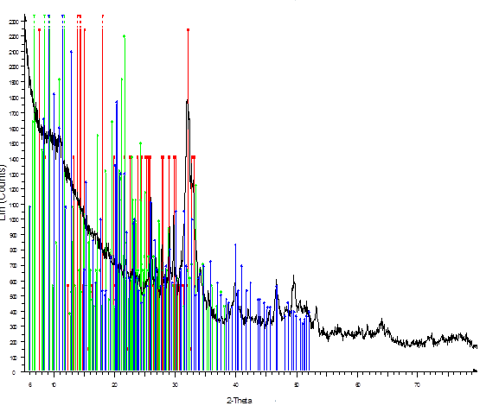
Figure 3. XRD of the synthesized ACB.
3.1.2. FTIR Analysis
Figure 4 (a,b) shows FTIR spectra of ACB, before and after CV adsorption respectively. ACB sample showed strong bands at 1023, 872, 724, 599 and 558 cm⁻¹ which can be attributed to the stretching and bending modes of PO₄³⁻ groups (the structure of natural hydroxyapatite) (Rehman and Bonfield, 1997; Paschalis et al., 1997; Mkukuma et al., 2004; Kagne et al., 2008; Asgari et al., 2014). The peak in the range of 1454–1943 cm⁻¹ is indicative of C꞊O, C꞊C and C꞊N groups corresponding the organic phase of the bone matrix. A broad peak at the 2011–3359 cm⁻¹ regions is assigned to C-H and O-H stretching vibrations respectively (Rojas-Mayorgaa et al., 2013). The peak around 800–500 cm⁻¹ can be attributed to C-H and CH꞊CH₂ stretching vibrations in aromatic structures (Hernández-Montoya, et al., 2012). There was a decrease in the intensity of -OH bands at 3359 cm⁻¹. The new peak at 599 cm⁻¹ is ascribed to the presence of alkyl halide band.
(a)
(b)
Figure 4. FTIR spectra of ACB before CV adsorption (a) and after CV adsorption (b)

3.1.3. Scanning Electron Microscopy
The impregnation of phosphoric acid on beef bones is beneficial. This effect will lead to the development of high surface areas and pore volumes in the resulting activated carbons. The SEM images are displayed in Figure 5 ACB. As seen, the surface of ACB has a porous structure with deep holes of different sizes as shown by the arrow in Fig. 5.
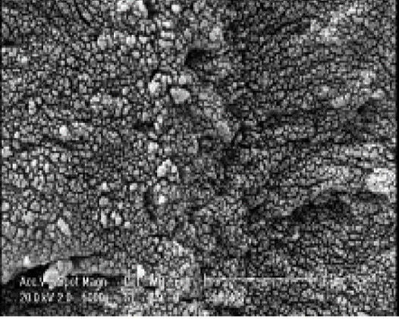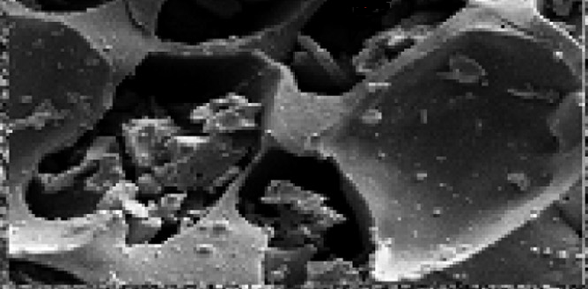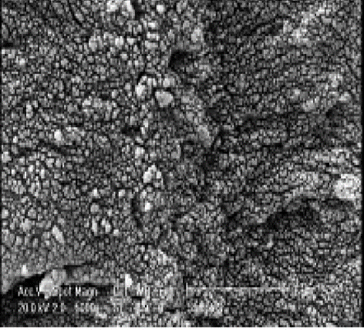
Figure 5. SEM images of ACB.

3.2. Crystal Violet Adsorption
3.2.1. Effect of contact time and mass adsorbent
Figure 6 shows the dependence of the of adsorption capacity with the contact time. From that curve which shows q_{t} versus t (min) for six ACB adsorbent samples with mass of 0.2, 0.3, 0.4, 0.5, and 0.6 g respectively. The effect of ACB amount on the CV adsorption was carried out by varying the mass from 0.2 to 0.6 g. Other parameters such as pH 11, initial dye concentration (10.0 mg L⁻¹) and stirring speed (100.0 rpm) were fixed. The values of qe (mg. g⁻¹) of CV at different ACB amount are presented in Figure 6. It can be seen that when the mass is increased from 0.2 to 0.6 g, the value of q_{e} (mg.g⁻¹) decreases from 9.97 to 2.44 mg.g⁻¹. This observation can be attributed to vacancy binding active sites (Pavan et al., 2014). The decrease in adsorbent capacity may be due to particle aggregation, resulting from high adsorbent mass. Such aggregation would lead to a decrease in total active sites on the surface of the adsorbent and an increase in diffusional path length (Safa et al., 2011; Domga et al., 2015; Domga et al., 2016; Domga et al., 2018; Domga et al., 2022a; Domga et al., 2022b). Figure 6 shows that at 0.2 g of ACB adsorbent, q_{e} was 9.97 mg.g⁻¹, respectively. Thus, 0.2 g was chosen as optimum mass value for the subsequent adsorption experiments.

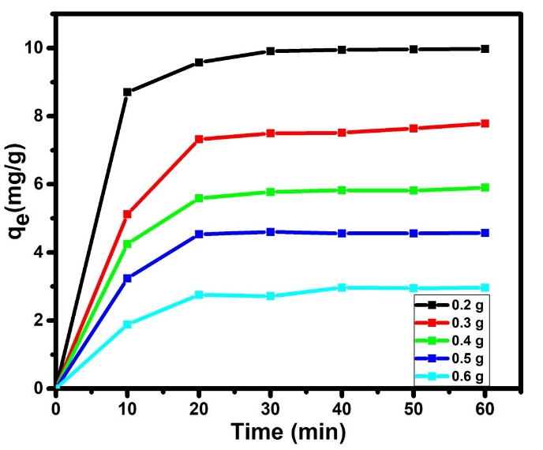 | 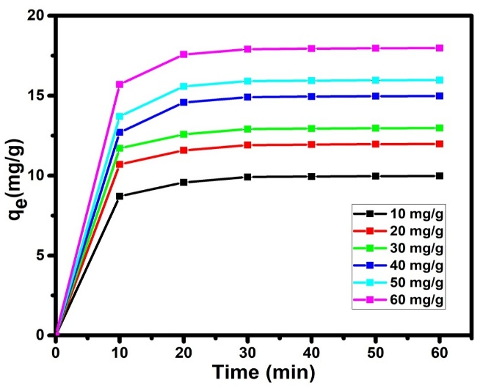
Figure 6. Effect of mass adsorbent on CV adsorption. | Figure 7. Effect of initial dye concentration.

3.2.2. Effects of contact time and initial dye concentration
Figure 7 shows Effect of initial dye concentration, it can be observed that the amounts of CV adsorbed on ACB increases at the first stage and at a certain time, where the adsorption of the CV molecule is maximal, a plateau was reached. The adsorption for CV on ACB adsorbent occurs in three steps. At the first 10.0 min, the adsorption rate is more rapid and then, slowing growth up to 20.0 min then finally reaches equilibrium after 30.0 min. The first phase as observed can be explained by the large surface area and abundant active sites available on the ACB, which rapidly interact with dye molecules from solution, thereby, increasing the adsorption rate (Pavan et al., 2014). Above 30.0 min, the adsorption rate did not significantly change with time. This result is observed due to the gradual saturation of active sites on ACB surface which are responsible for the adsorption of the CV molecule. Therefore, the adsorption stayed invariable (Gupta et al., 2012). This is the reason why the equilibrium time chosen for CV adsorption was 30.0 min. From Figure 7, it is also possible to observe that the adsorption capacity was increased from 8.681 to 17.331 mg g⁻¹ when the CV concentration increased from 10.0 to 60.0 mg L⁻¹. This result is attributed to the driving force that surpasses the mass transfer resistance (Pavan et al., 2014; Domga et al., 2015; Domga et al., 2016; Domga et al., 2018; Domga et al., 2022a; Domga et al., 2022b). q_{e}, increases rapidly when the initial concentration of CV C₀ steadily with increasing initial concentration. This is probably because when the CV concentration increases, the driving force of diffusion increases due to the higher concentration gradient (Domga et al., 2015; Domga et al., 2016; Domga et al., 2018).
3.2.3. pH at Zero Point Charge
The pH of the solution is an important factor in adsorption study, because it may influence both the structure of the adsorbent and adsorbate, as well as the mechanism of adsorption. For this, the effect of the solution’s pH on the adsorption of CV by activated animal carbon was studied at the concentration of 10 mg.L⁻¹, 0.2 g of activated carbon, in the pH range 2-12. Figure 8 shows the variations of the amount adsorbed versus medium pH. The pH at Zero Point Charge (pH_{ZPC}) is an important factor that indicates whether the surface of the adsorbent is likely to become negatively or positively charged (Asgari et al., 2014; Yao et al., 2016; Asgari et al., 2017).
 | 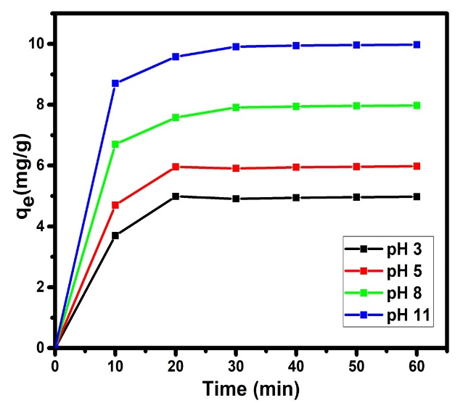
Figure 8. pH at Zero Point Charge | Figure 9. Effect of pH

3.2.4. Effects of contact time and pH solution on CV adsorption
The influence of pH solution of CV adsorption is shown in Figure 9. On that figure, it is possible to observe that pH solution affected the efficiency of CV adsorption. The CV qe increased from 5.216 to 9.875 mg/g when pH increased from 3 to 11 values. These behaviors can be explained considering both the chemical formula of the CV and Zero Point Charge (pH_{ZPC}) of ACB adsorbent. In fact, CV is a cationic dye (Figure 1) and the pH_{zpc} of ACB obtained was 6.84 (Figure 8) and Scheme 1 proposed mechanism for adsorption of CV on the surface Bos Indicus Gudali bones adsorbent. As Figure 8 shows, the pH_{zpc} value of ACB was 6.84, meaning that the ACB surface was negatively and positively charged at solutions with pH above and below 6.84, respectively. A study of the final pH indicated that ACB displays excellent buffering effects. The buffering capacity of ACB can be qualified to the properties of its main constituent, calcium hydroxyapatite (CaHa). It was described that acidic and basic solutions (in pH range 3–11) are buffered after reaction with the reactive surface sites of CaHa (in accordance with the equations below):

$≡{PO}^{-}+H^{+}↔≡{POH}^{0}$ (Eq.2)

$≡{CaOH}_{2}^{+}↔≡{CaOH}^{0}+H^{+}$ (Eq.3)
When the initial pH is below pH_{zpc}, final pH increases because of the use of H⁺ ions by the surface protonation of `$≡$PO⁻ and `$≡$CaOH⁰ groups. Under acidic conditions, the surface charge of the CaHa was dominated through positively charged `$≡$CaOH²⁺ and neutral `$≡$POH⁰ sites. Instead, the higher initial pH (above pH_{zpc}) results in a lower final pH due to hydroxyl radical utilization by deprotonation of surface $≡$CaOH²⁺ and `$≡$POH⁰ sites (Srivastava et al., 2014 ; Asgari et al., 2014). The lower adsorption of CV ions under acidic conditions can be due to the formation of $≡$CaOH²⁺ and the competition of excessive H⁺ ions in the solution with CV (Asgari et al., 2014). The highest adsorption efficiency of CV observed under alkaline conditions is associated may be due to attraction with hydroxyl radicals.
The association of CV and ACB can be described as below:
When pH is below pH_{PZC},
$Ca_{5}(PO_{4})_{3}OH +H^{+}⇄\left[Ca_{5}(PO_{4})_{3}\right]OH_{2}^{+}$ (Eq.4)
The rest of$Ca_{5}(PO_{4})_{3}OH$ works with CV by hydrogen bond,
$Ca_{5}(PO_{4})_{3}OH+{\left[C_{25}H_{30}N_{3}\right]}^{+}$ ⇄$Ca_{5}(PO_{4})_{3}OH⋯{\left[C_{25}H_{30}N_{3}\right]}^{+}$ (Eq.5)
When pH is above pH_{PZC},
$Ca_{5}(PO_{4})_{3}OH+{OH}^{-}⇄{\left[Ca_{5}(PO_{4})_{3}O\right]}^{-}$ $+H_{2}O$ (Eq.6)
This part of${\left[Ca_{5}(PO_{4})_{3}O\right]}^{-}$ works with CV by electrostatic attraction,
${\left[Ca_{5}(PO_{4})_{3}O\right]}^{-}+{\left[C_{25}H_{30}N_{3}\right]}^{+}⇄{\left[Ca_{5}(PO_{4})_{3}O\right]}^{-}-{\left[C_{25}H_{30}N_{3}\right]}^{+}$ (Eq.7)
The rest of$Ca_{5}(PO_{4})_{3}OH$ works with CV by hydrogen bond
$Ca_{5}(PO_{4})_{3}OH+{\left[C_{25}H_{30}N_{3}\right]}^{+}$ ⇄$Ca_{5}(PO_{4})_{3}OH⋯{\left[C_{25}H_{30}N_{3}\right]}^{+}$ (Eq.8)

Scheme 1: Proposed mechanism for adsorption of CV on the surface Bos Indicus Gudali bones adsorbent.
3.3. Influence of contact time on CV adsorption by ACB and Kinetic modeling
Influence of reaction time on adsorption of CV on ACB was investigated in real groundwater samples and results outlined the function of contact time. As it is shown in Figure 6, the adsorption of CV onto ACB takes place in three stages. Upon further increase of contact time, adsorption process reaches equilibrium and the removal efficiency stays almost constant. The kinetic data is perhaps the most significant data in adsorption system design when defining the adsorbent rate. Consequently, at this phase of the study, the kinetics of CV removal by ACB was analyzed by the pseudo-first-order, pseudo-second-order, intra-particle diffusion and Elovich models (Leyva-Ramos et al., 2013; Ghasemi et al., 2018).

Table 1. Non-linear and linearized isotherm model equations.
Isotherm model | Non-linear equation | Linearized equation | Plot | Eqs
Pseudo-first order model | $$\frac{{dq}_{t}}{dt}=k_{1}(q_{e}-q_{t})$$ | $$log\left(q_{e}-q_{t}\right)=logq_{e}-\frac{t}{2,303}K_{1}$$ | $$\log\left(q_{e}-q_{t}\right)vs.t$$ | (9)
Pseudo-second order model | $$\frac{{dq}_{t}}{dt}=k_{2}(q_{e}-q_{t})^{2}$$ | $$\frac{t}{q_{t}}=\frac{1}{k_{2}q_{e}^{2}}+\frac{t}{q_{e}}$$ | $$\frac{t}{q_{t}}vs.t$$ | (10)
Intra-particle | $$q_{t}=k_{int}t^{0,5}+X_{i}$$ | $$q_{t}=k_{int}t^{0,5}+X_{i}$$ | $$q_{t }vs.t^{1/2}$$ | (11)
Elovich | $$q_{t}=\frac{1}{β}ln⁡(αβ)+\frac{1}{β}lnt$$ | $$q_{t}=\frac{1}{β}ln⁡(αβ)+\frac{1}{β}lnt$$ | $$q_{t} vs.lnt$$ | (12)

Where q_{t} and q_{e} represent the amount of dye adsorbed at equilibrium (mg g⁻¹) and at time t (min), and k₁ (min⁻¹) and k₂ (g mg⁻¹min⁻¹) are the pseudo-first-order and pseudo-second- order rate constants, respectively. The rate constants k₁, k₂, and the calculated q_{e} (cal) obtained from Eq (4) and (5) along with the experimental qe (exp) (Figure 2) and coefficients of determination R², are presented in Tables 1 and 2. C is the intercept indicating the thickness of the boundary layer (mg/g); α the initial adsorption rate (mg/g·min) and β representing the desorption constant (mg/g). The parameters obtained from the intra-particle diffusion model with different initial mass are displayed in Table 2. The pseudo-first-order, pseudo-second-order, intra-particle diffusion and Elovich models are listed in Table 1 and the linear plots of four models.
As the results show, the pseudo-second-order better fits to experimental data with higher R² as compared to pseudo-first-order. As it is revealed in the kinetic data in Table 2, q_{e},calc value was very close to q_{e},exp, which confirms the high correlation between experimental data and pseudo-second-order. These results demonstrate that both CV and ACB affected adsorption process data under chosen conditions. Similarly, the excellent fitness of CV adsorption onto ACB with pseudo-second-order demonstrated that the rate-limiting step of adsorption by ACB adsorbent was the physical adsorption. Subsequently, the formation of chemical bonds is one of the key features that influence the pseudo-second-order kinetic (Yao et al., 2016). The earlier study also indicated that pseudo-second-order model was the best fitted model in adsorbing CV onto ACB and different adsorbents (Yao et al., 2016).
The uptake of contaminants onto the adsorbent involves a number of steps, which can each affect the rate of adsorption. Adsorption processes may involve film diffusion, pore diffusion and intraparticle diffusion (Tomar et al., 2013). A slow diffusion called the rate-limiting step, will control the rate of adsorption. Intra-particle diffusion (Eq. 5) and Elovich (Eq. 6) models were selected to predict the rate limiting step in CV adsorption onto ACB. They can be expressed by the equations bellow (Salifu et al., 2013; Mohan et al., 2014).
The kinetic plot of q_{t} versus t_{1/2} (intra-particle diffusion model) of CV onto the ACB is indicated. As data indicated, there are several steps in the plot drawn for CV adsorption by ACB. This data demonstrated that, different adsorption mechanisms (film and intraparticle diffusion) are possibly involved in the adsorption of CV onto ACB. The initial region of plots indicates that surface diffusion (boundary layer diffusion) probably limited CV adsorption onto ACB at the beginning of reaction time. The second region indicates occurrences of intra-particle or pore diffusion as the adsorption-limiting step. As results indicted the value of C as intercept of the Weber and Morris model is positive indicating that film diffusion occurred on the CV- ACB. Another important point that data indicated in Table 2, was the plots q_{t} vs t^{0.5} did not pass through the origin; therefore, intra particle diffusion was not the only rate-limiting step and confirmed that surface diffusion may play the main role as the rate controlling step in CV adsorption on ACB. Elovich model information was shown in Table 2, moreover, it reconfirmed that during initial stage of CV adsorption onto ACB, film diffusion was the main controlling step. Similarly, β for ACB of 0.755 mg/g suggested that the adsorbents may have affinity to develop chemical forces (Mohan et al., 2014; Petrović et al., 2016). From this reflection, it can be proposed that diffusion through the liquid film layer surrounding the ACB was the main rate limiting step during the adsorption of CV from bulk solution into ACB.
Table 2. Kinetic constants of the pseudo-first order, pseudo-second order, intraparticular and Elovich models for CV.
ACB | Pseudo-first order model |  |  | Pseudo-first  order model |  |  | Intra-particle |  |  | Elovich
Mass  (g) | $$q_{e}\left(cal\right)$$  (mg/g) | $$K_{1}$$  (1/min) | $$R^{2}$$ | $$q_{e}(cal)$$  (mg/g) | $$K_{2}$$  (g/mg/mi) | $$R^{2}$$ | $$K_{int}$$ | $$C$$ | $$R^{2}$$ | $$α$$ | $$β$$ | $$R^{2}$$
0.2 | 1.782 | 0.119 | 0.983 | 10.256 | 0.067 | 0.999 | 0.257 | 8.212 | 0.759 | 147.229 | 0.619 | 0.861
0.3 | 1.586 | 0.064 | 0.831 | 8.425 | 0.025 | 0.996 | 0.488 | 4.358 | 0.684 | 7.108 | 0.323 | 0.788
0.4 | 1.327 | 0.074 | 0.827 | 6.274 | 0.046 | 0.998 | 0.308 | 3.764 | 0.685 | 7.491 | 0.509 | 0.794
0.5 | 1.494 | 0.097 | 0.923 | 4.852 | 0.071 | 0.995 | 0.236 | 2.996 | 0.547 | 5.911 | 0.649 | 0.667
0.6 | 1.494 | 0.097 | 0.923 | 3.295 | 0.052 | 0.995 | 0.211 | 1.499 | 0.737 | 2.332 | 0.755 | 0.831

3.4. Isotherm and equilibrium adsorption study
The effect of ACB dose in the range of 10–60 g/L was measured on CV adsorption under the experimental conditions as given in Table 3.
As observed in Table 3, the CV adsorbed onto ACB increased from 8.681 to 17.331mg/g as ACB dose increased, respectively. The increase in removal efficiency of CV with the increase of ACB doses can be associated with the increased active sites accessible for adsorption of a constant amount of CV ions (Yao et al., 2016). This data showed the density of reactive groups available on the external surface of the ACB since CV binding increased as ACB dose increased (Rojas-Mayorgaa et al., 2013). Furthermore, this data approved consequently that the ACB prepared with pyrolysis process is an effective adsorbent for adsorbing CV from the actual groundwater water. The experimental data of CV adsorbed onto the ACB were fitted with the Langmuir, Freundlich, and Temkin models as: In the nomenclature section, the parameters and constants of fit models are described.
Table 3. Non-linear and linearized isotherm model equations
Isotherm model | Non-linear equation | Linearized equation | Plot | Eqs
Langmuir | $$q_{e}=\frac{q_{max}K_{L}C_{e}}{1+K_{L}C_{e}}$$ | $$\frac{C_{e}}{q_{e}}=\frac{1}{K_{L}q_{max}}+\frac{C_{e}}{q_{max}}$$ | $$\frac{C_{e}}{q_{e}}{vs.C}_{e}$$ | (13)
Freundlich | $$q_{e}=k_{F}C_{e}^{1/{n_{F}}}$$ | $${lnq}_{e}=\frac{1}{n_{F}}{lnC}_{e}+{lnK}_{F}$$ | $${lnq}_{e}{vs.lnC}_{e}$$ | (14)
Temkin | $$q_{e}=\frac{RT}{b}\ln{(AC_{e}})$$ | $${lnq}_{e}=BlnA+BlnC_{e}$$ | $${lnq}_{e}vs.lnC_{e}$$ | (15)
Dubinin-Radushkevich | $$q_{e}=q_{D}e^{k_{ad}ε^{2}}$$ | $${lnq}_{e}={lnq}_{D}-K_{ad}ε^{2}$$ | $${lnq}_{D}vs.ε^{2}$$ | (16)

Where q_{max} is the maximum monolayer adsorption capacity of the adsorbent (mg g⁻¹), K_{L} is the Langmuir adsorption constant (L mg⁻¹) which is related to the free energy of adsorption, and Ce (mg L⁻¹) is the equilibrium dye concentration. K_{F} [mg g⁻¹(L mg⁻ ¹)^{1/n}] is Freundlich constant an indicator of the adsorption capacity of the adsorbent while n_{F} indicates favorability of the adsorption process (adsorption intensity) or surface heterogeneity where n_{F} value between 1 and 10 represents favorable adsorption. The Temkin isothermal model witch B = RT/b, $q_{e}$ (mg.g⁻¹) and Ce (mg.L⁻¹) are respectively the equilibrium adsorbed amount and the equilibrium concentration. In addition, T is the temperature (K), R is the gas constant (8.314 J.mol⁻¹.K⁻¹). The constant B is related to the heat of adsorption. q_{D} is the theoretical isotherm saturation capacity (mg g-1), K_{ad} (mol². J⁻²) and ε are D–R isotherm constants. ε can be determined using Eq.17.
$ε=RTln(1+\frac{1}{C_{e}})$ (Eq.17)
The mean free energy of adsorption (E, kJ mol⁻¹) can be calculated by using Eq.18.
$E=\frac{1}{\sqrt{2K_{ad}}}$ (Eq.18)

Tabe 4. Plotted models, Fitted models and the Correlation coefficient (R²).

Models |  | Concentration (mol/L)
 |  | C=10 | C=20 | C=30 | C=40 | C=50 | C=60
Langmuir | $q_{m}$ $(mg/g)$ | 8.681 | 11.442 | 12.563 | 14.225 | 15.291 | 17.331
Langmuir | $K_{L}$ (L/mg) | 0.011 | 8.404 | 9.365 | 3.152 | 3.406 | 3.899
Langmuir | R² | 0.999 | 0.987 | 0.989 | 0.972 | 0.976 | 0.981
Freundlich | $K_{F}$ [mg/g(L/mg)^{1/n}] | 0.454 | 0.246 | 0.151 | 0.113 | 0.089 | 0.080
Freundlich | $${1/n}_{F}$$ | 0.032 | 0.763 | 1.432 | 1.897 | 2.377 | 2.570
Freundlich | R² | 0.827 | 0.999 | 0.999 | 0.999 | 0.999 | 0.999
Temkin | A | 6.865$×{10}^{-14}$ | 0.032 | 0.028 | 0.023 | 0.019 | 0.016
Temkin | B | -0.298 | -8.643 | -17.652 | -26.163 | -35.167 | -43.170
Temkin | R² | 0.836 | 0.999 | 0.999 | 0.999 | 0.999 | 0.999
Dubinin Raduskevich | $K_{ad}$ ${(mol}^{2}{.KJ}^{-2})$ | $5.$ ${10}^{-5}$ | $2.$ ${10}^{-5}$ | $2.$ ${10}^{-4}$ | $6.$ ${10}^{-4}$ | $1.5$ ${10}^{-4}$ | $2.3$ ${10}^{-4}$
Dubinin Raduskevich | $q_{D}$ $(mg/g)$ | 0.72256 | 0.479 | 0.547 | 1.152 | 0.496 | 0.597
Dubinin Raduskevich | E (KJ/mol) | 0.100 | 0.158 | 0.050 | 0.029 | 0.058 | 0.047
Dubinin Raduskevich | R² | 0.989 | 0.999 | 0.999 | 0.999 | 0.999 | 0.999

In Table 4, the parameters of fitted isotherms, the calculated and experimental adsorption capacity of synthesized ACB in CV adsorption were shown. As a result, Table 4 demonstrates, CV adsorption onto the synthesized ACB fitted with Langmuir models with the highest values of the correlation coefficient (R² = 0.95) for all concentrations compared to other fitted isotherms. This data suggested that adsorption of CV occurred on a homogeneous surface and on a mono-layer (the adsorbed film is one molecule in thickness), as expected in the formulation of the Langmuir isotherm onto the synthesized ACB surface. Equilibrium constant R_{L}, (R_{L}=1/(k_{L}C_{e})) was used to better evaluate the favorable Langmuir model. The value of R_{L} is stated in Table 4. The adsorption state may be unfavorable in R_{L} $>$ 1, linear in R_{L} = 1, favorable in 0$<$R_{L}$<$1, and irreversible in R_{L}=0 (Asgari et al., 2014). As results indicated the value of R_{L} was in the range of 0–1, confirming the favorable uptake of CV ions onto ACB.
This experimental data is in agreement with many other available data (Rojas-Mayorgaa et al., 2013; Tomar et al., 2013; Mohan et al., 2014). However, as results indicated in Table 4 Freundlich isotherm model moreover, provided good correlations with the data under investigation. In the Freundlich model the value of 1/n is the adsorption intensity and as observed in Table 4, 1/n is given for different concentration values at under favorable conditions (0 $<$1/n$<$1) confirming the favorable conditions for adsorption of CV onto ACB (Asgari et al., 2014).
Additional points observed in Table 4 are that, the calculated adsorption capacity of ACB from the Langmuir model (q_{e,calc}) (17. 331 mg/g) matched well with the experimental adsorption capacity (q_{e,exp}) under selected conditions (Table 4), (17.458 mg/g), which confirms the suitability of the Langmuir model to explain the adsorption process on ACB. The maximum adsorption capacity of prepared ACB in this study was comparable with commercial ACB and ACB as made under different conditions used for CV removal, reported in the literature (Rojas-Mayorgaa et al., 2014; Rojas-Mayorga et al., 2015). Therefore, in this study, experimental maximum saturation adsorption capacity of ACB was studied. For this purpose, 0.2 g of the bone char was added to 250 mL of solution with 10mg/L of CV. The solution was equilibrated and experimented repetitively several times until a ACB was fully saturated. Lastly, a maximum saturation experimental adsorption capacity of bone char was calculated using Eq.7. q_{max,exp} for bone char was 17.945 mg/g. These results demonstrate the advantages or benefits of ACB for use in removing CV from water. However, this result shows that the q_{max,exp} values of ACB are significantly higher than that reported by Rojas-Mayorga et al. (2013). From this data, it can be suggested that CV was favorably adsorbed onto ACB and ACB is an appropriate adsorbent due to their high adsorption capacity and their easy attainability at low costs for the removal of CV from groundwater.
3.5. Effect of temperature and thermodynamics of adsorption
Effect of temperature on CV removal efficiency by ACB under optimal conditions was evaluated. Results indicated that the adsorption efficiency, increased from 8.57 to 14.45 mg.g⁻¹ (see Figure 10) as temperature increased from 303 to 343 K; it also validated the endothermic adsorption process. By increasing the temperature in aqueous solution, the mobility of CV across the external boundary layer and in the internal pores of the ACB particle increases and the changing forces on the diffusing CV decrease, and thereby, the adsorption capacity of adsorbent increases (Rojas-Mayorgaa et al., 2014; Asgari et al., 2014). The thermodynamic feasibility of the process in CV-ACB system was evaluated taking bases on the free energy change (ΔGº). The free energy of an adsorption reaction, enthalpy (ΔHº) and entropy (ΔSº) were calculated using Eq.19 - 22.
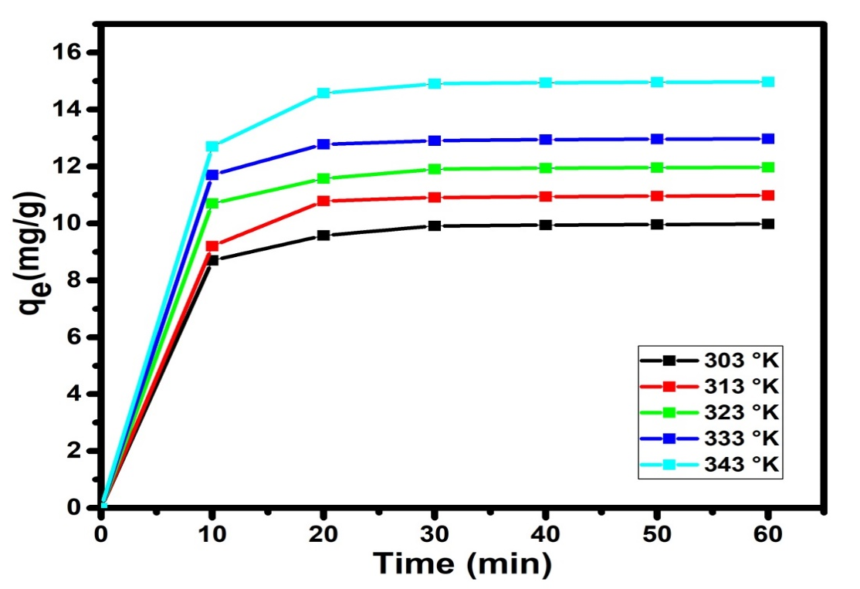
Figure 10: Effect of temperature adsorbent on CV adsorption.
3.6. Thermodynamic parameters
Important thermodynamic properties like Gibbs free standard energy ΔG° (Kj.mol⁻¹), standard enthalpy (ΔH°) (Kj.mol⁻¹)) and standard entropy (ΔS°) (Kj.mol⁻¹.K⁻¹) are calculated using the adsorbed relative amounts obtained at different temperatures .
The Gibbs free standard energy was evaluated by the equation below:
ΔG° = -$RTlnk_{d}$ (Eq.19)
The equilibrium constant $k_{d}$ was calculated using the ratio ΔS°:
$k_{d}=\frac{C_{0}-C_{e}}{C_{e}}$(Eq.20)
With $q_{e}$and $Ce$, the adsorbed amount (mg/g) and the equilibrium concentration of the metals in the solution (mg/L), respectively. The standard enthalpy (ΔH°) and entropy (ΔS°) values ​​were determined from the Van't Hoff equation:
$$Lnk_{d}=\frac{ΔS°}{R}-\frac{ΔH°}{RT} (Eq.21)$$ΔG° = ΔH° -TΔS° (Eq.22)
The representation of $lnk_{d}$ as a function of 1/T of the Van't Hoff equation is a line of slope ΔH°/R and intercept ΔS°/R, R is the universal gas constant (8.314 J/mol·K.).
The values ​​of (ΔH°) and (ΔS°) were deduced from the slope and the function $lnk_{d}$= f (1/T) gives the ordinate at the origin of the equation of the line. The thermodynamic data of the CV adsorption onto CAA are presented in Table 5. The values of ΔGº at 303, 313, 323, 333 and 343 K were calculated to be −21.134, −21.474, −21.805 and −22.145 KJ/mol, respectively, that confirmed that the adsorption of CV onto ACB was spontaneous and thermodynamically favorable. ΔG° decreases with increasing temperature of the solution. This can be explained by the fact that adsorption becomes easier, thus indicating the presence of a high drive strength. The values of ΔHº and ΔSº were -10.823 KJ/mol and 0.034 KJ/mol·K, respectively. The negative value of the standard enthalpy (ΔH°) indicates that the adsorption of CV on ACB is exothermic. Furthermore, analysis of the values of the standard enthalpy of adsorption (<40 kJ/mol) shows that it is a physisorption (Salifu et al., 2013). The positive value of (ΔS°) presents decreasing appearance at the solid/liquid interface during the adsorption CV were adsorbed by the adsorbent.

Table 5. Thermodynamic parameters of adsorption CV onto ACB
Dye | $$R^{2}$$ | ${∆H}^{0}$ (KJ/mol) | $${∆S}^{0}(KJ/mol.K)$$ | ${∆G}^{0}$(KJ/mol)
 |  |  |  | 293 K | 298 K | 303 K | 313 K
CV | 0.991 | -10.823 | 0.034 | -21.134 | -21.474 | -21.805 | -22.145

3.7. Comparison of adsorption capacity of Activated Carbon Prepared from Bos Indicus Gudali bones adsorbent with other available adsorbents.
For comparative purposes, Table 6 presents the adsorption capacities of various adsorbents. The data unequivocally demonstrate that Activated Carbon Prepared from Bos Indicus Gudali bones are significantly more efficient in removing Crystal Violet dye from aqueous solutions than several previously reported adsorbents.

Table 6. Comparison of maximum adsorption capacities of various types of adsorbents
Adsorbents
  q_{m} (mg/g)
  References
Date stone activated carbon
  12.02
  Alqaragully (2014)
Modified ball clay | 62.5 | Auta et Hameed.(2012)
Modified Mango Seeds | 69.07 | Mouthe et al. (2015)
Pozzolan | 0.576 | Moffo, 2016
Moroccan pyrophyllite | 13.88 | Miyah et al. (2016)
Zeolite a synthesized from coal fly ash |  | Jumaeri et al. (2017)
  10.672
  Coconut shell activated carbon
  46.53
  Aljeboree et al. (2017)
Modified Cameroonian local clay material | 114.54 | Tcheka et al. (2018)
Limon peel powders | 3.871 | Kagongbe et al. (2019)
Peanut husk | 20.95 | Sohail et al. (2021)
Calcium Carbonate from Chicken Eggshell Waste
  1.464
  Nandiyanto et al. (2024)
Naturel polysaccharide | - 10,80 | Mohamed et al. (2024)
Activated Carbon Bone | 17.331
  This work

This demonstrates the potential application of Activated Carbon Prepared from Bos Indicus Gudali Bones (ACB) (Picture 2) as a low-cost material for the efficient depollution of wastewater contaminated with Crystal Violet dye.
4. Conclusion
The results above indicate that ACB is a promising and new low cost adsorbent material for removal of CV from aqueous solutions. The kinetic studies of dyes on ACB indicated that the adsorption kinetics of dyes on ACB followed the pseudo- second order at different dye concentration values. The equilibrium data were analyzed. According to the results CV followed Langmuir isotherm models. Thermodynamic studies indicated that the dye adsorption onto ACB was a spontaneous, exothermic and physical reaction. Carbonaceous materials are thus commonly used in many domestic and industrial applications, particularly in the adsorption of pollutants. Among the carbonaceous materials, activated carbon, although used for a long time, continues to be developed, in particular due to the increasing demand for quality water. They are used in water purification channels, in the treatment of urban or industrial wastewater and also at home. This work has shown that activated carbons are complex porous materials but effective in complexing organic and / or inorganic pollutants. The most important parameter is their adsorption capacity. Activated carbons have excellent textural and physicochemical properties which explain their wide use as adsorbents, catalysts and catalyst support. However, it should be noted that the performance of activated carbons is intimately linked to the textural properties of the particles and to their surface chemistry. The control of the texture (in particular of the microporosity) is fundamental. It is also clear that it is essential to know the exact nature of the active sites (surface functional groups) and of the molecular surface interactions. All of this requires the implementation of investigation and characterization techniques so as to have a better understanding of the mechanisms of adsorption and regeneration to optimize and develop new carbons.
Research in the field of coal intended for water treatment will undoubtedly lead on a medium term to the development of materials perfectly suited to the resolution of specific problems to meet not only a better ease of implementation of operation, but also to new regulatory requirements. The appearance of new varieties of carbon (nanofibers, nanotubes) also portends vast developments to come. Finally, it seems, according to recent results on catalytic processes using carbon as catalyst supports or catalysts, that these coupling methods are efficient, economical, and technically feasible processes on an industrial scale.

Disclosure statement: Conflict of Interest: The authors declare that there are no conflicts of interest.
Compliance with Ethical Standards: This article does not contain any studies involving human or animal subjects.

References
Aaddouz, M., Azzaoui K., Akartasse N., Mejdoubi E. (2023). Removal of methylene blue from aqueous solution by adsorption onto hydroxyapatite nanoparticles. Journal of Molecular Structure, 1288, 135807. https://doi.org/10.1016/j.molstruc.2023.135807.
Abd El-Monaem, E.M., Elshishini, H.M., Bakr, S.S., El-Aqapa, H.G., Hosny, M., Andaluri, G., El-Subruiti, G.M., Omer, A.M., Eltaweil, A.S. (2023). A comprehensive review on LDH-based catalysts to activate persulfates for the degradation of organic pollutants. NPJ Clean Water. https://doi.org/10.1038/s41545-023-00245-x.
Adjia, Zangué., H, Ebio, Nko’o., G, Noumi, Guy, B., Villiéras, F., Kamga, R,. Kagongbe, D., Domga, R. (2019). Design and application of sintered clay pellets for the removal of methylene blue. International Journal of Applied Research, 5(1), 92-99.
Akbari, A., Remigy, J.C., Aptel, P. (2002). Treatment of textile dye effluents using a polyamide-based nanofiltration membrane. Chemistry Engineering and Processing, 41, 601–609.
Annadurai, G., Juang, R.S., Lee, D.J. (2002). Use of cellulose-based wastes for adsorption of dyes from aqueous solutions. Journal of Hazardous Materials, 92, 263–274.
Arbam, T., Domga, R., Dangwang, D., Younai, Felix., Djonga, w., Kagongbe, D., Ebio, N., Noumi, G. (2019). Adsorption of Cr (VI) onto clay modified by sodium chloride and clay modified by aluminum hydroxide of Karewa (North Cameroon). International Research Journal of Advanced Engineering and Science, 4(1), 247-255.
Asgari, G., Feradmal, J., Poormohammadi, A., Sadrnourmohamadi, M., Akbari, S., Taguchi. (2017). Optimization for the removal of high concentrations of phenol from saline wastewater using electro-Fenton process. Desalination and Water Treatment, 57, 27331–27338.
Asgari, G., Seid, Mohammadi, A.M., Poor, mohammadi, A., Ahmadian, M. (2014). Removal of cyanide from aqueous solution by adsorption onto bone charcoal. Fresenius Environmental Bulletin, 23, 720–727.
Asgher, M., Bhatti, H.N. (2012). Evaluation of thermodynamics and effect of chemical treatments on sorption potential of citrus waste biomass for removal of anionic dyes from aqueous solutions. Ecological Engineering, 38, 79–85.
Auta, M.,Hameed B,H. (2012). Modified mesoporous clay adsorbent for adsorption isotherm and
kinetics of methylene blue. Chem. Eng. J; 198–199:219–227.
Béné, M., Domga, Dangwang, D., Domga, R ., Tchatchueng, B., Kobbe-Dama, N., Tatsimo, S.( 2016). Preparation of crosslinked polyacrylamide hydrogels and their application to the removal of Manganese (II) ions from aqueous solution. International Journal of Innovation Sciences and Research, 6, (6), 996-1002.
Best, S.M., Porter, A.E., Thian, E.S., Huang, J. (2008). Bioceramics Past, present and for the future. Journal of European Ceramic Society, 28, 1319–1327.
Bhatti, H.N., Akhtar, N., Saleem, N. (2012). Adsorptive removal of methylene blue by low cost Citrus sinensis bagasse: equilibrium, kinetic and thermodynamic characterization. Arabian Journal of Science and Engineering, 37, 9–18.
Boukhlifi, F., Bencheikh, A. (2000). Caracterisation des biosorbants naturels utilises pour la depollution des eaux usees. Ann. Chim. Sci. Mat. 25, 153–160. https://doi.org/ 10.1016/S0151-9107(00)88722-X.
Chakraborty, S., Chowdhury, S., das Saha, P. (2011). Adsorption of Crystal Violet from aqueous solution onto NaOH-modified rice husk. Carbohydr. Polym. 86 https://doi. rg/10.1016/j.carbpol.2011.06.058
Chen, B., Hui, C.W., McKay, G. (2001). Film-pore diffusion modelling and contact time optimization for the adsorption of dyestuffs on pith. Chemical Engineering Journal, 84, 77– 94.
Daouda, Abia., Yowe, Kidwe., Domga, Richard., Domga., Massai, Harouna. (2019). Adsorption of Cu²⁺ and Cr⁶⁺ in Aqueous Solution by a Thermally Modified Biosorbent Based on Cotton Cakes. American Journal of Physical Chemistry,8 (4), 2019, 66-74.
Daouda, Abia., Amana, Tokodne., Noumi, Guy., Domga, Richard., Domga. (2019). Adsorption of Rhodamine B onto Orange Peel Powder. American Journal of Chemistry, 9, (5), 142-149.
Domga, Richard., Massai, Harouna., Tcheka, Constant., Tchatchueng , J, B., Arbam, Tsafam., Domga., Kobbe-Dama, Nathalie., Dangwang, Dikdim. (2015a). Batch Equilibrium, Kinetic and Thermodynamic Studies on the Adsorption of Methylene Blue in Aqueous Solution onto Activated Carbon Prepared from Bos Indicus Gudali Bones. chemistry journal, 1(6), 172-181.
Domga R, Togue-Kamga F, Noubactep C, Tchatchueng JB. (2015b). Discussing porosity loss
of Fe⁰ packed water filters at ground level. Chemical Engineering Journal 263:127-134.
Domga, Richard., Tcheka, Constant., Mouthe, A, G, A., Kobbe-Dama, Nathalie., Domga., Tchatchueng, J, B., Alifa, Tchigo., Arbam, Tsafam. (2016). Batch equilibrium adsorption of methyl orange from aqueous solution using animal activated carbon from gudali bones. International Journal of Innovation Sciences and Research, 5 (7), 798-805.
Domga R, Togue-Kamga F, Tchatchueng JB (2017). Mathematic analysis of porosity loss in granular metallic iron (Fe⁰) water filter. International Journal of Emerging Engineering Research and Technology 5(11): 28-35.
Domga, Richard., Domga., Tchatchueng, J, B., Nyounai, Félix., Fadeune, G, S., Fabane, Fidèle., Béné, Mathieu., Assokeng, Thomas., Arbam, Tsafam., NÔN, B, E. (2018). Synthesis of animal activated carbon from gudali (bos inducus) bones and its adsorption for chromium (VI) in aqueous solution. International Journal of Engineering Research and Science and Techology, 7 (1) 1-15.
Domga Richard, Musongo Balike, Kom Blaise, Inna Samomssa, Heukwa-Tefoung Anne, Togue Kamga Fulbert, Tchatchueng Jean Bosco (2025). A new model for analysing porosity loss in metallic iron packed-beds for water treatment Journal of Material and Environmental Sustainability Research, 5(4):38-50.
Domga Richard (2025). Removal of the methylene blue using activated charcoal derived from the
pyrolisis of Gudali (Bos Indicus) bones Generis Publishing 56p.
EL-Geundi, M.S. (1997). Adsorbents for industrial pollution control. Adsorption Science and Technology,15, 777–787.
El Hammari, L., Hamed, R., Azzaoui, K., et al. (2023). Optimization of the adsorption of lead (II) by hydroxyapatite using a factorial design: Density functional theory and molecular dynamics. Frontiers in Environmental Science, 11, 112019. https://doi.org/10.3389/fenvs.2023.1112019.
Eltaweil, A.S., Bakr, S.S., Abd El-Monaem, E.M., El-Subruiti, G.M. (2023). Magnetic hierarchical flower-like Fe3O4@ZIF-67/CuNiMn-LDH catalyst with enhanced redox cycle for Fenton-like degradation of Congo red: optimization and mechanism. Environ. Sci. Pollut. Res. 30 https://doi.org/10.1007/s11356-023-27430-2.
Erdem, E., Karapinar, N., Donat, R. (2004). The removal of heavy metal cations by natural zeolites. J. Colloid Interface Sci. 280 https://doi.org/10.1016/j.jcis.2004.08.028.
Fathi, A., Boutaleb, N., Bahlaouan, B., Bennani, M., Lazar, S., and El Antri, S. (2021). Filamentous fungi and natural supports as a carrier in moving bed biofilm reactors for ecological treatment of halieutic industrial effluent. Desalination and water treatment, 237, 37-44.
Fernandes, A., Morao, A., Magrinho, M., Lopes, A., Goncalves, I. (2004). Electrochemical degradation of C. I. Acid Orange 7. Dyes and Pigments, 61, 287–296.
Figueiredo, M., Fernando, A., Martins, G., Freitas, J., Judas, F., Figueiredo, H. (2010). Effect of the calcination temperature on the composition and microstructure of hydroxyapatite derived from human and animal bone. Ceramic International, 36, 2383–2393.
Figueiredo, M., Henriques, J., Martins, G., Guerra, F., Judas, F., Figueiredo, H. (2009). Physicochemical characterization of biomaterials commonly used in dentistry as bone substitutes-comparison with human bone. Journal of Biomaterials Materials Research, 92B, 409–419.
Ghasemi, N., Ghasemi, M., Moazeni, S., Ghasemi, P., Alharbi, N.S., Gupta, V.K., Agarwal, S. Burakova, I.V., Tkachev, A.G. (2018). Zn (II) removal by amino-functionalized magnetic nanoparticles: kinetics, isotherm, and thermodynamic aspects of adsorption. Journal of Industrial and Engineering Chemistry, 62, 302–310.
Gupta, V, K., Pathania, D., Agarwal, S., Sharma, S. (2012). Decoloration of hazardous dye from water system using chemically modified Ficus carica adsorbent. Journal of Molecular Liquids, 174, 86–94.
Hammou, A., Moussout, H., Slimani, M.Y.S., Boukhlifi, F., Daou, I. (2014). Bentonite/chitosan biocomposite as an adsorbent for hexavalent chromium from aqueous solutions. J. Adv. Chem. 10, 2786–2795. https://doi.org/10.24297/jac.v10i6.883.
Haq, I., Bhatti, H.N., Asgher, M. (2011). Removal of solar red BA textile dye from aqueous solution by low cost barley husk: equilibrium, kinetic and thermodynamic study. Canadian Journal of Chemical Engineering, 89, 593–600.
Hernández-Montoya, V., Ramírez-Montoya, L.A., Bonilla-Petriciolet, A., Montes- Morán, M.A. (2012). Optimizing the removal of fluoride from water using new carbons obtained by modification of nut shell with a calcium solution from egg shell. Biochemical Engineering Journal, 62, 1–7.
Ho, Y.S., McKay, G. (1998). Sorption of dye from aqueous solution by peat. Chemical Engineering Journal, 70, 115–124.
Jumaeri., E Kusumastuti., S. J, Santosa., Sutarno. (2017). Adsorption of crystal violet dye using zeolite a synthesized from coal fly ash, IOP Conf. Ser.: Mater. Sci. Eng. 172 012028.
Kagne, S., Jagtap, S., Dhawade, P., Kamble, S.P., Devotta, S.. Rayalu, S.S. (2008). Hydrate cement: a promising adsorbent for the removal of fluoride from aqueous solution. Journal of Hazardous Materials, 154, 88–95.
Kagongbe D.,Adjia Zangue H., Inna S., Noumi Guy B., Villieras F., and Ebio Nko’o G.(2019). Removal of Violet Crystal from Aqueous Solution by Limon Peel Powders from Adamawa Region of Cameroon, International Journal of Engineering Research & Technology, Vol. 8,Issue 07.
Kali, A., Amar, A., Loulidi, I., Hadey, C., Jabri, M., Alrashdi, A.A., Lgaz, H., Sadoq, M., El-Kordy, A., Boukhlifi, F. (2022a). Efficient adsorption removal of an anionic azo dye by lignocellulosic waste material and sludge recycling into combustible briquettes. Colloids Interfaces 6. https://doi.org/10.3390/colloids6020022.
Kali, A., Amar, A., Loulidi, I., Jabri, M., Hadey, C., Lgaz, H., Alrashdi, A.A., Boukhlifi, F.(2022b). Characterization and adsorption capacity of four low-cost adsorbents based on coconut, almond, walnut, and peanut shells for copper removal. Biomass Convers. Biorefin. https://doi.org/10.1007/s13399-022-02564-4.
Kali, A., Dehmani, Y., Loulidi, I., Amar, A., Jabri, M., El-kord, A., Boukhlifi, F. (2022c). Study of the adsorption properties of an almond shell in the elimination of methylene blue in an aquatic. Moroccan J. Chem. 10, 509–522. https://doi.org/ 10.48317/IMIST.PRSM/morjchem-v10i3.33140.

Kannan, N., Sundaram, M.M. (2001). Kinetics and mechanism of removal of methylene blue by adsorption on various carbons-a comparative study, Dyes and Pigments, 51, 25–40.
Khan, S., Ali, S., Muhammad, S., Khan, B., Ali, A., Hesham, E. L., and Begum, S. (2020). Bacterial contamination in drinking water of urban Peshawar: a comparative study at the sources and user points of tube wells. Desalination and Water Treatment, 181, 221-227.
Laasri, L., Elamrani, M.K., Cherkaoui, O. (2007). Removal of two cationic dyes from a textile effluent by filtration-adsorption on wood sawdust. Environ. Sci. Pollut. Res. https://doi.org/10.1065/espr2006.08.331.
Landi, E., Celotti, G., Logroscino, G., Tampieri, A. (2003). Carbonated hydroxyl-apatite as bone substitute. Journal of European Ceramic Society, 23, 2931–2937.
Le, O.T.H., Tran, L.N., Doan, V.T., van Pham, Q., van Ngo, A., Nguyen, H.H. (2020). Mucilage extracted from dragon fruit peel (Hylocereus undatus) as flocculant for treatment of dye wastewater by coagulation and flocculation process. Int. J. Polym. Sci. https://doi.org/10.1155/2020/7468343.
Lee, Y.C., Kim, E.J., Yang, J.W., Shin, H.J. (2011). Removal of malachite green by adsorption and precipitation using aminopropyl functionalized magnesium phyllosilicate. J. Hazard. Mater. 192 https://doi.org/10.1016/j. jhazmat.2011.04.094.
Leyva-Ramos, R., Rivera-Utrilla, J., Medellin-Castillo, N, A., Sanchez-Polo, M. (2010). Kinetic modeling of fluoride adsorption from aqueous solution onto bone char. Chemical Engineering Journal, 158, 458–467.
Leivisk¨a, T., Leskel¨a, T., Tanskanen, J .(2019). Effect of alkali regeneration on pore characteristics and performance of ferric oxyhydroxide and akagan´eite sorbents. J. Water Process Eng. 31 https://doi.org/10.1016/j.jwpe.2019.100838.
Mahmoodi, N.M., Arami, M. (2006). Bulk phase degradation of Acid Red 14 by nanophotocatalysis using immobilized titanium (IV) oxide nanoparticles. Journal of Photochemistry and Photobiology A. Chemistry, 182, 60–66.
Mall, I.D., Srivastava, V.C., Agarwal, N.K., Mishra, I.M. (2005). Removal of congo red from aqueous solution by bagasse fly ash and activated carbon: kinetic study and equilibrium isotherm analyses, Chemosphere, 61, 492–501.
Meshko, V., Markovska, L., Mincheva, M., Rodrigues, A.E. (2001). Adsorption of basic dyes on granular activated carbon and natural zeolite. Water Research, 35, 3357–3366.
Mishra R. K., Mentha S. S., Misra Y., Dwivedi N. (2023) Emerging pollutants of severe environmental concern in water and wastewater: A comprehensive review on current developments and future research, Water-Energy Nexus, 6, 74-95, https://doi.org/10.1016/j.wen.2023.08.002.
Mittal, A., Mittal, J., Malviya, A., Kaur, D., Gupta, V.K. (2010). Adsorption of hazardous dye crystal violet from wastewater by waste materials. J. Colloid Interface Sci. 343 https://doi.org/10.1016/j.jcis.2009.11.060.
Miyah, Y., Anissa Lahrichi., Meryem Idrissi., Saı¨d Boujraf., Hasnae Taouda ., Farid Zerrouq . (2016).
Assessment of adsorption kinetics for removal potential of Crystal Violet dye from aqueous
solutions using Moroccan pyrophyllite. Journal of the Association of Arab Universities for
Basic and Applied Sciences, http://dx.doi.org/10.1016/j.jaubas.2016.06.001.
Mkukuma, L.D., Skakle, J.M.S., Gibson, I.R., Imrie, C.T., Aspden, R.M., Hukins, D.W.L. (2004). Effect of the proportion of organic material in bone on thermal decomposition of bone mineral: an investigation of a variety of bones from different species using thermogravimetric analysis coupled to mass spectrometry, high temperature X-ray diffraction, and Fourier transform infrared spectroscopy. Calcified Tissue International, 75, 321–328.
Moffo Fosso. (2016). Etude de l’adsorption des colorants par la pouzzolane en milieu aqueux : cas du
cristal violet, Mémoire présenté en vue de l’obtention du diplôme de professeur de
l’enseignement secondaire deuxième grade, Université de Yaoundé I, 53p.
Mohamed, Sadoq., Hafssa, Atlas., Smail, Imame., Abderahim, Kali., Abdelouahed, Amar., Ilyasse,
Loulidi., Maria, Jabri., Badr-Edine, Sadoq., Mbarka, Ouchabi., Palsan, Sannasi. Abdullah.,
Fatima, Boukhlifi. (2024). Elimination of crystal violet from aqueous solution by adsorption
on naturel polysaccharide: Kinetic, isotherm, thermodynamic studies and mechanism
analysis, Arabian Journal of Chemistry, 17,105453.
Mohammadine, E, H., Rachid, S., Rachid, M., Saïd, ElAntri., Saïd, Lazar. (2013). Removal of two textile dyes from aqueous solutions onto calcined bones. Journal of the Association of Arab Universities for Basic and Applied Sciences, 14(1), 51-59, DOI: 10.1016/ j.jaubas.2013.03.002.
Mohan, D., Kumar, S., Srivastava, A. (2014). Fluoride removal from ground water using magnetic and nonmagnetic corn stover biochars. Journal of Ecological Engineering, 73, 798–806.
Morais, L.C., Freitas, O.M., Goncalves, E.P., Vasconcelos, L.T., Gonzaa Lez Bec, C.G. (1999). Reactive dyes removal from wastewaters by adsorption on eucalyptus bark: variables that define the process. Water Research, 33, 979–988.
Moreno-Piraján J.C, Gómez-Cruz R., García-Cuello V.S., Giraldo L. (2010). Binary system Cu(II)/Pb(II) adsorption on activated carbon obtained by pyrolysis of cow bone study. Journal of Analytical and Applied Pyrolysis, 89, 122–128.
Mouthe, Anombogo, Ghislain, Arnaud., Andrada, Măicăneanu., Jean, Baptiste, Bike, Mbah., Chrisdel, Chancelice, Ndjeumi., Richard Kamga. (2015). Optimitization of Crystal
Violet Adsorption Performances on to H₃PO₄⁻Modified Mango Seeds Kernel using a Box
Behnken Experimental Design. Int.J. ChemTech Res.,8(11), 502-510.
Nandiyanto A.B.D., Putri M. E., Fiandini M., Ragadhita R., Kurniawan T., Farobie O., Bilad M. R.
(2024) Characteristics of Ammonia Adsorption on Various Sizes of Calcium Carbonate
Microparticles from Chicken Eggshell Waste, Mor. J. Chem., 12(3), 1073-1096.
Nidheesh, P.V., Zhou, M., Oturan, M.A. (2018). An overview on the removal of synthetic dyes from water by electrochemical advanced oxidation processes. Chemosphere 197. https://doi.org/10.1016/j.chemosphere.2017.12.195.
Paschalis, E.P., Betts, F., DiCarlo, E., Mendelsohn, R., Boskey, A.L. (1997). FTIR microspectroscopic analysis of normal human cortical and trabecular bone. Calcified Tissue International, 61, 480–486.
Patela, S., Hanb, J., Qiu, W., Gao, W. (2015). Synthesis and characterization of mesoporous bone char obtained by pyrolysis of animal bones, for environmental application. Journal of Environment Chemical Engineering, 3, 2368–2377.
Pavan, FA., Camacho, E,S., Lima, E,C., Dotto, G, L., Branco, V, T, A., Dias, S, L, P. (2014). Formosa papaya seed powder (FPSP): preparation, characterization and application as an alternative adsorbent for the removal of crystal violet from aqueous phase. Journal of Environment Chemical Engineering, 2, 230–238.
Petrović, M., Šoštarić, T., Stojanović, M., Milojković, J., Mihajlović, M., Stanojević, M., Stanković, S. (2016). Removal of Pb²⁺ ions by raw corn silk (Zea mays L.) as a novel biosorbent. Journal Taiwan Institute Chemical Engineers, 58, 407–416.
Ravikumar, K., Krishnan, S., Ramalingam, S., Balu, K. (2007). Optimization of process variables by the application of response surface methodology for dye removal using a novel adsorbent. Dyes and Pigments, 72, 66–74.
Rehman, I., Bonfield, W. (1997). Characterization of hydroxyapatite and carbonated apatite by photo acoustic FTI, spectroscopy. Journal of Materials Science: Materials in Medicine, 8, 1–4.
Rojas-Mayorga, C.K., Silvestre-Albero, J., Aguayo-Villarreal, I.A., Mendoza-Castillo, D.I. Bonilla-Petriciolet, A. (2015). A new synthesis route for bone chars using CO₂ atmosphere and their application as fluoride adsorbents. Microporous Mesoporous Mater, 209, 38–44.
Rojas-Mayorgaa, C.K., Bonilla-Petricioleta, A., Aguayo-Villarreala, I, A., Hernández- Montoyaa, V., Moreno-Virgena, M.R., Tovar-Gómeza, R., Montes-Morán M.A. (2013). Optimization of pyrolysis conditions and adsorption properties of bone char for fluoride removal from water. Journal of Analytical and Applied Pyrolysis, 104, 10–18.
Safa, Y., Bhatti, H.N. (2011a). Kinetic and thermodynamic modeling for the removal of Direct Red 31 and Direct Red 26 dyes from aqueous solutions by rice husk. Desalination, 273, 313–322.
Safa, Y., Bhatti, H, N. (2011b). Adsorptive removal of direct textile dyes by low cost agricultural waste: application of factorial design analysis. Chemical Engineering Journal, 167:35– 41.
Salifu, A., Petrusevski, B., Ghebremichael, K., Modestus, L., Buamah ,R., Aubry C., Amy, G.L. Aluminum (hydr)oxide coated pumice for fluoride removal from drinking water: synthesis, equilibrium, kinetics and mechanism. Chemical Engineering Journal., 2013, 228, 63–74.
Sharma, S., and Bhattacharya, A. J. A. W. S. (2017). Drinking water contamination and treatment
techniques. Applied water science, 7(3), 1043-1067.
Senthilkumaar, S., Kalaamani, P., Subburaam, C. (2006). Liquid phase adsorption of Crystal violet onto activated carbons derived from male flowers of coconut tree. J. Hazard Mater. 136 https://doi.org/10.1016/j.jhazmat.2006.01.045
Sheibani, M., Zare-Shahabadi, V., Ghaedi, M., Asfaram, A., Anaraki-Ardakani, H. (2021). Designing, modelling, and optimising amido black and Eosin B dyes adsorption on MWCNT/ZrO2/Pb nanocomposites from aqueous solution by response surfacemethodology. Int. J. Environ. Anal. Chem. https://doi.org/10.1080/03067319.2021.1980784.
Sivaraj, R., Namasivayam, C., Kadirvelu, K. (2001). Orange peel as an adsorbent in the removal of acid violet 17 (acid dye) from aqueous solutions. Waste Management, 21,105 -110.
Sohail Abbas, Tariq Javeed, Shagufta Zafar, Muhammad Babar Taj, Ahmad Raza Ashraf, Muhammad Imran Din. (2021). Adsorption of crystal violet dye by using a low-cost adsorbent – peanut husk , Desalination and Water Treatment , 233, 387–398.
Srivastava, S.K., Gupta, V.K., Dwivedi, M.K., Jain, S. (1995). Caesium PVC-Crown (dibenzo-24-crown-8) based membrane senso. Analytical Proceedings Including Analytical Communication, 32, 21–23.
Tabaght, F.E, Azzaoui, K., Idrissi, A.E., et al., (2023). Synthesis, characterization, and biodegradation studies of new cellulose-based polymers. Scientific Reports, 13, 1673. https://doi.org/10.1038/s41598-023-28298-5.
Tadic, D., Epple, M. (2004). A thorough physicochemical characterization of 14 calcium phosphate-based bone substitution materials in comparison to natural bone. Biomaterials ,25, 987–994.
Tcheka, C., Raluca P., Andrada, M., Nkuigue, F., Hamou, M., Domga, Richard. (2018). Tetra-n-butylammonium bromide (TBAB) modified cameroonian local clay material for adsorption of crystal violet dye from aqueous solution. Advancements in Materials, 2, 1-16.
Tomar, V., Prasad, S., Kumar, D. (2013). Adsorptive removal of fluoride from water samples using Zr–Mn composite material. Microchemical Journal, 111, 116–124.
Varghese, A.G., Paul, S.A., Latha, M.S. (2019). Remediation of heavy metals and dyes from wastewater using cellulose-based adsorbents. Environ. Chem. Lett. https://doi. org/10.1007/s10311-018-00843-z.
Yao, S., Zhang, J., Shen, D., Xiao, R., Gu, S., Zhao, M., Liang, J. (2016). Removal of Pb (II) from water by the activated carbon modified by nitric acid under microwave heating. Journal Colloid Interface Science, 463, 118–127.

