Phytochemical characterization of Hedyotis purpurascens Hook.f. ethanolic leaf extract using HPLC and FTIR with standard comparison

Abstract
Medicinal plants continue to be an important source of structurally varied bioactive chemicals. The current study used High-Performance Liquid Chromatography (HPLC) and Fourier Transform Infrared (FTIR) spectroscopy to create a chemical fingerprint of Hedyotis purpurascens Hook.f.'s ethanolic leaf extract. Ampelopsin, quercetin, and myricetin were used as reference standards in a comparative HPLC analysis. The extract's chromatographic profile revealed twelve different peaks, including a prominent peak at 4.919 min that corresponded closely to Ampelopsin's retention time (4.992), indicating its presence. FTIR research revealed characteristic absorption bands for phenolic, aromatic, carbonyl, amine, and alkane functional groups. The comprehensive analytical results give a reliable chemical signature for H. purpurascens and support its phytochemical diversity. This work establishes a foundation for future pharmacological validation and quality standards.
Keywords: Hedyotis purpurascens, HPLC, FTIR, Ampelopsin, phytochemical profiling

1. Introduction
Plant-derived secondary metabolites continue to make substantial contributions to current medication discovery. Natural products are a valuable source of innovative chemical scaffolds with potential therapeutic applications (Newman & Cragg, 2020). Analytical characterisation of medicinal plants is critical to guaranteeing quality, repeatability, and biological validity. Chromatographic fingerprinting with HPLC is generally recognized as a dependable analytical method for the separation and identification of phytoconstituants. HPLC allows for exact separation of phytoconstituents, whereas FTIR spectroscopy permits quick identification of functional groups (Snyder et al., 2010; Stuart, 2015). Furthermore, FTIR spectroscopy allows for fast functional group analysis and acts as an authentication method in herbal standardization.
Hedyotis purpurascens Hook.f., belonging to the Rubiaceae family, is traditionally utilized in indigenous medicinal systems; however, detailed chemical profiling remains limited. Establishing a reproducible phytochemical signature is essential for pharmacognostic validation and future therapeutic exploration. The present study integrates HPLC comparison with flavonoid standards and FTIR spectral analysis to characterize the ethanolic leaf extract of H. purpurascens.

2. Materials and Methods
2.1 Plant Material and Extraction
Shade-dried leaf powder of Hedyotis purpurascens was extracted using sequential solvent extraction (petroleum ether, ethyl acetate, ethanol and aqueous) using soxhlet apparatus and maceration techniques. The extract was filtered and concentrated prior to analysis.
2.2 HPLC Analysis
High Performance Liquid Chromatography (HPLC) analysis was carried out to identify and compare the phytoconstituents present in the plant extract with reference standards of ampelopsin, myricetin, and quercetin. The analysis was performed using a reverse-phase HPLC system (Shimadzu/Agilent system equipped with a UV–Visible detector). Separation was achieved on a C18 reversed-phase column (250 mm × 4.6 mm, 5 µm particle size). The flow rate was maintained at 1.0 mL/min with an injection volume of 20 µL. Detection was carried out at 254 nm. The total run time was 20–30 minutes.
The plant extract was filtered through a 0.45 µm membrane filter prior to injection. Standard solutions of ampelopsin, myricetin, and quercetin were produced separately in HPLC-grade methanol at known concentrations and filtered prior to analysis. Compounds in the extract were identified by comparing peak retention durations and UV spectra to those of reference standards.
2.3 FTIR Analysis

Fourier Transform Infrared (FTIR) analysis was carried out on a PerkinElmer Spectrum Two FTIR spectrophotometer (PerkinElmer Inc., USA) with a diamond Attenuated Total Reflectance (ATR) accessory. The dried plant extract was directly put to the ATR crystal surface, with steady pressure applied to achieve good contact between the sample and the crystal. Spectral data were collected in the mid-infrared range (4000-400 cm⁻¹) at a resolution of 4 cm⁻¹, with 16 scans per sample. A background spectrum was acquired before each study to eliminate ambient and instrumental interferences. The spectra were analyzed using the instrument's software, and the characteristic absorption bands were used to identify the functional groups in the extract.

3. Results and Discussion
3.1 HPLC Profile of ethanolic leaf extract
The HPLC chromatogram of the ethanolic leaf extract exhibited twelve well-resolved peaks within a retention window of 2.7–28.2 min by indicating the presence of multiple secondary metabolites with varying polarity (Table 1; Fig. 1). The chromatographic separation exhibited quality peak symmetry and baseline resolution, suggesting appropriate method suitability for phytochemical fingerprinting.
Table 1: Table representing the peaks obtained in HPLC
S.NO | Retention time  (min) | Area  [mAU] | Height  [mAU] | Area  (%) | CONCENTRATION
1 | 2.769 | 12087093 | 2126.077 | 12.08 | 27.106
2 | 4.003 | 5139365 | 391.102 | 5.139 | 11.525
3 | 4.359 | 393281 | 106.538 | 0.393 | 0.882
4 | 4.919 | 19157014 | 972.957 | 19.15 | 42.961
5 | 5.675 | 2091922 | 114.380 | 2.091 | 4.691
6 | 13.585 | 363072 | 21.669 | 0.363 | 0.814
7 | 14.643 | 725744 | 44.861 | 0.725 | 1.628
8 | 17.833 | 3525649 | 213.803 | 3.525 | 7.907
9 | 18.689 | 368811 | 14.925 | 0.368 | 0.827
10 | 23.763 | 322178 | 20.274 | 0.322 | 0.723
11 | 26.103 | 152692 | 15.017 | 0.152 | 0.342
12 | 28.211 | 264621 | 18.077 | 0.264 | 0.593

Figure 1: HPLC chromatogram of H. purpurascens extract
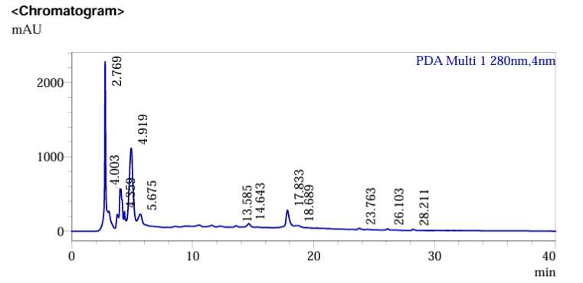
During the detection of constituents, a prominent peak appeared at 4.919 min with an area of 19,157,014 mAU which contributes 42.96% of the total chromatographic area. The high relative abundance of this peak indicates that, the compound is a dominant phytochemical in the ethanolic extract. When compared with authenticated standards (Ampelopsin. Quercetin and Myricetin) taken under study it is observed that under identical chromatographic conditions, the retention time closely matched with that of the standard Ampelopsin (4.992 min). Minor variation in retention time (±0.07 min) falls within acceptable analytical deviation limits for HPLC comparison (Snyder et al., 2010).
Table: 2 Table represents the comparison of the standards
Standard | Retention Time (min) | Area (mAU) | Concentration (µg/mL)
Ampelopsin | 4.992 | 458624 | 10
Quercetin | 6.111 | 856321 | 10
Myricetin | 10.990 | 903517 | 10

Figure 2: HPLC chromatogram of Ampelopsin standard
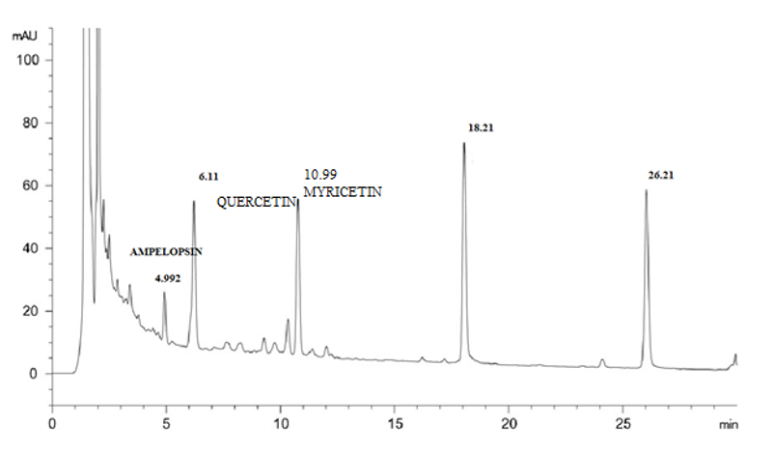
The absence of detectable peaks corresponding to Quercetin (6.111 min) and Myricetin (10.990 min) suggests that either these flavonols are absent or present below the detection threshold under the study conditions (Table:2; Fig:2). Such variability in flavonoid composition is common among the Rubiaceae family members and is influenced by ecological factors, developmental stage, and extraction solvent polarity (Gouveia & Castilho, 2011). Earlier in the HPLC and FTIR profiling of the inflorescence of Hedyotis purpurascens, nine chromatographic peaks were identified with rutin confirmed at 3.795 min, closely matching the standard (3.811 min). Rutin accounted for 27.29% of the peak area, indicating its prominence as a flavonoid marker (Betty T. et al., 2024).
The earlier eluted peaks (2.769–5.675 min) may represent relatively polar phenolic constituents, whereas late eluted peaks (17.833–28.211 min) correspond to less polar or more structurally complex molecules. Similar multi-peak chromatographic patterns have been reported in other medicinal plants that are rich in flavonoids and phenolic acids (Dai & Mumper, 2010; Ignat et al., 2011).
3.2 Confirmation and Significance of Ampelopsin (Dihydromyricetin)
The chromatographic analysis revealed a clear and well-resolved separation of the phytoconstituents present in the extract. The retention time of the ampelopsin standard (4.992 min) closely matched that of the corresponding peak in the extract (4.919 min), thereby confirming its occurrence in the sample. The substantial peak area percentage (42.96%) indicates that ampelopsin constitutes a major phytochemical component. Ampelopsin, also referred to as dihydromyricetin (DHM) (Fig. 3), is a naturally occurring flavonoid predominantly isolated from Ampelopsis grossedentata and Hovenia dulcis. Traditionally consumed as vine tea in East Asia, it has attracted considerable scientific interest due to its diverse pharmacological properties (Wu et al., 2013). Its identification in Hedyotis purpurascens further enhances the chemotaxonomic and pharmacognostic relevance of the species.
Figure 3: Structure of Ampelopsin
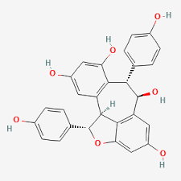
Phenolic compounds are extensively acknowledged for their anti-inflammatory properties, primarily attributed to the suppression of cyclooxygenase pathways and mitigation of oxidative stress. Ampelopsin (dihydromyricetin) has been documented to exert significant antioxidant and anti-inflammatory activities through regulation of the NF-κB signaling pathway (Zhang et al., 2018). Additionally, accumulating evidence indicates that DHM can safeguard neuronal cells from oxidative and inflammatory injury, underscoring its potential therapeutic significance in neurodegenerative disorders (Sun et al., 2022). Further investigations have also demonstrated its hepatoprotective, neuroprotective, and anticancer effects, largely mediated by the induction of apoptosis and modulation of mitochondrial signaling mechanisms (Wu et al., 2013; Zuo et al., 2018; Chen et al., 2015).
The notably high peak area percentage (42.96%) suggests that ampelopsin could be considered a promising chemical marker for the quality control and standardization of this species. Marker-based standardization approaches are increasingly advocated in herbal drug validation to maintain reproducibility and ensure batch-to-batch uniformity (Li et al., 2008).
3.3 Interpretation of Minor Peaks and Phytochemical Diversity
Polyphenolic-rich plant extracts typically exhibit synergistic biological activity, where minor compounds enhance or modulate the activity of major constituents (Wagner & Ulrich-Merzenich, 2009). Although Ampelopsin dominated the chromatographic profile, other peaks collectively accounted for approximately 57% of the total area, indicating a chemically diverse extract. Peaks observed at 2.769 min (12.08%) and 17.833 min (7.907%) represent substantial secondary constituents that warrant future isolation and structural elucidation.
3.4 FTIR Spectral Analysis and Functional Group Characterization
The FTIR spectrum revealed prominent absorption bands corresponding to hydroxyl (3365.17 cm⁻¹), aliphatic C–H (2972.73 and 2924.52 cm⁻¹), carbonyl and conjugated C=C groups (1667.16 and 1514.81 cm⁻¹), and C–O/C–N stretching vibrations (1268.93–1038.48 cm⁻¹), indicating the presence of phenolic and aromatic constituents. The broad O–H stretching band confirms hydrogen-bonded hydroxyl groups’ characteristic of polyphenolic compounds. These functional features are consistent with flavonoid structures, particularly ampelopsin (dihydromyricetin), which contains multiple hydroxyl substituents and aromatic rings. Thus, the FTIR profile substantiates the occurrence of bioactive flavonoids and supports the chromatographic identification of ampelopsin in the extract. (Table: 3; Fig: 4)
The FTIR findings complement the HPLC data by confirming functional groups typically associated with flavonoids. Infrared fingerprinting serves as a rapid authentication tool for herbal materials and is widely employed in pharmacognostic standardization (Kumar et al., 2014). Combining chromatographic profiling with FTIR functional group analysis enhances analytical confidence and reduces the possibility of misidentification. Such integrated approaches are recommended for herbal drug authentication and quality control (World Health Organization, 2011). Although extended calibration would enhance precision, the present validation confirms method suitability for phytochemical screening.

Figure 4: FTIR spectrum of ethanolic leaf extract
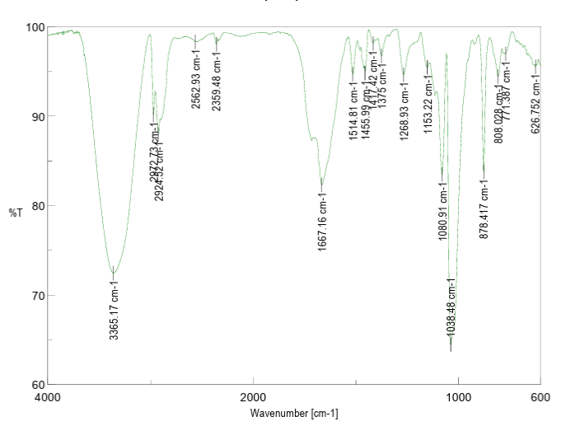
Table 3: Table represents the functional groups in FTIR
S.NO | FUNCTIONAL GROUP/ASSINGMENT | TYPES OF INTENSITY | CHARACTERISTIC ABSORPTION  (cm-1)
1 | Phenols & Alcohols  O-H (free), usually sharp  O-H (H-Bonded), usually broad | Stretching Vibration,  H-bonded- Strong | 3365.17
2 | Alkanes  CH3, CH2, CH | Stretching Vibration, Strong | 2972.73  2924.52
3 | Carboxylic Acids & Derivatives  O-H (Very broad) | Stretching Vibration, Strong | 2562.9
4 | Aldehydes  H-C=O | C-H Stretch off C=O | 2359.48
5 | Arenes  C=C(in ring) (2 bands)  (3 if conjugated) | Stretching Vibration, mid-weak | 1514.81
6 | Alkenes  C=C | Stretching Vibration, Variation | 1667.16
7 | Aromatic Alkanes compounds  CH2 & CH3 deformation | Bending Vibration, Medium | 1455.99
8 | Aldehydes & Ketones  CH2 | Bending Vibration, Medium | 1417.42
9 | Alkanes  CH3 | Bending Vibration, CH3 Deformation | 1375
10 | Carboxylic Acids & Derivatives  O-C (sometimes 2-peaks)) | Stretching Vibration, Medium | 1268.93
11 | Amines  C-N | Stretching Vibration, Medium Strong | 1153.22  1080.91  1038.48
12 | Arenes  C-H bending& ring puckering | Bending Vibration, strong-Medium | 878.41  808.03  771.38
13 | Alkynes  C-H Deformation | Bending Vibration, Strong | 626.752

Bottom of Form

4. Conclusion
HPLC analysis gives vital information about the extract's biological significance by allowing for the accurate identification and quantification of its bioactive ingredients. The identification and comparison of retention times with reference standards demonstrate the existence of pharmacologically important substances. Quantitative calculation using peak area confirms the contribution of main ingredients to observed biological activity. Thus, HPLC profiling not only validates the phytochemical composition but also enhances the relationship between chemical markers and medicinal potential, confirming the species' reliability and uniformity.
FTIR analysis provides biological insight by identifying functional groups associated with bioactive phytochemicals in the extract. The presence of phenolic, hydroxyl, carbonyl, and aromatic groups suggests compounds with antioxidant and anti-inflammatory potential. Thus, FTIR supports the biochemical basis of the plant’s therapeutic activity and complements chromatographic findings.
Integrated HPLC and FTIR investigations indicate a consistent phytochemical profile for Hedyotis purpurascens ethanolic leaf extract. The proven existence of Ampelopsin in H. purpurascens suggests that it may have medicinal potential and the confirmation of Ampelopsin, as well as the existence of various functional groups, lends support to additional pharmacological research.

References
Betty, T., Malini, R. P., Vasini, V., & Sumathi, P. (2024). Analysis of bioactive compounds in Hedyotis purpurascens inflorescence using HPLC and FTIR techniques. Journal of Xidian University, 18(4). https://doi.org/10.5281/zenodo.10936152
Chen, S., Zhao, X., Wan, J., Ran, L., Qin, Y., Wang, X., Gao, Y., Shu, F., Zhang, Y., Liu, P., Zhang, Q., Zhu, J., & Mi, M. (2015). Dihydromyricetin improves glucose and lipid metabolism and exerts anti-inflammatory effects in nonalcoholic fatty liver disease: A randomized controlled trial. Pharmacological research, 99, 74–81. https://doi.org/10.1016/j.phrs.2015.05.009
Dai, J., & Mumper, R. J. (2010). Plant phenolics: extraction, analysis and their antioxidant and anticancer properties. Molecules (Basel, Switzerland), 15(10), 7313–7352. https://doi.org/10.3390/molecules15107313.
Gouveia, S., & Castilho, P. C. (2011). Characterisation of phenolic acid derivatives and flavonoids from different morphological parts of Helichrysum obconicum by a RP-HPLC-DAD-(-)-ESI-MS^{n} method. Food chemistry, 129(2), 333–344. https://doi.org/10.1016/j.foodchem.2011.04.078.
Ignat, I., Volf, I., & Popa, V. I. (2011). A critical review of methods for characterisation of polyphenolic compounds in fruits and vegetables. Food chemistry, 126(4), 1821–1835. https://doi.org/10.1016/j.foodchem.2010.12.026.
Li, S., Han, Q., Qiao, C., Song, J., Lung Cheng, C., & Xu, H. (2008). Chemical markers for the quality control of herbal medicines: an overview. Chinese medicine, 3, 7. https://doi.org/10.1186/1749-8546-3-7.
Newman, D. J., & Cragg, G. M. (2020). Natural Products as Sources of New Drugs over the Nearly Four Decades from 01/1981 to 09/2019. Journal of natural products, 83(3), 770–803. https://doi.org/10.1021/acs.jnatprod.9b01285
Singh, P. K., Singh, J., Medhi, T., & Kumar, A. (2022). Phytochemical Screening, Quantification, FT-IR Analysis, and In Silico Characterization of Potential Bio-active Compounds Identified in HR-LC/MS Analysis of the Polyherbal Formulation from Northeast India. ACS omega, 7(37), 33067–33078. https://doi.org/10.1021/acsomega.2c03117.
Snyder, L. R., Kirkland, J. J., & Dolan, J. W. (2010). Introduction to modern liquid chromatography (3rd ed.). Wiley.
Stuart, B. (2015). Infrared spectroscopy: Fundamentals and applications. Wiley.
Sun, Y., Liu, S., Yang, S., Chen, C., Yang, Y., Lin, M., Liu, C., Wang, W., Zhou, X., Ai, Q., Wang, W., & Chen, N. (2022). Mechanism of Dihydromyricetin on Inflammatory Diseases. Frontiers in pharmacology, 12, 794563. https://doi.org/10.3389/fphar.2021.794563 Wu, S., Liu, B., Zhang, Q., Liu, J., Zhou, W., Wang, C., Li, M., Bao, S., & Zhu, R. (2013). Dihydromyricetin reduced Bcl-2 expression via p53 in human hepatoma HepG2 cells. PloS one, 8(11), e76886. https://doi.org/10.1371/journal.pone.0076886
Wagner, H., & Ulrich-Merzenich, G. (2009). Synergy research: approaching a new generation of phytopharmaceuticals. Phytomedicine : international journal of phytotherapy and phytopharmacology, 16(2-3), 97–110. https://doi.org/10.1016/j.phymed.2008.12.018.
World Health Organization. (2011). Quality control methods for herbal materials. WHO Press.
Zuo, Y., Xu, Q., Lu, Y., Sun, D., Wang, K., Lei, Y., Liang, X., & Li, Y. (2018). Dihydromyricetin induces apoptosis in a human choriocarcinoma cell line. Oncology letters, 16(4), 4229–4234. https://doi.org/10.3892/ol.2018.9220.

