Original Research Article
Hydrochemical and Microbial Quality of Groundwater in Anchal Gramapanchayat, Kerala: A Comparative Study of Open Wells and Tube Wells

ABSTRACT
Groundwater serves as a major source of drinking water in many rural and semi-urban regions; however, its quality can be influenced by both natural processes and anthropogenic activities. The present study evaluates the physicochemical and microbiological characteristics of groundwater sources in Anchal Gramapanchayat, Kerala, with particular emphasis on comparing open wells and tube wells. A total of 40 groundwater samples collected during 2022-2023 were analysed for parameters including pH, electrical conductivity, total dissolved solids (TDS), alkalinity, hardness, salinity, free carbon dioxide (CO₂), and total coliform counts following standard analytical procedures. The results showed that pH ranged from 5.30 to 8.41 with a mean value of 6.56, while TDS values varied between 54.5 and 656.8 mg/L. Most physicochemical parameters were generally within the permissible limits of the Bureau of Indian Standards (BIS 10500), with the exception of salinity, which exceeded the recommended limit in a few samples. However, significant variations were observed in microbial contamination. Open wells exhibited substantially higher total coliform counts (mean 831 ± 412.85 MPN/100 ml) compared to tube wells (7.15 ± 8.91 MPN/100 ml), indicating severe microbial contamination in shallow groundwater sources. Statistical analysis revealed that differences in physicochemical parameters between the two sources were not significant, whereas total coliform counts showed a highly significant difference (p < 0.001). Multivariate analyses including correlation analysis, Principal Component Analysis (PCA), and hierarchical cluster analysis further indicated that microbial contamination is largely independent of hydrochemical factors and mainly influenced by surface-related contamination sources. The findings highlight the greater vulnerability of open wells to microbial pollution and emphasize the need for regular monitoring, improved sanitary protection of wells, and effective groundwater management practices to ensure safe drinking water in the region.
Keywords: Groundwater quality, Open wells, Tube wells, Microbial contamination, Anchal Gramapanchayat.
1. INTRODUCTION
Groundwater is one of the most important sources of freshwater for domestic, agricultural, and industrial uses worldwide, particularly in developing countries where it often serves as the primary source of drinking water. In many rural and semi-urban regions, open wells and tube wells provide essential water supplies due to their accessibility and relatively low cost of construction (Lapworth et al., 2017; Foster, 2022). However, the quality of groundwater can vary considerably depending on natural hydrogeological conditions and anthropogenic influences (Majagi et al., 2008). Physicochemical parameters such as pH, total dissolved solids (TDS), alkalinity, and salinity are commonly used indicators to evaluate the hydrochemical characteristics of groundwater systems, while microbiological parameters such as total coliforms are critical indicators of potential faecal contamination and public health risks (Khatri & Tyagi, 2015; Palamuleni & Akoth, 2015; Mvongo & Defo, 2025). Ensuring the safety of groundwater resources is therefore essential for maintaining public health and sustainable water resource management (Saidu, 2024; Traoré et al., 2023).
Microbial contamination of groundwater sources has been widely reported in many developing regions where shallow aquifers and poorly protected wells are exposed to contamination from domestic waste, septic systems, and surface runoff (Adeyemo et al., 2023; Chatterjee et al., 2007; Adesakin et al., 2020). Several studies have demonstrated that open wells and shallow groundwater sources are particularly vulnerable to microbial pollution due to their direct interaction with surface environments and inadequate sanitary protection (Mukhopadhyay et al., 2012; Moyo, 2013; Aboh et al., 2015; Lutterodt et al., 2018). Elevated levels of coliform bacteria in drinking water indicate possible faecal contamination and the potential presence of pathogenic microorganisms that may cause waterborne diseases (Ramteke et al., 1992; Van Geen et al., 2011; Ahmed et al., 2013; Eshcol 2009; Ercumen et al., 2017). In contrast, deeper tube wells and boreholes are often less susceptible to microbial contamination because of natural filtration processes within aquifer layers and reduced exposure to surface pollutants (Maran et al., 2016; Traoré et al., 2023).
Despite the increasing dependence on groundwater resources in many parts of India, regular monitoring of both physicochemical and microbiological characteristics remains limited in several local communities. Understanding the spatial variation and controlling factors of groundwater quality is therefore essential for ensuring safe drinking water supplies and effective resource management. In this context, the present study evaluates the physicochemical and microbial characteristics of groundwater sources from open wells and tube wells in Anchal Gramapanchayat, Kerala. The study further employs statistical and multivariate analytical approaches to compare groundwater quality between the two sources and to identify the major factors influencing groundwater contamination in the study area.
2. METHODOLOGY
2.1. Sample Collection and Analysis
Groundwater samples were collected from selected open wells and tube wells located in Anchal Gramapanchayat during the period 2022 - 2023 to evaluate the physicochemical and microbial quality of drinking water sources. A total of 40 samples were collected following standard protocols. All physicochemical and microbial analyses were carried out in the Water Quality Testing Laboratory of the Department of Environmental Science, St. John’s College, Anchal, which is accredited by the Kerala State Pollution Control Board (KSPCB). The analysed parameters included pH, electrical conductivity, total dissolved solids (TDS), alkalinity, hardness, salinity, free carbon dioxide (CO₂), and total coliform counts. Physicochemical parameters were determined using standard analytical techniques such as pH meter measurements, conductivity meter analysis, and titrimetric methods for alkalinity, hardness, and free CO₂ determination. The obtained values were compared with the drinking water standards prescribed by the Bureau of Indian Standards (BIS 10500).
Microbiological analysis of groundwater samples was performed using the Most Probable Number (MPN) method to determine total coliform counts. Appropriate culture media and incubation conditions were maintained according to standard procedures. The results were expressed as MPN per 100 ml of water. All analytical procedures were conducted following the standard protocols described in Standard Methods for the Examination of Water and Wastewater (APHA, 2012) to ensure accuracy and reliability of the results.
2.2. Statistical analysis
Statistical analysis was performed to evaluate variations and relationships among groundwater quality parameters. Descriptive statistics including minimum, maximum, mean, and standard deviation were calculated to summarize the overall characteristics of the dataset. An independent sample t-test was applied to determine whether significant differences existed between open wells and tube wells for selected parameters such as pH, TDS, salinity, and total coliform counts. The significance of the test was evaluated at a 95% confidence level (p < 0.05).
In addition, Pearson correlation analysis was carried out to examine the relationships among physicochemical and microbial parameters. Multivariate statistical techniques including Principal Component Analysis (PCA) and Hierarchical Cluster Analysis (HCA) were also employed to identify the major factors influencing groundwater quality and to classify sampling locations based on similarities in water quality characteristics. Graphical representations such as box plots, violin plots, and logarithmic distribution plots were used to visualize variations in groundwater parameters and microbial contamination patterns between the two groundwater sources. All statistical analysis were carried out using windows based PAST 4.3 and Excel software.
3. RESULTS
3.1. Hydrochemical and Microbiological Baseline Characteristics
The physicochemical and microbial characteristics of groundwater samples collected from open wells and tube wells in Anchal Gramapanchayat during 2022 - 2023 are analysed during the study. A total of 40 groundwater samples were analysed for key parameters including pH, electrical conductivity, total dissolved solids (TDS), alkalinity, hardness, salinity, free carbon dioxide, and total coliform counts. The summary statistics of the analysed parameters are provided in Table 1. The results reveal noticeable variations in groundwater quality parameters and highlight significant differences in microbial contamination between shallow open wells and deeper tube wells.
Table 1. Descriptive Statistics and Compliance of Groundwater Quality Parameters with BIS 10500 Standards.
Parameter | Minimum | Maximum | Mean | Standard Deviation | Drinking Water Standard*
pH | 5.30 | 8.41 | 6.56 | 0.72 | 6.5 - 8.5
Conductivity (µS/cm) | 28.42 | 768.90 | 248.61 | 178.15 | –
TDS (mg/L) | 54.50 | 656.80 | 209.64 | 160.83 | 500
Alkalinity (mg/L) | 0 | 875 | 180.00 | 187.18 | 200
Free CO₂ (mg/L) | 2.2 | 291.6 | 69.22 | 67.50 | –
Hardness (mg/L) | 0 | 300 | 36.20 | 59.64 | 300
Salinity (ppt) | 0.037 | 1.07 | 0.43 | 0.27 | <0.5
Total Coliform (MPN/100 ml) | <2 | 1600 | 409.15 | 515.71 | <10
*Standards based on BIS drinking water guidelines (BIS 10500).
The pH ranged from 5.30 to 8.41 with a mean value of 6.56, indicating slightly acidic to alkaline conditions. Total dissolved solids varied between 54.5 and 656.8 mg/L with an average of 209.6 mg/L. Alkalinity exhibited a wide range (0–875 mg/L), while hardness values remained relatively low in most samples. Salinity ranged from 0.037 to 1.07 ppt, exceeding the recommended limit in several samples. Total coliform counts showed large variation (<2–1600 MPN/100 ml), indicating significant microbial contamination in certain groundwater sources.
3.2. Variation in Physicochemical and Microbial Load by Well Type
The comparative analysis of physicochemical and microbial parameters between open wells and tube wells is presented in Table 2. The mean pH of tube wells (6.86 ± 0.69) was slightly higher than that of open wells (6.26 ± 0.63), indicating relatively more stable hydrochemical conditions in deeper groundwater sources. Conductivity and TDS values showed moderate variation between the two water sources, although both remained generally within acceptable limits for drinking water. Open wells exhibited comparatively higher alkalinity and free CO₂ concentrations, suggesting stronger influence of surface infiltration and organic matter decomposition.
A striking difference was observed in microbial contamination. The mean total coliform count in open wells (831 ± 412.85 MPN/100 ml) was substantially higher than that recorded in tube wells (7.15 ± 8.91 MPN/100 ml), indicating severe microbial contamination in shallow groundwater sources. These results highlight the greater vulnerability of open wells to faecal contamination, likely due to surface runoff, improper well protection, and proximity to domestic waste disposal systems.
Table 2. Comparative Hydrochemical and Microbiological Profile of Shallow Open Wells versus Deep Tube Wells.
Parameter | Open Wells (Mean ± SD) | Tube Wells (Mean ± SD)
pH | 6.26 ± 0.63 | 6.86 ± 0.69
Conductivity (µS/cm) | 211.98 ± 124.63 | 285.23 ± 216.54
TDS (mg/L) | 194.91 ± 159.52 | 224.36 ± 162.77
Alkalinity (mg/L) | 213.75 ± 211.63 | 146.25 ± 152.36
Free CO₂ (mg/L) | 79.74 ± 78.24 | 58.70 ± 58.93
Hardness (mg/L) | 26.50 ± 33.84 | 45.90 ± 75.39
Salinity (ppt) | 0.43 ± 0.23 | 0.42 ± 0.31
Total Coliform (MPN/100 ml) | 831.00 ± 412.85 | 7.15 ± 8.91

3.3. Assessment of Coliform Distribution and Safety Thresholds
The distribution of total coliform counts in groundwater sources is illustrated using a violin plot (Fig. 1). The plot reveals a wide distribution of coliform concentrations in open wells, with several samples showing extremely high values, indicating significant microbial contamination. In contrast, tube wells exhibited a narrow distribution with generally low coliform counts. The density pattern clearly demonstrates that microbial contamination is predominantly associated with open wells, while tube wells show comparatively lower contamination levels. This observation suggests that shallow groundwater sources are more vulnerable to microbial pollution from surface activities.
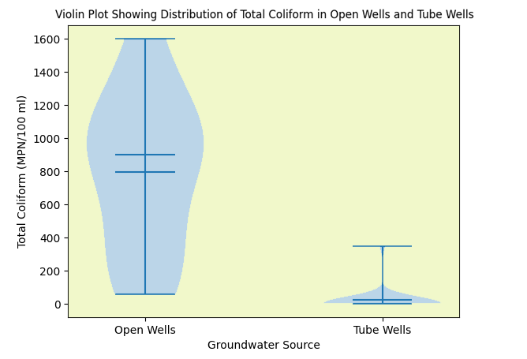
Figure 1. Density Distribution and Range of Microbial Load in Open versus Tube Wells.

The distribution of total coliform counts in groundwater samples is further presented on a logarithmic scale in Figure 2. The horizontal reference line represents the BIS drinking water standard of 10 MPN/100 ml. Most open well samples were positioned far above the permissible limit, indicating substantial microbial contamination. In contrast, the majority of tube well samples were located near or below the BIS threshold, suggesting relatively lower levels of microbial contamination in deeper groundwater sources. The log-scale representation clearly highlights the large difference in contamination levels between the two groundwater sources and emphasizes the vulnerability of open wells to faecal pollution.
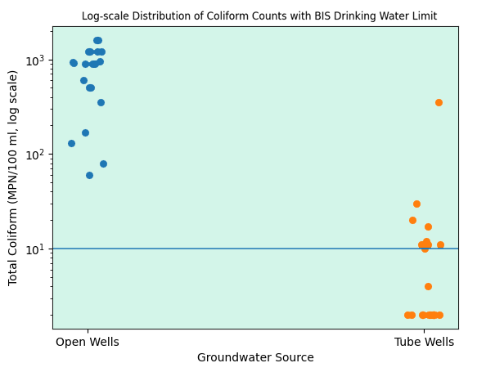
Figure 2. Logarithmic Distribution of Total Coliform Relative to the BIS Permissible Drinking Water Threshold.
3.4. Identification of Contamination Drivers through Multivariate Analysis
3.4.1. Boxplot Analysis
The distribution of selected physicochemical parameters between open wells and tube wells is illustrated through box plots (Fig. 3 to 5). The pH values of groundwater samples showed moderate variation, with tube wells generally exhibiting slightly higher median pH compared to open wells, indicating relatively stable hydrochemical conditions in deeper aquifers. The distribution of total dissolved solids (TDS) revealed wider variability in tube wells, with several samples exhibiting higher concentrations, possibly reflecting mineral dissolution in deeper groundwater strata. In contrast, alkalinity values demonstrated considerable variation in both groundwater sources, with some open wells showing elevated levels likely influenced by surface infiltration and geochemical interactions within the aquifer system. This box plot analysis highlights the variability of groundwater quality parameters and the influence of well type on hydrochemical characteristics.
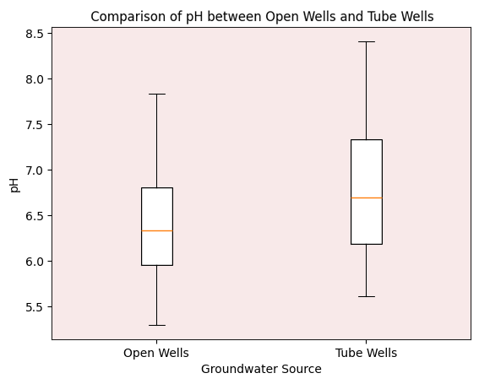
Figure 3. Comparative Box-and-Whisker Plots illustrating Interquartile Variations in pH by Groundwater Source.
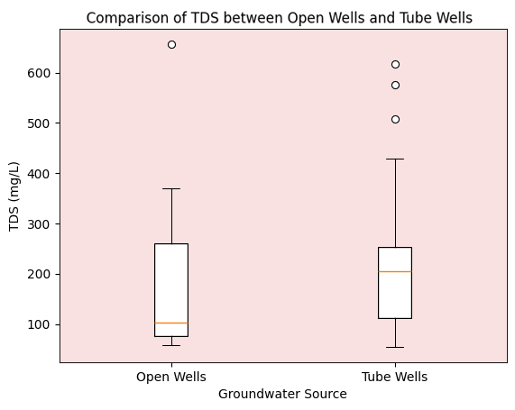
Figure 4. Comparative Box-and-Whisker Plots illustrating Interquartile Variations in TDS by Groundwater Source.
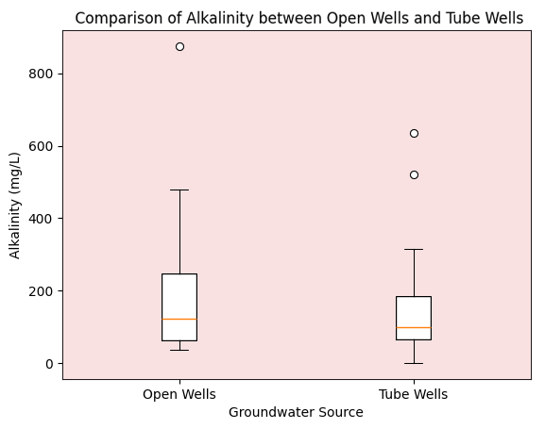
Figure 5. Comparative Box-and-Whisker Plots illustrating Interquartile Variations in Alkalinity by Groundwater Source.
3.4.2. T-test
An independent sample t-test was performed to evaluate the differences in groundwater quality parameters between open wells and tube wells (Table 3). The results indicated that pH, total dissolved solids (TDS), and salinity did not show statistically significant differences between the two groundwater sources (p > 0.05). However, total coliform counts exhibited a highly significant difference (p < 0.001), with open wells showing markedly higher microbial contamination compared to tube wells. The mean coliform concentration in open wells (794 MPN/100 ml) was substantially greater than that observed in tube wells (24.8 MPN/100 ml), highlighting the greater susceptibility of shallow groundwater sources to microbial pollution.
Table 3. Statistical Significance of Water Quality Variations between Well Types: Results of Independent Sample t-tests.
Parameter | Open Wells (Mean) | Tube Wells (Mean) | t-value | p-value | Significance
pH | 6.35 | 6.76 | -1.84 | 0.074 | Not significant
TDS (mg/L) | 182.80 | 236.47 | -1.06 | 0.297 | Not significant
Salinity (ppt) | 0.43 | 0.42 | 0.13 | 0.894 | Not significant
Total Coliform (MPN/100 ml) | 831 | 7.15 | 7.11 | <0.001 | Highly significant

3.4.3. Pearson correlation analysis
The relationships among selected groundwater quality parameters were evaluated using Pearson correlation analysis and are illustrated through a correlation matrix heatmap (Fig. 6). The analysis indicates moderate positive correlations between pH, TDS, and alkalinity, suggesting that mineral dissolution processes may influence the hydrochemical characteristics of groundwater in the study area. Salinity exhibited relatively weak correlations with most parameters, indicating localized variations in dissolved ionic content. Total coliform counts showed weak or negative correlations with physicochemical parameters, implying that microbial contamination is primarily controlled by external factors such as surface infiltration, sanitary conditions, and anthropogenic activities rather than intrinsic hydrochemical processes.
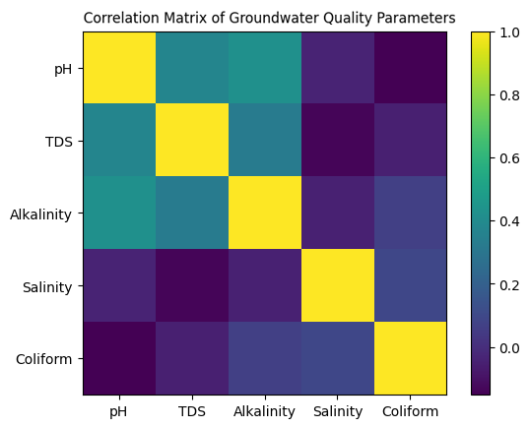
Figure 6. Heatmap Analysis of Inter-parameter Pearson Correlations for Groundwater Quality Indicators.
3.4.4. Principal Component Analysis (PCA)
Principal Component Analysis (PCA) was performed to identify the major factors controlling groundwater quality in the study area, and the results are illustrated in Figure 7. The analysis extracted two principal components with eigenvalues greater than one, explaining the majority of the variance in the dataset. The PCA biplot reveals the relative contribution and association of the measured parameters. Parameters such as TDS, pH, and alkalinity are positioned in similar directions along the first principal component (PC1), indicating a positive association and suggesting that these variables are primarily influenced by geochemical processes such as mineral dissolution. In contrast, salinity and total coliform show different orientations in the PCA space, reflecting distinct sources of variation. The second principal component (PC2) is mainly associated with microbial parameters, particularly total coliform counts. The separation of coliform along a different axis indicates that microbial contamination is largely independent of hydrochemical parameters and is likely influenced by external environmental factors such as surface infiltration, sanitation conditions, and anthropogenic activities.
Figure 7. PCA Biplot Identifying Dominant Geochemical and Anthropogenic Factors Controlling Groundwater Chemistry.
3.4.5. Hierarchical Cluster Dendrogram of Groundwater Samples
Hierarchical Cluster Analysis (HCA) was performed to classify groundwater samples based on similarities in physicochemical and microbial parameters, and the resulting dendrogram is presented in Figure 8. The analysis grouped the groundwater samples into three major clusters representing different water quality characteristics. Cluster I mainly consisted of tube well samples characterized by low coliform counts and relatively stable physicochemical parameters. Cluster II included samples showing moderate hydrochemical variation, particularly in dissolved solids and alkalinity. Cluster III comprised predominantly open well samples with elevated coliform concentrations, indicating significant microbial contamination in shallow groundwater sources. The clustering pattern highlights the influence of groundwater source type on water quality and suggests that shallow open wells are more vulnerable to microbial pollution compared to deeper tube wells.
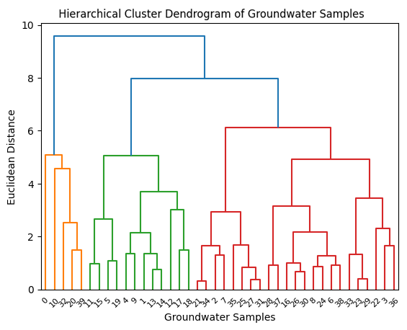
Figure 8. Dendrogram of Ward’s Hierarchical Clustering for Site Classification based on Multi-parameter Similarities.
4. DISCUSSION
The physicochemical characteristics of groundwater sources in Anchal Gramapanchayat indicate moderate variation in hydrochemical conditions between open wells and tube wells. The observed pH values ranging from slightly acidic to mildly alkaline conditions are generally consistent with groundwater systems influenced by natural geochemical interactions between aquifer materials and infiltrating water. Similar pH ranges and dissolved solids concentrations have been reported in groundwater studies from different regions, where mineral dissolution and aquifer lithology play important roles in determining water chemistry (Majagi et al., 2008; Khatri & Tyagi, 2015; Constant et al., 2025). The moderate levels of total dissolved solids, alkalinity and salinity observed in the present study also suggest that groundwater chemistry is largely governed by natural geochemical processes rather than intensive anthropogenic pollution (Islam, 2001; Nogueira et al., 2003). Previous studies have similarly reported that groundwater parameters such as TDS and alkalinity often reflect mineral weathering and groundwater–rock interactions within the aquifer system (Palamuleni & Akoth, 2015; Wali et al., 2022). The slightly higher alkalinity and free CO₂ concentrations observed in open wells further indicate the influence of surface infiltration and organic matter decomposition, which commonly affect shallow groundwater systems (Lapworth et al., 2017; Khatri & Tyagi, 2015).
In contrast to the relatively stable physicochemical parameters, microbial contamination showed pronounced differences between the two groundwater sources, with open wells exhibiting significantly higher total coliform counts compared to tube wells (Sarikar et al., 2024). This pattern reflects the greater vulnerability of shallow groundwater sources to faecal contamination from surface activities, poor sanitation, and inadequate well protection. Similar findings have been widely reported in groundwater studies where open wells or shallow aquifers show higher microbial contamination due to direct exposure to surface runoff and domestic waste disposal (Mukhopadhyay et al., 2012; Aboh et al., 2015; Akpataku et al., 2020). The high coliform levels detected in several open well samples also exceed the recommended drinking water standards, indicating potential public health risks associated with untreated groundwater consumption (WHO, 2017; BIS, 2012). Previous investigations in different regions have likewise reported elevated coliform contamination in shallow wells compared with deeper tube wells or boreholes, emphasizing the role of well depth and structural protection in determining microbial safety of groundwater sources (Maran et al., 2016; Lutterodt et al., 2018; Bashir et al., 2018; Traoré et al., 2023). The multivariate analyses conducted in the present study further support this observation by showing that microbial contamination is largely independent of physicochemical parameters and is primarily associated with external environmental and anthropogenic factors affecting shallow groundwater systems (Wali et al., 2022)
5. CONCLUSION
The present study assessed the physicochemical and microbiological characteristics of groundwater from open wells and tube wells in Anchal Gramapanchayat, Kerala, revealing noticeable variations in water quality between the two sources. Most physicochemical parameters, including pH, TDS, alkalinity, hardness, and salinity, were generally within acceptable limits for drinking water, indicating that the hydrochemical characteristics of groundwater are largely controlled by natural geochemical processes. However, microbial analysis demonstrated significantly higher total coliform contamination in open wells compared to tube wells, highlighting the greater vulnerability of shallow groundwater sources to faecal pollution from surface runoff, poor sanitation practices, and inadequate well protection. Statistical analyses, including t-test, correlation analysis, PCA, and cluster analysis, further confirmed that microbial contamination is the primary factor differentiating open wells from deeper tube wells in the study area. These findings emphasize the need for regular monitoring of groundwater quality, improved sanitary protection of open wells, and public awareness regarding safe water handling practices to ensure sustainable and safe drinking water resources in the region.

Ethical Approval: This article does not contain any studies with human participants or animals performed by the author.
Data Availability: The datasets generated and/or analysed during the current study are available from the corresponding author upon reasonable request.
Reference
- Aboh, E. A., Giwa, F. J. & Giwa, A. (2015). Microbiological assessment of well waters in Samaru, Zaria, Kaduna, state, Nigeria. Annals of African Medicine, 14 (1): 32-38. DOI: 10.4103/1596-3519.148732
- Adesakin, T. A., Oyewale, A. T., Bayero, U., Mohammed, A. N., Aduwo, I. A., Ahmed, P. Z., & Barje, I. B. (2020). Assessment of bacteriological quality and physico-chemical parameters of domestic water sources in Samaru community, Zaria, Northwest Nigeria. Heliyon, 6(8): e04773. https://doi.org/10.1016/j.heliyon.2020.e04773
- Adeyemo, A., Olayanju, T. & Ismail, A. (2023). Groundwater quality in urban centers of Sub-Saharan Africa: an assessment of microbial and chemical contamination, Water Qual. Health J. 18 (2): 76-85. DOI: 10.1007/s10040-016-1516-6
- Ahmed, T., Acharjee, M., Rahman, M. S., Meghla, M., Jamal, J., Munshi, S. K. & Noor, R. (2013). Microbiological study of drinking water: qualitative and quantitative approach, Asian Journal of Microbiology, Biotechnology and Environmental Sciences. 15 (4): 23-30
- Akpataku, K., Gnazou, M., Nomesi, T., Nambo, P., Doni, K., Bawa, L. & Djaneye-Boundjou, G. (2020). Physicochemical and Microbiological Quality of Shallow Groundwater in Lomé, Togo. Journal of Geoscience and Environment Protection, 8: 162-179. DOI: 10.4236/gep.2020.812010.
- APHA, (2012). Standard Methods for Examination of Water and Wastewater, 2nd ed.; American Public Health Association: Washington, DC, USA, p. 1360.
- Bashir, I., Adam, A. S., Yahaya, H. S., Makeri, D., Ntulume, I., & Aliero, A. A. (2018). Assessment of bacteriological quality of borehole water in Wamakko local government, Sokoto state, Nigeria. Nov Res Microbiol J. 25, 2, 6, 175–84.
- Baye, S., Eshetie, M. & Denekew, T. (2021). Bacteriological and physicochemical quality of drinking water in Wegeda Town, Northwest Ethiopia. Journal of Environmental and Public Health. 6646269: 8. https://doi.org/10.1155/2021/6646269
- BIS-10500. (2012). Indian standard, Drinking water - specifications, Bureau of Indian Standards, New Delhi, India.
- Chatterjee, S. N., Das, D., Roy, M., Banerjee, S., Dey, P., Bhattacharya, T. & Chandra, G. (2007). Bacteriological examination of drinking water in Burdwan, India with reference to coliforms. African Journal of Biotechnology, 6(22): 2601-2602. https://doi.org/10.5897/AJB2007.000-2415
- Constant, Zébré Arthur, Attien Yao Paul, Sina Haziz, Yao Amenan Bethsabé, Koffi-Nevry Rose, Connil Nathalie, Konaté Ibrahim & Baba-Moussa Lamine. (2025). Physicochemical and Microbiological Characteristics of Surface and Groundwater Frequently Used by Households in Some Districts of Daloa, Côte d’Ivoire. Journal of Advances in Microbiology 25 (3):1-12. https://doi.org/10.9734/jamb/2025/v25i3903.
- Ercumen, A., Naser, A. M., Arnold, B. F., Unicomb, L., Colford, J. M., Luby, S. P. (2017). Can sanitary inspection surveys predict risk of microbiological contamination of groundwater sources? Evidence from shallow tubewells in rural Bangladesh. American Journal of Tropical Medicine and Hygiene. 96: 561 - 568. DOI: 10.4269/ajtmh.16-0489
- Eshcol, J., Mahapatra, P., Keshapagu, S., Roy, J., Lucille, A. (2009). Is faecal contamination of drinking water after collection associated with household water handling and hygiene practices? A study of urban slum households in Hyderabad, India. Journal of Water Health. 7: 145 - 54. DOI: 10.2166/wh.2009.094
- Foster, S. (2022). The key role for groundwater in urban water-supply security, Journal of Water and Climate Change. 13 (10): 3566-3577, https://doi.org/10.2166/wcc.2022.174
- Islam, M. S., Brooks, A., Kabir, M. S., Jahid, I. K., & Rahman, M. (2001). Microbiological analysis of tube-well water in a rural area of Bangladesh. Applied and Environmental Microbiology, 67(7): 3328-3330. https://pmc.ncbi.nlm.nih.gov/articles/PMC93023
- Khatri, N. & Tyagi, S. (2015). Influences of natural and anthropogenic factors on surface and groundwater quality in rural and urban areas, Frontiers in Life Science 8 (1): 23-39. https://doi.org/10.1080/21553769.2014.933716
- Lapworth, D. J., Nkhuwa, D. C.W., Okotto-Okotto, J., Pedley, S., Stuart, M.E., Tijani, M.N., Wright, J. (2017). Urban groundwater quality in sub-Saharan Africa: Current status and implications for water security and public health. Hydrogeol. J. 25: 1093 - 1116. DOI: 10.1007/s10040-016-1516-6
- Lutterodt, G., Van de Vossenberg, J., & Hoiting, Y. (2018). Microbial groundwater quality status of hand-dug wells and boreholes in developing countries. International Journal of Environmental Research and Public Health, 15(4): 730. https://doi.org/10.3390/ijerph15040730
- Majagi, S., Vijaykumar, K., Rajshekar, M., & Vasanthkumar, B. (2008). Chemistry of Groundwater in Gulbarga district, Karantaka, India, Environmental Monitoring and Assessment. 136: 347-354. https://doi.org/10.1007/s10661-007-9690-6
- Maran, N. H., Crispim, B., Iahnn, S. R., Pires de Araújo, R., Grisolia, B. A., & Pires de Oliveira, K. M. (2016). Depth and well type related to groundwater microbiological contamination. International Journal of Environmental Research and Public Health, 13(1036): 2-9. DOI: 10.3390/ijerph13101036
- Mvongo, V. D., & Defo, C. (2025). Physicochemical and microbiological assessment of groundwater quality for drinking purposes in Ebolowa, Cameroon. Scientific African, 30, e03034. https://doi.org/10.1016/j.sciaf.2025.e03034
- Moyo, N. A. G. (2013). An analysis of the chemical and microbiological quality of ground water from boreholes and shallow wells in Zimbabwe. Phys. Chem. Earth. 66: 27 - 32. https://doi.org/10.1016/j.pce.2013.06.003
- Mukhopadhyay, C., Vishwanath, S., Eshwara, V. K., Shankaranarayana, S. A., & Sagir, A. (2012). Microbial quality of well water from rural and urban households in Karnataka, India: A cross-sectional study. Journal of Infection and Public Health. 5: 257–262. https://doi.org/10.1016/j.jiph.2012.03.004
- Nogueira, G, Nakamura, C. V., Tognim, M. C. B, Abreu Filho B. A. & Dias Filho B. P. (2003). Microbiological quality of drinking water of urban and rural communities, Brazil. Revista de Saude Publica. 37: 232 - 6. DOI: 10.1590/s0034-89102003000200011
- Palamuleni, L., & Akoth, M. (2015). Physicochemical and microbial analysis of selected borehole water in Mahikeng, South Africa. International journal of environmental research and public health, 12, 8, 8619-8630. https://doi.org/10.3390/ijerph120808619
- Ramteke, P. W., Bhattacharjee, J. W., Pathak, S. P., Kalra, N. (1992). Evaluation of coliforms as indicator of water quality in India. Journal of Applied Bacteriology. 72: 352 - 6. DOI: 10.1111/j.1365-2672.1992.tb01846.x
- Saidu, I, Muhammed N, Zubairu A.Y, Effiong, E.C (2024). Microbiological and Physicochemical Quality of Groundwater Sources in Wamakko, Nigeria, Global Academic Journal of Agriculture and Bio sciences. 6 (3): 65-75. DOI: 10.36348/gajab.2024.v06i03.003.
- Sarikar, S., Wankhede, S., & Sarikar, S. (2024). A comparative study on water quality and microbial conditions of open well and bore well water from Kalaburagi city, Karnataka, India. Holistic Approach to Environment, 14(4): 136-144. https://doi.org/10.33765/thate.14.4.3
- Traoré, O., Kpoda, D.S., Dembélé, R., Saba, C.K.S., Cairns, J., Barro, N. & Haukka, K. (2023). Microbiological and Physicochemical Quality of Groundwater and Risk Factors for Its Pollution in Ouagadougou, Burkina Faso. Water. 15: 3734. https://doi.org/10.3390/w15213734
- Van Geen, A., Ahmed, K.M., Akita, Y., Alam, M.J., Culligan, P.J., Emch, M., Escamilla, V., Feighery, J., Ferguson, A.S., Knappett, P., et al. (2011). Faecal contamination of shallow tubewells in Bangladesh inversely related to arsenic. Environmental Science and Technology. 45: 1199 - 1205. DOI: dx.doi.org/10.1021/es103192b
- Wali, S. U., Alias, N. B., Harun, S. B., Umar, K. J., Gada, M. A., Dankani, I. M. & Usman, A. A. (2022). Water quality indices and multivariate statistical analysis of urban groundwater in semiarid Sokoto Basin, Northwestern Nigeria. Groundwater for Sustainable Development, 18, 100779. DOI:10.1016/j.gsd.2022.100779
- World Health Organization. (2017). Guidelines for Drinking-Water Quality: Fourth Edition Incorporating the First Addendum. World Health Organization, Geneva, Switzerland. https://www.who.int/publications/i/item/9789241549950

