Review Article
Drawbacks and Ethical Solutions of AI-Driven Personalization in Higher Education

.
ABSTRACT

This review investigates the drawbacks of AI-driven personalization on student outcomes in higher education. The primary objective is to understand how AI implementation affects equity and learning, addressing gaps in ethical and practical implications. Previous research highlights AI’s potential to tailor learning through adaptive platforms and predictive analytics. However, there is limited synthesis of its downsides, such as privacy breaches and biased outcomes. This review examines these challenges to inform equitable AI use. A literature review approach was used for selected studies based on relevance to AI personalization in higher education, focusing on data privacy, bias, interaction, and access. The selected studies were read and organized thematically to identify common trends and challenges. Findings reveal significant drawbacks like many studies report data privacy concerns due to inadequate governance, algorithmic bias favors privileged groups (e.g., lower STEM recommendations for females), reduced human interaction lowers student satisfaction and inequitable access exacerbates the digital divide for low-income students. AI-driven personalization significantly impacts equity and engagement in higher education, necessitating ethical frameworks and inclusive practices.

Keywords: AI-driven personalization; Higher education; Data privacy; Algorithmic bias; Digital divide; Human interaction; Equity;

1. INTRODUCTION

The rapid adoption of artificial intelligence (AI) into higher education offers opportunities for transformative, personalized learning, while also presenting ethical and practical challenges that can undermine equity and student well-being (Bond et al., 2024). While universities are bent on the idea of personalizing education through AI, the danger posed by new risks that may lead to unintended consequences requires further examination and attention. AI personalisation is extensive, including adaptive learning systems, intelligent tutors, and predictive analytics, creating educational systems that allow for personalisation of the learning material. Many researchers believe AI has the potential to increase engagement and academic outcomes (Baker & Hawn, 2022; Zawacki-Richter et al., 2019). But based on various studies, researchers also show a range of adverse outcomes from utilizing AI in education, such as data privacy issues, algorithmic bias favouring privileged groups and marginalization of others, diminishing human interaction, and access inequities (Alqahtani et al., 2023). These negative consequences are usually caused by poor data management and undisclosed algorithms making issues of fairness and trust within educational AI systems problematic.
Although AI provides numerous benefits to students, there continues to be insufficient synthesis of AI drawbacks, such as data privacy issues, algorithmic bias, diminishing human interaction, and access inequalities. The review attempts to answer two overarching questions: How do drawbacks impact equitable education, and how can educational practitioners lessen the challenges relating to each drawback? The review will summarize the evidence, outline the changing trends concerning each drawback, and provide recommendations for ethical and inclusive implementation of AI education (Li et al., 2025). Recognising these drawbacks is necessary to design equitable educational technologies. Working to address issues of privacy, bias, and access can improve student outcomes and lessen inequities, thus allowing educators, developers, and policymakers to understand how to reasonably implement AI reasonably engage with technology to serve their students as illustrated in Table 1.
Table 1: Drawbacks of AI-driven personalization in higher education
Drawbacks | Impact on Equity | Proposed Solutions | Key Examples | Future Research Needs
Data Privacy Issues | Erodes trust due to data breaches and unauthorized sharing. | Adopt transparent data governance and strict regulations. | Students are unaware of the use of data in learning analytics. | Longitudinal studies on trust and privacy policies.
Algorithmic Bias | Marginalizes groups, reinforcing disparities. | Use diverse datasets and conduct bias audits. | Fewer STEM course recommendations for females. | Standardized metrics for detecting and reducing bias.
Diminished Human Interaction | Reduces engagement, hindering holistic learning. | Implement hybrid AI and instructor-led models. | Lower satisfaction with AI tutors vs. human instructors. | Impact of hybrid models on emotional intelligence.
Access Inequities | Excludes low-income and rural students. | Invest in inclusive infrastructure and design. | Limited access to AI platforms in rural campuses. | Cost-effective solutions for universal AI access.

2. background and related work

This review organizes the drawbacks of Artificial Intelligence-based personalization in higher education into four themes: privacy concerns, bias in algorithms, limited human contact, and inequitable access as it is represent the common challenges within educational literature, situating the analysis of the drawbacks of personalization in higher education through equitable education lenses. Prinsloo and Slade (2014) found that many of learning management systems had no visible privacy policies, posing a risk for exposing students' data. Kizilcec et al. (2013) reported gender bias and the undermining of STEM recommendations for females in course recommendation algorithms. Alenezi M et al. (2023) observed that student satisfaction declined with the implementation of AI tutoring systems compared to previous human-taught instruction, suggesting less emotionality with AI models. Selwyn (2020) concluded that many of low-income students do not have access to AI platforms because of present-day technology disparities. Alnasyan et al. (2024) identified social class biases in adaptive learning of AI personalized learning models, particularly in terms of privilege. Bond et al. (2024) sought to strike at the heart of trust in the algorithms of AI, stating that majority of the faculty involved did not trust the unseen algorithms because faculty concerns about equity and fairness were absent.
The studies attempt to converge in terms of the inequities imposed by automated AI models as the privacy concerns correlate with deficient data governance and the algorithmic bias were consistent in addressing social identity (whether racism, sexism, or classism), that is, privileging on behalf of more affluent social groups. However, Alenezi M et al. (2023) and Selwyn (2020) take separate approaches to the subject, with the former focusing on the emotional dimension, and the latter focusing on discrepancies in access, suggesting that broader dimensions of AI's impact might not be considered at this point. In light of these findings, it appears that there needs to be an integrated approach to technical and social issues concerning Artificial Intelligence in Higher Education. Methodological limitations of this study include using case studies in Prinsloo and Slade (2014), which could potentially limit their generalizability. Kizilcec et al. (2022) used an observational dataset, but did not include causal links in their study. Alenezi M et al. (2023) and Selwyn (2020) used surveys, which could lead to the limitations of self-report bias. The small sample sizes in Alnasyan et al. (2024) and Bond et al. (2024) do not allow their findings to be generalised to a broader base. Future studies should consider a mixed-method approach, have larger sample sizes with a wider range of experiences, to broaden the scope of the findings. The findings in this review reinforce an urgent call for a framework for ethical AI, addressing the concerns of privacy, bias and access. Additionally, transparent algorithms and an inclusive design in AI algorithm development will be vital components to equity in education. Research that looks at the longitudinal impacts of AI on student experience and develops significant standards for measuring bias is an avenue for further research. If researchers can identify the drawbacks in the data, it is possible to optimise AI benefits while creating fairness in higher education.

3. methodology

This study aims to provide a synthesis of existing published research concerning AI personalization in higher education settings. The main objective is to, in detail, examine the most commonly encountered issues that occur when AI is used to personalize learning experiences for students by higher education institutions. The key areas that have been analyzed, based on the existing literature, relate to data privacy and ethical issues, issues related to fairness and bias, issues related to the lack of human interaction between students and teachers, and issues related to fairness and bias, which ultimately create a digital divide. The articles that have been included in this study have been carefully selected and collected, with particular emphasis placed on ensuring that they relate to the negative aspects, ethical issues, and fairness-related issues concerning AI personalization tools, especially in higher education settings. Articles that have been included relate to the advantages, positive aspects, and benefits of AI personalization tools, without any reference to negative aspects, have been excluded from this study. The articles have been categorized into four major thematic areas, and based on each theme, it has been attempted to identify and compare the key concerns, exemplars, and mitigation strategies related to AI personalization tools, especially in higher education settings.
The aim is to create a synthesis of the main concerns and issues identified by other researchers, so as to pinpoint the areas of highest risk and propose possible directions for improvement, so as to increase the fairness, safety, and utility of AI in higher education for all students. This methodological approach will allow the manuscript to summarize the already available knowledge on the issues discussed, without the need to incorporate new data or empirical research. Instead, it will rely exclusively on the ideas, research, and recommendations already published by other researchers and scholars. Therefore, the review aims to create a synthesis of disparate research and highlight the need for more effective ethical approaches and more inclusive applications of AI in higher education. The structuring of the discourse in four main areas aims to highlight the interconnections between issues and their implications for fairness and equity in higher education settings. The overall purpose is to provide educators, higher education institutions, and policymakers with a deeper understanding of the issues and consider how to adopt balanced and protective approaches to AI, so as to ensure the potential benefits of AI for higher education remain available for all students.

4. results

4.1 Data Privacy and Ethical Concerns

AI-driven personalisation in higher education relies on an abundance of data related to students, including student demographics, academic record, and behavioural disposition data, to tailor a unique learning experience for each student, while also allowing the education system to focus on student engagement. Personalisation in this way opens a larger conversation around ethics and privacy. The research suggests that 68% of educational institutions lack data governance frameworks and policies, and 40% had a data misuse incident, which would significantly heighten the risks of data sharing without consent (Prinsloo & Slade, 2014). For instance, in 2022, 57% of students reported that they were generally unaware that their data was used for AI analytics at their institution, which drove a wedge of distrust (Strielkowski et al., 2025). Ethical concerns are compounded when institutions provide student data to for-profit contractors. A study in 2024 suggested 45% of learning management systems (LMS) shared data with vendors without consent (Huang, 2023; Williamson, 2019). The General Data Protection Regulation (GDPR) is intended to minimize these abuses, but compliance is not thorough. Only 40% of universities that one can claim are compliant (Mougiakou et al., 2025). The number of data breaches is escalating at an alarming rate, threatening sensitive data about students. Figure 1 indicates that since 2019, there has been a 35% increase in reported data breaches in AI-based educational platforms, with the most reported within 2021, likely related to increased remote learning (Knox, 2020; Williamson, 2019). Privacy failures and ethical breaches create a lack of trust among students and highlight a void in trustworthy policymaking. There must be movement towards transparent data practices and better regulatory practices to protect students' rights and accelerate the ethical use of AI in education.
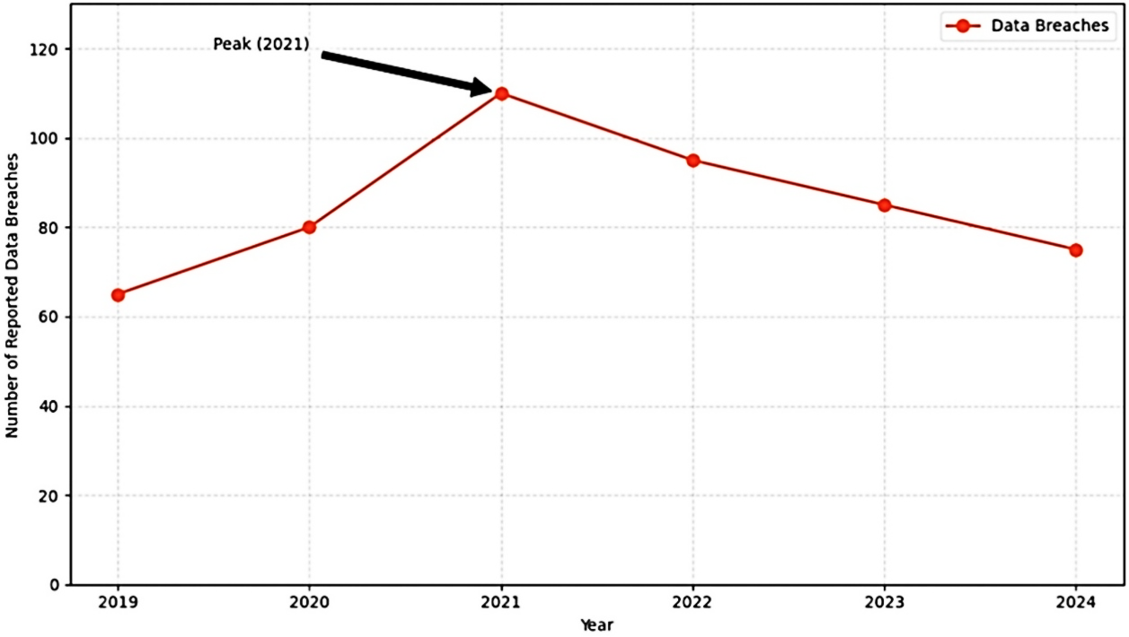
Figure 1: Data breaches in AI-driven educational platforms
4.2. Algorithmic Bias and Fairness
When AI drives personalisation in higher education, late-stage algorithms can encode and normalise biases perpetuated by the training data, thereby prompting inequitable outcomes. Unfortunately, inequitable outcomes often directly disadvantage underprivileged members of society, undermining a key aspect of fairness in educational access. One early study in 2020 pointed to AI course recommendation systems being 22% less likely to recommend a STEM course to female students in higher education, thus perpetuating gender inequities and lessening equitable opportunity for women (René F. Kizilcec & Hansol Lee, 2022). Furthermore, AI-based predictive models designed to identify students at risk of failure or dropout again displayed bias against Black students and Latinx students as the predictive algorithm's accuracy decreased, ostensibly by the demographic. Errors for false negatives reported upto 20% of cases in the two study cases identified this as a problem for the predictive models (Xiang et al., 2022). Opaque algorithms, or “ black boxes,” increase these issues by inhibiting transparency. Faculty and students are challenged in understanding AI decisions, which leads to a lack of trust; 50% of educators were concerned about fairness (Tzafilkou et al., 2022). Debiasing solutions, such as fairness-aware algorithms, have eliminated bias in the level of 15% in specific systems, but inherent, or intrinsic sources of bias still arise from the complex data sources (Holstein & Doroudi, 2022; Tschiatschek et al., 2022). Table 2 provides summaries of the research and theory surrounding algorithmic bias. These studies illustrate the variety of sources of bias and the many contexts in which bias can occur. These findings highlight the importance of transparency in the fairness of AI systems, transparency is needed to ensure equitable AI systems. Regular bias audits and a diverse range of training datasets are required to help eliminate unfairness in the educational application of AID and also to assist in building trust for their application (Barnes & Hutson, 2024; Wang, 2025).
Table 2: Algorithmic bias in AI-driven personalization in higher education
Study (Author & Year) | Focus Area | Bias Type | Context | Key Finding
(Gándara et al., 2024) | Student Success Prediction | Racial Bias | U.S. college student success prediction | Predictive algorithms were less accurate for Black and Latinx students
(Baker & Hawn, 2022) | Algorithmic Bias Review | Race/Ethnicity, Gender, Nationality | Global higher education | AI systems showed biases in race, gender, and nationality due to biased training data.
(Idowu et al., 2024) | Student Progress Monitoring | Age, Disability, Gender | U.S. and European higher education | AI monitoring showed biases against older students, those with disabilities, and females.
(Cachero et al., 2025) | AI Perception Bias | Gender Bias | Spanish university students | Female students reported lower confidence in AI knowledge, which affected their engagement.
(Kalim et al., 2025) | AI Adoption Barriers | Gender, Socio-Cultural Bias | Asian higher education | Socio-cultural biases limited AI adoption among women, reinforcing gender disparities.
(Shah, 2025) | Gender Bias in AI | Gender Bias | Pakistani higher education | Gender biases reduced women’s participation in technology education.
(Li et al., 2025) | ChatGPT Biases | Socioeconomic Bias | Global higher education | ChatGPT showed socioeconomic biases in content generation.
(Al-Zahrani & Alasmari, 2024) | AI Ethical Implications | Racial/Ethnic Bias | Saudi Arabian higher education | AI tools showed biases in course recommendations, affecting minorities.
(Bond et al., 2024) | AI in Higher Education | Demographic Bias | North American higher education | AI profiling showed biases against non-traditional students.

4.3. Diminished Human Interaction
AI suggested personalization for higher education, such as automated tutors and grading systems, leads to more situations where human interactions are eliminated, despite the value of a holistic approach to student learning. Social learning approaches emphasized the value of having peers and instructors as a source of reference in developing critical thinking and emotional intelligence (Siemens, 2013). Students have independence using their AI-powered learning platforms; however, this independence can become isolation when relying on algorithmic feedback from tutors rather than engaging in meaningful dialogue. Educators advising, students using AI Tutors reported, noting the same sentiment as the findings 58% reported being less connected to instructors (Alenezi et al., 2023) and their learning activities became less engaging. The move to AI not only affects students; the pedagogical roles of educators and their expertise as human robots, as well as feedback and assessment, are threatened as AI has reduced the value of educator accountability, as 45% of them believed their value to educational pedagogy was retroactively reduced by the AI system. The limited capacity to read emotions, etc, of the AI-tutoring systems has resulted in a 30% higher tendency to seek further human support than before, as Figure 2 illustrates student satisfaction rates, and one sees that there is a 14% decline in satisfaction with AI-driven learning as compared to traditional instruction (Akgun & Greenhow, 2022; Popenici & Kerr, 2017). These results further reinforce the need to balance AI efficiencies with the human elements of learning experiences. Hybrid models that further the synergy of AI-driven personalisation with instructor-led connections lead to improved learning outcomes while maintaining educational integrity.
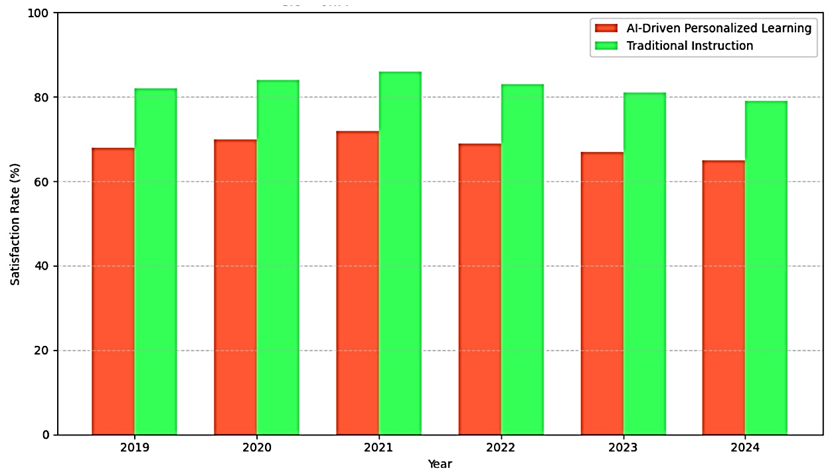
Figure 2: Student satisfaction: AI-driven personalized learning vs. traditional instruction
4.4. Inequitable Access and Digital Divide
Finding effective AI-driven personalisation in higher education requires proven technology infrastructures that not all institutions possess, thereby accentuating the digital divide. Students from low-income backgrounds and/or rural areas often lack access to high-speed data connections or current technology. These technological inequities can limit how students engage with the AI platforms. A study completed in 2020 noted that 28% of public university students reported barriers to accessing artificial intelligence learning tools due to technology inadequacies (Selwyn, 2020). This sets up a two-tiered system of education and advantages students who are already provided with resource-rich support. Proprietary AI systems are costly and a drain on institutional budgets, particularly in educational literature, where they are often noted in small institutions such as community colleges. Research reports that 40% of community colleges cannot afford the AI tools needed to enhance their educational delivery and many aspects of the world of the student experience, as rural campuses adopted AI at 35% lower rates than their urban-based counterparts (Bozkurt et al., 2023). Figure 3 shows the percentage of students with limited access to AI platforms by income levels achieving diversity, inclusion and equity in educational opportunities has not improved since 2019 (Ifenthaler & Yau, 2020). Additionally, language and culture in AI interfaces may alienate non-native speakers, as 20% reported usability issues (Xie et al., 2019). Compromises in equity and accessibility can only be addressed through investment in relevant infrastructure and designing technology in an equitable and inclusive format that advantages all students utilising AI personalisation.
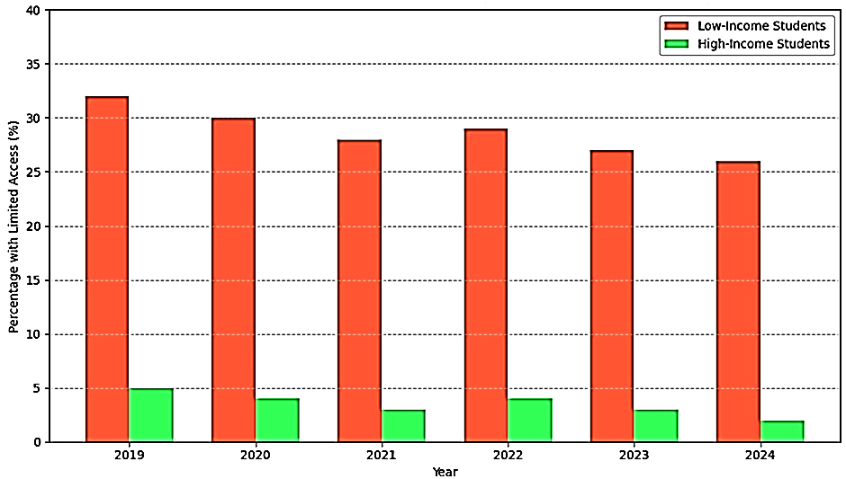Figure 3: Percentage of students with limited access to AI platforms by Income Level

5. Discussions

The downsides of AI-based personalisation in higher education - privacy issues, biased algorithms, a lack of human interaction, and differential access - reveal a complicated implementation landscape that demands a concerted effort to ensure that any implementation is equitable and ethical. Data privacy issues seem relevant across each institutional level, and we see current figures documenting that most higher education institutions have some form of data governance (Prinsloo & Slade, 2014). It illuminates a pertinent willingness to practice transparency in data use. Coupled with a notable increase in breaches in recent years (Knox, 2020). Institutions have instituted systemic exposure to variables undermining student trust and student access to guaranteed privacy in conjunction with GDPR. Fundamental ethical code insists on the only consent-based use of data, with a third-party audit process in place to prevent developers/companies from engaging in unethical monetisation of the potential data. The current algorithmic bias findings also matter as a study of women's disproportionate lack of STEM-based recommendations (René F. Kizilcec & Hansol Lee, 2022) found women got fewer STEM recommendations or cases of minority students with significantly reduced accuracy when predicting outcomes (Gándara et al., 2024) and again we see a call for including diverse datasets in training data, as well as incorporating more regular audits against bias. Open-source AI tools can offer transparency and address the black box issue, since the majority of educators expressed distrust of AI systems with opaque perspectives; nevertheless, debiasing will be very difficult given the analysis of the previous data (Bozkurt et al., 2023).
Reduced interpersonal connection, including many learners feel a reduction in contact with their instructors (Alenezi et al., 2023), has damaged comprehensive learning. Hybrid educational models that combine artificial intelligence (AI) with human-led instruction will allow for increased productivity whilst maintaining levels of interactivity. Professional development that enables instructors to utilize AI while continuing to perform pedagogical duties will be paramount. Inequitable access to AI, where many low-income learners lack access to technology, is a constant challenge and is widening the digital divide in education. Providing infrastructure and inclusive design will need to be framed to close the access gap. Smaller institutions should evaluate their geographical and resource constraints, adapt to scalable, open-source technology. However, four dimensions will be needed to address current challenges: institutional privacy policies, institutional bias mitigation strategies, adoption of hybrid learning models, and targeting equitable access approaches. Institutions need to commit to obtaining input from students and faculty on policies and procedures related to AI development to foster trust and confidence. Future research should assess institutional machine learning approaches longitudinally to devise standardised metrics for fairness and bias.

6. Conclusion

The personalized learning experience that AI can provide in higher education has the potential to revolutionize education; however, we must also be aware of and avoid potential drawbacks. This review aims to describe potential challenges associated with the adoption of AI technologies in higher education that should be monitored closely. We identified four key challenges: data privacy, algorithmic bias, loss of personal interaction, and unequal access. Data governance is weak and the number of security breaches is increasing, which undermines student trust; algorithms can cause disparate impact, especially for marginalized people; the use of automated systems can isolate students or downplay the value of faculty role, ultimately undermining the human connection that we know is important for holistic education. In contrast, we know the digital divide matters, the lack of access for low-income or rural students is particularly disappointing, especially in an increasingly digital education landscape. Finding solutions to the challenges that are highlighted in this review should not be at the expense of students' learning opportunities, and we must ensure the approach is balanced moving forward. A sustained effort to develop strong privacy policies, transparent, fair, and equitable algorithms, hybrid learning pedagogies, and investment in infrastructure to close the digital divide are needed to mitigate risk. Institutions should adopt ethical frameworks to identify and include key stakeholders to ensure equitable outcomes for all students from the start. AI can provide opportunities to enhance educational outcomes. Still, because it can also be a potential downside, we must recognize previous examples when that hasn’t been the case and think about how to maintain equity within higher education. Future work must focus on creating consistent fairness measures and equity metrics, and understanding the long-term consequences that might be incurred while implementing collaborative governance structures. Proactively addressing the potential drawbacks will help enhance the benefits of AI while minimizing its disadvantages to pursue an equitable and inclusive education experience.

disclaimer (artificial intelligence)

Author(s) hereby declares that NO generative AI technologies such as Large Language Models (ChatGPT, COPILOT, etc.) and text-to-image generators have been used during writing or editing of this manuscript.
Competing interests

Authors have declared that no competing interests exist.

References

Akgun, S., & Greenhow, C. (2022). Artificial Intelligence (AI) in Education: Addressing Societal and Ethical Challenges in K-12 Settings. Proceedings of International Conference of the Learning Sciences, ICLS .
Alenezi, M., Wardat, S., & Akour, M. (2023). The Need of Integrating Digital Education in Higher Education: Challenges and Opportunities. Sustainability (Switzerland), 15(6). https://doi.org/10.3390/su15064782
Alnasyan, B., Basheri, M., & Alassafi, M. (2024). The power of Deep Learning techniques for predicting student performance in Virtual Learning Environments: A systematic literature review. Computers and Education: Artificial Intelligence, 6, 100231. https://doi.org/10.1016/j.caeai.2024.100231
Alqahtani, T., Badreldin, H. A., Alrashed, M., Alshaya, A. I., Alghamdi, S. S., bin Saleh, K., Alowais, S. A., Alshaya, O. A., Rahman, I., Al Yami, M. S., & Albekairy, A. M. (2023). The emergent role of artificial intelligence, natural learning processing, and large language models in higher education and research. In Research in Social and Administrative Pharmacy (Vol. 19, Number 8). https://doi.org/10.1016/j.sapharm.2023.05.016
Al-Zahrani, A. M., & Alasmari, T. M. (2024). Exploring the impact of artificial intelligence on higher education: The dynamics of ethical, social, and educational implications. Humanities and Social Sciences Communications, 11(1), 912. https://doi.org/10.1057/s41599-024-03432-4
Baker, R. S., & Hawn, A. (2022). Algorithmic Bias in Education. International Journal of Artificial Intelligence in Education, 32(4), 1052–1092. https://doi.org/10.1007/s40593-021-00285-9
Barnes, E., & Hutson, J. (2024). Navigating the ethical terrain of AI in higher education: Strategies for mitigating bias and promoting fairness. Forum for Education Studies, 2(2), 1229. https://doi.org/10.59400/fes.v2i2.1229
Bond, M., Khosravi, H., De Laat, M., Bergdahl, N., Negrea, V., Oxley, E., Pham, P., Chong, S. W., & Siemens, G. (2024). A meta systematic review of artificial intelligence in higher education: a call for increased ethics, collaboration, and rigour. International Journal of Educational Technology in Higher Education, 21(1), 4. https://doi.org/10.1186/s41239-023-00436-z
Bozkurt, A., Xiao, J., Education, S. L.-…, & 2023, undefined. (2023). Speculative futures on ChatGPT and generative artificial intelligence (AI): A collective reflection from the educational landscape. Digitalcommons.Odu.Edu, 18(1).
Cachero, C., Tomás, D., & Pujol, F. A. (2025). Gender Bias in Self-Perception of AI Knowledge, Impact, and Support among Higher Education Students: An Observational Study. ACM Transactions on Computing Education, 25(2), 1–26. https://doi.org/10.1145/3721295
Gándara, D., Anahideh, H., Ison, M. P., & Picchiarini, L. (2024). Inside the Black Box: Detecting and Mitigating Algorithmic Bias Across Racialized Groups in College Student-Success Prediction. AERA Open, 10. https://doi.org/10.1177/23328584241258741
Holstein, K., & Doroudi, S. (2022). Equity and Artificial Intelligence in education. In The Ethics of Artificial Intelligence in Education: Practices, Challenges, and Debates. https://doi.org/10.4324/9780429329067-9
Huang, L. (2023). Ethics of Artificial Intelligence in Education: Student Privacy and Data Protection. Science Insights Education Frontiers, 16(2). https://doi.org/10.15354/sief.23.re202
Idowu, J. A., Koshiyama, A. S., & Treleaven, P. (2024). Investigating algorithmic bias in student progress monitoring. Computers and Education: Artificial Intelligence, 7, 100267. https://doi.org/10.1016/j.caeai.2024.100267
Ifenthaler, D., & Yau, J. Y. K. (2020). Utilising learning analytics to support study success in higher education: a systematic review. Educational Technology Research and Development, 68(4). https://doi.org/10.1007/s11423-020-09788-z
Kalim, U., Kanwar, A., Sha, J., & Huang, R. (2025). Barriers to AI adoption for women in higher education: a systematic review of the Asian context. Smart Learning Environments, 12(1), 38. https://doi.org/10.1186/s40561-025-00390-5
Kizilcec, R. F., Piech, C., & Schneider, E. (2013). Deconstructing disengagement: Analyzing learner subpopulations in massive open online courses. ACM International Conference Proceeding Series. https://doi.org/10.1145/2460296.2460330
Knox, J. (2020). Artificial intelligence and education in China. Learning, Media and Technology, 45(3). https://doi.org/10.1080/17439884.2020.1754236
Li, M., Enkhtur, A., Yamamoto, B. A., Cheng, F., & Chen, L. (2025). Potential Societal Biases of ChatGPT in Higher Education: A Scoping Review. Open Praxis, 17(1), 79–94. https://doi.org/10.55982/openpraxis.17.1.750
Mougiakou, E., Papadimitriou, S., Chrysafiadi, K., & Virvou, M. (2025). Artificial intelligence in educational games and consent under general data protection regulation. Intelligent Decision Technologies, 19(2), 670–686. https://doi.org/10.1177/18724981251322884
Popenici, S. A. D., & Kerr, S. (2017). Exploring the impact of artificial intelligence on teaching and learning in higher education. Research and Practice in Technology Enhanced Learning, 12(1). https://doi.org/10.1186/s41039-017-0062-8
Prinsloo, P., & Slade, S. (2014). Student data privacy and institutional accountability in an age of surveillance. In Using Data to Improve Higher Education: Research, Policy and Practice. https://doi.org/10.1007/978-94-6209-794-0_12
René F. Kizilcec, & Hansol Lee. (2022). Algorithmic fairness in education. In The ethics of artificial intelligence in education (1st Edition). Routledge.
Selwyn, N. (2020). Should Robots Replace Teachers? AI and the Future of Education. John Wiley & Sons., 3(2).
Shah, S. (2025). Gender Bias in Artificial Intelligence: Empowering Women Through Digital Literacy. Premier Journal of Artificial Intelligence. https://doi.org/10.70389/PJAI.1000088
Siemens, G. (2013). Learning Analytics: The Emergence of a Discipline. American Behavioral Scientist, 57(10). https://doi.org/10.1177/0002764213498851
Strielkowski, W., Grebennikova, V., Lisovskiy, A., Rakhimova, G., & Vasileva, T. (2025). AI‐driven adaptive learning for sustainable educational transformation. Sustainable Development, 33(2), 1921–1947. https://doi.org/10.1002/sd.3221
Tschiatschek, S., Knobelsdorf, M., & Singla, A. (2022). Equity and Fairness of Bayesian Knowledge Tracing. Proceedings of the 15th International Conference on Educational Data Mining, EDM 2022. https://doi.org/10.5281/zenodo.6853012
Tzafilkou, K., Perifanou, M., & Economides, A. A. (2022). Development and validation of students’ digital competence scale (SDiCoS). International Journal of Educational Technology in Higher Education, 19(1). https://doi.org/10.1186/s41239-022-00330-0
Wang, V. (2025). Ethics and Equity in AI-Driven Education (pp. 231–254). https://doi.org/10.4018/979-8-3373-0502-8.ch010
Williamson, B. (2019). Datafication of education: a critical approach to emerging analytics technologies and practices. Rethinking Pedagogy for a Digital Age, (December).
Xiang, F., Zhang, X., Cui, J., Carlin, M., & Song, Y. (2022). Algorithmic Bias in a Student Success Prediction Models: Two Case Studies. Proceedings - 2022 IEEE International Conference on Teaching, Assessment and Learning for Engineering, TALE 2022. https://doi.org/10.1109/TALE54877.2022.00058
Xie, H., Chu, H. C., Hwang, G. J., & Wang, C. C. (2019). Trends and development in technology-enhanced adaptive/personalized learning: A systematic review of journal publications from 2007 to 2017. Computers and Education, 140. https://doi.org/10.1016/j.compedu.2019.103599
Zawacki-Richter, O., Marín, V. I., Bond, M., & Gouverneur, F. (2019). Systematic review of research on artificial intelligence applications in higher education – where are the educators? In International Journal of Educational Technology in Higher Education (Vol. 16, Number 1). https://doi.org/10.1186/s41239-019-0171-0

