Hepatoprotective Effects of Syzygium aromaticum Ethanolic Extract Against Mercury Chloride Toxicity in Wistar Rats

ABSTRACT

Background: Mercury chloride is a highly toxic inorganic compound known to induce oxidative stress and severe hepatic damage. Natural plant products with antioxidant properties are increasingly investigated as protective agents against heavy metal toxicity.
Aim: This study evaluated the hepatoprotective effects of the ethanolic extract of Syzygium aromaticum in male Wistar rats exposed to mercury chloride.
Methodology: Twenty-five rats were randomly assigned to five groups (n = 5). Group A served as the control and was given distilled water and food only. Group B received mercury chloride (7.5 mg/kg), Group C received Syzygium aromaticum extract (400 mg/kg), while Groups D and E received mercury chloride followed by Syzygium aromaticum extract at 200 mg/kg and 400 mg/kg, respectively, for six weeks. Liver function enzymes such as aspartate aminotransferase (AST), alanine aminotransferase (ALT), alkaline phosphatase (ALP) and histological architecture were evaluated.
Results: The results showed that mercury chloride significantly elevated liver enzymes and caused marked hepatic degeneration. Treatment with Syzygium aromaticum extract resulted in dose-dependent reductions in liver enzyme profiles and preservation of hepatic histoarchitecture. Histological analysis revealed mild inflammatory changes in treated groups compared to severe degeneration in the mercury chloride-only rats.
Conclusion: These findings demonstrate that the ethanolic extract of Syzygium aromaticum exerts significant hepatoprotective effects against mercury chloride-induced liver toxicity and may represent a promising natural therapeutic agent.

Keywords: Syzygium aromaticum, Hepatoprotective effects, Mercury chloride toxicity, Liver enzymes, Heavy metal toxicity

- INTRODUCTION
Heavy metals are natural elements present in the Earth’s crust, characterised by a high atomic mass and a density more than five times higher than water. Despite their origin from natural sources, extensive usage and processing of raw materials and their presence as silent poisons in our daily products and diets have drastically altered their biochemical balance, making them a threat to the environment and human health (Ceramella et al., 2024). Heavy metal pollution constitutes a major global public health challenge arising from rapid industrialisation, environmental contamination, and increased human exposure through food, water, and occupational activities (Balali-Mood et al., 2021). Among these toxic heavy metals, mercury is regarded as one of the most hazardous due to its high bioaccumulation potential and severe toxicological effects on both humans and animals (Mani et al., 2025). Mercury exists naturally in the environment but is also released through various anthropogenic activities, leading to increased atmospheric levels. Environmental mercury persists within air–soil–water biogeochemical cycles for extended periods, thereby increasing environmental and biological exposure (Rice et al., 2014). Mercury exposure can occur through various routes, including consumption of contaminated fish and seafood, inhalation of mercury vapour in occupational settings, or exposure to mercury-containing products (Raj & Maiti, 2019). When mercury chloride enters the body, it is absorbed and distributed to various organs, including the liver, where it exerts its hepatotoxic actions (Imafidon & Ayomide, 2024).
Inorganic mercury compounds, particularly mercury chloride, exert toxicity primarily through the induction of oxidative stress, interaction with sulfhydryl groups of proteins, and disruption of cellular metabolism (Wu et al., 2024). The liver, being the primary organ responsible for detoxification and metabolism, is especially susceptible to mercury-induced injury. Exposure to mercury chloride has been associated with hepatocellular degeneration, inflammation, and impairment of antioxidant defence systems. Therefore, protecting the liver from mercury chloride-induced injury remains a critical health concern (Ajibade, 2021).
Current treatment for mercury toxicity relies primarily on chelation therapy using agents such as dimercaprol and D-penicillamine. However, these agents are often associated with adverse effects, including nephrotoxicity, hepatotoxicity, immunological disturbances, and poor clinical tolerability (Lauren and Lacey, 2023). Thus, there is growing interest in plant-derived compounds with antioxidant and cytoprotective properties as safer alternatives (Nweke et al., 2021; Nwajiobi et al., 2025)
Syzygium aromaticum (cloves), a member of the family Myrtaceae, is a medicinal plant widely used in traditional medicine and is rich in bioactive phytochemicals, particularly eugenol, which exhibits antioxidant, anti-inflammatory, and metal-chelating properties (Orheruataa et al., 2025; Kaur and Kaushal, 2019). Previous studies have demonstrated the protective effects of Syzygium aromaticum against chemically-induced organ damage, including hepatic injury (Orheruata and Tobalu, 2025). It has also been employed in the management of gastrointestinal disturbances, including diarrhoea, bloating, nausea, and indigestion and notable immunomodulatory effects (Hussain et al., 2017; Orheruata et al., 2025).

Despite several reports on the antimicrobial, anti-oxidative, anti-inflammatory and free radical-scavenging properties of Syzygium aromaticum. Limited experimental study exists on its protective role against mercury chloride-induced hepatotoxicity, especially in the study area. Thus, this study aimed to evaluate the hepatoprotective effects of the ethanolic extract of Syzygium aromaticum on liver biochemical markers and histological architecture in male Wistar rats exposed to mercury chloride toxicity.

- MATERIALS AND METHODS
  - Location and Duration of the Study
The study was conducted in the Department of Anatomy, Faculty of Basic Medical Science, Nnamdi Azikiwe University, Nnewi Campus.
Plant Material Collection and Extraction
Dried flower buds of Syzygium aromaticum were purchased from Nkwo Market, Nnewi, and authenticated at the Department of Botany, Nnamdi Azikiwe University, Awka. The buds were washed thoroughly with distilled water, air-dried in the shade at room temperature, and ground into a fine powder using a mechanical grinder. An ethanolic extract was prepared by macerating 100g of the powdered buds in 300 mL of ethanol (70%) for 72 hours, with intermittent shaking. The mixture was then filtered using Whatman No. 1 filter paper, and the solvent was evaporated using a rotary evaporator under reduced pressure to yield a concentrated extract. The extract was stored at 4°C for subsequent use.

  - Experimental Animals
Twenty-five male Wistar rats weighing between 150-250g were purchased from a local farm at Nnewi and were acclimatised for two weeks at the animal facility, Department of Anatomy, Nnamdi Azikiwe University, Awka. The rats were fed with standard rat chow and water ad libitum throughout the experiment.

  - Experimental Design
The rats were randomly divided into 5 groups (n= 5) and were housed in five standard cages.
- Group A: Control (rat chow and ad-libitum)
- Group B: Mercury chloride (7.5 mg/kg)
- Group C: S. aromaticum extract (400 mg/kg)
- Group D: Mercury chloride + S. aromaticum (200 mg/kg)
- Group E: Mercury chloride + S. aromaticum (400 mg/kg)
Treatment was administered orally. Animals were acclimatised for two weeks, and experimental treatment lasted for six weeks.

  - Biochemical and Histological Analysis
Blood samples were analysed for liver function tests such as ALP, AST, and ALT using standard spectrophotometric methods as described by King and Jegathesan (1959). Liver tissues were harvested, weighed, fixed in 10% neutral buffered formalin, processed and stained with hematoxylin and eosin for histological examination.

  - Statistical Analysis
Data were analysed using One-way ANOVA followed by Fisher’s LSD post-hoc test. Results were expressed as mean ± SEM, and statistical significance was set at p ≤ 0.05.

- RESULTS
3.1 Physical and Behavioural Observations
Mercury-treated rats showed physical signs of toxicity, including reduced activity, alopecia, abdominal distension, and hair discolourations. These signs were less pronounced in Syzygium aromaticum extract-treated groups.

3.2. Effect On Body Weight of Animals
Table 1 shows the effect of ehtanolic extract of Syzygium aromaticum on the body weight of experimental animals. Rats treated with Syzygium aromaticum extract showed improved weight gain compared to mercury-only rats, particularly at the higher dose, indicating possible restorative effects of the (400 mg/kg) dose of Syzygium aromaticum

Table 1: Effect of ethanolic extract of Syzygium aromaticum on body weight in rats

Group | Initial Weight (g) | Final Weight (g)
A Control | 162.50 ± 4.09 | 257.33 ± 11.84
B HgCl₂ (7.5 mg/kg) | 190.25 ± 7.14 | 252.00 ± 2.31
C ESA (400 mg/kg) | 221.50 ± 7.31 | 271.25 ± 8.56
D HgCl₂ + ESA (200 mg/kg) | 192.00 ± 2.35 | 248.00 ± 18.01
E HgCl₂ + ESA (400 mg/kg) | 207.00 ± 3.34 | 362.00 ± 12.00
Values are expressed as mean ± SEM.
ESA = Ethanolic extract of Syzygium aromaticum, HgCl₂ = Mercury chloride

3.3. Effect on Relative Liver Weight
Table 2 shows the effect of the ethanolic extract of Syzygium aromaticum on relative liver weight in rats exposed to mercury chloride toxicity. The Relative liver weight decreased significantly in mercury-treated rats (p<0.05) compared to controls, while the Syzygium aromaticum extract-treated groups showed partial restoration.

Table 2: Effect of Ethanolic Extract of Syzygium Aromaticum On Relative Liver Weight

Group | Relative Liver Weight (g)
A Control | 3.62 ± 0.09
B HgCl₂ | 3.00 ± 0.06*
C ESA (400 mg/kg) | 2.82 ± 0.15*
D HgCl₂ + ESA (200 mg/kg) | 2.65 ± 0.22*
E HgCl₂ + ESA (400 mg/kg) | 3.15 ± 0.13*

Values are expressed as mean ± SEM and were considered significant at p≤0.05.
*: significant when compared to group A, #: significant when compared to group B.
ESA = Ethanolic extract of Syzygium aromaticum, HgCl₂ = Mercury chloride

3.4. Effect on Liver Enzymes
Mercury chloride significantly elevated AST, ALT, and ALP levels. Table 3 shows the effect of the ethanolic extract of Syzygium aromaticum on serum liver enzymes. Treatment with Syzygium aromaticum extract resulted in dose-dependent reductions in these enzyme levels. The mean AST level in groups B, C, D, and E had a statistically significant increase (p<0.05) compared to group A. Also, Syzygium aromaticum extract-treated groups had a decrease in the mean AST level when compared to group B (Figure 1). There was an increase in the mean ALT level in groups B, C, D, and E (p<0.05) compared to group A, which had a significant difference in-group B. However, groups C, D, and E had a significant decrease in the ALT level compared to group B (Figure 2). The ALP level had a significant increase in groups B, C, D, and E (p<0.05) compared to group A. Conversely, groups C, D, and E had a decrease in the mean ALP level compared to group B, which had a significant difference in groups D and E (Table 3).

Table 3: Effect of Ethanolic Extract of Syzygium aromaticum on Serum Liver Enzymes (ALT, AST and ALP)

GROUP | AST (IU/L) | ALT (IU/L) | ALP (IU/L)
A Control | 86.26 ± 4.00 | 74.01 ± 0.38 | 123.62 ± 1.50
B HgCl₂ | 97.12 ± 0.75* | 80.67 ± 0.85* | 139.16 ± 0.67*
C ESA | 101.83 ± 0.45* | 74.70 ± 0.51# | 137.04 ± 0.58*
D HgCl₂ + ESA (200 mg/kg) | 95.28 ± 2.42* | 75.85 ± 1.18# | 128.21 ± 2.47*#
E HgCl₂ + ESA (400 mg/kg) | 93.15 ± 0.02* | 74.56 ± 1.41# | 133.63 ± 0.51*#
values were considered significant at p≤0.05,
*: significant when compared to group A, #: significant when compared to group B.

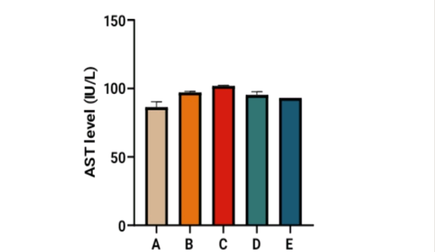
Figure 1: Effect of ethanolic extract of Syzygium aromaticum on serum AST levels in rats exposed to mercury chloride toxicity. A= control, B= HgCl₂, C= ESA, D= HgCl₂ + ESA (200 mg/kg), E= HgCl₂ + ESA (400 mg/kg)

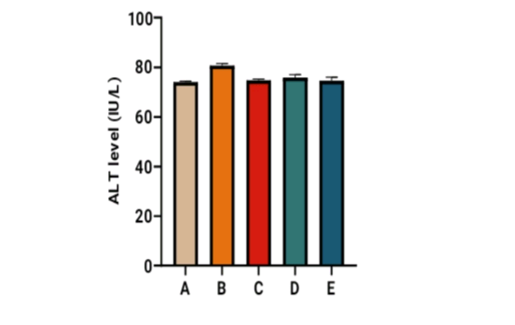
Figure 2: Effect of ethanolic extract of Syzygium aromaticum on Serum ALT level in rats exposed to mercury chloride toxicity.
A= control, B= HgCl₂, C= ESA, D= HgCl₂ + ESA (200 mg/kg), E= HgCl₂ + ESA (400 mg/kg)

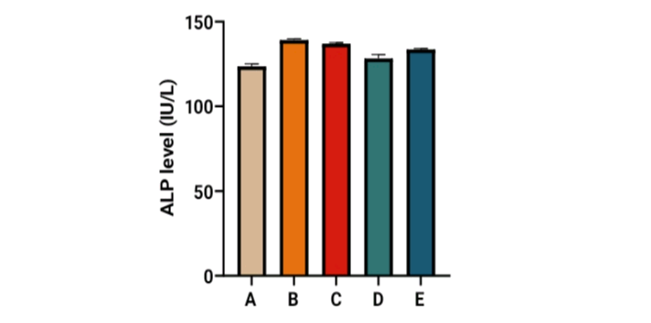
Figure 3: Effect of ethanolic extract of Syzygium aromaticum on Serum ALP level in rats exposed to mercury chloride toxicity.
A= control, B= HgCl₂, C= ESA, D= HgCl₂ + ESA (200 mg/kg), E= HgCl₂ + ESA (400 mg/kg)

3.5. Histopathological Analysis
Histological analysis revealed normal hepatic architecture in the control and Syzygium aromaticum extract-treated groups. Mercury only rats (group B) showed degenerative and reactive hepatic changes, whereas Syzygium aromaticum extract-treated groups displayed mild inflammation with improved liver architecture.

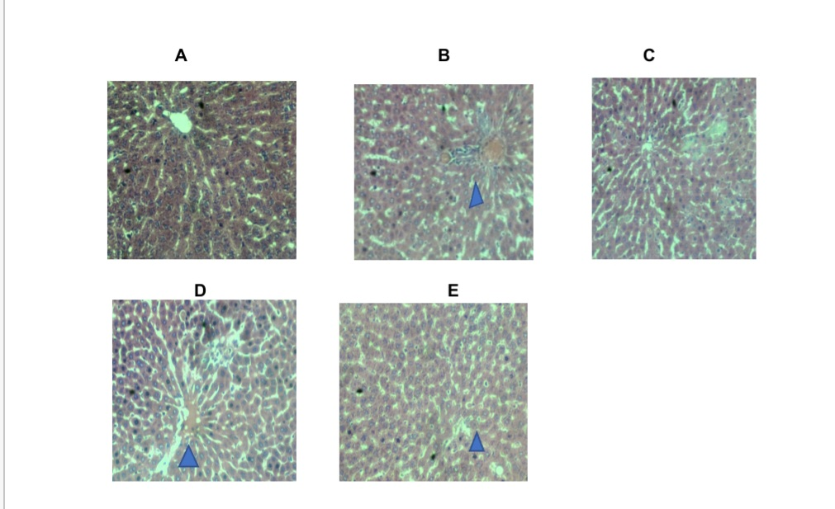
Figure 4: Photomicrographs of liver sections showing histological changes across experimental groups (H&E, ×400).
(A) Control showing normal hepatic architecture;
(B) Mercury chloride-treated group showing degenerative hepatocytes;
(C) S. aromaticum-only group showing preserved hepatic structure;
(D) Mercury chloride + 200 mg/kg Syzygium aromaticum extract showing mild inflammation;
(E) Mercury chloride + 400 mg/kg Syzygium aromaticum extract showing improved hepatic architecture.

- DISCUSSION
The present study demonstrated that mercury chloride induces significant hepatotoxicity in male Wistar rats, as evidenced by elevated serum liver enzyme levels, reduced relative liver weight, and marked histopathological alterations. These findings are consistent with previous reports (Innih and Nwachukwu, 2024; Umeboro et al., 2024), indicating that mercury chloride promotes oxidative stress, disrupts hepatocellular membrane integrity, and impairs normal liver function.

Body weight assessment revealed a general increase in weight across all experimental groups when the initial weight was compared to the final weight, with Syzygium aromaticum extract-treated rats exhibiting relatively higher weight gains compared to mercury-only animals. This observation suggests that administration of Syzygium aromaticum extract may mitigate systemic toxicity and support metabolic recovery following mercury exposure. These findings are in line with the previous studies done by Orheruata and Tobalu (2025), who reported Similar dose-dependent increases in body weight in rats treated with Syzygium aromaticum extracts. However, contrasting findings have been reported elsewhere, where reductions in body weight were observed following mercury exposure despite plant extract treatment (Abdelrahman et al., 2018), highlighting possible differences in extraction methods, dosage, and duration of exposure.
Mercury chloride administration resulted in significant elevations in serum AST, ALT, and ALP levels, indicating hepatocellular injury and compromised membrane permeability. These enzymes are widely recognised as biomarkers of liver damage, and their elevation reflects leakage from damaged hepatocytes into circulation. Treatment with the ethanolic extract of Syzygium aromaticum produced a dose-dependent reduction in these enzyme levels, particularly in groups receiving 400 mg/kg of the Syzygium aromaticum extract. This finding suggests restoration of hepatocellular integrity and improved liver function. Our findings are similar to studies done by Iwemi et al. (2025) and Adegbola et al. (2022), which reported a decrease in liver enzyme level in animals treated with Syzygium aromaticum extract compared to control.
The hepatoprotective effect observed in Syzygium aromaticum extract-treated groups may be attributed to the antioxidant and anti-inflammatory properties of Syzygium aromaticum, especially its major bioactive constituent eugenol. Eugenol has been shown to scavenge free radicals, inhibit lipid peroxidation, chelate metal ions, and stabilise cellular membranes, thereby reducing oxidative damage (Kaur and Kaushal, 2019; Buddhakala et al., 2023). The significant reduction in liver enzyme levels in the 400 mg/kg dose Syzygium aromaticum extract group further supports a dose-dependent protective effect.
Histopathological evaluation supported the biochemical findings. Mercury-treated rats exhibited degenerative and reactive hepatic changes characterised by disrupted hepatocyte architecture and inflammatory infiltration. In contrast, rats treated with Syzygium aromaticum extract showed preservation of hepatic architecture, with only mild inflammatory changes observed. The improved histological features in Syzygium aromaticum extract-treated groups indicate effective protection against mercury-induced structural damage. Similar histological recovery has been reported in studies investigating the protective effects of Syzygium aromaticum against chemically-induced hepatic injury (Imafiadon and Ayomide, 2024). The biochemical and histological findings of this study suggest that the ethanolic extract of Syzygium aromaticum effectively ameliorates mercury chloride–induced hepatotoxicity. The observed protective effects are likely mediated through antioxidant mechanisms, reduction of oxidative stress, and stabilisation of hepatocellular membranes.
Though this study provides valuable experimental evidence, further investigations involving molecular oxidative stress markers and longer exposure periods are recommended to show the precise mechanisms underlying the hepatoprotective activity of Syzygium aromaticum.

- CONCLUSION
Ethanolic extract of Syzygium aromaticum significantly ameliorated mercury chloride–induced hepatotoxicity in male Wistar rats by improving liver enzyme profiles and preserving hepatic histoarchitecture. These effects are likely mediated through antioxidant and anti-inflammatory mechanisms, supporting the therapeutic potential of Syzygium aromaticum against mercury-induced liver injury.

Ethical Approval
Animals were handled according to the guidelines of the National Institute of Health for the Care and Use of Laboratory Animals, and the study received ethical approval from the Animal Research Ethics Committee of Nnamdi Azikiwe University, Awka.

Disclaimer (Artificial intelligence)
Option 1:
Author(s) hereby declare that NO generative AI technologies such as Large Language Models (ChatGPT, COPILOT, etc.) and text-to-image generators have been used during the writing or editing of this manuscript.

REFERENCES

- Balali-Mood M., Naseri K., Tahergorabi Z., Khazdair MR. & Sadegh M. (2021). Toxic mechanisms of five heavy metals: mercury, lead, chromium, cadmium and arsenic. Frontiers in Pharmacology, 12, 643972.
- Rice, K.M, Walker, Jr EM. & Wu, M. (2014). Environmental mercury and its toxic effects. Journal of preventive medicine and public health, 47, 74-82
- Wu, Y.S., Osman, A.I., Hosny, M., Elgarahy, A.M., Eltaweil, A.S, Rooney, D.W., Chen, Z., Rahim, N.S., Sekar, M. & Gopinaih, S.C. (2024). The toxicity of mercury and its chemical compounds: molecular mechanisms and environmental and human health implication: A comprehensive review, ACS Omega, 9(5), 5100-5126
- Ajibade, A.J. (2021). Hepatotoxic effects of mercury chloride on the liver of adult Wistar rats. Journal of Toxicology and Environmental Health, 12(4):215–223.
- Lauren D., Lacey W (2023). Dimercaprol. In: StatPearls. Treasure Island (FL): StartPearls Publishing; available from: https:// www.ncbi.nlm.gov.
- Nweke, S.M., Okafor, N. & Eze, G.I. (2024). Investigating the effects of aqueous fruit extract of Tamarindus indica on mercuric chloride-induced liver toxicity in adult Wistar rats. Journal of Experimental and Clinical Anatomy, 21(2), 227-234
- Nwajiobi, F.O., Nwozor, N.C., Anene, C.C., Soludo, O.C., Ikegwuonu, A.E. (2025). Evaluation of probiotic and antimicrobial properties of lactobacillus species isolated from decaying Musa acumunata. International Journal of Science and Archive. 14, 1709-1717. https://doi.org/10.30574/ijsra.2025.14.2.0509
- Orheruataa, A.R., Pius, G.E., Tobalu, F.O., Ezeuko, V.C. & Enogieru, A.B. (2025). Neuroprotective role of aqueous extract of Syzygium aromaticum flower bud against mercury chloride induced toxicity in Wistar rats. Journal of Experimental and Clinical Anatomy, 22, 393-401
- Kaur, K. & Kaushal, S. (2019). Photochemistry and pharmacological aspects of Syzygium aromaticum: A review. Journal of Pharmocognosy and Photochemistry, 8:398-426
- Imaffidon, E.O. & Ayomide, A.O. (2024). Protective effects of aqueous Syzygium aromaticum extract on mercury chloride-induced liver damage in adult Wistar rats. Annals of A Basic and Medical Sciences 5(1), 497-502
- Hussain, S., Rahmari, R., Mushtaq, A. & Zerey-Belaskri, A. (2017). Clove; A review of a precious spices with multiple uses. International Journal of Chemical and Biochemical Sciences, 11, 129-133
- King, E. & Frankel, S. (1957). A colorimetric method for the determination of serum glutamic pyruvic transaminases. American Journal of Clinical Pathology. 28(1), 56-53
- Innih, S.O. & Nwachukwu, J.U. (2024). Possible Effects of Aqueous Extracts of Newbouldia laevis on Hematological and Cardiac Histo-Architecture in Mercury Chloride Induced Wistar Rats. Sokoto Journal of Medical Laboratory Sciences 9(3),
- Umeboro, P.C.1., Avwioro, O.G., Olaniyan, M.F., Iyare, I.G. & Amina, M. (2024). Effect of Mercury on the Histopathological Architecture and Hormonal Changes on the Ovary of Wistar Rats , Sokoto Journal of Medical Laboratory Science, 9, 2.
- Orheruata, R.A. & Tobalu, F.O. (2025). Effects of aqueous extract of Syzygium aromaticum (clove) on mercury chloride induced toxicity in the hippocampus of adult Wistar rats. Sokoto Journal of Medical Laboratory Science, 10:(1).
- Abdelrahman, M.T., Maina, E.N. & Elshemy, H.A. (2018). Clove (Syzygium aromaticum) and honey extracts significantly reduce inflammatory cytokines and liver function enzymes in experimental rats fed on carbon tetrachloride. Journal of radiation research and applied sciences. 1, 416-422
- Iwemi, O.A., Bello, K.T. & Adekunle, T. (2025). Effects of aqueous extracts of Syzygium aromaticum on liver enzyme activities in Wistar rats. Journal of Experimental Pharmacology, 17, 45–53.
- Adegbola, M.G., Anyim, N., Monde, A. & Ademola, O.T (2022). Potential effect of Syzygium aromaticum extract on serum antioxidant status and lipid profiles in Wistar rats with artesunate toxicity. Applied Sciences 12.
- Buddhakala, N., Yongkhamcha, B., Rattanaloeadnusorn, S. & Talubmook, C. (2023). Phytochemicals and antidiabetic, antioxidant and anti-inflammatory activities of ethanol flower extract of Syzygium aromaticum (L)Merr. & Perry (Myrtaceae). Trends in Science, 20(1), 3583-3583
- Ceramella, J., De Maio, A. C., Basile, G., Facente, A., Scali, E., Andreu, I., ... & Catalano, A. (2024). Phytochemicals involved in mitigating silent toxicity induced by heavy metals. Foods, 13(7), 978. https://doi.org/10.3390/foods13070978
- Mani, V., Krishnan, B., Govindaraj, D., & Nagappan, S. (2025). Bioaccumulation of Mercury and Its Consequences on Biochemical Parameters in Coriander (Coriandrum sativum) Plants. Asian Journal of Advanced Research and Reports, 19(1), 213–222. https://doi.org/10.9734/ajarr/2025/v19i1875
- Raj, D., & Maiti, S. K. (2019). Sources, toxicity, and remediation of mercury: an essence review. Environmental monitoring and assessment, 191(9), 566. https://doi.org/10.1007/s10661-019-7743-2

