Original Research Article
Soil Fertility and Nutrient Dynamics of Two Contrasting Tropical Wetlands of Kerala, India: Implications for Sustainable Agriculture

Abstract
This study evaluates soil fertility and nutrient dynamics in two contrasting tropical wetlands of Kerala, India - Ashtamudi (estuarine) and Kuttanad (below–sea-level), with emphasis on agricultural implications. Surface soil samples were analysed for pH, electrical conductivity, organic carbon, and available nitrogen, phosphorus, and potassium using standard methods. Descriptive statistics, independent samples t-test, Pearson correlation, principal component analysis, and nutrient index values were applied to identify dominant fertility patterns and controlling factors.
Soils of both wetlands were acidic, but Ashtamudi soils exhibited significantly higher electrical conductivity and greater spatial variability in nutrient concentrations, reflecting estuarine influence. Kuttanad soils were more uniformly acidic due to prolonged flooding. Correlation and PCA results showed that organic carbon strongly controlled nitrogen and potassium availability, while phosphorus availability was closely linked to soil pH. Nutrient index analysis revealed low nitrogen but high phosphorus status in Ashtamudi soils, whereas Kuttanad soils showed relatively balanced nutrient status under acidity constraints. The findings indicate that wetland soils are agriculturally differentiated mainly by salinity and acidity regimes rather than absolute nutrient levels. Site-specific nutrient and soil acidity management is therefore essential for sustainable wetland agriculture.
Keywords: Wetland soils, Soil fertility, Nutrient dynamics, Wetland agriculture, Ashtamudi wetland, Kuttanad Wetland

1. Introduction
Wetlands are among the most productive ecosystems on Earth and play a critical role in nutrient cycling, soil formation, and agricultural sustainability, particularly in tropical regions (Mitsch & Gosselink, 2015; Reddy & DeLaune, 2008). The chemical properties of wetland soils are strongly influenced by hydrological regime, sediment inputs, and redox processes, which collectively govern nutrient availability and crop productivity (Ponnamperuma, 1972; Brady & Weil, 2017). In India, coastal and inland wetlands support extensive rice-based agriculture, yet these systems are increasingly challenged by soil acidity, salinity intrusion, nutrient imbalance, and anthropogenic pressures (Doran & Parkin, 1994; Oviedo Celis et al., 2024). Understanding soil nutrient dynamics in such wetlands is therefore essential for balancing agricultural productivity with long-term ecological sustainability.
The Ashtamudi wetland, a Ramsar-listed estuarine system on the southwest coast of India, is characterized by complex river-estuary interactions, heterogeneous sediment deposition, and periodic saline water ingress, all of which contribute to high spatial variability in soil properties (Babu et al., 2000; Babu et al., 2010; RIS, 2002). Previous studies have documented significant variability in water and sediment quality in Ashtamudi, linked to both natural processes and anthropogenic influences (Alexander, 2025; Rajagopal & Sreekala, 2025). The Kuttanad wetland represents a unique below-sea-level agroecosystem dominated by reclaimed paddy fields subjected to prolonged flooding, restricted drainage, and persistent soil acidity (Alexander et al., 2010). The distinct geomorphological and hydrological settings of these wetlands provide an ideal natural framework for comparative assessment of soil fertility and nutrient behaviour under contrasting wetland agricultural systems.
Despite their agricultural importance, comparative, data-driven assessments of soil nutrient status across estuarine and below-sea-level wetlands remain limited, particularly using integrated statistical and multivariate approaches (Nosrati, 2012; Selmy et al., 2021; Zhang et al., 2022). The present study addresses this gap by evaluating soil chemical properties, nutrient availability, and fertility indices in the Ashtamudi and Kuttanad wetlands using descriptive statistics, hypothesis testing, correlation analysis, principal component analysis, and nutrient index values. By linking soil chemistry with dominant environmental drivers, this study provides agriculturally relevant insights into nutrient constraints and management priorities, contributing to sustainable wetland agriculture and informed soil management strategies in tropical wetland ecosystems (Vasu et al., 2017; Hale et al., 2018; Shokr et al., 2025).
2. Materials and Methods
2.1. Study Area
The study was conducted in two ecologically and agriculturally important tropical wetlands of Kerala, India, namely the Ashtamudi wetland and the Kuttanad wetland (Fig. 1). Ashtamudi Lake located at the geographical coordination of 76⁰ 13’ to 76⁰ 37’ E and 8⁰ 54’ to 8⁰ 59’ N in Kollam district in Kerala with a water spread area of 32 km². It is a Ramsar-listed estuarine wetland located along the southwest coast of India, characterized by multiple riverine inlets, islands, and periodic saline water intrusion from the Arabian Sea (Fig. 2). The wetland receives freshwater input primarily from the Kallada River and exhibits strong spatial heterogeneity in sediment and nutrient dynamics. The Kuttanad wetland located in between, 9° 17′ to 9° 40′ N latitude and 76° 19′ to 76° 33′ E longitude and is a unique below-sea-level agroecosystem, popularly known as the “rice bowl of Kerala,” traversed by the Pampa, Meenachil, Manimala, and Achencovil rivers. The region is dominated by reclaimed paddy fields subjected to prolonged inundation, restricted drainage, and intensive agricultural practices, resulting in distinct soil chemical conditions compared to estuarine wetlands.
Figure 1. Location map of the Ashtamudi and Kuttanad wetlands, Kerala, India

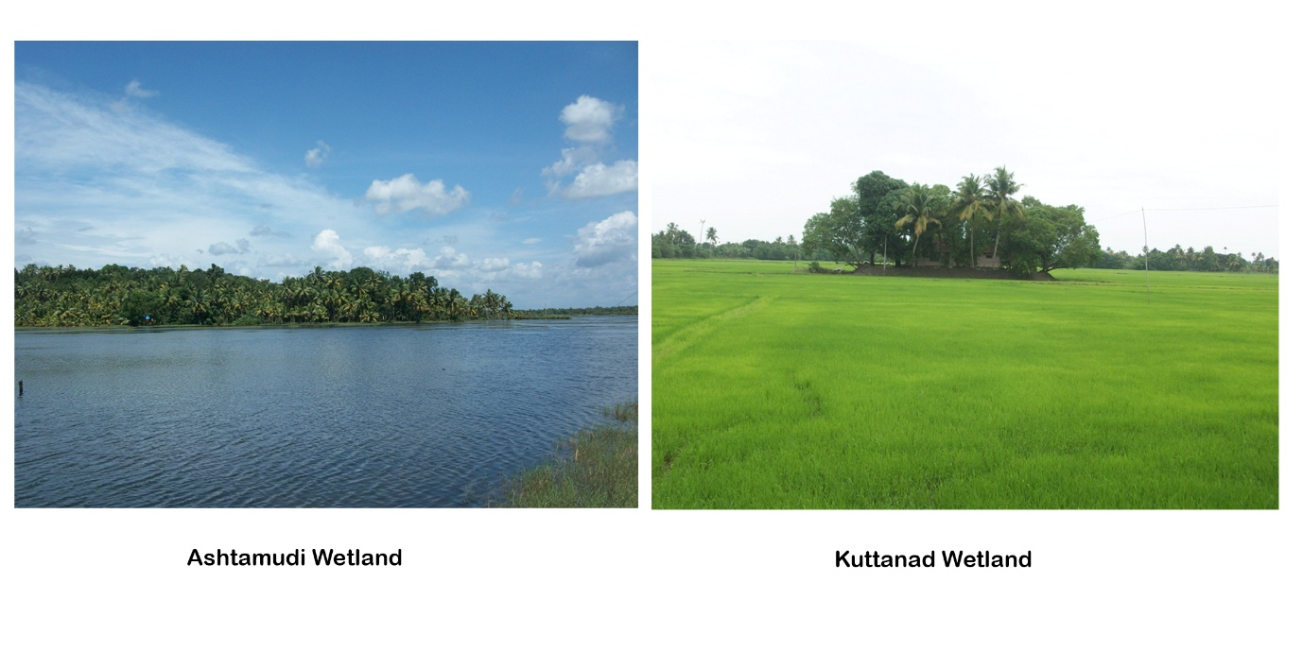
Figure 2. Representative views of the Ashtamudi and Kuttanad wetlands
2.2. Soil Sampling and Laboratory Analysis
A total of 47 surface soil samples were collected from representative locations across the two wetlands, comprising 23 samples from Ashtamudi and 24 samples from Kuttanad, covering major agricultural and hydrologically distinct zones. Surface soils (0-15 cm depth) were collected using a stainless-steel auger, air-dried, gently crushed, and sieved through a 2-mm mesh prior to analysis. Soil pH and electrical conductivity (EC) were determined in a soil-water suspension following standard procedures. Organic carbon (OC) content was estimated using the Walkley and Black wet oxidation method (Walkley & Black, 1934). Available nitrogen (N), phosphorus (P), and potassium (K) were analysed using standard soil analytical protocols commonly employed for agronomic fertility assessment. All laboratory analyses were carried out following established standard methods to ensure data reliability and comparability (Reddy & DeLaune, 2008; Vasu et al., 2017).
2.3. Statistical and Multivariate Analysis
Descriptive statistics, including mean, standard deviation, and range, were computed to assess spatial variability in soil chemical properties within and between wetlands. An independent samples t-test was applied to evaluate significant differences in soil parameters between Ashtamudi and Kuttanad wetlands. Pearson correlation analysis was used to examine interrelationships among soil variables, and correlation matrices were visualized using heat maps with significance levels. Principal Component Analysis (PCA) was performed on standardized soil variables to identify dominant fertility gradients and multivariate patterns controlling soil quality. Additionally, Nutrient Index Values (NIV) for available N, P, and K were computed to classify soil fertility status into low, medium, and high categories from an agricultural perspective. All statistical analyses were performed using standard statistical software - PAST 4.3, and results were interpreted at a 95% confidence level.
3. Results
3.1. Soil Chemical Characteristics of the Ashtamudi Wetland
The soils of the Ashtamudi wetland exhibited moderately acidic to acidic conditions (pH 3.7-6.55) with considerable spatial variability in nutrient status (Table 1). Organic carbon content ranged widely, indicating heterogeneous organic matter accumulation across sampling locations. Available nitrogen levels were generally moderate to high, reflecting substantial organic matter mineralization under wetland conditions. Phosphorus availability showed pronounced variability, with certain locations recording markedly elevated concentrations, suggesting localized enrichment possibly linked to sediment inputs and anthropogenic influences. Exchangeable potassium levels were predominantly moderate to high, highlighting the relatively good potassium-supplying capacity of Ashtamudi soils.
Table 1. Soil chemical properties of surface soils from the Ashtamudi wetland
 | Sample locations | pH | EC (mS/m) | OC (%) | N(kg/ha) | P(kg/ha) | K(kg/ha)
 | Anchalummood | 5.0 | 0.0085 | 7.761 | 705.6 | 138.6 | 1013.04
 | Chembakamthuruthu | 3.7 | 1.282 | 2.039 | 313.60 | 120.96 | 99.30
 | Kandachira kayal | 5.5 | 0.56 | 3.54 | 266.56 | 40.22 | 105.84
 | Munrothuruthu | 5.7 | 0.06 | 1.35 | 250.88 | 23.24 | 170.1
 | Murunthal | 5.4 | 0.11 | 4.65 | 392.00 | 6.79 | 113.4
 | Pattamthuruthu | 5.2 | 0.003 | 2.138 | 203.84 | 362.88 | 920.77
 | Perumon | 5.9 | 0.206 | 1.505 | 266.56 | 102.81 | 234.71
 | Prakkulam | 6.35 | 0.164 | 0.874 | 243.04 | 293.72 | 102.30
 | Sambranikodi | 6.55 | 0.258 | 1.25 | 235.2 | 3750.5 | 153.74
 | Vettiyathodu | 3.8 | 0.695 | 2.930 | 313.60 | 443.52 | 270.82
 | Kumbalam | 5.8 | 0.002 | 1.423 | 62.72 | 4.26 | 78.40
 | Palliyamathuruth | 5.4 | 0.562 | 2.195 | 237.84 | 395.47 | 353.71
 | Manakkadavu | 5.5 | 0.733 | 3.343 | 183.39 | 438.07 | 194.65
 | Kakkathuruth | 6.2 | 0.871 | 2.344 | 98.76 | 213.12 | 127.33
 | Kureepuzhakkadavu | 3.9 | 0.932 | 1.943 | 89.44 | 245.73 | 463.49
 | Kanjirottu Kayal | 5.2 | 0.443 | 3.198 | 533.83 | 492.48 | 643.74
 | Perayam | 4.4 | 0.743 | 9.312 | 263.35 | 538.91 | 454.03
 | Kuthiramunampu | 4.9 | 0.464 | 4.304 | 188.46 | 567.12 | 567.34
 | Neendakara | 5.27 | 0.172 | 2.64 | 237.35 | 355.53 | 237.62
 | Puthenthuruthu | 5.42 | 0.43 | 2.15 | 441.41 | 56.74 | 260.13
 | Asramom | 5.57 | 0.62 | 2.33 | 430.12 | 44.06 | 310.24
 | Kidapram | 4.76 | 0.46 | 2.35 | 281.78 | 56.55 | 242.69
 | Cherikadavu | 4.95 | 0.10 | 2.78 | 254.00 | 42.65 | 422.37

3.2. Soil Chemical Characteristics of the Kuttanad Wetland
Soils of the Kuttanad wetland were characterized by strongly acidic to moderately acidic pH, reflecting prolonged waterlogging and reduced soil conditions typical of below-sea-level agroecosystems (Table 2). Organic carbon content was generally moderate to high, supporting the retention of nutrients in flooded paddy soils. Available nitrogen levels were mostly moderate, indicating sustained nitrogen availability under anaerobic conditions. In contrast, available phosphorus concentrations were predominantly low to moderate, suggesting possible fixation under acidic soil conditions. Potassium levels varied from low to high, with several locations exhibiting appreciable potassium reserves, likely influenced by alluvial deposits and irrigation inputs.
Table 2. Physico-chemical characteristics and nutrient status of soils in the Kuttanad wetland
 | Sample Locations | pH | EC (mS/m) | OC (%) | N (Kg/ha) | P (kg/ha) | K (kg/ha)
 | Aryadu | 5.6 | 0.143 | 0.83 | 366.90 | 117.35 | 724.80
 | Alappuzha | 5.5 | 0.062 | 1.48 | 432.36 | 15.54 | 144.96
 | Kanjikkuzhy | 5.0 | 0.080 | 0.54 | 145.34 | 17.43 | 249.46
 | Muhamma | 6.0 | 0.887 | 2.25 | 282.24 | 126.65 | 337.12
 | Kavalam | 5.8 | 0.312 | 1.53 | 336.4 | 63.75 | 432.48
 | Kainakari | 4.3 | 0.453 | 3.71 | 536.25 | 18.27 | 269.69
 | Pulinkunnu | 4.3 | 0.077 | 2.47 | 381.02 | 16.41 | 279.80
 | Punnapra | 4.6 | 0.144 | 1.15 | 282.24 | 18.60 | 117.99
 | Nedumudi | 4.7 | 0.140 | 3.06 | 381.02 | 16.11 | 640.52
 | Ramankari | 4.9 | 0.227 | 2.92 | 451.58 | 76.09 | 269.69
 | Nattakam | 3.9 | 0.09 | 1.99 | 282.24 | 99.00 | 106.64
 | Thruvarppu | 4.1 | 0.07 | 0.98 | 235.20 | 59.79 | 213.11
 | Aimanom | 4.2 | 0.13 | 1.80 | 313.60 | 59.79 | 106.24
 | Vembanadu | 3.5 | 0.02 | 2.96 | 470.40 | 39.86 | 157.31
 | Vattakkayal | 5.3 | 0.18 | 2.98 | 423.36 | 79.72 | 320.16
 | Edathuva | 5.2 | 0.09 | 1.11 | 266.56 | 19.93 | 225.41
 | Thayamkari | 4.9 | 0.08 | 1.35 | 313.60 | 99.65 | 89.29
 | Kangayathodu | 4.9 | 0.50 | 1.70 | 392.00 | 39.86 | 720.13
 | Cherukara | 5.1 | 0.048 | 4.21 | 158.23 | 75.86 | 125.56
 | Pennukkara | 4.8 | 0.161 | 2.53 | 381.02 | 75.86 | 186.18
 | Ala | 5.4 | 0.080 | 3.54 | 225.79 | 122.54 | 298.76
 | Neduvaramcodu | 5.1 | 0.096 | 2.38 | 366.91 | 81.69 | 138.56
 | Puliyur | 4.1 | 0.153 | 3.78 | 183.45 | 303.42 | 251.13
 | Thalavadi | 4.8 | 0.236 | 1.57 | 197.57 | 332.61 | 303.09
3.3. Comparative Soil Fertility Status of Ashtamudi and Kuttanad Wetlands
A comparative evaluation of soil nutrient status revealed distinct fertility characteristics between the two wetlands. The Ashtamudi wetland exhibited greater spatial variability in nutrient concentrations, with relatively higher and more heterogeneous levels of available nitrogen, phosphorus, and potassium, reflecting its estuarine influence and diverse sediment inputs. In contrast, the Kuttanad wetland soils were more uniformly acidic and characterized by moderate organic carbon and nitrogen levels but comparatively lower phosphorus availability, likely due to fixation under prolonged flooded and acidic conditions. Potassium availability in Kuttanad showed moderate variability but was generally lower than in Ashtamudi. These differences highlight the influence of hydrological regime and geomorphological setting on soil fertility, with important implications for wetland-specific nutrient management and sustainable agricultural practices.
3.4. Descriptive Statistical Analysis of Soil Chemical Properties
Table 3. Descriptive statistics of soil chemical properties in Ashtamudi and Kuttanad wetlands
Parameter | Ashtamudi Wetland (n = 23) |  |  | Kuttanad Wetland (n = 24)
 | Mean ± SD | Min | Max | Mean ± SD | Min | Max
pH | 5.23 ± 0.76 | 3.70 | 6.55 | 4.83 ± 0.62 | 3.50 | 6.00
EC (mS m⁻¹) | 0.43 ± 0.34 | 0.002 | 1.28 | 0.19 ± 0.19 | 0.02 | 0.89
OC (%) | 2.97 ± 2.00 | 0.87 | 9.31 | 2.20 ± 1.03 | 0.54 | 4.21
N (kg ha⁻¹) | 282.32 ± 144.26 | 62.72 | 705.60 | 325.22 ± 102.99 | 145.34 | 536.25
P (kg ha⁻¹) | 379.74 ± 758.47 | 4.26 | 3750.50 | 82.32 ± 81.15 | 15.54 | 332.61
K (kg ha⁻¹) | 327.82 ± 254.78 | 78.40 | 1013.04 | 279.50 ± 182.83 | 89.29 | 724.80

Descriptive statistics revealed distinct soil chemical characteristics between the two wetlands (Table 3). The Ashtamudi wetland soils exhibited slightly higher mean pH, electrical conductivity, organic carbon, and markedly higher phosphorus levels, coupled with large standard deviations, indicating pronounced spatial heterogeneity in nutrient distribution. In contrast, the Kuttanad wetland soils were more uniformly acidic, with moderate organic carbon and nitrogen levels and comparatively lower mean phosphorus concentration, reflecting nutrient fixation under prolonged flooded and acidic conditions. Potassium availability was moderate in both wetlands, though greater variability was observed in Ashtamudi soils. These statistical trends highlight contrasting nutrient regimes governed by hydrological and geomorphological settings, with important implications for wetland-specific soil fertility management and sustainable agricultural practices.
3.5. Independent Samples t-test Analysis of Soil Chemical Parameters
Table 4. Independent samples t-test comparing soil chemical properties of Ashtamudi and Kuttanad wetlands
Parameter | t value | p value | Significance
pH | 1.97 | 0.055 | NS
EC (mS m⁻¹) | 2.98 | 0.005 | Significant
Organic Carbon (%) | 1.65 | 0.108 | NS
Available N (kg ha⁻¹) | –1.17 | 0.249 | NS
Available P (kg ha⁻¹) | 1.87 | 0.075 | NS
Available K (kg ha⁻¹) | 0.74 | 0.461 | NS
Independent samples t-test analysis was performed to evaluate whether the soils of the two wetlands differ significantly in terms of agriculturally important chemical properties (Table 4). Among the analyzed parameters, electrical conductivity (EC) differed significantly between Ashtamudi and Kuttanad wetlands (p < 0.05), indicating contrasting salinity and ionic environments influenced by estuarine processes in Ashtamudi and freshwater dominance in Kuttanad. Soil pH showed a near-significant difference, with Kuttanad soils tending toward stronger acidity. In contrast, organic carbon, available nitrogen, phosphorus, and potassium did not differ significantly between the two wetlands, suggesting broadly comparable nutrient reserves despite differences in hydrology and geomorphology. The present t-test results indicate that the two wetlands are agriculturally differentiated primarily by salinity and acidity regimes rather than by macronutrient availability.
3.6. Interrelationships among Soil Chemical Properties: Pearson Correlation Analysis
The Pearson correlation heat map for the Ashtamudi wetland revealed several statistically significant relationships among soil fertility parameters. Organic carbon showed a significant positive correlation with available nitrogen (r = 0.43, p < 0.05) and potassium (r = 0.47, p < 0.05), highlighting the dominant role of organic matter in regulating nutrient availability in estuarine wetland soils (Fig. 3). A significant positive association was also observed between nitrogen and potassium (r = 0.44, p < 0.05), indicating coupled nutrient dynamics. Soil pH exhibited a significant negative correlation with electrical conductivity (r = –0.52, p < 0.05), reflecting the influence of salinity on soil acidity. Other correlations were weak and statistically non-significant, emphasizing the heterogeneous and site-specific nutrient behavior in Ashtamudi soils.
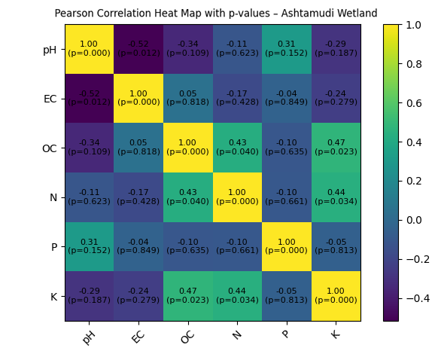
Figure 3. Pearson correlation heat map of soil chemical properties in the Ashtamudi wetland

In contrast, the Kuttanad wetland exhibited a simpler and more constrained correlation structure. The most prominent relationship was a significant negative correlation between available nitrogen and phosphorus (r = –0.45, p < 0.05), suggesting differential nutrient transformation and possible phosphorus fixation under prolonged flooded and acidic conditions (Fig. 4). Most other parameter pairs, including organic carbon with nitrogen and phosphorus, showed weak to moderate correlations that were statistically non-significant. Electrical conductivity displayed moderate positive but non-significant associations with pH and potassium, reflecting the influence of dissolved ions in flooded paddy soils. This correlation pattern indicates distinct biogeochemical controls on nutrient availability in the below-sea-level Kuttanad agroecosystem.
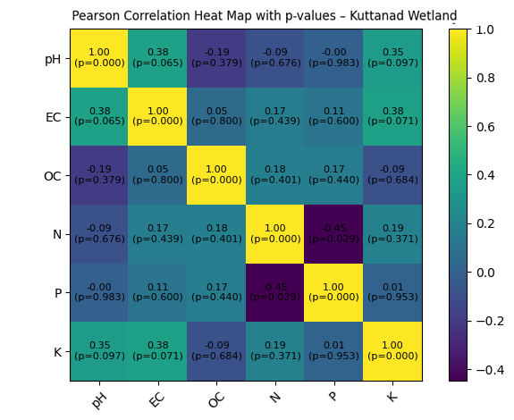
Figure 4. Pearson correlation heat map of soil chemical properties in the Kuttanad wetland
3.7. Principal Component Analysis of Soil Fertility Parameters
Principal Component Analysis (PCA) was employed to identify the dominant soil chemical factors governing fertility variation between the two wetlands. The first two principal components together explained 49.6% of the total variance in soil properties. PC1 (29.1%) was primarily influenced by organic carbon, available nitrogen, potassium, and electrical conductivity, representing a nutrient enrichment gradient. PC2 (20.5%) was largely associated with soil pH and available phosphorus, reflecting acidity-phosphorus interactions in wetland soils.

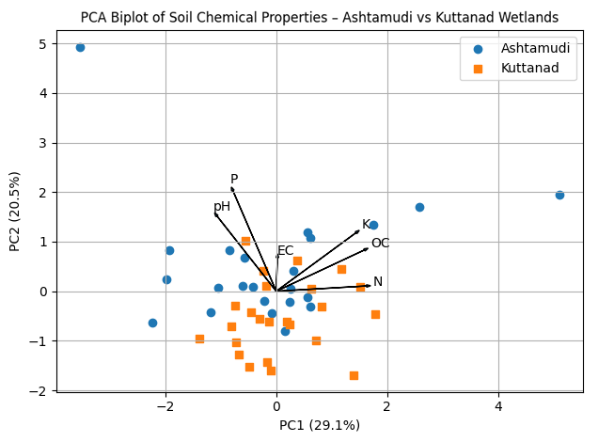
Figure 5. Principal Component Analysis (PCA) biplot showing soil fertility gradients in Ashtamudi and Kuttanad wetlands
The PCA biplot revealed a partial separation of soil samples from Ashtamudi and Kuttanad wetlands, indicating distinct soil fertility regimes (Fig. 5). Samples from the Ashtamudi wetland were more widely dispersed along PC1, reflecting greater variability in nutrient availability and salinity-related parameters, characteristic of estuarine environments. In contrast, Kuttanad wetland samples clustered more closely, suggesting relatively uniform soil chemical conditions dominated by acidity and flooded soil processes. The orientation of nutrient vectors indicates that organic carbon strongly governs nitrogen and potassium availability, while phosphorus distribution is closely linked to pH conditions. PCA results confirm that the two wetlands are agriculturally differentiated by dominant fertility drivers rather than absolute nutrient concentrations, underscoring the need for wetland-specific soil and nutrient management strategies.
3.8. Nutrient Index-Based Assessment of Soil Fertility Status
Nutrient Index Value (NIV) analysis revealed distinct fertility status and nutrient balance patterns between the two wetlands (Table 5). In the Ashtamudi wetland, available nitrogen exhibited a low fertility class, indicating potential nitrogen limitation despite relatively high organic carbon content. In contrast, available phosphorus recorded a high fertility status, reflecting substantial phosphorus enrichment and strong spatial variability. Potassium availability in Ashtamudi soils fell within the medium fertility class, suggesting moderate potassium-supplying capacity.
Table 5. Nutrient Index Values (NIV) and fertility classification of Ashtamudi and Kuttanad wetlands
Nutrient | Ashtamudi Wetland | Fertility Class | Kuttanad Wetland | Fertility Class
Available Nitrogen (N) | 1.39 | Low | 1.71 | Medium
Available Phosphorus (P) | 2.65 | High | 2.33 | Medium–High
Available Potassium (K) | 2.09 | Medium | 2.00 | Medium

In the Kuttanad wetland, nitrogen availability was classified as medium, indicating relatively better nitrogen status under flooded paddy conditions. Phosphorus exhibited a medium to high fertility status, while potassium remained within the medium fertility class. The comparative NIV results indicate that Ashtamudi soils are characterized by phosphorus-rich but nitrogen-deficient conditions, whereas Kuttanad soils exhibit a more balanced nutrient status, though still constrained by soil acidity (Fig. 6). These findings highlight the importance of wetland-specific, nutrient-targeted fertilizer management strategies for sustainable agricultural productivity.
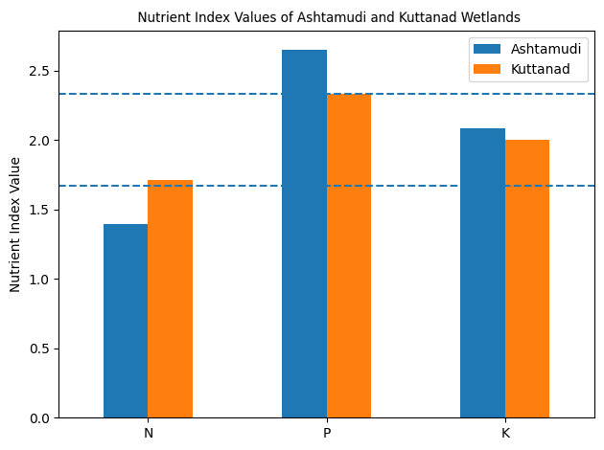
Figure 6. Comparison of Nutrient Index Values (NIV) for available nitrogen, phosphorus, and potassium in Ashtamudi and Kuttanad wetlands
3.9. Limitation of the Study
The present study is based on soil samples collected during a single sampling period and therefore does not capture seasonal variability in soil chemical properties and nutrient dynamics, which can be pronounced in tropical wetland agroecosystems due to monsoon-driven hydrological changes. Seasonal fluctuations in flooding, salinity intrusion, and organic matter decomposition may influence nutrient availability over time. Future studies incorporating multi-seasonal or long-term monitoring would provide a more comprehensive understanding of temporal nutrient dynamics and strengthen management recommendations.
4. Discussion
The present investigation reveals that soil fertility characteristics of the Ashtamudi and Kuttanad wetlands are primarily governed by hydrological setting and wetland biogeochemistry, rather than by uniform nutrient availability. The moderately acidic to acidic soil reaction observed in both wetlands is typical of submerged and periodically flooded soils, where anaerobic conditions regulate redox reactions and nutrient solubility (Ponnamperuma, 1972; Reddy & DeLaune, 2008; Mitsch & Gosselink, 2015). However, the relatively higher mean pH and significantly elevated electrical conductivity in Ashtamudi soils indicate estuarine influence and saline water intrusion, a characteristic previously reported for the Ashtamudi Ramsar site (Babu et al., 2000; Babu et al., 2010; RIS, 2002; Alexander, 2025). In contrast, the Kuttanad wetland, being a below-sea-level agroecosystem, exhibited more uniformly acidic soils with lower EC values, consistent with earlier environmental assessments highlighting persistent acidity, reduced drainage, and prolonged flooding in this region (Alexander et al., 2010). The significant difference in EC revealed by the t-test further confirms that salinity and ionic composition constitute the principal agricultural differentiators between the two wetlands, rather than absolute nutrient concentrations.
Multivariate and correlation analyses provided deeper insight into the mechanisms controlling nutrient dynamics in these wetlands. In Ashtamudi soils, the significant positive correlations between organic carbon, nitrogen, and potassium emphasize the role of organic matter-mediated nutrient retention and mineralization, a phenomenon commonly observed in estuarine sediments subjected to high organic inputs and sediment-water interactions (Babu et al., 2000; Li et al., 2024). The negative association between pH and EC further reflects the influence of saline ingress on soil acidity gradients in estuarine environments (Babu et al., 2010). Conversely, the Kuttanad wetland displayed a more constrained correlation structure, with a significant negative relationship between nitrogen and phosphorus, indicating differential nutrient transformation under prolonged anaerobic and acidic conditions, particularly phosphorus fixation (Ponnamperuma, 1972; Reddy & DeLaune, 2008). The PCA biplot corroborated these findings by demonstrating partial separation of soils along gradients dominated by organic carbon, nitrogen, potassium, and EC (PC1) and pH–phosphorus interactions (PC2). Similar studies have emphasized the effectiveness of PCA in identifying dominant soil fertility drivers in wetlands and agricultural landscapes (Nosrati, 2012; Selmy et al., 2021; Zhang et al., 2022; Shokr et al., 2025), reinforcing the robustness of the multivariate approach adopted in this study.
From an agricultural perspective, the Nutrient Index Value (NIV) analysis translates chemical data into practical fertility classes, offering direct relevance for nutrient management. Despite high organic carbon content, Ashtamudi soils exhibited low nitrogen fertility but high phosphorus status, indicating nutrient imbalance likely associated with external phosphorus enrichment and inefficient nitrogen retention, a condition frequently reported in estuarine and coastal wetlands (Babu et al., 2000; Brady & Weil, 2017). In contrast, Kuttanad soils showed medium nitrogen and potassium status and medium to high phosphorus availability, reflecting comparatively balanced nutrient reserves but under strong acidity constraints that can limit crop response (Alexander et al., 2010; Ponnamperuma, 1972). These findings align with soil quality concepts emphasizing that nutrient availability alone does not ensure agricultural sustainability unless accompanied by favourable soil chemical conditions (Doran & Parkin, 1994; Oviedo Celis et al., 2024). Collectively, the integration of classical statistics, multivariate analysis, and nutrient indices underscores that wetland-specific management strategies - incorporating nitrogen supplementation, phosphorus regulation, and acidity amelioration - are essential for sustaining agricultural productivity while maintaining ecological integrity in tropical wetland systems (Vasu et al., 2017; Hale et al., 2018; Rajagopal & Sreekala, 2025).
5. Conclusion
The present study provides a comprehensive agricultural assessment of soil chemical properties and nutrient dynamics in the Ashtamudi and Kuttanad wetlands, highlighting the influence of contrasting hydrological and geomorphological settings on soil fertility. Although both wetlands exhibited acidic soil conditions, Ashtamudi soils were characterized by higher electrical conductivity and pronounced spatial variability in nutrient availability due to estuarine influence, while Kuttanad soils showed more uniform acidity associated with prolonged flooding in below-sea-level paddy systems. Multivariate analyses and nutrient index evaluation revealed that the two wetlands are agriculturally differentiated primarily by salinity-acidity regimes and dominant fertility drivers rather than absolute nutrient concentrations, with Ashtamudi soils exhibiting phosphorus enrichment but nitrogen limitation and Kuttanad soils showing comparatively balanced nutrient status under acidity constraints. These findings emphasize the necessity of wetland-specific soil and nutrient management strategies, including targeted nitrogen supplementation, regulated phosphorus inputs, and soil acidity improvement, to enhance crop productivity while ensuring the long-term sustainability and ecological integrity of tropical wetland agroecosystems.
Conflict of Interest: The author declares that there is no conflict of interest regarding the publication of this manuscript.
Ethical Approval: This article does not contain any studies with human participants or animals performed by the author.

Disclaimer (Artificial intelligence)

Author(s) hereby declare that NO generative AI technologies such as Large Language Models (ChatGPT, COPILOT, etc.) and text-to-image generators have been used during the writing or editing of this manuscript.

References
- Alexander T. (2025). Diversity and Community Structure of Benthic Macrofauna in Ashtamudi Lake, Kerala: Implications for Estuarine Health and Productivity, International Journal of Science, Architecture, Technology, and Environment, 2 (11): 381-390. http://dx.doi.org/10.63680/ijsate1125039.032
- Alexander, T., Nair P. K. K. & Shaji P. K. (2010). Environmental perceptive of Kuttanad Wetland with special reference to Kainakari Panchayat. Proceedings of National Seminar on Conservation and management of Wetlands in an era of Climate change. Journal of Basic and Applied Biology. 4(3): 60-68.
- Babu, K. N., Ouseph, P. P., & Padmalal, D. (2000). Interstitial water-sediment geochemistry of N, P and Fe and its response to overlying waters of tropical estuaries: a case from the south west coast of India. Environmental Geology, 39(6): 633-640. DOI:10.1007/s002540050475.
- Babu, K.N., Omana, P.K. & Mohan, M. (2010). Water and sediment quality of Ashtamudi estuary, a Ramsar site, southwest coast of India-a statistical appraisal. Environmental Monitoring and Assessment, 307-319. https://doi.org/10.1007/s10661-009-0947-0
- Brady, N. C., & Weil, R. R. (2017). The nature and properties of soils (15th ed.). Pearson Education.
- Doran, J. W., & Parkin, T. B. (1994). Defining and assessing soil quality. In J. W. Doran et al. (Eds.), Defining soil quality for a sustainable environment (pp. 3-21). SSSA. https://doi.org/10.2136/sssaspecpub35.c1
- Hale, R., Reich, P., Daniel, T., Lake, P. S. & Cavagnaro, T. R. (2018). Assessing changes in structural vegetation and soil properties following riparian restoration. Agriculture, Ecosystems & Environment, 252: 22-29. https://doi.org/10.1016/j.agee.2017.09.036
- Li, Y., Wang, J., Zhang, C., Wang, Z., & Bai, J. (2024). Seasonal dynamics and driving factors of soil organic carbon and nitrogen in estuarine wetlands. Journal of Environmental Management, 349: 119683. https://doi.org/10.1016/j.jenvman.2023.119683
- Mitsch, W. J., & Gosselink, J. G. (2015). Wetlands (5th ed.). John Wiley & Sons. https://www.wiley.com/en-us/Wetlands%2C+5th+Edition-p-9780470699432
- Nosrati, K. (2012). Assessing soil quality indicator under different land use and soil erosion using multivariate statistical techniques. Environmental Monitoring and Assessment, 185(4), 2895-2907. https://doi.org/10.1007/s10661-012-2758-y
- Oviedo Celis, R. A., Hernández Gamboa, C., Pascual, J. A., & Ros, M. (2024). Conceptual and practical challenges of assessing soil quality. Soil Use and Management, 40(4): e13137. https://doi.org/10.1111/sum.13137
- Ponnamperuma, F. N. (1972). The chemistry of submerged soils. Advances in Agronomy, 24: 29–96. https://doi.org/10.1016/S0065-2113(08)60633-1
- Rajagopal, P. K. & Sreekala K. (2025). Ashtamudi Lake: Balancing ecosystem conservation and socio-cultural dynamics. Artha - Journal of Social Science. 26(2): 113-133 https://journals.christuniversity.in/index.php/artha/article/view/6846
- Reddy, K. R., & DeLaune, R. D. (2008). Biogeochemistry of wetlands: Science and applications. CRC Press. https://doi.org/10.1201/9780203491454
- RIS (Ramsar Information Sheet). (2002). Information Sheet on Ramsar Wetlands: Ashtamudi Wetland (No. 1204). Ramsar Convention Secretariat. https://rsis.ramsar.org/RISapp/files/RISrep/IN1204RIS.pdf
- Selmy, S. A. H., Abd Al-Aziz, S. H., Jiménez-Ballesta, R., Jesús García-Navarro, F., & Fadl, M. E. (2021). Soil quality assessment using multivariate approaches: A case study of the Dakhla Oasis arid lands. Land, 10(10), 1074. https://doi.org/10.3390/land10101074
- Shokr, M. S., El-Baroudy, A. A., Ali, R. R., & Moghanm, F. S. (2025). A PCA-based soil quality index for evaluating soil health under different land uses. PLOS ONE, 20(2): e0337063. https://doi.org/10.1371/journal.pone.0337063
- Vasu, D., Singh, S. K., Sahu, N., Tiwary, P., Chandran, P., Duraisamy, V. P., Ramamurthy, V., Lalitha, M., & Kalaiselvi, B. (2017). Assessment of spatial variability of soil properties using geospatial techniques for farm level nutrient management. Soil & Tillage Research, 169, 25–34. https://doi.org/10.1016/j.still.2017.01.006
- Walkley, A., & Black, I. A. (1934). An examination of the DEGTJAREFF method for determining soil organic matter. Soil Science, 37: 29-38. https://doi.org/10.1097/00010694-193401000-00003
- Zhang, G., Bai, J., Xi, M., Zhao, Q., Lu, Q., & Jia, J. (2022). Soil quality assessment using a minimum data set and soil quality index in a coastal wetland of the Yellow River Delta, China. Soil Use and Management, 38(2): 845-858. https://doi.org/10.1111/sum.12755

