Inflammatory Biomarkers as Predictors of Stroke Severity and Outcome
: A Narrative Review
ABSTRACT
Background:
Each year, nearly 12 million people suffer a stroke worldwide, resulting in over 7 million deaths, and approximately one in four adults is predicted to experience a stroke in their lifetime. Despite advances in acute stroke care and rehabilitation, stroke remains a leading cause of long-term disability. Inflammation plays a key role in stroke pathophysiology, influencing severity and recovery, and specific inflammatory biomarkers are increasingly recognized as potential indicators of patient outcomes.
Objective:
This narrative review examines the role of inflammatory biomarkers in relation to stroke severity and long-term outcomes.
Methods:
We conducted a narrative review of published studies on inflammatory biomarkers in stroke. Relevant articles were identified through searches of PubMed, Google Scholar, Dimensions, and Web of Science from January 2000 to December 2025. Studies were included based on relevance to stroke severity, prognosis, and biomarker assessment, encompassing both observational and experimental research. The narrative approach was used to qualitatively summarize findings, highlight methodological gaps, and propose directions for future research.
Results:
Elevated inflammatory biomarkers, including C-reactive protein (CRP), interleukin-6 (IL-6), interleukin-1β (IL-1β), tumor necrosis factor-alpha (TNF-α), CLEC4G, CKAP4, LY75, and ITGA11, have been associated with greater stroke severity, higher risk of complications, and poorer functional recovery. Composite indices and longitudinal biomarker profiling provide additional insight into the dynamics of post-stroke inflammation, supporting early risk stratification. Key gaps remain, including lack of standardization in biomarker measurement and potential confounding factors, which limit clinical translation.
Conclusion:
Inflammatory biomarkers show promise as indicators of stroke severity and prognosis. While they may help guide risk assessment and inform future targeted interventions, further validation is needed before routine clinical implementation.
Keywords: Stroke, Biomarkers, C-Reactive Protein, Interleukin-6, Interleukin-1β, Tumor Necrosis Factor-alpha, Prognosis

1.0 Introduction
Rapidly developing clinical signs of focal or global disturbance of cerebral function, with symptoms lasting more than 24 hours or leading to death, with no apparent cause other than of vascular origin, characterize stroke [1]. Stroke is a complex condition influenced by a combination of genetic, vascular, lifestyle, and environmental factors. Understanding these underlying causes is critical for preventing stroke, identifying at-risk individuals, and guiding appropriate management strategies. Each year, nearly 12 million people suffer a stroke worldwide, resulting in over 7 million deaths, and roughly one in four adults are predicted to experience a stroke in their lifetime [2]. Stroke is one of the leading causes of death and long-term disability worldwide, creating a heavy burden for patients, families, and healthcare systems [3]. Despite advances in imaging, predicting the severity of a stroke and the patient’s subsequent recovery remains challenging. Patients with similar clinical presentations or radiological findings may experience vastly different outcomes, highlighting the need for additional tools to understand the biological processes underlying stroke [4].

Inflammation plays a central role in stroke. It contributes to neuronal injury, swelling in the brain, and secondary complications. After a stroke, the immune system is quickly activated. Microglia in the brain and white blood cells from the bloodstream release pro-inflammatory chemicals, acute-phase proteins increase, and enzymes such as matrix metalloproteinases break down surrounding tissue and weaken the blood-brain barrier. These processes influence both early neurological deterioration and long-term recovery [5].
Inflammatory biomarkers, such as C-reactive protein (CRP), interleukins (IL-6 and IL-1β), tumor necrosis factor-alpha (TNF-α), neutrophil-to-lymphocyte ratio (NLR), and matrix metalloproteinases (MMP-2 and MMP-9), provide measurable insights into these changes [6]. Understanding how these biomarkers relate to stroke outcomes is clinically important. Monitoring these markers can inform treatment decisions and equip health workers and caregivers with a clearer understanding of the likely course of recovery. This way, stroke care moves closer to precision medicine, where treatments are tailored to the patient’s biological profile rather than a one-size-fits-all approach [7].
Despite growing evidence, there is a need to consolidate current knowledge on the predictive value of these biomarkers, particularly in terms of stroke severity, functional outcomes, and mortality.
This narrative review brings together current evidence on inflammatory biomarkers in stroke. It highlights their role in predicting severity, functional outcomes, and complications while identifying gaps in research and opportunities for applying these insights in clinical practice.

1.1 Inflammation and The Pathophysiology of Stroke
Stroke triggers a complex cascade of pathophysiological events, with inflammation at its core. Soon after an ischemic or hemorrhagic injury, damaged neurons and glial cells release damage-associated molecular patterns (DAMPs), which activate resident immune cells such as microglia and attract peripheral leukocytes to the injured area [8]. This inflammatory response plays a dual role: it helps clear damaged tissue and initiate repair, but if excessive or prolonged, it can also cause secondary neuronal injury.
The acute phase of inflammation involves the rapid release of pro-inflammatory cytokines, including interleukin-6 (IL-6), interleukin-1β (IL-1β), and tumor necrosis factor-alpha (TNF-α). These molecules amplify immune signaling, increase vascular permeability, and promote leukocyte adhesion to the endothelium, which can worsen cerebral edema and expand the infarct [9]. At the same time, activation of matrix metalloproteinases (MMP-2 and MMP-9) disrupts the blood-brain barrier, allowing further immune cell infiltration and increasing the risk of hemorrhagic transformation [10].
While inflammation is essential for tissue repair, an overly intense or prolonged response can lead to larger infarct volumes and poorer functional recovery. The magnitude and duration of this response are influenced by individual patient factors such as age, comorbidities, and pre-existing systemic inflammation [8].
Recognizing how the inflammatory response unfolds in stroke has guided the identification of measurable biomarkers that reflect ongoing immune activity. These biomarkers not only shed light on disease progression but also hold promise as tools for predicting stroke severity, complications, and long-term outcomes [11]. The inflammatory cascade following ischemic injury including microglial activation, cytokine release, and blood-brain barrier disruption is illustrated in Figure 1.

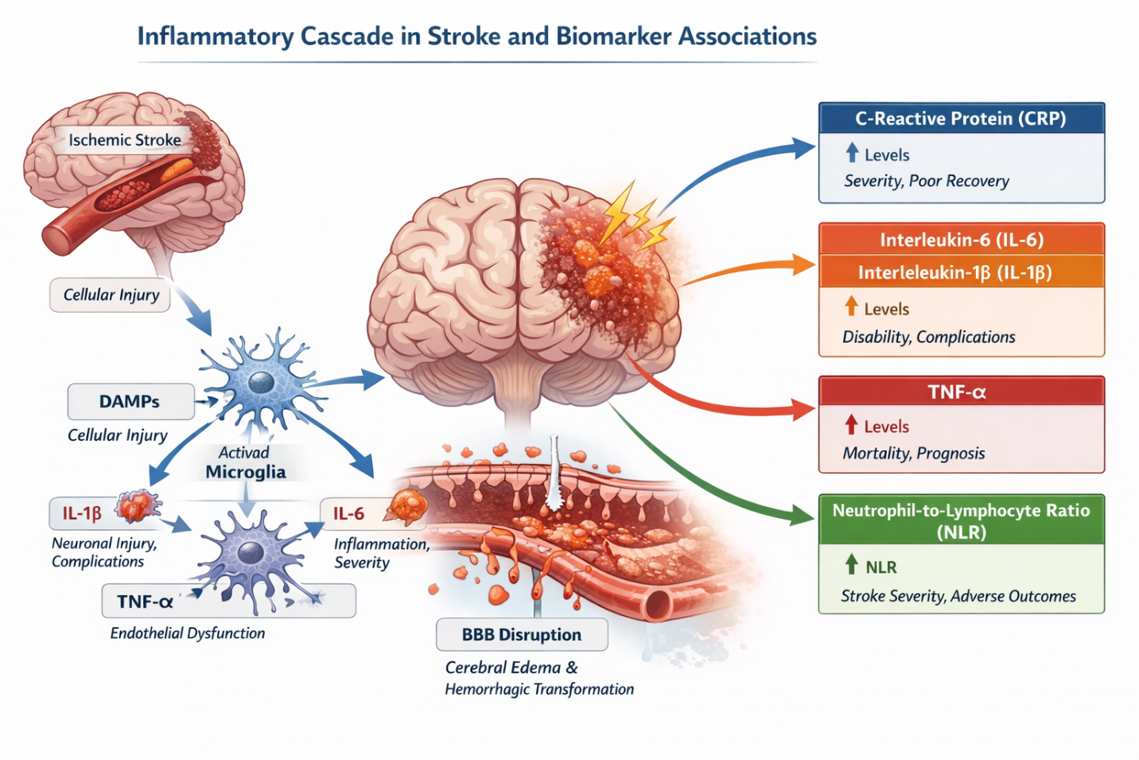

.
Figure 1: The inflammatory cascade following ischemic injury, including microglial activation, cytokine release, and blood-brain barrier disruption. Key biomarkers such as CRP, IL-6, IL-1β, TNF-α, NLR, and MMPs reflect the intensity of these processes and predict stroke severity and prognosis.

2.0 Key Inflammatory Biomarkers in Stroke
Among the most widely studied inflammatory biomarkers in stroke, C-reactive protein (CRP) stands out for its accessibility and strong predictive value. As an acute-phase protein produced by the liver in response to systemic inflammation, CRP levels rise rapidly following cerebral injury. High CRP levels have been consistently associated with larger infarct size, early neurological deterioration, and worse functional outcomes. Its measurement is simple and cost-effective, making it a practical tool in clinical settings to help stratify patients according to risk and anticipate complications [12]
Interleukin-6 (IL-6) plays a pivotal role in amplifying the inflammatory response. Beyond its early surge after stroke, IL-6 has been linked to both the severity of the initial neurological deficit and the risk of long-term disability. Because it integrates signals from multiple immune pathways, IL-6 provides a more dynamic picture of the ongoing immune activity than CRP alone. Monitoring IL-6 can therefore offer insight into the intensity of the inflammatory process and guide decisions about closer monitoring or therapeutic interventions [13].
Similarly, interleukin-1β (IL-1β) contributes to the inflammatory cascade by promoting the recruitment and activation of immune cells in the injured brain. Its levels often correlate with infarct progression and early neurological worsening. IL-1β has also been a target for experimental therapies, reflecting its central role in the pathophysiology of secondary neuronal injury [14]. By understanding its trajectory in individual patients, clinicians and researchers can gain a window into the mechanisms driving tissue damage and recovery.
Tumor necrosis factor-alpha (TNF-α) is another key cytokine that exerts profound effects on neuronal survival and vascular integrity. While it is essential for initiating repair processes, excessive TNF-α activity can exacerbate apoptosis and endothelial dysfunction, contributing to more severe strokes and poorer outcomes. Its presence in the bloodstream after stroke serves as a warning sign for heightened inflammatory activity, making it a potentially valuable biomarker for prognosis and, in the future, a target for therapeutic modulation [15].
The neutrophil-to-lymphocyte ratio (NLR) offers a different perspective by capturing the balance between innate and adaptive immune responses. Unlike single cytokines, NLR reflects systemic immune status and has been linked to stroke severity, risk of hemorrhagic transformation, and overall prognosis. Because it can be calculated from a routine blood count, NLR provides a cost-effective, widely available measure that can be incorporated into clinical decision-making without specialized assays [16].
Finally, matrix metalloproteinases (MMP-2 and MMP-9) represent enzymes that mediate structural changes in the brain following stroke. By degrading components of the extracellular matrix, they increase blood–brain barrier permeability, facilitate immune cell infiltration, and contribute to cerebral edema and hemorrhagic complications. Elevated MMP levels are associated with larger infarct volumes, early neurological deterioration, and increased risk of hemorrhagic transformation, making them critical indicators of both severity and potential complications. Their dynamic changes over time can also inform the timing of interventions aimed at limiting secondary injury [17]
Together, these biomarkers provide a comprehensive window into the inflammatory response after stroke. Each reflects a unique aspect of the underlying pathophysiology, offering opportunities to predict severity, anticipate complications, and ultimately guide personalized patient care.

2.1 Inflammation Biomarkers and Stroke Severity
Stroke severity is a critical determinant of short- and long-term outcomes, and inflammation biomarkers have emerged as important indicators of disease intensity. Clinical studies consistently show that elevated levels of biomarkers such as CRP, IL-6, IL-1β, TNF-α, and NLR correlate with higher scores on the NIHSS, a widely used measure of neurological impairment.
Inflammatory biomarkers are increasingly recognized as meaningful reflections of the biological response to stroke injury and have been linked with the severity of neurological impairment. Research consistently shows that higher levels of biomarkers such as interleukin-6 (IL-6), C-reactive protein (CRP), and matrix metalloproteinase-9 (MMP-9) are associated with more severe strokes, as measured by clinical scales like the National Institutes of Health Stroke Scale (NIHSS) [20]. For example, a study that measured IL-6, MMP-9, and CRP in acute ischemic stroke patients found that all of these markers were significantly higher in individuals with moderate to severe stroke compared with those with milder symptoms, and the associations remained statistically significant when analyzed across severity categories. The strongest associations were observed for IL-6 and MMP-9 (p < 0.001), indicating that both cytokine response and extracellular matrix breakdown are linked with the extent of neurological injury [18].
Among inflammatory markers, IL-6 stands out for its consistent correlation with severity. Multiple studies have shown that patients with higher IL-6 levels soon after symptom onset tend to have higher NIHSS scores on admission, indicating greater initial neurological deficit. In one prospective cohort, elevated IL-6 was not only linked with severity at presentation but also with poorer functional scales measured later, suggesting that this cytokine reflects both acute injury and early progression of damage [18].
CRP also correlates with stroke severity. Although CRP is a nonspecific marker of inflammation, its rapid elevation after brain injury has been associated with higher NIHSS scores and larger infarct volumes in several studies. Elevated CRP levels have likewise been shown to be independently associated with worse clinical presentations, supporting its use as an accessible and cost-effective marker in acute settings [19].
MMP-9, an enzyme involved in blood–brain barrier disruption, has also been strongly linked with clinical severity. Research shows that patients with higher serum MMP-9 levels tend to have more severe neurological deficits and greater disruption of vascular integrity, which can exacerbate brain edema and secondary damage. Elevated MMP-9 levels were significantly associated with NIHSS scores in acute ischemic stroke patients in well-powered observational studies [20].
Beyond individual molecules, composite indices derived from routine blood counts, such as the Systemic Immune-Inflammation Index (SII), further illustrate the relationship between inflammation and severity. Recent research has identified significant associations between higher SII values and increased NIHSS scores, indicating that a broader picture of systemic inflammation, including platelets, neutrophils, and lymphocytes can reflect overall stroke severity at presentation [21].
Taken together, these findings support a model in which inflammation serves both as a response to tissue injury and as a marker of injury extent. Elevated inflammatory biomarkers capture elements of immune activation, blood-brain barrier breakdown, and systemic immune imbalance that align with more profound neurological dysfunction. Clinically, this means that measuring these biomarkers early in the course of stroke can provide valuable information about how severe a patient’s stroke is likely to be, supplementing neurological examination and imaging to guide risk stratification and early management decisions.
A summary of the key inflammatory biomarkers discussed, along with their roles in stroke pathophysiology, associations with severity and prognosis, and potential clinical applications, is presented in Table 1.

Table 1: Key Inflammation Biomarkers in Stroke and Their Clinical Significance
Biomarker | Type / Source | Role in Stroke Pathophysiology | Association with Severity | Association with Prognosis | Clinical Utility
C-Reactive Protein (CRP) | Acute-phase protein, liver | Reflects systemic inflammation | Higher levels → larger infarct, higher NIHSS | Poor functional recovery, higher mortality | Early risk stratification; widely available
Interleukin-6 (IL-6) | Pro-inflammatory cytokine | Mediates immune activation, vascular inflammation | Correlates with infarct size, neurological deficits | Predicts long-term disability, post-stroke complications | Early prognostic marker
Interleukin-1β (IL-1β) | Pro-inflammatory cytokine | Amplifies inflammation, neuronal injury | Higher levels → severe neurological impairment | Associated with poorer functional recovery | Research and prognostic relevance
Tumor Necrosis Factor-alpha (TNF-α) | Pro-inflammatory cytokine | Promotes apoptosis, endothelial dysfunction | Linked to early neurological deterioration | Higher mortality, poor recovery | Potential therapeutic target
Neutrophil-to-Lymphocyte Ratio (NLR) | Hematological marker | Balance of neutrophil-driven inflammation and lymphocyte regulation | High NLR → severe stroke, early deterioration | Predicts hemorrhagic transformation, adverse outcomes | Cost-effective, especially in resource-limited settings
Matrix Metalloproteinases (MMP-2, MMP-9) | Enzymes degrading extracellular matrix | Disrupt blood–brain barrier, increase edema | Higher levels → worse neurological deficits | Higher risk of hemorrhagic transformation, poor recovery | Marker of complications and severity

3.0 Inflammation Biomarkers and Stroke Prognosis
Inflammatory biomarkers continue to show strong relationships not only with how a stroke presents but also with how patients fare over time. Large meta-analyses and cohort studies consistently demonstrate that markers of inflammation can help estimate the likelihood of poor functional outcomes, disability, and mortality after stroke. For example, pooled data from over 27,000 stroke patients reveal that an elevated neutrophil-to-lymphocyte ratio (NLR) is significantly associated with worse outcomes, including higher mortality and greater disability at follow-up, in both ischemic and hemorrhagic stroke populations. Patients with high NLR had approximately 1.1 to 1.3-times greater odds of poor outcome compared with those with lower values [22]
Routine inflammatory indices such as NLR and white blood cell count also predict adverse outcomes in intracerebral hemorrhage, with elevated NLR and CRP levels linked to both higher mortality and poor functional status. In one meta-analysis of nearly 26,000 hemorrhagic stroke patients, high NLR increased the risk of death, and high CRP was similarly associated with poor outcomes [23].
Specific cytokines likewise carry prognostic information. Interleukin-6 (IL-6) levels measured early after stroke have been repeatedly associated with poorer long-term outcomes, including disability at 3 months, and higher risk of recurrent events. Elevated IL-6 measured shortly after onset correlates with both early severity and long-term functional limitations [24]. Similarly, higher CRP, a stable, reproducible marker of systemic inflammation, has long been linked to disability and mortality after stroke, with meta-analyses showing that each standard deviation increase in CRP is associated with a 14 % higher risk of recurrent stroke and worse prognosis overall.
Beyond individual markers, composite indices such as inflammation-based hematological ratios also help predict prognosis. In studies of patients treated with thrombolysis, dynamic changes in NLR within the first 24-48 hours were more informative of 90-day outcomes than baseline measurements alone, and higher inflammatory indices were consistently linked to worse recovery, symptomatic intracerebral hemorrhage, and mortality [25].
Large retrospective cohort studies also support these biomarker effects. In a study of over 3,000 ischemic stroke patients, CRP and NLR were among the strongest independent predictors of mortality and functional outcomes even after adjusting for conventional risk factors and stroke subtypes [26].
Overall, these findings suggest that inflammation biomarkers capture critical aspects of the neuroimmune response that are not fully reflected by clinical scores or imaging alone. Elevated markers likely reflect both an intense immune reaction to brain injury and an increased vulnerability to complications such as secondary neuronal damage, hemorrhagic transformation, and systemic infections [26]. For clinicians, incorporating these biomarkers into prognostic models can improve early risk stratification, help guide rehabilitation planning, and support more informed discussions with patients and families about expected recovery trajectories.

3.1 Inflammatory Biomarkers Across Stroke Subtypes
The predictive value of inflammatory biomarkers can vary depending on the type of stroke. In ischemic stroke, markers such as IL-6, CRP, and NLR consistently correlate with larger infarct volumes, early neurological deterioration, and poorer functional outcomes at 3 months. For example, patients with IL-6 levels in the highest quartile within 24 hours of symptom onset were nearly twice as likely to have severe disability compared with those in the lowest quartile. Similarly, elevated NLR has been linked with higher rates of hemorrhagic transformation following thrombolytic therapy, emphasizing its role in guiding early risk stratification [24]
In intracerebral hemorrhage, inflammatory markers reflect both the initial injury and the risk of secondary complications. Studies show that elevated CRP and NLR at admission predict early hematoma expansion, neurological deterioration, and higher 30-day mortality. Matrix metalloproteinases, particularly MMP-9, have been associated with blood–brain barrier disruption and perihematomal edema, making them valuable for identifying patients at risk of worsening outcomes [27].
Even within ischemic subtypes, such as cardioembolic versus large-artery atherosclerotic stroke, biomarker patterns differ subtly. Cardioembolic strokes often show higher CRP and IL-6 levels, reflecting systemic inflammation related to underlying cardiac pathology, whereas large-artery strokes may have more pronounced MMP activation due to vascular remodeling and endothelial injury. Recognizing these nuances allows clinicians to interpret biomarker levels in the context of stroke subtype, improving their utility in predicting prognosis and tailoring management strategies [28]
Overall, integrating biomarker data across stroke types provides a more complete understanding of the inflammatory response, enhances early prognostic accuracy, and informs individualized patient care decisions.

4.0 Clinical Relevance of Inflammation Biomarkers
Inflammatory biomarkers provide valuable information that may improve how stroke is managed in clinical practice. A number of studies show that markers of systemic inflammation are linked with meaningful differences in patient outcomes. Higher levels of C-reactive protein (CRP) measured soon after stroke onset have been associated with poorer functional outcomes and higher risk of recurrent events. On meta-analysis, each standard deviation increase in CRP was linked with an approximate 14 % higher risk of recurrent stroke and major vascular events [29]
Pro-inflammatory cytokines such as interleukin-6 (IL-6) have been extensively studied in stroke cohorts. Elevated IL-6 levels in the first days after ischemic stroke correlate with both initial severity and worse functional status at follow-up, independent of other risk factors. In one large prospective cohort, patients with higher IL-6, CRP, and white blood cell counts showed an increased likelihood of poor outcome six months after stroke, even after adjusting for age and stroke severity [30]
Simple hematological ratios derived from routine blood counts, especially the neutrophil-to-lymphocyte ratio (NLR), also have clinical relevance. A recent multicenter study of acute ischemic stroke patients treated with mechanical thrombectomy found that an NLR above 4.30 at 24 hours was strongly associated with worse functional outcomes at 90 days. This supports the idea that early systemic inflammation may reflect ongoing injury or secondary complications that affect recovery [31].
Large cohort analyses reinforce these findings. In a study of over 3,000 ischemic stroke patients, inflammatory markers including CRP and NLR were among the strongest independent predictors of overall outcome, even after adjustment for traditional risk factors and stroke subtype. This suggests these markers carry prognostic information beyond established clinical variables such as age and baseline neurological scores [31].
Systematic reviews of inflammation-based hematological indices, including NLR and related ratios like the systemic immune-inflammation index (SII), have found consistent associations with 90-day functional outcomes. These indices, which integrate multiple elements of the immune response, show moderate to good discriminatory ability in predicting functional recovery when combined with traditional clinical predictors.
IL-6 is particularly informative because it correlates not only with the severity of the initial neurological injury but also with long-term functional recovery. Patients with higher IL-6 levels soon after stroke are more likely to experience greater disability at three months. Similarly, composite measures like NLR, which reflect the balance between neutrophils and lymphocytes, have proven to be practical and cost-effective indicators of systemic inflammation. Higher NLR values are linked with more severe strokes and can predict complications such as hemorrhagic transformation or early neurological deterioration [31].
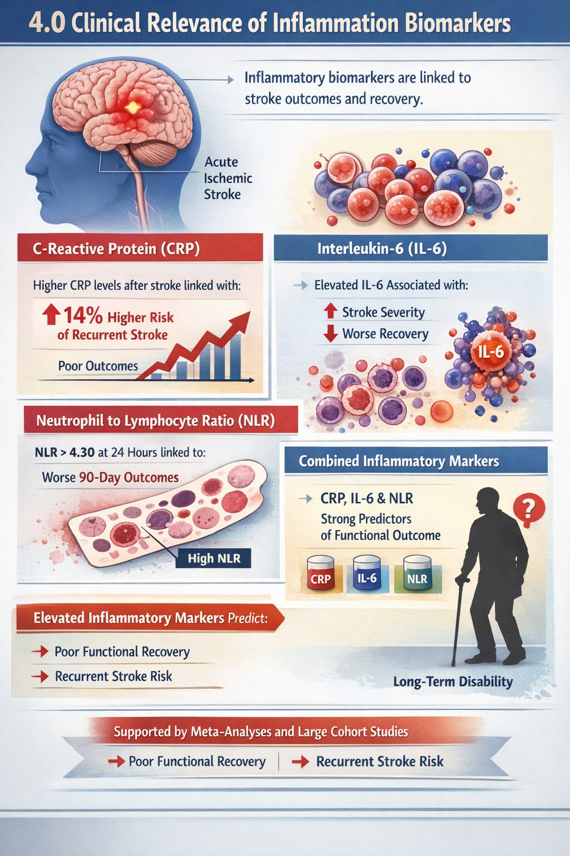
Figure 2: Clinical relevance of inflammatory biomarkers in acute ischemic stroke. Elevated CRP, IL-6, and neutrophil-to-lymphocyte ratio (NLR) reflect early systemic inflammation and independently predict stroke severity, poorer functional recovery, and higher risk of recurrent vascular events. Integrating these readily available markers with standard clinical assessment can improve prognostic stratification and guide post-stroke management.

5.0 Limitations and Research Gaps
Despite growing evidence supporting the role of inflammation biomarkers in stroke prognosis and severity, several limitations constrain their clinical adoption and highlight important gaps in current research.
One major issue is the lack of standardization in biomarker measurement. Studies often use different timings for blood sampling, varied laboratory assays, and inconsistent biomarker panels, which makes direct comparison difficult. For example, concentrations of IL-6, CRP, and MMP-9 are measured at different time points from onset in various studies, and there is no consensus on ideal sampling windows for prognostic use. Such variability reduces comparability and limits the development of unified clinical thresholds [32].
Another important limitation is confounding by non-stroke factors. Many biomarkers, especially CRP and IL-6, rise in response to infections, chronic inflammatory diseases, and other systemic conditions unrelated to stroke itself. A large prospective cohort study found that while elevated IL-6 and CRP levels were associated with poor outcomes, the added predictive value beyond standard clinical models was modest, partly because inflammatory marker elevations may reflect infection or comorbidity rather than stroke severity alone [21]
Patient selection bias and limited diversity also weaken many studies. Some large cohort studies note practical challenges in recruiting patients with very severe strokes, as these patients are less able to consent or participate, which can skew results toward milder cases [21]. Similarly, many biomarker studies are conducted in single centers or within specific populations, limiting generalizability to broader, multiethnic populations seen in global stroke care. Population differences in immune responses, stroke subtypes, and comorbidity profiles could affect biomarker performance and require broader validation.
The heterogeneity of biomarkers studied presents another gap. Most research focuses on single inflammatory markers, but stroke induces a complex immune response involving multiple pathways. Composite indices such as NLR, systemic immune-inflammation index (SII), and others show promise, yet substantial confusion remains about which indices are most useful and how they should be interpreted across different phases of stroke (acute vs subacute vs chronic) [33].
There is also a lack of prospective, multi-center validation. Observational and retrospective studies provide important initial insights, but few large-scale prospective studies rigorously validate biomarker thresholds in real-world settings. Prospective designs are needed to clarify the temporal dynamics of biomarkers, such as how early elevations relate to outcomes and whether serial measurements improve prediction over single snapshots.
Finally, while biomarkers show reliable associations with outcomes, there is limited evidence that measuring them meaningfully changes clinical decision-making or improves patient outcomes. Addressing these limitations through standardized protocols, larger and more diverse cohorts, multimarker panels, and prospective validation studies will be essential to move inflammation biomarkers from promising research tools to widely accepted components of clinical stroke care.

6.0 Future Directions
Future research on inflammatory biomarkers in stroke needs to move beyond simple associations and focus on practical clinical translation. One important step is the development of standardized protocols for when and how biomarkers are measured. Establishing agreed sampling time points and uniform laboratory methods would make results more comparable across studies and allow reliable clinical cut-off values to be defined.
There is also a need for large, prospective, multicentre studies that include diverse patient populations. Such studies would help confirm whether current findings hold true across different ages, ethnic groups, stroke subtypes, and healthcare settings. Broader validation is especially important in low- and middle-income regions where stroke burden is high and access to advanced imaging may be limited, making blood-based markers particularly valuable.
Another promising direction is the use of multimarker panels rather than single biomarkers. Stroke-related inflammation involves several interacting pathways, including cytokine release, endothelial activation, and blood–brain barrier disruption. Combining markers that reflect different parts of this cascade may improve predictive accuracy and better capture the biological complexity of each patient’s response.
Closely related to this is the idea of longitudinal profiling, where biomarker levels are measured repeatedly over time instead of at a single early point. Instead of relying on a single early measurement, tracking how biomarker levels change over hours and days after stroke may reveal patterns linked to recovery, complications, or secondary injury. This dynamic approach could help identify critical windows for intervention and refine prognosis over time.
Integration with clinical tools and advanced analytics will also shape the next phase of research. Incorporating biomarker data into clinical scores, imaging findings, and machine-learning models may produce more precise and individualized risk predictions. The goal is not to replace clinical judgement but to strengthen it with objective biological data.
Most importantly, future studies must test whether biomarker-guided strategies actually improve patient outcomes. Randomized trials could examine whether using inflammatory profiles to tailor monitoring intensity, rehabilitation plans, or anti-inflammatory treatments leads to better recovery or reduced complications. Demonstrating real clinical benefit will be essential for widespread adoption.
Finally, exploration of targeted anti-inflammatory therapies remains a key frontier. A deeper understanding of which inflammatory pathways are harmful and which support repair could open the door to treatments that modulate, rather than completely suppress, the immune response after stroke.
Advances in these areas would move inflammatory biomarkers from promising research signals to practical tools that support earlier, more personalized, and more effective stroke care.

7.0 Conclusion
Inflammation plays a central role in the pathophysiology of stroke, influencing both the immediate extent of brain injury and the trajectory of recovery. Biomarkers of inflammation, including CRP, IL-6, TNF-α, NLR, and matrix metalloproteinases, provide measurable insights into this complex biological response. Evidence demonstrates that these markers are associated with stroke severity, complications, and long-term functional outcomes, offering the potential to enhance early risk stratification and guide personalized care[34].
Despite promising findings, challenges remain in translating biomarker research into routine clinical practice. Variability in measurement protocols, patient heterogeneity, and the limited integration of biomarkers into prognostic models highlight the need for standardized approaches, larger and more diverse cohorts, and prospective validation. Future research focusing on multimarker panels, longitudinal monitoring, and targeted anti-inflammatory interventions may unlock the full clinical potential of these tools.
Ultimately, incorporating inflammation biomarkers into stroke care represents an important step toward precision medicine, where treatment and monitoring strategies are informed by a patient’s biological profile. By combining clinical assessment with biomarker insights, clinicians can better anticipate complications, optimize interventions, and support more informed discussions with patients and families about recovery and prognosis.
Disclaimer (Artificial intelligence)

Author(s) hereby declare that NO generative AI technologies such as Large Language Models (ChatGPT, COPILOT, etc.) and text-to-image generators have been used during the writing or editing of this manuscript.

References

1. Gosney, M., Harper, A., & Conroy, S. (Eds.). (2012). Stroke and transient ischaemic attack. In M. Gosney, A. Harper, & S. Conroy (Eds.), Oxford desk reference: Geriatric medicine (Oxford Desk Reference Series). Oxford University Press. https://doi.org/10.1093/med/9780199592340.003.0021

2. Feigin, V. L., Brainin, M., Norrving, B., Martins, S. O., Pandian, J., Lindsay, P., Grupper, F. M., & Rautalin, I. (2025). World Stroke Organization: Global stroke fact sheet 2025. International Journal of Stroke, 20(2), 132–144. https://doi.org/10.1177/17474930241308142

3. Donkor, E. S. (2018). Stroke in the 21st century: A snapshot of the burden, epidemiology, and quality of life. Stroke Research and Treatment, 2018, 3238165. https://doi.org/10.1155/2018/3238165

4. Quinn, T., Kitagawa, K., Leung, T., Molina, C., Rabinstein, A., Bentley, R., Henry, O., Heuser, M., Nair, V., & Saver, J. (2025). A systematic literature review on the burden of disease for patients with moderate to severe acute ischemic stroke. Medicine, 104(3), e41249. https://doi.org/10.1097/MD.0000000000041249

5. Wang, Y., Leak, R. K., & Cao, G. (2022). Microglia-mediated neuroinflammation and neuroplasticity after stroke. Frontiers in Cellular Neuroscience, 16, 980722. https://doi.org/10.3389/fncel.2022.980722

6. Menzel, A., Samouda, H., Dohet, F., Loap, S., Ellulu, M. S., & Bohn, T. (2021). Common and novel markers for measuring inflammation and oxidative stress ex vivo in research and clinical practice—Which to use regarding disease outcomes? Antioxidants, 10(3), 414. https://doi.org/10.3390/antiox10030414

7. Simpkins, A. N., Janowski, M., Oz, H. S., Roberts, J., Bix, G., Doré, S., & Stowe, A. M. (2020). Biomarker application for precision medicine in stroke. Translational Stroke Research, 11(4), 615–627. https://doi.org/10.1007/s12975-019-00762-3

8. Alsbrook, D. L., Di Napoli, M., Bhatia, K., Biller, J., Andalib, S., Hinduja, A., Rodrigues, R., Rodriguez, M., Sabbagh, S. Y., Selim, M., Farahabadi, M. H., Jafarli, A., & Divani, A. A. (2023). Neuroinflammation in acute ischemic and hemorrhagic stroke. Current Neurology and Neuroscience Reports, 23(8), 407–431. https://doi.org/10.1007/s11910-023-01282-2

9. Alfaro, S., Acuña, V., Ceriani, R., Cavieres, M. F., Weinstein-Oppenheimer, C. R., & Campos-Estrada, C. (2023). Involvement of inflammation and its resolution in disease and therapeutics. International Journal of Molecular Sciences, 24(3), 2487. https://doi.org/10.3390/ijms24032487

10. Rempe, R. G., Hartz, A. M. S., & Bauer, B. (2016). Matrix metalloproteinases in the brain and blood–brain barrier: Versatile breakers and makers. Journal of Cerebral Blood Flow & Metabolism, 36(9), 1481–1507. https://doi.org/10.1177/0271678X16655551

11. Huang, C., Wu, D., Yang, G., Huang, C., & Li, L. (2025). Identification of novel inflammatory response-related biomarkers in patients with ischemic stroke based on WGCNA and machine learning. European Journal of Medical Research, 30(1), 195. https://doi.org/10.1186/s40001-025-02454-1

12. McCabe, J. J., O'Reilly, E., Coveney, S., Collins, R., Healy, L., McManus, J., Mulcahy, R., Moynihan, B., Cassidy, T., Hsu, F., Worrall, B., Murphy, S., O'Donnell, M., & Kelly, P. J. (2021). Interleukin-6, C-reactive protein, fibrinogen, and risk of recurrence after ischaemic stroke: Systematic review and meta-analysis. European Stroke Journal, 6(1), 62–71. https://doi.org/10.1177/2396987320984003

13. Selvarajah, S., McKeown, P., & Smith, C. J. (2025). Immunological and inflammatory biomarkers in the prognosis, prevention, and treatment of ischemic stroke: A review of a decade of advancement. International Journal of Molecular Sciences, 26(16), 7928. https://www.mdpi.com/1422-0067/26/16/7928

14. Bonaventura, A., Montecucco, F., & Liberale, L. (2017). The impact of tumor necrosis factor-α and interleukin-1β levels and polymorphisms on long-term stroke outcomes. Cerebrovascular Diseases, 44(1–2), 34–43. https://pubmed.ncbi.nlm.nih.gov/29161722/

15. Ungureanu, V., & Popescu, P. (2025). The role of IL-6 and TNF-alpha biomarkers in predicting disability outcomes in acute ischemic stroke patients. Life, 15(1), 47. https://doi.org/10.3390/life15010047

16. Goyal, N., Tsivgoulis, G., Chang, J., et al. (2020). Neutrophil-to-lymphocyte ratio and outcomes after ischemic stroke: A systematic review and meta-analysis. Journal of Stroke and Cerebrovascular Diseases, 29(7), 104863. https://www.ncbi.nlm.nih.gov/pmc/articles/PMC7575025/

17. Rosell, A., Cuadrado, E., Ortega-Aznar, A., et al. (2012). MMP-9-positive neutrophil infiltration is associated with blood–brain barrier breakdown and basal lamina type IV collagen degradation during hemorrhagic transformation after human ischemic stroke. Stroke, 43(2), 448–455. https://pubmed.ncbi.nlm.nih.gov/29713446/

18. Elkind, M. S. V., Cheng, J., Boden-Albala, B., Paik, M. C., & Sacco, R. L. (2004). Interleukin-6 and risk of recurrent stroke and mortality in ischemic stroke patients: The Northern Manhattan Study. Stroke, 35(2), 374–379. https://doi.org/10.1161/01.STR.0000110104.01525.E1

19. Huang, Z., Huang, P., Li, W., & Zhang, J. (2014). Role of interleukin-6 in predicting acute ischemic stroke severity and outcomes: A systematic review. Journal of Neuroinflammation, 11, 134. https://doi.org/10.1186/s12974-014-0134-5

20. Zhou, X., Li, F., Wang, Y., et al. (2020). Inflammatory biomarkers and early neurological deterioration in acute ischemic stroke: Associations with IL-6, CRP, and MMP-9. Journal of Neuroinflammation, 17, 346. https://doi.org/10.1186/s12974-020-02020-3

21. Lee, J., Giannaris, P. S., Yilmaz, C. E., & Yilmaz, G. (2025). Emerging biomarkers in ischemic stroke. Vessel Plus, 9, 11. https://doi.org/10.20517/2574-1209.2025.58

22. Zhu, X., Wang, X., Xu, J., et al. (2021). Plasma matrix metalloproteinase-9 levels and neurological severity and functional outcomes in acute ischemic stroke. Frontiers in Neurology, 12, 666789. https://doi.org/10.3389/fneur.2021.666789

23. Fang, C., Li, W., Huang, L., & Hu, X. (2021). Systemic immune-inflammation index predicts clinical outcome in patients with acute ischemic stroke. Frontiers in Neurology, 12, 677168. https://doi.org/10.3389/fneur.2021.677168

24. Li, X., Xing, C., Shi, Y., et al. (2019). Prognostic value of neutrophil-to-lymphocyte ratio in acute ischemic stroke: A meta-analysis. Frontiers in Neurology, 10, 1159. https://doi.org/10.3389/fneur.2019.01159

25. Zhang, X., Xu, Y., Xu, J., & Wang, Y. (2020). Neutrophil-to-lymphocyte ratio and C-reactive protein predict poor outcomes in patients with intracerebral hemorrhage: A systematic review and meta-analysis. Neuroscience, 432, 20–30. https://doi.org/10.1016/j.neuroscience.2020.01.012

26. Maestrini, I., Strbian, D., Gautier, S., et al. (2015). Temporal profile and prognostic value of serum interleukin-6 in human acute ischemic stroke. Journal of Neurology, Neurosurgery & Psychiatry, 86(8), 930–937. https://doi.org/10.1136/jnnp-2014-309722

27. Sørensen, A. L., Skriver, E. B., Engeland, H., & Johnsen, S. P. (2014). C-reactive protein and risk of recurrent stroke: A systematic review and meta-analysis. European Journal of Neurology, 21(1), 51–61. https://doi.org/10.1111/ene.12202

28. Goyal, N., Tsivgoulis, G., Chang, J., et al. (2018). Neutrophil-to-lymphocyte ratio and symptomatic intracerebral hemorrhage after revascularization therapies in acute ischemic stroke. Journal of Stroke and Cerebrovascular Diseases, 27(12), 3321–3328. https://doi.org/10.1016/j.jstrokecerebrovasdis.2018.08.024

29. Di Napoli, M., Papa, F., Bocola, V., et al. (2011). C-reactive protein in ischemic stroke: An independent prognostic factor. Stroke, 42(5), 1303–1309. https://doi.org/10.1161/STROKEAHA.110.602493

30. Ridker, P. M., Cushman, M., Stampfer, M. J., Tracy, R. P., & Hennekens, C. H. (1998). Inflammation, aspirin, and the risk of cardiovascular disease in apparently healthy men. New England Journal of Medicine, 336(14), 973–979. https://doi.org/10.1056/NEJM199804023361401

31. Vila, N., Castillo, J., Dávalos, A., & Chamorro, A. (2000). Proinflammatory cytokines and early neurological worsening in ischemic stroke. Stroke, 31(10), 2325–2329. https://doi.org/10.1161/01.STR.31.10.2325

32. Tokgoz, S., Kayrak, M., Akpinar, Z., et al. (2014). Neutrophil to lymphocyte ratio as a prognostic marker in acute ischemic stroke. Journal of Stroke and Cerebrovascular Diseases, 23(3), 705–711. https://doi.org/10.1016/j.jstrokecerebrovasdis.2013.08.022

33. Tang, Q., Gong, Y., Han, Q., et al. (2025). Immunological and inflammatory biomarkers in the prognosis, prevention, and treatment of ischemic stroke: A review of a decade of advancement. International Journal of Molecular Sciences, 26(16), 7928. https://www.mdpi.com/1422-0067/26/16/7928
34. Braadt, L., Naumann, M., Freuer, D., Schmitz, T., Linseisen, J., & Ertl, M. (2023). Novel inflammatory biomarkers associated with stroke severity: Results from a cross-sectional stroke cohort study. Neurological Research and Practice, 5(1), 31. https://doi.org/10.1186/s42466-023-00259-3

