Short Research Article

Land-Use Dynamics in the N’Zi Watershed at M’Bahiakro, Côte d’Ivoire: A Multi-temporal Geospatial Analysis (2015–2024)

ABSTRACT

This study analyzes land cover dynamics in the N’Zi watershed at M’Bahiakro (Central-Eastern Côte d’Ivoire) between 2015 and 2024. Satellite images acquired in 2015, 2020, and 2024 were preprocessed to correct for radiometric and atmospheric effects and then classified into six land cover categories using supervised maximum likelihood classification: bare soil and urbanized areas, dense forests, degraded forests, savanna, cultivated land and fallow land, and water bodies. The classification accuracy, assessed using a confusion matrix, shows an overall accuracy greater than 85% and a high Kappa coefficient, confirming the reliability of the results. The diachronic analysis reveals major transformations. Between 2015 and 2020, savannas (-14.84 ha; -75.64%) and dense forests (-6.19 ha; -35.43%) decreased significantly, while degraded forests (+7.00 ha; +95.37%) and cultivated land (+6.09 ha; +45.58%) increased. Bare soils and urbanized areas declined slightly (-2.71 ha; -12.68%), while bodies of water increased (+10.65 ha; +51.13%).Between 2020 and 2024, the changes are even more pronounced: bare soil and urbanized areas increased significantly (+29.82 ha; +159.72%), while degraded forests (-9.65 ha; -67.29%) and cultivated land (-15.89 ha; -81.70%) decreased. Dense forests (+2.69 ha; +23.85%) and savannas (+1.08 ha; +22.59%) increased slightly, while water bodies decreased (-8.04 ha; -25.54%). These trends reflect increasing human pressure and the ongoing conversion of natural areas into agricultural land. The study recommends the use of predictive models (Markov, CA-Markov, Land Change Modeler, Random Forest) to anticipate future changes and support agricultural planning and environmental sustainability. Limitations include the lack of comprehensive field data, seasonal variations between images, and some classification uncertainties, despite the high Kappa coefficient.
Keywords: Land-Use Dynamics, Land Cover Change, Geospatial Analysis, N’Zi Watershed, M’Bahiakro, Côte d’Ivoire
1. INTRODUCTION
Land-use dynamics are a major concern for the sustainability of ecosystems and agricultural land worldwide. According to Baiwar et al. (2025), the rapid appropriation of natural resources, driven by population growth, improved living conditions, and the expansion of human activities, is leading to profound and accelerated transformations in land cover.
In West Africa, these changes are particularly pronounced. Under the combined effect of population growth, agricultural expansion, and climate variability, rural landscapes are experiencing a massive conversion of forests into cultivated areas (Kouassi et al., 2021; Kouassi et al., 2024). This transition is accompanied by major environmental impacts: soil erosion and degradation, habitat fragmentation, disruption of hydrological regimes, water pollution, and increased risks of flooding and drought. These changes directly affect the livelihoods of rural populations and exacerbate food insecurity and poverty (Foley et al., 2005).
In Côte d’Ivoire, deforestation is one of the most pressing environmental challenges. Forest areas, estimated at nearly 14 million hectares in 1912, had shrunk to approximately 2 million hectares by 2000 (Assoma et al., 2021). This sharp decline is primarily due to agricultural expansion, logging, and household energy needs (Kouassi et al., 2021).
The N’Zi River basin, a major tributary of the Bandama River, exemplifies these dynamics. Its central region, once considered the “cocoa belt,” has experienced intense deforestation linked to the development of industrial crops. The original forests have been progressively replaced by cocoa plantations, and more recently by cashew, yam, and other agricultural crops (Assoma et al., 2021).
Furthermore, the installation of the country's first inflatable hydro-agricultural dam in this basin, intended to irrigate 450 hectares of rice paddies (Kouassi et al., 2013; Baï et al., 2019), has attracted a significant number of migrants from other regions, leading to a rapid increase in population density (Baï et al., 2025). This increased demographic pressure has intensified the reduction of forest cover and accelerated the conversion of land to cultivated areas, thus contributing to the rapid transformation of rural landscapes.
Several studies have analyzed land cover in the N’Zi River basin (Kouassi et al., 2021; Yao et al., 2023). However, they focus on earlier periods or rely on sectoral approaches that do not fully integrate recent transformations or their implications for sustainable land management. Furthermore, the current dynamics, characterized by agricultural expansion, internal migration, and evolving agricultural practices, remain insufficiently documented.
In this context, the present study aims to complement existing knowledge by providing an updated and detailed analysis of the spatio-temporal dynamics of land cover in the N’Zi River basin between 2015 and 2024. This approach thus contributes to strengthening the understanding of ongoing socio-environmental dynamics and to informing the development of territorial resilience strategies in the face of increasing anthropogenic and climatic pressures.

2. material and methodOLOGY
2.1. Material
2.1. 1 Presentation of the study area
The N'Zi watershed at M'Bahiakro is located between longitudes 4° and 5° West and latitudes 6° and 9°27' North (Figure 1). This basin is drained exclusively by the N'Zi River, which is the only major watercourse in the study area. The N'Zi rises in northern Côte d'Ivoire in the Ferkéssedougou region at an altitude of 400 m and flows generally in a north-south direction to its outlet at M'Bahiakro. The density of the hydrographic network decreases from south to north. The climate is characterised by a transitional tropical regime (Sudanese-Guinean climate), with annual rainfall less than 1,200 mm in the north. The south of the basin is characterized by a humid tropical regime (Baouléan climate) with annual rainfall between 1200 and 1600 mm/year (Kouassi et al., 2022b). The main soil types are moderately desaturated ferralitic soils (North) and highly desaturated ferralitic soils (Center and South) (Kouassi et al., 2019).
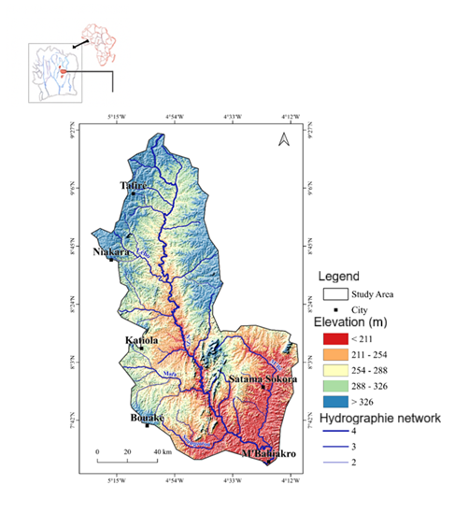

Figure 1: Presentation of the Study Area

2.2 Methodology
2.2.1 Acquisition of Satellite Images
The Landsat 8 scenes used in this study underwent rigorous preprocessing to ensure their quality and temporal comparability. The images were first subjected to atmospheric and radiometric corrections, an essential step to eliminate atmospheric effects and guarantee the consistency of spectral values across different dates. The data used come from the Landsat 8 sensor (OLI/TIRS), chosen for its 30 m spatial resolution, radiometric stability, and open access—three characteristics offering optimal conditions for reliable diachronic analysis. The scenes (197_055, 197_054, 196_054, and 196_055) were selected based on their low cloud cover (<10%) and their acquisition during the dry season, a period conducive to reducing biases related to seasonal variability. All the images covering the N’Zi watershed were acquired between December 11, 2015 and February 27, 2024, and then uploaded to the USGS Earth Explorer platform.
Acquisition Date | Download Date | Scene ID
26/01/2024 – 27/02/2024 | 20/10/2025 | 196_054 et 197_054
19/12/2024 – 27/12/2024 | 20/10/2025 | 196_055 et 197_055
07/01/2020 – 23/08/2020 | 22/10/2025 | 196_054 et 197_054
07/01/2020 – 23/08/2020 | 22/10/2025 | 196_055 et 197_055
11/12/2015 – 08/09/2020 | 27/10/2025 | 196_054 et 197_054
27/12/2015 – 08/09/2020 | 28/10/2025 | 196_055 et 197_055
Table 1: Main Characteristics of the Images Used

2.2.2 Processing and analysis methods

2.2.2.1 Preprocessing of Satellite Images
The raw Level-1 images were subjected to preprocessing steps aimed at correcting atmospheric and radiometric effects prior to analysis:
- Radiometric and atmospheric correction performed using the Semi-Automatic Classification Plugin (SCP) in QGIS 3.4.1;
- Conversion to surface reflectance to normalize spectral bands across the different acquisition dates;
- Clipping based on the hydrological boundaries of the study watershed;
- Mosaicking of the scenes to obtain complete and homogeneous coverage of the study area.

2.2.2.2 Image Processing
The various watersheds studied are fully covered by several satellite images. These images will be assembled or mosaicked to obtain images that completely represent the watersheds. Because the scenes (images) are very large, they were cropped at the boundaries of the study site after being mosaicked. Image processing began with the precise delimitation of the study area, corresponding to the N’Zi watershed in the locality of M’Bahiakro. This spatial area was then extracted from the various satellite images. A preliminary visual interpretation was carried out to develop a coherent nomenclature for the land cover units to be mapped. Following this phase, six classes were selected: (1) water, (2) settlement/bare soil, (3) cultivated land, (4) fallow land, (5) savanna, and (6) forest.

2.2.2.3 Color Composite
A color composite is a color image obtained from three bands, each assigned one of the primary colors: Red (R), Green (G), and Blue (B). The bands are chosen to avoid information redundancy and to obtain the maximum amount of information. Initially, the search for the best combination between the different image bands was undertaken. After the color composite, a visual interpretation of the images was carried out based on knowledge of the spectral signatures and the terrain. Generally, in terms of land cover, five types of landscape units can be identified: bare soil and habitats (human habitation areas, roads, rock outcrops), degraded forest, dense forest, savanna, cultivated land and fallow land, and water.
2.2.3. Land Use Classification
Land cover classification was performed for each of the three years (2015, 2020, and 2024) using the supervised maximum likelihood method. The thorough knowledge of the watershed allowed for the use of a supervised approach, well-suited to distinguishing between the different land cover classes. The maximum likelihood algorithm was chosen due to its robustness and widespread use in the scientific literature (Kouamé et al., 2019; Kouassi et al., 2020). Classification validation was carried out using a confusion matrix, overall precision, and the Kappa coefficient, ensuring the reliability of the results and their relevance for the diachronic analysis of land cover dynamics.The classes selected for the land use typology are:
- Bare soil and settlements
- Dense forests
- Degraded forests
- Savanna
- Crops and fallows
- Water

2.2.4. Accuracy Assessment of Classification
The reliability of the classifications was evaluated using a confusion matrix, comparing the assigned classes with independent reference points. Overall accuracy and Kappa indices were calculated to quantify the quality of the classification. An overall accuracy greater than 85% was considered nearly perfect or satisfactory.
Land cover mapping (LCM) of the N’Zi watershed was carried out using supervised classification with the Maximum Likelihood algorithm. The validation of the classification is obtained using the confusion matrix, the overall precision and the Kappa coefficient (Table 2, table 3, table 4). These tables display in the diagonal, the percentage of well classified pixels and off diagonal, the percentage of misclassified pixels. The confusion matrix shows a good classification of the images (McHugh’s 2012; kouassi et al 2020).
Table 2 : Confusion matrix of the 2015 image classification

Classes | Bare soil and settlements | Degraded forests | Savanna | Crops and fallows | Dense forests | Water
Bare soil and settlements | 82.74 | 1.29 | 4.85 | 3 | 0.87 | 2.52
Degraded forests | 0.01 | 90.63 | 0.1 | 0.2 | 2.56 | 0.49
Savanna | 3.33 | 0.04 | 94.99 | 0.2 | 0 | 0.01
Crops and fallows | 2.29 | 1.45 | 0.03 | 96.39 | 0.07 | 1.63
Dense forests | 11.6 | 6.43 | 0.01 | 0 | 95.09 | 3.31
Water | 0.04 | 0.15 | 0.01 | 0.2 | 1.41 | 92.04
2015: overall accuracy 91.34%, Kappa 0.8941

Table 3 : Confusion matrix of the 2020 image classification

Classes | Bare soil and settlements | Degraded forests | Savanna | Crops and fallows | Dense forests | Water
Bare soil and settlements | 92.63 | 0.08 | 0.18 | 0.99 | 12.75 | 0.18
Degraded forests | 0.03 | 98.13 | 2.88 | 0 | 2.33 | 0
Savanna | 0.56 | 0 | 97.42 | 0.19 | 0.31 | 0.96
Crops and fallows | 6.69 | 1.19 | 1.53 | 84.73 | 0.71 | 0.05
Dense forests | 0.09 | 0.56 | 0.06 | 0 | 95.92 | 0.02
Water | 0 | 0.04 | 0 | 0.2 | 0 | 98.79
2020: overall accuracy 94.27%, Kappa 0.9276

Table 4 : Confusion matrix of the 2024 image classification

Classes | Bare soil and settlements | Degraded forests | Savanna | Crops and fallows | Dense forests | Water
Bare soil and settlements | 97.66 | 2.19 | 4.85 | 3.11 | 0.27 | 0.98
Degraded forests | 1.17 | 89.36 | 0.01 | 0.09 | 5.31 | 0
Savanna | 0.13 | 0 | 97.71 | 0 | 0 | 0.38
Crops and fallows | 1.02 | 1.36 | 0 | 96.8 | 0 | 0
Dense forests | 0.02 | 7.09 | 0.05 | 0 | 94.43 | 0.03
Water | 0 | 0 | 0 | 0 | 0 | 98.62
2024: overall accuracy 97.09%, Kappa 0.9571

2.2.5. Assessment of land use dynamics
Land cover mapping was performed using supervised classification with the maximum likelihood algorithm. This algorithm was trained on a subset of data with known land cover classes. The classification was then extended to the entire study area to determine the coverage rate of each land cover type. To assess the classification quality, a confusion matrix was generated. The overall accuracy, corresponding to the ratio of correctly classified pixels to the total number of pixels, was calculated. This maximum likelihood method is widely used in supervised classifications and is considered one of the most effective algorithms for producing land cover maps (Konan-Waidhet et al.,2022). The spatio-temporal dynamics were analyzed by comparing maps from different dates (2015–2020; 2020–2024; and 2015–2024) and calculating the rates of change for the classes using the formula (Al-Akad et al.,2019 ; Kouassi et al 2020):
$$Tg(\%)=\frac{{(S}_{2}-S_{1})}{S_{1}}×100$$
$$Tc(\%)=100×\left\{{\left[-1+\left(\frac{S_{2}}{S_{1}}\right)\right]}^{1/t}\right\}$$

where:
Tg = overall rate of change (%)
Tc = rate of change (%)
S1 = area of the class at date t1
S2 = area of the class at date t 2 (t 2 > t 1).
t = number of years between the two dates

Analysis of the rate of change values shows that positive values indicate “progression” and negative values “regression”. Values close to zero indicate that the class is relatively “stable”.
2.2.6 Cartographic Production and Interpretation
The final maps were produced using QGIS 3.4.1, incorporating standard cartographic elements: title, legend, orientation, scale, geographic coordinates, and data sources.
The interpretation of results was based on comparing the observed trends, allowing for the assessment of the extent of anthropization and the spatio-temporal dynamics of the ecosystems in the study area.
The interpretation of the maps was based on comparing observed trends across the different years studied, which allowed us to:
- assess the level of human impact and the extent of areas transformed by human activities;
- analyze the spatio-temporal dynamics of the different ecosystems;
- highlight the dominant processes, such as deforestation, the expansion of cultivated land, the fragmentation of natural habitats, and the encroachment of savannas;
- identify the most vulnerable areas or those subject to increasing human pressures.
These cartographic analyses constitute an essential basis for understanding changes in land use and guiding decisions related to the sustainable management of the territory.

3. results and discussion
3.1. Land use patterns from 2015 to 2020
Changes in land cover classes between 2015 and 2020 reveal significant landscape transformations, characterized by a reduction in savanna, dense forest, and bare soil/habitat areasare (Figure 2 and Figure 3).
Bare soil and settlements decreased (from 3357 Km² to 2931 Km²), suggesting a redistribution of these areas toward other land-cover types. In contrast, degraded forests expanded sharply (from 1152 Km² to 2251 Km²), revealing intensified anthropogenic disturbance. Savanna cover collapsed over the period, a trend consistent with increasing agricultural pressure (from 3080 Km² to 750 Km²), reflected in the substantial rise of cultivated and fallow lands. Dense forests continued to decline (from 2743 Km² to 1771 Km²), confirming persistent deforestation dynamics. Meanwhile, water bodies increased markedly (from 3270 Km² to 4942 Km²), likely due to hydrological fluctuations or the development of water infrastructures.

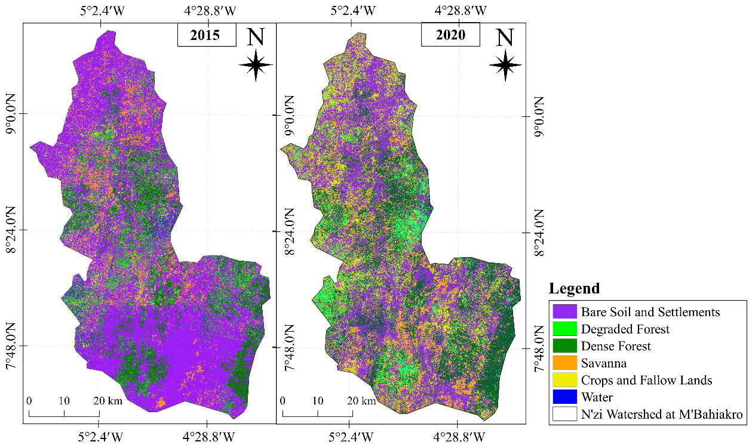

Figure 2. Changes in land cover classes between 2015 and 2020 revealing significant landscape transformations

Figure 3. Evolution of areas of land cover and land use classes between 2015 and 2020

3.2. Land use patterns from 2020 to 2024
The period 2020–2024 is distinguished by rapid changes in the landscape, resulting from agricultural expansion and the modification of natural and anthropized spaces (Figure 4 and Figure 5). Between 2020 and 2024, land-use patterns exhibited substantial shifts indicative of both ecological change and intensifying human pressures. Bare soil and settlements expanded rapidly, rising from 2,931 km² to 7,613 km², a trend consistent with accelerated land degradation, urban growth, or broader anthropogenic encroachment. Conversely, degraded forests declined sharply from 2,251 km² to 736 km², a change that may reflect transitions to ard other land-use categories, progressive canopy loss, or localized vegetation recovery.
Savanna areas increased moderately (751 km² to 920 km²), suggesting an expansion of open vegetation communities potentially linked to forest degradation or altered fire regimes. Crops and fallows contracted markedly, decreasing from 3,054 km² to 559 km², which may indicate extensive land abandonment, conversion to built-up areas, or reduced agricultural suitability due to biophysical constraints.

Dense forests showed a positive trajectory, expanding from 1,771 km² to 2,193 km². This renewal could be associated with natural regeneration processes, targeted restoration efforts, or protection measures that have limited disturbance. In contrast, water bodies diminished from 4,942 km² to 3,678 km², a reduction pointing to possible hydrological modification, declining surface water availability, or interannual variability in water extent.

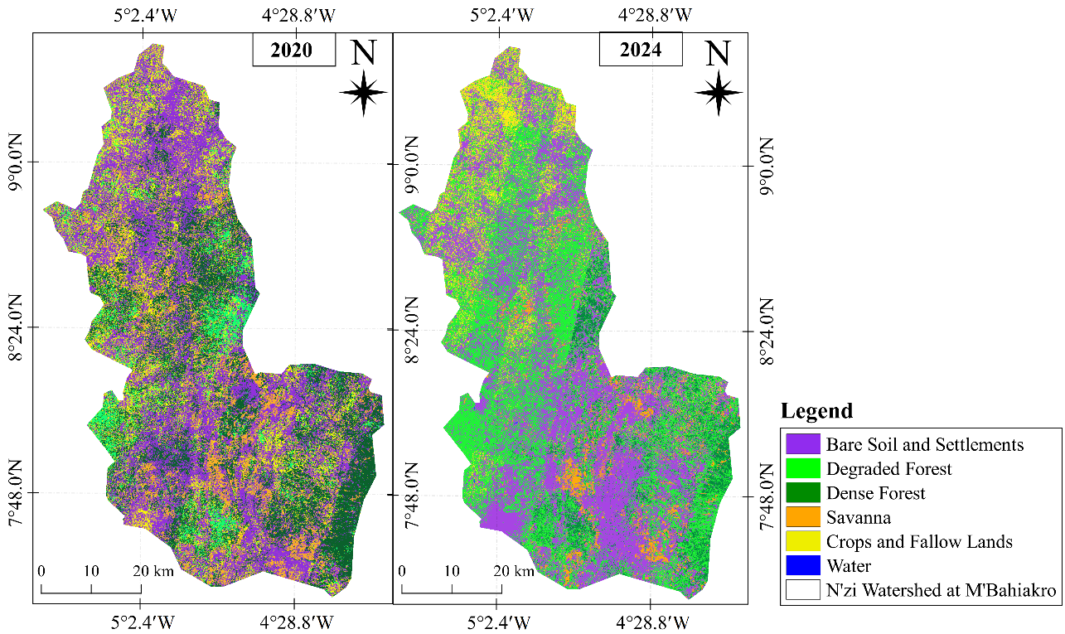
Figure 4. Degradation of forests reflecting a strong conversion of the areas to other uses and the continuation of anthropogenic pressures on forest environments

Figure 5. Evolution of areas of land cover and land use classes between 2020 and 2024

3.3. Land use patterns from 2015 to 2024
Between 2015 and 2024, significant shifts in land cover were observed. Bare soil and settlements experienced a marked increase, rising from 3,357 Km² in 2015 to 7,613 Km² in 2024, reflecting intensified urbanization and land degradation. Degraded forests initially expanded from 1,152 Km² to 2,251 Km² by 2020 but then sharply declined to 736 Km² in 2024, indicating partial recovery or conversion to other land uses. Savanna areas decreased dramatically from 3,080 Km² in 2015 to 750 Km² in 2020, with a slight recovery to 920 Km² by 2024. Cultivation and fallows followed a similar trend, peaking in 2020 at 3,054 Km² before declining to 559 Km². Dense forests decreased between 2015 and 2020 but partially recovered to 2,193 Km² by 2024. Water bodies expanded from 3,270 Km² in 2015 to 4,942 Km² in 2020, then slightly decreased to 3,679 Km², reflecting hydrological fluctuations or human interventions.
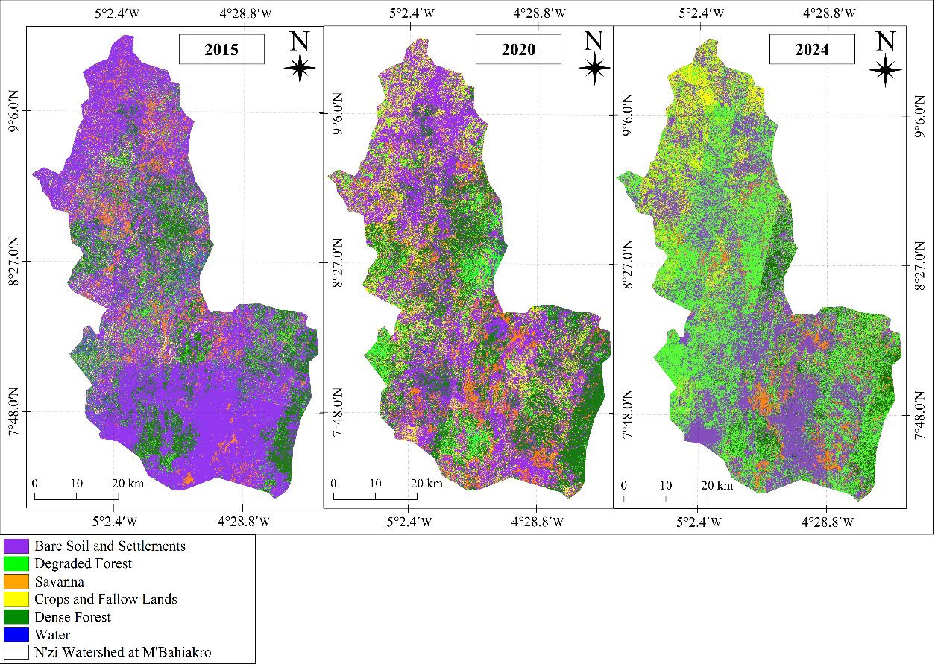
Figure 6. Land Use Dynamics in the N’Zi Watershed at M’Bahiakro

Figure 7. Evolution of areas of land cover and land use classes 2015, 2020 and 2024

3.4. Global and local change rates

3.4.1. Land-use change dynamics from 2015 to 2020

Between 2015 and 2020, land-use dynamics reveal contrasting trajectories across the major classes. Bare soil and settlements registered a slight overall decline (Tg = –12.68%; Tc = –2.67%), suggesting limited reductions in exposed surfaces or built-up areas. Degraded forests experienced a marked expansion (Tg = 95.37%; Tc = 14.33%), indicating intensified degradation processes or the conversion of other vegetation types into degraded forest states.
Savanna areas showed a substantial contraction (Tg = –75.64%; Tc = –24.60%), pointing to significant losses of open vegetation, potentially through encroachment by agriculture or degradation into bare soil. Crops and fallows increased moderately (Tg = 45.58%; Tc = 7.80%), reflecting the expansion of agricultural activities during the period.
Dense forests underwent a notable decline (Tg = –35.43%; Tc = –8.38%), consistent with ongoing deforestation or fragmentation pressures. Water surfaces expanded (Tg = 51.13%; Tc = 8.61%), a trend that may be associated with hydrological fluctuations, increased flooding, or changes in wetland extent.

Table 5 . Rate of change of land use classes between 2015 and 2020

Land use clases | Tg (%) | Tc (%)
Bare soil and settlements | -12.68 | -2.67
Degraded forests | 95.37 | 14.33
Savanna | -75.64 | -24.60
Crops and fallows | 45.58 | 7.80
Dense forests | -35.43 | -8.38
Water | 51.13 | 8.61

3.4.2. Land-use change dynamics from 2020 to 2024

The period 2020–2024 is marked by distinct shifts across land-use categories. Bare soil and settlements display a pronounced expansion (Tg = 159.72%; Tc = 26.95%), indicative of intensified human activities, urban growth, or accelerated land degradation. Degraded forests undergo a substantial decline (Tg = –67.29%; Tc = –24.38%), suggesting partial vegetation recovery, conversion into other classes, or continued degradation reducing their extent.
Savanna areas show a modest increase (Tg = 22.59%; Tc = 5.22%), pointing to a limited expansion of open vegetation. In contrast, crops and fallows register a strong contraction (Tg = –81.70%; Tc = –34.59%), reflecting possible agricultural abandonment, declining suitability, or land conversion to non-agricultural uses.
Dense forests experience moderate growth (Tg = 23.85%; Tc = 5.49%), a pattern that may stem from regeneration processes or targeted conservation efforts. Water bodies decline (Tg = –25.57%; Tc = –7.12%), which may signal hydrological changes, reduced surface water availability, or interannual variability in water extent.

Table 6 . Rate of change of land use classes between 2020 and 2024

Land use clases | Tg (%) | Tc (%)
Bare soil and settlements | 159,72 | 26,95
Degraded forests | -67,29 | -24,38
Savanna | 22,59 | 5,22
Cultivation and fallows | -81,70 | -34,59
Dense forests | 23,85 | 5,49
Water | -25,57 | -7,12

3.4.3. Land-use change dynamics from 2020 to 2024

Across the 2015-2024 period, land-use patterns reveal persistent and contrasting trajectories. Bare soil and settlements show a marked expansion (Tg = 126.80%; Tc = 22.72%), pointing to intensified anthropogenic pressures such as urban growth, infrastructure development, or progressive land degradation. Degraded forests register a moderate decline (Tg = –36.10%; Tc = –10.59%), which may reflect partial vegetation recovery, conversion to alternative land uses, or the depletion of degraded forest areas.
Savanna formations decline sharply (Tg = –70.13%; Tc = –26.07%), suggesting substantial losses of open vegetation, likely driven by agricultural encroachment, land conversion, or degradation processes. Cultivation and fallows also contract significantly (Tg = –73.35%; Tc = –28.15%), indicating a widespread reduction in agricultural land, potentially linked to land abandonment, declining soil productivity, or a shift toward other land-use categories.
Dense forests experience a moderate decrease (Tg = –20.03%; Tc = –5.44%), consistent with ongoing deforestation and fragmentation pressures over the decade. In contrast, water surfaces exhibit slight growth (Tg = 12.48%; Tc = 2.98%), a trend that may result from hydrological variability, increased water retention in certain areas, or changes in wetland dynamics.

Table 7 . Rate of change of land use classes between 2015 and 2024

Land use clases | Tg (%) | Tc (%)
Bare soil and settlements | 126,80 | 22,72
Degraded forests | -36,10 | -10,59
Savanna | -70,13 | -26,07
Cultivation and fallows | -73,35 | -28,15
Dense forests | -20,03 | -5,44
Water | 12,48 | 2,98

3.2 Discussion
3.2.1 Land use patterns from 2015 to 2020

Between 2015 and 2020, the N’Zi watershed underwent significant land-use changes, characterized by a marked decline in natural habitats and increasing human pressure. Savannas decreased sharply, from 308,034 ha to 75,046 ha (–75.6%), while dense forests shrank from 274,279 ha to 177,096 ha (–35.4%). Bare soils and urbanized areas decreased slightly (–12.7%), while cultivated land and fallow land increased significantly (+46%). Concurrently, the area of degraded forests nearly doubled (+95%), reflecting a process of degradation and progressive fragmentation of natural ecosystems. These observations confirm the trends noted by Koffi et al. (2023) in the Lobo River basin, where extensive agriculture and logging have been identified as the main drivers of deforestation. Angoua (2018) also highlights that the conversion of savannas and forests into agricultural land and habitats results from population growth and increased demand for arable land, while the expansion of cultivated land and fallow land reflects the intensification of food and cash crops, as observed in other rural areas of Côte d’Ivoire (Ruf & Varlet, 2019; Ouattara et al., 2021). The increase in degraded forests further illustrates habitat fragmentation and the progressive degradation of natural environments, consistent with the findings of Traoré et al. (2024), which show that extensive agriculture combined with firewood collection reduces forest connectivity and accelerates fragmentation. Overall, these transformations reflect an increase in human impact and a progressive conversion of natural ecosystems into agricultural land and degraded areas, confirming the vulnerability of the studied landscapes and highlighting the need to implement sustainable management strategies to preserve habitats and ecosystem services, in line with regional observations in Côte d’Ivoire and West Africa.
Water surface areas also increased (Tg = 51.13%; Tc = 8.61%), likely due to hydrological fluctuations and the expansion of local reservoirs. These findings are corroborated by the study of Kouamé et al. (2019), which analyzed land cover changes in the basin between 1988 and 2016. The authors show that water bodies and human-modified land (urban and agricultural areas) increased, while vegetated areas (savannahs, grasslands, forests, and evergreen forests) decreased. According to the same authors, the increase in water surface areas is attributed to the construction of small reservoirs, dams, and dams in the basin, highlighting the significant attention paid to the development of small-scale hydraulic structures for domestic water supply and livestock irrigation in West African basins.

3.2.2 Land use patterns from 2020 to 2024

For the period 2020 and 2024, the N’Zi watershed experienced rapid and contrasting land-use changes, mainly linked to agricultural expansion, the reorganization of human-modified areas, and natural regeneration processes. Bare soils and urbanized areas increased sharply (+159.7%; Tg = 159.72%; Tc = 26.95%), reflecting urbanization, the intensification of human activities, and the conversion of some agricultural or natural areas, in line with the observations of Kouassi et al. (2024), who document a significant expansion of non-forest areas in Côte d’Ivoire (DOI: 10.3846/gac.2024.18724). Concurrently, degraded forests decreased sharply (–67.3%; Tg = –67.29%; Tc = –24.38%), reflecting either partial vegetation recovery in some areas, conversion to other classes, or the persistence of human pressures on forests, consistent with the findings of Traoré et al. (2024).
Savannas registered a slight increase (+22.6%; Tg = 22.59%; Tc = 5.22%), suggesting limited expansion of open spaces, likely driven by agricultural abandonment or natural regeneration. Conversely, cultivated and fallow land experienced a significant contraction (–81.7%; Tg = –81.70%; Tc = –34.59%), reflecting possible land abandonment, decreased fertility, or conversion to non-agricultural uses. This illustrates the fluctuations in agricultural practices and their impact on land use, as also observed by Lambin & Meyfroidt (2011) and Ouattara et al. (2021) in other Ivorian basins.
Dense forests recorded moderate growth (+23.9%; Tg = 23.85%; Tc = 5.49%), likely linked to natural regeneration processes or targeted conservation efforts, thus contributing to improved forest connectivity and reduced habitat fragmentation.
The results of Yao et al. (2023) show that water surfaces decreased by 64.95% between 2000 and 2020 and by 52.47% between 1986 and 2020, indicating a persistent trend of water body decline in the region. This decline is primarily attributed to the intensification of agricultural activities, land conversion, overexploitation of water resources, and interannual climate variations. These observations corroborate the results obtained in the N’Zi watershed for the period 2020–2024, where water surfaces also declined by 25.5% (Tg = –25.57%; Tc = –7.12%), highlighting the vulnerability of aquatic ecosystems to anthropogenic pressures and hydrological changes.

3.2.3 Land use patterns from 2015 to 2024
Between 2015 and 2024, the N’Zi River basin underwent major land-use transformations, with a marked shift from forests and savannas to agricultural land and urban areas. This dynamic aligns with trends observed in Côte d’Ivoire and West Africa, where deforestation remains high, fueled by cash crops, the expansion of food crops, and population growth (Hansen et al., 2013; Kouassi et al., 2021).
The rise of cash crops, particularly cocoa and cashew, has led to the conversion of wooded savannas and secondary forests into agricultural land, exacerbating fragmentation and the loss of forest continuity (Ruf & Varlet, 2019; Ouattara et al., 2021; Akpa You et al., 2019; Soro et al., 2020 ; Kalischek et al., 2023; Traoré et al., 2024). The process of savannization, characterized by the transformation of forest environments into ecosystems dominated by herbaceous vegetation, is favored by recurrent fires, the decline of woody biomass, and droughts (Beckett et al., 2022; Staver et al., 2020; Abreu et al., 2021). Extreme fires and uncontrolled agricultural practices prevent forest regeneration and accelerate soil degradation, increasing the risk of erosion, particularly on plateaus and in forest-savanna transition zones (Tellen et al., 2020; Abindaw et al., 2023; Saravia-Maldonado et al., 2024; Koffi et al., 2024).
Schwantes Marinho et al. (2022) show that extreme fires, repeated annually, prevent forest regeneration. They subsequently promote the formation of treeless savannas.
Over the entire period, bare soils and urbanized areas increased sharply (Tg = 126.80%; Tc = 22.72%), reflecting urbanization and the intensification of human activities (Kouassi et al., 2024). Degraded forests declined moderately (Tg = -36.10%; Tc = -10.59%), while savannas decreased sharply (Tg = -70.13%; Tc = -26.07%), reflecting the loss of open spaces due to agriculture and slash-and-burn agriculture. Cultivated land and fallow land also decreased (Tg = –73.35%; Tc = –28.15%), reflecting the abandonment of some plots or their conversion to other uses, while dense forests declined slightly (Tg = –20.03%; Tc = –5.44%).
Water bodies increased slightly (Tg = 12.48%; Tc = 2.98%), although other regional studies report downward trends (Yao et al., 2023: Tg = –64.95% for 2000–2020 and Tg = –52.47% for 1986–2020; Tc values: –3.25% and –2.62%, respectively). These variations are explained by hydrological variability, the creation of reservoirs, water withdrawals, and changes in land use (Tellen et al., 2020; Abindaw et al., 2023).
Overall, these dynamics demonstrate a rapid and contrasting transformation of the watershed, with a progressive conversion of natural ecosystems into human-modified and agricultural areas, highlighting the need for sustainable management strategies to preserve habitats and strengthen ecological resilience.

CONCLUSION
The analysis of land-use dynamics in the N’Zi watershed between 2015 and 2024 highlights a rapid and contrasting transformation of landscapes, dominated by the decline of savannas and forests in favor of agricultural land, urban areas, and degraded spaces. The results reveal a marked decrease in both dense and degraded savannas and forests, accompanied by significant variability in cultivated land and water bodies.
The period 2015–2020 was characterized by a massive conversion of savannas and forests into agricultural land and degraded areas, driven by population growth, the expansion of food and cash crops, and increased exploitation of natural resources. In contrast, the period 2020–2024 presents a more contrasting scenario, marked by rapid urbanization, a contraction of cultivated land, a decline in degraded forests, and sporadic signs of forest regeneration.
Over the course of the decade, these dynamics reflect sustained human pressure on the basin's resources, leading to habitat fragmentation, hydrological disturbances, and the progressive degradation of ecosystem services. Despite some signs of resilience, such as a slight increase in water bodies and some vegetation conversions, the overall trend remains one of increasing ecosystem sensitivity to land-use changes.
These results underscore the urgent need to implement sustainable management strategies, including forest protection, control of agricultural expansion, restoration of degraded areas, and integrated land-use planning that considers environmental issues. They provide a solid scientific basis for guiding land-use policies and strengthening the ecological resilience of the N'Zi watershed.

Perspectives and Limitations*

This study provides key insights into land use dynamics and the vulnerability of cultivable lands in the N’Zi watershed, useful for agricultural planning and soil conservation.
However, certain limitations exist: reliance on satellite imagery may introduce classification uncertainties, and local socio-economic factors were only partially considered. The study period (2015–2024) also does not capture some long-term trends.
Future research should integrate predictive models, such as Markov chains, CA-Markov, Land Change Modeler, or machine learning approaches (Random Forest, Gradient Boosting), to anticipate land use changes and assess land vulnerability under different scenarios. Combining these models with field surveys and socio-economic data would provide a more integrated and precise framework for sustainable watershed management.

Ethical approval
None

DISCLAIMER (ARTIFICIAL INTELLIGENCE)
Author(s) hereby declare that NO generative AI technologies such as Large Language Models (ChatGPT, COPILOT, etc.) and text-to-image generators have been used during the writing or editing of this manuscript.

References

Abindaw, T., Hanyabui, E., Atiah, K., Akwasi, E. A., & Ziblim, I. A. (2023). Influence of land use types on the distribution of selected soil properties in tropical soils of the Coastal Savanna zone. Heliyon, 9(3), e14002. https://doi.org/10.1016/j.heliyon.2023.e14002
Abreu, R. C. R., Durigan, G., Melo, A. C. G., Pilon, N. A. L., & Hoffmann, W. A. (2021). Facilitation by isolated trees triggers woody encroachment and a biome shift at the savanna–forest transition. Journal of Ecology, 109(8), 2984–2998. https://doi.org/10.1111/1365-2664.13994
Angaman, Kadio Valère, Mirzabaev, Alisher & Niang, Birahim Bouna. (2024). Economic impacts of land degradation: Evidence from Côte d'Ivoire. Land Degradation & Development, 35(4), 1541–1552. https://doi.org/10.1002/ldr.5004
Aka, K. S. R., Kouakou, K., Kouassi, A., et al. (2023). Toward understanding land use/land cover changes and their effects on surface temperature in the Gontougo Region, Côte d’Ivoire. Frontiers in Remote Sensing, 4, 1221757. https://doi.org/10.3389/frsen.2023.1221757
Akpa You, L., Dibi, N. H., Kyereh, B., & Kouassi, B. K. (2019). Impact of cashew plantation on carbon stock in the forest‑savanna transition zone (north‑east Côte d’Ivoire). International Journal of Innovation and Applied Studies, 27(2), 591–598. https://doi.org/10.1016/j.heliyon.2023.e14002
Al-Akad, S., Akensous, Y., Mustapha, H., Alnahmi, F., Mahyoub, S., Khanbari, K., & Swadi, H. (2019). Mapping of land-cover change analysis in Ma’rib, Yemen using remote sensing and GIS techniques. The International Archives of the Photogrammetry, Remote Sensing and Spatial Information Sciences, XLII-4/W12, 1–10. https://doi.org/10.5194/isprs-archives-XLII-4-W12-1-2019
Assoma, V. T., Yao, N. A., Dio, J. S., & Jourda, J.-P. (2021). Contribution of remote sensing and GIS to the mapping of land use changes in the Lobo watershed in Côte d'Ivoire. Physio-Geo. Physical Geography and Environment, 16, 107–126. https://doi.org/10.4000/physio-geo.12654
Baï, R., Kouame, I. K., Kouassı, L. K., Konan, S. K., & N’Cho, H. A.(2019). Assessment of the physicochemical quality of irrigation water and soil for sustainable irrigated rice cultivation: Case of irrigated perimeter of M’Bahiakro (Central-East of Côte d’Ivoire). Journal of Environmental Protection, 10, 1536-1552. https://doi.org/10.4236/jep.2019.1011091
Baï Ruth, N’CHO Achié Hervé, SANTE Natacha, KONAN Kouakou Séraphin, KOUASSI Kouakou Lazare, and KOUAME Kouassi Innocent (2025). “Hydrogeological Parameters and Climate Variability Impacts on Groundwater Availability in M’Bahiakro (Central-East Côte d’Ivoire)”. Journal of Global Ecology and Environment 21 (4):185–200. https://doi.org/10.56557/jogee/2025/v21i49999
Bairwa, B., Sharma, R., Kundu, A., Sammen, S. Sh., Alshehri, F., Pande, C. B., Orban, Z., & Salem, A. (2025). Predicting changes in land use and land cover using remote sensing and land change models. Frontiers in Environmental Science, 13, Article 1540140. https://doi.org/10.3389/fenvs.2025.1540140
Beckett, H., Staver, A. C., Charles‑Dominique, T., & Bond, W. J. (2022). Pathways of savannization in a mesic African savanna–forest mosaic following an extreme fire. Journal of Ecology, 110(4), 902–915. https://doi.org/10.1111/1365-2745.13851
Chatelain, C., Gautier, L., & Spichiger, R.‑E. (2004). Forest cover changes in Côte d’Ivoire and Upper Guinea. In L. Poorter, F. Bongers, F. N. Kouamé & W. D. Hawthorne (Eds.), Biodiversity of West African Forests: An Ecological Atlas of Woody Plant Species (pp. 45‑82). CABI Publishing. https://doi.org/10.1079/9780851997346.0015
Dao, A., Koffi, E. S., Noufé, D. D., Kamagaté, B., Goné, L. D., Séguis, L., and Perrin, J (2021). L.: Soil loss vulnerability: the case study of Aghien lagoon watershed outskirts Abidjan city (Côte d'Ivoire), Proc. IAHS, 384, 121–126, https://doi.org/10.5194/piahs-384-121-2021
FAO. (2023). Adaptation and vulnerability context for Côte d’Ivoire – SCALA Program Report. Food and Agriculture Organization of the United Nations. https://www.fao.org/scala

Foley, J. A., DeFries, R., Asner, G. P., Barford, C., Bonan, G., Carpenter, S. R., … & Snyder, P. K. (2005). Global consequences of land use. Science, 309(5734), 570–574. https://doi.org/10.1126/science.1111772

Hansen, M. C., Potapov, P. V., Moore, R., Hancher, M., Turubanova, S. A., Tyukavina, A., Thau, D., Stehman, S. V., Goetz, S. J., Loveland, T. R., Kommareddy, I., Egorov, A., Chini, L., Justice, C. O., & Townshend, J. R. G. (2013). High‑Resolution Global Maps of 21st‑Century Forest Cover Change. Science, 342(6160), 850–853. https://doi.org/10.1126/science.1244693
Kalischek, N., Lang, N., Renier, C., Daudt, R. C., Addoah, T., Thompson, W.& Wegner, J. D. (2023). Cocoa plantations are associated with deforestation in Côte d’Ivoire and Ghana. Nature Food, 4, 384‑393. https://doi.org/10.1038/s43016-023-00751-8
Koffi, B., Brou, A. L., Kouadio, K. J. O., Ebodé, V. B., N’Guessan, K. J.-Y., Yangouliba, G. I. & Kouassi, K. L. (2023). Impact of climate and land use/land cover change on Lobo reservoir inflow, West‑Central of Côte d’Ivoire. Journal of Hydrology: Regional Studies, 47, https://doi.org/10.1016/j.ejrh.2023.101417
Koffi, E. S., Dao, A., Noufe, D. D., Ouedraogo, M., Yeo, N. B., Seguis, L., Perrin, J. L., Kamagate, B., & Gone, L. D. (2024). Dynamics of Water Erosion in the Aghien Lagoon Catchment. European Scientific Journal, ESJ, 20(33), 187. https://doi.org/10.19044/esj.2024.v20n33p187
Konan-Waidhet, A. B., Kouassi, H. K., & Kanga, K. E. (2022). Land Use Dynamics in the Department of Séguéla, Northwestern Côte D’Ivoire. Advances in Remote Sensing, 11(3), 63-79. https://doi.org/10.4236/ars.2022.113005
Kouame, Y. M., Obahoundje, S., Diedhiou, A., François, B., Amoussou, E., Anquetin, S., Didi, R. S., Kouassi, L. K., N’guessan Bi, V. H., Soro, E. G., & Yao, E. K. (2019). Climate, Land Use and Land Cover Changes in the Bandama Basin (Côte D’Ivoire, West Africa) and Incidences on Hydropower Production of the Kossou Dam. Land, 8(7), 103. https://doi.org/10.3390/land8070103
Kouassi, K. L., Kouame, K. I., Konan, K. S., Dibi, B., Soumahoro, M., Kone, D., & Dago, G. (2013). Prospects for minimizing the potential environmental impacts of the hydro-agricultural dam of M’Bahiakro (Côte d’Ivoire). Journal of Water Resource and Protection 5, 847-853. https://doi.org/10.4236/jwarp.2013.59085
Kouassi, A. M., Assoko, A. V. S., Kouakou, K. E., & Biémi, J. (2019). Analyse des impacts des changements climatiques sur les normes hydrologiques en Afrique de l’Ouest : cas du district d’Abidjan (sud de la Côte d’Ivoire). Revue des Sciences de l’Eau / Journal of Water Science, 32(3), 257–272. https://www.erudit.org/fr/revues/rseau/2019-v32-n3-rseau05058/1067305ar/
Kouassi, A. M., Gnangouin, A. Y. J., & Relwindé, N. A.-K. (2022a). Impacts of climate change on agroclimatic indicators in West Africa: Case study of the N’Zi (Bandama) watershed in Côte d’Ivoire. Current Journal of Applied Science and Technology, 41(43), 35–48. https://doi.org/10.9734/cjast/2022/v41i434006
Kouassi, C. J. A., Qian, C., Khan, D., Achille, L. S., Kebin, Z., Omifolaji, J. K., Ya, T., & Yang, X. (2024). Land use/land cover change mapping from Sentinel-1B & 2A imagery using random forest algorithm in Côte d’Ivoire. Geodesy and Cartography, 50(1), 43–59. https://doi.org/10.3846/gac.2024.18724
Kouassi, J.-L., Gyau, A., Diby, L., Bene, Y., & Kouamé, C. (2021). Assessing land use and land cover change and farmers’ perceptions of deforestation and land degradation in south-west Côte d’Ivoire, West Africa. Land, 10(4), 429. https://doi.org/10.3390/land10040429
Kouassi, J.-L., Wandan, N., & Mbow, C. (2022b). Observed climate trends, perceived impacts and community adaptation practices in Côte d’Ivoire. Environmental & Socio-economic Studies, 10(3), 43–58. https://doi.org/10.2478/environ-2022-0016
Kouassi, K.H., Konan-Waidhet, A.B., Yao, A.B., Koffi, B. and Kadjo, E.D. (2020) Simulation of the Dynamics of Land Cover and Land Use in the Lobo River Watershed Upstream of Nibéhibé (Center-West of Côte d’Ivoire). Journal of Geographic Information System, 12, 519-530. https://doi.org/10.4236/jgis.2020.125030
McHugh, M. L. (2012). Interrater reliability: The kappa statistic. Biochemia Medica, 22(3), 276–282. https://doi.org/10.11613/BM.2012.031.

Ouattara, T. A., Kouamé, K. F., Zo‑Bi, I. C., Vaudry, R., & Grinand, C. (2021). Changements d’occupation et d’usage des terres entre 2016 et 2019 dans le Sud-Est de la Côte d’Ivoire : impact des cultures de rente sur la forêt. Bois et Forêts des Tropiques, 347, 89‑104. https://doi.org/10.19182/bft2021.347.a31868

Ruf, F., Koné, S., & Bebo, B. (2019). Le boom de l’anacarde en Côte d’Ivoire : transition écologique et sociale des systèmes à base de coton et de cacao. Cahiers Agricultures, 28, article 21. https://doi.org/10.1051/cagri/2019019
Saravia‑Maldonado, S. A., Rodríguez‑González, M. Á., Ramírez‑Rosario, B., & Fernández‑Pozo, L. F. (2024). Change in land use affects soil organic carbon dynamics and distribution in tropical systems. Soil Systems, 8(3), 101. https://doi.org/10.3390/soilsystems8030101
Schwantes Marinho, M. A., Oliveira, R. S., Pinto, J. R., & Fernandes, G. W. (2022). Long-term fire effects in tropical ecosystems. Ecological Indicators, 144, 109470. https://doi.org/10.1016/j.ecolind.2022.109470
Soro, D., Kouamé, K., & Yao, B. (2020). Cashew expansion and land degradation in Côte d’Ivoire. Journal of Arid Environments, 181, 104245. https://doi.org/10.1016/j.jaridenv.2020.104245
Staver, A. C., Archibald, S., & Levin, S. A. (2020). Fire–vegetation feedbacks and biome shifts. Nature Ecology & Evolution, 4, 1173–1180. https://doi.org/10.1038/s41559-020-1250-0
Tellen, V.A., Yerima, B.P.K (2019). Effects of land use change on soil physicochemical properties in selected areas in the North West region of Cameroon. Environ Syst Res 7, 3. https://doi.org/10.1186/s40068-018-0106-0
Timité, N., Kouakou, A. T. M., Bamba, I., Barima, Y. S. S., & Bogaert, J. (2022). Climate Variability in the Sudanian Zone of Côte d’Ivoire: Weather Observations, Perceptions, and Adaptation Strategies of Farmers. Sustainability, 14(16), 10410. https://doi.org/10.3390/su141610410
Traoré, S., Zo Bi, I. C., Piponiot, C., Aussenac, R., & Henry, H. F. (2024). Fragmentation is the main driver of residual forest aboveground biomass in West African low forest–high deforestation landscapes. *Trees, Forests and People, 15, 100477. https://doi.org/10.1016/j.tfp.2023.100477
Yao, K. L., Kouakou, K. E., Kouassi, A. M., Deguy, A. J.-P., & Camara, M. (2023). Analysis of land use change in the N’Zi watershed of Côte d'Ivoire using Landsat satellite images. Earth and Space Science, 10(3). https://doi.org/10.1029/2022EA002744

