Short Research Article

Land-Use Dynamics in the N’Zi Watershed at M’Bahiakro, Côte d’Ivoire: A Multi-temporal Geospatial Analysis (2015–2024)

ABSTRACT

This study analyzes land cover dynamics in the N’Zi watershed at M’Bahiakro (Central-Eastern Côte d’Ivoire) between 2015 and 2024. Satellite images acquired in 2015, 2020, and 2024 were preprocessed to correct for radiometric and atmospheric effects and then classified into six land cover categories using supervised maximum likelihood classification: bare soil and urbanized areas, dense forests, degraded forests, savanna, cultivated land and fallow land, and water bodies. The classification accuracy, assessed using a confusion matrix, shows an overall accuracy greater than 85% and a high Kappa coefficient, confirming the reliability of the results. The diachronic analysis reveals major transformations. Between 2015 and 2020, savannas (-14.84 ha; -75.64%) and dense forests (-6.19 ha; -35.43%) decreased significantly, while degraded forests (+7.00 ha; +95.37%) and cultivated land (+6.09 ha; +45.58%) increased. Bare soils and urbanized areas declined slightly (-2.71 ha; -12.68%), while bodies of water increased (+10.65 ha; +51.13%).
Between 2020 and 2024, the changes are even more pronounced: bare soil and urbanized areas increased significantly (+29.82 ha; +159.72%), while degraded forests (-9.65 ha; -67.29%) and cultivated land (-15.89 ha; -81.70%) decreased. Dense forests (+2.69 ha; +23.85%) and savannas (+1.08 ha; +22.59%) increased slightly, while water bodies decreased (-8.04 ha; -25.54%). These trends reflect increasing human pressure and the ongoing conversion of natural areas into agricultural land. The study recommends the use of predictive models (Markov, CA-Markov, Land Change Modeler, Random Forest) to anticipate future changes and support agricultural planning and environmental sustainability. Limitations include the lack of comprehensive field data, seasonal variations between images, and some classification uncertainties, despite the high Kappa coefficient.

Keywords: Land-Use Dynamics, Land Cover Change, Cultivable Land Vulnerability, Geospatial Analysis, N’Zi Watershed, M’Bahiakro, Côte d’Ivoire
1. INTRODUCTION
The transformation of land uses and land occupations is currently one of the main factors eroding the sustainability of ecosystems and agricultural land in West Africa. Under the combined effects of population growth, agricultural expansion, and climate variability, rural landscapes are experiencing accelerated changes characterised by the conversion of forests into cultivated areas, increasing urbanization, and soil degradation (Kouassi et al., 2021; Kouassi et al., 2024). These changes are generating increased pressure on soils and water resources, jeopardizing food security and the socio-ecological resilience of rural communities (Yao et al., 2023; FAO, 2023).
En Côte d’Ivoire, ces transformations sont particulièrement marquées dans les zones de transition climatique et agroécologique du centre du pays. Elles se sont intensifiées surtout depuis les années 1960, période caractérisée par l’essor de l’agriculture et l’intensification de l’exploitation forestière (Chatelain et al., 2004).
The N’Zi watershed, a tributary of the Bandama River, illustrates these dynamics: forest cover has declined sharply in favor of food and industrial crops (cashew, yam), while extensive agriculture exacerbates soil vulnerability to erosion and organic depletion (Kouassi et al., 2022a; Dao et al., 2021). Recent rainfall fluctuations and the variability of water regimes amplify these degradation processes, further weakening arable land (Koffi, 2023). Geospatial approaches now offer powerful tools for analysing and monitoring these dynamics at different spatio-temporal scales. The use of satellite imagery allows for the assessment of land-use changes and the modeling of land vulnerability (Kouassi et al., 2024; Aka et al., 2023). However, despite significant progress, an integrated understanding of the interactions between land-use dynamics and the vulnerability of arable land remains limited in the N’Zi River basin, even though this territory constitutes a strategic area for agricultural planning and the sustainable management of natural resources in central-western Côte d’Ivoire.
Therefore, several questions remain:
•How do recent land-use changes influence the vulnerability of arable land?
• Which areas of the basin are at the highest risk of degradation?
• Which biophysical and anthropogenic indicators most strongly determine this vulnerability?
To answer these questions, this study proposes an integrated geospatial approach combining multi-temporal land-use analysis, vulnerability indicator modelling, and synthesis mapping of at-risk areas.
The objective is to: (i) characterize the spatio-temporal dynamics of land use in the N’Zi watershed between 2015 and 2024; and (ii) assess the current vulnerability of arable land in order to inform sustainable development strategies and soil conservation policies. This work contributes to a better understanding of the interactions between spatial dynamics, climate, and the sustainability of agricultural land, from a territorial resilience perspective.
2. material and methodOLOGY
2.1. Material
2.1. 1 Presentation of the study area
The N'Zi watershed at M'Bahiakro is located between longitudes 4° and 5° West and latitudes 6° and 9°27' North (Figure 1). This basin is drained exclusively by the N'Zi River, which is the only major watercourse in the study area. The N'Zi rises in northern Côte d'Ivoire in the Ferkéssedougou region at an altitude of 400 m and flows generally in a north-south direction to its outlet at M'Bahiakro. The density of the hydrographic network decreases from south to north. The climate is characterised by a transitional tropical regime (Sudanese-Guinean climate), with annual rainfall less than 1,200 mm in the north. The south of the basin is characterized by a humid tropical regime (Baouléan climate) with annual rainfall between 1200 and 1600 mm/year (Kouassi et al., 2022b). The main soil types are moderately desaturated ferralitic soils (North) and highly desaturated ferralitic soils (Center and South) (Kouassi et al., 2019).
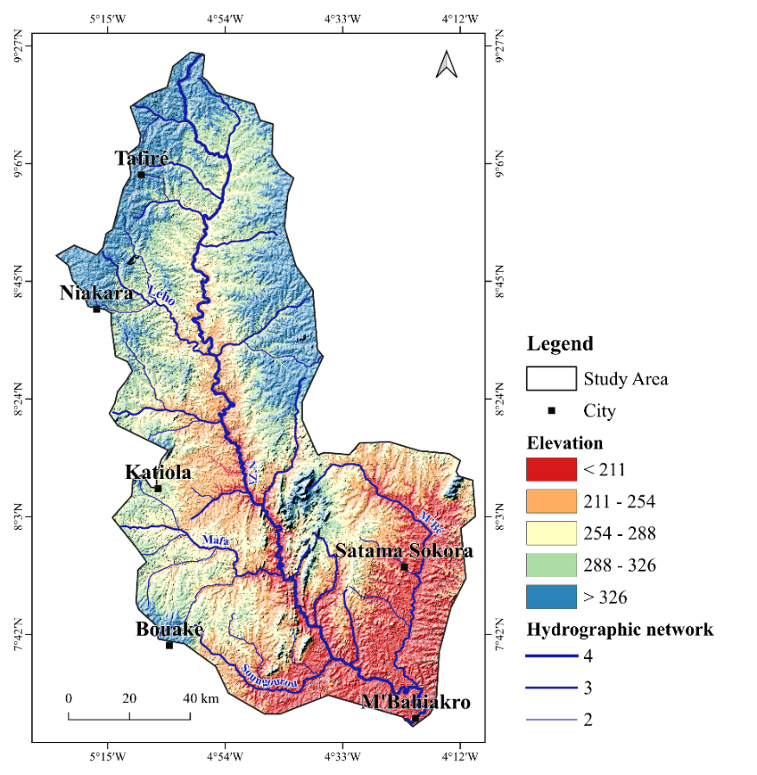
Figure 1: Presentation of the Study Area
2.2 Methodology
2.2.1 Acquisition of Satellite Images
The Landsat 8 scenes used in this study underwent rigorous preprocessing to ensure their quality and temporal comparability. The images were first subjected to atmospheric and radiometric corrections, an essential step to eliminate atmospheric effects and guarantee the consistency of spectral values across different dates. The data used come from the Landsat 8 sensor (OLI/TIRS), chosen for its 30 m spatial resolution, radiometric stability, and open access—three characteristics offering optimal conditions for reliable diachronic analysis. The scenes (197_055, 197_054, 196_054, and 196_055) were selected based on their low cloud cover (<10%) and their acquisition during the dry season, a period conducive to reducing biases related to seasonal variability. All the images covering the N’Zi watershed were acquired between December 11, 2015 and February 27, 2024, and then uploaded to the USGS Earth Explorer platform.
Acquisition Date | Download Date | Scene ID
26/01/2024 – 27/02/2024 | 20/10/2025 | 196_054 et 197_054
19/12/2024 – 27/12/2024 | 20/10/2025 | 196_055 et 197_055
07/01/2020 – 23/08/2020 | 22/10/2025 | 196_054 et 197_054
07/01/2020 – 23/08/2020 | 22/10/2025 | 196_055 et 197_055
11/12/2015 – 08/09/2020 | 27/10/2025 | 196_054 et 197_054
27/12/2015 – 08/09/2020 | 28/10/2025 | 196_055 et 197_055
chart 1: Main Characteristics of the Images Used
2.2.2 Processing and analysis methods

2.2.2.1 Preprocessing of Satellite Images
The raw Level-1 images were subjected to preprocessing steps aimed at correcting atmospheric and radiometric effects prior to analysis:
- Radiometric and atmospheric correction performed using the Semi-Automatic Classification Plugin (SCP) in QGIS 3.4.1;
- Conversion to surface reflectance to normalize spectral bands across the different acquisition dates;
- Clipping based on the hydrological boundaries of the study watershed;
- Mosaicking of the scenes to obtain complete and homogeneous coverage of the study area.

2.2.2.2 Image Processing
The various watersheds studied are fully covered by several satellite images. These images will be assembled or mosaicked to obtain images that completely represent the watersheds. Because the scenes (images) are very large, they were cropped at the boundaries of the study site after being mosaicked. Image processing began with the precise delimitation of the study area, corresponding to the N’Zi watershed in the locality of M’Bahiakro. This spatial area was then extracted from the various satellite images. A preliminary visual interpretation was carried out to develop a coherent nomenclature for the land cover units to be mapped. Following this phase, six classes were selected: (1) water, (2) settlement/bare soil, (3) cultivated land, (4) fallow land, (5) savanna, and (6) forest.

2.2.2.3 Color Composite
A color composite is a color image obtained from three bands, each assigned one of the primary colors: Red (R), Green (G), and Blue (B). The bands are chosen to avoid information redundancy and to obtain the maximum amount of information. Initially, the search for the best combination between the different image bands was undertaken. After the color composite, a visual interpretation of the images was carried out based on knowledge of the spectral signatures and the terrain. Generally, in terms of land cover, five types of landscape units can be identified: bare soil and habitats (human habitation areas, roads, rock outcrops), degraded forest, dense forest, savanna, cultivated land and fallow land, and water.
2.2.3. Land Use Classification
Land use classification was performed for each of the three years (2015, 2020, and 2024) using the supervised Maximum Likelihood method. The classes selected for the land use typology are:
- Bare soil and settlements
- Dense forests
- Degraded forests
- Savanna
- Croplands and fallows
- Water

2.2.4. Accuracy Assessment of Classification
The reliability of the classifications was evaluated using a confusion matrix, comparing the assigned classes with independent reference points. Overall accuracy and Kappa indices were calculated to quantify the quality of the classification. An overall accuracy greater than 85% was considered nearly perfect or satisfactory.
2.2.5. Assessment of land use dynamics
Land cover mapping was performed using supervised classification with the maximum likelihood algorithm. This algorithm was trained on a subset of data with known land cover classes. The classification was then extended to the entire study area to determine the coverage rate of each land cover type. To assess the classification quality, a confusion matrix was generated. The overall accuracy, corresponding to the ratio of correctly classified pixels to the total number of pixels, was calculated. This maximum likelihood method is widely used in supervised classifications and is considered one of the most effective algorithms for producing land cover maps (Konan-Waidhet et al.,2022). The spatio-temporal dynamics were analyzed by comparing maps from different dates (2015–2020; 2020–2024; and 2015–2024) and calculating the rates of change for the classes using the formula (Al-Akad et al.,2019 ; Kouassi et al 2020):
Rate of Change (%) =
$$Rate of Change (\%)=(\frac{A_{t_{2} }-A_{t_{1}}}{A_{t_{1}}})×100$$
Where:
$A_{t_{1} }$: Area of the land cover class at the initial date (e.g., 2015), expressed in hectares or km².
$A_{t_{2} }$Area of the same class at the final date (e.g., 2020 or 2024).
$A_{t_{2} }-A_{t_{1}}$: Absolute change in area between the two dates (gain or loss).
When: 𝑇𝑎𝑛𝑛𝑢𝑒𝑙 𝑒𝑡 𝑔𝑙𝑜𝑏𝑎𝑙 > 0, there is an expansion of the unit. We accept that positive values represent an increase in the area during the observation period;
𝑇𝑎𝑛𝑛𝑢𝑒𝑙 𝑒𝑡 𝑔𝑙𝑜𝑏𝑎𝑙 < 0, there is a decrease in this unit and we can conclude that negative values indicate a loss of area between the two dates;
𝑇𝑎𝑛𝑛𝑢𝑒𝑙 𝑒𝑡 𝑔𝑙𝑜𝑏𝑎𝑙 = 0, there is stability (no change in the unit). Values close to zero mean that the class remains relatively stable between the two observation dates.
Thus, the following cartographic synthesis operations were carried out to obtain the evolution of land cover classes. This approach made it possible to identify the major changes and trends of expansion or regression of land cover classes between 2015, 2020 and 2024
2.2.6 Cartographic Production and Interpretation
The final maps were produced using QGIS 3.4.1, incorporating standard cartographic elements: title, legend, orientation, scale, geographic coordinates, and data sources.
The interpretation of results was based on comparing the observed trends, allowing for the assessment of the extent of anthropization and the spatio-temporal dynamics of the ecosystems in the study area.
3. results and discussion
3.1 Results
Land cover mapping (LCM) of the N’Zi watershed was carried out using supervised classification with the Maximum Likelihood algorithm. The quality of the classifications was assessed using overall accuracy and the Kappa coefficient. The results for the three reference
dates are as follows:
2015: overall accuracy 91.34%, Kappa 0.8941
2020: overall accuracy 94.27%, Kappa 0.9276
2024: overall accuracy 97.09%, Kappa 0.9571
According to McHugh’s (2012) interpretation scale, these values indicate near-perfect agreement, confirming the reliability of the classifications produced.
3.1. Land use patterns from 2015 to 2020
Changes in land cover classes between 2015 and 2020 reveal significant landscape transformations, characterized by a reduction in savanna, dense forest, and bare soil/habitat areas (figure 2). Savanna experienced the most significant contraction, decreasing from 308,034 ha in 2015 to 75,046 ha in 2020, a reduction of 0.76. Dense forest also decreased, from 274,279 ha to 177,096 ha, representing a loss of 97,183 ha (a rate of change of -0.35), confirming the ongoing deforestation process. Bare soil and habitat areas saw a more moderate decline (-0.13), decreasing from 335,666 ha to 293,119 ha. This decrease does not necessarily indicate a real reduction in human-modified areas, but rather reflects a conversion of some land into cultivated areas. Conversely, degraded forest has expanded significantly, increasing from 115,238 ha to 225,138 ha (+0.95), reflecting the intensification of human pressures. Crops and fallow land also saw a notable increase, rising from 209,752 ha to 305,365 ha (+0.46), illustrating the development of subsistence farming and cash crops. Finally, water bodies increased significantly, from 327,031 ha to 494,236 ha (+0.51).

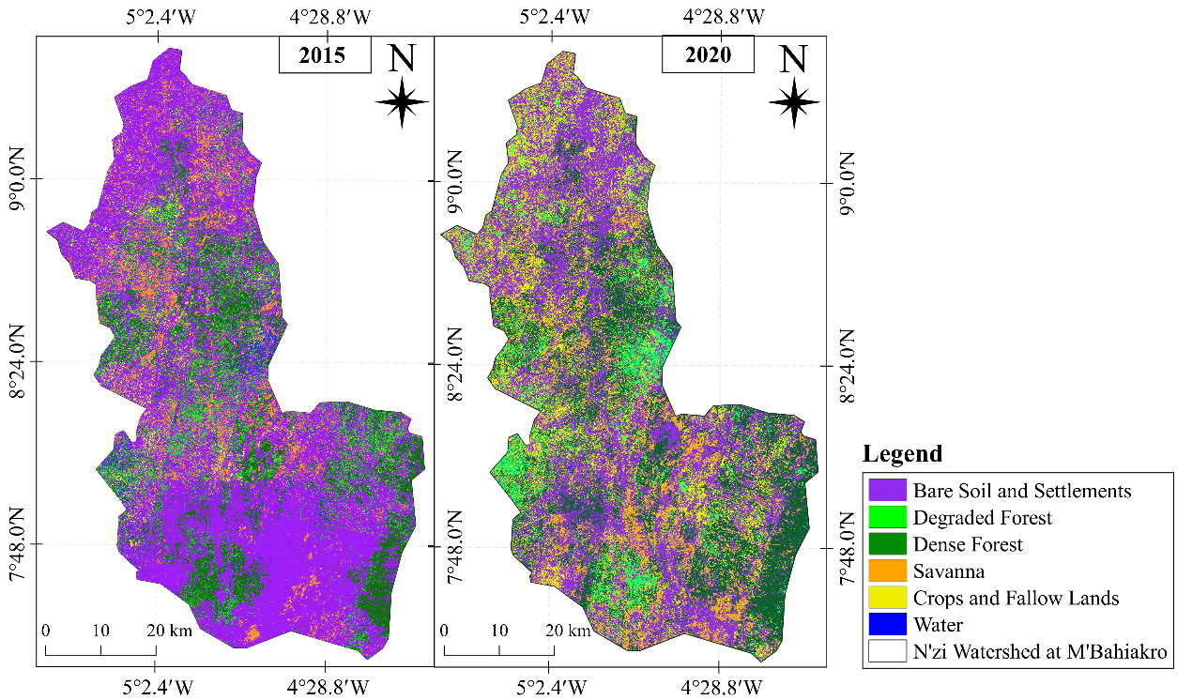

Figure 2: Changes in land cover classes between 2015 and 2020 revealing significant landscape transformations
Table 1 highlights the rate of Change between 2015 – 2020. The comparative analysis reveals a structural evolution marked by a significant decline in natural land classes and an expansion
of anthropogenic and hydrological land classes. The observed declines particularly concern savanna (-75.65%), dense forest (-35.43%), and bare soils/habitats (12.67%), mainly linked to agricultural conversion, logging, and the intensification of human pressure.

Table 1: Rate of Change between 2015 - 2020
Classes | 2015 | 2020 | Difference 2020 - 2015 | Rate of Change %
Bare Soil and Settlements | 21.38 | 18.67 | -2.71 | -12.68
Degraded Forest | 7.34 | 14.34 | 7.00 | 95.37
Dense Forest | 17.47 | 11.28 | -6.19 | -35.43
Savanna | 19.62 | 4.78 | -14.84 | -75.64
Crops and Fallow Lands | 13.36 | 19.45 | 6.09 | 45.58
Water | 20.83 | 31.48 | 10.65 | 51.13

3.2. Land use patterns from 2020 to 2024

The period 2020–2024 is distinguished by rapid changes in the landscape, resulting from agricultural expansion and the modification of natural and anthropized spaces (figure 2). Between 2020 and 2024, bare soils and habitats experienced a dramatic increase, rising from 293,119 ha to 761,293 ha, representing a growth rate of +1.60. Savanna also expanded, from 75,046 ha to 92,002 ha (+0.23). After its decline observed until 2020, dense forest resumed its expansion, increasing from 177,096 ha to 219,329 ha (+0.24). On the other hand, the "Crops and fallow land" class has seen a very marked decrease, from 305,365 ha in 2020 to 55,892 ha in 2024, representing a rate of change of -0.82. Degraded forest also declined sharply, from 225,138 ha to 73,633 ha (-0.67), reflecting a strong conversion of these areas to other uses and the continuation of anthropogenic pressures on forest environments (figure 3).
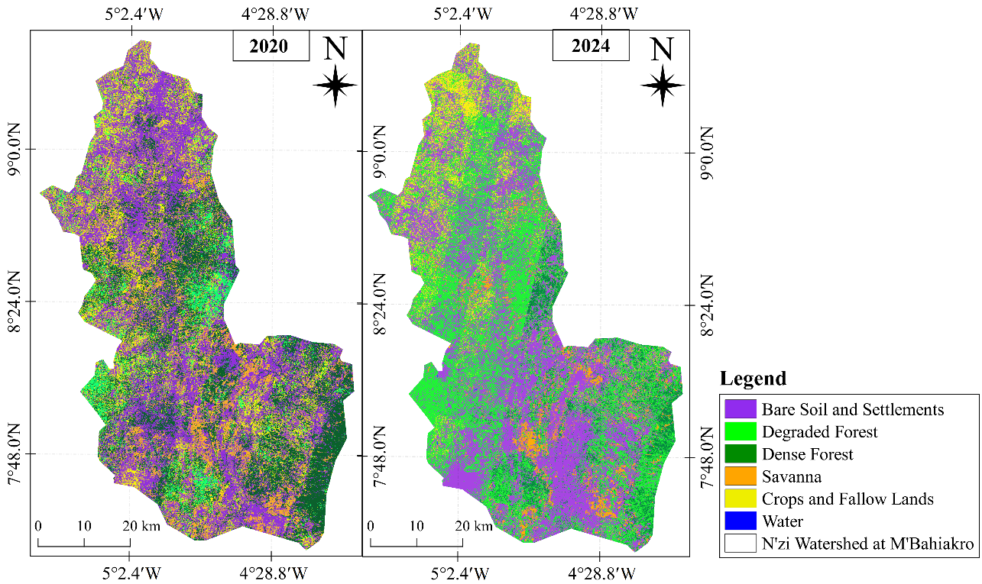
Figure 3: Degradation of forests reflecting a strong conversion of the areas to other uses and the continuation of anthropogenic pressures on forest environments
Table 2 highlights the rate of Change between 2020-2024. Bare soils and habitats experienced a major expansion (+159.72%), while cultivated and fallow land saw a sharp decline (81.70%). Degraded forest also declined significantly (-67.29%), while dense forest and savanna showed more moderate increases (+23.85% and +22.59%, respectively). Water bodies decreased by 25.54%, likely due to changes in land cover and human activity. These trends confirm the continuation of landscape transformations observed during the previous period (2015–2020), with intensified urbanization and increased pressure on agricultural and forest land.
Classes | 2020 | 2024 | Difference 2024 - 2020 | Rate of Change %
Bare Soil and Settlements | 18.67 | 48.49 | 29.82 | 159.72
Degraded Forest | 14.34 | 4.69 | -9.65 | -67.29
Dense Forest | 11.28 | 13.97 | 2.69 | 23.85
Savanna | 4.78 | 5.86 | 1.08 | 22.59
Crops and Fallow Lands | 19.45 | 3.56 | -15.89 | -81.70
Water | 31.48 | 23.44 | -8.04 | -25.54
Table 2: Rate of Change between 2020 and 2024

3.3. Land use patterns from 2015 to 2024
Between 2015 and 2024, the N’Zi watershed at M’Bahiakro underwent profound landscape transformations. Savannas decreased significantly, from 308,034 ha to 92,002 ha (–70.1%), and dense forest from 274,279 ha to 219,329 ha (–20.0%), with the period 2015–2020 marked by significant deforestation. Degraded forest also declined, from 115,238 ha to 73,633 ha (–36.1%), reflecting a conversion to agricultural land or bare soil and habitats.nThe area of cultivated land and fallow land fell from 209,752 ha to 55,892 ha (-73.4%) after an initial expansion, while bare soil and habitats increased sharply, from 335,666 ha to 761,293 ha (+126.8%). Water bodies increased slightly, from 327,031 ha to 367,851 ha (+12.5%), reflecting the proliferation of reservoirs and water bodies in the basin. These changes reflect the intensification of human pressures and a significant redistribution of land cover classes in the N’Zi watershed. Between 2015 and 2024, the N’Zi watershed at M’Bahiakro underwent major landscape transformations. Bare soils and habitats increased significantly (+126.8%), while savanna (-70.1%), dense forest (-20.0%), degraded forest (-36.1%), and cultivated/fallow land (-73.4%) declined. Water bodies increased slightly (+12.5%). These changes reflect the intensification of human pressures and the redistribution of land cover classes within the watershed.
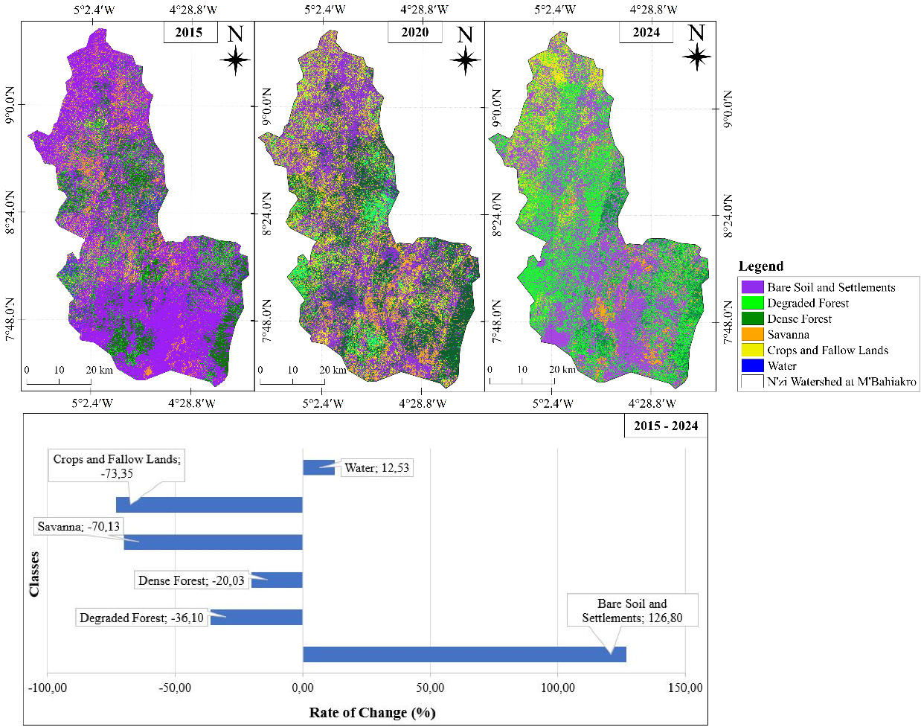
Figure 4: Land Use Dynamics in the N’Zi Watershed at M’Bahiakro
3.2 Discussion
3.2.1 Land use patterns from 2015 to 2020

Between 2015 and 2020, the N’Zi watershed underwent significant land-use changes, marked by a sharp decline in natural habitats. Savannas decreased from 308,034 ha to 75,046 ha (–75.6%), and dense forest from 274,279 ha to 177,096 ha (–35.4%), while bare soils and habitats decreased slightly (–12.7%), and cultivated land and fallow land expanded considerably (+46%). Degraded forest almost doubled (+95%), reflecting increasing human pressure on ecosystems. These trends are consistent with observations made by Koffi et al. (2023) in the Lobo watershed, Côte d’Ivoire, where extensive agriculture and logging were identified as the main drivers of deforestation. Angoua (2018) also emphasize that the conversion of savannas and forests into agricultural land and habitats results from population growth and increased demand for arable land. The expansion of cultivated and fallow land reflects the intensification of subsistence and cash crop farming, a phenomenon observed in other rural areas of Côte d'Ivoire (Ruf & Varlet, 2019; Ouattara et al., 2021). At the same time, the increase in degraded forest indicates that natural environments are undergoing fragmentation and progressive degradation, confirming the findings of Traoré et al. (2024), who show that extensive agriculture combined with firewood collection reduces forest connectivity and accelerates habitat fragmentation. Thus, the period 2015–2020 illustrates a dynamic of strong deforestation and transformation of savannas into anthropized spaces, in accordance with the general trends observed in Ivory Coast and West Africa.

3.2.2 Land use patterns from 2020 to 2024

Between 2020 and 2024, the N’Zi watershed experienced rapid landscape transformations, primarily due to agricultural expansion and the reorganization of human-modified areas. Bare soils and habitats increased significantly (+159.7%), reflecting urbanization and the expansion of human-modified zones, consistent with Kouassi et al. (2024), who documented a significant expansion of non-forest areas in Côte d’Ivoire (DOI: 10.3846/gac.2024.18724). Savanna (+22.6%) and dense forest (+23.9%) experienced moderate increases, reflecting partial regeneration or conversion of natural habitats. Cropland and fallow land decreased sharply (-81.7%), while degraded forest declined (-67.3%), indicating a shift towards other uses or continued human pressures on forests (Traoré et al., 2024). Water bodies decreased by 25.5%, likely linked to changes in land use and human water withdrawals. These results are consistent with the observations of Tellen et al. (2020) and Abindaw et al. (2023), which show that the intensification of agricultural practices and human pressure accelerate the degradation of tropical soils and the fragmentation of landscapes. These trends confirm the continuity of the transformations observed between 2015 and 2020, highlighting the need for sustainable land and forest management policies to limit degradation and strengthen the ecological resilience of the basin.
3.2.3 Land use patterns from 2015 to 2024
The transition observed between 2015 and 2024 in the N’Zi River basin shows a clear shift from forest to savanna and agricultural land. This evolution follows trends described in other regions of West Africa. Several studies indicate that Côte d’Ivoire still has one of the highest deforestation rates in the world. This situation is mainly explained by cash crops, the expansion of food crops, and population growth (Hansen et al., 2013; Kouassi et al., 2021).
The increase in arable land, especially between 2020 and 2024, reflects the rise of cash crops such as cocoa and cashew. These crops are the main drivers of land-use change in Côte d’Ivoire (Ruf & Varlet, 2019; Ouattara et al., 2021; Kalischek et al., 2023). The rapid expansion of cashew cultivation in the central part of the country has led to the conversion of numerous wooded savannas and secondary forests (Akpa You et al., 2019; Soro et al., 2020). In areas near the N’Zi River basin, Traoré et al. (2024) show that extensive agriculture and fuelwood harvesting reduce forest continuity and accelerate forest fragmentation.
The expansion of savannas is part of a savannization process. This phenomenon corresponds to the transition from a forest or semi-open environment to an ecosystem dominated by herbaceous plants. It is often difficult to reverse. The mechanisms described in the literature-recurrent fires, decline in woody biomass, fire-vegetation feedbacks, and droughts are also observed in the N’Zi River basin (Beckett et al., 2022; Staver et al., 2020; Abreu et al., 2021). Schwantes Marinho et al. (2022) show that extreme fires, repeated annually, prevent forest regeneration. They subsequently promote the formation of treeless savannas.
Uncontrolled agricultural expansion also increases soil vulnerability. These results are consistent with those of Tellen et al. (2020), Abindaw et al. (2023), and Saravia-Maldonado et al. (2024). These authors show that land-use changes accelerate the degradation of the physical and chemical properties of tropical soils. In Côte d'Ivoire, recent studies (Koffi et al., 2024; Angaman et al., 2024) confirm that vegetation degradation, combined with agricultural pressure, significantly increases the risk of erosion. The most affected areas are the plateaus and the forest-savanna transition zones.

CONCLUSION
This study examined land-use dynamics and the vulnerability of cultivable lands in the N’Zi watershed at M’Bahiakro (Central–Eastern Côte d’Ivoire) between 2015 and 2024. Satellite images from 2015, 2020, and 2024 were preprocessed to correct radiometric and atmospheric effects and were classified using the supervised Maximum Likelihood method into six land-use categories: bare soil and settlements, dense forest, degraded forest, savanna, croplands and fallows, and water. Classification accuracy, assessed through a confusion matrix, exceeded 85%, ensuring reliable outputs. The diachronic analysis reveals a rapid and significant transformation of the landscape: a marked decline in dense forests, a progressive expansion of savannas and croplands, and a strong intensification of agricultural activities, particularly in the central and southern sectors by 2024. Degraded forests expanded between 2015 and 2020 before decreasing in favour of croplands and fallows. Bare soil and built-up areas increased slightly, while water bodies remained largely stable. These changes reflect increasing anthropogenic pressure and the ongoing conversion of natural and degraded landscapes into agricultural areas.
The results fully meet the study objectives:
(i) they characterize the spatio-temporal dynamics of land use, highlighting deforestation, fragmentation, and agricultural expansion;
(ii) they provide a preliminary assessment of cultivable land vulnerability, which is highly exposed to erosion, soil degradation, and long-term productivity loss.
These findings call for the implementation of sustainable land-management strategies, including the restoration of remaining forest cover, the rational intensification of agriculture, the protection of sensitive zones (headwaters and lowlands), and the integration of sustainable land-use principles into local and national policies.

Perspectives and Limitations*

This study provides key insights into land use dynamics and the vulnerability of cultivable lands in the N’Zi watershed, useful for agricultural planning and soil conservation.
However, certain limitations exist: reliance on satellite imagery may introduce classification uncertainties, and local socio-economic factors were only partially considered. The study period (2015–2024) also does not capture some long-term trends.
Future research should integrate predictive models, such as Markov chains, CA-Markov, Land Change Modeler, or machine learning approaches (Random Forest, Gradient Boosting), to anticipate land use changes and assess land vulnerability under different scenarios. Combining these models with field surveys and socio-economic data would provide a more integrated and precise framework for sustainable watershed management.

Ethical approval
None

DISCLAIMER (ARTIFICIAL INTELLIGENCE)
Author(s) hereby declare that NO generative AI technologies such as Large Language Models (ChatGPT, COPILOT, etc.) and text-to-image generators have been used during the writing or editing of this manuscript.

References

Abindaw, T., Hanyabui, E., Atiah, K., Akwasi, E. A., & Ziblim, I. A. (2023). Influence of land use types on the distribution of selected soil properties in tropical soils of the Coastal Savanna zone. Heliyon, 9(3), e14002. https://doi.org/10.1016/j.heliyon.2023.e14002
Abreu, R. C. R., Durigan, G., Melo, A. C. G., Pilon, N. A. L., & Hoffmann, W. A. (2021). Facilitation by isolated trees triggers woody encroachment and a biome shift at the savanna–forest transition. Journal of Ecology, 109(8), 2984–2998. https://doi.org/10.1111/1365-2664.13994
Angaman, Kadio Valère, Mirzabaev, Alisher & Niang, Birahim Bouna. (2024). Economic impacts of land degradation: Evidence from Côte d'Ivoire. Land Degradation & Development, 35(4), 1541–1552. https://doi.org/10.1002/ldr.5004
Aka, K. S. R., Kouakou, K., Kouassi, A., et al. (2023). Toward understanding land use/land cover changes and their effects on surface temperature in the Gontougo Region, Côte d’Ivoire. Frontiers in Remote Sensing, 4, 1221757. https://doi.org/10.3389/frsen.2023.1221757
Akpa You, L., Dibi, N. H., Kyereh, B., & Kouassi, B. K. (2019). Impact of cashew plantation on carbon stock in the forest‑savanna transition zone (north‑east Côte d’Ivoire). International Journal of Innovation and Applied Studies, 27(2), 591–598. https://doi.org/10.1016/j.heliyon.2023.e14002
Al-Akad, S., Akensous, Y., Mustapha, H., Alnahmi, F., Mahyoub, S., Khanbari, K., & Swadi, H. (2019). Mapping of land-cover change analysis in Ma’rib, Yemen using remote sensing and GIS techniques. The International Archives of the Photogrammetry, Remote Sensing and Spatial Information Sciences, XLII-4/W12, 1–10. https://doi.org/10.5194/isprs-archives-XLII-4-W12-1-2019
Beckett, H., Staver, A. C., Charles‑Dominique, T., & Bond, W. J. (2022). Pathways of savannization in a mesic African savanna–forest mosaic following an extreme fire. Journal of Ecology, 110(4), 902–915. https://doi.org/10.1111/1365-2745.13851
Chatelain, C., Gautier, L., & Spichiger, R.‑E. (2004). Forest cover changes in Côte d’Ivoire and Upper Guinea. In L. Poorter, F. Bongers, F. N. Kouamé & W. D. Hawthorne (Eds.), Biodiversity of West African Forests: An Ecological Atlas of Woody Plant Species (pp. 45‑82). CABI Publishing. https://doi.org/10.1079/9780851997346.0015
Dao, A., Koffi, E. S., Noufé, D. D., Kamagaté, B., Goné, L. D., Séguis, L., and Perrin, J (2021). L.: Soil loss vulnerability: the case study of Aghien lagoon watershed outskirts Abidjan city (Côte d'Ivoire), Proc. IAHS, 384, 121–126, https://doi.org/10.5194/piahs-384-121-2021
FAO. (2023). Adaptation and vulnerability context for Côte d’Ivoire – SCALA Program Report. Food and Agriculture Organization of the United Nations. https://www.fao.org/scala

Hansen, M. C., Potapov, P. V., Moore, R., Hancher, M., Turubanova, S. A., Tyukavina, A., Thau, D., Stehman, S. V., Goetz, S. J., Loveland, T. R., Kommareddy, I., Egorov, A., Chini, L., Justice, C. O., & Townshend, J. R. G. (2013). High‑Resolution Global Maps of 21st‑Century Forest Cover Change. Science, 342(6160), 850–853. https://doi.org/10.1126/science.1244693
Kalischek, N., Lang, N., Renier, C., Daudt, R. C., Addoah, T., Thompson, W.& Wegner, J. D. (2023). Cocoa plantations are associated with deforestation in Côte d’Ivoire and Ghana. Nature Food, 4, 384‑393. https://doi.org/10.1038/s43016-023-00751-8
Koffi, B., Brou, A. L., Kouadio, K. J. O., Ebodé, V. B., N’Guessan, K. J.-Y., Yangouliba, G. I. & Kouassi, K. L. (2023). Impact of climate and land use/land cover change on Lobo reservoir inflow, West‑Central of Côte d’Ivoire. Journal of Hydrology: Regional Studies, 47, https://doi.org/10.1016/j.ejrh.2023.101417
Koffi, E. S., Dao, A., Noufe, D. D., Ouedraogo, M., Yeo, N. B., Seguis, L., Perrin, J. L., Kamagate, B., & Gone, L. D. (2024). Dynamics of Water Erosion in the Aghien Lagoon Catchment. European Scientific Journal, ESJ, 20(33), 187. https://doi.org/10.19044/esj.2024.v20n33p187
Konan-Waidhet, A. B., Kouassi, H. K., & Kanga, K. E. (2022). Land Use Dynamics in the Department of Séguéla, Northwestern Côte D’Ivoire. Advances in Remote Sensing, 11(3), 63-79. https://doi.org/10.4236/ars.2022.113005
Kouassi, A. M., Assoko, A. V. S., Kouakou, K. E., & Biémi, J. (2019). Analyse des impacts des changements climatiques sur les normes hydrologiques en Afrique de l’Ouest : cas du district d’Abidjan (sud de la Côte d’Ivoire). Revue des Sciences de l’Eau / Journal of Water Science, 32(3), 257–272. https://www.erudit.org/fr/revues/rseau/2019-v32-n3-rseau05058/1067305ar/
Kouassi, A. M., Gnangouin, A. Y. J., & Relwindé, N. A.-K. (2022a). Impacts of climate change on agroclimatic indicators in West Africa: Case study of the N’Zi (Bandama) watershed in Côte d’Ivoire. Current Journal of Applied Science and Technology, 41(43), 35–48. https://doi.org/10.9734/cjast/2022/v41i434006
Kouassi, C. J. A., Qian, C., Khan, D., Achille, L. S., Kebin, Z., Omifolaji, J. K., Ya, T., & Yang, X. (2024). Land use/land cover change mapping from Sentinel-1B & 2A imagery using random forest algorithm in Côte d’Ivoire. Geodesy and Cartography, 50(1), 43–59. https://doi.org/10.3846/gac.2024.18724
Kouassi, J.-L., Gyau, A., Diby, L., Bene, Y., & Kouamé, C. (2021). Assessing land use and land cover change and farmers’ perceptions of deforestation and land degradation in south-west Côte d’Ivoire, West Africa. Land, 10(4), 429. https://doi.org/10.3390/land10040429
Kouassi, J.-L., Wandan, N., & Mbow, C. (2022b). Observed climate trends, perceived impacts and community adaptation practices in Côte d’Ivoire. Environmental & Socio-economic Studies, 10(3), 43–58. https://doi.org/10.2478/environ-2022-0016
Kouassi, K.H., Konan-Waidhet, A.B., Yao, A.B., Koffi, B. and Kadjo, E.D. (2020) Simulation of the Dynamics of Land Cover and Land Use in the Lobo River Watershed Upstream of Nibéhibé (Center-West of Côte d’Ivoire). Journal of Geographic Information System, 12, 519-530. https://doi.org/10.4236/jgis.2020.125030
McHugh, M. L. (2012). Interrater reliability: The kappa statistic. Biochemia Medica, 22(3), 276–282. https://doi.org/10.11613/BM.2012.031.

Ouattara, T. A., Kouamé, K. F., Zo‑Bi, I. C., Vaudry, R., & Grinand, C. (2021). Changements d’occupation et d’usage des terres entre 2016 et 2019 dans le Sud-Est de la Côte d’Ivoire : impact des cultures de rente sur la forêt. Bois et Forêts des Tropiques, 347, 89‑104. https://doi.org/10.19182/bft2021.347.a31868

Ruf, F., Koné, S., & Bebo, B. (2019). Le boom de l’anacarde en Côte d’Ivoire : transition écologique et sociale des systèmes à base de coton et de cacao. Cahiers Agricultures, 28, article 21. https://doi.org/10.1051/cagri/2019019
Saravia‑Maldonado, S. A., Rodríguez‑González, M. Á., Ramírez‑Rosario, B., & Fernández‑Pozo, L. F. (2024). Change in land use affects soil organic carbon dynamics and distribution in tropical systems. Soil Systems, 8(3), 101. https://doi.org/10.3390/soilsystems8030101
Schwantes Marinho, M. A., Oliveira, R. S., Pinto, J. R., & Fernandes, G. W. (2022). Long-term fire effects in tropical ecosystems. Ecological Indicators, 144, 109470. https://doi.org/10.1016/j.ecolind.2022.109470
Soro, D., Kouamé, K., & Yao, B. (2020). Cashew expansion and land degradation in Côte d’Ivoire. Journal of Arid Environments, 181, 104245. https://doi.org/10.1016/j.jaridenv.2020.104245
Staver, A. C., Archibald, S., & Levin, S. A. (2020). Fire–vegetation feedbacks and biome shifts. Nature Ecology & Evolution, 4, 1173–1180. https://doi.org/10.1038/s41559-020-1250-0
Tellen, V.A., Yerima, B.P.K (2019). Effects of land use change on soil physicochemical properties in selected areas in the North West region of Cameroon. Environ Syst Res 7, 3. https://doi.org/10.1186/s40068-018-0106-0
Timité, N., Kouakou, A. T. M., Bamba, I., Barima, Y. S. S., & Bogaert, J. (2022). Climate Variability in the Sudanian Zone of Côte d’Ivoire: Weather Observations, Perceptions, and Adaptation Strategies of Farmers. Sustainability, 14(16), 10410. https://doi.org/10.3390/su141610410
Traoré, S., Zo Bi, I. C., Piponiot, C., Aussenac, R., & Henry, H. F. (2024). Fragmentation is the main driver of residual forest aboveground biomass in West African low forest–high deforestation landscapes. *Trees, Forests and People, 15, 100477. https://doi.org/10.1016/j.tfp.2023.100477
Yao, K. L., Kouakou, K. E., Kouassi, A. M., Deguy, A. J.-P., & Camara, M. (2023). Analysis of land use change in the N’Zi watershed of Côte d’Ivoire using Landsat satellite images. Earth and Space Science, 10, e2022EA002744. https://doi.org/10.1029/2022EA002744

