Original Research Paper

Comparative Statistical Analysis of Prey-Availability and Prey Dynamics of the Indian Panthers (Panthera pardus fusca) in Sisarma Banki Forest and Sajjangarh Wildlife Sanctuary of Southern Rajasthan, India

Abstract

Hunting patterns and feeding-behaviour of an apex predator in a region relies on the real-time studies of its habitat ecology and current status of available prey-base. Present study investigates the comparative statistical analysis of the ecological and behavioural studies conducted on Indian Panthers (Panthera pardus fusca) in Sisarma Banki Forest (SBF) and Sajjangarh Wildlife Sanctuary (SWS) of Udaipur in Southern Rajasthan, India in between 2014 and 2018 to understand and unfold its dietary-patterns. A total of 150 scat samples of Indian Panthers were collected, processed and examined accordingly, to record the related forage data in the form of number and percent frequency values of prey species in Indian Panther’s diet for season-wise and species-wise aspects. Further investigation by one-way ANOVA test for both study areas of SBF and SWS to evaluate and analyze the significant variation of these values across seasons for understanding seasonal as well as species level differences and similarities in the study areas revealed variations in prey-base number and percent frequency in terms of consumption at both seasonal and species level. Significant seasonal (F=4.484, p=0.014) and species-level (F=3.136, p=0.001) differences were observed in prey frequency. Collaboratively, both the study areas SBF and SWS showed similarities in domestic prey-base frequencies, but there were significant differences in the consumption of wild prey-base frequencies. Shannon-Wiener Diversity Indices for both the study areas of SBF and SWS ranging between 2 to 3 suggested towards higher levels of diversity and rich species configuration in both the ecosystems, with adequate evenness and relative abundance indicating healthy ecosystem. All these investigations help in efficient and better habitat conservation operations and connecting the position of Indian Panthers ecological behaviour, establishing them as generalist rather than specialist in its dietary patterns. These results underscore the impact of habitat type and legal status on the foraging behavior of leopards, suggesting that sanctuary status provides a different prey demographic compared to reserve forests.

Keywords: Indian Panthers, Panthera pardus fusca, conservation, wild, prey-base, Rajasthan, Sisarma Banki Forest (SBF), Sajjangarh Wildlife Sanctuary (SWS), Shannon-Wiener Diversity Index (H’), Effective Number of Species (ENS), ANOVA

1. Introduction:

For any wildlife and vegetation management, ecological stability is critical parameter governed by predator-prey relationships (Schaller, 1967, 1972; Krebs, 1978; Johnsingh, 1983, 1992; Karanth & Sunquist, 1995; Sharma, 2019; Pareek et al., 2023; Devgupta et al., 2024) and their interlinkages of that area (Avinandan et al., 2003; Andheria, et al., 2007; Arivazhagan et al., 2007; Athreya et al., 2014). Globally, Panthers show high adaptive behaviour in terms of their feed and habitat while showcasing wide range of fluctuations and flexibility in its ecological behaviour patterns. When compared between protected and unprotected areas, Panther’s monitor prey-population dynamics and altering in between is a customized dietary shift approach. Understanding predator biology in its natural habitat whether fragmented forest patch or wildlife sanctuary is critical in understanding its dietary patterns (Johnsingh et al., 1993a, Johnsingh et al. 1993b; Kumar, 2011; Ram et al., 2023; Ram et al., 2024) and further adopting and implementing efficient wildlife conservation policies (Sunquist, 1981; Bertram, 1982; Bekoff et al., 1984; Bothma et al., 1984, 1986; Bailey, 1993; Biswas & Sankar, 2002; Bagchi et al., 2003;). Ecological studies related to Indian Panthers (Daniel, 1996; Edgaonkar, 2008) and other Panther species worldwide (Grassman, 1999) attune to uncommon extraordinary habitat suitability and predation behaviours depicting its varied feeding behaviour which ranges from wild to domestic prey-base and from small-sized to large-sized, based on the availability or scarcity of food inside its natural territory, with least physical movements (Hamilton, 1976) and energy expenses, at the same time keeping its solitary nature intact. Various studies were conducted in understanding the feeding behaviour of Panthers which suggests that Panthers predatory habit (Sathyakumar, 1992; Sankar & Johnsingh, 2002) is not confined or narrowed to limited prey range but rather it showed a wide and flexible predation prey-base range which is agreement to the same.

Thus, Panthers are generalist not specialist in terms of prey-base selection for its survival with minimal availability (Chauhan & Goyal, 2001; Sharma, 2019) of food choices (Sunquist & Sunquist, 1989; Mondal et al., 2011) in its vicinity whether inside or outside the natural habitat. Increasing deforestation, mining (Sharma & Chishty, 2016) and other anthropogenic activities in and around its natural territory (Muckenhirn & Eisenberg, 1973) which is reducing day by day limited from small to very small fragmented forest patches and even encroaching human habituation towards protected wildlife areas enforcing these Panthers and other wild animals to come out from their natural habitat approaching human-settlements in search of food and water which results to increasing possibilities of Human-Panther Conflicts (HPC) (Sharma & Chishty, 2016; Sharma & Chishty, 2018) and conflicts of human with other wild animals, causing severe damages to both humans and wild animals. Studies on HPC utilizing machine learning applications (Sharma & Chishty, 2019, Sharma, 2019) in recent past globally, has shown a potential technological advancement in understanding the large data-sets may be in the form of images or videos or text leading to quick and efficient administration of wildlife conservation strategies on ground level.

When traditional predator-prey models were integrated with machine learning applications, it becomes robust in predicting complex predator-prey relationships (Schaller, 1967, 1972; Sharma, 2019; Devgupta et al., 2024) with enhanced predictive accuracies particularly in ecological arrangements not easy to understand (Pareek and Baghel, 2023; Devgupta et al., 2024; Sharma & Chishty, 2019; Sharma, 2019). Different wildlife zones provide varied prey-base opportunities which possibly can alter population-dynamics of the region resulting in both positive and negative aspects of the same, sometimes creating more challenging situations for wildlife sustainability. Present research paper provides a comparative statistical analysis of dietary patterns and foraging behaviour of Indian Panthers (Panthera pardus fusca) (Edgaonkar & Chellam, 2002; Sujai, 2004; Arivazhagan, 2007; Sharma, 2019) between the study areas of the Sisarma Banki Forest (SBF) which is a reserve forest and Sajjangarh Wildlife Sanctuary (SWS), both being natural laboratories and its significance in relation to prey-base population dynamics.

2. Materials and Methods

The Aravalli hills of Sothern Rajasthan are natural habitat of rich floral and faunal biodiversity with an apex carnivore from family Felidae, the Indian Panther (Panthera pardus fusca). The climatic conditions of the study areas are tropical semi-arid characterized by dry hot summer and intensive winter with an average precipitation of about 650 mm, ranging between 600 mm to 800 mm annually. Study areas of the SBF and SWS are composed of broad floral diversity dominated by tropical dry deciduous mixed forests and tropical thorny forests and the main tree species of these sub types are Anogeissus pendula. Both study areas of SBF and SWS consists of varying altitude ranges of Aravalli Hills. Figure 1 shows the study areas of SBF (20.4 km²) and SWS (7.95 km²) which were surveyed extensively (Figure 2a) explored while walking on natural trails (Figure 2b) of possible movement of Indian Panthers, which were confirmed by both direct and indirect presence signals and keeping the records of the same (Figure 2c). As direct sign of presence, natural sighting of Indian Panthers and as indirect signals, presence of its pug marks (Figure 3a), scats (Figure 3b), trunk rake (Figure 3c) and scrape marks (Figure 3d), were recorded and photographed with GPS coordinates for all signalling parameters to track animal movement patterns. Other sign surveys were also collected like soil diggings (wild boar), pellets (nilgai, hare), and faecal matter (dog) for identification and confirmation of presence of both wild as well as domestic prey-base, inside and immediate adjoining outside areas of SBF and SWS. For scatological analysis a total 150 scat samples were collected from the study areas of SBF (86) and SWS (64).

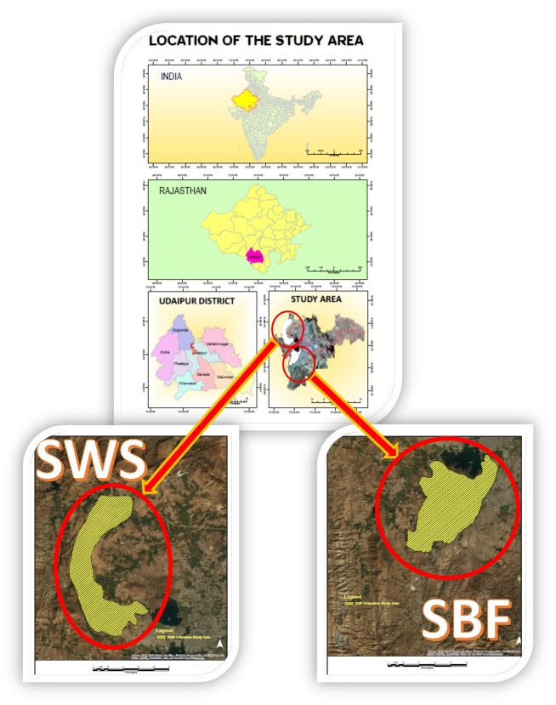
Figure 1. Location of the study areas: Sisarma Banki Forest (SBF) and Sajjangarh Wildlife Sanctuary (SWS)

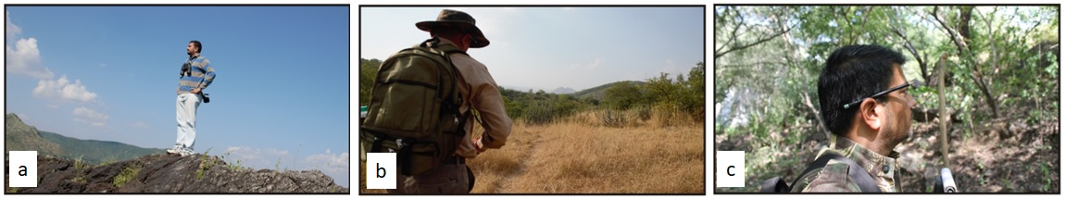
Figure 2. The study areas of SBF and SWS were a. surveyed b. trail-walked c. recorded for presence of possible movement of Indian Panthers

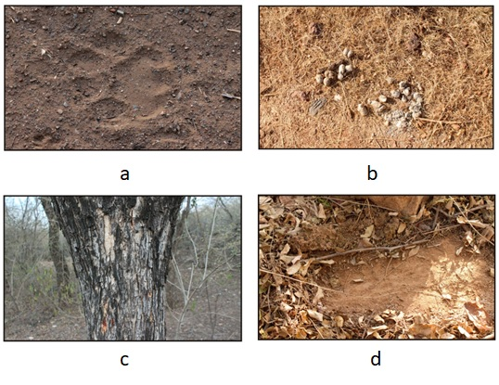
Figure 3. Indirect signs of Indian Panthers in the study areas of SBF and SWS a. Pug marks b. Scats c. Trunk rake d. Scrape marks

Prey-base animals in the diet of Indian Panthers of the study areas of SBF and SWS of Southern Rajasthan were confirmed with the help of scatological examination (Grobler & Wilson, 1972; Putman, 1984; Corbett, 1989; Mukherjee et al., 1994; Zabala & Zuberogoitia, 2003; Sharma, 2019) which comprises of process of careful washing and fine cleaning of scats as per standards while retaining the pieces of bones and hairs (Brunner, 1974; Oli, 1993; Tollit et al., 2004) present in the scat samples secured in biohazard specimen bags (Figure 4). These bone pieces and hairs collected from the scat samples of Indian Panthers of the study areas were then examined microscopically (Figure 5) and were matched with the standard references of the same to find out the prey-animal hunted and eaten by Indian Panthers in the study areas of SBF and SWS which were tabulated and further with the help of these recorded data, the variable of number and percent frequency of scats per prey-species of both domestic and wild prey-base were estimated by SPSS software (version 26), separately for SBF and SWS to evaluate season-wise (Table 1) and species-wise (Table 2) variations and were finally analyzed for its significance between the study areas with the help of one-way ANOVA test, between the groups and within the groups.

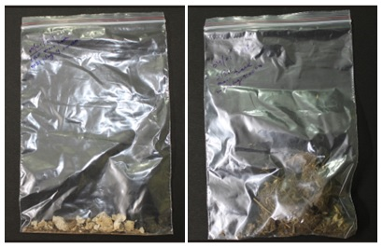

Figure 4. Bone pieces and hair specimens secured in biohazard specimen bags collected after processing the scat samples of Indian Panthers from the study areas of SBF and SWS

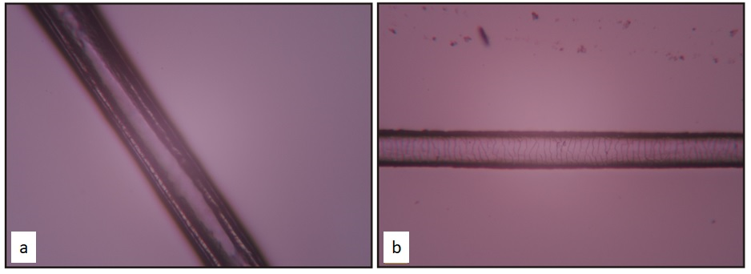

Figure 5. Microscopic image a. Hair Medulla and b. Hair Cuticle of sampled hair processed and collected from Indian Panther scats from the study areas of SBF and SWS

Table 1. Season wise ANOVA (one way) analysis for both study areas of SBF and SWS together for number and percent frequency occurrence of prey species in the diet of Panther between time period from 2014 to 2018
Group Category | Sum of Squares | df | Mean Square | F | p value | Result
Between Groups | 6002.030 | 2 | 3001.015 | 4.484 | 0.014 | *
Within Groups | 54214.957 | 81 | 669.320 | 4.484 | 0.014 | *
Total | 60216.987 | 83 |  | 4.484 | 0.014 | *
df = Degree of freedom, F = Fischer value,
Level of significance (Significant): * = p < 0.05, ** = p < 0.01, *** = p < 0.001,
NS = Non-Significant = p ≥ 0.05

Table 2. Species wise ANOVA (one way) analysis for both study areas of SBF and SWS together for number and percent frequency occurrence of prey species in the diet of Panther between time period from 2014 to 2018
Group Category | Sum of Squares | df | Mean Square | F | p value | Result
Between Groups | 22164.890 | 13 | 1704.992 | 3.136 | 0.001 | **
Within Groups | 38052.097 | 70 | 543.601 | 3.136 | 0.001 | **
Total | 60216.987 | 83 |  | 3.136 | 0.001 | **
df = Degree of freedom, F = Fischer value,
Level of significance (Significant): * = p < 0.05, ** = p < 0.01, *** = p < 0.001,
NS = Non-Significant = p ≥ 0.05

Percent occurrence of different prey species in the scats of Indian Panthers (Panthera pardus fusca) during Winter, Summer and Monsoon Seasons in the study areas of SBF (Figure 7) and SWS (Figure 8), were calculated during the time-period between 2014 to 2018.

Shannon-Wiener Diversity Index (H’) was calculated to depict the estimates of species diversity which considering the number of species habituating in the study areas (richness) and their relative abundance (evenness) (VA & Jhala, 2003; Panda et al., 2023; Joseph et al., 2007).

$$H’ =-\sum_{i=1}^{s}{{ p}_{i}\ln_{ }p_{i}}$$

Where, H’ = Shannon-Wiener Diversity Index

p_{i} = proportion of individuals belonging to species i

Exponential of the Shannon-Wiener Diversity Index (H’) that is e^{H’}is termed as the Effective Number of Species (ENS) which predicts that in the formation of a diversified community, how many species are actually equally abundant species, irrespective of total number of type of species found in that region which directly represents the bio-diversity of the study areas of SBF and SWS.

3. Results and Discussions

Both the study areas of SBF and SWS showed common wild prey-base except for one animal i.e. spotted deer which were present exclusively only in SWS due to its legal status and protection as wildlife sanctuary. Analytical studies of scat samples of Indian Panthers showed the presence of nilgai (Boselaphus tragocamelus) in major proportion in its diet for the study area of SBF, while common Indian Langur (Semnopithecus entellus) were major in the diet of Indian Panthers of SWS. All these investigations for dietary patterns of Indian Panthers indicate habitat variance significantly.

To evaluate the significant variation of the season-wise and species-wise estimation of number and percent frequency of prey-base, these values were tested by one-way ANOVA tests for both the study areas of SBF and SWS during scatological examination from the time period between 2014 to 2018 which revealed significant variation (p=0.014) when it is compared between the groups and within the groups (F=4.484) (Table 1) across the seasons. Similarly, at species level also the test results showed significant variation (p=0.001) when it is compared between the groups and within the groups (F=3.136) (Table 2).
Study area specific results indicate significant variations for rodents (p=0.002), nilgai (p=0.004), wild boar (p=0.000), birds (p=0.036), langur (p=0.048), buffalo (p=0.000), sheep (p=0.006) and goat (p=0.012). Contrary to these results non-significant variations were observed for wild hare (p=0.576), porcupine (p=0.406), reptiles (p=0.444), cattle (p=0.131) and dog (p=0.115) for number of Indian Panther scats analyzed to find prey-base species between the study areas of SBF and SWS in between the time period from 2014 to 2018.
One-way ANOVA test for number and frequency percent of prey species in the diet of Indian Panthers between the study areas of SBF and SWS during study period 2014 - 2018 showed significant variation with estimated values of Mean difference=14.34024, t=2.517, and p=0.014 (Table 3) which also indicates and accentuates towards varying levels of human-Panther and other wildlife linkages and inter-relationships significantly.

Table 3. ANOVA (one way) analysis between study areas of SBF and SWS for number and percent frequency occurrence of prey species in the diet of Panther between time period from 2014 to 2018
Study Area | N | Mean | Standard Deviation | Standard Error  (Mean) | Mean Difference | 't' | p value | Result
SBF | 42 | 26.1233 | 20.33275 | 3.13741 | 14.34024 | 2.517 | 0.014 | *
SWS | 42 | 40.4636 | 30.82138 | 4.75584
N = Number of samples, t = Student ‘t’ test, F = Fischer value,
Level of significance (Significant): * = p < 0.05, ** = p < 0.01, *** = p < 0.001,
NS = Non-Significant = p ≥ 0.05

Figure 6 depicts the mean performance and variability measure by group for the study areas of SBF and SWS between the time period from 2014 to 2018 for number and frequency percent of prey-base species in the diet of Indian Panthers in the study areas which showed higher frequency of availability of prey-base species which are more spread-out with less consistency in SWS as compared to SBF which is orderly and specific. Relatively lower values of standard deviation between SBF and SWS areas, indicates that the calculated means are reasonably accurate estimates of their respective populations. Also, sample size N=42 for both the study areas separately is ample for reliable estimation of the true population average of prey-base species which is proved by the low Standard Error relative to the Mean for the study areas.

Figure 6. Mean Performance and Variability Measures by Group for SBF and SWS

Figure 7 represent the percentage occurrence of prey-species in Indian Panthers scat samples and its further scatological-analysis for the season (a) winter (N=37), (b) summer (N=31) and (c) monsoon (N=18) in the study area of SBF. Opportunistic behaviour and hunting strategies of Indian Panthers with conserving energy and minimizing-efforts were also supported by the results indicating the diverse range of prey-base and dietary-pattern consisting of small to medium-sized animals constituting about 78.11% in winter season (Rodents = 27.39%, Cattle = 17.19%, Sheep = 17.76% and Goat = 15.77%), 80.61% in summer season (Rodents = 23.23%, Cattle = 23.29%, Sheep = 14.21% and Goat = 19.88%) and 76.51% in monsoon season (Rodents = 34.93%, Cattle = 19.93%, Sheep = 12.11% and Goat = 9.54%) in the diet of Indian-Panthers of SBF.
Similarly, Figure 8 represent the percentage occurrence of prey-species in Indian Panthers scat samples and its further scatological-analysis for the season (a) winter (N=30), (b) summer (N=23) and (c) monsoon (N=11) in the study area of SWS. In the study area of SWS almost around 50% of the major-diet of the Indian Panthers consists of livestock animals (cattle, goat, sheep) in all the three seasons viz. winter, summer and monsoon, which is indicating the frequent movement of Indian Panthers towards human-settlements, outside the legally protected wildlife sanctuary, showing a significant decrease of natural prey-base in the sanctuary. Rodents, birds, cattle and goat were major prey species during winter (73.13%) and summer (85.57%) while rodents, birds, cattle and sheep in the monsoon (67.92%) season during the entire study period from 2014 to 2018 in SWS.
Wild terrestrial natural-prey-base like nil-gai, hare, wild-pig, porcupine, langur, and reptiles were altogether always less than 20% in all the three seasons of winter, summer and monsoon during the study period of four years from 2014 to 2018 for both the study areas of SBF and SWS.

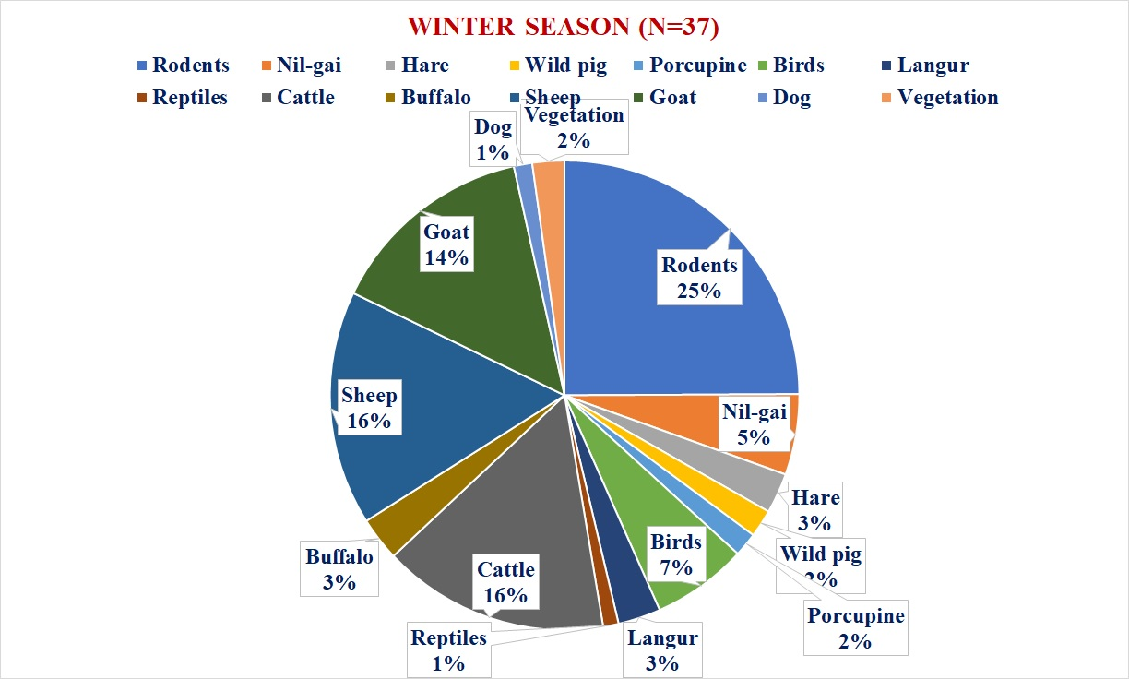
(a)
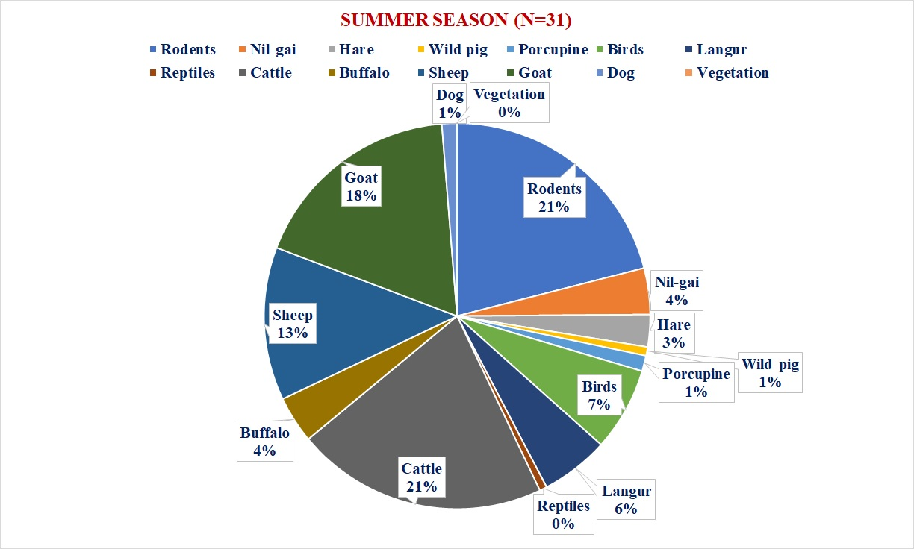
(b)
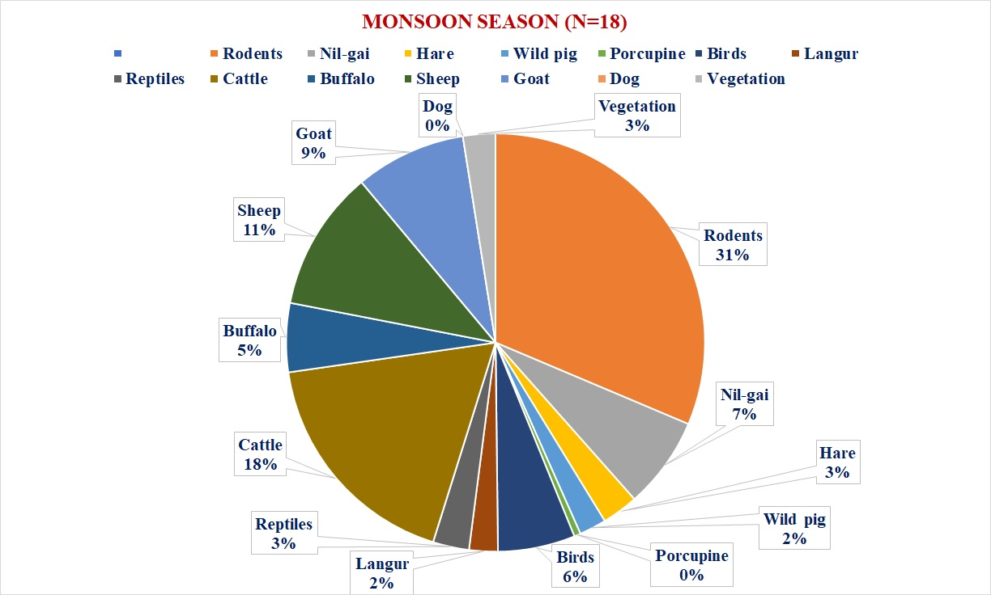
(c)
Figure 7. Percent occurrence of different prey species in the scats of Indian Panthers (Panthera pardus fusca) during (a) Winter, (b) Summer and (c) Monsoon Seasons in SBF, Udaipur, Rajasthan, India
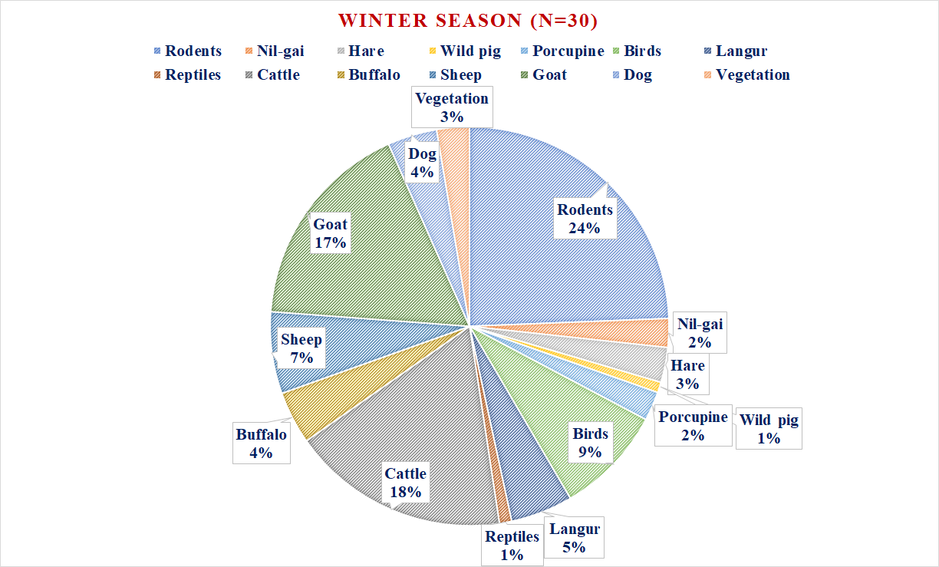
(a)
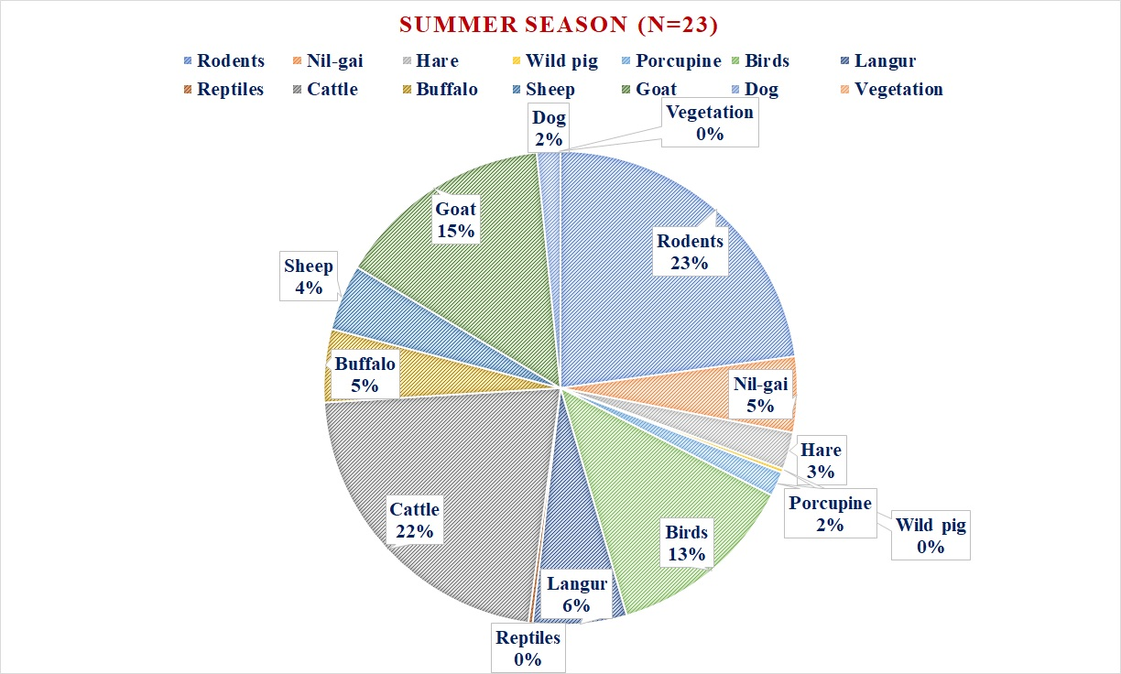
(b)
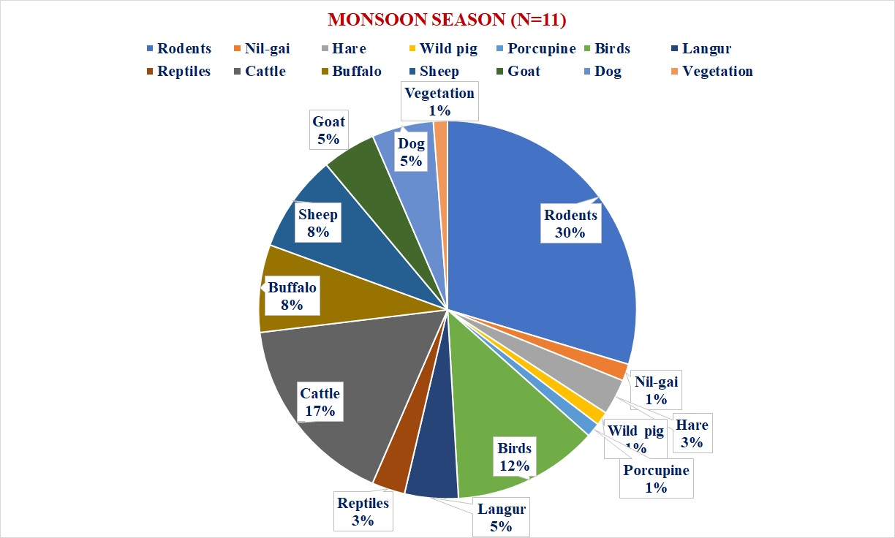
(c)
Figure 8. Percent occurrence of different prey species in the scats of Indian Panthers (Panthera pardus fusca) during (a) Winter, (b) Summer and (c) Monsoon Seasons in SWS, Udaipur, Rajasthan, India

Table 4 provides a mathematical and statistical overview of the biological diversity in the study area of SBF which indicates lower diversity in winter as compared to the peak in the bio-diverse ecosystem in monsoon season. Higher values of H’ predicts that the biological community in the SBF is typically complex with evenly distributed individuals among the species to which it pertains. Ecologically the values of H’ for all the seasons were moderate and consistent with constant increase in the availability of diverse food options from winter to summer and finally to the outset of the monsoon, suggesting that the monsoon season being favourable in terms of ample amount available food and water, supporting the complete food chain of the ecosystem for presence of more diverse and wider variety of species. ENS during winter (9.48), summer (10.38) and monsoon (10.66) indicates that approximately 9, 10 and 11 frequently and equally respectively occurring species were existing in the study area of SBF during the study period from 2014 to 2018.

Table 4. Shannon-Wiener Diversity Index (H') & Effective Number of Species (ENS)
for India-Panthers in the study area of SBF (scatological-analysis)
Shannon-Wiener Diversity Index (H') & Effective Number of Species (ENS)
for India-Panthers in the study area of SBF
Indices | Winter | Summer | Monsoon
Shannon-Wiener Diversity Index (H') | 2.248996 | 2.340627 | 2.366103
Effective Number of Species (ENS) = EXP(H') | 9.478218 | 10.38775 | 10.65579

Similarly, Table 5 summarizes and bring-forth the mathematical and statistical outline of the biological diversity in the study area of SWS, indicating lesser animal diversity in winters as compared to the maximum during monsoon season in the wildlife sanctuary ecosystem. Higher values of H’ predicts that the biological community in the SWS is comprehensively intricate with homogeneously and evenly distributed individuals amongst the species to which it belongs. Ecologically the values of H’ for all the seasons were moderate and consistent with sustained rise in the diverse variety of species availability across the seasons of winter, summer and the monsoon. Net primary productivity being greater in the monsoon season highlights the advantageous opportunities to all animals in terms of abundant and sufficient quantity of available natural resources like food and water, which further enhances the ecosystem in the presence of diversified variety of species. ENS during winter (8.42), summer (9.42) and monsoon (11.07) indicates that approximately 8, 9 and 11 frequently and equally respectively occurring species were existing in the study area of SWS during the entire course of the study period from 2014 to 2018.
Summarizing the result and discussion, the present study showed that the H’ values for both the study areas of SBF and SWS ranging in between 2 to 3 is indicating towards high diversity level and plentiful configuration of species in both the ecosystems, with adequate evenness and abundance indicates healthy ecosystem.
Table 5. Shannon-Wiener Diversity Index (H') & Effective Number of Species (ENS)
for India-Panthers in the study area of SWS (scatological-analysis)
Shannon-Wiener Diversity Index (H') & Effective Number of Species (ENS)
for India-Panthers in the study area of SWS
Indices | Winter | Summer | Monsoon
Shannon-Wiener Diversity Index (H') | 2.13177 | 2.242988 | 2.40472
Effective Number of Species (ENS) = EXP(H') | 8.429771 | 9.421438 | 11.07533

4. Conclusion

Higher the availability (Chauhan & Goyal, 2001; Sharma, 2019) of natural prey-base species to the Indian Panthers of SBF and SWS in its natural environment indicates the higher number and frequency of possible occurrence of these wild animals in its scat which was confirmed in the findings of scatological investigations that showed a strong correlation for the same. Both the study areas of SBF and SWS showed consistent presence of domestic prey-base also in its diet, reflecting higher foraging behaviour of Indian Panthers on the domestic prey-base in the Aravalli ecosystem, even though higher densities of wild-prey base species (Harihar, 2005; Sharma, 2019) were available in both the study areas of SBF and SWS. It is further highlighting a serious call to attention towards noticeable existence of human and human activities and its impact on the wildlife especially Indian Panthers, an apex-carnivore in the vicinity of the study areas of SBF and SWS. Present study which is the only and the first scientific research on Indian Panthers in Udaipur district of Southern Rajasthan assist in strategizing and executing efficient habitat conservation methodologies, understanding their ecological behaviour, establishing them as generalist rather than specialist in its dietary patterns. These results underscore the impact of habitat type and legal status on the foraging behavior of leopards, suggesting that sanctuary status provides a different prey demographic compared to reserve forests. Result highlights the conception and interpretation of prey-predator interactions and conservation of Indian Panthers in continuously transforming landscape structure due to anthropogenic activities. Finally, it is concluded from the present study that the management of wildlife habitat influences the seasonal and species level dietary patterns in the study areas of SBF and SWS of Southern Rajasthan, India.

Disclaimer (Artificial Intelligence)
Author hereby declares that NO generative AI technologies such as Large Language Models (ChatGPT, COPILOT, etc.) and NO text-to-image generators have been used during the writing or editing of this manuscript.

Acknowledgements
The author wishes to express his sincere gratitude to Prof. Sunita Farkya, Head, Division of Educational Kits, NIE, NCERT, New Delhi, for her invaluable feedback and guidance. The author would also like to thank Professor Dinesh Prasad Saklani, Director, National Council of Educational Research and Training (NCERT), for his steady support and inspiration. Similar appreciation is also extended to the Ministry of Education (MoE), Government of India (GoI). Special thanks to Professor Nadim Chishty for his consistent valuable support. The author did not receive any monetary grants and hereby declare no conflict of interest in the conduct and publication of this study.

Competing Interests
Author have declared that no competing interests exist.
Authors’ contributions: This work was originally carried out solely by the author only and the author solely read and approved the final manuscript.

Consent & Ethical approval
The author had taken authentic written permissions granted from Department of Forests, Government of Rajasthan for working in protected areas of forest and wildlife sanctuary of the study area with all ethical implication’s followed during the course of study time period which will the sole responsibility of author only.

5. References

Andheria, A. P., Karanth, K. U. and Kumar, N. S. (2007). Diet and prey profiles of three sympatric large carnivores in Bandipur Tiger Reserve, India. Journal of Zoology, 273: 169-175.

Arivazhagan, C., Arumugam, R. and Thiyagesan, K. (2007). Food habits of leopard (Panthera pardus fusca) dhole (Cuon alpinus) and striped hyena (Hyaena hyaena) in a tropical dry thorn forest of southern India. J. of the Bombay Natural History Society, 104 (2): 178-187.

Athreya, V., Odden M., Linnell J. D. C., Krishnaswamy J. and Karanth K. U. (2014). A cat among the dogs: leopard (Panthera pardus) diet in a human-dominated landscape in western Maharashtra, India. Oryx, 50: 156-162. (doi:10.1017/S0030605314000106).
Avinandan, D., Sankar, K., & Qureshi, Q. (2003). Food habits of tiger (Panthera tigris tigris) in Sariska Tiger Reserve, Rajasthan [Master's dissertation, Saurashtra University].
Avinandan, D., Sankar, K., & Qureshi, Q. (2008). Prey selection of tiger (Panthera tigris tigris) in Sariska Tiger Reserve, Rajasthan. Journal of the Bombay Natural History Society, 105, 247–254.
Bagchi, S., Goyal, S. P., & Sankar, K. (2003). Prey abundance and prey selection by tigers in a semi-arid, dry deciduous forest in western India. Journal of Zoology, London, 260, 285–290.
Bailey, T. N. (1993). The African leopard: A study of the ecology and behavior of a solitary felid. Columbia University Press.
Bekoff, M., Daniels, T. J., & Gittleman, J. L. (1984). Life history patterns and the comparative social ecology of carnivores. Annual Review of Ecology and Systematics, 15, 191–232.
Bertram, B. C. R. (1982). Leopard ecology as studied by radio tracking. Symposia of the Zoological Society of London, 49, 341–352.
Biswas, S., & Sankar, K. (2002). Prey abundance and food habit of tigers (Panthera tigris tigris) in Pench National Park, Madhya Pradesh, India. Journal of Zoology, London, 256, 411–420.
Bothma, J. Du P., & Le Riche, E. A. N. (1984). Aspects of the ecology and the behaviour of the leopard Panthera pardus in the Kalahari Desert. Koedoe Supplement, 27, 259–279.
Bothma, J. Du P., & Le Riche, E. A. N. (1986). Prey preference and hunting efficiency of the Kalahari Desert leopard. In S. D. Miller & D. D. Everett (Eds.), Cats of the world: Biology, conservation and management (pp. 381–414). National Wildlife Federation.
Brunner, H., & Coman, B. (1974). The identification of mammalian hair. Shanghai Printing Press Ltd.
Chauhan, D., & Goyal, S. P. (2001). Study on distribution relative abundance and food habits of leopard (Panthera pardus) in Garhwal Himalayas [Technical Report]. Wildlife Institute of India.

Corbett, L. K. (1989). Assessing the diet of dingoes from feces: A comparison of 3 methods. Journal of Wildlife Management, 53(2), 343–346.
Daniel, J. C. (1996). The leopard in India: A natural history. Nataraj Publishers.
Devgupta, R., Dandekar, R. A., Dandekar, R., & Panat, S. (2024). Scientific machine learning in ecological systems: A study on the predator-prey dynamics. arXiv preprint arXiv:2411.06858.
Edgaonkar, A. (2008). Ecology of the leopard (Panthera pardus) in Bori Wildlife Sanctuary and Satpura National Park, India [Doctoral thesis, University of Florida].
Edgaonkar, A., & Chellam, R. (2002). Food habit of the leopard, Panthera pardus, in the Sanjay Gandhi National Park, Maharashtra, India. Mammalia, 66(3), 353–360.
Grassman, L. I. Jr. (1999). Ecology and behaviour of the Indochinese leopard in Kaeng Krachan National Park, Thailand. Natural History Bulletin of the Siam Society, 47, 77–93.
Grobler, J. H., & Wilson, V. J. (1972). Food of the leopard (Panthera pardus) (Linn) in the Rhodes Matopos National Park, Rhodesia, as determined by faecal analysis. Arnoldia Rhodesia, 35(5), 1–9.
Hamilton, P. H. (1976). The movements of leopards in Tsavo National Park, Kenya, as determined by radio-tracking [Master's thesis, University of Nairobi].
Harihar, A. (2005). Population, food habits and prey densities of tiger in Chilla Range, Rajaji National Park, Uttaranchal, India.
Johnsingh, A. J. T. (1983). Large mammalian prey-predators in Baiulipur. J. Bombay Nat. Hist. Soc., 80: 1-57.
Johnsingh, A. J. T. (1992). Prey selection in three large sympatric carnivores in Bandipur. Mammalia, 56: 517-526.
Johnsingh, A. J. T., Goyal, S. P., Rawat, G. S. and Mukherjee, S. (1993a). Food habits of tiger and leopard in Rajaji, North-West India. In: Abstract compilation of International Symposium on the tiger. Ministry of Environment and Forest, Government of India, New Delhi.
Johnson, K. G., Wang, W., Reid, D. G. and Hu, J. (1993b). "Food Habits of Asiatic Leopards (Panthera pardus fusca) in Wolong Reserve, Sichuan, China". Journal of Mammalogy, 74 (3): 646-650.
Joseph, S., Thomas, A. P., Satheesh, R. and Sugathan, R. (2007). " Foraging ecology and relative abundance of large carnivores in Parambikulam Wildlife Sanctuary, southern India". Zoos' Print Journal, 22 (5).
DOI: 10.11609/JoTT.ZPJ.1491.2667-70
Karanth, K. U., & Sunquist, M. E. (1995). Prey selection by tiger, leopard and dhole in tropical forests. Journal of Animal Ecology, 64(4), 439–450.
Krebs, J. R. (1978). Optimal foraging: decision rules for predators. Ch. 2 in: J. R. Krebs and N. B. Davies (eds.). Behavioural Ecology: and evolutionary approach. Blackwell Scientific Publications, Oxford.
Kumar, D. (2011). Study of leopard menace, food habits and habitat parameters in Mandi District, Himachal Pradesh [Doctoral thesis, Saurashtra University].
Mondal, K., Gupta, S., Qureshi, Q., & Sankar, K. (2011). Prey selection and food habits of leopard (Panthera pardus fusca) in Sariska Tiger Reserve, Rajasthan, India. mammalia, 75(2), 201.
Muckenhirn, N., & Eisenberg, J. F. (1973). Home ranges and predation in the Ceylon leopard. In R. L. Eaton (Ed.), The world’s cats, Vol. I: Ecology and conservation (pp. 142–175). World Wildlife Safari.
Mukherjee, S., Goyal, S. P., & Chellam, R. (1994). Standardization of scat analysis techniques for leopards (Panthera pardus) in Gir National Park, Western India. Mammalia, 58(1), 139–143.
Oli, M. K. (1993). A key for the identification of the hair of mammals of a snow leopard (Panthera uncia) habitat in Nepal. The Zoological Society of London.
Panda, D., Sharma, S., Mohanty, S., Kumar, A., Suryan, T., Shukla, M., ... & Singh, R. (2023). Dietary preference of striped hyena in the anthropogenic landscape of Rajasthan, India. Acta Ecologica Sinica, 43(6), 1067-1073.
Pareek, Surabhi and Baghel, Randhir Singh (2023). Modelling and Analysis of Prey-Predator Interaction on Spatio-temporal Dynamics: A Systematic Review, 4th International Conference on Emerging Trends in Multi-Disciplinary Research, “ETMDR-2023” March 2-4, 2023 ISBN: 978-93-5812-990-8
Putman, R. J. (1984). Facts from faeces. Mammals Rev., 14: 79-97.
Ram, M., Sahu, A., Srivastava, N., Chaudhary, R., & Jhala, L. (2023). Diet composition of Asiatic lions in protected areas and multi-use land matrix. Journal of Vertebrate Biology, 72(22065), 22065-1.
Ram, M., Sahu, A., Srivastava, N., Chaudhary, R., Jhala, L., & Zala, Y. (2024). Assessment of wild prey of mammalian carnivores in Barda Wildlife Sanctuary, Gujarat, India. Ethology Ecology & Evolution, 36(4), 387-399.
Sankar, K., & Johnsingh, A. J. T. (2002). Food habit of tiger (Panthera tigris) and leopard (Panthera pardus) in Sariska Tiger Reserve, Rajasthan, India as shown by scat analysis. Mammalia, 66, 285–289.
Sathyakumar, S. (1992). Food habits of leopard (Panthera pardus) on Mundanthurai plateau, Tamil Nadu, India. Tiger Paper, 19(2), 8–9.
Schaller, G. B. (1967). The deer and the tiger: A study of wildlife in India. University of Chicago Press.
Schaller, G. B. (1972). The Serengeti lion: A study of predator-prey relations. University of Chicago Press.
Sharma, P. & N. Chishty (2016). Increasing mining and industrialization in the Aravalli's of southern Rajasthan: Vanishing natural habitat and natural prey leading to increasing human-panther conflicts. Proceedings of the National Conference on Advances in Chemical, Environmental and Biological Sciences 72–73.
Sharma, P. & N. Chishty (2018). Human-Panther Conflicts in the Aravalli Hills of Southern Rajasthan-A Case Study. Indian Journal of Ecology 45(3): 489–493.
Sharma, P. & N. Chishty (2019). Machine Learning Based Modelling of Human Panther Interactions in Aravalli Hills of Southern Rajasthan. Indian Journal of Ecology 46(1): 126–131.
Sharma, P. (2019). Population and behavioural Studies on Panthera pardus fusca in the Aravalli Hills of Southern Rajasthan [Doctoral Thesis, Mohan Lal Sukhadia University, Udaipur, Rajasthan, India]. INFLIBNET Centre: Shodhganga, http://hdl.handle.net/10603/303755
Sujai, R. (2004). Diet profile of three large sympatric carnivores in Central India [Master's thesis, Bharathidasan University].
Sunquist, M. E. (1981). The social organization of tigers (Panthera tigris) in Royal Chitwan National Park, Nepal. Smithsonian Contributions to Zoology, 336, 1–98.
Sunquist, M. E., & Sunquist, F. C. (1989). Ecological constraints on predation by large felids. In J. L. Gittleman (Ed.), Carnivore behavior, ecology, and evolution (pp. 283–301). Cornell University Press.
Tollit, D. J., Heaslip S. G., Zeppelin, T. K., Joy, R., Call, K. A. and Trites, A. W. (2004). A method to improve size estimates of walleye pollock (Theragra chalcogramma) and Atka mackerel (Pleurogrammus monopterygius) consumed by pinnipeds: digestion correction factors applied to bones and otoliths recovered in scats. Fish. Bull., 102: 498-508.
VA, B., & JHALA, Y. (2003). Sample size considerations for food habits studies of wolves from scats.
Zabala, J. and Zuberogoitia, I. (2003). Badger, Meles meles (Mustelidae, Carnivora), diet assessed through scat-analysis: a comparison and critique of different methods. Folia Zool., 52 (1): 23–30.

