Original Research Article
Concurrent Sarcoptic and Psoroptic Mange Infestation in Large White Yorkshire pigs: Clinical Signs, diagnostic and management

ABSTRACT
Mange is a common and economically significant dermatological condition that affects pigs, leading to compromised animal welfare and reduced productivity. Sarcoptic mange is caused by Sarcoptes scabiei var. suis and Psoroptic mange, caused by Psoroptes spp. are individually well-documented in porcine hosts. However, concurrent infestation of both mite species in pigs has not been reported previously. The present investigation documents a rare case of simultaneous infestation with S. scabies var. suis and Psoroptes spp. in Large White Yorkshire pigs reared at a commercial pig farm in Punjab, India. Clinically, affected animals exhibited intense pruritus, alopecia, erythema, thickened scaly skin, crust formation, and reduced body condition. Skin scrapings and microscopic examination confirmed the presence of both Sarcoptic and Psoroptic mites based on their distinct morphological characteristics. This dual infestation poses significant health concerns, including severe irritation, poor growth performance, and an increased risk of secondary infections. Additionally, the zoonotic potential of sarcoptic mange highlights the occupational health risks for pig handlers. The affected pigs were topically treated with 1.25% deltamethrin. All pigs tested negative for mites upon parasitological examination, and a decrease in skin lesions was observed after 12 days of therapy.
Keywords: Concurrent; Psoroptes spp.; Sarcoptes scabies var. suis; Large white Yorkshire Pigs
1. INTRODUCTION
Mange is a common skin problem that affects both domestic and wild animals worldwide. Sarcoptic mange, triggered by Sarcoptes scabiei var. suis, is a significant concern for morbidity and mortality in various animals, including non-domesticated, domesticated, and pet species (Eo et al., 2008., Chhabra and Pathak, 2011). Among domestic animals, pigs are particularly susceptible to mite infestations, with sarcoptic mange being the most common and economically important mite-related condition affecting swine (Laha, 2015). Sarcoptic mange is a highly contagious parasitic disease in which mites complete their entire life cycle on the host animal. This burrowing mite creates tunnels within the skin during infection, which serve as sites for egg deposition. Occasionally, other developmental stages, such as larvae and nymphs (protonymphs and deutonymphs), may remain within the parent's tunnel or forge new paths of their own. Adult mites possess four pairs of legs; however, the third and fourth pairs do not extend beyond the body margin (Soulsby, 2005). Infection typically results in intense pruritus, alopecia, thickened and scaly skin lesions, reduced feed efficiency, poor body weight gain, and a marked decline in overall productivity (Laha, 2015). During infection, red papules and vesicles develop on the skin, leading to inflammation and exudate release (Soulsby, 2005). The exudate solidifies to form crusts on the surface and may also induce excessive keratinization and proliferation of connective tissue, resulting in significant thickening and wrinkling of the skin. Hair loss occurs due to compromised blood supply, leading to bald patches (Soulsby, 2005). In India, sarcoptic mange is widely prevalent and is associated with high morbidity and considerable mortality in pig populations, leading to significant economic losses (Laha, 2015; Das et al., 2010). This condition also has zoonotic significance, as transmission to pig handlers has been reported, posing an occupational health risk (Laha, 2015).
In contrast, psoroptic mange is caused by Psoroptes spp., obligate ectoparasitic mites of mammals. These mites do not burrow into the skin but remain on the surface, where they cause the development of thick, heavy scabs rather than true skin thickening. Adult mites have four pairs of legs, with the third and fourth pairs extending beyond the body margin (Soulsby, 2005). Infestation with these mites is characterized by the formation of thick crusts, scabs, and exudative skin lesions at the affected site (Maramulla et al., 2021). The mite penetrates the epidermis and feeds on lymph, causing irritation and inflammation of the skin. The lymph subsequently coagulates to form crusts, with lesions initially appearing as small, yellowish, moist papules measuring approximately 5 mm in diameter (Soulsby, 2005).
Reports of mite infestations in pigs, including those caused by Sarcoptes spp, (Grahofer et al., 2018), and Psoroptes spp., are relatively common (Maramulla et al., 2021; Kompi et al., 2024). Concurrent or mixed infestations involving both sarcoptic and psoroptic mites have been documented in several animal species, including buffaloes (Randhawa et al., 1997; Rakesh et al., 2017; Mahala et al., 2025), rabbits (Divisha et al., 2020; Sudan et al., 2024), and calves (Ramprabhu et al., 2001; Kebede et al., 2022). However, such dual infestations in pigs have rarely been reported. The present communication describes cases of simultaneous sarcoptic and psoroptic mange infestation in a Large White Yorkshire pig farm located in Punjab, India.
2. MATERIALS AND METHODS
2.1 Ethical Statement
The animal ethics committee's approval was not required because this study did not involve blood collection or any other experimental procedures.
2.2 The region's topography
Punjab state in Indian subcontinent has a whole range of Fifty Thousand Three Hundred Sixty-Two square kilometres, is located at twenty-nine degrees, thirty minutes north and thirty-two degrees, thirty minutes north latitudes, seventy-three degrees, fifty-five minutes east and seventy-six degrees, fifty minutes east longitudes, and has an elevation of three hundred meter (980 ft) above sea-level, with a range of one hundred eighty meter (590 ft) in the south-western to more than five hundred meter (1,600 ft) round the north-eastern border (https://punjab.gov.in/know-punjab/#:~:text=Its%20average%20elevation%20is%20300,ft)%20around%20the%20northeast%20border.&text=Punjab%20extends%20from%20the%20latitudes,East%20to%2076.50%C2%B0%20East. There are 23 districts in the current state, which are further split into five primary agro-ecological/agroclimatic regions (sub-mountain undulating region, undulating plain region, central plain region, western region, and western plain region) based on variations in climate, edaphic, and agricultural patterns. The findings presented in this communication were observed in pigs housed at a pig farm in Rampura Phul, Bathinda, Punjab. The current district is located at latitude 30°31'23.55"N and longitude 75°53'17.7"E, or 30.523208 and 75.888251, respectively, and is part of the central plain zone (https://www.distancesto.com/coordinates/in/malerkotla-latitude-longitude/history/13127.html).
2.3 History of infected animals in the farm
A pig farm located in Rampura Phul, Bathinda district of Punjab, maintaining a herd of Large White Yorkshire pigs, reported dermatological abnormalities in four animals. The affected pigs exhibited visible skin lesions characterized by alopecia, erythema, crust formation, and pruritus (Fig. 1), raising concerns regarding ectoparasitic infestation and its potential impact on animal health and productivity. To ascertain the etiological agent responsible for these lesions, deep skin scrapings were collected aseptically from the margins of the affected areas of all four pigs. The samples were processed and examined microscopically for the presence of mites following established and standardized diagnostic procedures, as described by Soulsby (2005). Microscopic examination confirmed mite infestation, substantiating the parasitic origin of the dermatological condition. Based on the diagnostic findings, appropriate therapy was promptly initiated in the affected animals, along with supportive management practices to prevent secondary infections and further spread within the herd. Post-treatment monitoring revealed marked clinical improvement, including reduced pruritus, healing of skin lesions, and gradual hair regrowth. Notably, all four pigs showed complete recovery following the treatment regimen, highlighting the effectiveness of early diagnosis and timely therapeutic interventions.
3. RESULTS
3.1 Clinical signs
The affected animals exhibited prominent dermatological abnormalities, including extensive cutaneous lesions characterized by thickened, scaly crusts and areas of alopecia, accompanied by intense pruritus (Fig. 1a, b). The animals demonstrated persistent scratching and restlessness, indicating significant irritation and discomfort in the animals.
3.2 Microscopic findings
Microscopic examination of deep skin scrapings revealed a heavy infestation of mites, along with numerous eggs at various developmental stages (Fig. 2). Based on the distinct morphological features described in the relevant literature, including body shape, leg morphology, and arrangement of setae, the mites were identified as Sarcoptes scabies var. suis and Psoroptes spp., confirming a concurrent infestation.
3.3 Treatment performed and its outcome
For the management of this dual mite infestation, Liq Butox (deltamethrin 1.25%) was administered as a topical spray at a concentration of 4 ml per litre of water (50 ppm). The treatment was repeated after 10 days to eliminate newly emerged larvae. Clinical evaluation conducted 12 days after initiating therapy showed marked improvement, with a substantial reduction in skin lesions and pruritus. Follow-up skin scrapings revealed the absence of mites and their eggs, indicating the successful resolution of the parasitic infestation.
Additionally, the pig pen was cleaned, and a tiny bit of deltamethrin was applied to the floor. Before being combined with the current animals, recently introduced animals were isolated and checked for ectoparasites. The chance of environmental contamination was decreased by maintaining proper housing hygiene through routine cleaning and disinfection of pens, equipment, feeders, and bedding materials.
4. DISCUSSION
As mentioned above, the mites were identified as Sarcoptes scabiei var. suis and Psoroptes spp. through classical parasitological examination, including microscopic evaluation of skin scrapings. The clinical findings further corroborated the diagnosis of mite infestation and were consistent with the standard descriptions reported in the literature (Soulsby, 2005). Since the pigs were just bought, there are a number of possible causes of mange infection in pigs, including close contact with sick animals. Because mites may only live in the environment for brief periods of time, indirect transfer can happen through infected clothing, feeders, and equipment used by farm workers.
Pruritus and marked restlessness are characteristic clinical signs of sarcoptic mange (Chhabra and Pathak, 2011), resulting from the burrowing activity of mites and associated inflammatory and hypersensitivity reactions. In contrast, the development of thick scabs and crusts is a defining feature of psoroptic mange, which arises due to superficial feeding by mites and subsequent exudative dermatitis (Maramulla et al., 2021). The simultaneous presence of these two mite species can alter and intensify clinical manifestations, making diagnosis and disease progression more complex. Previous studies have documented concurrent sarcoptic and psoroptic mite infestations in several domestic animal species, such as buffaloes (Randhawa et al., 1997), rabbits (Divisha et al., 2020), and calves (Ramprabhu et al., 2001). However, to the best of our knowledge, no published reports describe such mixed infestations in porcine hosts, highlighting the rarity and significance of the present observation. In the affected pigs, the lesions were particularly severe and well-defined around the elbow and neck regions. These areas exhibited intense dermatitis with serous exudation and were covered with granulation tissue, indicating ongoing tissue damage and repair. As the condition progressed, the affected skin underwent necrosis, became dry, and eventually sloughed off from the underlying dermis. The gross appearance of these lesions closely resembled those associated with photosensitization, as described by other researchers (Manning, 1984; Bornstein and Zakrisson, 1993). The elevated mortality observed in heavily infested animals may be attributed to several interacting factors. These factors include the excessive loss of heat, fluids, and electrolytes through damaged skin; an increased susceptibility to secondary bacterial infections due to the disruption of the epidermal barrier; and potential systemic effects from toxic substances released by mites during infestation (Fisher and Crookshank, 1982; Bandi and Saikumar, 2013). Together, these factors can severely compromise animal health and contribute to poor clinical outcomes in cases of severe mixed mange infestation.
Mange infestation in pigs is a major parasitic problem with substantial economic implications for swine production systems worldwide. This condition adversely affects animal health and welfare, ultimately resulting in reduced productivity and financial losses (Davies, 1995; Sannö et al., 2023). The major economic consequences of mange include depressed growth rates, impaired reproductive performance, and inefficient feed utilization, all of which significantly reduce overall production efficiency (Laha, 2015; Lizana et al., 2024). Chronic irritation and pruritus associated with mange lead to restlessness, reduced feed intake, and increased energy expenditure, thereby negatively influencing weight gain and feed conversion efficiency. Sarcoptic mange is caused by Sarcoptes scabiei var. suis has been extensively studied for its detrimental effects on pig production performance. Previous investigations have demonstrated that sarcoptic infestation results in marked reductions in growth rates, ranging from 9.2% to 12.5%, primarily due to persistent pruritus, skin inflammation, and metabolic stress (Cargill & Dobson, 1979; Elbers et al., 2000). In addition to growth retardation, financial losses associated with sarcoptic mange are further exacerbated by reduced sow fertility, delayed onset of estrus, a decline in litter size, and a less efficient feed conversion ratio (Laha, 2015). Piglets affected by sarcoptic mange are particularly vulnerable to this disease. Elbers et al. (2000) reported a reduction in daily body weight gain of up to 41 g during the 0-112-day growth period, highlighting the long-term production losses attributable to early life infestation. Psoroptic mange in pigs, although less frequently reported than sarcoptic mange, is primarily characterized by intense irritation, pruritus, and formation of thick, crusty skin lesions. The pathogenesis of psoroptic mange is largely attributed to a hypersensitivity reaction elicited by antigenic components present in the mite’s saliva and fecal material, which provoke an exaggerated immune response in the host (Mathieson and Lehane, 1996). This immune-mediated reaction leads to exudation, crust formation, and secondary skin injury. Poor body weight gain observed in psoroptic mange has been well documented and is believed to result from the loss of serum proteins through damaged skin (Rehbein et al., 2025), along with reduced feed intake and increased metabolic demands associated with chronic inflammation (Randhawa et al., 1997; Debnath et al., 2020).
Despite the extensive literature documenting the individual impact of sarcoptic and psoroptic mange in pigs, information regarding concurrent infestation by both mite species is lacking. The authors were unable to identify any suitable references describing simultaneous sarcoptic and psoroptic mange in pigs for a comparative discussion. Although numerous reports of single-species infestations have been published in India, the present observation appears to be the first documented account of a concurrent infestation with S. scabiei var. suis and Psoroptes spp. in pigs. This finding underscores the need for further epidemiological studies to better understand the clinical, pathological, and economic implications of mixed mite infestations in the swine population.
5. Conclusion
The present study documents a rare and, to the best of our knowledge, the first reported case of concurrent sarcoptic and psoroptic mange infestation in pigs. The findings underscore the clinical severity and welfare implications of dual mite infestation, characterized by pronounced dermatological lesions, impaired body condition, and potential economic losses in commercial pig farming industry. Accurate diagnosis through careful clinical evaluation and microscopic identification of mites is essential for effective case management. The successful resolution of infestation following topical deltamethrin therapy highlights its efficacy in controlling mixed mite infections. This report emphasizes the need for routine surveillance, early diagnosis, and prompt intervention in pig herds, particularly in endemic areas. Furthermore, awareness of the zoonotic potential of sarcoptic mange is crucial for safeguarding the occupational health of pig handlers. Overall, this study provides novel clinical and epidemiological insights and adds valuable information to the existing literature on porcine mange.
6. ETHICAL APPROVAL
The animal ethics committee's approval was not required because this study did not involve blood collection or any other experimental procedures.
Disclaimer (Artificial intelligence)
Author(s) hereby declare that NO generative AI technologies such as Large Language Models (ChatGPT, COPILOT, etc) and text-to-image generators have been used during writing or editing of manuscripts.

REFERENCES
Bandi, K.M., Saikumar, C. (2013). Sarcoptic mange: a zoonotic ectoparasitic skin disease. Journal of Clinical and Diagnostic Research, 7(1), 156-7.
Bornstein, S., Zakrisson, G. (1993), Clinical picture and antibody response in pigs infected by Sarcoptes scabiei var. suis. Veterinary Dermatology, 4,123–131.
Cargill, C.F., Dobson, K.J. (1979). Experimental Sarcoptes scabiei infestation in pigs: Effects on production. Veterinary Record, 104, 33-36.
Chhabra, M.B., Pathak, K.M.L. (2011). Sarcoptic mange in domestic animals and human scabies in India. Journal of Veterinary Parasitology, 25, 1–10.
Das, M., Laha, R., Devi, P., Bordoloi, R.K., Naskar, S. (2010). Sarcoptic mange infestation in pigs in a hilly region of Meghalaya. Tropical Animal Health and Production, 42, 1009–11, 2010. DOI: 10.1007/s11250-009-9523-4
Davies, R.R. (1995). Sarcoptic mange and production performance of swine: a review of the literature and studies of association between mites infestation, growth rate and measures of growth severity in growing pigs. Veterinary Parasitology, 60, 249-264.
Debnath, P., Sarma, K., Arya, R. S., Chethan, G. E., Saikia, B., Prasad, H., Rajesh, J. B., Chaudhary, J. K., Debbarma, A., Bhowmik, A., Phom, O. K., Behera, B., & Debroy, S. (2020). Seroprevalence and Dermatopathology of Sarcoptes scabiei var. suis Infestation in Pigs. Indian Journal of Animal Research, 54(12), 1538–1543. https://doi.org/10.18805/ijar.B-3908.
Divisha, R., Soundararajan, C., Prakash, M.A. (2020). Therapeutic management of concurrent Sarcoptic and Psoroptic mange infestation in rabbits. Journal of Entomology and Zoological Studies, 8(1), 1041-1043.
Elbers, A.R., Rambags, P.G., Van der Heijden, H.M., Hunneman, W.A. (2000). Production performance and pruritic behaviour of pigs naturally infected with Sarcoptes scabiei var suis in a contact transmission experiment. Veterinary Quarterly, 22, 145-149. DOI: 10.1080/01652176.2000.9695044
Eo, K.Y., Kwon, O.D., Shin, N.S., Shin, T., Kwak, D. (2008). Sarcoptic mange in wild raccoon dogs (Nyctereutes procyonoides) in Korea. J Zoo Wildlife Med, 39, 671-673, 2008. DOI: 10.1638/2008-0034.1
Fisher, W.F., Crookshank, H.R. (1982). Effects of Psoroptes ovis on certain biochemical constituents of cattle serum. Veterinary Parasitology, 11, 241-251. DOI: 10.1016/0304-4017(82)90047-4
Grahofer, A., Bannoehr, J., Nathues, H., Roosje, P. (2018). Sarcoptes infestation in two miniature pigs with zoonotic transmission - a case report. BMC Veterinary Research, 13; 14(1), 91.
Kebede, A., Hirpa, S. (2022). Prevalence and Identification of Mange Mites on Cattle in and Around Nekemte Town, East Wollega Zone, Oromia Regional State, Western Ethiopia. Veterinary medicine (Auckland, N.Z.), 13, 109-116
Kompi, P.P., Mosebo, K.A., Morobe, M.M., Molapo, S., Phororo, M. (2024). Prevalence of mites infestation in smallholder pig farms in selected villages in Roma Valley, Lesotho. Journal of Advanced Veterinary Research, 14(1), 223-227.
Laha, R. (2015). Sarcoptic mange infestation in pigs: an overview. J Parasit Dis, 39(4):596-603.
Lizana, V., Martí-Marco, A., Gortázar, C., López-Ramon, J., Cerezo Valverde, J., Aguilo-Gisbert, J., Cardells, J. (2024). Epidemiological factors conditioning sarcoptic mange spreading in wild boar (Sus scrofa). Research in Veterinary Science, 176:105351.
Mahala, R., Sharma, S.K., Krishaniya, R., Rathore G. (2025). Prevalence, Clinico-haemato-biochemical Studies on Mange in Buffalo. Indian Journal of Animal Research, doi: 10.18805/IJAR.B-5392.
Manning, T.O. (1984). Non-infectious skin disorders of cattle. Veterinary Clinics of North America. Large Animal Practice, 6, 175-186.
Maramulla, A., Katta, P., Gadige, A., Keshamoni, R. (2021). Diagnosis and therapeutic management of psoroptic mange in large white Yorkshire piglets: A case report. Journal of Entomology and Zoological Studies, 9(5), 285-287.
Mathieson, B.R., Lehane, M.J. (1996). Isolation of Gram-negative bacterium Serratia marcescens, from the sheep scab mite, Psoroptes ovis. Veterinary Record, 138, 210-211.
Rakesh, R. L., Mahendran, K., Karthik, K., Priyanka, Bhanuprakash, A. G., & Gupta, V. K. (2017). Concurrent sarcoptic and psoroptic mange complicated with Staphylococcus aureus in a Murrah buffalo (Bubalus bubalis). Buffalo Bulletin, 36(1), 199–206.
Ramprabhu, R.A., Subramanian, A., Nambi, P., Prathaban, S., Dhanapalan, P. (2001) Concurrent sarcoptic and psoroptic mange infestation in Bubalus Bubalis - a case report. Veterinary Arhive, 71, 53-56.
Randhawa, C.S., Brar, R.S., Sharma, D.R., Randhawa, S.S. (1997). Biochemical responses in mixed chronic psoroptic and sarcoptic mange of buffaloes (Bubalus Bubalis). Tropical Animal Health and Production, 29, 253–254. DOI: 10.1007/BF02632318
Rehbein, S., Hamel, D., Visser, M., Rauh, R. (2025). Psoroptes ovis mange in sheep: Organ and tissue weights as indicators of the impact on organismal metabolism, lymphatic system and body composition. Veterinary Parasitology, 337, 110492.
Sannö, A., Ander, M., Ågren, E., Troell, K. (2021). Sarcoptic mange in the wild boar, Sus scrofa, in Sweden. Current Research in Parasitology & Vector-Borne Diseases, 15(1), 100060.
Soulsby, E.L.J. (2005). Helminths, Arthopods and Protozoa of Domestic Animal. Seventh ed. Elsevier.
Sudan, V., Sumbria, D., Kour, R., Singh, G. (2024). Outbreak and management of Sarcoptes scabiei in a rabbit colony from Bathinda, Punjab. Journal of Veterinary Parasitology, 2 (Accepted).

Fig 1. Large white Yorkshire pigs with mite infestations have widespread cutaneous lesions that are characterized by thicker, scaly, dark brownish crusts and patches of baldness.
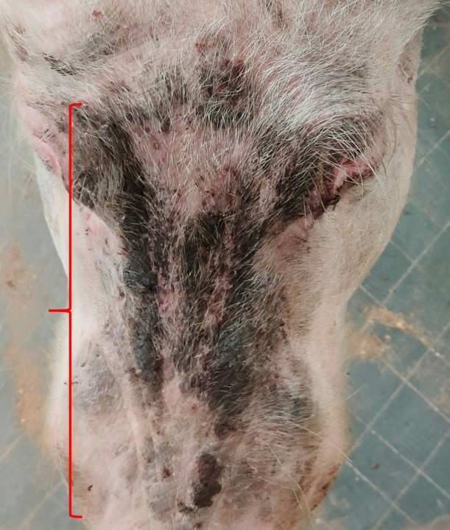 | 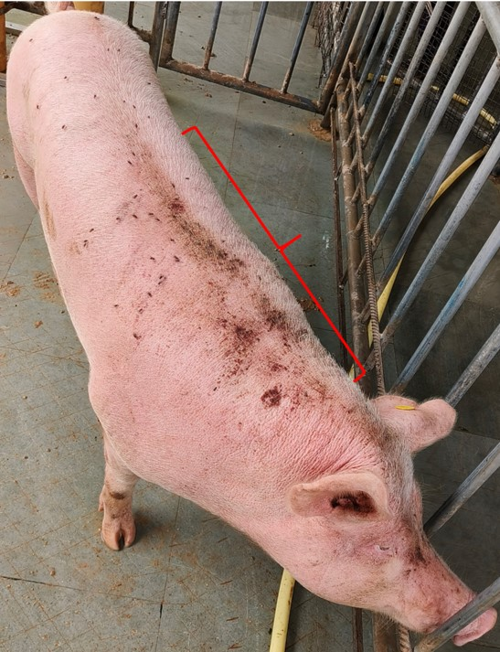
Fig 1a. Forehead region of Large white Yorkshire pig | Fig 1b. Back region of Large white Yorkshire pig

Fig 2. Skin scrapping examination revealing Sarcoptes scabies var. suis (A), Psoroptes spp. (B) mites alongside the eggs (C).
