Phytochemical Characterization of Digitaria ciliaris (Retz.) Koel Stem Extract Through GC–MS Analysis

ABSTRACT
A complete GC-MS-based analysis that focuses on the phytochemical profiling of Digitaria ciliaris stem extracts is still largely unexplored, despite earlier research that used various solvents and analytical techniques to investigate the phytochemical profile and medicinal qualities of the extracts. The purpose of this study was aimed to examine the phytochemical composition of the methanol extract of Digitaria ciliaris (Retz.) Koel stem. Digitaria ciliaris, also referred to as summer grass or Southern crabgrass, has long been prized for its therapeutic qualities, especially its anti-inflammatory and anti-diabetic actions using GC-MS analysis. The phytochemical components found in the methanol extract of Digitaria ciliaris stems were identified and characterized using Gas Chromatography-Mass Spectrometry (GC-MS). The extraction procedure was conducted in a controlled environment to assure the highest possible yield of bioactive components. Electron ionization (EI) mode was used to record the mass spectra, and retention times and spectral data were compared to entries in the NIST Mass Spectral Library. The phytochemical components found in the stem methanol extract of Digitaria ciliaris were accurately and consistently identified due to this exacting analytical method. A varied profile with 59 unique chemicals was found by GC-MS analysis, which 4-Vinylphenol (25.92%) being the most abundant, followed by n-Hexadecanoic acid (11.26%) and gamma- Sitosterol (5.55%). Other notable compounds included Stigmasta-3,5-dien-7-one (4.34%), and Pthalic acid, di(2-methoxybenzyl) ester (4.15%), Stigmasta-5,22-dien-3-ol, acetate,(3.beta.) (3.78%), gamma-Sitostenone (2.85%), n-Butyl ricinoleate (2.73%), Bicyclo[2.2.1]heptanes,2-chloro-7-[(2-nitrophenyl)thio] (2.51%), 2-Methoxy-4-vinylphenol (2.45%), Campesterol (2.39%), Lanosta-8,24-dien-3-one (2.24%),Cholesta-2,8-dien-6-ol,14-methyl-, acetate(5-alpha, 6-alpha) (1.92%), Benzene, 1-chloro-4-methoxy- (1.82%),13-Docosenamide,(Z)- (1.69%) and 4-Campestene-3-one (1.44%). The chemicals that were discovered point to a variety of pharmacological actions, including antibacterial, anti-inflammatory, and anti-diabetic properties. In order to isolate these bioactive chemicals and assess their individual and combined effects in a variety of biological models, more study is necessary. This thorough phytochemical analysis highlights the medicinal potential of Digitaria ciliaris stem extract. These findings support the potential use of Digitaria ciliaris in pharmaceutical and nutraceutical applications and advance our understanding of its therapeutic characteristics. Future research should focus on isolating these different compounds and investigating their specific biological roles, as well as any potential synergistic effects. This could lead to the development of novel therapeutic compounds derived from Digitaria ciliaris stems.

Keywords: Digitaria ciliaris, GC-MS analysis, phytochemical profiling, methanolic extract, medicinal properties, bioactive compounds.
INTRODUCTION
Grasses constitute one of the most ecologically and economically significant plant groups on Earth, forming the backbone of grassland ecosystems and supporting diverse trophic networks. They are essential components of grasslands, pastures, and agricultural landscapes, contributing to soil stability, carbon sequestration, and nutrient cycling . Beyond their ecological services, grasses provide a primary source of fodder for livestock and wild herbivores, sustaining the productivity of animal husbandry and the survival of wild populations (Sapunyo ety al., 2023; Langbang & Kumar, 2025). Digitaria ciliaris (Retz) Koel is an annual grass belonging to the Poaceae family that is referred to as summer grass or Southern crabgrass (Silva et.al., 2024). It grows in tropical and subtropical climates and is frequently found in disturbed areas, roadsides, and agricultural fields (Jones et.al., 2021), Because of its alleged anti-inflammatory and anti-diabetic qualities, it has historically been appreciated in herbal therapy (Gebashe et.al.,2020). Investigating the phytochemical composition of medicinal plants is essential to identifying their bioactive compounds and learning more about their potential therapeutic uses. Compared to other analytical techniques used for phytochemical profiling, gas chromatography-mass spectrometry (GC-MS) is a powerful tool for detecting and measuring a wide range of chemical components in plant extracts (Jangra et al., 2025).
To identify the bioactive molecules in medicinal plants and gain insight into their possible therapeutic applications, it is crucial to investigate their phytochemical contents. Gas Chromatography-Mass Spectrometry (GC-MS) is a potent approach for identifying and measuring a broad spectrum of chemical components in plant extracts, when compared to other analytical methods used for phytochemical profiling (Asmaey, 2024).
Digitaria ciliaris's extensive phytochemical profile, which consists of terpenoids, alkaloids, flavonoids, and phenolic chemicals, is principally responsible for its therapeutic potential. These bioactive ingredients have a wide range of pharmacological characteristics, including anti-inflammatory, anti-cancer, anti-microbial, and antioxidant activities. Some Digitaria species were proven to possess antimicrobial and antioxidant activities (Kalaiyarasu et.al., 2016).
A complete GC-MS-based analysis that focuses on the phytochemical profiling of Digitaria ciliaris stem extracts is still largely unexplored, despite earlier research that used various solvents and analytical techniques to investigate the phytochemical profile and medicinal qualities of the extracts.
The purpose of this work is to close this gap by characterising the phytochemical components in the methanol extract of Digitaria ciliaris (Retz) Koel stem using GC-MS analysis. We want to determine the chemical composition underlying its therapeutic qualities by identifying and measuring the bioactive components. This study may help us better understand the medicinal benefits of Digitaria ciliaris stem extract and support its possible uses in the nutraceutical and pharmaceutical industries.
MATERIALS AND METHODS
Collection and Identification of Plant Material
Digitaria ciliaris (Retz) Koel stems were collected from Kharawar village in the Indian state of Haryana's District Rohtak. At the National Bureau of Plant Genetic Resource Pusa Campus in New Delhi, the plant sample was subsequently identified. Only mature and healthy stems were hand-selected to ensure minimal contamination and damage.
Preparing a Plant Extract
To get rid of any surface contaminants, the collected Digitaria ciliaris stems were first carefully cleaned with distilled water. After being cleaned and allowed to air dry at room temperature, the stems were mechanically ground into a fine powder. A Soxhlet device, which was selected for its effectiveness in extracting a wide range of phytochemicals, was used to extract methanol from this material. The extraction procedure was conducted in a controlled environment to assure the highest possible yield of bioactive components. A concentrated plant extract was then obtained by filtering the resultant methanol extract and using a rotary evaporator to remove the solvent under lower pressure.
GC-MS Examination of Phytochemical Substances
In this investigation, the phytochemical components found in the methanol extract of Digitaria ciliaris stems were identified and characterised using Gas Chromatography-Mass Spectrometry (GC-MS). The extract was diluted in methanol prior to analysis in order to achieve the proper injection concentration. In accordance with recognised protocols, the GC-MS system was set up with particular parameters, such as detector settings, temperature programming, and column type, to guarantee the best possible separation and detection of the substances (Leffingwell et.al.,2015). To obtain distinct component resolution, chromatographic settings were meticulously adjusted. Electron ionization (EI) mode was used to record the mass spectra, and retention times and spectral data were compared to entries in the NIST Mass Spectral Library (NIST Mass Spectrometry Data Center, 2023) and other standard references in order to identify the molecule (Adams and Sparkman, 2007). The phytochemical components found in the stem methanol extract of Digitaria ciliaris were accurately and consistently identified due to this exacting analytical method.
RESULT AND DISCUSSION
The presence of several classes of volatile phytochemical substances was verified by the GC-MS analysis of Digitaria ciliaris stem methanolic extract. The stem extract included 59 different chemicals. Based on their high peak area percentages, retention time (RT), molecular weights, and molecular formulae, 16 well-known bioactive chemicals were chosen from this group. Table 1 and Figure 1 provide a summary and illustration of the specifics of these discovered bioactive compounds.
The predominant compound identified in the extract was 4-Vinylphenol, comprising 25.92% of the total peak area. This was followed by n-Hexadecanoic acid, which accounted for 11.26%, and gamma-Sitosterol, contributing 5.55% of the total extract composition. Other notable compounds included Stigmasta-3,5-dien-7-one (4.34%), and Pthalic acid, di(2-methoxybenzyl) ester (4.15%). Several compounds were present in smaller quantities, such as Stigmasta-5,22-dien-3-ol,acetate,(3.beta.) (3.78%), gamma-Sitostenone (2.85%), n-Butyl ricinoleate (2.73%), Bicyclo[2.2.1]heptanes,2-chloro-7-[(2-nitrophenyl)thio] (2.51%), 2-Methoxy-4-vinylphenol (2.45%), Campesterol (2.39%), Lanosta-8,24-dien-3-one (2.24%), Cholesta-2,8-dien-6-ol,14-methyl-,acetate(5-alpha, 6-alpha) (1.92%), Benzene, 1-chloro-4-methoxy- (1.82%), 13-Docosenamide,(Z)- (1.69%) and 4-Campestene-3-one (1.44%).
Table.1. GC-MS spectral analysis of methanolic extract of Digitaria ciliaris stem
 | RT(Min) | Name of the compound | Peak  Area % | Molecular  Weight | Molecular  Formula
  No.
1. | 15.430 | 4-Vinylphenol | 25.92% | 120 | C₈H₈O
2. | 33.102 | n-Hexadecanoic acid | 11.26% | 256 | C₁₆H₃₂O₂
3. | 54.586 | gamma- Sitosterol | 5.55% | 414 | C₂₉H₅₀O
4. | 56.070 | Stigmasta-3,5-dien-7-one | 4.34% | 410 | C₃₉H₄₆O
5. | 28.792 | Pthalic acid, di(2-methoxybenzyl) ester | 4.15% | 406 | C₂₄H₂₂O₆
6. | 51.180 | Stigmasta-5,22-dien-3-ol,acetate,(3.beta.) | 3.78% | 454 | C₃₁H₅₀O₂
7. | 56.720 | gamma-Sitostenone | 2.85% | 412 | C₂₉H₄₈O
8. | 62.808 | n-Butyl ricinoleate | 2.73% | 354 | C₂₂H₄₂O₃
9. | 28.730 | Bicyclo[2.2.1]heptanes,2-chloro-7-[(2-nitrophenyl)thio] | 2.51% | 283 | C₁₃H₁₄ClNO₂S
10. | 17.320 | 2-Methoxy-4-vinylphenol | 2.45% | 150 | C₉H₁₀O₂
11. | 53.530 | Campesterol | 2.39% | 400 | C₂₈H₄₈O
12. | 57.440 | Lanosta-8,24-dien-3-one | 2.24% | 424 | C₃₀H₄₈O
13. | 49.990 | Cholesta-2,8-dien-6-ol,14-methyl-,acetate(5-alpha, 6-alpha) | 1.92% | 440 | C₃₀H₄₈O₂
14. | 12.837 | Benzene, 1-chloro-4-methoxy- | 1.82% | 142 | C₇H₁₂ClO
15. | 47.095 | 13-Docosenamide,(Z)- | 1.69% | 337 | C₂₂H₄₃NO
16. | 35.753 | 4-Campestene-3-one | 1.44% | 398 | C₂₈H₄₆O

The methanolic extract of Digitaria ciliaris stem contains a variety of bioactive chemicals, according to the GC-MS study. Of them, 4-vinylphenol's high content indicates that it might be crucial to the extract's biological action. Notably, 4-vinylphenol has been shown to reduce cancer stem cell (CSC) characteristics in breast cancer cells that are enriched in CSCs and to prevent metastasis. This chemical has great potential as a therapeutic agent for the treatment of breast cancer because traditional medicines frequently fail to eradicate CSCs (Leung et.al.,2018). Its potential therapeutic significance is highlighted by its presence in the extract as well as its well-established anti-angiogenic and anti-tumour activities (Ravi and Krishnan, 2017).
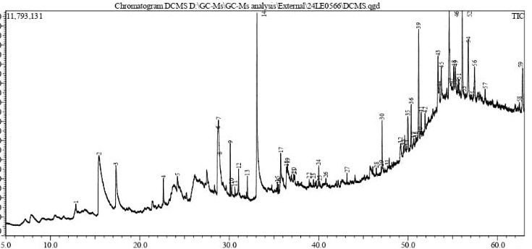
Fig.1. GC-MS chromatogram for methanolic extract of Digitaria ciliaris stem.
Complex bioactive compounds including gamma-Sitosterol are present in the extract, which highlights its potential for a range of medicinal uses. Gamma-Sitosterol is a prospective candidate for the creation of potent antidiabetic medications because of its noteworthy antidiabetic qualities. Furthermore, research has demonstrated that gamma-sitosterol may affect the expression and activity of important elements in the extrinsic apoptotic cascade in human lung and breast cancer cells (Tripathi et.al., 2013), underscoring its possible application in cancer treatment.
The primary psychopharmacological activity (i.e., antibacterial) of Stigmasta-3,5-Dien-7-one confirms the plant's effectiveness as a potent psychopharmacological agent (Kalita et.al,2018). Campesterol demonstrated anti-inflammatory properties.

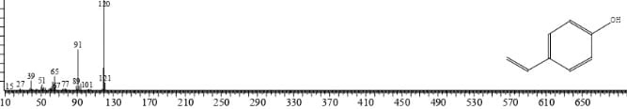
(4- Vinylphenol)
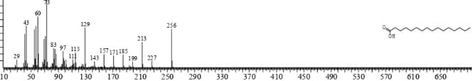
(n- Hexadeconoic acid)
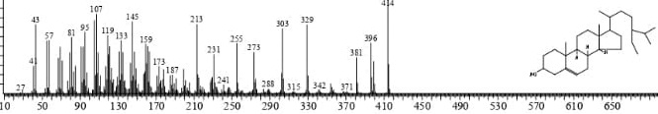
(gemma- Sitosterol)
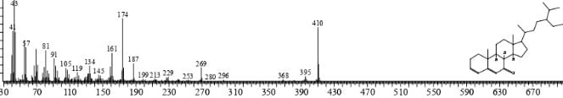
(Stigmasta-3,5-dien-7-one)
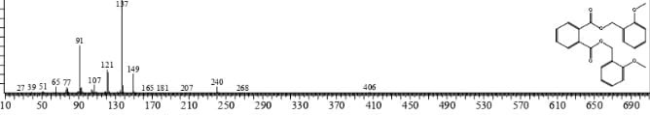
(Pthalic acid, di(2-methoxybenzyl) ester)
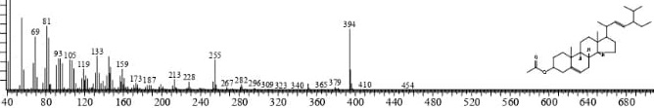
(Stigmasta-5,22-dien-3-ol,acetate,(3.beta.))
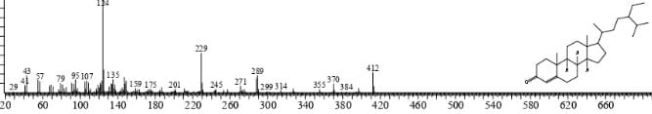
(gamma-Sitostenone)
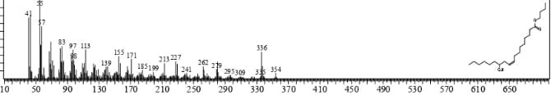
(n-Butyl ricinoleate)
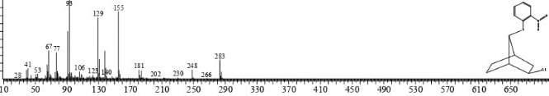
(Bicyclo[2.2.1]heptanes,2-chloro-7-[(2-nitrophenyl)thio])

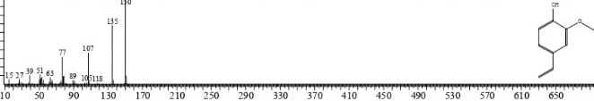
(2-Methoxy-4-vinylphenol)

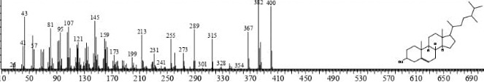
(Campesterol)
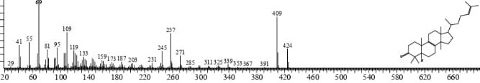
(Lanosta-8,24-dien-3-one)
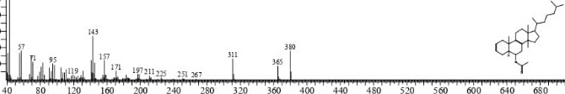
(Cholesta-2,8-dien-6-ol,14-methyl-,acetate(5-alpha, 6-alpha))

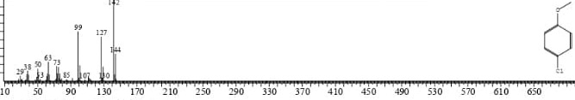
(Benzene, 1-chloro-4-methoxy)
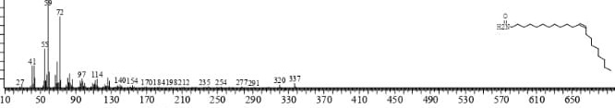
(13-Docosenamide,(Z)-)
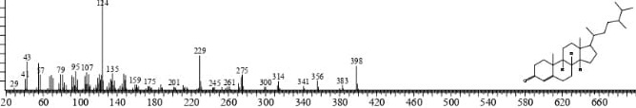
(4-Campestene-3-one)
Fig.2. Mass spectra of identified compound from methanolic extract of Digitaria ciliaris stem
Lanosta-8,24-dien-3-one compound includes a triterpenoid which has an anti-inflammatory function (Sudaryadi et.al.,2023). An appealing prospective medication for the treatment of pancreatic cancer is 2-Methoxy-4-vinyl phenol (2M4VP), a member of the phenol class, which has been shown to have anti-inflammatory and cell cycle-arresting effects (Kim et al.,2019).
In conclusion, a range of chemicals with noteworthy biological activities are present in the methanolic extract of Digitaria ciliaris stem. A wider range of pharmacological effects is suggested by the presence of complex molecules such as derivatives of steroids, while the high percentage of bioactive chemicals predicts significant antibacterial and anti-inflammatory potentials. Isolating these chemicals and assessing their individual and combined effects in diverse biological models requires more research.
CONCLUSION
A rich and varied composition of bioactive chemicals was found in the methanolic extract of Digitaria ciliaris stem, as determined by GC-MS analysis, which identified 16 different components. The most abundant compound was 4-Vinylphenol, which representing 25.92% of the total peak area, followed by n-Hexadecanoic acid (11.26%) and gamma- Sitosterol (5.55%).The presence of complex molecules such as 2-Methoxy-4-vinyl phenol, Lanosta-8,24-dien-3-one and gamma- Sitosterol suggests anti-inflammatory, anti-diabetic activities and anti-cancerous activities. Compounds like Campesterol and 4-Campestene-3-one add to the therapeutic potential of the extract due to their unique biochemical roles.
The identification of these numerous compounds supports the traditional use of Digitaria ciliaris in herbal medicine by indicating that the methanolic extract of the stem may have a range of pharmacological effects. Future research should focus on isolating these different compounds and investigating their specific biological roles, as well as any potential synergistic effects. This could lead to the development of novel therapeutic compounds derived from Digitaria ciliaris stems.

Disclaimer (Artificial intelligence)
Author(s) hereby declare that NO generative AI technologies such as Large Language Models (ChatGPT, COPILOT, etc.) and text-to-image generators have been used during the writing or editing of this manuscript.

REFERENCES
- W.C.da Silva, F.M.Feijó, S.P.Tironi, R.C.de Souza, Effects of water and nutrient on the growth of Digitaria nuda obtained from areas without reported herbicide resistance. Acta Physiologiae Plantarum, 2024, 46(10), 87.
- E.A.L.Jones, D.J.Contreras, W.J.Everman, Digitaria ciliaris, Digitaria ischaemum, and Digitaria sanguinalis. In Biology and management of problematic crop weed species (pp. 173-195), 2021, Academic Press.
- F.Gebashe, A.O.Aremu, J.Gruz, J.F.Finnie, J.Van Staden, Phytochemical profiles and antioxidant activity of grasses used in South African traditional medicine. Plants, 2020, 9(3), 371.
- M. A. Asmaey, Utilizing GC‒MS and UPLC‒MS for rapid metabolomic analysis in medicinal plants. In Propagation to Pharmacopeia ,2024, (pp. 361-378). CRC Press.
- T.Kalaiyarasu, N.Karthi, G.V.Sharmila, V.Manju, In Vitro assesment of antioxidant and antibacterial activity of green synthesized silver nanoparticles from Digitaria radicosa leaves. Asian J Pharm Clin Res. 9. 2016. 297-302
- J.C.Leffingwell, E.D. Alford, D.Leffingwell, Identification of the volatile constituents of raw pumpkin (Cucurbita pepo L.) by dynamic headspace analyses, 2015, Leffingwell Rep, 7(1-14), 293-301.
- NIST Mass Spectrometry Data Center (2023) NIST Chemistry Web Book, NIST Standard Reference Database Number 69. Retrieved from http://webbook.nist.gov.
- R.P.Adams, O.D. Sparkman, Review of identification of essential oil components by gas chromatography/mass spectrometry. J. Am. Soc. Mass Spectrom, 2007, 18(4), 803-806.
- H.W.Leung, C.H.Ko, G.G.L. Yue, I. Herr, C.B.S.Lau, The natural agent 4-vinylphenol targets metastasis and stemness features in breast cancer stem-like cells, Cancer chemotherapy and pharmacology, 2018, 82, 185-197
- L.Ravi & K.Krishnan, Research article cytotoxic potential of N-hexadecanoic acid extracted from Kigelia pinnata leaves. Asian J. Cell Biol, 2017, 12, 20-27.
- N.Tripathi, S.Kumar, R.Singh, C. J.Singh, P.Singh & V.K.Varshney, Isolation and Identification of γ-Sitosterol by GC-MS from the Leaves of (Decne). The Open Bioactive Compounds Journal, 2013, 4(1).
- B.C.Kalita, D.D.Gupta, A.K.Das, P.K.Hui, H.Tag, Research Article Journal of Basic and Applied Plant Sciences Open Access, 2018.
- I.Sudaryadi, F.Oktaweni, I.E.Pramono, K.W.Fatikasary, H.Widiawati, Bioactive compound profile of propolis product from Beekeeping (Meliponiculture) in Turi Yogyakarta Indonesia. In IOP Conference Series: Earth and Environmental Science ,2023, June, (Vol. 1200, No. 1, p. 012002). IOP Publishing.
- D.A.H.Kim, S.I. Han, B.Go, U.H.Oh, C.S.Kim, Y.H. Jung, J.Lee, J.H.Kim, 2-methoxy-4-vinylphenol attenuates migration of human pancreatic cancer cells via blockade of fak and akt signaling. Anticancer research, 2019, 39(12), 6685-6691
- Langbang, A., & Kumar, S. 2025. Phytochemical profiling and antimicrobial evaluation of Digitaria ciliaris (Retz.) Koeler (Poaceae). GRASSES, 33. In book: Grass & Sedges of India: Food, Medicinal & Ecological Aspects (pp.33-40) Publisher: Ambika Prasad Research Foundation
- Jangra, S., Kumar, M., & Sharma, A. (2025). Phytochemical Characterization of Digitaria horizontalis Willd leaf and stem extracts using GC-MS Analysis. Indian J. Applied & Pure Bio. Vol, 40(3), 2304-2311.
- Sapunyo, W. L., Mbaria, J. M., Kanja, L. W., Omolo, M. J., & Onyancha, J. M. (2023). Phytochemical screening, toxic effects, and antimicrobial activity studies of Digitaria abyssinica (hochst. Ex A. Rich.) Stapf (Poaceae) Rhizome extracts against selected Uropathogenic microorganisms. Evidence‐Based Complementary and Alternative Medicine, 2023(1), 4552095.

