Review Article
Artificial Intelligence Technologies and Applications in Food Safety and Quality Control in Ghana: A Narrative Review

ABSTRACT
Food safety and quality remain major public health and economic concerns in developing countries such as Ghana, where microbial contamination, chemical hazards, and food fraud persist across food supply chains. The increasing complexity of modern food systems has intensified the need for innovative, efficient, and scalable monitoring approaches. Artificial intelligence (AI) has emerged as a transformative tool capable of enhancing food safety and quality control through data-driven, real-time, and non-destructive assessment techniques. This narrative critical review synthesizes existing literature on the application of AI technologies—particularly machine learning and computer vision—in addressing food safety and quality challenges in Ghana. Machine learning models are increasingly applied for contaminant detection, risk prediction, and supply chain optimization, while computer vision systems enable automated food fraud detection, quality grading, and defect identification in agricultural products. The review also examines the integration of AI with complementary technologies such as blockchain and the Internet of Things to strengthen traceability and transparency across food systems. Despite their demonstrated potential, the adoption of AI technologies in Ghana remains constrained by key challenges, including infrastructure limitations, high implementation costs, limited technical expertise, and sociocultural barriers. Future research should prioritize low-cost, scalable machine learning and computer vision solutions tailored to informal food systems and high-risk commodities in low- and middle-income countries. Overall, this review bridges the gap between technological innovation and practical implementation, offering insights relevant to strengthening food safety systems in Ghana and comparable resource-constrained settings.
KEYWORDS: Food safety; Artificial intelligence; Machine learning; Food fraud; Traceability; Ghana

Graphical abstract
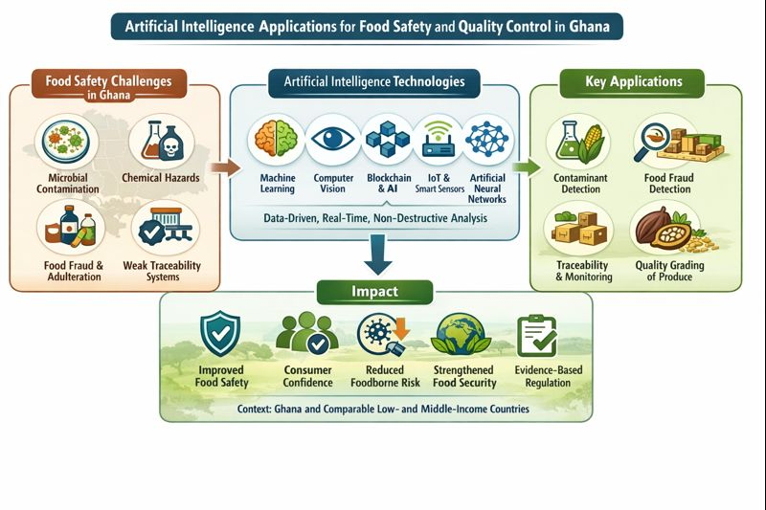

INTRODUCTION
Food is essential for human survival, and the global population has been steadily increasing throughout history. By 2050, it is projected that 70% of the world’s population will live in urban areas, resulting in a total population of around 10 billion. To meet the needs of this growing populace, we will require an additional 70% increase in food production. Moreover, it is important to recognize that agriculture currently accounts for 70% of total freshwater usage on Earth. (Tripathi et al.,2019)
Food safety and quality standards are a critical concern that affects individuals, communities, and nations worldwide. This is becoming more important in today’s world because more people are concerned about what they consume, leading to increased scrutiny of food production, processing, and distribution processes. Food safety refers to the assurance that food will not cause adverse health effects to the consumer when it is prepared and eaten according to its intended use. It includes freedom from environmental contaminants and substances injurious to health, while food quality encompasses characteristics related to appearance, sensory attributes, nutritional value, and wholesomeness.
. It is characterized by external attributes like appearance, defects, and feel, internal attributes like odour, taste, and texture, and hidden attributes like nutritive value and wholesomeness.
The World Health Organization (WHO) estimated that approximately 600 million cases of foodborne illnesses occur annually, resulting in 420,000 deaths, with a disproportionate burden on low- and middle-income countries, including those in West Africa. These issues contribute to the spread of unsafe food products, which are linked to over 200 diseases caused by bacteria, viruses, parasites, or harmful chemical substances. (World Food Safety Day Spotlights Global Health Threat,2022) . Incidents involving food safety and quality around the world have shown weaknesses in food supply chains and production.
In 2013, Europe faced a significant food scandal when horse meat was discovered in products labelled as beef, affecting numerous retailers and food producers across the continent. (Madichie & Yamoah, 2017). China encountered issues due to the discovery of melamine in newborn milk powder in 2008 (Xiu & Klein, 2010), and clenbuterol, a veterinary medication, was discovered to be excessively utilized in animal food production in 2011(Xue & Zhang, 2013). In recent years, South Korea has encountered several food-related scandals: lead was detected in crab in 2000, parasites were discovered in kimchi in 2005, and in 2010, a snack produced by a renowned food company contained parts of rat carcasses(Yang & Yang, 2013). Taiwan encountered notable instances of food adulteration, such as plasticizer additives, maleic anhydride starch products, copper chlorophyll-infused olive oil, recycled cooking oil, and processed soymilk curd from 2011 to 2015. (Peng et al., 2017) Commonly affected food items include meat and meat products, dairy products, fruits and vegetables, fish and fish products, beverages, and confectionery, which are susceptible to contamination by pathogens, chemical adulterants, or mislabelling. (Park et al., 2017). These incidents highlight systemic vulnerabilities in food supply chains and underscore the need for advanced, technology-driven monitoring and detection systems
Ghana faces significant food safety and quality challenges, including microbial contamination and chemical hazards. These issues are closely linked to food fraud, adulteration, and mislabelling, which exacerbate health risks and undermine consumer confidence. Food fraud refers to the deliberate adulteration, substitution, tampering, or mislabelling of food products for economic gain.
In Ghana, common food fraud actions include adulteration, tampering, substitution, and mislabelling. For instance, beverages and juices, fruits and vegetables, spices, oils, meat and fish, baked foods, honey, milk, and semi-processed local foods have been implicated in food fraud cases. Adulteration was identified as the most common food fraud action in a study conducted in Tamale, Ghana. (Lawal et al., 2023). Figure 1 illustrates the predominant food commodities commonly implicated in food fraud research, highlighting high-risk product categories relevant to the Ghanaian context.
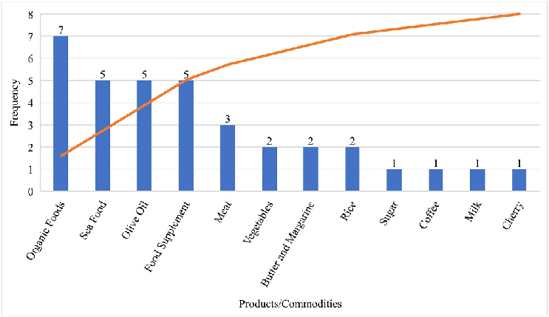

Fig 1: Predominant commodities in food fraud research (Kwasi Bannor et al., 2023)
Leveraging rapid detection technologies and artificial intelligence can significantly enhance the ability to identify and prevent food fraud, adulteration, and mislabelling, ensuring a more transparent and secure food supply chain. The application of artificial intelligence (AI) in food safety and quality control has emerged as a transformative solution to address longstanding challenges in ensuring food security and consumer health.(Liu et al., 2023). AI has transformed traditional methods to analyse vast datasets, predict potential risks, and optimize processes across the food supply chain, offering improved efficiency, precision, and real-time decision-making capabilities.
In the food industry, artificial intelligence (AI) is frequently combined with external sensors for real-time detection. These sensors include near infrared spectroscopy (NIRS), computer vision systems (CVS), electronic nose (E-nose), electronic tongue (E-tongue), and machine learning (ML). This allows for real-time detection and faster, more accurate results. Over the past few years, the food sectors have demonstrated a number of ways to integrate these sensors with artificial intelligence techniques (Kumar, 2023). Figure 2 presents the major artificial intelligence technologies currently adopted in the food industry for safety and quality control applications.

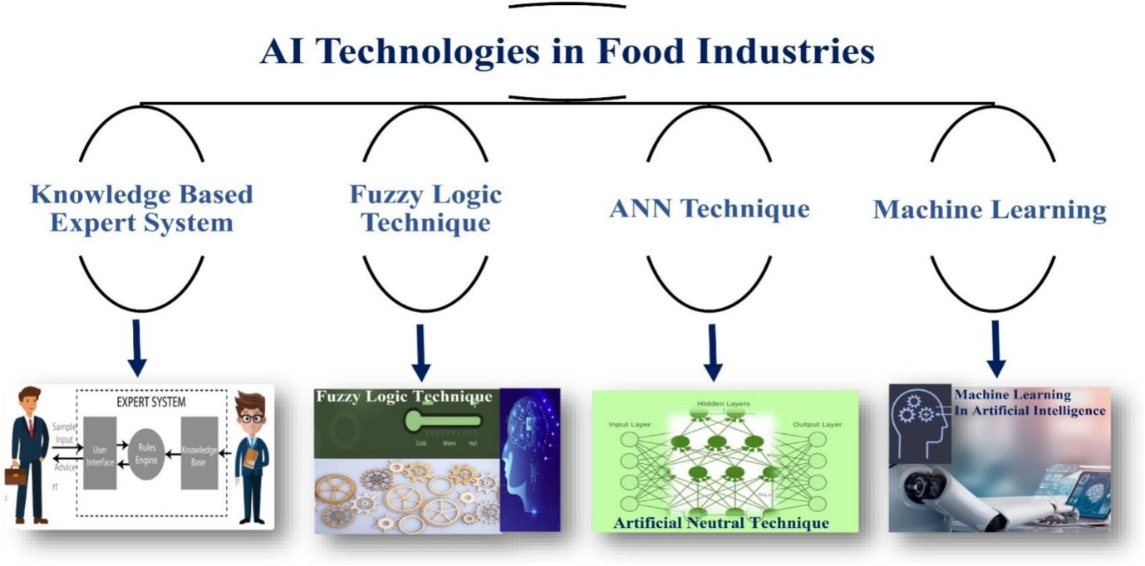
Fig. 2 Common AI technologies adopted by the food industry (Zatsu et al., 2024)
This research looks at the various types of artificial intelligence technologies and their application in food safety and quality control in Ghana. It further focuses on the challenges with the adoption of these technologies.
Despite the growing global literature on artificial intelligence applications in food safety, evidence remains fragmented and largely concentrated in high-income settings. This review addresses this gap by synthesizing and contextualizing AI-driven food safety and quality control applications within Ghana, a representative low- and middle-income country. By linking technological capabilities with real-world constraints, the manuscript provides a transferable framework for responsible AI deployment in similar resource-constrained food systems.

2.0 ARTIFICIAL INTELLIGENCE TECHNOLOGIES IN FOOD SAFETY AND QUALITY
Artificial intelligence (AI) has transformed food safety and quality prediction in precision agriculture and food technology. The key obstacles to ensuring food safety and monitoring food item quality and expiration dates include time-consuming examination and sample destruction. The process of ensuring food safety and food quality necessitates quick, precise, and efficient analysis. Given the likelihood of redundant and unneeded data in many datasets, data analysis is critical for determining food safety and quality. (Benefo et al., 2022). The digital revolution revealed artificial intelligence (AI) as a powerful analytical tool for assessing the quality of various food and agricultural products, offering rapid, non-destructive, and cost-effective solutions.(Mohd Ali et al., 2021). Deep learning and machine learning are fundamental artificial intelligence components. (Bresilla et al., 2019). Machine learning and deep learning improved food quality estimation. while addressing post-harvest loss, shelf-life prediction, authenticity, and quality management. Machine learning, particularly artificial neural networks (ANN), is widely used to analyse food product quality.(Stasenko et al., 2023). Table 1 provides a comparative overview of major artificial intelligence techniques applied in food safety and quality control, highlighting their typical applications, key benefits, and main limitations, particularly in low- and middle-income country contexts.
Table 1. Comparison of Artificial Intelligence Techniques Applied in Food Safety and Quality Control
AI Technique | Typical Applications in Food Safety & Quality | Key Benefits | Main Limitations (Especially in LMICs)
Machine Learning (ML) | Contaminant detection, risk prediction, shelf-life estimation, demand forecasting, food fraud analytics | High predictive accuracy; ability to analyze large and complex datasets; supports early warning systems | Requires high-quality and labeled data; limited interpretability; computational and data infrastructure demands
Computer Vision (CV) | Food fraud detection, quality grading, defect identification, adulteration detection, visual inspection | Non-destructive and rapid assessment; real-time monitoring; reduces human error | Sensitive to lighting and image quality; high initial setup cost; limited performance with poor-quality images
Artificial Neural Networks (ANNs) | Pattern recognition, classification, process optimization, quality prediction | High accuracy for complex nonlinear relationships; adaptable to diverse applications | Computationally intensive; “black-box” nature limits interpretability; requires technical expertise
AI + IoT Systems | Real-time monitoring, temperature and humidity tracking, spoilage detection | Continuous data collection; improves traceability and process control | Dependence on reliable connectivity and power supply; maintenance costs
AI + Blockchain | Supply chain traceability, fraud prevention, transparency assurance | Tamper-proof records; enhanced trust and accountability | High implementation cost; regulatory and scalability challenges

The most commonly used AI technology for assessing food quality and ensuring food safety includes artificial neural networks (ANN), computer vision, and machine learning.
Table 2: AI application in food processing
Application | Description | Reference
Food Yield, Quality, and Nutrition Enhancement | AI optimizes food production, ensures high quality, and enhances nutritional content, revolutionizing food processing. | (Ahmadi, A. (2023)
Research in Food Chemistry and Molecular Analysis | AI methods provide insights into food composition and properties, advancing food chemistry and molecular analysis research. | (Tseng et al., 2023)
Predictive Analysis for Operational Efficiency | AI and big data analytics improve operational efficiency and quality through advanced predictive modelling techniques in the food and beverage industry. | (Sharma et al., 2021)
Digitalization and Automation in Food Supply Chains | AI facilitates digitalization and automation, integrating RFID, IoT, and blockchain for enhanced food supply chain efficiency, precision, and traceability. | (Abideen et al., 2021)
Smart Production Control Systems Optimization | AI, machine learning, IoT, and cloud computing combine with intelligent production control systems, optimizing food manufacturing processes. | (Oluyisola et al., 2022)
Food Quality Inspection with Big Data Technologies | AI-driven quality inspection uses big data technologies and high-performance computation, opening new opportunities in the agri-food domain. | (Rejeb et al., 2022)
Addressing Food Insecurity in Vulnerable Populations | AI analyses diet and activity patterns, contributing to targeted interventions for improving food security and nutrition among vulnerable populations, such as American Indians and Alaska Natives | (Mechanick et al., 2019)

2.1 Machine Learning in Food Safety
Machine learning (ML) is an emerging technique demonstrated to effectively integrate diverse data kinds, encompassing both structured and unstructured data. (Geng et al., 2017) relating to the presence of food safety hazards to make predictions about food safety. In machine learning, computers are designed to learn from the input data provided to them.(Alpaydin, 2020). Machine learning models for monitoring and predicting food safety have been employed in many studies.(Bouzembrak & Marvin, 2019). ML algorithms, such as convolutional and recurrent neural networks, are commonly used to analyse unstructured data, such as image and text data, particularly in food safety analysis, as reviewed by Zhou et al, (2019). ML methods, including Bayesian Networks (BN), Neural Networks (NN), Support Vector Machines (SVM), and Decision Trees (DT), along with other combinations of these fundamental models (e.g., Principal Component Analysis [PCA] combined with NN), ensemble models (e.g., Random Forest [RF]), or other derived model types (e.g., Extreme Learning Machine [ELM]), can be employed to evaluate structured data. (Wang, Bouzembrak, et al., 2022)
ML models, such as Bayesian networks, neural networks, and support vector machines, have been employed to monitor and predict the presence of biological, chemical, and physical hazards in food products. (Wang, Bouzembrak, et al., 2022) This indicates that a machine learning model is a promising instrument for tackling the challenges of food safety oversight and forecasting. ML algorithms predict plant growth and yield, optimize energy consumption in food retail refrigeration, and verify food expiration dates, thereby ensuring food quality and safety(Kollia et al., 2021). Also, ML algorithms have been developed to track shelf life and expiration dates, helping to reduce food waste and prevent foodborne illnesses. By correlating sensory observations with spoilage data, these systems provide consumers with accurate information on food freshness (Mamidala, 2023)
The application of machine learning (ML) and artificial intelligence (AI) in food safety and quality management is gaining traction in Ghana, offering innovative solutions to longstanding challenges. In Ghana, where food safety and quality management are critical to public health and economic development, these technologies offer promising solutions to longstanding challenges. ML and AI have demonstrated the ability to predict and monitor food contamination, optimize production processes, and improve compliance with safety regulations. Figure 3 summarizes the key functional roles of machine learning models in food safety and quality management.

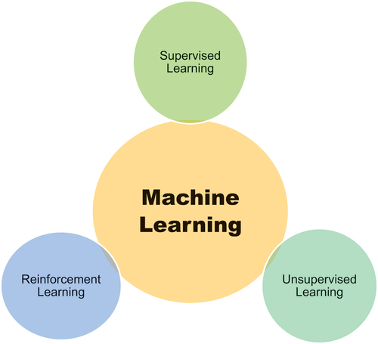
Fig. 3: Machine learning (ML) key roles.(Ikram et al., 2024b)

2.2 Computer Vision Models
Computer vision tries to mirror the human visual system, enabling computers to see, observe, and understand the world through digital images and videos. This capacity extends beyond merely acquiring visual information. It involves interpreting and making decisions based on that data, opening up myriad applications that span from autonomous driving and facial recognition to medical imaging, agri-technology, precision farming, and beyond.(Zhu & Spachos, 2021) It integrates with MVS and utilizes data-intensive methods to achieve high agricultural yields while reducing environmental impact.
In food processing, a machine vision system may collect a variety of information, including the size, weight, shape, texture, and colour of the food, as well as numerous minutiae that the human eye cannot see, with the purpose of monitoring and controlling the process. This prevents human errors due to repetitive effort. (Cubero et al., 2011) . Image processing generates new images to improve ROI characterization, a digital signal processing process. It includes low, intermediate, and high levels, with different levels focusing on different aspects of the image. Figure 4 illustrates the core components of a machine vision system used in food quality inspection and process monitoring.

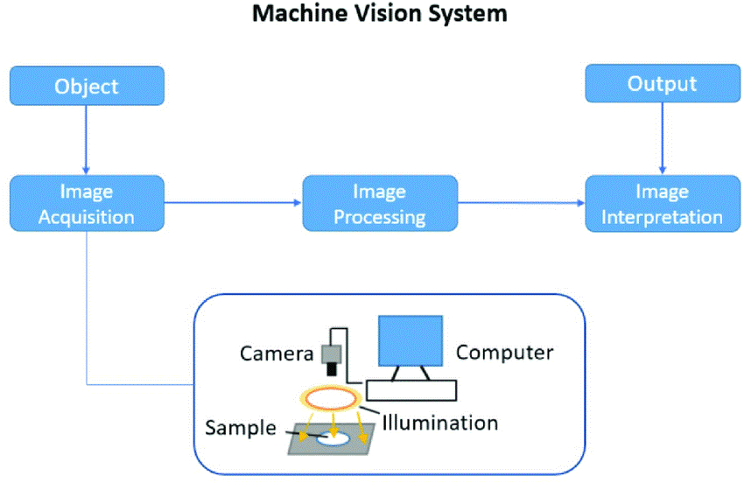
Fig 4: major components of the machine vision system (Zhu et al., 2021)

Computer vision systems play a pivotal role in the detection of defects, including bruises, discoloration, and the presence of foreign materials, as well as the classification of food products. For example, a mobile food grading system employing Support Vector Machine (SVM) and YOLO models has been successfully developed to evaluate banana ripeness and identify peel defects, demonstrating an impressive overall accuracy of 96.4%(Zhu & Spachos, 2021). They have been used for quality assessment, food grading, and process monitoring in food processing.(Udayanga et al., 2023) They assess attributes like colour, size, and shape, detect adulteration, and aid in quality control processes. (Wang, et al., 2022)They also help monitor operations, ensuring safety standards and enhancing efficiency, with deep learning and machine vision techniques being effective in various applications.(Zhu et al., 2021)

2.3 ANN Techniques
The most commonly used AI technology for assessing food quality is the artificial neural network (ANN). An artificial neural network (ANN) is a mathematical model based on nodes or linear or nonlinear processing features. Dębska & Guzowska-Świder (2011) suggested that a connected neural network, where synapses are located at the terminals of each node, facilitates the transmission of electrical signals between neurons through axons. An artificial neural network (ANN) emulates the human brain by encouraging the system to perform internal tasks rather than conventional computational activities. Its fundamental architecture comprises three primary layers: input, hidden, and output. The input layer acquires data from the system and directs it to the hidden layer, which processes the raw information (Ikram et al., 2024a). Subsequently, the processed data is transmitted to the output layer, interconnected through nodes, to generate the final result. The principal benefits of ANN layers include their capacity to predict based on parallel reasoning and to train neural networks efficiently (Prieto et al., 2016). Generally, ANNs can be characterized by a learning approach, a neuron model, and an architecture that defines the interaction patterns between neurons across various layers.
The following examples illustrate the adaptability and effectiveness of artificial neural networks (ANNs) in advancing food safety and quality across diverse applications. A detailed review underscored the application of ANNs in modelling and optimizing various processes within the food industry, highlighting their contribution to enhancing both process efficiency and product quality. (Funes et al., 2015). In one study, convolutional neural networks (CNNs), a subset of ANNs, were utilized to analyse thermal images for detecting adulterated honey, demonstrating high accuracy in ensuring quality. (Boulbarj et al., 2024). Additionally, ANNs have been employed to predict food safety risks by analysing data from the European Union, facilitating proactive management of potential hazards within the food supply chain. Morshed et al, (2022) Implemented a densely connected convolutional neural network to assess fruit quality, achieving an impressive accuracy of 99.67% in classifying fruits based on their quality grades.
3.0 METHODOLOGY
This study adopts a narrative critical review approach to synthesize existing literature on the application of artificial intelligence in food safety and quality control, with emphasis on developing countries and Ghana. A comprehensive literature search was conducted using Scopus, Web of Science, PubMed, ScienceDirect, and Google Scholar.
Search terms included combinations of: “artificial intelligence,” “machine learning,” “computer vision,” “neural networks,” “food safety,” “food quality,” “food fraud,” “traceability,” “supply chain,” “developing countries,” and “Ghana.” Peer-reviewed articles published between 2015 and 2024 were prioritized to capture recent technological developments.
Studies were included if they (i) examined AI-based methods applied to food safety, quality control, or food supply chains, and (ii) provided empirical, review, or policy-relevant insights applicable to low- and middle-income contexts. Articles focusing solely on non-food applications of AI or lacking relevance to safety or quality assurance were excluded. Selected studies were thematically analyzed and synthesized into key application domains relevant to Ghana’s food systems. This review follows a narrative critical synthesis approach and does not involve quantitative meta-analysis.

4.0 APPLICATION OF AI MODELS IN FOOD SAFETY AND QUALITY, GHANA
Food safety and quality remain a critical public health concern in Ghana, where traditional monitoring systems face significant challenges in ensuring consistent quality control across the food supply chain. The integration of AI models presents a promising frontier in revolutionizing food safety management in the country, offering potential solutions for rapid detection of contaminants, predictive analytics for foodborne illness outbreaks, and automated quality assessment systems. (Qian et al., 2023). AI and ML models can scrutinize ingredient information, supply chain records, and consumer feedback to identify patterns and anomalies and detect risky features that indicate potential fraud in the food industry. Not only can AI and ML technology aid in the detection of food fraud, but it can also contribute to prevention efforts. This chapter examines the current landscape of AI applications in Ghana's food safety sector.

4.1 AI in the detection of contaminants
In the Ghanaian context, the detection of food contaminants remains a critical public health priority. The identification and quantification of foodborne pathogens and contaminants are vital to ensuring food safety. The application of AI techniques, such as machine learning, image recognition, and predictive modelling, has shown immense potential in detecting contaminants in food systems. These contaminants include aflatoxins, mycotoxins, adulterant and residues. These toxic compounds are cancer-causing, teratogenic, and mutagenic and pose a serious threat to the health of humans. Studies have shown that a substantial percentage of maize and groundnut samples in Ghana are contaminated with aflatoxins, with some exceeding the regulatory limits set by the Ghana Standards Authority(Agbetiameh et al., 2018).
Machine learning algorithms, such as Classification and Regression Trees (CART), have been employed to assess safety knowledge and awareness among market women in the Greater Accra Region. (Kyei-Baffour et al., 2023). Teye et al. (2024), Feasibility study on the use of smartphone images coupled with multivariate algorithms" explores the application of AI in assessing honey authenticity in Ghana. The study used smartphone-acquired honey images and multivariate algorithms to detect honey adulteration patterns, using machine learning techniques to distinguish pure and adulterated honey. A study by MacArthur et al. (2020) employed shortwave handheld spectroscopy combined with chemometric modelling to detect the adulteration of palm oil with Sudan IV dye. They compared various models, including partial least squares (PLS) regression and support vector machines (SVM), to determine the most effective approach. The findings indicated that the SVM model outperformed others, achieving higher accuracy in identifying adulterated samples. This research underscores the potential of integrating handheld spectroscopic devices with advanced chemometric techniques for rapid, non-destructive detection of food adulteration, offering a practical solution for quality assurance in the food industry.

4.2 AI in Traceability and Monitoring
Within Ghana’s food supply chains, traceability and monitoring remain essential for ensuring food safety and consumer confidence.
As food systems become increasingly complex, ensuring traceability and maintaining quality standards have become essential for food security and public health (Kumperščak et al., 2019). AI technologies such as machine learning, blockchain, and sensor integration have been applied to improve transparency and efficiency across the supply chain. For instance, blockchain-powered AI systems enable the tracking of food products from farm to fork, ensuring that every stage of the supply chain complies with safety and quality standards. (Temilade Abass et al., 2024). Similarly, AI-driven predictive analytics help in identifying potential contamination risks and mitigating them before they escalate.
Hefft & Adetunji, (2023) explored the role of AI in detecting food fraud and improving traceability within the supply chain, ensuring product authenticity and safety. AI models coupled with blockchain technology ensure transparency and traceability in food supply chains, especially for exports like cocoa and cashew (Musah et al., 2019). The integration of AI-based packaging technologies, such as RFID, barcoding, and QR codes, significantly enhances the security and traceability of packaged foods. These methods help detect and prevent food fraud by ensuring that products are accurately tracked from manufacturing to the end consumer. (Frank Abimbola et al., 2023). The study by Tang et al. (2024) evaluates the feasibility of implementing blockchain and Internet of Things (IoT) technologies to enhance food traceability within African agricultural supply chains, with a particular focus on Ghana. The authors identify significant potential for these technologies to improve food safety and transparency.
4.3 AI in food quality management and Grading
In Ghana, artificial intelligence is increasingly applied to food quality management and the grading of agricultural produce.
Artificial intelligence (AI) has transformed food quality prediction in precision agriculture and food technology. The key obstacles to monitoring food item quality and expiration dates include time-consuming examination and sample destruction.
Machine learning algorithms, computer vision systems, and neural networks are applied to assess and grade agricultural produce such as cocoa, cashew, and other staple crops. (Aran et al., 2016). These systems employ various techniques, including image segmentation, machine learning, and morphological feature analysis, to assess crop characteristics such as size, colour, and surface texture.(Shandookh et al., 2022). Recent studies by Çınarer et al. (2024) demonstrated high accuracy rates in crop classification, with some methods achieving up to 99% accuracy. AI enhances food safety by creating a more transparent supply chain management system. By optimizing delivery routes and ensuring efficient distribution of fresh meals, AI helps maintain food quality and safety standards.(Ikram et al., 2024)
A study conducted by Nogales et al.(2022) investigated the application of AI in mitigating risks associated with extreme weather events in the cocoa supply chain. The authors employ a resource-based view framework to analyse how AI technologies can enhance the resilience of cocoa supply chains by improving risk management practices. Their findings suggest that AI can effectively identify and manage risks arising from extreme weather conditions, thereby contributing to the sustainability and stability of the cocoa industry.
AI, in conjunction with big data and the Internet of Things (IoT), develops early warning systems and identifies emerging food safety risks. Mu et al. (2024) discussed how AI technologies, particularly machine learning algorithms, are utilized to analyse real-time, diverse data streams, enabling proactive detection and mitigation of potential hazards. The review underscores the necessity of integrating AI into food safety management to improve resilience against risks, especially in the context of climate change and global food supply chain complexities.
4.4 AI in food supply chain optimization
AI-driven optimization of food supply chains is particularly relevant in Ghana, where logistical inefficiencies contribute to food quality losses. Artificial intelligence (AI) is crucial in improving delivery and optimizing operations in the food supply chain, as seen in Table 2. Incorporating AI technologies such as RFID and the Internet of Things (IoT) has enhanced the effectiveness and productivity of food supply chains ( Maulana, H. et al., 2021)AI significantly affects the halal status of food items across the supply chain by implementing procedures to avoid and safeguard against any compromise of integrity (Díaz-Rodríguez et al., Citation2023). In addition, artificial intelligence (AI) can enhance supply chain operations by addressing product quality and cost concerns. This, in turn, impacts pricing and coordination mechanisms, ultimately leading to improved supply chain profitability (Belhadi et al., Citation2024)
Table 3: AI in supply chain optimization
Application | Description | Reference
Demand Forecasting | AI can accurately evaluate past data, customer behaviour, and market trends to estimate demand, improving production and inventory control. | (Javaid et al., 2023)
Inventory Management | AI algorithms can optimize inventory levels by considering demand variations, shelf life, and seasonality. This reduces waste and increases efficiency. | (Díaz-Rodríguez et al., 2023)
Supply Chain Coordination | AI technologies can facilitate better coordination among various stakeholders in the supply chain, leading to improved communication, collaboration, and overall efficiency. | (Modgil et al., 2022)
Quality and Transportation Optimization | Artificial intelligence (AI) can minimize expenses while preserving quality by optimizing transportation routes and circumstances to guarantee the quality of fresh food goods throughout transit. | (Jagtap et al., 2020)
Risk Management | AI can assess a range of supply chain risk indicators, including interruptions, quality problems, and market volatility, to facilitate proactive risk mitigation plans. | (Aljohani, 2023)
Sustainability Management | AI can be used to enhance sustainability management in the design of the food supply chain, allowing for the adoption of sustainable practices. | (DiVaio et al., 2020)
5.0. Challenges to the adoption of artificial intelligence technology in the food industry
Integrating artificial intelligence (AI) into food safety and quality control represents a significant advancement in enhancing food security and public health, despite certain challenges. AI technology can streamline the monitoring of food safety standards, allowing for quicker detection of contaminants and more efficient tracking of supply chains.(Gbashi & Njobeh, 2024). One important consideration is the high initial cost of AI deployment, which may limit access for smaller businesses.(Tishtykbayeva et al., 2023). However, as technology evolves and becomes more affordable, innovative solutions are likely to emerge for companies of all sizes.
Cultural challenges, including concerns about job displacement and misuse of AI is another challenge in the adoption of AI. This displacement comes with fear. Concerns include fears of job displacement and the potential misuse or manipulation of AI technologies in the future (Hammerkopf, 2019).
One significant impediment to the effective implementation of AI in developing countries lies in infrastructure limitations. Reliable access to high-speed internet, robust computing resources, and advanced data storage facilities are often prerequisites for optimal performance. AI deployment. However, many developing regions face infrastructural challenges, hindering the seamless integration of AI technologies.(Adebayo Olusegun Aderibigbe et al., 2023; Barsha & Munshi, 2024). Insufficient connectivity and inadequate power supply can impede the real-time processing demands of AI applications, creating a digital divide between regions with and without adequate infrastructure.
Almgerbi et al., (2022) stated that the growing demand for specialized skills in data analysis presents an opportunity for companies to invest in training programs. Additionally, increased transparency and consumer involvement in decision-making can foster trust and loyalty. By embracing a culture of openness regarding AI, companies can strengthen consumer relationships. Many current AI applications focus on specific tasks, allowing for performance optimization. As AI capabilities advance, broader applications will likely emerge, transforming various aspects of the food industry. (Chidinma-Mary-Agbai, 2020)
To fully realize the benefits of AI in ensuring food safety, a focused approach that combines technological innovation with education and infrastructure improvements is essential to overcoming these challenges in Ghana.
These challenges can be addressed through targeted capacity-building initiatives, infrastructure investment, and public–private partnerships tailored to Ghana’s food systems.

5.1 Global Practices and Local Implementation Challenges in AI-Enabled Food Safety
Globally, the application of artificial intelligence in food safety and quality control has advanced rapidly, particularly in high-income countries where robust digital infrastructure, harmonized regulatory frameworks, and strong public–private partnerships support large-scale deployment. In these settings, machine learning models are routinely integrated into national surveillance systems for predictive risk assessment, while computer vision systems are widely used for automated inspection, grading, and fraud detection in industrial food processing environments. The availability of high-quality datasets, standardized reporting systems, and skilled technical personnel has enabled continuous model refinement and real-time decision support across food supply chains.
In contrast, the implementation of similar AI-driven solutions in Ghana and other low- and middle-income countries is constrained by structural and contextual challenges. Food systems are often characterized by a high degree of informality, fragmented supply chains, limited digitization, and inconsistent data availability. These conditions reduce the effectiveness of data-intensive machine learning models and limit the scalability of computer vision systems that rely on controlled imaging environments. In addition, infrastructure limitations—including unreliable electricity, limited internet connectivity, and high deployment costs—further hinder sustained AI adoption.
Regulatory and governance gaps also contribute to the disparity between global practices and local implementation. While international best practices emphasize data governance, algorithm transparency, and interoperability, many developing contexts lack clear regulatory guidance specific to AI applications in food safety. Consequently, direct transfer of AI models developed in high-income settings often proves impractical without substantial adaptation. Addressing this gap requires context-sensitive approaches that prioritize low-cost, scalable, and interpretable AI solutions, capacity building, and alignment with local food safety priorities. Bridging global innovation with local realities is therefore essential for achieving equitable and effective AI-enabled food safety systems.
CONCLUSION
The integration of artificial intelligence technologies in food safety and quality control represents a significant advancement in Ghana's food security landscape. Studies across various regions have demonstrated that AI applications are reshaping traditional approaches to food safety management through enhanced detection capabilities, predictive analytics, and automated monitoring systems. This review has demonstrated that various AI technologies, including machine learning, computer vision systems, and artificial neural networks, are being successfully applied to address critical challenges in food safety and quality control. These applications span multiple areas, from contaminant detection and supply chain traceability to quality grading of agricultural products. The implementation of machine learning algorithms has shown particular promise in detecting food adulterants, assessing product authenticity, and monitoring safety compliance. Computer vision systems have proven effective in quality grading and defect detection, while artificial neural networks have demonstrated high accuracy in classification tasks and process optimization. The integration of these technologies with blockchain and IoT systems has further enhanced traceability and transparency across food supply chains. However, despite the remarkable potential of AI technologies in food safety and quality control, several significant challenges persist in their adoption and implementation in Ghana.
Future research should prioritize low-cost, scalable AI applications tailored to informal food systems and high-risk commodities. Policymakers, researchers, and industry stakeholders must collaborate to develop data infrastructure, regulatory guidelines, and pilot programs that facilitate responsible AI adoption. With coordinated efforts, AI can play a pivotal role in improving food safety, consumer confidence, and food security in Ghana and similar developing economies. These findings support the development of scalable, low-cost AI pilot programs aligned with Ghana’s food safety regulatory framework and informal food systems.
Disclaimer (Artificial intelligence)
Author(s) hereby declare that NO generative AI technologies such as Large Language Models (ChatGPT, COPILOT, etc.) and text-to-image generators have been used during the writing or editing of this manuscript.

REFERENCES
Abideen, A. Z., Sundram, V. P. K., Pyeman, J., Othman, A. K., & Sorooshian, S. (2021). Food Supply Chain Transformation through Technology and Future Research Directions—A Systematic Review. Logistics, 5(4), 83. https://doi.org/10.3390/logistics5040083
Adebayo Olusegun Aderibigbe, Peter Efosa Ohenhen, Nwabueze Kelvin Nwaobia, Joachim Osheyor Gidiagba, & Emmanuel Chigozie Ani. (2023). ARTIFICIAL INTELLIGENCE IN DEVELOPING COUNTRIES: BRIDGING THE GAP BETWEEN POTENTIAL AND IMPLEMENTATION. Computer Science & IT Research Journal, 4(3), 185–199. https://doi.org/10.51594/csitrj.v4i3.629
Agbetiameh, D., Ortega-Beltran, A., Awuah, R. T., Atehnkeng, J., Cotty, P. J., & Bandyopadhyay, R. (2018). Prevalence of Aflatoxin Contamination in Maize and Groundnut in Ghana: Population Structure, Distribution, and Toxigenicity of the Causal Agents. Plant Disease, 102(4), 764–772. https://doi.org/10.1094/PDIS-05-17-0749-RE
Ahmadi, A. (2023). The AI food revolution: Reshaping food sciences through artificial intelligence. International Journal of BioLife Sciences (IJBLS), 2(1), 62–7. (n.d.).
Aljohani, A. (2023). Predictive Analytics and Machine Learning for Real-Time Supply Chain Risk Mitigation and Agility. Sustainability, 15(20), 15088. https://doi.org/10.3390/su152015088
Almgerbi, M., De Mauro, A., Kahlawi, A., & Poggioni, V. (2022). A Systematic Review of Data Analytics Job Requirements and Online-Courses. Journal of Computer Information Systems, 62(2), 422–434. https://doi.org/10.1080/08874417.2021.1971579
Alpaydin, E. (2020). Introduction to machine learning. (fourth edition). MIT Press. https://books.google.ru/books?hl=en&lr=&id=tZnSDwAAQBAJ&oi=fnd&pg=PR7&ots=F4UTc16qvg&sig=JHlWdaBVK4Ylq7I3Gc5aYPhrIsk&redir_esc=y#v=onepage&q&f=false
Aran, M. O., Nath, A. G., & Shyna, A. (2016). Automated cashew kernel grading using machine vision. 2016 International Conference on Next Generation Intelligent Systems (ICNGIS), 1–5. https://doi.org/10.1109/ICNGIS.2016.7854063
Barsha, S., & Munshi, S. A. (2024). Implementing artificial intelligence in library services: A review of current prospects and challenges of developing countries. Library Hi Tech News, 41(1), 7–10. https://doi.org/10.1108/LHTN-07-2023-0126
Benefo, E. O., Karanth, S., & Pradhan, A. K. (2022). Applications of advanced data analytic techniques in food safety and risk assessment. Current Opinion in Food Science, 48, 100937. https://doi.org/10.1016/j.cofs.2022.100937
Boulbarj, I., Abdelaziz, B., Alami, Y. E., Samira, D., & Hassan, D. (2024). Unmasking honey adulteration: A breakthrough in quality assurance through cutting-edge convolutional neural network analysis of thermal images (No. arXiv:2402.08122). arXiv. https://doi.org/10.48550/arXiv.2402.08122
Bouzembrak, Y., & Marvin, H. J. P. (2019). Impact of drivers of change, including climatic factors, on the occurrence of chemical food safety hazards in fruits and vegetables: A Bayesian Network approach. Food Control, 97, 67–76. https://doi.org/10.1016/j.foodcont.2018.10.021
Bresilla, K., Perulli, G. D., Boini, A., Morandi, B., Corelli Grappadelli, L., & Manfrini, L. (2019). Single-Shot Convolution Neural Networks for Real-Time Fruit Detection Within the Tree. Frontiers in Plant Science, 10, 611. https://doi.org/10.3389/fpls.2019.00611
Chidinma-Mary-Agbai. (2020). Application of artificial intelligence (AI) in the food industry. GSC Biological and Pharmaceutical Sciences, 13(1), 171–178. https://doi.org/10.30574/gscbps.2020.13.1.0320
Çınarer, G., Erbaş, N., & Öcal, A. (2024). Rice Classification and Quality Detection Success with Artificial Intelligence Technologies. Brazilian Archives of Biology and Technology, 67, e24220754. https://doi.org/10.1590/1678-4324-2024220754
Cubero, S., Aleixos, N., Moltó, E., Gómez-Sanchis, J., & Blasco, J. (2011). Advances in Machine Vision Applications for Automatic Inspection and Quality Evaluation of Fruits and Vegetables. Food and Bioprocess Technology, 4(4), 487–504. https://doi.org/10.1007/s11947-010-0411-8
Dębska, B., & Guzowska-Świder, B. (2011). Application of an artificial neural network in food classification. Analytica Chimica Acta, 705(1–2), 283–291. https://doi.org/10.1016/j.aca.2011.06.033
Di Vaio, A., Boccia, F., Landriani, L., & Palladino, R. (2020). Artificial Intelligence in the Agri-Food System: Rethinking Sustainable Business Models in the COVID-19 Scenario. Sustainability, 12(12), 4851. https://doi.org/10.3390/su12124851
Díaz-Rodríguez, N., Del Ser, J., Coeckelbergh, M., López De Prado, M., Herrera-Viedma, E., & Herrera, F. (2023). Connecting the dots in trustworthy Artificial Intelligence: From AI principles, ethics, and key requirements to responsible AI systems and regulation. Information Fusion, 99, 101896. https://doi.org/10.1016/j.inffus.2023.101896
Frank Abimbola, O., Okpara, M. O., Jacqueline Njikam, M., & Christiana Elejo, A. (2023). Artificial Intelligence in Food Fraud and Traceability. In D. Hefft & C. O. Adetunji, Sensing and Artificial Intelligence Solutions for Food Manufacturing (1st ed., pp. 117–130). CRC Press. https://doi.org/10.1201/9781003207955-8
Funes, E., Allouche, Y., Beltrán, G., & Jiménez, A. (2015). A Review: Artificial Neural Networks as a Tool for Control of Food Industry Process. Journal of Sensor Technology, 05(01), 28–43. https://doi.org/10.4236/jst.2015.51004
Gbashi, S., & Njobeh, P. B. (2024). Enhancing Food Integrity through Artificial Intelligence and Machine Learning: A Comprehensive Review. Applied Sciences, 14(8), 3421. https://doi.org/10.3390/app14083421
Geng, Z., Zhao, S., Tao, G., & Han, Y. (2017). Early warning modeling and analysis based on analytic hierarchy process integrated extreme learning machine (AHP-ELM): Application to food safety. Food Control, 78, 33–42. https://doi.org/10.1016/j.foodcont.2017.02.045
Hefft, D., & Adetunji, C. O. (Eds.). (2023). Sensing and artificial Intelligence solutions for food manufacturing (First edition). CRC Press.
Ikram, A., Mehmood, H., Arshad, M. T., Rasheed, A., Noreen, S., & Gnedeka, K. T. (2024a). Applications of artificial intelligence (AI) in managing food quality and ensuring global food security. CyTA - Journal of Food, 22(1), 2393287. https://doi.org/10.1080/19476337.2024.2393287
Ikram, A., Mehmood, H., Arshad, M. T., Rasheed, A., Noreen, S., & Gnedeka, K. T. (2024b). Applications of artificial intelligence (AI) in managing food quality and ensuring global food security. CyTA - Journal of Food, 22(1), 2393287. https://doi.org/10.1080/19476337.2024.2393287
Jagtap, S., Bader, F., Garcia-Garcia, G., Trollman, H., Fadiji, T., & Salonitis, K. (2020). Food Logistics 4.0: Opportunities and Challenges. Logistics, 5(1), 2. https://doi.org/10.3390/logistics5010002
Japan Advanced Institute of Science and Technology, Maulana, H., Lorena Br Ginting, S., Center for Artificial Intelligence Technology, Universitas Kebangsaan Malaysia, Malaysia, Aryan, P., Departemen Sistem Informasi, Universitas Komputer Indonesia, Indonesia, Restu Fadillah, M., Departemen Sistem Informasi, Universitas Komputer Indonesia, Indonesia, Nurajmi Kamal, R., & Departemen Sistem Informasi, Universitas Komputer Indonesia, Indonesia. (2021). Utilization of Internet of Things on Food Supply Chains in the Food Industry. International Journal of Informatics, Information System and Computer Engineering (INJIISCOM), 2(1), 103–112. https://doi.org/10.34010/injiiscom.v2i1.5457
Javaid, M., Haleem, A., Khan, I. H., & Suman, R. (2023). Understanding the potential applications of Artificial Intelligence in the Agriculture Sector. Advanced Agrochem, 2(1), 15–30. https://doi.org/10.1016/j.aac.2022.10.001
Kollia, I., Stevenson, J., & Kollias, S. (2021). AI-enabled Efficient and Safe Food Supply Chain (No. arXiv:2105.00333). arXiv. https://doi.org/10.48550/arXiv.2105.00333
Kumperščak, S., Medved, M., Terglav, M., Wrzalik, A., & Obrecht, M. (2019). Traceability Systems and Technologies for Better Food Supply Chain Management. Quality Production Improvement - QPI, 1(1), 567–574. https://doi.org/10.2478/cqpi-2019-0076
Kwasi Bannor, R., Arthur, K. K., Oppong, D., & Oppong-Kyeremeh, H. (2023). A comprehensive systematic review and bibliometric analysis of food fraud from a global perspective. Journal of Agriculture and Food Research, 14, 100686. https://doi.org/10.1016/j.jafr.2023.100686
Kyei-Baffour, V. O., Ketemepi, H. K., Brew-Sam, N. N., Asiamah, E., Baffour Gyasi, L. C., & Amoa-Awua, W. K. (2023). Assessing aflatoxin safety awareness among grain and cereal sellers in the Greater Accra region of Ghana: A machine learning approach. Heliyon, 9(7), e18320. https://doi.org/10.1016/j.heliyon.2023.e18320
Lawal, M., Yahaya, D., Murtala, S., & Sulley, Y. S. (2023). The Status and Trends of Food Fraud in Tamale, Ghana. European Journal of Nutrition & Food Safety, 15(3), 22–31. https://doi.org/10.9734/ejnfs/2023/v15i31298
Liu, Z., Wang, S., Zhang, Y., Feng, Y., Liu, J., & Zhu, H. (2023). Artificial Intelligence in Food Safety: A Decade Review and Bibliometric Analysis. Foods, 12(6), 1242. https://doi.org/10.3390/foods12061242
MacArthur, R. L., Teye, E., & Darkwa, S. (2020). Predicting adulteration of Palm oil with Sudan IV dye using shortwave handheld spectroscopy and comparative analysis of models. Vibrational Spectroscopy, 110, 103129. https://doi.org/10.1016/j.vibspec.2020.103129
Madichie, N. O., & Yamoah, F. A. (2017). Revisiting the European Horsemeat Scandal: The Role of Power Asymmetry in the Food Supply Chain Crisis. Thunderbird International Business Review, 59(6), 663–675. https://doi.org/10.1002/tie.21841
Mamidala, S. (2023). The SLED (Shelf Life Expiration Date) Tracking System: Using Machine Learning Algorithms to Combat Food Waste and Food-Borne Illnesses (No. arXiv:2309.02598). arXiv. https://doi.org/10.48550/arXiv.2309.02598
Mechanick, J. I., Adams, S., Davidson, J. A., Fergus, I. V., Galindo, R. J., McKinney, K. H., Petak, S. M., Sadhu, A. R., Samson, S. L., Vedanthan, R., & Umpierrez, G. E. (2019). Transcultural Diabetes Care in The United States – A Position Statement by the American Association of Clinical Endocrinologists. Endocrine Practice, 25(7), 729–765. https://doi.org/10.4158/PS-2019-0080
Modgil, S., Singh, R. K., & Hannibal, C. (2022). Artificial intelligence for supply chain resilience: Learning from Covid-19. The International Journal of Logistics Management, 33(4), 1246–1268. https://doi.org/10.1108/IJLM-02-2021-0094
Mohd Ali, M., Hashim, N., Abd Aziz, S., & Lasekan, O. (2021). Quality Inspection of Food and Agricultural Products using Artificial Intelligence. Advances in Agricultural and Food Research Journal. https://doi.org/10.36877/aafrj.a0000237
Morshed, M. S., Ahmed, S., Ahmed, T., Islam, M. U., & Rahman, A. B. M. A. (2022). Fruit Quality Assessment with Densely Connected Convolutional Neural Network (No. arXiv:2212.04255). arXiv. https://doi.org/10.48550/arXiv.2212.04255
Mu, W., Kleter, G. A., Bouzembrak, Y., Dupouy, E., Frewer, L. J., Radwan Al Natour, F. N., & Marvin, H. J. P. (2024). Making food systems more resilient to food safety risks by including artificial intelligence, big data, and internet of Things into food safety early warning and emerging risk identification tools. Comprehensive Reviews in Food Science and Food Safety, 23(1), e13296. https://doi.org/10.1111/1541-4337.13296
Musah, S., Medeni, T. D., & Soylu, D. (2019). Assessment of the Role of Innovative Technology through Blockchain Technology in Ghana’s Cocoa Bean Food Supply Chains. 2019 3rd International Symposium on Multidisciplinary Studies and Innovative Technologies (ISMSIT), 1–12. https://doi.org/10.1109/ISMSIT.2019.8932936
Nogales, A., Morón, R. D., & García-Tejedor, Á. J. (2022). Food safety risk prediction with Deep Learning models using categorical embeddings on European Union data. Food Control, 134, 108697. https://doi.org/10.1016/j.foodcont.2021.108697
Oluyisola, O. E., Bhalla, S., Sgarbossa, F., & Strandhagen, J. O. (2022). Designing and developing smart production planning and control systems in the Industry 4.0 era: A methodology and case study. Journal of Intelligent Manufacturing, 33(1), 311–332. https://doi.org/10.1007/s10845-021-01808-w
Park, M. S., Kim, H. N., & Bahk, G. J. (2017). The analysis of food safety incidents in South Korea, 1998–2016. Food Control, 81, 196–199. https://doi.org/10.1016/j.foodcont.2017.06.013
Peng, G.-J., Chang, M.-H., Fang, M., Liao, C.-D., Tsai, C.-F., Tseng, S.-H., Kao, Y.-M., Chou, H.-K., & Cheng, H.-F. (2017). Incidents of major food adulteration in Taiwan between 2011 and 2015. Food Control, 72, 145–152. https://doi.org/10.1016/j.foodcont.2016.07.043
Prieto, A., Prieto, B., Ortigosa, E. M., Ros, E., Pelayo, F., Ortega, J., & Rojas, I. (2016). Neural networks: An overview of early research, current frameworks, and new challenges. Neurocomputing, 214, 242–268. https://doi.org/10.1016/j.neucom.2016.06.014
Qian, C., Murphy, S. I., Orsi, R. H., & Wiedmann, M. (2023). How Can AI Help Improve Food Safety? Annual Review of Food Science and Technology, 14(1), 517–538. https://doi.org/10.1146/annurev-food-060721-013815
Rejeb, A., Rejeb, K., Zailani, S., Keogh, J. G., & Appolloni, A. (2022). Examining the interplay between artificial intelligence and the agri-food industry. Artificial Intelligence in Agriculture, 6, 111–128. https://doi.org/10.1016/j.aiia.2022.08.002
Shandookh, R. A., Salman, T. M., & Miry, A. H. (2022). Crop Sorting Using Image Segmentation and Artificial Intelligence: A Review. 2022 Fifth College of Science International Conference of Recent Trends in Information Technology (CSCTIT), 118–124. https://doi.org/10.1109/CSCTIT56299.2022.10145693
Sharma, S., Gahlawat, V. K., Rahul, K., Mor, R. S., & Malik, M. (2021). Sustainable Innovations in the Food Industry through Artificial Intelligence and Big Data Analytics. Logistics, 5(4), 66. https://doi.org/10.3390/logistics5040066
Stasenko, N., Shukhratov, I., Savinov, M., Shadrin, D., & Somov, A. (2023). Deep Learning in Precision Agriculture: Artificially Generated VNIR Images Segmentation for Early Postharvest Decay Prediction in Apples. Entropy, 25(7), 987. https://doi.org/10.3390/e25070987
Tang, A., Tchao, E. T., Agbemenu, A. S., Keelson, E., Klogo, G. S., & Kponyo, J. J. (2024). Assessing blockchain and IoT technologies for agricultural food supply chains in Africa: A feasibility analysis. Heliyon, 10(15), e34584. https://doi.org/10.1016/j.heliyon.2024.e34584
Temilade Abass, Esther Oleiye Itua, Tabat Bature, & Michael Alurame Eruaga. (2024). Concept paper: Innovative approaches to food quality control: AI and machine learning for predictive analysis. World Journal of Advanced Research and Reviews, 21(3), 823–828. https://doi.org/10.30574/wjarr.2024.21.3.0719
Teye, E., Amuah, C. L. Y., Lamptey, F. P., Obeng, F., & Nyorkeh, R. (2024). Artificial intelligence for honey integrity in Ghana: A feasibility study on the use of smartphone images coupled with multivariate algorithms. Smart Agricultural Technology, 8, 100453. https://doi.org/10.1016/j.atech.2024.100453
Tishtykbayeva, А. Z., Gelashvili, N. N., & Тurusbekov, А. Е. (2023). Artificial Intelligence Implementation in Small Businesses. Bulletin of the Karaganda University Economy Series, 111(3), 125–132. https://doi.org/10.31489/2023ec3/125-132
Tripathi, A. D., Mishra, R., Maurya, K. K., Singh, R. B., & Wilson, D. W. (2019). Estimates for World Population and Global Food Availability for Global Health. In The Role of Functional Food Security in Global Health (pp. 3–24). Elsevier. https://doi.org/10.1016/B978-0-12-813148-0.00001-3
Tseng, Y. J., Chuang, P.-J., & Appell, M. (2023). When Machine Learning and Deep Learning Come to the Big Data in Food Chemistry. ACS Omega, 8(18), 15854–15864. https://doi.org/10.1021/acsomega.2c07722
Udayanga, D., Serasinghe, A., Dassanayake, S., Godaliyadda, R., Herath, H. M. V. R., Ekanayake, M. P. B., & Malshan, H. L. P. (2023). Dual mode multispectral imaging system for food and agricultural product quality estimation (No. arXiv:2310.03110). arXiv. https://doi.org/10.48550/arXiv.2310.03110
Wang, X., Bouzembrak, Y., Lansink, A. O., & Van Der Fels‐Klerx, H. J. (2022). Application of machine learning to the monitoring and prediction of food safety: A review. Comprehensive Reviews in Food Science and Food Safety, 21(1), 416–434. https://doi.org/10.1111/1541-4337.12868
Wang, X., Wang, K., Li, X., & Lian, S. (2022). Vision-Based Defect Classification and Weight Estimation of Rice Kernels. https://doi.org/10.1109/ACCESS.2017.DOI
World Food Safety Day Spotlights Global Health Threat. (2022, June 7). Garcia, Jesus. https://www.usda.gov/about-usda/news/blog/2022/06/07/world-food-safety-day-spotlights-global-health-threat
Xiu, C., & Klein, K. K. (2010). Melamine in milk products in China: Examining the factors that led to deliberate use of the contaminant. Food Policy, 35(5), 463–470. https://doi.org/10.1016/j.foodpol.2010.05.001
Xue, J., & Zhang, W. (2013). Understanding China’s food safety problem: An analysis of 2387 incidents of acute foodborne illness. Food Control, 30(1), 311–317. https://doi.org/10.1016/j.foodcont.2012.07.024
Yang, S. B., & & Yang, S. R. (2013). A study of the perception and purchase behavior on foreign matters in food. The Korean Journal of Food And Nutrition, 26(3), 470-475.
Zatsu, V., Shine, A. E., Tharakan, J. M., Peter, D., Ranganathan, T. V., Alotaibi, S. S., Mugabi, R., Muhsinah, A. B., Waseem, M., & Nayik, G. A. (2024). Revolutionizing the food industry: The transformative power of artificial intelligence-a review. Food Chemistry: X, 24, 101867. https://doi.org/10.1016/j.fochx.2024.101867
Zhou, L., Zhang, C., Liu, F., Qiu, Z., & He, Y. (2019). Application of Deep Learning in Food: A Review. Comprehensive Reviews in Food Science and Food Safety, 18(6), 1793–1811. https://doi.org/10.1111/1541-4337.12492
Zhu, L., & Spachos, P. (2021). Support Vector Machine and YOLO for a Mobile Food Grading System. Internet of Things, 13, 100359. https://doi.org/10.1016/j.iot.2021.100359
Zhu, L., Spachos, P., Pensini, E., & Plataniotis, K. (2021). Deep Learning and Machine Vision for Food Processing: A Survey (No. arXiv:2103.16106). arXiv. https://doi.org/10.48550/arXiv.2103.16106

