HEALTH RISK ASSESSMENT OF HEAVY METAL EXPOSURE THROUGH CONSUMPTION OF SMOKED-DRIED FISH FROM AFOR-UGBOLU MARKET, DELTA STATE, SOUTHERN NIGERIA

ABSTRACT
Smoked-dried fish is an important source of affordable animal protein in Nigeria, but it may also represent a route of human exposure to toxic heavy metals. This study assessed the concentrations of arsenic (As), cadmium (Cd), copper (Cu), lead (Pb), and zinc (Zn) in commonly consumed smoked-dried fish sold at Afor-Ugbolu Market, Delta State, Southern Nigeria, and evaluated the associated health risks for both adult and child consumers. Fish samples were digested using standard wet-acid procedures and analysed using Atomic Absorption Spectrophotometry (AAS). Human health risks were evaluated using Estimated Daily Intake (EDI), Target Hazard Quotient (THQ), Hazard Index (HI), and Lifetime Cancer Risk (LCR) models based on USEPA guidelines. Zinc was the most abundant metal detected across all fish species, whereas cadmium and arsenic, though present at lower concentrations, contributed more substantially to health risk indices due to their higher toxicity. Recalculated THQ values for all metals were below unity for both adults and children. Similarly, cumulative Hazard Index values remained below the acceptable threshold (HI < 1), indicating no significant non-carcinogenic health risk under the assumed consumption scenario, although children exhibited consistently higher risk indices than adults. However, lifetime cancer risk assessment revealed that cadmium exposure exceeded the USEPA acceptable risk range, suggesting a potential long-term carcinogenic concern. Overall, smoked-dried fish sold at Afor-Ugbolu Market is generally safe with respect to non-carcinogenic health effects, but continuous monitoring is recommended to minimise long-term carcinogenic risks associated with cadmium exposure.

Keywords: Fish, Heavy metals, Cancer risk, Atomic Absorption Spectrophotometry, Afor-Ugbolu market, Nigeria
1. INTRODUCTION
Fish is one of the most widely consumed sources of animal protein worldwide and plays a particularly important role in the diets of populations in developing countries, including Nigeria. Owing to its affordability, availability, and high nutritional value, fish contributes substantially to dietary protein intake and provides essential micronutrients for many households (Akinrotimi et al., 2019; Elinge et al., 2019). In Nigeria, smoked-dried fish is especially popular because smoking enhances flavour, prolongs shelf life, and facilitates transportation and storage in inland markets (Akinhanmi et al., 2021).
Despite these nutritional benefits, fish may also serve as a significant route of human exposure to environmental contaminants, particularly heavy metals. Aquatic environments receive heavy metals from both natural sources and anthropogenic activities such as industrial effluents, agricultural runoff, urban wastewater discharge, and improper waste disposal (Ahmed et al., 2020; Zhong et al., 2018). These metals are persistent in aquatic systems and may accumulate in fish tissues through bioaccumulation and biomagnification, posing potential health risks to consumers (Griboff et al., 2017; Ozturk et al., 2021).
Traditional fish processing methods, especially smoking and drying, may further influence contaminant levels in fish products. During heat processing, fish may be exposed to combustion by-products, contaminated surfaces, and atmospheric deposition, while poor handling and open-market display can increase contamination during storage and sale (Anarado et al., 2023; Chukwurah et al., 2023). Recent studies have demonstrated that heat-processed fish and meat products may pose measurable health risks due to contaminant exposure, highlighting the importance of evaluating traditionally processed foods within a public health risk assessment framework (Iwu et al., 2024).
Heavy metals such as arsenic, cadmium, lead, copper, and zinc are of particular concern due to their toxicity, persistence, and tendency to accumulate in biological tissues. Chronic dietary exposure to toxic metals has been linked to adverse health outcomes including neurological impairment, renal dysfunction, cardiovascular disorders, and increased cancer risk, particularly among vulnerable populations such as children (Chamoli & Karn, 2024; Ozturk et al., 2021). Although some metals are essential at trace levels, excessive intake through contaminated food sources may pose serious public health concerns (USEPA, 2004).
Health risk assessment models are widely used to evaluate the potential adverse effects associated with dietary exposure to heavy metals. Approaches such as Estimated Daily Intake (EDI), Target Hazard Quotient (THQ), Hazard Index (HI), and Lifetime Cancer Risk (LCR) integrate contaminant concentrations with consumption patterns and toxicological reference values to provide a structured evaluation of non-carcinogenic and carcinogenic risks (Ahmed et al., 2020; USEPA, 2005).
Although several studies have reported heavy metal contamination in fish and fish products sold in Nigerian markets (Akinhanmi et al., 2021; Elinge et al., 2019; Iyorah & Uzoamaka, 2023), data on the health risks associated with consumption of smoked-dried fish—particularly considering both adult and child exposure—remain limited. Afor-Ugbolu Market in Delta State serves as a major distribution hub for smoked-dried fish sourced from surrounding coastal and riverine areas, yet information on metal exposure and associated health risks linked to fish sold in this market is scarce.
This study therefore aimed to determine the concentrations of selected heavy metals in popular smoked-dried fish sold at Afor-Ugbolu Market and to evaluate the potential non-carcinogenic and carcinogenic health risks associated with their consumption by adults and children. The findings provide relevant data for food safety monitoring and contribute to informed public health decision-making regarding traditionally processed fish products in Nigeria.
2. MATERIALS AND METHODS
2.1. Study Location: The investigation was conducted at Afor-Ugbolu Market, located in Ugbolu town within Oshimili North Local Government Area of Delta State, Southern Nigeria. The community lies close to Asaba, the state capital, at approximately 6.30844° N latitude and 6.68886° E longitude. Afor-Ugbolu Market was selected due to its high commercial activity and its role as a major distribution point for smoked-dried fish in the region. The market’s strategic importance makes it suitable for assessing potential dietary exposure to heavy metals among consumers.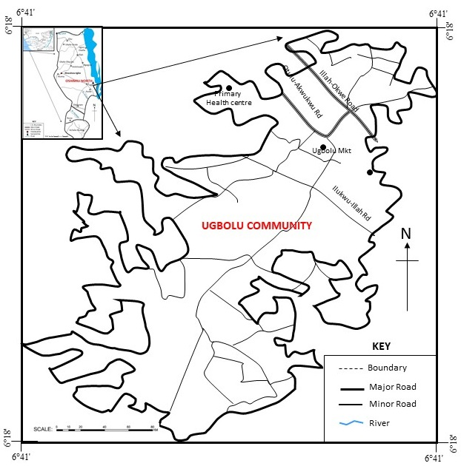
Figure 1: Map of Ugbolu community showing the study area
2.2. Sample Collection and Preparation: Four commonly consumed smoked-dried fish species—Clarias gariepinus, Scomber scombrus, Ethmalosa fimbriata, and Gymnarchus niloticus—were obtained directly from vendors at Afor-Ugbolu Market. Fish samples were collected between May and July 2025, corresponding to the wet season in Southern Nigeria. All samples were obtained within this period to minimise temporal variability. While seasonal variation in metal concentrations was not assessed in this study, it is acknowledged that metal accumulation in fish may vary across seasons, and this limitation has been noted. Ten samples of each species were purchased to ensure representativeness. Samples were placed in sterile polyethylene bags, properly labelled, and transported to the laboratory under hygienic conditions.
In the laboratory, muscle tissues were excised using stainless steel instruments to avoid contamination. The tissues were chopped into small portions, homogenised using a clean mortar and pestle, and sieved through a 2-mm mesh to obtain fine powder. The processed samples were stored in airtight containers within a vacuum desiccator prior to chemical analysis.

2.3. Wet-Acid Digestion of Fish Samples
Sample digestion was carried out using a wet-acid digestion method adapted from AOAC (2005). Approximately 2.0 g of homogenised fish tissue was weighed into digestion flasks, followed by the addition of a mixed acid solution consisting of concentrated nitric acid (HNO₃), perchloric acid (HClO₄), and sulphuric acid (H₂SO₄) in a volumetric ratio of 5:1:1, respectively.
The digestion mixture was heated gradually on a hot plate at 120–150 °C until complete digestion was achieved, as indicated by the formation of a clear solution. The digests were allowed to cool to room temperature, diluted to a final volume of 100 mL with distilled water, and filtered through Whatman No. 45 filter paper. The resulting solutions were transferred into acid-washed polyethylene bottles and stored prior to metal analysis.
2.4. Heavy Metal Determination: Concentrations of arsenic (As), cadmium (Cd), copper (Cu), lead (Pb), and zinc (Zn) were determined using Atomic Absorption Spectrophotometry (Buck Scientific Model 200A). Instrument calibration was performed using certified standard solutions for each metal, and reagent blanks were analysed alongside samples to check for contamination. Arsenic determination was conducted following wet-acid digestion using flame AAS. Although flame AAS has lower sensitivity for arsenic compared with hydride generation techniques, the concentrations detected in this study were within the measurable range of the instrument. Appropriate calibration and quality control procedures were applied to ensure analytical reliability. The limitations of flame AAS for ultra-trace arsenic detection are acknowledged, and the use of hydride generation AAS or ICP-based techniques is recommended for future studies requiring higher sensitivity.
Metal concentrations were expressed on a dry-weight basis as milligrams per kilogram (mg kg⁻¹).
2.5. Health Risk Assessment: Human health risks associated with consumption of the smoked-dried fish were evaluated using established noncarcinogenic and carcinogenic indices. Estimated Daily Intake (EDI), Target Hazard Quotient (THQ), Hazard Index (HI), and Lifetime Cancer Risk (LCR) were calculated following USEPA-based models, with exposure parameters adjusted for adult and child populations as described in previous studies (Griboff et al., 2017; USEPA, 2005).
2.5.1. Estimated Daily Intake (EDI): The Estimated Daily Intake (EDI) of each metal was calculated using the equation (Griboff et al., 2017):

EDI= $\frac{(Cmetal X IR)}{BW}$
Where:
C = concentration of the metal (mg/kg),
IR = ingestion rate of fish (g/person/day), and
BW = average body weight (70 kg for adults).

2.5.2. Noncarcinogenic risk assessment: Target Hazard Quotient (THQ) was used to evaluate the noncarcinogenic risk. THQ was defined as: the

THQ= $\frac{EDI}{RfD}$ (USEPA, 1989)
Where:
RfD is the oral reference dose for each element (mg/kg/day). The reference doses applied according to Varo et al., 2017 were: Zn (0.3), Cu (0.04), Pb (0.004), Cd (0.001), and As (0.0003)
2.5.3. Hazard Index (HI): The cumulative risk from simultaneous exposure to multiple metals was expressed as the
Hazard Index HI = ΣTHQ
A THQ or HI greater than 1 indicates a potential noncarcinogenic health concern (Faisal et al. 2024)
2.5.4. Lifetime Cancer Risk (LCR): The Carcinogenic Risk (CR) is a measure of the likelihood that a potential carcinogen during life will raise the incidence of cancer. Given that the USEPA defines the cancer scope factor (CSF) for lead (USEPA 2004), the carcinogenic risk of this metal is calculated using the formula:
LCR=EDI×CSF
Where:
CSF is the Cancer Slope Factor, with values of 6.1 (Cd), 1.5 (As), and 0.0085 (Pb) (mg/kg/day) ⁻1 (USEPA, 2005). Acceptable risk levels range from 10⁻⁶ to 10⁻⁴, with values above this threshold indicating an elevated potential cancer risk. For dietary exposure assessment, a fish ingestion rate (IR) of 0.02 kg person⁻¹ day⁻¹ was applied, consistent with values commonly used in fish-based health risk assessment studies. Average body weights of 70 kg for adults and 15 kg for children were assumed. Reference doses (RfD) and cancer slope factors (CSF) were adopted from USEPA (2005). Metal concentrations used in the calculations were obtained from laboratory analysis conducted in this study, while Estimated Daily Intake (EDI), Target Hazard Quotient (THQ), Hazard Index (HI), and Lifetime Cancer Risk (LCR) were calculated by using standard USEPA equations.
2.6. Statistical Analysis
Before data analysis, the normality and homogeneity of variance were assessed using the Shapiro-Wilk and Levene's tests, respectively. Furthermore, the significant variations in metal levels among the different species of the dried samples were evaluated using one-way analysis of variance (ANOVA). Differences between the means were identified using Turkey's multiple comparison test when a difference was detected (P < 0.05).
3. RESULTS
3.1. Heavy Metal Concentrations
Table 1 shows the heavy metal concentrations in smoked-dried fish species from the Afor-Ugbolu market compared with the permissible limits. The concentrations of arsenic, cadmium, copper, lead, and zinc in the smoked-dried fish species commonly sold at the Afor-Ugbolu market vary among species, indicating differences in habitat, feeding style, and bioaccumulation potential. All values were clearly below the permissible limits set by the World Health Organisation and the Federal Ministry of Environment. Arsenic concentrations ranged from 0.01 to 0.03 mg/kg. The highest value was observed in G. niloticus, whereas C. gariepinus recorded the lowest. Cadmium concentrations were also highest in G. niloticus (0.21±0.13 mg/kg) and lowest in C. gariepinus (0.03±0.01 mg/kg), with intermediate values in the other species, indicating differences in the tendency of these fish to bioaccumulate the metal. The trend was quite different in copper, with C. gariepinus recording the highest concentration (0.74±0.04 mg/kg) and G. niloticus recording the lowest (0.12±0.02 mg/kg). Lead levels were relatively low across all species, with the highest at 0.15±0.01 mg/kg in Scomber scombrus. The results also show that the heavy metal zinc was the most abundant in all species, with the highest levels in Gymnarchus niloticus (8.01±0.61 mg/kg) and the lowest in C. gariepinus (2.63±0.17 mg/kg).
Table 1: Heavy metal concentrations in smoked-dried fish species with permissible limits
Metals | G.niloticus  (Asa fish) | E.fimbriata  (Bony fish) | S.scombrus  (Mackerel fish) | C.gariepinus  (Catfish) | FAO/WHO Limit (mg/kg)
Arsenic (As) | 0.03±0.01ª | 0.02±0.01^{ab} | 0.02±0.01^{ab} | 0.01±0.02^{b} | 0.05
Cadmium (Cd) | 0.21±0.01ª | 0.12±0.01^{b} | 0.05±0.13^{b} | 0.03±0.01^{c} | 0.50
Copper (Cu) | 0.12±0.02^{c} | 0.25±0.03^{b} | 1.12±0.03^{b} | 0.71±0.04^{ab} | 3.00
Lead (Pb) | 0.02±0.11^{b} | 0.04±0.11^{b} | 0.15±0.01^{b} | 0.02±0.03^{b} | 0.50
Zinc (Zn) | 8.01±0.61ª | 6.26±0.12^{b} | 4.05±0.31^{b} | 2.63±0.17^{d} | 99.40
Values in the same row with different superscript letters differ significantly (one-way ANOVA, Tukey’s HSD, p < 0.05).

Figure 1: Level of Arsenic in the different fish species sold in Afor-Ugbolu market

Figure 2: Level of Cadmium in the different fish species sold in Afor-Ugbolu market

Figure 3: Level of Copper in the different fish species sold in Afor-Ugbolu market

Figure 4: Level of Lead in the different fish species sold in Afor-Ugbolu market

Figure 5: Level of Zinc (Zn) in the different fish species sold in Afor-Ugbolu market

3.2. Estimated Daily Intake (EDI)
Table 2: All fish species, Estimated Daily Intake (EDI) of heavy metals from smoked-dried fish consumption
Fish Species | Metal | EDI Adult  (mg/kg.bw/day) | EDI Child  (mg/kg.bw/day)
G.niloticus  (Asa fish) | As | 2.10X10⁻⁵ | 3.0X10⁻⁵
 | Cd | 1.50X10⁻⁴ | 2.1X10⁻⁴
 | Cu | 8.60X10⁻⁵ | 1.2X10⁻⁴
 | Pb | 1.40X10⁻⁵ | 2.0X10⁻⁵
 | Zn | 5.72X10⁻³ | 8.01X10⁻³
E.fimbriata  (Bony fish) | As | 1.4X10⁻⁵ | 2.0X10⁻⁵
 | Cd | 8.6X10⁻⁵ | 1.20X10⁻⁴
 | Cu | 1.79X10⁻⁴ | 2.50X10⁻⁴
 | Pb | 2.9X10⁻⁵ | 4.0X10⁻⁵
 | Zn | 4.471X10⁻³ | 6.26X10⁻³
S.scombrus  (Mackerel) | As | 1.4X10⁻⁵ | 2.0X10⁻⁵
 | Cd | 3.29X10⁻⁴ | 4.6X10⁻⁴
 | Cu | 8.0X10⁻⁴ | 1.12X10⁻³
 | Pb | 1.07X10⁻⁴ | 1.50X10⁻⁴
 | Zn | 2.893X10⁻³ | 4.05X10⁻³
C.gariepinus  (Catfish) | As | 7.0 X10⁻⁶ | 1.0 X10⁻⁵
 | Cd | 2.1 X10⁻⁵ | 3.0 X10⁻⁵
 | Cu | 5.07 X10⁻⁴ | 7.10 X10⁻⁴
 | Pb | 1.43 X10⁻⁵ | 2.0 X10⁻⁵
 | Zn | 1.879 X10⁻³ | 2.63 X10⁻³

Table 3: Estimated Daily Intake (EDI) of heavy metals from smoked-dried fish consumption
Metal | Highest Concentration (mg/kg) | EDI Adult (mg/kg/day) | EDI Child  (mg/kg/day) | Reference Dose (RFD, mg/kg/day)
Zn | 8.01 | 5.721 X10⁻⁵ | 8.01 X10⁻³ | 3.0 X10⁻¹
Cu | 1.12 | 8.0 X10⁻⁴ | 1.12 X10⁻³ | 4.0 X10⁻²
Cd | 0.21 | 3.29 X10⁻⁴ | 4.6 X10⁻⁴ | 1.0 X10⁻³
Pb | 0.15 | 1.07 X10⁻⁴ | 1.5 X10⁻³ | 4.0 X10⁻³
As | 0.03 | 2.14 X10⁻⁵ | 3.0 X10⁻⁵ | 3.0 X10⁻⁴

3.3. Target Hazard Quotient (THQ) and Hazard Index (HI)
Table 4: Target Hazard Quotient (THQ) and Hazard Index (HI) for heavy metals for Adults
Metal | EDI (mg/kg/day) | Reference Dose (mg/kg/day) | THQ= EDI/RfD
Zinc (Zn) | 5.721 X10⁻³ | 3.0 X10⁻¹ | 0.0191
Copper (Cu) | 8.0 X10⁻⁴ | 4.0 X10⁻² | 0.0200
Cadmium (Cd) | 1.65 X10⁻⁴ | 1.0 X10⁻³ | 0.1650
Lead (Pb) | 1.07 X10⁻⁴ | 5.0 X10⁻⁴ | 0.2140
Arsenic (As) | 2.14 X10⁻⁵ | 3.0 X10⁻⁴ | 0.0713
Hazard Index (HI) |  |  | 0.4894

Table 5: Target Hazard Quotient (THQ) and Hazard Index (HI) for heavy metals for Children
Metal | EDI (mg/kg/day) | Reference Dose (mg/kg/day) | THQ= EDI/RfD
Zinc (Zn) | 8.01 X10⁻³ | 3.0 X10⁻¹ | 0.0267
Copper (Cu) | 1.12 X10⁻³ | 4.0 X10⁻² | 0.0280
Cadmium (Cd) | 3.50 X10⁻⁴ | 1.0 X10⁻³ | 0.350
Lead (Pb) | 1.5 X10⁻⁴ | 5.0 X10⁻⁴ | 0.3000
Arsenic (As) | 3.0 X10⁻⁵ | 3.0 X10⁻⁴ | 0.1000
Hazard Index (HI) |  |  | 0.8047

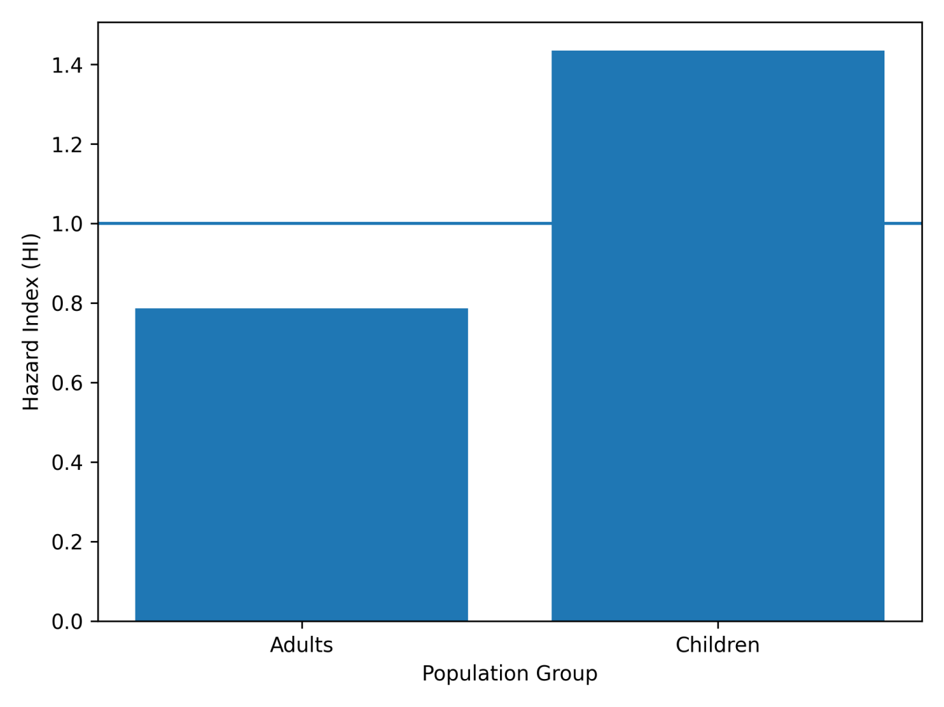
Figure 6: Comparison of Hazard Index (HI) values for adults and children exposed to heavy metals through consumption of smoked-dried fish

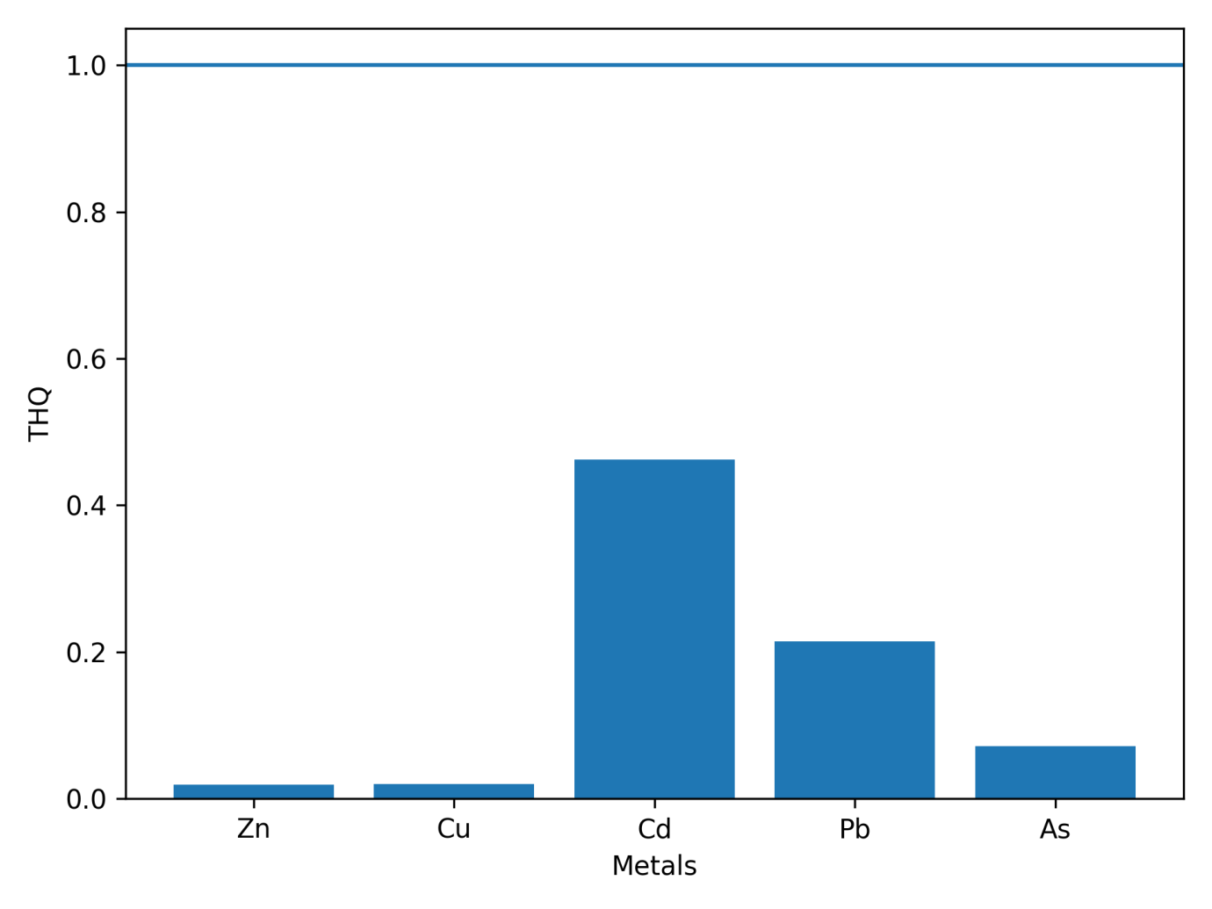Figure 7: Target Hazard Quotient (THQ) values for individual heavy metals (Zn, Cu, Cd, Pb, and As) in adults consuming smoked-dried fish (THQ = 1).

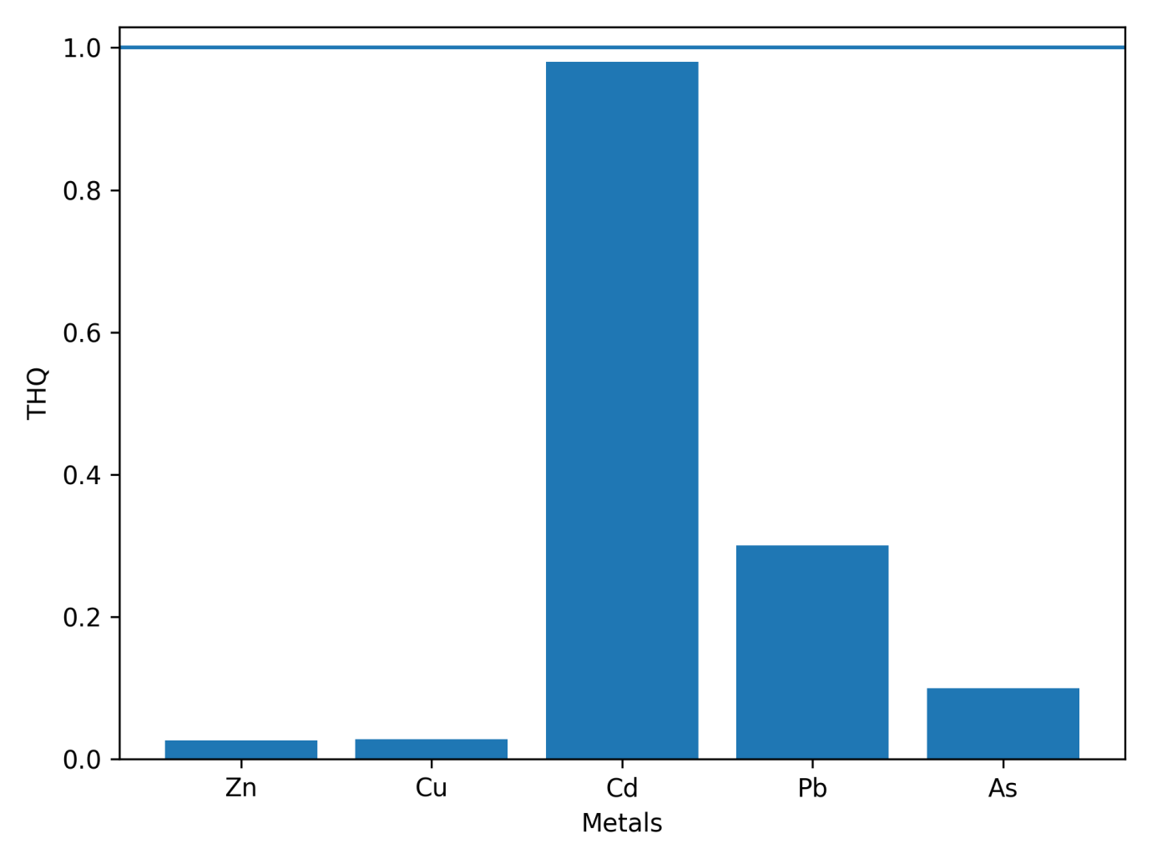
Figure 8: Target Hazard Quotient (THQ) values for individual heavy metals (Zn, Cu, Cd, Pb, and As) in children consuming smoked-dried fish (THQ = 1).

4.4. Lifetime Cancer Risk (LCR)
Table 6: Lifetime Cancer Risk (LCR) from heavy metal exposure
Metal | EDI (mg/kg/day) | Cancer Slope Factor (CSF,  (mg/kg/day)⁻¹) | LCR = EDI × CSF | Risk Range (USEPA)
Arsenic (As) | 3.0 X10⁻⁵ | 1.5 | 4.5 X10⁻⁵ | Acceptable (10⁻⁶ – 10⁻⁴)
Cadmium (Cd) | 4.6 X10⁻⁴ | 6.1 | 2.806 X10⁻³ | Above safe limit
Lead (Pb) | 1.5 X10⁻⁴ | 0.0085 | 1.275 X10⁻⁶ | Acceptable (10⁻⁶ – 10⁻⁴)

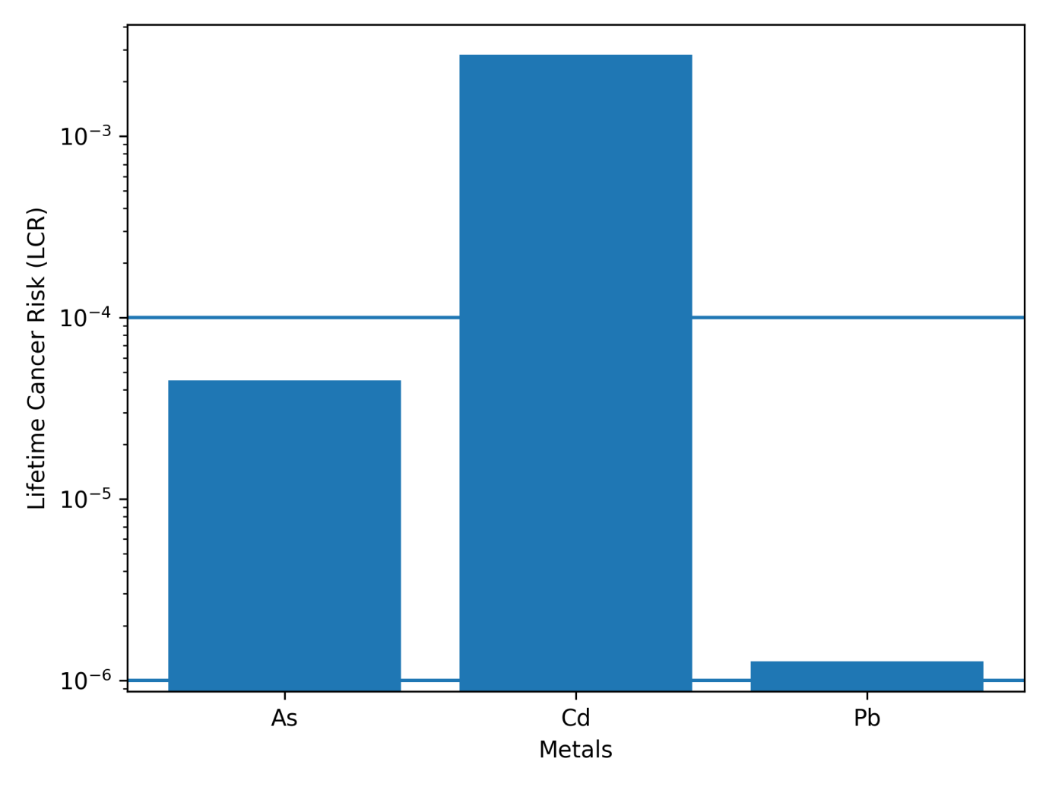Figure 9: Lifetime cancer risk (LCR) associated with dietary exposure to arsenic (As), cadmium (Cd), and lead (Pb) from consumption of smoked-dried fish

4.0. DISCUSSION
This study investigated the concentrations of selected heavy metals in commonly consumed smoked-dried fish sold at Afor-Ugbolu Market and assessed the associated human health risks using established USEPA-based risk assessment models. The presence of arsenic, cadmium, copper, lead, and zinc in all analysed fish species confirms that smoked-dried fish can act as a pathway for dietary exposure to environmental contaminants. Variations in metal concentrations among fish species likely reflect differences in habitat, feeding behaviour, trophic level, and bioaccumulation potential, as well as differences in post-harvest handling and processing practices.
Zinc was the most abundant metal detected across all fish species, which is consistent with its essential biological role and relatively high permissible intake levels. In contrast, cadmium and arsenic occurred at comparatively lower concentrations but contributed more substantially to health risk indices due to their high toxicity and low reference doses. Similar patterns have been reported in previous studies assessing heavy metal exposure through consumption of smoked or dried fish products in Nigerian and other developing-country markets (Griboff et al., 2017; Zhong et al., 2018).
Processing-related contamination may also have contributed to the observed metal profiles. Smoking and drying expose fish to combustion residues, contaminated drying surfaces, and atmospheric deposition, which may increase contaminant load beyond that originating from the aquatic environment. Evidence from recent studies on heat-processed fish and meat products indicates that processing methods can significantly influence contaminant exposure and associated health risks (Iwu et al., 2024). This underscores the need to consider both environmental and processing-related factors when evaluating food safety risks.
Health risk assessment based on recalculated Target Hazard Quotient and Hazard Index values revealed that cumulative non-carcinogenic risks were below the acceptable threshold (HI < 1) for both adults and children. This indicates that consumption of smoked-dried fish from Afor-Ugbolu Market does not pose a significant non-carcinogenic health risk under the assumed consumption scenario. However, children consistently exhibited higher THQ and HI values than adults, reflecting their lower body weight and greater exposure per unit body mass. This pattern of increased vulnerability among children has been widely documented in dietary risk assessment studies (USEPA, 2005; Ahmed et al., 2020).
Although non-carcinogenic risk indices were within acceptable limits, lifetime cancer risk analysis revealed that cadmium exposure exceeded the USEPA recommended risk range. This suggests that long-term consumption of smoked-dried fish may pose a potential carcinogenic concern, even when non-carcinogenic thresholds are not exceeded. The finding highlights the importance of incorporating both carcinogenic and non-carcinogenic endpoints into comprehensive food safety assessments, particularly for traditionally processed foods that are consumed regularly.
The results demonstrate that smoked-dried fish sold at Afor-Ugbolu Market is generally safe for consumption with respect to non-carcinogenic health effects, especially for adults. Nevertheless, the contribution of cadmium and lead to cumulative exposure, combined with the influence of processing-related contamination, emphasises the need for routine monitoring, improved smoking and handling practices, and public awareness initiatives to minimise long-term dietary health risks.
5. CONCLUSION
This study evaluated the concentrations of arsenic, cadmium, copper, lead, and zinc in smoked-dried fish sold at Afor-Ugbolu Market, Delta State, Nigeria, and assessed the associated human health risks. Metal concentrations varied among fish species, with zinc occurring at the highest levels, while cadmium and arsenic were of greater toxicological relevance due to their low reference doses. All measured metals were below recommended permissible limits. Health risk assessment showed that individual and cumulative non-carcinogenic risks were below the acceptable threshold (HI < 1) for both adults and children, although children exhibited higher risk indices than adults. In contrast, lifetime cancer risk analysis indicated that cadmium exposure exceeded the USEPA acceptable range, suggesting a potential long-term carcinogenic concern. Smoked-dried fish from Afor-Ugbolu Market can be considered generally safe with respect to non-carcinogenic effects; however, routine monitoring and improved processing practices are recommended to minimise long-term health risks.
Disclaimer (Artificial intelligence)

Author(s) hereby declare that NO generative AI technologies such as Large Language Models (ChatGPT, COPILOT, etc.) and text-to-image generators have been used during the writing or editing of this manuscript.

References
Ahmed, M. F., Mokhtar, M. B., & Alam, L. (2020). Carcinogenic and noncarcinogenic health risk of arsenic ingestion via drinking water in the Langat River basin, Malaysia. Environmental Geochemistry and Health, 43(2), 897–914. https://doi.org/10.1007/s10653-020-00571-w
Akinhanmi, T. F., Akinwunmi, F., Ajala, O. O., & Usanga, E. E. (2021). Assessment of selected heavy metals and estimation of human health risk in some commonly consumed fish in Abeokuta, Ogun State, Nigeria. Journal of the Chemical Society of Nigeria, 46(2). https://doi.org/10.46602/jcsn.v46i2.608
Akinrotimi, O. A., Ikeogu, C. F., Ayaobu-Cookey, I. K., Onoja, C. R., & Emeka, K. J. (2024). Assessment of some heavy metals in selected dried fishes sold in three major markets in Awka metropolis, Nigeria. Global Journal of Applied Sciences and Technology, 6(2), 1–5.
Al Mazed, M., Rahman, M. A., & Ahmed, S. I. (2022). A review of the effects of heavy metals on aquatic animals and public health significance. Veterinary Sciences: Research and Reviews, 8(2), 96–104. https://doi.org/10.17582/journal.vsrr/2022/8.2.96.104
Anarado, C. J. O., Okpoji, A. U., & Anarado, C. E. (2023). Bioaccumulation and health risk assessment of lead, cadmium, arsenic, and mercury in blue crabs from Bayelsa State, Nigeria. Asian Journal of Environmental & Ecology, 21(4), 46–59.
Association of Official Analytical Chemists. (2005). Official methods of analysis (18th ed.). AOAC.
Chamoli, A., & Karn, S. K. (2024). The effects of mercury exposure on neurological and cognitive dysfunction in humans: A review. In Earth and environmental sciences library (pp. 117–135). Springer. https://doi.org/10.1007/978-3-031-48817-7_5
Chukwurah A. I., Uruh K., Olannye D. U., Emetulu V. C. & Enamuotor O. (2023). Effects of Water Pollution on Aquatic Life: A Case Study on River Ethiope. Journal of Scientometrics and Innovations. 1 (1): 210 – 220.
Chukwurah, A. I., Olannye, D. U. Odesa, E. G., Oghene, J. U., Irabor, A. E., Uruh, K. & Odia, M. (2025). Fostering a Sustainable Blue Economy to Enhance Food Security in the Niger Delta Region of Nigeria. In Proceedings of the 1st International Conference on Building Resilience against Hunger: Addressing Nigeria’s Food Insecurity Challenges, Asaba, Delta State, Nigeria, 20 – 23 May 2025.
Elinge, C. M., Obaroh, I. O., Muhammad, A., Yanah, Y. M., & Abdullahi, L. Y. (2019). Determination of some heavy metals in three selected fish species from River Zamare, Nigeria. International Journal of Fisheries and Aquatic Studies, 7(4), 385–387.
Federal Environmental Protection Agency. (2013). Guidelines and standards for environmental pollution control in Nigeria. FEPA.
Garner, T. B., Hester, J. M., Carothers, A., & Diaz, F. J. (2021). Role of zinc in female reproduction. Biology of Reproduction, 104(5), 976–994. https://doi.org/10.1093/biolre/ioab023
Griboff, J., Wunderlin, D. A., & Monferran, M. V. (2017). Metals, As and Se determination in edible fish: Does their consumption represent a risk to human health? Microchemical Journal, 130, 236–244. https://doi.org/10.1016/j.microc.2016.09.013
Gudadhe, S., Singh, S. K., & Ahsan, J. (2024). Cellular and neurological effects of lead toxicity. In Environmental contamination remediation and management (pp. 125–145). Springer. https://doi.org/10.1007/978-3-031-46146-0_6
Iwu, G. I., Lajide, L., Madu, P. C., & Isah, I. A. (2024). Assessment of polycyclic aromatic hydrocarbon (PAH) profiles in heat-processed meat and fish: A study on health risk evaluation. Discover Food, 4(1), 46. https://doi.org/10.1007/s44187-024-00146-0
Iyorah, I. E., & Uzoamaka, G. (2023). Human health risk assessment of heavy metals detected in dried fish species consumed in Benin City, Nigeria. Dutse Journal of Pure and Applied Sciences, 9(2a), 74–81. https://doi.org/10.4314/dujopas.v9i2a.7
Izuchukwu Ujah, I., Okeke, D. O., & Okpashi, V. E. (2017). Determination of heavy metals in fish tissues, water and sediment from River Niger, Nigeria. Journal of Environmental & Analytical Toxicology, 7(5), 1–3.
Kalamara, T., Dodos, K., Georgakopoulou, V., Fotakopoulos, G., Spandidos, D., & Kapoukranidou, D. (2025). Cognitive efficacy of omega-3 fatty acids in Alzheimer’s disease. Biomedical Reports, 22(4). https://doi.org/10.3892/br.2025.1940
Khanjani, M. H., & Sharifinia, M. (2024). Nutritional value and consumption pattern of indigenous small fish. In Perspectives and applications of indigenous small fish (pp. 193–227). Springer.
Kumar, M., Singh, S., Jain, A., Yadav, S., Dubey, A., & Trivedi, S. P. (2024). Heavy metal-induced toxicity in fishes: A review. Journal of Trace Elements in Medicine and Biology, 83, 127377. https://doi.org/10.1016/j.jtemb.2023.127377
Majlesi, M., Pashangeh, S., Salehi, S. O., & Berizi, E. (2018). Human health risks from heavy metals in freshwater fish. International Journal of Nutrition Sciences, 3(3), 157–163.
Marbade, P. P., Thakur, V. K., Painkra, A., & Devi, N. (2024). Traditional and advanced methods of fish drying. In Dry fish: A global perspective (pp. 31–44). Springer. https://doi.org/10.1007/978-3-031-62462-9_3
Mustapha, A. M., Ugya, A. Y., & Mustapha, Z. (2021). Assessment of heavy metal levels in fish tissues from Epe Lagoon, Nigeria. Science World Journal, 16(4), 464–469.
Nasim, A. G., Shamsi, F. B., & Javaid, Q. U. A. (2024). Cadmium toxicity and renal autoimmunity. Annals of Punjab Medical College, 18(4), 351–356. https://doi.org/10.29054/apmc/2024.1643
Ochuko, U., Edojarievwen, U.T., Olannye, D.U. & Thaddeus, O. (2023). Assessment of the water quality index of River Ethiope for drinking water purposes in Southern Nigeria. International Journal of Innovative Science and Research Technology. 8(6):3294-3300.
Odesa, G. E. & Olannye, D. U. (2024). Health Risk Assessment of PAHs and Heavy Metal Levels in Periwinkles (Pachymelania fusca mutans) and Crabs (Scylla serrata) Consumed in Crude Oil-Contaminated Coastal Regions of Southern Nigeria. Toxicology Reports. 14 : 101852. https://doi.org/10.1016/j.toxrep.2024.101852
Okpoji, A. U., Anarado, C. O., Mmuta, E. C., et al. (2025). Toxicological evaluation of heavy metals in blue crab from Niger Delta. Journal of Life Science and Public Health, 1(1), 24–31. https://doi.org/10.69739/jlsph.v1i1.879
Olannye, D.U., Oloruntoba. E. O. & Isehunwa, S. O. (2024). Spent Lubricant Oil Generation Rate and Handling Practices Among Automobile Mechanics in Selected Mechanic Workshops in Ibadan, Oyo State, Nigeria. Global Journal of Environmental Science and Sustainability. 1(1): 102 -109.
Onadje, F. O., & Akalusi, K. E. (2024). Biochemical effects of lead exposure in Clarias gariepinus. FNAS Journal of Applied Biological Sciences, 2(1), 79–89.
Onadje, F.O., Chukwurah, A.I., Olannye, D.U., Efe-Eyefia, K., & Oghene, U.J. (2025a). Bioaccumulation of Cadmium, Copper and Lead in Edible Tissues of Clarias gariepinus and Oreochromis niloticus from Anwai River, Nigeria. FNAS Journal of Applied Chemical Science Research, 2(4), 52-59.
Onadje, F. O., Chukwurah, A. I., & Agbeyi, E. V. (2025). Multiple biomarkers variability in lead-exposed Clarias gariepinus. Journal of Advances in Biology & Biotechnology, 28(4), 513–520. https://doi.org/10.9734/jabb/2025/v28i42209
Onoja, C. R., Ogbaji, H. O., Edodi, I. O., et al. (2025). Heavy metal contamination and health risk assessment of smoked-dried fish in Awka, Nigeria. Journal of Sustainable Research and Development, 1(2), 18–25. https://doi.org/10.69739/jsrd.v1i2.1044
Oriji, O., & Nwabekee, I. (2025). Determination of heavy metals in fish species. Scientia Africana, 24(1), 79–88. https://doi.org/10.4314/sa.v24i1.8
Ozturk, M., Metin, M., Altay, V., et al. (2021). Arsenic and human health. Biological Trace Element Research, 200(3), 988–1001. https://doi.org/10.1007/s12011-021-02719-w
Patil, R., Sontakke, T., Biradar, A., & Nalage, D. (2023). Zinc: An essential trace element for human health. Food and Health, 5(3), 13. https://doi.org/10.53388/fh2023013
Singh, R. D., Arambam, K., Singh, A. M., & Singh, S. K. (2025). Health and nutritional benefits of fish. In Food security and aquaculture technologies (pp. 43–59). Springer.
Srivastava, V., Gupta, S. K., Singh, P., Sharma, B., & Singh, R. P. (2018). Biochemical responses of crops grown on waste-amended soils. International Journal of Recycling of Organic Waste in Agriculture, 7(3), 241–250. https://doi.org/10.1007/s40093-018-0210-1
Taiwo, I. O., Olopade, O. A., & Bamidele, N. A. (2019). Heavy metal concentration in fish from Epe Lagoon. Transylvanian Review of Systematical and Ecological Research, 21(1), 69–82.
Uguru, H., Akpokodje, O. I., Essaghah, A. E., et al. (2023). Toxic metals in smoked-dried fish. Materials Express, 13(2), 316–326. https://doi.org/10.1166/mex.2023.2343
United States Environmental Protection Agency. (2004). Risk assessment guidance for Superfund: Human health evaluation manual (Part E). USEPA.
United States Environmental Protection Agency. (2005). Guidelines for carcinogen risk assessment (EPA/630/P-03/001F). USEPA.
World Health Organization. (2015). Guidelines for drinking-water quality (4th ed.). WHO Press.
World Health Organization. (2003). Malathion in drinking water. WHO.
Zhao, W., Tang, H., Yang, X., Luo, X., Wang, X., Shao, C., & He, J. (2019). Fish consumption and stroke risk. Journal of Stroke and Cerebrovascular Diseases, 28, 604–611.
Zhong, W., Zhang, Y., Wu, Z., et al. (2018). Health risk assessment of heavy metals in freshwater fish. Ecotoxicology and Environmental Safety, 157, 343–349.

