Concentrations and Health Risk Assessment of Potentially Toxic Elements in Indoor Dusts from Secondary Schools in Port Harcourt, Rivers State, Nigeria

Original Research Article
ABSTRACT
In educational environments such as secondary schools, poor air quality poses risk due to long-term student exposure as well as potential respiratory morbidity. Dust particles in school environments are major source for toxic elements. Contaminated classroom dust can pose a potential risk to the health of young school children. This study therefore conducted a comprehensive assessment of concentrations of potentially toxic elements in indoor dusts at some secondary schools in Port Harcourt, Rivers State. Field sampling was carried out using standard procedures and Atomic Absorption Spectrophotometer by Perkin Elmer Analyst 400. The results revealed a heterogeneous spatial distribution of the elements with chromium (Cr) and nickel (Ni) generally occurring at very low concentrations (0.001 mg/kg), except for localized elevations at PH04CSSN (0.0825±0.0815 mg/kg and 0.1235±0.12 mg/kg respectively) and PH07GCSS (As, 0.47±0.41 mg/kg) showed pronounced site- specific peaks with high variability, while copper (Cu) concentrations were notably elevated at PH06GGSS and PH07GCSS (0.822±0.097mg/kg and 1.2825±0.4175 mg/kg respectively). Lead (Pb) exhibited extreme enrichment at PH05CIA (1.2855±1.2645 mg/kg), indicating probable point-source contamination, whereas cadmium (Cd) remained low with minor increases at a few locations. Correlation analysis showed strong positive relationships among several schools, implying shared contamination sources or similar environmental influences. A Two-way ANOVA indicated borderline statistical differences across schools and metals, further confirming spatial heterogeneity. The findings underscore the urgent need for improved cleaning and dust management practices in schools, continuous air quality monitoring, and targeted policy interventions addressing traffic and industrial emissions. Regular maintenance and cleaning of classrooms, including wet-mopping instead of sweeping, can significantly reduce coarse particulate and dusts resuspension were recommended.
Keywords: Toxic Elements, Health Risk, Indoor Dusts, Secondary Schools, Nigeria

INTRODUCTION
Dust is one of the global environmental problems facing the world today especially in developing countries. Dust can be in the form of fine powder, lying on the ground or the surface objects or blown about by the wind (Evans et al., 2013; Gbadebo et al., 2013). They are generated naturally in sandstorms, volcanoes, wind or anthropogenic activities such as bagging, sweeping, grinding etc. In many tropical and developing countries like Nigeria, dust particles are usually seen on most surfaces due to several uncontrolled human activities and natural factors. It is worrisome to notice the amount of settled indoor dust in some public schools’ classrooms in Nigeria. The health effects of toxic metals in dust inhaled can inflame, sensitize and even scar the lungs and tissue (Olutona et al., 2012). One of the most prevalent and neglected diseases in Nigeria and most of the Sub-Saharan African countries probably is lead poisoning which is one of the major heavy metals and it has affected a large fraction of the childhood population because of the growing multiplicity of potential exposure routes. (Nriagu et al., 1997; Pfitzner et al., 2000; Wright et al., 2005). Dust makes a significant contribution to pollution in urban areas like Port Harcourt city and consists of vehicle exhaust, sinking particles in air, house dust, soil dust and aerosols that are carried by air and water. The sizes of dust particles vary; some may be less than 1µm and up to about 100µm in diameter (Doyi et al., 2020). Different types of dust are generated from environmental processes due to their different sources. Therefore, the chemical constituents of dust particles vary and the chemical components of dust are metals. Human exposure to high levels of some metals leads to adverse health effects. If dust is laden with heavy metals, it provides a critical link in the exposure pathway for young children; contaminated classroom dust can pose a potential risk to the health of young school children (Ugwu & Ofomatah, 2021). A study by Lanphear et al. (1996) conducted among children in Rochester (New York, USA) indicates that dust lead content explains most of the variance in blood lead levels. Previous studies in Nigeria have shown that 70% of children aged 6 to35 months had blood lead levels greater than 10 g/dL (Nigeria et al., 2012; Keating et al., 2011) and that flaking house paint was an important determinant of this (Wright et al., 2005). It has been shown that emulsion and gloss types of paints currently manufactured and sold in Nigeria contained substantial levels of lead (Adebamowo et al., 2006). However, much attention has not been paid to the problem of heavy metal contamination in classrooms. There is a lack of information on classroom dust and consequently; there are no regulations, and guidelines for heavy metal contamination in classrooms.

MATERIALS AND METHODS
Study Area
The study was carried out in Port Harcourt Local Government Area (LGA), Rivers State, Nigeria which is located in latitudes 4°51´ 30˝ N and 4° 57´ 30˝ N and longitudes 6°50´ 00˝ E and 7°00´ 00˝ E (Fig. 1).
The study determined the concentrations of potentially toxic elements in indoor dusts and from nine (9) randomly selected secondary schools in Port Harcourt LGA. Sample collection covered a period of twelve (12) months (twice per term during academic sessions in each school) covering dry and wet seasons.

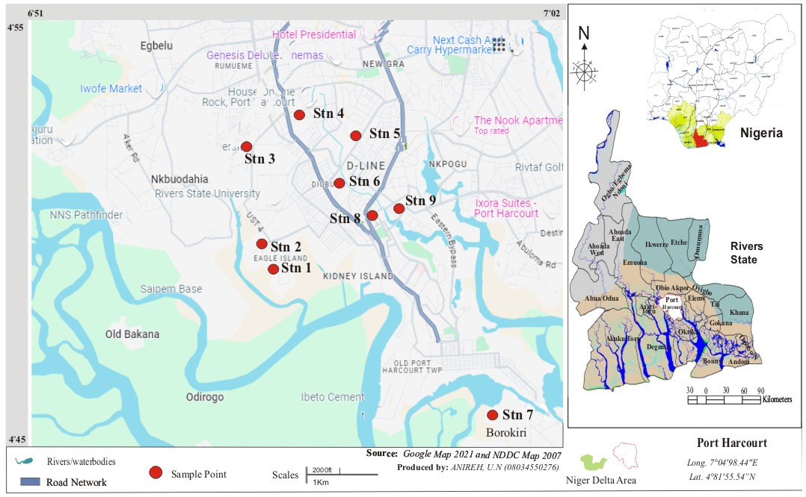
Fig.1 Study Area Showing Sampling School Locations

Sample Collection and Analysis
Potentially toxic elements from dust particles were collected from surfaces of fans, windows and classroom desks using a hand brush and placed in a foil paper which was covered with an envelope and labelled according to sampling stations. Dust on the filters were extracted using hot nitric acid digestion. This was done by cutting a 1 × 8 strip from the exposed filter paper. The filter paper was placed in a 250mL quartz beaker. 30ml of the 10% nitric acid was poured into the filter. It was refluxed gently for 30 minutes at 95 ºC. After refluxing, 10ml of clean deionized water was added and allowed to cool for 30 minutes. The extract was filtered using Whatman 541 filter paper. The samples were diluted with 20ml clean deionized water and analyzed using an Atomic Absorption Spectrometer (Perkins Elmer Analyst 400).

RESULTS AND DISCUSSION
The results in Tab;le 1 show that Chromium (Cr) and Nickel (Ni) concentrations are mostly very low or at the detection limit across most locations, except for PH04CSSN and PH07GCSS where significantly higher levels were observed with large variations. Arsenic (As) levels vary considerably, with PH07GCSS and PH04CSSN having the highest mean values and large standard deviations, indicating uneven contamination. Copper (Cu) concentrations are generally higher, especially at PH06GGSS and PH07GCSS, suggesting localized sources of contamination. Lead (Pb) showed a strikingly high average at PH05CIA, which is much greater than all other sites, indicating possible point-source pollution or contamination at this site. Cadmium (Cd) concentrations were low overall but showed moderate variability with PH031SS and PH04CSSN having slightly elevated levels. Overall, the data indicated significant spatial variability in heavy metal contamination across the study locations with some sites exhibiting notably higher pollution levels likely due to localized environmental or anthropogenic influences.
Table 1 Mean Concentrations (mg/kg) of Potentially Toxic Elements in some Schools from Port Harcourt
Study Locations | Chromium (Cr) | Arsenic (As) | Nickel (Ni) | Copper (Cu) | Lead (Pb) | Cadmium (Cd)
PH01ASSE | 0.001±0 | 0.275±0.07 | 0.001±0 | 0.098±0.006 | 0.083±0.011 | 0.021±0.009
PH02HH | 0.001±0 | 0.19±0.03 | 0.001±0 | 0.106±0.006 | 0.055±0.007 | 0.016±0.004
PH031SS | 0.001±0 | 0.001±0 | 0.001±0 | 0.123±0.011 | 0.0665±0.0155 | 0.05±0.01
PH04CSSN | 0.0825±0.0815 | 0.445±0.215 | 0.1235±0.12 | 0.3205±0.2125 | 0.1705±0.1165 | 0.0595±0.0205
PH05CIA | 0.001±0 | 0.085±0.075 | 0.001±0 | 0.0695±0.0135 | 1.2855±1.2645 | 0.0235±0.0025
PH06GGSS | 0.001±0 | 0.195±0.045 | 0.001±0 | 0.822±0.097 | 0.0235±0.0085 | 0.023±0.001
PH07GCSS | 0.265±0.2645 | 0.47±0.41 | 0.3155±0.31 | 1.2825±0.4175 | 0.346±0.334 | 0.0135±0.0025
PH08HRC | 0.001±0 | 0.175±0.04 | 0.001±0 | 0.0185±0.0065 | 0.008±0.002 | 0.0065±0.0015
PH09CSSO | 0.001±0 | 0.041±0.01 | 0.001±0 | 0.016±0.005 | 0.0105±0.0025 | 0.0035±0.0015

Correlation matrix, Table 2, showed strong positive correlations among most schools in Port Harcourt, particularly between PH01ASSE, PH02HH, PH04CSSN, PH08HRC, and PH09CSSO, indicating similar potentially toxic elements concentration patterns in these locations. Some schools like PH03 1SS and PH05CIA showed weak or even negative correlations with others, suggesting distinct contamination profiles at these sites. The two-way ANOVA summary, Table 3, revealed that PH07GCSS and PH05CIA have the highest mean concentrations and variances for heavy metals indicating greater contamination and variability at these locations. Chromium (Cr) showed relatively low average concentration and variance, while Arsenic (As), Copper (Cu), and Lead (Pb) exhibited higher means and variances, reflecting their more significant presence and variability across schools. ANOVA results indicated no statistically significant difference in mean potentially toxic element levels either across the different schools (rows, p=0.067) or among the different metals (columns, p=0.060), though both are borderline cases. In general, the data suggested heterogeneous potentially toxic elements contamination in Port Harcourt schools with certain sites showing elevated and variable contamination that warrants further investigation.
Table 2 Correlation Matrix of Potentially Toxic Elements Concentrations between Schools in Port Harcourt LGA
 | PH01ASSE | PH02HH | PH031SS | PH04CSSN | PH05CIA | PH06GGSS | PH07GCSS | PH08HRC | PH09CSSO
PH01ASSE | 1
PH02HH | 0.977781 | 1
PH031SS | -0.01779 | 0.149948 | 1
PH04CSSN | 0.93033 | 0.974262 | 0.155304 | 1
PH05CIA | 0.07649 | 0.023392 | 0.284972 | -0.03248 | 1
PH06GGSS | 0.305114 | 0.49787 | 0.759527 | 0.579855 | -0.18796 | 1
PH07GCSS | 0.306555 | 0.488595 | 0.683649 | 0.61136 | -0.0746 | 0.95916 | 1
PH08HRC | 0.9464 | 0.887413 | -0.30369 | 0.837454 | -0.14022 | 0.110856 | 0.101129 | 1
PH09CSSO | 0.997326 | 0.983901 | -0.01745 | 0.944219 | 0.008905 | 0.342797 | 0.3386 | 0.952349 | 1

The health risk assessment revealed that Hazard Index (HI) values for children ranged from 0.018932 (PH031SS) to 0.453412 (PH07GCSS), while adult HI values ranged from 0.017186 (PH031SS) to 0.411600 (PH07GCSS), with all values remaining below the USEPA safety threshold of 1.0. At PH01ASSE, HI values were 0.240848 (children) and 0.218638 (adults), largely influenced by arsenic HQ values of 0.228971 and 0.207856, respectively, whereas PH02HH recorded HI values of 0.166878 and 0.151489 with corresponding arsenic HQ contributions of 0.158198 and 0.143610. PH031SS exhibited the lowest cumulative risk (0.018932; 0.017186), with minimal HQ contributions from chromium (8.33E-05; 7.56E-05), nickel (1.25E-05; 1.13E-05), copper (0.000768; 0.000697), lead (0.004746; 0.004308), cadmium (0.012489; 0.011338), and arsenic (0.000833; 0.000756). Elevated HI values were observed at PH04CSSN (0.407961; 0.370340) and PH07GCSS (0.453412; 0.411600), driven primarily by arsenic HQ values of 0.370517 and 0.391333 in children and 0.336349 and 0.355245 in adults, alongside moderate contributions from lead (0.012168; 0.024693) and cadmium (0.014862; 0.003372) in children. Intermediate risk levels were recorded at PH05CIA (0.168916; 0.153339) and PH06GGSS (0.175013; 0.158874), where lead at PH05CIA (0.091743; 0.083283) and copper at PH06GGSS (0.005133; 0.004660) contributed notably to cumulative risk. Overall, children consistently exhibited slightly higher HQ and HI values than adults across all schools, reflecting greater vulnerability due to lower body weight and higher exposure per unit mass, although the cumulative non-carcinogenic risks remain within acceptable limits.

Table 3: Health Risk Assessment of Potentially Toxic Elements in Selected Schools within Port Harcourt LGA

School | HQ Child Cr | HQ Adult Cr | HQ Child As | HQ Adult As | HQ Child Ni | HQ Adult Ni | HQ Child Cu | HQ Adult Cu | HQ Child Pb | HQ Adult Pb | HQ Child Cd | HQ Adult Cd | HI Child | HI Adult
PH01ASSE | 8.33E-05 | 7.56E-05 | 0.228971 | 0.207856 | 1.25E-05 | 1.13E-05 | 0.000612 | 0.000556 | 0.005924 | 0.005377 | 0.005246 | 0.004762 | 0.240848 | 0.218638
PH02HH | 8.33E-05 | 7.56E-05 | 0.158198 | 0.14361 | 1.25E-05 | 1.13E-05 | 0.000662 | 0.000601 | 0.003925 | 0.003563 | 0.003997 | 0.003628 | 0.166878 | 0.151489
PH031SS | 8.33E-05 | 7.56E-05 | 0.000833 | 0.000756 | 1.25E-05 | 1.13E-05 | 0.000768 | 0.000697 | 0.004746 | 0.004308 | 0.012489 | 0.011338 | 0.018932 | 0.017186
PH04CSSN | 0.006869 | 0.006236 | 0.370517 | 0.336349 | 0.001542 | 0.0014 | 0.002001 | 0.001817 | 0.012168 | 0.011046 | 0.014862 | 0.013492 | 0.407961 | 0.37034
PH05CIA | 8.33E-05 | 7.56E-05 | 0.070773 | 0.064247 | 1.25E-05 | 1.13E-05 | 0.000434 | 0.000394 | 0.091743 | 0.083283 | 0.00587 | 0.005329 | 0.168916 | 0.153339
PH06GGSS | 8.33E-05 | 7.56E-05 | 0.162361 | 0.147389 | 1.25E-05 | 1.13E-05 | 0.005133 | 0.00466 | 0.001677 | 0.001522 | 0.005745 | 0.005215 | 0.175013 | 0.158874
PH07GCSS | 0.022065 | 0.02003 | 0.391333 | 0.355245 | 0.00394 | 0.003577 | 0.008009 | 0.00727 | 0.024693 | 0.022416 | 0.003372 | 0.003061 | 0.453412 | 0.4116
PH08HRC | 8.33E-05 | 7.56E-05 | 0.145709 | 0.132272 | 1.25E-05 | 1.13E-05 | 0.000116 | 0.000105 | 0.000571 | 0.000518 | 0.001624 | 0.001474 | 0.148115 | 0.134456
PH09CSSO | 8.33E-05 | 7.56E-05 | 0.034138 | 0.03099 | 1.25E-05 | 1.13E-05 | 9.99E-05 | 9.07E-05 | 0.000749 | 0.00068 | 0.000874 | 0.000794 | 0.035957 | 0.032641

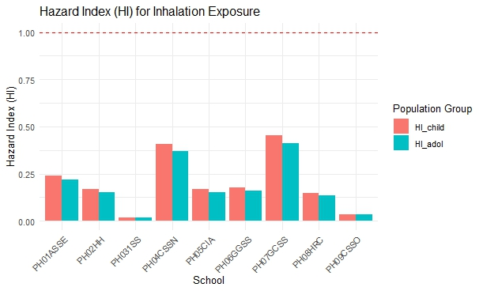

Fig.2. Harzard Index for Inhalation Exposure
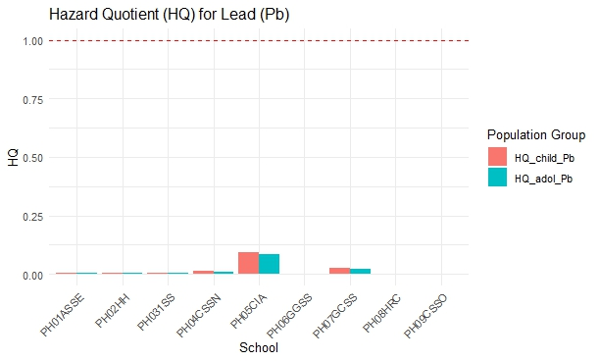

Fig. 3. Harzard Quotient for Lead

The inhalation-related health risk assessment across selected schools in Port Harcourt City revealed Hazard Index (HI) values ranging from 0.018932 to 0.453412 for children and from 0.017186 to 0.411600 for adults, with all values remaining below the USEPA safety threshold of 1.0. These findings indicate low to moderate non-carcinogenic risk levels and align with several international studies that similarly reported HI values below unity for inhalation exposure to heavy metals in particulate matter and dust. For instance, in Islamabad, Pakistan, Khan et al. (2020) documented inhalation HI values below 1.0 for all population groups exposed to PM₁₀-bound metals, reflecting a comparable low-risk profile to that observed in the present study. Likewise, in Pathum Thani, Thailand, Rattanaphra et al. (2025) reported adult inhalation HI values between 0.0459 and 0.1090, which are lower than the maximum values recorded in Port Harcourt (0.453412 for children and 0.411600 for adults), while child HI values (0.3285–0.7811) were close to or slightly higher than the upper range of the present findings. Similarly, Hu et al. (2012) in Nanjing, China and Ghanavati et. al.. in Ahvaz, Iran observed HI_inh and HQ_inh values below 1.0 for children across assessed pathways, further supporting the consistency of low inhalation-related risk in urban environments not heavily impacted by extreme industrial emissions.
In Nigeria, Okoro et al. (2025) reported extremely low inhalation HI contributions in classroom dust from Ilorin, with values ranging from 1.74×10⁻⁴ to 1.30×10⁻³ for children and 2.40×10⁻⁵ to 3.33×10⁻³ for adults, which are substantially lower than the Port Harcourt results. This contrast suggests that although the present study indicates risk values below unity, the metal burden in Port Harcourt school environments may be comparatively higher than in less industrialized or traffic-influenced Nigerian cities such as Ilorin. Similarly, Tashakor et al. (2022) in Asaluyeh, Iran, reported inhalation HQ values for individual metals below 1.0 in indoor dust, with ingestion dominating total risk, which aligns with the conclusion of the present study that inhalation risk remains within acceptable safety limits. Chen et al. (2022) in Hong Kong found that most metals exhibited inhalation HQ values below 1.0, though copper exceeded unity at the 95th percentile, indicating that while general exposure may be low, upper-tail risks can occur under high pollution conditions; this partially contrasts with the Port Harcourt results, where copper HQ values remained consistently below 1.0 across all schools.
Conversely, several studies reported markedly higher inhalation risk levels compared to the present findings. In Zabol, Iran, Behrooz et al. (2020) documented inhalation HI values greater than 1.0 for both children and adults during extreme dust events, indicating significant health concerns that contrast strongly with the Port Harcourt results. Similarly, Belle et al. (2024) in Matjhabeng, South Africa, reported inhalation HQ values ranging from 5 to 15 in mining-impacted soils, with chronic HI values exceeding 5.0, representing substantially elevated risk levels far beyond those observed in the present study. Sah et al. (2018) in Agra, India, also reported a combined inhalation HI of approximately 2.50 for roadside PM_{2.5} exposures, demonstrating higher metal-related health risks in traffic-dominated environments compared to Port Harcourt schools. In Chile, Cáceres et al. (2021) observed that chromium in PM_{2.5} near mine tailings contributed to total inhalation HI values exceeding 1.0 in children, contrasting with the relatively low chromium HQ values recorded in the present study (maximum 0.022065 in children).
Further contrast is evident in industrial and high-traffic settings. Al-Shaweesh (2020) reported inhalation HQ values greater than 1.0 for multiple metals (Pb, Zn, Cu, Cr, Mn, Ni, Fe) in Aqaba Industrial Estate, Jordan, with overall HI values exceeding 1.0 and children exhibiting approximately fourfold higher risk than adults, reflecting much more hazardous environmental conditions than those observed in Port Harcourt. In Eket, Nigeria, Nta et al. (2025) documented inhalation HI values exceeding 1.0 at major roadside junctions, where chromium, cadmium, nickel, and arsenic surpassed reference concentrations, again demonstrating substantially higher risk compared to the present findings. Hu et al. (2012) also noted potential inhalation non-carcinogenic risks (HI_inh >1) in adult populations exposed to TSP and PM_{2.5} in Nanjing, China, highlighting how industrial intensity and particulate concentration can significantly influence risk magnitude.
Overall, the present study aligns with urban and suburban environments characterized by moderate anthropogenic activity, where inhalation-related HI values typically remain below unity, as reported in Islamabad (Khan et al., 2020), Pathum Thani (Rattanaphra et al., 2025), Hong Kong (Chen et al., 2022), Asaluyeh (Tashakor et al., 2022), Ilorin (Okoro et al., 2025), and partially Nanjing (Hu et al., 2012). However, it contrasts markedly with studies conducted in mining regions, industrial estates, intense dust storm zones, and heavily trafficked roadside areas such as Zabol (Behrooz et al., 2020), Matjhabeng (Belle et al., 2024), Agra (Sah et al., 2018), Chilean mining areas (Cáceres et al., 2021), Aqaba (Al-Shaweesh, 2020), and Eket (Nta et al., 2025), where HI values frequently exceeded 1.0. Importantly, consistent with nearly all referenced studies, children in the present research exhibited higher HI values than adults, reflecting increased susceptibility due to lower body weight and higher inhalation rate per unit mass. Therefore, while the Port Harcourt school environments demonstrate acceptable non-carcinogenic inhalation risk levels, the comparative analysis underscores that environmental context-particularly proximity to mining, heavy industry, traffic density and dust intensity remains a critical determinant of inhalation-related health risk magnitude.

CONCLUSION
This study revealed a heterogeneous distribution of potentially toxic elements in dusts from schools in Port Harcourt LGA, with most metals occurring at low levels but showing localized hotspots. Notably, Pb exhibited extreme elevation at PH05CIA, while As and Cu showed site-specific peaks, indicating possible point-source contamination and potential health risks. Statistical analyses confirmed variability across the schools and the toxic elements, reflecting uneven contamination patterns. The study showed generally, Cr and Ni levels but similar site-specific metal enrichment, emphasizing the influence of local environmental and anthropogenic factors on school dust contamination.

The study recommended regular maintenance and cleaning of classrooms, including wet-mopping instead of sweeping, can significantly reduce coarse particulate and dusts resuspension. Community-based environmental management strategies, including dust suppression on unpaved roads and the enforcement of industrial emission controls, are critical for improving overall air quality, regulatory intervention, environmental monitoring, industrial compliance and public health awareness.

Disclaimer (Artificial intelligence)

Author(s) hereby declare that NO generative AI technologies such as Large Language Models (ChatGPT, COPILOT, etc.) and text-to-image generators have been used during the writing or editing of this manuscript.

REFERENCES
Adebamowo, E. O., Agbede, O. A., Sridhar, M. K., & Adebamowo, C. A. (2006). An examination of knowledge, attitudes and practices related to lead exposure in South Western Nigeria. BMC Public Health, 6(1), 82.
Al-Shaweesh, M. (2020). Health risk assessment through exposure to heavy metals in urban and suburban dust emitted from workplace in Aqaba Industrial Estate, Jordan. International Journal of GEOMATE, 18(69), 214–226. https://doi.org/10.21660/2020.69.22768
Behrooz, R., Kaskaoutis, D., Grivas, G., & Mihalopoulos, N. (2020). Human health risk assessment for toxic elements in the extreme ambient dust conditions observed in Sistan, Iran. Chemosphere, 262(3), 127835–127846. https://doi.org/10.1016/j.chemosphere.2020.127835
Belle, G., Schoeman, Y., & Oberholster, P. (2024). Source to receptor: Assessing health risks from heavy metal exposure in mining soils. Minerals, 14(9), 858–874. https://doi.org/10.3390/min14090858
Cáceres, D., Flores-Jimenez, P., Hernández, K., Peres, F., Maldonado, A., Klarián, J., & Cáceres, D. (2021). Health risk due to heavy metal(loid)s exposure through fine particulate matter and sedimented dust in people living next to a beach contaminated by mine tailings. Revista Internacional de Contaminación Ambiental, 37(1), 211–226. https://doi.org/10.20937/rica.53830
Chen, X., Ward, T., Sarkar, C., Ho, K., & Webster, C. (2022). Health risks of adults in Hong Kong related to inhalation of particle-bound heavy metal(loid)s. Air Quality, Atmosphere & Health, 15(2), 189–205. https://doi.org/10.1007/s11869-021-01115-6
Doyi, I. N., Strezov, V., Isley, C. F., Yazdanparast, T., & Taylor, M. P. (2020). The relevance of particle size distribution and bioaccessibility on human health risk assessment for trace elements measured in indoor dust. Science of the Total Environment, 733, 137931.
Evans, D. E., Turkevich, L. A., Roettgers, C. T., Deye, G. J., & Baron, P. A. (2013). Dustiness of fine and nanoscale powders. Annals of Occupational Hygiene, 57(2), 261-277.
Gbadebo, A. M., Taiwo, A. M., & Adeola, A. J. (2013). Assessment of dissolved silica content of groundwater from Southwestern Nigeria. J Hum Ecol, 43(3), 273-279.
Ghanavati, N., Nazarpour, A., & De Vivo, B. (2019). Ecological and human health risk assessment of toxic metals in street dusts and surface soils in Ahvaz, Iran. Environmental geochemistry and health, 41(2), 875-891.
Hu, X., Zhang, Y., Ding, Z., Wang, T., Lian, H., Sun, Y., & Wu, J. (2012). Bioaccessibility and health risk of arsenic and heavy metals (Cd, Co, Cr, Cu, Ni, Pb, Zn, and Mn) in TSP and PM2.5 in Nanjing, China. Atmospheric Environment, 57(4), 146–152. https://doi.org/10.1016/j.atmosenv.2012.04.056
Keating, E. M., Fischer, P. R., Pettifor, J. M., Pfitzner, M., Isichei, C. O., & Thacher, T. D. (2011). The effect of calcium supplementation on blood lead levels in Nigerian children. The Journal of pediatrics, 159(5), 845-850.
Khan, S., Muhammad, S., Nazir, S., & Shah, F. (2020). Heavy metals bounded to particulate matter in the residential and industrial sites of Islamabad, Pakistan: Implications for non-cancer and cancer risks. Environmental Technology & Innovation, 19(2), 100822–100835. https://doi.org/10.1016/j.eti.2020.100822
Lanphear, B. P., Burgoon, D. A., Rust, S. W., Eberly, S., & Galke, W. (1998). Environmental exposures to lead and urban children's blood lead levels. Environmental Research, 76(2), 120-130.
Nigeria, L. (2012). Heavy metals content in classroom dust of some public primary schools in metropolitan Lagos, Nigeria. Res J Environ Earth Sci, 4, 460-465.
Nriagu, J., Oleru, N. T., Cudjoe, C., & Chine, A. (1997). Lead poisoning of children in Africa, III. Kaduna, Nigeria. Science of the Total Environment, 197(1-3), 13-19.
Nta, S., Ukoha-Onuoha, E., Udom, I., & Udoumoh, U. (2025). Heavy metals pollution in ambient air and health risk assessment in Eket, Akwa Ibom State, Nigeria. International Journal of Environment and Climate Change, 15(4), 112–129. https://doi.org/10.9734/ijecc/2025/v15i44800
Okoro, H., Orosun, M., Agboola, A., Emenike, E., Nanduri, S., Kedia, N., Kariem, M., Priya, A., & Rab, S. (2025). Health risk assessments of heavy metals in dust samples collected from classrooms in Ilorin, Nigeria and its impact on public health. Heliyon, 11(5), e42769–e42782. https://doi.org/10.1016/j.heliyon.2025.e42769
Olutona, G. O., Aribisala, O. G., Akintunde, E. A., & Obimakinde, S. O. (2012). Chemical speciation and distribution of trace metals in roadside soil from major roads in Iwo, a semi-urban city, southwestern Nigeria. Terrestrial and aquatic environmental Toxicology, 6(2), 116-126.
Pfitzner, M. A., Thacher, T. D., Pettifor, J. M., Zoakah, A. I., Lawson, J. O., & Fischer, P. R. (2000). Prevalence of elevated blood lead levels in Nigerian children. Ambulatory child health, 6(2), 115-123.
Rattanaphra, D., Tawkaew, S., Kingkam, W., Nuchdang, S., Kitpakornsanti, K., & Suwanmanee, U. (2025). Health impacts and risk assessment of PM2.5 and PM10 at suburban site in Pathum Thani, Thailand. Toxicology Reports, 15(1), 102109–102121. https://doi.org/10.1016/j.toxrep.2025.102109
Sah, D., Verma, P., Kumari, K., & Lakhani, A. (2018). Chemical fractionation of heavy metals in fine particulate matter and their health risk assessment through inhalation exposure pathway. Environmental Geochemistry and Health, 40(6), 2451–2468. https://doi.org/10.1007/s10653-018-0223-8
Tashakor, M., Behrooz, R., Asvad, S., & Kaskaoutis, D. (2022). Tracing of heavy metals embedded in indoor dust particles from the industrial city of Asaluyeh, south of Iran. International Journal of Environmental Research and Public Health, 19(13), 7905–7921. https://doi.org/10.3390/ijerph19137905
Ugwu, K. E., & Ofomatah, A. C. (2021). Concentration and risk assessment of toxic metals in indoor dust in selected schools in Southeast , Nigeria. SN Applied Sciences, 3, 1-13.
Wright, N. J., Thacher, T. D., Pfitzner, M. A., Fischer, P. R., & Pettifor, J. M. (2005). Causes of lead toxicity in a Nigerian city. Archives of disease in childhood, 90(3), 262-266.

