Original Research Article

Effect of Different pH Level on the Formation of Calcium Oxalate Homogenous Precipitate in Simulated Urine Environment

______________________________________________________________________

ABSTRACT

Kidney stones, particularly those composed of calcium oxalate (CaOx), are a common urological disorder influenced by urinary chemistry, especially pH. This study aimed to investigate how pH affects the precipitation of calcium oxalate in a simulated urine environment at 37 °C. Artificial urine solutions were prepared to reflect typical ionic compositions and adjusted to seven pH levels ranging from 5.0 to 8.0. The formation of precipitate after the reaction between calcium chloride and sodium oxalate was recorded by measuring sediment thickness. The results showed that acidic conditions significantly promoted CaOx precipitation, whereas near-neutral pH (around 6.5–7.0) minimized it. A slight increase in precipitation under alkaline conditions (pH 7.5–8.0) was observed, which may have resulted from the formation of calcium hydroxide due to the supraphysiological calcium concentration used or precipitation of calcium oxalate dihydrate, which is favoured under alkali conditions. These findings support existing research on the inhibitory effect of physiological pH on stone formation and emphasize the importance of maintaining balanced urinary chemistry.

Keyword: Kidney stone, calcium oxalate, citrate, pH, urine, precipitation.

1. INTRODUCTION
Kidney stone disease is a common urological condition with increasing global prevalence, affecting approximately 10–15% of the population at least once in their lifetime and nearly 50% of people who have developed kidney stones will develop another stone in 10 years if they do not take steps to prevent a recurrence (Bershow, 2023). Among the various types of renal calculi, calcium oxalate (CaOx) stones are the most prevalent, accounting for around 80% of all cases (Watson & Rossiaky, 2024). A study by Olrando et al. (2008) analyzed renal stones collected from Vitoria, Brazil by X-ray diffraction (XRD) and found that 61% of the studied renal stones were composed exclusively of calcium oxalate. The formation of CaOx stones is a complex physicochemical process influenced by multiple factors, including urinary supersaturation, ion concentration, urinary flow, and the presence of inhibitors such as citrate. Among these variables, urinary pH plays a particularly important role by regulating both the solubility of calcium salts and the activity of crystallization inhibitors (Nazarian et al., 2024).
In healthy individuals, urinary pH typically ranges from 5.5 to 7.0, with an average value close to 6.5, and fluctuates throughout the day due to diet, metabolism, and circadian rhythms (Worcester et al., 2018). Previous studies have demonstrated that acidic urine environments tend to favor calcium oxalate crystallization, while near-neutral conditions are generally associated with reduced stone formation (Manissorn et al., 2017; Ibis et al., 2020; Nazarian et al., 2024). This effect is closely linked to citrate, a naturally occurring urinary anion that inhibits CaOx precipitation by chelating calcium ions and reducing free calcium activity in solution (Leslie & Bashir, 2024). At lower pH, citrate becomes increasingly protonated, reducing its ability to bind calcium and thereby promoting CaOx supersaturation.
Multiple researches around the world focused on investigating the effect of urine pH on formation of CaOx precipitation as well as its physiological and biochemical mechanism. For example, a research by Sakhaee and his colleagues in 2009 also showed that kidney stone formation increases under low pH, but this study is more relevant to uric acid stones rather than CaOx (Sakhakaee et al, 2009). Another study from Mahidol University by Manissorn et al. (2017) investigated the interaction between cells in the ureters and CaOx along with the impact of pH on formation of such crystals by Fourier-transform infrared (FTIR) spectroscopy. The result indicated that monohydrate CaOx precipitate with the largest mass and size formed at highly acidic pH of 4, while the least precipitate emerged in the basic environment with pH 8. In addition, another research on the journal Crystals, combining experimental and modelling methods, studied the solubility of CaOx at different physiologically relevant pH and temperature and found that citrate’s ability to chelate calcium ions and prevent CaOx crystals peaked at around pH 6.5 (Ibis et al., 2020). Such studies do not only show that low pH increases risk of calcium oxalate kidney stone formation, but also delve into mechanisms like chelation and interaction among ions.
Several recent studies have expanded understanding of CaOx stone pathogenesis beyond urinary pH alone. A large retrospective analysis by Wang et al. (2024) involving 1055 patients in Southern China reported a male-to-female ratio of 2.33:1 among stone formers, a finding that may reflect hormonal influences such as androgen-mediated modulation of urinary oxalate and citrate metabolism. Steely et al. (2024) further demonstrated that thiazide therapy significantly reduced urinary calcium excretion in both CaOx and calcium phosphate stone formers, whereas potassium citrate (K-Cit) alone did not decrease urinary calcium levels. These findings highlight that thiazides primarily reduce lithogenic risk by lowering urinary calcium concentration, while citrate therapy exerts its protective effect through calcium complexation and modulation of urinary chemistry rather than direct alteration of calcium excretion. Complementing these clinical observations, Dietrich et al. (2025) showed through FT-IR and powder X-ray diffraction (PXRD) that hydroxycitrate exhibited greater inhibitory effects on CaOx crystallization than citrate, underscoring the importance of molecular chelation strength in regulating precipitation dynamics. In contrast, Zomorodian and Moe (2025) reported that increased activity of the renal sodium-dicarboxylate cotransporter 1 (NaDC-1) enhances citrate reabsorption in proximal tubular cells, thereby lowering urinary citrate levels and potentially increasing CaOx stone risk. Collectively, these findings emphasize that CaOx formation is governed by a complex interplay of urinary calcium concentration, citrate availability, hormonal influences, and renal transport mechanisms, reinforcing the mechanistic framework explored in the present simulated urine model
In Vietnam, although direct studies on the effect of pH on calcium oxalate precipitation are still limited, there is a considerable body of clinical research related to kidney stones–focusing mainly on recurrence rates, clinical characteristics, treatment methods, and surgical outcomes. For example, the study “Clinical and subclinical characteristics of patients with recurrent kidney stones” in Ho Chi Minh City examined the size, location, and number of stones, but did not analyze in depth chemical factors such as urinary pH or the role of citrate in precipitation (Nguyen & Bui, 2023). Similarly, the study “Flexible ureteroscopic lithotripsy at Viet Tiep Friendship Hospital” evaluated factors influencing surgical success and stone-free rates (such as size, number, and location), but did not directly consider the effect of the urinary chemical environment (e.g., pH or ionic strength) on precipitation (Pham et al., 2022). In general, research in Vietnam tends to focus more on treatment methods (such as percutaneous lithotripsy or endoscopy) rather than on the fundamental biochemical mechanisms of stone formation.
Despite these advances, much of the existing literature relies on either clinical observations or advanced analytical techniques such as FTIR and XRD, which may not be readily accessible in educational or small-scale laboratory settings. Furthermore, clinical studies often face challenges in isolating the effects of individual chemical parameters due to the complexity of physiological regulation. As a result, simplified in vitro models that simulate urinary composition remain valuable tools for investigating the fundamental chemical mechanisms underlying stone formation under controlled conditions.
Therefore, this study aims to investigate the effect of urinary pH on calcium oxalate precipitation using a simulated urine system with physiologically relevant ionic composition. By systematically varying pH across a range encompassing acidic, neutral, and alkaline conditions, this research seeks to clarify how pH influences CaOx precipitation behavior in a controlled environment. In doing so, the study contributes to a clearer understanding of the chemical factors governing kidney stone formation while highlighting the strengths and limitations of simplified experimental models.

2. METHODOLOGY
2.1. Quantitative method
In a 24-hour period, a healthy individual typically excretes approximately 800–2000 mL of urine, containing a wide range of dissolved solutes. Major urinary ions include sodium (Na⁺: 40–220 mmol/24 h), potassium (K⁺: 25–125 mmol/24 h), and chloride (Cl⁻: 110–250 mmol/24 h)(Ferrao et al., 2024). The average concentration of urea in urine is approximately 9.3 g/L (Thomas, 2023), while urinary citrate excretion ranges from 0.6–4.8 mmol/24 h in males and 1.3–6.0 mmol/24 h in females (South Tees Hospitals, 2021) .
Based on these physiological values, a simulated urine solution was prepared by dissolving 610 mg citric acid (C₆H₈O₇), 9.3 g urea [CO(NH₂)₂], 5.59 g potassium chloride (KCl), and 5.844 g sodium chloride (NaCl) in 1 L of distilled water. The final simulated urine solution contained approximately 155 mmol urea, 3.175 mmol citrate, 75 mmol potassium ions, 100 mmol sodium ions, and 175 mmol chloride ions.
Table 1. Amount of substances for preparing simulated urine solution

Substances | Mass/g | Amount/mmol
Distilled water | 1000 | 55500
Citric acid | 0.610 | 3.175
Urea | 9.3 | 155
Potassium chloride | 5.59 | 75
Sodium chloride | 5.844 | 100

2.2. Experimental method
The formation of calcium oxalate precipitate was induced by reacting calcium chloride (CaCl₂) with sodium oxalate (Na₂C₂O₄). The extent of precipitation was assessed by measuring the thickness of the sediment layer formed at the bottom of each test tube following reaction completion.
In healthy individuals, urinary pH typically ranges from 5.5 to 7.0, with an average of approximately 6.5, and varies physiologically with factors such as sleep and food intake. In this experiment, identical test tubes containing equal volumes of simulated urine were adjusted to seven pH values ranging from 5.0 to 8.0 at intervals of 0.5. Sodium bicarbonate (NaHCO₃) was used to increase pH, while diluted hydrochloric acid (HCl) was added to lower pH. The simulated urine solution did not contain uric acid, which precipitates at pH <5.5 (Manish & Leslie, 2023). Therefore, the experiment models homogeneous nucleation of calcium oxalate rather than heterogeneous nucleation mediated by uric acid crystals.
Each test tube was first heated to 37 °C to approximate physiological temperature. Subsequently, 1.34 g of sodium oxalate and 1.11 g of calcium chloride (corresponding to 10 mmol of each reagent) were added to the solution. The mixtures were stirred thoroughly and allowed to stand until visible precipitation occurred and sedimentation stabilized. The thickness of the sediment layer was then measured as an indirect indicator of precipitate formation. Each experiment was repeated in triplicate, and average values were recorded.
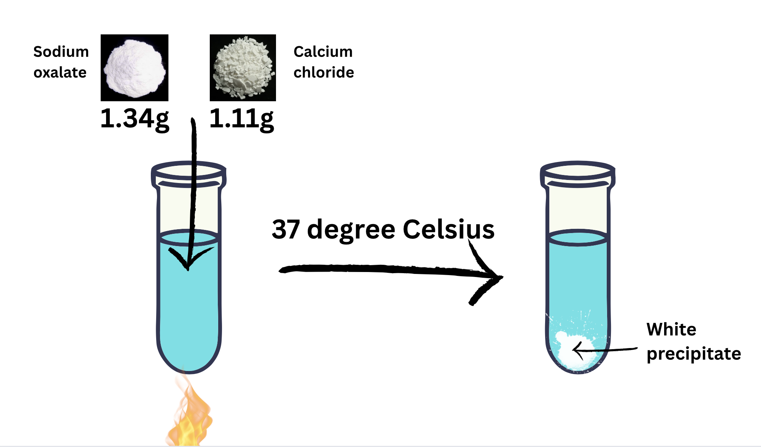
Figure 1. Illustration of experimental method

3. RESULTS AND DISCUSSION
The amount of precipitate measured increases significantly in acidic environments with pH 5.0–6.0, remains relatively low in slightly acidic to neutral environments with pH 6.5–7.0, and slightly increases in basic environments with pH 7.5–8.0.
Table 2. Results measured from 2 experiments (ppt = precipitate, exp = experiment)

pH | Thickness of ppt in 1st exp/mm | Thickness of ppt in 2nd exp/mm | Average thickness of ppt/mm
5.0 | 66 | 34 | 50.0
5.5 | 38 | 35 | 36.5
6.0 | 29 | 27 | 28.0
6.5 | 25 | 29 | 27.0
7.0 | 28 | 24 | 26.0
7.5 | 33 | 29 | 31.0
8.0 | 35 | 30 | 32.5

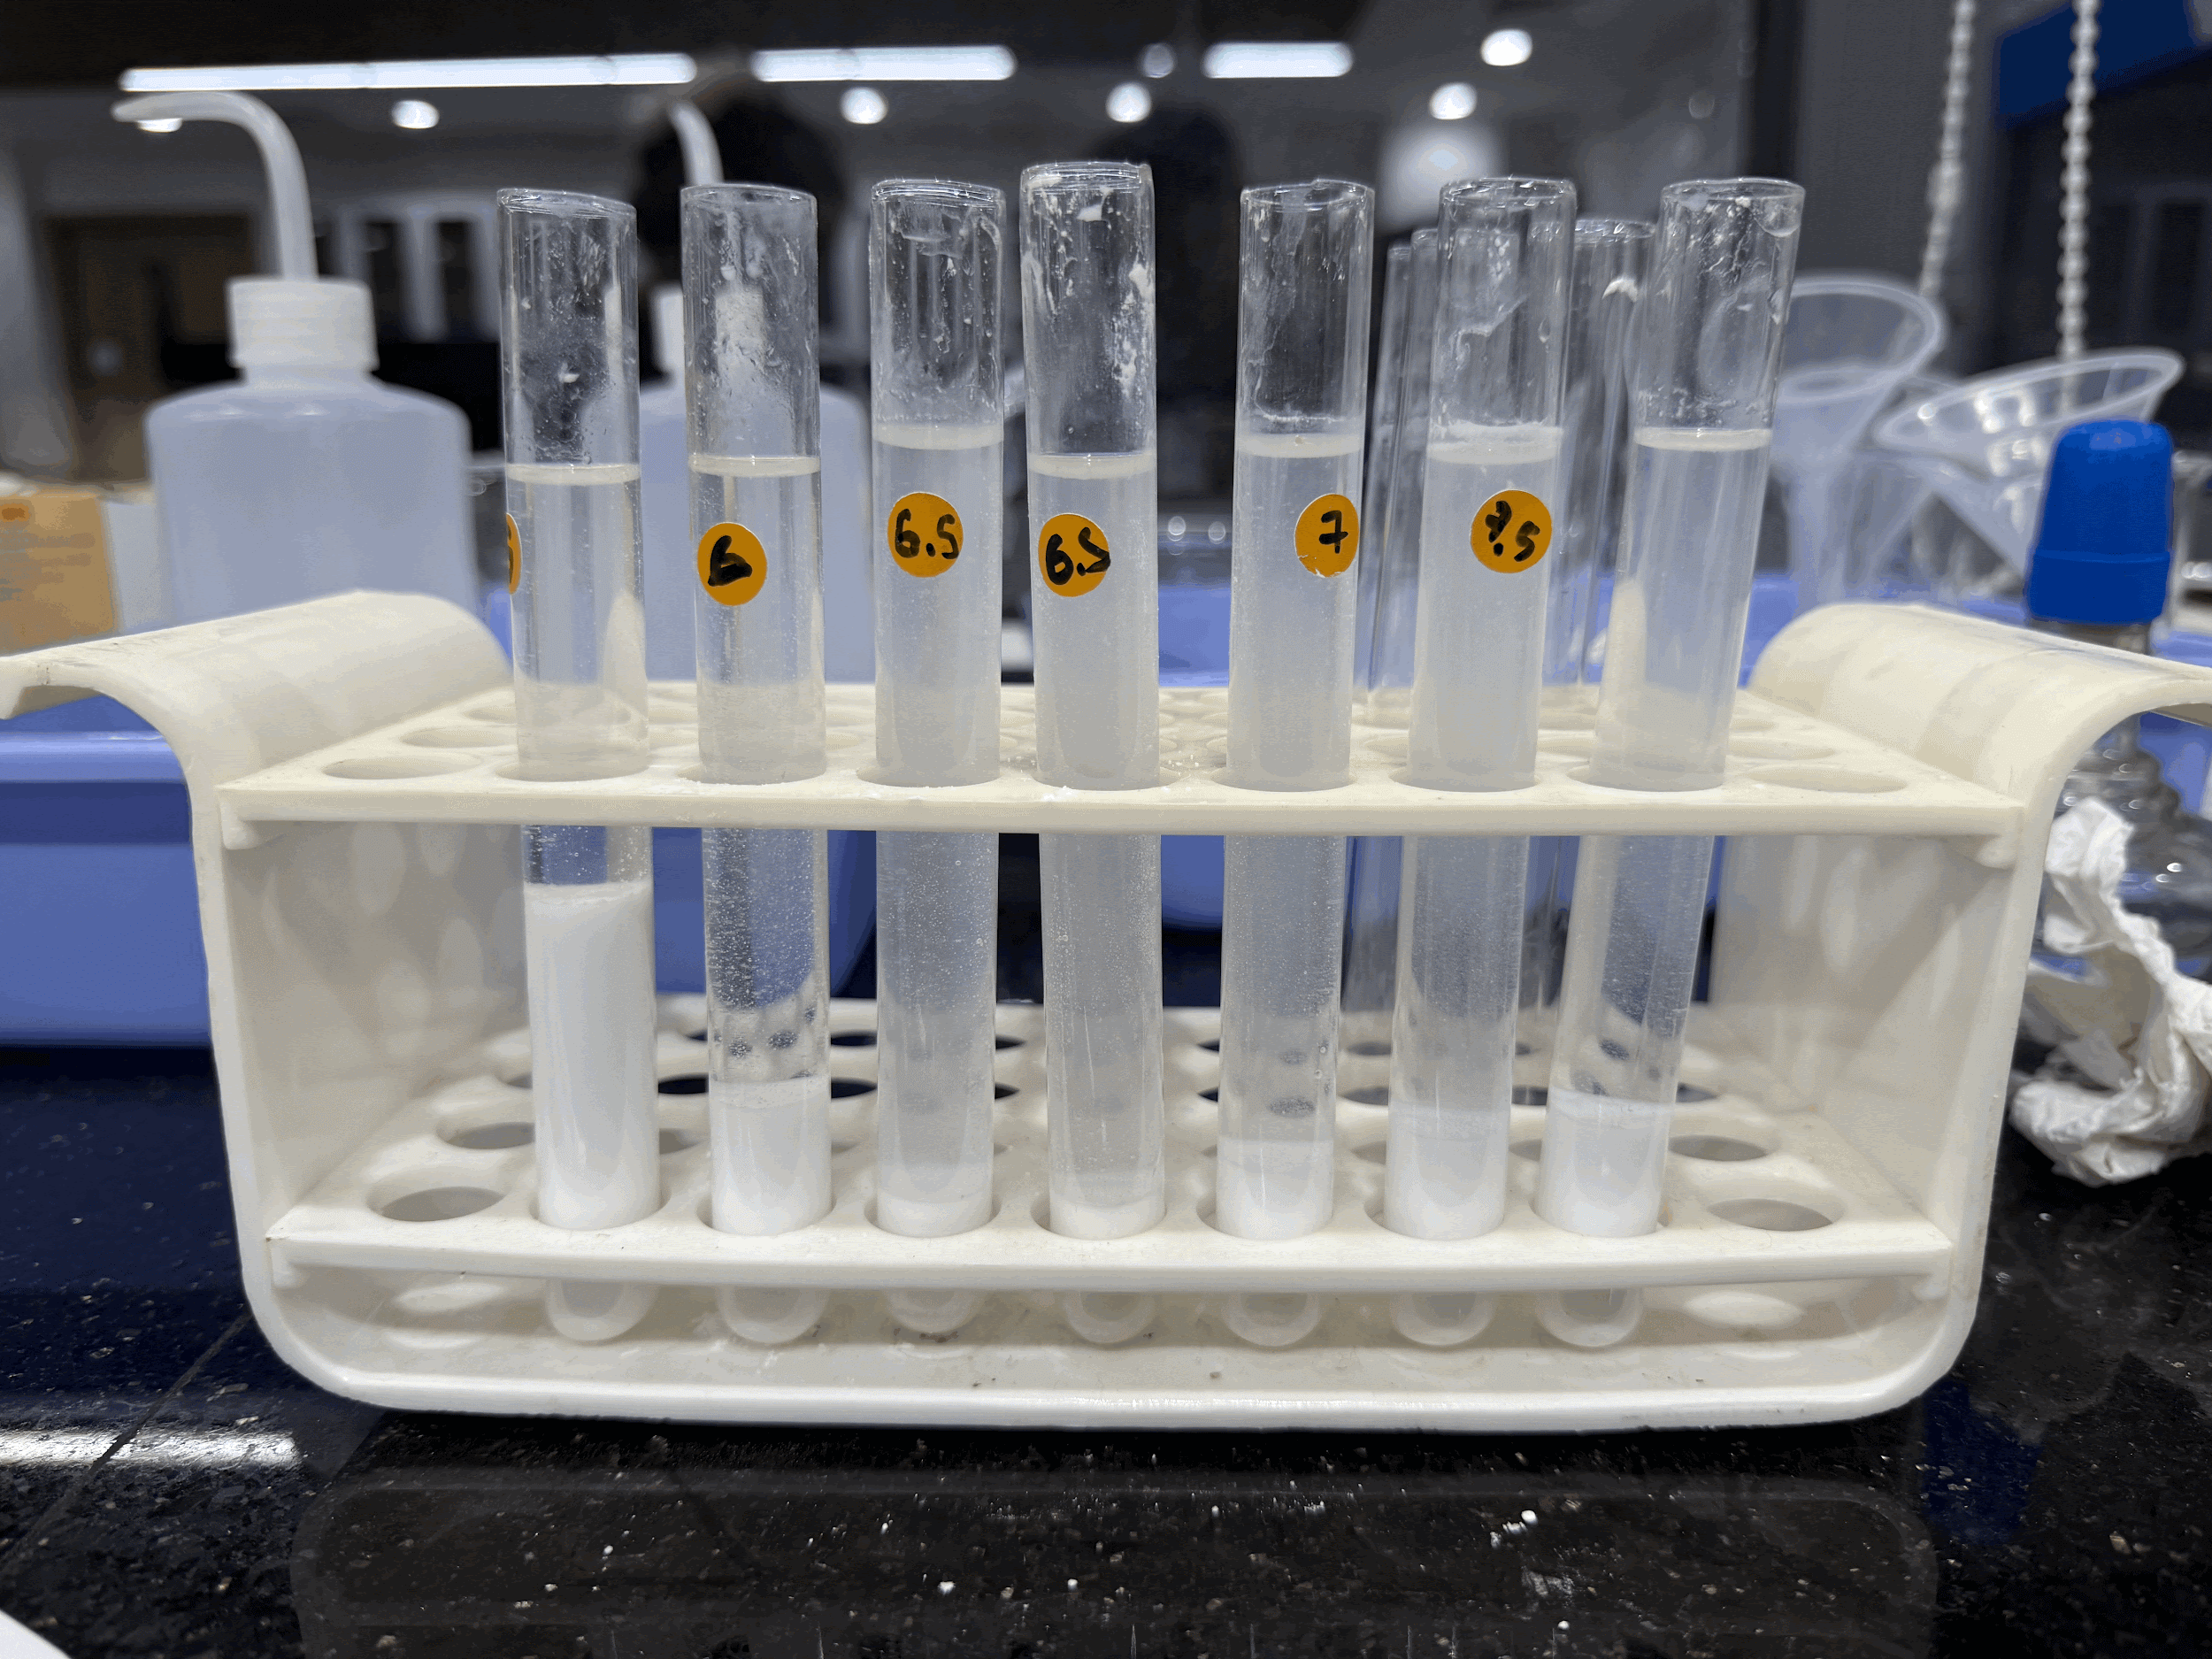
Figure 2. Post-reaction sediment in the first experiment
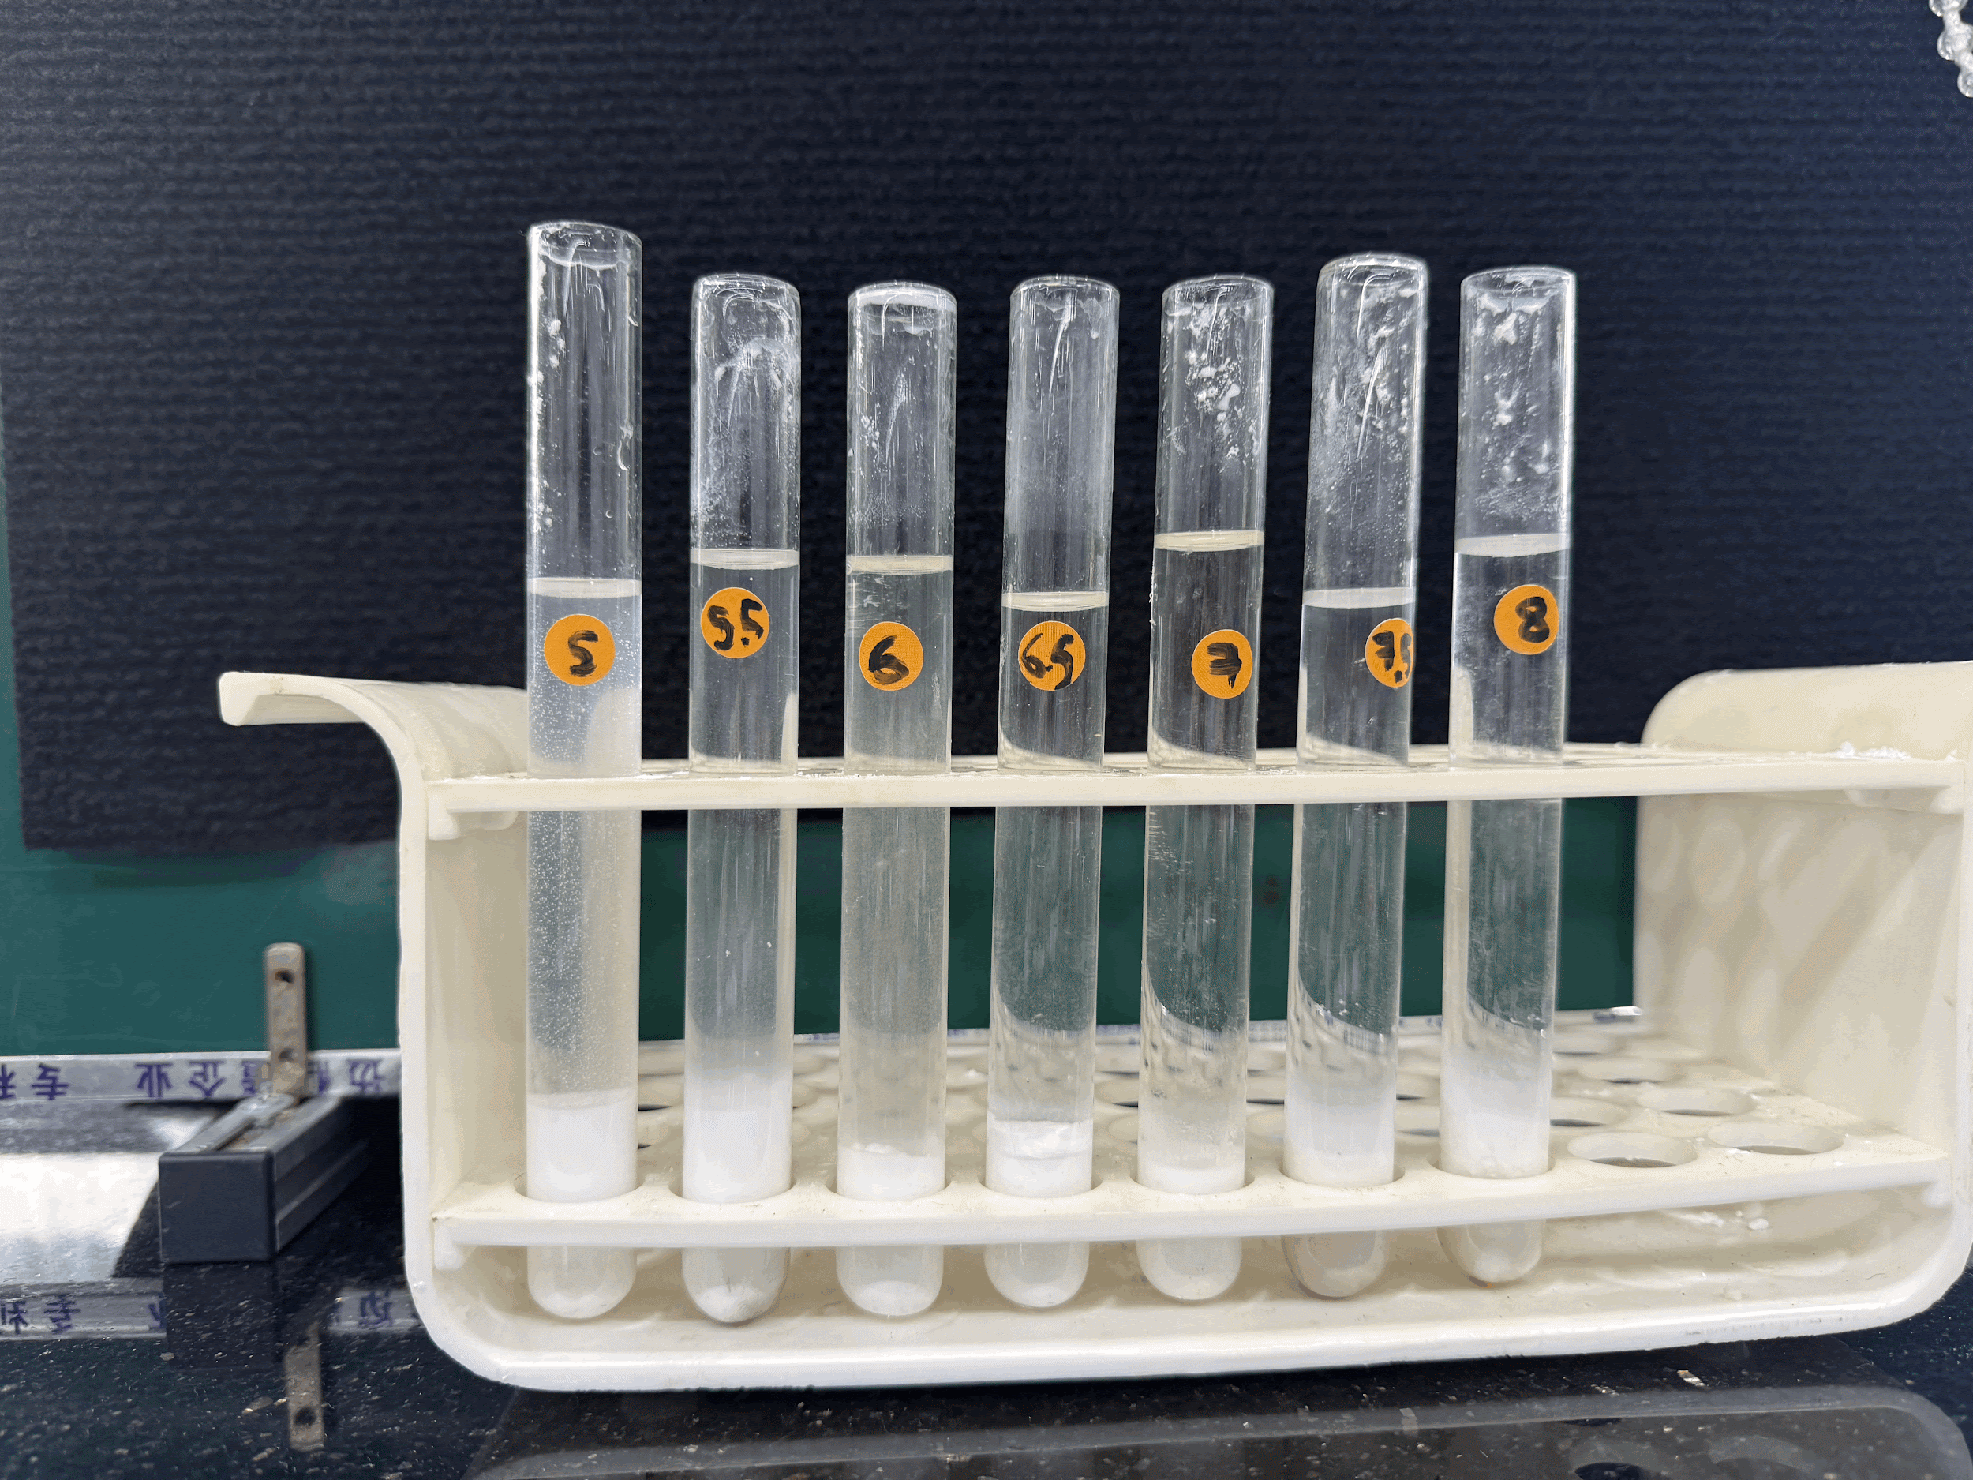
Figure 3. Post-reaction sediment in the second experiment
The results of this study indicate that acidic urine with pH 5.0–5.5 provides the most favorable environment for the formation of CaOx kidney stones, whereas the urine of healthy individuals–typically slightly acidic to neutral–is capable of inhibiting the formation of such stones. The trend can be explained by the interaction between hydrogen ions and citrate in low-pH environments. Under physiological conditions (slightly acidic to neutral pH 6.0–7.0), citrate acts as a natural inhibitor of calcium oxalate precipitation by forming complexes with calcium ions (Leslie & Bashir, 2024). This minimizes the risk of developing kidney stones.
Citrate has three dissociation steps: H₃Cit ⇌ H₂Cit⁻ ⇌ HCit²⁻ ⇌ Cit³ and the highest binding affinity observed for the Ca²⁺citrate³⁻ complex (Zomorodian & Moe, 2025). At lower pH values, the increased concentration of hydrogen ions shifts citrate acid–base equilibria toward more protonated species (H₃Cit and H₂Cit⁻), thereby reducing the fraction of fully deprotonated trivalent citrate (Cit³⁻). Because Cit³⁻ possesses the strongest calcium-chelating capacity, its reduced availability weakens calcium complexation and increases the concentration of free Ca²⁺ ions available for calcium oxalate precipitation.
The findings of this study are largely consistent with previous international research demonstrating that acidic urinary environments promote calcium oxalate (CaOx) stone formation, while conditions closer to physiological pH exert an inhibitory effect. Early compositional analyses of renal stones, such as the X-ray diffraction study conducted by Orlando et al. (2008), established that calcium oxalate constitutes the majority of kidney stones, underscoring the clinical relevance of investigating factors influencing CaOx precipitation. Similarly, although the work by Sakhaee et al. (2009) primarily focused on uric acid stones, it highlighted the broader role of urinary pH in stone pathogenesis and provided indirect support for the increased lithogenic risk associated with acidic conditions.
Nevertheless, while previous studies have demonstrated that alkaline urine reduces the risk of calcium oxalate stone formation, this experiment showed the opposite trend: a slight increase in calcium oxalate precipitation at higher pH values. This discrepancy can be explained by limitations of the experimental method. In addition to calcium oxalate, alkaline conditions may also promote the precipitation of calcium hydroxide, another poorly soluble white compound. In healthy individuals, the average urinary excretion of calcium is about 2.5–7.5 mmol per 1–2 liters of urine, which is not high enough to produce calcium hydroxide precipitates (UCSF, 2023; RCPA, 2024). However, in this study the experimental setup used 0.01 mol (10 mmol) of calcium in each test tube, far exceeding normal urinary levels, thereby facilitating the formation of calcium hydroxide. As a result, the measured precipitate in alkaline conditions may have been greater than the actual amount of calcium oxalate that would form physiologically. The slight increase in precipitate observed at alkaline pH may also reflect a shift in calcium oxalate polymorphism, with greater formation of calcium oxalate dihydrate (COD), which is more likely to form under alkaline conditions compared to calcium oxalate monohydrate (COM) (Manissorn et al., 2017). As the present methodology did not differentiate between COM and COD phases, phase-specific contributions to sediment thickness cannot be determined. Additionally, the formation of other calcium-containing precipitates under alkaline conditions cannot be excluded.
Regression analysis was conducted to examine the relationship between urinary pH and precipitate thickness, where precipitate thickness was used as a proxy for the extent of calcium oxalate formation. Several non-linear models were tested due to the expected inverse relationship between hydrogen ion concentration and calcium oxalate inhibition. While more complex models incorporating additional parameters yielded higher coefficients of determination (R²), these models produced non-physical parameter values and poor visual agreement with the experimental data, suggesting overfitting given the limited sample size. Consequently, a simpler inverse power-law model of the form y = a / x^{b}, with y being the thickness of precipitate obtained and x being pH level, was selected as the most appropriate representation of the data. This model yielded parameters a = 266.13 and b = 1.13, with an R² value of 0.5062. Although the R² indicates moderate explanatory power, the model captures the overall decreasing trend in precipitate thickness with increasing pH and remains chemically interpretable. The inverse relationship is consistent with established biochemical mechanisms, whereby increasing pH reduces hydrogen ion concentration, enhances citrate deprotonation, and strengthens calcium–citrate complexation, thereby inhibiting calcium oxalate precipitation. Given the inherent variability of biological systems and the semi-quantitative nature of sediment thickness measurements, the observed fit is considered acceptable and supports the proposed mechanistic interpretation.
To evaluate the robustness of the observed inverse relationship, a secondary regression analysis was conducted excluding data points at pH 7.5 and 8.0. These alkaline conditions are more susceptible to the formation of non–calcium oxalate precipitates, such as calcium hydroxide or carbonate, which may confound the measurement of true CaOx formation. When these data points were omitted, the inverse power-law model y = a / x^{b}​ yielded parameters a = 1730 and b = 2.23, with an improved coefficient of determination R² = 0.9122. The substantially higher R² suggests that within the physiologically relevant pH range, urinary pH more strongly predicts calcium oxalate precipitation. This finding supports the interpretation that the reduced fit observed in the full dataset arises from chemical interference under alkaline conditions rather than random experimental error.
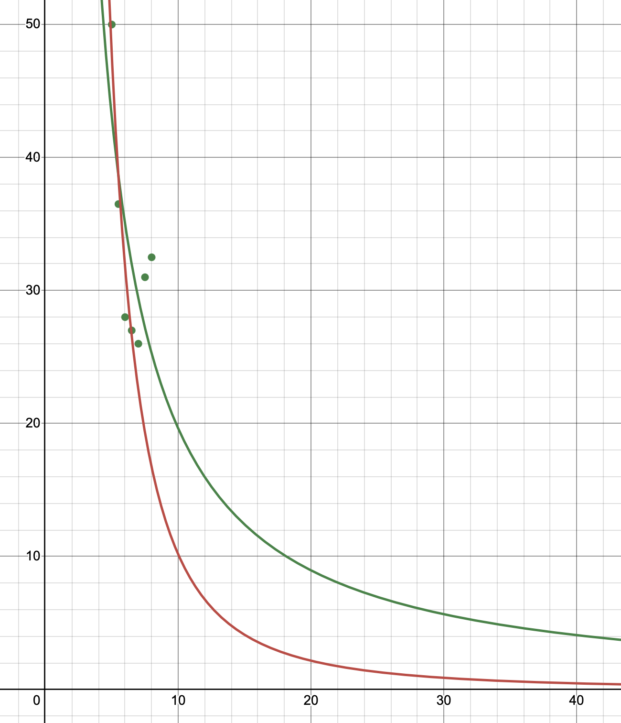
Figure 4. Regression lines of thickness of precipitate sediment and sample urine pH against built before (green) and after (red) omitting data points at pH 7.5 and 8.0
From a clinical perspective, these findings provide a chemical basis for preventive strategies that aim to maintain urinary pH within the physiological range. Dietary patterns and metabolic factors known to influence urinary pH and citrate excretion may therefore play an indirect role in modulating calcium oxalate stone risk. For example, diets rich in fruits and vegetables are associated with increased urinary citrate and higher urinary pH, whereas high animal protein intake is linked to increased acid load and reduced citrate excretion (UCSF, 2023). Although this study does not assess dietary interventions directly, the results support existing preventive approaches that emphasize balanced urinary chemistry rather than extreme pH modification.
4. CONCLUSION
This study demonstrates that urinary pH plays a critical role in calcium oxalate (CaOx) precipitation, with acidic conditions (pH 5.0–5.5) favoring stone formation and slightly acidic to neutral conditions characteristic of healthy urine exerting a protective effect. The results support established biochemical mechanisms in which citrate inhibits CaOx crystallization through calcium complexation, an effect that is weakened under acidic conditions due to citrate protonation. Although a slight increase in precipitate was observed under alkaline conditions, this outcome is attributed to experimental limitations, particularly the formation of non-CaOx calcium salts at supraphysiological calcium concentrations. Regression analyses further reinforce an inverse relationship between pH and CaOx precipitation within the physiologically relevant range, with improved model fit upon exclusion of alkaline conditions susceptible to chemical interference. Overall, these findings highlight the importance of urinary pH regulation in kidney stone prevention and underscore the need for more refined experimental techniques to distinguish CaOx from other calcium-containing precipitates in alkaline environments.

Disclaimer (Artificial intelligence)

Author(s) hereby declare that NO generative AI technologies such as Large Language Models (ChatGPT, COPILOT, etc.) and text-to-image generators have been used during the writing or editing of this manuscript.

5. REFERENCES
M. T. D. Orlando, L. Kuplich, D.O. de Souza, H. Belich, J. B. Depianti, C. G. P. Orlando. (2008). Study of calcium oxalate monohydrate of kidney stones by X-ray diffraction. Power Diffraction, 23(S1), S59–S64. https://doi.org/10.1154/1.2903738
R. Nazarian, N. Lin, S. Thaker, R. Yang, G. C. L. Wong, K. B. Scotland. (2024). What causes calcium oxalate kidney stones to form? An update on recent advances. Uro, 5(1), 30–45. https://doi.org/10.3390/uro5010006
E. M. Worcester, K. J. Bergsland, D. L. Gillen, F. L. Coe. (2018). Mechanism for higher urine pH in normal women compared with men. American Journal of Physiology-Renal Physiology, 314(4), F623–F629. 10.1152/ajprenal.00494.2017
J. Manissorn, K. Fong-Ngern, P. Peerapen, V. Thongboonkerd. (2017). Systematic evaluation for effects of urine pH on calcium oxalate crystallization, crystal–cell adhesion and internalization into renal tubular cells. Scientific Reports, 7(1), 1798. https://doi.org/10.1038/s41598-017-01953-4
K. Sakhaee. (2009). Recent advances in the pathophysiology of nephrolithiasis. Kidney Int, 75(6), 585–595. 10.1038/ki.2008.626
F. Ibis, P. Dhand, S. Suleymanli, Antoine E. D. M., M. van der Heijden, H. J. M. Kramer et al. (2020). A combined experimental and modelling study on solubility of calcium oxalate monohydrate at physiologically relevant pH and temperatures. Crystals, 10(10), 924. https://doi.org/10.3390/cryst10100924
Y. Wang, Y. Zhu, W. Luo, Q. Long, Y. Fu, X. Chen. (2024). Analysis of components and related risk factors of urinary stones: a retrospective study of 1055 patients in southern China. Sci Rep, rep 14, 28357. https://doi.org/10.1038/s41598-024-80147-1
A. Steeley, E. Worcester, M. Prochaska. (2024). Contrasting Response of Urine Stone Risk to Medical Treatment in Calcium Oxalate versus Calcium Phosphate Stone Formers. Kidney360, 5(2), 228-236. https://doi.org/10.34067/KID.0000000000000362
J. Dietrich, A. Costa-Bauza, F. Grases. (2025). Thermodynamic and Kinetic Aspects of Calcium Oxalate Crystallization and Renal Lithiasis. Biomolecules, 15(8), 1141. https://doi.org/10.3390/biom15081141
A. Zomorodian, O. W. Moe. (2025). Citrate and calcium kidney stones. Clinical Kidney Journal, 18(9).https://doi.org/10.1093/ckj/sfaf244
S.W. Leslie, K. Bashir. (2024). Hypocitraturia and renal calculi. StatPearls. PMID: 33232062;
NBK564392
Nguyễn M. A., Bùi H. T. (2023). Nghiên cứu đặc điểm lâm sàng, cận lâm sàng của bệnh nhân có sỏi thận tái phát. Vietnam Medical Journal, 521(1), 80–86. https://doi.org/10.51298/vmj.v521i1.3990
Phạm T. H., Nguyễn C. B., Trần Đ., Phạm V. T. (2022). Nghiên cứu các yếu tố ảnh hưởng đến tỷ lệ thành công và tỷ lệ sạch sỏi của nội soi ngược dòng tán sỏi thận với ống mềm tại Bệnh viện Hữu nghị Việt Tiệp. Vietnam Medical Journal, 511(2), 25–31. https://doi.org/10.51298/vmj.v511i2.2135
A. L. Ferrao, P. Pestana, L. Borges, R. Palmeira-de-Oliveira, A. Palmeira-de-Oliveira, J. Martinez-de-Oliveira. (2024). Quantification of Ions in Human Urine—A Review for Clinical Laboratories. Biomedicines, 12(8). https://doi.org/10.3390/biomedicines12081848
K. C. Manish, S. W. Leslie. (2023). Uric Acid Nephrolithiasis. StatsPearl. PMID: 3280956; NBK560726

Reference to web-resource or electronic articles:
L. Thomas. (2023). Urine composition: What’s normal? News-Medical. https://www.news-medical.net/health/Urine-Composition-Whats-Normal.aspx
S. Watson, D. Rossiaky. (2024). 8 Signs and Symptoms of Kidney Stones. Healthline.
https://www.healthline.com/health/symptoms-of-kidney-stones#summary
S. Bershow. (2023). Preventing kidney stones before they form. Mayo Clinic Health System. https://www.mayoclinichealthsystem.org/hometown-health/speaking-of-health/preventing-kidney-stones#:~:text=This%20is%20the%20most%20effective,for%20preventing%20urinary%20tract%20infections.

Reference to organization as author:
South Tees Hospitals NHS Foundation Trust. (2021). Urine citrate. https://www.southtees.nhs.uk/services/pathology/tests/urine-citrate/
University of California San Francisco. (2023). Calcium - urine. USCF Health. https://www.ucsfhealth.org/medical-tests/calcium---urine#:~:text=How%20the%20Test%20will%20Feel,High%20vitamin%20D%20level
Royal College of Pathologists of Australasia. (2024). Calcium urine. RCPA Manual.
https://www.rcpa.edu.au/Manuals/RCPA-Manual/Pathology-Tests/C/Calcium-urine
University of California San Francisco. (2023). Urine pH test. UCSF Health. https://www.ucsfhealth.org/medical-tests/urine-ph-test#:~:text=A%20diet%20high%20in%20fruits,can%20decrease%20your%20urine%20pH.

