Prenatal Acetaminophen Exposure and Autism Risk: A Narrative Review of the Evidence, Mechanisms, and Clinical Implications

Abstract
Acetaminophen (also known as paracetamol or Tylenol) is the most widely used analgesic and antipyretic during pregnancy and is globally recommended as the first-line treatment when needed. In recent years, observational studies and high-profile regulatory statements have linked prenatal acetaminophen exposure to neurodevelopmental disorders, such as autism spectrum disorder (ASD). These developments have created considerable uncertainty among clinicians and pregnant individuals regarding established pain and fever management practices.
This narrative review synthesizes evidence from large cohort studies, meta-analyses, and mechanistic research to evaluate the strength, consistency, and clinical relevance of these associations. Although some cohort studies report modestly increased relative risks, these are substantially weakened or eliminated in more rigorous designs, particularly sibling-controlled analyses. This pattern strongly indicates residual confounding by familial factors and indications for acetaminophen use. Proposed biological mechanisms including oxidative stress, prostaglandin inhibition, epigenetic modifications, and endocrine disruption are theoretically plausible but lack convincing evidence at therapeutic human doses. The risks of untreated maternal fever and pain are well established. Current evidence does not support avoiding acetaminophen when clinically indicated. Instead, guidelines emphasize judicious use (lowest effective dose for the shortest duration), shared decision-making, and careful risk-benefit assessment. Further research with robust designs, such as sibling comparisons, is needed to guide clinical and regulatory advice.

Keywords: Acetaminophen; Pregnancy; Neurodevelopmental disorders; Confounding; Sibling-controlled analyses.

1. Introduction
Acetaminophen (also known as paracetamol or Tylenol) is one of the most commonly used medications during pregnancy. It is recommended worldwide as the first-line analgesic and antipyretic agent when clinically indicated. Owing to its widespread availability, longstanding record of apparent safety, and decades of routine clinical use, acetaminophen has become the standard pharmacological option for managing pain, fever, and discomfort in pregnant women [1].
Nevertheless, emerging concerns have raised questions about a potential association between prenatal acetaminophen exposure and an increased risk of neurodevelopmental disorders, particularly autism spectrum disorder (ASD). These concerns gained considerable attention following statements from the United States Department of Health and Human Services (HHS) suggesting a possible link between acetaminophen use during pregnancy and autism. The ensuing public and scientific discourse has generated substantial uncertainty among clinicians, researchers, patients, and policymakers alike [2,3].
This ongoing debate carries profound implications for public health. Given that acetaminophen is used by the majority of pregnant women worldwide, even a modest increase in risk, if conclusively established, could translate into substantial population level consequences. Conversely, premature or inadequately supported conclusions risk unintended harm. Untreated fever and severe pain during pregnancy are well documented contributors to adverse outcomes, including preterm birth, congenital anomalies, and miscarriage. Pregnant individuals who become unduly alarmed about acetaminophen may forgo essential treatment, resort to less-studied alternatives, or experience heightened anxiety, all of which can adversely affect maternal and fetal health [4,5-8]
The intersection of near-universal medication exposure, persisting scientific uncertainty, and the deeply emotive nature of neurodevelopmental disorders such as autism underscores the urgent need for rigorous, impartial evaluation of the evidence.
The objective of this narrative review is to critically evaluate the existing evidence concerning acetaminophen use during pregnancy and the potential risk of autism spectrum disorder (ASD). It encompasses a comprehensive examination of epidemiological studies, mechanistic and toxicological findings, regulatory and policy responses, and the potential benefits and risks associated with modifying current clinical practices.
By synthesising the highest-quality available evidence and explicitly highlighting persisting knowledge gaps, this review seeks to provide clinicians, researchers, and policymakers with a clear, balanced, and nuanced understanding of the issue. The ultimate aim is to facilitate evidence based decision making that optimises maternal health while safeguarding the well-being of the developing child.
Taken together, the most methodologically robust evidence suggests that reported associations between prenatal acetaminophen exposure and autism largely reflect confounding rather than causation, and do not justify avoidance of acetaminophen when clinically indicated during pregnancy.
2. Regulatory and Policy Context
At a White House press conference on September 2025, the U.S. Department of Health and Human Services (HHS) highlighted emerging concerns regarding the potential association between acetaminophen use during pregnancy and neurodevelopmental disorders, such as autism spectrum disorder (ASD) and attention-deficit/hyperactivity disorder (ADHD). A growing body of epidemiological evidence, HHS noted, suggests that prolonged exposure to this widely used over the counter analgesic particularly during the later stages of pregnancy, may elevate the risk of these conditions in offspring. In response, HHS announced the launch of a nationwide public service campaign aimed at informing healthcare providers and pregnant individuals about these findings, with an emphasis on promoting cautious and judicious use of the medication[3,9-12].
FDA Actions
On September 22, 2025, the U.S. Food and Drug Administration (FDA) formally initiated the process to update the labeling of acetaminophen products (such as Tylenol) to reflect emerging evidence suggesting that prenatal use may be associated with an increased risk of neurodevelopmental disorders in children, including autism spectrum disorder (ASD) and attention-deficit/hyperactivity disorder (ADHD). Concurrently, the FDA issued a “Dear physician” letter to inform medical professionals of these concerns. Although the accumulated body of evidence is considerable and includes multiple large-scale epidemiological studies, a definitive causal relationship has not been established, and acetaminophen remains a reasonable therapeutic option during pregnancy when clinically indicated. In his public statement, FDA Commissioner Dr. Marty Makary underscored the precautionary considerations within this evolving scientific landscape [13].
Reaction from the Medical Community
The medical community has responded with measured caution. Although observational studies have identified correlations, leading experts in pediatric neurology and obstetrics emphasize that the current evidence remains insufficient to establish causation. For example, the Society for Maternal-Fetal Medicine (SMFM) has highlighted the well documented risks of untreated fever and pain during pregnancy including preterm birth, congenital anomalies, and miscarriage and strongly recommends that clinicians continue to weigh individual risks and benefits when considering acetaminophen use. Similarly, the International Society for Pharmacovigilance (ISoP) has urged restraint in public messaging, noting that the existing body of evidence is inconsistent, ambiguous, and constrained by significant methodological limitations [8,14,15].
Global Perspective
International health authorities have similarly weighed in with restrained perspectives. The World Health Organization (WHO) has publicly rejected claims of a definitive link between prenatal paracetamol (acetaminophen) exposure and autism, affirming that “no consistent association has been established” based on the available evidence. Multiple regulatory and pharmacovigilance bodies, including the International Society for Pharmacovigilance (ISoP), continue to endorse acetaminophen as the preferred first-line antipyretic and analgesic during pregnancy when administered at the lowest effective dose for the shortest duration necessary [14,16,17].
Importance of a Balanced Review
The rapidly evolving regulatory landscape underscores the imperative for a balanced, evidence-based synthesis. Policy decisions particularly those with profound implications for maternal and fetal health must be grounded in rigorous science rather than sensational headlines. Given that acetaminophen remains one of the few over-the-counter analgesics considered safe for use during pregnancy and is relied upon by millions of pregnant individuals worldwide, any modifications to clinical guidelines or product labeling demand meticulous scrutiny. Accordingly, a comprehensive narrative review that critically evaluates the strengths, limitations, and overall weight of the existing evidence is both timely and essential.

3. Epidemiological Evidence
Over the past decade, epidemiological research on prenatal acetaminophen exposure and neurodevelopmental outcomes has grown substantially. While numerous observational studies have reported associations between maternal acetaminophen use during pregnancy and increased risks of conditions such as autism spectrum disorder (ASD) in offspring, the strength, consistency, and interpretation of this evidence continue to spark debate [18,19].

Key factors influencing these findings include variations in study design, the extent to which potential confounders are addressed, and the precision of exposure assessment. This section synthesizes evidence from major cohort studies, meta-analyses, and systematic reviews, followed by a critical evaluation of the reliability of the evidence and inherent limitations.

3.1 Cohort Studies
Large-Scale Prospective Cohorts
One of the most influential studies in this field is the Swedish national cohort, a population-based investigation encompassing approximately 2.48 million children. Initial analyses from this cohort indicated modest associations between prenatal acetaminophen exposure and subsequent neurodevelopmental diagnoses. However, a more rigorous sibling controlled sub-analysis which effectively accounts for shared genetic and familial environmental factors revealed that these associations were substantially attenuated or entirely eliminated after adjusting for familial confounding [5].

Sibling-comparison designs are particularly valuable in neurodevelopmental research because they help mitigate bias from unmeasured inherited traits, parental behaviors, socioeconomic conditions, and shared environmental exposures. In the Swedish cohort, comparisons of siblings discordant for in utero acetaminophen exposure showed no persisting association with autism spectrum disorder (ASD). This finding implies that much of the risk observed in conventional cohort analyses may reflect differences between families rather than a direct effect of the medication itself [5].

The strengths of the Swedish study are considerable: its enormous sample size, prospective design, high-quality diagnostic registries, and sophisticated statistical approaches. That said, important limitations remain. Acetaminophen exposure was primarily assessed through maternal self-reports or prescription records, yet the drug's widespread over the counter availability likely led to substantial exposure misclassification. Additionally, the study lacked detailed information on dosage, duration, and gestational timing of use; factors that could be critical to any potential risk. Finally, while sibling designs are robust against confounding, they may reduce statistical power to detect small true effects, particularly if familial factors interact with the exposure [5].

Other National Cohort Data
The Danish National Birth Cohort (DNBC) offers another major source of evidence. This prospective study followed over 64,000 mother–child pairs from early pregnancy, using computer assisted telephone interviews to obtain relatively detailed information on acetaminophen use. In contrast to the Swedish sibling analyses, the DNBC found statistically significant increases in risk for ASD, especially when accompanied by hyperkinetic symptoms or attention-deficit/hyperactivity disorder (ADHD) [18].

A key observation from the DNBC was a dose–response pattern: prolonged exposure; defined as use for more than 20 weeks during pregnancy, was linked to substantially higher risks of both ASD and hyperkinetic disorders. This pattern lends support to the idea that extended or repeated use may pose greater concerns than brief, intermittent exposure [18].

The DNBC benefits from prospective data collection, extended follow-up, and more nuanced exposure assessment. Nonetheless, as with all observational research, confounding by indication remains a concern: maternal conditions that necessitate acetaminophen (e.g., fever, infection, inflammation, migraine, or chronic pain) might independently affect fetal brain development [6,18,20].

Summary of Cohort Evidence
In summary, evidence from large prospective cohorts is mixed. Some studies document elevated risks, particularly with prolonged exposure, whereas analyses employing advanced methods, most notably sibling controls, often attenuate or eliminate these associations. Such discrepancies highlight the critical role of methodological rigor in interpreting epidemiological findings on this topic [5,18,19].

3.2 Meta-Analyses and Systematic Reviews
Older Meta-Analyses
Early meta-analyses synthesised findings from the initial prospective cohort studies. They concluded that prenatal acetaminophen use was associated with small but statistically significant increases in neurodevelopmental risks [21,22]. Masarwa et al, for instance, reported a risk ratio (RR) of approximately 1.19 for autism spectrum disorder (ASD)) in exposed children [21].

Although these results generated considerable scientific and public interest, the early analyses largely pooled data from studies with moderate to high risks of confounding and limited exposure characterisation. Most did not incorporate sibling-controlled designs, and many relied on unvalidated maternal self-reports.

Umbrella Reviews and High-Level Syntheses
As the body of evidence grew, umbrella reviews began to assess the overall quality and reliability of the accumulated findings. One such review, encompassing nine systematic reviews that included around 40 primary studies, reported that the included reviews described associations between prenatal acetaminophen (paracetamol) exposure and adverse neurodevelopmental outcomes (autism spectrum disorder and/or attention-deficit/hyperactivity disorder) as ranging from possible to strong. Nevertheless, it assigned low (two reviews) to critically low (seven reviews) confidence to these associations, primarily because of widespread methodological limitations [23].
The review highlighted several critical shortcomings: (1) Absence of sibling-comparison models, which are essential for controlling familial and genetic confounders (only one review included such studies, where apparent risks attenuated to null in sibling analyses); (2) exposure misclassification, especially concerning dosage and timing; (3) potential publication bias, amplified by intense public and media attention; (4) confounding by indication, particularly from maternal fever, an independent risk factor for neurodevelopmental harm in offspring[6].
Notably, the limited number of studies that employed sibling controls generally showed attenuation of the associations toward the null, lending further support to the view that earlier findings may reflect residual confounding [5,23,24].

Recent Systematic Reviews and Evaluations
In recent years, there have been more systemic reviews and meta analyses undertaken [25,26-28]. A particularly influential assessment was carried out by a group at Mount Sinai, applying the standardised Navigation Guide methodology for environmental health questions. This systematic review included 46 studies on prenatal acetaminophen exposure and neurodevelopmental outcomes [25]. Its main conclusions were as follows: (1) Associations appeared more consistent in higher-quality studies, especially those with detailed exposure assessment; (2) the evidence met criteria for “limited but suggestive” developmental toxicity; (3) the strongest signals emerged in studies examining prolonged duration of use, consistent with observations from the Danish National Birth Cohort (DNBC) [18]. The review, however, stressed considerable remaining uncertainty and explicitly stated that causality had not been established.
In reaching its conclusions, the Mount Sinai analysis carefully weighed exposure measurement quality, temporality, consistency across studies, biological plausibility, and the degree of confounding control [25].

3.3 Hierarchy of Epidemiological Evidence and Causal Inference
Interpretation of epidemiological findings regarding prenatal acetaminophen exposure critically depends on study design and the extent to which confounding particularly familial and indication-related confounding is addressed. Not all observational evidence contributes equally to causal inference, and greater evidentiary weight must be assigned to designs that more effectively control shared genetic, environmental, and clinical factors. Figure 1 shows the hierarchy of study designs.

Figure 1: Flowchart of Evidence Hierarchy in Evaluating Prenatal Acetaminophen Exposure and ASD Risk
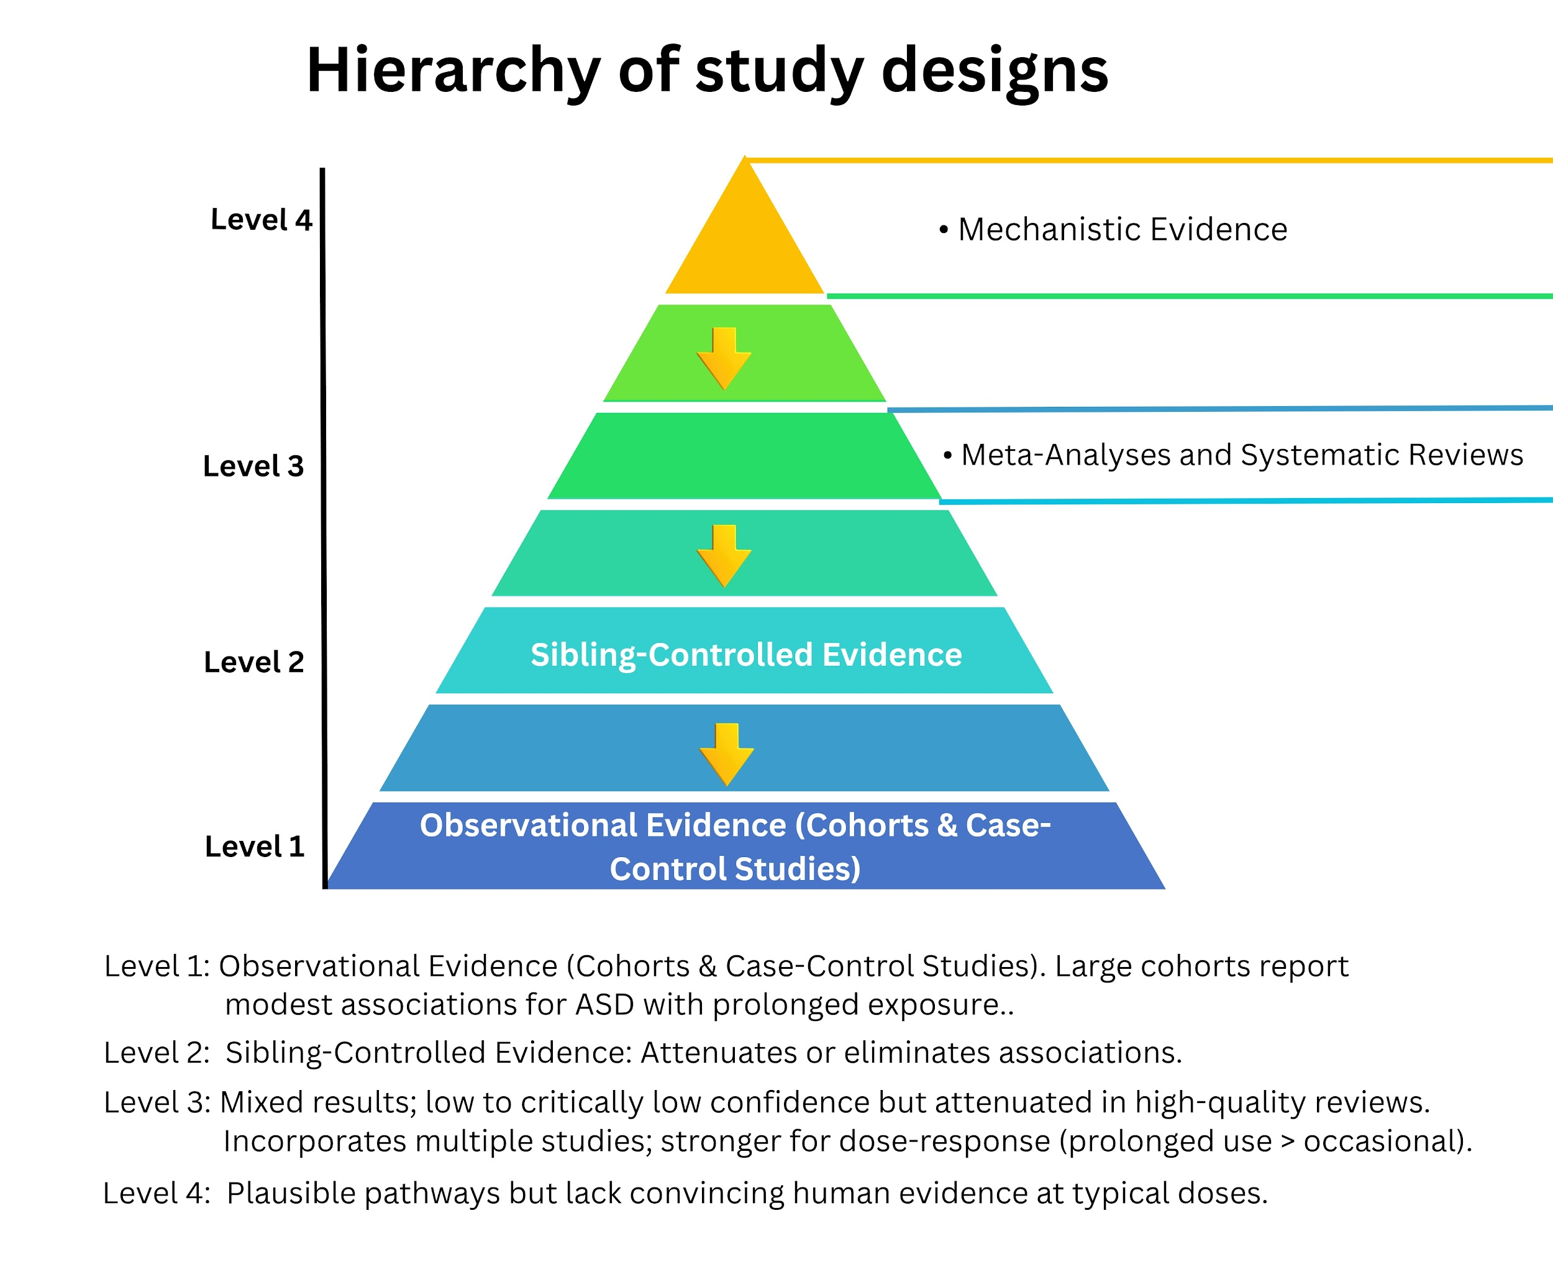

3.4 Critical Appraisal of the Evidence
Confounding and Familial Factors
One of the most significant challenges in interpreting the epidemiological evidence lies in distinguishing the effects of acetaminophen from familial, genetic, and environmental confounders. Sibling-control designs, such as those employed in the Swedish study, effectively control for these shared factors and typically reveal weaker or absent associations. This pattern suggests that many earlier findings may reflect underlying familial vulnerabilities rather than the direct influence of acetaminophen exposure [5,18,29,30].

In contrast, traditional cohort studies are more susceptible to confounding by: Genetic predispositions to autism spectrum disorder (ASD) [29]; Environmental and behavioural differences across families; Maternal psychiatric conditions, which may increase the likelihood of medication use; Maternal illnesses (e.g., fever, infection, or immune activation) that prompt acetaminophen administration [6,30]. This last issue known as indication bias represents a particularly stubborn confounder that is difficult to fully eliminate.

Exposure Measurement Issues
Accurately assessing acetaminophen exposure during pregnancy remains problematic for several reasons: The drug is widely available over the counter [5]; mothers often underreport their use; details on dosage, frequency, and duration are infrequently captured with precision [1]; the timing of exposure, including potential critical windows, is rarely documented accurately [1]. Underreporting generally biases results toward the null, whereas imprecise timing may mask important periods of vulnerability [28].

Dose–Response and Timing
A convincing causal association typically requires evidence of a dose–response relationship. Here, the findings are inconsistent: some studies, including the Danish National Birth Cohort, report stronger associations with prolonged or high-frequency use [18,24]; many others lack the detailed exposure data needed to evaluate dose–response gradients reliably [29]; evidence pinpointing specific trimester-specific windows of susceptibility remains limited [18]. Consequently, prolonged exposure appears more consistently linked to increased risk, whereas occasional or short-term use shows weaker and less reliable associations [18].

Publication Bias and Reverse Causality
Given the intense public and scientific interest in autism, publication bias is a plausible concern: studies finding positive associations are more likely to be published than those reporting null results. Reverse causality, though less probable, has also been proposed—maternal inflammation associated with ASD risk might itself cause pain or fever, thereby increasing acetaminophen use [1,5,6,15,23,25].

Statistical Power and Heterogeneity
Considerable heterogeneity across studies further complicates interpretation. Differences arise in: population characteristics; methods of exposure assessment; diagnostic criteria for ASD; strategies for confounder adjustment. Such variability hinders meaningful meta-analysis and erodes confidence in summary estimates [21,23,25].

Remaining Gaps
Despite a substantial body of research, important gaps persist:

• Randomised trials are ethically impossible;
• Exposure timing and dosage are still poorly measured;
• The independent role of maternal illness remains unclear;
• High-quality familial control studies are scarce;
• Putative biological mechanisms are incompletely elucidated;
• Data from low- and middle-income countries are limited.

These limitations underscore the need for continued caution when interpreting the current evidence base [5,23,25].

Table 1. Summary of Key Epidemiological Studies Examining Prenatal Acetaminophen Exposure and Neurodevelopmental Outcomes
Study (Author/Year) | Design | Sample Size | Key Finding (Association with ASD) | Strength of Association (RR/OR/HR) | Notable Limitations | Sibling-Control Adjusted?
Liew et al. (2016) | Prospective cohort | 64,322 mother–child pairs | Increased ASD risk, esp. with prolonged use (>20 weeks) | HR 1.51 (95% CI 1.19-1.92) for ASD + hyperkinetic symptoms | Confounding by indication; self-reported exposure; no sibling controls | No [18]
Avella-García et al. (2016) | Prospective cohort | 2,644 mother-child pairs | Greater autism spectrum symptoms in males; adverse attention effects in both genders; dose-response by frequency | β = 0.63 (95% CI 0.09-1.18) for CAST scores in males; higher with frequent use (β = 1.91, 0.44-3.38) | Self-reported exposure; no sibling controls; focused on symptoms not clinical diagnoses; gender-specific effects | No [19]
Ahlqvist et al. (2024) | Prospective cohort + sibling sub-analysis | 2.48 million children; ~1.2 million sibling pairs | Modest initial link; null after sibling adjustment | HR ≈1.0 (null) after sibling adjustment | Exposure misclassification; no dose/timing data; potential low power for small effects | Yes [5]
Masarwa et al. (2018) | Meta-analysis | Pooled >700,000 | Increased ASD risk | RR 1.19 (95% CI 1.02-1.39) | High confounding; unvalidated reports; no sibling designs; publication bias | No  [21]
Alemany et al. (2021) | Meta-analysis of prospective cohorts | ~73,881 children (6 European cohorts) | Increased borderline/clinical ASD symptoms after prenatal exposure | OR 1.19 (95% CI 1.07-1.33) for ASD symptoms | Self-reported exposure; no sibling controls; symptom-based (not diagnoses); potential confounding | No [26]
Prada et al. (2025) | Systematic review (Navigation Guide methodology) | 46 studies  No (focus on overall evidence) | Limited but suggestive evidence of developmental toxicity; positive associations in most studies, stronger in higher-quality ones; supports link to ASD/ADHD/NDDs | Various (e.g., OR/RR 1.2-1.5 in consistent studies); dose-response in some | Observational nature; variable confounding control; inconsistent dose/timing data; no definitive causality | No [25]
Sheikh et al. (2025) | Umbrella review of systematic reviews (9 reviews, including 4 meta-analyses; ~40 primary studies) | Pooled from ~40 primary studies (large cohorts, total participants in hundreds of thousands to millions) | Possible/strong associations reported, but low/critically low confidence; no clear causal link; familial confounding likely explains signals | RR/OR typically 1.1–1.5 (unadjusted); null/attenuated after familial adjustment (e.g., absolute risk 0.98, 95% CI 0.93-1.04) | Low evidence quality; bias; confounding (e.g., indication); exposure misclassification; limited familial controls | Partial (only 1-2 studies/reviews) [23]

ASD — Autism Spectrum Disorder; ADHD — Attention-Deficit/Hyperactivity Disorder; NDDs — Neurodevelopmental Disorders; RR — Relative Risk; OR — Odds Ratio; HR — Hazard Ratio; CI — Confidence Interval; CAST — Childhood Asperger Syndrome Test (a screening tool for autism spectrum symptoms); β — Beta coefficient (regression coefficient)

4. Biological Plausibility and Mechanisms
For an epidemiological association to be considered potentially causal, it must be supported by biologically plausible mechanisms. Acetaminophen has long been regarded as safe during pregnancy, yet growing attention has focused on its pharmacokinetics in gestation and its potential to affect fetal neurodevelopment through several biological pathways. Although definitive mechanisms remain unestablished, multiple hypotheses have emerged from toxicological, developmental, and experimental evidence, as shown in figure 2.

Pharmacokinetics in Pregnancy
Acetaminophen is a small, lipophilic molecule that readily crosses the placenta, leading to fetal plasma concentrations similar to maternal levels. This placental transfer occurs throughout pregnancy, exposing the developing fetus during critical periods of brain development, such as neuronal proliferation, migration, synaptogenesis, and network formation. Notably, the fetus has limited metabolic capacity compared with adults. The immature fetal liver detoxifies reactive metabolites less effectively, which may heighten vulnerability to oxidative or metabolic stress. These pharmacokinetic factors provide a foundational reason for concern, especially with prolonged or repeated exposure [27,31,32,33,34].

Proposed Mechanisms
Oxidative Stress and Reactive Metabolites
Acetaminophen is mainly metabolized via glucuronidation and sulfation, but a small portion is converted by cytochrome P450 enzymes into the reactive metabolite N-acetyl-p-benzoquinone imine (NAPQI). In adults, glutathione rapidly detoxifies NAPQI. In the fetal environment, however, glutathione reserves are lower, raising the possibility that reactive metabolites could trigger oxidative stress. Oxidative stress during neurodevelopment can disrupt neuronal differentiation, synaptic plasticity, and long-term neurobehavioral outcomes, making this a biologically plausible pathway[2,35,36,37]

Prostaglandins and Endocrine Disruption
Acetaminophen inhibits cyclooxygenase (COX) activity, particularly in the central nervous system, thereby affecting prostaglandin synthesis. Prostaglandins play key roles in neurodevelopment, neuronal signaling, and neuroinflammation. Experimental studies also indicate that acetaminophen may act as a weak endocrine disruptor, potentially interfering with sex hormone signaling. Since sex hormones guide brain sexual differentiation and neurodevelopmental trajectories, disruption of these pathways offers a plausible link to neurodevelopmental disorders following prenatal exposure [36,38-42].

Epigenetic Modifications
Emerging evidence suggests that acetaminophen exposure may alter epigenetic regulation, including DNA methylation and histone modifications. Such changes during prenatal development can produce lasting shifts in gene expression without altering the DNA sequence itself. Preliminary observational studies have linked prenatal acetaminophen exposure to differential DNA methylation in genes involved in neurodevelopment, immune regulation, and oxidative stress. Although these findings remain early-stage, they highlight the potential for acetaminophen to exert enduring effects through epigenetic programming [34,43,44].

Inflammation and Immune Modulation
Another proposed mechanism centers on immune and inflammatory pathways. Maternal immune activation during pregnancy is a recognized risk factor for altered neurodevelopment. Acetaminophen may modulate cytokine production or immune signaling, potentially interacting with maternal inflammatory conditions, such as infection or fever. In this scenario, acetaminophen might not act as a primary cause but could modify or amplify ongoing inflammatory processes, which complicates causal inference [36,45].

Animal and In Vitro Evidence
Preclinical studies offer mixed yet valuable insights. Rodent models have shown that prenatal or early postnatal acetaminophen exposure can alter neurobehavioral outcomes, including changes in locomotion, attention, and social behavior. In vitro studies using neuronal cultures and placental models indicate effects on oxidative stress markers, mitochondrial function, and inflammatory signaling. These results support biological plausibility, but they require cautious interpretation: experimental doses often exceed typical human therapeutic levels, and developmental timing may not align directly with human gestation [46].

Figure 2: Conceptual Diagram of Potential Mechanisms

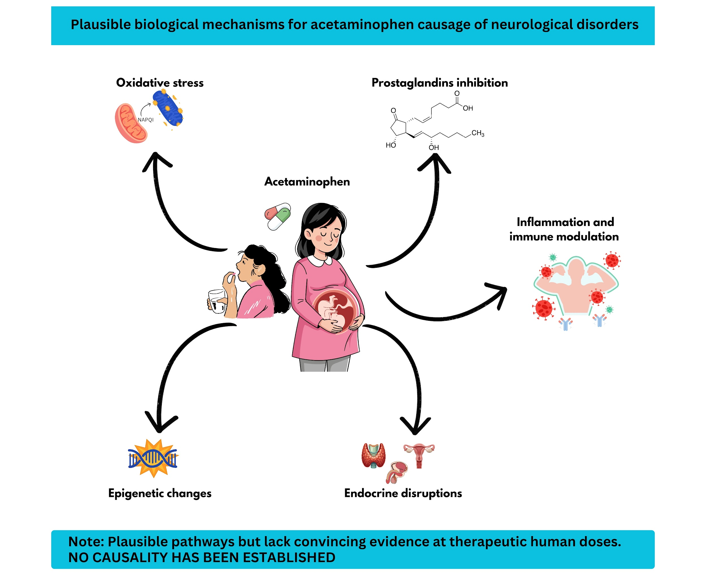

Limitations of Mechanistic Evidence
Despite these proposed mechanisms, the evidence base has significant limitations. Some experimental studies rely on animal models, which differ from humans in metabolism, brain development timing, and enzyme expression. Laboratory dosing regimens may not mirror real-world therapeutic use. Moreover, many studies fail to distinguish adequately between intermittent and chronic exposure or to replicate human gestational timing precisely. Thus, while mechanistic data bolster plausibility, they fall short of establishing causality and should be regarded as supportive rather than conclusive.

5. Benefits, Risks, and Clinical Implications
Benefits of Acetaminophen Use in Pregnancy
Acetaminophen has long been considered one of the safest options for managing pain and fever during pregnancy, especially when compared to nonsteroidal anti-inflammatory drugs (NSAIDs) and opioids. Major obstetric and maternal-fetal medicine societies recommend it as the first-line treatment for these symptoms across all trimesters. This recommendation stems from extensive clinical experience and a lack of consistent evidence linking it to major congenital anomalies [1,8,15].

Treating maternal pain and fever effectively is crucial. Untreated fever, particularly in the first trimester, has been linked to risks such as miscarriage, neural tube defects, and other birth defects. Fever often signals underlying infection or inflammation, which can harm fetal development on its own [6]. Unmanaged pain, meanwhile, can lead to increased stress, disrupted sleep, reduced mobility, and poorer mental health for the mother. In many situations such as viral illnesses, postoperative recovery, or chronic conditions, acetaminophen remains the safest pharmacologic choice available [1,15,16].

Pregnancy care always involves a personalized assessment of risks and benefits. For some women, acetaminophen is essential to avoid greater harm to themselves or their baby, highlighting the importance of viewing any potential neurodevelopmental concerns in the full context of maternal well-being.

Potential Risks if the Hypothesis Is True
If prenatal exposure to acetaminophen were proven to cause even a small increase in the risk of neurodevelopmental disorders, the public health impact could be significant, given how commonly it is used in pregnancy. Conditions like autism spectrum disorder and it's management already place heavy burdens on individuals, families, and society, making any avoidable risk factor a serious concern [47].

Such findings could also reshape clinical guidelines, patient choices, regulations, and legal frameworks. Greater awareness might discourage use even when it is needed, raising the dangers of untreated fever or pain. It could also heighten anxiety for pregnant women, foster guilt among parents of affected children, and create new liability issues for drug makers and clinicians.

Clinical Guidance and Recommendations
Current evidence leads major professional organizations to endorse acetaminophen during pregnancy when it is clinically needed [1,8,15,16]. That said, a cautious approach makes sense: clinicians should advise using the lowest effective dose for the shortest time required, avoiding prolonged or unsupervised chronic use, and encouraging patients to seek advice for ongoing symptoms [14].

Shared decision making is key. Providers should guide patients in balancing the clear risks of untreated maternal conditions against the uncertain and likely small neurodevelopmental risks hinted at in observational studies. Discussions should be more focused on absolute risks rather than relative ones, steer clear of alarming language, and stress that causality has not been established.

Figure 3 shows various scenarios for judicious acetaminophen use in pregnancy. If stronger evidence emerges in the future, obstetric, pediatric, and pharmacology societies may revise their guidance to reflect it clearly and consistently.

Figure 3: Scenarios for Judicious Acetaminophen Use in Pregnancy: Recommendations Based on Current Evidence
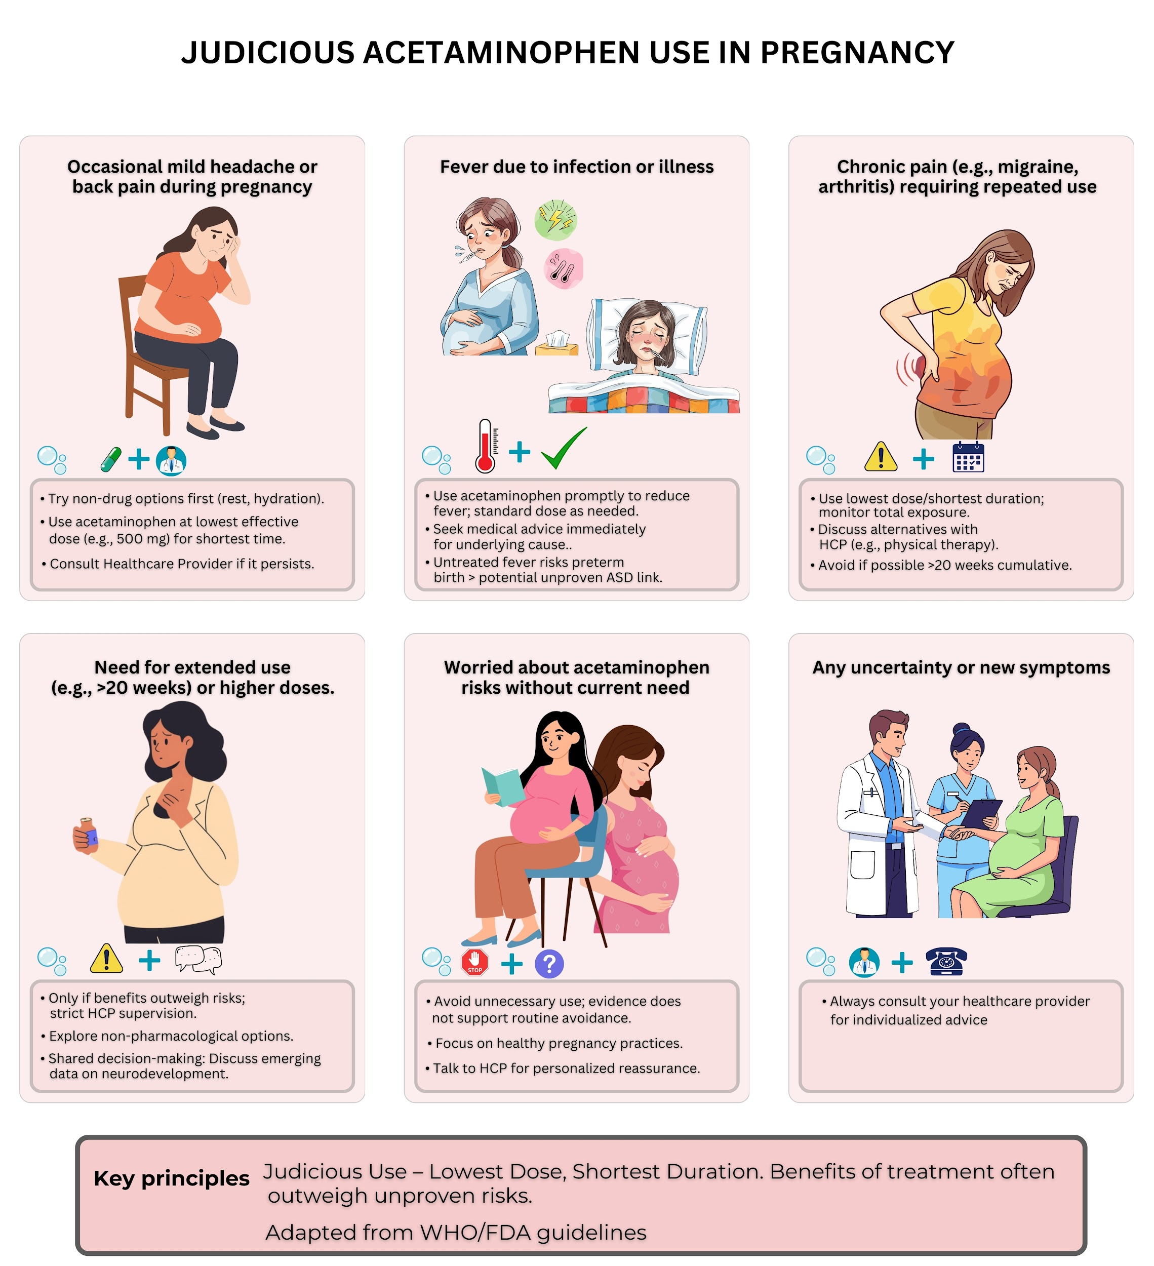

Public Health and Policy Implications
On a broader scale, emerging data on this topic risk being misinterpreted or overstated, especially if scientific uncertainty is not communicated well. Hasty policy changes could unintentionally harm patients by limiting access to needed treatment. On the other hand, thoughtful measures such as updated labeling, better clinician training, and clear patient information could promote safer use without denying availability [13].

Public health efforts should also highlight non-drug options for managing pain and fever in pregnancy when suitable, while preserving acetaminophen as a vital medication [48]. In the end, decisions at the policy level must strike a careful balance between caution and proportion, always anchored in strong evidence and transparent communication.

Table 2: Positions of Major Regulatory and Professional Bodies on Acetaminophen Use During Pregnancy
Organization / Regulatory Body | Year of Statement | Position on Acetaminophen Use in Pregnancy | Key Rationale | Overall Stance
U.S. Food and Drug Administration (FDA) | 2025 | Initiated labeling updates highlighting possible association with neurodevelopmental disorders; continues to allow use when clinically indicated | Observational evidence suggests potential risk, but causality not established; benefits for pain and fever management acknowledged | Cautious / Precautionary [13]
U.S. Department of Health and Human Services (HHS) | 2025 | Public-service campaign encouraging judicious use during pregnancy | Emphasized emerging epidemiological findings, particularly with prolonged exposure | Cautious [3,12]
Society for Maternal-Fetal Medicine (SMFM) | 2021–2025 | Recommends acetaminophen as first-line analgesic and antipyretic in pregnancy when clinically indicated | Risks of untreated fever and pain outweigh uncertain and unproven neurodevelopmental risks | Supportive with Risk–Benefit Framing [8]
World Health Organization (WHO) | Ongoing | Endorses acetaminophen as preferred antipyretic and analgesic during pregnancy  Supportive | No consistent evidence of causal association with autism; long-standing safety record | Supportive [16]
International Society for Pharmacovigilance (ISoP) | 2021–2024 | Urges restraint in public messaging; no change to current clinical recommendations | Evidence considered inconsistent and methodologically limited; risk of misinterpretation | Supportive / Caution Against Overinterpretation [14]
American College of Obstetricians and Gynecologists (ACOG) | 2021 | Continues to recommend acetaminophen for pain and fever in pregnancy | Lack of high-quality causal evidence; importance of maternal symptom control | Supportive [1]
European Medicines Agency (EMA) | Ongoing | No formal restriction; acetaminophen remains recommended when necessary | Available data insufficient to establish causal relationship  Supportive | Supportive [17]

6. Critiques, Counterarguments, and Limitations of the Narrative
Although a growing body of observational research has explored prenatal acetaminophen exposure and subsequent neurodevelopmental outcomes, the evidence remains fundamentally associative rather than causal [49]. A core limitation of this literature is that most studies are observational: they can identify correlations but cannot definitively prove that acetaminophen causes autism spectrum disorder (ASD) or related conditions. As regulatory bodies, including the U.S. Food and Drug Administration (FDA), have noted, replicated associations do not equate to proof of causality. The FDA has acknowledged the body of evidence suggesting possible links while consistently emphasizing that a causal relationship has not been established [13]. This scientific uncertainty calls for cautious interpretation and measured messaging in clinical and public health settings.

Some of the most rigorous studies challenge the idea of a strong causal link. Sibling-control analyses, such as those conducted in large Scandinavian cohorts, naturally account for shared familial factors which includes genetics and environmental influences that can confound standard cohort designs [5]. These studies often weaken or eliminate the observed associations between prenatal acetaminophen exposure and ASD, suggesting that familial and genetic confounders explain much of the risk seen in less controlled analyses. Similarly, independent teams from institutions like Drexel University and the Karolinska Institutet have reported findings that do not support a robust association once key confounders are properly addressed [50].

A major potential bias in this field is indication bias. The maternal conditions that lead to acetaminophen use such as fever, infection, inflammation, or chronic pain are themselves associated with adverse neurodevelopmental outcomes [6,30]. Without fully accounting for these underlying indications, it becomes challenging to separate the effects of the medication from those of the condition it treats. This issue highlights the inherent difficulties in interpreting observational data in perinatal pharmacology.

The public and policy discourse surrounding acetaminophen in pregnancy has also grown politically charged, especially following high-profile statements and debates. In some instances, messaging has risked outpacing the scientific evidence, leading to confusion among clinicians and patients. A balanced, evidence-based approach is crucial to prevent unintended harms.

Important ethical considerations arise as well. Overemphasizing unproven risks may deter pregnant individuals from treating pain or fever effectively, which can themselves jeopardize maternal and fetal well-being. Moreover, labeling acetaminophen as a "cause" of complex, multifactorial outcomes risks stigmatizing and blaming mothers for events beyond their full control. Ethical communication must strike a careful balance: being transparent about ongoing uncertainties while avoiding undue alarm or judgment.

7. Future Directions and Research Needs
Epidemiological Research
The highest priority is to advance epidemiological studies with stronger, family-informed designs. Additional sibling-controlled cohort studies are needed in diverse populations beyond Northern Europe, including North America, Africa, and Asia, where genetic backgrounds, reasons for acetaminophen use, and patterns of over the counter access vary considerably. These studies should ideally be nested within prospective birth cohorts that offer far better exposure assessment. Relying solely on retrospective maternal recall or prescription databases is no longer adequate. Future work would benefit from daily medication diaries, pharmacy purchase records, biomarkers of acetaminophen or its metabolites in maternal or cord blood [11,44], and detailed documentation of dose, formulation, and timing. Special emphasis should be placed on trimester-specific exposure, cumulative duration, and frequency of use to enable robust evaluation of dose–response relationships and to pinpoint potential critical windows of vulnerability.

Mechanistic and Translational Studies
Progress in mechanistic research must run in parallel. Additional preclinical studies are essential to test proposed pathways such as oxidative stress, endocrine disruption, and epigenetic modifications at doses and exposure patterns relevant to human use. Sophisticated models, including placental perfusion systems, cerebral organoids, and single-cell transcriptomic or epigenomic profiling [51,52], could help determine whether acetaminophen or its metabolites directly alter neurodevelopment. Animal studies should adopt clinically realistic intermittent dosing regimens and assess long-term behavioral outcomes that more closely mirror human ASD disorders. Closing the translational gap between toxicological findings and human developmental biology remains critical before mechanistic evidence can meaningfully guide clinical or policy decisions.

Natural Experiments and Intervention Designs
Although randomized trials that assign acetaminophen exposure to assess autism risk are ethically unacceptable, natural experiment designs offer valuable opportunities. In regions where labeling requirements or prescribing guidelines change, researchers could track population-level neurodevelopmental outcomes before and after such shifts, applying rigorous causal inference techniques. Pragmatic trials could also evaluate alternative strategies for managing fever or pain such as non-pharmacologic approaches without requiring complete avoidance of acetaminophen.

Policy and Communication Research
Another important frontier lies in understanding the real-world effects of risk communication. Research should explore how clinicians and pregnant individuals interpret absolute versus relative risks, identify messaging approaches that reduce unnecessary anxiety while supporting informed treatment decisions, and determine how professional societies can provide consistent, evidence-based guidance. Systematic evaluation of regulatory label changes on prescribing patterns and maternal health outcomes will help ensure that precautionary measures do not inadvertently cause harm.

Pharmacovigilance
Finally, stronger pharmacovigilance infrastructure is needed. Dedicated pregnancy exposure registries with long-term follow-up, integrated electronic health records linked to pediatric developmental services, and standardized diagnostic criteria would enable more reliable ongoing surveillance. Harnessing real-world data through transparent, reproducible methods could identify rare but important signals while preserving public trust in both the medication and the monitoring systems.

8. Conclusion
The debate over acetaminophen use in pregnancy and its potential association with autism risk presents a profound clinical dilemma. Acetaminophen is widely regarded as the safest recommended analgesic and antipyretic for pregnant individuals, particularly when compared with alternatives such as nonsteroidal anti-inflammatory drugs or opioids, both of which carry well established obstetric risks. Nevertheless, several observational studies have raised concerns about possible links to neurodevelopmental disorders, most notably autism spectrum disorder and attention-related conditions. This review highlights an inconsistent evidence base characterized by studies of varying methodological quality. Although many cohort investigations report modest associations, analyses based on the most robust designs especially sibling-controlled studies and those addressing indication bias routinely weaken or eliminate these signals. Such findings suggest that familial and genetic confounding, rather than a direct effect of acetaminophen, may account for much of the observed risk. Proposed biological mechanisms, including prostaglandin inhibition, oxidative stress, and endocrine disruption, remain plausible given the drug’s ability to cross the placenta; however, these hypotheses lack strong validation at typical human doses and have not been clearly linked to adverse clinical outcomes. In the context of ongoing uncertainty, clinical practice should continue to emphasize careful risk–benefit assessment. The most prudent approach is to use the lowest effective dose for the shortest necessary duration under medical guidance, while avoiding communication that could deter appropriate treatment. Public health efforts must acknowledge unresolved questions without generating undue alarm, safeguard access to effective symptom relief, and champion rigorous research to definitively address these critical issues.

References

1. American College of Obstetricians and Gynecologists. Acetaminophen Use in Pregnancy and Neurodevelopmental Outcomes. Practice Advisory. September 2025 [cited 2025 Oct 25]. Available from: https://www.acog.org/clinical/clinical-guidance/practice-advisory/articles/2025/09/acetaminophen-use-in-pregnancy-and-neurodevelopmental-outcomes.

2. Ji Y, Azuine RE, Zhang Y, Hou W, Hong X, Wang G, Riley A, Pearson C, Zuckerman B, Wang X. Association of cord plasma biomarkers of in utero acetaminophen exposure with risk of attention-deficit/hyperactivity disorder and autism spectrum disorder in childhood. JAMA Psychiatry. 2020;77(2):180-9. doi:10.1001/jamapsychiatry.2019.3259.

3. U.S. Department of Health & Human Services. Autism announcement & fact sheet [Internet]. Washington, DC: U.S. Department of Health & Human Services; [cited 2025 Oct 25]. Available from: https://www.hhs.gov/press-room/autism-announcement-fact-sheet.html.

4. Zafeiri A, Mitchell RT, Hay DC, Fowler PA. Over-the-counter analgesics during pregnancy: a comprehensive review of global prevalence and offspring safety. Hum Reprod Update. 2021;27(1):67-95. doi:10.1093/humupd/dmaa042.

5. Ahlqvist VH, Sjöqvist H, Dalman C, Karlsson H, Stephansson O, Johansson S, Magnusson C, Gardner RM, Lee BK. Acetaminophen use during pregnancy and children’s risk of autism, ADHD, and intellectual disability. JAMA. 2024;331(14):1205-14. doi:10.1001/jama.2024.3172.

6. Dreier JW, Andersen AMN, Berg-Beckhoff G. Systematic review and meta-analyses: fever in pregnancy and health impacts in the offspring. Pediatrics. 2014;133(3):e674-e688. doi:10.1542/peds.2013-3205.

7. Organization of Teratology Information Specialists (OTIS). Fever / Hyperthermia [Internet]. Brentwood (TN): MotherToBaby | Fact Sheets; February 2025 [cited 2025 Oct 25]. Available from: https://www.ncbi.nlm.nih.gov/books/NBK582757/.

8. Society for Maternal-Fetal Medicine (SMFM). SMFM Statement on Acetaminophen Use During Pregnancy and Autism [Internet]. Birmingham (AL): SMFM; 5 Sep 2025 [cited 2025 Oct 25]. Available from: https://www.smfm.org/news/smfm-statement-on-acetaminophen-use-during-pregnancy-and-autism/.

9. The White House. FACT: Evidence suggests link between acetaminophen, autism [Internet]. Washington, DC: The White House; 22 Sep 2025 [cited 2025 Oct 25]. Available from: https://www.whitehouse.gov/articles/2025/09/fact-evidence-suggests-link-between-acetaminophen-autism/.

10. Liew Z, Kioumourtzoglou MA, Roberts AL, O’Reilly ÉJ, Ascherio A, Weisskopf MG. Use of negative control exposure analysis to evaluate confounding: an example of acetaminophen exposure and attention‑deficit/hyperactivity disorder in Nurses’ Health Study II. Am J Epidemiol. 2019;188(4):768‑75. doi:10.1093/aje/kwy288.

11. Ji Y, Azuine RE, Zhang Y, Hou W, Hong X, Wang G, Riley A, Pearson C, Zuckerman B, Wang X. Association of cord plasma biomarkers of in utero acetaminophen exposure with risk of attention‑deficit/hyperactivity disorder and autism spectrum disorder in childhood. JAMA Psychiatry. 2020;77(2):180‑9. doi:10.1001/jamapsychiatry.2019.3259.

12. U.S. Department of Health & Human Services. President Trump, Secretary Kennedy announce bold actions to tackle autism epidemic [Internet]. Washington (DC): U.S. Department of Health & Human Services; 22 Sep 2025 [cited 2025 Oct 25]. Available from: https://www.hhs.gov/press-room/hhs-trump-kennedy-autism-initiatives-leucovorin-tylenol-research-2025.html.

13. U.S. Food and Drug Administration. FDA responds to evidence of possible association between autism and acetaminophen use during pregnancy [Internet]. Silver Spring (MD): U.S. Food and Drug Administration; 22 Sep 2025 [cited 2025 Oct 25]. Available from: https://www.fda.gov/news-events/press-announcements/fda-responds-evidence-possible-association-between-autism-and-acetaminophen-use-during-pregnancy.

14. International Society of Pharmacovigilance (ISoP). ISoP statement on the use of paracetamol during pregnancy [Internet]. Uppsala (Sweden): International Society of Pharmacovigilance; 2025 [cited 2025 Oct 25]. Available from: https://isoponline.org/news/isop-statement-on-the-use-of-paracetamol-during-pregnancy/.

15. International Federation of Gynecology and Obstetrics (FIGO). Paracetamol (acetaminophen) use during pregnancy and autism risk: evidence does not support causal association [Internet]. 2025 Sep [cited 2025 Oct 25]. Available from: https://www.figo.org/paracetamol-acetaminophen-use-during-pregnancy-and-autism-risk-evidence-does-not-support-causal.

16. World Health Organization. WHO statement on autism-related issues [Internet]. Geneva (CH): World Health Organization; 24 Sep 2025 [cited 2025 Oct 25]. Available from: https://www.who.int/news/item/24-09-2025-who-statement-on-autism-related-issues.

17. European Medicines Agency. Use of paracetamol during pregnancy unchanged in the EU [Internet]. Amsterdam (NL): European Medicines Agency; 23 Sep 2025 [cited 2025 Oct 25]. Available from: https://www.ema.europa.eu/en/news/use-paracetamol-during-pregnancy-unchanged-eu.

18. Liew Z, Ritz B, Virk J, Olsen J. Maternal use of acetaminophen during pregnancy and risk of autism spectrum disorders in childhood: a Danish national birth cohort study. Autism Res. 2016;9(9):951–8. doi:10.1002/aur.1591.

19. Avella-Garcia CB, Julvez J, Fortuny J, Rebordosa C, García-Esteban R, Galán IR, Tardon A, Santa-Marina L, Ibarluzea J, Fernández-Somoano A, Guxens M, Forns J, Vrijheid M, López-Sabater MC, Sunyer J. Acetaminophen use in pregnancy and neurodevelopment: attention function and autism spectrum symptoms. Int J Epidemiol. 2016;45(6):1987-96. doi:10.1093/ije/dyw115.

20. Hasan JA, Shahid S, Rao S. The paradox of ubiquity: reassessing the reported association between prenatal acetaminophen (Tylenol) exposure and autism. INNOVAPATH. 2025;1(8):1–??. doi:10.63501/wkdepf81.

21. Masarwa R, Levine H, Gorelik E, Reif S, Perlman A, Matok I. Prenatal exposure to acetaminophen and risk for attention deficit hyperactivity disorder and autistic spectrum disorder: a systematic review, meta‑analysis, and meta‑regression analysis of cohort studies. Am J Epidemiol. 2018;187(8):1817–27. doi:10.1093/aje/kwy086.

22. Bauer AZ, Kriebel D, Herbert MR, Bornehag CG, Swan SH. Prenatal paracetamol exposure and child neurodevelopment: A review. Horm Behav. 2018;101:125-47. doi:10.1016/j.yhbeh.2018.01.003.

23. Sheikh J, Allotey J, Sobhy S, Plana MN, Martinez‑Barros H, Naidu H, Junaid F, Sofat R, Mol BW, Kenny LC, Gladstone M, Teede H, Zamora J, Thangaratinam S. Maternal paracetamol (acetaminophen) use during pregnancy and risk of autism spectrum disorder and attention deficit/hyperactivity disorder in offspring: umbrella review of systematic reviews. BMJ. 2025;391:e088141. doi:10.1136/bmj‑2025‑088141.

24. Brandlistuen RE, Ystrom E, Nulman I, Koren G, Nordeng H. Prenatal paracetamol exposure and child neurodevelopment: a sibling‑controlled cohort study. Int J Epidemiol. 2013;42(6):1702–13. doi:10.1093/ije/dyt183.

25. Prada D, Ritz B, Bauer AZ, Baccarelli AA. Evaluation of the evidence on acetaminophen use and neurodevelopmental disorders using the Navigation Guide methodology. Environ Health. 2025;24(1):56. doi:10.1186/s12940‑025‑01208‑0.

26. Alemany S, Avella‑García C, Liew Z, García‑Esteban R, Inoue K, Cadman T, López‑Vicente M, González L, Riaño Galán I, Andiarena A, Casas M, Margetaki K, Strandberg‑Larsen K, Lawlor DA, El Marroun H, Tiemeier H, Iñiguez C, Tardón A, Santa‑Marina L, Júlvez J, Porta D, Chatzi L, Sunyer J. Prenatal and postnatal exposure to acetaminophen in relation to autism spectrum and attention‑deficit and hyperactivity symptoms in childhood: meta‑analysis in six European population‑based cohorts. Eur J Epidemiol. 2021;36(10):993–1004. doi:10.1007/s10654‑021‑00754‑4.

27. Ricci C, Albanese CM, Pablo LA, Li J, Fatima M, Barrett K, Levis B, Brown HK. In utero acetaminophen exposure and child neurodevelopmental outcomes: systematic review and meta-analysis. Paediatr Perinat Epidemiol. 2023;37(5):473-84. doi:10.1111/ppe.12963.

28. Bérard A, Cottin J, Leal LF, Picot C, Pleau J, Friedman JM, Damkier P, Cucherat M, Alwan S, Jurek L, Winn LM, Carleton BC, Bertoldi AD, Grandi SM, Masarwa R, Dodin P, Ceulemans M, Platt RW, Nourredine M, Björkström Gram E, Veroniki AA, Massardier J, Tricco AC. Systematic review and meta-analysis: acetaminophen use during pregnancy and the risk of neurodevelopmental disorders in childhood. J Am Acad Child Adolesc Psychiatry. 2025;In press. doi:10.1016/j.jaac.2025.09.031.

29. Damkier P, Gram EB, Ceulemans M, Panchaud A, Cleary B, Chambers C, Weber-Schoendorfer C, Kennedy D, Hodson K, Grant KS, Diav-Citrin O, Običan SG, Shechtman S, Alwan S. Acetaminophen in pregnancy and attention-deficit and hyperactivity disorder and autism spectrum disorder. Obstet Gynecol. 2025;145(2):168-76. doi:10.1097/AOG.0000000000005802.

30. Brooks M. No clear evidence of Tylenol-autism link, major review shows. Medscape Medical News. 2025 Nov 11 [cited 2025 Oct 25]. Available from: https://www.medscape.com/viewarticle/no-clear-evidence-tylenol-autism-link-major-review-shows-2025a1000v6x/.

31. Nitsche JF, Patil AS, Langman LJ, Penn HJ, Derleth D, Watson WJ, Brost BC. Transplacental Passage of Acetaminophen in Term Pregnancy. Am J Perinatol. 2017;34(6):541-3. doi:10.1055/s-0036-1593845.

32. Mian P, Allegaert K, Conings S, Annaert P, Tibboel D, Pfister M, van Calsteren K, van den Anker JN, Dallmann A. Integration of Placental Transfer in a Fetal–Maternal Physiologically Based Pharmacokinetic Model to Characterize Acetaminophen Exposure and Metabolic Clearance in the Fetus. Clin Pharmacokinet. 2020;59(7):911-25. doi:10.1007/s40262-020-00861-7.

33. Bauer AZ, Kriebel D. Prenatal and perinatal analgesic exposure and autism: an ecological link. Environ Health. 2013;12:41. doi:10.1186/1476-069X-12-41.

34. Addo KA, Bulka C, Fry RC, Smeester L. Acetaminophen use during pregnancy and DNA methylation in the placenta of the extremely low gestational age newborn (ELGAN) cohort. Environ Epigenet. 2019;5(2):dvz010. doi:10.1093/eep/dvz010.

35. Chu S, Woodfin S, Bayliss E, Smith M, Fulp A, Mirabelli E, Moore W. Acetaminophen’s Role in Autism and ADHD: A Mitochondrial Perspective. Int J Mol Sci. 2025;26(17):8585. doi:10.3390/ijms26178585.

36. Bührer C, Endesfelder S, Scheuer T, Schmitz T. Paracetamol (Acetaminophen) and the Developing Brain. Int J Mol Sci. 2021;22(20):11156. doi:10.3390/ijms222011156.

37. Albano E, Rundgren M, Harvison PJ, Nelson SD, Moldéus P. Mechanisms of N-acetyl-p-benzoquinone imine cytotoxicity. Mol Pharmacol. 1985;28(3):306-11. doi:10.1124/mol.28.3.306.

38. Addo KA, Palakodety N, Fry RC. Acetaminophen Modulates the Expression of Steroidogenesis-Associated Genes and Estradiol Levels in Human Placental JEG-3 Cells. Toxicol Sci. 2021;179(1):44-52. doi:10.1093/toxsci/kfaa160.

39. Lecante LL, Leverrier-Penna S, Gicquel T, Giton F, Costet N, Desdoits-Lethimonier C, Froment P, Mazaud-Guittot S. Acetaminophen (APAP, Paracetamol) Interferes With the First Trimester Human Fetal Ovary Development in an Ex Vivo Model. J Clin Endocrinol Metab. 2022;107(6):1647-61. doi:10.1210/clinem/dgac080.

40. Abdi SAH, Ali A, Sayed SF, Ali A, Abadi SSH, Tahir A, Abuzer A. Potential of paracetamol for reproductive disruption: molecular interaction, dynamics, and MM-PBSA based in-silico assessment. Toxicol Mech Methods. 2023;33(5):349-63. doi:10.1080/15376516.2022.2137872.

41. Cohen IV, Cirulli ET, Mitchell MW, Jonsson TJ, Contreras C, Macpherson AK, Nguyen K, Nemat-Gorgani N, Simott-Armstrong N, O’Rourke M, McLellan M, Weldon C, Rieble S, Matheis EA, Jonikas M, Costello Z, Andrade A, Avina M, Tuggle C, Niles RK, Klein TE, Effingham M, Blish CA, Bustamante CD, Wheeler MT, Ashley EA, Topol EJ, Mangravite LM, Telenti A. Acetaminophen (Paracetamol) Use Modifies the Sulfation of Sex Hormones. EBioMedicine. 2018;28:316-23. doi:10.1016/j.ebiom.2018.01.033.

42. Özel F, Rueegg J. Exposure to endocrine-disrupting chemicals and implications for neurodevelopment. Dev Med Child Neurol. 2023;65(8):1005-11. doi:10.1111/dmcn.15551.

43. Gervin K, Nordeng H, Ystrom E, Reichborn-Kjennerud T, Lyle R. Long-term prenatal exposure to paracetamol is associated with DNA methylation differences in children diagnosed with ADHD. Clin Epigenet. 2017;9:77. doi:10.1186/s13148-017-0376-9.

44. Eslamimehr S, Jones AD, Anthony TM, Arshad SH, Karmaus W, Holloway JW, Zhang H, Ewart S, Everson TM. Association of prenatal acetaminophen use and acetaminophen metabolites with DNA methylation of newborns: analysis of two consecutive generations of the Isle of Wight birth cohort. Environ Epigenet. 2022;8(1):dvac002. doi:10.1093/eep/dvac002.

45. Estes ML, McAllister AK. Maternal immune activation: Implications for neuropsychiatric disorders. Science. 2016;353(6301):772-7. doi:10.1126/science.aag3194.

46. Bauer AZ, Swan SH, Kriebel D, Liew Z, Taylor HS, Bornehag CG, Andrade AM, Olsen J, Jensen RH, Mitchell RT, Skakkebaek NE, Jégou B, Kristensen DM. Paracetamol use during pregnancy — a call for precautionary action. Nat Rev Endocrinol. 2021;17(12):757-66. doi:10.1038/s41574-021-00553-7.

47. Enabulele AB, Oyebamiji I, Ikubanni O, Okwah MN, Babalola WS, Azeez OM, Olaniyi AO. A coordinated project-management approach to multisite implementation of motor-rehabilitation programs for children with autism spectrum disorder in United States healthcare systems: a narrative review. Cureus. 2025;17(12):e100513. doi:10.7759/cureus.100513.

48. Mayo Clinic Health System. Pregnancy back pain relief: tips for easing discomfort [Internet]. Rochester, MN: Mayo Clinic Health System; [cited 2025 Oct 25]. Available from: https://www.mayoclinichealthsystem.org/hometown-health/speaking-of-health/pregnancy-back-pain-relief.

49. Louwen F, Deuster M. Paracetamol (acetaminophen) use during pregnancy and autism risk: Evidence does not support causal association. Int J Gynaecol Obstet. 2025;171(3):915-9. doi:10.1002/ijgo.70577.

50. Dornsife School of Public Health, Drexel University. No link between acetaminophen use during pregnancy and children’s autism risk [Internet]. Philadelphia (PA): Drexel University; 09 Apr 2024 [cited 2025 Oct 25]. Available from: https://drexel.edu/news/archive/2024/April/No-link-between-acetaminophen-use-during-pregnancy-and-child-risk-of-autism.

51. Lancaster MA, Knoblich JA. Organogenesis in a dish: Modeling development and disease using organoid technologies. Science. 2014;345(6194):1247125. doi:10.1126/science.1247125.

52. Cao J, Packer JS, Ramani V, Cusanovich DA, Huynh C, Daza R, Qiu X, Lee C, Furlan SN, Steemers FJ, Adey A, Waterston RH, Trapnell C, Shendure J. Comprehensive single-cell transcriptional profiling of a multicellular organism. Science. 2017;357(6352):661-7. doi:10.1126/science.aam8940.

Comments

The Topic is well stated.
Abstract is fairly written, the aims and methods need to be clearly described as it appears in the document;
….The objective of this narrative review is to critically evaluate the existing evidence concerning acetaminophen use during pregnancy and the potential risk of autism spectrum disorder (ASD). It encompasses a comprehensive examination of epidemiological studies, mechanistic and toxicological findings, regulatory and policy responses, and the potential benefits and risks associated with modifying current clinical practices.
By synthesising the highest-quality available evidence and explicitly highlighting persisting knowledge gaps, this review seeks to provide clinicians, researchers, and policymakers with a clear, balanced, and nuanced understanding of the issue. The ultimate aim is to facilitate evidence based decision making that optimises maternal health while safeguarding the well-being of the developing child.

The recommendation also needs to be well articulated as in the text.

Taken together, the most methodologically robust evidence suggests that reported associations between prenatal acetaminophen exposure and autism largely reflect confounding rather than causation, and do not justify avoidance of acetaminophen when clinically indicated during pregnancy.

