Biochemical Characterization of Stinging Nettle (Urtica dioica L.) from the Tabarka Region (Tunisia)

Abstract
The valorization of Aromatic and Medicinal Plants (AMPs) represents a strategic priority for countries with rich floristic biodiversity such as Tunisia. Among these plants, Urtica dioica L. (stinging nettle) is a widely distributed species in the Mediterranean basin, known for its multiple traditional, nutritional, agricultural, and therapeutic uses. This study aims to contribute to the conservation and valorization of Urtica dioica by investigating its phytochemical composition .The experimental work focused on the chemical characterization of aqueous extracts obtained from the leaves and stems of Urtica dioica. Phytochemical analyses revealed that the leaves are particularly rich in bioactive compounds, including total phenols (2.3mg GAE/g DW ), flavonoids (3.3 mg QE/g DW)with higher contents than those found in the stems. In addition, leaves showed higher levels of mineral matter, carbon, phosphorus, lipids, and total nitrogen compared to stems.
keywords: urtica dioïca, polyphenols, methanolic extracts matter, carbon ; lipids
1. Introduction
Tunisia, despite its relatively small area, has a very diverse floristic heritage, where there is a great potential for the exploitation of Aromatic and Medicinal Plants. This potential constitutes a significant source of subsistence for rural populations. It can contribute to socio-economic development in a substantial way.
Too few species have been the subject of detailed studies, the same is true for the species that populate the Kroumirie forest. Research and work aimed at the conservation and enhancement of aromatic and medicinal species in this region deserve to be intensified.
Urtica dioica, from the Surtaceae family, which is widespread in the Mediterranean basin.
This species represents a typical example of multipurpose plants, with great potential for use in several areas. Nettle is a commonly spread plant, known for its stinging contact that leaves an unpleasant memory. It is a medicinal plant used since ancient times for its many therapeutic properties. In addition, Nettle is a very nutritionally rich plant, which allows it to be consumed as a vegetable. Finally, Nettle is also used in agriculture for animal nutrition and as fertilizer.
This species is rich in phenolic compounds, flavonoids and tannins. It was targeted by this study for its multiple properties, as well as for its uses in traditional and modern medicine.
This work aims to promote the conservation, improvement and sustainable use of this plant, in Tunisia, highly recommended by herbalists for its various actions. Our objective is to study the chemical parameters of the different extracts of the leaves and stems of Urtica dioica.
2. Materials and Methods
2.1. Plant material
In April 2024, plants of Urtica dioïca L., were collected from the Tabarka, Tunisia
2.2.Total lipid extraction
Samples of ground powder (1g) in triplicate were weighed and extracted using the modified method of Bligh and Dyer . Thus, leaves were fixed by boiling water for 5min to inactivate the tissue phospholipases by A.A. Benson and E.H. Strickland (1960),and then ground manually using a mortar and pestle. A chloroform/methanol (Analytical Reagent, LabScan, Ltd., Dublin, Ireland) mixture (2:1, v/v) was used for total lipid extraction. After washing with water, the mixture was shaken and centrifuged (Eppendorf 5810R, Le Pecq, France) at 3000 × g for 10 min to allow phase development. The organic layer containing total lipids was collected and ﬁltered. The total extracted lipid material was recovered after the solvent was removed in a stream of nitrogen. The total fat content (TFC) expressed as percent of the dry matter and was calculated using the following formula Gandour et al. (2011) ;
$$TFC \left(\% of dw\right)=100\frac{m}{M}$$
Where m is the mass of extracted oil, M the mass of dry matter, dw the dry weight, and TFC the total fat content.
2.3. Preparation of methanolic extracts
The air-dried and finely ground leaves (1 g) were extracted by stirring with 20 ml of absolute methanol at room temperature for 30 min. Extracts were kept for 24 h at +4°C, and then filtered through Whatman filter paper. Extracts were evaporated under vacuum to dryness to give yields of 15.11 to 19.29%, and stored at +4°C until analysis.

2.5. Total polyphenol content
Total phenolic of urtica dioïca extracts were determined with Folin–Ciocalteu (F-C) assay as per Singleton et al. method and slightly modiﬁed by Dewanto et al. . An aliquot of 0.125 ml diluted extract was added to 0.5 ml deionized water and 0.125 ml (F-C) reagent. After shaking, the mixture was incubated for 3 min at room temperature. Then 1.52 ml of sodium carbonate solution (7%) was added. The volume obtained was adjusted to 3 ml using distilled water, mixed vigorously, and held for 90 min at ambient temperature. The absorbance of solution was then measured at 760 nm using a UV/Vis Jenway 6300 spectrophotometer (United Kingdom) against a blank. The total phenolics content was expressed as mg of Gallic acid equivalents per gram of dry weight (mg GAE/g dw) through the calibration curve of Gallic acid. The sample was analyzed in three replications.
2.6. Total ﬂavonoids content
Flavonoid contents were determined according to aluminum chloride colorimetric method Yi et al. (2007).One milliliter of diluted methanolic extract was mixed with 1 ml of 2% AlCl3 methanolic solution. After incubation at room temperature for 15 min, the absorbance was measured at 430 nm using a UV/Vis Jenway 6300 spectrophotometer. Total ﬂavonoids were expressed as mg quercetin equivalent/g dw (mgQE/g dw), through the calibration curve of quercetin. All samples were analyzed in three replications.

2.7.Ash and Organic Matter Content
Previously dried samples were incinerated in a muffle furnace at 550°C for 4 hours, then allowed to cool and subsequently weighed. The weight loss observed during incineration corresponds to the organic matter content, while the residual ash represents the mineral fraction of the sample, according to AOAC (Quirino et al., 2022).
The percentage of mineral matter was calculated using the following formula:

$$\%MM=\frac{PEC-PT}{P}×100$$

Where:
- PEC: Weight of the calcined sample plus the weight of the crucible (g)
- PT: Weight of the crucible (g)
- P: Mass of the test portion (g)
The organic matter content can be calculated using a simple equation based on the mineral matter (MM).

%MO = 100-%MM

2.7. Statistical analysis
Data were subjected to statistical analysis using the statistical package SAS (version 9.1). The results are expressed in mean ± S.E of three experiments. The one-way analysis of variance (ANOVA) followed by Duncan multiple range test was employed and the differences between individual means were deemed to be significant at P < 0.05.

3. Results and discussion

Total lipid content

The results of lipid assay are given in Table 1. The highest content was recorded in the leaves of nettle (0.0245 mg/g DM). The lowest content was recorded in the stem (0.0182 mg/g DM). The plant has low lipid content.

Table 1: Total lipid content
Organs | Lipid %
Leaves | 2,45±0,002ª
Stem | 1,82±0,002^{b}

The observed variations in total lipid content can be explained by an activation of lipid degradation processes, via the stimulation of lipolytic enzymes. It has also been demonstrated by many authors that total lipid content is influenced by abiotic and biotic factors (Laribi et al., 2011; Trabelsi et al., 2012).

In the majority of plant species, primary metabolisms (lipids, proteins, carbohydrates,) are strongly influenced by many factors, including plant physiology, soil mineral status, climate and growing region (Ramachandra et al., 2004; Jedidi et al., 2020). We can also mention the operating and analytical conditions, which can induce remarkable variations in lipid composition (Cheikh-Rouhou et al., 2007).

Total phenolics and total flavonoid contents
Table2 shows the total flavonoids content expressed in quercetin equivalent, while gallic acid equivalent is used to express the total phenolic content of plant extracts. There was a significant variation (P<0.05) in the total phenolic and flavonoids content between the different extracts. However, leaves contained the highest concentration of the total phenolic content (2.3±0.02 mg GAE/g DW) followed by roots (1.7±0.13 mg GAE/g DW). Similarly for the flavonoid content, the leaves are the most concentrated (3.30±0.02 mg QE/g DW) followed by the stems respectively (Table 2).

Table 2. Variation in the contents of secondary metabolites (phenolic and flavonoids content) in the methanolic extracts of different parts

Samples | Total Phenolic content  (mg GAE/g DW) | Total Flavonoids content (mg QE/g DW)
Leaf | 2.3±0.02a | 3.3±0.02a
Stem | 1.7±0.13b | 2.1±0.05b
E.g. Different letters between Samples denote significant differences (Duncan test, p < 0.05).

The total flavonoids content have been reported to be influenced by various factors such as meteorological conditions, season and post-harvest conditions (De Almeida 2011;Dziriet al. 2012). In addition, other research have demonstrated that biotic factors (organ and physiological stage) and abiotic stresses (edaphic factors, salinity) play a significant role in the production and accumulation of phenolic compounds (Jemâa 2014). Due to their hydroxyl groups, phenols play a significant role in scavenging free radicals in plants. It’s possible that the phenolic content of plants plays a role in their antioxidant action and it’s probable that the extracts is due to these compounds (Olszowy 2019).

Organic Matter, Mineral Matter, and Carbon Content
The results of organic matter (OM) content in the different organs of nettle (Urtica dioica) are illustrated in Figure 1. The relative OM content is an important indicator of the species’ production efficiency. Organic matter values range from 78.00 to 78.41% in the stem and from 82.78 to 83.30% in the leaves. Overall, the organic matter content of the plant is influenced by climatic and physiological factors, vegetation, plant age, and agricultural practices (Drouet et al., 2010).
Table 3: Phosphorus concentration in Urtica dioica

Organs | P (ppm)
Leaves | 85.86 ± 0.06ᵃ
Stem | 82.54 ± 0.45ᵇ
p | 0.0018

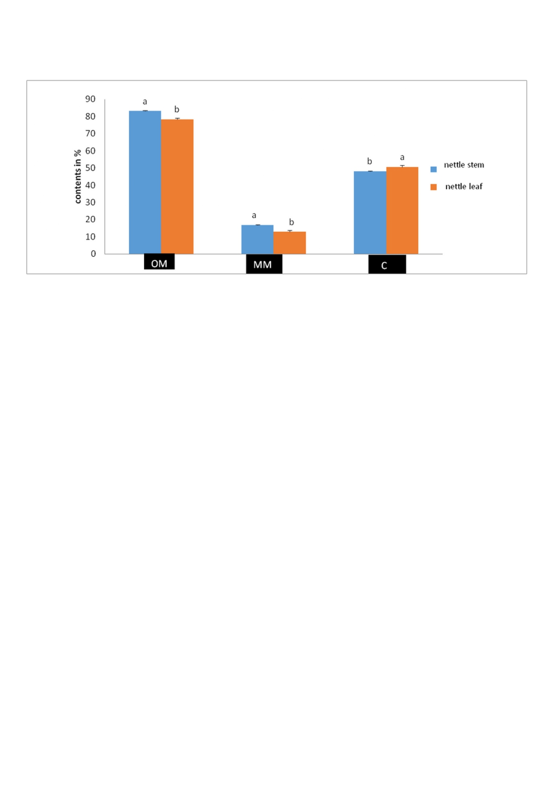
The results show a significant variation in mineral matter content depending on the plant organ. Mineral matter values were 12.83% in the stem of Urtica dioica and 16.92% in the leaves.
Figure 1 Organic matter, mineral matter, and carbon contents

Phosphorus Content
Regarding carbon content, relatively high values were recorded in the different plant organs, with 50.533% in the stem and 48.162% in the leaves.

Colorimetric results showed that nettle leaves contain relatively high phosphorus concentrations (85.857 ppm). In contrast, the stem of Urtica dioica exhibited a lower phosphorus concentration (82.52 ppm).

The leaves of nettle (Urtica dioica L.) represent an important source of polyphenolic compounds, mainly flavonoids (quercetin, rutin, kaempferol) and phenolic acids, which are well known for their high antioxidant properties. (Đurović et al., 2024)
These secondary metabolites play a key role in cellular protection by limiting damage induced by oxidative stress, which explains the growing interest in nettle in the fields of phytotherapy, functional nutrition, and pharmacology. Recent studies have shown that the polyphenol composition and concentration in nettle vary significantly depending on the plant organ, the phenological stage, and environmental conditions, highlighting the importance of ecological factors in the valorization of this species. (Wójcik-Borowska, 2025)

CONCLUSION
The present research revealed also that methanolic extracts of Urtica dioïca L were contains phenolics and flavonoids in the different part of plant.
This species possesses different components that are responsible for its biological activities. It has exhibited high total polyphenol content (2.3mgGAE/g DW) as well as high levels of flavonoid (3.3 QE /g DW) . verall, the results confirm that Urtica dioica is a valuable source of natural antioxidant compounds and highlight its strong potential for sustainable use in the pharmaceutical, nutraceutical, and agro-industrial sectors.

References
- Đurović, S., Kojić, I., Radić, D., Smyatskaya, Y. A., Bazarnova, J. G., Filip, S., & Tosti, T. (2024). Chemical Constituents of Stinging Nettle (Urtica dioica L.): A Comprehensive Review on Phenolic and Polyphenolic Compounds and Their Bioactivity. International Journal of Molecular Sciences, 25(6), 3430.
- Wójcik-Borowska, K. (2025). Oxidative Stress Protection and Anti-Inflammatory Activity of Polyphenolic Fractions from Urtica dioica. Molecules, 30(12), 2515.
- S. Cheikh-Rouhou, S. Besbes, B. Hentati, C. Blecker, C. Deroanne, H. Attia, N. sativa L.: Chemical composition and physicochemical characteristics of lipid fraction. Food Chem., 101(2007) 673-681.
- H. Trabelsi, O.A. Cherif , F. Sakouhi , P. Villeneuve , J. Renaud , N. Barouh , S. Boukhchina , P. Mayer, Total lipid content, fatty acids and 4-desmethylsterols accumulation in developing fruit of Pistacia lentiscus L. growing wild in Tunisia. Food Chemistry 131(2012)434–440.
- E.G. Bligh, W.J. Dyer, A rapid method of total lipid extraction and purification. Can. J. Biochem. Physiol., 37(1959)911–917.

- A.A. Benson, E.H. Strickland, Plant phospholipids III. Identification of diphosphatidylglycerol. Biochem. Biophys. Acta., 41(1960) 328–333.
- M. Gandour, W. Tamaalli, N. Trabelsi, K. Hessini, K. Sebei, A. Debez, and C. Abdelly, How to optimize the seed and seed-oil production in the cash crop halophyte Cakile maritima Journal of Medicinal Plants Research 5(2011)5982-5987.
- V.L. Singleton, R. Orthofer, and R.M. Lamuela-Raventos, Analysis of total phenols and other oxidation substrates and antioxidants by means of Folin Ciocalteu reagent. Methods in Enzymology 299(1999)152-178.
- V.X. Dewanto, K.Wu, K. Adom, RH. Liu, Thermal processing enhances the nutritional value of tomatoes by increasing total antioxidant activity. J Agric Food Chem., 50(2002) 3010–3014.
- Z.-B.Yi, Y.Yu, Y.Z. Liang, B. Zeng, In vitro antioxidant and antimicrobial activities of the extract of Pericarpium Citri Reticulatae of a new Citrus cultivar and its main flavonoids, LWT-Food Science and Technology 4(2007)1000-1016.
- Laribi, B., Kouki, K., Sahli, A., Mougou, A., & Marzouk, B. (2011). Essential oil and fatty acid composition of a Tunisian caraway (Carum carvi L.) seed ecotype cultivated under water deficit. Advances in Environmental Biology, 5(2), 257-264

- SARITA RAMACHANDRAN, ARUN KUMAR RAY(2004) INCLUSION OF EXTRUDED GRASS PEA, LATHYRUS SATIVUS SEED MEAL IN COMPOUND DIETS FOR ROHU, LABEO ROHITA (HAMILTON, 1822) FINGERLINGSACTAICHTHYOLOGICAETPISCATORIA(2004) 34 (2): 205–218

-Dziri et al. (2012): Dziri, K., et al. (2012). Phytochemical composition, antioxidant and antimicrobial activities of the essential oil from leaves of Tunisian Mentha pulegium L. Journal of Medicinal Plants Research, 6(10), 1920-1926
- de Almeida, C. L. F., Falcão, H. de S., Lima, G. R. de M., Montenegro, C. A. de G., Lira, N. S., Athayde-Filho, P. F., ... & Ferreira, M. R. A. (2011). Bioactivities from marine algae of the genus Gracilaria. International Journal of Molecular Sciences, 12(7), 4550-4573.

-Małgorzata Olszowy (2019) .What is responsible for antioxidant properties of polyphenolic compounds from plants? Plant Physiology and Biochemistry
Volume 144, November 2019, Pages 135-143

