Coffee Husk Biochar: A Sustainable Amendment for Soil Acidity Mitigation and Carbon Sequestration — A Review

Abstract
Coffee husks are the most abundant biomass waste generated by coffee processing plants. Converting this waste into biochar is an emerging and promising approach for reclaiming acidic soils and enhancing carbon sequestration. This paper provides an overview of the characteristics of coffee husk biochar (CHB) and its effects on soil properties, liming and agronomic potential, and environmental impacts. Application of CHB produced at different pyrolysis temperatures and application rates increased soil pH, organic carbon, and the availability of P, K⁺, and Ca²⁺ in acidic soils, while significantly reducing exchangeable acidity and the concentrations of Al³⁺ and H⁺. The high ash content of CHB, together with the presence of KHCO₃ and CaCO₃, contributes to its strong liming potential in acidic soils. Furthermore, CHB produced at moderate pyrolysis temperatures (350–550°C) exhibited high cation exchange capacity (CEC), indicating its potential to improve soil nutrient retention, reduce greenhouse gas emissions, and enhance carbon sequestration, thereby reducing dependence on agricultural lime. Overall, this review synthesises current knowledge on the effects of CHB on soil properties and highlights its potential role in mitigating soil acidity and climate change. The findings provide valuable insights for researchers, practitioners, and farmers seeking sustainable strategies to improve acidic soils using CHB. However, as most existing studies have been conducted under controlled conditions, further research across diverse soil types and agroecological zones is required to fully understand the long-term impacts and practical applicability of CHB.
Keywords:C sequestration; soil acidity; biomass; pyrolysis; biochar

Introduction
Soil acidity is a serious agricultural constraint that directly affects soil physicochemical properties, crop productivity, and human health (Kalkhoran et al., 2019; Yadav et al., 2020). Globally, more than 50% of potentially arable soils are affected by acidity (Kochian et al., 2004). In Ethiopia, soil acidity affects over 43% of agricultural land (Agegnehu et al., 2021), with approximately 80% of Nitisols and Luvisols classified as strongly acidic (pH 4.5–5.5) (Eyasu, 2016). The severity and spatial extent of soil acidity have continued to increase in Ethiopia, particularly in the Sidama region. High rainfall, intensive leaching of basic cations, removal of crop residues, and the continuous use of nitrogen- and sulfur-based fertilisers are major factors exacerbating soil acidity (Kalkhoran et al., 2019). Elevated concentrations of H⁺, Al³⁺, and Mn²⁺ in acidic soils severely reduce crop productivity and pose risks to food safety (Briffa et al., 2020). In addition, low availability of essential nutrients such as P, Ca²⁺, K⁺, and Mg²⁺ further constrains plant growth in acidic soils (Briffa et al., 2020; Cui et al., 2020).

To address this challenge, Ethiopia has launched a national acid soil reclamation strategy aimed at supplying agricultural lime in a timely, sustainable, and cost-effective manner (Ali et al., 2023c). However, the high costs associated with purchasing, transporting, mixing, and applying large quantities of lime (up to 20 q ha⁻¹) often discourage farmers and impose significant financial burdens. In this context, the conversion of agro-industrial wastes into biochar represents a promising alternative, offering dual benefits of soil acidity amelioration and climate change mitigation (Liu et al., 2014). Biochar application enhances carbon sequestration and reduces greenhouse gas emissions (Agegnehu et al., 2017; Yu et al., 2019; Ayaz et al., 2021). Moreover, the high ash content of biochar, together with its oxides, carbonates, silicates, and surface functional groups (e.g., carboxylic and phenolic groups), contributes significantly to the neutralisation of soil acidity (Das et al., 2021a).

Ethiopia is the largest producer of highland Arabica coffee (Coffea arabica L.) in Africa (Tefera and Tefera, 2014). During the 2020/2021 growing season, more than seven million smallholder farmers produced approximately 5,847,895.69 tonnes of coffee cherries from an area of 856,591.99 ha (Motebayenore, 2022). In the same year, the Sidama region alone produced 50,454.44 tonnes of coffee cherries from 73,030.04 ha. These figures indicate that an equivalent proportion of coffee husk is generated from each tonne of coffee cherries and is often dumped into the surrounding environment, causing serious environmental pollution.Converting this waste into coffee husk biochar (CHB) through pyrolysis offers a climate-smart and resilient agricultural solution (Filho et al., 2021). Application of CHB represents an affordable alternative for smallholder farmers to ameliorate soil acidity (Yazhini et al., 2020), enhance carbon sequestration, reduce atmospheric CO₂ concentrations, and improve soil fertility and crop productivity (Lehmann et al., 2021; Bolan et al., 2021). However, only a limited number of studies have examined the effects of CHB on soil properties, and most existing research has been conducted under controlled laboratory or simulated conditions.

Therefore, this review aims to highlight the potential agricultural benefits of CHB and to raise awareness among researchers, farmers, and extension services. The overarching objective of this review is to critically analyse recent advancements in the use of CHB to improve soil fertility, enhance crop yields, promote soil carbon sequestration, and explore its potential role in large-scale climate change mitigation.

Methods and Materials
Data collection and synthesis
For this review, a systematic literature search was conducted using Google Scholar with multiple relevant keywords. Both research and review articles were considered, with particular emphasis on publications containing the term “coffee husk biochar.” The selected studies were further screened based on their reporting of: (a) biochar production conditions and physicochemical characteristics of coffee husk biochar (CHB); (b) the effects of CHB on the properties of acidic soils; and (c) the environmental and agronomic benefits associated with CHB application. After organising the extracted data and selected parameters, the effects of CHB on various soil chemical properties were analysed and compared between CHB-amended and unamended acidic soils.
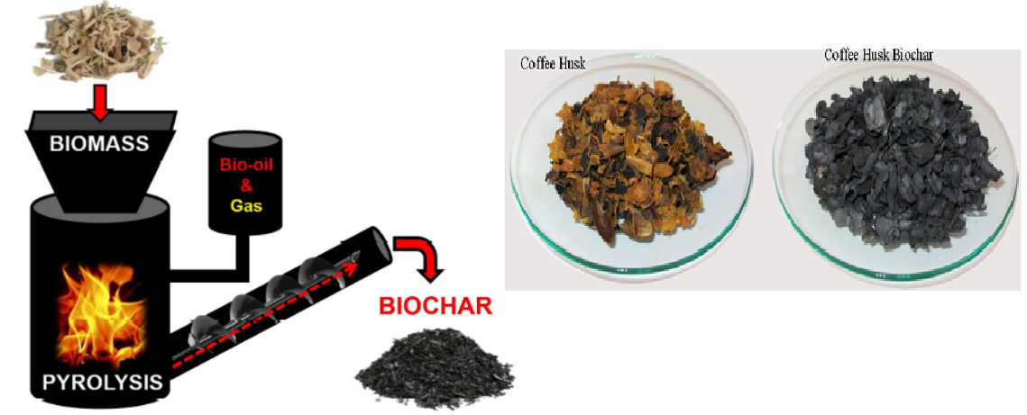
Figure 1. Biochar production process (Vicky et al., 2022)

Coffee husk biochar production
Slow and fast pyrolysis are the most commonly used techniques for producing biochar for agricultural applications (Brewer et al., 2012). In fast pyrolysis, dry biomass is heated very rapidly (approximately 1000°C s⁻¹) in the absence of oxygen, with a very short residence time in the reactor (about 2 sec). In contrast, slow pyrolysis involves the gradual heating of biomass at rates of 1–20°C min⁻¹ under oxygen-limited conditions, with residence times ranging from several hours to days (Dutta and Mahanta, 2012). The primary objective of fast pyrolysis is to maximise bio-oil production, whereas slow pyrolysis is designed to maximize biochar yield.

Biochar properties such as specific surface area, porosity, pH, and ash content generally increase with increasing pyrolysis temperature (Tomczyk et al., 2020). As pyrolysis temperature rises, hydrogen and oxygen relative to carbon (H/C and O/C ratios) decrease due to volatilisation of labile organic compounds, promoting the formation of inorganic phases, particularly carbonates (Bakshi et al., 2020). At lower pyrolysis temperatures (<300°C), biochars retain higher concentrations of carboxylic and phenolic functional groups, which contribute to pH buffering capacity (Tomczyk et al., 2020).

Biochars produced at moderate temperatures (300–550°C) typically exhibit intermediate H/C and O/C ratios, partial carbonisation, and moderate specific surface area. These characteristics make them suitable for soil amendment applications, as they enhance nutrient availability, improve soil fertility, and contribute to carbon sequestration (Saha et al., 2020). In contrast, biochars produced at higher temperatures (550–700°C) are dominated by well-carbonised, stable aromatic carbon structures, characterised by low H/C ratios, reduced contents of N, P, and S, and a larger specific surface area (Chan and Xu, 2009). Such biochars are particularly effective when long-term carbon sequestration is the primary objective.

Consequently, coffee husk biochar produced at an optimal pyrolysis temperature range of 450–550°C, characterised by low hydrophobicity, high ash content, elevated pH, and high specific surface area, is considered highly suitable for improving soil nutrient retention and enhancing the liming potential of acidic soils (Domingues et al., 2017; Ghorbani et al., 2022).
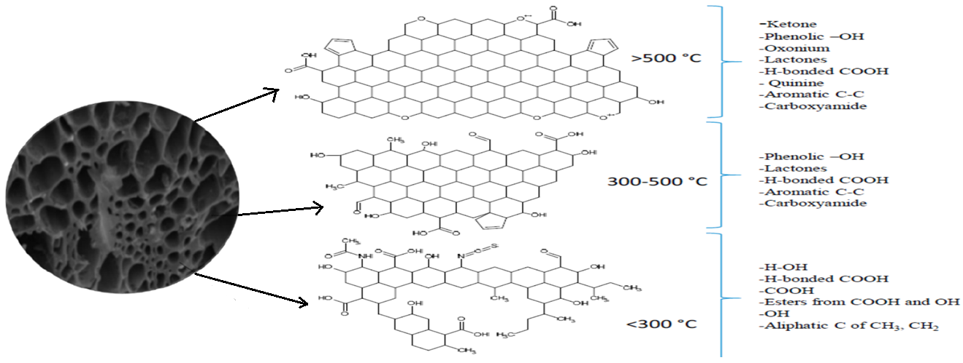

Figure 2. Functional groups on the biochar surface at different pyrolysis temperatures (Tusar et al., 2023)

Characteristics of coffee husk
Coffee husk is the primary by-product generated by coffee processing plants and is composed of approximately 39.2% cellulose, 12.6% hemicellulose, 23.3% lignin, 11.6% extractives, and 9.5% ash by weight (Nguyen et al., 2023). From an agricultural perspective, lignin acts as a slow-release source of nutrients and supports sustainable plant growth by improving soil structure and enhancing nutrient availability (Lu et al., 2021). In addition, coffee husk contains substantial elemental constituents within its lignocellulosic matrix, including 51.28% C, 41.23% O, 4.78% K, 1.23% Ca, 0.34% Mg, 0.29% Fe, 0.54% S, and 0.03% Si (Nguyen et al., 2023) (Figure 2).
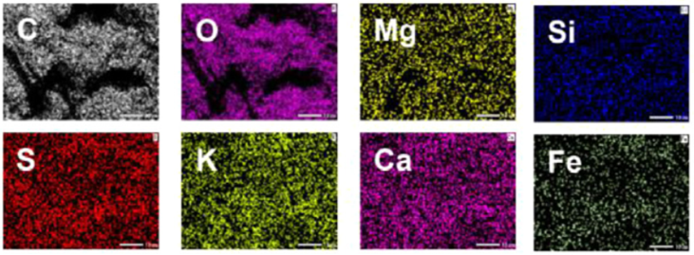
Figure 3. Elemental mapping of coffee husks (Nguyen et al., 2023).

Characteristics of coffee husk biochar
Following pyrolysis, ash content and fixed carbon increased, whereas volatile matter decreased significantly with increasing pyrolysis temperature (450–750°C) (Figure 1). Gilles et al. (2023) reported a significant reduction (p < 0.05) in coffee husk biochar (CHB) yield from 38.7% to 30.3% at 350°C and from 38.4% to 32.0% at 550°C, respectively. Increasing pyrolysis temperature also led to a marked increase in organic carbon content, ranging from 16.45% to 58.66%, primarily due to the thermal decomposition and volatilisation of labile organic compounds (Table 1). Total carbon content increased by 60.5%, 61.3%, and 66.0%, while H/C and O/C ratios decreased to 0.78, 0.71, and 0.29, and 0.24, 0.23, and 0.11, at pyrolysis temperatures of 350, 450, and 750°C, respectively (Domingues et al., 2017).

The increase in aromaticity and the reduction in hydrophilic character of CHB with increasing pyrolysis temperature are primarily attributed to dehydration reactions and the progressive removal of oxygen- and hydrogen-containing functional groups (Gilles et al., 2023). Fourier transform infrared (FTIR) spectra confirmed the presence of aromatic C=C stretching, –CH₂ bending, and aromatic C–H bending vibrations at approximately 1600, 1400, and 885 cm⁻¹, respectively, in CHB (Domingues et al., 2017). In contrast, raw coffee husk biomass exhibited characteristic absorption bands corresponding to O–H stretching from water or phenolic groups (3200–3400 cm⁻¹), C–H stretching (2920–2885 cm⁻¹), and C–O stretching of aliphatic functional groups (≈1030 cm⁻¹) associated with cellulose, hemicellulose, and methoxyl groups of lignin (Domingues et al., 2017).Overall, these results indicate that increasing pyrolysis temperature promotes the formation of inorganic functional groups, such as carbonates, oxides, and silicates, leading to a corresponding increase in ash content and enhanced alkalinity of CHB (Waqas et al., 2018).
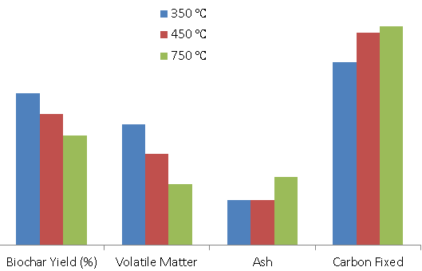
Figure 4. Biochar yield, volatile matter, ash and fixed carbon contents at different pyrolysis temperatures.

The pH values of coffee husk biochar (CHB) were found to be strongly alkaline, ranging from 9.33 to 11.30 (Table 1), indicating a high potential for neutralising soil acidity. This alkalinity is primarily attributed to the presence of substantial amounts of carbonates, oxides, and hydroxides formed during pyrolysis (Figure 2). The high pH and alkalinity of CHB therefore make it an effective amendment for ameliorating acidic soils. Previous studies have demonstrated that increasing pyrolysis temperature enhances the formation of basic cations and alkaline compounds, such as carbonates, oxides, and hydroxides (Yuan et al., 2011; Houben et al., 2013), while simultaneously reducing acidic surface functional groups in biochar (Singh et al., 2010), leading to an overall increase in pH (Meena et al., 2019).
In addition, appreciable concentrations of Ca, Mg, and K were detected in CHB (Table 1). X-ray diffractometry further confirmed the presence of mineral phases such as CaCO₃, KHCO₃, KCl, and SiO₂ in CHB (Figure 2). The high contents of carbonates and bicarbonates significantly enhance the liming potential of CHB (Bayu et al., 2017). Moreover, the relatively high availability of P and K in CHB suggests that it can also serve as a supplementary source of phosphorus and potassium fertilisers.

Pyrolysis temperatures above 300°C generally increase CHB pH, whereas biochars produced below 300°C tend to contain higher concentrations of organic acids and phenolic compounds derived from the partial decomposition of cellulose and hemicellulose, which can lower the pH of the resulting biochar (Yu et al., 2014).
Table 1: Characteristics of coffee husk biochar

Pyrolysis temperature | pH | OC | TN | Avai. P  mg kg⁻¹ | Ca | Mg |  | K |  | Reference
Pyrolysis temperature | pH | % |  | Avai. P  mg kg⁻¹ | cmol(+)kg⁻¹ |  |  |  |  | Reference
350 | 9.62 | 16.45 | 1.42 | 105.25 | 50.48 |  | 6.71 |  | 1.96 | Bayu et al., 2015
 | 9.33 | 67.10 | - | 866.02 | - |  | - |  | 1.96 | Gilles et al., 2023
500 | 11.04 | 26.91 | 2.32 | 149.12 | 61.48 |  | 8.21 |  | 2.77 | Bayu et al., 2015
 | 10.31 | 67.11 | 2.05 | 470.65 | 0.14 |  | 0.12 |  | 22.17 | Lima et al., 2018
 | 10.31 | 67.11 | 2.05 | 470.65 | 0.14 |  | 0.12 |  | 22.17 | Argemiroet al.,2021
 | 11.05 | 17.29 | 0.62 | 1109 | 16.23 |  | 7.63 |  | 243 | Alemnesh et al.,2021
550 | 9.69 | 66.67 | - | 954.54 | - |  | - |  | - | Gilles et al., 2023
 | 10.61 | 31.26 | 2.03 | 16.8 | 58.3 |  | 7.77 |  | 3.10 | Solomon et al., 2024
 | 9.42 | 46.4 | 2.81 | 1.11% | 0.97% |  | 0.43% |  | 4.37% | Alefsiet al., 2023
 | 8.10 | 29.05 | 0.36 | 536.20 | - |  | - |  | 449.36 | Situmeanget al.,2023
OC: Organic carbon, TN: Total nitrogen, Avai. P: available phosphorus, Ca: calcium, K: potassium, Mg: magnesium

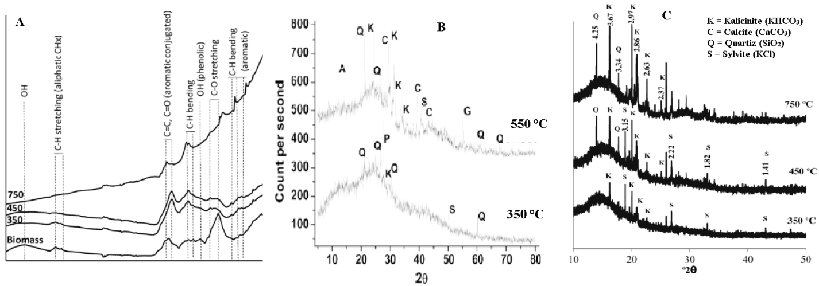
Figure5. Coffee husk biochar pyrolized at different temperatures:(A) FTIR-ATR spectra, (B and C) X-ray diffraction spectra (Domingues et al., 2017^{A&C}; Gilles et al., 2023^{B}).

Coffee husk biochar effects on soil chemical properties
Soil pH
Soil pH is one of the most important parameters influencing the surface charge of both adsorbents and adsorbates, thereby affecting nutrient availability and chemical reactions in soil systems. Application of coffee husk biochar (CHB) has been consistently shown to increase soil pH in acidic soils. For example, Alemnesh et al. (2021) reported an increase in soil pH from 4.89 to 6.68 following the application of CHB at a rate of 20 t ha⁻¹. Similarly, Bayu et al. (2016) observed increases in soil pH from 5.20 to 6.21 and from 5.20 to 6.66 with CHB produced at 350 °C and 500 °C, respectively, applied at 15 t ha⁻¹. Solomon et al. (2024) further confirmed that CHB application increased soil pH from 5.10 to 6.11 in Farm-1 and from 4.64 to 6.22 in Farm-2. Moreover, incubation studies demonstrated that after 60 days, soil pH increased by 0.46, 0.81, and 2.51 units at 350°C and by 0.75, 1.41, and 2.71 units at 550°C compared with the control at application rates of 20, 40, and 80 g kg⁻¹, respectively (Gilles et al., 2023).

The observed increase in soil pH is primarily attributed to the presence of silicates, carbonates, and bicarbonates, the high alkalinity (expressed as % CaCO₃ equivalent), and the abundance of negatively charged surface functional groups, such as phenolic, carboxyl, and hydroxyl groups, on biochar surfaces (Dai et al., 2017; Gilles et al., 2023). Consequently, the alkaline components of biochar react with H⁺ and Al³⁺ ions in the soil solution, reducing their activity and concentration and thereby increasing soil pH (Chintala et al., 2014; Zhang et al., 2019).

Soil organic carbon
Application of coffee husk biochar (CHB) produced at different pyrolysis temperatures and applied at various rates has been shown to increase soil organic carbon (SOC) (Table 2). For instance, Bayu et al. (2016) reported that CHB applied at 15 t ha⁻¹ increased SOC from 3.64% to 6.18% at 350°C and to 6.69% at 500°C. Similarly, Solomon et al. (2024) observed an increase in organic carbon (OC) from 57.24% to 398.47% over the control following CHB application. Alemnesh et al. (2021) also reported that applying CHB at 20 t ha⁻¹ increased OC from 2.76% to 5.04% in acidic soils. Incubation studies showed that SOC increased by 2.7, 2.6, and 3.2 times at 350 °C and by 1.99, 1.97, and 2.1 times at 550°C compared with the control at application rates of 20, 40, and 50 g kg⁻¹, respectively (Gilles et al., 2023). Furthermore, CHB produced at 500°C increased SOC by 38.84% relative to the control (3.7%) in acidic soils (Bayu et al., 2015).The observed increase in SOC is attributed to the presence of highly recalcitrant carbon in biochar (Nyambo et al., 2018), the sorption of labile organic matter onto biochar surfaces (Zhang et al., 2019; Singh and Cowie, 2014), and the reduced mineralisation of organic carbon in amended soils (Spokas et al., 2011). These mechanisms collectively enhance the stabilisation and accumulation of SOC in acidic soils following CHB application.
Total nitrogen
Application of coffee husk biochar (CHB) to acidic soils has been shown to significantly increase total nitrogen (TN) content, with reported gains ranging from 15.87% to 195.24% over control soils (Solomon et al., 2024). For example, Bayu et al. (2015) reported that applying 15 t ha⁻¹ of CHB produced at 500°C increased TN from 0.32% in the control soil to 0.45%, representing a 40.74% increase. Similarly, Bayu et al. (2016) found that 15 t ha⁻¹ of CHB raised TN from 0.32% to 0.53% at 350°C and to 0.58% at 500°C, highlighting the positive effect of both application rate and pyrolysis temperature on nitrogen enrichment in acidic soils.

Available phosphorous
Application of coffee husk biochar (CHB) to acidic soils significantly (P < 0.05) increased available phosphorus (P) at various pyrolysis temperatures and application rates (Table 2). Biochars produced at higher pyrolysis temperatures (300–500°C) generally exhibited higher available P content. For example, applying 15 t ha⁻¹ of CHB increased available P from 4.51 to 11.33 mg kg⁻¹ at 350 °C and to 18.21 mg kg⁻¹ at 500°C (Bayu et al., 2016). At 20 t ha⁻¹, CHB raised available P from 7.48 to 13.56 mg kg⁻¹ (Alemnesh et al., 2021). Similarly, Solomon et al. (2024) reported increases in available P ranging from 45.19% to 147.68% over control soils. Incubation studies further showed that CHB applied at rates of 20, 40, and 80 g kg⁻¹ increased available P by 23.9%, 40.6%, and 147.5% at 350°C, and by 24.0%, 36.0%, and 32.0% at 550°C compared with the control (Gilles et al., 2023).

The increase in soil P availability is attributed to several mechanisms: the direct contribution of P from CHB, dissolution of inorganic P in acidic soils (Chathurika et al., 2016; Dume et al., 2017), reduced leaching through adsorption (Madiba et al., 2016), mineralisation of organic P (Biederman and Harpole, 2013), and the liming effect of CHB. Additionally, ligand exchange between functional groups on biochar and phosphate anions at Al–OH and Fe–OH sites decreases P sorption, further enhancing P availability. Consequently, CHB can serve as an effective source of phosphorus for plant growth in acidic soils.

Table 2.Effects of coffee husk biochar on soil properties
Rate  (t ha⁻¹) | Effects | From | To | Temperature  (°C) | References
15 | Increase soil pH | 5.18  5.18 | 6.08 | 350 | Bayu et al., 2015
15 | Increase soil pH | 5.18  5.18 | 6.14 | 500 | Bayu et al., 2015
15 | Increase organic carbon | 3.70  3.70 | 5.41 | 350 | Bayu et al., 2015
15 | Increase organic carbon | 3.70  3.70 | 6.24 | 500 | Bayu et al., 2015
15 | Increase TN | 0.32  0.32 | 0.47 | 350 | Bayu et al., 2015
15 | Increase TN | 0.32  0.32 | 0.54 | 500 | Bayu et al., 2015
15 | Increase available phosphorus | 4.51  4.51 | 11.33 | 350 | Bayu et al., 2015
15 | Increase available phosphorus | 4.51  4.51 | 18.21 | 500 | Bayu et al., 2015
15 | Increase CEC | 14.37  14.37 | 18.27 | 350 | Bayu et al., 2015
15 | Increase CEC | 14.37  14.37 | 20.99 | 500 | Bayu et al., 2015
15 | Increase exchangeable Ca²⁺ | 5.57  5.57 | 9.50 | 350 | Bayu et al., 2015
15 | Increase exchangeable Ca²⁺ | 5.57  5.57 | 10.84 | 500 | Bayu et al., 2015
15 | Increase exchangeable Mg²⁺ | 1.53  1.53 | 3.66 | 350 | Bayu et al., 2015
15 | Increase exchangeable Mg²⁺ | 1.53  1.53 | 3.98 | 500 | Bayu et al., 2015
15 | Increase exchangeable K⁺ | 2.85  2.85 | 3.99 | 350 | Bayu et al., 2015
15 | Increase exchangeable K⁺ | 2.85  2.85 | 5.96 | 500 | Bayu et al., 2015
20 | Increased soil pH | 4.89 | 6.68 |  | Alemnesh et al., 2021
20 | Reduce exchangeable acidity | 2.82 | 1.19 |  | Alemnesh et al., 2021
20 | Exchangeable Al³⁺ | 1.63 | 0.76 |  | Alemnesh et al., 2021
20 | Exchangeable H⁺ | 1.19 | 0.43 |  | Alemnesh et al., 2021
20 | Increase organic carbon | 2.76 | 5.04 |  | Alemnesh et al., 2021
20 | Increase available phosphorus | 7.48 | 13.57 |  | Alemnesh et al., 2021
20 | Increase CEC | 19.56 | 41.56 |  | Alemnesh et al., 2021
10 | Increased soil pH | 5.1 | 6.11 |  | Solomon et al., 2024
10 | Increased soil pH | 4.64 | 6.22 |  | Solomon et al., 2024
10 | Increase organic carbon | 1.52 | 6.37 |  | Solomon et al., 2024
10 | Increase organic carbon | 1.02 | 5.59 |  | Solomon et al., 2024
10 | Increase total nitrogen | 0.63 | 1.40 |  | Solomon et al., 2024
10 | Increase total nitrogen | 0.27 | 0.97 |  | Solomon et al., 2024
10 | Rise in available phosphorus | 2.19 | 2.81 |  | Solomon et al., 2024
10 | Rise in available phosphorus | 2.81 | 4.08 |  | Solomon et al., 2024
10 | Reduce exchangeable Acidity | 4.64 | 3.19 |  | Solomon et al., 2024
10 | Reduce exchangeable Acidity | 5.00 | 2.79 |  | Solomon et al., 2024
10 | Reduce exchangeable Al³⁺ | 3.92 | 2.66 |  | Solomon et al., 2024
10 | Reduce exchangeable Al³⁺ | 3.95 | 2.23 |  | Solomon et al., 2024

Cation exchange capacity and Exchangeable cations
The high surface area, presence of hydroxyl and carboxylic functional groups, and variable surface charges of coffee husk biochar (CHB) contribute to improvements in the cation exchange capacity (CEC) of soils (Van Zwieten et al., 2010). For example, application of CHB at 20 t ha⁻¹ increased soil CEC from 19.65 to 41.56 cmol(+) kg⁻¹ (Alemnesh et al., 2021). Similarly, Bayu et al. (2015) reported that CHB increased CEC from 14.37 to 18.27 cmol(+) kg⁻¹ at 350°C and to 20.99 cmol(+) kg⁻¹ at 500°C. In addition, the CHB application enhanced the levels of exchangeable K⁺, Ca²⁺, and Mg²⁺ in acidic soils. At a rate of 15 t ha⁻¹, CHB increased exchangeable K⁺, Ca²⁺, and Mg²⁺ by 52.52%, 48.61%, and 61.55%, respectively (Bayu et al., 2015). These effects are primarily due to the high ash content of CHB, which facilitates the immediate release of K⁺, Ca²⁺, and Mg²⁺ (Scheuner et al., 2004; Niemeyer et al., 2005) and can also partially supplement inorganic potassium fertilisers (Singh et al., 2019).

Exchangeable acidity, Al³⁺ and H⁺
Application of coffee husk biochar (CHB) significantly (P < 0.05) reduces exchangeable acidity, Al³⁺, and H⁺ in acidic soils across different rates and pyrolysis temperatures (Table 2). For instance, applying 10 t ha⁻¹ of CHB decreased exchangeable acidity from 4.64 to 3.19 cmol(+) kg⁻¹ in Farm-1 and from 5.00 to 2.79 cmol(+) kg⁻¹ in Farm-2 (Solomon et al., 2024). Similarly, Alefsi et al. (2023) reported a 60% reduction in exchangeable acidity at 16 t ha⁻¹ of CHB, while Alemnesh et al. (2021) observed a decrease from 2.82 to 1.19 cmol(+) kg⁻¹ at 20 t ha⁻¹. Incubation studies further demonstrated reductions in exchangeable acidity of 60.8%, 87.2%, and 95% at 350°C and 75.6%, 90%, and 97.3% at 550°C compared with controls at application rates of 20, 40, and 80 g kg⁻¹, respectively (Gilles et al., 2023).

Exchangeable Al³⁺ and H⁺ also decreased substantially; for example, at 20 t ha⁻¹ of CHB, Al³⁺ decreased from 1.63 to 0.76 cmol(+) kg⁻¹ and H⁺ from 1.19 to 0.43 cmol(+) kg⁻¹ (Alemnesh et al., 2021). Solomon et al. (2024) further confirmed reductions in exchangeable Al³⁺ from 3.92 to 2.66 cmol(+) kg⁻¹ in Farm-1 and from 3.95 to 2.23 cmol(+) kg⁻¹ in Farm-2 at 10 t ha⁻¹ of CHB. These effects are attributed to the presence of oxides, carbonates, silicates, and organic functional groups (–O, –OH, –COOH) in CHB, which complex with Al³⁺ and H⁺ ions in the soil solution, thereby reducing their concentrations in acidic soils (Qian et al., 2013). The high liming potential and acid-neutralising capacity of CHB make it an effective amendment for reclaiming acidic soils and reducing exchangeable acidity and toxic Al³⁺ levels.

Liming potential of coffee husk biochar
The liming potential of coffee husk biochar (CHB) is relatively high compared with other locally available feedstocks, averaging approximately 12% CaCO₃ equivalent (Table 3). CHB produced from the Dale and Aleta Wondo districts in the Sidama region exhibited the highest CaCO₃ content at 17.14% (Hibret et al., 2023). Liming potential generally increases with pyrolysis temperature due to elevated levels of carbonates (CaCO₃) and bicarbonates (KHCO₃) in the biochar (Domingue et al., 2017; Gilles et al., 2023). Notably, the acid-neutralising capacity of CHB remains high regardless of pyrolysis temperature, which is attributed to the presence of alkaline mineral components such as calcite and kalicinite (confirmed by XRD; Figure 2) and functional groups (–O⁻ and –COO⁻) capable of binding H⁺ ions (Gilles et al., 2023).

Overall, CHB demonstrates superior liming potential due to its greater alkalinity, higher CaCO₃ equivalent, and enhanced acid-neutralising capacity. This makes it a practical and cost-effective alternative for smallholder farmers who face challenges in remediating acidic soils due to the high cost of agricultural lime. Specifically, CHB produced at a pyrolysis temperature of 450 °C represents an economically viable solution for reclaiming soil acidity and improving soil fertility on small-scale farms.

Table 3. Biochar liming equivalence of CaCO₃ (%).
Feedstock | Temperature (  °C) | CaCO₃ (% ) | References
Coffee husk | 350 | 1.39 | Domingues et al.,2017
 | 450 | 1.6 | Domingues et al.,2017
 | 450 | 17.14 | Hibretet al., 2023
 | 750 | 2.1 | Domingues et al.,2017
Bamboo | 450 | 5.47 | Hibretet al., 2023
 | 550 | 5.22 | Hibretet al., 2023
Avocado seed | 450 | 3.19 | Hibretet al., 2023
 | 550 | 7.47 | Hibretet al., 2023
Corncob | 450 | 6.43 | Hibretet al., 2023
Switchgrass | 400 | 1.9 | Singh et al.,2017
 | 550 | 3 | Singh et al.,2017
Pine chips | 400 | 3.9 | Singh et al.,2017
 | 550 | 5 | Singh et al.,2017
Eucalyptus wood | 450 | 2.6 | Singh et al.,2017
 | 550 | 6.3 | Singh et al.,2017
Poultry litter | 550 | 11.8 | Singh et al.,2017

Environmental benefits of coffee husk biochar

Coffee husk biochar (CHB) exhibits a highly aromatic character due to its low H:C ratio, which contributes to a long carbon residence time in CHB-amended soils (Domingue et al., 2017). This prolonged carbon stability enhances soil carbon sequestration and helps mitigate greenhouse gas emissions (Zimmerman, 2010). A significant proportion of N₂O emissions originates from agricultural fields fertilised with nitrogen and from manure deposition in both low- and high-intensity livestock production systems. Biochars with an H:C ratio below 0.3, indicating a high degree of polymerisation and aromaticity, have been shown to reduce N₂O emissions by up to 73%, whereas biochars with H:C ratios above 0.5 decrease N₂O emissions by only 40% (Cayuela et al., 2015).

In contrast, biochars produced at lower pyrolysis temperatures (350–450°C) retain a higher aliphatic character and O:C ratio, making them more susceptible to microbial degradation. This can result in short-term immobilisation of inorganic nitrogen in the soil (Deenik et al., 2011), which may temporarily limit nitrogen availability to plants (Deenik et al., 2011; Rondon et al., 2007) while simultaneously mitigating N₂O emissions and reducing inorganic nitrogen leaching (Novak et al., 2010).

Agronomic benefits of coffee husk biochar
The high ash content of coffee husk biochar (CHB) ensures it is rich in nutrients and possesses strong alkalizing capacity (Deenik et al., 2011; Sigua et al., 2016). This ash is largely composed of alkaline chemical species such as KHCO₃ and CaCO₃, as confirmed by XRD analysis (Figure 2) (Domingue et al., 2017; Gilles et al., 2023). These characteristics make CHB a promising amendment for increasing soil buffering capacity and neutralising soil acidity, potentially reducing the need for large applications of agricultural lime in crop fields. The solubilization of these alkaline compounds can increase soil pH, decrease exchangeable acidity, Al³⁺, and H⁺ concentrations, reduce the availability of Fe and Mn, and enhance soil cation exchange capacity (CEC) (Fellet et al., 2011; Qian and Chen, 2014). These changes may also decrease phosphorus fixation while increasing the availability of Ca and K for plants, enhancing the agronomic value of CHB (Figure 4)(Xu et al., 2014).

However, the nutrient availability and functional properties of CHB are strongly influenced by pyrolysis temperature. Low-temperature CHB (350–450°C) exhibits high CEC, enabling it to adsorb up to 2.3 mg g⁻¹ of NH₄⁺ and reduce nitrogen leaching (Gai et al., 2014). In contrast, high-temperature CHB (>600°C) has a high surface area but low CEC and markedly lower levels of N, P, and S, which may limit its nutrient contribution in soils (Zhang et al., 2019). Overall, CHB has strong potential to ameliorate soil acidity and partially replace limestone for soil reclamation in crop production systems in Ethiopia.
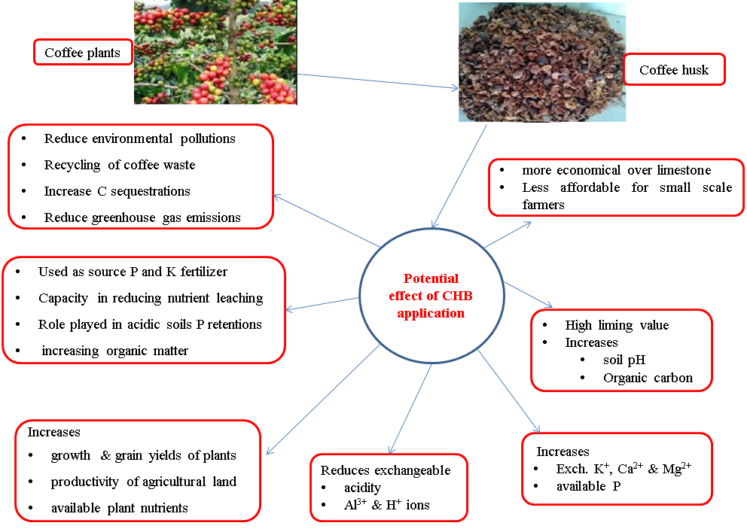
Figure 6: Coffee husk biochar integration into a coffee production system, and potential impacts

Carbon Sequestration Potential

Biochar is an effective strategy for long-term carbon storage in soils because its aromatic carbon compounds are highly resistant to microbial decomposition (Basanta and Rajasekhar, 2025). Application of biochar has also been shown to reduce soil CO₂ fluxes in agricultural systems (He et al., 2017). Several key factors contribute to the enhanced carbon sequestration potential of biochar-amended soils (Figures 7and 8), including: (i) increased soil organic carbon (SOC) content, (ii) protection of organic matter against microbial degradation, (iii) improved soil aggregation, (iv) enhanced nutrient and water retention, (v) stabilization of labile carbon fractions, and (vi) promotion of soil microbial abundance, diversity, and functional enzyme activity (Li and Tasnady, 2023).
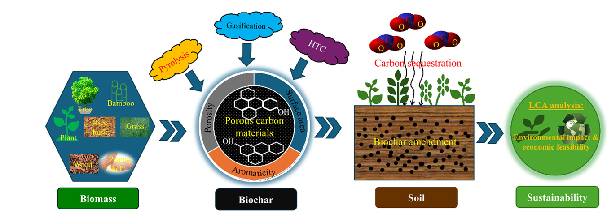
Figure 7. Schematic presentation on the overall scope and objectives of this comprehensive review (Basanta and Rajasekhar, 2025).
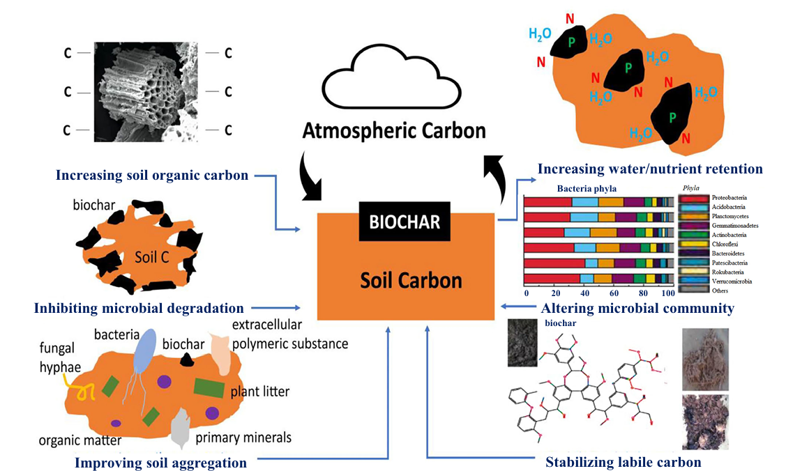

Figure 8. Key mechanisms of biochar on enhancing soil carbon sequestration (Zhou et al., 2017)

Conclusions and Future Perspective

Coffee husk biochar (CHB), a sustainable solid material produced through biomass pyrolysis, has received increasing attention for its potential to sequester atmospheric CO₂ in soils and contribute to carbon neutrality. This review comprehensively examines recent developments on the use of biomass-derived CHB as a sustainable material for soil carbon sequestration. Coffee husk residues are rich in lignocellulose, making them ideal feedstocks for biochar production with a high carbon content, which enhances long-term carbon storage in soils. Biochar produced at high pyrolysis temperatures (e.g., >500°C) contains a high proportion of aromatic carbon compounds, rendering it stable and recalcitrant. This carbon-rich biochar exhibits strong sorption capacity for CO₂ and is highly resistant to microbial and physicochemical degradation.Most studies report that CHB amendment enhances soil carbon sequestration by reducing organic carbon mineralisation and decreasing CO₂ release, thereby enabling soils to act as long-term carbon sinks. Incorporation of CHB also alters soil microbial communities, shifting bacterial and fungal populations and influencing enzymatic activities, particularly those involved in C, N, and P cycling. Key mechanisms facilitating enhanced carbon sequestration include the adsorption of labile soil organic carbon (SOC) onto biochar surfaces and the regulation of carbon-metabolising microbial communities.However, most experiments on biochar-mediated carbon sequestration have been conducted under controlled pot conditions, with limited field-scale studies in real environmental settings. Therefore, well-designed field experiments are urgently needed to fully evaluate the potential of CHB for enhancing carbon sequestration in complex soil systems.

References
Agegnehu G, Amede T, Erkossa T, Yirga C, Henry C, Tyler R, Nosworthy M G, Beyene S, Sileshi G W,2021. Extent and management of acid soils for sustainable crop production system in the tropical agroecosystems: a review, Acta AgriculturaeScandinavica, Section B — Soil & Plant Science, DOI: 10.1080/09064710.2021.1954239
Agegnehu G, Srivastava A K, Bird M I, 2017. The role of biochar and biochar-compost in improving soil quality and crop performance: A Review. Appl. Soil Ecol. 119: 156–170.
Alefsi D S, Edgar Á Á, Leonardo L, Hermann R, 2023. Chemical and biological characteristics of soil for coffee cultivation. J. Soil Science Plant Nutrition. 23:2512–2524.
Alemnesh S., Alemayhu A., Getachew A., 2022. Response of Coffee Husk Biochar on Growth of Faba Bean on Nitisol and Soil Nutrients. Journal of Natural Sciences Research. 13(13).
AlemneshSisay, EndashawGirma, 2021. Effect of incubation study of coffee husk on the amendment of chemical properties in acid soil. I. J Resea. Studies Agric. Scien. 7(7): 35-41.
Ali M, Oumer AB, Samuel Diro A, Geremew Taye A, Tadele Mamo A, Moti Jaleta 2023c Agricultural lime value chain efficiency for reducing soil acidity in Ethiopia. Soil Security. 11: 100092.
Argemiro P, Martins Filho, Erika V. De Medeiros, José Romualdo S. Lima, Diogo P. Da Costa, et al., 2021 Impact Of Coffee Biochar On Carbon, Microbial Biomass And Enzyme Activities Of A Sandy Soil Cultivated With BeananAcad Bras Cienc (2021) 93(4):
Ayaz M, Feizienė D, Tilvikienė V, Akhtar K, Stulpinaitė U, Iqbal R, 2021. Biochar's role in the sustainability of agriculture and the environment. Sustainability. 13 (3): 1330.
Bakshi D, Kalia S, Kalia M, 2020. A Review on Integrated Nutrient Management in Agriculture. International Journal of Current Microbiology and Applied Sciences. 9(6): 2067-2070.
Basanta K B., Rajasekhar B., 2025. Use of biomass-derived biochar as a sustainable material for carbon sequestration in soil: recent advancements and future perspectives. Materials Sustainability| () 3:26)
Bayu Dume, Dejene Ayele Tessema, Alemayehu Regassa, Gezahegn Berecha, 2017. Effects of biochar on phosphorus sorption and desorption in acidic and calcareous soils. Civil Environmental Research.9:5.
Bayu Dume, Dejene Ayele, Alemayehu Regassa, Gezahegn Barecha, 2016. Interactive effects of biochar in soil related to feedstock and pyrolysis temperature. American-Eurasian J. Agric. Environ. Sci., 16 (3): 442-448.
Bayu Dume, Gezahegn Berecha, Solomon Tulu, 2015. Characterisation of biochar produced at different temperatures and its effect on acidic Nitosol of Jimma, Southwest Ethiopia. I. J. Soil Science: 10 (2): 63-73.
Biederman L A, Harpole W S, 2013. Biochar and its effects on plant productivity and nutrient cycling: a meta-analysis. GCB Bioenergy. 5: 202–214.
Bolan N S, Hoang S A, Beiyuan J, Gupta S, Hou D, Karakoti A, et al., 2021. Multifunctional applications of biochar beyond carbon storage. Int. Mater. Rev. 67,
Brewer C E, Unger R, Schmidt-Rohr K, Brown R C, Joseph S, 2012. Comprehensive characterisation of biochar: structural and chemical properties. Agric. Food Chem. 59: 10488–10498.
Briffa J, Sinagra E, Blundell R, 2020. Heavy metal pollution in the environment and its toxicological effects on humans. Heliyon 6. E04691
Cayuela M L, Jeffery S, van Zwieten L, 2015. The molar H: Corg ratio of biochar is a key factor in mitigating N2O emissions from soil. Agric Ecosyst Environ. 202: 135-138.
Chan, K. and Xu, Z. 2009. Biochar: Nutrient Properties and Their Enhancement. In: Lehmann, J. and Joseph, S., Eds., Biochar for Environmental Management: Science and Technology, Earthscan, London, UK, 67-84.
Chathurika J A S, Kumaragamage D, Zvomuya F, Akinremi O O, Flaten D N, Indraratne S P, et al., 2016. Woodchip biochar with or without synthetic fertilisers affects soil properties and available phosphorus in two alkaline, chernozemic soils. Can. J. Soil Sci. 96: 472–484.
Chintala R, Schumacher T E, McDonald L M, Clay D E, Malo D D, Papiernik S K, et al., 2014. Phosphorus sorption and availability from biochars and soil/biochar mixtures. Cleanðsoil, Air, Water. 42: 626- 634.
Cui L, Liang J, Fu H, Zhang L, 2020. The contributions of socioeconomic and natural factors to the acid deposition over China. Chemosph. 253: 126491.
Dai Z, Zhang X, Tang C, Muhammad N, Wu J, Brookes P C, Xu J, 2017. Potential role of biochars in decreasing soil acidification: a critical review. Sci. Total Environ. 581(582): 601–611.
Das S K, Ghosh GK, Avasthe RK, Sinha K, 2021a. Morpho-mineralogical exploration of crop, weed and tree-derived biochar. J. Hazard. Mater. 407: 124370.
Deenik J L, Diarra A, Uehara G, Campbell S, Sumiyoshi Y, Antal M J, 2011. Charcoal ash and volatile matter effects on soil properties and plant growth in an acid ultisol. Soil Sci. 176: 336-345.
Domingues R R, Trugilho P F, Silva CA, Melo Icnad, Melo LCA, Magriotis ZM, Et Al., 2017. Properties of biochar derived from wood and high- nutrient biomasses with the aim of agronomic and environmental benefits. Plos ONE 12(5): E0176884.
Dume B, Ayele D, Regassa A, Berecha G,2017. Improving available phosphorus in acidic soil using biochar. Journal of Soil Science and Environmental Management. 8(4): 87-94.
Dutta H, Mahanta C, 2012. Effect of hydrothermal treatment varying in time and pressure on the properties of parboiled rice with different amylose content. Food Research International. 49(2012):655-663. DOI:10.1016/j.foodres.2012.09.014
Eyasu Elias, 2016. Soils of the Ethiopian highlands: geomorphology and properties. CASCAPE Project, ALTERA, Wageningen University and Research Centre (Wageningen UR). The Netherlands. 385pp.
Fellet G, Marchiol L, DelleVedove G, Peressotti A, 2011. Application of biochar on mine tailings: effects and perspectives for land reclamation. Chemosphere. 83: 1262-1267.
Filho A P M, De Medeiros E V, Lima J R S, Da Costa D P, Duda G P, Da Silva J S A, et al., 2021. Impact of coffee biochar on carbon, microbial biomass and enzyme activities of a sandy soil cultivated with beans. Anais Da Academia Brasileira De Ciencias, 93:1-15.
FondG,DoKN,DangAK,DoHP,LatkinCA,
FondG,DoKN,DangAK,DoHP,LatkinCA,
Ghorbani M, Amirahmadi E, Neugschwandtner R W, Konvalina P, Kopecký M, Moudrý J, Perná K, Murindangabo Y T, 2022. The impact of pyrolysis temperature on biochar properties and its effects on soil hydrological properties. Sustainability. 14: 14722.
Gilles Ouangamngalani, Frankdzemzekagho, Nanseunjikicharlespeguy, Pascaleprudent, Jean
healthinterventions
healthinterventions
HibretDemissie, Andargachew Gedebo, Getachew Agegnehu, 2023. Agronomic potential of avocado-seed biochar in comparison with other locally available biochar types: a first-hand report from Ethiopia. Applied Enviro. Soil Science. Article ID 7531228, 15 Pages
HoRCMandHoCSH(2023)Prevalenceand
HoRCMandHoCSH(2023)Prevalenceand
Houben D, Evrard L, Sonnet P, 2013. Mobility, bioavailability and ph-dependent leaching of cadmium, zinc, and lead in a contaminated soil amended with biochar. Chemosphere. Elsevier Ltd. 92: 1450-7.
impactsofself-medicationinadisadvantaged
impactsofself-medicationinadisadvantaged
Kalkhoran S S, Pannell D J, Thamo T, White B, Polyakov M, 2019. Soil acidity, lime application, nitrogen fertility, and greenhouse gas emissions: optimising their joint economic management. Agric. Syst. 176: 102684.
Kochian Leon V, Owen A Hoekenga, Miguel A Pineros, 2004. How Do Crop Plants Tolerate Acid Soils? Mechanisms of Aluminium Tolerance and Phosphorus Efficiency. Annual Review of Plant Biology. 55 (1): 459–93.
Lehmann J., Et Al. 2021, Biochar In Climate Change Mitigation, Nat. Geosci. 14 () 883–892,
Li, S. &Tasnady, D. 2023. Biochar for soil carbon sequestration: current knowledge, mechanisms, and future perspectives. C. 9, 67.
Lima Jrs, MoraesSw, De Medeiros Ev, DudaGp, Correa Mm, Martins Filho Ap &Hammecker C. 2018. Effect of Biochar on Physicochemical Properties of a Sandy Soil and Maize Growth in a Greenhouse Experiment. Geoderma 319: 14-23.
Liu J, Shen J, Li Y, Su Y, Ge T, Jones D L, et al. 2014. Effects of biochar amendment on the net greenhouse gas emission and greenhouse gas intensity in a Chinese double rice cropping system. Eur. J. Soil Biol. 65, 30–39.
Lu J., Cheng M, Zhao C, Li B, Peng H, Zhang Y, Shao Q, Hassan M, 2021. Application of lignin in preparation of slow-release fertiliser: current status and future perspectives, ind. Crops Prod. 176: 114267.
Madiba O F, Solaiman Z M, Carson J K, Murphy D V, 2016. Biochar increases the availability and uptake of phosphorus to wheat under leaching conditions. Biol. Fertil. Soils. 52: 439–446.
Meena R S, Kumar S, Bohra J S, Lal R, Yadav G S, Pandey A, 2019. Response of alley cropping-grown sesame to lime and sulphur on yield and available nutrient status in an acidic soil of Eastern India. Energ. Ecol. Environ. 4(2): 65–74.
Motebayenore E, 2022. Review of coffee production constraints and opportunities in Ethiopia. J Hortic. 9:82
NguyenCT,NguyenHT,BoyerL,AuquierP,
NguyenCT,NguyenHT,BoyerL,AuquierP,
Nguyen CT, Nguyen HT, Boyer L, Auquier P,Fond G, Do KN, Dang AK, Do HP, Latkin CA,Ho RCM and Ho CSH (2023). Prevalence andimpacts of self-medication in a disadvantagedsetting: the importance of multi-dimensionalhealth interventions. Front. Public Health 11:1176730.
Niemeyer T, Niemeyer M, Mohamed A, Fottner S, Hardtle W, 2005. Impact of prescribed burning on the nutrient balance of heathlands with particular reference to nitrogen and phosphorus. Applied Veg. Sci. 8: 183-192.
Novak J M, Busscher W J, Watts D W, Laird D A, Ahmedna M A, Niandou M A S, 2010. Short-term CO2 mineralisation after additions of biochar and switchgrass to a Typic Kandiudult. Geoderma. 154: 281-288.
Nyambo P, Taeni T, Chiduza C, Araya T, 2018. Effects of maize residue biochar amendments on soil properties and soil loss on acidic Hutton soil. Agronomy. 8(11):256.
Qian L, Chen B, 2014. Interactions of aluminium with biochars and oxidisedbiochars: implications for the biochar ageing process. J Agric Food Chem. 62: 373-380.
Qian L, Chen B, Hu D, 2013. Effective alleviation of aluminium phytotoxicity by manure-derived biochar. Environ Sci Technol. 47(6):2737–2745.
Rondon M A, Lehmann J, RamõÂrez J, Hurtado M, 2007. Biological nitrogen fixation by common beans (Phaseolus vulgaris L.) increases with biochar additions. Biol Fertil Soils. 43: 699-708.
Saha, R.; Galagedara, L.; Thomas, R.; Nadeem, M.; Hawboldt, K 2020. Investigating The Influence Of Biochar Amendment On The Physicochemical Properties Of Podzolic Soil. Agriculture, 10, 471.
Scheuner E T, Makeschin F, Wells E D, Carter P Q, 2004. Short-Term impacts of harvesting and burning disturbances on physical and chemical characteristics of forest soils in Western Newfoundland, Canada. Eur. J. For. Res. 123: 321-330.
setting:theimportanceofmulti-dimensional
setting:theimportanceofmulti-dimensional
Sigua G C, Novak J M, Watts D W, 2016. Ameliorating soil chemical properties of a hard-setting subsoil layer in the Coastal Plain, USA, with different designer biochars. Chemosphere. 142: 168±175.
Singh A, Singh A P, Purakayastha T J, 2019. Characterisation of biochar and its influence on microbial activities and potassium availability in an acid soil. Arch. Agron. Soil Sci. 65: 1302–1315.
Singh B P, Cowie A L, 2014. Long-Term influence of biochar on native organic carbon mineralisation in a low-carbon clayey soil. Sci Rep. 4(1):3687.
Singh B, Singh B P, Cowie A L, 2010. Characterisation and evaluation of biochars for their application as a soil amendment. Aust J Soil Res. 48: 516.
Solomon Abeba Kenea, ToleraAberaGoshu, KinatiChimdessa, 2024. Examining the effect of combined biochar and lime rates on selected soil physicochemical properties of acid soils in Gimbi District, Western Ethiopia. Applied Enviro. Soil Science. Article ID 4440448, 23 Pages
Spokas K A, Novak J M, Stewart C E, Cantrell K B, Uchimiya M, Dusaire M G, Ro K S, 2011. Qualitative analysis of volatile organic compounds on biochar. Chemosphere. 85(5):869 882.
Steinbeiss S, Gleixner G, Antonietti M, 2009. Effect of biochar amendment on soil carbon balance and soil microbial activity. Soil Biol Biochem. 41: 1301-1310.
Tefera A, Tefera T, 2014. Coffee annual report approved, Global Agricultural Information Network 1–9.
Tomczyk A, Sokołowska Z, Boguta P, 2020. Biochar physicochemical properties: pyrolysis temperature and feedstock kind effects. Rev Environ Sci Biotechnol. 19:191–215
Tomczyk A, Sokołowska Z, Boguta P, 2020. Biochar physicochemical properties: pyrolysis temperature and feedstock kind effects. Rev. Environ. Sci. Biotechnol. 19: 191–215.
Tusar H M, Uddin M K, Mia S, Suhi A A, Wahid S B A, Kasim S, Sairi N A, Alam Z, Anwar F, 2023. Biochar-Acid Soil Interactions—A Review. Sustainability. 15: 13366.
Van Zwieten, Kimber S, Morris S, Chan K. Y., Downie A., Rust J., Joseph S., Cowie A., 2010. Effects of biochar from slow pyrolysis of papermill waste on agronomic performance and soil fertility. L. Plant Soil. 327:235–246 DOI 10.1007/s11104-009-0050-
Vicky L, Maren O, Noura Z, 2022. Biochar in temperate soils: opportunities and challenges1 Can. J. Soil Sci. 102,
Waqas, M., Nizami, A. S., Aburiazaiza, A. S., Barakat, M. A., Ismail, I. M. I., and Rashid, M. I. (2018). Optimisation of food waste compost with the use of biochar. J. Environ. Manage. 216, 70–81. doi: 10.1016/j.jenvman.2017.06.015
Xu G, Sun J, Shao H, Chang S X, 2014. Biochar had effects on phosphorus sorption and desorption in three soils with differing acidity. Ecol Eng. 62: 54-60.
Yadav D S, Jaiswal B, Gautam M, Agrawal M, 2020. Soil acidification and its impact on plants. in plant responses to soil pollution; Springer: Singapore. 1–26.
Yazhini RI, Jayanthi D, Gnanachitra M, Malarkodi M, Gokila B, 2020. Effect of long term fertiliser and manure application on Soil Nitrogen Fractions in an Inceptisol under Fingermillet: Maize cropping Sequence. Journal of Pharmacognosy and Phytochemistry. 9(5): 1112-1116
Yu H, Zhang Z, Li Z, Chen D, 2014. Characteristics of tar formation during cellulose, hemicellulose and lignin gasification. Fuel 118:25–256
Yu H, Zou W, Chen J, Chen H, Yu Z, Huang J, Tang H, Wei X, Gao B, 2019. Biochar amendment improves crop production in problem soils: A Review. J. Environ. Manag. 232: 8–21.
Yuan J H, Xu R K, Zhang H, 2011.The forms of alkalis in the biochar produced from crop residues at different temperatures. Bioresour Technol. Elsevier Ltd. 102: 3488-97.
Zhang J, LuÈ F, Zhang H, Shao L, Chen D, He P, 2019. Multiscale visualisation of the structural and characteristic changes of sewage sludge biochar oriented towards potential agronomic and environmental implications. Sci Rep. 5: 9406
Zhou, H. et al. 2017. Changes in microbial biomass and the metabolic quotient with biochar addition to agricultural soils: a meta-analysis. Agric. Ecosyst. Environ. 239,80–89.

