Review Article
Perspectives on Genome Editing Techniques

Abstract
Genome editing has emerged as a revolutionary technique for highly precise and effective crop improvement. It allows for specific genetic alterations without the complications associated with traditional breeding. Functional genomics and precision breeding have accelerated as a result of the technologies that employ site-directed nucleases, including zinc finger nucleases, TALENs, and particularly CRISPR/Cas systems. These strategies make it easy to precisely insert, delete, and substitute nucleotides. Recent advances, such as base editing and prime editing, improved precision by allowing for predictable modifications without causing double-strand breaks. In Indian agriculture, genome editing is critical for accelerating crop improvement. This is critical in era of climate change, emerging pests and diseases, inefficient resource use, and nutritional deficits. It has been widely employed to increase biotic and abiotic stress resistance, as well as to improve yield, nutritional quality, and climate resilience. Despite concerns about delivery efficiency, off-target impacts, and public perception, continuous technology advancements and clearer laws make genome editing an essential component of sustainable and resilient agriculture.
Keywords: Genome Editing, CRISPR/Cas, SDN-1, Agriculture, Regulatory Framework
- Introduction
Growing human demands and the intensifying effects of climate change are putting greater pressure on the world's food supply. According to the World Resources Institute estimates, it is projected that there will be 9.7 billion people on the planet by 2050, necessitating a more than 50% increase in food production to maintain food security (FAO, 2023). Such a scenario is further complicated by climate-related stressors. Recent IPCC assessments highlight that rising global temperatures, along with more frequent extreme droughts, floods, and heatwaves, along with changes in pest and disease patterns, are increasingly impacting the productivity and stability of major crops around the world (IPCC,2021). For instance, each 1°C increase in mean air temperature reduces global maize yield by approximately 7.4%. This might result in a total drop of about 45% by 2080. Rising temperatures in India resulted in a 5.2% decline in wheat grain yield between 1981 and 2009 (Agho et al., 2024). The need for resilient, high-performing crop varieties has increased as a result of these pressures, which have a significant impact on countries that rely heavily on agriculture.
Biotechnology has significantly contributed to addressing these issues. Methods such as marker-assisted selection, genetic modification, and molecular breeding have accelerated the enhancement of traits and boosted stress resilience in crops (Hamdan, M. et al., 2022; Smyth, 2022; Bhattacharya et al., 2021). Nevertheless, conventional transgenic techniques have limitations, including lengthy regulatory processes, challenges with public acceptance, and uncertainty regarding the incorporation of foreign DNA into host genomes (Fernández Ríos et al., 2025; Bansal et al., 2022). These limitations can be effectively addressed by genome editing.
Genome editing has emerged as one of the most important breakthroughs in contemporary biological research. It allows for accurate and focused modifications in the genetic material of living beings. In contrast to conventional breeding and random mutagenesis that may result in unintended genomic modifications, genome editing facilitates precise changes. These alterations can vary from single-nucleotide changes to extensive sequence substitutions or structural adjustments (Iqbal et al., 2020; Bhambhani et al., 2022). This accuracy has resulted in significant advancements in agricultural biotechnology, functional genomics, and crop enhancement. The foundational principle of genome editing relies on generating targeted DNA breaks with the help of designed nucleases. These breaks are subsequently mended via natural processes such as non-homologous end joining (NHEJ) or homology-directed repair (HDR) (Yoshimi & Mashimo, 2022). In the past twenty years, gene-editing technologies have transitioned from protein-based tools, including Meganucleases, Zinc Finger Nucleases (ZFNs), and Transcription Activator-Like Effector Nucleases (TALENs), to the more versatile and efficient CRISPR/Cas systems, which provide enhanced simplicity, modularity, and accuracy (Iqbal et al., 2020; Lokya et al., 2025).
In agriculture, genome editing has accelerated the creation of high-yielding, climate-resilient, disease-resistant, and nutritionally improved crops. These bolsters initiatives aimed to enhance productivity in the face of escalating environmental issues (Mann et al., 2024; Kumar & Singh, 2025). India demonstrates the real-world impacts of genome editing through the release of its first-ever genome-edited rice varieties, DRR Dhan 100 (Kamala) and Pusa DST Rice 1 (IIRR & IARI, 2025). These cultivars were developed using transgene-free methods mediated by SDN-1 that are consistent with national objectives for climate-resilient agriculture (Ahuja, 2025; Shivani & Shrishailam, 2025; Kumar et al., 2025). Furthermore, I ongoing genome editing projects at ICAR, DBT, and CSIR institutions are advancing trait improvements in rice, wheat, pulses, oilseeds, and horticultural crops. Research on rice, pigeonpea, groundnut, and potato highlights the adaptability of CRISPR/Cas tools in functional genomics and the precise enhancement of traits (Sharma et al., 2025; Mangrauthia et al., 2024).
The regulatory modifications have additionally facilitated the deployment of genome-edited crops. In India, the Genome-Edited Plants Safety Guidelines released by the Department of Biotechnology (DBT, 2022) exempt SDN-1 and SDN-2 plants from the stringent regulations applicable to genetically modified organisms (GMOs). These science-driven policies have streamlined research, field testing, and the marketing of transgene-free edited crops. With advancements in the field, next-generation technologies such as base editing and prime editing offer enhanced accuracy and reduced off-target changes (Bhambhani et al., 2022; Kumar, M. et al., 2023). Moreover, integrating genome editing with artificial intelligence, multi-omics frameworks, and high-throughput phenotyping is anticipated to accelerate precision breeding and enable the rapid creation of climate-resilient and nutritionally enhanced crop varieties (Kumar & Singh, 2025). Overall, Genome editing is a pivotal technology with significant potential to boost global food security, promote sustainable agriculture, and increase resilience to climate change.
- Need for Genome Editing
- Addressing Increasing Food Needs and Production Goals – By 2047, India needs to generate 520 million tonnes of food grains to meet the demands of the growing population, representing a 1.6 times increase from current levels. Pulse output must increase by 33% by the year 2030. The national requirement for vegetable oils is anticipated to hit 34 million tonnes by 2030 (ICAR EFC, 2025). To achieve these goals, India needs innovative genetic enhancement methods in addition to conventional breeding. Long breeding cycles and low genetic variety make it difficult to achieve these high goals by traditional breeding. Genome editing enables rapid and precise improvements in yield-related, stress-responsive, and resource-efficiency genes. This speeds up the development of novel varieties to meet national food and nutrition security objectives (Kumar et al., 2024; Sampath et al., 2023).
- Enhancing Input-Use Effectiveness within Resource Limitations – Agriculture needs to enhance water and nutrient efficiency by over 1.7 times, which is a challenging task with decreasing freshwater supplies and worsening soil quality (ICAR EFC, 2025). Genome modification facilitates the rapid development of plant varieties with enhanced nutrient absorption, improved water efficiency, and increased resilience to stress (Kumar & Singh, 2025). Recent CRISPR/Cas9 treatments in cereals, legumes, and tuber crops demonstrate how genome editing can improve input efficiency while reducing dependency on chemical fertilizers and irrigation (Tiwari et al., 2022; Kumar et al., 2024).
- Stress due to Escalating Climate Change – Rising heatwaves, droughts, floods, and pest migrations are leading to significant declines in yield and quality, especially in climate-sensitive crops (Yadav et al., 2023). Genome editing enables the swift incorporation of climate-resistant characteristics to mitigate these impacts (Hamdan et al., 2024; Sprink et al., 2022). Forthcoming productivity and dietary requirements demand quicker genetic advancement. Genome editing allows for exact modifications of genes associated with yield, stress response, and nutrition, providing a significantly more efficient approach compared to conventional breeding (Lokya et al., 2025; Kumar, M. et al., 2023).
- Overcoming Constraints of Traditional and Induced Mutagenesis – Mutations induced by physical or chemical factors are arbitrary and unforeseen, necessitating thorough examination. Incorporating these mutations into high-quality backgrounds requires considerable time and may result in undesirable characteristics. Genome editing offers accurate and predictable modifications, addressing these issues (Hamdan et al., 2024; Park et al., 2022). In contrast, genome editing enables precise alterations at specified sites with predictable results. This greatly reduces breeding timeframes and improves selection efficiency. These advantages are demonstrated in targeted mutagenesis investigations on pigeonpea, groundnut, and rice (Prasad et al., 2024; Jeong et al., 2025).
- Tackling Limitations of Genetically Modified (GM) Technologies – Transgenic approaches frequently encounter lengthy regulatory approval timelines, biosafety issues, and public hostility to transgenic plants due to the incorporation of foreign DNA (Bansal et al., 2022). Genome editing, particularly SDN-1 and SDN-2, offers genetic enhancements in plants with the absence of transgenes, thereby reducing regulatory challenges and increasing public acceptance (Sharma et al., 2025). The successful usage of transgene-free genome-edited crops in India demonstrates their ability to supplement conventional breeding. They also contribute to addressing regulatory and public perception challenges related to GM technologies (Kumar et al., 2024; Sampath et al., 2023).
- Efficiently Engineering Complex, Polygenic Traits – Essential characteristics such as drought resistance, heat adaptability, nutrient utilization, and oil/nutrient improvement are influenced by several genes. Multiplex genome editing enables simultaneous modifications to multiple genes, addressing intricate traits that are challenging to enhance using conventional techniques (Jin & Ding, 2025).
- Necessity of Genome editing
Genome editing includes various molecular techniques that allow precise modifications to an organism's genome. This enables scientists to modify specific genes more accurately than traditional genetic engineering techniques (Bhattacharya et al., 2021). These instruments enable the development of gene knockouts, base modifications, or sequence additions at exact genomic locations. As a result, they speed up efforts to improve traits in plants (Pillay, 2020). Genome editing can alter current genes without adding external DNA. This trait makes it extremely advantageous for creating robust, high-yielding, and nutritionally superior crop varieties (Lokya et al., 2025). The following sections provide a brief overview of the development of genome editing technologies, the basic principles that govern their functionality, and the various editing platforms that make up the methods currently available.
  - Evolution of Genome Editing Technologies
The transition from genetic engineering to genome editing began with initial recombinant DNA techniques. These techniques enabled gene transfer and paved the way for precise modifications in plant genomes (Lokya et al., 2025). Early editing attempts utilized meganucleases capable of identifying long DNA sequences. Nonetheless, they were challenging to adjust to new targets, restricting their application in agriculture (Mann et al., 2024). The advent of Zinc Finger Nucleases (ZFNs) expanded the scope of editing options. ZFNs merged customized zinc-finger DNA-binding modules with the FokI nuclease, resulting in among the earliest targeted modifications in plant species (Pillay, 2020). The development of TALENs enhanced precision. These instruments employed repeat-variable di-residues to identify specific nucleotides, providing enhanced versatility in the engineering of plant genomes (Bhattacharya et al., 2021). A significant achievement was reached with CRISPR-Cas systems, as these systems substituted protein-based targeting for RNA-guided recognition. This alteration streamlined design and accelerated trait modification in numerous crops (Yadav et al., 2023). The progress moved deeper into multiplex gene modification. This was demonstrated by the concurrent CRISPR alteration of several yield-associated loci in rice intended to enhance intricate agronomic traits (Jin & Ding, 2025). India’s effective creation of genome-edited rice varieties that are free of transgenes by ICAR-IIRR and ICAR-IARI marks the newest advancement in the practical progression of this technology (ICAR-IIRR, 2025).
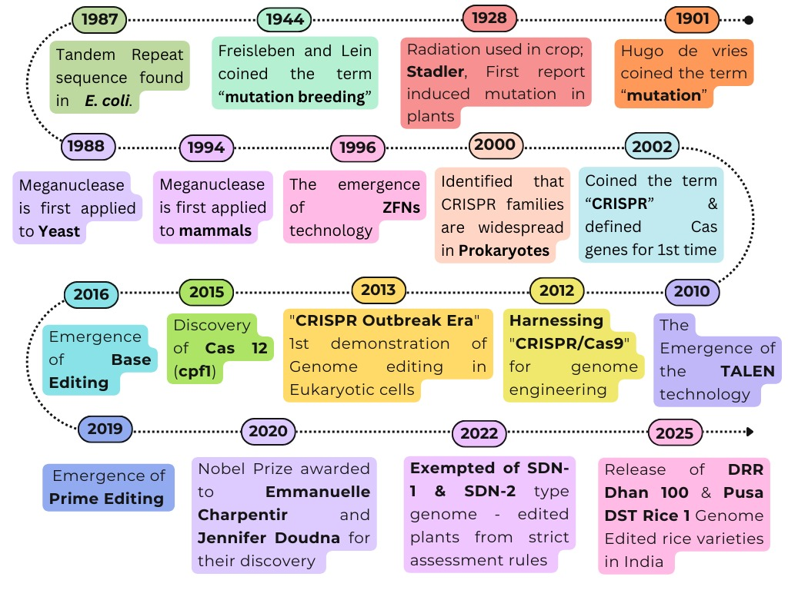
Fig. 1: Timeline of Genome editing (Source: Created by the author; concept adopted from Wei et al., 2022; Chavez-Granados et al., 2022; Varshney & Burgess, 2025; and Fiaz et al., 2021)
  - Working mechanism of Genome editing
Genome editing functions on the core principle by introducing precise modifications to genomic DNA through the use of programmable nucleases. These nucleases generate double-strand breaks (DSBs) or single-strand nicks at selected sites. The cell subsequently repairs these breaks with its inherent DNA repair mechanisms, resulting to the intended genetic alterations (Zhao et al., 2022). The identification of target sites is achieved through DNA-binding proteins or guide RNA molecules, which assist in directing the editing tools to specific genomic locations (Mann et al., 2024).
Genome editing primarily involves two genome editing enzymes: site-specific recombinase systems (SSRs) and site-specific nuclease systems (SSNs). SSRs recognize short DNA sequences approximately 35 to 40 base pairs long and generate accurate recombination events without inducing DSBs. Initially found in bacteria and yeast, these systems are extensively applied in plants to integrate single-copy transgenes, eliminate selectable markers, and insert genes at precise locations. They have been effectively implemented in Arabidopsis, rice, maize, tomato, tobacco, and Populus. Their primary benefit is the ability to edit without DSBs, though unintended recombination may occur (Mann et al., 2024).
SSNs are designed enzymes featuring a customizable DNA-binding region and a nuclease region, which induce targeted DNA breaks to trigger repair processes. Major SSN technologies include meganucleases, zinc finger nucleases, TALENs, and CRISPR/Cas systems, with CRISPR/Cas9 being the most widely used because of its simplicity, efficiency, and capability to target multiple sites simultaneously (da Cunha et al., 2025). Once the DNA is cleaved, repair may occur via non-homologous end joining, resulting in insertions or deletions, or through homology-directed repair, which enables precise sequence replacements. Recent advancements, such as base editing and prime editing, allow for accurate genome modifications without inducing double-strand breaks (DSBs), thereby greatly expanding opportunities for plant genome engineering (Yadav et al., 2023).
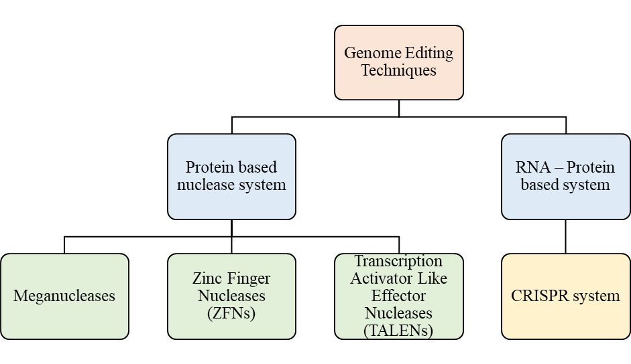
Fig. 2: Classification of Genome Editing Techniques
  - Classification of Genome Editing Techniques
Genome editing techniques are broadly classified into two main groups: Protein-based nuclease system and RNA – Protein based system. Under Protein based nuclease system, we have Meganucleases, Zinc Finger Nucleases, and Transcription activator like effector nucleases while under RNA – Protein based system we have Clustered Regularly Interspaced Short Palindromic Repeats (CRISPR) system. Below is the detailed explanation of these techniques.
    - Meganucleases
Meganucleases, also referred to as homing endonucleases, are the first class of sequence-specific nucleases developed for targeted genome modification. They can precisely cause double-strand breaks (DSBs) by identifying very long DNA sequences that range from approximately 12 to 40 base pairs (Abdullah et al., 2023). These enzymes were identified in the late 1980s and are present in a wide range of organisms, including unicellular eukaryotes, fungi, algae, yeast, prokaryotes, and archaea. They function as rare-cutting endonucleases and are encoded by mobile genomic elements (Yadav et al., 2023).
Meganucleases are the most specific restriction enzymes that exist naturally. Compared to traditional type II restriction enzymes employed in recombinant DNA technology, their recognition sites are substantially longer (Kumar et al., 2022). Structurally, Meganucleases have overlapping DNA-binding and DNA-cleavage domains. Their enzymatic activity generates site-specific DSBs that are primarily repaired via homologous recombination (HR) pathways (Iqbal et al., 2020). Based on conserved sequence patterns and structural characteristics, meganucleases are divided into five major families: (i) LAGLIDADG, (ii) GIY-YIG, (iii) HNH, (iv) His-Cys box, and (v) PD-(D/E) XK. The LAGLIDADG family is the most frequently utilized for genome editing and is typically found in the mitochondria and chloroplasts of unicellular eukaryotes. They function as dimeric proteins having endonuclease and intron-splicing RNA maturase activities (Kaur et al., 2022).
In 1993, meganuclease-mediated genome editing was successfully applied for the first time in plants. Targeted DSBs were produced in Nicotiana tabacum using the I-SceI meganuclease, which greatly increased the efficacy of homologous recombination (Bhambhani et al., 2022). Subsequent research revealed that in plants like maize, cotton, and Arabidopsis thaliana, meganuclease-induced double-strand breaks (DSBs) could aid in precise gene insertion and replacement. This proved that they could be used for targeted genome engineering (Iqbal et al., 2020). Engineered meganucleases have successfully inserted hppd and modified epsps genes at precise genomic sites, resulting in herbicide tolerance traits in cotton and maize (Hamdan et al., 2022). Additionally, they have been employed in targeted gene knockout research. For instance, insertion and deletion mutations were created at particular maize loci by CreI-based nucleases, and these alterations were heritable and passed on to subsequent generations (Iqbal et al., 2020).
Despite their excellent selectivity and small molecular size (about 40 kDa), which allows for delivery via certain viral vectors, meganucleases have seen limited usage in crop improvement (Mann et al., 2024). The overlap between the catalytic and DNA-binding domains is one major problem. This makes protein engineering more difficult and it often lowers enzymatic activity when target specificity is altered (Mangrauthia et al., 2024; Limbalkar et al., 2025). Moreover, unlike zinc-finger nucleases or TALENs, meganucleases do not have a modular DNA-binding structure. This increases the difficulty of reprogramming them to identify novel genetic targets (Iqbal et al., 2020). The scarcity of meganuclease recognition sites in plant genomes complicates matters, as lengthier cleavage sites must frequently be pre-introduced into target areas (Mangrauthia et al., 2024). The technological intricacy and high development costs have prevented the widespread deployment of directed nuclease editor platforms, despite efforts by businesses such as Cellectis and Precision Biosciences to produce customizable meganucleases (Mann et al., 2024). As a result, even though meganucleases laid the groundwork for sequence-specific genome editing, their use has been largely eclipsed by more adaptable and easily programmable technologies such as ZFNs, TALENs, and CRISPR/Cas systems (Zhao et al., 2022).
    - Zinc finger nucleases (ZFNs)
Zinc finger nucleases (ZFNs) were among the first developed tools for targeted genome editing. They are chimeric proteins consisting of a C-terminal non-specific FokI endonuclease cleavage domain linked to an N-terminal Cys2-His2 zinc finger DNA-binding domain (González Castro et al., 2021; Abdullah et al., 2023). A trinucleotide DNA sequence in the major groove of double-stranded DNA is specifically recognized by each zinc finger domain, which consists of approximately 30 amino acids arranged in a ββα configuration (Ali et al., 2025). Three to six zinc finger motifs are combined to target DNA sequences ranging from 9 to 18 base pairs, assuring sequence specificity (Kumar et al., 2022). For ZFNs to cleave DNA, the FokI nuclease domains require dimerize, which necessitates the binding of two ZFN monomers in the correct orientation and spacing on the target DNA (Hamdan et al., 2022). Once ZFNs bind and cleave, they cause double-strand breaks (DSBs), which the cell repairs using internal pathways, primarily non-homologous end joining (NHEJ) or homology-directed repair (HDR). This results in specific gene alterations or targeted mutations. ZFN-mediated genome editing is classified into three techniques based on the repair strategy used: ZFN-1, ZFN-2, and ZFN-3, which focus on NHEJ-based mutations, HDR-mediated point mutations, and large fragment insertions, respectively (Yadav et al., 2023). ZFNs enable a variety of genomic modifications, including insertions, deletions, point mutations, inversions, duplications, and chromosomal translocations (Bhambhani et al., 2022).
Numerous plant species, including Arabidopsis thaliana, tobacco, soybean, maize, rice, rapeseed, apple, and fig, have effectively employed ZFNs. This demonstrates their adaptability in the field of plant genome engineering (Iqbal et al., 2020). Targeted disruption of endogenous genes, trait stacking, insertional mutagenesis, and adding herbicide resistance to crops are important applications (Iqbal et al., 2020 & Zhao et al., 2022). For instance, inositol phosphate metabolism was altered and herbicide resistance was enhanced when the phosphinothricin acetyltransferase (PAT) gene cassette was inserted by ZFN into the ZmIPK1 locus in maize (Yadav et al., 2023).
Despite their excellent specificity and efficiency, the intricacy of protein design has hindered ZFNs' widespread application. Each target sequence necessitates unique zinc finger assemblies (Limbalkar et al., 2025). The overlapping DNA-binding specificity of zinc finger domains can result in inappropriate interactions and increased off-target cleavage events (González Castro et al., 2021; Ali et al., 2025). Additionally, designing ZFNs is costly, time-consuming, and technically challenging, making it less accessible to many labs (Pillay, 2020; Singh, et al., 2023). Their usage in routine crop improvement efforts has been further constrained by worries about cytotoxicity, restricted target sites, and unpredictability resulting from single nucleotide alterations (Bhuyan et al., 2023). Although ZFNs greatly advanced plant functional genomics and helped develop programmable genome editing, their use has mostly been supplanted by more adaptable and affordable editing technologies like TALENs and CRISPR/Cas systems (Mangrauthia et al., 2024).
    - TALENS
Transcription Activator-Like Effector Nucleases (TALENs) are a type of engineered site-specific nuclease designed to improve on previously described genome-editing tools like as meganucleases and Zinc Finger Nucleases (ZFNs). TALENs are chimeric nucleases that combine the nonspecific DNA cleavage domain of the FokI endonuclease with a programmable DNA-binding domain from transcription activator-like effectors (TALEs) (Mangrauthia et al., 2024). Plant pathogens called Xanthomonas spp. are the source of TALE proteins. During infection, they function as type III secreted virulence factors that bind to particular host DNA sequences and activate susceptibility genes (Hamdan et al., 2022). Tandem repeats of roughly 34 amino acids make up the center repeat domain of TALENs' DNA-binding domain. Each repeat recognizes a single nucleotide within the target DNA sequence (Limbalkar et al., 2025). Two variable amino acid residues, known as repeat variable di-residues (RVDs), at the 12th and 13th positions of each repetition provide the specificity for DNA binding. These RVDs affect a nucleotide's recognition accuracy (Ali et al., 2025). The one-to-one recognition of TALE repeats offers greater flexibility in target site selection within complex plant genomes compared to ZFNs, which recognize a group of three nucleotides (Son & Park, 2022). To cleave DNA, TALENs must operate as dimers. Only when two monomers unite does the FokI nuclease domain become active. As a result, a double-strand break (DSB) occurs in the space between the binding sites when two TALEN monomers attach to opposing DNA strands in a tail-to-tail configuration (Bhambhani et al., 2022). This DSB is subsequently repaired via endogenous cellular pathways, which include non-homologous end joining (NHEJ) and homology-directed repair (HDR). This repair mechanism can result in specific insertions, deletions, substitutions, or gene additions at the break site (Limbalkar et al., 2025).
Since its introduction in 2011, TALENs have been used to modify the genomes of numerous plant species, including rice, wheat, maize, soybean, sugarcane, potato, tomato, rapeseed, barley, flax, Nicotiana, and Arabidopsis (Yadav et al., 2023). The first documented use of TALENs in crop improvement was to disrupt the OsSWEET14 gene, which makes rice sensitive to bacterial blight, resulting in improved resistance to Xanthomonas oryzae pv. oryzae (Matres et al., 2021). Other applications include deleting the GL2 gene in maize to modify the composition of epicuticular wax, altering fatty acid desaturase genes in soybeans to enhance oil quality, and eliminating TaMLO homoeologs in wheat to increase resistance to powdery mildew (Limbalkar et al., 2025). Through targeted mutation of genes associated with cell walls, TALENs have also facilitated changes in metabolic features, such as increased saccharification efficiency in sugarcane (Zhao et al., 2022).
Despite its accuracy and capacity to target single nucleotides, TALEN-based genome editing has constraints that prevent it from being widely used. TALE sequences are repetitive, which complicates cloning and assembly. The composition of the repetitions and the requirement for a thymidine residue at the 5′ end of the binding site might also affect targeting efficiency (González Castro et al., 2021). Additional difficulties include a limited capacity for RNA editing or multiple gene knockout techniques, modest selectivity, inconsistent efficacy, and complex protein engineering (Kumar et al., 2022). Compared to smaller genome-editing techniques, TALEN constructs are more challenging to deliver and produce in plant cells due to their size, which is around 3 kb in cDNA length per monomer (Iqbal et al., 2020). As a result, while TALENs are still a potent and precise platform for genome editing, their popularity has declined as CRISPR/Cas technologies have become more simple, scalable, and cost-effective (Zhao et al., 2022).
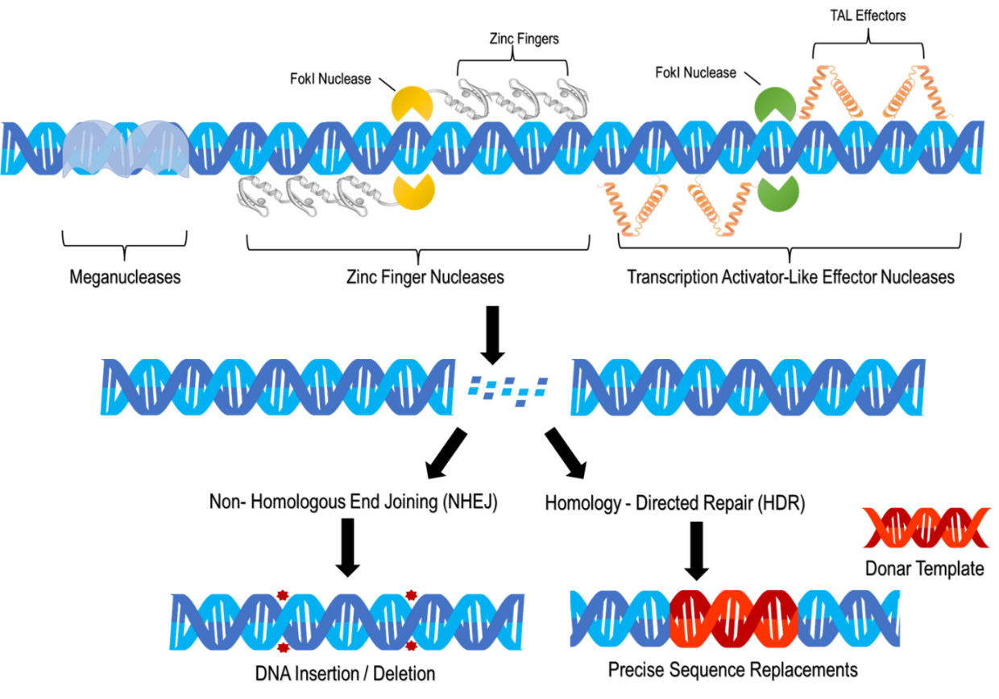
Fig. 3: Genome Editing Mechanism using Meganucleases, ZFNs, TALENs
    - CRISPR System
The Clustered Regularly Interspaced Short Palindromic Repeats (CRISPR) system is the most commonly utilized genome editing tool, allowing for precise, efficient, and programmed genetic modifications in many plant species (Lokya et al., 2025). It was initially identified in bacteria and archaea as an immunological response. The CRISPR system detects and chops intrusive nucleic acids from bacteriophages or plasmids, providing the host with targeted immunity (Yadav et al., 2023). By allowing precise insertions, deletions, substitutions, and chromosomal rearrangements at particular genomic regions, this natural defense mechanism has been modified for genome engineering, revolutionizing plant biotechnology (Kumar et al., 2024). In 2012, Emmanuelle Charpentier and Jennifer Doudna elucidated the mechanism of the CRISPR–Cas9 system and reprogrammed it. They developed it as an RNA-guided, programmable instrument for precise DNA cleaving, which enabled its landmark application in genome editing in 2013. Their discovery was recognized with the Nobel Prize in Chemistry in 2020.
In bacterial systems, CRISPR-Cas immunity occurs in three stages: adaption, expression, and interference. Foreign DNA pieces are taken up as spacers during these phases and incorporated into the host genome's CRISPR arrays. The CRISPR arrays are transcribed into a single precursor CRISPR RNA (pre-crRNA), which is then processed to mature crRNAs with individual spacer sequences surrounded by repeat regions (Yoshimi & Mashimo, 2022; Limbalkar et al., 2025). The mature crRNA interacts with Cas nucleases (a protein known as biological scissors or as molecular scissors) to produce complexes that recognize and cut complementary protospacer sequences in invading nucleic acids, neutralizing the foreign DNA (Gong et al., 2025).
CRISPR genome editing in plants is primarily based on Class 2 systems. Single, multidomain Cas proteins that are capable of independently identifying and cleaving targets are present in these systems (Hamdan et al., 2022). Because of its ease of usage, effectiveness, and compatibility with plant genomes, Streptococcus pyogenes' Type II CRISPR–Cas9 system is the most widely utilized (Bhambhani et al., 2022). This technique uses a ribonucleoprotein complex consisting of a guide RNA (gRNA) and the Cas9 endonuclease to modify the genome. Through Watson–Crick base pairing, the gRNA guides the Cas9 protein to the target region (Lokya et al., 2025; Gao et al., 2021). A short protospacer adjacent motif (PAM), commonly 5′-NGG-3′, must be present immediately following the target sequence for the editing to operate (Ahmad et al., 2023).
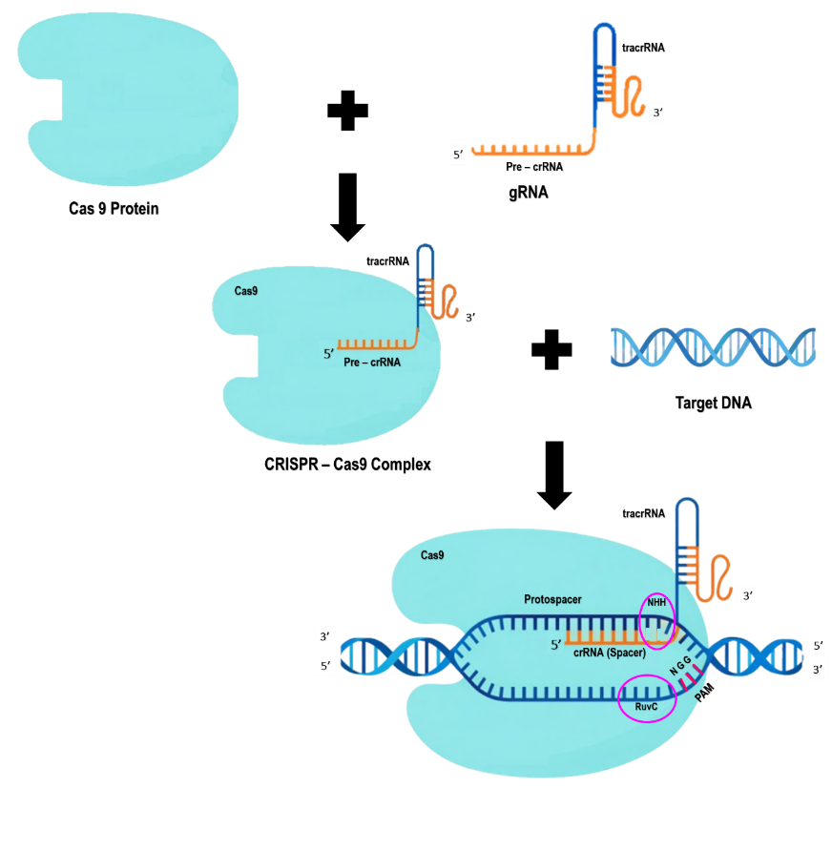
Fig. 4: Mechanism of CRISPR/Cas 9 system
Cas9 binds to the target DNA and causes a specific double-strand break (DSB) roughly three nucleotides upstream of the PAM. This is accomplished through the joint action of its HNH and RuvC nuclease domains, which cut the complementary and non-complementary DNA strands, respectively (Kumar et al., 2022). After the DSB is generated, the plant's inherent DNA repair systems begin to repair the genome, resulting in precise genetic modifications where the cut was made. The Non-Homologous End Joining (NHEJ) mechanism frequently predominates in plant cells, resulting in tiny insertions or deletions that impair gene function. In functional genomics and crop improvement, this technique is frequently employed for knockout mutations (Singh et al., 2023). Alternatively, Homology-Directed Repair (HDR) can make precise alterations to a donor DNA template, but its effectiveness is restricted by cell-cycle constraints and competition from NHEJ (Zhao et al., 2022).
Based on the composition of their effector complex, CRISPR systems are divided into two main types. Class 1 systems employ multi-protein complexes, whereas Class 2 systems rely on a single effector nuclease. Because of their simpler structure and easier delivery, class 2 systems, such as Cas9 (Type II), Cas12 (Type V), and Cas13 (Type VI), are primarily utilized for genome engineering (Hamdan et al., 2022). Cas9 and Cas12 nucleases target double-stranded DNA, whereas Cas13 is exclusive to single-stranded RNA. This feature broadens CRISPR's applications beyond genome editing, including transcriptome modulation and RNA virus resistance (Yoshimi & Mashimo, 2022). The possibility for editing in complex plant genomes has been further improved by modifying Cas variants, such as Cas9-NG, xCas9, SaCas9, and Cas12a, to have broader or varied PAM specificities (Ahmad et al., 2023).
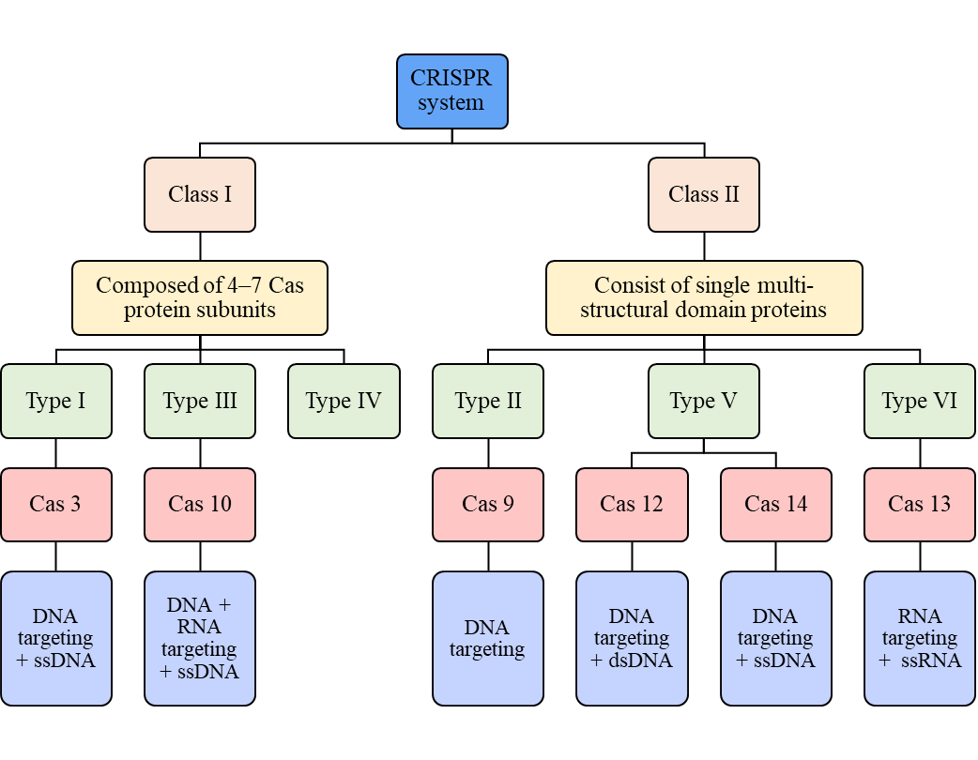
Fig. 5: Classification of CRISPR system
CRISPR-based genome editing is commonly employed to improve crops. It improves nutritional quality, yield, disease resistance, and tolerance to environmental stressors (Kumar et al., 2024). Resistance to bacterial, fungal, and viral diseases has increased as a result of targeted modifications to susceptibility genes. Enhanced resistance to drought, salinity, and temperature fluctuations has been achieved with precise alterations of regulatory genes (Kumar, M. et al., 2023). Furthermore, using CRISPR to modify metabolic pathway genes has enhanced nutrition and produced crop biofortification, demonstrating its potential to address global food security concerns (Kumar et al., 2022).
Traditional CRISPR–Cas9 editing has a substantial impact, but it has drawbacks such PAM dependency, off-target effects, mosaicism, and reliance on DSB-mediated repair techniques. These concerns can result in unwanted genetic alterations (Pillay, 2020). To address these issues, new precision genome editing tools are being developed that do not generate DSBs, with base editing and prime editing being key developments (Jiang et al., 2024). Base editing enables direct, irreversible alterations to single nucleotides without generating DSBs or requiring donor DNA templates. Single-nucleotide polymorphisms associated with desired qualities can be precisely altered using this technique (Jin & Ding, 2025). Adenine base editors use a combination of catalytically inactive Cas9 nickase and nucleotide deaminase enzymes to change A•T to G•C, whereas cytosine base editors change C•G to T•A (Choe et al., 2020). Eliminating DSBs in base editing reduces unwanted mutations and improves editing accuracy in plants (Bhambhani et al., 2022).
A further advancement in CRISPR technology is prime editing. It allows for precise "search-and-replace" genome alterations in the absence of DSBs or donor templates (Lokya et al., 2025). This method employs a combination of Cas9 nickase and reverse transcriptase, with a primary editing guide RNA (pegRNA) that comprises both the target site and the targeted edit (Kumar et al., 2023). The altered sequence can be transferred straight into the genome once the nicked DNA strand has identified the target and aligned with the pegRNA primer-binding site (Jiang et al., 2024). Prime editing can accommodate all twelve possible base substitutions, as well as tiny insertions and deletions. It provides more flexibility and precision than base editing, particularly in areas with limited PAM availability (Hamdan et al., 2022).
Overall, continued improvements in CRISPR technology, such as modified Cas variants, multiplex editing approaches, base editing, and prime editing, have solidified CRISPR's position as the most versatile genome editing tool in current plant biotechnology (Ahmar et al., 2022). CRISPR's promise for precision breeding, functional genomics, and sustainable agricultural modification is quickly expanding due to ongoing technological advancements, despite ongoing issues with delivery, editing consistency, and regulatory approval (Mangrauthia et al., 2024).
- Genome Editing Regulations in India
Genome editing employs site-directed nucleases (SDNs) to perform precise genomic modifications such as nucleotide deletion, replacement or addition. This results in desirable phenotypic traits without randomly changing the DNA (Sharma et al., 2025). These alterations are comparable to natural variations or those produced through traditional breeding. This distinguishes transgenic crops, which contain foreign DNA from unrelated species, from genome-edited plants (Mann et al., 2024). Based on how DNA repair takes place and the genetic outcomes obtained, genome editing events are divided into three types: SDN-1, SDN-2, and SDN-3. For regulatory reasons, this classification is crucial (Hamdan et al., 2022).
SDN-1 modification causes site-specific double-strand breaks. These breaks are repaired utilizing a mechanism known as non-homologous end joining, which results in small insertions or deletions without the need for an external repair template (Matres et al., 2021). SDN-2 editing employs homology-directed repair to precisely substitute nucleotides or make minor sequence modifications using a brief homologous donor template (Lokya et al., 2025). However, SDN-3 editing enables the selective insertion of larger DNA pieces, like transgenes or cisgenes. This yields outcomes that are comparable to those observed in traditional genetically modified organisms (Sharma et al., 2025; Sprink et al., 2022).
In India, the "Rules for the Manufacture, Use, Import, Export, and Storage of Hazardous Microorganisms/Genetically Engineered Organisms or Cells, 1989" have historically governed the regulation of genome-edited plants. This is governed under the Environmental (Protection) Act of 1986 (DBT, 2022). In March 2022, a significant regulatory reform occurred. The Ministry of Environment, Forest, and Climate Change exempted genome-edited plants generated under the SDN-1 and SDN-2 categories from biosafety assessments under Rule 20 of the 1989 Rules, as long as they did not include any foreign DNA (DBT, Guidelines for the Safety Assessment of Genome-Edited Plants, 2022). Later, the Department of Biotechnology publicly released the "Guidelines for the Safety Assessment of Genome-Edited Plants, 2022," establishing a precise regulatory framework for genome-edited crops in India (Mann et al., 2024).
According to these rules, SDN-1 and SDN-2 genome-edited plants are treated similarly to conventionally bred types. After adhering to conventional evaluation procedures, they can be released without undergoing the rigorous biosafety testing necessary for genetically modified organisms (GMOs) (Sharma et al., 2025). On the other hand, because SDN-3 products contain foreign genetic material, they are subject to strict regulatory control (DBT, 2022). This risk-based framework aligns India with numerous other countries with similar regulatory regimes, including the United States, Canada, Brazil, Argentina, and Japan (Bansal, 2022).
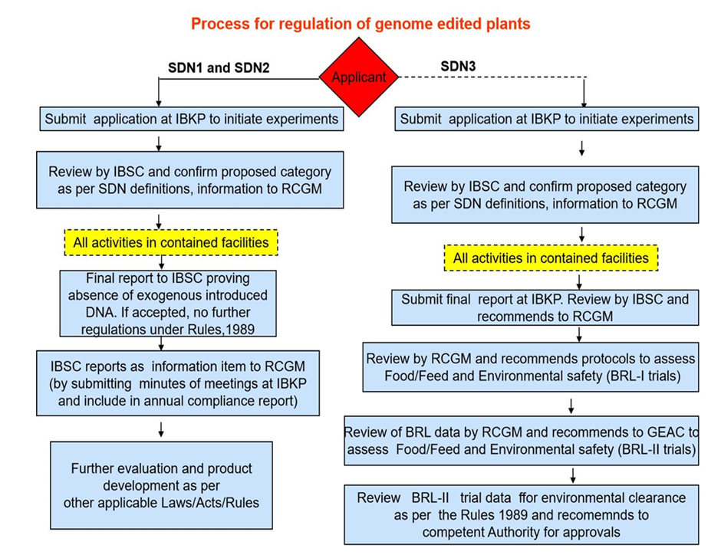
Fig. 6: The regulatory process for genome-edited plants in India.
where IBKP – Indian Biosafety Knowledge Portal, IBSC – Institutional Biosafety Committees, RCGM – Review Committee on Genetic Manipulation (Source: DBT, 2022. Link: https://dbtindia.gov.in/sites/default/files ).

The exemption for SDN-1 and SDN-2 products is projected to accelerate crop development activities aimed at generating varieties resistant to stress, climate change, and nutritional problems, while also reducing regulatory delays and costs (Sharma et al., 2025). Overall, India's regulatory framework, which goes into effect in 2022, takes a balanced approach to encouraging innovation in genome editing while protecting biosafety and the environment (DBT, 2022).

- Applications of Genome Editing
Genome editing has emerged as an effective way to increase crop tolerance to stress from adverse conditions. It enables precise alterations to genes that detect stress, transmit messages, and initiate adaptive responses (Yadav et al., 2023). It has also enabled the fine-tuning of hormonal signaling pathways, such as abscisic acid and ethylene responses, thereby improving stress tolerance while maintaining yield stability in normal growth conditions (Das et al., 2023). Unlike traditional breeding, genome editing accelerates trait development by directly modifying natural alleles associated with stress adaptability. This speeds up the creation of crops that can resist changing climates (Smyth, 2022).
Genome editing has significantly improved crop resilience to abiotic stresses by allowing precise modification of stress-responsive regulatory and metabolic genes. In rice, CRISPR/Cas9 editing of CKX2/Gn1a and DST genes has produced drought-tolerant varieties like DRR Dhan 100 and Pusa DST Rice 1. These varieties show better water-use efficiency and yield stability during dry conditions (Kumar et al., 2025). Disrupting the DST gene has also boosted salt tolerance by adjusting stomatal behavior and ionic balance. This has improved plant performance in salty environments without hindering growth in normal conditions (Shivani & Shrishailam, 2025).
Similarly, Genome editing holds significant capacity for enhancing resistance to biological stresses by either altering genes that render plants susceptible or boosting innate immune responses against diseases and pests (Hamdan et al., 2022). Disease susceptibility genes were carefully knocked out or modified to provide long-term resistance to bacterial, fungal, and viral diseases in cereals, vegetables, and horticulture crops, all without the addition of foreign DNA (Bhattacharya et al., 2021). CRISPR/Cas9 editing of OsSWEET genes in rice has conferred enduring resistance to bacterial blight by inhibiting sugar depletion induced by the pathogen, essential for disease proliferation (Zeng et al., 2020; Hamdan, M. et al., 2022). Likewise, the disruption of the TaMLO susceptibility gene in wheat by TALENs or CRISPR/Cas has resulted in extensive resistance to powdery mildew, hence diminishing the reliance on fungicides (Waites et al., 2025). In tomato, precise modification of the host translation factor eIF4E has interrupted viral replication cycles, yielding robust resistance against major viral infections (Yoon et al., 2020). Collectively, these findings demonstrate genome editing's capacity to confer enduring, transgene-free disease resistance in various crop species. CRISPR-based techniques are used not just to build resistance, but also to diagnose pathogens and monitor diseases. These methods utilize CRISPR-based molecular testing to rapidly and accurately detect plant diseases (Gong et al., 2025). These applications demonstrate how genome editing might modify crops, increasing their resilience to both abiotic and biotic challenges while supporting sustainable farming techniques (Bansal et al., 2022).
Genome editing has also been utilized extensively to improve crop production potential, hormonal regulation, and nutritional quality by accurately altering critical metabolic and developmental processes. Multiplex CRISPR/Cas9 editing of yield-related genes in rice has enabled simultaneous improvements in grain number and plant structure, resulting in considerable production gains (Jin & Ding, 2025). In tomatoes, altering hormone signalling genes such as SIIAA9 has improved fruit set and uniformity. Modifying genes that govern cell wall breakdown increased shelf life by delaying fruit softening (Das et al., 2023; Smyth, 2022). Furthermore, specific modifications in metabolic pathways have enabled biofortification, resulting in enhanced GABA levels, better flavour, higher lycopene content, and improved texture. This demonstrates how genome editing can be used to improve yield, quality, and nutritional attributes all at once.
S. No. | Trait | Crop | Technique used | Reference
- Abiotic Stress
 | Drought Tolerance | Rice (DRR Dhan 100 & Pusa DST Rice 1) | CRISPR/Cas9 (CKX2 Gn1a gene & DST gene) | Kumar et al., 2025
 | Salt Tolerance | Rice (Pusa DST Rice 1) | CRISPR/Cas9 (DST gene) | Shivani & Shrishailam, 2025
 | Nutrient Use Efficiency | Rice | CRISPR/Cas9 (OsNRT1.1B gene) | Sampath et al., 2023
- Biotic Stress
 | Bacterial Disease Resistance | Rice | CRISPR/Cas9 (OsSWEET gene editing) | Hamdan, M. et al., 2022
 | Fungal Disease Resistance | Wheat | TALEN / CRISPR (TaMLO knockout) | Waites et al., 2025
 | Viral Disease Resistance | Tomato | CRISPR/Cas9 (eIF4E editing) | Yoon et al., 2020
- Yield and Quality Improvements
 | Yield Improvement | Rice | CRISPR/Cas9 multiplex editing | Jin & Ding, 2025
 | Parthenocarpy | Tomato | CRISPR/Cas9 (SIIAA9) | Das et al., 2023
 | Biofortification | Tomato (GABA-rich) | CRISPR/Cas9 | Marone et al., 2023
 | Taste Quality | Tomato | CRISPR/Cas9; RNA interference (RNAi) | Marone et al., 2023
 | Self Life | Tomato | CRISPR/Cas9 (polygalacturonase) | Smyth, 2022
 | Texture | Tomato | CRISPR/Cas9 | Ansori et al., 2023
 | Vitamin Enhancement | Tomato | CRISPR/Cas9 (lycopene pathway) | Kumar et al., 2022
 | Amino Acid Enhancement | Soybean | CRISPR/Cas9 (oil composition) | Zhao et al., 2022
Table 1: Application of Genome Editing Techniques for improving various traits.

  - Recently released GE varieties in India
India achieved a key milestone by showing the significance of practical application of the genome editing technique with the release of its first genome-edited rice varieties, DRR Dhan 100 (Kamala) and Pusa DST Rice 1. These were generated utilizing CRISPR/Cas9-based SDN-1 technology that did not include any foreign DNA (Ahuja, 2025; Shivani & Shrishailam, 2025). The development of these cultivars required coordinated research efforts headed by ICAR institutes such as IIRR and IARI. They worked to improve yield stability and climate resilience in Indian agricultural settings (Sharma et al., 2025). The detailed characterization of Dhan 100 (Kamala) and Pusa DST Rice 1 is given in the table below. These genome-edited varieties were made possible by India's regulatory exemption of SDN-1 and SDN-2 products from the 2022 criteria, allowing them to be designated as non-GMO crops (Sharma et al., 2025). These results provide a successful technique to translate genome editing research into cultivars suitable for Indian farmers (Mangrauthia et al., 2024).
S. No. | Characteristics | CRISPR/Cas9 Technology, SDN1 type Genome edited Plants
1. | Rice Variety | DRR Dhan 100 (Kamala) | Pusa DST Rice 1
2. | Parent | Samba Mahsuri / BPT-5204 (elite background) | MTU 1010 (high-yielding indica rice)
3. | Gene edited | Cytokinin oxidase/ dehydrogenase gene (CKX2 Gn1a) was generated using targeted genome editing to modulate cytokinin metabolism | Drought and Salt Tolerance (DST) gene
4. | Trait Improved / Purpose | - Mean yield increase of 19% over Samba Mahsuri  - Matures 20 days earlier (~130 days)  - Save water and fertilizers, and reduce methane gas emissions  - Possesses a strong culm, providing superior lodging resistance  - Moderate drought tolerance  - Require low nitrogen and phosphorus inputs | - Increase yields by 9.66% to 30.4% in saline and alkaline soils,  - With the potential for up to 20% increase in production
5. | Scientist & Institute (Lead) & Released year | Dr. Satendra Kumar Mangrauthia and team, ICAR –IIRR, Hyderabad; released May 2025 | Dr. Viswanathan Chinnusamy and team, ICAR – IARI, Pusa, New Delhi; released May 2025
6. | Developed for states | Andhra Pradesh, Telangana, Karnataka, Tamil Nadu, Puducherry, Kerala (Zone VII), Chhattisgarh, Maharashtra, Madhya Pradesh (Zone V), Odisha, Jharkhand, Bihar, Uttar Pradesh, and West Bengal (Zone III)
Table 2: Characteristic features of DRR Dhan 100 (Kamala) and Pusa DST Rice 1.
(Source: IIRR & IARI, 2025. Link: https://www.icar-iirr.org/index.php/en/component/ content/article/30-iirr-articles/282-variety-released?Itemid=258)

  - Research Progress of Genome Editing for crop improvement in India
Genome editing research in India has expanded rapidly across important crops, with ICAR, IARI, IRRI-India, IIHR, and IIVR leading targeted trait improvement initiatives based on CRISPR/Cas technologies (Bhattacharya et al., 2021). Rice has made significant progress through multiplex editing of genes associated to yield, stress responses, and nutrient usage (Jin & Ding, 2025). Genome editing in horticultural crops has enhanced shelf life, disease resistance, and nutritional quality in vegetables such as tomatoes and cucurbits, thanks to efforts spearheaded by IIHR (Das et al., 2023). Genome editing techniques have also been used to improve abiotic stress tolerance in cereals, pulses, and oilseeds, thereby contributing to national climate resilience goals (Kumar, M. et al., 2023). To achieve regulatory norms and earn public trust, Indian research programs are increasingly focusing on transgene-free editing via ribonucleoprotein delivery and transient expression systems (Mann et al., 2024). All of these efforts demonstrate that genome editing has emerged as a revolutionary tool for crop improvement in India, linking fundamental research to practical breeding while promoting sustainable agriculture and food security (Bansal et al., 2022; FAO, 2022).

S. No. | Crop | Variety | Trait | Organization
A) Cereals:
 | Rice | MTU1010-DST | Drought and salt tolerance; Yield | ICAR – IARI, New Delhi
 | Rice | MTU1010-DST | Herbicide resistance | ICAR – IARI, New Delhi
 | Rice | Manipur Black rice, Pusa Samba 1850 | Drought and salt tolerance; Yield | ICAR – IARI, New Delhi
 | Rice | Oryza longistaminata | De novo domestication | ICAR – IARI, New Delhi
 | Rice | MTU1010-TB1 | Culm strength | ICAR – IARI, New Delhi
 | Rice | Kala Champa, MTU1010, Manipur Black rice | Yield | ICAR – IARI, New Delhi
 | Rice | MTU1010, Pusa Samba 1850 | Nitrogen Use Efficiency (NUE) | ICAR – IARI, New Delhi
 | Rice | Samba Mahsuri DST | Blast resistance | ICAR – IARI, New Delhi
 | Rice | Samba Mahsuri | Blast resistance | ICAR – IARI, New Delhi
 | Rice | PR126, Pusa-2090, Pusa-1824 | Southern rice black-streaked dwarf virus | ICAR – IARI, New Delhi
 | Rice | PR126, Pusa-2090, Pusa-1824 | Bacterial blight resistance | ICAR – IARI, New Delhi
 | Rice | PR126, Pusa-2090, Pusa-1824 | Nematode resistance | ICAR – IARI, New Delhi
 | Rice | Swarna, Sahbhagi Dhan (Popular varieties) | Yield enhancement | ICAR – CRRI, Cuttack, Odisha
 | Rice | Gobhindobhog, Nuakalajeera | Lodging resistance | ICAR – CRRI, Cuttack, Odisha
 | Rice | MTU1010 | NUE (Nitrogen Use Efficiency) | ICAR – CRRI, Cuttack, Odisha
 | Rice | CR Dhan 315 | Nutrient Bioavailability | ICAR – CRRI, Cuttack, Odisha
 | Rice | Pooja | Water Use Efficiency | ICAR – CRRI, Cuttack, Odisha
 | Rice | Rajlaxmi hybrid | Apomictic Rice | ICAR – CRRI, Cuttack, Odisha
 | Rice | Samba Mahsuri | Male sterility | ICAR – IIRR, Hyderabad, Telangana
 | Rice | Samba Mahsuri CKX2 (Kamala) | Yield | ICAR – IIRR, Hyderabad, Telangana
 | Rice | Chitti Muthyalu | Dwarfness, grain yield, and culm strength | ICAR – IIRR, Hyderabad, Telangana
 | Rice | BPT 5204 | Salt tolerance | ICAR – CSSRI, Karnal, Haryana
 | Rice | MTU1010 | Fe Biofortification | ICAR – NIPB, New Delhi
 | Rice | MTU1010 | Bacterial blight disease | ICAR – NIPB, New Delhi
 | Rice | MTU1010 | Ideal Plant Type | ICAR – NIPB, New Delhi
 | Rice | PR126, MTU1010 | Yield | ICAR – NIPB, New Delhi
 | Wheat | HD 3406; HD 3226 | Salt tolerance | ICAR – CSSRI, Karnal, Haryana
 | Wheat | HD3406 | Nitrogen Use Efficiency | ICAR – NIPB, New Delhi
 | Wheat | HD3406 | Nitrogen and Phosphorus Use Efficiency | ICAR – NIPB, New Delhi
 | Wheat | HD3406 | Heat stress tolerance | ICAR – NIPB, New Delhi
 | Wheat | DBW187/DBW303 | Nitrogen use efficiency | ICAR – IIWBR, Karnal, Haryana
 | Wheat | DBW187/DBW303 | Heat stress tolerance | ICAR – IIWBR, Karnal, Haryana
 | Wheat | DBW187/DBW303 | Biofortification of Fe and Zn | ICAR – IIWBR, Karnal, Haryana
 | Wheat | DBW187/DBW303 | Resistant starch | ICAR – IIWBR, Karnal, Haryana
 | Maize | Inbreds & responsive varieties | Haploid induction | ICAR – IARI, New Delhi
 | Maize | Inbreds & responsive varieties | High planting density | ICAR – IARI, New Delhi
 | Maize | DMRH 1308 / BML 6 | High-amylose / Low-glycemic maize | ICAR – IIMR, Ludhiana, Punjab
 | Maize | DMRH 1308 / BML 6 | BLSB resistance | ICAR – IIMR, Ludhiana, Punjab
 | Maize | DMRH 1308 / BML 6 | Herbicide tolerance | ICAR – IIMR, Ludhiana, Punjab
B) Pulses:
 | Chickpea | GNG2171, JAKI9218 | Yield attributing traits: i) No. of seeds per pod (NSPP), ii) Double podding | ICAR – IIPR, Kanpur, Uttar Pradesh
 | Chickpea | Pusa-Chickpea Manav (BGM20211) | Drought | ICAR – NIPB, New Delhi
 | Chickpea | JAKI 9218 | Fusarium wilt | ICAR – NIPB, New Delhi
 | Pigeon pea | IPA 15-6 | Productivity / Yield attributing traits | ICAR – IIPR, Kanpur, Uttar Pradesh
 | Grass pea | Mahateora | Anti-nutritional factor | ICAR – IIPR, Kanpur, Uttar Pradesh
 | Urd bean | LBG 752 | High isoflavone content, tolerance to MVYV and UCLV | ICAR – IIAB, Ranchi, Jharkhand
 | Urd bean | IPU13-01 | Productivity / Yield attributing traits | ICAR – IIPR, Kanpur, Uttar Pradesh
 | Lentil | IPL316 | Productivity / Yield attributing traits | ICAR – IIPR, Kanpur, Uttar Pradesh
C) Oilseed crops:
 | Indian Mustard | Pusa Bold, PM30, PM33, PM34 | Seed yield | ICAR – IARI, New Delhi
 | Indian Mustard | Pusa Bold, PM30, PM33, PM34 | Resistance to silique shattering; Sclerotinia tolerance | ICAR – IARI, New Delhi
 | Indian Mustard |  | Oil content | ICAR – IARI, New Delhi
 | Indian Mustard | Pusa Bold, PDZ31, Varuna | Sclerotinia resistance | ICAR – IARI, New Delhi
 | Indian Mustard | Pusa Bold, PDZ31, Varuna | Early flowering | ICAR – IARI, New Delhi
 | Indian Mustard | Pusa Bold, PM30, PM33, PM34 | Improved oil yield / architecture | ICAR – IARI, New Delhi
 | Indian Mustard | PM29, PM30 | Improved yield & seed shattering resistance | ICAR – IARI, New Delhi
 | Indian Mustard | CS 60 | Low Erucic acid (≤2%) | ICAR – CSSRI, Karnal, Haryana
 | Indian Mustard | PM32, PM34, Pusa jai | kisan Yield | ICAR – NIPB, New Delhi
 | Indian Mustard | PM 32, PM34 | Aphid resistance | ICAR – NIPB, New Delhi
 | Indian Mustard | PJK & PM32 | Yield | ICAR – NIPB, New Delhi
 | Indian Mustard | Pusa jai kisan, PM 32/PM34 | Seed number per silique (Yield) | ICAR – NIPB, New Delhi
 | Indian Mustard | PM-30, PM-32, PM-34 | High oil content | ICAR – NIPB, New Delhi
 | Indian Mustard | PM-30, PM-32, PM-34 | Orobanche resistance | ICAR – NIPB, New Delhi
 | Indian Mustard | NRCHB101/DRMR-1165-40/DRMR/JI-31 | Orobanche resistance | ICAR – DRMR, Bharatpur, Rajasthan
 | Indian Mustard | NRCHB101/DRMR-1165-40/DRMR/JI-31 | Early flowering phenotype | ICAR – DRMR, Bharatpur, Rajasthan
 | Indian Mustard | NRCHB101/DRMR-1165-40/DRMR/JI-31 | Higher number of seeds per siliqua | ICAR – DRMR, Bharatpur, Rajasthan
 | Groundnut | TG37A / GG20 | Seed RFOs | ICAR – IIAB, Ranchi, Jharkhand
 | Groundnut | GG 20 Low | Phytic Acid | ICAR – IIGR, Junagadh, Gujarat
 | Groundnut | TG 37 A | Spodoptera Resistance | ICAR – IIGR, Junagadh, Gujarat
 | Groundnut | Girnar-4 and Girnar-5 | Herbicide Tolerance | ICAR – IIGR, Junagadh, Gujarat
 | Soybean | JS335 | Photoperiod insensitivity | ICAR – IIAB, Ranchi, Jharkhand
 | Soybean | JS 20-98 | Oleic acid content | ICAR – IISR, Indore, Madhya Pradesh
 | Soybean | JS 20-98 | Seed and oil yield | ICAR – IISR, Indore, Madhya Pradesh
 | Soybean | NRC 142 | Seed yield and photosynthesis | ICAR – IISR, Indore, Madhya Pradesh
 | Soybean | NRC 130 | Insect resistance + removal of pod shattering | ICAR – IISR, Indore, Madhya Pradesh
 | Soybean | JS-335 | Drought tolerance | ICAR – NIASM, Baramati, Maharashtra
 | Soybean | JS-335 | Water logging tolerance | ICAR – NIASM, Baramati, Maharashtra
 | Soybean | JS-335 | Salinity stress tolerance | ICAR – NIASM, Baramati, Maharashtra
 | Soybean | JS-335 | Yield | ICAR – NIASM, Baramati, Maharashtra
 | Soybean | JS-335 | Yellow Mosaic Disease (YMD) | ICAR – NIBSM, Raipur, Chhattisgarh
 | Castor | DPC 9 (Good pistillate line, responds well to tissue culture) | Bio-detoxification | ICAR – IIOR, Hyderabad, Telangana
 | Sunflower | RHA-6D-1, RHA-1-1, RGP 100 | High oleic acid content | ICAR – IIAB, Ranchi, Jharkhand
 | Sunflower | 6D-1, RHA1-1, 243B (Well-adapted R lines used in breeding programmes) | Powdery Mildew Resistance | ICAR – IIOR, Hyderabad, Telangana
 | Sesame | TMV-3, Shwetha | Non-shattering Determinate Habit High Oleic Oil | ICAR – IIOR, Hyderabad, Telangana
 | Sesame | Swetha, GT-10, TKG-22, VR1-2, and TMV-7 | More no. capsules | ICAR – NBPGR, New Delhi
 | Sesame | Swetha, GT-10, TKG-22, VR1-2, and TMV-7 | Seed no. per capsule | ICAR – NBPGR, New Delhi
 | Sesame | Swetha, GT-10, TKG-22, VR1-2, and TMV-7 | High oil and seed weight | ICAR – NBPGR, New Delhi
 | Linseed | T-397 | 1000 seed weight | ICAR – NBPGR, New Delhi
 | Linseed | T-397 | Early flowering | ICAR – NBPGR, New Delhi
D) Millets:
 | Pearl millet | HHB 67 Improved, Pusa 1201, MPMH 17 | Grain yield | ICAR – IARI, New Delhi
 |  | Dhanshakti | Shelf life | ICAR – IIMR, Hyderabad, Telangana
 | Foxtail millet | SiA3156, SiA3085, SiA3088 | Grain yield | ICAR – IARI, New Delhi
 | Foxtail millet | SiA3156, SiA3085, SiA3088 | Shelf life | ICAR – IARI, New Delhi
 | Foxtail millet | SiA3156, SiA3085, SiA3088 | Low phytic acid | ICAR – IARI, New Delhi
 | Finger millet | VL 375, GPU67 | Grain yield | ICAR – IARI, New Delhi
 | Finger millet | GN-5 | Drought stress tolerance | ICAR – NIPB, New Delhi
 | Sorghum | C43 | Herbicide | ICAR – IIMR, Hyderabad, Telangana
E) Cash/commercial crops:
 | Sugarcane | Co 86032 | Drought | ICAR – SBI, Coimbatore, Tamil Nadu
 | Sugarcane | Co 86032 | Sucrose | ICAR – SBI, Coimbatore, Tamil Nadu
 | Sugarcane | Co 86032 | Biomass | ICAR – SBI, Coimbatore, Tamil Nadu
 | Sugarcane | Co 99004 | Tiller | ICAR – SBI, Coimbatore, Tamil Nadu
 | Sugarcane | Co 13013 | Flowering | ICAR – SBI, Coimbatore, Tamil Nadu
 | Sugarcane | CoC 671 / Co 0238 | Red rot | ICAR – SBI, Coimbatore, Tamil Nadu
 |  | Co 0238 | Red rot resistance | ICAR – IISR, Lucknow, Uttar Pradesh
 |  | CoLk 14201 | Virus resistance | ICAR – IISR, Lucknow, Uttar Pradesh
 |  | CoLk 15207 | Sucrose content | ICAR – IISR, Lucknow, Uttar Pradesh
 |  | CoLk 15201 | Reduced lignin | ICAR – IISR, Lucknow, Uttar Pradesh
 | Cotton | Coker 310 and 312 | Tolerance to premature square and boll shedding | ICAR – IIAB, Ranchi, Jharkhand
 | Cotton | Coker 312 (Mutant allele introgressed into Suraksha/Yugank Bt) | Compact architecture, determinate sympodial shoots | ICAR – CICR, Nagpur, Maharashtra
 | Cotton |  | Seed oil quality | ICAR – CICR, Nagpur, Maharashtra
 | Cotton |  | Fibre quality, yield & agronomic traits | ICAR – CICR, Nagpur, Maharashtra
 | Cotton |  | Seed oil content & salt tolerance | ICAR – CICR, Nagpur, Maharashtra
 | Jute | JRO-524 | - Reduced lignin biosynthesis  - Delayed flowering | ICAR – CRIJAF, Barrackpore, West Bengal
 | Tobacco | Banket A1 | TSNA (Tobacco Specific Nitrosoamines) | ICAR – NIRCA, Rajahmundry, Andhra Pradesh
 | Flax | JRF2 | Haploid induction | ICAR – CRIJAF, Barrackpore, West Bengal
F) Fodder crops:
 | Cowpea | BL-1/BL-2/ BL-4/ MFC-09-1 | High Biomass | ICAR – IGFRI, Jhansi, Uttar Pradesh
Table 3: Crop-wise list of traits targeted by the ICAR institutes for crop improvement through genome editing under the project “ICAR EFC - Enhancing climate resilience and ensuring food security with Genome Editing Tools” (Source: https://icargenomeediting.in/).

- Conclusion and Future Prospects
Genome editing has emerged as a crucial approach for crop improvement. It provides greater precision, efficiency, and flexibility than traditional breeding and molecular breeding procedures. Targeted alterations can be made using tools like CRISPR/Cas, as well as newer approaches like base and prime editing. These can vary from single-nucleotide changes to specific gene insertions. As a result, the creation of crop varieties with higher yields, nutritional value, and resistance to various pressures has quickened. In India, supporting legislation, particularly the exemption of SDN-1 and SDN-2 genome-edited plants from stringent GMO regulations, has provided a favourable climate. This transition enables research triumphs to become field-ready varieties, as demonstrated by the recent release of genome-edited rice varieties. These advancements demonstrate how genome editing can have a significant influence on food security, climate change adaptation, and sustainable farming.
However, genome editing still faces a number of scientific, technological, and societal hurdles. Technical challenges include developing effective and universal delivery mechanisms, reliable plant regeneration processes, and uniform editing results across crop kinds. Although improved guide RNA design and engineered Cas variations have reduced off-target mutations, they are still a source of worry, particularly for regulatory approval and long-term safety. Furthermore, while modern methods such as base and prime editing reduce double-strand breaks, they still require fine-tuning for greater efficiency and use across complex plant genomes. Uncertainty in legislation governing SDN-3 alterations and larger DNA insertions also limits the application of various genome-editing techniques.
Public perception is another important factor influencing the future of genome editing in agriculture. Although crops modified with genome editing tools, particularly transgene-free SDN-1 and SDN-2 products, are scientifically distinct from typical GMOs, public awareness of these differences remains limited. Concerns about food safety, the environment, and ethics all can have an impact on consumer acceptability and market growth. Building public trust requires transparent communication, stakeholder engagement, and scientific risk assessment. Effective labelling policies, communication campaigns, and sharing evidence demonstrating the safety and benefits of genome-edited crops will be critical in modelling educated public opinion.
The future of genome editing is promising. Precision editing tools, multiplex editing approaches, and delivery technology are projected to continue to progress, improving efficiency and specificity. Combining genome editing with genomics, phenomics, and AI-powered breeding methods will most certainly accelerate trait discovery and variety development. Genome editing has the potential to become a critical tool for developing climate-resilient, nutritionally improved, and sustainable crop types to address global agricultural concerns with proper regulatory control, extensive safety studies, and active public participation.

- References
- Abdullah, M. A., Fatima, S., Khaliq, F., Mehmood, M., Yousaf, T., Mustafa, M. B., & Hassan, A. (2023). Using CRISPR/Cas9 Technology to Improve Crops and Address the Global Food Crisis: A Review. Asian Journal of Research in Crop Science, 8(4), 454-464.
- Agho, C., Avni, A., Bacu, A., Bakery, A., Balazadeh, S., Baloch, F. S., ... & Fragkostefanakis, S. (2024). Integrative approaches to enhance reproductive resilience of crops for climate-proof agriculture. Plant stress, 100704.
- Ahmad, M. (2023). Plant breeding advancements with “CRISPR-Cas” genome editing technologies will assist future food security. Frontiers in plant science, 14, 1133036.
- Ahmar, S., Saeed, S., Khan, M. H. U., Ullah Khan, S., Mora-Poblete, F., Kamran, M., ... & Jung, K. H. (2020). A revolution toward gene-editing technology and its application to crop improvement. International Journal of Molecular Sciences, 21(16), 5665.
- Ahuja, V. (2025). Launch of two genome-edited rice varieties by India. South Asia Biosafety Program Newsletter, 22(5), 1.
- Ali, N., Singh, S., & Garg, R. (2025). Unlocking crops’ genetic potential: Advances in genome and epigenome editing of regulatory regions. Current Opinion in Plant Biology, 83, 102669.
- Ansori, A. N., Antonius, Y., Susilo, R. J., Hayaza, S., Kharisma, V. D., Parikesit, A. A., Zainul, R., Jakhmola, V., Saklani, T., Rebezov, M., Ullah, M. E., Maksimiuk, N., Derkho, M., & Burkov, P. (2023). Application of CRISPR-Cas9 genome editing technology in various fields: A review. Narra J, 3(2), e184.
- Bansal, K. C., Molla, K. A., & Chinnusamy, V. (2022). Genome editing: a boon for plant biologists, breeders and farmers. Curr Sci, 123(1), 15-19.
- Bhambhani, S., Kondhare, K. R., & Giri, A. P. (2022). Advanced genome editing strategies for manipulation of plant specialized metabolites pertaining to biofortification. Phytochemistry Reviews, 21(1), 81-99.
- Bhattacharya, A., Parkhi, V., & Char, B. (2021). Genome editing for crop improvement: A perspective from India. In Vitro Cellular & Developmental Biology-Plant, 57(4), 565-573.
- Bhuyan, S. J., Kumar, M., Ramrao Devde, P., Rai, A. C., Mishra, A. K., Singh, P. K., & Siddique, K. H. (2023). Progress in gene editing tools, implications and success in plants: a review. Frontiers in Genome Editing, 5, 1272678.
- Chavez-Granados, P. A., Manisekaran, R., Acosta-Torres, L. S., & Garcia-Contreras, R. (2022). CRISPR/Cas gene-editing technology and its advances in dentistry. Biochimie, 194, 96-107.
- Choe, D. C., & Musunuru, K. (2020). Base editing: a brief review and a practical example. Journal of Biomedical Research, 35(2), 107.
- da Cunha, N. B., Leite, M. L., Rodrigues, J. C. M., Carrijo, J., Costa, F. F., Dias, S. C., ... & Vianna, G. R. (2025). Molecular tools for genome editing in plants: a synthetic overview. Vegetable Research, 5(1).
- Das, T., Anand, U., Pal, T., Mandal, S., Kumar, M., Radha, Gopalakrishnan, A.V., Lastra, J.M.P.D.L., & Dey, A. (2023). Exploring the potential of CRISPR/Cas genome editing for vegetable crop improvement: an overview of challenges and approaches. Biotechnology and Bioengineering, 120(5), 1215-1228.
- Department of Biotechnology, Ministry of Science & Technology, Government of India. (2022). Guidelines for the safety assessment of genome edited plants, 2022. https://dbtindia.gov.in/sites/default/files
- FAO. 2023. Gene editing and food safety – Technical considerations and potential relevance to the work of Codex Alimentarius. Rome. https://doi.org/10.4060/cc5136en
- Fernández Ríos, D., Quintana, S. A., Gómez Paniagua, P., Arrúa, A. A., Brozón, G. R., Bertoni Hicar, M. S., Castro Alegría, A., & Goberna, M. F. (2025). Regulatory challenges and global trade implications of genome editing in agriculture. Frontiers in Bioengineering and Biotechnology, 13, 1609110.
- Fiaz, S., Ahmar, S., Saeed, S., Riaz, A., Mora-Poblete, F., & Jung, K. H. (2021). Evolution and application of genome editing techniques for achieving food and nutritional security. International journal of molecular sciences, 22(11), 5585.
- Food and Agriculture Organization of the United Nations. (2022). Gene editing and agrifood systems. FAO. https://doi.org/10.4060/cc3579en
- Gao, C. (2021). Genome engineering for crop improvement and future agriculture. Cell, 184(6), 1621-1635.
- Gong, X. Y., Wang, Z. H., Bashir, M., Tang, T., Gan, X., & Yang, W. C. (2025). Recent application of CRISPR/Cas in plant disease detection. TrAC Trends in Analytical Chemistry, 118251.
- González Castro, N., Bjelic, J., Malhotra, G., Huang, C., & Alsaffar, S. H. (2021). Comparison of the Feasibility, Efficiency, and Safety of Genome Editing Technologies. International Journal of Molecular Sciences, 22(19), 10355. https://doi.org/10.3390/ijms221910355
- Hamdan, M. F., & Tan, B. C. (2024). Genetic modification techniques in plant breeding: A comparative review of CRISPR/Cas and GM technologies. Horticultural Plant Journal. 11(5), 1807-1829.
- Hamdan, M. F., Karlson, C. K. S., Teoh, E. Y., Lau, S. E., & Tan, B. C. (2022). Genome editing for sustainable crop improvement and mitigation of biotic and abiotic stresses. Plants, 11(19), 2625.
- Hamdan, M. F., Mohd Noor, S. N., Abd-Aziz, N., Pua, T. L., & Tan, B. C. (2022). Green revolution to gene revolution: technological advances in agriculture to feed the world. Plants, 11(10), 1297.
- Indian Agricultural Research Institute (IARI). (2025, May 4). ICAR genome edited rice: Breakthrough for climate-resilient agriculture [PDF]. https://www.iari.res.in/files/Latest-News/ICAR_Genome_Edited_Rice_04052025.pdf
- Indian Council of Agricultural Research. (n.d.). ICAR Genome Editing Project. Retrieved December 21, 2025, from https://icargenomeediting.in/
- Indian Institute of Rice Research. (2025, May 5). Breakthrough in crop innovation: India unveils its first genome-edited rice varieties for climate-resilient agriculture. IIRR Articles. Retrieved December 21, 2025, from https://www.icar-iirr.org/index.php/en/component/content/article/30-iirr-articles/282-variety-released?Itemid=258
- Intergovernmental Panel on Climate Change. (2021). Climate change 2021: The physical science basis (V. Masson-Delmotte et al., Eds.). Cambridge University Press. https://doi.org/10.1017/9781009157896
- Iqbal, Z., Iqbal, M. S., Ahmad, A., Memon, A. G., & Ansari, M. I. (2020). New prospects on the horizon: genome editing to engineer plants for desirable traits. Current Plant Biology, 24, 100171.
- Jeong, S. K., Park, J. R., Kim, E. G., & Kim, K. M. (2025). Development of Resistance to Damping-Off in Rice, Oryza sativa L., Using CRISPR/Cas9. International Journal of Molecular Sciences, 26(19), 9761.
- Jiang, C., Li, Y., Wang, R., Sun, X., Zhang, Y., & Zhang, Q. (2024). Development and optimization of base editors and its application in crops. Biochemical and Biophysical Research Communications, 739, 150942.
- Jin, M., & Ding, D. (2025). Multiplex CRISPR-Cas9 Editing of Yield-related Genes in Rice. Rice Genomics and Genetics, 16.
- Kaur, N., Sharma, S., Hasanuzzaman, M., & Pati, P. K. (2022). Genome editing: a promising approach for achieving abiotic stress tolerance in plants. International Journal of Genomics, 2022(1), 5547231.
- Kumar, D., Yadav, A., Ahmad, R., Dwivedi, U. N., & Yadav, K. (2022). CRISPR-based genome editing for nutrient enrichment in crops: a promising approach toward global food security. Frontiers in Genetics, 13, 932859.
- Kumar, K. R. R., & Singh, P. K. (2025). Genome editing for climate change adaptation in agriculture: innovations, applications, and regulatory considerations. Frontiers in Genome Editing, 7, 1711767.
- Kumar, M., Prusty, M. R., Pandey, M. K., Singh, P. K., Bohra, A., Guo, B., & Varshney, R. K. (2023). Application of CRISPR/Cas9-mediated gene editing for abiotic stress management in crop plants. Frontiers in Plant Science, 14, 1157678.
- Kumar, N., Singh, A., Priyansha, P. R. S., Sharma, B., Kumar, S., Aggarwal, N. K., & Arya, A. (2025). India biotech revolution: The approval of genome-edited rice. The Bioscan, 20(3), 893–897. https://doi.org/10.63001/tbs.2025.v20.i03.pp893-897
- Kumar, R. K., Senthamizhkumaran, V. R., Alagendran, S., Chitra, M., Kumar, K. R., Tyagi, T., & Tyagi, A. (2024). Advances in agricultural biotechnology: Enhancing productivity and sustainability in India: A review. Journal of Scientific Research and Reports, 30(7), 366-383.
- Kumar, V., Bahadur, V., Sharma, S. K., Saini, P. K., & Tripathi, A. M. (2023). Genome editing in Agriculture: CRISPR/Cas9’s promise in creating resilient and high-yielding crops. Acta Botanica Plantae.
- Limbalkar, O. M., Srivastava, P., Reddy, K. R., Lali, S., Lal, S. K., Bishi, S. K., ... & Tribhuvan, K. U. (2025). Genome editing and its impact on crop improvement: current approaches and future prospects. Discover Plants, 2(1), 358.
- Lokya, V., Singh, S., Chaudhary, R., Jangra, A., & Tiwari, S. (2025). Emerging trends in transgene-free crop development: insights into genome editing and its regulatory overview. Plant Molecular Biology, 115(4), 84.
- Mangrauthia, S. K., Sundaram, R. M., & Jain, R. K. (2024). Transforming Indian Agriculture Through Genome Editing Technologies: Challenges and Opportunities. Biotechnology in India-Reworking A Strategy, 3-34.
- Mann, A., Ranga, P., Choudhary, P., Yadav, S., Kaul, N., Dahiya, A., Prakash, N.R., Kumar, A., Kumar, A., & Sanwal, S. K. (2024). Genome editing technologies for enhancing plant resilience to biotic and abiotic stresses-brief review. Journal of Soil Salinity and Water Quality, 16(2), 180-193.
- Marone, D., Mastrangelo, A. M., & Borrelli, G. M. (2023). From transgenesis to genome editing in crop improvement: applications, marketing, and legal issues. International Journal of Molecular Sciences, 24(8), 7122.
- Matres, J. M., Hilscher, J., Datta, A., Armario-Nájera, V., Baysal, C., He, W., Huang, X., Zhu, C., Valizadeh-Kamran, R., Trijatmiko, K. R., Capell, T., Christou, P., Stoger, E., & Slamet-Loedin, I. H. (2021). Genome editing in cereal crops: an overview. Transgenic research, 30(4), 461–498. https://doi.org/10.1007/s11248-021-00259-6
- Park, J. R., Kim, E. G., Jang, Y. H., Jan, R., Farooq, M., Ubaidillah, M., & Kim, K. M. (2022). Applications of CRISPR/Cas9 as new strategies for short breeding to drought gene in rice. Frontiers in Plant Science, 13, 850441.
- Pillay, M. (2020). Genome editing technologies for crop improvement. In Quantitative genetics, genomics and plant breeding (pp. 33-43). Wallingford UK: CaBI.
- Prasad, K., Gadeela, H., Bommineni, P. R., Reddy, P. S., Tyagi, W., & Yogendra, K. (2024). CRISPR/Cas9-mediated mutagenesis of phytoene desaturase in pigeonpea and groundnut. Functional & Integrative Genomics, 24(2), 57.
- Sampath, V., Rangarajan, N., CH, S., Deori, M., Veeraragavan, M., Ghodake, B. D., & Kaushal, K. (2023). Advancing crop improvement through CRISPR technology in precision agriculture trends-a review. International Journal of Environment and Climate Change, 13(11), 4683-4694.
- Sharma, N., Thakur, K., Zinta, R., Mangal, V., Tiwari, J. K., Sood, S., Dutt, S., Kumar, V., Singh, B., & Thakur, A. K. (2025). Genome editing research initiatives and regulatory landscape of genome edited crops in India. Transgenic Research, 34(1), 1-18.
- Shivani, D., & Shrishailam, B. (2025). Revolutionizing rice cultivation in India through genome editing: The emergence of DRR Dhan 100 (Kamala) and Pusa DST Rice 1. Just Agriculture Multidisciplinary e-Newsletter, 5(9).
- Singh, S., Chaudhary, R., Deshmukh, R., & Tiwari, S. (2023). Opportunities and challenges with CRISPR-Cas mediated homologous recombination based precise editing in plants and animals. Plant molecular biology, 111(1), 1-20.
- Smyth, S. J. (2022). Contributions of genome editing technologies towards improved nutrition, environmental sustainability and poverty reduction. Frontiers in Genome Editing, 4, 863193.
- Son, S., & Park, S. R. (2022). Challenges facing CRISPR/Cas9-based genome editing in plants. Frontiers in plant science, 13, 902413.
- Sprink, T., Wilhelm, R., & Hartung, F. (2022). Genome editing around the globe: an update on policies and perceptions. Plant Physiology, 190(3), 1579-1587.
- Tiwari, J. K., Buckseth, T., Challam, C., Zinta, R., Bhatia, N., Dalamu, D., Naik, S., Poonia, A.K., Singh, R.K., Luthra, S.K., & Kumar, M. (2022). CRISPR/Cas genome editing in potato: current status and future perspectives. Frontiers in Genetics, 13, 827808.
- Varshney, G. K., & Burgess, S. M. (2025). CRISPR-based functional genomics tools in vertebrate models. Experimental & Molecular Medicine, 57(7), 1355-1372.
- Waites, J., Achary, V. M. M., Syombua, E. D., Hearne, S. J., & Bandyopadhyay, A. (2025). CRISPR-mediated genome editing of wheat for enhancing disease resistance. Frontiers in Genome Editing, 7, 1542487.
- Wei, X., Pu, A., Liu, Q., Hou, Q., Zhang, Y., An, X., Long, Y., Jiang, Y., Dong, Z., Wu, S., & Wan, X. (2022). The bibliometric landscape of gene editing innovation and regulation in the worldwide. Cells, 11(17), 2682. https://doi.org/10.3390/cells11172682
- Yadav, R. K., Tripathi, M. K., Tiwari, S., Tripathi, N., Asati, R., Chauhan, S., Tiwari, P.N., & Payasi, D. K. (2023). Genome editing and improvement of abiotic stress tolerance in crop plants. Life, 13(7), 1456.
- Yoon, Y. J., Venkatesh, J., Lee, J. H., Kim, J., Lee, H. E., Kim, D. S., & Kang, B. C. (2020). Genome editing of eIF4E1 in tomato confers resistance to pepper mottle virus. Frontiers in plant science, 11, 1098.
- Yoshimi, K., & Mashimo, T. (2022). Genome editing technology and applications with the type I CRISPR system. Gene and Genome Editing, 3, 100013.
- Zeng, X., Luo, Y., Vu, N. T. Q., Shen, S., Xia, K., & Zhang, M. (2020). CRISPR/Cas9-mediated mutation of OsSWEET14 in rice cv. Zhonghua11 confers resistance to Xanthomonas oryzae pv. oryzae without yield penalty. BMC Plant Biology, 20(1), 313.
- Zhao, K., Mishra, R., & Joshi, R. K. (2022). Genome editing technologies for crop improvement. Springer.

