ASSESSING THE IMPACT OF ORGANIC AMENDMENTS PREPARED FROM FOOD WASTE WITH VARYING BIOCHAR CONTENTS ON CARBON DIOXIDE EMISSION

ABSTRACT. In the last few decades there has been an increase in the emission of naturally occurring, radiatively active gases like carbon dioxide (C0₂), methane (CH₄), and nitrous oxide (N₂O); popularly known as greenhouse gases. Human health, terrestrial and aquatic ecological systems, agriculture, forestry, fisheries and water resources are sensitive to changes in climate. Amongst the greenhouse gases, carbon dioxide (CO₂) is the most important, accounting for 60% of global warming. This study investigates the utilization of coconut husks for biochar production and their impact on CO₂ emissions in tropical soil. Biochar, produced from coconut husks, was finely powdered and combined with domestic waste to create compost using the windrow method. Different treatments, including a control and various biochar-compost combinations, were applied to highly weathered tropical soil in containers. Carbon dioxide (CO₂) emissions were measured over 58 days using sodium hydroxide (NaOH) solution and titration with hydrochloric acid (HCl). Results indicate a significant reduction in CO₂ emissions after the initial incubation day, with the compost and 10% biochar treatment showing the lowest emissions. Daily emission analysis consistently highlights treatment differences. This study highlights the potential of biochar and compost mixtures as an environmentally friendly practice to reduce greenhouse gas emissions while enhancing soil structure and fertility, ultimately promoting healthier and more productive soils. These healthier soils can support plant growth and carbon sequestration, reducing the reliance on fossil fuel-intensive agricultural practices

Keywords: biochar, biochar co- compost, NPK fertilizer, carbon dioxide emission

INTRODUCTION
Greenhouse gas (GHG) emissions particularly carbon dioxide (CO₂) have risen significantly over recent decades contributing to approximately 60% of global warming (Hall et al. 2021). Soils play a dual role in the global carbon cycle acting both as a major source and a potential sink for atmospheric CO₂. Soil respiration alone accounts for about 20% of total CO₂ emissions (Kudeyarov, 2023).Agricultural activities contribute 20–35% of global GHG emissions second only to the energy sector (Chataut et al., 2023) making sustainable soil management critical for climate change mitigation.
Organic amendments especially those derived from food waste offer a promising strategy to improve soil health while reducing reliance on synthetic inputs (Yadav et al., 2024). Globally an estimated 931 million tons of food were wasted in 2019 about 17% of total food available to consumers accounting for 8–10% of global GHG emissions (UNEP 2021). In Ghana rapid population growth and urbanization exacerbate solid waste challenges with municipal systems often overwhelmed leading to indiscriminate dumping (Kwakye et al., 2024). Converting food waste into compost presents a waste-to-resource opportunity that can enhance soil fertility reduce landfill emissions and support circular agriculture (Kumar et al., 2025).
However the application of organic amendments can influence GHG dynamics in complex ways (Matisic et al., 2024). While compost improves soil structure water retention and microbial activity (Wang et al., 2022) it may also stimulate microbial respiration and root activity potentially increasing CO₂ emissions (Panchal et al., 2022). The impact depends on the composition of the organic material particularly its carbon-to-nitrogen (C/N) ratio which affects decomposition rates and gas fluxes (Shakoor et al. 2021). Moreover organic fertilizers often contain variable nutrient concentrations posing challenges for precise nutrient management (Rajanna, 2023).
Biochar a carbon-rich stable product of biomass pyrolysis has emerged as a promising soil amendment for climate-smart agriculture (Bhattacharyya et al., 2024). When incorporated into soil biochar can enhance carbon sequestration improve nutrient retention and suppress CO₂ emissions by stabilizing organic matter and reducing microbial decomposition rates (Elkhlifi et al., 2023). Coconut husks abundant in tropical regions like Ghana represent an underutilized feedstock for biochar production (Fadavi et al., 2025). Combining biochar with compost may synergistically improve soil properties while mitigating GHG emissions yet systematic research on such blends particularly those using food waste and varying biochar ratios is limited (Mia & Zzaman, 2025).
The overuse of inorganic fertilizers further complicates this landscape contributing to soil acidification nutrient runoff reduced microbial diversity and elevated GHG emissions (Ali et al., 2025). Integrating organic and inorganic inputs in balanced proportions can optimize nutrient availability support soil health and reduce environmental impacts (Rajanna, 2023). However access to organic fertilizers remains constrained in Ghana due to high costs logistical barriers and limited awareness (Daadi & Latacz-Lohmann, 2021).
The purpose of this study is to assess the impact of organic amendments prepared from food waste with varying biochar contents on CO₂ emissions. To achieve this objective, the study specifically evaluates the effect of biochar incorporation on CO₂ emissions, assesses the impact of compost derived from food waste on CO₂ emissions, and compares these organic treatments with inorganic fertilizer amendments to determine their relative influence on soil CO₂ fluxes.

MATERIALS AND METHODS

Experimental site
The experiments were conducted from 2022 to 2023 at A.G. Carson Technology Village at the School of Agriculture, University of Cape Coast, Ghana. The study area is in Cape Coast in the Central Region of Ghana, which is situated between latitudes 50.07° and 50.20° north of the equator and between longitudes 1.11° and 1.41° west of Greenwich. It is bounded on the east by Abura-Asebu-Kwamankese District, west by Komenda-Edina-Eguafo-Abrem (KEEA) District and south by Gulf of Guinea and north Twifo-Heman lower Denkyria District. The total land area of Cape Coast municipality is approximately 122sq. km. (Dankwa et al., 2018).

Climatic Conditions of the region
The area has two seasons of rainfall, with the highest rainfall occurring from March to July and the minor season occurring from September to November. According to Asamoah (1973), the mean annual rainfall in the Cape Coast metropolis range between 900mm and 1600 mm, and the annual mean is 940.1mm. The mean or dry maximum and night temperatures are 32.7˚C and 23.5˚C respectively. The variation in temperature is greater February and March the relative humidity is uniformly, high at about 70% in the morning and 55% in the afternoon, (Johnson, 2020).

Biochar Production
Biochar used in the experiment were made from coconut husk. The feedstock for the pyrolysis were chosen as a result of readily availability, ease of accessibility and relatively cheaper. Dried coconut husk was collected from roadside sale locations in Ekumfi Abor, a farming village in Ghana's Central Region where the majority of farmers sell fresh coconut water along the highway. The feedstock was sun-dried for another day before pyrolysis began the next day (Ghysels et al., 2020). ELSA biomass pyrolytic barrels were loaded with dried coconut husk. The barrel is built from metal and has a combustion chamber, a ventilation exit, and a lid. The barrel was filled with dry coconut husk feedstock and dried rice straw was placed on the surface of the feedstock in the chamber as fuel material, and a match was ignited. The charring occurred between 550 and 620 °C, with a residence time of 30 to 45 minutes and a 46% char yield. The generated coconut husk biochar was milled into powdered form using a miller to obtain a uniform size before incorporation after two days of sun drying.
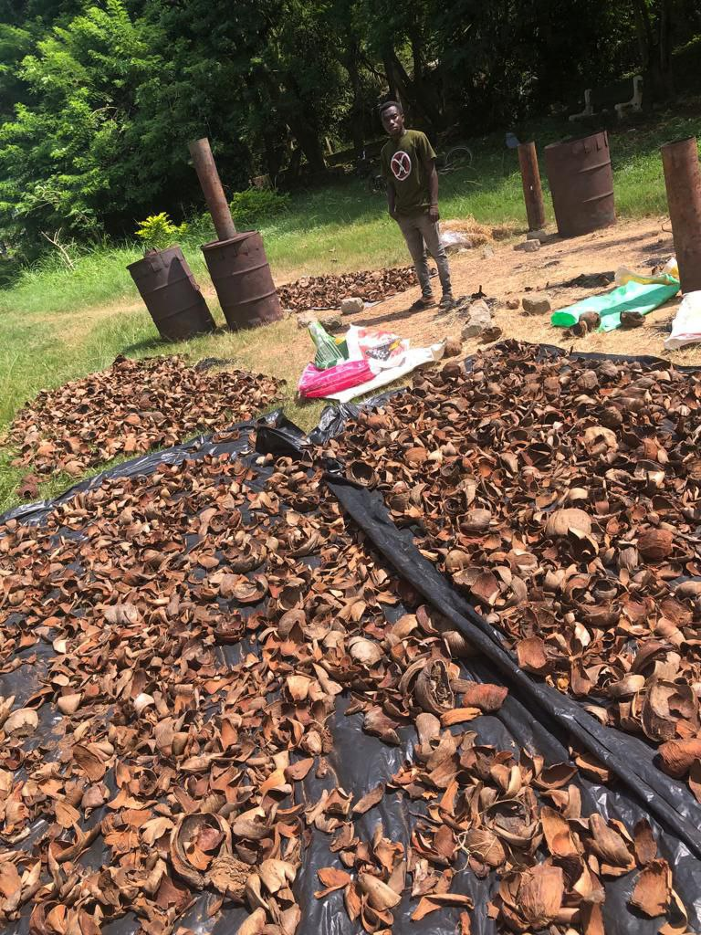 Figure 1. Coconut husk being dried in the sun before pyrolysis. Figure 2. Barrel filled with coconut husk for the charring process

3.3 Co-Composted Biochar preparation
Compost used for the study was prepared from three basic materials which include domestic waste (cassava peels, plantain peels, pineapple peels and solid food leftover), poultry manure and Coconut husk biochar using the windrow method. Coconut husk biochar was obtained through pyrolysis, poultry manure with decomposed bedding material collected from deep litter system layer pen in the University of Cape Coast Teaching and Research Farms, cassava, plantain and pineapple peels collected from nearby restaurants and solid food leftover collected from nearby Senior High Schools such as Adisadel College, Ghana National College and University Practice S.H.S. The food waste was air dried, separated, and grating was used to decrease the particle size. The remaining feedstocks, except the biochar, were then measured, divided into four equal portions, and made into four compost heaps, each containing 100 kg of the feedstocks. The biochar co-composts were prepared separately by adding varying amounts (0%,2%, 5% and 10%) of the coconut husk biochar. In the four biochar co-compost rates, all feedstocks, including biochar, were thoroughly mixed, moistened, and heaped. Pure compost was Heap 1, 2 kg of biochar is added in Heap 2, 5 kg of biochar is added in Heap 3, and 10 kg of biochar is added in Heap 4. For the first two weeks, the heaps were turned on every three days, then once a week until they reached maturity. The compost took two months to mature, three weeks to cure and dry.
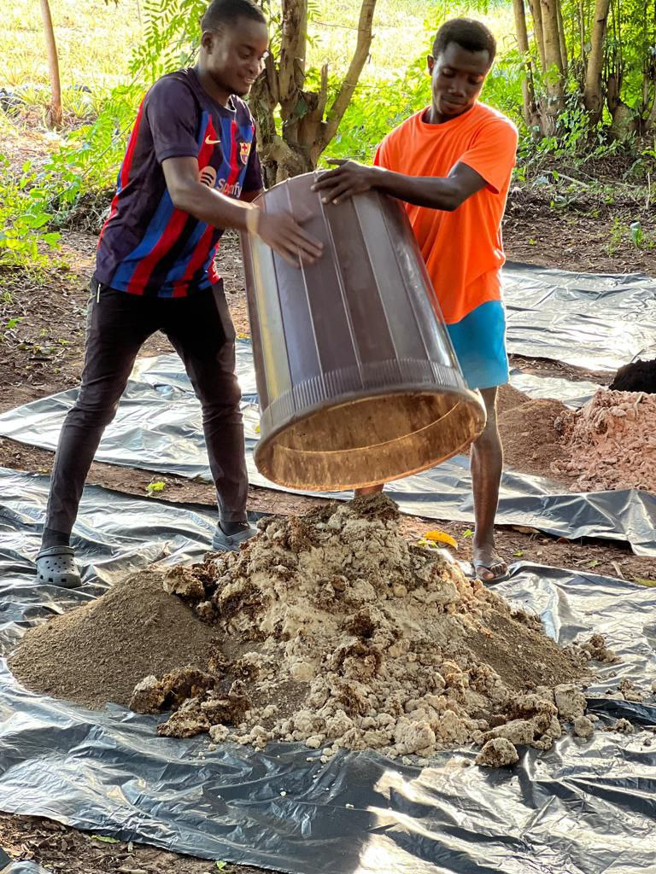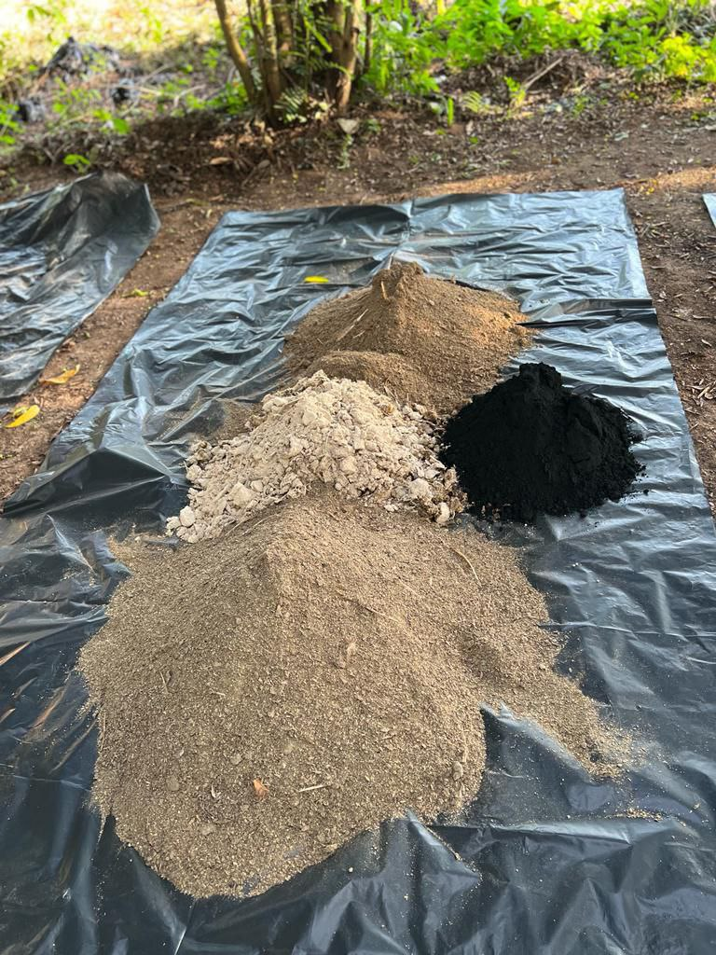
Figure 3. Domestic waste, poultry manure and Coconut husk biochar being mixed for compost using the windrow method

3.4 Table 1: Treatments details
TREATMENTS | SOIL | N | P | K | COMPOST
Grams(g)
CONTROL | 100 | - | - | - | -
INORGANIC | 100 | 0.033 | 0.020 | 0.015
COMPOST | 100 | - | 0.018 | 0.012 | 1.24
COMPOST+5%  BIOCHAR | 100 | - | 0.018 | 0.012 | 1.06
COMPOST+10%  BIOCHAR | 100 | - | 0.018 | 0.012 | 0.81
COMPOST+10%  BIOCHAR | 100 | - | 0.018 | 0.012 | 0.73

A characterized, extremely weathered tropical soil was chosen, sampled, air dried and placed in containers. 100g of the air-dried soil was weighed into each of the containers. For each container, various co-composted biochar was weighed based on plant nutrient requirements and compost nitrogen contents. Straight fertilizers’ (Urea, Muriate of Potash & Triple Supper Phosphate) top-up was used to supplement nutrient limitations in the composts. Treatments were six and four replications summing up to twenty – four (24) containers in total. Treatment 1 - absolute control, Treatment 2 -- amended control-NPK, Treatment 3 – 0% biochar (pure compost), Treatment 4 -- 2% biochar co-compost with P&K top up, Treatment 5 -- 5% biochar co-compost with P&K top up Treatment 6 -- 10% biochar co-compost with P&K top up. For each treatment and its replications; the composition 100g (0.1kg) of soil, compost and straight fertilizers). The 24 containers were incubated in a dark environment i.e., in an anaerobic condition (carboard) in the soil science laboratory. 17mL of water was sprayed on each treatment.
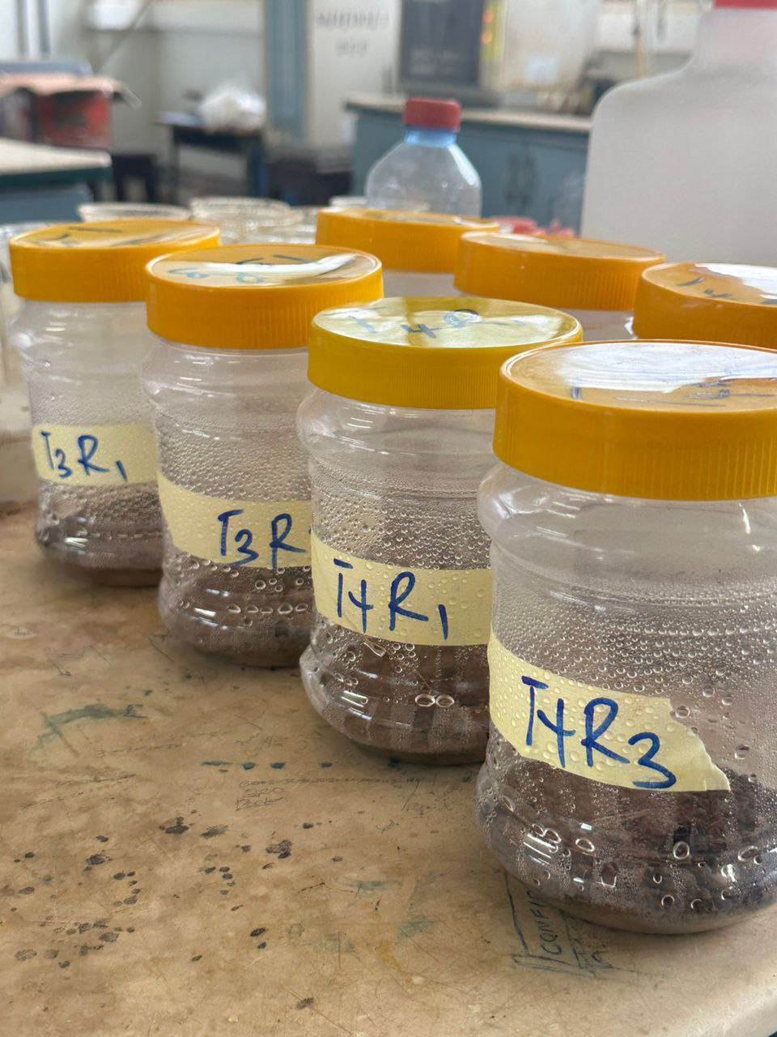
Figure 4. Incubation of treatment in an anaerobic condition

3.5 Laboratory analysis and carbon dioxide emission measurement
About 20 mL of 0.1M of sodium hydroxide solution (NaOH) was poured into small containers which was used for the trapping of the CO₂ and was placed in the containers filled with the treatments. The containers were closed tightly and incubated under anaerobic condition (in a carboard). After 6 hours of incubation, the containers, containing the NaOH were removed. The various treatments containing the incubated NaOH were poured into a conical flask, 5mL of 1M barium chloride (BaCl₂) was added to each incubated NaOH and there was a milky precipitate formed. 2- 3 drops of phenolphthalein indicator were dropped and there was a color change from milky precipitate to pinkish. The NaOH was titrated against 1M hydrochloric acid solution (Nag et al., 2025) and the titer value was recorded. The study was conducted for 58 days of which after 6 hours of incubation, the titration done was noted as day 0, the analysis continued after every 3 days for 3 times, then weekly for 2 times, then after the 14th day and then the 21st day. The amount of CO₂ evolved from the soil during the incubation was calculated using the formula;

Milligrams of $C or CO2=Vx Nx E$
Where V is the volume (mL) of HCl needed to titrate the NaOH in the containers incubated, N is the Normality of the HCl and E is the equivalent weight.
To express the data in terms of carbon, $E = 6$ to express it as CO₂, $E = 22.$

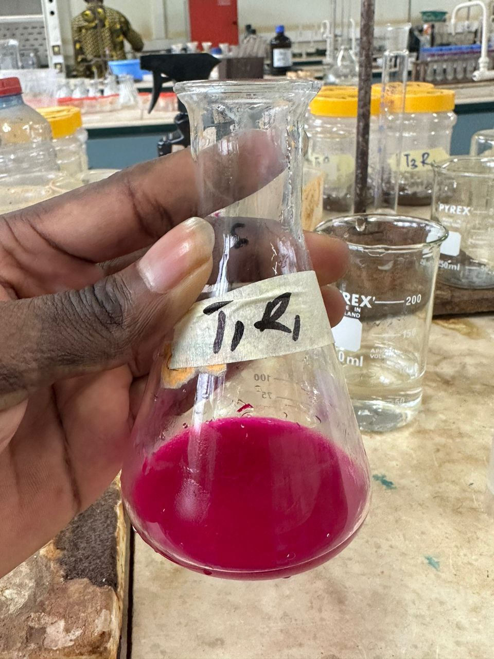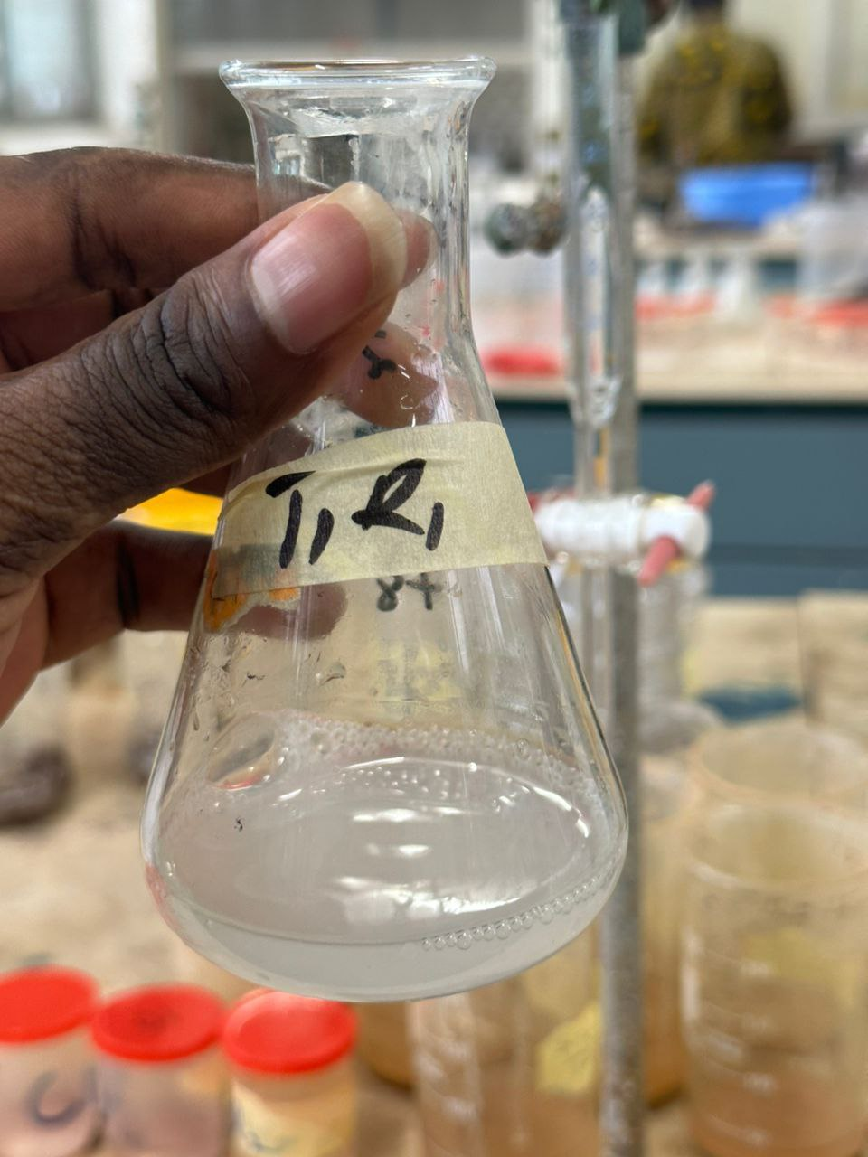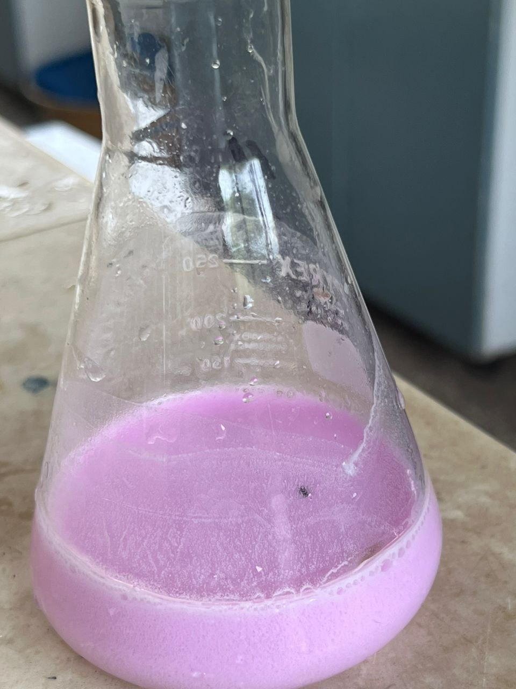
Figure 5. Incubated NaOH were poured into a conical flask, 5mL of 1M BaCl₂ was added to each incubated NaOH and there was a milky precipitate formed, 2-3 drops of phenolphthalein indicator were dropped and there was a color change from milky precipitate to pinkish.

Data analysis

The statistical analysis involved conducting four independent one-way ANOVA, one for each sampling day (Days 0, 3, 6, and 9), to assess the effect of soil amendment treatments on CO₂ emissions. When the ANOVA indicated significant differences (p ≤ 0.05), a post-hoc mean separation test (Duncan’s Multiple Range Test) was used to assign homogeneous letter groups, enabling clear visual identification of which treatments differed significantly from one another on each day.

4.0 Results
The daily carbon dioxide emissions from the various treatments are shown in table 2 and 3 below.
4.1 Table 2: Soil amendments effects on CO₂ emission on daily basis.
TREATMENTS | DAY 0 | DAY 3 | DAY 6 | DAY 9
CO₂d/kg
CONTROL | 1.21± 0.11a | 0.07± 0.00a | 0.03± 0.00a | 0.05±0.02a
INORGANIC | 1.18± 0.06a | 0.02± 0.01b | 0.03± 0.01a | 0.04±0.00a
COMPOST | 1.03± 0.05b | 0.01± 0.01bc | 0.00± 0.00b | 0.01±0.00b
COMPOST+ 2% BIOCHAR | 1.04± 0.12b | 0.01± 0.01bc | 0.01± 0.00b | 0.02±0.01b
COMPOST+ 5% BIOCHAR | 0.96± 0.10bc | 0.01± 0.01bc | 0.01± 0.01bc | 0.02±0.01b
COMPOST+ 10% BIOCHAR  ANOVA p-value | 0.88± 0.08c  < 0.001 | 0.01± 0.01c  < 0.001 | 0.01± 0.01c  0.003 | 0.02±0.00b  < 0.001

Table 3: Soil amendments effects on CO₂ emission on daily basis continued
TREATMENTS | DAY 16 | DAY 23 | DAY 37 | DAY 58
CO₂d/kg
CONTROL | 0.02± 0.00a | 0.01± 0.00a | 0.00± 0.00a | 0.00± 0.00a
INORGANIC | 0.02± 0.00a | 0.01± 0.00b | 0.00± 0.00ab | 0.00± 0.00a
COMPOST | 0.01± 0.00b | 0.00± 0.00c | 0.00± 0.00bc | 0.00± 0.00a
COMPOST+ 2% BIOCHAR | 0.01± 0.00c | 0.00± 0.00c | 0.00± 0.00bc | 0.00± 0.00a
COMPOST+ 5% BIOCHAR | 0.00± 0.00c | 0.00± 0.00c | 0.00± 0.00c | 0.00± 0.00a
COMPOST+ 10% BIOCHAR  ANOVA p-value | 0.00± 0.00c  < 0.001 | 0.00± 0.00c  < 0.001 | 0.00± 0.00c  0.01 | 0.00± 0.00a  >0.05

Based on the CO₂ emission trend, it was noted that there was a significant reduction in emissions after the first day of incubation across all types of treatments. The specific level of CO₂ emissions varied depending on the treatment. Aligning with the respective sampling dates. The maximum emission was recorded on the first day of incubation. After 3 days of incubation, CO₂ emission came down sharply in all types of treatments. The lowest amount of CO₂ emission was recorded in the treatment with compost+10% biochar (Table 2), while the highest amount of CO₂ emission was recorded in the control where only soil was used. At the first 6 hours of incubation CO₂ emission was about 1.21 CO₂/day/kg soil in the control, 1.181 CO₂/day/kg soil when inorganic amendments (NPK) were added, while it was about 1.03 CO₂/day/kg soil when pure compost was added. Co-composted biochar (2%) mixed with soil released 1.043 CO₂/day/kg soil, co-composted biochar (5%) mixed with soil released 0.955 CO₂/day/kg soil while co-composted biochar (10%) mixed with soil also released 0.876 CO₂/day/kg soil.
From (Table 3), the lowest emissions were observed in the co-composted biochar (10%) treatment. This can be attributed to the fact that this treatment initially had the lowest emission of carbon compared to the control. The reason behind this phenomenon is that the co-composted biochar (10%) has a high carbon content but is relatively stable and less prone to rapid decomposition. When 10% biochar is co-composted with other organic materials, it can act as a carbon sink, effectively sequestering carbon and reducing the overall emissions of CO₂.The control emitted significantly higher CO₂ in day 0, day 6, day 9, day 16 and day 58 than any other treatment except inorganic while compost with 10% biochar emitted significantly lower CO_{2.} For day 3, day 23 and day 37, only the control emitted significantly higher CO₂ than any other treatment while the compost with 10% biochar still emitted the lowest CO₂.
After 6 hours of incubation the average CO₂ emission was recorded as 1.049 CO₂/day/kg soil. On day 3, the average CO₂ emission was recorded as 0.022 CO₂/day/kg soil, while the average CO₂ emission was about 0.016 CO₂/day/kg soil on 6th day of incubation. On the 9thday of incubation, the average CO₂ emission recorded as 0.027 CO₂/day/kg soil, also on the 16th day of incubation, the average CO₂ emission recorded 0.01 CO₂/day/kg soil. The average emission recorded 0.006 CO₂/day/kg soil on the 23rd day while it also recorded 0.003 CO₂/day/kg soil and 0.001 CO₂/day/kg soil on the 37th day and 58th day.

The daily carbon emissions from the various treatments are shown in table 4 and 5 below.
Table 4: Soil amendments effects on CO₂-C emission on daily basis

TREATMENTS | DAY 0 | DAY 3 | DAY 6 | DAY 9
mg_CO₂_C d/kg
CONTROL | 0.33± 0.03a | 0.02± 0.00a | 0.01± 0.00a | 0.01± 0.00a
INORGANIC | 0.32± 0.02a | 0.01± 0.00b | 0.01± 0.00a | 0.01± 0.00a
COMPOST | 0.28± 0.01b | 0.00± 0.00bc | 0.00± 0.00b | 0.00± 0.00b
COMPOST+2% BIOCHAR | 0.28± 0.03b | 0.00± 0.00bc | 0.00± 0.00b | 0.01± 0.00b
COMPOST+5% BIOCHAR | 0.26± 0.03bc | 0.00± 0.00bc | 0.00± 0.00bc | 0.01± 0.00b
COMPOST+10% BIOCHAR  ANOVA p-value | 0.23± 0.02c  < 0.001 | 0.00± 0.00c  < 0.001 | 0.00± 0.00c  0.004 | 0.01± 0.00b  0.02

Table 5: Soil amendments effects on CO₂-C emission on daily basis continued
TREATMENTS | DAY 16 | DAY 23 | DAY 37 | DAY 58
mg_CO₂_C d/kg
CONTROL | 0.01± 0.00a | 0.00± 0.00a | 0.00± 0.00a | 0.00± 0.00a
INORGANIC | 0.00± 0.00a | 0.00± 0.00b | 0.00± 0.00ab | 0.00± 0.00a
COMPOST | 0.00± 0.00b | 0.00± 0.00c | 0.00± 0.00bc | 0.00± 0.00a
COMPOST+ 2% BIOCHAR | 0.00± 0.00c | 0.00± 0.00c | 0.00± 0.00bc | 0.00± 0.00a
COMPOST+ 5% BIOCHAR | 0.00± 0.00c | 0.00± 0.00c | 0.00± 0.00c | 0.00± 0.00a
COMPOST+ 10% BIOCHAR  ANOVA p-value | 0.00± 0.00c  < 0.001 | 0.00± 0.00c  < 0.001 | 0.00± 0.00c  0.01 | 0.00± 0.00a  >0.05

Based on the CO₂-C emission trend, it was noted that there was a significant reduction in emissions after the first day of incubation across all types of treatments. The specific level of CO₂-C emissions varied depending on the treatment. Aligning with the respective sampling dates. The maximum emission was recorded on the first day of incubation. After 3 days of incubation, CO₂-C emission came down sharply in all types of treatments. The lowest amount of CO₂-C emission was recorded in the treatment with compost+10% biochar (Table 4 and 5), while the highest amount of CO₂-C emission was recorded in the absolute control where only soil was used. At the first 6 hours of incubation CO₂-C emission was about 0.33 mg CO₂/day/kg soil in the absolute control, 0.3222 mg CO₂/day/kg soil when inorganic amendments (NPK) were added, while it was about 0.2808 mg CO₂/day/kg soil when pure compost was added. Co-composted biochar (2%) mixed with soil released 0.2844 mg CO₂/day/kg soil, co-composted biochar (5%) mixed with soil released 0.2604 mg CO₂/day/kg soil while co-composted biochar (10%) mixed with soil also released 0.2388 mg CO₂/day/kg soil. The control emitted significantly higher CO₂-C in day 0, day 6, day 9, day 16 and day 58 than any other treatment except inorganic while compost with 10% biochar emitted significantly lower CO₂-C. For day 3, day 23 and day 37, only the control emitted significantly higher CO₂-C than any other treatment while the compost with 10% biochar still emitted the lowest CO₂-C.
After 6 hours of incubation, the average CO₂-C emission was 0.286 mg CO₂/day/kg soil. On day 3, the average CO₂-C emission decreased to 0.006 mg CO₂/day/kg soil. By the 6th day of incubation, the average CO₂-C emission further decreased to approximately 0.004 mg CO₂/day/kg soil. On the 9th day of incubation, the average CO₂-C emission slightly increased to 0.007 mg CO₂/day/kg soil. Subsequently, on the 16th day of incubation, the average CO₂-C emission decreased to 0.002 mg CO₂/day/kg soil. Further monitoring showed a continued decrease, with the average emission reaching 0.001 mg CO₂/day/kg soil on the 23rd day. As time progressed, the emissions declined even more, recording 0.0007 mg CO₂/day/kg soil on the 37th day and 0.00028 mg CO₂/day/kg soil on the 58th day.
This data illustrates the dynamic nature of CO₂-C emissions from the soil over the course of the incubation period, with an initial increase followed by a gradual decline. t was reported that if organic matter added to soil containing high amount of labile carbon potentially enhances CO₂ emission and thus restricts carbon accumulation in soil (Moore et al., 2008). The trend of CO₂ and CO₂-C emission from different treatments where emission dropped down after weeks of incubation forced us to rethink the direct use of these biochar co-compost in agriculture. Biochar combined with compost could be the alternative environment-friendly practice, which reduces greenhouse gases in the atmosphere and can enhance soil structure and fertility, leading to healthier and more productive soils. Healthy soils support plant growth and sequester carbon through plant biomass, reducing the need for fossil fuel-intensive agricultural practices.
DISCUSSION
The rate at which CO₂ emissions change in response to biochar application is correlated with the amount of biochar added (Lyu et al., 2022). In particular, it was observed that cumulative CO₂ production significantly increased compared to the control when biochar was applied at rates of 1% and 2% (Olaniyan et al., 2020). However, no discernible trends in CO₂ emissions occurred when soil was amended with 5% and 10% biochar application rates. Moreover, the impact of biochar on CO₂ emissions was contingent upon the initial carbon content of the soil it was applied to. The introduction of biochar to soil with a high carbon content did not yield any additional shifts in CO₂ emissions (Lehmann et al., 2021).
From this study, the combination of biochar and compost had a considerable effect on the reduction of CO₂ emissions after the initial days of incubation. This indicates that biochar contributed to the mitigation of initial emissions. The lowest emissions were seen in the treatment containing 10% of biochar, which is attributed to the high carbon content of the biochar and its stability, which reduces its tendency to decompose quickly. Furthermore, when the 10% biochar was added in the soil, it acted like a carbon sink, absorbing carbon and reducing CO₂ emissions overall. These results suggest that biochar, if properly integrated into soil, not only has the potential to reduce CO₂ emissions, but it also has the potential to sequester carbon, which is important for mitigating climate change. In our study, we observed that the effects of adding biochar with compost differ from the findings mentioned in the literature. This disparity can be attributed to the specific feedstock used during the biochar and compost preparation processes. The type and source of feedstock used in the production of both biochar and compost can significantly influence their properties and, subsequently, their impact on soil and CO₂ emissions. Variations in feedstock characteristics, such as carbon content, nutrient composition, and physical structure, can lead to distinct outcomes when biochar and compost are combined and applied to soil. It is important to acknowledge that biochar and compost can be tailored to suit particular objectives. Therefore, the choice of feedstock and the preparation methods play a crucial role in determining how they interact with soil and influence CO₂ emissions.
Composting can increase the content of soil organic matter, improve soil physiology and microbial characteristics, promote microbial fixation of nutrients, reduce nutrient loss, and reduce CH₄ emissions (Manea et al., 2024). However, at the same time, it can lead to an increase in N₂O emissions, and promote the recycling of natural resources (Filonchyk et al., 2024). Therefore, transformation from inorganic agriculture to ecological and green agriculture is necessary (Lou et al., 2024). Use of compost can promote resource utilization of agricultural waste, reduce the use of chemical fertilizers, and improve crop yield and quality, indicating that it has a high practical application value (Mengqi et al., 2023).
From this study, the results indicate that when pure compost is added to incubated soil, there is an initial rise in CO₂ emissions within the first 6 hours. This is to be expected, as compost provides organic matter that encourages microbial activity, resulting in the release of carbon dioxide. However, over time, the emissions decrease, suggesting that the pure compost may have contributed to improved soil structure and microbial community, which can help to maintain carbon sequestration and reduce emissions. This suggests that pure compost may be a viable option for soil management practices, as it may provide a balance between short-term emissions increases and potentially long-term benefits to soil health and sequestration of carbon.
The addition of inorganic amendments (NPK) resulted in a slight reduction in CO₂ emissions compared to the control, in the long run. The initial rise can be explained by the presence of nitrogen-containing inorganic fertilizers in the soil. These nitrogen-containing fertilizers provide readily accessible nutrients to soil microbes, which in turn stimulate microbial activity. This microbial activity accelerates the rate at which organic matter decomposes in the soil. As a result of this microbial activity, CO₂ is produced as a by-product. As a result, there is an initial increase in emissions. Inorganic amendments such as NPK are mainly responsible for the provision of essential nutrients to plants, such as nitrogen, phosphorus, and potassium. However, their effects are not limited to plant nutrition alone. The added nutrients stimulate an increase in microbial activity, especially among nitrogen fixation and nitrification bacteria. As nitrogen is a fundamental component of amino acid and protein synthesis, it is essential for microbial development. Consequently, the rapid microbial degradation of organic matter may result in an increase in CO₂ emissions.

Conclusion
This study highlights that while pure compost initially boosts CO₂ emissions due to heightened microbial activity, this effect declines over time, supporting its role in improving soil health and enabling long-term carbon sequestration. Combining compost with biochar especially at 10% significantly reduces CO₂ emissions after the initial phase, demonstrating biochar’s potential to stabilize carbon and mitigate climate change. Inorganic NPK fertilizers slightly lower early emissions compared to the control but may accelerate organic matter decomposition and emissions later. Therefore, a balanced soil management strategy integrating compost and 10% biochar is recommended to harness short-term microbial benefits and long-term carbon storage, while inorganic fertilizer use should be carefully calibrated or supplemented with slow-release or organic alternatives to minimize CO₂ release.

REFERENCES
Ali, A., Jabeen, N., Chachar, Z., Chachar, S., Ahmed, S., Ahmed, N., Laghari, A. A., Farruhbek, R., & Yang, Z. (2025). The role of biochar in enhancing soil health & interactions with rhizosphere properties and enzyme activities in organic fertilizer substitution. June, 1–23. https://doi.org/10.3389/fpls.2025.1595208
Bhattacharyya, P. N., Protim, S., Bhaskar, S., & Abhay, S. (2024). Biochar as Soil Amendment in Climate ‑ Smart Agriculture : Opportunities , Future Prospects , and Challenges. Journal of Soil Science and Plant Nutrition, 24(1), 135–158. https://doi.org/10.1007/s42729-024-01629-9
Chataut, G., Bhatta, B., Joshi, D., Subedi, K., & Kafle, K. (2023). Greenhouse gases emission from agricultural soil : A review. Journal of Agriculture and Food Research, 11(January), 100533. https://doi.org/10.1016/j.jafr.2023.100533
Daadi, B. E., & Latacz-Lohmann, U. (2021). Organic fertilizer use by smallholder farmers: Typology of management approaches in northern Ghana. Renewable Agriculture and Food Systems, 36(2), 192–206. https://doi.org/10.1017/S1742170520000228
Elkhlifi, Z., Iftikhar, J., Sarraf, M., Ali, B., Saleem, M. H., Ibranshahib, I., Bispo, M. D., Meili, L., Ercisli, S., & Kayabasi, E. T. (2023). Potential Role of Biochar on Capturing Soil Nutrients , Carbon Sequestration and Managing Environmental Challenges : A Review.
Fadavi, C., Felicia, T., & Daniel, A. (2025). Biochar as a Soil Amendment in Rice Production : Current Status , Debates , and Opportunities for Enhancing Rice Farming in Ghana License : This is an open access article under the CC BY 4 . 0 license : https://creativecommons.org/licenses/by/4.0/ Corresp. 148–184. https://doi.org/10.65150/EP-jnsrr/V1E6/2025-02
Filonchyk, M., Peterson, M. P., Zhang, L., Hurynovich, V., & He, Y. (2024). Greenhouse gases emissions and global climate change: Examining the influence of CO2, CH4, and N2O. Science of the Total Environment, 935(January). https://doi.org/10.1016/j.scitotenv.2024.173359
Ghysels, S., Acosta, N., Estrada, A., Pala, M., De Vrieze, J., Ronsse, F., & Rabaey, K. (2020). Integrating anaerobic digestion and slow pyrolysis improves the product portfolio of a cocoa waste biorefinery. Sustainable Energy and Fuels, 4(7), 3712–3725. https://doi.org/10.1039/d0se00689k
Kudeyarov, V. N. (2023). Soil Respiration and Carbon Sequestration : A Review. 56(9), 1191–1200. https://doi.org/10.1134/S1064229323990012
Kumar, K., Khatri, A., & Thakur, I. S. (n.d.). Agricultural Waste Management for Food Security and Sustainability.
Kwakye, S. O., Ebo, E., Amuah, Y., Ankoma, K. A., Agyemang, E. B., & Owusu, B. (2024). Understanding the performance and challenges of solid waste management in an emerging megacity : Insights from the developing world. Environmental Challenges, 14(December 2023), 100805. https://doi.org/10.1016/j.envc.2023.100805
Lehmann, J., Cowie, A., Masiello, C. A., Kammann, C., Woolf, D., Amonette, J. E., Cayuela, M. L., Camps-arbestain, M., & Whitman, T. (2021). Biochar in climate change mitigation. 14(December). https://doi.org/10.1038/s41561-021-00852-8
Lou, R., Li, Y., Liu, Y., Jiang, Q., Wu, Q., He, Y., & Liu, J. (2024). Is green manure a viable substitute for inorganic fertilizer to improve grain yields and advance carbon neutrality in paddy agriculture? Agriculture, Ecosystems and Environment, 359(September 2023), 108762. https://doi.org/10.1016/j.agee.2023.108762
Lyu, H., Zhang, H., Chu, M., Zhang, C., Tang, J., Chang, S. X., Mašek, O., & Ok, Y. S. (2022). Biochar affects greenhouse gas emissions in various environments: A critical review. Land Degradation and Development, 33(17), 3327–3342. https://doi.org/10.1002/ldr.4405
Manea, E. E., Bumbac, C., Dinu, L. R., Bumbac, M., & Nicolescu, C. M. (2024). Composting as a Sustainable Solution for Organic Solid Waste Management: Current Practices and Potential Improvements. Sustainability (Switzerland), 16(15), 1–25. https://doi.org/10.3390/su16156329
Matisic, M., Dugan, I., & Bogunovic, I. (2024). Challenges in Sustainable Agriculture — The Role of Organic Amendments.
Mengqi, Z., Shi, A., Ajmal, M., Ye, L., & Awais, M. (2023). Comprehensive review on agricultural waste utilization and high-temperature fermentation and composting. Biomass Conversion and Biorefinery, 13(7), 5445–5468. https://doi.org/10.1007/s13399-021-01438-5
Mia, S., & Zzaman, W. (2025). Review Article Food Waste – Derived Organic Fertilizers : Critical Insights , Agronomic Impacts , and Pathways for Sustainable Adoption. 2025. https://doi.org/10.1155/ijfo/1551054
Moore, D. J. P., Gonzalez-Meler, M. A., Taneva, L., Pippen, J. S., Kim, H.-S., & DeLucia, E. H. (2008). The effect of carbon dioxide enrichment on apparent stem respiration from Pinus taeda L. is confounded by high levels of soil carbon dioxide. Oecologia, 158, 1–10.
Nag, S. K., Ghosh, B. Das, Das, B. K., & Sarkar, U. K. (2025). Wetlands function as carbon sink: Evaluation of few floodplains of middle Assam, northeast India in the perspective of climate change. Journal of Environmental Management, 373(December 2024), 123841. https://doi.org/10.1016/j.jenvman.2024.123841
Olaniyan, J. O., Isimikalu, T. O., Raji, B. A., Affinnih, K. O., Alasinrin, S. Y., & Ajala, O. N. (2020). An investigation of the effect of biochar application rates on CO2 emissions in soils under upland rice production in southern Guinea Savannah of Nigeria. Heliyon, 6(11). https://doi.org/10.1016/j.heliyon.2020.e05578
Panchal, P., Preece, C., Peñuelas, J., & Giri, J. (2022). Soil carbon sequestration by root exudates. Trends in Plant Science, 27(8), 749–757. https://doi.org/10.1016/j.tplants.2022.04.009
Rajanna, G. A. (2023). Integrated nutrient management for improving crop yields , soil properties , and reducing greenhouse gas emissions. June, 1–13. https://doi.org/10.3389/fsufs.2023.1173258
Wang, D., Lin, J. Y., Sayre, J. M., Schmidt, R., Fonte, S. J., Rodrigues, J. L. M., & Scow, K. M. (2022). Geoderma Compost amendment maintains soil structure and carbon storage by increasing available carbon and microbial biomass in agricultural soil – A six-year field study. 427(August).
Yadav, H., Neeraj, A., & Vats, P. (2024). Improvement of soil health and crop production through utilization of organic wastes : A sustainable approach. 13(1), 1–15.

