Geospatial modelling and participatory governance: an integrated framework for phase-wise ecotourism development in Jhargram district, West Bengal, India

Abstract
This study formulates an integrated framework for ecotourism development in Jhargram District, India, by synthesising geospatial modelling with participatory governance. Addressing the critical gap between planning and implementation in tribal-forest landscapes, the research employs a multi-criteria decision-making model (Analytic Hierarchy Process) and Weighted Overlay Analysis in ArcGIS. A comprehensive database, built from multi-source geospatial data and primary surveys across 16 sites, informed ten thematic layers for site suitability analysis. The results categorise the district into five suitability zones, identifying Binpur-II block as the most promising region. The core of the framework is a three-tier micro-zoning model (Core, Ecotourism, and Buffer Zones) designed to regulate carrying capacity and conserve biodiversity. This is coupled with the institutionalisation of Village Ecotourism Committees (VECs) to ensure participatory governance and equitable benefit-sharing. The proposed three-phase development plan strategically sequences interventions: from site preparation and community mobilisation (Phase 1), through eco-friendly infrastructure development (Phase 2), to diversification into agro-tourism, handicraft corridors, and wellness retreats (Phase 3). The study concludes that this integrated approach, blending spatial analytics with robust community institutions, offers a viable pathway for transforming Jhargram into a model ecotourism destination that simultaneously safeguards ecological resilience, empowers tribal communities, and generates sustainable livelihoods, thereby providing a scalable blueprint for similar regions in India.
Keywords: Ecotourism, GIS-AHP, Community Participation, Micro-Zoning, Sustainable Development, Jhargram district.
1. Introduction:
Ecotourism has emerged globally as a sustainable alternative to conventional mass tourism, emphasising the harmonious coexistence of environmental conservation, community participation, and socio-economic development (Tesema et al., 2020; Svіtlichna et al., 2024; Wani et al., 2025). It is broadly defined as “responsible travel to natural areas that conserves the environment and improves the well-being of local people” (Kiper, 2013). Unlike mass tourism, which often contributes to ecological degradation and resource depletion, ecotourism advocates for low-impact travel, biodiversity preservation, and inclusive community engagement (Baloch et al., 2023; Bentley & Halim, 2024; Mazzuoli, 2025). In developing countries such as India-where environmental diversity intersects with rich cultural heritage-ecotourism has increasingly been recognized as a strategic instrument for rural development and livelihood enhancement.
West Bengal, endowed with diverse landscapes ranging from the Sundarbans mangrove delta to the Himalayan foothills and tribal-inhabited plateau regions, has incorporated ecotourism into its sustainable development agenda. Among its various regions, Jhargram District stands out as a promising ecotourism destination due to its distinctive ecological and cultural characteristics. Situated at the interface of the Chhotanagpur Plateau and the Bengal plains, Jhargram exhibits undulating topography, dense sal-palas-mahua forests, and a network of rivers such as the Subarnarekha, Kangsabati, and Dulung. The district’s tribal communities, including the Santhal, Munda, Lodha, and Sabar, possess rich traditions of folk music, dance, handicrafts, and indigenous ecological knowledge that form the cultural foundation of the region (Tribe, 2024; Siddique et al., 2022). This fusion of natural and cultural heritage provides an ideal setting for developing an integrated eco-cultural tourism model.
Covering approximately 3,037 km², nearly 31% of which is under forest cover, Jhargram harbours a variety of natural attractions: waterfalls such as Ghagra and Hudhudi, hillocks like Gadrasini and Kankrajhore, and water bodies such as Khandarani Lake. In addition, sacred groves, ancient temples, Chikigarh Fort, and the Jhargram Raj Palace enhance its cultural and historical value. Collectively, these resources form a strong basis for developing a comprehensive ecotourism framework that connects ecological sustainability with cultural preservation.
Despite its substantial natural and cultural endowments, ecotourism in Jhargram remains underdeveloped. Inadequate infrastructure, poor accessibility to remote sites, and fragmented planning have limited organised tourism activities. Weak coordination among government departments, private enterprises, and local communities further constrains growth. Although the district has high tourism potential, the absence of structured development policies, promotional initiatives, and investment mechanisms prevents its resources from being effectively utilised.
Moreover, tribal communities, who represent the cultural custodians of the landscape, often remain marginalised in tourism governance and benefit-sharing processes. Their limited involvement not only reduces the inclusivity of tourism development but also risks cultural commodification. The expansion of unregulated tourism activities in ecologically sensitive zones poses additional threats to biodiversity, forest ecosystems, and water resources. Over-tourism, deforestation, and pollution are emerging risks that demand spatially informed planning measures such as micro-zoning and carrying capacity assessment.
Existing government initiatives like the Rural Tourism Development Program (RTDP) have attempted to promote community-based tourism but often operate in isolation, lacking integrated frameworks that link conservation, community welfare, and tourism growth. With high underemployment rates and dependence on subsistence agriculture, the district’s rural population could greatly benefit from ecotourism-based non-farm employment if properly planned and implemented through participatory mechanisms.
Globally, ecotourism success stories illustrate the critical role of spatial planning, zoning, and participatory governance. Latin America’s Biosphere Reserves (Montes et al., 2025) and Southeast Asia’s community-based tourism models (Phong, 2025) demonstrate how conservation and livelihoods can be effectively integrated. In India, examples such as the Sundarbans mangrove ecotourism, Meghalaya’s living root bridges (Shankar, 2015), and Odisha’s handicraft-based tourism villages (Dash & Mishra, 2021) show how traditional knowledge and biodiversity conservation can coexist with sustainable tourism. These examples emphasise the need for a holistic framework that combines scientific assessment, spatial planning, and local participation principles, particularly relevant for a tribal-forest district like Jhargram.
The use of Geographic Information Systems (GIS) and multi-criteria decision-making (MCDM) methods such as the Analytic Hierarchy Process (AHP) has revolutionised scientific tourism planning. These methods facilitate spatial suitability analyses by integrating environmental, physical, and socio-economic parameters, including land use/land cover, slope, accessibility, proximity to water bodies, and ecological sensitivity (Sharif et al., 2020; Maiti et al., 2022). GIS-based overlay models help identify and prioritise potential ecotourism zones through weighted evaluation of criteria. In the Central Himalayas, such techniques have guided eco-restoration strategies (Maiti et al., 2022), while in the Sundarbans, spatial zoning has been successfully applied to regulate tourism activities and conserve biodiversity (Ghosh, 2014). Applying these geospatial approaches to Jhargram enables scientific micro-zoning of ecotourism sites based on carrying capacity and ecological vulnerability.
Equally critical to sustainable ecotourism is community involvement. As Selman (2004) argued, local participation ensures cultural integrity and minimises external exploitation. Participatory models in the Sundarbans have demonstrated how community governance and conservation can coexist (Mondal et al., 2021). International experiences from Thailand and Costa Rica also highlight how community-based ecotourism empowers indigenous populations and promotes livelihood diversification (Gardner, 2010). Institutional models like Village Ecotourism Committees (VECs) and cooperatives encourage shared decision-making, skill development, and equitable benefit distribution (Marrewijk et al., 2004). Such models are well-suited for Jhargram, where tribal communities serve as both ecological stewards and cultural ambassadors.
Cultural tourism forms a complementary component of ecotourism in tribal landscapes. Indigenous handicrafts, folk performances, and traditional knowledge systems enrich the visitor experience while strengthening local economies. Studies in Pakistan (Yang et al., 2018) and Odisha (Azharunnisa et al., 2024) have shown that handicraft tourism can sustain both cultural heritage and livelihoods. In West Bengal, Purulia’s Chhau dance and Jhargram’s Sabai grass crafts (Mukherjee & Chatterjee, 2024) exemplify how cultural assets can be integrated into ecotourism circuits, promoting both economic resilience and cultural continuity.
Innovative tourism practices-such as wellness tourism, agro-tourism, and nocturnal biodiversity tourism-offer additional opportunities for diversification. Smith and Puczkó (2014) linked wellness tourism with traditional healing systems and forest environments, while Chatterjee and Prasad (2019) highlighted agro-tourism’s potential to revitalise rural economies through organic farming and indigenous agricultural practices. Likewise, firefly tourism, examined by Lewis et al. (2021), showcases how biodiversity conservation can generate novel visitor attractions. Given its herbal medicine traditions, agricultural diversity, and nocturnal ecological richness, Jhargram holds significant potential to integrate such niche tourism initiatives.
Although numerous studies have explored ecotourism in India, research on tribal-dominated plateau regions such as Jhargram remains limited. Existing literature in West Bengal has primarily focused on the Sundarbans (Ghosh, 2014; Mondal et al., 2021) and Himalayan ecosystems (Maiti et al., 2022). Few studies have applied GIS-based suitability analysis to plateau-forest transition zones or proposed integrated, phase-wise frameworks that align spatial planning with participatory governance. Similarly, while handicraft and cultural tourism have been studied in Odisha and Purulia, such integrative approaches are yet to be applied in Jhargram.
This research addresses these gaps by proposing a phase-wise strategic framework for sustainable ecotourism development in Jhargram District. It combines geospatial analysis using GIS and AHP with participatory mechanisms such as Village Ecotourism Committees (VECs). The framework delineates three micro-zones-Core, Ecotourism, and Buffer-based on ecological sensitivity and carrying capacity. It unfolds in three sequential phases: Site preparation and community mobilisation, Eco-infrastructure and connectivity enhancement, and Diversification into agro-tourism, handicraft tourism, wellness, and cultural festivals.
The approach integrates conservation goals with livelihood development and aligns district-level ecotourism planning with the United Nations Sustainable Development Goals (SDGs).
The significance of this study lies in three key contributions:
- It operationalises ecotourism theory by applying advanced geospatial and multi-criteria analysis to a tribal-dominated ecological landscape.
- It advances a participatory governance model that positions local communities as co-managers and beneficiaries of tourism development.
- It presents a replicable, phase-wise framework that can guide sustainable ecotourism initiatives across similar tribal-forest districts in India, contributing to the global agenda of environmental sustainability and inclusive rural development (TIES, 2015; NITI Aayog, 2018; Fennell, 2020).
2. Materials and Methods:
2.1 Study Area:
Jhargram District, located in the southwestern part of West Bengal, covers 3,037 km² between 22°30′N-22°58′N and 86°34′E-87°20′E. Formed in 2017, it lies at the transition between the Chhotanagpur Plateau and the Gangetic plains, bordered by Jharkhand, Odisha, and Paschim Medinipur. The terrain is undulating, with elevations from 10 to 421 m, lateritic soils, and a landscape shaped by crystalline rocks and alluvial deposits.
The climate is tropical monsoonal, with annual rainfall of about 1,400 mm, mostly during June-September. Major rivers include the Subarnarekha, Kangsabati, Dulung, and Tarafeni, while Khandarani Lake and several waterfalls (Ghagra, Hudhudi) enhance scenic beauty. Forests cover about 31% of the district (927 km²), dominated by Sal, Mahua, Palash, and Kusum. Wildlife such as deer, elephants, and diverse bird species make the district suitable for eco-adventure and nature tourism.
Jhargram has a population of around 1.1 million, with tribal groups such as the Santhal, Munda, Lodha, Bhumij, and Sabar forming nearly one-third. Their cultural identity is expressed through folk dances (Jhumur, Dong), handicrafts (sabai grass, bamboo, wood, dokra, stone carvings), and traditional gastronomy (Handia, mahua sweets, bamboo shoot curry). These cultural assets provide opportunities for eco-cultural tourism.
Tourism resources include natural sites (Kankrajhore, Belpahari, Gadrasini Hills, Tarafeni Gorge), cultural-historical sites (Jhargram Raj Palace, Chikigarh Rajbari), and eco-cultural attractions such as tribal villages and handicraft hubs. Despite rich resources, the district faces poor infrastructure, weak connectivity, and minimal organised tourism, limiting visitor inflows.
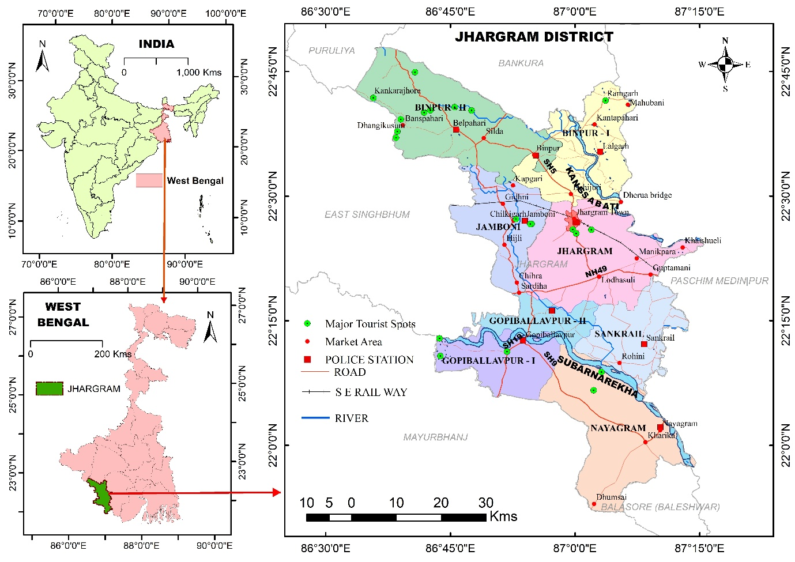
Fig. 1: Location map of study area, Jhargram district, prepared with help of ArcGIS by the researcher.
2.2. Method
The methodological framework for this study was designed to be both exploratory and analytical, integrating quantitative geospatial analysis with qualitative, community-based insights to formulate a holistic plan for ecotourism development (Yasin & Woldemariam, 2023; Aksoy et al., 2025). This research design systematically combined field-based data collection, geospatial modelling, and participatory approaches to identify ecotourism potential zones and conduct critical sensitivity analyses (Gutierrez-Lopez et al., 2023), as illustrated in Figure 2.
A multi-layered geospatial database was built using primary and secondary sources. Key parameters influencing ecotourism potential, including distance from geo-sites, elevation, slope, proximity to forests and rivers, land use/land cover (LULC), and accessibility to cultural sites, tribal villages, roads, and accommodations, were mapped. Data sources included 30-meter SRTM DEM (USGS) for terrain, Sentinel-2 imagery (ArcGIS Living Atlas) for LULC and forest cover, OpenStreetMap for transportation networks, and Google Earth Pro (GPS-verified) for specific site locations. The relative weight of each factor was determined using the Analytic Hierarchy Process (AHP), and a potential zones map was generated through Weighted Overlay Analysis (WOA) in ArcGIS.
Primary data was collected from December 2023 to December 2024 through a mixed-methods approach. Structured surveys using a Likert scale were administered to 415 respondents, including visitors, tribal community members, and local stakeholders, selected via stratified and purposive sampling. Qualitative depth was added through Participatory Rural Appraisal (PRA) techniques-semi-structured interviews, focus group discussions, and transect walks. Secondary data from the Census of India, Forest Survey of India, and State Tourism Department policies provided contextual and policy-level insights.
This integrated database forms the empirical foundation for the proposed phase-wise ecotourism development model, linking identified geospatial potential with on-ground stakeholder perspectives and governance structures.
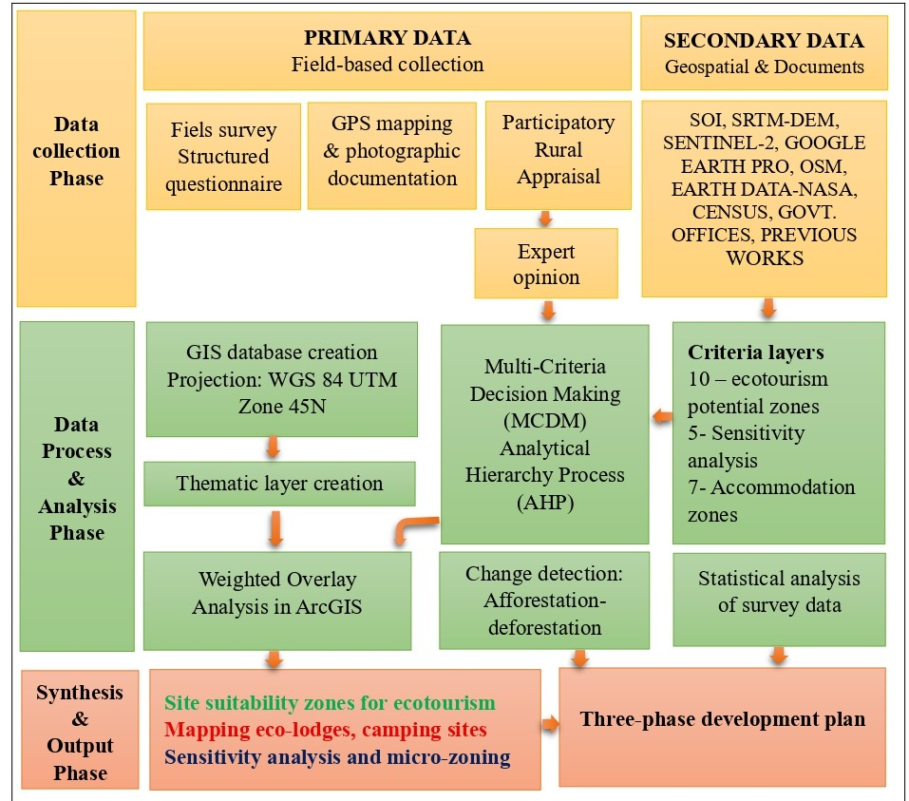
Fig. 2: Methodological framework.
The core of the spatial analysis involved a two-tiered analytical approach using thematic layers and the Analytic Hierarchy Process (AHP) for distinct but sequential purposes, moving from macro-level identification to micro-level regulation of ecotourism potential (Yasin & Woldemariam, 2023; Aksoy et al., 2025).
Site Suitability Analysis (Macro-level): This initial analysis aimed to identify and rank broad areas across the entire district with the highest potential for ecotourism development. Ten thematic layers were integrated for this purpose. The AHP, a well-established multi-criteria decision-making method (Sharif et al., 2020; Maiti et al., 2022), was applied to assign objective weights to these criteria. A pairwise comparison matrix constructed using Saaty's 1-9 scale yielded weights that logically emphasised geo-sites (27%), elevation (20%), and slope (15%) as the primary drivers of ecotourism potential in Jhargram's rugged landscape. The derived weights were normalised, and consistency was rigorously verified, with a Consistency Ratio (CR) of 0.027, which is well below the acceptable threshold of 0.10. All raster datasets were projected to a common coordinate system (WGS 84 UTM Zone 45N), reclassified, and integrated using a Weighted Overlay Analysis in ArcGIS 10.8 to generate a composite suitability map. This macro-level analysis answered the question: Where in Jhargram should ecotourism be developed?
Sensitivity Analysis for Micro-Zoning (Micro-level): Building directly on the results of the Site Suitability Analysis, this second step focused on the identified "Highly" and "Moderately Suitable" zones. Its purpose was to regulate and manage development sustainably by assessing ecological fragility, inspired by the UNESCO Biosphere Reserve model (Gutierrez-Lopez et al., 2023). Five weighted criteria-including Potential Zone (45%, derived from the first analysis), LULC (25%), and Slope (15%)-were used to delineate a three-tier micro-zoning framework (Core, Ecotourism, and Buffer). This sensitivity analysis answered the subsequent critical question: Within the suitable areas, how should different zones be managed to minimize environmental impact?
A separate analysis was conducted for accommodation zoning using seven thematic layers to identify optimal sites for eco-lodges and homestays, ensuring infrastructure development aligns with sustainability principles.
A forest cover change detection analysis was conducted between 2017 and 2023 to quantify afforestation and deforestation trends, providing a critical baseline for conservation planning.
Recognising that technocratic solutions are insufficient, the methodology embeds community participation at its core. The formation of Village Ecotourism Committees (VECs) was proposed as the primary institutional mechanism for governance. The structure and functions of these committees were designed based on successful global and national models (Marrewijk et al., 2004) to ensure inclusive decision-making, skill development in areas such as eco-guiding and handicraft promotion, and equitable revenue sharing, thereby actively integrating local populations into the ecotourism value chain. The study employed a suite of analytical tools for this integrated analysis; ArcGIS 10.8 and QGIS were used for spatial modelling and thematic mapping, the AHP model was implemented for criterion weighting, and Microsoft Excel was utilised for statistical analysis of survey data and AHP matrix calculations. This mixed-methods approach ensures that the resulting ecotourism framework is not only spatially optimal but also socially inclusive, ecologically sensitive, and institutionally viable.
3. Result and Discussion:
3.1 Identification of Potential Sites of Ecotourism:
The AHP-GIS analysis, supported by primary survey data, identified ten weighted criteria influencing ecotourism site suitability in Jhargram District, with: geo-sites (27%), elevation (20%), slope (15%), forest proximity (11%), rivers (8%), cultural sites (6%), LULC (5%), tribal villages (4%), roads (3%), and hotels & homestays (2%).. The pairwise comparison matrix achieved a CR of 0.027, confirming consistency.
The district was categorised into five suitability zones (Fig. 3): Very Highly Suitable (0.16%), Highly Suitable (14.28%), Moderately Suitable (73.21%), Less Suitable (11.97%), and Not Suitable (0.38%). The Very Highly Suitable areas are confined to Binpur-II block (4.98 km²), while Highly Suitable areas are distributed across Binpur-II, Jamboni, Nayagram, and Jhargram blocks, reflecting the district’s diverse landscapes and biodiversity.
Binpur-II emerged as the most promising ecotourism zone due to its natural beauty, forest cover, and accessibility. Overall, 50 potential ecotourism sites were identified within very high, high, and moderate suitability zones, underscoring the district’s strong potential for sustainable ecotourism development, though infrastructural and environmental constraints remain in less suitable areas.
3.2 A Participatory and Spatially-Grounded Development Framework
A structured phase-wise development plan is crucial for ensuring sustainable ecotourism growth in Jhargram District while minimising ecological degradation (Marrewijk et al., 2004; Sharif et al., 2020; Maiti et al., 2022). Phase I (1-2 years) focused on site preparation, awareness campaigns, community mobilisation, and provision of basic infrastructure. Phase II (3-5 years) emphasised eco-friendly infrastructure, interpretation centres, connectivity improvements, skill training, and cultural festivals. Phase III (6-10 years) proposed diversification into agro-tourism, handicraft tourism, wellness retreats, firefly festivals, and digital promotion strategies. This phased approach ensures gradual, sustainable expansion of ecotourism.
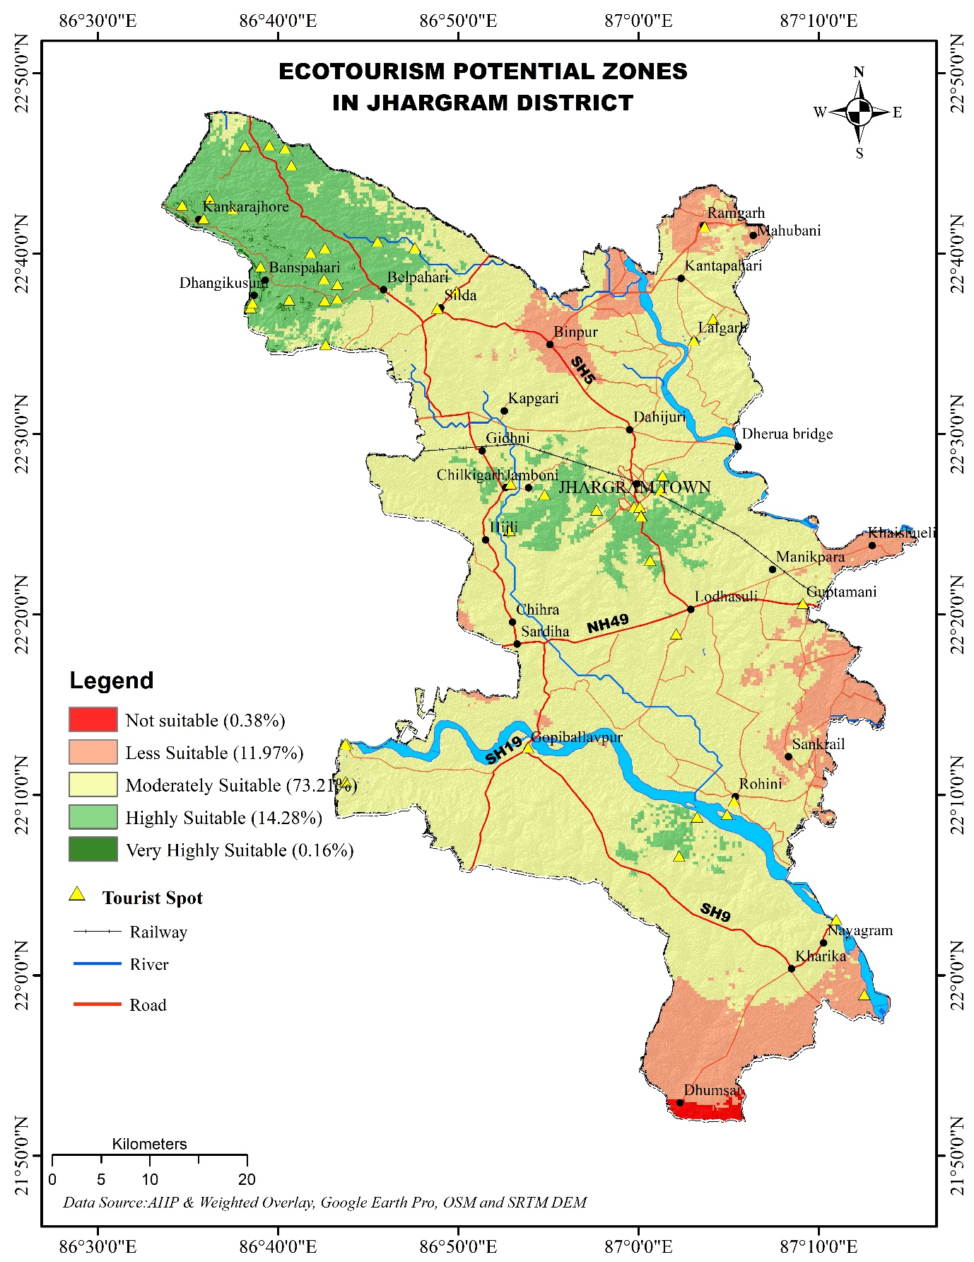
Fig. 3: Identification of potential sites of ecotourism by weighted overlay analysis in ArcGIS.

3.2.1 Phase 1 (Years 1-2): Foundation Building through Micro-Zoning and Community Mobilization
The initial phase focuses on establishing the regulatory and social infrastructure for sustainability.
3.2.1.1 Scientific Micro-Zoning for Carrying Capacity Management
Informed by the GIS-based sensitivity analysis (using criteria like Potential Zone and LULC), a three-tier micro-zoning framework was delineated (Fig. 4, Table 1). This model, inspired by the UNESCO Biosphere Reserve concept (Batisse, 1997), is crucial for preventing the ecological degradation often associated with unregulated tourism.
Core Conservation Areas: These zones protect the most sensitive ecosystems. Restricting access to 20-50 visitors per day for research and guided eco-study tours is essential to preserve Jhargram's dense forests and wildlife habitats, mirroring successful conservation-first approaches in the Sundarbans (Ghosh, 2014).
Ecotourism Zones: Designated for low-impact activities like trekking and birdwatching, these areas allow for higher visitation (100-300/day) under guided supervision. This balances recreational demand with environmental protection.
Buffer Zones: Acting as transitional spaces, these zones with gentler slopes can host 500-1000 visitors daily for accommodations, markets, and cultural shows. This structure channels economic activity towards communities while shielding core ecological assets.
Zone Type | Maximum Visitors Per Day | Tourism Activities Allowed | Entry Regulation
Core Conservation | 20-50 | Research, Eco-study Tours | Pre-booking only, No walk-ins
Ecotourism | 100-300 | Trekking, Birdwatching, Cultural Shows | Guided entry, Timed slots
Buffer | 500-1000 | Market Visits, Folk Shows, Accommodation | Open access, but regulated
Table 1: Micro-zoning of ecotourism sites with carrying capacity of visitors, tourism activity and regulation.

Sustainable ecotourism cannot succeed without the meaningful participation of local communities, as they are the custodians of both cultural heritage and natural resources. A strong example is the Sundarbans of West Bengal, where ecotourism has been integrated with mangrove conservation through active community engagement (Mondal et al., 2021). In Jhargram District, community consultation and skill development programs should be strategically implemented near potential ecotourism sites to enhance local participation, generate employment, and foster sustainable tourism.
The establishment of Village Ecotourism Committees (VECs) is a cornerstone of community-driven ecotourism. Composed of panchayat members, tribal leaders, women, youth, artisans, and conservation officials, these committees act as local governance bodies ensuring that tourism initiatives align with community needs, cultural traditions, and environmental priorities. VECs prevent external exploitation by promoting inclusive decision-making and equitable benefit-sharing. Their responsibilities include maintaining ecotourism sites, monitoring visitor flows, enforcing eco-guidelines, and planning tourist circuits so that benefits extend across multiple villages. Moreover, they act as intermediaries between government agencies, NGOs, and private investors to ensure that interventions serve local interests.
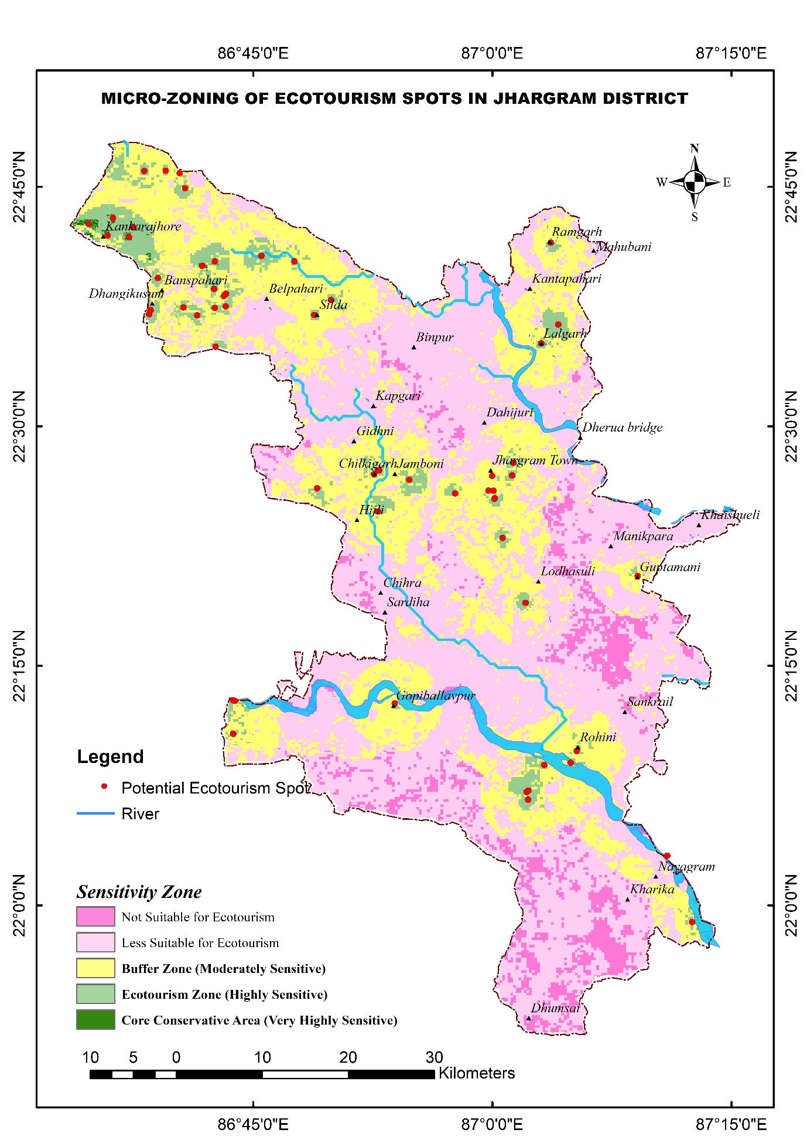
Fig.4: Micro-zoning of ecotourism sites by weighted overlay analysis in ArcGIS.

3.2.1.2 Institutionalizing Participation through Village Ecotourism Committees (VECs)
A key mandate of VECs is capacity building. They should organise training on eco-guiding, biodiversity interpretation, cultural storytelling, and wildlife conservation to strengthen visitor experiences. Training in homestay management, hospitality, and customer service empowers local families, while women and youth can be integrated into handicrafts and cultural tourism. Programs should also extend to financial literacy, digital marketing, and tour management so that local entrepreneurs can effectively market and manage ecotourism products.
For financial sustainability, VECs should design robust revenue models grounded in conservation principles. Revenue streams may include ecotourism fees, homestays, eco-lodges, handicraft sales, guided tours, and cultural events. These funds must be reinvested into welfare schemes, education, and conservation programs. Standardisation of services such as homestays, eco-cafés, and farm-based tourism ensures high-quality visitor experiences while protecting community rights.
Environmental protection remains integral to VEC operations. Zero-waste tourism policies should be adopted through plastic bans, recycling, and eco-friendly alternatives. Community-led afforestation and reforestation initiatives, integrated with carbon credit mechanisms, can restore degraded lands while providing income. Training eco-guards to monitor wildlife reduces human-animal conflict. In addition, water conservation strategies like rainwater harvesting and sustainable irrigation methods help prevent resource depletion. By balancing ecological conservation with livelihood generation, VECs can foster a self-sustaining ecotourism model.
The success of VECs requires robust government and NGO support. The West Bengal Tourism Department should provide financial assistance through schemes such as the Rural Tourism Development Program (RTDP) and NREGA, while MFIs can facilitate micro-credit and cooperatives. Capacity-building support from the Skill India Mission, WWF-India, and ATREE should focus on eco-guiding, handicrafts, sustainable agriculture, and hospitality training. Infrastructure investment must prioritize eco-lodges, signboards, solar-powered guesthouses, sanitation facilities, and green transport. Public-private partnerships (PPPs) may further strengthen infrastructure through funding of nature trails, interpretation centres, and conservation projects. NGOs should additionally spearhead waste management, afforestation, water conservation, carbon credit schemes, and wildlife monitoring programs.
3.2.1.3 Biodiversity Conservation and Regulation in Ecotourism
Biodiversity conservation must remain central to ecotourism planning in Jhargram. The district’s forests, wildlife, and natural landscapes are its prime attractions, and their degradation would undermine tourism potential. Two strategies are vital: afforestation programs and strict ecotourism guidelines.
Afforestation, using native tree species, should be pursued in degraded landscapes through partnerships between VECs, forest departments, and NGOs. Such programs must engage schools, universities, and even eco-tourists to enhance environmental awareness and stewardship. Between 2017 and 2023, afforestation covered 175.74 km² (6% of Jhargram’s area); however, deforestation claimed 104.49 km² (3%), threatening ecological balance (Figure 5). Sustainable afforestation is crucial for mitigating these losses, supporting tribal livelihoods, and combating climate impacts. Agroforestry initiatives and community-managed forest resources can reduce deforestation risks tied to tourism. Protected green zones around ecotourism sites further safeguard biodiversity from unregulated land-use changes.
Without regulation, tourism risks pollution, cultural erosion, and ecological damage. VECs, forest departments, and tourism authorities must enforce strict eco-guidelines:
- Visitor Limits: Apply carrying capacity models to control numbers in sensitive areas.
- Waste Management: Adopt zero-waste policies, enforce plastic bans, and provide disposal and recycling facilities. Tourists should carry reusable and biodegradable products.
- Eco-Friendly Infrastructure: Encourage solar-powered lodges, composting toilets, and low-impact facilities.
- Wildlife Protection: Ban loud noise, littering, and off-trail trekking in fragile habitats.
- Eco-Certification: Homestays, cafés, and tour operators should adopt eco-practices such as local sourcing, energy efficiency, and waste reduction.
3.2.1.4 Basic Access and Infrastructure Planning
Infrastructure planning must enhance tourism potential while protecting ecological and cultural assets. Poor road connectivity hampers ecotourism in Jhargram. Instead of wide highways, existing village roads should be upgraded using eco-friendly materials such as permeable pavers, gravel, or stabilised soil. Low-impact designs, including tree-lined roads, green corridors, and natural drainage systems, reduce erosion and preserve ecosystems. Additional features such as solar lighting, rainwater drains, rest spots with biodegradable seating, and eco-shuttle services will improve accessibility. Walking trails and cycling routes in core ecotourism areas can further minimise carbon emissions.
The site selection for accommodation infrastructure in Jhargram District, covering eco-lodges, camping sites, and interpretation centres, is a strategic process linking ecological preservation, accessibility, and community welfare. Using a GIS-based weighted overlay model with seven criteria, the study prioritised Proximity to Tourism Sites (21%) and Ecological Sensitivity (20%) to balance visitor convenience with minimal environmental disturbance. Land Use/Land Cover (18%) guided development toward non-forest, degraded, or fallow lands, avoiding ecologically fragile zones. Moderate weights for Road Access and Market Proximity (each 12%) ensured practicality without compromising sustainability, while Slope (9%) and Distance from Existing Hotels (8%) promoted construction safety and equitable economic distribution across blocks like Nayagram.
The resulting suitability map (Fig. 6) identifies optimal accommodation zones in Binpur-II, Jhargram, and Nayagram blocks, offering a policy-ready framework for government and private investment. This scientific approach integrates tourism infrastructure within the broader ecotourism circuit, transforming sustainability principles into a spatially grounded development strategy for balanced regional growth.
Eco-Lodges should use bamboo, mud, or reclaimed wood, with solar panels, composting toilets, and rainwater systems. Camping Sites should be near trekking routes or rivers with minimal vegetation clearance. Information Centres should serve as eco-hubs, educating tourists, showcasing local handicrafts, and operating on renewable energy.
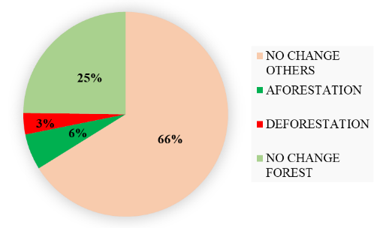
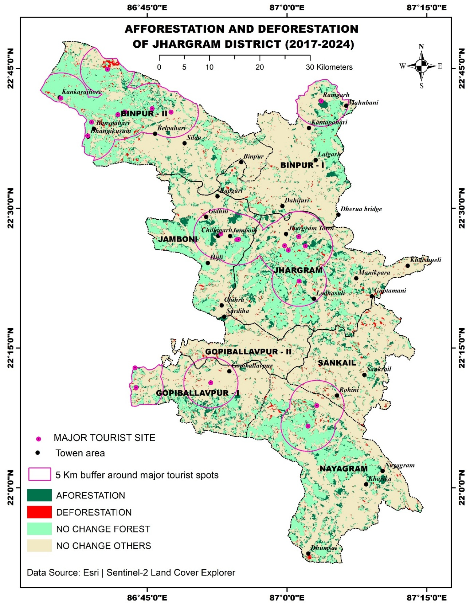
Fig.5: Afforestation and deforestation area (change detection) identified by ArcGIS.

Fig.6: Site selection for accommodation must follow GIS-based weighted overlay analysis
3.2.1.5 Improvement of Transport Connectivity
Transport links are essential for regional ecotourism integration. Jhargram should strengthen road and rail connections to neighbouring districts such as Bankura, Purulia, Paschim and Purba Medinipur, East Singhbhum, Mayurbhanj, Balasore, and Saraikela-Kharsawan. Improved National and State Highways, more frequent trains to destinations like Susunia, Ajodhya Hills, or Gangani, and dedicated eco-buses and regulated taxi services can enhance accessibility. Establishing tourist information centres at transport hubs will provide visitors with guidance and itineraries.
3.2.1.6 Innovative Media Strategies for Promotion
In the first phase, focus should be on awareness and digital outreach. An Interactive Digital Tourism Map, like the Kaziranga Virtual Guide, can help visitors explore sites and attractions with GPS, offline access, and virtual tours (Osipchuk et al., 2023). A Documentary on Tribal Culture and Biodiversity, inspired by Meghalaya’s storytelling model, should showcase Santhali traditions, ecology, and ecotourism, distributed through YouTube and OTT platforms (Osipchuk et al., 2023). A Social Media Photo Challenge can engage tourists, with winners receiving local handicrafts (Hays et al., 2013). A Local Radio Show (“Explore Jhargram FM”) can further promote destinations through grassroots communication (van Wyk-Jacobs, 2018). Complementary attractions like Night Safaris, the Jhargram Tribal & Cultural Carnival, and the Monsoon Waterfall Trail (Hudhudi, Ghagra, Tarafeni, Ketki Jharna) will enhance seasonal tourism.
3.2.2 Phase 2: Eco-Friendly Infrastructure Development (Year 3-5)
Phase 2 focuses on developing sustainable infrastructure in Jhargram’s buffer zones. Green construction for eco-lodges, campsites, and interpretation centres will employ solar energy, rainwater harvesting, and zero-waste systems (Gross, 2002; Lewis et al., 2021). Community involvement in building and management ensures local employment and ownership.
Biodiversity experiences will be enhanced through guided walks in Kankrajhor and deer parks, with trained local guides. Regulated river activities on the Subarnarekha and Dulung will be community-monitored. Innovative accommodations like floating eco-lodges and bamboo treehouses (inspired by Sri Lanka’s model) will minimise impact. Unique attractions include bioluminescent gardens, firefly sanctuaries (Lewis et al., 2021), forest bathing (Hansen et al., 2017), and tribal wellness retreats (Arora et al., 2023).
Cultural heritage will be promoted via AI-driven storytelling hubs with QR-coded oral histories (Nanduri, 2024), a Tribal Heritage Museum with AR, and a mobile ‘Eco Caravan’ for crafts (Mangaraj & Smrutirekha, 2021). Gastronomy will highlight wild foods and Mahua-based drinks, with foraging tours (Russo & McCarthy, 2024) and a tribal cooking studio (Moon, 2015).
Transport links will improve connectivity to sites like Similipal, supported by digital ticketing. Solar-powered amenities and organic restaurants serving local cuisine will ensure sustainability and visitor comfort.
3.2.3 Phase 3: Diversified Ecotourism Activities & Soft Launch (Year 6-10)
This phase diversifies Jhargram’s ecotourism through thematic, year-round initiatives (Aayog, NITI, 2018). Agro-tourism immerses visitors in tribal farming and seasonal harvests (Chatterjee & Prasad, 2019; Koohafkan & Altieri, 2011). Handicraft tourism promotes Sabai grass and Dokra art in dedicated villages (Yang et al., 2018; Azharunnisa et al., 2024). Wellness retreats utilise local medicinal plants (Sahoo et al., 2024; Paul & Dey, 2022) and therapies like herbal massages (Jurri, Kumar & Mollick, 2022) alongside forest mindfulness (Smith & Puczkó, 2014). Adventure offerings include trekking, kayaking, and cultural sports. A Tribal Food Trail highlights local cuisine (Mason & O’Mahony, 2007), while annual Firefly Festivals create nocturnal experiences (Lewis et al., 2021).
4. Conclusion:
This study has established a comprehensive, phase-wise strategic framework for ecotourism development in Jhargram District, demonstrating the critical synergy between geospatial science and community-centric governance. The GIS-AHP analysis successfully identified and prioritised ecotourism potential, with Binpur-II block emerging as the most promising zone, thereby providing a data-driven foundation for targeted investment and conservation efforts. The resultant micro-zoning model- delineating Core, Ecotourism, and Buffer Zones-offers a pragmatic mechanism for regulating tourist carrying capacity, mitigating environmental degradation, and safeguarding the district's rich biodiversity.
The proposed three-phase development strategy provides an actionable roadmap to transition from foundational capacity-building to sustainable economic diversification. Crucially, the institutionalisation of Village Ecotourism Committees (VECs) is positioned as the linchpin of this model, ensuring that ecotourism evolves as a vehicle for participatory governance, equitable benefit-sharing, and the preservation of indigenous knowledge and cultural heritage. By strategically sequencing interventions, from site preparation and eco-friendly infrastructure to the introduction of agro-tourism, handicraft corridors, and wellness retreats, the framework ensures that growth is managed, resilient, and aligned with ecological limits.
The broader significance of this research lies in its integrated approach to sustainability. Environmentally, it champions biodiversity conservation through scientific zoning and strict eco-guidelines. Socially, it empowers tribal communities, strengthens cultural identity, and fosters inclusivity. Economically, it catalyses the creation of non-farm livelihoods, revitalises local crafts, and stimulates rural entrepreneurship. This trifecta of benefits underscores ecotourism's potential as a powerful tool for sustainable regional development in Jhargram.
While this study provides a comprehensive framework, it is subject to certain limitations. The initial scoring in the AHP model, though consistent, involves an element of expert judgment. The successful implementation of VECs is contingent on mitigating real-world challenges such as potential elite capture or political interference. Future research should involve longitudinal studies to monitor the social and ecological impacts of this framework once implemented and refine the dynamic carrying capacity models based on real-time data.
In conclusion, this study affirms that Jhargram District can indeed transform into a model ecotourism destination, but this transformation is contingent upon disciplined, phased planning and robust institutional collaboration. For successful implementation, it is recommended that the West Bengal government formally adopt this framework and establish a dedicated multi-stakeholder task force to oversee its rollout. Future research should focus on longitudinal monitoring of the social and ecological impacts of implemented initiatives and on refining dynamic carrying capacity models. Ultimately, this replicable framework offers a viable blueprint for balancing conservation with development, not only fulfilling local aspirations but also contributing meaningfully to national priorities and the global Sustainable Development Goals (SDGs).
Ethics approval statement
This study was conducted in accordance with institutional and national ethical standards. As the research involved no interventions, experiments, or the collection of sensitive personal data, formal ethical approval was deemed unnecessary. Before participation, verbal informed consent was obtained from all subjects, and the anonymity and confidentiality of all participants were rigorously preserved throughout the study.

References:
Aayog, N. I. T. I. (2018). Sustainable tourism in the Indian Himalayan region. Report of Working Group II, NITI Aayog, Government of India.
Aksoy, T., Metin, T. C., Altunel, M. C., Kavlak, M. Ö., Erdoğan, Ö., Korkmaz, C., ... & Çabuk, A. (2025). Relational analysis of publications on the use of geographic information systems in tourism-Recreation planning and management. Journal of Tourism Leisure and Hospitality, 7(1), 90-113.
Arora, M., Dhiman, V., & Sharma, R. L. (2023). Exploring the dimensions of spirituality, wellness and value creation amidst Himalayan regions promoting entrepreneurship and sustainability. Journal of Tourismology, 9(2), 86-96.
Azharunnisa, A., Gupta, S., & Panda, S. (2024). Craft culture revival through a sustainable approach of integrating tourism with craft promotion: case study of Puri, Odisha. Journal of Cultural Heritage Management and Sustainable Development, 14(3), 397-418.
Baloch, Q. B., Shah, S. N., Iqbal, N., Sheeraz, M., Asadullah, M., Mahar, S., & Khan, A. U. (2023). Impact of tourism development upon environmental sustainability: a suggested framework for sustainable ecotourism. Environmental Science and Pollution Research, 30(3), 5917-5930.
Batisse, M. (1997). Biosphere reserves: a challenge for biodiversity conservation & regional development. Environment: Science and Policy for Sustainable Development, 39(5), 6-33.
Bentley, L., & Halim, H. B. (2024). Evaluating the long-term impact of sustainable tourism practices on local communities and natural resources in developing countries. Integrated Journal for Research in Arts and Humanities, 4(3), 136-141.
Chatterjee, S., & Prasad, D. M. V. (2019). The Evolution of Agri-Tourism Practices in India: Some Success Stories. Madridge J Agric Environ Sci, 1(1), 19-25.
Dash, M., & Mishra, B. B. (2021). Problems of handicraft artisans: an overview. International Journal of Managerial Studies and Research, 9(5), 29-38.
Gardner, T. (2010). Monitoring forest biodiversity: improving conservation through ecologically responsible management. Routledge.
Ghosh, P. (2014). Subsistence and biodiversity conservation in the Sundarban Biosphere Reserve, West Bengal, India.
Gross, M. (2002). Light and life (Vol. 120). OUP Oxford.
Gutierrez-Lopez, J., McGarvey, R. G., Costello, C., & Hall, D. M. (2023). Decision support frameworks in solid waste management: a systematic review of multi-criteria decision-making with sustainability and social indicators. Sustainability, 15(18), 13316.
Hansen, M. M., Jones, R., & Tocchini, K. (2017). Shinrin-yoku (forest bathing) and nature therapy: A state-of-the-art review. International journal of environmental research and public health, 14(8), 851.
Hays, S., Page, S. J., & Buhalis, D. (2013). Social media as a destination marketing tool: its use by national tourism organisations. Current issues in Tourism, 16(3), 211-239.
Hutson, J., Hutson, P., & Harper-Nichols, M. (2024). Integrating Sensory Modalities and Technologies in Artistic Contexts. In Sensemaking and Neuroaesthetics: Neuroarts and the Spectrum of Neurodiverse Experiences (pp. 45-106). Cham: Springer Nature Switzerland.
Jurri, R., Kumar, A., & Mollick, F. (2022). Medicinal Importance of Mahua Among Gond, Halba and Dorla Tribes of Bijapur District Of Chhattisgarh. J. Bio. Innov, 11(2), 288-295.
Kiper, T. (2013). Role of ecotourism in sustainable development.
Koohafkan, P., & Altieri, M. A. (2011). Globally important agricultural heritage systems: a legacy for the future (pp. 1-47). Rome: Food and Agriculture Organization of the United Nations.
Lewis, S. M., Thancharoen, A., Wong, C. H., López‐Palafox, T., Santos, P. V., Wu, C., ... & Reed, J. M. (2021). Firefly tourism: Advancing a global phenomenon toward a brighter future. Conservation Science and Practice, 3(5), e391.
Lewis, S. M., Thancharoen, A., Wong, C. H., López‐Palafox, T., Santos, P. V., Wu, C., ... & Reed, J. M. (2021). Firefly tourism: Advancing a global phenomenon toward a brighter future. Conservation Science and Practice, 3(5), e391.
Lukas, S. A. (2016). A reader in themed and immersive spaces. Lulu. com.
Maiti, P., Kuniyal, J. C., Sekar, K. C., Satish, K. V., Singh, D., Bisht, N., ... & Sundriyal, R. C. (2022). Landscape-level ecological assessment and eco-restoration strategies for alpine and sub-alpine regions of the Central Himalaya. Ecological Engineering, 180, 106674.
Mangaraj, J. K., & Smrutirekha, P. R. S. (2021). Destination attributes contributing to customer satisfaction among Glamping tourists in India. Indian Journal of Hospitality Management, 3(1), 55-60.
Marrewijk, M. V., Wuisman, I., Cleyn, W. D., Timmers, J., Panapanaan, V., & Linnanen, L. (2004). A phase-wise development approach to business excellence: Towards an innovative, stakeholder-oriented assessment tool for organizational excellence and CSR. Journal of Business Ethics, 55(2), 83-98.
Mason, R., & O'Mahony, B. (2007). On the trail of food and wine: The tourist search for meaningful experience. Annals of Leisure Research, 10(3-4), 498-517.
Mazzuoli, S. (2025). Community based ecotourism for biodiversity in Africa.
Mondal, T., Bowers, W. W., & Ali, M. H. (2021). Sustainable management of Sundarbans: Stakeholder attitudes towards participatory management and conservation of mangrove forests. Journal of Sustainable Development, 14(3), 23.
Montes, J. R., Lado, C., López-Ortiz, N. M., & Estrada-Torres, A. (2025). Desert Protists unveiled: Myxomycetes (Amoebozoa) diversity in the Mapimí Biosphere Reserve, Chihuahuan Desert's arid refugia. Phytotaxa, 715(1), 1-31.
Moon, M. (2015). Interpreting food at museums and historic sites. Rowman & Littlefield.
Mukherjee, J., & Chatterjee, A. (2024). “From Nature, to Nature”: Articulating the Discourse of Environmental Sustainability in a Chhau Dance Community (West Bengal), India. In Environmental and Ecological Sustainability Through Indigenous Traditions: Perspectives from the Global South (pp. 217-238). Singapore: Springer Nature Singapore.
Nanduri, D. K. (2024). Exploring the Role of Generative Artificial Intelligence in Culturally Relevant Storytelling for Native Language Learning Among Children (Master's thesis, University of Maryland, College Park).
Osipchuk, A. S., Skydan, V., Valinkevych, N. V., Tyshchenko, S. V., & Lunov, A. O. (2023). Innovative ecotourism product development based on the use of geographic information technologies. Journal of Geology, Geography and Geoecology, 32(1), 164-177.
Paul, S., & Dey, A. (2022). A survey on ethnomedicinal plants of Nayagram Block of Jhargram District, West Bengal, India. J Phytopharmacol, 11(1), 35-39. https://doi.org/10.31254/phyto.2022.11107
Phong, N. N. (2025). CONFIDENCE-MODEL FOR TOURISM COOPERATIVE NETWORKS TO FOSTER RESILIENT VALUE CO-CREATION IN THE DESTINATION.
Russo, A., & McCarthy, L. (2024). Designing edible cities: Exploring the origins and future of urban foraging and wild herbalism in the United Kingdom. In Urban foraging in the changing world (pp. 169-204). Singapore: Springer Nature Singapore.
Sahoo, K. P., Siddique, G., Roy, A., Ghosh, S., & Mandal, M. H. (2024). Ethnomedicinal knowledge and utilization of the medicinal plant resources by the tribal people of the Jhargram District, West Bengal, India. Plant Biosystems, 158(4), 668-687. https://doi.org/10.1080/11263504.2024.2351886
Sarkar, S., & Modwel, N. Y. (Eds.). (2020). Oral Traditions, Continuities and Transformations in Northeast India and Beyond. Taylor & Francis.
Selman, P. (2004). Community participation in the planning and management of cultural landscapes. Journal of environmental planning and management, 47(3), 365-392.
Shankar, S. (2015, September). Living Root Bridges: State of knowledge, fundamental research and future application. In IABSE Symposium Report: Structural Engineering: Providing Solutions to Global Challenges (Vol. 1, No. 1, pp. 1974-1981).
Sharif, A., Saha, S., Campbell, N., Sinha, A., & Ibrahim, D. M. (2020). Tourism, environment and energy: an analysis for China. Current Issues in Tourism, 23(23), 2930-2949.
Siddique, G., Siddique, Z. F., & Kahlon, L. (2022). Significance of social systems in forest and biodiversity conservation: experiences from Jangal Mahals of West Bengal, India. In Conservation, Management and Monitoring of Forest Resources in India (pp. 107-129). Cham: Springer International Publishing.
Smith, M., & Puczkó, L. (2014). Health, tourism and hospitality: Spas, wellness and medical travel. Routledge.
Svіtlichna, V., Tonkoshkur, M., Cirella, G. T., Radionova, L., Yatsiuk, M., & Uhodnikova, O. (2024). Sustainable ecotourism development: Integrating public marketing, community engagement, and environmental stewardship in Ukraine. In Handbook on Post-War Reconstruction and Development Economics of Ukraine: Catalyzing Progress (pp. 271-291). Cham: Springer International Publishing.
Tesema, D., Garbole, D., & Umata, T. (2020). Role of sustainable tourism and ecotourism development in Ethiopia. Journal of Forestry and Environment, 2(2), 25-35.
TRIBE, E. O. A. I. (2024). THE KHARIA. Particularly Vulnerable Tribal Groups of India: Livelihood Patterns and Development Strategies (Volume 1), 168.
van Wyk-Jacobs, L. (2018). Astro-tourism as a catalyst for rural route development. University of Pretoria (South Africa).
Verdes, A., Navarro, C., & Álvarez‐Campos, P. (2021). Mobile learning applications to improve invertebrate zoology online teaching. Invertebrate Biology, 140(1), e12321.
Wani, M. D., Dada, Z. A., Bhat, W. A., & Shah, S. A. (2025). Community-driven ecotourism in the trans Himalayan region: A sustainable model for cultural and environmental preservation. Community Development, 1-23.
Yang, Y., Shafi, M., Song, X., & Yang, R. (2018). Preservation of cultural heritage embodied in traditional crafts in the developing countries. A case study of Pakistani handicraft industry. Sustainability, 10(5), 1336.
Yasin, K. H., & Woldemariam, G. W. (2023). GIS-based ecotourism potentiality mapping in the East Hararghe Zone, Ethiopia. Heliyon, 9(8).

