Integrated Application of NAA, PGPR and Micronutrients to Reduce Panicle Malformation and Improve Floral Health in Mango (Mangifera indica L.)

ABSTRACT
The present investigation was conducted at the Horticulture Complex, Department of Horticulture, JNKVV, Jabalpur (M.P.) to evaluate the integrated effect of Naphthalene Acetic Acid (NAA), Plant Growth-Promoting Rhizobacteria (PGPR – Pseudomonas fluorescens), and micronutrients (ZnSO₄ + borax) on reducing panicle malformation and improving floral health in mango cv. Amrapali. The experiment was laid out in a factorial randomized block design with three replications and 27 treatment combinations comprising three levels of PGPR (0%, 0.5%, and 1%), NAA (0, 20, and 40 ppm), and micronutrients (0%, 0.5%, and 1%). Results revealed that the integrated application of 1% PGPR, 40 ppm NAA, and 1% micronutrients (P₂N₂M₂) was most effective in minimizing malformation, recording the lowest number of malformed panicles (1.88/m²) and the least malformation percentage (9.71%), while also producing the highest number of healthy panicles (15.97/m²). In contrast, the untreated control (P₀N₀M₀) exhibited the maximum malformation (3.94/m²) and the minimum healthy panicles (11.63/m²). The superior performance of P₂N₂M₂ can be attributed to NAA-induced hormonal balance, PGPR-mediated suppression of Fusarium spp., and improved reproductive physiology through Zn and B supplementation. The study demonstrates that the combined foliar application of NAA, PGPR, and micronutrients generates a synergistic effect, significantly reducing panicle malformation and enhancing floral health, thereby offering a sustainable and effective strategy for improving productivity in mango cv. Amrapali.

Keywords: Mangifera indica, NAA, Pseudomonas fluorescens, Zinc, Boron, Panicle Malformation, Floral Health, Sustainable Horticulture
INTRODUCTION
Mango (Mangifera indica L.) is one of the most ancient, commercially significant, and widely cultivated fruit crops in tropical and subtropical regions of the world. India is the largest global producer, contributing nearly 41% of total world mango production (NHB, 2023). Despite its economic importance, productivity of mango orchards remains constrained by several physiological and pathological disorders, among which mango panicle malformation is considered the most destructive and yield‐limiting problem. Economic losses due to malformation have been reported as high as 50–80% in severely affected orchards (Kumar et al., 2011; Chakrabarti, 2018).
Panicle malformation in mango appears in two forms—vegetative malformation and floral malformation, the latter leading to reduced flowering, increased sterile panicles, and poor fruit set (Singh & Ram, 2017). Although its etiology is complex, the disorder is influenced by hormonal imbalance, nutritional deficiencies, and pathogenic involvement, particularly Fusarium mangiferae (Ploetz, 2001; Freeman et al., 2014). Imbalances in endogenous auxins, cytokinins, and ethylene have been closely linked with malformed panicles (Singh, 2016), which makes the use of appropriate plant growth regulators essential for management.
Naphthalene acetic acid (NAA), a synthetic auxin, plays a key role in regulating apical dominance, floral development, and reproductive balance. Exogenous NAA application has been shown to suppress excessive vegetative growth, improve panicle emergence, and reduce the incidence of malformed tissues by restoring hormonal equilibrium (Majumder et al., 2022; Das et al., 2019).
In recent years, plant growth-promoting rhizobacteria (PGPR), particularly Pseudomonas spp., have emerged as a promising eco-friendly tool in perennial fruit crops. Pseudomonas fluorescens and related species enhance nutrient uptake, suppress pathogenic fungi, produce phytohormones, and modulate plant defense responses (Kumar et al., 2020). Their ability to reduce the severity of mango malformation has been attributed to antagonism against Fusarium, improved nitrogen utilization, and enhanced physiological vigor of flowering shoots (Singh & Sharma, 2018).
Similarly, micronutrients such as Zinc (Zn) and Boron (B) are crucial for high-quality floral development and reproductive success in mango. Zinc activates auxin metabolism, enzymatic functions, and protein synthesis, whereas boron is essential for pollen germination, pollen tube growth, and cell wall formation. Deficiencies in Zn and B are strongly associated with malformed panicles and poor fruit set (Sharma & Dhillon, 2019; Wani et al., 2021). Their integrated application has been shown to improve floral health, increase the proportion of healthy panicles, and enhance fruiting efficiency.
Given the multifactorial nature of mango malformation, a combined approach integrating plant growth regulators, PGPR, and micronutrients is considered more effective than single-factor interventions. However, comprehensive studies evaluating the three-factor interaction of NAA × Pseudomonas × Micronutrients on floral malformation and panicle health remain limited.
Therefore, the present investigation titled “Integrated Application of NAA, Pseudomonas and Micronutrients to Reduce Panicle Malformation and Improve Floral Health in Mango (Mangifera indica L.)” was undertaken to evaluate the effectiveness of combined treatments on reducing malformed panicles, enhancing healthy panicles per square meter, and minimizing overall malformation percentage under field conditions.

MATRERIALS AND METHODS
The present investigation was carried out during 2020–2022 at the Horticulture Complex, Department of Horticulture, Jawaharlal Nehru Krishi Vishwa Vidyalaya (JNKVV), Jabalpur, Madhya Pradesh. The experimental site is located in a semi-arid subtropical region characterized by hot summers, mild winters and an average annual rainfall of 500–1200 mm. The experiment was conducted on uniform ten-year-old mango (Mangifera indica L.) cv. ‘Amrapali’ trees spaced at 2.5 m × 2.5 m under high-density planting. A Randomized Block Design (RBD) with factorial experiment was adopted comprising 27 treatment combinations formed by three levels of PGPR (Pseudomonas fluorescens at 0%, 0.5% and 1%), three levels of NAA (0, 20 and 40 ppm), and three levels of micronutrients (ZnSO₄ + borax at 0%, 0.5% and 1%), with each treatment replicated three times. All treatment solutions were applied as foliar sprays twice during the flowering period—first at flower bud initiation and again at 50% flowering using 5 L of spray solution per tree to ensure uniform coverage. For recording observations, ten healthy shoots per tree were tagged prior to panicle emergence. Data were collected on key floral and reproductive traits including number of malformed panicles/m², number of healthy panicles/m², and percentage of malformed panicles. All standard orchard management and plant protection measures recommended for mango were uniformly applied across treatments to minimize environmental variation. The data pooled over two years were subjected to analysis of variance (ANOVA) appropriate for factorial RBD, and treatment means were tested using the F-test at 5% level of significance. The standard error of mean (SEm±) and critical difference (CD) values were computed as per the statistical procedures outlined by Panse and Sukhatme (1985) to determine significance among treatment effects.

RESULTS AND DISCUSSION
The pooled data presented in Table 1 clearly indicate that the combined application of NAA, PGPR (Pseudomonas fluorescens), and micronutrients (ZnSO₄ + borax) exerted a significant influence on flowering health and panicle malformation in mango. A substantial reduction in malformed panicles/m² was recorded with increasing levels of all three inputs. The minimum number of malformed panicles (1.88/m²) was obtained under the treatment P₂N₂M₂ (1% Pseudomonas + 40 ppm NAA + 1% ZnSO₄ + borax), followed by P₂N₂M₁ (2.05/m²) and P₁N₂M₂ (2.32/m²), whereas the untreated control P₀N₀M₀ recorded the highest malformation incidence (3.94/m²). This reduction aligns with earlier findings that hormonal imbalance; nutritional deficiency and pathogenic activity viz., Fusarium mangiferae are major contributors to mango malformation (Freeman et al., 2014; Chakrabarti, 2018). The application of NAA effectively supports auxin homeostasis, which suppresses excessive vegetative anomalies and reduces incidence of malformed floral primordia, as also reported by Das et al. (2019).
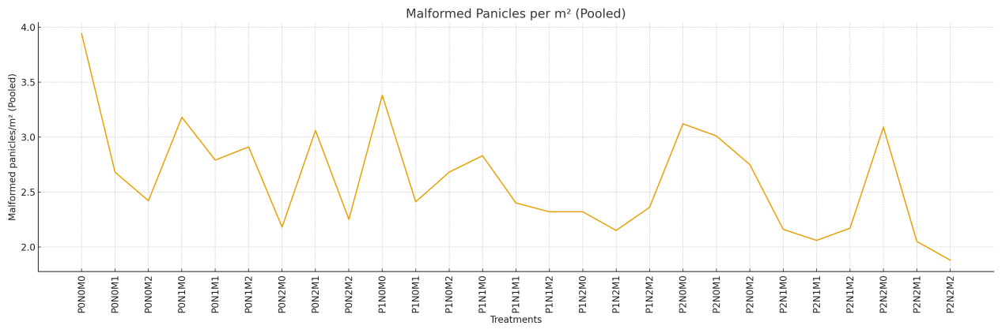
Figure 1: Effect of NAA, PGPR and Micronutrients on malformed panicles per square meter
Healthy panicles/m² increased markedly under combined treatments. The maximum number of healthy panicles (15.97/m²) was recorded in P₂N₂M₂, followed by P₁N₂M₂ (15.72/m²) and P₂N₂M₁ (15.88/m²). In contrast, the lowest values were obtained in the untreated control (11.63/m²). This improvement reflects the synergistic action of Pseudomonas fluorescens, which enhances nutrient uptake, secretes phytohormones, and suppresses malformation-associated pathogens (Kumar et al., 2020). PGPR-mediated improvement in panicle health is also supported by findings of Kumar et al. (2022), who reported enhanced vegetative vigor and reproductive growth in mango following Pseudomonas application.
A similar trend was observed for the percentage of malformed panicles. The minimum malformation (9.71%) was recorded under P₂N₂M₂, representing nearly a 61% reduction compared with the control (25.28%). Treatments containing higher levels of micronutrients showed consistent reductions in malformation percentage, confirming the crucial role of Zn and B in floral development, meristematic activity, pollen viability, and panicle health (Sharma & Dhillon, 2019; Wani et al., 2021). The integration of micronutrients with PGRs and PGPR aligns with the multi-factor etiological model of mango malformation, which emphasizes the need for simultaneously correcting hormonal, nutritional, and pathological factors (Ploetz, 2001; Chakrabarti, 2018).
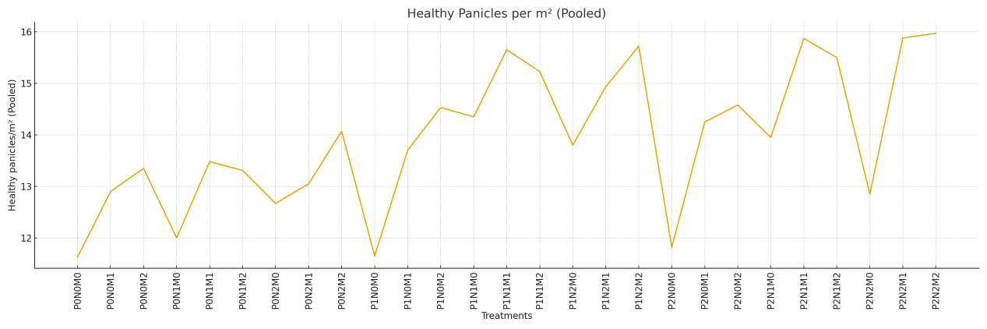
Figure 2: Effect of NAA, PGPR and Micronutrients on healthy panicles per square meter
The three-factor interaction (P × N × M) clearly demonstrated that the combined highest levels (P₂N₂M₂) consistently improved all parameters. This synergistic improvement may be attributed to the NAA-induced regulation of auxin balance, which promotes normal floral differentiation and reduces hormonal disorders associated with malformation. In addition, Pseudomonas fluorescens exhibits strong antagonistic activity against Fusarium spp., thereby lowering pathogen-associated malformation and improving overall panicle health. The concurrent application of zinc and boron further strengthens reproductive physiology by enhancing meristematic activity, pollen viability, and carbohydrate translocation. Comparable synergistic interactions between nutrient supplementation and plant growth regulators in promoting mango flowering and fruit set have also been reported by Majumder et al. (2022).
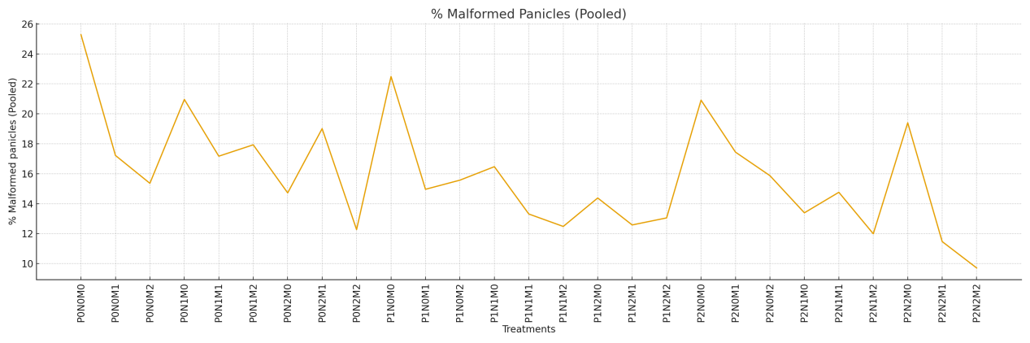
Figure 3: Effect of NAA, PGPR and Micronutrients on % malformed panicles

Table 1: Effect of NAA, PGPR and Micronutrient on malformed panicles/m², healthy panicles/m² and % malformed panicles.
Treatment | Malformed panicles/m² | Healthy panicles/m² | % Malformed panicles
P₀N₀M₀ | 3.94 | 11.63 | 25.28
P₀N₀M₁ | 2.68 | 12.9 | 17.22
P₀N₀M₂ | 2.42 | 13.35 | 15.36
P₀N₁M₀ | 3.18 | 12.0 | 20.96
P₀N₁M₁ | 2.79 | 13.48 | 17.17
P₀N₁M₂ | 2.91 | 13.31 | 17.93
P₀N₂M₀ | 2.18 | 12.67 | 14.72
P₀N₂M₁ | 3.06 | 13.05 | 19.01
P₀N₂M₂ | 2.25 | 14.07 | 12.27
P₁N₀M₀ | 3.38 | 11.65 | 22.49
P₁N₀M₁ | 2.41 | 13.7 | 14.96
P₁N₀M₂ | 2.68 | 14.53 | 15.57
P₁N₁M₀ | 2.83 | 14.35 | 16.47
P₁N₁M₁ | 2.4 | 15.65 | 13.31
P₁N₁M₂ | 2.32 | 15.23 | 12.48
P₁N₂M₀ | 2.32 | 13.8 | 14.38
P₁N₂M₁ | 2.15 | 14.93 | 12.58
P₁N₂M₂ | 2.36 | 15.72 | 13.05
P₂N₀M₀ | 3.12 | 11.82 | 20.91
P₂N₀M₁ | 3.01 | 14.25 | 17.44
P₂N₀M₂ | 2.75 | 14.58 | 15.87
P₂N₁M₀ | 2.16 | 13.95 | 13.39
P₂N₁M₁ | 2.06 | 15.87 | 14.76
P₂N₁M₂ | 2.17 | 15.5 | 11.99
P₂N₂M₀ | 3.09 | 12.85 | 19.4
P₂N₂M1 | 2.05 | 15.88 | 11.47
P₂N₂M₂ | 1.88 | 15.97 | 9.71
CD (P = 0.05) | 0.15 | 0.41 | 0.90

REFERENCES

Chakrabarti, D. K. (2018). Mango malformation: Etiology and management. Journal of Applied and Natural Science, 10(1), 1–9.
Das, B., Hazarika, M., & Bhagawati, R. (2019). Effect of plant growth regulators on fruit retention, yield and quality of mango (Mangifera indica L.) cv. Amrapali. Journal of Pharmacognosy and Phytochemistry, 8(1S), 1–4.
Freeman, S., Shtienberg, D., Maymon, M., Levin, A. G., Ploetz, R. C., & Maharachchikumbura, S. S. N. (2014). Etiology and epidemiology of mango malformation disease. Plant Disease, 98(3), 317–326.
Kumar, P., Singh, S., & Barman, D. (2020). Physiological and biochemical basis of flowering and fruit set in mango: A review. International Journal of Chemical Studies, 8(4), 1222–1227.
Kumar, P., Singh, S., & Kumar, S. (2022). Bio-efficacy of native plant growth-promoting rhizobacteria on vegetative growth, yield and quality of mango (Mangifera indica L.) cv. Dashehari. Indian Journal of Agricultural Sciences, 92(2), 227–231.
Majumder, D. A. N., Sarker, B. C., & Rani, S. (2022). Performance of Amrapali mango under high density planting system: A review. International Journal of Environment and Climate Change, 12(11), 3380–3387.
NHB. (2023). Indian Horticulture Database. National Horticulture Board, Government of India.
Panse, V. G., & Sukhatme, P. V. (1985). Statistical methods for agricultural workers (4th ed.). ICAR Publication.
Ploetz, R. C. (2001). Malformation: A unique and important disease of mango. In J. Janick (Ed.), Horticultural Reviews (Vol. 25, pp. 233–267). John Wiley & Sons.
Sharma, R., & Dhillon, W. S. (2019). Effect of micronutrients on flowering and fruiting of mango. Journal of Horticultural Research, 27(2), 81–88.
Sharma, S., & Singh, D. (2018). Role of plant growth-promoting rhizobacteria (PGPR) in fruit crops: A review. International Journal of Current Microbiology and Applied Sciences, 7(4), 2504–2515.
Singh, V. K. (2016). Understanding hormonal interactions in mango malformation: A review. Scientia Horticulturae, 199, 70–78.
Singh, Z., & Ram, S. (2017). Mango flower physiology and disorders. Acta Horticulturae, 1183, 93–102.
Wani, M. A., Mushtaq, F., & Shah, M. (2021). Importance of boron and zinc in fruit crops: A review. Journal of Applied and Natural Science, 13(2), 624–632.

