Case report
Surgical Management of Extra-Thoracic Axillary Inter-muscular Chondrolipoma in a Dog

ABSTRACT:
A 5-year-old female Belgian Malinois dog was presented with a firm, progressively enlarging mass in the left axilla adjacent to cranio-ventral thoracic region for the past six months. Clinical signs included inconvenience to gait and reduced appetite. Lateral thoracic radiograph revealed multifocal amorphous mineralizations inside the mass without any association with any specific organ and the Ultrasound-guided fine needle aspiration cytology revealed adipose tissue involvement. Surgical excision of the mass was performed under general anesthesia. Histopathological examination revealed that the mass as an inter-muscular chondrolipoma with dystrophic calcification. With good post operative care and management, animal showed uneventful recovery without any postoperative complications.
Key Words: Dog, axillary extra thoracic mass, adipose tissue, surgical excision, inter-muscular chondrolipoma, dystrophic calcification.
1. INTRODUCTION:
Lipoma is the most common benign adipose tissue tumor composed of well-differentiated adipocytes of mesenchymal origin and is frequently reported in domestic animals, especially in dogs (Hendrick, 2016). Elderly and obese dogs were more predisposed to developing lipomas, particularly females, due to their physiological tendency to accumulate greater amounts of adipose tissue (Huppes et al., 2016). Superficial lipomas were usually located within the subcutaneous tissue, while deep-seated lipomas develop in deeper tissues such as muscles (Unsaldi et al., 2023). Subcutaneous lipomas were soft and mobile, whereas inter-muscular lipomas were firmer and immobile (Bodh et al., 2013). Inter-muscular lipoma is a form of deep-seated lipoma that develops from the inter-muscular septum and accumulations of fat between muscle bundles and situated in the subcutaneous tissue between muscle bellies and does not invade the surrounding tissues. Canine inter-muscular lipomas were most often seen in the thigh region between the semitendinosus and semimembranosus muscles and were less commonly found in the forelimb (Farzad-Mohajeri et al., 2025). However, the other sites such as intra thoracic, intra-abdominal, extra-abdominal and intrapelvic were also on record (Tanabe et al., 2005). As per World Health Organization (WHO) classification, infiltrative lipoma, and angiolipoma were the two types of benign adipose tissue tumors recognized in domestic animals. Lipoma with cartilaginous metaplasia, which is called as chondrolipoma (CLA) was rare in humans (Yamada et al., 2005). The present paper describes a rare case of canine extra-thoracic inter-muscular chondrolipoma.
2. CASE HISTORY AND CLINICAL EXAMINATION:
A five year old female Belgian Malinois dog, weighing about 20 kg was referred to the Department of Veterinary Clinical Complex, NTR College of Veterinary Science Gannavaram for evaluation of a gradually enlarging mass on the left axillary ventro-lateral thoracic region over a period of six months (Fig. 1). The owner reported that the dog was operated for mammary tumor one year before and now exhibiting signs of reduced food and water intake. On clinical examination, the mass was in the left axilla adjacent to ventral thorax was firm in consistency and the animal showed altered gait while walking. All the vital signs were within physiological limits. The hematological and biochemical parameters were in the normal range. Lateral thoracic radiographic examination revealed multifocal amorphous mineralization, mostly in the lateral aspect of left ventral thorax (Fig. 2). The mineralization did not appear to be associated with any specific organ. Ultra sound guided fine needle aspiration of the mass revealed presence of fat cells and fatty droplets suggestive of lipomatous tissue.
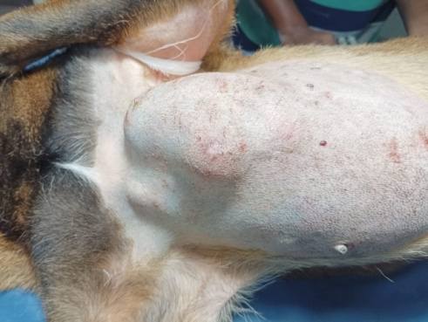
Fig. 1: Mass at the left axillary ventrolateral thoracic area.

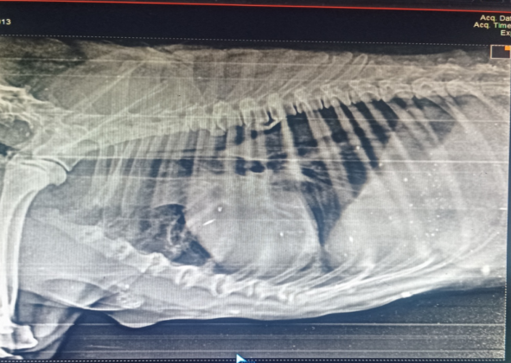
Fig. 2: Lateral thoracic radiograph showing well-defined soft tissue opacity in the ventral thoracic region. No signs of metastasis.

3. TREATMENT:
The left ventro-lateral thoracic region containing the mass was aseptically prepared for surgery. After proper preparation, the dog was pre-anaesthetized with Atropine @ 0.04 mg/kg body weight given subcutaneously. General anesthesia induction was done with inj. Ketamine and inj. Midazolam @ 5 mg/kg body weight and 0.1 mg/kg body weight respectively IV followed by endotracheal intubation and maintained with 2% of Isoflurane. The animal was positioned in dorsal recumbency with the mass facing the surgeon. An elliptical incision was made at the base of the inter-muscular tumorous mass attached to the muscle fibers between descending pectorals and transverse pectorals was completely excised through blunt dissection (Fig. 3 & 4). Haemostasis was achieved by ligating and cauterizing the bleeding vessels. Following removal of the mass, dead space was minimized by placing sutures in the superficial fascia and subcutaneous tissue using polyglactin 910 no. 0 (Fig. 5). The skin was closed in horizontal mattress pattern with polyamide no. 0 (Fig. 6) and a pressure bandage was maintained for one week postoperatively. The excised mass measured approximately 12 cm long, 9 cm wide and 6 cm thick (Fig. 7).
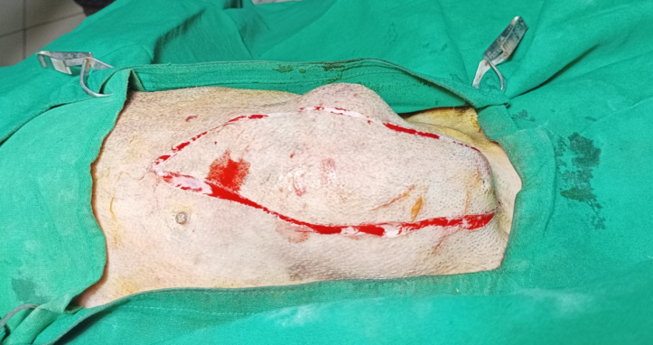
Fig. 3: Photograph showing elliptical skin incision made over the mass.
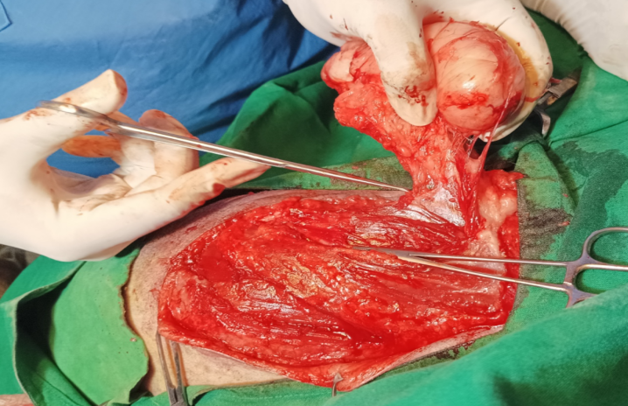
Fig. 4: Photograph showing surgical resection of mass

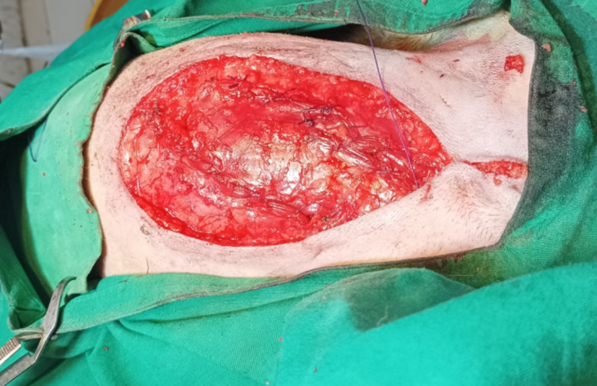
Fig. 5: Photograph showing closure of superficial fascia

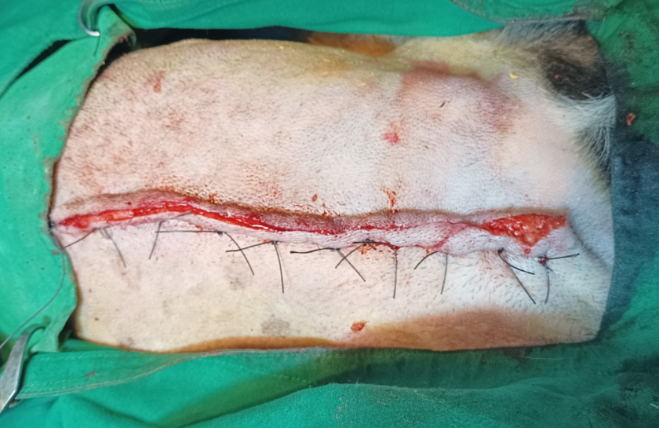
Fig. 6: Photograph showing apposition of skin with horizontal mattress sutures
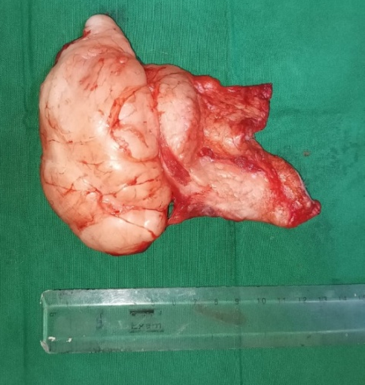
Fig. 7: Photograph showing the resected intermuscular lipoma after surgery with a soft, greasy, white to yellowish color.
Postoperatively, animal was administered with inj. Ceftriaxone @ 20 mg/kg body weight for 5 days and inj. Meloxicam @ 0.2 mg/kg body weight for 3 days given intramuscularly along with daily antiseptic wound dressing using 5% povidone iodine. Skin sutures were removed on the 12th postoperative day and animal recovered uneventfully.
4. HISTOPATHOLOGY:
The excised representative tissue samples were fixed in 10% neutral buffered formalin and processed using standard histological procedures followed by hematoxylin and eosin (H&E) staining. Histopathological examination revealed a well-demarcated, encapsulated and lobulated tumor mass composed of mature adipose and cartilaginous tissues (Fig. 8). The lobules were separated by a thin fibrovascular stroma. Each lobule was composed of mature adipose tissue and variable amounts of chondroid matrix (Fig. 9). The adipocytes were characterized by vacuolated cytoplasm and eccentrically placed hyperchromatic nuclei. The chondroid matrix was composed of hyalinized cartilage containing chondroblasts and chondrocytes in the lacunae. These features were confirmative of chondrolipoma, a rare benign mixed mesenchymal tumor comprising both mature adipocytes and cartilaginous elements.
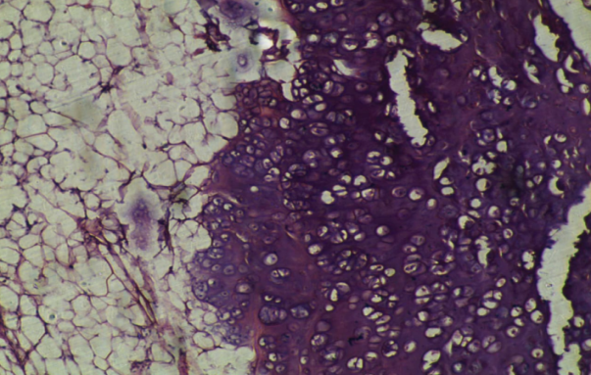
Fig. 8: Photomicrograph of intermuscular chondrolipoma showing mature adipocytes and chondroid matrix (H & E 40x).

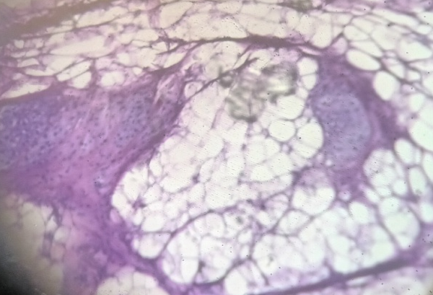
Fig. 9: Photomicrograph showing a well-demarcated, encapsulated and lobulated tumor mass composed of mature adipose and cartilaginous tissues. The lobules were separated by a thin fibrovascular stroma (H & E 10x).
5. DISCUSSION:
Chondrolipoma is a rare and benign variant of lipoma in dogs characterized by mature adipose tissue with areas of chondroid metaplasia. Two main hypotheses were proposed for the presence of cartilage in chondrolipomas. The first is chondro-osseous metaplasia of fat tissue, triggered by chronic trauma, repeated stress, or poor blood supply. The second involves pluripotent mesenchymal cells within the tumor, which can differentiate into cartilage under certain conditions (Annoni and Morandi, 2021). The diagnosis of chondrolipoma was made based on the presence of a well-formed lipoma that had small, clearly developed cartilage areas scattered throughout the fatty tissue. This is in accordance with Jakab et al. (2009) and Souza et al. (2017) who reported that chondrolipoma is characterized by the presence of cartilage islands spread within a typical lipoma, often surrounded by mucin and collagen around the chondrocytes. In the present case, complete surgical excision of the tumor was carried out under aseptic conditions. According to Tanabe et al. (2005) the primary treatment for lipoma is surgical removal as the recurrence rate is rare in both, dogs and humans followed by excision, though deep lipomas have a higher risk because of the difficulty of complete removal. In this case, the observed calcification within the thoracic mass was likely due to dystrophic mineralization secondary to localized cellular injury. The postoperative evaluations revealed normal gait, with no signs of seroma, infection, or tumor recurrence up to six months following surgery.
6. CONCLUSION:
Considering its non-invasive behavior and favorable prognosis, surgical excision appears to be a reliable and preferred approach for managing chondrolipomas in dogs.

REFERENCES:
Asproni, P., Millanta, F., & Poli, A. (2012). A mammary gland chondrolipoma in the dog. Journal of Veterinary Diagnostic Investigation, 24(5), 1017-1020.
Bodh, D., Singh, K., Aithal, H. P., Sivanarayanan, T. B., & Gugjoo, M. B. (2013). Cutaneous lipoma in dogs and its surgical management. Intas Polivet, 14(2), 472-475.
de Souza, M. D. F., Sarmento, A. E. M., Barbos, F. M. S., Siqueira, R. A. S., Barbosa, F. M. S., Talieri, I. C., & Lucena, R. B. (2017). Condrolipomanaorelha de um cão. Acta Scientiae Veterinariae, 45, 1-4.
Farzad-Mohajeri, S., Safavi, S. F., Soroori, S., & Sasani, F. (2025). A Large Inter-muscular Lipoma in the Axillary Region of a Dog: Diagnosis, Surgery and Follow-up. Iranian Journal of Veterinary Medicine, 19(3), 611- 616.
Jakab, C., Szász, A., Kulka, J., Schaff, Z., Rusvai, M., Németh, T., & Gálfi, P. (2009). Cutaneous mast cell tumour within a lipoma in a boxer. Acta Veterinaria Hungarica, 57(2), 263-274.
Hendrick, M. J. (2016). Mesenchymal tumors of the skin and soft tissues. Tumors in domestic animals, 142-175.
Huppes, R. R., Dal Pietro, N., Wittmaack, M. C., Sembenelli, G., Bueno, C. M., Pazzini, J. M., Jark, P.C., De Nardi, A.B. & Castro, J. L .C. (2016). Inter-muscular lipoma in dogs. Acta Scientiae Veterinariae, 44, 1-7.
Annoni, M. & Morandi, M.C.A. (2021). Epiglottic Chondrolipoma in a Dog”. EC Veterinary Science 6.7 (2021): 98-104.
Mutinelli, F., Vascellari, M., Melchiotti, E., Bigolaro, M., & Bozzato, E. (2007). Intra-pelvic chondrolipoma in a dog. Journal of Comparative Pathology, 137(2-3), 160-164.
Tanabe, S., Yamada, K., Kobayashi, Y., Suzuki, K., Yamaguchi, M., Uzuka, Y., Sarashina, T. & Inoue, M. (2005). Extra-abdominal chondrolipoma in a dog. Veterinary Radiology and Ultrasound, 46(4), 306-308.
Unsaldı, E., Polat, E., Incılı, C. A., Eroksuz, Y., & Can, U. K. (2023). Histopathological findings and treatment of inter-muscular lipoma in a dog: A rare case. Erciyes Üniversitesi Veteriner Fakültesi Dergisi, 20 (2), 152-155.

