An Assessment of Seasonal Variation in Water Quality of Sai River in Pratapgarh, UP

ABSTRACT
Aim- The present study investigates seasonal variations in the physico-chemical characteristics of the Sai River in Pratapgarh district, India, across three sites representing different levels of anthropogenic influence.
Study Design- The study was based on field based quantitative analysis.
Place and Duration of study- Three sites at Sai River in district Pratapgarh, UP, India. Duration of the study was 2 years.
Methodology- Water samples were collected during winter, summer, and rainy seasons and analysed for temperature, pH, turbidity, dissolved oxygen (DO), biochemical oxygen demand (BOD), chemical oxygen demand (COD), electrical conductivity (EC), total alkalinity (TA), nutrients, solids, and other parameters following APHA standard methods.
Results- The findings reveal distinct spatial and seasonal differences in water quality. Downstream sites exposed to domestic sewage, agricultural runoff, and industrial discharge exhibited consistently higher values of turbidity, BOD, COD, EC, TDS, alkalinity, and nutrients, while DO levels decreased notably during summer. Rainfall improved oxygen availability but increased suspended solids and nutrient influx.
Conclusion- Among the three sites, Site III showed the highest degree of degradation. Overall, the study highlights the cumulative impact of human activities on the Sai River and emphasizes the need for regular monitoring and effective pollution-mitigation strategies to preserve riverine health.

Key words- Anthropogenic, sewage, influx, oxygen demand, mitigation.

1. INTRODUCTION
Rivers are vital freshwater resources that sustain agricultural production, domestic needs, industry, and ecological balance. Rapid urban development, expanding industries, and intensive farming practices have led to significant deterioration of freshwater bodies globally (Whitton et al., 1991). In India, riverine pollution has intensified due to the continuous discharge of untreated municipal wastewater, industrial effluents, and nutrient-rich agricultural runoff (Hatje et al., 1998). Such contaminants alter the physico-chemical nature of water, disrupt biodiversity, and pose serious risks to human health.
The Sai River, locally known as the Adi Ganga, is an important tributary of the Gomti River. It originates in Bijgwan village near Pihani in Hardoi district and travels approximately 600 km through Hardoi, Raebareli, and Pratapgarh before merging with the Gomti at Rajepur in Jaunpur (Kumari & Chaurasia, 2015). In Pratapgarh, the river supports agriculture, fisheries, and the local ecosystem, but growing pressures from sewage discharge, industrial wastes, and agricultural inputs have compromised its water quality. Seasonal changes strongly influence river water characteristics.
Parameters such as temperature, pH, and dissolved oxygen vary naturally with climatic shifts, while rainfall and runoff significantly affect pollutant movement and concentration (Gupta & Paul, 2021). Monitoring these seasonal dynamics is therefore crucial for evaluating river health and planning restoration measures. The present study examines seasonal fluctuations in the physico-chemical properties of the Sai River at three sites experiencing different levels of human interference. The findings help illustrate pollution patterns and the influence of seasonal hydrology on river condition.

2. MATERIALS AND METHODS

2.1 Study Area
The study was conducted along a 72 km stretch of the Sai River that passes through the Pratapgarh district (latitude 25.34°–26.11° N; longitude 81.19°–82.27° E). The river enters Pratapgarh near Mustafabad, traversing predominantly agricultural and semi-urban landscapes. The district Pratapgarh is bounded by Sultanpur, Prayagraj, Jaunpur, Fatehpur, and Raebareli, and is partly bordered by the Ganga and Gomti rivers (Central Statistical Organization, 2022).
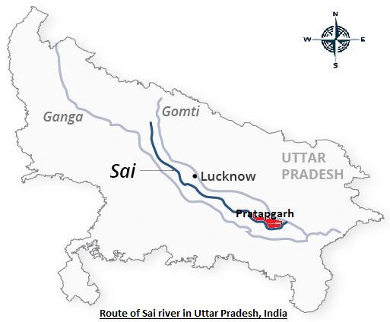
Fig 1- Route and site of study of Sai River in Pratapgarh, Uttar Pradesh, India

2.2 Site Selection
Three sampling sites, representing varying intensities of anthropogenic stress were chosen:
- Site I: Ishipur (Reference Site) having minimal human activity.
- Site II: Beerapur (Moderately Polluted Site) which is influenced by intermediate urban runoff and agricultural practices.
- Site III: Bela (Highly Polluted Site) which is exposed to heavy domestic sewage, agricultural runoff, and industrial discharge.

2.3 Sample Collection
The water samples (1000 mL each) were collected during three seasons: winter (December–February), summer (March–May) and rainy season (June–September). Five samples per site (n=5) were taken following the APHA guidelines (APHA, 2017). Samples were stored in acid washed bottles, filtered when necessary, preserved with KI solution, and transported under refrigeration for further laboratory analysis.

2.4 Physico-Chemical Analysis
The collected samples were analyzed for temperature, pH, colour, dissolved oxygen (DO), biochemical oxygen demand (BOD), chemical oxygen demand (COD), electrical conductivity (EC), chloride, nitrate, phosphate, total alkalinity (TA), turbidity, total dissolved solids (TDS), total suspended solids (TSS), total solids (TS), and total hardness (TH). Standard procedures recommended by APHA (2017), AWWA, and WPCA (2005) were followed for all examinations.

3. RESULTS AND DISCUSSION
The study revealed pronounced spatial and seasonal variations in the physico-chemical parameters of the Sai River. Differences among sites reflected the increasing influence of domestic sewage, agricultural runoff, and industrial wastes from upstream to downstream.

3.1 Temperature
Temperature showed a distinct seasonal pattern with maximum values during summer at all sites. Site III recorded the highest temperature (34.08°C), while Site II exhibited slightly elevated summer temperatures relative to Sites I and III. Winter and monsoon temperatures showed no significant differences. These variations affect oxygen solubility, metabolic rates, and overall biological activity (Singh et al., 2020). Comparable patterns were noted in other urban-impacted rivers, where shallow depth and human activities increase localized warming (Verma & Saksena, 2019).

3.2 pH
pH ranged from slightly acidic at Site I (6.64–6.80) to more alkaline at Sites II and III. Higher winter pH at Sites II and III indicates the presence of detergent-laden wastewater and agriculturally derived bicarbonates. Dilution during rainfall reduced differences across sites in other seasons. These outcomes agree with earlier findings where polluted stretches showed elevated pH values that normalize during monsoon flow (Sharma et al., 2018; Gupta & Paul, 2021).

3.3 Colour and Taste
Water colour and taste deteriorated progressively downstream. Site I remained largely clear, whereas Sites II and III displayed yellow-brown coloration, especially during the rainy season. The change corresponds with increased suspended matter, organic debris, and sewage inputs. Quantitative analysis and visual observations clearly indicated water quality degradation, which is consistent with trends in other polluted Indian rivers (Mishra et al., 2017).

3.4 Turbidity
Turbidity varied significantly across all seasons, with Sites II and III showing consistently higher values due to silt, organic particles, and wastewater inflow. Maximum turbidity (22.12 NTU) occurred at Site III in winter, while Site I recorded the lowest value in summer (5.96 NTU). Elevated turbidity restricts light penetration and impairs photosynthesis (Wetzel, 2001). Similar high turbidity levels have been reported in the Yamuna and Gomti rivers (Chopra & Sharma, 2018).

3.5 Dissolved Oxygen (DO)
DO levels showed strong seasonal and spatial differences. Summers DO at Sites II and III was significantly lower, reflecting oxygen depletion from high organic loads and microbial activity. Rainy season DO peaked at Site I (7.30 mg/L) due to improved aeration and dilution. These findings mirror DO reductions in polluted stretches of the Ganga and Cauvery rivers (Kumar & Chauhan, 2020).

3.6 Biochemical Oxygen Demand (BOD)
BOD increased progressively downstream, with the highest values observed during summer. Site III recorded a maximum of 10.06 mg/L. Winter BOD values at Sites II and III differed significantly from Site I, indicating substantial organic pollution. Although seasonal differences during summer and monsoon were statistically insignificant, overall elevated BOD levels suggest significant organic loading. Similar patterns have been reported in rivers impacted by untreated sewage (Pathak et al., 2019).

3.7 Chemical Oxygen Demand (COD)
COD trends resembled those of BOD, with downstream sites showing higher concentrations. During the rainy season, COD was significantly higher at Sites II and III, suggesting chemical pollutant inflow via runoff. Winter COD peaked at Site III (121 mg/L), implying accumulation of both biodegradable and non-biodegradable substances. Comparable COD enrichment has been observed in the Chambal River (Singh & Mathur, 2018).

3.8 Total Alkalinity (TA)
TA was markedly higher at Sites II and III throughout the year, reaching a maximum of 295.4 mg/L at Site III in winter. This increase reflects bicarbonate-rich domestic wastewater and agricultural residues. Comparable downstream alkalinity elevation has been documented in earlier studies (Goel & Kaur, 2017).

3.9 Electrical Conductivity (EC)
EC increased downstream due to higher dissolved ion concentrations from sewage, fertilizers, and industrial waste. Site III consistently showed the highest values. Winter EC reached 1580 µS/cm at Site III. Similar ionic enrichment has been reported in the polluted Sabarmati River stretch (Patel & Raju, 2019).

3.10 Total Dissolved Solids (TDS)
TDS values were significantly higher at Sites II and III during summer and monsoon seasons, indicating enriched dissolved salts and pollutants. Winter values also showed downstream increase although without statistical significance. Elevated TDS affects taste and aquatic suitability (WHO, 2017), and similar spatial patterns have been observed in the Yamuna and Krishna rivers (Rao et al., 2020).

3.11 Total Solids (TS) and Total Suspended Solids (TSS)
TS and TSS increased progressively from Site I to Site III, particularly during the rainy season due to higher erosion and runoff. Significant differences were recorded for TS, while TSS showed numerical increase. These trends correspond with monsoon-driven suspended solids surges reported in previous studies (Rawat & Singh, 2021).

3.12 Total Hardness (TH)
TH showed significant variation only during the rainy season, with the highest value at Site III (250.2 mg/L). Increased monsoon hardness likely results from leaching of minerals into the river. Although seasonal differences in winter and summer were minor, a downstream rise was evident. Similar patterns have been documented in the Narmada River (Trivedi et al., 2018).

3.13 Chloride
Chloride concentrations increased downstream, reflecting wastewater input, even though the statistical differences were prominent. Elevated chloride can disrupt osmotic balance in aquatic organisms (Sawyer et al., 2003).

3.14 Nitrate and Phosphate
Nutrient (nitrate and phosphate) levels increased from Site I to Site III, with significant differences during the rainy season. The highest nitrate (1.34 mg/L) and phosphate (0.95 mg/L) values occurred at Site III in winter, likely due to agricultural fertilizers and sewage discharge. These nutrients contribute to eutrophication, a trend widely documented in polluted Indian rivers (Carpenter et al., 1998; Singh et al., 2020).

Table 1: Seasonal variation in physico-chemical parameters of Sai River Water at three sites in three different seasons.
Sl. No. | Parameter | Site | Winter | Summer | Rainy
1. | Temperature (°C) | I | 29.70 ± 0.48 | 34.00 ± 0.50 | 32.36 ± 0.59
1. | Temperature (°C) | II | 30.16 ± 0.17 | 33.86 ± 0.27ᵃ | 32.46 ± 0.64
1. | Temperature (°C) | III | 30.03 ± 0.43 | 34.08 ± 0.74 | 32.86 ± 0.52
2. | pH | I | 6.80 ± 0.29 | 6.64 ± 0.24 | 6.64 ± 0.22
2. | pH | II | 8.36 ± 0.05ᵃ | 7.92 ± 0.04 | 7.86 ± 0.09
2. | pH | III | 8.50 ± 0.03ᵃ | 8.13 ± 0.14 | 8.06 ± 0.12
3. | Turbidity (NTU) | I | 6.48 ± 0.66 | 5.96 ± 0.43 | 7.34 ± 0.83
3. | Turbidity (NTU) | II | 17.96 ± 1.27ᵃ | 17.22 ± 1.19ᵃ | 17.49 ± 1.41ᵃ
3. | Turbidity (NTU) | III | 22.12 ± 1.85ᵃ | 20.89 ± 0.41ᵃᵇ | 21.16 ± 1.25ᵃ
4. | DO (mg/L) | I | 7.02 ± 0.089 | 6.92 ± 0.048 | 7.30 ± 0.054ᵃᵇ
4. | DO (mg/L) | II | 6.94 ± 0.12 | 6.50 ± 0.094ᵃ | 7.16 ± 0.02ᵃ
4. | DO (mg/L) | III | 6.82 ± 0.09 | 6.22 ± 0.03ᵃ | 7.04 ± 0.06ᵃ
5. | BOD (mg/L) | I | 4.20 ± 0.03 | 6.38 ± 0.14ᵃ | 6.86 ± 0.27ᵃ
5. | BOD (mg/L) | II | 5.06 ± 0.10 | 9.24 ± 0.36ᵃ | 8.70 ± 0.22ᵃ
5. | BOD (mg/L) | III | 5.80 ± 0.09 | 10.06 ± 0.22ᵃ | 9.34 ± 0.21ᵃ
6. | COD (mg/L) | I | 84.20 ± 1.24 | 76.20 ± 3.56ᵃ | 80.60 ± 5.78ᵇ
6. | COD (mg/L) | II | 110.0 ± 2.66 | 94.00 ± 1.61ᵃ | 88.60 ± 2.78ᵃᵇ
6. | COD (mg/L) | III | 121.0 ± 2.53 | 103.6 ± 1.80ᵃ | 94.80 ± 2.90ᵃᵇ
7. | Total Alkalinity (mg/L) | I | 221.8 ± 3.96 | 204.6 ± 1.56 | 202.6 ± 1.74
7. | Total Alkalinity (mg/L) | II | 284.0 ± 6.62ᵃ | 265.8 ± 1.85ᵃ | 255.2 ± 6.64ᵃ
7. | Total Alkalinity (mg/L) | III | 295.4 ± 4.68ᵃ | 273.6 ± 2.89ᵃ | 269.4 ± 1.63ᵃ
8. | Electrical Conductivity (µS/cm) | I | 252.6 ± 9.52 | 249.4 ± 6.24 | 292.0 ± 31.73
8. | Electrical Conductivity (µS/cm) | II | 1272 ± 51.22 | 1194 ± 28.98 | 1095 ± 47.21
8. | Electrical Conductivity (µS/cm) | III | 1580 ± 35.15 | 1349 ± 47.83ᵃ | 932.6 ± 88.19ᵃᵇ
9. | TDS (mg/L) | I | 154.4 ± 11.34 | 142.9 ± 7.16 | 140.2 ± 8.65
9. | TDS (mg/L) | II | 652.4 ± 58.17 | 547.7 ± 49.77 | 497.3 ± 28.80ᵃ
9. | TDS (mg/L) | III | 826.8 ± 24.95 | 651.1 ± 44.75ᵃ | 658.2 ± 44.76ᵃ
10. | TS (mg/L) | I | 142.9 ± 7.16 | 175.3 ± 24.25 | 122.3 ± 3.14
10. | TS (mg/L) | II | 547.7 ± 49.77 | 608.1 ± 22.91 | 406.4 ± 26.37ᵃᵇ
10. | TS (mg/L) | III | 651.1 ± 44.75 | 762.6 ± 68.26 | 583.0 ± 64.23ᵃᵇ
11. | TSS (mg/L) | I | 39.47 ± 10.21 | 43.05 ± 3.80 | 36.55 ± 4.59
11. | TSS (mg/L) | II | 148.4 ± 9.27 | 135.6 ± 5.59 | 127.2 ± 5.37
11. | TSS (mg/L) | III | 158.8 ± 8.08 | 145.7 ± 5.13 | 138.6 ± 3.79
12. | Total Hardness (mg/L) | I | 96.27 ± 2.89 | 89.39 ± 3.66 | 82.31 ± 3.63
12. | Total Hardness (mg/L) | II | 244.9 ± 13.85 | 230.8 ± 11.69 | 220.7 ± 8.08
12. | Total Hardness (mg/L) | III | 295.6 ± 2.57 | 263.2 ± 17.07 | 250.2 ± 17.07ᵃ
13. | Chloride (mg/L) | I | 10.91 ± 0.51 | 9.85 ± 0.33 | 9.85 ± 0.33
13. | Chloride (mg/L) | II | 129.4 ± 1.07 | 126.0 ± 3.86 | 126.0 ± 3.86
13. | Chloride (mg/L) | III | 139.4 ± 2.44 | 137.5 ± 4.28 | 137.5 ± 4.28
14. | Nitrate (mg/L) | I | 0.43 ± 0.03 | 0.47 ± 0.02 | 0.33 ± 0.03
14. | Nitrate (mg/L) | II | 0.98 ± 0.11 | 0.85 ± 0.07 | 0.66 ± 0.07ᵃ
14. | Nitrate (mg/L) | III | 1.34 ± 0.06 | 1.15 ± 0.04 | 0.78 ± 0.03ᵃᵇ
15. | Phosphate (mg/L) | I | 0.44 ± 0.03 | 0.39 ± 0.03 | 0.33 ± 0.03
15. | Phosphate (mg/L) | II | 0.79 ± 0.02 | 0.66 ± 0.06 | 0.66 ± 0.07ᵃ
15. | Phosphate (mg/L) | III | 0.95 ± 0.10 | 0.84 ± 0.07 | 0.78 ± 0.03ᵃᵇ

Fig 1 : Graphical Analysis of data for all parameters

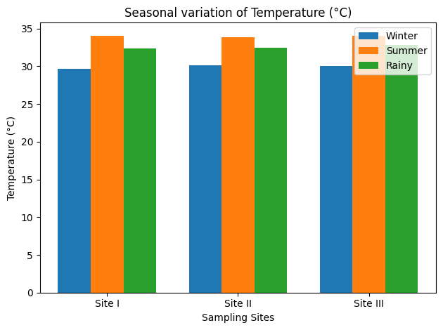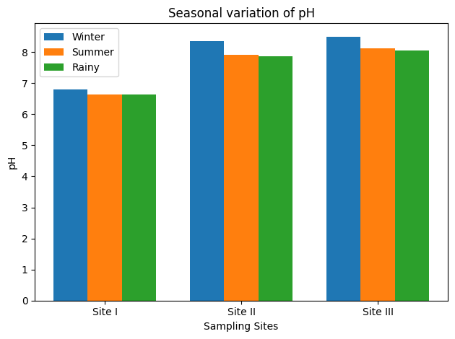

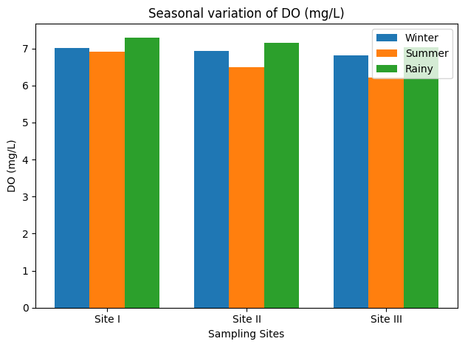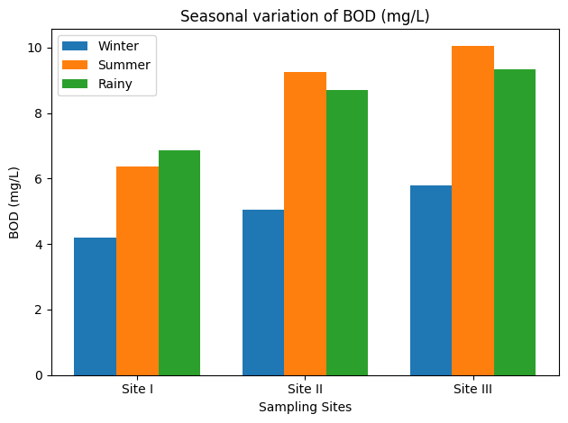

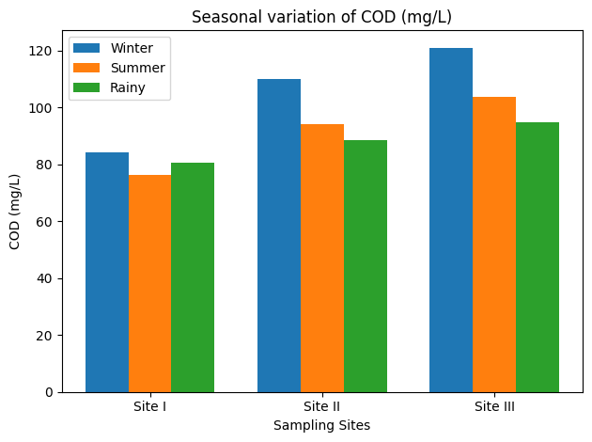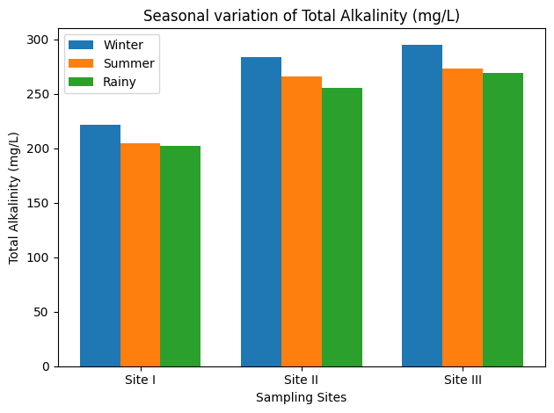

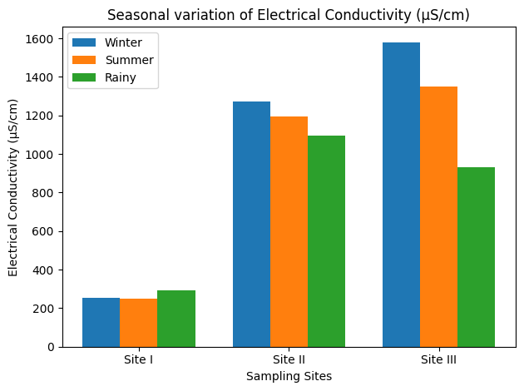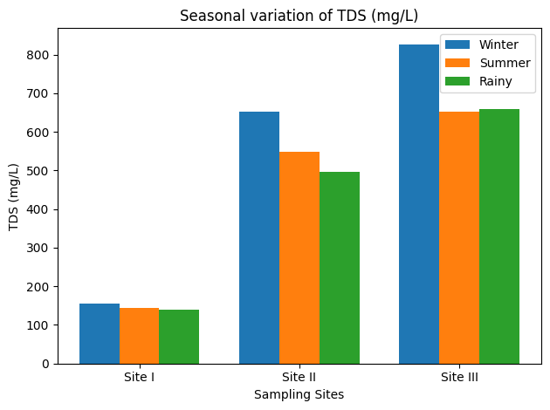

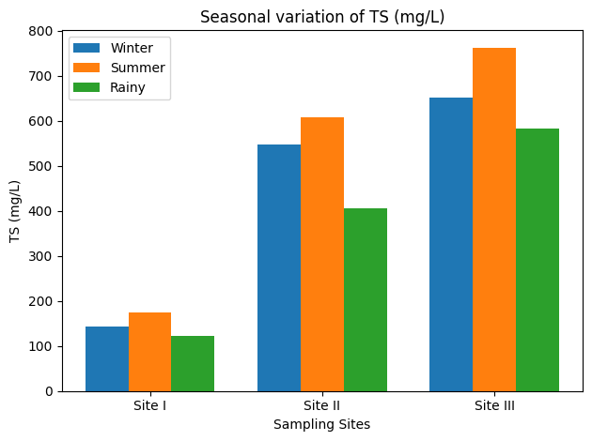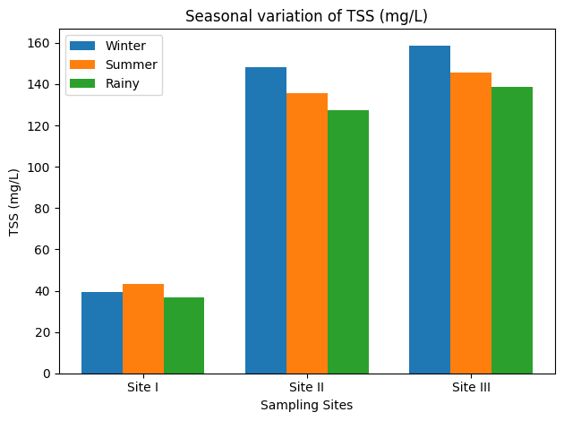

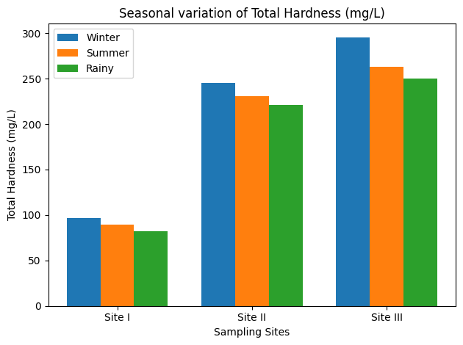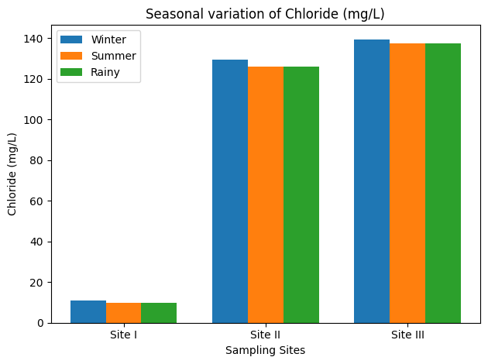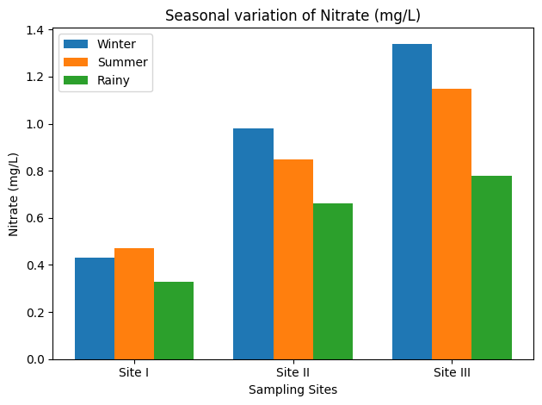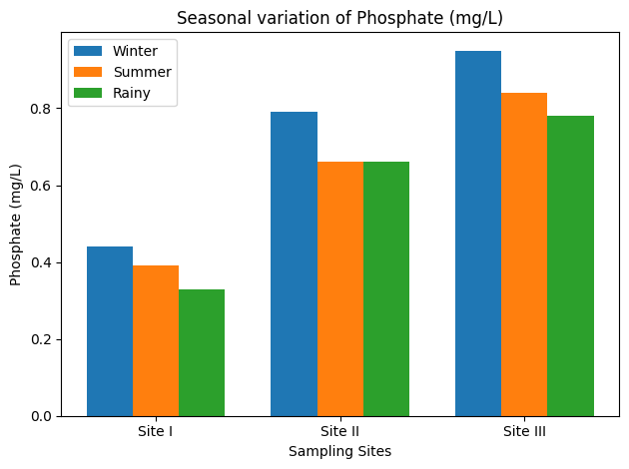

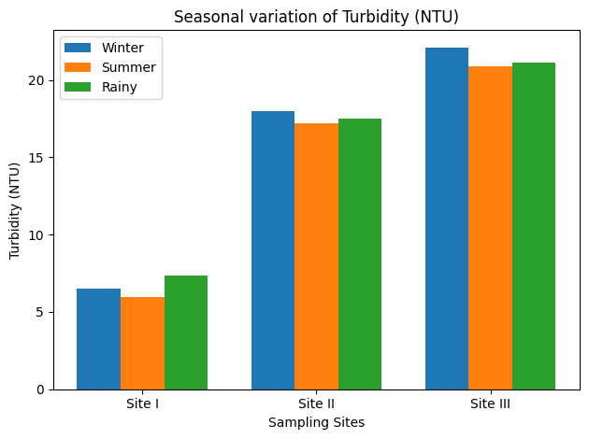

4. Conclusion
The study reveals clear spatial and seasonal disparities in the water quality of the Sai River. Site III consistently experienced the highest pollution load, followed by Site II, confirming the intensifying anthropogenic pressure downstream. Summer months imposed the greatest stress on water quality, while monsoon conditions improved DO but increased turbidity and nutrient inflow. Although rainfall provides some dilution, it does not mitigate overall pollution intensity. Continuous monitoring and targeted pollution-control measures are essential to safeguard the ecological functioning of the Sai River.

References
- Baird, R., & Bridgewater, L. (2017). Standard methods for the examination of water and wastewater. 23rd edition. Washington, D.C.: American Public Health Association.
- Carpenter, S. R., Caraco, N. F., Correll, D. L., Howarth, R. W., Sharpley, A. N., & Smith, V. H. (1998). Nonpoint pollution of surface waters with phosphorus and nitrogen. Ecological Applications, 8(3), 559–568.
- Chopra, A. K., & Sharma, M. K. (2018). Assessment of water quality indices of River Yamuna. Applied Water Science, 8, 1–13.
- Chopra, S., & Sharma, A. (2018). Seasonal variation in water quality parameters of the Yamuna and Gomti rivers. International Journal of Environmental Sciences, 8(4), 623–632.
- Goel, P. K., & Kaur, H. (2017). Impact of sewage on freshwater ecosystems. Journal of Environmental Biology, 38(4), 623–630.
- Goel, P. K., & Kaur, N. (2017). Assessment of water quality of rivers affected by sewage and industrial effluents in Northern India. Journal of Environmental Biology, 38(5), 1071–1080.
- Gupta, N., & Paul, S. (2021). Seasonal fluctuations in water quality of monsoon-fed rivers of India. Water Science and Technology, 83(7), 1515–1527. https://doi.org/10.2166/wst.2021.070
- Gupta, N., & Paul, S. (2021). Seasonal variations in water quality of monsoon-fed rivers. Ecohydrology Journal, 14(2), 211–225.
- Kumar, M., & Chauhan, A. (2020). Water quality assessment of River Ganga. Environmental Monitoring and Assessment, 192, 1–15.
- Kumar, R., & Chauhan, M. (2020). Dissolved oxygen dynamics in polluted stretches of the Ganga and Cauvery rivers. Environmental Monitoring and Assessment, 192, 58. https://doi.org/10.1007/s10661-019-8012-4
- Mishra, A., Singh, V., & Tiwari, S. (2017). Impact of domestic wastewater on surface water quality. Water Science, 31(2), 119–131.
- Mishra, P., Singh, V., & Sharma, R. (2017). Qualitative assessment of water quality degradation in Indian rivers. Environmental Pollution Research, 5(2), 45–53.
- Patel, P., & Raju, N. (2019). Physicochemical analysis of Sabarmati River water. Environmental Earth Sciences, 78, 1–12.
- Patel, R., & Raju, K. (2019). Assessment of water quality and pollution load in the Sabarmati River. Applied Water Science, 9, 121. https://doi.org/10.1007/s13201-019-0990-1.
- Pathak, A., Singh, S., & Singh, R. (2019). Monitoring of organic pollution in Indian river systems. Journal of Environmental Science and Engineering, 61(3), 261–271.
- Pathak, L., Sharma, P., & Gupta, R. (2019). BOD and COD trends in polluted rivers of India. Journal of Water Resource Engineering, 5(1), 12–21.
- Rao, P., Reddy, D., & Sharma, V. (2020). Seasonal variation in total dissolved solids in the Yamuna and Krishna rivers. International Journal of River Basin Management, 18(4), 487–498.
- Rao, S., Raju, R., & Patil, K. (2020). TDS and EC analysis in Krishna River. Environmental Processes, 7, 345–360.
- Rawat, N., & Singh, P. (2021). Suspended solids and sedimentation patterns in monsoon-affected rivers. Journal of Hydrology, 595, 125–135. https://doi.org/10.1016/j.jhydrol.2021.125135.
- Rawat, S., & Singh, J. (2021). Seasonal suspended solids variation in Himalayan rivers. Hydrology Research, 52(1), 145–158.
- Sawyer, C. N., McCarty, P. L., & Parkin, G. F. (2003). Chemistry for environmental engineering and science (5th ed.). McGraw-Hill.
- Sharma, D., Meena, R., & Gupta, S. (2018). Physicochemical assessment of agricultural runoff-impacted rivers. Water and Environment Journal, 32(4), 581–590.
- Sharma, K., Singh, R., & Kumar, P. (2018). Seasonal variation of pH and other water quality parameters in urban rivers. Environmental Monitoring and Assessment, 190, 45. https://doi.org/10.1007/s10661-017-6360-1.
- Singh, A., & Mathur, V. (2018). Chemical oxygen demand trends in Indian riverine systems. Environmental Science and Pollution Research, 25, 12345–12356. https://doi.org/10.1007/s11356-018-1405-8.
- Singh, R., & Mathur, P. (2018). Chemical pollution assessment of Chambal River. International Journal of Environmental Studies, 75(6), 901–915.
- Singh, R., Singh, A., & Verma, P. (2020). Temperature and nutrient dynamics in urban rivers of India. Journal of Environmental Management, 264, 110489. https://doi.org/10.1016/j.jenvman.2020.110489.
- Singh, S., Verma, R., & Yadav, R. (2020). Seasonal water quality variation in River Gomti. Journal of Environmental Protection, 11, 155–170.
- Trivedi, A. K., Soni, H., & Patel, R. (2018). Seasonal hardness variation in Narmada River. Asian Journal of Water, Environment and Pollution, 15(1), 7–12.
- Trivedi, P., Sharma, V., & Kaur, R. (2018). Seasonal hardness variation in the Narmada River. Environmental Monitoring and Assessment, 190, 672. https://doi.org/10.1007/s10661-018-6985-2.
- Verma, A., & Saksena, D. (2019). Localized heating and water quality impacts in urban river stretches. Water Quality Research Journal, 54(3), 205–215.
- Wetzel, R. G. (2001). Limnology: Lake and river ecosystems (3rd ed.). Academic Press.
- World Health Organization. (2022). Guidelines for drinking-water quality: Incorporating the first and second addenda. World Health Organization.

